What drives illegitimate customer complaining behaviour?

An empirical study on the drivers of illegitimate customer complaining behaviour, the types of complaints and the relationship between the customer and the organisation.

Student: Jan Peters
Student Number: s4490207
Supervisor: Dr H.W.M. Joosten
Second Examiner: Dr N.V.T. Belei

What drives illegitimate customer complaining behaviour?

An empirical study on the drivers of illegitimate customer complaining behaviour, the types of complaints and the relationship between the customer and the organisation.



Student: Jan Peters
Student Number: s4490207
Email: jw.peters@student.ru.nl
Supervisor: Dr H.W.M. Joosten
Second Examiner: Dr N.V.T. Belei

Course: Master Thesis
University: Radboud University Nijmegen
Faculty: Faculty of Management
Date: June 11, 2021

I hereby state that this master thesis is originally and exclusively written by myself. In case I made use of the knowledge or ideas of others, I mentioned this explicitly within the text and references.
Preface

I hereby proudly present my master’s thesis ‘What drives illegitimate customer complaining behaviour?’, which focuses on the drivers that customers use to illegitimately complain. This thesis has been written in order to complete the master’s specialisation of Marketing at the Radboud University in Nijmegen, the Netherlands. The trajectory in which this thesis was completed spanned from November 2020 to June 2021.

Because of the sensitive nature of the topic of the research and its limited available existing literature, conducting the research was rather difficult and a shot in the dark for me. However, these challenges did enable an adventurous and exciting experience of conducting research. Helpful in this regard was the fact that I started this trajectory together with supervisor Dr H.W.M. Joosten and three other marketing students, all with the same goal of contributing to the knowledge of illegitimate complaining. We frequently met, in which we consulted each other as a coherent group of scientists. Therefore, a true aid within conducting this research was the help of Dr Joosten, for whose ever enthusiastic and interested attitude I express my gratitude. Besides, I thank the students with whom I pleasantly cooperated; thank you Lyn Bannink, Matty Cooijmans and Myrthe Eijkelkamp. I hope our cooperation in conducting this research paved the way towards a total understanding of the interesting but complex world of complaining behaviour, ultimately benefiting organisations in their approach towards the prevention of illegitimate complaints from happening. I truly believe that knowledge enables optimal business operations, for which I hope to have contributed.

A last and personally very important mention of gratitude goes towards my amazing parents, brothers and partner, whose caring and loving words have kept me motivated at all times.

I hope you enjoy reading.

Jan Peters

Nijmegen, June 11, 2021
Abstract
In order to retain a competitive position within the market, service recovery, and thus complaint handling, is increasing in importance for organisations. Therefore, organisations receive a lot of complaints about their products or services. However, research has shown that many of these complaints are illegitimate, which is a costly affair for organisations. In order to prevent this illegitimate complaining from happening, this study, based on a typology of complainers as identified by Joosten (2020), aims to identify what the drivers of this illegitimate complaining are. Therefore, the main research question within this study reads ‘What drives illegitimate customer complaining behaviour?’.
An online survey was distributed in order to measure whether this typology holds. Here, respondents were asked to reflect upon a type of complainer, in which they had to indicate scores upon various drivers to illegitimately complain, types of illegitimate complaining and the relationship between the customer and the organisation.
An analysis of the results demonstrated that the proposed typology of Joosten (2020) could not be supported in full. Here, not all proposed significant differences between types of complainers and drivers to complain illegitimately, neutralisation techniques, types of illegitimate complaining and relationship variables were found to indeed differ significantly. However, some differences between the proposed types of complainers and the neutralisation techniques, types of illegitimate complaining and relationship between the customer and the organisation were found to be significant. These results provide interesting information for organisations by for example demonstrating that certain drivers lead to a different valuation of the organisation by the customers. Therefore, organisations are encouraged to limit their proneness to one of the predecessors of drivers to complain.
Due to the limitations within this research, the results of this study are not generalisable for other societies and further research is needed to identify what drivers lead to the formation of a possibly more accurate typology. Since a typology including different drivers might prove to be more accurate, future research is heavily encouraged.

Keywords: Customer Behaviour, Illegitimate Behaviour, Complaints, Fraud

Table of Contents
1. Introduction 1
1.1. Customer Complaining 1
1.2. Problem Statement 2
1.3. Research Aim 3
1.4. Theoretical Relevance 3
1.5. Practical Relevance 4
1.6. Thesis Outline 4
2. Theoretical Background 5
2.1. Customer Complaint Handling 5
2.2. Illegitimate Customer Complaining 6
2.3. Drivers of Illegitimate Complaint 7
2.4. Types of Illegitimate Complainers 13
2.5. Neutralisation Techniques 14
2.6. Relationship Variables 19
2.7. Typology of Joosten 21
2.7.1. Must-Type of Complainers 22
2.7.2. Need-Type of Complainers 23
2.7.3. Want-Type of Complainers 24
2.7.4. Can-Type of Complainers 25
2.8. Conceptual Model 27
3. Method 28
3.1. Research Design 28
3.2. Procedure 28
3.2.1. Pre-Test 28
3.2.2. Survey 29
3.3. Sampling Method 29
3.4. Measurement 30
3.4.1. Illegitimate Complaining 31
3.4.2. Scenarios & Drivers of Illegitimate Complaining 31
3.4.3. Neutralisation Techniques 34
3.4.4. Relationship Variables 36
3.5. Data Analysis 37
3.6. Research Ethics 37
4. Results 39
4.2. Assumptions 41
4.3. Categorical Variables 45
4.4. Analysis of Covariance 46
4.5. Multivariate Analysis of Covariance 52
4.6. Hypotheses Testing 56
5. Discussion 59
5.1. Conclusion 59
5.2. Theoretical Contribution 61
5.3. Managerial Implications 63
5.4. Limitations 65
5.5. Future Research 67
References 69
Appendices 82
Appendix I. Pre-Test Feedback 82
Appendix II. Survey 86
Appendix III. Skewness & Kurtosis 95
Appendix IV. Tests of Normality 98
Appendix V. Box Plots 101
Appendix VI. Scatterplot 108
Appendix VII. Correlation Matrices 109

Introduction

In modern-day business environments, organisations strive to outperform competitors and deliver the most optimal products and services. In doing so, organisations believe it is paramount to accomplish quality products and services. Within the pursuit of delivering this quality, there are several factors an organisation has to take into account. Here, meeting customers’ expectations might be the most important one, since it encapsulates both customers’ expectations and the actual performance of the product or service. In the always possible scenario of a discrepancy or mismatch between these two factors (Hess, Ganesan & Klein, 2003), meaning that a product’s or service’s actual performance does not meet or exceed the customer’s expectation, a customer becomes dissatisfied (Karatepe, 2006; Osarenkhoe & Komunda, 2013). This dissatisfaction can lead to a customer filing a complaint (Singh & Wilkes, 1996), making complaint handling an important factor within operating a business (Anderson, 1973). Besides, the importance of complaint handling is stressed by the possibility of dissatisfaction evolving into customer disloyalty (Varela-Neira, Vázquez-Casielles & Iglesias, 2010). Therefore, it seems pivotal to straight away and thus without consideration address customer complaints. This can be done by solving the issue that customers refer to within their complaint in an appropriate manner and is translated in the broadly adopted thought that ‘The customer is always right’.

1.1. Customer Complaining

It is widely considered that organisations benefit from satisfied customers, since it enables the organisation to be competitive and successful (Hennig-Thurau & Klee, 1997). Here, customer satisfaction can be generally translated as ‘the consumer’s response to the evaluation of the perceived discrepancy between prior expectations and the actual performance of the product [or service] after its consumption’ (Tse & Wilton, 1988, p. 204). Therefore, it is of vital importance to keep one’s customers satisfied. However, as Del Rio-Lanza, Vázquez-Casielles & Diaz-Martin (2009) stated, it is only natural that mistakes are being made during humanly conducted actions, assuming that customer satisfaction is not always obvious. Here, the possibilities of what happens after a mistake has been made vary. Customers can for example do nothing, they can recognise the mistake and leave it at that, or they can address the mistake in the form of a complaint (Michel, Bowen & Johnston, 2009). This illustrates that complaining on its own is not something coming out of the blue, nor is it illogical. However, in order to understand and process these complaints, insights into why customers complain is crucial. Therefore, a closer look at the origins of and reasons for complaining is necessary. Generally, a complaint is the result of an organisation failing to provide customer satisfaction (Blodgett & Li, 2007), resulting in the customer feedbacking this dissatisfaction to the organisation or to third parties (Hirschman, 1970). Therefore, complaining behaviour can be assigned to customer dissatisfaction, also referred to as a customer’s experience that is lower than the perceived expectation (Oliver, 1997; Tronvoll, 2011). Here, various issues can lead to the complaining behaviour, such as poor product quality, slowness of service providers, lack of staff competence or unreliable services with a limited or no apology at all (Gruber, Szmigin & Voss, 2006). To express this dissatisfaction, and thus by complaining, customers provide organisations the opportunity to try and solve the damage done by their failure(s) (Blodgett & Li, 2007), leading to the organisations aiming to learn from their previous failure(s) and to try to recover from it or them if possible (Tax & Brown, 1998).

1.2. Problem Statement

Most of the time, complaints are being solved by organisations conducting service recovery (Hart, Heskett & Sasser, 1990), but there are also cases in which customers illegitimately complain (Baron, Harris, Elliott, Reynolds & Harris, 2005). This is a costly affair for organisations, costing them money, time and efforts (Michel et al., 2009) they preferably would have spent on other matters. Therefore, organisations want and aim to prevent illegitimate complaining from happening. In order to explore illegitimate complaining, Joosten (2020) developed a typology of illegitimate complaints in which he distinguished various types of illegitimate complainers by combining drivers to illegitimately complain, neutralisation techniques and relationship variables. Here, the drivers to illegitimately complain refer to various underlying causes to illegitimately complain, whereas the neutralisation techniques refer to various theories which could possibly explain these drivers. The relationship variables describe and capture the perceived relationship a customer has with an organisation (Gordon & Bruner, 2017). The first type that Joosten (2020) mentioned is the Must-type of complainers, referring to customers who perceive that the organisation purposely takes advantage of the customer. Here, the customer admits that he or she did everything he or she could, but nothing worked out. Therefore, filing an illegitimate complaint was the only option left. Secondly, and most recently added to his typology, Joosten (2020) introduced the Need-type of complainers, referring to customers who are angry and disappointed because the product or service is not what they expected of it. In their opinion, the organisation is to blame for this. Thirdly, there is the Want-type of complainers, including complainers who deliberately plan their illegitimate complaining in order to gain (financial) advantage. Lastly, Joosten (2020) distinguished the Can-type of complainers, referring to customers who file illegitimate complaints simply because they can. This group did not plan to complain but perceives their illegitimate behaviour as accepted by others and by themselves. However, this seemingly all-including typology of Joosten (2020) is not yet empirically tested.

1.3. Research Aim

This study aims to provide additional knowledge regarding illegitimate customer complaining behaviour, by which entrepreneurs are possibly aided within their pursuit to prevent the bulk of (illegitimate) complaining from happening. Therefore, this study focuses on the central concept of drivers of illegitimate customer complaints, as well as neutralisations techniques concerning this behaviour and relationship variables between customers and organisations. By doing so, a more in-depth analysis on the typology as identified by Joosten (2020) is needed. Concretely put, this study aims to answer the following research question:

‘What drives illegitimate customer complaining behaviour?’

1.4. Theoretical Relevance

There is limited knowledge and little research conducted on illegitimate complaining, possibly since the topic includes illegal behaviour that individuals are not likely to be (willing to be) associated with (Robertson, McNeill, Green & Roberts, 2012). Besides, the little existing literature on illegitimate complaining (e.g., Baker, Magnini & Perdue, 2012; Baron et al., 2005; Wirtz & McColl-Kennedy, 2010) is of conceptual and theoretical nature, thus not empirical. Also, existing studies are rather inconsistent, since they include overlapping categories of types of complainers, in which the authors used various and interchangeably used criteria on the basis of which they categorised illegitimate complainers. Therefore, existing literature does not exactly state which types of illegitimate complainers exist. Moreover, there is no specific overview of drivers of illegitimate customer complaints. It is therefore that this study aims to provide empirical evidence for the typology as identified by Joosten (2020). By doing so, this study is expected to contribute to current academic literature in the field of illegitimate customer complaining.

1.5. Practical Relevance

Although organisations encourage customer complaining in order to extract customer feedback (Larivet & Brouard, 2010; Prim & Pras, 1999), they also deal with a large number of illegitimate complaints. As said, this is a costly and time-consuming affair (Michel et al., 2009). Thus, organisations strive to identify illegitimate complaints and try to prevent them from happening. This research aims to add to this identification and prevention of illegitimate complaints by distinguishing the types of illegitimate complaints and the drivers behind illegitimate complaining behaviour, resulting in both monetary and time savings for organisations.

1.6. Thesis Outline

This thesis is structured in such a way that, after the previous introduction of its topic, the following chapter will provide an elaborated theoretical background with regards to illegitimate customer complaints and its accessory theories. Also, a conceptual model is provided within the theoretical background chapter. Subsequently, chapter three continues with an explanation of the method used within this empirical research, followed by an in-depth analysis of the results in chapter four. The thesis concludes with the discussion in chapter five, in which next to the extracted conclusions, also theoretical and managerial implications, limitations and directions for future research are being provided.

2. Theoretical Background

Within this chapter, customer complaint handling will be looked upon, after which an overview of existing literature concerning illegitimate customer complaining is provided. Next, various drivers of illegitimate complaining are elaborated upon, followed by various types of illegitimate complaining. After, various neutralisation techniques concerning illegitimate complaining behaviour are being outlined. Furthermore, the relationship variables and the possible effects of the relationships between illegitimate complainers and the respective organisations they complain towards are being reflected upon. What follows is the typology of illegitimate complainers as distinguished by Joosten (2020) and the hypotheses following this typology. The chapter concludes with the conceptual model.

2.1. Customer Complaint Handling

As stated by Oliver (1997), customer complaining follows customer dissatisfaction, thus preventing customer dissatisfaction contributes to a decrease of customer complaining. Adding to this, the importance of handling complaints is stressed by Levesque & McDougall (1996, p. 264), who state that ‘successfully managing customer dissatisfaction is crucial to a firm's stability and profitable growth’. Also, Hart et al. (1990) found that recruiting new customers is five times as costly as retaining current customers, again stressing the importance of successfully handling complaints. Furthermore, various research states that successful recovery of complaints leads to multiple other benefits, such as favourable word-of-mouth (Gilly & Hansen, 1985), higher customer profitability (Cambra-Fierro, Melero & Sese, 2015), increased future purchase intent (Maxham & Netemeyer, 2003) and increased customer loyalty (Smith & Bolton, 2002), the latter ‘even beyond the degree before the failure’ (Homburg & Fürst, 2005, p. 4). On the contrary, poor recovery will reduce customer satisfaction (Bendall-Lyon & Powers, 2001; Kim & Baker, 2020; Varela-Neira et al., 2010), resulting in decreased customer loyalty (Cai & Chi, 2018) and decreased evaluations of the organisation (Bitner, Booms & Tetreault, 1990). Therefore, the importance of handling customer dissatisfaction in a both successful and sufficient manner, in the form of complaint handling, seems certified.
Building on the mentioned organisation’s stability and profitable growth, there is the development of organisations encouraging customers to complain (Larivet & Brouard, 2010; Prim & Pras, 1999; Stauss & Seidel, 2008, Wirtz & McColl-Kennedy, 2010). Here, the organisations aim to use the complaints as a means to extract feedback (Barlow & Møller, 1996) in order to optimise the organisation’s products and services (Filip, 2013). This development coincides with the growing interest of organisations to, no matter the circumstances, adhere to customer demands (Reynolds & Harris, 2006), whereas adhering to customer demands leads to organisations tending to give in to customer complaints. On its own turn, this giving in leads to the organisations being likely to compensate the customers for the organisations’ failures in order to increase customer satisfaction and minimise customer’s perceived risk of purchase before their actual purchase (Baker, et al., 2012; Davidow, 2003; Gelbrich & Roschk, 2011; Kandampully & Butler, 2001; Widmier & Jackson, 2002). In practice, this (promise of) compensation of the customers includes offering pre-sale guarantees, such as money-back guarantees and hassle-free policies (Hsiao & Chen, 2014).

2.2. Illegitimate Customer Complaining

Besides legitimate complaints, pre-specified (and prematurely) offered (money back) guarantees possibly enable ungenuine complaining, since this sort of guarantee does not require any proof of malfunction of the product or service (Hess, Chu & Gerstner, 1996; Heiman, McWilliams, Zhao & Zilberman, 2002; Twigg-Flesner, 2017). This assumption of ungenuine, or illegitimate, complaining is acknowledged as a repeatedly occurring phenomenon (Berry & Seiders, 2008), in which recordings of customers who exaggerate when complaining (Ro & Wong, 2012; Sharma, Marshall, Alan Reday & Na, 2010) and customers who even completely make up their complaint (Kowalski, 1996; Michel, Bowen & Johnston, 2008) are known. Within these occurrences, amongst others fraudulent (Kowalski, 1996), faked (Day, Grabicke, Schaetzle & Staubach, 1981) and aberrant (Fullerton & Punj, 1993) customer behaviour was found. Thus, the elements of customers knowingly and incorrectly reporting product failures and customers acting illegitimate, dishonest and unreasonable are distinguished within illegitimate complaining (Baron et al., 2005; Daunt & Harris, 2012; Huang, Zhao, Miao & Fu, 2014). This means that illegitimate complaining does not necessarily have to be initiated by conscious customer behaviour, but can also evolve from unconscious behaviour (Joosten, 2020). Therefore, perception, and thus not (always) the real situation, leads to behaviour (Perugini & Prestwich, 2007). Following these occurrences of customer behaviour concerning complaining, a perhaps most comprehensive definition of illegitimate complaints is provided by Joosten (2020), who defined illegitimate customer complaints as follows: ‘Illegitimate complaints are 1) complaints resulting from dissatisfaction but in which the fact or situation is exaggerated, altered or lied about, 2) complaints without experiencing dissatisfaction, which results in complaints that are completely invented (made-up complaints) and 3) complaints resulting from a customer falsely accusing the organisation’.

2.3. Drivers of Illegitimate Complaint

Wirtz & McColl-Kennedy (2010) conducted research in which they aimed to explicitly expose the drivers of illegitimate complaining, whereas Baker et al. (2012) also elaborated upon multiple drivers related to illegitimate customer complaining. Within their studies, they distinguished firm-centric drivers (such as firm size) and relationship-centric drivers (such as employee knowledge). By doing so, they divided possible drivers of illegitimate complaints into categories. More categories were distinguished within other research, such as reason, intent, timing, emotion, customer-centred drivers, cognitions and social influences (e.g., Baron et al., 2005; Berry & Seiders, 2008; Daunt & Harris, 2012; Huang et al., 2014). However, Joosten (2020) found other, more specific, drivers that explain customers’ reasons behind illegitimate complaints. Therefore, the drivers as distinguished by Joosten (2020) are used within this research. They include: Lack of Morality, Loss of Control, Perceived Injustice, External Attribution, Contrast Effect, Disappointment, Anger, Internal Attribution, Financial Greed, Planning, Opportunism, Liberal Redress Policy, Social Norm towards Illegitimate Complaint and Attitude towards Illegitimate Complaint. This section continues with an elaboration upon each of these drivers.
Lack of Morality - Acting morally is widely considered as ‘entailing the construction of judgements about justice, equality and cooperation’ (Turiel, 2002, p. 1). Besides, moral behaviour stimulates harmony within relationships (DeGrazia, 2014). Therefore, moral behaviour is seen as beneficial towards a healthy and good relationship and seems to set the standard of how people ought to behave within a relationship. However, sometimes moral behaviour does not occur, for example when a party conducts injustice behaviour (Turiel, 2002). Wooten (2009) described this occurrence as the customer having the perception that an organisation lacks morality within the customer-organisation relationship. This perceived lack of morality is caused by the customer’s feeling that an organisation purposely mistreats the customer, in which for example the organisation does not make enough efforts towards delivering an optimal product or service because this is a costly affair for them. Thus, customers perceive that organisations fail to deliver optimal services and products for their own gain. Therefore, customers perceive this behaviour as a form of organisational greed, since greed can be described as ‘the judgement that the perpetrator is causing damage to others in order to obtain a personal advantage’ (Antonetti & Maklan, 2016, p. 432). As a reaction, a customer with a strong perception of lack of morality regarding the organisation can lead to the customer’s intent to punish the organisation for its behaviour (Wooten, 2009). Consequently, this intent to punish the organisation can lead to the customer filing an illegitimate complaint.
Loss of Control - Being in control refers to being able to ‘manage one’s life circumstances, as well as having accountability, possessing leadership skills and being able to contain emotions’ (Day, Stump & Carreon, 2003, p. 316). Chang (2006, p. 207) adds to this definition by stating that ‘people feel in control when they can take responsibility for causing both desired and undesired outcomes, instead of attributing them to external parties’, thus indicating that (loss of) control can be initiated from external factors as well. When a loss of control appears, individuals naturally aim to restore this loss by trying to re-establish it. This natural reflex has its roots in psychology, since it is initiated by an aversive psychological state that aims at restoring control when it is lost (Averill, 1973). More specifically, and applicable within the current study, people tend to engage in various actions aimed at restoring loss control (Inesi, Botti, Dubois, Rucker & Galinsky, 2011). One such action could be the filing of a complaint, in which case the customer wants the complaint to be addressed adequately by the organisation (Gursoy, McCleary, Lepsito, 2007). However, when the customer does not hear back from the organisation or does not see the situation improved after a certain amount of time, the customer might feel that his or her grip on the situation is loosening, resulting in a feeling of further decrease of control over the situation. In these instances, and out of fear of completely losing control over the situation, the customer aims to increase his or her control once again by filing another, illegitimate or exaggerated, complaint.
Perceived Injustice - Perceptions of injustice occur when ‘an individual is exposed to situations that are characterised by a violation of basic human rights, transgression of status or rank or challenge to equity norms and just world beliefs’ (Sullivan, Scott & Trost, 2012, p. 484). Thus, when one of these factors is negatively affected, the feeling of perceived injustice will increase. Reflecting perceived injustice upon complaining behaviour, Tax, Brown & Chandrashekaran (1998) discovered that customers value complaint handling within firms on the basis of perceived fairness. In doing so, the authors distinguished three different evaluations on complaint handling based on the justice theory (Tax et al., 1998), including distributive justice (i.e. the outcome that the customers receive), procedural justice (i.e. the used procedures to come to these outcomes) and interactional justice (i.e. the interaction with the service provider). Within this study, these three dimensions combined form the driver Perceived Injustice. Naturally, after the complaint has been handled, and customers evaluate the various justices to be of a decent level, the likelihood of satisfaction towards the organisation increases (Gelbrich & Roschk, 2011), resulting in the likelihood of another complaint decreasing. On the other hand, when customers evaluate the various justices to be of an insufficient or unfair level, the likelihood of satisfaction towards the organisation decreases (Gelbrich & Roschk, 2011), resulting in the likelihood of filing another complaint increasing. In such instances, the likelihood of filing exaggerated, and illegitimate complaints also increases (Wirtz & McColl-Kennedy, 2010), since the customers seek revenge towards the organisation.
External Attribution - The Attribution Theory refers to ‘the study of perceived causation, in which ‘attribution’ refers to the perception or inference of cause’ (Kelley & Michela, 1980, p. 458). In short, the theory describes that attribution is the process by which individuals explain the causes of their behaviour (Manusov & Spitzberg, 2008) in two possible ways: external and internal. Therefore, within this research, the Attribution Theory is split up into externally attributable problems as well as internally attributable problems. This driver explanation deals with the External Attribution, whereas Internal Attribution will be dealt with later on. External Attribution occurs when individuals attribute the cause of a problem to be externally initiated, thus coming from ‘outside social and environmental pressures’ (Gudjonsson & Singh, 1989, p. 67). Reflecting upon the current study, when a customer attributes a problem towards an external party, and thus blames the organisation for the problem, the customer feels betrayed by this organisation and can potentially get angry (Folkes, 1984). Also, customers might develop the urge for revenge (Folkes, 1984), possibly leading towards the customer filing illegitimate complaints since the customer feels betrayed by the organisation.
Contrast Effect - When a customer purchases a product or a service, he or she has certain expectations about the product or service. In case the customer’s expectations are met or even exceeded, customer satisfaction and customer retention is likely to occur (Ang & Buttle, 2006). However, the customer’s expectations can also be evaluated negatively when they are not met, possibly resulting in the customer feeling betrayed by the organisation (Anderson, 1973). Within this research, this occurrence is called the Contrast Effect. When this discrepancy between expectations and experience occurs, the disappointed customer can, out of revenge, file an exaggerated or illegitimate complaint.
Disappointment - When a customer is not content with his or her purchase, he or she feels disappointed. This driver is initiated by emotion and can, as mentioned within the explanation of the previous driver, be caused by set expectations (Anderson, 1973). However, Disappointment can also be caused by regret (Bui, Krishen & Bates, 2011), the processing of social interaction during the purchase process or service delivery (Zeelenberg & Pieters, 2004) or the processing of previously encountered disappointment in response to the purchase process or service delivery (Levine, 1996). As a response to the disappointed feeling(s), and the urge to need to do something to turn the situation into something gainable, the customer might file an illegitimate complaint.
Anger - As mentioned within the explanation of previous drivers, emotions can play a major role within the filing of complaints (Svari & Olsen, 2012). Here, negative emotions are likely to cause specific behaviour to happen, such as the filing of an (illegitimate) complaint (Tronvoll, 2011; Zeelenberg & Pieters, 2004). Anger is an emotion found to be particularly considered (Holloway, Wang & Beatty, 2009), since it is known that it ‘is experienced often in response to failed service encounters’ (Zeelenberg & Pieters, 2004, p. 453). It is even found that ‘in the case of services, anger may result in complaining and switching, but also in malicious attempts to hurt the service provider’ (Zeelenberg & Pieters, 2004, p. 453). Thus, here, the angry complaining behaviour seems to come rather from the emotion itself than from dissatisfaction towards the product or service. In support, Bougie, Pieters & Zeelenberg (2003) state that within angry behaviour, the belief of the customer comes from the given that he or she feels deliberately treated in an unfair manner by the organisation. Therefore, Anger seems to result in the customer not considering any other option than to hurt the organisation, possibly by illegitimately complaining in that pursuit.
Internal Attribution - As mentioned within the explanation of the driver External Attribution, this research splits the Attribution Theory up into externally attributable problems as well as internally attributable problems. This driver explanation deals with the Internal Attribution. Contrasting the mentioned attribution towards problems caused by others, Internal Attribution attributes the cause of a problem to be initiated by one’s self (Brewin, 1986). However, an individual can also tend to not assign any cause of problem towards himself or herself, in which the self-serving attribution bias occurs. Here, individuals tend to assign success to themselves and failures towards others (Bitner, Booms & Mohr, 1994). Reflecting this upon product and service failures, the customer dodges any responsibility for his or her own behaviour, resulting in the customer filing an illegitimate complaint.
Financial Greed - Greediness is an occurrence in various settings, ranging from sociology to economics to psychology. However, in all settings ‘it all centers on insatiability: no amount of a given commodity is ever sufficient’ (Krekels & Pandelaere, 2015, p. 225). Concerning financial motives, complaining customers aim to obtain free goods and services without having any legitimate claim towards those goods and services (Baker et al., 2012). This finding is supported by Harris & Daunt (2011), who found that financially greedy customers aim to take advantage of an organisation without returning anything at all, thus fully making use of opportunistic complaining for the sake of gaining. Besides, the findings of previous studies support that Financial Greed indeed stimulates the filing of illegitimate complaints (Baron et al., 2005; Harris & Daunt, 2011).
Planning - Joosten (2020) mentioned the occurrence of planned complaining behaviour, in which he referred to a customer consciously pre-planning his or her illegitimate complaint. Therefore, this driver consists of a customer wanting to complain beforehand, no matter how the product or service functions, in order to deliberately take advantage of the situation. Consequently, the complaint is thus fake under any circumstance (Day et al, 1981).
Opportunism - Williamson (1975, p. 6) defined opportunism as ‘self-interest seeking with guile’, referring to behaviour in which deceit is involved (MacNeil, 1982), whereas Singh & Sirdeshmukh (2000) defined Opportunism as a customer taking advantage of an opportunity. More recently, Wirtz & McColl-Kennedy (2010) referred to Opportunism by stating that it is behaviour in which customers take superfluously, thus misleading the party they take advantage of. Regarding opportunism in relation to complaining behaviour, Wirtz & McColl-Kennedy (2010, p. 659) defined opportunistic complaints as ‘the customer appearing to be taking advantage of the firm given the context’, therefore labelling opportunism as a driver of illegitimate complaining. This study aims to test whether customers indeed take advantage of the opportunity to complain, in which they thus take advantage of the respective organisation in an illegitimate way.
Liberal Redress Policy - Liberal Redress Policies are policies that pro-actively encourage and provoke customer complaints, such as the principles of ‘The customer is always right’ and ‘100% satisfaction guarantee’. The policies are initiated by organisations’ strive to maximise customer satisfaction, a factor highly valued within business operations (Singh, 2006). As the policies themselves imply, they tend to give customers the benefit of the doubt when handling a complaint, regardless of the legitimacy and sincerity of the complaint (Osarenkhoe & Komunda, 2013; Wirtz & McColl-Kennedy, 2010). The consequence of granting this benefit of the doubt seems to be that customers file illegitimate complaints, after which they hope and enjoy being compensated by the organisation (Yani-de-Soriano & Slater, 2009). Naturally, these pre-specified policies are a costly affair for organisations (Wang, Wu, Lin & Wang, 2011).
Social Norm towards Illegitimate Complaint - Baron, Kerr & Miller (1992, p. 6) described norms as ‘perceptions, attitudes and behaviours that are approved of by the group and expected of its members’. Therefore, norms ‘specify what group members should or ought to do in particular situations’ (Cialdini, Kallgren & Reno, 1991, p. 203). Also, these usually not written down norms have a strong influence on behaviour of individuals (Feldman, 1984). Within this study, this driver is derived from Ajzen & Fishbein’s (1975) Theory of Reasoned Action, here referring to as the social norm of acceptance of filing an illegitimate complaint. Translating this to illegitimate complaining behaviour, when a customer believes that illegitimate complaining is socially accepted (at least within his or her social group), the customer does not feel any guilt whatsoever in filing an illegitimate complaint. Moreover, behaviour complying to social norms creates a good impression or is praised by the group (Oakes, Turner & Haslam, 1991), possibly fuelled by the feeling of cohesion (Turner, Hogg, Turner & Smith, 1984). This even occurs when the behaviour is seen as illegitimate from people outside, or even inside, one’s social group. On the other hand, not complying with the behaviour can result in a negative evaluation by the group(’s members) (Mummendey, Klink & Brown, 2001). Therefore, Social Norm towards Illegitimate Complaint can be recognised as a driver for illegitimate complaining.
Attitude towards Illegitimate Complaint - This driver has an almost complete overlap with the previous driver, except that instead of the group’s norm, this driver concerns one’s own attitude. People have a natural tendency to act according to their own beliefs (Kothandapani, 1971), thus they are likely to conduct behaviour that is approved by themselves. As is the previous driver, this construct is also derived from Ajzen & Fishbein’s (1975) Theory of Reasoned Action. Reflecting this upon illegitimate complaining, this driver refers to a customer’s own tendency and acceptance to voice an illegitimate complaint. Here, the customer approves his or her own illegitimate complaint if his or her attitude towards illegitimate complaining in general is positive.

2.4. Types of Illegitimate Complainers

Adding to the addressed research on the drivers of illegitimate complaining, literature from the 1970s, 1980s and 1990s onwards report various clusters of customers that illegitimately complain. For example, literature mentions financial gain-complainers (Landon, 1977), as well as customers who are harbouring an anti-business attitude and seize the possibility of gaining from making an illegitimate complaint (Jacoby & Jaccard, 1981). Also, there are reports of customers who attempt to compete with each other in fabricating fraudulent complaints (Kowalski, 1996). More recent research notes that conscious complaints arise in which amongst others dysfunctional customers (Harris & Reynolds, 2003), dishonest or feigned customers (Seger-Guttmann, Vilnai-Yavetz, Wang & Petruzzellis, 2018), deviant customers (Harris & Daunt, 2011), unfair customers (Berry & Seiders, 2008), opportunistic complaining customers (Ro & Wong, 2012; Wirtz & McColl-Kennedy, 2010) and jay customers (Harris & Reynolds, 2004) can be distinguished as classifications of complainers. Other classifications of different types of illegitimate complainers are provided by Baron et al. (2005), who aimed at providing an overview by grouping these types of illegitimate complainers. In doing so, the authors identified one-off complainers as the first group. This group refers to customers who illegitimately complain and do so only once. Secondly, they categorised opportunistic complainers; complainers who complain unjustified when a potentially lucrative opportunity arises. Next are the conditioned customers, defining the customers who regularly complain illegitimately by observing other customers’ illegitimate complaining behaviour. Lastly, professional complainers are described, referring to customers who consciously and frequently complain illegitimately. Daunt & Harris (2012) also elaborated upon various motives of illegitimate customer complaining behaviour, after which they distinguished three types of complainers. The first type, financial-incentivised customers, concerns customers whose ‘misbehaviour occurs due to the (possible) gaining of financial advantage(s)’ (p. 294). The second type distinguished by Daunt & Harris (2012, p. 295) concerns ego gainers, referring to ‘customers who are motivated by an individual need for self-worth’. Within this type, the desire to strive for self-worth can be both internally and externally motivated. The last type of complainers mentioned by Daunt & Harris (2012) are the revenge-seekers, referring to customers with ‘a desire to effectuate vengeance over an organisation or individual within the respective organisation’ (p. 295). This desire results in a payback or punishing move. Harris & Reynolds (2004) have a more in-depth view on this type of complainer, stating that revenge-seekers can conduct both physical and verbal vengeance. Other research also noted that the desire for vengeance can lead to amongst others aggressive customer behaviour towards the organisation (Yagil, 2008), framing of the organisation (Ward & Ostrom, 2006) and the establishment of anti-organisation social media channels or websites (Obeidat, Xiao, Iyer & Nicholson, 2017).
However, these studies are rather inconsistent in their classifications, since they include overlapping categories of types of complainers in which the authors used various and interchangeably used criteria on the basis of which they categorised illegitimate complainers. Therefore, Joosten (2020) developed a typology in order to create a most comprehensive overview. Within his typology, Joosten (2020) coupled the drivers of illegitimate complaining with neutralisations techniques and relationship variables, resulting in the distinction between the following four types of illegitimate complainers; Want-type, Can-type, Must-type and Need-type of complainers. In order to clarify the basis on which Joosten (2020) developed his typology, the upcoming two sections will elaborate upon the neutralisation techniques and relationship variables. After, section 2.7 will elaborate on the types themselves.

2.5. Neutralisation Techniques

After an elaboration upon the possible drivers of illegitimate complaining is provided within the previous section, the underlying thought of this complaining behaviour will be looked upon. More concretely, various theories which could possibly explain the drivers to complain illegitimately will be outlined. This has been done since an understanding of these techniques can provide fruitful insights into how they can be of use within a service recovery context. Besides, the neutralisation techniques can possibly be used as a means of prevention within service recovery. Here, previous research conducted in other domains addressing the issue of specific behaviour has been reviewed, in which a pivotal role has been reserved for the Neutralisation Theory. This theory elaborates upon reasons and justifications that customers use to justify their illegitimate behaviour. The studies that have been reviewed in this matter include Sykes & Matza (1957), within a juvenile delinquency setting, and Vitell & Grove (1987), within a marketing ethics setting. Both these studies reviewed the justifications of misbehaviour within their setting on the basis of five cognitive techniques of neutralisation as distinguished by Sykes & Matza (1957), including Denial of Responsibility, Denial of Injury, Denial of the Victim, Condemnation of the Condemners and lastly Appeal to Higher Loyalties. Besides, a more recent research on the same topic by Harris & Dumas (2009) has also been reviewed. On the basis of a collection of techniques within this study, within an online setting, another seven techniques of neutralisation are added, knowingly Defense of Necessity, Metaphor of the Ledger, Claim of Normalcy, Denial of Negative Intent, Claim of Relative Acceptability, Justification by Postponement and lastly Claim of Entitlement.
Denial of Responsibility - As indicated by Sykes & Matza (1957), this technique contains a denial of responsibility by an individual, in which the individual shifts the blame to, for example, third parties. What individuals claim within this technique, is that the situation is beyond their control. Noteworthy here is that the denial of responsibility can be sincere, in which the individual indeed is not responsible. However, the denial can also be false, in which case the individual falsely claims to be irresponsible. An example is when a customer claims that his or her induction pan is peeling off when cooking with it on induction, whereas in fact the customer cooked with it on a gas pit.
Denial of Injury - This technique is used when an individual feels that he or she does not harm the respective victim. For example, when a customer complains towards a multinational organisation, he or she does not have the conviction that he or she is dealing (monetary) damage towards this organisation, since the organisation possesses more than enough (financial) funds to cover the complaints and move on unharmed. Therefore, individuals who use this technique aim to justify their acts by denying the (negative) impact their complaint has on the respective organisation. Consequently, this technique is used by complainers acting on purpose.
Denial of the Victim - This technique typically applies when customers feel that the organisation causes the misbehaviour, for example by charging prices that are perceived too high by the customers. Therefore, the customers feel that blame should be at the organisation, in which the customer itself does not take any form of blame. This technique distinguishes itself from Denial of Responsibility in such a way that the customers completely acknowledge and take full responsibility of their complaint, since they feel that the organisation conducted the misbehaviour and deserved the customer’s complaint. Thus, this manner of complaining is fully conscious and on purpose. Besides, it is even stated that, in this case, the customers see their action as ‘a form of rightful retaliation or punishment towards the organisation’ (Sykes & Matza, 1957, p. 668).
Condemnation of the Condemners - Within this technique, customers aim to neutralise their misbehaviour by indicating that they are not the only ones conducting specific misbehaviour, in which case the organisation is also in the wrong. In doing so, the customers downgrade the severity of their specific behaviour by comparing it to the behaviour of the organisation. Thus, the complaining customer, the condemner in this case, judges the organisation in order to justify his or her own illegitimate complaining behaviour. Briefly said, the Condemnation of the Condemners technique ‘shifts attention from the deviant’s transgressions to the hypocrisy and moral failings of those who disapprove of the violations’ (Hollinger, 1991, p. 173). A typical example is when a customer states that the organisation itself is not honest either.
Appeal to Higher Loyalties - The fifth technique by Sykes & Matza (1957) includes the conduction of misbehaviour in order to achieve greater goals. This situation often occurs when an individual has to make a choice between two, in the eyes of the individual, reasonable options. Therefore, and in order to justify their behaviour, customers (or organisations) aim to neutralise their misbehaviour by claiming they conducted deviant behaviour for the greater good for everyone (Vitell & Grove, 1987). Adding to this, Harris & Dumas (2009) found that this technique has been used with the intention of achieving justice, which is perceived as the greater good. Thus, conducting this kind of technique within complaining is a conscious act, conducted on purpose. An example is when an insured customer claims to be ill (which he or she is not) in order to receive medicines, after which the medicines will be passed on to a non-insured person who is in need of the medicines.
Thus far the neutralisation techniques as brought up by Sykes & Matza (1957). The following techniques are the ones assembled within the study by Harris & Dumas (2009).
Defense of Necessity - This first technique is first opted for within research by Minor (1981) and contains the customer’s sense that he or she had no other choice than conducting the misbehaviour, in which the misbehaviour thus occurs as a (perceived) necessary act. Therefore, this technique is brought into practice when the customer sees no other way to get the desired means than by complaining, for example when money (from a money-back guarantee) is desperately needed. This makes this technique often being brought into practice by making an exaggerated claim, in which the customer assumes that complaining is the only way of being heard by the organisation.
Metaphor of the Ledger - This technique was originally brought up by Klockars (1974), who labelled the technique as a kind of balance between the good and the bad. In practice, the customer assumes he or she outweighs his or her misbehaviour by conducting good behaviour, thus making his or her behaviour balancing itself. Concretely put, the customer focuses on his or her normal behaviour, in which he or she indicates to normally never violate the rules. Thus, the customer exaggerated the situation only once. In doing so, the customer assumes that ‘a surplus of good acts mitigates bad acts’ (Piquero, Tibbetts & Blankenship, 2005, p. 164). For example, an insured customer might state that he or she normally always pays his or her insurance costs and never claims, and therefore he or she feels that it is acceptable to claim illegitimately once.
Claim of Normalcy - This technique is defined as the customers sincerely believing that they do nothing wrong within their complaint. The customer acts on the basis of the idea that everyone is conducting this behaviour, so it must be normal behaviour (Coleman, 1994). What distinguishes this technique from the Condemnation of the Condemners technique is that within this technique, customers are unaware of the misbehaviour, whereas in the Condemnation of the Condemners technique, the customers are fully aware of their misbehaviour. Thus, the difference lies in the reasoning of the customer and the perceived normalcy of filing a complaint. An example of this technique is that a customer complains illegitimately because he or she feels that his or her partner, colleagues and neighbours also claim a lot.
Denial of Negative Intent - When using this technique, the customer aims to indicate that he or she did not mean to cause any harm whatsoever to the organisation. Instead, the misbehaviour was solely intended as a joke, or even happened accidentally. This technique is often used due to unrelated circumstances, in which for example current mood, such as frustration caused by the customer’s workday, leads to an exaggerated complaint, when in fact the product or service was not as bad as indicated.
Claim of Relative Acceptability - Within this technique, also tossed as ‘Justification by Comparison’ (Cromwell & Thurman, 2003), customers compare their own misbehaviour with (often worse) misbehaviour conducted by other people. In doing so, the customers tend to downgrade their own misbehaviour by stating that other people’s misbehaviour is way worse, in which they thus aim to relatively decrease their wrongdoings. Noteworthy is that the comparison between one’s own misbehaviour and the misbehaviour conducted by others does not necessarily need to be the same or likewise, since the type of misbehaviour can vary between for example vandalism to illegal downloads (Hinduja, 2007). This enables the customers to make a comparison that is completely out of proportion, for example by stating that committing a murder is way worse than the customer’s own innocent claim to a simple refund.
Justification by Postponement - This neutralisation technique, once again firstly distinguished by Cromwell & Thurman (2003), entails behaviour that excludes thinking about the consequences of the misbehaviour, by simply putting the misbehaviour out of mind when conducting it. The customer thus prevents any thoughts on the matter. Concretely put, ‘the offender suppresses his or her guilt feelings - momentarily putting them out of mind to be dealt with at a later time’ (Cromwell & Thurman, 2003, p. 546). An example of this technique is when a customer files an illegitimate complaint and immediately shifts his or her attention towards something else, thus not thinking about the possible consequences and outcomes of the complaint.
Claim of Entitlement - The last neutralisation technique is described as the feeling that a customer has towards his or her own behaviour and claims, in which the customer prescribes benefits to himself or herself. In this case, the customer believes that he or she genuinely has the right to the gains of the crime they committed since ‘the customer feels that he or she is entitled to the gains of a crime’ (Eliason, 2003, p. 228). An example is when a customer perceives that everyone enjoys particular advantages, resulting in the customer sincerely believing that he or she should also enjoy advantages because otherwise the customer will be missing out.

2.6. Relationship Variables

Naturally, when a customer approaches an organisation and proceeds by purchasing a product or service, a relationship between the customer and organisation arises (Hennig-Thurau & Hansen, 2013). Within building such a relationship, various factors contribute to the foundation of the relationship, such as mutual trust and commitment (Morgan & Hunt, 1994), shared values (Dembek, Singh & Bhakoo, 2016), (symmetrical) communication (Grunig, 1992; Lo, 2012), emotions (Clark & Reis, 1988) and, perhaps most applicable within this study, the need for service guarantees (Berry, 1995). The result of a strong relationship between the customer and the organisation is found to benefit both parties involved (Richards & Jones, 2008), in which on the one hand the customer feels individually valued (Rigby, Reichheld & Schefter, 2002), for example by being offered customised products, whereas on the other hand, the organisation benefits from the relationship in such a way that re-purchases are likely (Olsen, 2002). Here, not only the repurchase itself is beneficial, but it is also cheaper to retain a current customer than to gain new ones (Heskett, 2002; Watts, 2016). In this light, maintenance of a good relationship between the customer and the organisation seems of interest to both parties involved. Hence, serious attention should be given in order to remain this relationship intact (Bohling et al., 2006). Therefore, organisations tend to highly value customer relationship management and involve themselves in this form of management in an increasing amount (Butler, 2000; Haddara & Constantini, 2017; Preece, Chong, Golizadeh & Rogers, 2015). In doing so, the focus is on ‘attracting, maintaining and enhancing customer relationships’ (Berry, 2002, p. 23), in which the existence and extension of mutual benefits remains intact or increases. However, despite the opportunity of mutual benefits, both the customer and the organisation could perceive the relationship differently (Buttle, 2004; Roemer, 2006), resulting in an unequal valuation of (the importance of) the relationship. Adding to this, a possible decrease of the customer-organisation relationship could be caused by an arising problem within (the delivery of) the product or service. Hirschman (1970) identified three possible responses from the customer’s perspective in such a scenario, including exit (completely ending the relationship), loyalty (no action-taking by the customer and thus unchangeably continuing the situation) and calling a voice (voicing a complaint). Since the focus of this study concerns (illegitimate) customer complaints, the latter response within the disturbed customer-organisation relationship will be elaborated upon within this section. In doing so, this section, based on previous research by Joosten (2020), distinguishes five types of relationship variables possibly being affected by the complaints, knowingly Customer Satisfaction, Customer Loyalty, Word of Mouth, Customer Trust and lastly Customer Commitment. These relationship variables were found to capture the perceived relationship that a customer has with the organisation (Gordon & Bruner, 2017) and can possibly alter this relationship when illegitimate complaints occur. Therefore, these relationship variables are selected to be compared in relation to their dependency on the distinguished types of complainers.
Customer Satisfaction - Since satisfaction is accomplished when a customer looks back positively on a purchase (Oliver & Bearden, 1985), satisfaction is considered a necessity when striving to maintain or increase customer loyalty, and thus remaining a positive relationship with the customer (Bowen & Chen, 2001; Singh, 2006). Since high customer loyalty can lead to repurchasing, organisations aim to accomplish high customer satisfaction in various ways, for example by delivering high quality products and services (Edvardsson, Johnson, Gustafsson & Strandvik, 2000) and conducting effective complaint handling (Homburg & Fürst, 2005). For the latter applies the principle that organisations can, if effectively done, turn unfavourable mistakes from their side into positive outcomes. An example of this is the organisation offering adequate solutions towards the occurring problem, resulting in increased customer loyalty (Hart et al., 1990). When the customer’s satisfaction is higher after such an adequately offered solution, the recovery paradox (Magnini, Ford, Markowski & Honeycutt, 2007; McCollough, 2009) has occurred. In other words, the situation has been handled so well by the organisation that previous mistakes enabled higher customer satisfaction than if that mistake had not been made, solely due to the offered solution.
Customer Loyalty - Jacoby & Kyner (1973) stated that Customer Loyalty can be looked upon twofold, emphasising it can be seen as either an attitude or a behaviour. In the first case, it is defined as a combination of feelings that together form a perception towards a product, service or organisation (Fournier & Yao, 1997). When looked upon as a behaviour, the definition of loyalty is based on possible repurchasing and recommendation of the product or service towards other potential customers (Bontis, Bart, Wakefield, Booker & Serenko, 2007; Keiningham, Cooil, Aksoy, Andreassen & Weiner, 2007).
Word of Mouth - The variable Word of Mouth (also WoM) includes informal communication regarding the products and services of an organisation in private party atmospheres and can be of both positive and negative nature (Anderson, 1998). Therefore, it is a free form of experience-sharing, which organisations naturally appreciate to achieve when of positive nature (Gremler, Gwinner & Brown, 2001). Concerning customers’ motivation to conduct WoM, their level of (dis)satisfaction is considered pivotal (Anderson, 1998; Reichheld & Sasser, 1990).
Customer Trust - The variable Customer Trust contains the customer's belief that the organisation can be relied upon to behave in such a manner that the long-term interests of the customers will be adhered to (Crosby, Evans & Cowles, 1990). When trust in an organisation is present, the customer is convinced that his or her needs are being fulfilled by the organisation (Anderson & Weitz, 1989), since the customer has faith in the reliability and integrity of the organisation (Morgan & Hunt, 1994). Adding to this, when a purchase meets a customer’s expectation, the customer’s trust in an organisation is created or strengthened, resulting in a feeling of satisfaction with the organisation (Frenzen & Nakamoto, 1993). Also, it should be noted that trust consists of two components, namely competence trust and benevolence trust (Martínez & Del Bosque, 2013), including that the customer must rely on both the product or service offered by the organisation (competence trust) and the organisation’s honesty (benevolence trust).
Customer Commitment - The last relationship variable, Customer Commitment, concerns a customer’s emotional attachment to and identification with an entity that the customer can adapt to (Allen & Meyer, 1990; Fullerton, 2005). This refers to the bond of continuance a customer has with a particular organisation (Tozer, Atkin & Wenham, 2013). Adding to this continuance, Morgan & Hunt (1994) study even opts that commitment has such an importance within the customer-organisation relationship, that everything possible has to be done in order to preserve this bond.

2.7. Typology of Joosten

Within this section, Joosten’s (2020) typology of complainers is elaborated upon. As mentioned, this typology is based upon a combination of drivers to illegitimately complain, neutralisation techniques and relationship variables. Each subsection concludes with hypotheses based on the typology by Joosten (2020).

2.7.1. Must-Type of Complainers
This type of complainers assumes that the organisation purposely aimed to take advantage of the customer (Lack of Morality), which the customer perceives as highly unjust (Perceived Injustice). Besides, the customer is convinced that he or she did everything possible to solve the situation in another way, but no previous actions were heard and thus no proper solution had been offered so far. Therefore, the customer sees illegitimate complaining as the only solution left in order to be heard (Loss of Control), and thus as an absolute necessity. As (partly) mentioned, Joosten (2020) claims that this type of complainers is driven by the drivers Lack of Morality, Loss of Control and Perceived Injustice. Concerning neutralisation techniques, this type of complainers uses Denial of Responsibility, Denial of Victim, Condemnation of the Condemners, Appeal to Higher Loyalties, Defense of Necessity and Denial of Negative Intent. Furthermore, Joosten (2020) states that this type of complainers scores low on all relationship variables, possibly due to the customers’ opinion that the organisation purposely took advantage of them. Altogether, this type of complainers scores lowest of all types of complainers concerning exaggeration within their complaints. This can be assigned to the customers not having a motive of gaining an advantage, but solely to be heard and force the organisation to react and solve the matter. Therefore, concerning the Must-type of complainers, the following hypotheses have been formulated:
H1a: The Must-type of complainer scores higher on the neutralisation Denial of Responsibility compared to the other types of complainers.

H1b: The Must-type of complainer scores higher on the neutralisation Denial of Victim compared to the other types of complainers.

H1c: The Must-type of complainer scores higher on the neutralisation Condemnation of the Condemners compared to the other types of complainers.

H1d: The Must-type of complainer scores higher on the neutralisation Appeal to Higher Loyalties compared to the other types of complainers.

H1e: The Must-type of complainer scores higher on the neutralisation Defense of Necessity compared to the other types of complainers.

H1f: The Must-type of complainer scores higher on the neutralisation Denial of Negative Intent compared to the other types of complainers.

H2: The Must-type of complainer scores lowest on the illegitimacy of the complaints compared to the other types of complainers.

H3: The Must-type of complainer scores lowest on the relationship variables compared to the other types of complainers.

2.7.2. Need-Type of Complainers
There are customers who complain because they are either angry (Anger) or disappointed (Disappointment) because the product or service they purchased did not meet their pre-specified expectations (Contrast Effect). Here, the organisation is to blame for this problem (External Attribution). However, in the eyes of the customer, the organisation did not do it on purpose. As (partly) mentioned, Joosten (2020) claims that this type of complainers is driven by the drivers External Attribution, Contrast Effect, Disappointment and Anger. Concerning neutralisation techniques, this type of complainers scores highest on Denial of Injury and Denial of Responsibility. Furthermore, Joosten (2020) states that this type of complainers scores low on all relationship variables, but not as low as the Must-type. This difference is possibly due to this type’s belief that the organisation did not act the way they did on purpose. Hence, this type of complainers does not exaggerate as much as the Must-type, but they do feel the need to complain. Therefore, concerning the Need-type of complainers, the following hypotheses have been formulated:

H4a: The Need-type of complainer scores higher on the neutralisation Denial of Injury
compared to the other types of complainers.

H4b: The Need-type of complainer scores higher on the neutralisation Denial of responsibility compared to the other types of complainers.

H5: The Need-type of complainer scores second lowest on the illegitimacy of the complaints compared to the other types of complainers.

H6: The Need-type of complainer scores second lowest on the relationship variables compared to the other types of complainers.

2.7.3. Want-Type of Complainers
Sometimes a customer has a preconceived plan to lie towards an organisation in order to take (financial) advantage (Financial Greed). In doing so, the customer illegitimately complains in a planned, conscious and intentional way (Planning), in which the customer explicitly wants to complain (Internal Attribution). Besides, the customer knows that the organisation did nothing wrong and that he or she is reproaching the organisation of untrue situations. In fact, the complainers solely want to take advantage of the organisation. Therefore, this type of complainers exaggerates the most, which they do fully on purpose. As (partly) mentioned, Joosten (2020) claims that this type of complainers is driven by the drivers Internal Attribution, Financial Greed and Planning. Concerning neutralisation techniques, this type of complainers scores highest on Claim of Entitlement. Furthermore, Joosten (2020) states that this type of complainers scores the highest on all relationship variables. This can be explained by the complaining being self-initiated, in which the complainers do not blame the organisation for anything since the customer knows that the organisation did nothing wrong. Therefore, concerning the Want-type of complainers, the following hypotheses have been formulated:

H7: The Want-type of complainer scores higher on the neutralisation Claim of Entitlement compared to the other types of complainers.

H8: The Want-type of complainer scores highest on the illegitimacy of the complaints compared to the other types of complainers.

H9: The Want-type of complainer scores highest on the relationship variables compared to the other types of complainers.

2.7.4. Can-Type of Complainers
In some instances, simple opportunism can lead to complaining behaviour. Here, the principle of opportunity makes a thief applies, in which customers seize their chance and illegitimately complain just because they can (Opportunism and Liberal Redress Policy). However, the customer’s illegitimate complaint is not per definition planned, nor on purpose. Therefore, in order to justify their act, this type states that ‘normally, they would adhere to the rules, and this illegitimate complaint is just an exemption’. Besides, other people approve it (Social Norm towards Illegitimate Complaint) and ‘other customers are committing even much more severe acts.’ In other words, and compared to the customer committing more severe acts, this group labels itself as relatively decent (Attitude towards Illegitimate Complaint). This type of complainers exaggerates the most after the Want-type and within their complaining, they claim considerably less than the Want-type. As (partly) mentioned, Joosten (2020) claims that this type of complainers is driven by the drivers Opportunism, Liberal Redress Policy, Social Norm towards Illegitimate Complaint and Attitude towards Illegitimate Complaint. Concerning neutralisation techniques, this type of complainers scores highest on Metaphor of the Ledger, Claim of Normalcy and Claim of Relative Acceptability. Adding to this, Joosten (2020) states that this type of complainers is aware that they themselves exaggerate, and thus they do not reproach the organisation anything at all or, at its maximum, very little. Therefore, this type of complainers’ relationship with the organisation is barely under pressure, since this type of complainers knows that they themself exaggerate, in which the organisation is not to blame. Concluding, concerning the Can-type of complainers, the following hypotheses have been formulated:

H10a: The Can-type of complainer scores higher on the neutralisation Metaphor of the Ledger compared to the other types of complainers.

H10b: The Can-type of complainer scores higher on the neutralisation Claim of Normalcy compared to the other types of complainers.

H10c: The Can-type of complainer scores higher on the neutralisation Claim of Relative Acceptability compared to the other types of complainers.

H11: The Can-type of complainer scores second highest on the illegitimacy of the complaints compared to the other types of complainers.

H12: The Can-type of complainer scores second highest on the relationship variables compared to the other types of complainers.

Whether Joosten’s (2020) typology holds, and the hypotheses are thus supported, will be tested and discussed within the remainder of this research. Therefore, after section 2.8 presents the conceptual model, chapter 3 will elaborate upon how Joosten’s (2020) typology will be empirically tested.

2.8. Conceptual Model

Based on the typology of Joosten (2020), the following conceptual model has been developed.
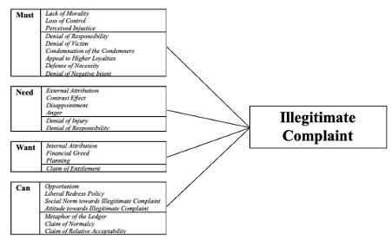
Figure 1. Conceptual Model.

3. Method

This chapter elaborates upon the research methodology applicable within this research. In doing so, the chapter firstly discusses the research design, followed by the procedure section. The chapter continues with an elaboration upon the sampling method. Hereafter, the used measurements are explained. After the data analysis has been presented, the chapter concludes with a section on research ethics.

3.1. Research Design

In order to test the typology of Joosten (2020), this research conducts a quantitative study in the form of an online survey including a questionnaire via the program Qualtrics. This has been done in order to not only be able to reach a wide audience of respondents, but also to ensure the respondents’ anonymity (Evans & Mathur, 2005). Especially the latter factor weighed high within this decision, the more since this study’s subject is about fraudulent, and thus socially undesirable, behaviour. In addition, empirical experiments are a renowned method to extract potentially socially undesirable responses (Wirtz & McColl-Kennedy, 2010). In line with this, the survey included a brief introduction in which some examples of illegitimate complaints were being provided by the researchers. Here, in order to stimulate a personal touch, the researchers were represented by a photo of themselves and a personal introduction, after which they shared personal encounters in which they complained illegitimately. By doing so, the researchers enabled the respondents to potentially identify with likewise situations and feel more at ease when providing socially undesirable responses, thus reducing the social desirability bias (Gordon, 1987).

3.2. Procedure

3.2.1. Pre-Test
In order to ensure that the respondents would understand the survey and would reply adequately (i.e., provide applicable answers), the survey was pre-tested by ten respondents. By conducting this pre-test, the researchers ensured that all items were clearly formulated, understandable and unambiguous within the final version of the survey (Collins, 2003). In order to effectuate this pre-check, Collins’ (2003) think-aloud method was used, including the out-loud reading of the survey by the ten respondents. By reading the survey out-loud, and making their thought-processes explicit, the respondents were requested to indicate whether they would not understand something, and if so, why this was the case. Following the pre-test, the remarks provided by the pre-testers were processed and unclear factors were adjusted within the final survey. The adjustments mainly included unclear questions, which were transformed into more understandable questions in order to enable and extract appropriate replying. Also, some superfluous questions and linguistic errors were removed from the survey. (see Appendix I for the pre-test results).

3.2.2. Survey
After the pre-test had been conducted and adjustments had been made, the researchers sent out the fully reviewed survey. The build-up of the survey included an introduction in which the purpose of the research and some background information about the occurrence of (illegitimate) customer complaints had been stated. As mentioned, the researchers also provided personal examples of themselves conducting illegitimate complaining. By doing so, the setting and not-uncommon occurrence of illegitimate complaining was created, as well as a stimulation of the respondents’ memories towards (illegitimate) complaining. Hereafter, the respondents were asked various questions about a personal (illegitimate) complaint filed by them and the degree to which their complaint was exaggerated, made-up or unfairly assigned towards the organisation. The survey continued by phrasing multiple items concerning possible drivers of illegitimate complaining, followed up by items on the neutralisation techniques and the relationship variables. The survey concluded with demographic questions, followed by the researchers’ appreciation of the respondents’ time and effort. Besides, the researchers offered the respondents the opportunity to get insights into the final results of their study by leaving their email addresses, as well as offering the respondents the opportunity to inquire about the survey, inquire about the study in general or leave any other form of remark. For the full survey, see Appendix II.

3.3. Sampling Method

The used survey aimed to approach as many respondents as possible. In doing so, there was no specific target group to be approached, leading to all possible respondents being valuable and equally appreciated. Therefore, convenience sampling has been used, since this is an ideal approach in order to generate as many responses as possible (Emerson, 2015). Furthermore, convenience sampling includes various other advantages, including easy (online) accessibility and respondents’ freedom of when to fill in the survey (Robinson, 2014). The relatively high time pressure and timespan in which the research had to be conducted contributed to the support of using convenience sampling. In order to distribute the survey, the four co-working students distributed the same survey amongst family members, friends, colleagues and other respondents they could digitally reach. The distribution of the survey was done via various digital channels, knowingly WhatsApp, Facebook, LinkedIn and email.

3.4. Measurement

After the first (open) questions within the survey addressed personal experiences with filing illegitimate complaints, or a fictively sketched encounter in which the respondent would illegitimately complain, the survey continued with a series of closed scale questions on the basis of Joosten’s (2020) typology. The fictively sketched encounters respondents would have with illegitimate complaining have been implemented in the survey in order to extract respondents’ views and possible behaviour regarding illegitimate complaining behaviour, regardless whether they had not illegitimately complained in their life or not. Thus, even if respondents never complained illegitimately, they were enabled to fill out the survey instead of being redirected towards the last, demographical, questions within the survey. Concerning the operationalisation of the constructs, the operationalisation and measuring items of the drivers by Van Laar (2018) were consulted, whereas for the operationalisation of the neutralisation techniques and the relationship variables, Rouwhorst’s (2020) measuring items were consulted. The drivers, neutralisation techniques and relationship variables were all measured by the limited use of one item per variable. This has been done in order to reduce the length of the survey. The researchers are aware that this might have reduced the validity of the research, but it also contributed towards responsiveness since it reduced non-responsiveness caused by a lengthy survey.

3.4.1. Illegitimate Complaining
Firstly, Illegitimate Complaining itself was measured on the basis of three items on a 5-point Likert Scale. Here, the definition provided by Joosten’s (2020) was leading, including ‘Illegitimate complaints are 1) complaints resulting from dissatisfaction but in which the fact or situation is exaggerated, altered or lied about, 2) complaints without experiencing dissatisfaction, which results in complaints that are completely invented (made-up complaints) and 3) complaints resulting from a customer falsely accusing the organisation’.
The first item on which this construct was measured included ‘To what extent did you exaggerate the complaint (i.e., present the situation worse than reality)?’, with the extremes ranging from 1 (not at all) to 5 (completely).
The second item to measure the construct included ‘To what extent did you make up the complaint (i.e., present the situation differently than reality)?’, with the extremes ranging from 1 (not at all) to 5 (completely).
The final item to measure Illegitimate Complaining included ‘To what extent did you falsely blame the organisation for the situation (while the organisation was in fact not to blame)?’, with the extremes ranging from 1 (not at all) to 5 (completely).

3.4.2. Scenarios & Drivers of Illegitimate Complaining
Secondly, the drivers to illegitimately complain were measured based on one of four created scenarios, in which each scenario impersonated a type of illegitimate complainer. Therefore, respondents had to indicate which of the four scenarios best fitted with their (fictively sketched) illegitimate complaining behaviour. In order to acquire the applicability and fit of the chosen scenario, the following question had been asked on a 5-point Likert Scale: ‘To what extent does the chosen description capture your situation?’, with the extremes ranging from 1 (completely not fitting) to 5 (completely fitting). The use of scenarios instead of all individual drivers had been made in order to prevent a high non-response, since asking all individual drivers would have made the survey too extended. See Appendix II for the original scenarios as used within the survey (in Dutch).
The following scenario had been composed in order to capture the Must-type of complainers: ‘The organisation tried to take advantage of me as a customer, for example by purposefully delivering a bad product or conducting a bad service. This felt very unjust. I complained and did everything in my power in order to call the organisation to account, but the organisation did not respect their promises and did not care at all.’. This scenario has been composed based on the following drivers:
Lack of Morality - Customers can perceive Lack of Morality as a greedy act by the organisation, in which customers are convinced that the organisation benefits at the expense of the customer (Antonetti & Maklan, 2016). Within this conviction, the customer believes that the organisation acts on purpose, resulting in the customer aiming to punish the organisation for this behaviour in the form of filing a complaint.
Loss of Control - Control refers to an individual’s belief that the individual can manage his or her own behaviour and circumstances (Day et al., 2003), resulting in the ability of being in control within both desired and undesired outcomes (Chang, 2006). However, when loss of control occurs, the individual perceives that his or her influence upon the happening of things is decreasing.
Perceived Injustice - When a customer evaluates that he or she is ‘exposed to situations that are characterised by a violation of basic human rights, transgression of status or rank or challenge to equity norms and just world beliefs’ (Sullivan et al., 2012, p. 484), then the customer perceives injustice. After complaint handling, customers can evaluate the justice done to be of an insufficient or unfair level, resulting in an increased likelihood of filing an exaggerated or illegitimate complaint since the customer seeks revenge towards the organisation (Wirtz & McColl-Kennedy, 2010).
The following scenario had been composed in order to capture the Need-type of complainers: ‘The organisation did not perform as they should have done. Therefore, their product or service was way below expectation, resulting in me being disappointed/angry towards the organisation. Perhaps the organisation did not act like this on purpose, but I consider them as being responsible for their bad product or service.’. This scenario has been composed based on the following drivers:
Contrast Effect - When a discrepancy between a customer’s expectation(s) and experience(s) occurs, the customer might feel betrayed by the organisation, resulting in him or her filing an illegitimate complaint out of revenge.
Disappointment - A disappointed customer can strive to alter their disappointment by filing an illegitimate complaint, in which he or she feels the need to take action in order to change the situation.
Anger - In order to release one’s anger, the customer aims to hurt the organisation by filing an illegitimate complaint.
External Attribution - External Attribution occurs when individuals attribute the cause of a problem to be externally initiated, thus coming from ‘outside social and environmental pressures’ (Gudjonsson & Singh, 1989). Therefore, the customer is prepared to file an illegitimate complaint in order to punish the organisation for the problem.
The following scenario had been composed in order to capture the Want-type of complainers: ‘The organisation did nothing wrong really. Actually, the opposite. It is me myself who purposefully exaggerated or made up the complaint in order to (financially) benefit, resulting in compensation, a new product or a voucher.’. This scenario has been composed based on the following drivers:
Internal Attribution - This driver attributes the cause of a problem to be initiated by one’s self (Brewin, 1986). However, when the self-serving attribution bias occurs, individuals tend to assign success to themselves and failures towards others (Bitner et al., 1994). In these instances, the customer thus files an illegitimate complaint, since the failure is not perceived as one’s own.
Planning - Pre-Planned complaining behaviour consists of deliberately planning a fake complaint in advance in order to take advantage of the situation.
Financial Greed - Financially greedy customers are found to file illegitimate complaints in order to take advantage of the organisation (Harris & Daunt, 2011).
Lastly, the following scenario had been composed in order to capture the Can-type of complainers: ‘The organisation has very flexible warranties or a very kind customer service, such as a money-back guarantee. Therefore, I noticed an opportunity to take advantage of the situation, resulting in me exaggerating or making up my complaint. I did not plan this beforehand. Also, I think that others would do the same if they had the opportunity to do so. I am not bothered by it.’. This scenario has been composed based on the following drivers:
Opportunism - Opportunism within complaining occurs because customers simply see the opportunity to complain and seek to gain advantage out of it (Wirtz & McColl-Kennedy, 2010).
Liberal Redress Policy - Liberal Redress Policies are policies that pro-actively encourage and provoke customer complaints. The organisation’s accompanying service recovery guarantee therefore evokes illegitimate complaining.
Social Norm towards Illegitimate Complaint - Social norms ‘specify what group members should or ought to do in particular situations’ (Cialdini et al., 1991, p. 203). In order to belong to the group, individuals adhere to the conduction of the desired behaviour by the respective group, even if this includes illegitimate behaviour.
Attitude towards Illegitimate Complaint - People have a natural tendency to act according to their own beliefs (Kothandapani, 1971). They are thus likely to conduct behaviour that is approved by themselves. If a customer’s attitude towards illegitimate complaining is positive, the customer is likely to conduct illegitimate complaining.

3.4.3. Neutralisation Techniques
Thirdly, the neutralisation techniques that respondents used to justify their illegitimate complaining behaviour were measured on a 5-point Likert Scale with the extremes ranging from 1 (completely disagree) to 5 (completely agree). See Appendix II for the original neutralisation techniques and their measuring items as used within the survey (in Dutch). The following neutralisation techniques were examined within the survey:
Denial of Responsibility - As indicated by Sykes & Matza (1957), this technique contains a denial of responsibility by an individual, in which the individual shifts the blame. The item used to measure Denial of Responsibility was ‘It was not my fault.’.
Denial of Injury - This technique is used when an individual feels that he or she does not harm the respective victim. Individuals who use this technique aim to justify their acts by denying the (negative) impact their complaint has on the respective organisation. The item used to measure Denial of Injury was ‘My complaint will not cause severe harm to the organisation.’.
Denial of the Victim - This technique typically applies when customers feel that the organisation causes the misbehaviour. Here, the customers feel that the organisation is to be blamed. The item used to measure Denial of Victim was ‘The organisation deserves my complaint because of what they have done.’.
Condemnation of the Condemners - Within this technique, customers aim to neutralise their misbehaviour by indicating that they are not the only ones conducting that specific misbehaviour. The item used to measure Condemnation of the Condemners was ‘The organisation itself is also not always honest towards their customers.’.
Appeal to Higher Loyalties - This technique includes the conduction of misbehaviour in order to achieve greater goals. This situation often occurs when an individual has to make a choice between two, in the eyes of the individual, reasonable options. In order to justify their behaviour, customers (or organisations) aim to neutralise their misbehaviour by claiming that ‘they conducted deviant behaviour for the greater good for everyone’ (Vitell & Grove, 1987). The item used to measure Appeal to Higher Loyalties was ‘I did not do it for myself (but out of principle or for someone else).’.
Defense of Necessity - This technique contains the customer’s sense that he or she had no other choice than conducting the misbehaviour, in which the misbehaviour thus occurs as a necessary act. Therefore, this technique is brought into practice when the customer sees no other way to get the desired means than by complaining. The item used to measure Defense of Necessity was ‘Otherwise I would not have been taken seriously by the organisation’.
Metaphor of the Ledger - This technique is labelled as a kind of ‘balance between the good and the bad’ (Klockars, 1974). In practice, the customer assumes he or she outweighs his or her misbehaviour by conducting good behaviour. The item used to measure Metaphor of the Ledger was ‘Normally, I would adhere to the rules.’
Claim of Normalcy - This technique is defined by the customers sincerely believing that they do nothing wrong within their complaint. The item used to measure Claim of Normalcy was ‘Everyone exaggerates every now and then.’.
Denial of Negative Intent - When using this technique, the customer aims to indicate that he or she did not mean to cause any harm whatsoever to the organisation. Instead, the misbehaviour was solely intended as a joke, or even happened accidentally. The item used to measure Denial of Negative Intent was ‘I did not plan or intend to complain illegitimately.’.
Claim of Relative Acceptability - Within this technique, customers compare their own misbehaviour with (often worse) misbehaviour conducted by other people. The item used to measure Claim of Relative Acceptability was ‘Other people conduct much worse behaviour.’.
Justification by Postponement - This neutralisation technique entails behaviour that excludes thinking about the consequences of the misbehaviour by simply putting the misbehaviour out of mind, thus preventing any thoughts on the matter when complaining. The item used to measure Justification by Postponement was ‘On the moment of complaining I did not think about the consequences (the realisation only came later).’.
Claim of Entitlement - This neutralisation technique is described as the feeling that a customer has towards his or her own behaviour. In this case, the customer believes that he or she genuinely has the right to the gains of the crime they committed (Eliason, 2003). The item used to measure Claim of Entitlement was ‘For once, I might benefit too.’.

3.4.4. Relationship Variables
Lastly, the relationship variables were measured on a 5-point Likert Scale with the extremes ranging from 1 (decreased a lot) to 5 (increased a lot). See Appendix II for the original relationship variables and their measuring items as used within the survey (in Dutch). The following relationship variables were examined within the survey:
Customer Satisfaction - Satisfaction is accomplished when a customer looks back positively on a purchase (Oliver & Bearden, 1985). The item used to measure Customer Satisfaction was ‘After this situation, my satisfaction with the organisation in question...’.
Customer Loyalty - Loyalty can be seen as either an attitude or behaviour towards an organisation. In order to have an unambiguous definition of Customer Loyalty within this study, loyalty is defined as the possibility of repurchasing and recommending a product or service towards other potential customers (Bontis, et al., 2007). The item used to measure Customer Loyalty was ‘After this situation, the likelihood of me repurchasing from the organisation in question...’.
Word of Mouth - Word of Mouth includes informal communication regarding the products and services of an organisation in private party atmospheres (Anderson, 1998). The item used to measure Word of Mouth was ‘After this situation, the likelihood of me recommending the organisation in question (towards family/friends/etc.) ...’.
Customer Trust - The variable Customer Trust refers to a customer's belief that an organisation can be relied upon (Crosby et al., 1990). The item used to measure Customer Trust was ‘After this situation, my trust in the organisation in question...’.
Customer Commitment - Customer Commitment, concerns a customer’s emotional attachment to and identification with the organisation. (Fullerton, 2005). The item used to measure Customer Commitment was ‘After this situation, my bond with the organisation...’.

3.5. Data Analysis

Within this research, the drivers that lead to illegitimate complaints, coupled within their respective scenario and thus forming a type of complainer, are functioning as the independent variables, whereas the neutralisation techniques, the relationship variables and the (illegitimate) complaints function as the dependent variables. Within the analysis of this study, the independent variables were tested against the dependent variables. After the four students conducted the same research and cooperated in their pursuit to collect as many responses as possible, the students initiated an individual interpretation of the results, thus independently from the other students.
The analysis of the gathered data was done using IBM SPSS Statistics 24.0, only after the data was prepared to appropriate formats. This had been done in order to enable the conduction of appropriate analyses.
Within processing the data, multiple ANCOVAs had been conducted in order to distinguish the scores on each variable per scenario. After, a MANCOVA was conducted in order to examine the differences between the four distinguished types of illegitimate complainers, as collected within a scenario. This MANCOVA analysis seemed appropriate since this kind of analysis ‘can be thought of as an AN[C]OVA for situations in which there are several dependent variables’ (Field, 2013, p. 624), a situation that was applicable within this study.

3.6. Research Ethics

Naturally, research ethics have to be considered, the more since the topic of this study is (mainly) focused upon socially undesired behaviour. Therefore, within this paper, both anonymity and confidentiality were guaranteed by various means. One such means was that the researchers assured that the (anonymously extracted) information is untraceable and for academic purposes solely. Next to the anonymity guarantee, the scientific purposes were stated in the beginning of the survey, indicating the relevance of the survey’s content. Also, the respondents, who completely voluntarily decided whether or not to participate and fill in the survey, were eligible to quit the survey at any time. Besides, the survey included no right or wrong answers, which was also stated within the survey in order to inform the respondents about this. Lastly, the social desirability bias was limited in different ways. This had been done by not only assuring the respondents anonymity, but also by the use of an online survey and the inclusion of Likert-scale answering. Therefore, every possible answer could be considered as plausible, and personal confrontation and judgement by the researchers concerning the respondents’ provided responses had been disabled.

4. Results

This chapter elaborates upon the results extracted from the analyses. In doing so, this chapter concerns the outcome of the survey, in which the sample as a whole is being discussed. After, the checked assumptions are being discussed, followed by an elaboration upon both the conducted ANCOVAs and the MANCOVA. The chapter concludes with the testing of the hypotheses.
First of all, it has to be noted that immediately after the extraction of the data, the dataset had been checked on various aspects. One of these aspects included the adjustment of the measuring levels (in which Firm Size, Timing of Complaint and Level of Education were made ordinal and Type of Complainant and Sex were made nominal). Following, the order of the provided responses was adjusted into a logical order (e.g., the number of complaints were adjusted from less to most frequent). Furthermore, some variables were recoded (e.g., 40 years old into 40). Lastly, any missing data within this study’s dependent variables has been corrected for by filling in the average score for that respective dependent variable, as provided for by the other respondents’ responses.

4.1. Sample

As mentioned within the previous chapter, this study collected responses by convenience sampling. By using this sampling method, respondents with various backgrounds were able to fill in the questionnaire. After having aired for nine days, a total of 719 respondents filled in the questionnaire, of which 275 were useful for the analysis.
Concerning descriptive statistics, the results indicated that the majority of the respondents, a total of 181, identified as being female (65%), against 91 identifying as male respondents (33%). The other respondents either failed to indicate their sex or did not identify as either male or female. Secondly, the age range of the respondents stretched from 14 to 70 years old, with an average of 35 years old and the most occurring age being 23 years old. Here, three respondents failed to indicate their age. Lastly, the indicated highest (finished or unfinished) level of education of the respondents varied over five different levels of education, with one respondent indicating to have followed primary school (0.4%), sixteen respondents indicating to have followed secondary school (5.8%), 48 respondents indicating to have followed post-secondary vocational education (17.5%), 88 respondents indicating to have followed university for applied sciences (32%) and the majority of 121 respondents indicated to have followed university (44%). One respondent (0.4%) failed to indicate what level of education had been followed.
When looking at the data reflected upon complaining behaviour and related questions, the results indicated that the majority of the respondents, 152 (55.3%), identified mostly with the Need-type of complainers, whereas 63 respondents (22.9%) mostly with the Want-type, 36 respondents (13.1%) mostly with the Can-type and 24 respondents (8.7%) mostly with the Must-type of complainers. Concerning these identifications with the presented scenarios, the majority, 117 respondents (42.5%), indicated that the description fit a lot, whereas 64 respondents (23.3%) indicated that the scenario fit somewhat, 53 respondents (19.3%) had a little fit, 34 respondents (12.4%) indicated to fit completely, and seven respondents (2.5%) did not fit at all with the scenario. Considering the number of times that the respondents complained, a small majority of 99 respondents (36.4%) indicated to have complained only once, closely followed by 90 respondents (33.1%) who indicated to have never complained. Furthermore, 52 respondents (19.1%) indicated to have complained twice, whereas twenty respondents (7.4%) said to have complained more than three times. The minority, eleven respondents (4%), indicated to have complained three times. Lastly, the monetary value of the product or service that respondents complained about ranged from €0.00 to €500,000, with an average of roughly €4040. However, 99.2% of the complainers complained about a product or service with a value of maximally €12,500, making the two highest values indicated by the respondents, knowingly €500,000 and €400,000, hugely increasing the average value. Also, twelve respondents failed to indicate the value of the product or service they complained about. Table 1 provides an overview of all descriptives.

Variable | N (valid/missing) | Mean | SD | Min. | Max.
Product Value | 275 (263/12) | 4040.46 | 39377.258 | 0 | 500000
Exaggerated Complaint | 275 (273/2) | 2.58 | 1.161 | 1 | 5
Made-Up Complaint | 275 (275/0) | 1.95 | 1.215 | 1 | 5
Falsely Blamed the Organisation | 275 (274/1) | 1.91 | 1.249 | 1 | 5
Description Fit | 275 (275/0) | 3.43 | 1.017 | 1 | 5
Denial of Responsibility | 275 (274/1) | 3.74 | 1.300 | 1 | 5
Denial of Injury | 275 (274/1) | 4.31 | .874 | 1 | 5
Denial of Victim | 275 (274/1) | 2.91 | 1.288 | 1 | 5
Condemnation of the Condemners | 275 (274/1) | 3.09 | 1.138 | 1 | 5
Appeal to Higher Loyalties | 275 (272/3) | 2.09 | 1.141 | 1 | 5
Claim of Normalcy | 275 (271/4) | 3.82 | .861 | 1 | 5
Denial of Negative Intent | 275 (272/3) | 3.68 | 1.157 | 1 | 5
Claim of Relative Acceptability | 275 (271/4) | 3.86 | .984 | 1 | 5
Metaphor of the Ledger | 275 (270/5) | 4.07 | .768 | 1 | 5
Claim of Entitlement | 275 (271/4) | 3.54 | .838 | 1 | 5
Defense of Necessity | 275 (272/3) | 3.21 | 1.187 | 1 | 5
Justification by Postponement | 275 (272/3) | 2.55 | 1.135 | 1 | 5
Customer Loyalty | 275 (274/1) | 2.69 | .957 | 1 | 5
Word of Mouth | 275 (274/1) | 2.66 | .979 | 1 | 5
Customer Trust | 275 (274/1) | 2.70 | 1.016 | 1 | 5
Customer Commitment | 275 (271/4) | 2.69 | .930 | 1 | 5
Customer Satisfaction | 275 (273/2) | 2.82 | 1.092 | 1 | 5
Age | 275 (272/3) | 35.00 | 15.606 | 14 | 70
Table 1. An overview of the descriptive statistics per variable.

4.2. Assumptions

Before conducting the Analyses of Covariances (ANCOVAs) and Multivariate Analyses of Covariances (MANCOVAs), the data had been tested on several necessary assumptions. Here, the assumptions required before conducting a MANCOVA had been tested, while by conducting a MANCOVA, the assumptions included within an AN(C)OVA had naturally been tested too since they are automatically included within a MANCOVA.
Normality - The first assumption that was tested included normality. In general, normality is not a major issue within studies including large (i.e., 200 or more respondents) sample sizes (Field, 2013). Therefore, within this study, with N = 275, it can be assumed that the sample is normally distributed, enabling a continuation with the original data. For an overview of the skewness and kurtosis per dependent variable, see Appendix III. For an overview of the output of the Tests of Normality per dependent variable, including Kolmogorov-Smirnov, see Appendix IV. Here, it has to be noted that all outcomes are significant, because there is no perfect symmetrical normal distribution within the output since this study consists of such a large sample size. Lastly, for an overview of all distributions within the Boxplots, see Appendix V. In sum, this assumption has not been violated.
Homoscedasticity of Variance - The second assumption tested within this study included homoscedasticity (Hair, Black, Babin, Anderson & Tatham, 2014). Therefore, a Box’s Test of Equality of Covariance Matrices has been conducted for all dependent variables. Also, despite literature stating that the Levene’s Test of Equality of Error Variances can be left out because of robustness within large samples (Brown & Forsythe, 1974), which is applicable within this study, the results of a Levene’s Test are also provided per dependent variable. For the Must-type, the Box’s Test showed that the observed covariance matrices of the dependent variables were not significant, F(63,25809.781) = 1.273, p = .071. Here Levene’s Test showed significance for Denial of Responsibility, F(3,271) = 5.518, p = .001 and Denial of Negative Intent, F(3,271) = 3.195, p = .024. The other neutralisation techniques were not found to be significant, F(3,271) = .766, p = .514 (Denial of Victim), F(3,271) = .401, p = .753 (Condemnation of the Condemners), F(3,271) = 1.365, p = .254 (Appeal to Higher Loyalties) and F(3,271) = 1.675, p = .173 (Defense of Necessity). For the Need-type, the Box’s Test showed that the observed covariance matrices of the dependent variables were not significant, F(9,59489.045) = 14.882, p = .104. The outcome of the Levene’s Test did show significance for Denial of Responsibility, F(3,271) = 5.518, p = .001, whereas no significance was found for Denial of Injury, F(3,271) = .960, p = .412. For the Want-type, the Levene’s Test for Claim of Entitlement was not significant, F(3,271) = 1.671, p = .174. Lastly, for the Can-type, the Box’s Test showed that the observed covariance matrices of the dependent variables were not significant, F(18,34331.992) = 26.544, p = .108. The Levene’s Test showed significance for Claim of Normalcy, F(3,271) = 2.651, p = .049. The other neutralisation techniques were not significant, F(3,271) = .710, p = .546 (Metaphor of the Ledger) and F(3,271) = 1.247, p = .293 (Claim of Relative Acceptability). Besides for the scenarios, a Box’s Test of Equality of Covariance Matrices and a Levene’s Test of Equality of Error Variances have also been conducted for the illegitimacy of complaints. Here, the Box’s Test showed that the observed covariance matrices of the dependent variables were significant, F(18,34331.992) = 68.288, p < 001. The Levene’s Tests did not show significance for Exaggerated Complaint, F(3,271) = 1.990, p = .116. On the contrary, the other dependent variables were significant, F(3,271)= 14.273, p < .001 (Made-Up Complaint) and F(3,271) = 11.673, P < .001 (Falsely Blamed the Organisation). To conclude with, a Box’s Test of Equality of Covariance Matrices and a Levene’s Test of Equality of Error Variances had been conducted for the relationship variables. Here, the Box’s Test showed that the observed covariance matrices of the dependent variables were significant, F(45,26903.321) = 127.777, p < 001. The Levene’s Tests showed significance for all relationship variables, F(3,271) = 9.224, p < .001 (Customer Loyalty), F(3,271) = 9.050, p < .001 (Word of Mouth), F(3,271) = 11.670, p < .001 (Customer Satisfaction), F(3,271) = 14.875, p < .001 (Customer Trust) and F(3,271) = 12.538, p < .001 (Customer Commitment). In sum, the assumption of Homoscedasticity of Variance was partly violated.
Linearity - Although considered, the assumption of linearity is of little meaning within this study. This can be explained by the data not logically enabling linearity, since all dependent variables were measured on Likert Scales. Because of these measures on Likert Scales, the responses were not continuous and thus restricted (Hair et al., 2014). For the same reason, no transformation has been conducted, since none of the extremes on the Likert Scales would have created skewed distributions. In order to illustrate the inapplicability of the outcome in terms of scatterplots, Appendix VI shows one output, in which Denial of Responsibility and Denial of Victim are compared. However, as can be seen in the output, the scatterplot does not explain much, since the results simply cannot be non-linear. Besides, Appendix VI shows just one example. Only for the first conducted MANCOVA itself, fourteen more scatterplots are possible, stressing the possible size of all the outputs. This size, weighed against the inapplicability and the unusefulness of the output, led to the decision to not conduct any more likewise analyses and inclusion of scatterplots within this study. Therefore, this assumption is deemed as not applicable within this research. The next assumption, correlation between dependent variables, will elaborate upon these correlations.
Group Differences & Outliers - The assumption of group differences and outliers has overlap with the assumption of linearity. Therefore, it would be rather strange to present the respondents the possibility to reply on a restricted Likert Scale of 1 to 5, after which they are then marked as an outlier if they replied with an extreme score on the scale, in case the other respondents replied with more middle or neutral scores. An option would be to look at the Box plots and note an outlier as an outstanding case. However, for the provided reason, doing this has been omitted within this study. For that reason, when measuring on a Likert Scale, the use of the word outlier is considered strange and illogical. Therefore, this assumption is considered as not being violated.
Correlation between Dependent Variables - The output of the correlation matrices for the conducted MANCOVAs show the correlation between the grouped neutralisation techniques within each created scenario. For the first scenario, the Must-type, the correlation matrix shows a total of eight correlations (excluding covariates), out of a possible total of 15. Including the covariates, the matrix shows a total of 12 correlations, out of a possible total of 28. Overall, the majority of the correlations within this type are extremely weak to weak, with the only exception being Denial of Victim and Denial of Responsibility, who correlate moderately (.540). Concerning the Need-type, the correlation matrix shows one out of the possible one correlation excluding covariates. When the covariates are included, the matrix shows one correlation out of a possible total of six correlations. Within this type, all correlations are extremely weak. The matrix for the Want-type, consisting of only a single neutralisation technique, shows one correlation out of a possible three (including the covariates). Here, all correlations are extremely weak. The correlation matrix for the last distinguished scenario, the Can-type, shows three out of a possible total of three correlations excluding covariates, whereas the matrix shows five correlations out of a possible total of 10 correlations including the covariates. Overall, the correlations within this type range from extremely weak to weak. Concerning the illegitimacy of complaints, the correlation matrix shows three correlations out of a possible total of three excluding covariates, whereas including covariates, the matrix shows a total of four correlations out of a possible total of 10. Here, the correlations are extremely weak to weak, with the exception of Made-Up Complaint and Exaggerated Complaint, who correlate moderately (.421) Lastly, concerning the relationship variables, the correlation matrix shows a total of 10, out of a possible 10, correlations without covariates, whereas the matrix shows a total of 17 out of a possible total of 21 including covariates. Here, all correlations with the covariates are extremely weak. However, all other correlations are either strong or very strong, with the highest correlation being between Customer Loyalty and Word of Mouth (.899). Summed up, the assumption of the correlation between the dependent variables has been violated, because not all grouped neutralisation techniques and variables within illegitimacy have a strong correlation, if at all. See Appendix VII for all mutual correlations within the correlation matrices.

4.3. Categorical Variables

Before conducting the analyses, the measured scale variables and the measured categorical variables were checked for differences between the four scenarios. Therefore, the six scale variables have been measured with an ANCOVA, whereas the five control variables have been checked by a crosstab analysis and a Chi-Square Test. The first measured scale variable, Age, showed no significant difference for the average age between the four scenarios, F(3,268) = 1.39, p = .246. The second variable, Amount of Complaints, did show a significant difference for the amount of complaints between the four scenarios, F(3,268) = 3.49, p = .016. The variable Fit of Description again showed no significant difference for the fit with the description between the four scenarios, F(3, 271) = 1.70, p = .167. Lastly, all three variables concerning the illegitimacy of the complaint showed a significant difference between the scenarios, which is understandable when you consider that various ways to illegitimately complain led to the formation of various scenarios within this study. In other words, the variable Falsely Blamed the Organisation showed a significant difference between the four scenarios, F(3,270) = 4.83, p = .003. The second variable, Made-Up the Complaint, also showed a significant difference between the four scenarios, F(3, 271) = 33.92, p < .000. As mentioned, the last variable, Exaggerated Complaint, also showed a significant difference between the four scenarios, F(3,269) = 2.73, p = .045. For the control variables, Firm Size, a significant difference within the distribution of small, medium and large firms has been found between the four scenarios: χ2 (6,275) = 12.93, p = .044. The variable Time of Complaint also showed a significant difference within the distribution of when the complaint has been filed, knowingly last year, longer than one year ago and longer than two years ago, between the four scenarios, χ2 (6,275) = 13.46, p = .036. The variable Sex did not show a significant difference between the distribution of male, female and other/does not say between the four scenarios, χ2 (6, 274) = 5.18, p = .521. The variable Level of Education did not show a significant difference between the distribution of educational level, knowingly primary school, secondary school, post-secondary vocational education, university for applied sciences and university, between the four scenarios, χ2 (12, 274) = 20.48, p = .059. The last control variable, Number of Complaints, did also not show a significant difference between the distribution of amounts of complaining, knowingly never, one time, two times, three times and more than three times, χ2 (12, 272) = 19.29, p = .082. Thus, the crosstab analyses and Chi-Square Tests showed that both Firm Size (.044) and Time of Complaint (.036) significantly differed per scenario. Therefore, both these variables were included as control variables within the conducted ANCOVAs per dependent variable.

4.4. Analysis of Covariance

In order to compare the four distinguished types of complainers, this research had been split up into two parts. Within the first part, the scores on all dependent variables, i.e., the neutralisation techniques, the types of illegitimate complaints and the relationship variables for each type of complainer, had been measured to test for their (possible) significance. This distinction had been done by repeatedly conducting an ANCOVA. The lay-out of the results of these ANCOVAs is based on a model as defined by Joosten (2020), in which the types of complainer function as the within-subjects factor. The control variables, knowingly Firm Size and Time of Complaint, function as the between-subjects factor. This decision had been made since the variables Firm Size and Time of Complaint were both found to be significant (i.e., p = .044 for Firm Size and p = .036 for Time of Complaint). Noteworthy here is that within this study, the chosen covariates are ordinal, thus categorical variables. These ANCOVAs provide an overview of the data for each dependent variable for each type of complainers. After, within the second part of the research, an overarching one-way MANCOVA had been conducted, in which the different types of complainers had been compared in order to test whether Joosten’s (2020) typology holds. The remainder of this section shows the results of the conducted ANCOVAs. Here, Table 2 shows the results for the neutralisation techniques, Table 3 shows them for the illegitimacy of the complaint and Table 4 does so for the relationship variables.

Dependent Variable | Within-Subjects Factor | N | F | Sig. | Eta sq. | Effect
Denial of Responsibility | Must  Need  Want  Can | 24  152  63  36 | M=4.38; SD=.71  M=4.29; SD=.98  M=2.54; SD=1.24  M=3.08; SD=1.16  F(3,269)= 51.32 | *** | .364 | Medium
Denial of Responsibility | Between-Subjects Factors  Firm Size  Time of Complaint |  | F(1,269)= 3.973  F(1,269)= 2.831 | *  ns | .0 15 Small
Denial of Victim | Must  Need  Want  Can | 24  152  63  36 | M=4.21; SD=1.06  M=3.33; SD=1.07  M=1.89; SD=1.00  M=2.06; SD=.96  F(3,269)= 45.32 | *** | .336 | Medium
Denial of Victim | Between-Subjects Factors  Firm Size  Time of Complaint |  | F(1,269)= 1.671  F(1,269)= 1.662 | ns  ns
Condemnation of the Condemners | Must  Need  Want  Can | 24  152  63  36 | M=3.96; SD=1.04  M=3.18; SD=1.13  M=2.76; SD=1.03  M=2.72; SD=1.06  F(3,269)= 9.74 | *** | .098 | Small
Condemnation of the Condemners | Between-Subjects Factors  Firm Size  Time of Complaint |  | F(1,269)= 3.992  F(1,269)= .307 | *  ns | .015 | Small
Appeal to Higher Loyalties | Must  Need  Want  Can | 24  152  63  36 | M=2.38; SD=1.34  M=2.11; SD=1.11  M=1.92; SD=1.17  M=2.14; SD=1.05  F(3,269)= .402 | ns
Appeal to Higher Loyalties | Between-Subjects Factors  Firm Size  Time of Complaint |  | F(1,269)= 8.570  F(1,269)= .061 | **  ns | .031 | Small
Defense of Necessity | Must  Need  Want  Can | 24  152  63  36 | M=3.93; SD=1.09  M=3.34; SD=1.09  M=2.79; SD=1.23  M=2.94; SD=1.22  F(3,269)= 4.26 | ** | .045 | Small
Defense of Necessity | Between-Subjects Factors  Firm Size  Time of Complaint |  | F(1,269)= 6.665  F(1,269)= 6.617 | *  * | .024  .024 | Small  Small
Denial of Negative Intent | Must  Need  Want  Can | 24  152  63  36 | M=4.36; SD=.83  M=3.77; SD=1.11  M=3.29; SD=1.22  M=3.58; SD=1.13  F(3,269)= 6.44 | *** | .067 | Small
Denial of Negative Intent | Between-Subjects Factors  Firm Size  Time of Complaint |  | F(1,269)= .410  F(1,269)= 5.853 | ns  * | .021 | Small
Denial of Injury | Must  Need  Want  Can | 24  152  63  36 | M=4.13; SD=.95  M=4.38; SD=.88  M=4.27; SD=.77  M=4.19; SD=.95  F(3,269)= .86 | ns
Denial of Injury | Between-Subjects Factors  Firm Size  Time of Complaint |  | F(1,269)= .006  F(1,269)= 1.909 | ns  ns
Claim of Entitlement | Must  Need  Want  Can | 24  152  63  36 | M=3.40; SD=.71  M=3.46; SD=.86  M=3.86; SD=.72  M=3.38; SD=.87  F(3,269)= 6.671 | *** | .069 | Small
Claim of Entitlement | Between-Subjects Factors  Firm Size  Time of Complaint |  | F(1,269)= 5.036  F(1,269)= 10.449 | *  ** | .018  .037 | Small  Small
Metaphor of the Ledger | Must  Need  Want  Can | 24  152  63  36 | M=4.17; SD=.76  M=3.98; SD=.81  M=4.22; SD=.68  M=4.11; SD=.62  F(3,269)= 1.919 | ns
Metaphor of the Ledger | Between-Subjects Factors  Firm Size  Time of Complaint |  | F(1,269)= 5.343  F(1,269)= 1.504 | *  ns | .019 Small
Claim of Normalcy | Must  Need  Want  Can | 24  152  63  36 | M=3.49; SD=.98  M=3.77; SD=.88  M=4.05; SD=.75  M=3.86; SD=.76  F(3,269)= 3.213 | * | .035 | Small
Claim of Normalcy | Between-Subjects Factors  Firm Size  Time of Complaint |  | F(1,269)= .188  F(1,269)= .914 | ns  ns
Claim of Relative Acceptability | Must  Need  Want  Can | 24  152  63  36 | M=3.99; SD=.98  M=3.81; SD=1.00  M=3.90; SD=.86  M=3.86; SD=1.10  F(3,269)= .454 | ns
Claim of Relative Acceptability | Between-Subjects Factors  Firm Size  Time of Complaint |  | F(1,269)= 5.108  F(1,269)= .764 | *  ns | .019 | Small
Justification by Postponement | Must  Need  Want  Can | 24  152  63  36 | M=2.30; SD=1.49  M=2.45; SD=1.10  M=2.56; SD=1.06  M=3.11; SD=1.04  F(3,269)= 3.793 | * | .041 | Small
Justification by Postponement | Between-Subjects Factors  Firm Size  Time of Complaint |  | F(1,269)= 3.081  F(1,269)= .199 | ns  ns
* = p<0.05 ** = p<0.01 *** = p<0.001 (ns) = non-significant
Small = Eta sq. < .3 Medium = Eta sq. < .5 Large = Eta sq. > .5
Table 2. ANCOVA for the neutralisation techniques. Note that the neutralisation technique Justification by Postponement was not included in any scenario.

Dependent Variable | Within-Subjects Factor | N | F | Sig. | Eta sq. | Effect
Exaggerated Complaint | Must  Need  Want  Can | 24  152  63  36 | M=2.38; SD=1.28  M=2.45; SD=1.10  M=2.88; SD=1.23  M=2.77; SD=1.07  F(3,269)= 3.224 | * | .035 | Small
Exaggerated Complaint | Between-Subjects Factors  Firm Size  Time of Complaint |  | F(1,269)= .179  F(1,269)= 4.580 | ns  * | .017 | Small
Made-Up Complaint | Must  Need  Want  Can | 24  152  63  36 | M=1.71; SD=1.20  M=1.48; SD=.80  M=3.03; SD=1.31  M=2.17; SD=1.30  F(3,269)= 31.702 | *** | .261 | Small
Made-Up Complaint | Between-Subjects Factors  Firm Size  Time of Complaint |  | F(1,269)= .285  F(1,269)= .316 | ns  ns
Falsely Blamed the Organisation | Must  Need  Want  Can | 24  152  63  36 | M=1.83; SD=1.37  M=1.68; SD=1.03  M=2.29; SD=1.50  M=2.28; SD=1.34  F(3,269)= 6.126 | *** | .064 | Small
Falsely Blamed the Organisation | Between-Subjects Factors  Firm Size  Time of Complaint |  | F(1,269)= .029  F(1,269)= 9.001 | ns  ** | .032 | Small
* = p<0.05 ** = p<0.01 *** = p<0.001 (ns) = non-significant
Small = Eta sq. < .3 Medium = Eta sq. < .5 Large = Eta sq. > .5
Table 3. ANCOVA for the variables concerning illegitimacy of the complaint.

Dependent Variable | Within-Subjects Factor | N | F | Sig. | Eta sq. | Effect
Customer Satisfaction | Must  Need  Want  Can | 24  152  63  36 | M=1.70; SD=1.03  M=2.60; SD=1.09  M=3.37; SD=.63  M=3.53; SD=.77  F(3,269)= 22.561 | *** | .201 | Small
Customer Satisfaction | Between-Subjects Factors  Firm Size  Time of Complaint |  | F(1,269)= .926  F(1,269)= 1.719 | ns  ns
Customer Loyalty | Must  Need  Want  Can | 24  152  63  36 | M=1.67; SD=.96  M=2.56; SD=.93  M=3.14; SD=.67  M=3.17; SD=.81  F(3,269)= 19.675 | *** | .180 | Small
Customer Loyalty | Between-Subjects Factors  Firm Size  Time of Complaint |  | F(1,269)= .268  F(1,269)= .016 | ns  ns
Word of Mouth | Must  Need  Want  Can | 24  152  63  36 | M=1.67; SD=1.13  M=2.48; SD=.93  M=3.14; SD=.64  M=3.19; SD=.82  F(3,269)= 19.921 | *** | .182 | Small
Word of Mouth | Between-Subjects Factors  Firm Size  Time of Complaint |  | F(1,269)= 2.161  F(1,269)= .047 | ns  ns
Customer Trust | Must  Need  Want  Can | 24  152  63  36 | M=1.54; SD=1.06  M=2.55; SD=1.02  M=3.16; SD=.55  M=3.28; SD=.74  F(3,269)= 20.923 | *** | .189 | Small
Customer Trust | Between-Subjects Factors  Firm Size  Time of Complaint |  | F(1,269)= .756  F(1,269)= 2.562 | ns  ns
Customer Commitment | Must  Need  Want  Can | 24  152  63  36 | M=1.70; SD=1.03  M=2.56; SD=.91  M=3.15; SD=.55  M=3.14; SD=.72  F(3,269)= 18.925 | *** | .174 | Small
Customer Commitment | Between-Subjects Factors  Firm Size  Time of Complaint |  | F(1,269)= 2.860  F(1,269)= .934 | ns  ns
* = p<0.05 ** = p<0.01 *** = p<0.001 (ns) = non-significant
Small = Eta sq. < .3 Medium = Eta sq. < .5 Large = Eta sq. > .5
Table 4. ANCOVA for the relationship variables.

4.5. Multivariate Analysis of Covariance

Building on the previous section, this section elaborates upon the output of the previously conducted ANCOVAs by a comparison of the scores per variable per type of complainer. Here, (in)significant differences between the four types of complainers by the means of a conducted MANCOVA are provided, in which the outcomes are reflected upon the hypotheses. The outcome has been based on post hoc tests, by the means of Bonferroni tests.
Must-Type - Concerning the neutralisation techniques initially prescribed towards the Must-type, the MANCOVA’s Pillai’s Trace showed that there is a significant difference between the four scenarios when measuring the six dependent variables altogether (p < .001). This significant difference applies for the variables Denial of Responsibility (p < .001), Denial of Victim (p < .001), Condemnation of the Condemners (p < .001), Denial of Negative Intent (p < .001) and Defense of Necessity (p = .006), whereas Appeal to Higher Loyalties does not show a significant difference between the various types (p = .752). Therefore, hypothesis H1d is rejected. The analyses showed that both the Must-type and the Need-type of complainer score highest for the neutralisation technique Denial of Responsibility, followed by the Can-type (second lowest) and the Want-type (lowest). Therefore, hypotheses H1a and H4b are confirmed. For Denial of Victim, the analyses showed that the Must-type scores highest, followed by the Need-type (second highest) and both the Can-type and Want-type (shared lowest). Therefore, hypothesis H1b is confirmed. Concerning Condemnation of the Condemners, the analyses showed that the Must-type scores highest. The Need-type and the Can-type both score second highest. However, whereas the Need-type and the Can-type differ significantly, the Want-type and the Can-type do not. Therefore, hypothesis H1c is confirmed. The analyses showed that for Denial of Negative Intent, both the Must-type and the Need-type score highest, whereas the Need-type and the Can-type do not show significant differences. The Want-type scores lowest. Therefore, since the Must-type does score (shared) highest upon the neutralisation technique, hypothesis H1f is partially confirmed. For the neutralisation technique Defense of Necessity, the analyses showed that the Must-type and the Need-type both score highest. However, whereas the Must-type does significantly differ from the Want-type and the Can-type, the Need-type does not. Therefore, since the Must-type does score (shared) highest upon this neutralisation technique, hypothesis H1e is partially confirmed.
Need-Type - Concerning the neutralisation techniques initially prescribed towards the Need-type, the MANCOVA’s Pillai’s Trace showed that there is a significant difference between the four scenarios when measuring the two dependent variables together (p < .001). This significant difference applies for the variable Denial of Responsibility (p < .001), whereas Denial of Injury does not show a significant difference between the various types (p = .461). Therefore, hypothesis H4a is rejected. As previously mentioned, the analyses showed that both the Must-type and the Need-type of complainer score highest for the neutralisation technique Denial of Responsibility, followed by the Can-type (second lowest) and the Want-type (lowest). Therefore, hypotheses H1a and H4b are confirmed.
Want-Type - Concerning the neutralisation technique initially prescribed towards the Want-type, the MANCOVA’s Pillai’s Trace showed that there is a significant difference between the four scenarios when measuring the dependent variable (p < .001). This significant difference thus naturally applies for the only variable measured within this scenario, Claim of Entitlement. For this variable, the analyses showed that the Want-type scores highest, whereas there is no significant differences between the Must-type, the Need-type and the Can-type. Therefore, hypothesis H7 is confirmed.
Can-Type - Concerning the neutralisation techniques initially prescribed towards the Can-type, the MANCOVA’s Pillai’s Trace showed that there is no significant difference between the four scenarios when measuring the three dependent variables together (p = .102). However, the individual ANCOVAs showed that there is a significant difference for the variable Claim of Normalcy (p = .023), whereas Metaphor of the Ledger (p = .127) and Claim of Relative Acceptability (p = .714) did not show a significant difference between the various types. Therefore, hypotheses H10a and H10c are rejected. Concerning Claim of Normalcy, the analyses showed that almost all types scored likewise, besides the Want-type, who scored significantly higher than the Must-type. However, no clear rank could be extracted from the data. Hence, hypothesis H10b is also rejected.
Extra Neutralisation Technique - Despite not being integrated into one of the scenarios, the theory mentioned the neutralisation technique Justification by Postponement. Therefore, this variable has also been tested upon possible significant differences between occurrences within the four scenarios. Here, the conducted ANCOVA showed a significant difference for the variable between the four scenarios (p = .011), in which the Can-type scores significantly higher than the Must-type and the Need-type, but not significantly higher than the Want-type. All other types do not mutually differ.
Illegitimacy of the Complaints - Concerning the illegitimacy of the complaints per scenario, the MANCOVA’s Pillai’s Trace showed that there is a significant difference between the four scenarios when measuring the three dependent variables altogether (p < .001). This significant difference applies for all variables, thus Exaggerated Complaint (p = .023), Made-Up Complaint (p < .001) and Falsely Blamed the Organisation (p < .001). For Exaggerated Complaint, the analyses showed that the Want-type scores significantly different from the Need-type but does not have a significant difference with the other two types. Besides the difference between the Need-type and the Want-type, all other types have no mutual differences. Concerning Made-Up Complaint, the analyses showed that the Want-type scores significantly higher than all other types, thus highest. The Can-type and the Must-type do not differ significantly, but the Can-type and the Need-type do. Furthermore, the Must-type and the Need-type do not differ significantly. Lastly, concerning Falsely Blamed the Organisation, the Must-type does not differ significantly from any other types, whereas the Need-type scores significantly lower than the Want-type and the Can-type. The Want-type scores significantly higher than the Must-type, as does the Can-type. Concluding, concerning Illegitimacy of the Complaints, there is no clear rank of scores between the scenarios. Therefore, hypotheses H2, H5, H8 and H11 are rejected.
Relationship Variables - Concerning the relationship variables per scenario, the MANCOVA’s Pillai’s Trace showed that there is a significant difference between the four scenarios when measuring the five dependent variables altogether (p < .001). This significant difference applies for all variables, thus Customer Satisfaction (p < .001), Customer Loyalty (p < .001), Word of Mouth (p < .001), Customer Trust (p < .001) and Customer Commitment (p < .001). For Customer Satisfaction, the analyses showed that the Can-type scores significantly higher than the Must-type and the Need-type, but not significantly higher as the Want-type. The Want-type does also score significantly higher than the Must-type and the Need-type. Therefore, both the Can-type and the Want-type score highest on the relationship variables. Furthermore, the Need-type scores significantly higher than the Must-type, resulting in the Need-type scoring second lowest and the Must-type scoring lowest upon this relationship variable. Concerning Customer Loyalty, the analyses showed that the Can-type scores significantly higher than the Must-type and the Need-type, but not significantly higher as the Want-type. The Want-type does also score significantly higher than the Must-type and the Need-type. Therefore, both the Can-type and the Want-type score highest on this relationship variable. Furthermore, the Need-type scores significantly higher than the Must-type, resulting in the Need-type scoring second lowest and the Must-type scoring lowest upon this relationship variable. When looking at Word of Mouth, the analyses showed that the Can-type scores significantly higher than the Must-type and the Need-type, but not significantly higher as the Want-type. The Want-type does also score significantly higher than the Must-type and the Need-type. Therefore, both the Can-type and the Want-type score highest on the relationship variables. Furthermore, the Need-type scores significantly higher than the Must-type, resulting in the Need-type scoring second lowest and the Must-type scoring lowest upon this relationship variable. For the relationship variable Customer Trust, the analyses showed that the Can-type scores significantly higher than the Must-type and the Need-type, but not significantly higher as the Want-type. The Want-type does also score significantly higher than the Must-type and the Need-type. Therefore, both the Can-type and the Want-type score highest on the relationship variables. Furthermore, the Need-type scores significantly higher than the Must-type, resulting in the Need-type scoring second lowest and the Must-type scoring lowest upon this relationship variable. Lastly, concerning the variable Customer Commitment, the analyses showed that the Can-type scores significantly higher than the Must-type and the Need-type, but not significantly higher as the Want-type. The Want-type does also score significantly higher than the Must-type and the Need-type. Therefore, both the Can-type and the Want-type score highest on the relationship variables. Furthermore, the Need-type scores significantly higher than the Must-type, resulting in the Need-type scoring second lowest and the Must-type scoring lowest upon this relationship variable. Concluding, concerning the relationship variables, the Can-type and the Must-type both score highest, followed by the Need-type, which scores second lowest. The Must-type scores lowest on all relationship variables. Therefore, hypotheses H3 and H6 can be confirmed, hypothesis H9 is partially confirmed and hypothesis H12 is rejected.
For a complete overview, in which all scores for the neutralisation techniques, the illegitimacy of complaints and the relationship variables are visualised per scenario, see Appendix V.

4.6. Hypotheses Testing

Based on the findings of the conducted analyses and a comparison between the scenarios, the hypotheses could be reviewed and either confirmed, partially confirmed or rejected. Here, the created ranking of each type of complainer upon each dependent variable enables this confirmation, partial confirmation or rejection of the hypotheses. Table 5 provides an overview of all hypotheses.

 | (Sub-)Hypothesis | Outcome  Confirmed/Rejected
H1 | H1a: The Must-type of complainer scores higher on the neutralisation Denial of Responsibility compared to the other types of complainers. | Confirmed
 | H1b: The Must-type of complainer scores higher on the neutralisation Denial of Victim compared to the other types of complainers. | Confirmed
 | H1c: The Must-type of complainer scores higher on the neutralisation Condemnation of the Condemners compared to the other types of complainers. | Confirmed
 | H1d: The Must-type of complainer scores higher on the neutralisation Appeal to Higher Loyalties compared to the other types of complainers. | Rejected
 | H1e: The Must-type of complainer scores higher on the neutralisation Defense of Necessity compared to the other types of complainers. | Partially Confirmed
 | H1f: The Must-type of complainer scores higher on the neutralisation Denial of Negative Intent compared to the other types of complainers. | Partially Confirmed
H2 | The Must-type of complainer scores lowest on the illegitimacy of the complaints compared to the other types of complainers. | Rejected
H3 | The Must-type of complainer scores lowest on the relationship variables compared to the other types of complainers. | Confirmed
H4 | H4a: The Need-type of complainer scores higher on the neutralisation Denial of Injury compared to the other types of complainers. | Rejected
 | H4b: The Need-type of complainer scores higher on the neutralisation Denial of Responsibility compared to the other types of complainers. | Confirmed
H5 | The Need-type of complainer scores second lowest on the illegitimacy of the complaints compared to the other types of complainers. | Rejected
H6 | The Need-type of complainer scores second lowest on the relationship variables compared to the other types of complainers. | Confirmed
H7 | The Want-type of complainer scores higher on the neutralisation Claim of Entitlement compared to the other types of complainers. | Confirmed
H8 | The Want-type of complainer scores highest on the illegitimacy of the complaints compared to the other types of complainers. | Rejected
H9 | The Want-type of complainer scores highest on the relationship variables compared to the other types of complainers. | Partially Confirmed
H10 | H10a: The Can-type of complainer scores higher on the neutralisation Metaphor of the Ledger compared to the other types of complainers. | Rejected
 | H10b: The Can-type of complainer scores higher on the neutralisation Claim of Normalcy compared to the other types of complainers. | Rejected
 | H10c: The Can-type of complainer scores higher on the neutralisation Claim of Relative Acceptability compared to the other types of complainers. | Rejected
H11 | The Can-type of complainer scores second highest on the illegitimacy of the complaints compared to the other types of complainers. | Rejected
H12 | The Can-type of complainer scores second highest on the relationship variables compared to the other types of complainers. | Rejected
Table 5. Overview of Hypotheses & Outcomes.

5. Discussion

This chapter elaborates upon the results of the study, in which the prespecified types of complainers and their respective scenarios are evaluated. Here, the conclusion section compares the scenarios based on neutralisation techniques, the variables on the illegitimacy of the complaints and the relationship variables. Therefore, the confirmations and rejections of the hypotheses are being reviewed. Also, this chapter will provide theoretical contributions, managerial implications, limitations and lastly, suggestions for areas of future research.

5.1. Conclusion

Within modern-day business operations, organisations strive to deliver a most optimal product or service in order to adhere to customers’ desires. In the instances that the organisations fail to do so, and thus when a negative discrepancy between customers’ desires and the actual product or service occurs, the organisation has to do everything within their power in order to recover the situation. Here, service recovery, and thus accessory complaint handling, is of pivotal importance. However, as Joosten (2020) stated, many customers falsely address an organisation with a complaint, in which they amongst other things exaggerate a complaint, make-up a complaint or even falsely blame the organisation for a (fictitious) problem. It is therefore that Joosten (2020) investigated the possibilities to prevent these so-called illegitimate complaints from happening. In doing so, Joosten (2020), based on previous literature (e.g., Baker et al., 2012; Baron et al., 2005; Daunt & Harris, 2012; Harris & Dumas, 2009; Sykes & Matza, 1957), developed a typology of complainers. Within his typology, Joosten (2020) grouped several drivers to illegitimately complain, which led to the formation of the so-called Must-type of complainers, Need-type of complainers, Want-type of complainers and lastly the Can-type of complainers.
Within this study, the main aim was to test whether the developed typology holds, in which the four types of complainers were expected to differ significantly upon various neutralisation techniques, ways to illegitimately complain and relationship variables. In order to test these possible differences, this study firstly described the various drivers on which the types of complainers were based, after which the various neutralisation techniques were described. After, the expected use of various neutralisation techniques was formulated within hypotheses, which presumed that particular neutralisation techniques were used by a specific type of complainer, and less or not by other types. The analyses of the data showed that only some of the hypotheses concerning the neutralisation techniques had been confirmed, in which only the techniques of Denial of Responsibility, Denial of Victim, Condemnation of the Condemners and Claim of Entitlement were proven to be more commonly used by (a) specific type(s) of complainers. However, the data showed that all other hypotheses concerning the neutralisation techniques had to be (partially) rejected. Therefore, based on the results of this study, some of the neutralisations within Joosten’s (2020) typology were found to differ per type of complainers. However, the majority did not. Furthermore, previous research opted for the neutralisation technique Justification by Postponement. Therefore, this technique had also been tested and was found to differ per type of complainer, in which the Can-type and the Must-type of complainers score significantly higher on this technique. However, since there was no significant difference between the score of this neutralisation technique upon the two mentioned types, this result can be deemed neglectable, resulting in this technique being possibly left out within possible future research.
A second variable on which the four types of complainers were tested for significant differences included ways to illegitimately complain. After an elaboration upon the illegitimacy of complaints, including Exaggerated Complaints, Made-Up Complaints and Falsely Blamed the Organisation, hypotheses on the illegitimacy of complaints were formulated. Here, the formulated hypotheses proposed a ranking of the scores for the four types on their expected score on ways to illegitimately complain. However, the analyses of the data showed that all hypotheses concerning illegitimacy of the complaints were rejected. This means that Joosten’s (2020) typology concerning illegitimacy of complaints seems inapplicable, implying that no clear order between the significant differences of the four types of complainers upon these variables could be extracted.
Lastly, the four types of complainers were tested for significant differences upon relationship variables, including Customer Satisfaction, Customer Loyalty, Word of Mouth, Customer Trust and Customer Commitment. As with the ways to illegitimately complain, the formulated hypotheses ranked the four different types on their expected scores on the relationship variables. However, in contrast to the previous hypotheses, the analyses of the data showed that three hypotheses concerning the relationship variables were (partially) confirmed. These findings therefore (partially) support Joosten’s (2020) typology, at least concerning the four types of complainers and their relation towards the relationship variables. Therefore, a clear order between the significant differences of the four types of complainers upon these variables could be extracted.
Overall, the four distinguished types of complainers by Joosten (2020) were not found to differ significantly. However, the types did differ within their use on some of the neutralisation techniques and the relationship variables.

5.2. Theoretical Contribution

The mentioned ‘potential significant issue’ (Wirtz & McColl-Kennedy, 2010, p. 654) concerning illegitimate customer complaining behaviour is an area of research currently not extensively addressed. Besides, the little research on illegitimate complaining behaviour is of conceptual and theoretical nature, and thus not empirically tested (e.g., Baker et al., 2012; Baron et al., 2005). Therefore, the nature of this study, in which the previously described complaining occurrences are empirically tested within a field-setting by measuring and researching real cases of complaining, contributes to existing literature in that area already.
Moreover, existing literature did not clearly distinguish various types of illegitimate complainers, let alone provide an overview of possible types of (illegitimate) complainers. Therefore, this study, mainly based on Joosten’s (2020) proposed typology of generalisable justifications for complaining behaviour, attempted to create this overview of complainers.
Firstly, this study demonstrated that Joosten’s (2020) typology is not completely applicable upon illegitimate complainers, stressing the difficulty to demarcate various types of complainers. Therefore, this finding again emphasises the currently existing limited literature on illegitimately complaining customers. However, although the results within this study did not support Joosten’s (2020) typology in full, some findings did contribute to the literature on illegitimate customer complaints by providing limited insights into factors concerning illegitimate customer complaining.
Secondly, reflecting the types of complainers upon the neutralisation techniques, the hypotheses did not show evidence of all neutralisation techniques matching their prescribed type of complainers. However, the few neutralisations that did match with their prescribed type demonstrate that they indeed can be clustered into a type of complainer. Therefore, the neutralisation techniques Denial of Responsibility, Denial of Victim, Condemnation of the Condemners, Denial of Responsibility and Claim of Entitlement show fruitful promises for a generalising clustering of types of complainers. Moreover, since the majority of the mentioned neutralisation techniques belong to one type, the Must-type, this distinguished type’s relation with other variables, such as the relationship variables, can shine light upon the underexposed justification, reasoning and possible consequences that illegitimate complaining has for both the complainer and the organisation they complain towards. These findings might therefore prove a major contribution to existing literature concerning illegitimate customer complaining and the necessity to prevent it.
Thirdly, the hypotheses concerning the illegitimacy of the complaints demonstrated that, at least within this study, there are significant differences between the types of complainers and the illegitimacy of the complaints, but in no particular rank. These findings hint at significant differences between the types of complainers and the illegitimacy, making illegitimacy of complaints not completely randomised amongst various illegitimate complaints. Therefore, these findings contribute to existing literature in such a way that they demonstrate that the illegitimacy of the complaints differ per type of complainer. Thus, the illegitimacy of a complaint seems to relate towards other variables and could therefore be possibly coupled with for example drivers to illegitimately complain or specific neutralisation techniques.
Lastly, concerning the relationship variables, the hypotheses indicated fruitful insights into how the types of complainers relate to various relationship variables. Concretely put, the different types of complainers were found to have different outcomes regarding the perceived relationship between the complainer and the organisation. Here, it is found that the Want-type scores shared highest on the relationship variables, likely because they feel intrinsically motivated to complain in order to gain something. Therefore, their relationship with the organisation does not alter much based on the complaint (handling), since their complaining is not, or partly, motivated by the actions of the organisation. Likewise, the Can-type also scores highest concerning the relationship variables, with the possible explanation that they see the opportunity to complain and simply want to make use of the possibility. Therefore, their relationship with the organisation does not alter much either after the complaint (handling). The Must-type scores lowest on the relationship variables, with the possible explanation of them feeling that they must complain in order to turn their (bad) situation around. Here, the reason for them to complain is based upon their feeling(s) that the situation is not within their control. This type thus feels more or less pressured in their position by the organisation, resulting in a reduced relationship between customer and organisation. The Need-type scores second lowest, for more or less the same reason, be it that this type feels driven to complain based on more emotionally initiated reasons, such as anger and disappointment. Therefore, the Need-type of complainers likes to act based on their emotions, and not per definition based on the situation the organisation has put them in. This results in a higher value of the relationship they have with the organisation compared to the Must-type. In short, the relationship variables do shine light upon (the appreciation of) the relationships that complainers have with the respective organisation they complain towards. Therefore, this study contributes to existing literature by showing the significant differences concerning relationship variables amongst various proposed types of complainers, stressing that the relationship a complaining customer has with an organisation is not the same for every (type of) complainer.

5.3. Managerial Implications

While organisations encourage fair and honest customer complaints in order to improve their products and services (e.g., Barlow & Møller, 1996; Larivet & Brouard, 2010), various customers try to make use of this policy by filing illegitimate complaints (Berry & Seiders, 2008). In order to reduce this costly and time-consuming affair, an early identification, or better, a prevention, of these illegitimate complaints by the organisation is of importance. Since this study attempted to identify the various types of complainers, in which it aimed to seek what the drivers behind and reasons for illegitimate customer complaining are, this study provides useful means to identify, and thus prevent, illegitimate complaints from happening. Therefore, this study is of interest to organisations struggling with a large amount of (illegitimate) complaints, since early identification might lead to prevention, and thus time and monetary savings (Michel et al., 2009).
First of all, this study identified that the idea of clustering types of complainers can work out, in which the results show that certain neutralisation techniques are related. Here, it is interesting for managers to timely acknowledge the presence of certain neutralisation techniques in order to prevent other neutralisation techniques from following. By doing so, the organisations can prevent a build-up of neutralisations techniques possibly leading towards the filing of (an) illegitimate complaint(s). Therefore, organisations should aim to prevent being prone to any of the predecessors of the neutralisation techniques. For example, organisations should not offer a money-back guarantee easily, or at least a limited one, since a money-back guarantee might create the idea that asking money back for no specific reason is a normal occurrence (Claim of Normalcy) or is accepted by other people (Social Norm towards Illegitimate Complaining). A build-up of these neutralisation techniques might then lead to the customer filing an illegitimate complaint. Likewise, being transparent in what you offer as an organisation is as important. By being transparent and open, organisations reduce the possibilities of giving customers false ideas of the product or service they are to receive. By doing so, organisations are also more likely to rule out customers that see themselves as victims of the actions of the organisation (Denial of Victim), in which the customers no longer see a valid reason to complain and recognise no need for the organisation to hear them out (Defense of Necessity).
Secondly, the hypotheses show that there are differences between the various types of complainers concerning the illegitimacy of the complaint. Therefore, organisations face different possible approaches for various types of illegitimate complaints. Here, organisations can therefore make use of ambiguous approaches towards the prevention of different types of complaints. As mentioned earlier, in order to realise this prevention, organisations should mainly focus their attention on the prevention of being prone to any of the predecessors of the neutralisation techniques. Here, when an organisation sees an occurrence of a specific type of complaint, they can turn towards neutralisation techniques or types of complainers matching this type of complaint in order to track down the possible motives of the complaint(s) and aim to prevent them from happening afterwards.
Thirdly, the hypotheses concerning the relationship variables shine light on how the mutual relationship between the customer and the organisation develops according to complaint handling. Here, significant differences between the types of complainers were found, in which different types were found to score differently upon various relationship variables. Therefore, the findings emphasise the possible alteration of these relationship variables when complaints are not handled sufficiently. These findings are of high concern for organisations, the more since organisations benefit from a good customer-organisation relationship in such a way that repurchases are likely (Olsen, 2002) within good relationships. Furthermore, not only are repurchases more likely, but it is also cheaper for organisations to retain current customers instead of gaining new ones (Heskett, 2002; Watts, 2016). Therefore, the outcomes concerning relationship variables should be very well considered when organisations aim to retain a good relationship with their customers, during and after complaint handling.
Lastly, this study showed that a whopping 76.7% of all respondents indicated to complain towards a big organisation (i.e., a chain store or a major producer). Therefore, these organisations should be aware that they are especially vulnerable towards (illegitimate) complaints. However, as for the rest of the results, all organisations would benefit from taking the findings of this study into account.
Overall, this study shows that customers do not always file legitimate complaints and are thus not always right and fair within their filed complaints (Berry & Seiders, 2008). This is a costly affair for organisations, since their efforts to deal with complaints in general are very time and money consuming (Michel et al., 2009). Therefore, organisations should focus their attention upon the prevention of illegitimate complaints from happening, since these kinds of complaints are not legitimately grounded and thus cause unnecessary costs. Within their pursuit of preventing these illegitimate complaints from happening, organisations are therefore strongly advised to minimise the likeability to be prone to any of the predecessors of the neutralisation techniques, since these neutralisation techniques constitute the underlying thought for customers to illegitimately complain. Therefore, organisations should act fairly, transparent and open within their business operations, products, services and promises towards (potential) customers.

5.4. Limitations

Naturally, this study encountered some limitations and shortcomings along the way. First of all, the sample. Although the questionnaire within this research had been distributed via multiple channels in order to reach a variety of respondents, more than half of the respondents indicated to be students in their early twenties. Besides, 68.8% of the respondents were female. These distributions did not necessarily influence the outcome of the study, but a more varied sample concerning age, educational level and sex might have resulted in a different outcome of the study, the more since these factors have shown to be possibly influencing the results (McColl-Kennedy, Daus & Sparks, 2003). Adding to this, online surveys in general can result in an inaccurate validity, since (possible) respondents can only be extracted from the population that are online users. Therefore, there is no equal chance for everyone within the whole population to be selected (Duda & Nobile, 2010). Lastly, the sample within this study consisted of people from a Western society. Therefore, the results are not generalisable for other societies or cultures.
Secondly, concerning the responses, a major gap between the number of respondents (719) and ultimately useful responses (275) occurred. This total deletion of 444 responses has various possible explanations. Firstly, the nature of the sensitive topic of this study itself. It is likely that people did not want to be associated with their own misbehaviour from the past, even not when doing so anonymously (Wirtz & McColl-Kennedy, 2010). Secondly, the survey could be stopped at any time, possibly resulting in respondents starting the survey at one time, but for whatever reason failed to continue after. Again, this could be due to the sensitivity of the topic, but also because the respondents did not want to continue, did not remember to continue or did not understand the questions and therefore decided to not complete the survey. Although the latter reason had been tried to avoid by conducting a pre-test, this might still have been a valid reason for failing to fill in the survey. Lastly, the survey did not require the respondents to fill in a reply to every question. This could have resulted in respondents skipping too many questions, resulting in their responses not being useful.
Thirdly, in contrast to previous research, the drivers and neutralisation techniques within this study have been measured with a single item. Therefore, a wrong view upon the relations could have been created, in which for example the respondents could not express their thorough opinion concerning certain drivers or neutralisation techniques (Fink & Lewin, 1995). Furthermore, the use of only one item limited reliability and validity (Wanous, Reichers & Hudy, 1997). However, as mentioned within chapter 3, the survey within this study was purposefully developed with solely one item per variable in order to reduce the length of the survey.
Fourthly and lastly, the violated assumptions caused limitations to this research. Although many assumptions were met, others were not. This could have possibly been (partly) solved by having equal group sizes, or a bigger sample, something that was not applicable within this study. The main violated assumption included the correlation between the dependent variables, in which dependent variables (i.e., the neutralisation techniques) were put together that did not correlate and were thus not found to be significant. Therefore, some assumed relationships with various variables could have proved invalid. This appears to be the main limitation within the whole study. However, the testing of the (possible) clustering of these variables was also the main aim and thread of the study, resulting in the insignificance of the types a reasonable possible outcome of the study as a whole. Another assumption, the assumption of homoscedasticity of variance, was partly violated. This could have influenced the results, since a violation of this assumption might influence the confidence intervals and thus the significance tests (Field, 2013).

5.5. Future Research

To conclude the chapter, a view upon possible future research will be provided. Firstly, the method addressed within this research could be altered. Literature and studies upon the topic of illegitimate complaining are limited already, let alone that there is much empirically conducted research on the matter. Therefore, it would be interesting to see a qualitative study conducting for example interviews with complainers. Naturally, this possible direction of future research could face some sensitivity related resistance, but complainers who fairly believe in the legitimacy of their complaint might be willing to cooperate in order to get their desired justice. Also, with the risk of ‘being caught complaining illegitimately’ in mind, it can be assumed that mostly unintentional and legitimately complaining customers will participate within these interviews. Therefore, possible differences between unintentional and intentional complainers might come to surface. Another advantage of this possible study might be that complainers who are in the process of complaining participate within the study. Therefore, the time interval between the complaint itself and the reflection upon the complaint afterwards is greatly reduced, resulting in a more accurate and detailed recall of the situation (Coughlin, 1990). If combined with legal actions of Consumers’ Association and organisations to conduct samples amongst received complaints, this possible new study might even discourage illegitimate complainers from complaining, resulting in an overall decrease of complaints. Besides, this possible new study creates triangulation of the data, which on its own might provide fruitful insights concerning the validity of the data on the topic (Bryman, 2004).
Secondly, whereas this study was conducted amongst Dutch speakers only, possible future research could turn their attention towards differences between for example age groups, people with different educational backgrounds, sexes, income and even cultures. In doing so, (demographic) differences between the background of complainers might be proven to significantly differ, the more since several studies have indicated that there are differences between complaining, complaining behaviour and intentions across cultures (e.g., Yuksel, Kilinc & Yuksel, 2006). Here, studies within other societies than the Western society could be conducted, but also studies with bigger samples than the currently conducted study. In this light, future research could also distinguish illegitimate complaints between for example small versus medium versus big organisations and see whether the outcome differs between these sample sizes and natures.
Lastly, and perhaps a major direction for future research, possible future research could examine whether other types of complainers exist. The current study did not support the proposed typology by Joosten (2020) in full, but some of the outcomes within this study did provide promising results concerning the existence of types of complainers. Therefore, these to be examined new types of complainers might be based on the outcomes of this study, but also on other literature and perhaps most interestingly, a mix of both. Here, the significant results from the current study can still be used within their respective type, whereas a new type could for example be constructed from an assemblage of different or other drivers.
In this light, the variables concerning the type of illegitimate complaints and the relationship variables could be examined again, but this time with a more specific ranking of each of the variables individually per type of complainer, thus not clustered as illegitimacy of complaints and relationship variables. By doing so, a clear rank of these variables per type could be distinguished, enabling organisations insights into which types of complaints occur most for what types of complainers, and which relationship variables score highest for which type of complainers. Then, organisations will have a clear overview of the significant differences of the four types of complainers concerning these variables.
By conducting future research on the matter, more knowledge concerning the occurrence of customer complaining will be gathered and the phenomena of illegitimate customer complaining might be repulsed bit by bit.

References

Ajzen, I., & Fishbein, M. (1975). A Bayesian analysis of attribution processes. Psychological
bulletin, 82(2), 261.
Allen, N. J., & Meyer, J. P. (1990). The measurement and antecedents of affective, continuance
and normative commitment to the organization. Journal of occupational psychology,
63(1), 1-18.
Anderson, E. W. (1998). Customer satisfaction and word of mouth. Journal of service research,
1(1), 5-17.
Anderson, R. E. (1973). Consumer dissatisfaction: The effect of disconfirmed expectancy on
perceived product performance. Journal of marketing research, 10(1), 38-44.
Anderson, E., & Weitz, B. (1989). Determinants of continuity in conventional industrial channel
dyads. Marketing science, 8(4), 310-323.
Ang, L., & Buttle, F. (2006). Customer retention management processes: A quantitative study.
European journal of marketing.
Antonetti, P., & Maklan, S. (2016). An extended model of moral outrage at corporate social
irresponsibility. Journal of Business Ethics, 135(3), 429-444.
Averill, J. R. (1973). Personal control over aversive stimuli and its relationship to stress.
Psychological Bulletin, 80, 286–303.
Baker, M. A., Magnini, V. P., & Perdue, R. R. (2012). Opportunistic customer complaining:
Causes, consequences, and managerial alternatives. International Journal of Hospitality Management, 31(1), 295-303.
Barlow, J., & Møller, C. (1996). A complaint is a gift: using customer feedback as a strategic
tool. Berrett-koehler publishers.
Baron, S., Harris, K., Elliott, D., Reynolds, K. L., & Harris, L. C. (2005). When service failure is
not service failure: an exploration of the forms and motives of “illegitimate” customer
complaining. Journal of services marketing.
Baron, R. S., Kerr, N. L., & Miller, N. (1992). Group Process, Group Decision. Group action.
Bendall-Lyon, D., & Powers, T. L. (2001). The role of complaint management in the service
recovery process. The Joint Commission journal on quality improvement, 27(5), 278-286.
Berry, L. L. (1995). On great service: A framework for action. Simon and Schuster.
Berry, L. L. (2002). Relationship marketing of services perspectives from 1983 and 2000.
Journal of relationship marketing, 1(1), 59-77.
Berry, L. L., & Seiders, K. (2008). Serving unfair customers. Business Horizons, 51(1), 29- 37.
Bitner, M. J., Booms, B. H., & Mohr, L. A. (1994). Critical service encounters: The employee's
viewpoint. Journal of marketing, 58(4), 95-106.
Bitner, M. J., Booms, B. H., & Tetreault, M. S. (1990). The service encounter: diagnosing
favorable and unfavorable incidents. Journal of marketing, 54(1), 71-84.
Blodgett, J. G., & Li, H. (2007). Assessing the effects of post-purchase dissatisfaction and
complaining behavior on profitability: a monte carlo simulation. Journal of Consumer Satisfaction, Dissatisfaction and Complaining Behavior, 20, 1.
Bohling, T., Bowman, D., LaValle, S., Mittal, V., Narayandas, D., Ramani, G., & Varadarajan, R.
(2006). CRM implementation: Effectiveness issues and insights. Journal of Service Research, 9(2), 184-194.
Bontis, N., Bart, C., Wakefield, P., Booker, L. D., & Serenko, A. (2007). The mediating effect of
organizational reputation on customer loyalty and service recommendation in the banking
industry. Management decision.
Bougie, R., Pieters, R., & Zeelenberg, M. (2003). Angry customers don't come back, they get
back: The experience and behavioral implications of anger and dissatisfaction in services.
Journal of the academy of marketing science, 31(4), 377-393.
Bowen, J. T., & Chen, S. L. (2001). The relationship between customer loyalty and customer
satisfaction. International journal of contemporary hospitality management.
Brewin, C. R. (1986). Internal attribution and self-esteem in depression: A theoretical note.
Cognitive therapy and research, 10(4), 469-475.
Brown, M. B., & Forsythe, A. B. (1974). Robust tests for the equality of variances. Journal of
the American Statistical Association, 69(346), 364-367.
Bryman, A. (2004). Triangulation and measurement. Retrieved from Department of Social
Sciences, Loughborough University, Loughborough, Leicestershire: www.
referenceworld. com/sage/socialscience/triangulation. Pdf.
Bui, M., Krishen, A. S., & Bates, K. (2011). Modeling regret effects on consumer post‐purchase
decisions. European Journal of Marketing.
Butler, S. (2000). Customer Relationships: Changing the Game: CRM in the e‐World. Journal of
Business Strategy.
Buttle, F. A. (2004). CRMatters:[Customer Relationship Management (CRM).]. Keeping Good
Companies, 56(1), 48.
Cai, R., & Chi, C. G. Q. (2018). The impacts of complaint efforts on customer satisfaction and
loyalty. The Service Industries Journal, 38(15-16), 1095-1115.
Cambra-Fierro, J., Melero, I., & Sese, F. J. (2015). Managing complaints to improve customer
profitability. Journal of Retailing, 91(1), 109-124.
Chang, C. C. (2006). When service fails: The role of the salesperson and the customer.
Psychology & Marketing, 23(3), 203-224.
Cialdini, R. B., Kallgren, C. A., & Reno, R. R. (1991). A focus theory of normative conduct: A
theoretical refinement and reevaluation of the role of norms in human behavior. In
Advances in experimental social psychology (Vol. 24, pp. 201-234). Academic Press.
Clark, M. S., & Reis, H. T. (1988). Interpersonal processes in close relationships. Annual review
of psychology, 39(1), 609-672.
Coleman, J. S. (1994). Foundations of social theory. Harvard university press.
Coughlin, S. S. (1990). Recall bias in epidemiologic studies. Journal of clinical epidemiology,
43(1), 87-91.
Cromwell, P., & Thurman, Q. (2003). The devil made me do it: Use of neutralizations by
shoplifters. Deviant Behavior, 24(6), 535-550.
Crosby, L. A., Evans, K. R., & Cowles, D. (1990). Relationship quality in services selling: an
interpersonal influence perspective. Journal of marketing, 54(3), 68-81.
Daunt, K. L., & Harris, L. C. (2012). Motives of dysfunctional customer behavior: an empirical
study. Journal of Services Marketing.
Davidow, M. (2003). Organizational responses to customer complaints: What works and what
doesn’t. Journal of service research, 5(3), 225-250.
Day, K., Stump, C., & Carreon, D. (2003). Confrontation and loss of control: Masculinity and
men's fear in public space. Journal of Environmental Psychology, 23(3), 311-322.
Day, R. L., Grabicke, K., Schaetzle, T., & Staubach, F. (1981). The hidden agenda of consumer
complaining. Journal of retailing.
DeGrazia, D. (2014). Moral enhancement, freedom, and what we (should) value in moral
behaviour. Journal of medical ethics, 40(6), 361-368.
Del Rio-Lanza, A.B., Vazquez-Casielles, R. & Diaz-Martin, A.M. (2009). Satisfaction with
service recovery: Perceived justice and emotional responses. Journal of Business
Research, 62(8), 775-81.
Dembek, K., Singh, P., & Bhakoo, V. (2016). Literature review of shared value: a theoretical
concept or a management buzzword?. Journal of Business Ethics, 137(2), 231-267.
Duda, M. D., & Nobile, J. L. (2010). The fallacy of online surveys: No data are better than bad
data. Human Dimensions of Wildlife, 15(1), 55-64.
Edvardsson, B., Johnson, M. D., Gustafsson, A., & Strandvik, T. (2000). The effects of
satisfaction and loyalty on profits and growth: products versus services. Total quality
management, 11(7), 917-927.
Eliason, S. (2003). Illegal hunting and angling: The neutralization of wildlife law violations.
Society & Animals, 11(3), 225-243.
Collins, D. (2003). Pretesting survey instruments: an overview of cognitive methods. Quality of
life research, 12(3), 229-238.
Emerson, R. W. (2015). Convenience sampling, random sampling, and snowball sampling: How
does sampling affect the validity of research?. Journal of Visual Impairment & Blindness,
109(2), 164-168.
Evans, J. R., & Mathur, A. (2005). The value of online surveys. Internet research.
Feldman, D. C. (1984). The development and enforcement of group norms. Academy of
management review, 9(1), 47-53.
Field, A. (2013). Discovering Statistics Using IBM SPSS Statistics, 4th Edition. SAGE
Publications Ltd.
Filip, A. (2013). Complaint management: A customer satisfaction learning process.
Procedia-Social and Behavioral Sciences, 93, 271-275.
Fink, A., & Litwin, M. S. (1995). How to measure survey reliability and validity (Vol. 7). Sage.
Folkes, V. S. (1984). Consumer reactions to product failure: An attributional approach. Journal
of consumer research, 10(4), 398-409.
Fournier, S., & Yao, J. L. (1997). Reviving brand loyalty: A reconceptualization within the
framework of consumer-brand relationships. International Journal of research in
Marketing, 14(5), 451-472.
Frenzen, J., & Nakamoto, K. (1993). Structure, cooperation, and the flow of market information.
Journal of consumer research, 20(3), 360-375.
Fullerton, G. (2005). How commitment both enables and undermines marketing relationships.
European journal of marketing.
Fullerton, R. A., & Punj, G. (1993). Choosing to misbehave: A structural model of aberrant
consumer behavior. ACR North American Advances.
Gelbrich, K., & Roschk, H. (2011). A meta-analysis of organizational complaint handling and
customer responses. Journal of Service research, 14(1), 24-43.
Gilly, M. C., & Hansen, R. W. (1985). Consumer complaint handling as a strategic marketing
tool. Journal of Consumer Marketing.
Gordon, C., & Bruner, I. I. (2017). Marketing Scale, Multi Item Measure for Consumer Insight
Research. GCBII Production, LLc. Texas USA.
Gordon, R. A. (1987). Social desirability bias: A demonstration and technique for its reduction.
Teaching of Psychology, 14(1), 40-42.
Gremler, D. D., Gwinner, K. P., & Brown, S. W. (2001). Generating positive word‐of‐mouth
communication through customer‐employee relationships. International Journal of
Service Industry Management.
Gruber, T., Szmigin, I. & Voss, R. (2006). The desired qualities of customer contact employees
in complaint handling encounters. Journal of Marketing Management, 22(5-6), 619- 642.
Grunig, J. E. (1992). Communication, public relations, and effective organizations: An overview
of the book. Excellence in public relations and communication management, 1-28.
Gudjonsson, G. H., & Singh, K. K. (1989). The revised Gudjonsson blame attribution inventory.
Personality and Individual Differences, 10(1), 67-70.
Gursoy, D., McCleary, K. W., & Lepsito, L. R. (2007). Propensity to complain: Effects of
personality and behavioral factors. Journal of Hospitality & Tourism Research, 31(3), 358-386.
Haddara, M., & Constantini, A. (2017). ERP II is dead-long live CRM. Procedia Computer
Science, 121, 950-959.
Hair, J. F., Black, W. C., Babin, B. J., Anderson, R. E., & Tatham, R. L. (2014). Pearson new
international edition. In Multivariate data analysis, Seventh Edition. Pearson Education
Limited Harlow, Essex.
Harris, L. C., & Daunt, K. L. (2011). Deviant customer behaviour: A study of techniques of
neutralisation. Journal of Marketing Management, 27(7-8), 834-853.
Harris, L. C., & Dumas, A. (2009). Online consumer misbehaviour: an application of
neutralization theory. Marketing Theory, 9(4), 379-402.
Harris, L. C., & Reynolds, K. L. (2003). The consequences of dysfunctional customer behavior.
Journal of service research, 6(2), 144-161.
Harris, L. C., & Reynolds, K. L. (2004). Jaycustomer behavior: an exploration of types and
motives in the hospitality industry. Journal of Services Marketing.
Hart, C. W., Heskett, J. L., & Sasser, W. E., Jr. (1990). The profitable art of service recovery.
Harvard business review, 68(4), 148-156.
Heiman, A., McWilliams, B., Zhao, J., & Zilberman, D. (2002). Valuation and management of
money-back guarantee options. Journal of retailing, 78(3), 193-205.
Hennig-Thurau, T., & Hansen, U. (Eds.). (2013). Relationship marketing: Gaining competitive
advantage through customer satisfaction and customer retention. Springer Science &
Business Media.
Hennig‐Thurau, T., & Klee, A. (1997). The impact of customer satisfaction and relationship
quality on customer retention: A critical reassessment and model development.
Psychology & marketing, 14(8), 737-764.
Hess, J. D., Chu, W., & Gerstner, E. (1996). Controlling product returns in direct marketing.
Marketing Letters, 7(4), 307-317.
Hess, R. L., Jr., Ganesan, S., & Klein, N. M. (2003). Service failure and recovery: The impact of
relationship factors on customer satisfaction. Journal of the academy of marketing
science, 31(2), 127-145.
Heskett, J. L. (2002). Beyond customer loyalty. Managing Service Quality: An International
Journal.
Hinduja, S. (2007). Neutralization theory and online software piracy: An empirical analysis.
Ethics and Information Technology, 9(3), 187-204.
Hirschman, A. O. (1970). Exit, voice, and loyalty: Responses to decline in firms, organizations,
and states (Vol. 25). Harvard university press.
Hollinger, R. C. (1991). Neutralizing in the workplace: An empirical analysis of property theft
and production deviance. Deviant Behavior, 12(2), 169-202.
Holloway, B. B., Wang, S., & Beatty, S. E. (2009). Betrayal? Relationship quality implications in
service recovery. Journal of Services Marketing.
Homburg, C., & Fürst, A. (2005). How organizational complaint handling drives customer
loyalty: an analysis of the mechanistic and the organic approach. Journal of Marketing,
69(3), 95-114.
Hsiao, L., & Chen, Y. J. (2014). Return policy: Hassle‐free or your money‐back guarantee?
Naval Research Logistics (NRL), 61(5), 403-417.
Huang, Z. J., Zhao, C., Miao, L., & Fu, X. (2014). Triggers and inhibitors of illegitimate
customer complaining behavior. International Journal of Contemporary Hospitality
Management.
Inesi, M. E., Botti, S., Dubois, D., Rucker, D. D., & Galinsky, A. D. (2011). Power and choice:
Their dynamic interplay in quenching the thirst for personal control. Psychological
Science, 22(8), 1042-1048.
Jacoby, J., & Jaccard, J. J. (1981). The sources, meaning, and validity of consumer complaint
behavior: A psychological analysis. Journal of retailing.
Jacoby, J., & Kyner, D. B. (1973). Brand loyalty vs. repeat purchasing behavior. Journal of
Marketing research, 10(1), 1-9.
Joosten, Herm (2020). Illegitimate complaining, manuscript in preparation.
Kandampully, J., & Butler, L. (2001). Service guarantees: a strategic mechanism to minimise
customers’ perceived risk in service organisations. Managing Service Quality: An
International Journal.
Karatepe, O. M. (2006). Customer complaints and organizational responses: the effects of
complainants’ perceptions of justice on satisfaction and loyalty. International Journal of
Hospitality Management, 25(1), 69-90.
Keiningham, T. L., Cooil, B., Aksoy, L., Andreassen, T. W., & Weiner, J. (2007). The value of
different customer satisfaction and loyalty metrics in predicting customer retention,
recommendation, and share‐of‐wallet. Managing service quality: An international
Journal.
Kelley, H. H., & Michela, J. L. (1980). Attribution theory and research. Annual review of
psychology, 31(1), 457-501.
Kim, K., & Baker, M. A. (2020). Managing service failure and recoveries. The Routledge
Handbook of Tourism Experience Management and Marketing.
Klockars, C. B. (1974). The professional fence (pp. 7899-7899). New York: Free Press.
Kothandapani, V. (1971). Validation of feeling, belief, and intention to act as three components
of attitude and their contribution to prediction of contraceptive behavior. Journal of
Personality and Social Psychology, 19(3), 321.
Kowalski, R. M. (1996). Complaints and complaining: Functions, antecedents, and
consequences. Psychological bulletin, 119(2), 179.
Krekels, G., & Pandelaere, M. (2015). Dispositional greed. Personality and Individual
Differences, 74, 225-230.
Landon, E. L. (1977). A model of consumer complaint behavior. Consumer
satisfaction,dissatisfaction and complaining behavior, 31-35.
Larivet, S., & Brouard, F. (2010). Complaints are a firm's best friend. Journal of Strategic
Marketing, 18(7), 537-551.
Levesque, T. J., & McDougall, G. H. (1996). Customer dissatisfaction: the relationship between
types of problems and customer response. [Abstract]. Canadian Journal of
Administrative Sciences/Revue Canadienne des Sciences de l'Administration, 13(3), 264-276.
Levine, L. J. (1996). The anatomy of disappointment: A naturalistic test of appraisal models of
sadness, anger, and hope. Cognition & Emotion, 10(4), 337-360.
Lo, S. C. (2012). A study of relationship marketing on customer satisfaction. Journal of social
sciences, 8(1), 91.
MacNeil, I. R. (1982). Comments to the Workshop on Transaction Cost Analysis in Marketing
(August). Evanston, IL.
Magnini, V. P., Ford, J. B., Markowski, E. P., & Honeycutt, E. D. (2007). The service recovery
paradox: justifiable theory or smoldering myth?. Journal of Services Marketing.
Manusov, V., & Spitzberg, B. (2008). Attribution theory. na.
Martínez, P., & Del Bosque, I. R. (2013). CSR and customer loyalty: The roles of trust, customer
identification with the company and satisfaction. International Journal of Hospitality
Management, 35, 89-99.
Maxham, J. G., & Netemeyer, R. G. (2003). Firms Reap what they Sow: The Effects of Shared
Values and Perceived Organizational Justice on Customers’ Evaluations of Complaint
Handling. Journal of Marketing, 67(1), 46–62.
McColl-Kennedy, J. R., Daus, C. S., & Sparks, B. A. (2003). The role of gender in reactions to
service failure and recovery. Journal of Service Research, 6(1), 66-82.
McCollough, M. A. (2009). The recovery paradox: The effect of recovery performance and
service failure severity on post-recovery customer satisfaction. Academy of Marketing
Studies Journal, 13(1), 89-104.
Michel, S., Bowen, D., & Johnston, R. (2008). Making the most of customer complaints. Wall
Street Journal, 4.
Michel, S., Bowen, D., & Johnston, R. (2009). Why service recovery fails. Journal of service
management.
Minor, W. W. (1981). Techniques of neutralization: A reconceptualization and empirical
examination. Journal of research in crime and delinquency, 18(2), 295-318.
Morgan, R. M., & Hunt, S. D. (1994). The commitment-trust theory of relationship marketing.
Journal of marketing, 58(3), 20-38.
Mummendey, A., Klink, A., & Brown, R. (2001). Nationalism and patriotism: National
identification and out‐group rejection. British Journal of Social Psychology, 40(2),
159-172.
Oakes, P. J., Turner, J. C., & Haslam, S. A. (1991). Perceiving people as group members: The
role of fit in the salience of social categorizations. British Journal of Social Psychology,
30(2), 125-144.
Obeidat, Z. M. I., Xiao, S. H., Iyer, G. R., & Nicholson, M. (2017). Consumer revenge using the
internet and social media: An examination of the role of service failure types and
cognitive appraisal processes. Psychology & Marketing, 34(4), 496-515.
Oliver, R. L. (1997). Emotional expression in the satisfaction response. Satisfaction: A
behavioral perspective on the consumer, 291325.
Oliver, R. L., & Bearden, W. O. (1985). Disconfirmation processes and consumer evaluations in
product usage. Journal of business research, 13(3), 235-246.
Olsen, S. O. (2002). Comparative evaluation and the relationship between quality, satisfaction,
and repurchase loyalty. Journal of the academy of marketing science, 30(3), 240-249.
Osarenkhoe, A., & Komunda, M. B. (2013). Redress for customer dissatisfaction and its impact
on customer satisfaction and customer loyalty. Journal of Marketing Development and
Competitiveness, 7(2), 102-114.
Perugini, M., & Prestwich, A. (2007). The gatekeeper: Individual differences are key in the chain
from perception to behaviour. European Journal of Personality: Published for the
European Association of Personality Psychology, 21(3), 303-317.
Piquero, N. L., Tibbetts, S. G., & Blankenship, M. B. (2005). Examining the role of differential
association and techniques of neutralization in explaining corporate crime.
Preece, C., Chong, H. Y., Golizadeh, H., & Rogers, J. (2015). A review of customer relationship
(CRM) implications: benefits and challenges in construction organizations. International
Journal of Civil Engineering, 13(3), 362-371.
Prim, I., & Pras, B. (1999). “Friendly” complaining behaviors: toward a relational approach.
Journal of Market-Focused Management, 3(3-4), 333-352.
Reichheld, F. F., & Sasser, W. E. (1990). Zero defections: Quality comes to services. Harvard
business review, 68(5), 105-111.
Reynolds, K. L., & Harris, L. C. (2006). Deviant customer behavior: An exploration of frontline
employee tactics. Journal of Marketing Theory and Practice, 14(2), 95-111.
Richards, K. A., & Jones, E. (2008). Customer relationship management: Finding value drivers.
Industrial marketing management, 37(2), 120-130.
Rigby, D. K., Reichheld, F. F., & Schefter, P. (2002). Avoid the four perils of CRM. Harvard
business review, 80(2), 101-109.
Ro, H., & Wong, J. (2012). Customer opportunistic complaints management: A critical incident
approach. International Journal of Hospitality Management, 31(2), 419-427.
Robertson, K., McNeill, L., Green, J., & Roberts, C. (2012). Illegal downloading, ethical
concern, and illegal behavior. Journal of business ethics, 108(2), 215-227.
Robinson, O. C. (2014). Sampling in interview-based qualitative research: A theoretical and
practical guide. Qualitative research in psychology, 11(1), 25-41.
Roemer, E. (2006). The impact of dependence on the assessment of customer lifetime value in
buyer-seller relationships. Journal of Marketing Management, 22(1-2), 89-109.
Rouwhorst, K. (2020). What drives consumers to complain illegitimately? (Master’s thesis).
Radboud University, Nijmegen, Netherlands.
Seger-Guttmann, T., Vilnai-Yavetz, I., Wang, C. Y., & Petruzzellis, L. (2018). Illegitimate returns
as a trigger for customers’ ethical dissonance. Journal of Retailing and Consumer
Services, 45, 120-131.
Sharma, P., Marshall, R., Alan Reday, P., & Na, W. (2010). Complainers versus non-complainers:
a multi-national investigation of individual and situational influences on customer
complaint behaviour. Journal of Marketing Management, 26(1-2), 163-180.
Singh, H. (2006). The importance of customer satisfaction in relation to customer loyalty and
retention. Academy of Marketing Science, 60(193-225), 46.
Singh, J., & Sirdeshmukh, D. (2000). Agency and trust mechanisms in consumer satisfaction and
loyalty judgments. Journal of the Academy of Marketing Science, 28(1), 150-167.
Singh, J., & Wilkes, R. E. (1996). When consumers complain: A path analysis of the key
antecedents of consumer complaint response estimates. Journal of the Academy of
Marketing science, 24(4), 350-365.
Smith, A. K., & Bolton, R. N. (2002). The effect of customers' emotional responses to service
failures on their recovery effort evaluations and satisfaction judgments. Journal of the
academy of marketing science, 30(1), 5-23.
Stauss, B., & Seidel, W. (2008). Discovering the “customer annoyance iceberg” through
evidence controlling. Service Business, 2(1), 33-45.
Sullivan, M. J., Scott, W., & Trost, Z. (2012). Perceived injustice: a risk factor for problematic
pain outcomes. The Clinical journal of pain, 28(6), 484-488.
Svari, S., & Olsen, L. E. (2012). The role of emotions in customer complaint behaviors.
International Journal of Quality and Service Sciences.
Sykes, G. M., & Matza, D. (1957). Techniques of neutralization: A theory of delinquency.
American sociological review, 22(6), 664-670.
Tax, S. S., & Brown, S. W. (1998). Recovering and learning from service failure. MIT Sloan
Management Review, 40(1), 75.
Tax, S. S., Brown, S. W., & Chandrashekaran, M. (1998). Customer evaluations of service
complaint experiences: implications for relationship marketing. Journal of marketing,
62(2), 60-76.
Tozer, R., Atkin, K., & Wenham, A. (2013). Continuity, commitment and context: Adult siblings
of people with autism plus learning disability. Health & social care in the community,
21(5), 480-488.
Tronvoll, B. (2011). Negative emotions and their effect on customer complaint behaviour.
Journal of Service Management.
Tse, D. K., & Wilton, P. C. (1988). Models of consumer satisfaction formation: An extension.
Journal of marketing research, 25(2), 204-212.
Turiel, E. (2002). The culture of morality: Social development, context, and conflict. Cambridge
University Press.
Turner, J. C., Hogg, M. A., Turner, P. J., & Smith, P. M. (1984). Failure and defeat as
determinants of group cohesiveness. British Journal of Social Psychology, 23(2), 97-111.
Twigg-Flesner, C. (2017). Consumer product guarantees. Routledge.
Van Laar, E. (2018). What drives illegitimate complaining behavior? (Master’s thesis). Radboud
University, Nijmegen, Netherlands.
Varela‐Neira, C., Vázquez‐Casielles, R., & Iglesias, V. (2010). Explaining customer satisfaction
with complaint handling. International Journal of Bank Marketing.
Vitell, S. J., & Grove, S. J. (1987). Marketing ethics and the techniques of neutralization. Journal
of Business Ethics, 6(6), 433-438.
Wang, Y. S., Wu, S. C., Lin, H. H., & Wang, Y. Y. (2011). The relationship of service failure
severity, service recovery justice and perceived switching costs with customer loyalty in
the context of e-tailing. International journal of information management, 31(4), 350-359.
Wanous, J. P., Reichers, A. E., & Hudy, M. J. (1997). Overall job satisfaction: how good are
single-item measures?. Journal of applied Psychology, 82(2), 247.
Ward, J. C., & Ostrom, A. L. (2006). Complaining to the masses: The role of protest framing in
customer-created complaint web sites. Journal of Consumer Research, 33(2), 220-230.
Watts, H. (2016). It’s Cheaper than Acquiring New Ones: Retaining Members to Your Service.
Consumer Commerce Newsletter.
Widmier, S., & Jackson, D. W., Jr. (2002). Examining the effects of service failure, customer
compensation, and fault on customer satisfaction with salespeople. Journal of Marketing
Theory and Practice, 10(1), 63-74.
Williamson, O. E. (1975). Markets and hierarchies: analysis and antitrust implications: a study in
the economics of internal organization. University of Illinois at Urbana-Champaign's
Academy for Entrepreneurial Leadership Historical Research Reference in Entrepreneurship.
Wirtz, J., & McColl-Kennedy, J. R. (2010). Opportunistic customer claiming during service
recovery. Journal of the academy of marketing science, 38(5), 654-675.
Wooten, D. B. (2009). Say the right thing: Apologies, reputability, and punishment. Journal of
consumer psychology, 19(2), 225-235.
Yagil, D. (2008). When the customer is wrong: A review of research on aggression and sexual
harassment in service encounters. Aggression and Violent Behavior, 13(2), 141-152.
Yani‐de‐Soriano, M., & Slater, S. (2009). Revisiting Drucker's theory: Has consumerism led to
the overuse of marketing?. Journal of Management History.
Yuksel, A., Kilinc, U., & Yuksel, F. (2006). Cross-national analysis of hotel customers’ attitudes
toward complaining and their complaining behaviours. Tourism management, 27(1),
11-24.
Zeelenberg, M., & Pieters, R. (2004). Beyond valence in customer dissatisfaction: A review and
new findings on behavioral responses to regret and disappointment in failed services.
Journal of business Research, 57(4), 445-455.

Appendices

Appendix I. Pre-Test Feedback
Table 6 includes background information about the pre-testers and their pre-testing device, date of pre-testing and time spent pre-testing. Table 7 includes the pre-testers’ remarks upon the draft version of the survey. After the pre-test had been conducted, the pre-testers’ remarks were thoroughly considered, and applicable adjustments were conducted within the final survey.

Respondent | Age | Education level (Dutch educational  system) | Device | Date  (dd-mm-yyyy) | Time
1 | 58 | MBO | Laptop | 28-03-2021 | 14 min
2 | 56 | HBO | Laptop | 28-03-2021 | 16 min
3 | 24 | WO | Laptop | 28-03-2021 | 12 min
4 | 56 | MBO | Laptop | 28-03-2021 | 14 min
5 | 59 | HBO | Laptop | 28-03-2021 | 15 min
6 | 23 | WO | Laptop | 29-03-2021 | 15 min
7 | 25 | HBO | Laptop | 30-03-2021 | 14 min
8 | 23 | WO | Laptop | 30-03-2021 | 16 min
9 | 16 | MBO | Laptop | 30-03-2021 | 15 min
10 | 20 | MBO | Laptop | 31-03-2021 | 12 min
Table 6. Pre-Test results.

Respondent | Remark
1 | Het lijkt nu net alsof je het ook mag verzinnen, dat is een beetje gek. Het voelt dan niet alsof het een valide onderzoek is. Misschien is het slimmer om het te verwoorden op een manier dat voorstelt om een situatie te bedenken die je zelf kan voorstellen of waarin je je kan inleven o.i.d.?  - De ‘mee oneens’ klinkt een beetje gek vind ik. Ik zou de ‘mee’ weghalen, of er van maken ‘niet mee eens’.
2 | De zin dat er gevraagd wordt om de vragenlijst in te vullen voor een niet verzonnen klacht of overdreven klacht die je te binnen schiet vind ik onduidelijk en hier moet ik lang over nadenken.  - De vraag: Wat is uw hoogst genoten opleiding, waarom staat hier tussen haakjes met of zonder diploma? Dit is overbodig aangezien er toch geen verschil wordt gemaakt.
3 | Vraag me af of het nodig is om de bedrijfsnaam te weten.  In de scenario's wordt financieel voordeelTJE genoemd, ik zou dit gewoon aanpassen naar voordeel, dit is wat zakelijker.  In de scenario’s zie ik veel losse kort zinnen, denk dat het mooier is om de zinnen aan elkaar te maken.  - Vervolgens wordt er gevraagd in hoeverre de situatie bij mij past. Wat wordt bedoeld met past half? Beetje onduidelijk. Dit kan denk ik duidelijker door dit te veranderen in de zin: “De omschreven situatie past bij mijn situatie” en dan variëren van helemaal mee eens tot helemaal mee oneens.
4 | - Beetje gek dat ik zelf een klacht moet verzinnen, klopt het onderzoek dan wel?
5 | Ik vind het persoonlijk mooier als bij het beginstukje ‘namelijk overdreven of verzonnen’ buiten de haakjes staan.  Bij het beginstuk bovendien erg heftige voorbeelden van klachten. Dit zou kunnen afschrikken. Misschien al voorbeelden doen die iets minder heftig zijn zoals dat je na 10 dagen klaagt dat je al weken zonder internet zit i.p.v. dat je dat al na een dag doet.  - Jan’s stukje moet ook nog tussenhaakjes  - Ik vind dit zin “Mocht u nog nooit een klacht overdreven of verzonnen hebben, wilt u dan de vragenlijst invullen voor een niet verzonnen over overdreven klacht die u te binnen schiet?’’ onduidelijk. Misschien alleen van maken: ‘‘Mocht u nog nooit een klacht overdreven of verzonnen hebben, wil u dan toch de vragenlijst invullen?’’.  - Ik zou voor de vragenlijst begint de anonimiteit nogmaals benadrukken.  - I.p.v. bv. Zou ik bijv. of bijvoorbeeld neerzetten.  - Bij de vraag over de verschillende beschrijvingen benadrukken dat er sowieso iets gekozen moet worden. Bijvoorbeeld zeggen: ‘‘Misschien past de beschrijving niet volledig, maar we vragen u om wel een keuze te maken voor de beste passende beschrijving’’.
6 | - Bij het beginstuk is het dan wel handig om te verwijzen naar u in plaats van het breed pakken en naar iemand of een persoon verwijzen.  - Bij de vraag: “Mocht u nog nooit een klacht overdreven of verzonnen hebben, wilt u dan de vragenlijst invullen voor een niet verzonnen of overdreven klacht die u te binnen schiet?” verzin je nog steeds een nieuwe klacht. De omschrijving wordt niet goed geïnterpreteerd door de respondent.  - Apart dat als je nog nooit een klacht hebt verzonnen/overdreven dat je daar nu over moet liegen in de survey/zomaar iets verzinnen. Mij lijkt dat je hiermee niet meet wat je wilt meten. Ook kon ik hierdoor niet goed antwoord geven op de vragen erna.  - Vraag: “In hoeverre heeft u de klacht overdreven (dus erger voorgesteld dan het daadwerkelijk was)?”staat lettertype anders. Geldt ook voor de volgende vraag.  - Ik zou het woord ‘half’ veranderen in vraag 12,13, en 14 vervangen door het woord ‘enigszins’.  - Bij de vraag 18 “het was niet mijn schuld”, oppassen dat het een dubbele ontkenning is. Dit geldt voor meerdere vragen. Volgens mij hoort dit zoveel mogelijk vermijden te worden dus dan zou je er eerder van kunnen maken “het was mijn schuld”.  - Vraag: “Het bedrijf is ook niet altijd eerlijk tegenover klanten”, eventueel van maken óók.  - Vraag 23: “Mijn band met het bedrijf is na deze situatie…” mijn band met het bedrijf na deze situatie is dan sterker of zwakker ipv groter of kleiner.  - Soms staat er het bedrijf in kwestie en soms niet dus kijk er nog even naar ivm consistentie.
7 | - Het zou kunnen dat mensen een door hen overdreven klacht niet bestempelen als overdreven, vandaar dat de gegeven optie om een een niet verzonnen of overdreven klacht die hen te binnen schiet te beschrijven goed is. Maar ik zou het wel anders formuleren, want nu komt het wat vreemd over.  - Gek dat demografische vragen aan het einde zijn; eerst profiel opstellen omtrent klachten en erna pas info over wie je bent.
8 | - Een spatie na Matty  - Ik zou namelijk overdreven of verzonnen tussen komma’s zetten  - De voorbeelden zijn vrij heftig in het beginstuk, ze komen nogal heel overdreven over, dus ik zou een iets simpelere tussen zetten  - Bij Matty: uiteindelijk heb ik bij de vliegmaatschappij, de heb ik mist zeg maar  - dit bleek waar: misschien van maken en dit bleek ook zo te zijn  - ‘Mocht u nog nooit een klacht overdreven of verzonnen hebben, wilt u dan de vragenlijst invullen voor een niet verzonnen of overdreven klacht die u te binnen schiet?’ - vind ik een beetje gek dat je dan alsnog een klacht verzint, misschien ervan maken: wilt u dan de vragenlijst invullen op basis van een van de eerder genoemde voorbeelden oid  - Ik zou er: heeft u ooit, dus de al weghalen  - Als je dan dus nee invult, krijg je wel de vraag: over welk product of welke dienst heeft u overdreven of geklaagd. Dus eigenlijk is het niet logisch dat je dan alsnog de vragen moet beantwoorden, dus misschien moet je voor die mensen gewoon de survey laten eindigen  - Waarom willen jullie eigenlijk de naam van het bedrijf weten?  - Bij de vraag in hoeverre de klacht is overdreven ‘probleem overdreven’ weghalen, beetje overbodig, same voor de verdere vragen  - De lettertypes op die pagina en kleuren zijn trouwens anders.  - Bij de vraag om een best passende beschrijving te kiezen staat bij de eerste bv, ik zou dit uitschrijven want is niet zo professioneel  - De past beschrijving ook weer weghalen, het staat zo gek en dubbel haha. Tenzij dit moet natuurlijk, maar mij lijkt het alleen maar onnodig  - Kan een band groter zijn? Ik zou eerder sterker oid verwachten  - Dit was de enige keer misschien gewoon 1 keer van maken, consistent met de 2 en 3 keer  - Wat is uw hoogst genoten opleiding met of zonder diploma? Dan krijg je toch verschillende antwoorden want de 1 zegt met en de ander zonder, dus ik zou er 1 kiezen
9 | - Op de eerste pagina’s staan er geen komma’s achter Lynn en Matty.  - Op bladzijde 1 staat er dat ‘Iedereen heeft wel eens geklaagd over een product of dienst.’ Hierna begint pagina 2 met ‘Uit onderzoek blijkt dat veel mensen wel eens een klacht hebben overdreven of verzonnen.’ Dit klopt dus niet.  - Het is een beetje onduidelijk wat jullie bedoelen met ‘Neem de tijd om goed na te denken over een situatie waarin u een klacht (deels) heeft overdreven of verzonnen. Mocht u nog nooit een klacht overdreven of verzonnen hebben, wilt u dan de vragenlijst invullen voor een niet verzonnen of overdreven klacht die u te binnen schiet?’  - Bij vraag 1 staat ‘al’, daarom lijkt het alsof het normaal is om een klacht te overdrijven of te verzinnen.  - Bij vraag 9 is het antwoord ‘Helemaal niet onterecht de schuld gegeven’ een beetje raar. Het klinkt niet logisch.  - Op pagina 5 staat ‘In hoeverre bent u het eens met de volgende stellingen betreffende uw klacht?’, maar de vragen hierover staan op pagina 6. Ik zou die zin op dezelfde pagina als de vragen zetten.
10 | - In de voorbeelden over klagen worden niet echt volle zinnen gebruikt, meer losse stukken. Bijvoorbeeld bij ‘Uiteindelijk bij de vliegmaatschappij een hoger bedrag opgegeven over de waarde van de inhoud dan dat er daadwerkelijk in zat.’ Hier kun je ‘Uiteindelijk HEB IK bij de vliegmaatschappij…..’ van maken.  - De overloop van vraag 1 naar vraag 2 is vreemd. Voeg dan toe: ‘wanneer u ‘nee’ invult, vul de volgende vragen dan in voor een niet verzonnen of overdreven klacht die u te binnen schiet’. Dit is wat dubbelop, maar beter dubbelop dan onlogisch/verwarrend.  - Bij vraag 3 zou ik erachter zetten ‘in euro’s’  - Bij vraag 6: wat moet je invullen als er geen probleem was?  - Vraag 25 is geen vraag, en de echte vragen staan pas op de volgende pagina (denk ik).  - Vraag 26: ‘aan aankoop’ moet ‘een aankoop’ zijn  - Vraag 34: kun je ‘genoten’ niet vervangen door iets anders?
Table 7. Pre-test remarks.

Appendix II. Survey

Beste meneer/mevrouw,

Hartelijk dank voor uw deelname aan dit onderzoek! Wij zijn Myrthe, Jan, Lyn en Matty, masterstudenten van de Radboud Universiteit Nijmegen. Voor onze thesis doen wij - onder begeleiding van onze docent Dr. Herm Joosten - onderzoek naar het klaaggedrag van consumenten.

Iedereen heeft wel eens geklaagd over een product of dienst. Veel mensen willen ook wel toegeven dat hun klacht soms niet helemaal eerlijk, namelijk overdreven of verzonnen, is. U claimt bijvoorbeeld schade aan uw mobiele telefoon die u zelf veroorzaakt heeft of u klaagt over het eten in een restaurant, terwijl er niets mis mee is. Het kan ook zijn dat u klaagt bij uw kabelmaatschappij dat u al een week zonder internet zit, terwijl u maar een dag zonder zat of u eist daarbij een schadevergoeding die helemaal of deels onterecht is.
Dit onderzoek richt zich op de omstandigheden waarin klanten klachten overdrijven of verzinnen. Wij begrijpen dat dit onderwerp wellicht gevoelig ligt, daarom is deze enquête volledig anoniem. Deelname is uiteraard geheel vrijwillig, uw antwoorden worden alleen voor dit onderzoek gebruikt en u kunt op elk moment stoppen. Tot slot zijn er geen goede of foute antwoorden, omdat het gaat over hoe u de situatie heeft beleefd. De enquête zal ongeveer 10 minuten duren.

Nogmaals hartelijk dank voor uw deelname! U helpt ons en de wetenschap een stap verder!

Myrthe Eijkelkamp,

Jan Peters,

Lyn Bannink,

Matty Cooijmans,

Dr. Herm Joosten


Uit onderzoek blijkt dat veel mensen wel eens een klacht hebben overdreven of verzonnen. Heeft u ook wel eens een klacht overdreven of verzonnen? Denk dan terug aan die situatie bij het beantwoorden van de vragen.

Toelichting: Mocht u niet onmiddellijk een eigen overdreven of verzonnen klacht te binnen schieten, dan helpen misschien voorbeelden uit ons eigen leven:

Myrthe: ‘Mijn mobiele telefoon was buitenshuis gevallen en hierdoor kapot gegaan. Vervolgens heb ik aan de verzekering doorgegeven dat dit in huis was gebeurd. Daardoor heb ik geld terug kunnen krijgen via mijn inboedelverzekering, en bleef de schade voor mij beperkt.’

Jan: ‘Mijn provider had eens storing waardoor ik een half uur lang geen tv kon kijken. Ik heb vervolgens de provider gebeld en gezegd dat ik een voor mij heel belangrijke voetbalwedstrijd niet heb kunnen kijken omdat de storing ‘de hele middag’ duurde. Door deze overdreven klacht heeft de provider mij een maand lang alle voetbalkanalen gratis aangeboden.’

Lyn: ‘Ik heb wel eens een nieuwe blouse op een te warme temperatuur gestreken (zonder te kijken of ik die blouse wel kon strijken) waardoor het materiaal smolt. Op het label stond echter dat je het kledingstuk op een lage temperatuur kon strijken. Ik heb het bedrijf daarom verteld dat ik niet te warm gestreken heb en mijn klacht dus overdreven om zo een nieuwe blouse te krijgen.’

Matty: ‘Mijn koffer is de heenreis van vakantie eens kwijtgeraakt. Waar ik de eerste vijf dagen aan het lijntje werd gehouden met de belofte dat mijn koffer ‘de dag er na zou aankomen’ hoorde ik vanaf dag vijf niks meer over mijn koffer. Uiteindelijk heb ik bij de vliegmaatschappij een hoger bedrag opgegeven over de waarde van de inhoud dan dat er daadwerkelijk in zat. Ik verwachtte niet het gehele bedrag te krijgen, en dit bleek ook zo te zijn.’

Herm: ‘De touroperator vertelde dat ze mij om moesten boeken naar een ander hotel in Spanje. Ik heb gedaan alsof ik dit heel erg vond en daardoor kreeg ik uiteindelijk voor elkaar dat ik een veel betere hotelkamer kreeg, met uitzicht op zee.’

Neem de tijd om goed na te denken over een situatie waarin u een klacht (deels) heeft overdreven of verzonnen. Ook wanneer u vindt dat uw klacht niet overdreven of verzonnen is, vragen wij u de vragen te beantwoorden. Ook dan zijn de antwoorden waardevol voor het onderzoek.

1. Over welk product of welke dienst heeft u overdreven of verzonnen geklaagd (of een claim ingediend)?
________________________________________________________________

2. Wat was de waarde van het product/de dienst ongeveer? (in euro’s)
________________________________________________________________

3. Hoe groot was het bedrijf waar u heeft geklaagd?
o Klein bedrijf (bijvoorbeeld eenmanszaak)
o Middelgroot bedrijf (bijvoorbeeld 2 of 3 vestigingen)
o Groot bedrijf (bijvoorbeeld winkelketen of grote producent)

4. Wat was (volgens u) het probleem met het betreffende product of de dienst?
________________________________________________________________

5. In hoeverre heeft u de klacht overdreven (dus erger voorgesteld dan het daadwerkelijk was)?

 | Helemaal niet | Een klein beetje | enigszins | Grotendeels | Volledig
Probleem overdrijven | o | o | o | o | o

6. In hoeverre heeft u de klacht verzonnen (ofwel anders voorgesteld dan het daadwerkelijk was)?
 | Helemaal niet | Een klein beetje | enigszins | Grotendeels | Volledig
Probleem verzonnen | o | o | o | o | o

9. In hoeverre heeft u ten onrechte de ondernemer de schuld gegeven van de klacht (terwijl hij er in werkelijkheid geen schuld aan had)?
 | Helemaal niet | Een klein beetje | enigszins | Grotendeels | Volledig
Onterecht de schuld geven | o | o | o | o | o
10. Wanneer speelde uw beschreven situatie?
o Het afgelopen jaar.
o Langer dan een jaar geleden.
o Langer dan twee jaar geleden.

11. Welke beschrijving hieronder past het best bij wat u is overkomen? Toelichting: Misschien past de beschrijving niet volledig, maar we vragen u om wel een keuze te maken voor de beste passende beschrijving.

a. Het bedrijf heeft geprobeerd misbruik van mij te maken, door bijvoorbeeld opzettelijk een slecht product of slechte dienst te leveren. Dat voelde erg onrechtvaardig. Ik heb geklaagd en alles gedaan wat ik kon om ze ter verantwoording te roepen, maar ze hielden zich niet aan afspraken en trokken zich nergens wat van aan.
b. Het bedrijf heeft niet gepresteerd zoals ze zouden moeten presteren. Hun product of dienst was ver beneden mijn verwachtingen, hierdoor was ik teleurgesteld/boos op het bedrijf. Het was misschien geen opzet van hun kant, maar ze zijn wel verantwoordelijk voor hun slechte product of dienst. (need-type)
c. Het bedrijf heeft niet echt iets verkeerd gedaan. Integendeel. Ik heb zélf opzettelijk de zaak overdreven of verzonnen om een (financieel) voordeeltje te behalen, zoals een vergoeding, een nieuw product of een tegoedbon.
d. Het bedrijf heeft een erg soepele garantieregeling of erg vriendelijke klantenservice. Zoiets als ‘niet goed, geld terug’. Dus ik zag een mooie kans om een voordeeltje te behalen. Daarom heb ik de zaak overdreven of verzonnen. Het was niet vooraf gepland van mijn kant. Ik denk dat anderen ook hun kans gegrepen zouden hebben. Ik zit er niet mee.

12. In hoeverre past de gekozen beschrijving bij uw situatie?

 | Past helemaal niet | Past een beetje | Past enigszins | Past grotendeels | Past helemaal
Past beschrijving? | o | o | o | o | o

In hoeverre bent u het eens met de volgende stellingen betreffende uw klacht?
 | Helemaal mee oneens | Mee oneens | Niet mee eens/niet mee oneens | Mee eens | Helemaal mee eens
13. Het was niet mijn schuld | o | o | o | o | o
14. Het bedrijf zal er heus geen ernstige schade door lijden | o | o | o | o | o
15. Het bedrijf verdient het door wat ze gedaan hebben | o | o | o | o | o
16. Het bedrijf is ook niet altijd eerlijk tegenover klanten | o | o | o | o | o
17. Ik deed het niet voor mezelf (maar uit principe of voor anderen) | o | o | o | o | o
18. Iedereen overdrijft wel eens | o | o | o | o | o
19. Ik was niet op voorhand van plan om overdreven te klagen | o | o | o | o | o
20. Andere mensen doen veel ergere dingen | o | o | o | o | o
21. Normaal gesproken houd ik me wel aan de regels | o | o | o | o | o
22. Ik mag ook wel eens een meevallertje hebben | o | o | o | o | o
23. Anders werd ik niet serieus genomen door het bedrijf | o | o | o | o | o
24. Op dat moment dacht ik niet echt na over de consequenties (gevoelens kwamen later pas) | o | o | o | o | o

We zijn bijna aan het einde van de vragenlijst!

25. In hoeverre is uw houding ten opzichte van het bedrijf veranderd na het indienen van uw klacht?
 | Veel kleiner | Kleiner | Onveranderd | Groter | Veel groter
26. De kans dat ik nogmaals een aankoop doe bij het bedrijf in kwestie is na deze situatie... | o | o | o | o | o
27. De kans dat ik anderen (familie/vrienden/etc.) het bedrijf in kwestie aanraad is na deze situatie... | o | o | o | o | o
28. Het vertrouwen dat ik in het bedrijf in kwestie heb na deze situatie... | o | o | o | o | o
29. Mijn band met het bedrijf in kwestie is na deze situatie... | o | o | o | o | o
30. Mijn tevredenheid over het bedrijf in kwestie is na deze situatie... | o | o | o | o | o

31. Heeft u al vaker een klacht overdreven/verzonnen?
o Nog nooit
o 1 keer
o 2 keer
o 3 keer
o Vaker dan 3 keer

32. Wat is uw leeftijd?
________________________________________________

33. Wat is uw geslacht?
o Man
o Vrouw
o Anders/ wil niet zeggen
34. Wat is uw hoogst genoten opleiding (met of zonder diploma)?
o Lagere school/basisonderwijs
o Voortgezet onderwijs
o MBO
o HBO
o WO
Dit waren de vragen. We willen nogmaals benadrukken dat de gegevens uitsluitend voor dit onderzoek gebruikt zullen worden en anonimiteit verzekerd is.
Nogmaals hartelijk dank voor uw medewerking! Indien u geïnteresseerd bent in de resultaten van het onderzoek of anderzijds vragen heeft kunt u een e-mail sturen naar
myrthe.eijkelkamp@student.ru.nl
jw.peters@student.ru.nl
l.bannink@student.ru.nl
m.cooijmans@student.ru.nl

Appendix III. Skewness & Kurtosis
Table 8 provides an overview of skewness and kurtosis per dependent variable, per scenario.

Variable | Skewness | Kurtosis
Denial of Responsibility | Must: -.705  Need: -1.584  Want: .480  Can: .065 | Must: -.621  Need: 2.237  Want: -.805  Can: -.615
Denial of Victim | Must: -1.639  Need: -.232  Want: 1.028  Can: .719 | Must: 2.715  Need: -.245  Want: .502  Can: -.218
Condemnation of the Condemners | Must: -1.170  Need: -.204  Want: .040  Can: -.014 | Must: 1.556  Need: -.530  Want: -.263  Can: -.709
Appeal to Higher Loyalties | Must: .517  Need: .773  Want: 1.162  Can: 1.287 | Must: -1.280  Need: -.286  Want: .257  Can: 1.681
Defense of Necessity | Must: -.919  Need: -.585  Want: -.018  Can: -.391 | Must: .633  Need: -.331  Want: -1.131  Can: -.901
Denial of Negative Intent | Must: -1.270  Need: -.895  Want: -.355  Can: -.847 | Must: 1.310  Need: .165  Want: -1.054  Can: -.124
Denial of Injury | Must: -.937  Need: -1.707  Want: -.974  Can: -1.046 | Must: .178  Need: 2.928  Want: .833  Can: .248
Claim of Entitlement | Must: -.008  Need: -.674  Want: -.602  Can: -.856 | Must: .108  Need: .790  Want: .756  Can: 1.791
Metaphor of the Ledger | Must: -.311  Need: -1.004  Want: -.626  Can: -.835 | Must: -1.136  Need: 1.402  Want: .606  Can: 3.057
Claim of Normalcy | Must: -.902  Need: -1.060  Want: -1.264  Can: -1.381 | Must: .626  Need: 1.480  Want: 3.855  Can: 4.687
Claim of Relative Acceptability | Must: -.284  Need: -.786  Want: -.132  Can: -.792 | Must: -1.349  Need: .599  Want: -.979  Can: .488
Justification by Postponement* | Must: .688  Need: .384  Want: .396  Can: .093 | Must: -.939  Need: -.665  Want: -.280  Can: -.869
Exaggerated Complaint | Must: .168  Need: .511  Want: -.086  Can: .211 | Must: -1.712  Need: -.334  Want: -1.042  Can: -.480
Made-Up Complaint | Must: 1.284  Need: 1.616  Want: -.060  Can: .751 | Must: -.130  Need: 1.786  Want: -1.189  Can: -.674
Falsely Blamed the Organisation | Must: 1.436  Need: 1.414  Want: .624  Can: .730 | Must: .670  Need: 1.003  Want: -1.181  Can: -.703
Customer Loyalty | Must: 1.074  Need: -.272  Want: .833  Can: .019 | Must: -.256  Need: -.314  Want: 3.700  Can: 3.002
Word of Mouth | Must: 1.720  Need: -.157  Want: .611  Can: -.384 | Must: 2.320  Need: -.390  Want: 3.690  Can: 2.158
Customer Satisfaction | Must: 1.689  Need: .038  Want: .732  Can: -.880 | Must: 3.121  Need: -.996  Want: .478  Can: 2.171
Customer Trust | Must: 2.255  Need: .050  Want: 1.336  Can: -.059 | Must: 4.798  Need: -.667  Want: 3.484  Can: 2.321
Customer Commitment | Must: 1.716  Need: -.273  Want: 1.941  Can: -.698 | Must: 3.282  Need: -.472  Want: 5.047  Can: 3.881
Table 8. Overview of skewness and kurtosis per dependent variable.
*Although not included within a scenario, Justification by Postponement is included within this table since it is a neutralisation technique opted for by literature.

Appendix IV. Tests of Normality
Here, an overview of the output of the Tests of Normality per dependent variable, including Kolmogorov-Smirnov, is provided. Figures 2-6 provide the tests for the neutralisation techniques, whereas Figure 7 provides the test for the illegitimacy of the complaints. Figure 8 provides the tests for the relationship variables.
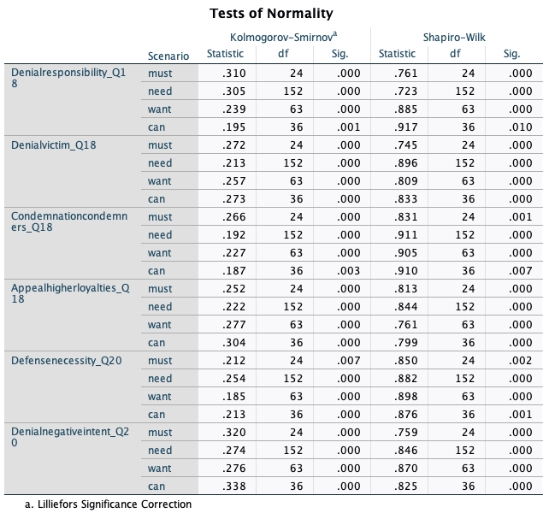
Figure 2. Tests of Normality for the Must-scenario.
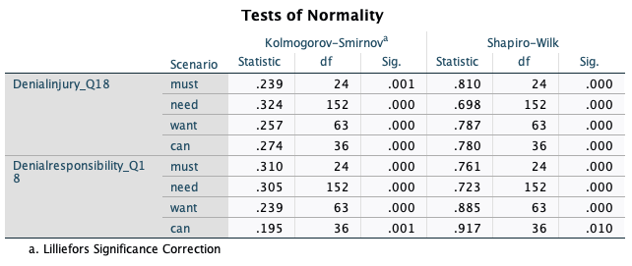
Figure 3. Tests of Normality for the Need-scenario.
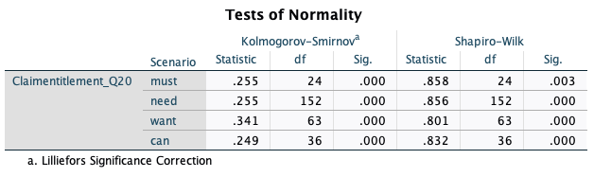
Figure 4. Tests of Normality for the Want-scenario.

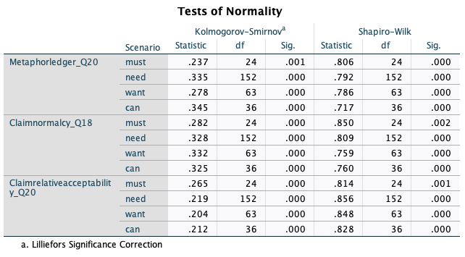
Figure 5. Tests of Normality for the Can-scenario.

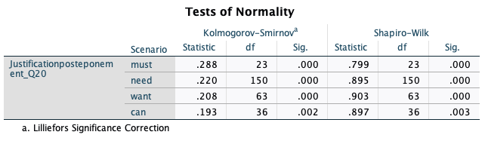
Figure 6. Tests of Normality for the neutralisation technique Justification by Postponement.
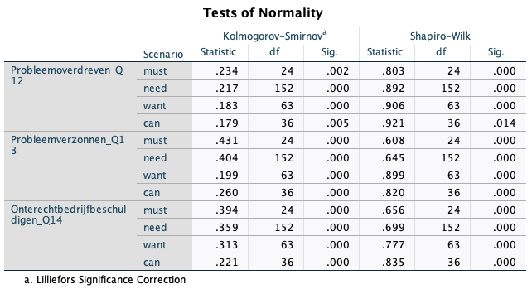
Figure 7. Tests of Normality for the illegitimacy of the complaints.

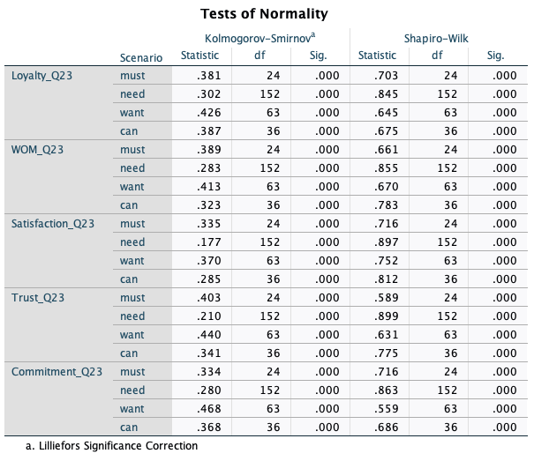
Figure 8. Tests of Normality for the relationship variables.

Appendix V. Box Plots
Here, an overview of all distributions of the variables are provided within Box Plots, in which Figures 9-20 show the Box Plots for the neutralisation techniques. Figures 21-23 show the Box Plots for the illegitimacy of the complaints. Lastly, Figures 24-28 show the Box Plots for the relationship variables.

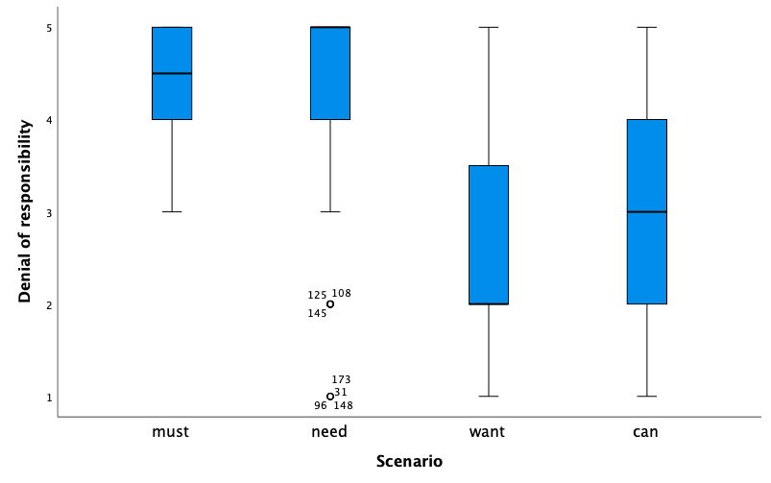
Figure 9. Box Plot for the neutralisation technique Denial of Responsibility.

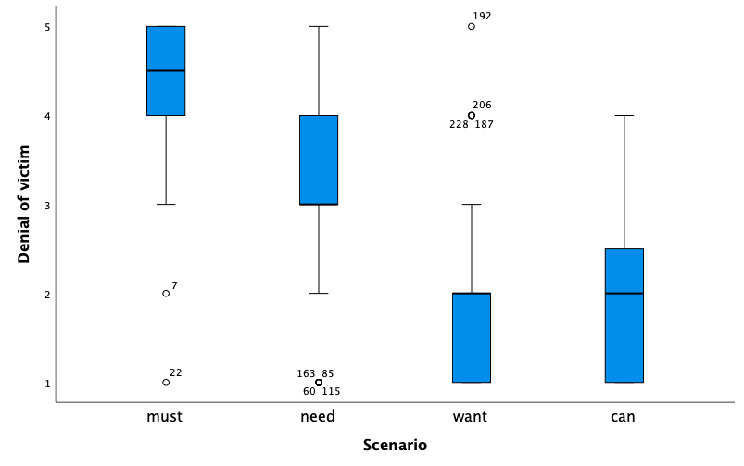
Figure 10. Box Plot for the neutralisation technique Denial of Victim.

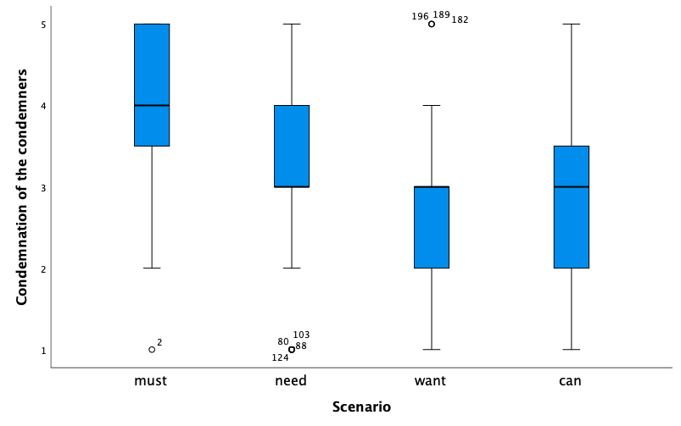
Figure 11. Box Plot for the neutralisation technique Condemnation of the Condemners.

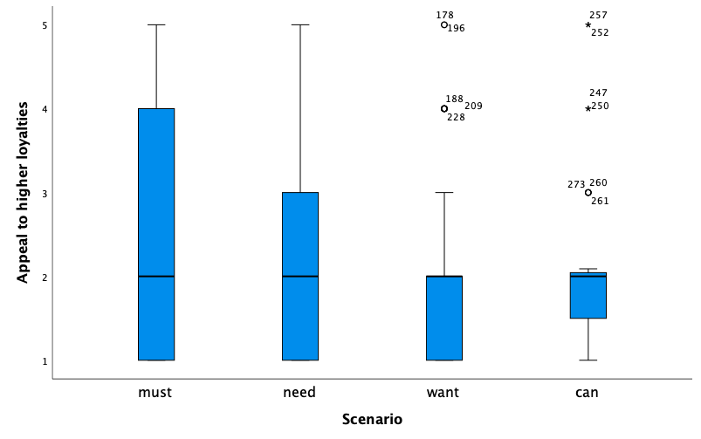
Figure 12. Box Plot for the neutralisation technique Appeal to Higher Loyalties.

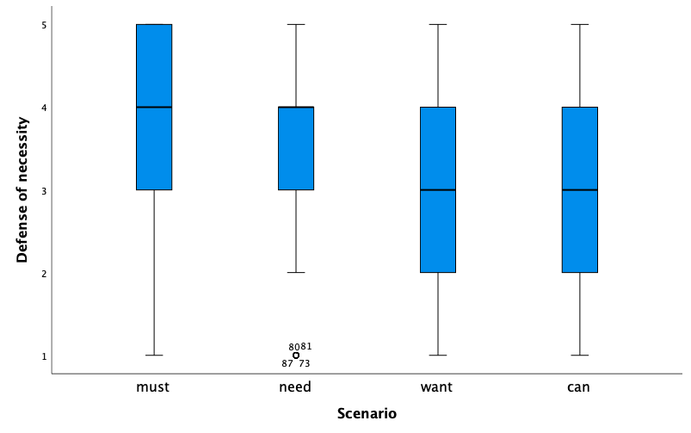
Figure 13. Box Plot for the neutralisation technique Defense of Necessity.
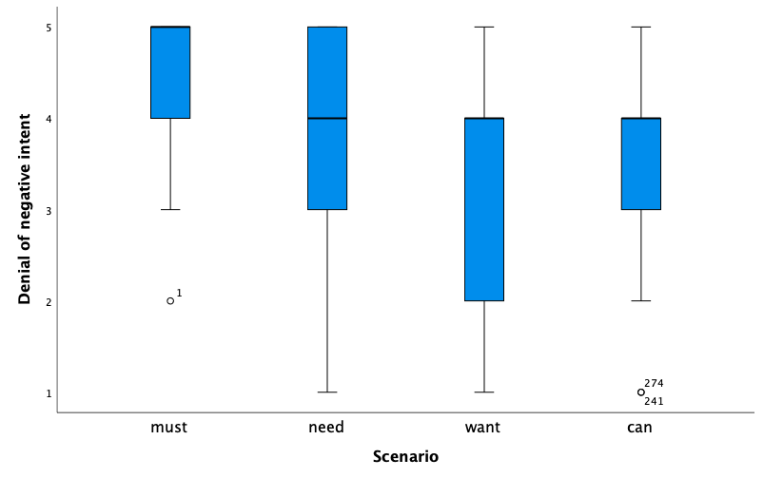
Figure 14. Box Plot for the neutralisation technique Denial of Negative Intent

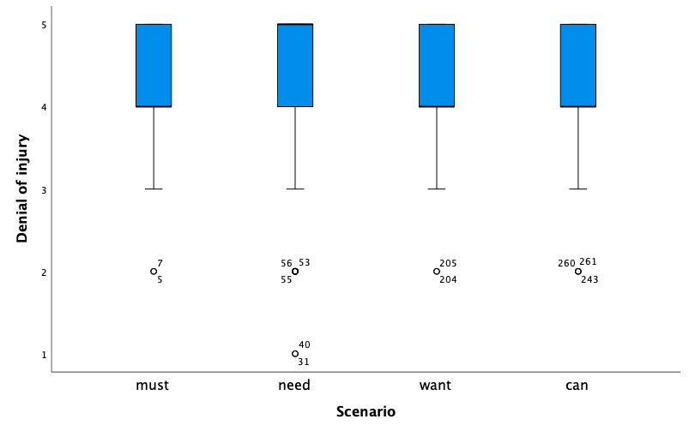
Figure 15. Box Plot for the neutralisation technique Denial of Injury.

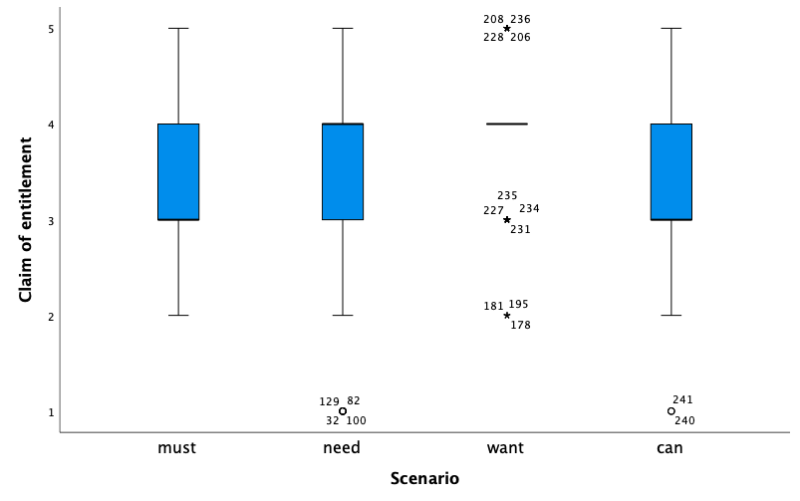
Figure 16. Box Plot for the neutralisation technique Claim of Entitlement.
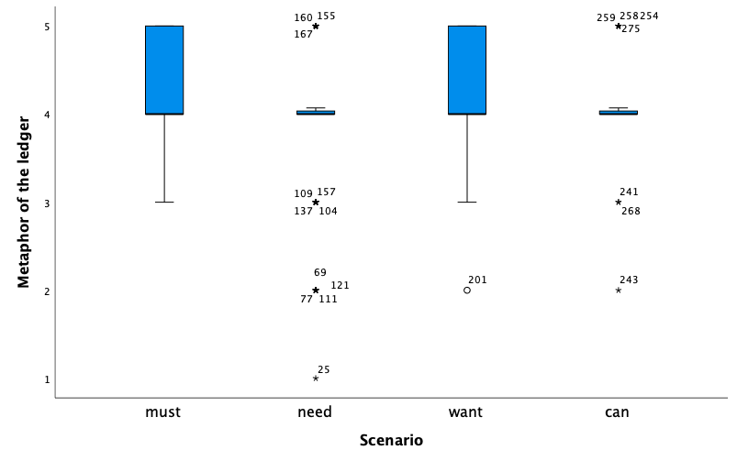
Figure 17. Box Plot for the neutralisation technique Metaphor of the Ledger.

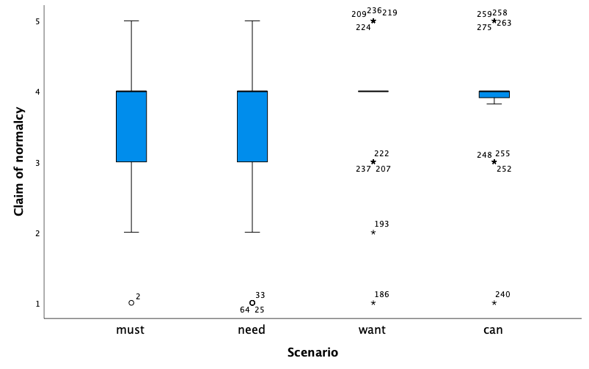
Figure 18. Box Plot for the neutralisation technique Claim of Normalcy.

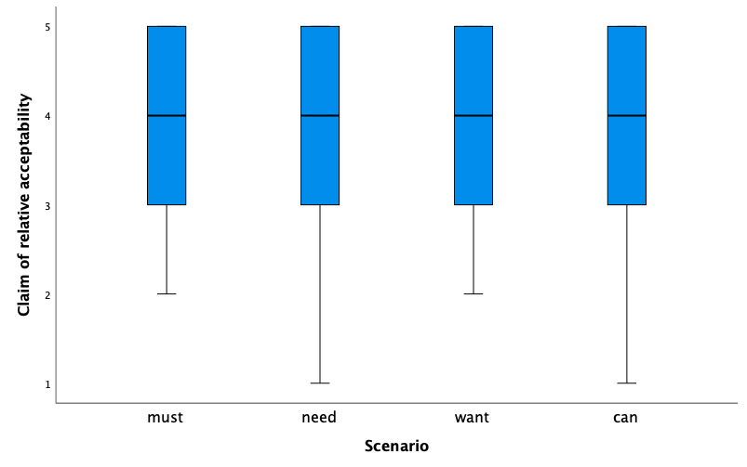
Figure 19. Box Plot for the neutralisation technique Claim of Relative Acceptability.
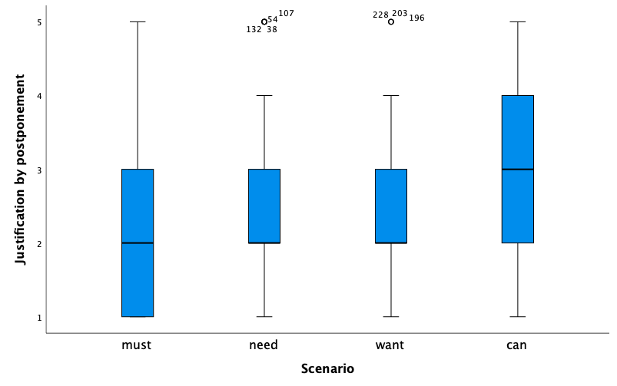
Figure 20. Box Plot for the neutralisation technique Justification by Postponement.

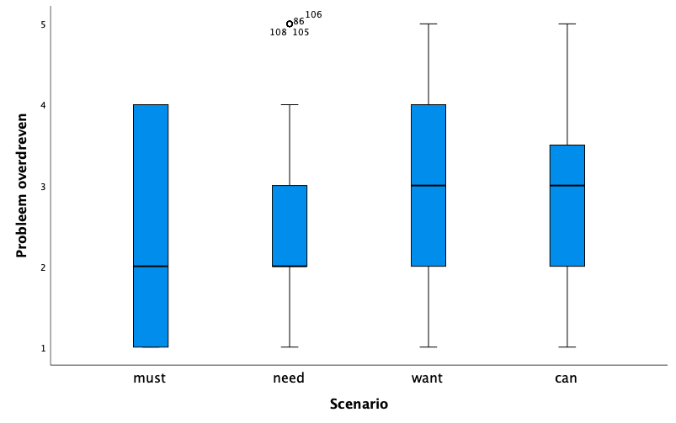
Figure 21. Box Plot for Exaggerated Complaint.

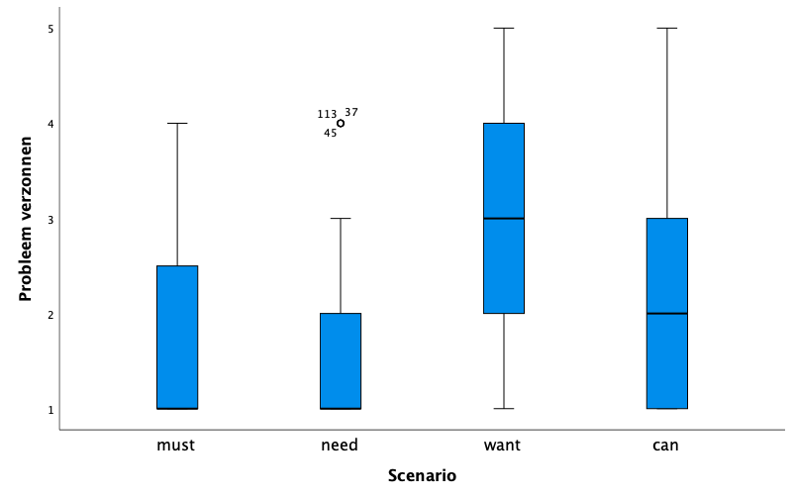
Figure 22. Box Plot for Made-Up Complaint.

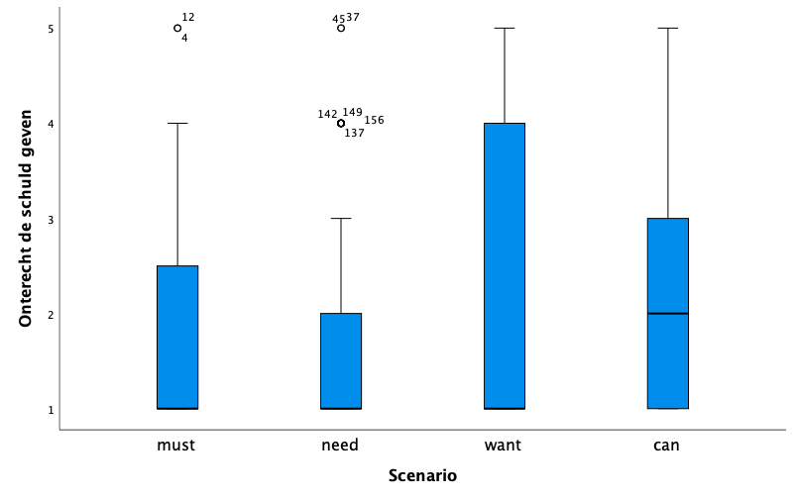
Figure 23. Box Plot for Falsely Blamed the Organisation.

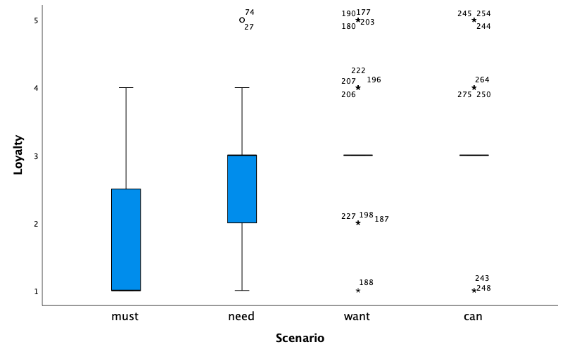
Figure 24. Box Plot for the relationship variable Customer Loyalty.

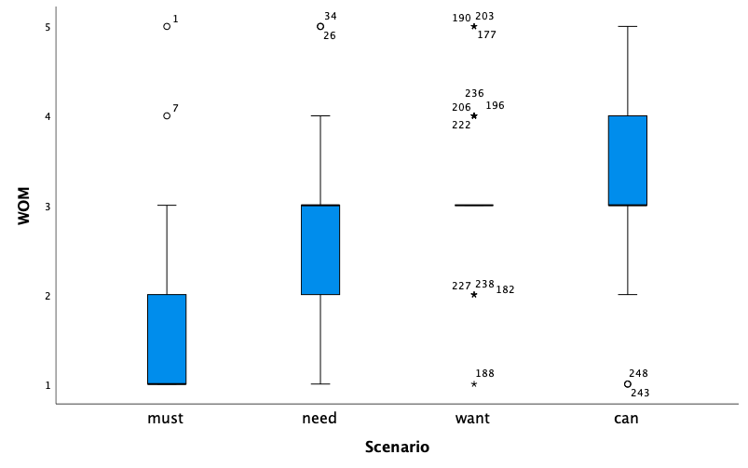
Figure 25. Box Plot for the relationship variable Word of Mouth.

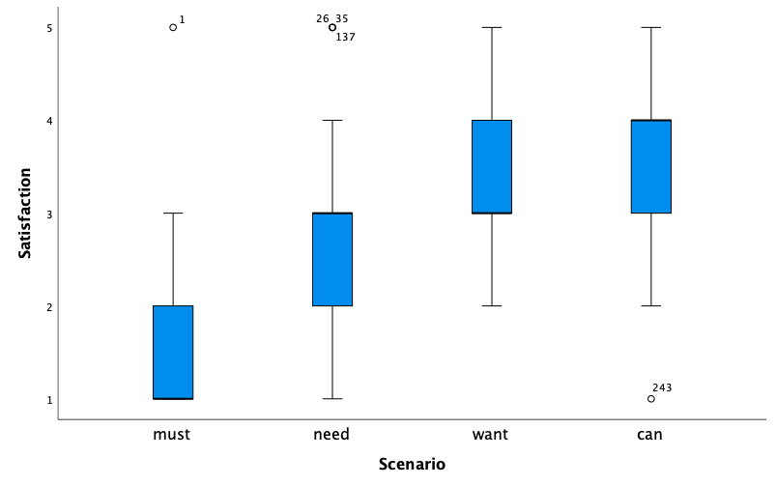
Figure 26. Box Plot for the relationship variable Customer Satisfaction.

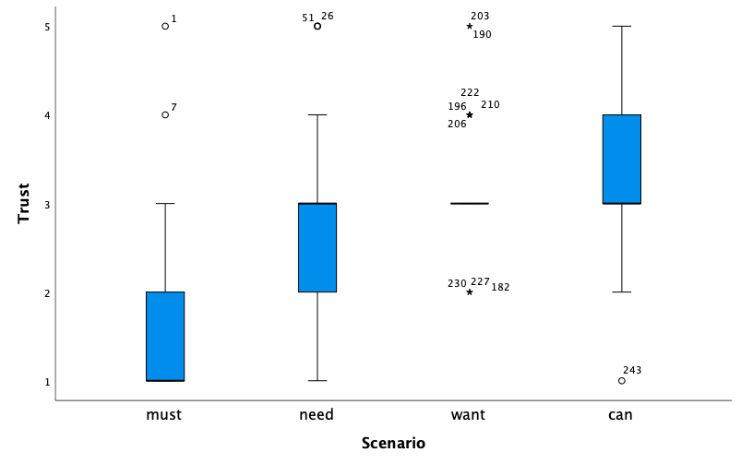
Figure 27. Box Plot for the relationship variable Customer Trust.

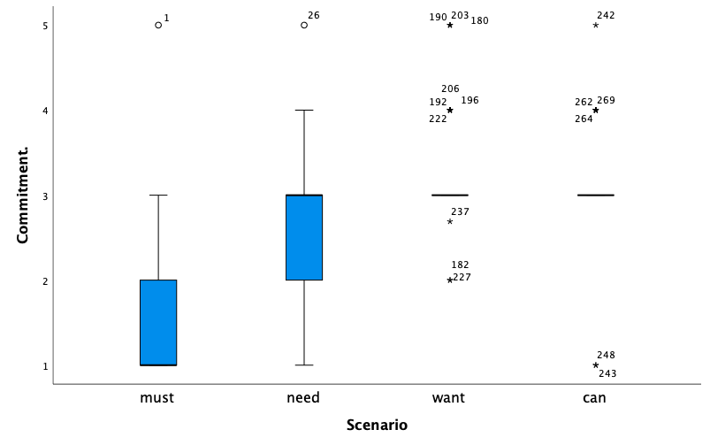
Figure 28. Box Plot for the relationship variable Customer Commitment.

Appendix VI. Scatterplot
The scatterplot within Figure 29 has the highest correlation coefficient (.540) of all correlations within the Must-scenario. Adding to the explanation provided within the sections about the assumption of linearity and correlation between dependent variables (4.2), a large number of other dependent variables do not correlate. Hence, only this scatterplot is included within this appendix, as an example of its inapplicability.

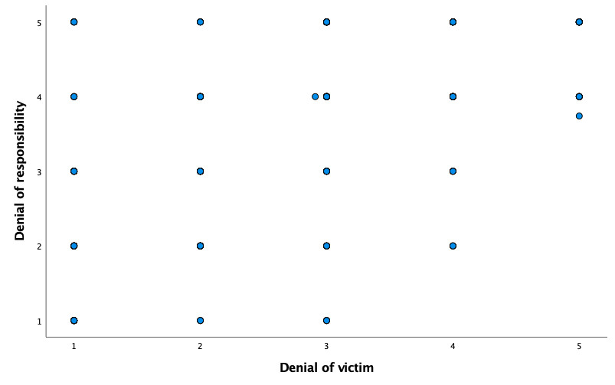
Figure 29. Scatterplot for the variables Denial of Responsibility and Denial of Victim.

Appendix VII. Correlation Matrices
Here, the correlation matrices are provided, including covariates. Figures 30-34 concern the matrices for the neutralisation techniques, Figure 35 shows the matrix for the illegitimacy of the complaints and lastly, Figure 36 shows the matrix for the relationship variables.
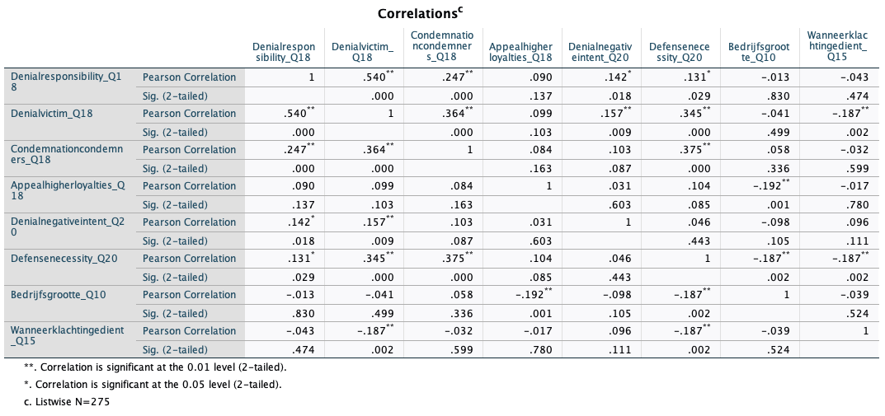
Figure 30. Correlation Matrix for the Must-scenario.

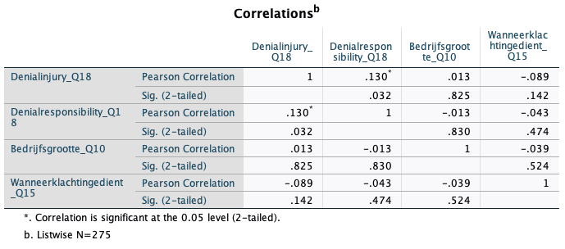
Figure 31. Correlation Matrix for the Need-scenario.

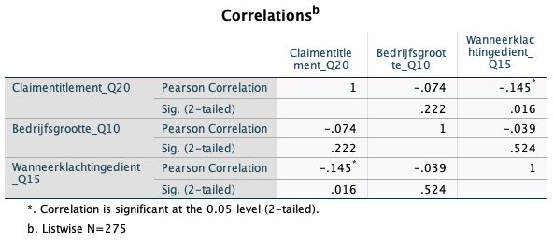
Figure 32. Correlation Matrix for the Want-scenario.

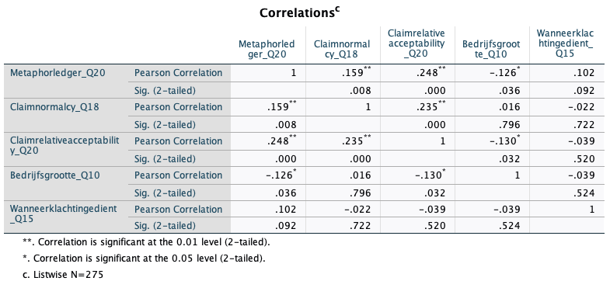
Figure 33. Correlation Matrix for the Can-scenario.

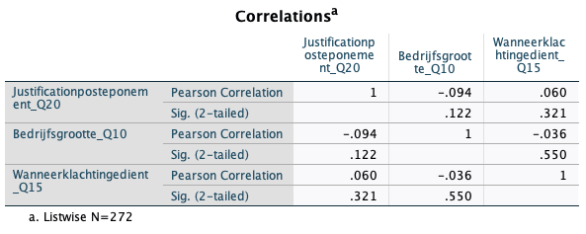
Figure 34. Correlation Matrix for the neutralisation technique Justification by Postponement.

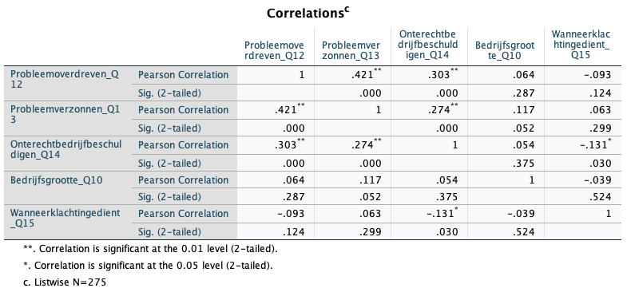
Figure 35. Correlation Matrix for the illegitimacy of the complaints.

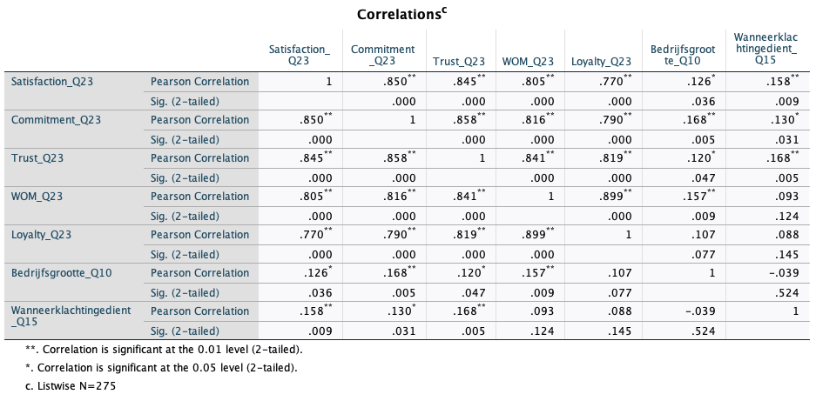
Figure 36. Correlation Matrix for the relationship variables.

Note that hypotheses 1a and 4b state that both the Must-type of complainers and the Need-type of complainers score higher on the neutralisation technique Denial of Responsibility compared to the other types of complainers. To clarify; it is hypothesised that both the Must-type and the Need-type of complainers score higher on Denial of Responsibility compared to the Want-type and the Can-type of complainers.
Note that hypotheses 1a and 4b state that both the Must-type of complainers and the Need-type of complainers score higher on the neutralisation technique Denial of Responsibility compared to the other types of complainers. To clarify; it is hypothesised that both the Must-type and the Need-type of complainers score higher on Denial of Responsibility compared to the Want-type and the Can-type of complainers.
Please note that no type of complainers seems to use Justification by Postponement as a neutralisation technique. However, since this technique is opted by Harris & Dumas (2009), this technique is included within the survey. By including the technique, this research could possibly identify the technique to belong to a specific type of complainers, whereas otherwise the technique can be left out in possible future research.
Note that hypotheses 1a and 4b state that both the Must-type of complainers and the Need-type of complainers score higher on the neutralisation technique Denial of Responsibility compared to the other types of complainers. To clarify; it is hypothesised that both the Must-type and the Need-type of complainers score higher on Denial of Responsibility compared to the Want-type and the Can-type of complainers.
See Footnote 4.

