Faculty of Management Sciences
Master Thesis in Economics
Academic year 2015-2016
Date: 23-08-2016

Disentangling the mechanisms driving the treatment effect in the gender-competitiveness bias

Theory and experiment

Achiel Fenneman
Student number 3032744

First Supervisor: Prof. dr. Utz Weitzel
Second Supervisor: Prof. dr. Stephanie Rosenkranz

Disentangling the mechanisms driving the treatment effect in the gender-competitiveness bias
Theory and experiment

Abstract
Despite the large body of research regarding the gender-effect in competiveness, a large hiatus still remains. Whilst ample previous research has demonstrated that males are more likely than females to engage in competition in stereotypically “male” tasks (e.g. relying on visuo-spatial orientation or mathematical skills), the differentiated predisposition to competition has not been observed in stereotypically “female” tasks (e.g. relying on memory or verbal skills). Research into this treatment-effect has been relatively scarce, with only a limited number of studies aimed at experimentally verifying its effects. Based on the previous literature, we identify three possible mechanisms driving this treatment-effect: females under-select into competition as they perform worse in male tasks (“gender-treatment performance differences”), they under-select into competition as a result of pessimistic beliefs regarding their opportunity to succeed in male competitive environments (“biased estimates”), or females could have an selective aversion towards competing against males in a male task (a gender-task performance bias). In the present research, we develop five formal models (two benchmark models and three treatment-specific models) aimed at capturing these mechanisms. The behavioral predictions of these models are empirically verified in a setup similar to the one utilized by Niederle and Versterlund (2007), with the modification of two treatments: memory versus maze. In the first treatment, subjects (n=39) interact in a female task (memory game), whilst subjects in the second treatment (n=27) interact in a stereotypically male task (maze-solving). Based on the empirical results, we observe that the biased-estimates model (notably in the form of hot-state confidence) provides the best fit of the observed data. As a result, this implies that females under-select into competition in male (but not female) tasks due to a more pessimistic view regarding their probability to win tournaments in these circumstances. These results provide a deeper understanding of the gender-bias in competitiveness in specific and the gender-wage gap in general. In turn, this knowledge allows for a more detailed set of policy-implications.

Keywords: experimental economics, gender-wage gap, gender-competitiveness bias, stereotype tasks.

TABLE OF CONTENTS
1 | INTRODUCTION | 5
2 | MODELS AND HYPOTHESIS FORMATION | 9
2.1 | Benchmark models | 9
2.1.1 | GNO: Gender-Neutral Optimal | 9
2.1.2 | GBC: Gender Bias in Competitiveness | 12
2.2 | Treatment-specific models | 13
2.2.1 | GTPD: Gender-Treatment Performance Differences | 14
2.2.2 | BE: Biased Estimations | 17
2.2.2.1 | Beliefs | 17
2.2.2.2 | Confidence | 19
2.2.3 | Gender-Task Stereotype Bias | 20
2.3 | Chapter Summary | 21
3 | EXPERIMENTAL METHODOLOGY | 22
3.1 | Experimental Subjects | 22
3.2 | Experimental Procedure | 23
3.3 | Experimental Treatments | 28
3.4 | Analysis | 30
4 | RESULTS | 33
4.1 | Descriptive Statistics | 33
4.1.1 | Performance on Tasks | 33
4.1.2 | Tournament Selection | 34
4.1.3 | Probability of winning T3/T4 | 36
4.1.4 | Beliefs | 37
4.1.5 | BRET-scores | 39
4.1.6 | Questionnaire data | 40
4.2 | Regression Results | 41
4.3 | Chapter Summary | 43
5 | DISCUSSION | 44
5.1 | Hypotheses | 44
5.1.1 | Results GNO | 44
5.1.2 | Results GBC | 45
5.1.3 | Results GBPD | 46
5.1.4 | Results BE | 46
5.1.5 | Results GTSB | 48
5.1.6 | Summary of Results | 48
5.2 | Shortcomings | 49
5.3 | Suggestions for Future Research | 50
6 | CONCLUSION | 51
7 | REFERENCES | 53
Appendix A | DETAILED SUBJECT DEMOGRAPHICS | 55
A.1 | Subject Demographics | 55
A.2 | Earnings Per Treatment | 56
A.3 | Questionnaire Data | 57
Appendix B | DETAILED TECHNICAL SPECIFICATIONS OF THE EXPERIMENTAL SOFTWARE | 60
B.1 | Software Framework | 60
B.2 | Treatment-Specific Software | 61
B.2.1 | Common Aspects | 61
B.2.2 | Memory-treatment Specific Software | 62
B.2.3 | Maze-treatment Specific Software | 63
B.3 | Detailed Instructions | 67

- INTRODUCTION
The existence of a gender-pay gap appears to be a global constant; over vast ranges of the cultural, geographical and historical spectrum of human civilization, males out-earn their female counterparts in nearly all societies. Although this gender-pay gap has somewhat narrowed in the Western world in recent decades (for a meta-analysis, see Wiseichselbaumer & Winter-Ebmer, 2007), there still exists a strong divergence in both the type of occupation and the amount of wage earned between the genders. Typically, males are over-abundantly represented in high-income positions, both in the private and public sectors. Conversely, females are more likely to be unemployed or, if they are employed, less likely to climb the hierarchical ladder as compared to their male counterparts. As a result, the gender-wage gap increases over the wage distribution; the higher the associated pay of a position, the lower the probability the position is filled by a female employee.
This difference in wages and positions in the hierarchy persist in the Western world despite an equalization in formal rights and a strong institutional drive for equality. Booth (2009) outlines multiple explanations, focusing both on supply and demand side of labor. On the demand-side, females may be through off as less attractive employees for high-income positions due to (statistical) discrimination; young women are on average more likely to drop out of the labor force at some point in the future. As a result, an employer may be biased against long-term investment in the form of traineeships, promotions or formal education. In turn, this leads to a lower demand for female employees in top positions drive the observed gender-wage gap.
Conversely, supply-side explanations of the gender-wage gap focus on the amount of females available for high-position jobs. Under this interpretation of the problem, employers are not specifically biased against hiring or promoting female employees to high positions. In contrast, there is an inadequate supply of female candidates available for high-income positions, notably as women tend to stay away from typically “male”-oriented high-skill professions (e.g. Blau & Kahn, 1994). Recent research in behavioral economics has led to a boost into this line of research. Based upon two early studies by Gneezy, Niederle and Rustichini (2003) and Niederle and Versterlund (2007), a primary focal point of experimental research regarding the gender-wage gap have the differentiated preferences for competition between men and women.
The experimental work done by Gneezy et al (2003) consisted of three treatments. In all of these treatments, experimental subjects completed a simple task (solving a computer-generated maze) under a time restraint of 15 minutes. In the first treatment, subjects are paid a piece-rate wage; a riskless-payoff based on the number of mazes successfully completed. In contrast to the individual nature of the first part, in the second part of the experiment subjects are grouped together. Again, they perform the same task. However, subjects in this treatment are paid based on a tournament scheme; e.g. they receive a fixed payment only if they are the highest-performing group member. Finally, in the third treatment the highest subjects earn a payment based upon a hybrid scheme; a piece-rate reward based upon the number of successfully completed mazes but only if they are the highest-performing group member. The behavioral results obtained from this experiment indicated a strong gender effect. Even after controlling for a subject’s risk aversion, the mere presence of competition itself generates a gender-bias in performance such that female subjects have a lower average number of completed mazes in the tournament and hybrid treatments as compared to male subjects. This effect is strongest for mixed-sex tournaments and tends to disappear in single-sex tournaments. These results suggest that either women on average have an aversion for competition (and hence underperform due to a lack of motivation) or experience a decreasing confidence with respect to male competitors (and hence underperform as they do not expect to receive a reward).
Niederle and Vesterlund (2007) further developed this design by having subjects add five 2-integer numbers (as opposed to solving mazes) and by introducing a within-subjects methodology. In contrast to the work by Gneezy et al, subjects in this experiment conducted several tasks each. In the first task, subjects received a piece-rate wage for each sum solved. In the second task, subjects were organized in groups of four (two male and two female subjects per group) and subjected to tournament incentives, such that they received a payoff four times larger as compared to the first task, but only if the subjects solved the most sums in his or her group. In the crucial third stage of the experiment, subjects again performed the same task but were now allowed to select their own payoff scheme prior to engaging in the task; they could choose to be rewarded individually (by piece-rate scheme) or by competing in a group (a tournament scheme). As in the setup developed by Gneezy et al, the experimental results again indicated a strong gender-effect; while women performed (on average) equally well in the tasks as males, they disproportionally self-selected into the piece-rate payment.
These findings have spurred a range of replication studies an in-depth analyses of this gender differences. Experimental research has observed this gender-bias in competitiveness to take effect from an early age (e.g. 7-10 year olds: Dreber, von Essen & Ranehill, 2011; 3-18 year olds: Sutter & Rützler, 2010; 9-10 year olds: Gneezy & Rustichini, 2004) and is observed over a vast range of countries such as Sweden and Columbia (Cardenas, Dreber, Von Essen & Ranehill, 2012), Germany: (Bartling, Feh, Maréchal & Schunk, 2009), Tanzania (Gneezy, Leonard & List, 2009), Israel (Gneezy & Rustichini, 2004) and the UK (Booth & Nolen, 2012). In all these observations, female experimental subjects persistently tend to avoid competition by self-selecting into the piece-rate scheme. This effect is especially pronounced when women are asked to compete directly in mixed-gender groups (Niederle & Vesterlund, 2010).
As there is typically a high degree of competition required to obtain a high-income position, several authors have argued that this gender-competitiveness bias has a strong contribution to the observed gender-wage gap. In response, Balafoutas & Sutter (2012) provide experimental evidence in favor of four policy implications designed to address this issue. The authors utilize a similar setup as Niederle and Vesterlund (2007), but with the inclusion of an additional stage. In this stage, the outcome tournament-competition is influenced by one of four affirmative-action policies; a minimum quote for female subjects, a performance-bonus for females based either on a head-start (e.g. female subjects start with a non-zero positive score) or on a different incremental reward for performance (female subjects receive more points per correct answer as compared to their male counterpart) or a repetition of the competition if there are insufficient female winners. Results indicate that these affirmative-action policies increase the participation rates of the female subjects in the competitive tournament scheme, without resulting in a significant decrease in overall efficiency (the average performance of all subjects remains similar to a control condition). As a conclusion, the authors argue that such policies could potentially prove beneficial in addressing the gender-bias in competitiveness. The potential benefits of a quota-based affirmative-action policy are further corroborated by Niederle, Segal & Vesterlund (2013), who similarly observe such a policy increases the entry-rates of female experimental subjects.
However, despite the strong body of evidence in favor for the existence of a gender bias in competition, there are a few notable shortcomings in the existing research. Primarily, the majority of researchers utilize tasks with a focus on mathematical ability (integer-summation tasks) or spatial reasoning skills (maze tasks). Notable other designs include physical activity (e.g Dreber et al, 2011) or verbal tasks (Cardenas et al, 2012). Crucially, the first three of these tasks are generally considered to be “male-biased”, with males having (on average) a higher performance than females on these tasks (Cvencek et al 2011; Nosek and Smith, 2011). In contrast, the verbal task is generally considered to be female-biased or neutral. Tellingly, several studies utilizing a verbal task (e.g. a word puzzle) do not replicate a gender bias in competitiveness (Dreber et al, 2014; Grosse & Riener, 2010; Gunther et al, 2010; Wozniak et al, 2010).
Notably, Gunther et al (2010) utilized a between-subjects setup similar to Gneezy et al (2003) to test subject’s competitiveness in three different tasks: male, neutral and female-oriented. For the male task they utilized a standard maze solving procedure. For the neutral task, subjects had to generate words from a given set of letters. Finally, in the female task subjects were given a pattern and where asked to remember its contents during an interval of distracting stimuli. Apart from the differences in tasks, treatments differed in incentive structure: random pay versus competition. Results indicate that the typical gender bias (increased performance for males, but not females, in the tournament incentive) is replicated for the male task, but not for the other two tasks. Women in the neutral task responded on par to males to the incentive and tellingly responded more strongly than males on the female task. The authors explain these observations by positing the existence of a stereotype threat in these tasks; a concept derived from psychological literature in which the conceptual activation of a specific stereotype can adversely impact the task performance of the subject. This stereotype threat hypothesis makes a straightforward implication into the cause of the gender bias in self-selection to competitive environments; due to the stereotype, females underperform in competitive “male” tasks and hence self-estimate the probability that they win a tournament to be lower with respect to males.
Similar findings have been observed for within-subject competitiveness using a design similar to Niederle and Vesterlund (2007). Dreber et al. (2014) test for the existence of a gender-bias in competitiveness in adolescents by utilizing (and explicitly contrasting) two separate between-subject treatments: a “male” integer-summation task, versus a “female” word-finding task. Results indicate the expected differentiation; while there is no gender-based differences in competitiveness behavior in the female task, men are observed to overselect into the tournament-scheme in the male task. In line with the findings of Gunther et al (2010), male subjects objectively perform better in the male task, but there is no significant difference between the genders in the female task. Furthermore, for both genders there is no difference between the performance in the piece-rate and tournament tasks. Notably, in both tasks the gender-gap disappears after controlling for the subject’s beliefs regarding their relative performance, risk aversion and the objective performance. As a result, the authors hypothesize that the gender gap is driven by a combination of the subject’s task-based (and stereotype-informed) subjective confidence and objective performance.
Experimental results obtained by Wozniak, Harbaugh & Mayr (2010) conceptually replicate these results in an adult subject pool consisting mostly of university students. The authors utilize a similar two-task design consisting of an integer-summation task and a word generation task identical to the one utilized by Gunther et al (2010). Based on the obtained results, the authors conclude that the gender-bias in competitiveness in male tasks disappears when subjects are given information regarding their relative performance. In effect, this observation strongly implies that the treatment-effects obtained by Dreber et al (2014) are the result of differential confidence levels between the genders.
Finally, Grosse and Riener (2010) utilize a complicated version of the design utilized by Niederle and Vesturlund (2007), with a direct test between a numerical integer-summation task versus a verbal word-ordering task. Similar to the research outlined above, results again indicated a selective effect of task on the gender-bias in competitiveness. Notably however, the authors do not find this effect to be supported by a difference in performance, nor in overconfidence. As such, the authors argue that the commonly observed gender bias are driven by gender-task stereotypes. Under this interpretation, women have a selective aversion towards competition in stereotypical male tasks, but not in female tasks.
While the research outlined above provides a strong set of evidence in favor of the existence of a treatment-effect in the gender-bias in competitiveness, the underlying mechanisms appear to differ. Stated differently, while there is evidence in favor of such an effect, it is unclear which gender-based mechanisms generate the treatment-effect. Based on the literature above, we observe three competing candidates: women complete less in male tasks (but not in female tasks) as a result of an underlying difference in performances between male and female tasks (based on Gunther et al, 2010), as a result of a difference in beliefs regarding their relative performance in both tasks (based on Dreber et al, 2014 and Wozniak et al, 2010), or because of a selective aversion to compete in stereotypically male tasks (based on Grosser and Riener, 2010). At this moment in time, there has not been any empirical research aimed at estimating the relative strength of these three mechanisms. It is the aim of the present research to be the first to do so.
In order to disentangle these three mechanisms, we utilize a conjoined theoretical and experimental approach. First, the second chapter of this thesis will outline a set of models aimed at capturing the essence of the different mechanisms. Based on these models, we generate a series of theoretical predictions open to experimental verification. The third chapter of this thesis will outline the methodology employed to do so, with the associated results being reported in the fourth chapter. The fifth chapter will discuss the experimental findings and will utilize them to assess the relative effect of all three treatment-specific models. Finally, the sixth and last chapter of this thesis will provide a conclusion.
The present body of work has a tangible societal relevance. The causal path driving the gender-bias in competitiveness is poorly understood at present. Whilst the policy implications proposed by Balafoutas & Sutter (2012) have been demonstrated to work efficiently in a male-oriented task, it remains unclear if these policies sufficiently generalize to female-oriented or neutral tasks. In order to properly construct policies aimed at removing the gender-bias in competitiveness, it is crucial to understand the mechanisms that give rise to it in the first place

2. MODELS AND HYPOTHESIS FORMATION
The second chapter of this thesis will develop the theoretical models utilized in the present research. In total, five distinct models will be outlined; two benchmark models and three treatment-specific models. The first two are included to provide a general benchmark of optimality and as a replication of the previously observed gender-bias in competitiveness. These models will be outlined in Section 2.1. In order to capture the different mechanisms behind the treatment-effect in the gender-bias in competitiveness, we further develop three treatment-specific models. Each of these models captures a single proposed mechanism and derives testable predictions. Section 2.2 will provide an in-depth discussion of all three models separately. Finally, Section 2.3 summarizes the models developed in this chapter.
  - Benchmark models
In order to provide a theoretical framework and corroborate earlier research, we first develop two benchmark models: a gender-neutral optimal model and a gender-bias in competitiveness model. The first of these models assumes rational, unbiased behavior of all agents and does not allow for any specific gender- or treatment- biases between agents. As such, this model is not expected to accurately predict reality. However, its importance is significant as it provides a framework to which the deviations observed in the other models can be tested.
The second benchmark model relaxes the assumptions of the first model by allowing agents to have differential preferences for competition based on their gender. This relaxation is in line with the previous literature regarding the gender-bias in competitiveness, as well as the biological causes outlined in the introduction.
    - Gender-neutral optimal model
In order to function as a benchmark model, we will first posit and derive a gender-neutral optimal (abbreviated GNO) solution. Here, “gender-neutral” refers to the absence of a differentiation between male and female agents, whilst “optimal” refers to the maximization of utility as done by a von-Neumann-Morgenstern rational agent (further abbreviated to vNM-rational; Von-Neumann & Morgenstern, 2007).
Assumptions – in order to constrain the parameter-space of the GNO model, we posit a number of (simplifying) assumptions. First, we assume that agents make unbiased estimations regarding their own performance and the distribution of the performances of other players. Stated differently, an agent’s subjective expectation of relative performances and the associated probability of being the highest-performing member of a group converges (on average) to their objective counterparts. We further assume that agents have concave utility functions, such that $∀αϵR \left(aU\left(x\right)>U\left(ax\right)\right)$, where $a>0$ (a decreasing marginal return in utility over reward). Finally, we assume agents to have some risk preference $c_{i} ∈ \left[0, ∞\right]$, such that $c_{i}aU\left(x\right)=U(ax)$, with $c_{i}<1$ implying risk-averse agents.
Performance Inferences – in the GNO model, there are no systematic differences between subsets of agents; all agents perform at their peak capacity. As such the performances of all agents are drawn from the same underlying distribution $X$, defined as:
$$X \sim N(μ,σ)$$
Since agents do not explicitly learn their own performance, they have to infer their objective performance (denoted by $X_{i} ∈X$) based on their subjective beliefs (denoted $x_{i}$). Hence, they infer:
$$x_{i}=\left(1+ε_{i} \right)*X_{i} (1.1)$$
Under the assumption of unbiased estimations, let $ε_{i}\sim N(0,σ_{i})$. Furthermore, subjects make an unbiased estimate of the distribution of the performances by other group members, denoted by $X_{j}$
$${{\{x}_{j}…x_{n}\}= X}_{j} \sim X$$
Individual Payment Scheme Decision – Agents are assumed to maximize their expected utility. Hence, they self-select into the tournament scheme iff equation (1.2) holds :
$$E\left(U\left[Tournament\right]\right)>E\left(U\left[Piece Rate\right]\right) \left(1.2\right)$$
With:
$$E\left(U\left[P\right]\right)=U\left(x_{i}\right)$$
$$E\left(U\left[T\right]\right)= E\left(π_{i}\right)*U(nx_{i})$$
And where $E\left(π_{i}\right)= E(Pr⁡[x_{i}>\max\left\{x_{j}..x_{n}\right\}])$is agent i’s estimated probability of winning the tournament, given its subjective estimated score $x_{i}$ and the number of competing agents.
Substituting the expected utilities into equation (1.2) leads to:
$$E\left(π_{i}\right)*U\left(nx_{i}\right)>U\left(x_{i}\right)$$Which can be rewritten as
$$E\left(π_{i}\right)>\frac{U\left(x_{i}\right)}{U\left(nx_{i}\right)}$$
Under our assumption of risk-preferences $U\left(nx_{i}\right)=c_{i}nU\left(x_{i}\right)$, we can rewrite this equation as:
$$E\left(π_{i}\right)>\frac{1}{c_{i}n} \left(1.3\right)$$
where $c_{i}$is the agent’s risk preference. Furthermore, the agent’s objective probability of winning the tournament (denoted as $π_{i}$ )is given by:
$$π_{i}=\operatorname{Pr}\left[x_{i}>x_{j}\right]*\operatorname{Pr}\left[x_{i}>x_{k}\right]*…*\operatorname{Pr}\left[x_{i}>x_{n}\right]= \prod_{j≠i}^{n}{Pr\left[x_{i}-x_{j}>0 \right]}$$
Since $x_{j}…x_{n}$ are all drawn from the same distribution $X_{j}$, $π_{i}$ can be rewritten as:
$$π_{i}=\prod_{j≠i}^{n}{Pr\left[x_{i}-μ>0 \right]}={\left(Pr\left[x_{i}-X_{j}>0 \right]\right)}^{n-1}$$
Under the assumption that agents make unbiased predictions, we can substitute $E\left(π_{i}\right)= π_{i}$. Rewriting equation (1.2), we conclude that an unbiased agent selects the tournament scheme iff:
$${\left(Pr\left[x_{i}-X_{j}>0 \right]\right)}^{n-1}>\frac{1}{c_{i}n}$$
$$Pr\left[x_{i}-X_{j}>0 \right] >{\left(c_{i}n\right)}^{\frac{-1}{n-1}} \left(1.4\right)$$
As a result, Proposition 1a is formulated as follows:
Proposition 1a: the probability that an GNO agent self-selects into the tournament scheme is strictly dependent on its estimated personal score (positive sign), the estimated distribution of the score of other agents in its group (negative sign), its risk aversion (negative sign) and the number of other agents in the group (negative sign).
Experimental verification of this proposition is captured in Hypothesis 1, below:
Hypothesis 1a: the experimental subject’s selection into either the piece-rate or tournament payment scheme is strictly determined by his/her personal score, his/her beliefs about the relative scores of others (as measured by his/her confidence, his/her risk preferences and the number of the agents in the group.
Group aggregates – We denote a single agent i as $α_{i}$ and the set of all agents as $Α$, which is composed of its two constituent subsets $Τ$ (agents preferring the tournament scheme) and $Ψ$ (agents preferring the piece-rate scheme). Furthermore, we denote $τ,ψ ∈N$ as the cardinality of these subsets, such that:
$$τ= \left|Τ\right|= \left|\{ \left(a_{i} | E\left(π_{i}\right)>\frac{1}{c_{i}n} \right)\}\right|$$
$$ψ= \left|Ψ\right|= \left|\{ \left(a_{i} | E\left(π_{i}\right)≤\frac{1}{c_{i}n} \right)\}\right|$$
Under the assumption of non-biased estimates, the value of $ε_{i}$ (see equation (1.1), above) converges to 0 when averaged over multiple agents. As a result, on average agents correctly infer their own objective performance. Furthermore, they correctly infer the distribution of all agents’ scores in their group, including themselves, to be approximated by the distribution $X$. Let $X_{(n)}$ be the n^{th} order statistic of this distribution, such that $X_{(n)}=max⁡(x_{i},x_{j},…,x_{n})$.
Let $\overline{π}$ be the agent’s expected probability the tournament when averaged over $k$ groups, each containing $n$ players, such that:
$$\overline{π}=\sum_{1}^{k}{\left(\frac{\sum_{i}^{n}{Pr\left[x_{i}=X_{\left(n\right)}\right]} }{n}\right)/k }=\sum_{i}^{k}{\left(\frac{\sum_{i}^{n}{Pr\left[x_{i}=\max\left\{x_{i},x_{j},…{,x}_{n}\right\}\right]} }{n}\right)/k}≈\frac{1}{n}$$
Hence, the number of agents that correctly infer that their performance is equal to the n^{th} order statistic approaches a ratio of $\frac{1}{n}$ . Finally, assuming that (in line with the vast majority of the economic literature), agents are on average risk-averse such that $\overline{c_{i}}<1$, we expect a fraction strictly smaller than $\frac{1}{n}$ to self-select into the tournament scheme. To be precise, we expect:
$$\frac{τ}{τ+ψ}<\frac{1}{n}$$
As a final observation: the exact compositions of the agents in both subsets $Τ$ and $Ψ$ are randomly drawn from the set $Α$ (as their objective performances are drawn from the same normal distribution). As a result, a repeated sampling of both subsets is expected to yield the observation that their elements are not systematically predicable from $A$ (i.e. they do not differ in any fundamental characteristics).
Based on the predictions above, Proposition 1b is formulated:
Proposition 1b: the subset of GNO agents self-selecting into the tournament scheme is randomly sampled from the total set of all unbiased agents. Moreover, the relative size of this subset is strictly smaller than $\frac{1}{n}$.
Verification of this proposition is captured by Hypothesis 1b, below:
Hypothesis 1b: the relative size of the subset of agents in both payment schemes is uncorrelated to variables other than those outlined in hypothesis 1a. Specifically: there is no differences in the distribution of gender in both payment schemes. For both genders, the fraction of subjects selecting the tournament scheme is strictly smaller than $\frac{1}{n}$.
2.1.2 Gender Bias in Competitiveness model
This section extends the GNO model by allowing systematic differences between male and female agents, such that male agents have a higher preference for engaging in tournaments for the act of competition in itself. Stated differently, males may (on average) be competition-seeking whilst females on average display competition-aversion. For brevity’s sake, we will refer to this model as the Gender Bias in Competitiveness model (GBC).
This line of reasoning is not novel. To the contrast, these are the gender differences which form the core of the present thesis. The observation that males and females have differential rates of selection into a tournament scheme is trivial and it’s possible cause and consequences are discussed in the introduction. As such, this model should be read as a second control-model to verify that we can in fact replicate these findings.
Assumptions – There exists a differentiation between the genders in terms of the utility derived from the act of engaging in competitions an sich. Specifically, let $α_{i}$ be the gender-dependent constant utility derived by the act of competing in itself such that $α_{i}>0$if the agent is male and $α_{i}<0$ if the agent is female.
Performance Inferences – The new assumption does not influence the agent’s objective performance, its subjective estimate of this performance nor its beliefs regarding the performance of the other agents. As a result, all steps of the GNO model leading up to equation (1.2) remain identical.
Individual Payment Scheme Decision – In contrast to the GNO model, under the GBC models’ assumptions the agents’ utility function for the tournament-scheme is extended by its additional utility received from the act of cooperation in itself. As such, the utility derived by self-selecting into the tournament scheme is now given by equation (2.1) below:
$$E\left(U\left[T\right]\right)= E\left(π_{i}\right)*U\left(nx_{i}\right)+α_{i} (2.1)$$
Using the same intermediary steps as in the GNO model, equation (1.3) which determines an agent’s entry decision into a tournament, can be rewritten to yield equation (2.2):
$$E\left(π_{i}\right)>\frac{1-\left(\frac{α_{i}}{U\left(x_{i}\right)}\right)}{c_{i}n} \left(2.2\right)$$
Hence, for the same objective probability, GBC-male subjects require a lower threshold to participate in the tournament while GBC-female subjects require a higher threshold. As a result, equation 1.4 can be rewritten as into equation 2.3:
$$Pr\left[x_{i}-X_{j}>0 \right]>{\left(\frac{1-\left(\frac{α_{i}}{U\left(x_{i}\right)}\right)}{c_{i}n}\right)}^{\frac{1}{n-1}} (2.3)$$
Group Aggregates – extending this condition to the group-level aggregates is trivial. Since males and females have performances drawn from an identical underlying distribution, but have (on average) a different additional utility derived from the act of cooperation, it follows that males over-select (and females under-select) into the subsets $Τ$ and $Ψ$. As a result, the groups’ relative cardinalities depend on the distribution of males and females in set $A$.
We summarize these results into Proposition 2, below:
Proposition 2: The probability that an GBC-agent self-selects into the tournament depends on the same factors as the GNO model, with the inclusion of a gender-difference between male and female agents. In particular, male agents are more likely to participate in any tournament (as compared to GNO predictions), whilst females are less likely to participate in any tournament (as compared to GNO predictions).
Experimental verification of this proposition is captured in Hypothesis 2, below:
Hypothesis 2: the experimental subject’s selection into either the piece-rate or tournament payment scheme is strictly determined by his/her GNO-derived factors, plus his/her gender. Specially, males are on average more likely to select into the tournament and females are less likely to select into the tournament.
2.2 Treatment-specific Models
The two models outlined in the section above have posited general predictions, independent of potentially different task-specific demands. In line with the literature discussed in the introduction, we do not expect these models to hold in reality; instead, they perform the roles of benchmark estimations to which the models outlined in this section can be tested.
As such, the current section will extend the models outlined above to incorporate task-specific demand and their effects on the gender-competitiveness bias. As a point of clarification, the present thesis defined a “male” task to be a task in which males are stereotypically perceived to have a higher ability at performing such as visuo-spatial orientation and mathematical tasks. In contrast, a “female” task is defined as any task in which females are stereotypically perceived to be more adept at performing, such as verbal tasks, memory tasks or tasks that require a high degree of diligence.
In total, this subsection will outline three distinct models. All of these models are based on the literature discussed in the introduction; the Gender-Treatment Performance Differences model is loosely based on the stereotype-threat hypothesis discussed by Gunther et al (2010) and previously observed gender-difference in specific mental abilities (e.g. Cvencek et al, 2011; Nosek & Smith, 2011). This models assumes that the gender-task competiveness difference is generated by differential performances in gender-congruent and gender-incongruent performances.
In contrast, the Biased-Estimations model incorporates the findings by Dreber et al (2014) and Wozniak et al (2010), which indicates that a gender-based difference in beliefs and confidence between may exist between different tasks. In line with previous literature on the Hot-Cold Empathy gap, we posit two distinct versions of the model: BE-B, in which the genders differ by the accuracy of their beliefs in both treatments and BE-C, in which the genders differ in their confidences to win the tournament in both treatments.
Finally, the Gender-Task Stereotype Bias follows the line of reasoning outlined by Grosse and Riener (2010) and assumes that agents may have a selective aversion to competition based on their gender and the task at hand. Specifically, this model assumes females to avoid competition in male tasks, but not in female tasks.
2.2.1 GTPD – Gender-Treatment Performance Differences
The first treatment-specific model extends the GNO and GBC models by allowing the existence of differentiated responses to different task-demands. Specifically, it allows performances to differ in a systematic way in accordance to gender and the nature of the performed task. In the GNO and GBC models, we made no such distinction between tasks. In effect, the underlying assumption of these models was that the subset of male agents and the subset of female agents performed similar under all potential task-demands, be they visuo-spatial orientation tasks, cognitive-load tasks, memory tasks, or any other specific subset of task demands.
In reality, this assumption may not hold; as discussed in the introduction, previous literature in evolutionary biology and psychology has argued that males and females are differentially adapted to different skills (e.g. Cvencek et al, 2011; Nosek & Smith, 2011). Notably, male experimental subjects on average perform better on visuo-spatial skills (such as maze solving), whilst female experimental subjects perform better on memory-related or verbal tasks.
Note that this assumption is distinctly different from the assumption that female perform worse under competitive incentives on the same task. Previous research has indicated that this effect is marginal to non-existent in a the presently used setup. As a primary example, Niederle and Versterlund (2007) utilize two separate compensation scheme decision tasks in which a subject’s payoff-relevance performance compared to group members who perform under competitive pressures (tournament incentives) or under non-competitive pressure (piece-rate incentives, for more details, see tasks 3 and 4 in the Methods section). In their results, they find no difference in experimental subjects’ performance under tournament payment scheme as compared to their performance under piece-rate incentive system.
The GTPD model differs from the GBC model in that it does not make any assumptions regarding a male/female disparity in the utility derived by engaging in competitions. In contrast: the GTPD is much closer to the GNO model, but with the added assumption of a task-gender interaction effect in agent’s performance.
Assumptions – in the GTPD model, agents still make unbiased estimates of their own performance and the performance of group members. Agents further assume that the genders of the other agents are male and female in equal numbers OR the agents make second-order inference under no information.
Performance Inferences – The performance and self-selection of agents in the GTPD model have identical predictions when the agents interact in a non-competitive environment OR in a gender-congruent task (i.e. a female agent in a female task). However, in contrast to the GNO model, the performance of agents in the GTPD is no longer drawn from an identical underlying distribution. Denoting the performance of agents in a gender-congruent and gender-incongruent competitive environment as $X_{con}$ and $X_{inc}$, respectively, we write:
$$X_{con} \sim N\left(μ_{con},σ\right), X_{inc} \sim N\left(μ_{inc},σ\right), where μ_{con}> μ_{inc}$$
Where the average performance of agents in a gender-congruent and incongruent competitive task is denoted as $μ_{con}$ and $μ_{inc}$, respectively. As no further assumptions are made, all steps leading up to equation (1.3) of the GNO model remain identical; agents still make unbiased predictions of their performance (denoted by $x_{con}$ and $x_{inc}$ to differentiate between congruent/incongruent agents), and their selection-criteria for the tournament scheme remains unchanged.
However, in contrast to the GNO model, performances of the agent’s group members are no longer drawn from an identical underlying distribution. Let $r_{i}^{con}$ and $r_{i}^{inc}$ denote the agent’s subjective belief of the number of gender-congruent and gender-incongruent agents in its group, such that $r_{i}^{con}+ r_{i}^{inc}=1$. Hence, the agent infers the group average of the competing group members (denoted by $μ_{g}$) as the weighted sum of $μ_{con }$and $μ_{inc}$, such that $μ_{g}=r_{con}μ_{con}+r_{inc}μ_{inc}$.
As a result, in a competitive environment, congruent and incongruent agents differentially infer their probability of winning the tournament as:$$π_{i}^{con}=\prod_{j≠i}^{n}{Pr\left[x_{con}-{(r}_{con}μ_{con}+r_{inc}μ_{inc}) >0 \right]}= \prod_{j≠i}^{n}{Pr\left[x_{con}-μ_{g}>0 \right]= {\left(Pr\left[x_{con}-μ_{g}>0 \right]\right)}^{n-1}}$$
$$π_{i}^{inc}=\prod_{j≠i}^{n}{Pr\left[x_{inc}-{(r}_{con}μ_{con}+r_{inc}μ_{inc}) >0 \right]}= \prod_{j≠i}^{n}{Pr\left[x_{inc}-μ_{g}>0 \right]= {\left(Pr\left[x_{inc}-μ_{g}>0 \right]\right)}^{n-1}}$$
As such, the relative thresholds for self-selecting into the tournament scheme are similarly differentiated. For gender-congruent and -incongruent agents respectively:
$$Pr\left[x_{con}-μ_{g}>0 \right]>{\left(c_{i}n\right)}^{\frac{-1}{n-1}} \left(3.1\right)$$
$$Pr\left[x_{inc}-μ_{g}>0 \right]>{\left(c_{i}n\right)}^{\frac{-1}{n-1}} \left(3.2\right)$$
Note that these equations can be reduced to equation (1.4) of the GNO model if agents’ assume they compete in a homogenous-gender group (i.e. when all performances are again drawn from the same underlying normal distribution). The difference between equations (3.1) and (3.2) is maximal if the agent assumes to be the odd-one-out in a group, as this maximizes the differences between $x_{con}$ and $x_{inc}$ as compared to $μ_{g}$.
As a final note, similar to the GNO model, agents in the GTPD model make accurate predictions of their own performance. Furthermore, self-selection follows the same rules as in the GNO model, with agents’ selection in the tournament scheme strictly depending on the agent’s performance, risk preferences, beliefs about the scores of other agents and the number of agents in the group. However, in contrast to the GNO-model, the average performance of the two subgroups now differs, as $μ_{con}> μ_{inc}$. While the right-hand side of equations (3.1) and (3.2) is not influenced by this distinction (e.g. the threshold-probability required to self-select into the tournament remains identical to GNO predictions for both equations), the right-hand side of both equations now differ. Agents in a congruent-task will, on average, have a higher performance as compared to incongruent agents ($x_{con}>x_{inc}$), with $μ_{g}$ identical over both groups. As a result, we observe:
$$Pr\left[x_{con}-μ_{g}>0 \right]>Pr\left[x_{inc}-μ_{g}>0 \right]$$
On the group-level aggregates for heterogeneous gender-groups, gender-task congruence now predicts the size and makeup of the subsets $Τ$ and $Ψ$, such that gender-congruent agents are more likely to populate $Τ$ and gender-incongruent agents are more likely to populate $Ψ$.
Summarizing these observations, Proposition 3 is posited:
Proposition 3: In homogenous-gender groups, the GTPD model makes no differential predictions from the GNO model. As compared to the GNO model, in mixed-gender groups, gender-congruent agents accurately predict they have a higher score than gender-incongruent agents and as such are more likely to select into the tournament scheme. This effect is reversed for gender-incongruent agents (lower score and lower participation in the tournament scheme). This effect is mediated by the agents’ belief of the groups’ gender composition, such that the effect disappears in single-gender groups and is maximal when the agent is the odd-one-out.
Verification of this proposition is captured by Hypothesis 3 below:
Hypothesis 3: the experimental subject’s selection into either the piece-rate or tournament payment scheme is strictly determined by his/her GNO-derived factors, plus a variable coding for task-gender congruence. Specially, males are on average more likely to select into the tournament in a male task and females are more likely to select into the tournament in a female task. This effect is driven by a difference in performance in gender-congruent versus gender-incongruent tasks.

2.2.2 Biased Estimations
The GBC model outlined in Section 2.1.2 extended the GNO model by assuming that males may have a differential preference to engage in tournaments, based on deriving an additional utility from the act of competition in itself. In contrast, the GTPD model assumed an objective difference in performance between the two genders, based on task-gender congruency. However, such a difference in performances need not exists in order to generate a gender-task bias in competitiveness; agents of different genders may differ substantially in their estimations of winning the tournament, regardless of their actual performance. In effect, agents from different genders may either have a different set of biased beliefs regarding their probability to win the tournament, or they may have a differential set of confidences regarding their probability to win.
At first glance, these two options appear to be equivalent: agents with accurate beliefs about their relative performance would logically be expected to have an accurate confidence in their ability to win the tournament. However, we now make a clear distinction between beliefs and confidences, such that we assume beliefs to be an agent’s cold-state estimation of performances, whilst confidence is assumed to be the agent’s hot-state propensity to act upon this information. Stated differently, cold-state beliefs are the emotionless inference of information, whilst hot-state confidence is colored by emotional processes.
Such a difference in cold-state estimations and hot-state propensity is not unique to the present research. Instead, it mimics earlier work in psychology and behavioral economics, describing a strong difference in human subject’s cold appraisal of facts and their willingness to act upon these facts “in real life” (i.e. a hot state). Notable examples of this work can be found in the Hot-Cold Empathy Gap in medical decision making (Loewenstein, 2005) or smoking behavior (Sayette, Loewenstein, Griffin & Block, 2008). From a neural perspective, previous research has observed differential neural regions to be activated by both types of information-processing (Kang & Camerer, 2012), further strengthening our differentiation of the two types of information processing. For a somewhat dated, but excellent introduction into this topic, see Loewenstein (2000).
As a result of this differentiation in information-processing, we posit two more treatment-specific sub-models to capture the task-gender competitiveness bias. In the first model (BE-B), we allow the agent’s accuracy of beliefs to differ between genders. In the second model (BE-C), we instead allow different degrees of confidence between the genders.
2.2.2.1 Biased Estimations - Beliefs
Assumptions - In contrast to the assumption of unbiased estimates in the GNO model, the BE-B model assumes that agents’ performance prediction errors are not centered on zero, such that $ε_{i}≁N\left(0,σ_{i}\right)$. Instead, let $β_{i}$ denote the agent’s bias in estimation given its gender. Furthermore, let $u_{i}$ denote the agent’s new distribution of estimation errors such that:
$$u_{i} \sim N\left(β_{i},σ_{i}\right) where \left\{\begin{aligned}\begin{matrix}β_{i}>0 & if male in male task \end{matrix} \\ \begin{matrix}β_{i}=0 & if in female task \end{matrix} \\ \begin{matrix}β_{i}<0 & if female in male task\end{matrix} \end{aligned}\right. (4.1)$$
Under this definition, the interpretation of $β_{i}$ is straightforward: a value larger than zero implies that the agent (on average) overestimates its performance, while a value smaller than zero implies that the agent (on average) underestimates its performance. As such, $β_{i}$ is a measure of the agents’ overestimated beliefs. These beliefs shape the agent’s estimate of its performance $x_{i}$, such that:
$$x_{i}=\left(1+μ_{i} \right)*X_{i}$$
Individual payment scheme decision – As all intermediary steps up to equation (1.4) remain identical, we can rewrite this equation such that gender-biased agents self-select into the tournament scheme iff:
$$Pr\left[x_{i}-X_{j}>0 \right]= Pr\left[{(1+μ}_{i})X_{i} -X_{j}>0 \right] >{\left(c_{i}n\right)}^{\frac{-1}{n-1}}$$
$$Pr\left[μ_{i}>\frac{X_{j}}{X_{i}}-1 \right] >{\left(c_{i}n\right)}^{\frac{-1}{n-1}} (5.1)$$
Where the ratio distribution $\frac{X_{j}}{X_{i}}$ is the performance of the agent’s competitors, relative to its own performance. As a result of the differential mean of the prediction error (as given by $β_{i})$, the agents’ decision to self-select into the tournament scheme is now no longer strictly dependent on the factors outlined in the GNO model (the agents objective performance, its unbiased belief of the group members’ performance, its risk aversion and the number of group members). In contrast: an agents’ decision to self-select into the tournament scheme now partially depends on the bias introduced in its beliefs, differentiated by gender.
Group aggregates – as before, it is trivial to aggregate the individual agent’s payment scheme decision to that of the group-level. As a value of $β_{i}$ is larger only for males in male tasks, these subjects overselect into the tournament scheme. In contrast, as the value of $β_{i}$ is negative for females, they under-select in to the tournament scheme. In the female task, all subjects are assumed to form accurate beliefs about their relative performance. As a result, this model predicts differentiated scheme selections only for the male task; for the female task, its predictions follow that of the GNO model.
Summarizing these observations, Proposition 4a is posited:
Proposition 4a: In a female task, the BE-B model makes no differential predictions from the GNO model. Predictions for the two models differ in the male task, such that an agent’s decision to self-select into a tournament is now dependent upon its gender. Specifically, males over-select into the tournament scheme in male tasks, whilst females under-select into the tournament. This effect is driven by a differentiation in beliefs, such that males overestimate their relative performance and females underestimate their relative performance.
Verification of this proposition is captured by Hypothesis 4a below:
Hypothesis 4a: in a female task, the experimental subject’s selection into either the piece-rate or tournament payment scheme is strictly determined by his/her GNO-derived factors. However, in the male task, male subjects over-select into the tournament, whilst female subjects under-select into the tournament. This effect is driven by a bias in beliefs, such that male subjects overestimate their relative performance and females underestimate their relative performance.
2.2.2.2 Biased Estimates – Confidence
Assumptions – where the BE-B model was based on differential assumptions from the GNO model for the first steps of its derivation, the BE-C model makes a differential assumption only for step 1.4 of the GNO model. Specifically, it no longer assumes subject’s expectations of winning the tournament to be accurate (e.g. $E\left(π_{i}\right)≠ π_{i}$). Instead, we assume the subject’s expectations to be biased in a similar manner as in the BE-B model, such that:
$$E\left(π_{i}\right)=γ_{i} π_{i} where \left\{\begin{aligned}\begin{matrix}γ_{i}>1 & if male in male task \end{matrix} \\ \begin{matrix}γ_{i}=1 & if in female task \end{matrix} \\ \begin{matrix}γ_{i}<1 & if female in male task\end{matrix} \end{aligned}\right.$$
Individual payment scheme decision – given the modified mapping of subjects’ objective probability to win the tournament to their subjective confidence, equation 1.4 can be rewritten as equation 5.2:
$${y_{i}\left(Pr\left[x_{i}-X_{j}>0 \right]\right)}^{n-1}>\frac{1}{c_{i}n}$$
$$Pr\left[x_{i}-X_{j}>0 \right] >{\left({nc}_{i}y_{i}\right)}^{\frac{-1}{n-1}} (5.2)$$
The implication of this new equation is that males have (on average) a lower threshold to engage in the competition in male tasks, but not on female tasks. Conversely, female agents have a higher threshold to engage in the tournament scheme in male tasks, but not on female tasks.
Group aggregates – group-level predictions for the BE-C model mimic those of the BE-B model, with GNO-predictions for female tasks and differentiated predictions for male tasks.
These observations are summarized in Proposition 4b:
Proposition 4b: In a female task, the BE-C model makes no differential predictions from the GNO model. Predictions for the two models differ in the male task, such that an agent’s decision to self-select into a tournament is now dependent upon its gender. Specifically, males overselect into the tournament scheme in male tasks, whilst females underselect into the tournament. This effect is given by a differentiation in confidences (but not beliefs), such that males are more likely to engage in competition than females for any set of beliefs.
Verification of this proposition is captured by Hypothesis 4b below:
Hypothesis 4b: in a female task, the experimental subject’s selection into either the piece-rate or tournament payment scheme is strictly determined by his/her GNO-derived factors. However, in the male task, male subjects over-select into the tournament whilst female subjects under-select into the tournament. This effect is driven by a bias in confidence (but not beliefs), such that male subjects are overconfident whilst female subjects are under-confident in their relative performance.

2.2.3 Gender-Task Stereotype Bias model
In the third and final treatment-specific model, we allow for the possibility that both genders are unwilling to engage in incongruent tasks. This final model theoretically mimics the GTPD model of Section 2.2.1, with one important difference: objective performances do not systematically differ between the two genders.
The rationale for this model is based on observations by Grosse and Riener (2011). These authors report that women self-select less into competitive tasks against male subjects only in a male-based task (a summation task). This effect remains even when the authors control for subject’s performance, risk aversion and overconfidence. As such, the authors hypothesize the existence of a gender-task stereotype, in which female agents avoid competition with males in male tasks (but not in female tasks).
The GTSB model is posited to capture this effect by allowing a selective difference in utility derived from engaging into a tournament scheme. Conceptually, it extends the GBC model to incorporate task-based differences in line with the findings discussed above.
Assumptions – Similar to the GTSB model, let $δ_{i}$ be the task-specific gender-dependent constant utility derived by the act of engaging into a competition, such that:
$$f(δ_{i})= \left\{\begin{matrix}δ_{i}<0 & if female in male task \\ δ_{i}=0 & if female in female task \\ δ_{i}>0 & if male\end{matrix}\right.$$
Individual Payment Scheme Decision - In contrast to the GNO model, but identical to the GBC model, the GTSB model assumes that agents’ utility function for the tournament-scheme is extended by its additional utility received from the act of cooperation in itself. As such, the utility derived by self-selecting into the tournament scheme is now given by equation 6.1 below:
$$E\left(U\left[T\right]\right)= E\left(π_{i}\right)*U\left(nx_{i}\right)+δ_{i} (6.1)$$
Since these and all further steps of the GTSB model perfectly fit those of the GBC and GNO models, they will not be replicated in this section. However, based on the differentiated predictions, Proposition 5 will be posited below.
Proposition 5: the probability that a GTSB-agent self-selects into the tournament depends on the same factors as the GNO and GBC models, with the inclusion of a treatment-specific gender-difference between male and female agents. In particular, male agents are more likely to participate in any tournament (as compared to GNO predictions), whilst females are less likely to participate in tournaments for male tasks, but not for female tasks.
Experimental verification of this proposition is captured in Hypothesis 5, below:
Hypothesis 5: the experimental subject’s selection into either the piece-rate or tournament payment scheme is strictly determined by his/her GNO-derived factors, plus his/her gender. Specially, males are on average more likely to select into the tournament. Females are less likely to select into the tournament for male tasks, but not for female tasks.
2.3 Chapter Summary
In the second chapter of this thesis, we further developed the theories outlined in the introduction into testable empirical models. Overall, we specified 5 distinct models; 2 baseline models (the Gender-Neutral Optimal model and the Gender-Bias in Competitiveness Model) and 3 treatment-specific models (Gender-Treatment Performance Differences model, the Biased Estimates model and the Gender-Task Stereotype Bias model). Table 2.1 summarizes these models.

 | Model |  | Abbreviated description | Tournament selection depends on:
Benchmark models | GNO | Gender-Neutral Optimal | Optimal performance model with unbiased, rational agents. | Personal performance, beliefs regarding other players’ performance, risk aversion and group-size (in the following referred to as GNO-factors)
Benchmark models | GBC | Gender-Bias in Competitiveness | Optimal performance model in which males receive a higher utility from the act of engaging in competition. | The GNO-factors plus the subject’s gender, such that males over-select in Tournaments (in the following referred to as GBC-factors).
Experimental models | GTPD | Gender-Treatment Performance Differences | The gender-task effect in the competitiveness bias is generated by performance differences; males perform better on male tasks and females perform better on female tasks. | The GNO-factors plus an interaction between gender and performance, such that females perform worse in male tasks and males perform worse in female tasks.
Experimental models | BE (B) | Biased Estimates – Beliefs | The gender-task effect in the competitiveness bias is generated by differential beliefs in male (but not female) tasks; males overestimate their own performance, whilst females underestimate their performance. | The GNO-factors. However, the subject’s beliefs regarding his/her relative performance are biased in male tasks (i.e. a three-way-interaction between beliefs, gender and task).
Experimental models | BE (C) | Biased Estimates - Confidence | The gender-task effect in the competitiveness bias is generated by differential confidence levels in male (but not female) tasks; males exhibit overconfidence in their own performance, whilst females exhibit under-confidence. | The GNO-factors, plus an interaction of the subject’s confidence, gender and treatment.
Experimental models | GTSB | Gender-Task Stereotype Bias | The gender-task effect in the competitiveness bias is generated by a female’s selective aversion to engage in competition in male tasks, along the male subject’s selective competition-seeking behavior in male tasks. | The GBC-factors, along with an interaction between gender and treatment.
Table 2.1: Summary of all theoretical models and their associated predictions.
3. EXPERIMENTAL METHODOLOGY
The previous chapter outlined five theoretical models, all making differentiated predictions regarding agents’ propensity to engage in competition. All of these models are based on findings collected from previous literature and all make tangible predictions regarding the underlying mechanism of the gender-task effect in the competitiveness bias. The aim of this thesis is to differentiate between these models through the use of a behavioral experiment, the details of which will be discussed in this chapter.
This third chapter is subdivided into three subsections; experimental subjects, experimental procedure and analysis. The first of these subsections will provide details regarding the subject sample utilized to collect the required data. The second subsection will outline how the data was collected and the third subsection will detail the statistical methodology employed to test the five differential models.
3.1 Experimental Subjects
Subjects - The experiments took place at the Experimenteel Laboratorium voor Sociologie en Economie (ELSE) lab, located at Utrecht University in the Netherlands. A total of 75 subjects participated in four experimental sessions on June 16th (3 sessions) and June 17th (1 session). Subjects were recruited from the ORSEE (Greiner, 2004) page associated to the lab. Of the participating subjects, 9 subjects (all in the Memory-treatment, see below) were unable to complete the experiment due to an error in the Otree-server. These subjects were excluded for all further analyses. Of the remaining 66 subjects, 20 subjects (30.3%) were male and all were students at the Utrecht University (see appending A for a detailed overview of the subject’s demographics).
In accordance to the policy of the ELSE-lab, subjects where paid according to their performance but did not receive a show-up fee. As a result of the competition-based earnings in parts of the experiment, the earnings of subjects where heavily skewed; whilst the average subject earned €9.88, the standard deviation of payments was €5.72. In total, the experimental sessions lasted between 40 and 50 minutes.
Group Composition - In contrast to the methodology used by Niederle and Versterlund (2007, amongst others), subjects were randomly matched to groups of four, independent of gender or physical location in the laboratory. This procedure was implemented for two reasons. First, the present research is strictly interested in the task-related determinants of the gender-bias effect in competition. Hence, the non-occurrence of this bias in homogeneous gender groups is outside of the scope of the present research. Second, the more commonly-used methodology of grouping the subjects per physical row in the laboratory has a number of downsides, as it reduces experimental control (i.e. it is impossible to verify whether a specific subject has in fact realized the actual gender composition of his/her group) and it reduces the perceived anonymity of subjects (as each subject can easily learn the identities of his/her group members). The presently used matching procedure nullifies these concerns.

3.2 Experimental Procedure
Software – the present research was conducted via the internet, using the Python-based OTree platform (Chen, Schonger & Wickens, 2016). This platform managed the behind-the-curtains technical aspects of the experiment such as group matching, server management and database storage. The screens presented to the subjects where generated using a custom-made set of webpages. These webpages where supported by a combination of HTML/CSS (for the layout management) and JavaScript/JQuery (for the content). This method allowed the experimental software to be fully flexible and interactive to a degree far beyond the standard experimental toolbox used in economics (Z-Tree; Fischbacher, 2007). Appendix B provides a detailed overview of the interactions and relative tasks of all the supporting software.
Task sequence – in a setup highly similar to the one utilized by Niederle and Versterlund (2007), the present experiment utilized a total of 6 tasks, followed by a questionnaire. Prior to the first task, all subjects were presented with a screen containing the experiment’s general instructions. On this screen, subjects were informed they would be matched in groups of four subjects, the general outline of the experiment, the conditions of anonymity for all decisions made during the experiment and the experimental currency utilized (“Points”, with an exchange rate such that 1 Point = €0.06). After reading the instructions at their own pace, subjects were informed that they could raise their hands in the case of any questions. If they did not have any such questions, they could press a button to start the experiment. There was no time limit for this page. A screenshot containing the full text of these instructions can be found in Appendix B
Competition tasks - After pressing the button on the general instructions page, subjects where automatically redirected to the first task of the experiment. In this task, subjects were first introduced to the general setup of the puzzles they could solve to earn Points (for a detailed description, see “Treatments” below). After being familiarized with the task demands, subjects were informed that they were given a total of 5 minutes to solve as many puzzles as they could. They were further informed that they were paid according to a piece-rate scheme; a fixed payoff for each puzzle solved. In line with Dreber et al (2014), subjects did not learn either their score or their payoff until the end of the experiment. Once subjects indicated that they understood the setup of the task by pressing a button, they were taken to the first puzzle and the timer was initiated. After 5 minutes, the puzzle-sets disappeared and the subjects were taken to a waiting page (to ensure all subjects in the group continued through the experiment at a similar pace).
The second and third tasks of the experiments progressed in a similar setup. In the second task, subjects were informed that they would again have 5 minutes to solve as many puzzles as they could. However, subjects were informed that they would now be paid under a tournament setting; they would receive 4 times the number of points per correctly solved puzzle, but only if they had the highest overall performance in their group. If not, their earnings for this part of the experiment were equal to zero. After 5 minutes, the screen again indicated to subjects that the time had expired, and subjects were again relegated to a waiting page.
Tournament-selection - In the third task of the experiment, subjects where now given a choice between being paid according to the piece-rate (as in the first task) or under a tournament scheme (as in the second task). This decision forms the main dependent variable of the present thesis. After subjects selected their preferred payment scheme, they were again given 5 minutes to solve puzzles, on which their payoff of the third task would be determined.
Confidence - In the fourth task subjects did where again given a choice between the piece-rate and tournament payment schemes. However, instead performing the puzzle task again, their score from the first task would now be taken as a reference point. If subjects selected the piece-rate scheme, they again received the same payoff as in the first task. In contrast, if they selected the tournament scheme their performance in the first task would be compared to the performance of the other group members in the second task. In line with the methodology utilized by Niederle and Versterlund, this task was included to measure subject’s confidence levels.
Beliefs - The fifth task of the experiment elicited the subjects’ confidence in their relative performance in the first three tasks. This was done by providing the subjects with three sliders in which they could indicate their estimated relative performance. The slider snapped to place on one of four distinct options (“worst”, “third”, “second” or “best”). Figure 3.1 provides a screenshot of this task, as presented to subjects. All three questions where incentivized separately, such that every correct answer resulted in a reward of 10 points (an incorrect answer resulted in no reward).
Beliefs - Default Position | Beliefs – After input
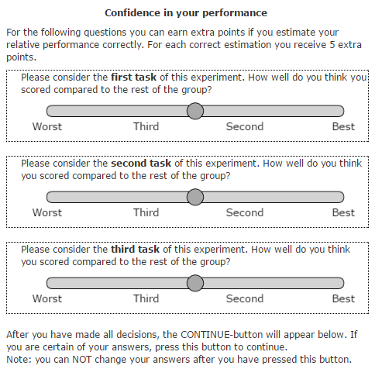 | 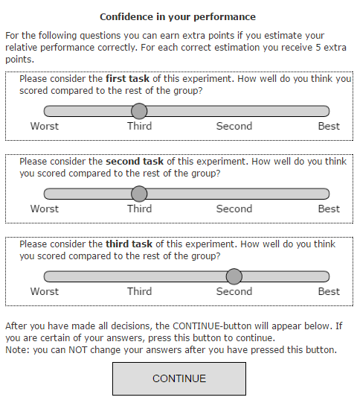
Figure 3.1: Sliders eliciting subject’s estimated relative beliefs. Left: the default-state of the page, with all sliders in a neutral position (no CONTINUE-button available at this time). Right: sliders snap to place on one of the four labels. The CONTINUE-button appeared only after the subject shifted all sliders to valid positions (i.e. away from the center).
The subject’s indicated rank estimates are utilized to calculate his/her overconfidence level by subtracting it from the subject’s actual rank. As such, the subjects’ observed overconfidence level was described as an integer ranging from -3 (maximum under confidence) to 3 (maximum overconfidence), with a value of 0 indicating fully accurate predictions (i.e. no over- nor under confidence).
Risk aversion - The sixth and last task of the experiment consisted of an adaptation on the bomb risk elicitation task (BRET; Crosetto & Filippin, 2013). This computerized task elicits subjects’ risk preferences by presenting them with a 10x10 grid of boxes, one of which (randomly selected) contains a bomb. Subjects are requested to open any number of boxes, with a linear monetary incentive based on the number of boxes opened. After a subject indicates his/her preferred number of boxes to be opened, the location of the bomb is revealed. If the bomb was located in one the opened boxes, the subject does not earn any reward for this task. However, if the bomb-containing box was not opened, the subject earns a fixed amount for every box opened. The task can be conducted in a dynamic version, in which boxes are selected to be opened by a constant timer (generally one box per second), on a row-by-row basis starting from a fixed point in the grid (generally top left). Alternatively, a static version of the task can be conducted, in which the subject indicates an integer ranging from 0 to 100, indicating the number of boxes are to be opened. The computer then starts opening the number of packages similar as to the dynamic version of the task. The present research utilized a modified version of the dynamic BRET task. The dynamic version was utilized as it allows for a more visual and naturalistic approach to risk-taking preferences.
The simplified and visual nature of this task allows for a number of benefits in the elicitation of subject’s risk preferences. First, as it requires little to no mathematical skill, subject’s confusion will be limited. Second, since the task payoffs are strictly in the gain domain, the BRET task provides a measurement of the subject’s risk preferences without contamination by loss aversion. See Crosetto & Filippin (2013) for an in-depth discussion of the tasks’ relative benefits. However, despite these benefits, the dynamic version of the BRET has some disadvantages. First, since subjects are not able to select their own boxes (but instead have boxes selected in a row-by-row fashion), subjects may experience distrust in the setup, as the experimenter may have pre-programmed the box to appear in a relatively early box. Second, subjects with a high degree of risk-loving preferences may have to wait a considerable amount of time (upwards of a full minute) to select the preferred amount of boxes. As such, a strong argument can be made that the standard dynamic BRET task picks up on a subject’s degree of impulsivity. Although a subject is expected receives a net positive utility from selecting additional boxes up to the point of his/her risk preferences, the negative utility of the associated waiting time may result in a smaller-than-optimal number of boxes to be selected. As a result, the BRET overestimates the subject’s risk aversion. Finally, time is linear in the standard dynamic BRET task; once a box is selected by the timer, it cannot be unselected. As such, there is no mechanism that allows subjects’ to restore errors due to over selection.
In order to mitigate these shortcomings in the standard dynamic BRET, the present research utilized a modified design. In contrast to the row-by-row timed selection of boxes in the standard setup, subjects could now select any box in the grid separately by clicking on them. Similarly, subjects had the possibility to deselect boxes if they required to do so. Figure 3.2 provides a screenshot depicting the setup of these modifications.
Apart from these modifications, all other elements of the BRET remained unchanged. In line with the other literature utilizing this task, the subject’s observed risk preferences was computed by subtracting 50 from the number of selected boxes.

BRET - Instructions | BRET- Initial Screen
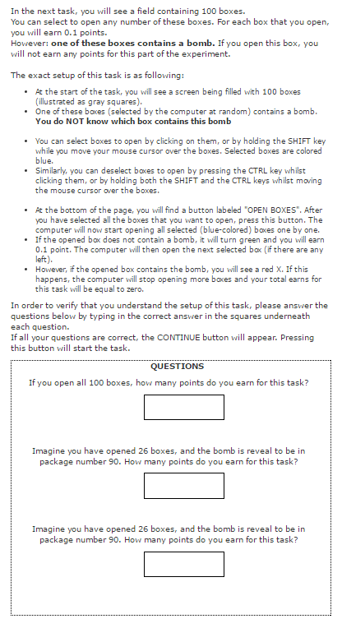 | 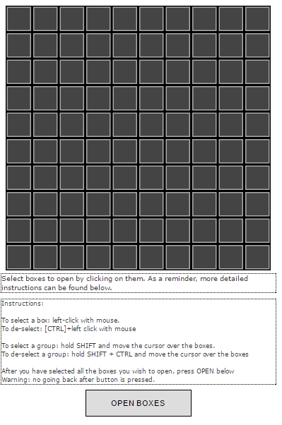
 | BRET - Feedback
 | 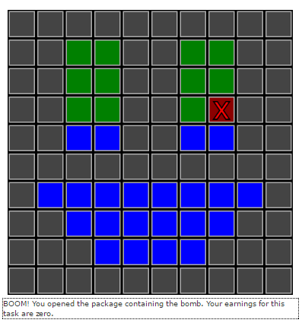
Figure 3.2: the modified BRET game as implemented in the present research. Left instructions for the task .Subjects could only continue to the next stage of the BRET after providing correct answers the three questions Top-Right: interface for the task as first presented to the subjects. Bottom-Right: After the subject had completed his/her selection of boxes (indicated by the blue fill-color of the box), the program started to “open” boxes, starting from the top-left. Once a box was openened, a green fill-color indicated that the box did not contain a bomb and the next box-in-line would be opened. This continued either until all boxes would be opened or until the bomb was discovered (indicated by the red fill-color and the bright-red X).
Questionnaire – After the subjects completed the BRET, but before they learned their earnings for the experiment, all subjects were asked to fill out an unincentived questionnaire. This questionnaire consisted of three separate screens, shown in sequential order. Figure 3.3 below provides a screenshot of all three pages. On the first screen, subjects were asked for their demographic details (gender, age and field of study). The second screen and third screens consisted of questions based around sliders, each of which elicited the subject’s opinion about the task performed in the first three parts of the experiment. The default position for all sliders was the center of the range (coded as a value of 50). Subjects could freely manipulate the slider’s position from the left-most value (coded as 0) to the right-most value (coded as 100), or any value in-between.
Questionnaire – Demographics | Questionnaire – Feedback on tasks | Questionnaire – gender stereotypes
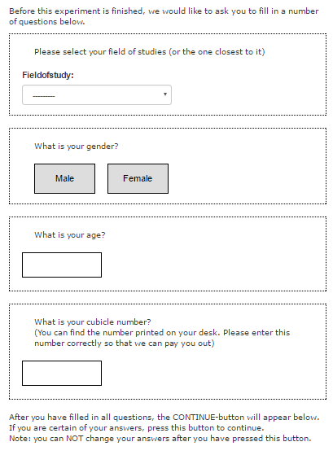 | 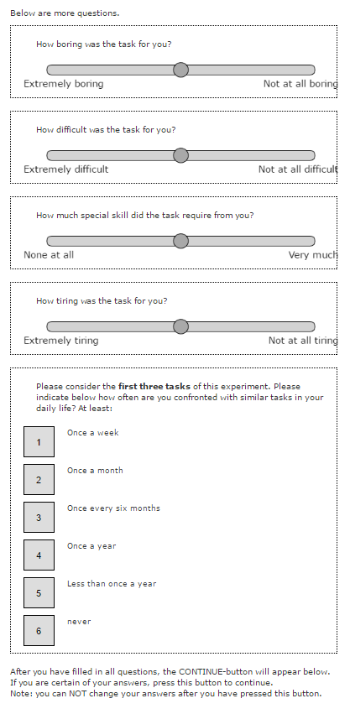 | 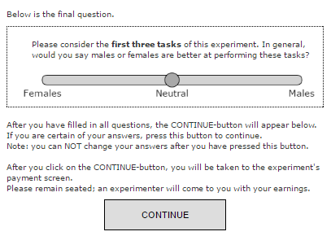
Figure 3.3: screenshots depicting the questionnaire. Left: the first page, containing demographic questions. Middle: sliders elicitation subject’s feedback on the tasks. Right: a single question eliciting the subject’s gender stereotypes regarding the performed task.
Four sliders where presented on the second screen of the questionnaire. These sliders elicited the degree to which the subject found the task boring (ranging from “Extremely boring” to “not at all boring”), how difficult the task was for the subject (ranging from “Extremely difficult” to “Not at all difficult), the amount of special skill the task required of the subject (“None at all” to “Very much”) and how tiring they found the task to be (“Extremely” to “Not at all”). The third and last screen of the questionnaire contained one more slider, eliciting the subject’s preconceive gender-bias in performance on the task. Subjects could indicate whether they believed females or males where comparatively advantaged in the task.

3.3 Experimental Treatments
Treatments - The present research consisted of two separate between-subjects treatments. The experimental procedure for both groups was identical, save for the nature of the task performed in the first three parts of the experiment. At the start of each experimental session, subjects where quasi-randomly assigned to one of two treatment groups, such that each treatment group contained subgroups of four subjects. The treatment groups consisted of a memory (n = 39, 69% female) treatment and a maze (n = 27, 70% female) treatment. In both treatments, all random numbers where generated by an identical seed. This procedure ensured that subjects could not reasonably predict the pattern of randomness used in generating the puzzles, whilst at the same time providing all subjects with an identical set of puzzles. Hence, there was no between-subject difference in task-difficulty. Appendix B contains a detailed description of the underlying software and the algorithms that generated the puzzles in both treatments.
Instructions | Interface
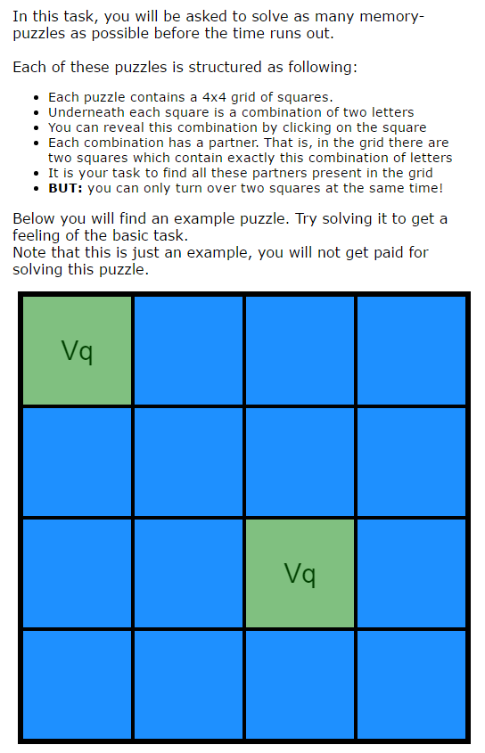 | 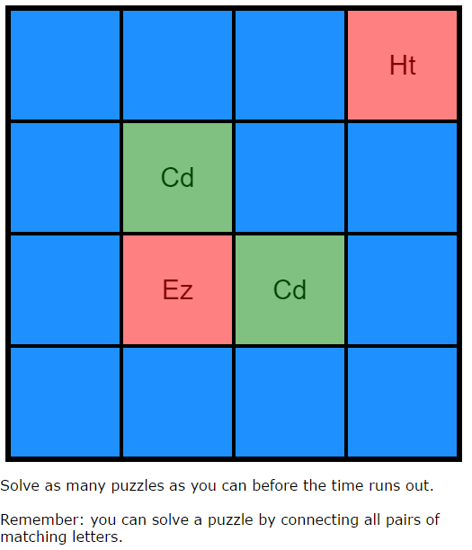
Figure 3.4: screenshot of the memory tasks instructions (left) and interface (right). Blue cells are unopened, green cells are previously unsolved and the red cells indicate a mismatched pair opened by the subject.
Memory – subjects in the “female” memory task where given a 4x4 grid of cells. Each cell contained a pair of letters (lower-case and upper-case, respectively). Exactly two cells in the grid shared an identical set of letters, which the subject had to connect. The values of each cell where hidden by a blue mask. Subjects could “open” a cell by clicking on the blue mask, with the condition that only two cells could be revealed at a time. If the letter combinations of the revealed cells matched, the pair was considered “solved”, resulting in the mask to turn into a translucent green color and disabling the cell for future interaction. If the pairs did not match, the mask of both cells would colored translucent red for 500ms before returning to their default blue masked states. Subjects received 1 Point per matched pair. Once the whole puzzle (i.e. all 16 cells) was solved, subjects received an additional 8 Points as a bonus. The computer then generated a new set of 16 cells and the task would continue. Figure 3.4 provides screenshots of both the instructions and the interface for this treatment.
Maze - subjects in the “male” maze task where given a 15x15 grid of cells. Each cell contained four possible walls (top, down, left, right), which could either be present or absent. The pattern of absent walls was generated by an algorithm such that the entire grid contained a fully connected maze (i.e. every cell could be reached from every other cell by exactly one path, without crossing walls). Within this maze, 4 balls where generated in the colors green, blue, red and yellow. The green-colored functioned as a starting position for the player. This ball was clearly marked “S”, and would always be generated at the center of the screen. The other three colors of balls functioned as target positions for the player. The location of all three balls was randomized, with the condition that the Manhattan-distance between them would be no smaller than 5 cells.
After generation of the maze, the computer randomly selected one of five possible solutions: starting from the green starting position, the subject could either reach none of the targets (solution 1), only the red target (solution 2), only the blue target (solution 3), only the yellow target (solution 4) or all of the targets (solution 5). Solutions where randomly selected with a uniform distribution. Sequential to selecting the solution, the algorithm modified the maze to generate the required answer. This was done by having the computer find the path to all three targets (originating from the starting position), selecting which subsections of these paths where unique to a single target (i.e. a path to a target which was not a subset of the other two paths) and then blocking this unique path by a wall. This procedure ensured that only one solution was valid.
Finally, after the algorithm finished generation of a maze, it was drawn on the subject’s screen. After a waiting period of 2500ms (to prevent subjects from double-clicking), five buttons (corresponding to the five possible solutions) where generated below the maze. Subjects could indicate the solution they considered correct by pressing on one of these buttons. After a button was clicked, the computer registered the subject’s answer and a new maze would be generated. Subjects received 1 Point per correct answer. No feedback was provided to subjects at any point in the task. Figure 3.5 below provides screenshots of both the instructions and the interface for this treatment.

Instructions | Interface
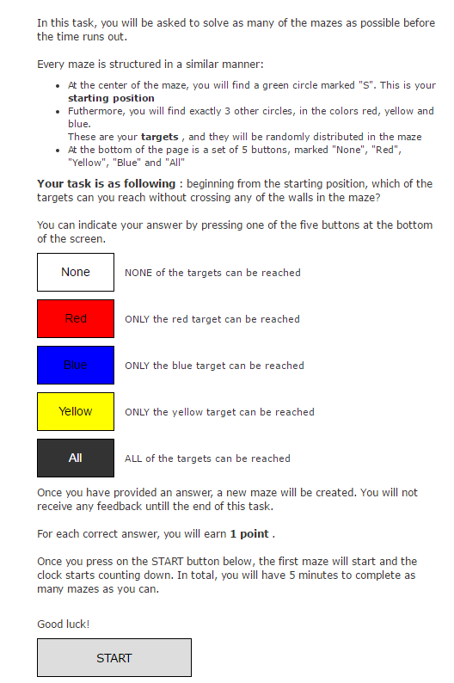 | 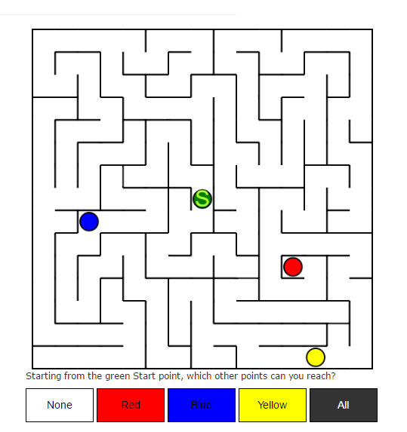
Figure 3.5: instructions (left) and interface (right) for the Maze-treatment.
3.4 Analysis
Based on the hypotheses developed in chapter two of this thesis, a total of six separate logistic regression models were estimated to predict subject’s self-selection into the tournament scheme. Each of these models provided a best-fit (OLS) approximation of the included variables by fitting a sigmoid-function to match the subject’s distribution in the two payment schemes.
Table 3.1 outlines the variables included for all regression models. A specific note should be made: whilst the crucial measurement variable is an interaction term for four out of the six models, the associated main effects were included in the model. This was done such as to include a stringent test of the interaction effect; if the main effects would be omitted from analyses, the OLS-algorithm would attribute the explained variance of the main effects into the interaction terms, thereby overestimating their underlying effects.

Model |  |  | Included variables | Measurement variable
1 | GNO | Gender-Neutral Optimal | (Constant)  Performance  Beliefs  Risk Aversion. | Model Fit
2 | GBC | Gender-Bias in Competitiveness | GNO  GBC-dummy | Model Fit  GBC-dummy
3 | GTPD | Gender-Treatment Performance Differences | GNO  GTBD-dummy  GTBD-dummy*Performance | Model Fit  GTBD-dummy*Performance
4 | BE (B) | Biased Estimates – Beliefs | GNO  BE-Dummy  BE-dummy*Beliefs | Model Fit  BE-dummy*Beliefs
5 | BE (C) | Biased Estimates - Confidence | GNO  Confidence  BE-dummy  BE-dummy * Confidence | Model Fit  BE-dummy * Confidence
6 | GTSB | Gender-Task Stereotype Bias | GNO  GTSB-dummy | Model Fit  GTSB-dummy
Table 3.1: summary of the six regression models and their associated crucial measurement-variables.

Prior to analysis, all continuous (non-categorical) variables were standardized. This processes ensured that the regression variables are comparable in size (e.g. are all “speaking the same language”). Comparisons between models were be based on their relative log-likelihood and McFadden $R^{2}$ measures. Specifically, the regression variables were modified in the following manner (where D denotes a binary dummy-variable):
Tournament Selection (D) – the dependent variable for all seven analyses was recoded into a dummy variable, such that self-selection into the tournament was denoted by a “1”.
Treatment (D) – the subject’s treatment condition was recoded into a dummy variable, such that the Maze treatment had a value of 1, and the Memory treatment a value of 0. As a result, this variable can be interpreted as “subject was in a male task”.
Gender (D) – recoded into a dummy variable, such that males had a score of 1. As such, this variable can be interpreted as “subject was a male”.
Performance – a subject’s performance was measured as his/her standardized score of on the second task of the experiment (in line with Dreber et al, 2014).
Confidence (D) – in line with the methodology employed by Niederle and Vesterlund (2007), a subject’s confidence was measured by his/her decision to enroll into a tournament in the fourth task, coded such that a Tournament-enrolment was recoded as a 1.
Risk Aversion – in order to transform the subject’s BRET score into a measure of risk aversion, two steps were taken. First: the BRET score was subtracted from 50 to center the subjects on absolute risk-neutrality. These scores where then standardized over the sample.
Beliefs – in order to compute a subjects beliefs, their stated answers on the three incentivized relative performance estimations (included in the questionnaire) were contrasted to their actual rank (such that their subjective estimations was subtracted from their objective rank). After these results were found to sufficiently correlate (see section 4.1.4, below), they were combined into a single score by computing the unweighted average of these three scores. This average was then standardized over the population.
GTPD-dummy (D): a dummy coding for task-gender congruence, such that males in a male task are coded by 1, females in a female task are coded by 1 and all other subjects are coded by 0.
GBC-Dummy (D): a dummy coding for the specific effects predicted by the GBC model, such that this dummy has a value of -1 for females and 1 for males. Note that this dummy is perfectly correlated to gender, but is more straightforward to interpret under the GBC-model.
BE-Dummy (D): a gender-treatment dummy coding for the predicted effects of the BE-A and BE-B models. This dummy has three discrete values: 0 for subjects in a female task, 1 for male subjects in a male task and -1 for female subjects in a female task.
GTSB-Dummy (D): a dummy coding for the predicted effects of the GTSB model. This dummy has three discrete values: 1 for males, -1 for females in a male task and 0 for females in a female task.

4. RESULTS
The fourth chapter of this thesis will outline the empirical results obtained from the experimental procedure described in the last chapter. The chapter is subdivided into three distinct subsections; descriptive statistics, regression results and a summary of the observations. The first of these will provide a detailed visual inspection of the data and the distribution of all pertinent variables. The second will provide a direct test of the hypotheses outlined in chapter 2 along the models outlined in section 3.4. Finally, the last subsection of this chapter will summarize the observed findings.
All analyses where conducted using the R software package for statistical analyses (R Core Team, 2016). Plots where generated using the ggplot2 package (Wickham, 2009).
4.1 Descriptive Statistics
This first section provides a graphical and numeric outline of the main variables analyzed in this thesis. Due to the unequal and relatively low number of observations per treatment and the lack of a family-wise error correction, the reader is urged to interpret results mean-difference tests reported in this subsection with some reservation; they are indicative of the relative differences within this sample only and may not be fully generalizable to the population mean. Furthermore, as the overall cell-level sample sizes and observed distributions do not meet the GLM-assumptions ($n<30$, non-normally distributed independent variables), all computed z-scores in the mean-difference tests below rely on a series of permutation tests. This family of statistical inference tests relies on a large number of subsamples randomly drawn (by a Monte-Carlo simulation method) from the available data. Based on these subsamples, the null hypothesis of no-difference in means between the selected genders is tested. This statistical approach has the benefit of being more robust to deviations from the underlying assumptions; a valuable property in the present research. All tests were implemented by the “Computational Framework for Conditional Inference” package in R (coin; Hothorn, Hornik, van de Wiel & Zeileis , 2008). Furthermore, as a robustness-check, all mean-difference tests were further confirmed using t-tests and Kruskal-Wallis test where applicable. In none of the reported findings did the results from both test-families substantially differ; as such, we report only the (more precise) permutation-tests.
4.1.1 Performance on tasks
Table 4.1 and figure 4.1 below outlines the subject’s performance per task and per treatment. A number of observations stand out from these graphs. First, the standard deviation of scores is substantially smaller in the maze task as compared to the memory task. This is to some extent due to the difference in performance metrics (i.e. the 8-point bonus per completed puzzle in the memory-treatment). Furthermore, it can readily be observed that males outperform females on all tasks for both treatments. The last three columns in table 4.1 provides the results for a set of three permutation tests comparing the performances of males and females per task. Results indicate that the gender-bias in performance differs per treatment; the tests indicate a significant result of the T1 and T3 differences (with a marginal significance for the T2 difference) in the memory-task only. Average performances on the maze-task do not appear to differ significantly per gender.

Treatment-specific Task Performances
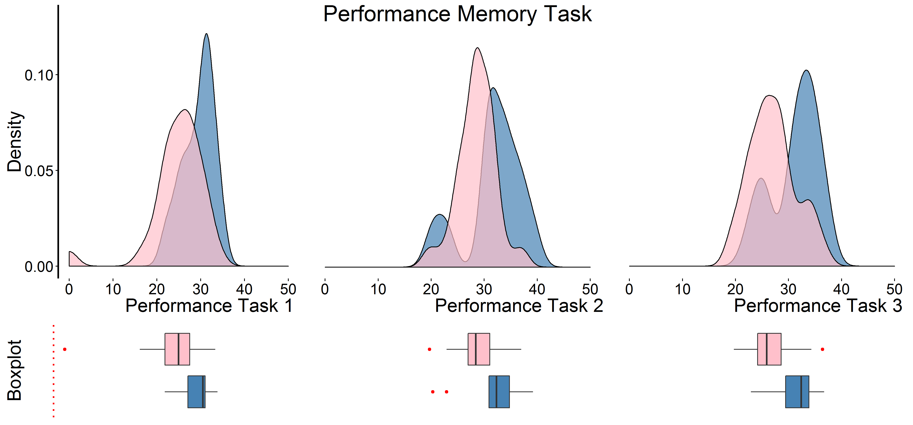
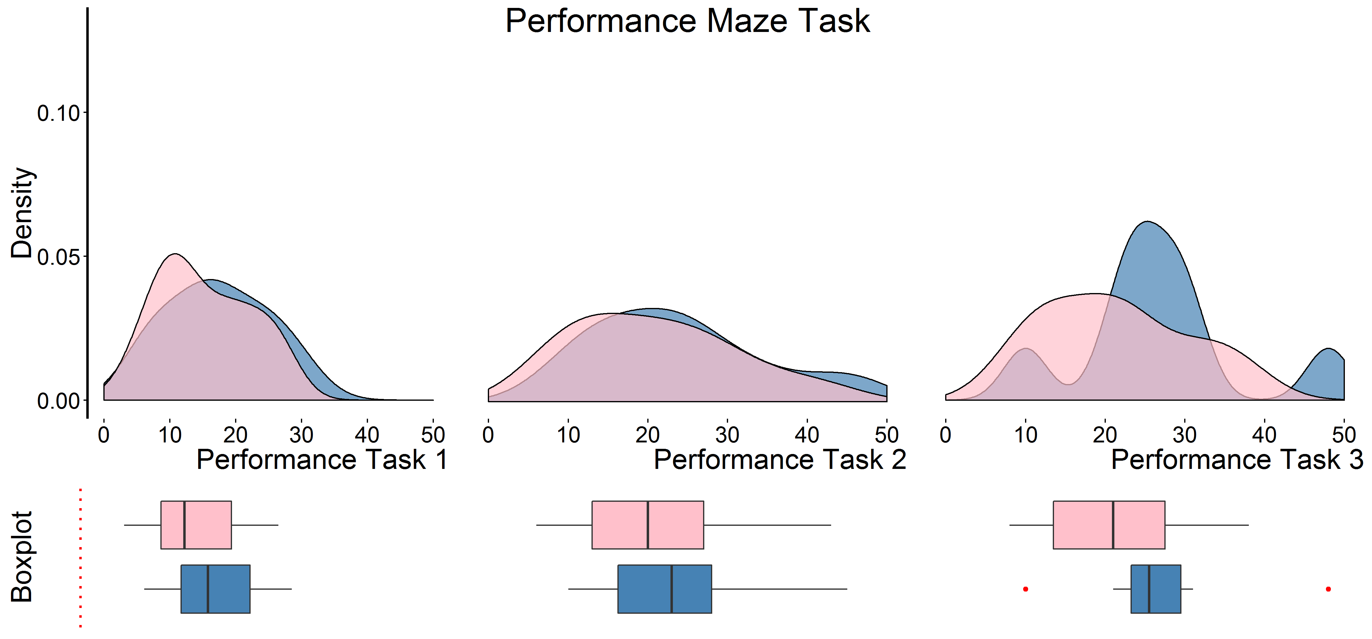
Figure 4.1: combination plot indicating the density and boxplots of the distribution of subject’s performance, separated per gender (color: blue for males, pink for females) and per task. Top: subjects performance on the memory task. Bottom: subjects performance on the maze task.
Task | Treatment | Gender | N | Mean | St. Dev | Z | p
T1 | Memory | M | 12 | 29.475 | 3.565 | 3.3367 | 0.0176
 |  | F | 27 | 24.837 | 3.439
 | Maze | M | 8 | 17.25 | 7.778 | 0.6593 | 0.5273
 |  | F | 19 | 15.263 | 7.007
T2 | Memory | M | 12 | 31.733 | 5.456 | 2.071 | 0.0398
 |  | F | 27 | 28.615 | 3.439
 | Maze | M | 8 | 24 | 11.339 | 0.6895 | 0.5119
 |  | F | 19 | 20.947 | 10.32
T3 | Memory | M | 12 | 31.225 | 4.487 | 2.5409 | 0.0093
 |  | F | 27 | 27.015 | 4.376
 | Maze | M | 8 | 26.75 | 10.714 | 1.3218 | 0.1907
 |  | F | 19 | 21.316 | 9.141
Table 4.1: descriptive statistics of the T1, T2 and T3 performances outlined per treatment and per gender. The last two columns indicate the results obtained from a 10,000 samples Monte-Carlo permutation test.
We summarize these findings in observation 1, below:
Observation 1: males have a higher performance than females on all tasks, for both treatments. This effect is most pronounced for the memory-task, but not statistically significant for the maze-task.
4.1.2 Tournament Selection
Figure 4.2 outlines the relative distribution of payment-scheme selections, outlined per task, treatment and gender. Selection decisions for the third task form the dependent variable in this thesis, whilst the selection decisions for the fourth task function as a measure for the subject’s confidence levels.
Tournament Selection (T3) | Confidence Levels (T4)
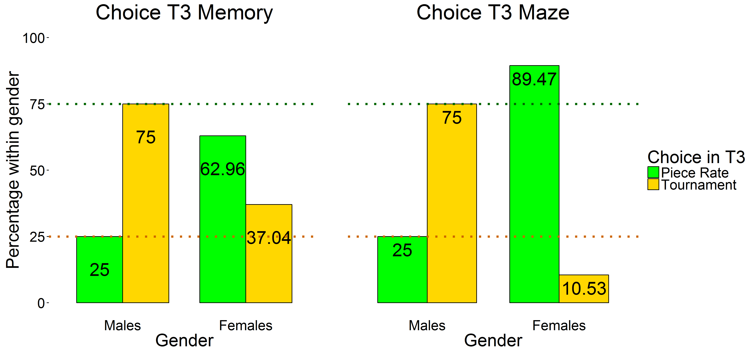 | 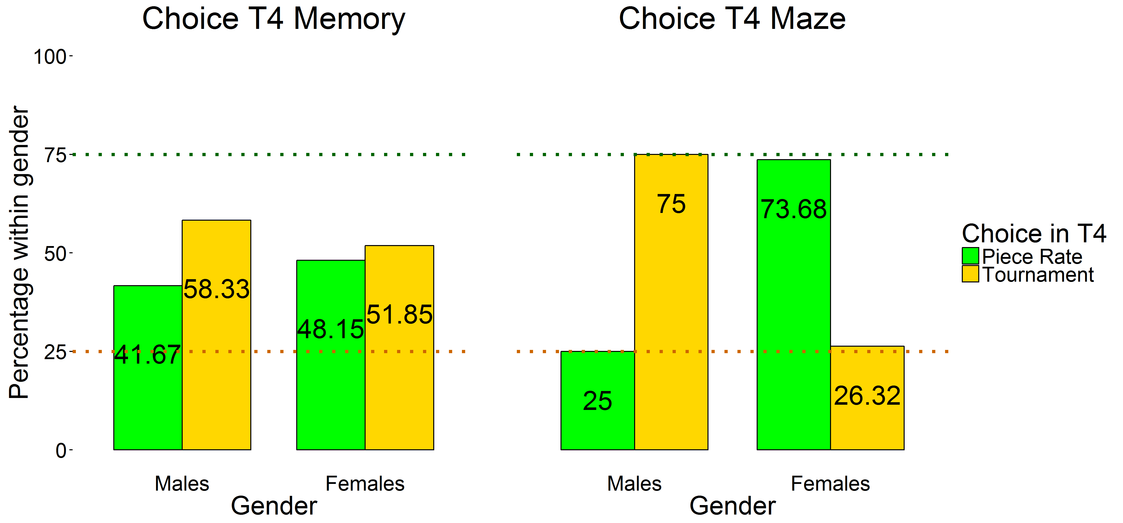
Figure 4.2: graphical illustration of subjects’ preferred payment scheme in tasks 3 (left) and 4 (right), by gender and treatment. The orange-dotted and green-dotted lines indicate the optimal population-level boundaries for both payment schemes (25% for the tournament scheme versus 75% for piece-rate scheme)

Overall, we replicate the results observed in the majority of the gender-competitiveness literature: males over-select into the tournament (as compared to an optimal population level of 25%) for both treatments, with the frequency of this selection being highly similar over tasks. Conversely, females tend to self-select into tournaments to a much smaller degree, with lower rates for the Maze-treatment as compared to the Memory-treatment. Table 4.2 provides a set of four permutation tests based on the gender-difference within each subset. These results further substantiate the visual observations; males have a higher self-selection into the tournament scheme for three out of the four subsets (with the exception of the T4-Memory subset).
Task | Treatment | Gender | N | Tournament (%) | $χ^{2}$ | p
T3 | Memory | M | 12 | 9 (75%) | 4.7923 | 0.0377
 |  | F | 27 | 10 (37.04)
 | Maze | M | 8 | 6 (75) | 11.224 | 0.0026
 |  | F | 19 | 2 (10.53)
T4 | Memory | M | 12 | 7 (58.33%) | 0.1404 | 0.7399
 |  | F | 27 | 14 (51.85)
 | Maze | M | 8 | 6 (75) | 5.5268 | 0.0363
 |  | F | 19 | 5 (26.32)
Table 4.2: self-selection into the tournament scheme for tasks 3 and 4, subdivided by treatment and gender. Per-gender test-statistics are based on 4 separate chi-square tests, computed using a Monte-Carlo simulated permutation test (10,000 samples).

Finally, Figure 4.3 provides a graphical depiction of the tournament-selection CDF-curve over performance, again outlined per task, treatment and gender. In the maze-treatment, males are monotonically more likely to self-select into tournament for both tasks; for every performance, the cumulative percentage of males self-selecting into the tournament is higher than females. In the memory-treatments, low-performing females are more likely to engage in the tournament scheme as compared to low-performing males (although the total area under the curve is larger for males in the T4-memory task). In none of the four samples was the peak-level of tournament-selection of males overall lower than those of the female subjects.

Tournament Selection (T3) | Confidence Levels (T4)
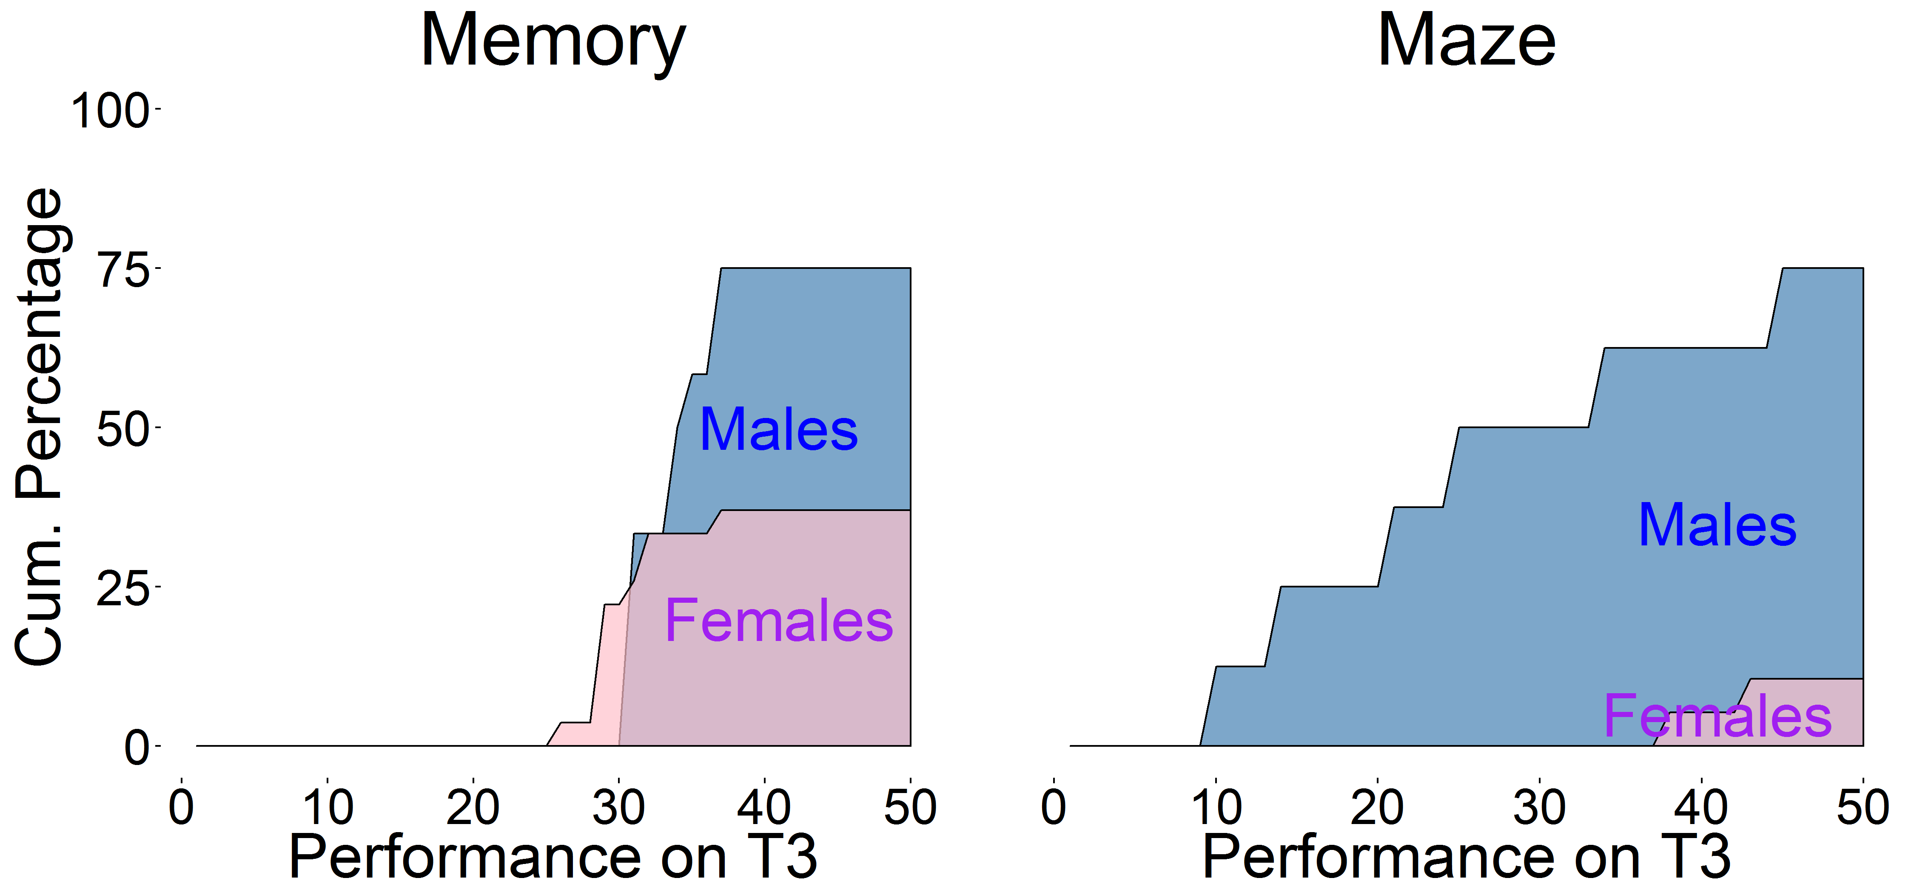 | 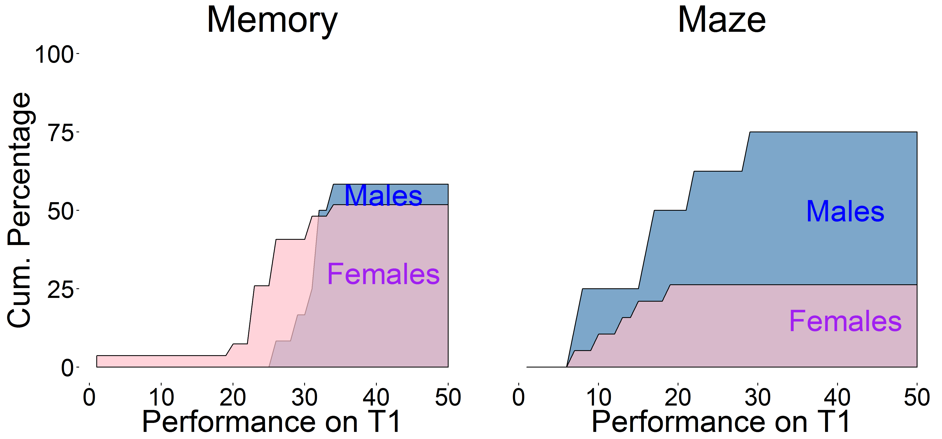
Figure 4.3: CDF curves plotting the cumulative percentage of subject self-selecting into the tournament scheme as a function of their performance.
Overall, we summarize these findings into observation 2, below:
Observation 2: for both treatments, males are more prone to (incorrectly) self-select into the tournament scheme. In contrast, females show this bias to a lesser degree and self-select closer to the optimal population-level rates. Finally, females are less likely to engage in a tournament in the maze treatment, as compared to the memory treatment.
4.1.3 Probability of winning T3/T4
Similar to the procedure utilized by Niederle and Versterlund (2007), the expected probabilities of winning the tournaments in the third and fourth task where calculated for each subject separately. These probabilities were calculated by using a bootstrapping procedure, in which the subject was grouped with 3 other subjects (randomly sampled without replacement within his/her treatment condition). For the third task (tournament selection), the subjects’ score on the third task was compared to the group members’ performance on the second task. In the probability of the fourth task, a subjects’ performance on the first task was compared to the group members’ performance on the first task. Based on these comparisons, the subjects’ rank within this fictive group was determined. This sampling procedure was repeated 10,000 times for each subject. The resulting percentage-wise distribution of ranks is indicated by Figure 4.4 below (differentiated by treatment) .
Tournament Selection (T3) | Confidence Levels (T4)
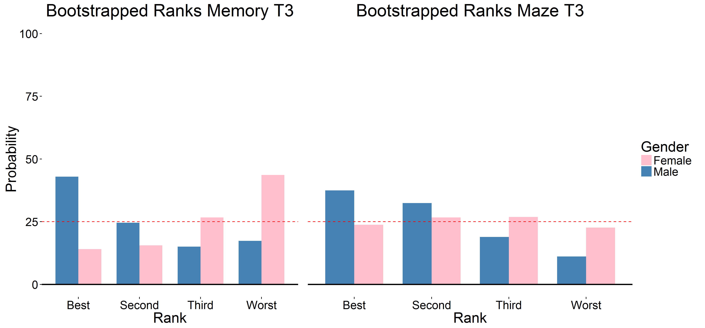 | 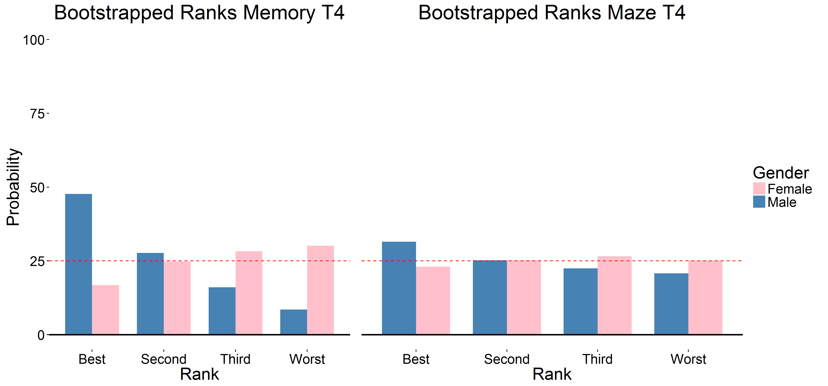
Figure 4.4: bootstrapped estimated probabilities of winning the T3 and T4 tournaments. For each subject, his/her probability of winning the tournament was bootstrapped by placing the subjected in 10,000 fictive groups (sampled without replacement from the other subjects within the same treatment). Bars indicate averaged percentages over gender and treatment. The dotted red line indicates the expected unbiased average (25%).

Overall, we observe that males are more likely than females to win the tournament-scheme on all subsets. This effect is stronger for the Memory-treatment than for the Maze-treatment but not substantially different between the two tasks.
Observation 3 summarizes these results:
Observation 3: males are more likely to win the tournament scheme for both tasks and both treatments. This effect is stronger for the Memory-treatment than for the Maze-treatment.
4.1.4 Beliefs
The three separate heatmaps in Figure 4.5 (next page) depict the distribution of subject’s estimated scores in the first three tasks as a function of their actual performance. A number of observations can be made. First, subjects on average tend to be under-confident in the first performance task, but overconfident in the second and third tasks. This effect is more pronounced for males than for females.
Treatment | Memory |  |  | Maze
Task | T1 | T2 | T3 | T1 | T2 | T3
T1 | 1 | 0.0126 | 0.0022 | 1 | 0.001 | 0.0023
T2 | 0.4 | 1 | 0.0006 | 0.6 | 1 | 0.001
T3 | 0.48 | 0.53 | 1 | 0.56 | 0.6 | 1
Table 4.4: Spearman Correlation coefficients for the three overconfidence scores, separated by treatment. Values below the diagonal indicate the size of the correlation, while values above the diagonal indicate the associated p-value of this correlation.

Overconfidence scores were calculated by subtracting a subject’s actual rank from his/her believed rank. Table 4.4 provides a correlation matrix for the three separate overconfidence scores. As the correlations between these scores are statistically significant and sufficiently strong, all three scores are combined to calculate a subject’s average overconfidence levels. The descriptive statistics of this variable are reported in Table 4.5.
Treatment | Gender | N | Mean | Std. Dev | Z | p
Memory | M | 12 | 0.111 | 0.672 | -1.5681 | 0.1307
 | F | 27 | 0.58 | 0.909
Maze | M | 8 | 0.417 | 0.496 | 0.5685 | 0.5799
 | F | 19 | 0.175 | 1.162
Table 4.5: summary statistics for the combined overconfidence scores, separated per treatment and per gender. Test-statistics are based on two separate Monte-Carlo simulated permutation tests (10,000 samples)

OVERCONFIDENCE HEATMAPS | 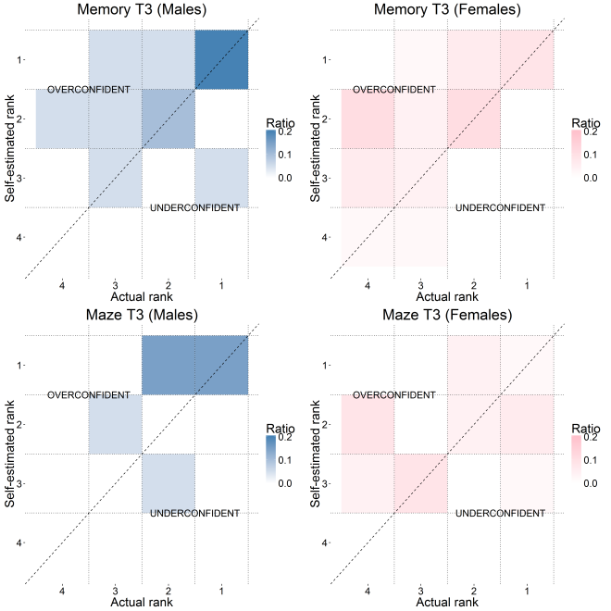 | Figure 4.5: heatmaps indicating subject’s estimated (subjective) ranks, versus their actual performance. Maps are separated by gender (indicated by color) , treatment (separate graphs per cell) and task .
OVERCONFIDENCE HEATMAPS | 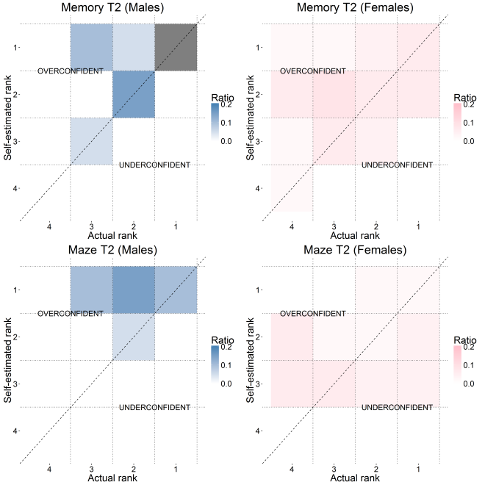
OVERCONFIDENCE HEATMAPS | 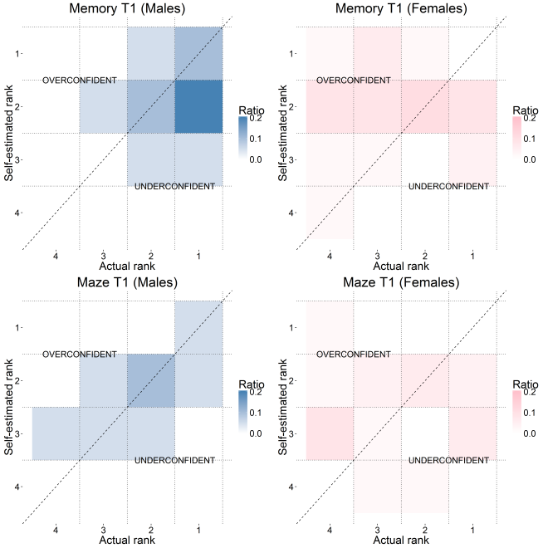

In line with previous research, we observe that subjects in both treatments tend to be overconfident in their beliefs (i.e. an average overconfidence score larger than 0 on both tasks). On average, males tend to be less overconfident in the memory-treatment as compared to females. The inverse pattern holds: within the maze-treatment, female subjects display less overconfidence than males. Two permutation-tests were conducted to test the gender-differences within both treatments, but neither could reject the null-hypothesis that both samples were drawn from the same underlying distribution.
The observations of this subsection are summarized below.
Observation 4: On average, subjects tend to be overconfident in their relative performance beliefs, with females being more overconfident than males in the Memory-treatment, but less overconfident than males in the Maze-treatment. The differences between these subsets are not statistically significant.
4.1.5 BRET-scores
Figure 4.6 provides a graphical depiction of the subjects’ raw BRET scores (i.e. the number of boxes selected), outlined per treatment and per gender. We observe that the distributions for both genders are closely matched in the Memory-treatment. For the Maze-treatment, male subjects appear to have a higher BRET score as compared to female subjects, with the standard-deviation of the latter being substantially higher. Overall, most subjects appear to be risk-averse (i.e. have a BRET score lower than 50), although there appear to be a substantial number of subjects who display risk-loving behavior.
Raw BRET scores
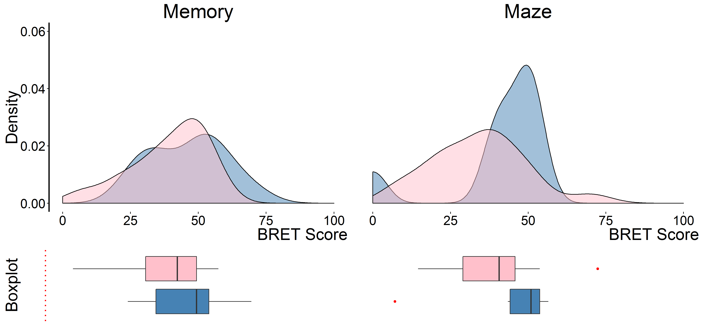
Figure 4.6 the distribution of raw BRET scores, outlined per treatment and per gender

Table 4.6 provides summary statistics for all four distributions, which further strengthen the graphical observations made above. A set of two permutation-tests could not reject the null-hypothesis of no difference between the genders in either treatment.
Treatment | Gender | N | Mean | Std. Dev | Z | p
Memory | M | 12 | 46 | 14.02 | 1.3901 | 0.1632
 | F | 27 | 39.111 | 14.138
Maze | M | 8 | 40.75 | 17.244 | 0.9985 | 0.3334
 | F | 19 | 34.106 | 15.187
Table 4.6: summary statistics for the BRET scores. Test statistics are based on a pair of Monte-Carlo simulated permutation tests (10,000 samples).

The observations regarding the subject’s BRET scores are summarized below:
Observation 5: the distribution of raw BRET scores does not appear to differ between the genders in the Memory-treatment. In the Maze-treatment, males appear to be more risk-loving, although this difference is not statistically significant.
4.1.6 Questionnaire data
Finally, the questionnaire consisted of 6 sub-questions: the degree to which the subject found the task boring, difficult, to require a large amount of skill, to be tiring, to be frequently exposed to the relevant task in his/her life and the degree to which men (or women) performed better at the task in general.
The latter was the most important of these questions, as it measured the subject’s (unincentivized) gender-stereotype bias (i.e. the degree to which they considered females [=0] or males [=100] to be on average better in performing the treatment). Figure 4.7 outlines the distributions of subject’s responses, again outlined per treatment and per gender. We observe a number of differences between the genders on both treatments. In the memory treatment, the distribution of male’s responses has a substantially smaller standard-deviation, with the majority of males indicating that both genders are equally adept at the task. In contrast, the female subjects in the Memory-treatment indicated a much more diffuse pattern, with most indicating they considered females to be more adept at the task. In the Maze-treatment, the pattern was somewhat inverse; males generally expected males to be more adept at the task, with females being more drawn to the center of indifference. The summary statistics and permutation tests outlined in Table 4.7 corroborate these observations; the difference between the genders is reaches marginal significance for both treatments. Given these observations, we conclude that there is mixed evidence in favor of the assumed stereotypes; while male subjects perceive males as being more adept in the maze task, (but roughly equally adapt as females in the memory task), this effect does not appear to exist for female subjects.
Genderbias Ratings
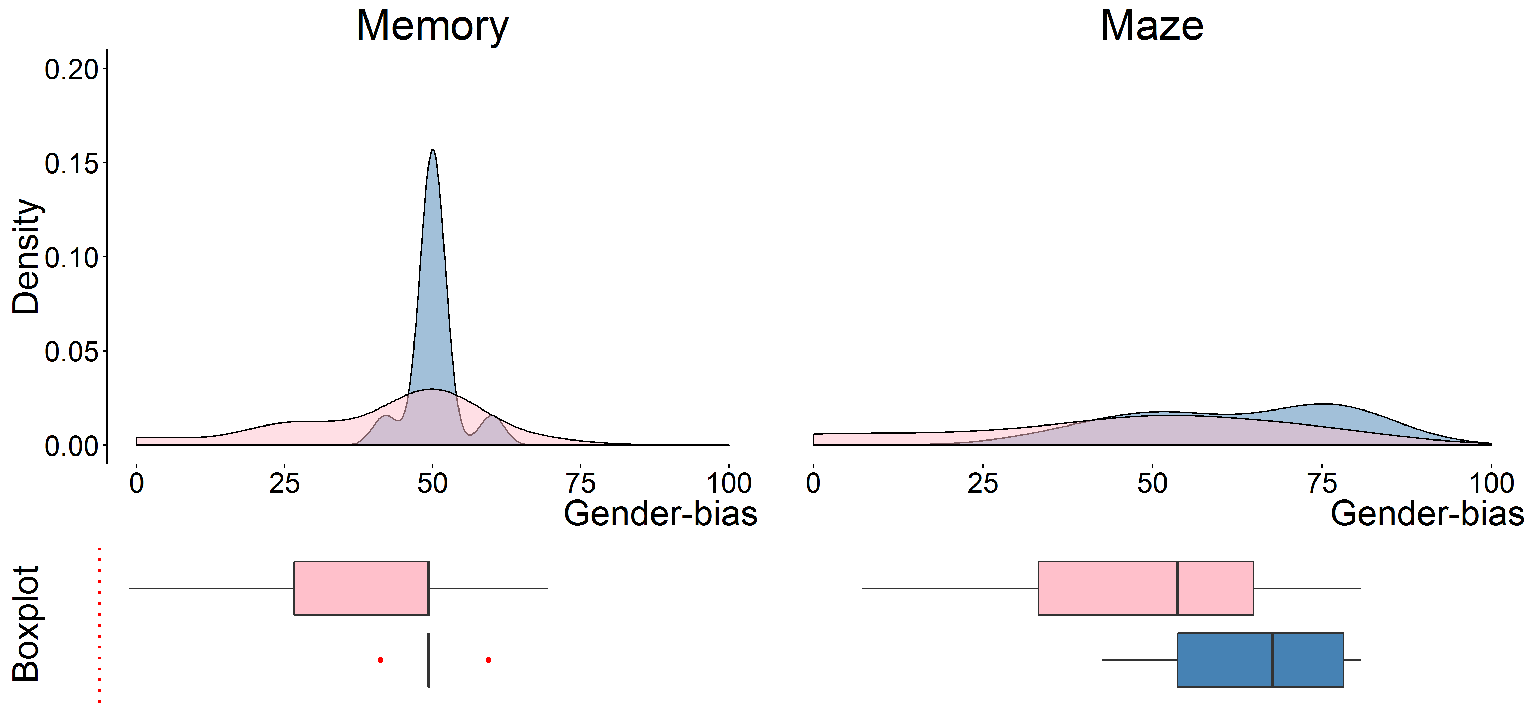
Figure 4.7 distribution of subject’s genderbias, differentiated per treatment and per gender. A score of 0 indicated that the subject expected females to be (on average) more adept at performing the task, whilst a score of 100 indicated that the subject expected males to be (on average) more adept at performing the task.

A detailed description of the observations derived from the remaining questionnaire items can be found in appendix A. For the sake of brevity, they are not reported in the present thesis.

Treatment | Gender | N | Mean | Std. Dev | Z | p
Memory | M | 12 | 50.167 | 3.857 | 1.7366 | 0.0828
 | F | 27 | 41.333 | 16.82
Maze | M | 8 | 62.5 | 15.666 | 1.8255 | 0.0684
 | F | 19 | 44.158 | 24.905
Table 4.7: summary statistics for the self-reported gender-bias scores (0=females perform better, 100 = males perform better). Test-statistics are based on a pair of Monte-Carlo permutation tests (10,000 samples)

4.2 Regression Results
The second section of this chapter will outline the results derived from the regression analysis. Table 4.8 outlines the observed effects of the predictors for all models.
Based on these regression results, a number of observations stand out. Starting from the Gender-Neutral Optimal model, we observe that only performance appears to be a significant predictor of the subjects’ tournament selection decision. In contrast to the model predictions, neither beliefs nor risk aversion appear to play any significant role. The overall fit between the model and the data is low, with a mere 18.59% of the variation in subjects’ tournament selections accounted for.
The Gender-Bias in Competitiveness model appears to fare somewhat better; both the subject’s performance and his/her beliefs significantly predict the dependent variable, with the correct sign of the predictions. Crucially, the GBC-dummy provided a significant prediction of the data. Overall, including the GBC-dummy into the regression increased the model fit to 33.26% of the total variance.
The Gender-Task Performance Difference model was the first of the three treatment-specific models to be tested. Its results are somewhat puzzling; with no observed significant GTBD dummy and a significant effect of the model-specific three-way interaction term with an unpredicted sign. Overall, the model has a somewhat lower explained variance as compared to the first two models, with 22.94% of the total variation accounted for.
The next two columns provided estimates for the two Biased Estimates models. In the first of these (Biased Estimates-Beliefs) we observe a significant effect of the BE-dummy, but not of the predicted interaction effect between the BE dummy and the subject’s beliefs. Overall, this model explains 33.01% of the variance, thereby providing a lower fit than the GTPD model. The second version of this model (Biased Estimates-Confidence) provided a more accurate set of predictions, with a significant effect of the subject’s confidence. Importantly, the expected effect of the confidence * BE-dummy interaction was observed in the data, with the predicted sign. Overall, out of the treatment-specific models, this model provided the best fit with the data; accounting for nearly half of the total variance in subject’s tournament-selection decisions.
Finally, the Gender-Treatment Stereotype Bias model observed a significant effect on its associated dummy variable, with the predicted sign. Overall, this model explained a total of 32.34 percent of the data.

 | LOGISTIC REGRESSION RESULTS
Regressor | Model
 | GNO | GBC | GTPD | BE-B | BE-C | GTSB
Dependent variable: Tournament selection (1=Tournament, 0=Piece-rate)
Performance | 1.278*** | 1.575*** | 3.115*** | 2.011*** | 2.260*** | 1.390***
 | (0.411) | (0.521) | (1.116) | (0.716) | (0.808) | (0.521)
Beliefs | 0.467 | 0.766** | 0.472 | 0.625 | 0.846 | 0.531
 | (0.316) | (0.390) | (0.367) | (0.416) | (0.544) | (0.389)
Risk Aversion | -0.228 | 0.111 | -0.475 | -0.031 | 0.173 | 0.103
 | (0.318) | (0.373) | (0.361) | (0.349) | (0.437) | (0.373)
GBC-dummy |  | 1.305***
 |  | (0.414)
GTPD-dummy |  |  | 1.090
 |  |  | (0.950)
Performance * GTPD-dummy |  |  | -3.064**
 |  |  | (1.227)
Confidence |  |  |  |  | 2.399***
 |  |  |  |  | (0.832)
BE-dummy |  |  |  | 2.992** | 0.217
 |  |  |  | (1.175) | (1.129)
Beliefs * BE-dummy |  |  |  | 1.288
 |  |  |  | (0.863)
Confidence * BE-dummy |  |  |  |  | 3.332*
 |  |  |  |  | (1.929)
GTSB-dummy |  |  |  |  |  | 1.749***
 |  |  |  |  |  | (0.603)
Constant | -0.526* | -0.019 | -1.395 | -0.835* | -2.227*** | -0.803**
 | (0.299) | (0.359) | (0.860) | (0.444) | (0.735) | (0.368)
Observations | 66 | 66 | 66 | 66 | 66 | 66
Log Likelihood | -36.351 | -29.799 | -31.283 | -29.912 | -23.803 | -30.213
Afaike Inf. Crit. | 80.702 | 69.599 | 74.565 | 71.825 | 61.607 | 70.427
Pseudo $R^{2}$ | 0.1859 | 0.3326 | 0.2994 | 0.3301 | 0.4669 | 0.3234
Note: *p<0.1; **p<0.05; ***p<0.01
Table 4.8: regression results for the six models. The number in parenthesis indicate the standard errors associated to the predictor
4.3 Chapter Summary
The fourth chapter of this thesis has outlined the empirical results obtained by testing the models developed in chapter 2, using the methodology outlined in chapter 3. Based on the descriptive statistics, we observe that males outperform females for both treatments, although this effect is most pronounced for the memory-treatment. As a direct result of this difference in performance, males are more likely to win the tournament if they would self-select into one, with a higher probability of winning for the memory task than for the maze task.
As in previous literature, males are more prone than female subjects to self-select into a competitive tournament scheme. Overall, males vastly over-select into tournaments, whilst females select the tournament more in-line with the optimal population rate. Interestingly, females are more likely to compete in the memory-treatment and less likely to compete in the maze-treatment; a pattern inverse to their objective performances.
We further observe that subjects tend to be overconfident, both in their beliefs regarding their over relative performance, as in their confidence in engaging in tournaments. Although the differences are not statistically significant, female subjects tend to hold more overconfident beliefs regarding their relative performance as compared to males, but only in the female memory-treatment. For the male maze-treatment, this pattern is reversed. In their overconfidence to engage into tournaments, female subjects tend to score below their male counterparts in both treatments, although this effect is only significant for the maze-treatment.
An additional observation is that risk-aversion levels do not differ between the genders in the memory-treatment, but males tend to be more risk-loving in the maze treatment (again, this difference is not statistically significant).
Finally, in the regression results of the benchmark models we observe that the GNO model proves the least-matching fit with the observed data, while the GBC-model performs better. Of the three treatment-specific models, the GTPD model provides some puzzling results; with the direction of effect inverse to theoretical predictions by the model and its overall fit with the data being relatively low. The two sub-types of the BE model perform in a differential manner; while the BE-B model has a mediocre overall fit and its constituent dummy does not appear to accurately predict the data, the BE-C version provides the highest fit of all tested models, with its constituent predictors being both statistically significant and in the predicted direction. Finally, the results of the GTSB model indicate that its dummy had the predicted effect. Overall, this model provides a relatively mediocre fit of the data, on par with the BE-C and GBC models.
The aim of these present thesis was outlined in the introduction; utilizing a combined theoretical and empirical approach, we aimed to capture the mechanisms driving the treatment-effect of the gender-bias in competitiveness. During the second chapter of the thesis, we outlined a total of five theoretical models, including three that describe distinct alternatives based on previous research. In the third chapter, we have outlined the empirical strategy and methodology utilized to asses these differential predictions, the results of which were outlined in this chapter. In the next chapter of the thesis, we will return to the hypotheses posited by the theoretical predictions of the second chapter. Here, we will address which of these mechanisms provides a best-fit for the observed data along with the limitations of our findings and suggestions for future research.
5. DISCUSSION
During the introductory chapter of this thesis, we outlined the existing research regarding the treatment-effect in the gender-bias in competitiveness. We observed three potential mechanisms that could drive this effect and set out to simultaneously test them in a single design. In the second chapter, we generated theoretical models and their associated empirical predictions for all three potential mechanisms. In the third and fourth chapter we described the experimental methodology and the results required for testing these models. In this fifth and penultimate chapter of the thesis we will now utilize the observed results to verify the accuracy of the hypotheses derived in the second chapter.
After discussion the implications of the experimental results, this chapter will discuss the shortcomings of the present research and will provide directions for future research.
5.1 Hypotheses
Each model outlined in the second chapter was captured in one or more propositions. These propositions were then reformulated into empirically verifiable hypotheses. This subsection will return to each of these hypotheses separately and verify their fit with the data.
5.1.1 Results for the GNO-model
The Gender-Neutral Optimal model was the first of the two benchmark models discussed in the introduction. It was based on a mathematical derivation of the expected optimal strategies as utilized by vNM-rational agents. It generated two separate hypotheses; one regarding the individual subject’s decision criteria and one regarding the resulting population-averages. The former was stated as:
Hypothesis 1a: the experimental subject’s selection into either the piece-rate or tournament payment scheme is strictly determined by his/her personal score, his/her beliefs about the relative scores of others (as measured by his/her confidence, his/her risk preferences and the number of the agents in the group.
Based on the existing data, we cannot reject the inverse null-hypotheses associated with the claims posited in this hypotheses; within the GNO-estimated regression model, only the subject’s performance appeared to significantly influence his/her selection into the tournament scheme. Subjects did not appear to be (sufficiently) influenced by their beliefs regarding their relative performance, nor by their risk-aversion measurements
The second hypothesis associated to the GNO model was formulated as following:
Hypothesis 1b: the relative size of the subset of agents in both payment schemes is uncorrelated to variables other than those outlined in hypothesis 1a. Specifically: there is no differences in the distribution of gender in both payment schemes. For both genders, the fraction of subjects selecting the tournament scheme is strictly smaller than $\frac{1}{n}$.
In the results obtained from the experimental methodology, we observe strong arguments against maintaining this hypothesis. First, several other variables obtained from the regression results (notably the GBC-dummy, the BE-dummy and the GTSB-dummy) provided a significant prediction of the subject’s tournament selection rates. Second, the fraction of subjects selecting the tournament scheme was strongly dependent on gender and treatment, such that males strongly over-selected into the tournament scheme (75% instead of the proposed value of <25%). This effect was not mediated by the treatment condition. For female subjects, a slightly more nuanced pattern emerged, with females in the memory-treatment over-selecting (at 37.04% selecting for the tournament scheme). Only female subjects in the maze-treatment followed the predicted GNO-population averages, with 10.53% self-selecting into the tournament scheme.
Overall, the GNO-model provided a relatively poor fit of the data, with only 18.59% of the total variance explained (in constrast, all other models explained at least 29.94% of the observed variance). Combinding this poor model fit with the lack of support for the two hypotheses outlined above, we conclude that the GNO-model in its entirety did not provide a satisfactory mechanism for the observed data. We capture this result below:
Result 1: the GNO-model’s predictions were not observed in the experimental data. Overall, the GNO model did not provide a satisfactory description of the data.
5.1.2 Results for the GBC-model
The second benchmark model developed in the second chapter was the Gender-Bias in Competitiveness model. This model was based on the large amount of previous literature regarding the gender-competitiveness bias, in which male agents receive a higher utility from the act of competition in itself. In contrast, female subjects receive a net disutility from the act of competition. The GBC model generated a single clear prediction:
Hypothesis 2: the experimental subject’s selection into either the piece-rate or tournament payment scheme is strictly determined by his/her GNO-derived factors, plus his/her gender. Specially, males are on average more likely to select into the tournament and females are less likely to select into the tournament.
We can only partially confirm this hypothesis. Overall, we observe that the gender-based GBC-dummy provided a significant prediction in the GBC-regression model. Males were indeed more likely to engage in the tournament scheme, even after controlling for the GNO-factors. However, whilst the main positive predictions of the GBC model are observed, we do not observe the negative predictions of the model; the BE and GTSB dummies (which were based on a subject’s treatment condition and his/her gender) provided a better fit of the data than the GBC-dummy. Overall, the GBC-model explained 33.26% of the data, less than the 46.69% variance explained by the BE-C model. We capture these findings in Result 2:
Result 2: the GBC-model is partially confirmed; a subject’s gender does indeed provide a significant prediction of his/her self-selection into the competitive tournament scheme, with males being more likely to self-select as compared to female subjects. However, observed significant differences in subject’s treatments are not included in the GBC model. Overall, the GBC-model has a mediocre fit of the data.

5.1.3 Results for the GBPD-model
The Gender-Bias in Performance Differences was the first of three proposed treatment-specific models. At its core, the underlying assumption was that agents had a higher performance in a gender-task congruent treatment (e.g. males in a male task), as compared to a gender-incongruent task (e.g. females in a male task). This mechanism was proposed to explain the observed treatment-dependent differences in the competiveness bias; whilst most “traditional” experiments utilized a male task (e.g. solving mazes or adding numbers), the competitiveness effect disappeared when female tasks (e.g. verbal tasks) were utilized (e.g. Dreber et al, 2014; Wozniak et al, 2010; Grosse and Reiner, 2010). As such, the model made the following prediction:
Hypothesis 3: the experimental subject’s selection into either the piece-rate or tournament payment scheme is strictly determined by his/her GNO-derived factors, plus a variable coding for task-gender congruence. Specially, males are on average more likely to select into the tournament in a male task and females are more likely to select into the tournament in a female task. This effect is driven by a difference in performance in gender-congruent versus gender-incongruent tasks.
The observed results do not sufficiently support these predictions; while there is an observed treatment-dependent difference in the competitiveness bias, the objective performances by both genders do not fall in line with the GBPD predictions. Males outperform females in both treatments, but this effect is smaller in the male task. As a result, the GBPD-dummy included in the regression analyses had an inverted sign as compared to the model predictions. As such, we conclude that the task-dependent effect of the competitiveness bias cannot be explained by underlying differences in performance resulting from gender-congruence or gender-incongruence in subject’s performance. Furthermore, the model underperformed the GBC-benchmark model in terms of explained variance: 29.94% versus 33.26%. We summarize these observations below:
Result 3: the GBPD-model does not accurately predict the observed data. In contrast to the model’s predictions, male subjects perform (on average) better than females on both tasks. This difference is smaller in the Memory-treatment, not in the Male-treatment. As such, gender-biased performance differences cannot explain the treatment-effect in the gender-bias on competitiveness.
5.1.4 Results for the BE-model
The second treatment-specific model formulated in the second chapter was the Biased-Estimates model, in which the previously observed treatment-effect in the gender-bias in competitiveness is captured by allowing males and females to have differentiated estimates of their probability to win the tournament. Based on previous literature regarding the hot-cold empathy gap in economic decision making, we formulated two subtypes of this model. The first of these predicted a differentiation in a subject’s cold-state beliefs regarding his/her relative performance, such that males overestimate their relative performance in male tasks, whilst females underestimate their relative performance in this treatment. The model makes no gender-differentiated predictions for the female task. Based on this interpretation of the BE model, Hypotheses 4a was formulated as:
Hypothesis 4a: in a female task, the experimental subject’s selection into either the piece-rate or tournament payment scheme is strictly determined by his/her GNO-derived factors. However, in the male task, male subjects overselect into the tournament, whilst female subjects underselect into the tournament. This effect is driven by a bias in beliefs, such that male subjects overestimate their relative performance and females underestimate their relative performance.
We observe mixed results for this hypotheses; whilst the BE-specific dummy provided a significant prediction of the subject’s decision to engage in a tournament, we found no such evidence in favor of the predicted interaction between the BE dummy and subject’s beliefs. However, the descriptive statistics outlined in Table 4.5 (Section 4.1.4) did corroborate the proposed gender-differences in beliefs, such that males in the Maze-treatment (but not the Memory-treatment) where significantly more likely to have overconfident beliefs. Overall, the BE-B model provided a mediocre fit of the observed data, with 33.01% of the total variance explained by its predictors. These observations are captured in Result 4a:
Result 4a: whilst the descriptive statistics follow the predictions made by the BE-B model, the regression results fail to obtain the expected BE*Beliefs interaction. Overall, the model provided a mediocre fit with the observed data, accounting for 33.01% of the overall variance. As such, we observe only partial empirical support for this model.
The second incantation of the Biased Estimates model was focused on subject’s hot-state confidence to engage in tournaments. Specifically, it attempts to capture the treatment-effect of the gender bias in competitiveness by allowing subject’s confidences to differ according to their gender and their treatment, such that males tend to be overconfident in male tasks, females tend to be underconfident in male tasks and both genders make unbiased estimates in female task. In line with these predictions, Hypotheses 4b was formulated as:
Hypothesis 4b: in a female task, the experimental subject’s selection into either the piece-rate or tournament payment scheme is strictly determined by his/her GNO-derived factors. However, in the male task, male subjects overselect into the tournament whilst female subjects underselect into the tournament. This effect is driven by a bias in confidence (but not beliefs), such that male subjects are overconfident whilst female subjects are underconfident in their relative performance.
The descriptive statistics of the subjects’ measured confidence levels fall neatly in line with this hypothesis; in the male task, males indicate a strong degree of overconfidence (with 75% selecting into the tournament scheme), whilst females prefer the piece-rate scheme 75% of the time. This gender-difference does not exist for the female task, in which both genders show equal amounts of overconfidence.
The evidence in favor of this model is further corroborated by the regression results; the expected BE*Confidence dummy provided a strong and statistically significant (albeit at the 10% level) prediction of the subject’s selection into the tournament scheme, in line with model predictions. This effect remained after controlling for the difference in subject’s overall confidence. Overall, the model provided a strong fit of the data, with close to half of the total variance captured by its predictors. We capture these observations in Result 4b:
Result 4b: the BE-C model provides a good fit of the data; accurately predicting both the descriptive statistics and the regression estimates. Hence, the underlying mechanism (biased confidences) appears to provide a fitting mechanism for the observed treatment-difference in the gender-competitiveness bias.
5.1.5 Results for the GTSB-model
The Gender-Treatment Stereotype Bias model was the third and last treatment-specific model outlined in this thesis. Its underlying mechanism attempted to capture the mechanisms behind the treatment-effect in the gender-competitiveness bias by allowing subjects to have differentiated aversions to competition, based on prevailing stereotypes. Specifically, it predicts males to have a biased propensity to engage in competition in both treatments. In contrasts, females in the male task (but not in the female task) are expected to avoid competition based on preexisting stereotypes. In line with these predictions, Hypothesis 5 was posited:
Hypothesis 5: the experimental subject’s selection into either the piece-rate or tournament payment scheme is strictly determined by his/her GNO-derived factors, plus his/her gender. Specially, males are on average more likely to select into the tournament. Females are less likely to select into the tournament for male tasks, but not for female tasks.
The descriptive statistics regarding the subject’s tournament selection choice provide a first set of tests for this model. Here, we observe that males in both tasks over-selected into the tournament scheme at an equal rate (75% in both treatments). However, female subjects where substantially more likely to self-select into the tournament scheme in the Memory-treatment (37.04%) as compared to the Maze-treatment (10.53%). The results partially corroborate hypothesis 5, although the male/female ratio in self-selection into the tournament scheme was lower in the memory treatment than predicted by the model.
The results from the regression analysis provide a second test of this hypotheses. In these results, we observed a significant effect of the GTSB-dummy, in the predicted sign. However, despite this promising evidence the model provided only a mediocre fit of the data, with 32.34% of the total variance explained by its predictors. As such, we conclude that the results derived from this model are mixed; whilst the predicted effects exists, it does not provide a great overall prediction of the data. This conclusion is captured by Result 5:
Result 5: while the GTSB-model’s predictions are partially confirmed by the data, the overall fit of with model with the observed data is mediocrity. Hence, we can neither reject nor confirm that the treatment-effect of the gender-bias in competitiveness is driven by a gender-task stereotype.
5.1.6 Summary of Results
Of the five models tested in the present thesis, two models where benchmark models and three models where formulated in an attempt to capture the mechanisms behind the treatment-effect in the gender-bias in competitiveness. Of these three models, we observed that the GBPD model did not provide an accurate description of the data, as the empirical observations where in direct opposition to the model predictions. The GTSB- and BE-B models provided a better, but mediocre fit of the data; while we obtained evidence in favor if their predicted effects, the overall model fits did not substantially outperform those of the GBC-benchmark model. Finally, the BE-C model provided an excellent description of the observations; we empirically verified its predicted implications and the model overall substantially outperformed both benchmark models.
Returning to the main research question of this thesis, we attempted to differentiate the likelihood of three hypothesized mechanisms. Based on the empirical results observed from the experimental data, we make a number of conclusions. First off, we do not observe any evidence in favor of a gender-treatment performance difference; as such, the treatment-effect in the gender-competitiveness bias is unlikely to be caused by a differential underlying performance between the genders. Second, we observe mediocre evidence in favor of the existence of a gender-task stereotype bias. While it is possible that this the effect is driven by a selective aversion of female subjects to compete in male tasks, it does not provide the most fitting mechanism for the effect. Finally, we find strong evidence in favor of biased estimates as the causal mechanism. In particular, we observe a gender-biased differential effect of hot-state confidence, such that female subjects feel less confident to engage in competitions in male tasks. In contrast, male subjects do not feel such a drop in confidence when engaging in female tasks.
5.2 Shortcomings of the present research
Where the previous subsection of this chapter interpreted the results obtained from the empirical evidence, they should be interpreted with some caution. Specifically, due to some shortcomings in the present design, we cannot generalize to a wider population with full confidence. In particular, there were four main shortcomings observed in the present research. In no particular order of significance, they will be discussed below.
Sample Size – Perhaps the foremost limitation of the present research was the number of observations. In total, 66 subjects completed the experiment. As the present research design called for a 2 (Treatment: Maze versus Memory) by 2 (Gender: Male versus Female) factorial design, this resulted in an average of only around 15 subjects per cell. This relatively low number of observations implies that normally distributed random errors within each cell may not be adequately averaged out over subjects. Stated differently, due to the low number of subjects we cannot assume that the results obtained from our sample size adequately generalize to the population.
This problem is further exacerbated by the unequal distribution of subjects over the four cells; while the memory treatment had 27 females and 12 males, the Maze-treatment only contained 19 males and 8 females. As a direct result, the regression-models fitted in the previous chapter where strongly influenced by individual subject’s responses, particularly of the males in the maze-treatment.
Overabundance of female subjects – A second shortcoming of the present research is directly tied to the relative overabundance of female subjects. Apart from the unequal observations per cell, this mismatch in genders implied that female subjects may have accurately inferred that their competing group members were more likely to be male than female, potentially biasing their results. Previous research (e.g. Niederle & Versterlund, 2010) has observed that the gender-competitiveness bias partially disappears in gender-homogenous groups. Furthermore, Gupta, Poulsen and Villeval (2005) previously observed that female subjects were more likely to engage in a competition when paired against other female subjects. Although we are at present unable to control for this potential confound, it should be noted that this effect would be more likely to underestimate than overestimate the observed effects, as it narrows the competitiveness-bias between the genders (and thus resulting in less variance to be explained by the regression models).
WEIRD subjects – A third shortcoming related to the experiment’s subject pool relates to the source of the subjects. As all subjects were recruited via the ORSEE platform of the ELSE-lab in Utrecht University, most subjects can be assumed to be Dutch university students. Previous experimental research in human behavior (including economics) has demonstrated that such WEIRD (Western, Educated and from Industrialized, Rich and Democratic countries; Henrich, Heine & Norenzayan, 2010) subjects yield a biased sample as compared to the wider population. Although such a confound is unlikely to have influenced the regression estimates for the present research, it hampers generalization of the observed results to a wider (non-WEIRD) population.
Treatments – A final shortcoming of the present research lies in the two utilized treatments; memory versus maze. While these tasks are assumed to provide sufficiently “female” and “fmale” demands, we currently have no means to empirically verify these beliefs (although the gender-bias question in the questionnaire yields some rough estimates). Furthermore, the binary nature of these two tasks may have provided a relatively inflexible test of the models by making the model-predictions relatively similar. The inclusion of a third and neutral task would have allowed for a more differentiated set of predictions.
5.3 Suggestions for Future research
The main suggestions for future research revolve around the shortcomings of the present thesis; above all else, future research is needed to confirm the present findings on a larger (and more gender-equal) subject population. At present, the relatively small number of subjects per cell may have inadvertently biased the sample. For a full-scale replica, future research should strive for at a bare minimum of thirty to forty subjects per cell, resulting in a minimum total sample of 160 subjects.
Assuming the presently observed results are robust, a next step would be to replicate these findings on a non-WEIRD sample, preferably conducted in multiple countries to control for cultural artifacts. It is in this suggestion that the design presently utilized may prove highly fruitful; due to its internet-based programming structure, the experimental software is highly portable and allows for rapid dissemination to non-standard (read: non-university) subjects.
Furthermore, future research is needed to determine whether the inclusion of a neutral task and/or intermediary gender-stereotyped tasks can aid in further disjunction of the hypothesized mechanisms by providing a more continuous set of variables to regress the model on. A prime example of such a task would be a pure-effort task (e.g. counting figures), a verbal task (e.g. hangman or a word solver) or a strategic task (e.g. an adaptation of the classic game “Battleship”).
Finally, the present research provides the basis for further research to develop a set of preferences and mechanisms that allows for a detailed understanding of the gender-bias in competitiveness in particular and, more globally, for gender-differences in economic decision making. Such a set of model-based preferences may provide a powerful tool towards understanding the core mechanisms driving human decision making and the influence of stereotypes, confidence and beliefs thereon.
6. CONCLUSION
During the introduction of the present thesis, we outlined the research regarding the treatment-effect in the gender-competitiveness bias. Notably, we focused on the theoretical gap in understanding the mechanisms that give rise to this differentiation between the genders. Based on the available literature, we outlined three potential candidates: the treatment-effect may arise from gender-based performance differences in male versus female tasks, it could arise due to differences in confidence (either hot-state or cold-state) or it could be a result of a female-linked aversion to compete in male tasks. For each of these candidates, we constructed an explicit and empirically verifiable theoretical model to capture their core mechanisms.
Based on the experimental research developed and reported in the present work, we concluded that the second set of mechanisms best fits the data; in our sample, the treatment-effect arose as female subjects (as contrasted to male subjects) have more pessimistic cold-state beliefs regarding their relative performance and a lower degree of hot-state confidence to engage in competition in male tasks. The latter explanation provided the best fit with the data, such that the treatment-effect is best captured by the subject’s confidence levels.
This observation has a number of implications, both for academic research as for real-world policy. In terms of the former, the present research hints at a distinct mechanism driving the treatment-effect in the gender-competitiveness bias. Although the present research had a number of notable shortcomings, it provides a more clear picture as to the how; how the treatment-effect in competitiveness arises, how the gender-wage gap persist in modern Western societies and how individual-level characteristics yield such an influential societal effect.
Furthermore, the present research can be considered an argument in favor of the potential benefits of modeling human-decision making in a more mechanistic manner. While previous research in this topic has generally been focused on describing the occurrence of the gender-bias in competitiveness (i.e. the age-, cultural and situation-specific circumstances which do or do not result in an observed gender-bias), the present thesis is amongst the first to provide a set of testable model-based predictions on the individual level. In particular, the present thesis can be considered a proof-of-concept in this regard; by formulating explicit mechanisms, a more differentiated picture of observed differences in genders can be construed. In turn, this would yield a powerful tool in the understanding of the economic reality and the causal factors that give rise to the persistently observed gender-wage gap.
Apart from the theoretical relevance of the present research, the observed findings give rise to a number of potential policy-implications. Pending on successful verification of the present findings, the observations of the present research resonate with the affirmative-action treatments outlined by Balafoutas & Sutter (2012) and Niederle, Segal & Versterlund (2013). As outlined in the introduction, these authors provide experimental evidence in favor of the net positive effects of four types of affirmative-action policies. These four policies where aimed at providing female subjects with an increased probability of winning in a tournament settings. The authors further observed that these policies where efficiency-enhancing over the full population, hinting at the fact that the overall benefit received by female subjects need not be overly large in size; a minor increase in winning probability yielded a large return in participation rates.
In particular, the present research provides a powerful hint of why these types of policies might work; not by increasing the female subject’s objective probability of winning a tournament, but by providing a direct boost to their hot- and cold-state confidence . This has direct implications for a more tailored approach to achieving gender-neutral workforce developments. One notable policy-implication can be found in open solicitations for stereotypically male job-positions; as the bias in confidence is most notable for this subset of jobs, human-resource managers could increase the pool of potential female employees by downplaying the male stereotype, or alternatively by rephrasing the job-description in line with more stereotypically female properties. A second policy-implication could be directed at managerial agents, as the female participation rate to promotion-track positions could be enhanced by coaching female employees in such a manner as to best support their hot-state confidence.

7. REFERENCES
Anderson, D. R., Burnham, K. P., & Thompson, W. L. (2000). Null hypothesis testing: problems, prevalence, and an alternative. The journal of wildlife management, 912-923.
Arulampalam, W., Booth, A. L., & Bryan, M. L. (2007). Is there a glass ceiling over Europe? Exploring the gender pay gap across the wage distribution.Industrial & Labor Relations Review, 60(2), 163-186.
Balafoutas, L., & Sutter, M. (2012). Affirmative action policies promote women and do not harm efficiency in the laboratory. Science, 335(6068), 579-582.
Bartling, B., Fehr, E., Maréchal, M. A., & Schunk, D. (2009). Egalitarianism and competitiveness. The American Economic Review, 99(2), 93-98.
Blau, F. D., & Kahn, L. M. (1994). Rising wage inequality and the US gender gap. The American Economic Review, 84(2), 23-28.
Booth, A. L. (2009). Gender and competition. Labour Economics, 16(6), 599-606.
Booth, A., & Nolen, P. (2012). Choosing to compete: How different are girls and boys?. Journal of Economic Behavior & Organization, 81(2), 542-555.
Cárdenas, J. C., Dreber, A., Von Essen, E., & Ranehill, E. (2012). Gender differences in competitiveness and risk taking: Comparing children in Colombia and Sweden. Journal of Economic Behavior & Organization, 83(1), 11-23.
Chen, D. L., Schonger, M., & Wickens, C. (2016). oTree—An open-source platform for laboratory, online, and field experiments. Journal of Behavioral and Experimental Finance, 9, 88-97.
Cohen, J. (1990). Things I have learned (so far). American psychologist, 45(12), 1304.
Cohen, J. (1994). The earth is round (p<05). American psychologist, 49(12), 997.
Crosetto, P., & Filippin, A. (2013). The “bomb” risk elicitation task. Journal of Risk and Uncertainty, 47(1), 31-65.
Cvencek, D., Meltzoff, A. N., & Greenwald, A. G. (2011). Math–gender stereotypes in elementary school children.Child Development,82 (3), 766–779
Datta Gupta, N., Poulsen, A., & Villeval, M. C. (2005). Male and female competitive behavior-experimental evidence.
Dreber, A., von Essen, E., & Ranehill, E. (2011). Outrunning the gender gap—boys and girls compete equally. Experimental Economics, 14(4), 567-582.
Dreber, A., von Essen, E., & Ranehill, E. (2014). Gender and competition in adolescence: task matters. Experimental Economics, 17(1), 154-172.
Fischbacher, U. (2007). z-Tree: Zurich toolbox for ready-made economic experiments. Experimental economics, 10(2), 171-178.
Gneezy, U., Leonard, K. L., & List, J. A. (2009). Gender differences in competition: Evidence from a matrilineal and a patriarchal society.Econometrica, 77(5), 1637-1664.
Gneezy, U., Niederle, M., & Rustichini, A. (2003). Performance in competitive environments: Gender differences. QUARTERLY JOURNAL OF ECONOMICS-CAMBRIDGE MASSACHUSETTS-, 118(3), 1049-1074.
Gneezy, Uri, and Aldo Rustichini, “Gender and Competition at a Young Age,” American Economic Review, Papers and Proceedings, 94 (2004), 377-381.
Greiner, B. (2004). An online recruitment system for economic experiments.
Grosse, N. D., & Riener, G. (2010). Explaining gender differences in competitiveness: gender-task stereotypes. Jena Economic Research Papers,17.
Günther, C., Arslan Ekinici, N., Schwieren, C., & Strobel, M. (2009). Women can’t jump?—An experiment on competitive attitudes and stereotype threat.Journal of Economic Behavior & Organization , 75 (3), 395–401.
Henrich, J., Heine, S. J., & Norenzayan, A. (2010). The weirdest people in the world?. Behavioral and brain sciences, 33(2-3), 61-83.
Kang, M. J., & Camerer, C. (2012). fMRI evidence of a hot-cold empathy gap in hypothetical and real aversive choices. Available at SSRN 2087824.
Loewenstein, G. (2000). Emotions in economic theory and economic behavior.The American Economic Review, 90(2), 426-432.
Loewenstein, G. (2005). Hot-cold empathy gaps and medical decision making.Health Psychology, 24(4S), S49.
Niederle, M., & Vesterlund, L. (2007). Do women shy away from competition? Do men compete too much?. The Quarterly Journal of Economics, 1067-1101.
Niederle, M., & Vesterlund, L. (2010). Explaining the gender gap in math test scores: The role of competition. The Journal of Economic Perspectives, 24(2), 129-144.
Niederle, M., Segal, C., & Vesterlund, L. (2013). How costly is diversity? Affirmative action in light of gender differences in competitiveness.Management Science, 59(1), 1-16. .
Nosek, B. A., & Smyth, F. L. (2011). Implicit social cognitions predict sex differences in math engagement and achievement.American Educational Research Journal,48 (5), 1125–1156.
R Core Team (2016). R: A language and environment for statistical computing. R Foundation for Statistical Computing, Vienna, Austria. URL https://www.R-project.org/.
Sayette, M. A., Loewenstein, G., Griffin, K. M., & Black, J. J. (2008). Exploring the cold-to-hot empathy gap in smokers. Psychological science, 19(9), 926-932.
Sutter, M., & Rützler, D. (2010). Gender differences in competition emerge early in life.
Team, R. C. (2013). R: A language and environment for statistical computing.
Torsten Hothorn, Kurt Hornik, Mark A. van de Wiel, Achim Zeileis (2008). Implementing a Class of Permutation Tests: The coin Package. Journal of Statistical Software 28(8), 1-23. URL http://www.jstatsoft.org/v28/i08/.
Von Neumann, J., & Morgenstern, O. (2007). Theory of games and economic behavior. Princeton university press.
Wasserstein, R. L., & Lazar, N. A. (2016). The ASA's statement on p-values: context, process, and purpose. The American Statistician.
Weichselbaumer, D., & Winter‐Ebmer, R. (2005). A meta‐analysis of the international gender wage gap. Journal of Economic Surveys, 19(3), 479-511.
Wickham, H. (2009). ggplot2: elegant graphics for data analysis. Springer Science & Business Media.
Wozniak, D., Harbaugh, W., & Mayr, U. (2010). Choices about competition: differences by gender and hormonal fluctuations, and the role of relative performance feedback . MPRA Paper 21097.

APPENDIX A: DETAILED SUBJECT DEMOGRAPHICS
The first of the appendices included with this thesis will outline the subject-based statistics and empirical results which were not included in the thesis-proper. This appendix is subdivided into three sections: subject demographics, earnings per treatment and the questionnaire data. As in the thesis-proper, all test statistics are based on 10,000-samples Monte-Carlo permutation tests.
A.1 Subject Demographics
The second screen of the questionnaire presented to the experimental subjects contained one question regarding the subject’s field of study and one question regarding his/her age. This section of the appendix will provide summary statistics for the answers provided to both questions.
Age – Figure A.1 provides combination plots representing the age-distribution of both treatments, outlined by gender. Overall, no distinct differences in the distributions appear for either treatment; the density-plots mostly overlap in both treatments.
Distribution of subject’s age
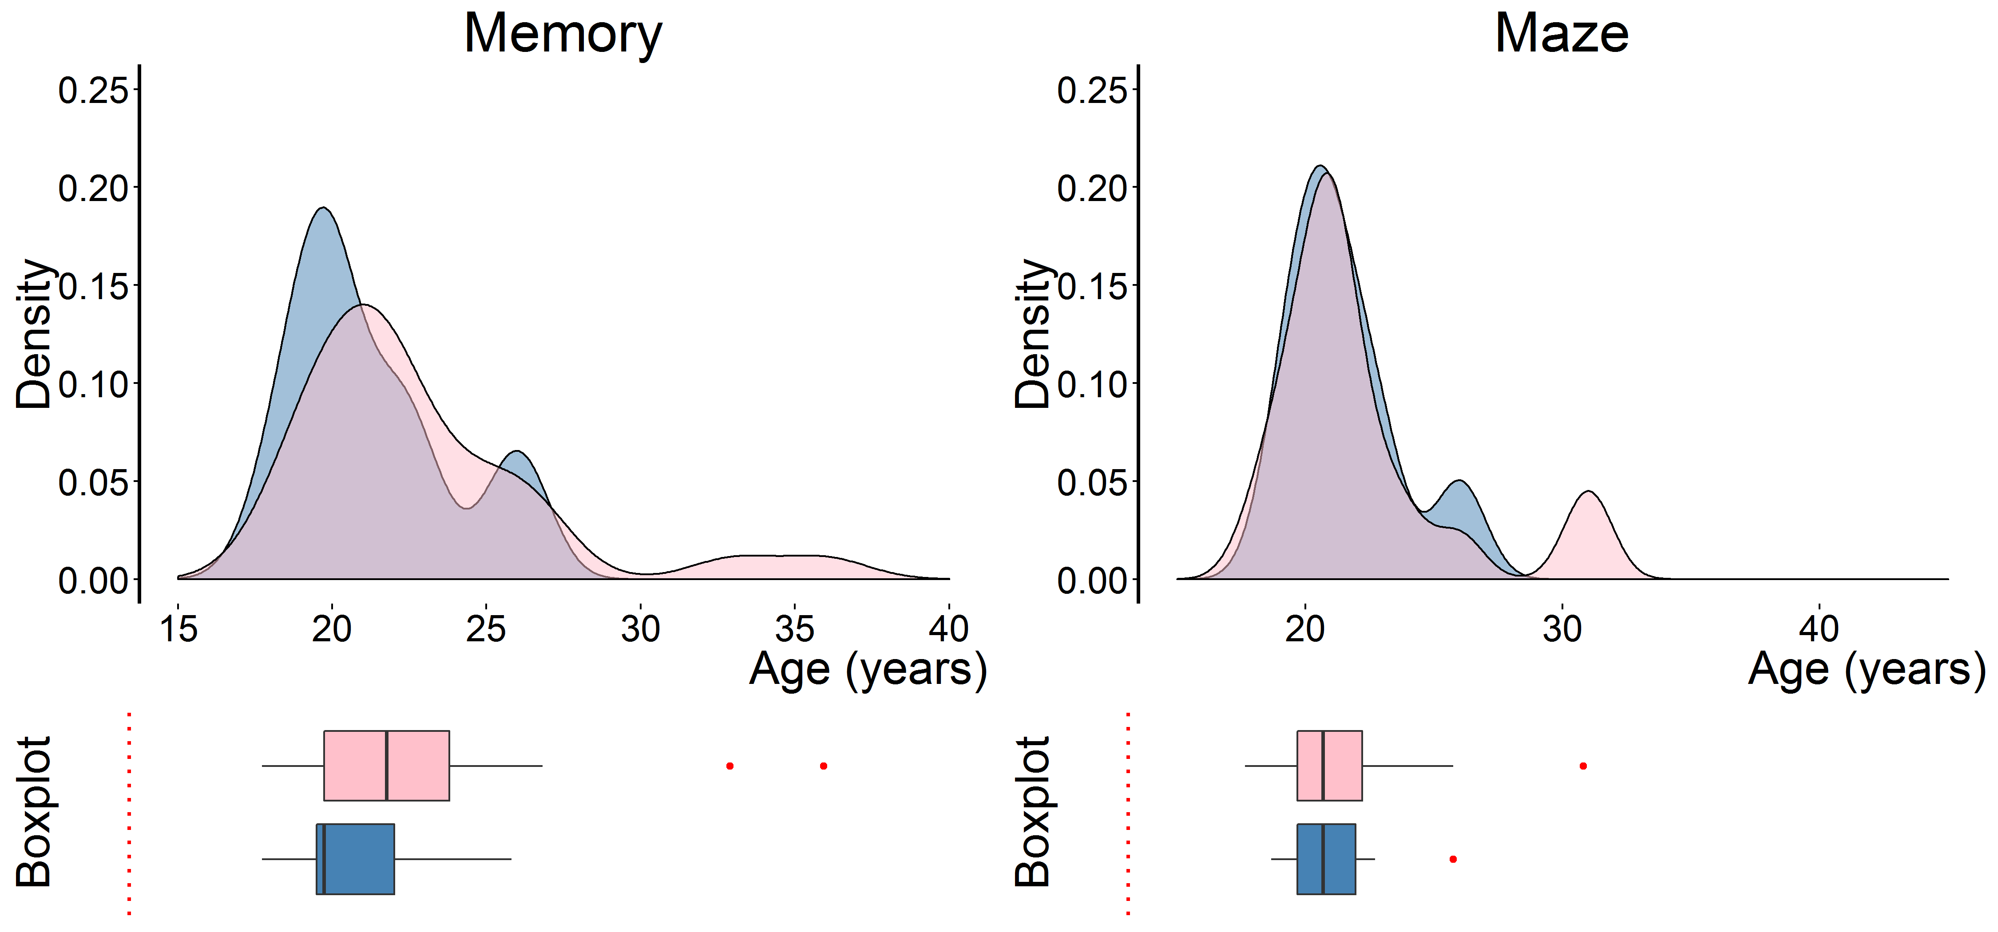
Figure A.1: density-boxplot combination plot outlining the distribution of the subject’s self-reported age (in year), outlined by treatment and gender.

This observation is corroborated by the summary statistics outlined in table A.1. For all four subsets, the differences in the mean age and its associated standard-deviations are highly similar. Nearly all subjects were college-aged, with few subjects older than 30 years of age. As a result, a set of permutation-tests could not reject the null hypothesis of no difference in ages between male and females. Based on these observations, we conclude that the observed differences discussed in the thesis-proper are unlikely to be the result of age-related differences.
Treatment | Gender | N | Mean | Std. Dev | Z | p
Memory | M | 12 | 21.25 | 2.633 | -1.2214 | 0.2482
 | F | 27 | 22.852 | 4.139
Maze | M | 8 | 21.5 | 2.204 | -0.4835 | 0.6774
 | F | 19 | 22.158 | 3.61
Table A.1: summary statistics for the subject’s self-reported age. Test-statistics are based on a pair of Monte-Carlo permutation tests (10,000 samples)

Field of Study – Table A.2 provides the frequencies of each reported field of study, outlined by treatment and by gender. Overall, no inferential statistics are reported as the range of responses was too large compared to the total number of observations to allow for any meaningful comparisons. Despite this lack of significance-tests, we observe a number of features. First, in both treatments, a large section of the subjects studied a topic loosely categorizable as “management sciences”, the most notable of which would be economics. This cluster accounted for 43.59% (17 out of 39) of the subjects in the memory-treatment and 33.33% (9 out of 27) of the subjects in the maze-treatment. Overall, we do not observe any striking differences between the treatment in their subject’s field of study.
 |  |  | Memory |  |  | Maze
Cluster | Field of Study | Total | Subtotal | Males | Females | Subtotal | Males | Females
Management Sciences | Accounting | 1 | 0 | 0 | 0 | 1 | 0 | 1
Management Sciences | Business Administration | 2 | 2 | 0 | 2 | 0 | 0 | 0
Management Sciences | Economics | 22 | 15 | 6 | 9 | 7 | 3 | 4
Management Sciences | Public Administration | 1 | 0 | 0 | 0 | 1 | 0 | 1
Humanities | Arts and Humanities | 2 | 0 | 0 | 0 | 2 | 0 | 2
Humanities | Language and Literature Studies | 1 | 0 | 0 | 0 | 1 | 0 | 1
Humanities | Media Sciences | 3 | 2 | 0 | 2 | 1 | 0 | 1
Social Sciences | Educational Sciences | 2 | 2 | 0 | 2 | 0 | 0 | 0
Social Sciences | Sociology | 5 | 1 | 0 | 1 | 4 | 0 | 4
Medical Sciences | Biology | 3 | 3 | 1 | 2 | 0 | 0 | 0
Medical Sciences | Medicine / Biomedical Sciences | 5 | 2 | 1 | 1 | 3 | 1 | 2
Beta-Sciences | Computer Sciences | 4 | 2 | 2 | 0 | 2 | 1 | 1
Beta-Sciences | Engineering | 2 | 0 | 0 | 0 | 2 | 2 | 0
Beta-Sciences | Geography | 1 | 1 | 1 | 0 | 0 | 0 | 0
Beta-Sciences | Geology | 2 | 2 | 1 | 1 | 0 | 0 | 0
 | Other | 10 | 7 | 0 | 7 | 3 | 1 | 2
Total |  | 66 | 39 | 12 | 27 | 27 | 8 | 19
Table A.2: Frequency table outlining the field of study for all experimental subjects, split by treatment and gender.

A.2 Earnings per treatment
Figure A.2 outlines the distribution of the subject’s earnings in Euros during the experiment, outlined by treatment and gender. It should be noted that these earnings do not fully coincide with the actual payments received by the subjects; in accordance to the lab-policy at the ELSE laboratory, subjects whose earnings did not exceed €5. As a result, the mean earnings reported in this section are somewhat divergent to the numbers cited in the thesis-proper (Chapter 3).
Based on both graphs, we observe that male subjects (as compared to female subjects) in general had higher earnings during the experiment. This is primarily due to the difference in earnings for the competition-tasks; males on average had a higher performance, were more likely to win the tournament if they competed in one and had a higher propensity of engaging in tournaments when this option was available. This effect appears to be most pronounced for the memory-treatment.
Earnings per Treatment
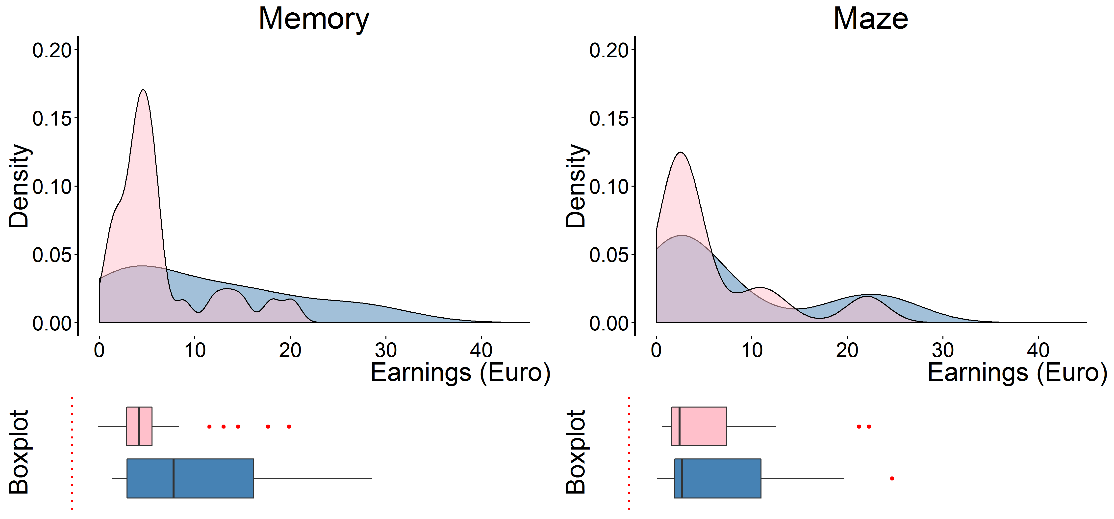
Figure A.2: distribution of the subject’s earnings, outlined by treatment and gender. Earnings did not include the bonus awarded to subjects earning below €5

The summary statics of the subjects’ earnings and their associated permutation tests are outlined in table A.3. These numbers confirm our previous observation; male subjects had higher average earnings as compared to female subjects in both treatments. However, this effect was only statistically significant for the memory-treatment, not for the maze-treatment.
Treatment | Gender | N | Mean | Std. Dev | Z | p
Memory | M | 12 | 11.052 | 9.454 | 1.9853 | 0.0431
 | F | 27 | 6.250 | 5.084
Maze | M | 8 | 9.322 | 9.322 | 0.6397 | 0.5398
 | F | 19 | 6.062 | 6.552
Table A.3: summary statistics for amount of euros earned during the experiment (excluding the additional payment to low-earning subjects). Test-statistics are based on a pair of Monte-Carlo permutation tests (10,000 samples)

A.3 Questionnaire Data
The last part of this appendix is based on the five items presented to subjects on the second page of the questionnaire. These questions elicited feedback from the subject regarding their experience of the treatment-specific tasks. The exact phrasing of the questions was presented as:
- How boring was the task for you? [Extremely boring – Not at all boring]
- How difficult was the task for you? [Extremely difficult – Not at all difficult]
- How much special skill did the task require from you? [None at all – Very much]
- How tiring was the task for you? [Extremely Tiring – Not at all tiring]
- How often are you confronted with similar tasks in your daily life? At least: [Once a week, once a month, once every six months, once a year, less than once a year, never]
On the first four of these questions, subjects could indicate their response by shifting a slider to a preferred position. The extreme values of the slider is given by the text in square brackets, such that a score of 0 indicated full agreement to the first value and a score of 100 indicated full agreement with the second value. All sliders had a neutral default-position of 50. Figure A.3 provides combination plots for these questions, with Table A.4 providing summary statistics and permutation tests.
Boring Task | Difficult Task
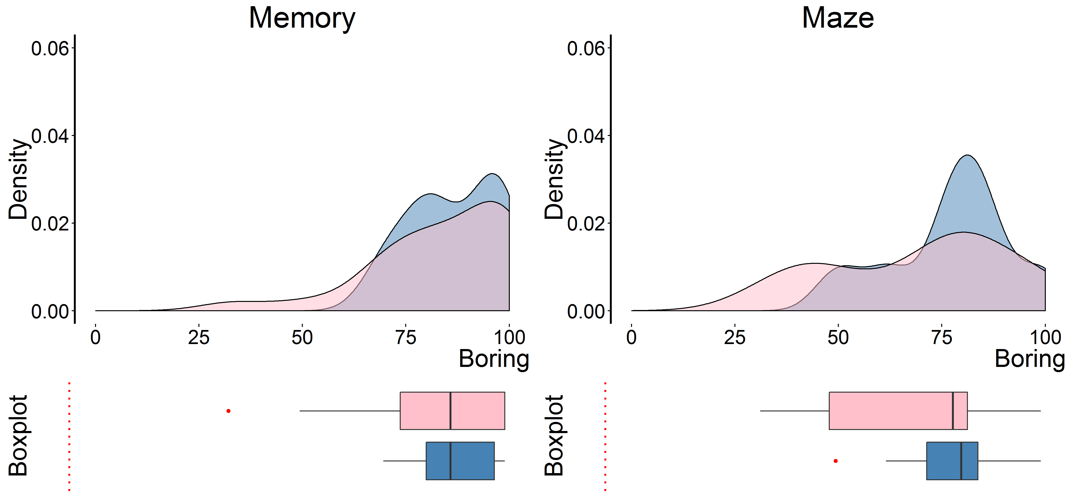 | 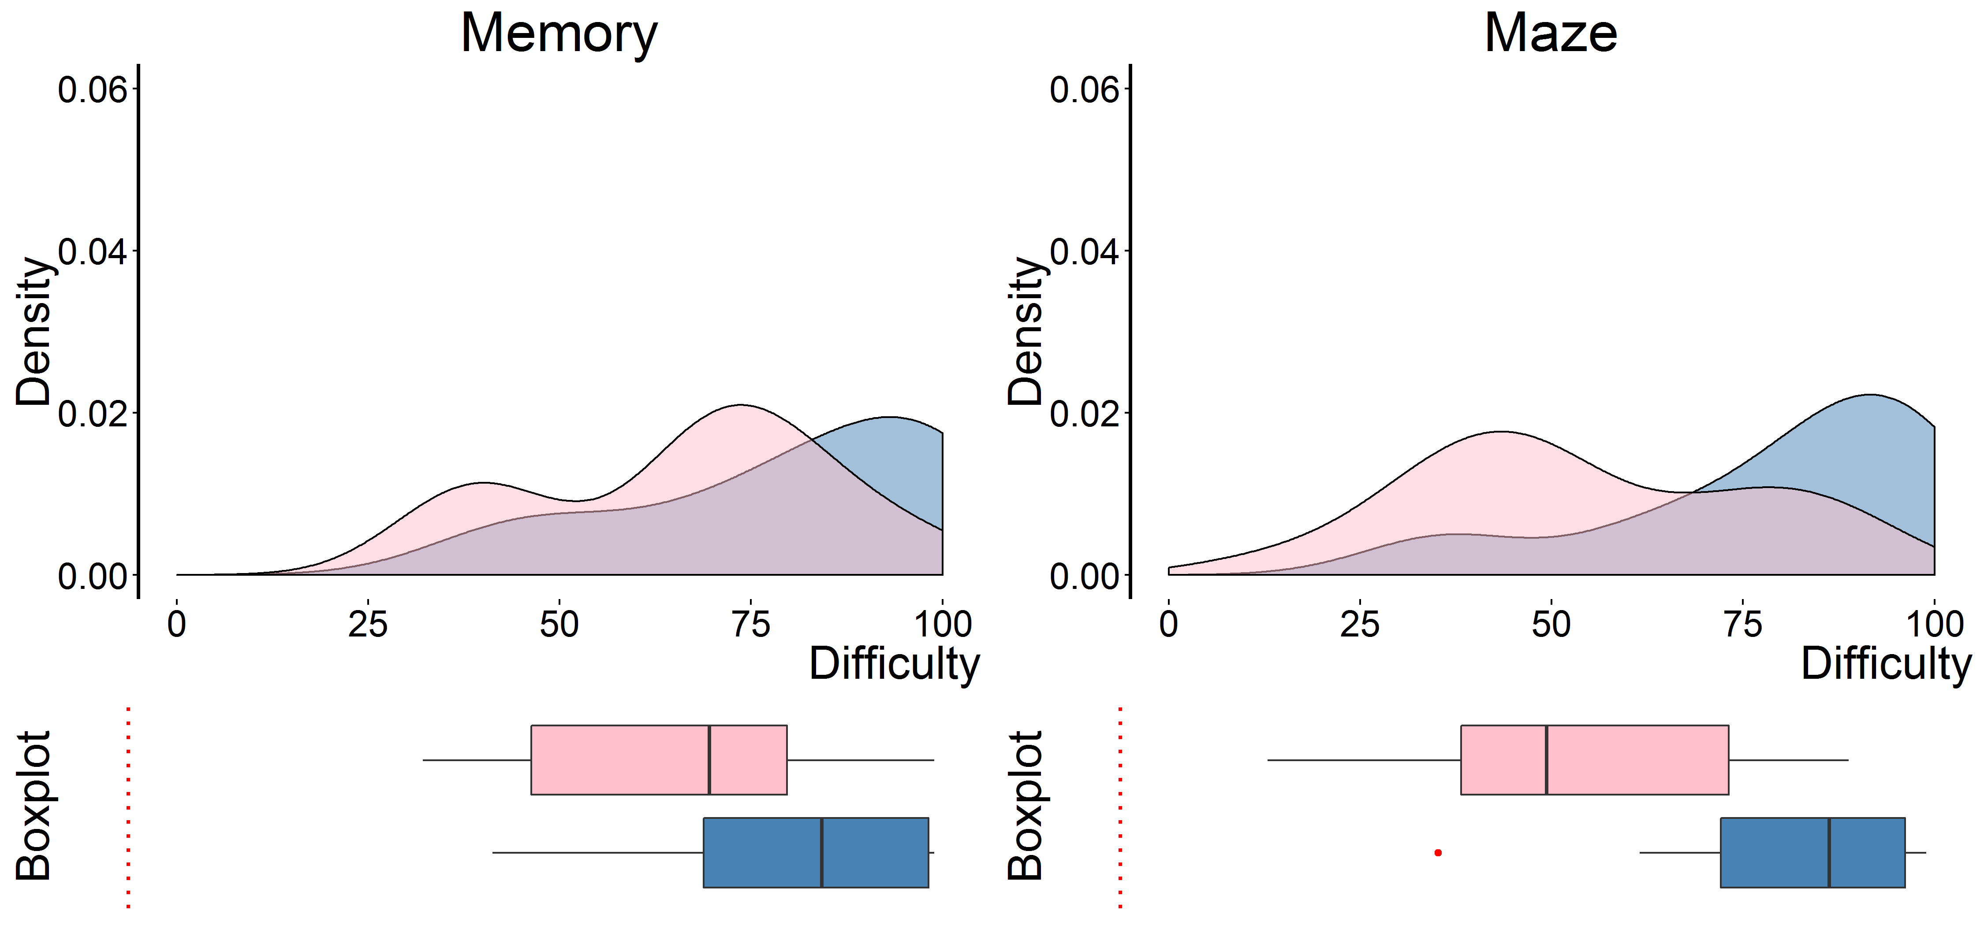
Skill Required | Tiring Task
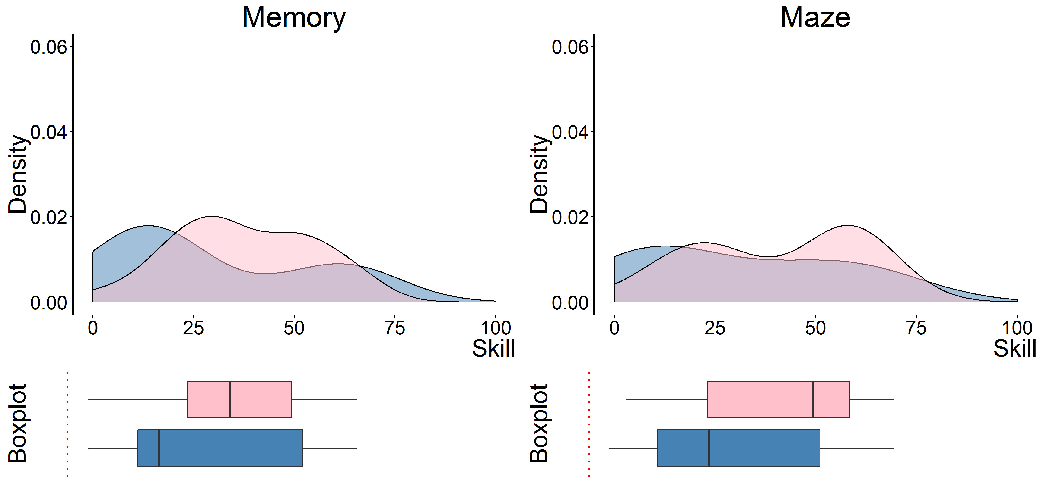 | 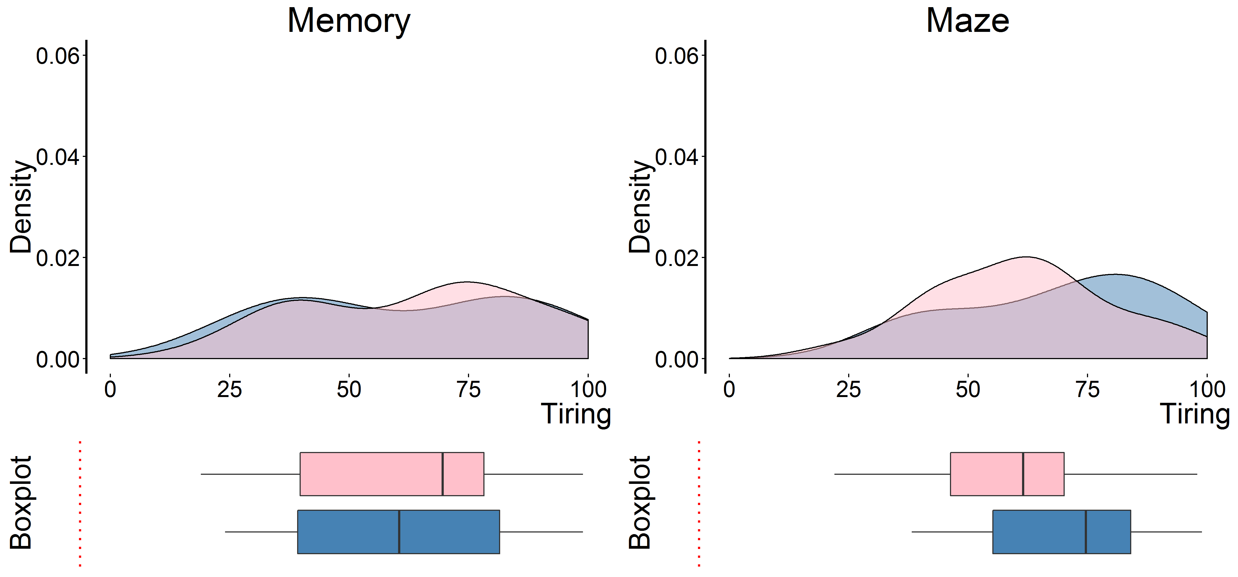
Figure A.3: combination plots for the four feedback-questions of the questionnaire, outlined by treatment and gender.

Overall, we observe a general trend of strong similarity between the genders on three of the four questions; the distribution of responses was neither visibly nor statistically different between the two subpopulations on Questions 1, 3 and 4. The only exception was the degree to how the subjects rated the difficulty of their task (Question 2). Interestingly, male subjects reported both tasks to be more difficult as compared to female subjects, while at the same time also performing better on both.
Question | Treatment | Gender | N | Mean | Std. Dev | Z | p
Boring | Memory | M | 12 | 86.67 | 10.66 | 0.5629 | 0.5897
 |  | F | 27 | 83.7 | 16.9
 | Maze | M | 8 | 77 | 15.14 | 0.8998 | 0.3795
 |  | F | 19 | 69.47 | 21.5
Difficult | Memory | M | 12 | 80.17 | 20.66 | 1.95 | 0.0484
 |  | F | 27 | 66.11 | 19.68
 | Maze | M | 8 | 79.88 | 21.62 | 2.4826 | 0.0106
 |  | F | 19 | 54.32 | 21.82
Skill Required | Memory | M | 12 | 29 | 24.42 | -1.2137 | 0.2351
 |  | F | 27 | 37.33 | 17.26
 | Maze | M | 8 | 30.63 | 25.95 | -1.1011 | 0.2807
 |  | F | 19 | 41 | 20.65
Tiring | Memory | M | 12 | 61.67 | 25.69 | -0.3036 | 0.7689
 |  | F | 27 | 64.19 | 23.55
 | Maze | M | 8 | 69.75 | 21.8 | 1.0351 | 0.3192
 |  | F | 19 | 61.11 | 18.95
Table A.4 summary statistics for the four feedback-questions of the questionnaire. For all questions, 0 indicates that the relevant attribute is in no way applicable to the task, while a score of 100 indicates that task contained an extreme amount of the relevant attribute. Test-statistics are based on a set of Monte-Carlo permutation tests (10,000 samples).
Finally, the fifth question elicited the familiarity of the treatment-specific task. The subject was asked to mark the answer-category best-fitting to the frequency he/she encountered similar tasks in his/her daily life. Figure A.4 provides a graphical depiction of the subject’s responses. Overall, we observe that both male and female subjects in the memory-treatment indicated that they encountered the task with a higher frequency as compared to subjects in the maze-treatment. Within a treatment, the responses of both genders appear relatively similar.
Frequency Task is Encountered
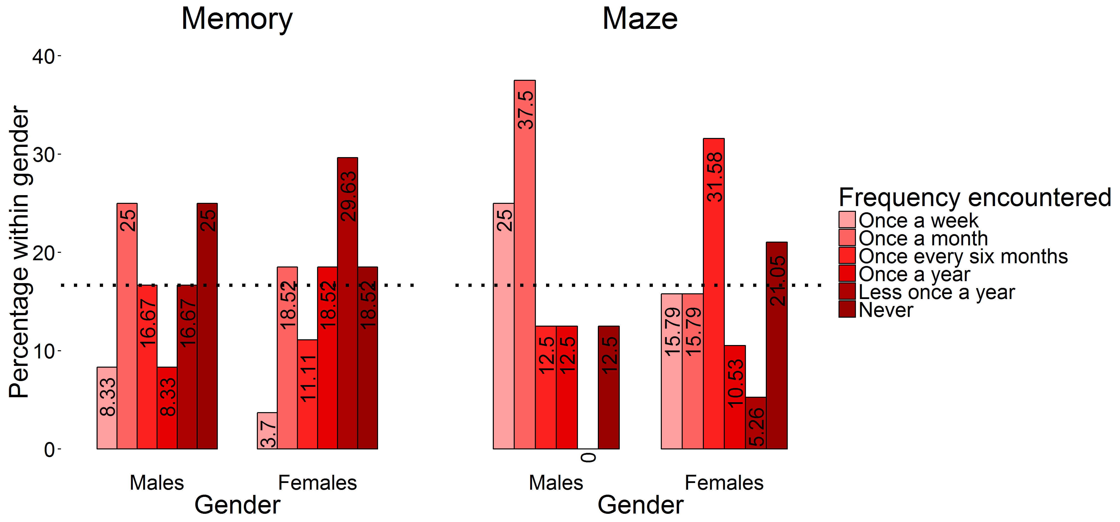
Figure A.4: bar graph indicating the distribution of subject’s responses on the question: “How often do you encounter the problem presented in tasks 1-3”, outlined by treatment and gender. The dotted line indicates the values associated with a uniform distribution over the six answer categories (16.67%).

Table A.5 corroborates these observations; for both treatments, a permutation-test could not reject the null hypothesis that both samples were drawn from an identical underlying distribution. As such, we conclude that a difference in familiarity to the task cannot explain the experimental effects observed in the present research.

Treatment | Gender | N | Frequency (%) |  |  |  |  |  | $$χ^{2}$$ | p
 |  |  | Week | Month | Six Months | Year | < Year | Never
Memory | M | 12 | 1 (8.33%) | 3  (25) | 2 (16.67) | 1  (8.33) | 2 (16.67) | 3  (25) | 1.9921 | 0.8744
 | F | 27 | 1  (3.7%) | 5 (18.42) | 3 (11.11) | 5 (18.52) | 8 (29.63) | 5 (18.52)
Maze | M | 8 | 2  (25%) | 3  (37.5) | 1  (12.5) | 1  (12.5) | 0  (0) | 1  (12.5) | 2.9055 | 0.8054
 | F | 19 | 3  (15%) | 3 (15.79) | 6 (31.58) | 2 (10.53) | 1  (5.26) | 4 (21.05)
Table A.5: frequencies of the answers provided to the fifth questionnaire item, outlined by treatment and gender. Test-statistics are based on a set of Monte-Carlo permutation tests (10,000 samples).

APPENDIX B: DETAILED TECHNICAL SPECIFICATIONS OF THE EXPERIMENTAL SOFTWARE
The second and last appendix of this thesis outlines the computational strategies employed in the construction of the experimental software and the instructions to the experiment. The appendix is subdivided into three subsections; software framework, treatment-specific software and the detailed instructions to the experiment. The first of these subsections outlines the different software frameworks employed “behind the scenes” of the experiment. The second subsection provides a detailed account of the computational algorithm utilized to generate the memory- and maze-treatment specific software. Finally, the third section provides annotated screenshots containing all instructions as presented to the experimental subjects.
B.1 Software framework
In contrast to the majority of experimental research in economics, the present thesis relied on an internet-based interaction between subjects (in contrast to LAN-based experiments commonly programmed in ZTree). This was done for multiple reasons; first, it allows for a vastly more flexible set of possible experiments, as the underlying software is visually oriented, has a large user-base and can be implemented on any web browser independent of physical location. This latter portion is especially important, as it allows for a future extension of the research project through internet-based data collection.
The experimental portion of this thesis was conducted through the utilization of several programming languages and experimental support software; ORSEE, OTREE, HTML & CSS and Javascipt & JQuery. Figure B.1 provides an overview of the relative tasks managed by each of these software packages.
SOFTWARE FRAMEWORK
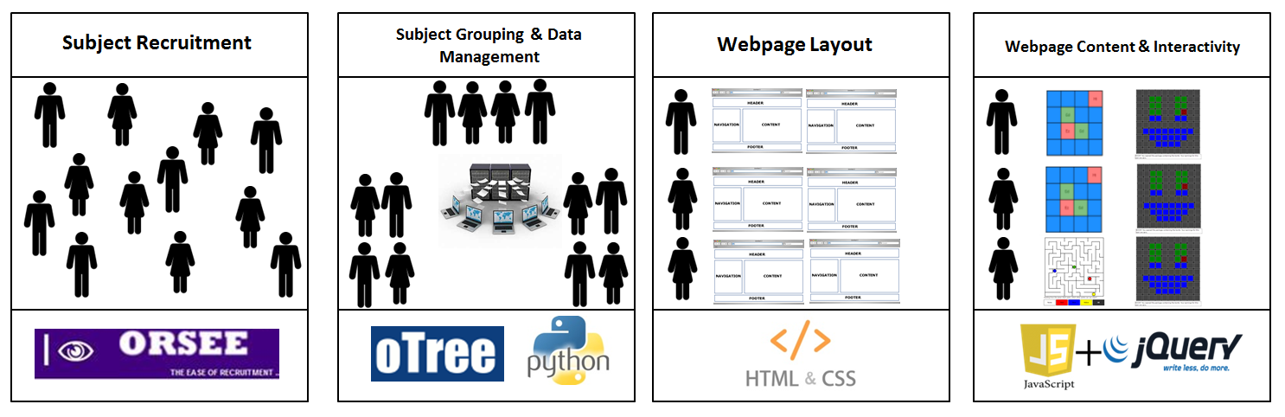
Figure B.1: graphical summary of the programming language utilized in the present experiment and their relative function.

Several days prior to the experiment, subjects were invited through the Online Recruitment System for Economic Experiments (Greiner, 2004) webpage of the ELSE-lab in Utrecht. This software manages the contact details for all possible subjects known in the database of the ELSE lab. Upon scheduling an experimental session, the ORSEE software sends out invitation emails to all members of this pool, announcing the time and location for the experiment. Potential subjects are then allowed to register to exactly one of the open sessions, up to the point that the pre-set maximum number of subjects was reached. This software further prevents the occurrence of double bookings for experimental sessions (i.e. such that the physical lab is not doubly booked) and/or double bookings for subjects (i.e. such that one subject registered to multiple sessions of the experiment).
After subjects were invited to the lab, the Online Toolbox for Readymade Economic Experiments (OTREE; Chen et al, 2016) software managed the subjects grouping and data management. This software provides an easy-to-use set of Python-based commands, facilitating the logistic demands of an internet-based experimental session. The tasks of OTREE consisted of server-client interactions, subdividing subjects into groups of four, keeping track of all subjects responses during the experiment, calculating the tournament-rankings and subjects earnings and finally providing an easily accessible dataset containing all experimental observations. However, the main task of the OTREE software included providing the right sequence of webpages to each subject.
In turn, the display properties of these webpages were managed by a combination of HTML & CSS and Javascript & JQuery. The former two languages are the universal standards for the layout of any webpage, handling the positioning and properties of all items (boxes, buttons, text, etc). Finally, the actual visible content and the interactivity (i.e. the interaction between the subject and the computer) was handled using custom-written code programming in Javascript and JQuery. These software packages allow for a relatively straightforward online programming language, relying on a large number of built-in features that are standardly present in any (relatively modern) web browser. All software is available from the author upon request.
B.2 Treatment-specific software
The second section of this appendix provides a detailed description of the software utilized in both treatments. This section is subdivided into three subsections: common aspects, memory-treatment specific software and maze-treatment specific software. The first subsection will list some important features applied in both computer programs, whilst the second and third section will provided a detailed description of the tasks-generation algorithms in the memory- and maze-treatment, respectively.
B.2.1 Common Aspects
The software of both treatments had three important properties in common. First, both programs generated their tasks locally; instead of sending a pre-generated image containing a version of the task it transferred a set of instructions (computer code) which allowed the subject’s computer to generate the task locally. This procedure had a number of benefits. First, it limited the amount of data which needed to be send from the server to all of the clients; while a single image containing a maze or a memory-puzzle can run up to 2 megabytes, the instructions themselves only required up to 50 kilobytes of data. This reduction of data-transfer proved highly beneficial for the Otree-server; at present, the underlying software associated with the platform is still in its pre-release stages and is prone to a large temporal latency under data-intense transfers. A second benefit was that it allowed each computer to generate an infinite set of tasks.
Apart from the local generation of puzzles, the software for both treatments utilized a seeded pseudo-random number generator. This number-generator performs a series of bit-wise operators on a single a-priori provided integer (the seed). The generated pseudo-random number then took the place of the previous seed and in turn provided the seed for the next pseudo-random number. In effect, this results in an infinite set of pseudo-randomly generated values. Each of these values depends deterministically on its predecessor in a non-linear fashion, such that the resulting value is nearly impossible to predict but consistent when executed multiple times. This in turn implied that the random numbers generated by each computer are identical over all subjects, but sufficiently unpredictable such that a single subject will be unable to infer it’s value. On a practical level, this procedure ensured that all subjects of a treatment were presented with identical tasks. As a result, we could exclude the possibility that the experimental results observed in this thesis were driven by random variations in perceived difficulty between subjects.
Finally, the software for both tasks utilized an identical time-out mechanism. After the page first finished loading, a timer was set for 300,000ms (5 minutes). Once this timer was completed, the treatment-specific elements (i.e. the memory- or the maze-task) where removed from the screen. In their place, a printed text appeared to inform the subjects that their time had run out. Simultaneously, a button labeled “CONTINUE” appeared below the text. Upon pressing of this button, the subject’s final score was transmitted to the server and the next task in the experiment would commence.
B.2.2 Memory-treatment specific software
Subjects in the memory-treatment had to connect sets of two identical pairs of letters in a grid of M*N cells (chosen such that M*N is smaller than 26*26 and divisible by 2; in the present experiment, values of 4 and 4 where utilized). Overall, the Javascript-based software utilized in this treatment consisted out of two separate sections: a problem-generation section and an answer registration section. The first section handled the generation of the grid of M*N cells and the (M*N)/2 pairs of letters contained within. The second section was in charge of providing feedback to the subject after boxes where opened.
Grid generation – the first step of this algorithm was to generate an M*N grid of cells and display these on the screens (cells are indicated by their square borders). After this was completed, the algorithm had to generate the letter-pairs with which these items had to be filled. This was done in the following manner: first, the algorithm generated (M*N)/2 letter-pairs. Each pair consisted of one upper-case and one lower-case alphabetical letter (e.g. “Aa”,”Bc”,”Xx”, etc). After all random pairs were generated, the algorithm checked for the existence of double combinations in this set; if so, the set would be re-generated until no such doubles existed. The resulting (M*N)/2 list of unique items was now duplicated and randomly distributed over the cells, such that each cell contained exactly one item.
Answer registration – the feedback system utilized in this software consisted out of three distinct states; no answer was selected, one answer was selected and two answers were selected. In accordance with the rules of the game, the first state can be considered the basic-state: all previously matched pairs of cells are permanently visible on the screen (with a translucent-green overlay), while all unmatched pairs are hidden from view by a solid-blue mask. At this point, the subject could select one of the unmatched (hidden) cells by performing a mouse-click on its location with the left mouse button. This action revealed the contents of the selected cell (i.e. its associated letter-pair) to the subject, and moved the screen to the second state. In this second state, the unmatched selected cell was visible to the subject whilst he/she could freely select a second unmatched cell (excluding the presently selected cell), again by left-clicking the mouse on its location. This moved the screen to the third state. In this state, the letter-pairs associated to the two selected cells were compared to each other. If they were identical, both cells would be registered as “matched”. In this event, the subject’s score was increase by 1 point and both cells would be colored translucent green for 500ms. If the pairs did not match, both cells would remain to be marked as “unmatched” and be colored translucent red for 500ms.
The three states of the memory-treatment software
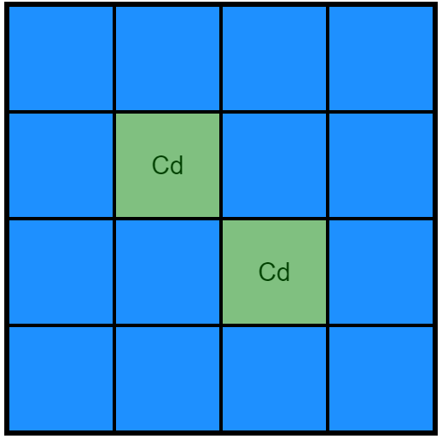 | 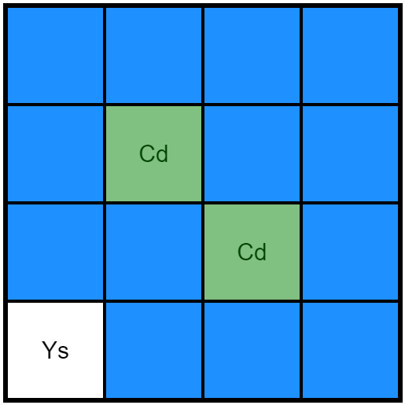 | 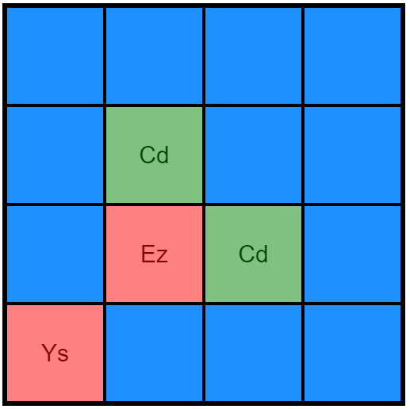
Figure B.2: the three states of the software used in the memory treatment. Left: the first state, in which all matched cells are displayed with an overlay of translucent green. All unmatched cells are hidden from view by a solid-blue overlay. Middle: the second state, in which one cell was selected (bottom-left in this instance, revealing that this cell contained the letter-pair “Ys”). Right: the third state, in which two cells were selected. The second cell (containing the letter-pair “Ez”) did not match the first cell, feedback of which was graphically depicted by the overlay of a translucent-red mask. After 500ms, this software returned to the first state.

After the third state was presented for the required 500ms, the contents of the entire grid was analyzed by the software. If not all pairs has been matched, the grid would revert to state 1. However, if all cells were now matched, the subject’s score would increase by 8 points and the entire grid would be colored solid-green. The center of the screen now contained the text “PUZZLE SOLVED!” for 2000ms. After this time, the grid would reset; a new set of letter-pairs would be generated and all cells would be checked as unmarked. Figure B.2 provides a graphical depiction of the three states.
B2.3 Maze-treatment specific software
The software developed for subjects in the maze-treatment was computationally more complex than the software required for the memory-treatment. Overall, the algorithm contained three distinct steps: maze generation, target placement and solution implementation. Each of these sub-algorithms will be discussed separately below.
Maze generation – the “base” feature of the maze-treatment consisted of a 15x15 cell basic maze. The exact structure of this maze (e.g. the placement of its walls) was locally generated on the subject’s computer using a depth-first-search (DFS) recursive algorithm. The (pseudo-code) implementation of the algorithm is presented in Box B.1, with a graphical illustration depicted in Figure B.3
This algorithm terminated when none of the cells had any remaining unvisited neighbors (e.g. when all cells have been visited). As a result, this algorithm ensures that the final maze is fully connected (all cells can be reached by all other cells) an the path between any two cells is unique (given two randomly selected cells, only a single path exists between them). These properties are crucial for the further steps outlined below.

Illustration of the maze generation algorithm
Start | Step 1 | Step 2 | Step 3
 | 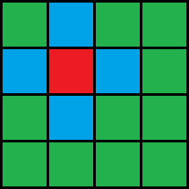 | 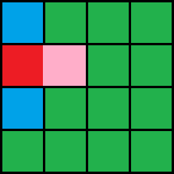 | 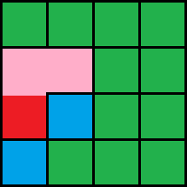
Step 4 | Step 5 | Step 6 | Step 7
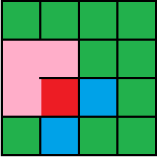 | 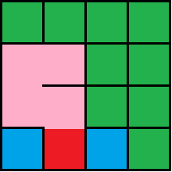 | 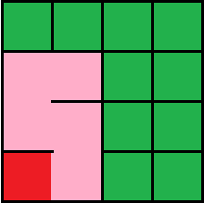 | 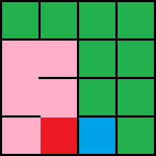
Step 8 | Step 9 |  | Step 16
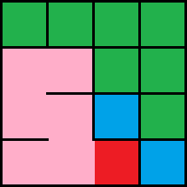 | 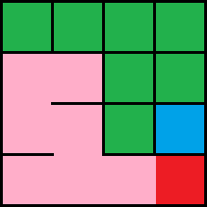 | … | 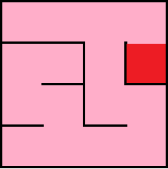
Finished Result
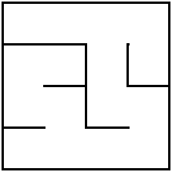
Figure B.3: Graphical illustration of the maze-generation algorithm in a 4x4 maze. Start: start with a set of cells, all containing exactly four walls (north, south, east, west), and all marked as “unvisited” (indicated by the green color). Step 1: randomly select a single starting cell and mark this cell as visited (indicated by the bright-red color). Compile a list of all the cell’s unvisited neighbors (indicated by the blue color) and randomly select one of these. Step 2: “move” to the newly selected cell, and remove the borders between both cells. Repeat step 2 for this cell. This continues in an iterative manner for all next cells. If a cell does not contain any unvisited neighbors (e.g. in step 6), then move to the previously visited cell and repeat step 2 for this cell. The algorithm terminates when no cell has any unvisited cells (e.g. when all cells are connected), at outlined in step 16.

Maze-generation Algorithm
Start: generate an M*N grid of “cells”. Each of these cells has four bothers (north, south, east, west) and is marked as “unvisited”.

Step 1: select a random starting cell.

Step 2: mark the selected cell as “visited” and generate a list of all unvisited neighbors. While this list is not empty:

Step 3: select a random neighbor from the list and remove the borders between the selected cell and the selected neighbor. Remove this neighbor from the list generated in step 2. Proceed to step 2 for this selected neighbor.

Box B.1: Maze-generation algorithm in pseudo-code

Target placement – In order to provide a problem for the subjects to solve, a total of 4 targets have the be placed in the newly-generated maze. The location for the first target is straightforward, as the green “Start” target always appears in the middle (e.g. at location [M/2,N/2] if M and N both are odd integers). The location of the other three targets is randomly determined by the algorithm. This is done in the following manner: first, the algorithm generates 3 pairs of randomly selected integers $x_{i},y_{i}$, such that $x_{i} ϵ \left\{0,1,2,…,M-1\right\}$ and $y_{i} ϵ \{0,1,2,…,N-1\}$. Second, in order to ensure that the maze was not trivially easy to solve, for each combination of the four coordinate pairs (the three randomly sampled coordinate pairs, plus the Start-target) the algorithm computed the Manhattan-distance between the pairs. This is calculated according to:
$$MD_{i,j}= \left|x_{i}-x_{j}\right|+ \left|y_{i}-y_{j}\right|$$
As four coordinate pairs were evaluated to this formula, a total of 6 distances where calculated. If this distance was smaller than 5 for any of the comparisons, the algorithm resampled the three random pairs and retried. This continued until a valid set of coordinates was reached. The algorithm then assigned the random coordinate pairs to the three goal-targets (red, blue and yellow, respectively) and drew all targets on the subject’s screen.
Solution implementation – At this point in the algorithm, a fully-connected maze has been generated and populated by the four targets. Now, the computer randomly draws an integer between 0 and 5 to determine the solution for the maze. The randomly drawn number corresponded to one of the following possible solutions:
- All goal-targets (red, blue and yellow) can be reached from the Start-target
- Only the red goal-target can be reached from the Start-target
- Only the blue goal-target can be reached from the Start-target
- Only the yellow goal-target can be researched from the Start-target
- None of the goal-targets can be researched from the Start-targets
If the first solution was randomly selected, the algorithm did not need to further adjust the maze and was terminated. However, adjustments were required in order to bring the maze in line with one of the four other solutions. In all four cases, the algorithm now had to determine the correct path between the Start-target and all three goal-targets. Similar to the maze-generation algorithm, these paths were computed using a DFS-sub-algorithm. This sub-algorithm is outlined in Box B.2.
Pathfinding-Algorithm
Start: select the cell containing the Start-target and mark all cells as “unvisited”.

Step 1: mark the cell as visited. Check if the present cell contains the searched-for target. If yes: return the coordinates of this cell. If no: proceed to step 2.

Step 2: generate a list of unvisited neighbors reachable from the present cell (i.e. having no border with the present cell). If this list is empty, return an empty set of coordinates. If the list is not empty, then while there are still items in the list:

Step 3: select a random neighbor from the list. Ask this other cell to go to step 1. If it returns a non-empty-coordinate list, then attach the cells ‘ own coordinates to the list and return the result

Box B.2: pathfinding algorithm in pseudo code

This algorithm was executed three times (one for each goal-path) and resulted in three lists of coordinates, each containing the (shortest) path to one of the three goal-targets. Parts of these paths may be overlapping, as illustrated in Figure B.4 below. Specifically, each path can be subdivided into two sections: a shared section and a unique section. The shared section consists of the elements (coordinates) in the complementary subset of the three paths. The unique sections (one for each goal-target) consisted of the elements not contained in the complementary subset of the three paths.
If the solutions numbered 2, 3 or 4 were selected, the algorithm adjusted the underlying maze by blocking the unique paths of the two targets not part of the solution. Blocking was executed by generating a wall between the middle-point of the unique path and its predecessor. It was possible that the maze and targets where generated in such a manner that the path to the selected target did not have a unique section (i.e. path to the selected goal-target was a full subset of a path to one or both of the other goal-targets). If this was the case, a solution could not be generated and the algorithm generated a new set of targets and associated paths until the selected solution could be applied. If solution 5 was selected, the algorithm placed a blockage halfway through each of the three paths separately.
After this step, the main algorithm for the maze-treatment was concluded. As a result, a maze was now randomly generated with the inclusion of 4 targets and one single solution. The HTML-code now generated the solution-associated buttons below the drawn maze. Once the subject indicated his/her answer by pressing on one of these buttons, his/her answer was logged by the webpage and a new maze was randomly generated after a 2500ms delay (to prevent double-clicking by the subject).

Path-Finding Illustration
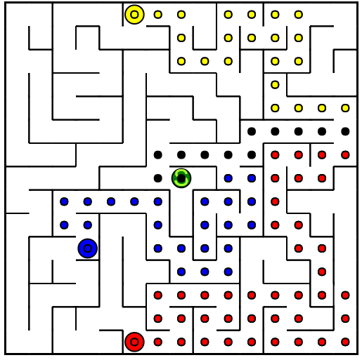
Figure B.4: paths generated for a set of targets. The green circle indicated the Start-target. The unique large yellow, blue and red circles indicated the three goal-targets. The smaller colored circles indicated the computed shortest path between the Start-target and its associated goal-target, not shared by the other paths (and hence being part of its unique section). A small black circle indicates that this coordinate is part of more than one path; hence that this is part of the shared section of the path. In this example solution 1 resulted in no changes made, solution 2 resulted in a wall-placement to block the yellow and blue paths, solution 3 in a wall-placement to bock the red and yellow paths, solution 4 in a blockage of the red and blue paths and solution 5 in a blockage of all the colored paths. Note: the small circles where not displayed to the subjects.

As a final note, while the algorithms outlined above may appear to be computationally intense, a modern personal computer (such as the ones utilized in the ELSE-laboratory) can generate a full maze (with associated solution) within a few (<50) milliseconds. As such, subjects where at no point hampered by computation lag when completing the treatment-specific maze-solving task.
B.3 Detailed Instructions
The final section of this appendix contains screenshots of the instruction-pages as presented to the subjects. These include screenshots of the general instructions and the instructions to Tasks 2, 3 and 4. The instructions associated to Task 1 (treatment-specific instructions), Task 5 (beliefs), Task 6 (BRET) and the questionnaire will not be presented here, as they have already been included in the thesis-proper.

General Instructions
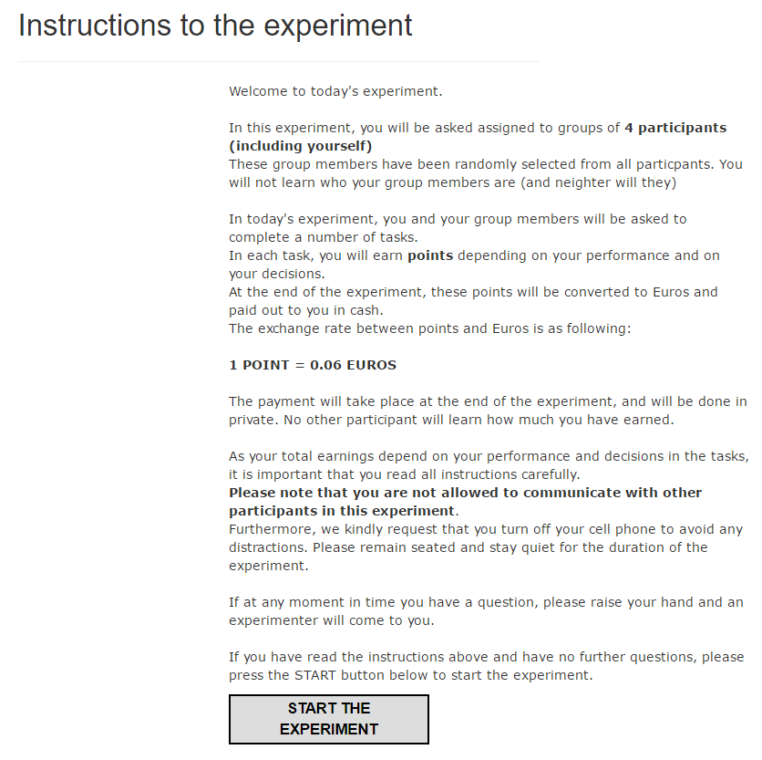
Figure B.5: a screenshot depicting the general instructions to the experiment. This screen was visible to all subjects upon entry to the ELSE-laboratory.

Instructions Task 2
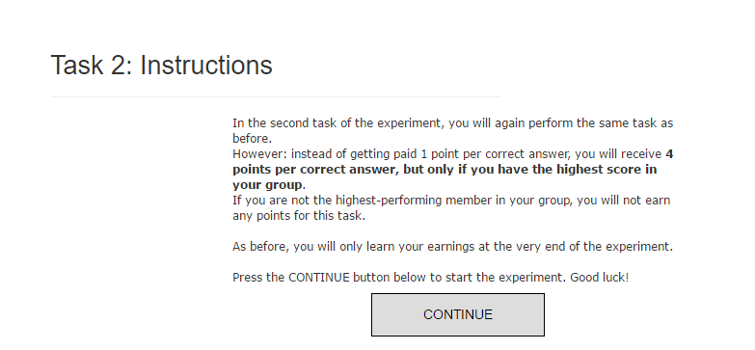
Figure B.6: a screenshot depicting the instructions to Task 2. These instructions where presented to the subjects after the first task had been concluded. Upon pressing the CONTINUE button, the second task would be initiated.
Instructions Task 3
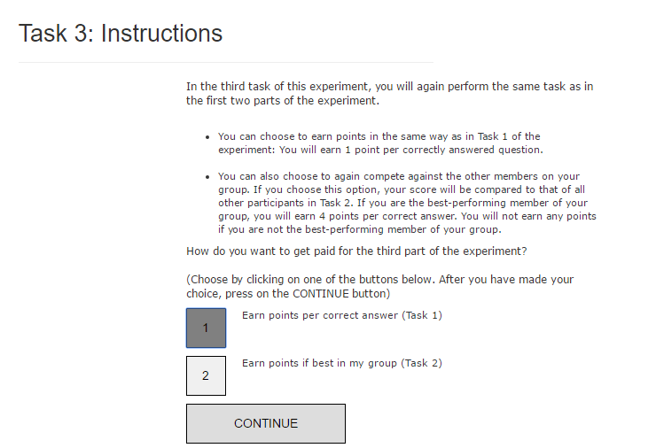
Figure B.7: a screenshot depicting the instructions to Task 3. These instructions where presented to the subjects after the second task had been concluded. When this screen first appears, both buttons labeled “1” and “2” are unselected (represented as the light-gray color) and the CONTINUE-button is hidden. Once one of the two options is selected by the subject (selection was done by mouse-click), the selected button was colored dark-gray and the CONTINUE-button appeared. Upon pressing the CONTINUE button, the third task would be initiated.

Instructions Task 4
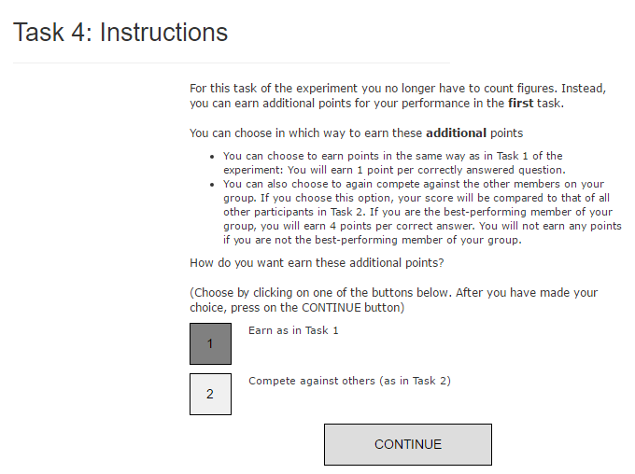
Figure B.8: a screenshot depicting the instructions to Task 4. These instructions where presented to the subjects after the third task had been concluded. When this screen first appears, both buttons labeled “1” and “2” are unselected (represented as the light-gray color) and the CONTINUE-button is hidden. Once one of the two options is selected by the subject (selection was done by mouse-click), the selected button was colored dark-gray and the CONTINUE-button appeared. Upon pressing the CONTINUE button, the subject would continue to the fifth task (beliefs).

See Aralumpalam, Booth & Bryan (2007) for an analysis in 11 European countries.
Gneezy et al (2009) replicate the standard observations for a tribal patriarchal society, but not a matrilineal society.
For notational simplicity, we further assume that indifferent subjects strictly prefer the piece-rate scheme. Note that this simplification does not impact the shape nor sign of any following calculations.
An alternative strategy would be to model the agent’s beliefs regarding its relative performance by introducing a bias in the estimated performance of group members (with an inverse effect of $β_{i}$). However, as the final results are equivalent, the presently used approach is utilized for its notational simplicity.
Subjects earning less than €5 for the experiment received a bonus at the end of the experiment, to ensure a minimum payoff to all subjects. Subjects were not informed of this at any point during the experiment.
Due to some unforeseen issues in the software, some subjects were inadvertently grouped into groups smaller than four. In these cases, one of the experimenters filled the group as a silent member (i.e. a group member that had a performance equal to 0 in the first three tasks). As a result of the anonymous group-matching procedure outlined above, subjects are presumed not to have been able to infer this issue during the experiment.
In rare cases it would be possible for one of two targets to have no unique path (i.e. the entire path to these targets was a subset of the path to another target). If this would occur, the generation-algorithm would re-generate the maze in its entirety until it converged upon a valid solution.
In the present thesis, the reported regression results were based on a logit link-function. A robustness analysis utilizing a probit link-function yielded qualitatively identical results. However, as the regression estimates are more easily interpretable for the logit link-function, only these results are reported.
McFadden’s pseudo-$R^{2}$ was calculated with the following formula: $pseudo R^{2}=1-\left(\frac{LM}{L0}\right)$, where LM is the observed log-likelihood of the model and L0 is the log-likelihood of an intercept-only model. This metric is a close (although relatively conservative) measure of the model’s explained variance. It should be noted that this measure does not fully match a “regular” OLS $R^{2}$ measure, as it is not the square of the underlying correlation matrix. Nonetheless, it can be interpreted as a measure of relative explained variance.
As a result of the bootstrapping procedure used, rank-estimates are slightly biased in favor of the higher ranks for all estimates. This is due to the occurrence of ties; when multiple subjects had the same score, they both shared the highest of the two possible rank-orders. As an example, a group with performances of {30,35,35,40} would be given the relative ranks of {1,2,2,4}.
No significance-tests are provided for two reasons: first, the large number of observations (66,000) will ensure that any test will yield significant results regardless of effect size (for a review of this well-known shortcoming of Fisherian p-value testing, see Cohen, 1990,1994; Anderson, Burnham & Tompson, 2000 and Wassertein & Lazar, 2016). Second, as the 10,000 are expected to involve all possible group formations within the dataset, inferential statistics do not add any novel information.
The maximum values of x and y are M-1 and N-1 respectively. This is due to the way in which arrays are addressed in most programming languages; starting at position 0 as the first address. As a result, the cardinalities of both sets from which x and y are drawn are M and N, respectively.

