
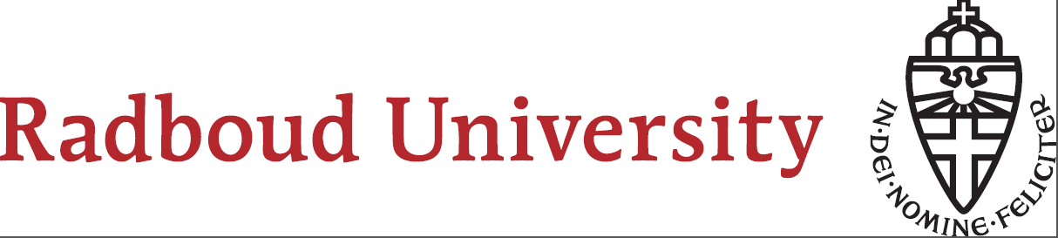
Local translations of the CE concept
MAPPING THE DRIVERS FOR THE INVENTION AND DEVELOPMENT OF CIRCULAR ECONOMY BUSINESS INITIATIVES

Master thesis Human Geography
Lars Paardekooper

Local translations of the CE concept
MAPPING THE DRIVERS FOR THE INVENTION AND DEVELOPMENT OF CIRCULAR ECONOMY BUSINESS INITIATIVES

Master thesis Human Geography
02 – October – 2015

Lars Paardekooper
S4056736

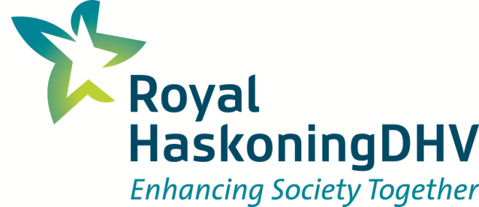


Royal HaskoningDHV
Energy, Industry and Mining
Department: Nijmegen
Supervisor: Tom Houben
larspaardekooper@hotmail.com

Radboud University Nijmegen
Human Geography
(S) Economic Geography
S4056736
Supervisor: Arnoud Lagendijk
Larspaardekooper@student.ru.nl

Preface

Approximately a year ago I started my journey called ‘writing your master thesis’. There you are, at the beginning of the academic year without a clue for a possible master thesis subject. My interests reached as far as the range of topics that are discussed within the scientific discipline of the Economic Geography. After some discussions with fellow students and lecturers (and a few months later) I made my decision, I was going to write my master thesis on the ‘circular economy’. At the beginning I was slightly sceptical about this choice. However, ‘alternative economies’ and ‘sustainability’ are hot topics within the Economic Geography, so my choice had to be good. My scepticism made place for enthusiasm when I immersed myself in the world of sustainability and the circular economy (CE) in particular.

During the process of writing my master thesis, I did an internship at Royal HaskoningDHV in Nijmegen from February until August. By doing this internship and writing my mater thesis, I gained a lot of experience within the organisation. This proved to be a tough combination, especially in combination with my work as a student assistant at the university and other non-related academic activities. However, gaining experience within a renowned consultancy firm as Royal HaskoningDHV was one of my goals in my final year of the master. Moreover, those activities turned out to be very relevant for my research as well. Which is after all a better way to gain knowledge and experience about the way in which a concept such as CE influences practice, than participating in the organisation of an event that is part of the whole contemporary buzz surrounding CE.

After dozens of interviews and attending just as many events and workshops, I was overwhelmed by information about the CE. Processing all this information in a final product and to let it fit within the chosen research plan, proved to be challenging. But I succeeded and the result of this is in front of you. All by myself I would not have achieved this result. Therefore, I want to thank a number of people. First of all, all those people that participated in this research and who shared their knowledge and experience with a lot of passion. Without them I wouldn’t have the necessary information and even more important I wouldn’t be as captivated by the theme as I am now. In addition, I also want to thank Arnoud Lagendijk, my supervisor at the Radboud University, who guided me during this process. Finally, a big thanks to Tom Houben from Royal HaskoningDHV for his supervision of both my master thesis and internship.

I hope you will enjoy reading this thesis as much as I enjoyed exploring the field of sustainability and, in particular the circular economy.

Lars Paardekooper

Nijmegen, October 2015

Executive summary

Scientists, policy makers and entrepreneurs have been struggling for years with the question how we can realise a sustainable and resistant economy. In context of contemporary issues on e.g. resource scarcity, population growth, environmental pollution and the stability of our financial and economic system, a transition towards a more sustainable economic system seems to be indispensable. Yet, there are pioneers who go their own way and break with the dominant linear economic structures that are associated with the described issues. In working on our aspiration of a sustainable and resistant future, we are driven by concepts which represent our desire. These concepts act as guidance in achieving our desire and could eventually result in actual business and policy initiatives. Different concepts gained attention over the last years. At this moment, circular economy [CE] is a popular discourse in both academic and societal debates. Despite the popularity of the concept, a specific definition or understanding of what CE would look like is missing. This makes research on the CE concept interesting and relevant for both social sciences and society.
In the interaction between the CE concept and practice, business initiatives emerge that contribute to achieving the aspiration of a sustainable and resistant future. This research explores how these business initiatives are conceived and developed as a local translation of the CE concept. The following research question is used in order to examine this: “How do notions of CE circulate in society and how are business initiatives conceived and developed as a local translation of these notions and ideas about CE?”. So, in this research it is not about the universal and ‘right’ definition or implementation of the CE concept. It rather looks at the way in which the concept is created and travels from place to place constituting actual CE business initiatives.
This research uses a ‘Theoretical triangle’ in order to retrieve drivers for the emergence and development of CE business initiatives. The triangle consists of three elements (1) model, (2) practices and (3) interaction between actors. The elements are in turn, connected to a specific theoretical notion. (1) The model, or the specific ‘CE’ idea for the business initiative, is connected to the notion of ‘open concepts’. (2) Practices are related to practice theory. And finally, (3) the interaction between actors is approached by making use of insights from ‘governance’. The way in which CE business initiatives are conceived and developed can be explained by the interaction between the described elements in the triangle. Pioneers are the binding factor in this context.
A qualitative research strategy is used in this research. First, the development of the CE concept is described. By mapping the dominant discourses and key actors in the development and diffusion of the CE concept, this research is equipped with the necessary context information on the buzz surrounding the concept. For this, a desk research is conducted and multiple interviews were held with actors and policy makers working with the CE concept. The core activity in this research, relates to the analysis of the emergence and development of four actual CE business initiatives. The cases that are analysed are: Lazuur food community, Dirk III, EcoProFabrics and Energie en Grondstoffen Fabriek. In all cases the CE concept is used and/or embedded in the business initiative. Interviews were held with pioneers and key actors in the development of these initiatives. The transcripts of the interviews were supplemented by additional and relevant secondary data. Atlas.ti, a qualitative data analysis and research program, is used in the encoding and analysis of the data. The results of the analysis of the individual cases are compared in order to deduce common drivers. Demarcating the research area to the Gelderland region allowed the researcher to compare the results of the individual cases, because business initiatives are examined in a similar (institutional) context.
The most important insights derived from this research can be found in the individual results of the analysis of the four CE business initiatives. In every case drivers are decisive which are specific and unique for the initiative. The way in which the understanding of the CE concept is established and is implemented in practice, depends on e.g. the type of initiative, the sector and the environment. Nevertheless, similarities between the individual cases are found. On the basis of these results assumptions can be made regarding the research question. However, this does not relate to statistical generalisation.
The CE business initiatives seem to develop independent from the contemporary buzz surrounding CE. Instead theoretical insights and concepts which are reflected in the roots of the CE concept are important in the development of the initiatives. But, even more important are insights derived from practice. It is striking that during the entire development of the studied business initiatives continuously interaction takes place between the three elements in the ‘Theoretical triangle’. In the establishment of the model, both the ‘governance’ and ‘the bundle of practices’, are important. And in the establishment of the model in practice, mainly the ‘governance structures’ change. Also the barriers are mainly most related to governance. This confirms the proposition that the notion of CE mainly relates to a change in the process-side of economic activities.
The most important implications of this research, based on the analysis of the four CE business initiatives could be formulated as follows:
- This research must be seen as ‘learning from good examples’, because in every CE business initiative different drivers are decisive.
- The establishment of CE business initiatives is to a great extent determined by coincidence. However, these coincidences can be facilitated. Networks can be an important means in this context.
- Indispensable in the development of CE business initiatives are pioneers who persevere. The competences of ‘networking’ and ‘people management’ are decisive for achieving success.
- The CE concept can be a useful tool for inspiring people and motivate people to participate.
- Making use of (practical) examples is an important key in understanding, implementing and diffusing CE notions.
- CE principles can be reinforced by adding a material dimension. This makes it understandable.
- Practical knowledge and experiences from practice are important in making the CE concept tangible, as well as giving substantive meaning to the business initiative.
- A change in mindset or roles of actors, is crucial for the emergence of CE business initiatives. Therefore, facilitating this process must be optimised.
Despite the formulated advice based on this research, further (scientific) research is relevant and necessary. This research had an explorative character and provides a perspective on the relation between practice and the CE concept. Despite the fact that CE seems to be a label, which is replaceable by other concepts, it has a visible affect on society. In this context, it is important that follow-up research is conducted on the way in which a concept like CE affects specific practices and initiatives. Because these insights contribute to the transition of our society towards a more resistant and sustainable variant.
Table of contents

Preface I
Executive summary II
Table of Contents IV
List of Figures VI
List of Tables VI
List of Abbreviations VII

1 Introduction 1
1.1 Rise of the Circular Economy 1
1.2 Societal relevance 3
1.3 Academic relevance 5
1.4 Research objective and research question 7
1.5 Read manual 9
2 Theoretical framework 10
2.1 Introduction 10
2.1 Open concepts 10
2.3 Practice theory 12
2.4 Governance 16
2.5 Conceptual model 17
3 Methodological framework 20
3.1 Introduction 20
3.2 Research strategy 21
3.3 Research design 22
3.4 Data collection and research methods 23
3.5 Analysis and coding 25
3.6 Analysis of the CE concept 27
3.7 Criteria for trustworthiness 28

4 The development of the CE concept 31
4.1 Introduction 31
4.2 Roots of the concept 31
4.3 Definition and dominant discourses 32
4.4 CE in the Netherlands 34
4.5 CE in Gelderland 36

5 Lazuur food community 39
5.1 Introduction 39
5.2 A description of the CE business initiative 39
5.3 The analysis of the development of Lazuur food community 41
5.3.1 The emergence of an organic food store 41
5.3.2 Expansion of the organic food store 42
5.3.3 Working on a renewed vision for the food retail 43
5.3.4 Implementation of the renewed principles 44
5.4 Future: towards a closed loop in food retail 46
6 Dirk III 47
6.1 Introduction 47
6.2 A description of the CE business initiative 47
6.3 The analysis of the development of Dirk III 48
6.3.1 The establishment of the BEC 49
6.3.2 Towards a holistic view on the economy 50
6.3.3 Execution of the ideas in practice 52
6.4 Future: towards a new economy in the Betuwe 54
7 EcoProFabrics 56
7.1 Introduction 56
7.2 A description of the CE business initiative 56
7.3 The analysis of the development of EcoProFabrics 57
7.3.1 The establishment of a sustainable clothing industry 58
7.3.2 Towards the establishment of a CE vision on the textile industry 59
7.3.3 Execution of the CE work wear chain 61
7.4 Future: towards a closed loop for the textile industry 62
8 Energie en Grondstoffen Fabriek 64
8.1 Introduction 64
8.2 A description of the CE business initiative 64
8.3 The analysis of the development of the EFGF 65
8.3.1 The emergence of the ‘Energie Fabriek’ 66
8.3.2 Embedding of the ‘Energie Fabriek’ in the Water Authorities 67
8.3.3 Implementation of the ‘Energie Fabriek’ in the WWTP 68
8.3.4 Extension of the vision: the emergence of the ‘EFGF’ 70
8.4 Future: towards a closed loop in wastewater treatment 71

9 Conclusion 73
9.1 Introduction 73
9.2 Conclusions 73
9.3 Implications 76
9.4 Research reflection 78
9.5 Recommendations for further research 81

References 83

Appendix A: List of interviewees 89
Appendix B: Interviewguide 90
Appendix C: Code book 91

List of Figures
Figure 1: Visualisation of the connection between the theoretical notion and the model | 12
Figure 2: Position practice theory in social theory | 13
Figure 3: The dimensions of practice theory that constitute the bundle of practices | 15
Figure 4: Visualisation of the two types constituting ‘governance’ in this research | 17
Figure 5: Conceptual model: ‘Theoretical triangle’ | 18
Figure 6: The research model | 20
Figure 7: Snapshot of the code book | 26
Figure 8: Snapshot of the coding process in Atlas.ti | 27
Figure 9: Radar of differences in goals and interests in the CE concept | 32
Figure 10: The butterfly diagram of the EMF | 34
Figure 11: Overview of the principles embedded in the Lazuur concept | 40
Figure 12: The ‘Theoretical triangle’ for the analysis of the development of Lazuur | 41
Figure 13: Translation of the seven principles of the Dirk III ideology | 48
Figure 14: The ‘Theoretical triangle’ for the analysis of the development of Dirk III | 49
Figure 15: Background of founding fathers ‘BEC’ | 50
Figure 16: Background of Dennis Kerkhoven | 51
Figure 17: Overview of the CE work wear chain of EcoProFabrics | 57
Figure 18: The ‘Theoretical triangle’ for the analysis of the development of EcoProFabrics | 58
Figure 19: Short description of the wastewater treatment process | 65
Figure 20: The ‘Theoretical triangle’ for the analysis of the development of EFGF | 66
Figure 21: Barriers and enablers during implementation of ‘EF’ at policy level | 68
Figure 22: The ‘Theoretical triangle’ for the conclusion | 74

List of Tables

Table 1: Schools of thought, accompanied by main principles and authors, which are ........ ....reflected in the CE concept | 32

List of Abbreviations

BEC: Betuwse Energie Coöperatie
BDA: Biodynamic agriculture
C2C: Cradle to Cradle
CCMS: Circular Content Management System
CE: Circular Economy
Dirk III: Dirk de Derde
EF: Energie Fabriek
EFGF: Energie en Grondstoffen Fabriek
EDC: European Design Centre
EU: European Union
GF: Grondstoffen Fabriek
RHDHV: Royal HaskoningDHV
WWTP: Wastewater treatment plant

1 Introduction
1.1 Rise of the Circular Economy
“The power of population is indefinitely greater than the power in the earth to produce subsistence for man”
(Malthus, 1798, p. 4)
Wouldn’t it be great if all regional economies in the Netherlands flourished? That we experience economic growth rates similar to those of the late 90’s. And that this growth is achieved without large environmental damage, loss of biodiversity and the maintenance of a healthy and clean living environment. So, that the next generations can live in the same convenient conditions as we live in and that ‘an economically balanced, durable and fair society’ is created. But as Thomas Malthus already stated in the 18th century, our (economic) growth is not infinite.
There is an expected explosive growth of the world’s population in the upcoming decades (United Nations Population Fund, n.d.). Especially the fast growth of the economic middle class will lead to a huge increase in the demand for products and services. Moreover, the depletion of resources and land is continuing (UNEP, 2011). In 2030 for example, only 60% of the world’s population can fulfil their need for water (Spitz, Koks & Heintze, 2012). In addition to the increasing demand, economic production and consumption are a burden to the environment, the climate and the biodiversity. Costs arising from this pressure are expenses for society. Because nowadays our economies are strongly intertwined, developments - even elsewhere in the world - have greater impact. All these developments cause a discrepancy between our aspiration of ‘a sustainable and resistant society’ and the reality. You would expect that this discrepancy will lead to a change in our producing and consuming behaviour. But despite earlier warnings (e.g. the Club of Rome, Brundtland commission and global political attention to climate and sustainable issues) structural change has not been adopted yet (Cole, 1999; Buttel, Hawkins & Power, 1990; Jonker, Oosting & Verhagen, 2013).
Scientists, policy makers and entrepreneurs have been struggling for years with the question how we can realise a sustainable and resistant economy. But, what actually causes a large structural societal and economic change, in other words: ‘a transition’? A transition is an autonomous process that cannot be controlled or managed (Rotmans, 2006; Shove & Pantzar, 2005). This can be learned from large transitions in the past, such as the impact of the invention of the computer on society. Transitions require a change in daily practices on a large scale. Such impact on society will be achieved if for example all commuters would travel by bike or public transport instead of by car. Not only changes in behaviour have an influence on practices, other factors such as (technological) innovations are important as well. Practices that need to change for a transition are embedded in our daily routines (Røpke, 2009; Spaargaren, 2011). People live by these routines and try to maintain the status-quo. That is why transitions are not achieved easily (Accenture, 2014).
Yet, there are pioneers who go their own way and break with the dominant economic structures in order to achieve the aspiration of a durable and resistant social economic system (Jonker, et al., 2013). These, often local, initiatives go further than solely the conventional recycling of waste and are characterised by attention for value retention, the use of environmental friendly materials and advanced forms of collaboration. A transition towards a more sustainable society may take place when these new sustainable initiatives are widespread diffused. A small group of pioneers alone is capable of causing this diffusion. These are people with spirit, vision and ambition who are able to transmit a message. In this process not the practices are transferred to others, but the idea about the practice - the mental frame of interpretation and understanding - is spread (Rotmans, 2006). Epidemic spread of an idea will only take place when the ideas are ‘contagious’ enough, when they take place in the required context and when the right people are involved (Gladwell, 2000).
An interesting aspect in this transition is the ongoing interaction between practice on the one hand and the concept or discourse on the other hand (Lagendijk & Needham, 2012). In working on our aspiration of a sustainable and resistant future, we are driven by concepts which represent our desire. These concepts act as guidance in achieving the desire and could eventually result in actual business and policy initiatives. A nice illustration of this interaction is given by Kooij and his colleagues on the ‘cluster’ concept (Kooij, et al., 2012). The circulation of concepts is a complex process which is difficult to get a grip on. “Ideas are turned into things, then things into ideas again, transferred from their time and place of origin and materialized again elsewhere” (Czarniawska & Joerges, 1996, p. 18). As a result a concept can have different interpretations and implementations depending on the context.
In achieving a sustainable and resistant society, different concepts have gained attention. Among these are: Sustainable development; People, Planet, Profit; the Performance Economy; Industrial Ecology; Cradle to Cradle [C2C]; Blue Economy; Clean Technology and Circular Economy [CE] (Cole, 1999; Elkington, 1998; Stahel & Reday-Mulvey, 1981; Frosch & Gallopoulos, 1989; Pauli, 2010; Hart & Milstein, 2003; McDonough & Braungart, 2005; Ellen MacArthur Foundation, 2012). Some of these concepts are still alive and kicking, such as C2C, Clean Technology and CE. Others are disappeared or passed into other concepts, such as Blue Economy, the Performance Economy and Industrial Development. Beyond the circulation of these different concepts in society, the underlying conception of sustainability issues and the limited shelf life of our economic system travels along with it (Peyroux, Pütz & Glasze, 2012). In other words: the challenges remain the same, only the dominant discourse changes – how it is given hands and feet to the desired vision.
The latest trend in sustainability debates is the ‘circular economy’. This concept is used by pioneers working on a more sustainable and resistant society (Ellen MacArthur Foundation, 2012; Accenture, 2014; Bastein, et al., 2013). CE is Increasingly referred to by scientists, entrepreneurs, intermediaries and policy makers. The Dutch government placed CE on the political agenda (Ministry of Infrastructure and the Environment, 2013; Schuurman, 2013) and also local and regional authorities try to link up with the concept (VNG, 2015). In only the Netherlands, already dozens of organisations are aimed at stimulating and promoting the concept. Moreover, scientific & practical research is conducted and seminars & workshops are organised (e.g. Nieuwe Business Modellen WWW, 2015; Rheden Nieuws, 9 December 2014). These events inspire people and result in the diffusion of the concept. Events are only one way in which the concept has influence on practice. All these activities make CE tangible, making it more than a (theoretical) concept on paper.
Regularly concepts like CE are disregarded by academics as the latest trend or hype, which will eventually pass. However, recent reports indicate that our society will benefit strongly when the circular economy would expand at large scale (Ellen MacArthur Foundation, 2012; Meyer, 2011). Only in the Netherlands this would already create thousands of jobs and each year billions of Euros could be saved due to a more sustainable way of producing and consuming (Bastein, et al., 2013). Despite the described potential of the concept, it is not entirely clear what a CE would look like. CE is an ample concept, with a lack of clarity about the definition (Mentink, 2014; O’Brien, et al., 2014). The concept acts as a guidance in achieving the desire of a more sustainable and resistant society. That is why the specific understanding and implementation of CE depends on practice. It is an ongoing process of changing ideas and local translations, in which actors need to make sense of the environmental issues in a way that it fits within their personal interests and local context (Stenberg, 2007). Because the concept CE does not fit within the existing societal and economic structures, people come up against all kind of barriers in an attempt to implement these ideas (Het Groene Brein, 2015). These existing structures, which are tailored to a linear economic system, include e.g. legislation and collaboration- and financing structures relating to both internal and external business affairs (European Commission, 2014). Those structures are based on other dominant concepts in society. Moreover, the ideas on CE must compete with other concepts and other societal developments that take place at the same time.
So, in the emergence of new business initiatives that contribute to a resistant and sustainable future, the interaction between the aspired concept and practice is crucial. It does not only concern the (local) translation of CE, ideas have to fit within the complex (local) environment as well. An environment which is characterised by linear social economic structures and the continuing interplay between actors. This research aims at gaining insight in these different implementations of the CE concept in business initiatives. This research is not about the universal and ‘right’ definition or implementation of CE. Rather it looks at the way in which the concept is created and travels from place to place constituting actual CE business initiatives.
1.2 Societal relevance
With this research different insights are obtained in the way CE travels from place to place, resulting in actual initiatives. But what is the relevance of these insights for society? In social sciences the researcher is part of the observed and examined reality. Especially in this context, it is important to make a connection between research and practice.
Given the challenges our society faces in terms of sustainability, there is an urgent and clear issue to work on a concept that provides an alternative perspective. Research that could contribute to a transition is useful in this manner. Moreover, there is a clear demand in society for research on CE as well. A transition towards a circular economy requires change and adoption on many different scales and by many different stakeholders (Bastein, et al., 2013). It is a complex process in which an integral approach is important. A lot of research on different aspects of CE has been conducted already. Despite the deepening of the subject, there are still many questions among policy makers, companies and other organisations. Both on national level and supranational level there is a concrete request for more research (EREP, 2014, European Commission, 2014; O’Brien et al., 2014; MVO Nederland, 2014; Ministry of Infrastructure and the Environment, 2013). This request relates to research in the technological paradigm. Since a transition towards a CE is a complex process in which dominant linear economic structures need to change, process oriented research is important as well (Bastein, et al., 2013; O’Brien et al., 2014). In order to comply with the demand for a better understanding of the concept, it is important that this research provides knowledge that is consistent with developments that take place in society. Recent debates in social sciences about the position of science in society and the credibility of society reflects this. Often is criticised that scholars are sitting in their ivory tower. Instead, science should move more into society, with an eye for local knowledge and the context in which the research is conducted. Designing this research in such a way will affect the practical utility, because: “processes of knowledge-making are intimately bound up with the assumptions about political and social ordering which lie implicit in the institutions which enable and endorse this knowledge” (Hulme, 2010, p. 563).
Insights in the CE concept could be useful for the support of companies and other organisations that want to explore the possibilities of CE for their own business. In this context the societal relevance of this research is quite clear. But what exactly is the societal relevance of focussing on the ‘movement’ of the concept and the way it results in local implementations? As outlined in the previous section, concepts or discourses are determining in social economic transitions. They shape the aspiration of a sustainable future. A transition towards a more sustainable economic system can be attained when ideas and interpretations about sustainable practices are widespread diffused in society (Rotmans, 2006). Because these interpretations are shaped and powered by concepts, it is highly relevant to do research on a sustainable concept.
At this moment CE is the dominant discourse in sustainability debates. CE is increasingly used by pioneers working on a sustainable and resistant future. According to them, CE is the answer to the constraints by which our current economic system is characterised. A quote of the Ellen MacArthur Foundation illustrates this perfectly:

“Whilst major strides have been made in improving resource efficiency and exploring new forms of energy, less thought has been given to systematically designing out material leakage and disposal. However, any system based on consumption rather than on the restorative use of non-renewable resources entails significant losses of value and negative effects all along the material chain” (Ellen MacArthur Foundation, 2012, p. 6).

Several concepts gained awareness on a large scale over the last years, but none of these concepts have resulted in an achievement of our sustainable aspiration for society. Take for example Cradle to Cradle. Approximately ten years ago C2C became increasingly the subject of interest in societal and scientific debates. Among a growing group of policy makers, entrepreneurs and intermediaries prevailed the idea that C2C was the guiding principle for a sustainable future. C2C has led to specific policy and business initiatives in the Netherlands. In Venlo and environs for example, the concept was embraced on a large scale in the region. A Cradle to Cradle Lab emerged, different C2C business initiatives were started and C2C was incorporated in the policies of the authorities in the region (Municipality of Venlo WWW, n.d.). Nowadays, C2C is a less important discourse in sustainability debates, instead new concepts such as CE have become dominant. At the same time, a trend is visible in which C2C is less used in practice. Taking again the example of the Venlo region, C2C is less prominent in the policies of the region. Despite the fact that C2C seems to have fizzled, it had an apparent impact in practice. So, insights in the impact of sustainable concepts on practice could be very useful in understanding the transition process. Due to the importance of CE in sustainable debates and the emergence of actual CE policy and business initiatives (Fusion, 2014), it is highly relevant to put the CE concept in the centre of attention.

1.3 Academic relevance
Despite the strong societal relevance and the link with practice, this is still a scientific research. It has a strong theoretical foundation and contributes to different scientific debates. Studying actual business initiatives, is a valuable addition to already existing knowledge. Knowledge about CE is part of the society, where entrepreneurs and pioneers are working with the concept. By deducting information from pioneers in practice, insights are derived which are a useful contribution to the already existing knowledge in social sciences. Science is always evolving in the context of the society and the cultural setting. If the context changes, science should change as well (Hulme, 2010). The acquisition of knowledge from pioneers in practice fits within this vision on science.
Besides, the recent appearance of the concept, already quite some scientific research is done on CE. Because CE is an ample concept or umbrella term, there is not an unified definition of understanding of the concept (Mentink, 2014; O’Brien, et al., 2014). In this view, research on the definition of CE would be very useful. However, in this research is not tried to provide perspicuity, instead the researcher is guided by the multiplicity of implementation, resulting in actual business initiatives. In the existing scientific research on CE, the focus is often on the effects and possible benefits (Ellen MacArthur Foundation, 2012;2013; Meyer, 2011; Bastein, et al., 2013), the implementation of CE (Zhijun & Nailing, 2007; Mathews & Tan, 2011), policies (Gregson, N., et al., 2014; Bermejo, 2014) and an application on different sectors and regions (Qing-Zhong, 2006; Giurco, et al., 2014). The more practical inserted research has the aim to provide a manual or guide for companies and other actors in the transformation towards a CE (IMSA, 2013; Accenture, 2014; C2C BIZZ, 2013). The majority of these studies focus on a general strategy for CE, while this doesn’t correspond with the diverse character of CE (O’Brien, et al., 2014). Most new research on CE is necessary on the process-side of the concept.
In addition to the literature that refers directly to CE, there is a huge range of studies which discusses elements of the concept. This kind of research in social sciences builds on the extensively explored relation between sustainability, the economy and businesses. Research on the sustainability of companies and the improvement hereof focuses mainly on the internal side of business. The focus is primarily on the internal operations and corporate social responsibility reporting (Tate, Ellram & Gölgeci, 2013). The attention for the business external affairs in research on the sustainability of organisations and the improvement of the sustainability, is in comparison less explored. While new sustainable business initiatives emerge in the dynamic with other actors and their environment.
A transition towards a more sustainable business model for organisations will only take place when practices on large scale change. Transition literature is very useful in this context. This strand of literature provides insight in the process of transitions, from small innovative practices or ideas to broad societal change (Rotmans, 2006). Especially in the Netherlands, knowledge on transition and transition management is developed extensively. There are even different programs for the development and spread of knowledge, and the implementation of innovations created, such as: Sustainable Technology Development (DTO), National Initiative for Sustainable Development (NIDO) and Knowledge Network for System Innovations and Transitions (KSI) (Bastein, et al., 2013).
In addition to the transition literature, insights on diffusion could be useful as well (Shove, Pantzar & Watson, 2012). General literature about diffusion focuses mainly on the meaning of the concept, the process, the determining factors and the way in which the process can be influenced (Rogers, 1995; Ceci & Lubatti, 2012; Strang & Meyer, 1993). Also, research specifically focused on the diffusion of sustainable innovations in businesses (Dieperink, Brand & Vermeulen, 2004; Rohdin & Thollander, 2006; Gonzales, 2005). These studies tend to focus on the meaning of diffusion and an exploration of the factors which could influence the pace of diffusion. This strand of literature is often based on the spread of specific practices or innovations, for example Bruns & Ohlhorst (2011). Less attention is paid in how concepts are spread in society. In the diffusion of innovative practices not the practice itself, but the ideas and scripts about these practice (the concept) spreads (Rotmans, 2006). As this research is about the way in which notions of CE ‘travel’ in society, constituting actual business initiatives, it is useful contribution to the diffusion literature as well.
The field of tension between concept and practice has already been an important object of study. Concepts or discourses and the way in which they interact with practice are crucial in understanding a possible transition towards a sustainable society. There are several studies about the circulation of concepts (Stenberg, 2007; Peyroux, Pütz & Glasze, 2012; Neumann & Tygstrup, 2009; Kooij, et al., 2012; Shove & Pantzar, 2005). These studies show that the implementation of a certain concept (it does not matter if it is about Nordic Walking or Business Improvement Districts) depends on the context in which the concept is implemented. So, there is no universal theory for the circulation of concepts. Therefore, new case studies in this research field are relevant in knowledge building. Moreover, there is no comparable research done about CE and other sustainable concepts in this field. Highlighting the field of tension between the concept CE and practice is therefore highly relevant.
In this research I build on the work of Kooij, Van Assche & Lagendijk (2014) about ‘open concepts’ as the theoretical framework for the circulation of concepts. Chapter 2 will elaborate this in more detail. Practice is examined from the perspective of practice theory. An approach in which, in particular, the work of Shove and her colleagues is important (Shove & Pantzar, 2005). In practice theory there is no universal or uniform set of rules which can be used (Kuijer, 2014). By conducting an empirical study in which a theoretical approach is used, a contribution is made to the scientific debate in practice theory. The approach recently gained more interest among scientists, but compared to other theoretical streams, the number of studies is relatively low. An example of a research field in which practice theory is increasingly used are studies on (change in) consumption (Halkier, Katz-Gerro & Martens, 2011; Shove & Walker, 2010; Spaargaren, 2011). These studies try to explain the diffusion of new forms of behaviour and practices. Using practice theory to understand the emergence of business initiatives in light of the field of tension between concept, practice and the interplay of actors, contributes directly to the scientific debate about practice theory.
So, besides a high societal relevance this research has a strong scientific relevance as well. This research contributes to several academic debates on CE and in more general sustainability, the circulation of practices (open concepts) and practice theory. Important to note is that the academic and societal relevance are closely related. Different societal organisations plead for more scientific research on CE and the manner in which we can stimulate and support it (EREP, 2014; European Commission, 2014, MVO Nederland, 2014). This is also emphasised in the scientific literature, which calls for more research into the manner in which transitions take place and ultimately how they can be influenced (Smith, A., Voß, J.P., Grin, 2010; Geels & Schot, 2007; Shove & Walker, 2007).

1.4 Research objective and research question
Following from the previous sections it can be concluded that there is a challenge in terms of the transition towards a more sustainable and resistant future, since this transition has not occur despite all increasingly (sustainable) problems. In order to reach this aspiration, daily practices must change. Transitions are caused by the spread of innovative sustainable initiatives, which break with the principles of the current economic system. Concepts are the guiding force in this process and at this moment CE is the dominant sustainability discourse. The concept CE circulates and leads to actual policy and business initiatives. Vice-versa, the practice influences the debate and discussion about CE. The story is even made more complex because it takes place in a constantly changing environment in which a web of actors is decisive for the implementation of the ideas in practice. By conducting this research, insights are gained in the way CE is translated in actual business initiatives. These business initiatives are crucial in the transition towards a more sustainable future.
This research explores how four business initiatives are conceived and developed as a local translation of the CE concept. How did these initiatives emerge in light of the development of the concept CE and what are the main drivers behind this process? These preliminary questions have resulted in the following objective for this research:
“Gaining insight in the combination of drivers that explain the way in which CE business initiatives are conceived and developed in light of the field of tension between practice and concept, where these insights could be used to support companies and other organisations in their transition towards a more sustainable economic model.”
In order to reach this objective a main research question is formulated. This research question is described as follows:
“How do notions of CE circulate in society and how are business initiatives conceived and developed as a local translation of these notions and ideas about CE?”
In total, four sub questions are derived from the research question. These sub questions are displayed below, accompanied by an explanation and a justification. The first sub question relates to the development of the CE concept, which has resulted in the contemporary buzz surrounding CE (Chapter 4). The other sub questions are related to the analysis of the business initiatives (Chapter 5-8).
- How is the concept ‘CE’ conceived and developed in Gelderland and which key discourses and actors can be identified in this development?
In section 1.1 it is argued that CE is an ample concept without a unified definition. Moreover, implementations of CE emerge in the interaction between concepts and practice. That is why it is not important to formulate a definition of CE in this research. Instead, insight must be gained in the way the concept ‘circulates’ in society. This information is necessary to understand the process of implementation of CE in actual business initiatives. So, answering this sub question provides necessary information about the context of the CE concept. Mapping the crucial actors and dominant discourses in this sustainability debate, displays the channels in which the concept CE is developed. This allows us to explore how the development of the studied CE business initiatives fit within those channels. Ideas and scripts about CE are locally and regionally translated into specific business initiatives. Therefore, the geographical scale is set at regional level. Delineating the research at this scale is consistent with this. The research area for the analysis of the four business initiatives is set at regional level as well. Such demarcation increases the feasibility of this research. Moreover, business initiatives emerge in their unique and complex (local) environment. Conducting research on a smaller geographical scale provides in this context more detailed information about the environment. In section 3.4 a motivation is given on the choice for Gelderland as research area.
- How is the notion of CE for the business initiative established and which crucial drivers can be identified in this development?
A crucial step in the emergence and development of actual CE business initiatives relates to the establishment of the CE notion for the business initiative. New ideas are never invented and developed in a confined space. Instead, they are the result of interaction and inspiration. In section 1.1 it is described that concepts such as CE are decisive for working on the aspiration of a sustainable future. Those concepts are translated into an actual vision or sustainable idea for practice. This sub question must provide insight in the way in which this vision is developed: where is the notion of CE inspired and based on, and through which ‘channels’ did the notion develop?
- How is the concept CE implemented in the business initiative and to what extent are the business activities and governance structures adjusted to the principles of CE?
This sub question provides insight in the way in which ideas and scripts about CE are implemented in the business initiative. With the second sub question, insight is provided in the development of the notions of CE for the business initiative. To determine the nature and influence of this vision, it is necessary to take a closer look at the implementation of the constituted CE model. In other words: “How does the local translation of CE looks like and do business activities and governance structures change in service of the model? In fact, it is possible that business activities or governance structures change due to other reasons than and/or develop separately from, the development of the concept CE. Therefore, it is important to take a closer look at the implementation of CE in the actual business initiative.
- What are the barriers for the implementation of CE in practice and how do pioneers deal with these barriers?
Derived from section 1.1, it appears that pioneers have to deal with the dominant structures in which our daily practices are embedded. In the development of CE business initiatives, pioneers face barriers. With this sub question these barriers for the implementation of CE in practice are explored. Not only the barriers are described, also insights will be gained in the way practitioners deal with these barriers. This provides information which is useful in order to explain the success of CE business initiatives, despite all barriers.

1.5 Read manual
In this Chapter the background of this research and the relevance for both society and science were described. Moreover, the central research questions and objectives of the research were defined. These insights provide the starting point of this research and are important for gaining a deeper understanding of the other Chapters. In Chapter (2) the theoretical framework will be outlined, which is used for the analysis in this research. In this Chapter the key concepts and the relations between these concepts are presented. Chapter (3) elaborates on the methodological framework of this research. An overview is given of the research strategy, design and methods used for data collection and analysis. Moreover, the trustworthiness of the chosen approach is discussed. Chapter (4) is devoted to the development of the CE concept and provides an answer on the first sub question. In the Chapters five to eight the analysis of the four cases will be discussed. These Chapters cover the results of ‘Lazuur food community’ (5), ‘Dirk III’ (6), ‘EcoProFabrics’ (7) and ‘Energie en Grondstoffen Fabriek’ (8). The final Chapter (9) discusses the conclusion of the research. In this Chapter, answers are provided on the central question in this research. Moreover, recommendations for further research are made and a critical reflection on the overall research process is given.

2 Theoretical framework
2.1 Introduction
In the previous Chapter a context is outlined, from which can be concluded that new sustainable (CE) business initiatives emerge, develop and diffuse in the interplay between practice, concepts and the interaction between actors. These elements represents a sort of triangle. Pioneers are the binding factor between these aspects. In order to understand the emergence and development of CE business initiatives, insights must be gained of the interplay between this elements. A theoretical framework is indispensable in order to conduct the research in a systematic and scientific manner.
This theoretical framework is summarised in the ‘Theoretical triangle’ in figure 5 (section 2.5). In this Chapter, the theoretical notions behind the three central concepts in this triangle will be discussed. In the selection of these notions I am inspired by the work of Shove & Pantzar (2005) and Kooij et al. (2013;2014). First, these notions will be discussed separately. Section 2.2 is about the theoretical notion of ‘open concepts’. In this section will be explained how concepts or discourses result in a model (a CE vision) that is important in the emergence of new practices. Section 2.3 concerns the second element of the triangle ‘practice’. In this section the theoretical notion of ‘practice theory’ is introduced, a theory that explains how practices are constituted. The last element of the triangle ‘the interaction between actors’ is discussed in section 2.4. Theoretical notions on ‘governance’ will be used to explain the last node.
Subsequently, in the final section 2.5 the conceptual model will be presented. The conceptual model contains the visualisation of the ‘Theoretical triangle’ that is used to explain the emergence and development of CE business initiatives. The mutual relations between the three central notions are explained and on the basis of these insights, hypotheses are formulated. It is important to mention that the provided theoretical framework is only one possible way in order to observe the reality. Therefore, the chosen approach is determining for the outcome of this research.
2.1 Open concepts
From Chapter 1 it became evident that in working on our aspiration of a sustainable and resistant future we are driven by concepts which represent our desire. In addition, these concepts or mental frames of interpretation and understanding are determining for the diffusion of sustainable initiatives as well. At this moment, CE is the dominant concept in sustainability debates. It is not necessary to define CE, in order to understand the role the concept plays. Instead of looking at definitions and descriptions of CE, insights from literature on the functioning of concepts are important. How is it possible that a concept, such as CE, structures and performs in our daily lives? Open concepts are a strand of literature which deals with this issue. In Kooij, et al. (2014) a reflection is given on the role of concepts as reproductive devices of discursive configurations. Although this paper is about concepts in planning, it offers insights which are useful for all other types of concepts; it is all about the process.
Concepts structure our daily lives and create the complex world we live in. Concepts “function as enablers in the reproduction of discursive configurations tied to existing governance systems” (Kooij, et al., 2014, p. 85). As a result, it is possible that a concept leads to structural change on large scale. The CE concept has yet not resulted in structural change, therefore the concept has to be widespread in society and has to embraced by a large group of people. CE has different meanings and interpretations and that is why the concept is still a topic of discussion. We can speak of the concept in a symbolic order, but since CE is not widely spread in society we can describe the concept as persuasive and promotional as well (Throgmorton, 1996). Besides different interpretations and definitions, the concept can also be used in different ways. Looking at CE in multiple different ways, places this approach in the post-structuralist tradition. In the post-structuralist tradition concepts are seen as a mix of power and knowledge, which can arise both consciously and unconsciously (Foucault, 2003). Hereby, the implementation of a concept in practice is not the result of an individual process, but the result of collaboration between a large group of actors is decisive. Implementation will be easier and the impact greater “if the plans and the embedded concepts reflect beliefs already held” (Kooij, et al., 2014, p. 87). In this case concepts are seen as if they acted themselves in a certain way. The nature of CE, with its multiple understandings, fits well within this post-structuralist tradition. This is a great advantage of using ‘open concepts’.
How is it possible that concepts seem to act by themselves? The answer can be found in literature on signifiers. In the linguistics we can distinguish a signifier and a signification. The signification refers to the meaning of the word and the signifier is made up by the characteristics of the word (i.e. the way it looks). Between the signifier and the signification there is a gap. Due to this gap the concept gets an ambiguous or a more general meaning. This is called the empty signifier (Gunder & Hillier, 2009). CE is an example of an empty signifier. “The signifier gives coherence to a grouping of conflicting meanings by signifying it or giving a general label of explicit connotation and agreement for this contested ground” (Gunder & Hillier, 2009, p. 3). The empty signifier provides in this case meaning to the concept. Besides the empty signifier, the master signifier can be distinguished in the work of Gunder and Hillier (2009). The master signifier provides meaning about who we are to others, it is a way to structure our daily lives. A “master signifier can only be understood in a logically consistent and theoretically productive way if it is seen as category of use, not as conceptual category that can be simply traced by finding the signifier” (Kooij, et al., 2014, p. 89). This notion of master signifier can be illustrated with the example of the concept ‘sustainability’. In our society there is a shared idea about what is meant by sustainability. Within this understanding different interpretations are possible. One can think about sustainability in terms of protection of our environment and climate for now and future generations, but it is also possible to have a broader understanding of sustainability, linking it to all kinds of societal aspects. So, a concept like ‘sustainability’ could have different and contesting interpretations, but the idea underlying the concept (the master signifier) remains the same.

‘Open concepts’ builds on this notion of signifiers. Why choosing ‘open concepts’ then, instead of for example the work of Gunder and Hillier (2009) on empty signifiers? The terminology of empty signifier seem to be a bit confusing. It implies that there is no meaning of the concept, that is why the term ‘open concepts’ is a better fit. The master signifier on the other hand forms the basis of ‘open concepts’ as a further specification, which can be linked differently in distinct empirical settings and discursive evolutions. This insight can only be grasped productively when open concepts and master-signifiers are seen as categories of use in discursive configurations (Kooij, et al., 2014, p. 96). So, a concept (such as CE) can have different interpretations depending on the context. The practice determines the meaning of CE and this can result in the use of the concept in different ways.

This can nicely be illustrated with the example of the concept ‘cluster or valley’. The concept ‘cluster’ originated in Silicon Valley. Because of the success of Silicon Valley, policy makers all over the world tried to copy this concept in their own country, region or city. All over the world clusters were invented, but the meaning and implementation of the concept differs from place to place. In the Netherlands for example clusters are used a solution for different spatial problems, this is significantly different from the way in which the concept is originally used in Silicon Valley.

The notion of open concepts is useful in this research in order to understand the way in which CE is interpreted and implemented in practice. “Open concepts enable the capturing of desires of society in the face of an uncertain future… they function as imaginaries, strongly underpinned by underlying ideologies” (Kooij, et al., 2014, p. 97). This makes the concept suitable to do research on the emergence and development of CE business initiatives. CE represents a way of economic production and consumption that could be an answer to the sustainability issues of our (linear) economic system. It stands for a sustainable future in which our economy is driven by collaboration and sharing, a future in which economic growth remains possible. By using open concepts, insight is gained in the ideologies underlying this imaginary. In this research it is referred to the specific and unique interpretation of CE as ‘the model’. This connection is visualised in Figure 1.
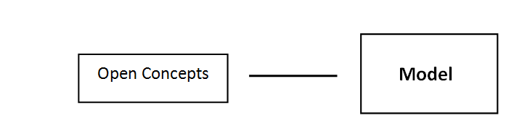
Figure 1: Visualisation of the connection between the theoretical notion and the model

2.2 Practice theory
A sophisticated model does not make a new sustainable business initiative. Eventually the model, which represents the specific interpretation of CE, needs to be implemented in practice. That is why practices are the second and indispensable element in the emergence and development of CE business initiatives. After all, existing practices of an organisation need to be adopted or in some cases even new organisations are founded. If not, the status-quo will be maintained and new initiatives will not emerge. Using a theoretical notion observing the practice, is relevant in two ways. First, using a theory helps to observe and analyse the object of interest more systematically (Verschuren & Doorewaard, 2007). Besides this general argument, there is also an advantage related to the objective of this research, by gaining insight in the combination of drivers behind the development of the initiatives. These drivers relate to all kind of aspects: the discourses, environment, but also the practice itself. For example, it is possible that certain practices are strongly rooted in the linear economic structures, with result that they are loathe to change. Using a theoretical perspective makes it possible to distinguish these factors in a systematic manner. In this research the notions of practice theory will be used.
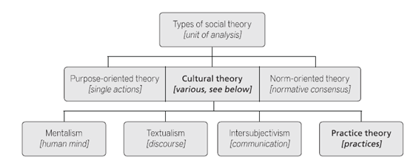
“Practice theory offers a system of interpretation, a conceptual framework that comprises a certain way of seeing and analyzing social phenomena, which enables certain empirical statements, and excludes others” (Kuijer, 2014, p. 24). Practice theory differs from other theories in social sciences, because practices are the fundamental unit of analysis as opposed to other common used theories. Practice theory tries to undermine the traditional individual – non-individual divide, by using elements of both sides (Schatzki, Cetina & Savigny, 2001). So in explaining a social phenomenon, structures are not seen as an explanation of individual behaviour. And the other way around, structures are not able to explain individual behaviour. Instead, both structure and the individual behaviour play a role in explaining the practice (Schatzki, et al., 2001; Kuijer, 2014). The place of practice theory within social theory is visualised in Figure 2.
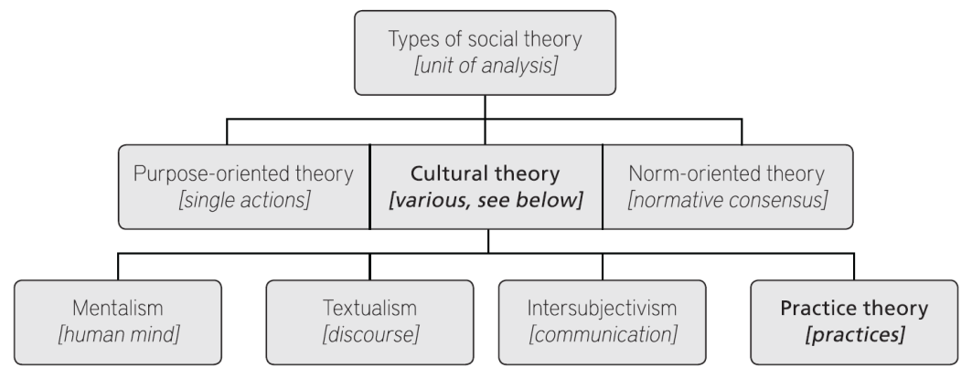
Figure 2: Position practice theory in social theory (Source: Kuijer, 2014, p.25)
By using practice theory, the existing dichotomy in science between agency and structure can be breached. Most studies on transitions towards more sustainable behaviour focus on the individual behaviour of people and the way in which behavioural change can be triggered. This perspective is also reflected in policies, which are dominated by social psychologists and economists using an individualistic perspective (Spaargaren, 2011). Using practice theory could therefore point at new directions for governance on steering and influencing the transition towards a more sustainable and resistant future. Transitions are difficult to have a grip on (Shove & Pantzar, 2005). Every transition process is unique and it depends on several factors if a concept or discourse leads to a widespread of policy and business initiatives (Gladwell, 2000). In understanding the emergence of new initiatives the focus should be on the socially embedded foundation of behaviour, the network underlying these CE business initiatives (Spurling, et al., 2013). Changes in this network result in adoptions of the daily practices. Practice theory is very useful in this context.
Another added value of practice theory in contrast to other social theories relates to the diversity of elements brought together in the understanding of a practice. So, not only habits, technological aspects or behavioural aspects are considered, but all elements which could be of relevance are explored (Gram-Hanssen, 2011). For example the material dimension is included (Shove & Pantzar, 2005) and also attention is paid to the symbolic structures of knowledge. “The implicit, tacit or unconscious layer of knowledge which enables a symbolic organization of reality”, is acknowledged by practice theory (Reckwitz, 2002b, pp. 245-246). So, practice theory offers an alternative way of looking at reality. Given the objective of this research such approach is highly relevant to use. Moreover, it fits well within the current relational turn in economic geography. In this turn more and more attention is paid to relational approaches and relations between places, instead of a focus on demarcated places and objects (Jones, 2009).
The position of practice theory and the importance of this theoretical approach for this research is discussed, but what does practice theory actually mean and what are the main principles? As is mentioned earlier, there is no universal set of rules or guidelines within practice theory. A general conception of the concept exists, but scholars operationalise the concept in different ways (Reckwitz, 2002b). Practice theory emerged already in the 1970s. With scientists like Anthony Giddens (structuration theory), Pierre Bourdieu (habitus) and Jürgen Habermas (communicative rationality) developing the concept. In Jones & Murphy (2010) a good overview is given of the theoretical foundations of practice-orientated research. Despite the development of multiple practice-orientated approaches, which arose as a response to similar challenges in social sciences, it took until the end of the 1990’s until a more coherent approach of practice theory was developed. In this ‘practice turn’, practices became the fundamental unit of social analysis and the recursive relation between (social) practices and individual performances provided a basis for empirical social research and science (Southerton, et al., 2012, p. 239). Therefore in this research I will build on the practice theories emerged after the practice turn. Practices in these theories refer to practices as a noun. That is why every type of behaviour or action can be seen as a practice (Schatzki et al., 2001; Kuijer, 2014). A widely used definition of ‘a practice’ is the one formulated by Reckwitz:
A practice is “a routinized type of behaviour which consists of several elements, interconnected to one other: forms of bodily activities, forms of mental activities, ‘things’ and their use, a background knowledge in the form of understanding, know-how, states of emotion and motivational knowledge” (Reckwitz 2002b, p. 249).
So, different elements constitute a practice by their congregation and interaction. Schatzki (2002) illustrates this with the example of football. In order to play football we need players, a ball and goals. But these physical elements do not constitute the game alone. A certain idea of playing and a measure of competence are necessary to play the game as well. These are just among other elements which constitute the practice ‘football’. The existence of the practice depends on the interconnectedness of these elements and that is why the practice cannot be reduced to one of these elements alone. If one element changes, disappears or new elements are introduced, the practice will change or a new practice will emerge (Shove, et al., 2012). Practices constitute a routinised pattern of these individual elements, which reproduce the practice. “The single individual - as a bodily and mental agent – then acts as the ‘carrier’ of a practice – and, in fact, of many different practices which need not be coordinated with one another. Thus, she or he is not only a carrier of patterns of bodily behaviour, but also of certain routinized ways of understanding, knowing how and desiring” (Reckwitz, 2002b, p. 250).
Different terminologies are used to categorise the individual elements. An important reason for the differences in conceptualisation can be found in the question how technologies, things or products (the material) are incorporated in the theory (Gram-Hansen, 2011). In this research I will build on the categorisation used by Shove and her colleagues (e.g. Shove & Pantzar, 2005). Her terminology is often used in research on sustainability and in empirical studies (Shove & Pantzar, 2005). This in contrast to the conceptualisation provided by Schatzki. His work is more philosophical and therefore more difficult to apply in empirical research (Warde, 2005). Three categories can be distinguished: (1) material, (2) competence and (3) meaning. These dimensions are visualised in Figure 3.
The (1) material dimension consist of the physical objects such as infrastructure, encompassing objects, tools, hardware, materials and the human body itself (Shove, et al., 2012). In social studies this material dimension is often not taken into account, while this is an essential component in the development. The second distinguished dimension is (2) ‘competence’, which refers to practical consciousness or in other words described as deliberately cultivated skills (Giddens, 1984). It is about “the learned bodily and mental routines, including know-how, levels of competence and ways of feeling and doing” (Kuijer, 2014, p. 27). So, competences consist of (shared) knowledge which is used to reach a certain standard by means of physical and mental skills. (3) ‘Meaning’ is the third dimension. ‘Meaning’ refers to mental activities, motivational knowledge and emotion, which represent the social and symbolic significance of participation at any moment (Shove, et al., 2012, p. 23). In other words, these are shared ideas that give meaning to the practice (Kuijer, 2014).
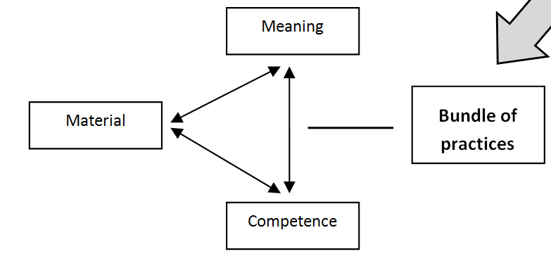
Figure 3: The dimensions of practice theory that constitute the bundle of practices
The discussed elements are not independent; they all mutually influence and shape each other. This is why all three elements must be taken into account. In this research, CE business initiatives are traced back to the roots in order to identify the drivers for conceiving and developing these initiatives. Practice theory in this context can be used to look for a change in the bundle of practices. In order to develop a CE business initiative, existing structures must be adopted or even a new organisation must be created. This takes place through a change in the bundle of practices – the presence and interaction of the material, competence and meaning dimension. New practices consist of a constellation of existing elements with an introduction of new elements, or new configurations of existing practices (Røpke, 2009). “From this point of view, innovations in practice are not simply determined by the generation of new products, images or skills. What really matters is the way in which constituent elements fit together” (Shove & Pantzar, 2005, p. 61). The emergence of new CE business initiatives in light of the field of tension between practice and concept can be understood by looking at these configurations of elements, see Figure 3. The context (e.g. company, country, and region) in which CE is implemented in specific local business initiatives is decisive for the result. Røpke (2009) illustrates this as follows: “Interestingly, a game like baseball can take on very different meanings in different national contexts; but the game can be played by teams from two different nations even though, in a sense, they play two different games.... In the same way, practices can be differentiated when they travel across the social spectrum, as playing golf has done” (p. 2494).
The comprehensive character is a great advantage of practice theory, but at the same time this makes the concept fuzzy. Because there are no guidelines, the delimitation of practices is the biggest challenge using practice theory in empirical studies. Therefore, it is important to stick to the research objective and structure. Looking at the objective we can conclude that it is only necessary to look at the elements that changed in the bundle of practices, because these are the practices that played a role in the development of the CE business initiative. Moreover, somewhere a border has to be drawn; otherwise you can indefinitely continue labelling elements of practices. Another problem relates to setting the boundaries between elements considered to be constitutive for a practice. Also for the elements there is not a guideline or topic list. Defining something as a practice or an element constituting a practice, has to make sense to people (Røpke, 2009). The categorisation has to be logical and fit within the research design. The work of Elisabeth Shove and her colleagues (Shove, 2012; Shove & Pantzar, 2005; Shove & Walker, 2010) is a useful inspiration in this context, because they use practice theory in empirical research, which is comparable to the design and content of this research.
2.4 Governance
The external objective of this research is to gain insights which could be used to support companies and other organisations in their transition towards a more sustainable and resistant economic model. These insights are based on the acquired knowledge about the drivers for the emergence of CE business initiatives. These initiatives are not conceived and developed in a demarcated area; they are the result of interaction and collaboration. More important, people on different levels (try to) influence and steer the development of CE business initiatives. Therefore, ‘the interaction between actors’ is the third distinguished element. The theoretical notion of ‘governance’ will be used to explain the interaction of actors.
The term ‘governance’ refers to “the process of social and economic coordination, management and ‘steering’” (Gregory, et al., 2009, p. 312). This umbrella term consists of numerous, sometimes contradictory, definitions. Often is referred to governance as the opposite counterpart of government. This means, the changing boundaries between the authorities (government) and private actors, whereby the latter gets more influence in the decision-making process (Pike, Rodríguez-Pose & Tomaney, 2006; Rhodes, 1996; Shove & Walker, 2010). In this research we are not talking about governance as equivalent of government, but about governance as collaboration structure. In this context “governance refers to forms of inter-organizational coordination modelled neither on hierarchies nor on markets but on networks, especially where these are ‘self-organizing’” (Gregory, et al., 2009, p. 312-313). A widely cited scholar who used this definition is Rhodes, he speaks about governance as “self-organizing, interorganizational networks” (Rhodes, 1996, p. 660). In this definition four characteristics are distinguished:
- Organisations are interdependent from each other.
- Due to the need to exchange resources and negotiate shared purposes, members in the network have continuing interactions.
- Interactions of network members are rooted in trust and regulated by (invisible) rules, which are agreed by all participants.
- There is a significant degree of autonomy from authorities and the state in general.

(Gregory, et al., 2009; Rhodes, 1996)
‘Network’ is a central element in the definition of Rhodes (1996). The actors participating in these networks are in a certain way depending on each other, for e.g. money, expertise, resources and sales. In order to prevent complete dependency, collaboration is necessary. And these networks are characterised by trust, reputation, reciprocity and mutual interdependence (Larson, 1992). Network in the definition of Rhodes can be described as the interaction and collaboration between different actors. Mapping this network involved in the emergence and development of CE business initiatives, provides insight in the governance.
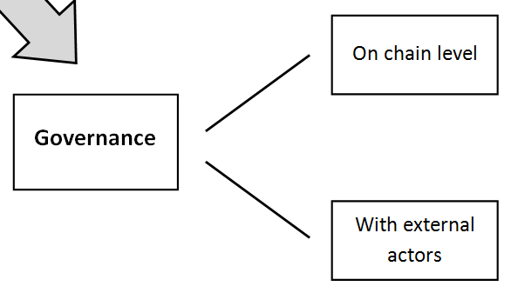
Using governance in this research, a distinction can be made between two types of governance. On the one hand governance is one of the elements that is decisive in the development of CE business initiatives, as a local translation of the model. This relates to the way in which the collaboration between actors involved in the genesis of the initiative is shaped and the ability of actors involved to steer and manage the process within the chain. In this case, steering takes place at chain level. On the other hand it is referred to governance as the interaction, both voluntary and involuntary, of the organisation with ‘external’ actors. This type of governance refers to the inter organisational network and is constituted by among others, the interaction with authorities. In this context different means ‘can be used’ to influence the interaction, such as jurisdiction, facilitation and subsidisation. This second type is also named governance with external actors. Both governance relations, are visualised in Figure 4.
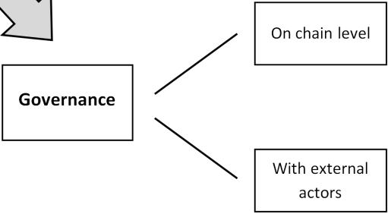
Figure 4: Visualisation of the two types constituting ‘governance’ in this research
Also in context of the external objective in this research we can speak of governance. The insights obtained are a way to facilitate the transition process as optimal as possible. So, governance is about managing the networks. If this would be applied to this research, the question would be: “how could we manage the drivers underlying CE business initiatives, which create this local translation of CE in practice?”. When this question is translated into terms of ‘practice theory’, the purpose would be as follows: “which bundle or constellation of elements should be steered in order to support the development of a CE business initiative, as a local translation of the CE concept in practice?”.
2.5 Conceptual model
In the previous sections, theoretical notions of ‘open concepts’, ‘practice theory’ and ‘governance’ were provided. These insights can be used in order to analyse the emergence and development of CE business initiatives. The business, the model or the environment alone does not lead to structural change. It is the mutual and continuously interaction between these elements, which results in CE business initiatives. Therefore in this section the relations between the central concepts in this research will be described.
The relations are visualised in the conceptual model ‘the Theoretical triangle’ in Figure 5. The model is a summary of the previous sections and represents the individual relations from Figure 1, 3 and 4. The conceptual model forms the basis for the data collection and analysis of the CE business initiatives (Chapter 5-8) and should provide answers on the second, third and fourth sub question of this research. The first sub question on the development of the concept CE is a descriptive one and aims at outlining the context of the CE concept. Therefore, this question is not relevant for the conceptual model. The objective in this research is to identify the drivers that explain how CE business initiatives are conceived and developed. With the conceptual model in Figure 5, those drivers can be identified.

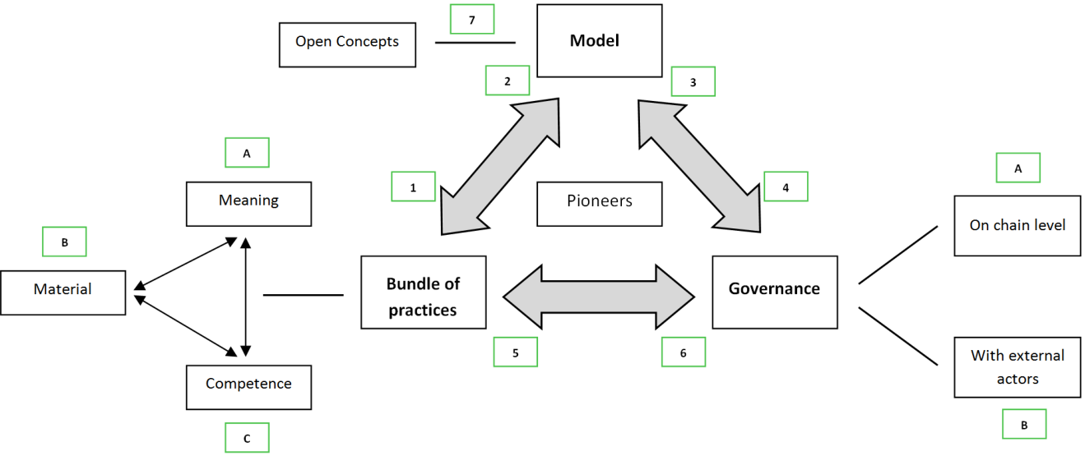
Figure 5: Conceptual model: ‘Theoretical triangle’
A practice consists of three elements: (A) meaning, (B) material and (C) competence. The interaction between these elements results in a unique bundle of practices. If one of the elements will change, the practice changes as well. In this way, new practices emerge and if practices change on large scale ultimately a transition towards a more sustainable and resistant economic system will take place. The relation between ‘the bundle of practices’ and ‘model’ is crucial. This relation puts the label CE on the practice; otherwise it could be any kind of practice. The model represents the idea or vision for the CE business initiative. The model is constituted by all kind of inspiration, sources, scripts, ideas and definitions. This can be understood by means of the notion ‘open concepts’ [7]. The relation between practice and the model is twofold. First, the model influences the bundle of practices [1]. The model (specific vision on CE) shows how the bundle of practices should look like. Existing practices could not correspond to this model. In order to meet the vision, existing practices change in service of the model. On the other hand [2] there is resistance and friction within the bundle of practices (barrier), because the implementation of the CE concept is new. This could result in a change in the model, because there is a discrepancy with the practice. Experiences in practice change the model and could in this way also serve as inspiration for the model. CE is in fact a radical change of the existing structures in which the daily activities of organisations are deeply embedded in.
The second relation in the ‘Theoretical triangle’ relates to ‘the bundle of practices and governance’. Governance includes the whole of interaction between actors and the way in which processes are steered or managed. In this context a distinction is made between ‘governance on chain level’ [A] and ‘governance with external actors’ [B]. The relation between governance and the bundle of practices is twofold as well. The governance influences the bundle of practices by means of collaboration structures within the chain or the institutional setting (the governance with external actors) [5]. For example elements in the institutional setting could be barrier or an enabler for the emergence and development of new practices. So, the bundle of practices is depending on the governance structures for achieving change. For example: a change in the production process could be restrained by legislation or the collaboration between actors in the chain. The bundle of practices influences the governance as well [6]. This refers to signals that are issued to governance structures, result of which structures change. For example, because of the change in the production process, new actors are introduced in the chain. In the ‘Theoretical triangle’ the relation between the ‘bundle of practices and governance’ is the least interesting, because this research is about the CE concept and the way in which this concept result in actual initiatives. And, this notion of CE concept is embedded in ‘the model’ in the ‘Theoretical triangle’ in Figure 5.
The relation between the model and governance also acts in two ways. With governance the model is steered. So, what the vision on the CE business contains and how it should be implemented in practice is influenced and steered by the interaction between actors [3]. The interplay of actors and barriers in this, both voluntary and involuntary, can change the ideas about CE. The other direction of the relation between governance and model relates to the implementation of the model in the governance structures [4]. The model has to fit within the existing collaboration structures (governance in the chain) and institutional setting (governance with external actors). Therefore, governance structures could change in service of the model. For example, an adoption of the jurisdiction or facilitation is necessary in order to implement the CE model.
The pioneers are the binding force in the ‘Theoretical triangle’ In case of the business initiatives; entrepreneurs are these pioneers who are indispensable for the success of the initiatives. In addition, also policy makers, intermediaries, scientists or inspirers, may have this role. Pioneers are the crucial link making the interaction between the three concepts ‘practice’ – ‘model’ – ‘governance’. The relations between the central concepts are globally described above. The specific interpretation of these relations depends on the examined cases. Every business initiative is unique and the way in which these concepts are intertwined and linked together can therefore differ from case to case. More insight in the specific content of the relations in the ‘Theoretical triangle’ will therefore be provided in the analysis (Chapter 5-8) and the conclusion (Chapter 9). This theoretical framework provides one way in which the emergence of CE business initiatives can be analysed. Therefore it is possible that developments take place due to other reasons than can be explained by this conceptual model.
On the basis of the conceptual model, theoretical framework and the introductory first Chapter hypotheses could be formulated for the three sub questions which are relevant for the examination of the CE business initiatives. These hypotheses will be tested in the analysis.
- How is the notion of CE for the business initiative established and which crucial drivers can be identified in this development?
- Pioneers are the driving force behind the emergence of the CE notion. In the collaboration with others, these pioneers are driven by various sustainability concepts and a strong connection with the contemporary buzz surrounding CE can be identified.

- How is the concept CE implemented in the business initiative, and to what extent are the business activities and governance structures adjusted to the principles of CE?
- CE is implemented in various ways. Both the governance structures and the bundle of practices change in service of the model. Major adjustments are realised, because ideas about CE have to fit within the current linear (economic) structures.

- What are the barriers for the implementation of CE in practice and how do pioneers deal with these barriers?
- The variety in barriers will be great, determined by the type of business initiative and environment in which the CE model is implemented. It can be expected that the barriers mainly are related to the governance (e.g. jurisdiction, financing and collaboration with other actors). The competences of the pioneers involved in the business initiative will be crucial in overcoming these barriers.
3 Methodological framework
3.1 Introduction
Different phases must be completed in order to achieve the objective. These steps are visualised in the research model in Figure 6. The first phase (A) consists of a desk research on the central concepts in this research. The gained insights in this phase form the input for the theoretical Chapter and provide a basis for data collection, in phase (B). In phase (B) the fieldwork is conducted. Necessary information is gained from stakeholders for the four cases. Phase (C) covers the analysis. Each case is separately analysed and the outcomes of the different cases will be compared to map similarities and differences between the cases. The answers on the sub questions form the output of the analysis in phase (D). During this phase, the results are transferred into a coherent story on paper. The results from the analysis are put together with the results following from phase (E). Phase (E) covers the analysis of the CE concept. Answers are provided on the questions: ‘how did the concept developed?’ and ‘how is CE used in Dutch or ‘Gelderse’ context?’, in other words what are the dominant discourses about the CE concept? These questions provide the necessary context information. Phase (F) covers the concluding remarks of this research. In this phase the results are interpreted and it will be examined whether they contribute to the objective of the research.
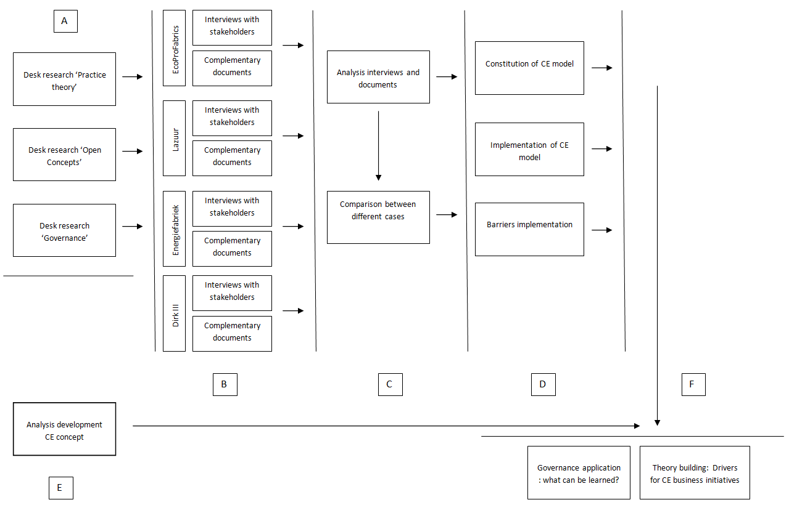
Figure 6: The research model
The described process has been iterative instead of linear. Continuously is reflected on the choices made in this research and approaches were changed when new insights and experiences revealed that change was necessary. Nevertheless, it is of great importance that a research has a strong structure and that there is a high degree of consistency, otherwise it is very difficult to gain reliable and valid results. In this context a strong methodological foundation is indispensable (Clifford, et al., 2010). That is why this Chapter provides a detailed description of the methodological framework. First, in section 3.2 the used research strategy is explained. Section 3.3 discusses the research design. In section 3.4, the used research methods and the data collection process is described. Next, section 3.5 will discuss the data analysis phase. In section 3.6, an explanation is given for the approach and research methods used in the analysis for the first sub question about the development of the CE concept. This question also relates to phase (E) in the research model in Figure 6. Answering this question provides necessary context information about the development of the concept CE. However, this question is unrelated from the other sub questions, which have a shared and different research methodology. Finally, in section 3.7 a conclusion about the used methodology is given, in which the research methodology is accessed against criteria for trustworthiness.
3.2 Research strategy
The type of research carried out and the own philosophical orientation of the researcher are important factors that are determining for the research methodology (Verschuren & Doorewaard, 2007). The philosophy gives insight in the researcher’s position in ontology and epistemology. Ontology is related to the essence of ‘being’. It describes the characteristics of existence. Within a scientific frame, it makes a meaningful measurement of the reality possible. Roughly speaking, two opposing views on the ontology can be distinguished; ontology that is nourished by constructivism and assumes multiple relations versus ontology based on a positivistic tradition. Constructivism assumes the idea that there is no single truth (Gunder & Hillier, 2009). Things exist because we (as persons) give meaning to it. That is why according to constructivists, multiple relations and perspectives on reality are possible. The positivist tradition on the other hand, is based on a single truth perspective. Things exist because we observe them and this determines the meaning of reality (Verschuren & Doorewaard, 2007). As ontology refers to ‘being’, epistemology is about ‘knowledge’. Epistemology is about the nature, source, conditions and scope of knowledge. For scientific research the epistemological position is of great importance because it defines what knowledge is. Roughly speaking, a distinction can be made between positivist epistemology and interpretative epistemology. The first strand is strongly rooted within the physical sciences and can be described as a hard paradigm. It is about objective facts and sees knowledge as a reflection of reality. Knowledge emerges through research in which scientific verification is indispensable. The opposite of positivist epistemology is the interpretative epistemology. According to this perspective knowledge does not relate to finding facts or a single truth, instead it is about believes that give access to reality. Knowledge emerges because people give meaning to things (Kumar, 1999).
In this research will be worked from ontology based on constructivism and an interpretative epistemology. In this research it is about the way in which CE moves in society from place to place, resulting in actual local translations in business initiatives. So, there is no universal or right understanding of the CE concept. In this context a single truth does not exist and therefore the interpretative epistemology and ontology based on constructivism, fits this research the best.
The research strategy is related to the philosophical orientation as described above. A research strategy is a coherent set of procedures and rules to explore a certain phenomenon (Vennix, 2010). It is a framework that gives the researcher a guideline. Different frameworks or designs can be combined. Not the research design, but the phenomenon or problem under study determines the shape of the research (Verschuren & Doorewaard, 2007; Vennix, 2010). Thereby, the most important methodological aspect of the research relates to a systematic way of conducting the research. Building on the philosophical orientation of a constructivist ontology and an interpretative epistemology, a qualitative research strategy is used. Qualitative research works from a holistic approach in which a certain phenomenon is examined as a whole (Venix, 2010). In addition to the research philosophy, there are other arguments that legitimise the choice for a qualitative research strategy instead of a quantitative strategy. First, policy and business initiatives based on the CE concept are still confined to a select group of pioneers (Jonker, et al., 2013). A more qualitative and holistic approach exploring this field is therefore more suitable. Moreover, the research is carried out at ‘meso’ level, because business initiatives emerge in the interaction between actors. Therefore, I look beyond the business initiative alone. In this way a complex network of relations is mapped. It is impossible given time constraints to use a quantitative research strategy in this context. A final reason relates to the objective of this research. The objective is to gain in-depth insights, instead of a generalisation of the outcomes to a larger ‘population’. So, a qualitative research strategy suits therefore this research the best.
Often there is critique on qualitative research, especially from scientists in the positivist tradition. According to them this kind of research gives to much room to subjectivity and is vague too. Baxter and Eyles (1997) conclude on the basis of a review of empirical research in Human Geography, that geographers paid little attention to the principles for using qualitative research, especially when making use of in-depth interviews. Instead they were more focused on the comparison with quantitative research (Visser, 2012). In order to prevent this research from vagueness, it is important that transparency is given in the used methodology. The sections that follow in this Chapter should contribute in making this process more insightful.
3.3 Research design
Within the qualitative strand there are different methodologies to work with. The case study fits this research the best. “A case study is an empirical inquiry that investigates a contemporary phenomenon within its real-life context, especially when the boundaries between the phenomenon and the context are not clear evident” (Yin, 1994, p. 10). So, a case study design is a flexible and cyclic process, making it very suitable for this research. The trajectories of CE business initiatives are explored, not knowing in advance what they look like. In a case study design, the unit of analysis is studied detailed from different angles. This character fits well within the objective of this research. Moreover, as a researcher I have no control over the situation. The business initiative has to be studied in their real-life context, because the initiative develops within this specific context. A case study design is for this reason very useful (Yin, 2003). Another characteristic of the case study relates to the fact that there are less data points than variables of interest. Therefore the research relies upon more than one data source for the case. This means that triangulation will be used to understand and explain the drivers for the emergence of CE business initiatives in light of the field of tension between concept and practice.
Working with a case study framework has also its limitations. The most important limitation is described by Clifford, French and Valentin (2010) as follows:
“The generality of the case is unknown. There is no formal basis for substantiating inferences made about a population on the basis of a single sample, such that extrapolating the findings of the case to the population remains merely a matter of intuitive judgement on the part of the investigator” (p.232).
However, the objective of this research is not to generalise the outcomes. This does not fit with the nature and the background. In this research four cases are analysed, making it a multiple case study design. Making use of a multiple case study design makes comparison possible and in some situations even generalisation (Yin, 2003). This generalisation does not refer to statistical generalisation, making use of sampling units. Instead we can speak of analytical generalisation, which means that a set of results is generalised to a broader theory (Yin, 2003; Visser, 2012).
3.4 Data collection and research methods
The data collection consisted of different parts depending on the phase of the research. As described in the research model in Figure 6, the first part of this research consisted of an extensive literature review on practice theory, the circulation of concepts (open concepts) and governance (phase A in Figure 4). Phase (B) in Figure 6 refers to the data collection of the four business initiatives which are studied. Data indispensable for answering three of the four sub questions (the first sub question is related to the development of the CE concept).
Casus selection
In total, four cases are analysed in an attempt to gain more insight in the emergence and development of CE business initiatives. The case selection has been established on the basis of a number of criteria. First, the research area has to be taken into account. Gelderland is the area in which this research is conducted. The borders of this region are set at the institutional borders of the province Gelderland. The geographical scale is set at regional level, because ideas and scripts are often local or regional translated into specific business or policy initiatives (Lagendijk & Needham, 2012; EREP, 2014). Besides, in economic geography more often the focus in research moves to regional level (Hendrikx & Lagendijk, 2008). Delineating the research at regional level is consistent with these points. Moreover, such demarcation reduces the research area; this increases the feasibility of the research. Specifically, Gelderland is chosen more or less because of practical reasons. On forehand I knew that already some CE business initiatives were developed in this region. Moreover, my internship organisation, Royal HaskoningDHV, is located in Nijmegen, which implicates that they have a lot of contacts with experts and organisations engaged with the subject of CE. Also for personal reasons Gelderland is chosen as research area. I am living and studying in Nijmegen and due to this experience with the region, I have already some useful contacts myself.

With the choice for Gelderland as the research area, a first criterion for the selection of cases has been created. The case has to be located in Gelderland. Nowadays, often business activities are not demarcated to one region alone. That is why the practical consideration is made that the core of the business initiative has in fact to be located in Gelderland. A business initiative develops within a certain context. This environment makes every business initiative unique. Derived from the first Chapters we could state that the context in which understanding and meanings of a practice are spread is a crucial enabler for a transition towards a more sustainable economy. So, when different cases are located within the same context they are better comparable.
A second criterion concerns the relation of the business initiative with the concept CE. In this research no use is made of a definition of CE because it is all about the way in which the concept is implemented. However, there needs to be a connection with the CE concept. The organisations behind the initiative need themselves to put the label CE on the initiative. In addition the initiative needs to be seen by others as an example of CE, then the initiative meets the required criterion. In addition to this, it is interesting to select cases that are seen as classic examples of CE. Because, these ‘best practices’ provide often inspiration for other companies and organisations. This is also encouraged by the EU. They endeavour to build on ‘best practices’ at national and regional level in the support of companies (EREP, 2014). So, best cases have often much impact on practice and that makes them interesting to examine.
The last criterion concerns the typology of the business initiative. A business initiative in this research relates to the emergence of new business activities or a change in the existing business activities, containing an economically component and organised by more than one person in a professional organisation. The exact type or form of the initiative has not been a decisive factor. The initiative could be a complete value chain, but it is also possible that a small local initiative between residents was selected. So, in the selection of cases there were no strict requirements regarding the characteristics of business initiative. If the selection criteria had been too strict, there were probably not enough cases to study as this research explores a relatively new phenomenon. So, my own consideration about the degree to which the cases were interesting to select, played a role.
On the basis of the criteria described above, I started looking for interesting cases. I searched the Internet and had interviews with CE experts in the region. On the basis of this search I composed a list of CE (related) initiatives in Gelderland. In compiling this list I asked CE experts, municipalities, the province, research institutes and intermediaries to make additions to this list. On the basis of this list I selected four cases, which seemed to be achievable looking at the available time. So, in the selection of cases the snowball method was used (Creswell, 2007). By word of mouth I got in touch with the following diverse cases: Lazuur food community (Chapter 5), Dirk III (6), EcoProFabrics (7) and Energie en Grondstoffen Fabriek (8). Before was started with the analysis of these cases, the proposal for this case selection was put to my supervisors at the university as well as Royal HaskoningDHV.
Data collection
After a preparatory period of almost three months, in which I explored the theme, had talks with CE experts and finalised the research plan and strategy, I started the fieldwork in late April. The fieldwork covers phase (B) in the research model in Figure 6. Within the chosen research design and strategy, a number of methods could be used. Looking at the objective of this research, in-depth interviews seemed to be the most suitable method.

You don’t know what you will encounter tracing the development of a business initiative from contemporary until the roots. Interviews are a flexible method and allow you to follow the developments you come across. Moreover, with interviews it is possible to gain in-depth insight in the processes and important drivers behind the development of the business initiative, these are important insights looking at the objective of this research. The implementation of the CE concept in the initiative can often be found in policy documents of the organisation(s) involved. But, sources of inspiration, challenges and barriers in the implementation or insights in the state of affairs of the process, are (usually) not documented. Therefore, interviews are useful in order to gain insights in these aspects. Conducting multiple interviews allow the researcher to analyse the story from different angles. This is necessary to gain a clear image of the process, because several persons are involved in the development of these business initiatives. Besides, often different actors are involved in different phases of the process. This makes it even more necessary to conduct more than one interview for each case. Finally, 16 interviews were conducted for the four cases. An overview of the respondents can be found in Appendix A. For each case I started with an interview with the key actor in the process. At the end of the interviews I asked these persons for other decisive actors in the process. In the second interview I did the same, and in this way I managed to speak with the crucial actors in the development of the initiatives. So, the snowball method was used for the recruitment of the respondents as well (Creswell, 2007).
Face-to-face semi-structured interviews were used in collecting the data. Every interview covered the own story or perspective on the emergence and development of the CE business initiative of the interviewee. So, there was relatively much space for the actual content of the interview by the respondent. This corresponds to the character of the research. In spite of this space, I made use of a topic list in order to ensure that all information necessary for answering the research question was retrieved. On the basis of the sub questions and conceptual model, a scheme was made (Appendix B), which was used as a guide during the interviews. The advantage of using a semi-structured interview relates to the fact that follow-up questions can be asked if necessary. But using semi-structured interviews means that you need to be sharp during the entire conversation. The interviewer should be able to intervene, if the respondent digresses.
The sixteen interviews are complemented with relevant (policy) documents of the organisations involved in the initiative. This is necessary because in some cases respondents referred to documents (statutes, transition documents, etc.). In other cases there were already some useful documents available online, which contained a lot of information about the development process and the way in which the concept CE is translated in the business initiative. Making use of already existing sources has an advantage in comparison with interviews, because a level of interpretation disappears. During interviews, the vision, perspective and way of working had an influence on the results gained from the respondents. This first level of interpretation doesn’t take place while making use of existing materials, because the information is already ‘on paper’. By making use of both interviews and documents, and in an earlier stage of the research a literature study as well, triangulation is used. This is an asset of the methodology in this research (Vennix, 2010). In section 3.7 there will be elaborated on the way in which is dealt with subjectivity and interpretation in more detail.
3.5 Analysis and coding
The output, resulting from the interviews and complementary documents, is systematically analysed. This constitutes phase (C) in the research model in Figure 6. It is important that the collected information is systematically analysed. Looking at the critique of among others Baxter and Eyles (1997) on the transparency and use of methodologies in qualitative research, this is an important aspect to keep in mind while designing and carrying out the analysis.
The first step in the process contains the analysis of the individual cases. When the storyline of each individual case is put on paper, the cases can be compared in order to look for similarities and differences. For each case multiple interviews are conducted, as is described in the previous section. In order to systematically deduct valid answers to the sub questions relevant for this part of the research, the interviews are coded. “Coding is not just labelling, it is linking: “It leads you from the data to the idea, and from the idea to all the data pertaining to that idea”” (Saldana, 2013, p. 8). In all its simplicity the process of coding can be seen as a tool to bridge the data collection with the data analysis.
Consistency is in this process of great importance. The researcher is surrounded by subjectivity. As a researcher you will always be influenced by your past, expertise, experiences and preoccupations, which results in the fact that we observe the reality through a lens or filter (Creswell, 2007). In social sciences we are not able to ban this subjectivity completely. In order to deduct results which are not highly steeped by the researcher his vision, it is important to structure the coding process.
First, a statistical program called Atlas.ti is used. This qualitative data analysis software makes it easier to analyse data sources in a systematic manner, in comparison to manual coding. Interviews were transformed into verbatim transcripts, which in turn were imported in Atlas.ti. By means of codes, categories and memos an overview of the useful information from the interviews was created. Second, in advance a code book was made, which was used for encoding the transcripts. Using codes made it possible that key moments, actors and factors in the development of the CE business initiative were identified. The code book was constituted based on the conceptual model in Figure 5 and the sub questions. This means that a deductive way of coding is used. A snapshot of the codebook is displayed in Figure 7. The entire codebook can be found in Appendix C.
In addition to the deductive codes, open codes (inductive coding) were used for information that did not fit within the deductive codes created in advance. Open codes were only used when the information was useful for answering the research questions. Also an overview of the open codes can be found in Appendix C. In addition to the open codes that are similar for all four cases, there is a special category of codes used in the analysis. These are the codes referring to a time period in the development of the individual initiatives. Those codes are different for each examined case, depending on the way in which the business initiative developed. A distinction in time is useful in order to structure the data, because there is a lot of information that is only relevant for a part of the development process. Also, these codes can be found in Appendix C.
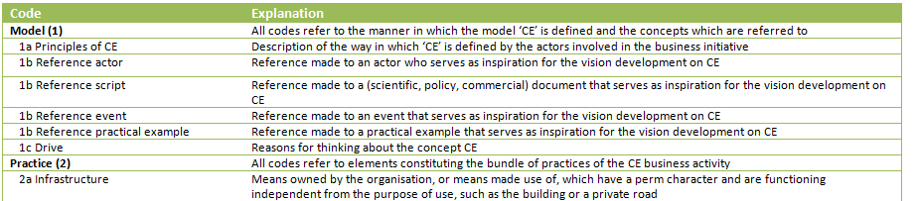
Figure 7: Snapshot of the code book
The code book is a tool for the researcher to analyse the data in a more structured way. An additional example of structuring used in the analysis can be found in the use of numbers for the deductive codes (see Figure 7). Codes part of the same category received the same number. This made it easier to find the useful codes during the writing process in the analysis. Another example can be found in the coincidence of different codes. When different codes apply to the same quote this provides detailed information. For example, the coincidence of the codes ‘enabler’, ‘shared mental activities’ and ‘continuity’. In Figure 8 an example is given of the coding process, making use of the different types of codes in Atlas.ti.
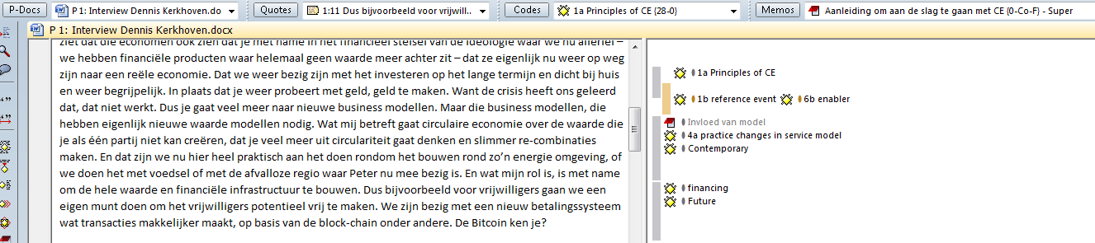
Figure 8: Snapshot of coding process in Atlas.ti
The overview emerging from the coding process is used to provide answers on the sub questions. In the research model in Figure 6 this is visualised in phase (D). On the basis of the distinguished time periods in every case, I structured and printed the coded information. The output emerging from this step constituted the basis for the writing process. The result of those analysis can be found in the Chapters 5 – 8.
3.6 Analysis of the CE concept
In addition to the analysis of the CE business initiatives, an answer must be provided on the first sub question: “how is the concept ‘CE’ conceived and developed in Gelderland and which key discourses and actors can be identified in this development?” The objective corresponding with this sub question can be described as follows: “Mapping the (geographical) development of the concept ‘CE’ within Gelderland and figuring out how CE is invented, developed and implemented in this region”. By doing this, the most important channels through which the CE concept develops are identified. This research activity is visualised in the research model in Figure 6 as phase (E). Another research strategy is used for this part of the analysis as it ‘only’ relates to a description of the context.
When people refer to CE they approximately mean the same: ‘a more sustainable economic system’ and ‘closing value chains’. However, the exact implementation differs from time to time, place to place and actor to actor. So, CE is a category of use in discursive configurations that constantly changing and developing. The development of the CE concept takes place through a certain pattern. First, the roots of the CE concept must be explored. Subsequently, the invention of the concept in the Netherlands must be explored. Important in this context are the dominant discourses and key actors that are decisive for the invention and later in the development ‘the diffusion’ of the concept. After describing the dominant discourse and key actors in the Netherlands, in more detail is looked at the invention and the spread of the CE concept in the Gelderland region.
The chosen strategy to explore the development of the CE concept and corresponding to this the methodology, is inspired by the work of Kooij and his colleagues on ‘clusters’ (Kooij, et al., 2012; Kooij, et al., 2014). In order to understand the circulation of the CE concept (in Gelderland) different data sources and methods were used. First, a desk research was conducted. The internet was searched for information about the roots of the concept, the dominant discourses on CE in both the Netherlands and the Gelderland region and key actors in the buzz surrounding CE. So, I have looked for e.g. definitions, actors and scripts were regularly is referred to in relation to the CE concept. In addition, I consulted (scientific) literature. In the work of Mentink (2014) for example, a good overview of the roots of the CE concept and dominant discourses in definitions of the concept are given. I complemented the analysis of the development of the concept CE with the information of in-depth interviews I held with e.g. the province Gelderland and experts and intermediaries on CE (in the region). A complete overview of the held interviews can be found in Appendix A.
So, the insights are gained by making use of different data sources information. All information is merged and translated into a logical storyline. Because this part of the research relates to the outlining of the context, additional analysis techniques were not necessary to use.
3.7 Criteria for trustworthiness
In the previous sections the research process and the methodology used in this research were described. As Baxter and Eyles (1997) conclude in their paper; qualitative research in social geography gives often much room to subjectivity, and is vague too. Therefore, it is important that the research process is transparent for the reader. According to Mason (2002) there are three main principles that determine the trustworthiness of the research. These are: generalisability, validity and reliability. These principles need to be obtained in order to convince the reader of the quality of the research. As a concluding remark in this Chapter the methodological framework has been tested on the basis of these principles of trustworthiness.
Generalisability
The first principle is generalisability and refers to the extent to which you are able to make a wider claim on the basis of the results of the research, rather than statements on the studied case alone (Mason, 2002). The case selection is crucial for a strong generalisability. The extent to which the studied population corresponds with the environment is crucial. Relevant aspects in this context are: the number of cases, the criteria for selection of the casus and the procedure of selection. For quantitative research generalisability, is often a main objective. However, in qualitative research it is often more difficult to generalise. Therefore the number of studied cases is often too low in comparison with the real number of the phenomenon in society (Vennix, 2010). Clifford, French and Valentin (2010) describe the extrapolating of findings in case study research as the most important limitation of this type of research design. But as mentioned earlier in this Chapter, the objective of this research is not to generalise the results to a broader population. Instead, an in-depth analysis of CE business initiatives is conducted. However, the external objective of this research is to use the gained insights to support companies and other organisations in their transition towards a more sustainable economic model. So, the results of the case study need to be relevant for a wider purpose.

There seems to be a discrepancy between the output of this research and the external objective. In order to close this gap I chose to select four cases to study. This should provide a more diverse image of the concept. Moreover, CE is a relatively new phenomenon, which needs to be explored. According to Clifford, French and Valentin (2010), it depends on the intuitive judgements on the part of the investigator, in order to make the results more suitable for generalisation. If in four diverse cases, comparable developments are identified, one could assume that these developments also apply to others cases. Starting from this thought you could argue, with caution, that results are useful for a wider purpose. More important, the results are not presented as a single truth. This would not match the character of this research. Looking at the diverse and multiple character of the CE concept and the business initiatives related to the concept, I chose to work from a constructivist ontology and an interpretative epistemology. That is why results derived from this research can be seen as ‘learning from good examples’, instead of a universal truth.
Validity
If a researcher adheres strictly to the research design, then the results should be correct and trustworthy. However, it is possible that structural mistakes are made, due to errors in the research design or methodology (Creswell, 2007). This may result in output that was not intended in advance. This is called ‘validity’ and revolves around the following question: “does the research measure what you want to measure?” Validity is strongly influenced by the conceptualisation and operationalisation in the research (Mason, 2002). Also the use of research methods that don’t fit the research well, may affect the validity in a negative way. In this research is made use of different research methods, e.g. literature study, interviews and document analysis. Looking at the process and the research background, these methods fit the research well. This triangulation has a positive effect on the validity.

During the research process I had to keep the objective of the research constantly in mind. Despite the fact that I tried to adhere strictly to the research design, in order to confine my own interpretations as much as possible, I approach the research as an iterative process. Changes were made in the research design, if it proved to be relevant on the basis of gained experiences. By being transparent in this, this is not a limitation for the trustworthiness of this research. In fact, it contributes to a higher degree of validity (Mason, 2002; Creswell, 2007).
In quantitative research it is possible to do a pre-test, to figure out if the research methods contribute in achieving the objective and if the results are in line with the research design (check of the operationalisation) (Vennix, 2010). This is more difficult in qualitative research, especially if you use in-depth interviews for the collection of data. By conducting the interviews one by one, it was possible to reflect on the interviews and use these insights in the next interview, changing the emphasis of the interview a little bit. In addition, starting the fieldwork at my internship with the first interview, it was relatively easy to reflect on this interview and it was even possible to do it over again. The intention of giving these examples, is to show the importance of flexibility in scientific research. Being guided by practice and more important being transparent in this, is crucial in obtaining trustworthy results.
Reliability
The last core principle distinguished by Jennifer Mason is reliability, it covers the accuracy of the research methods and techniques (Mason, 2002). By replication of the research by someone else with the same research design and methods, the researcher should gain the same results. Because strict replication of a study is often not possible (the environment changes as well), the criteria for reliability is that the research should be imitable. Therefore an elaborated and detailed research protocol is necessary (Yin, 2003). In quantitative research the reliability is often improved by means of standardisation. This concerns de standardisation of research methods and techniques and the use of different methods. The influence of external factors on the research results need to be banned. If the researcher is able to manage this successfully, the reliability will increase. In qualitative research this is more difficult. Standardisation can only be achieved to a certain extent, by making use of a conceptual model, interview guide, code book, etc. Such measures have been taken.
Despite the use of different methods and guides in the research process, the researcher is influenced by extent biases, motivations, experiences and perceptions (Baxter & Eyles, 1997). It is important to limit the subjectivity as much as possible; otherwise it is possible that the results don’t reflect the reality. Yanow (2006) describes four interpretative moments during the research in which the researcher consciously or unconsciously could put its subjective mark on the research. The first moment takes place during the interaction with the situational actor in the data collection. The words and sentences are interpreted by the researcher, which has an influence on how the interview is going. By letting people tell their story and by maintaining distance from the object of research, the objectivity must be maintained as much as possible. That is why I used only a small interview guide (Appendix B). So, the interviewee was only steered, when he or she was too much strayed. The second interpretative moment relates to the interpretation of the secondary material, which consists of the coding and analysis of the interview transcripts. Triangulation helped to improve the reliability in this phase of the research, making use of different data sources (Yanow, 2006). While coding the data in Atlas.ti, memos were written to reflect on the choices made. Reflection of the coding process contributes to the reliability as well. In the third interpretative moment the codes are analysed and the report is written. Also this is a moment in which the subjectivity of the researcher can influence the results. By letting someone look over my shoulder during the interpretation of the codes, my insights are compared with the interpretation of someone else. So, reflection is in the third moment important as well. The fourth and last interpretative moment relates to the reading or hearing of the report (Yanow, 2006; Visser 2012). First a draft version has been submitted to my supervisor. His check has been useful to reflect critically on the written text. For all four phases applies that transparency of the process is crucial. Transparency is one of the main keys to stay objective that is applied in this research in order to improve the reliability of the research.

4 The development of the CE concept
4.1 Introduction
This Chapter provides an insight in the most important developments of the CE concept. The four examined cases (Chapter 5 – 8) are a local translation of the CE concept in practice. Therefore, insights in the development of the concept are necessary to put the results of the analysis into perspective. In the previous Chapter on the methodology, it is discussed that this part of the research relates to phase (E) of the research model in Figure 6. The completion of this phase resulted in an answer on the following sub question: “how is the concept CE conceived and developed in Gelderland and which key discourses and actors can be identified in this development?”. First, in section 4.2 the roots of the concept are described. In section 4.3 an overview will be given of the (dominant) definitions of CE. Subsequently in section 4.4 the development of the concept in the Netherlands is described. Insights are provided on the dominant discourses and key actors in the development and spread of CE in the Netherlands. Finally, in section 4.5 a close-up will be taken of the way in which the concept ‘travels’ within the Gelderland region.
4.2 Roots of the concept
The CE concept is conceived and developed in the context of scientific and societal debates on sustainability and the organisation of our economy. Discussions that gain more and more attention, because we experience to an increasing extent consequences of the way in which production and consumption processes are dominantly organised. The CE concept is used from different perspectives and for different reasons. For example, CE is used as a solution for the resource scarcity and climate change issues. But at the same time, the concept is also applied for an increase in the participation of citizens and a transition of economic activities from a global scale towards a more local geographical scale. The reason for this diversity can be found in the multiple sources underlying the concept.
In scientific research, the concept of CE is often traced back to the work of Kenneth Boulding’s work from 1966. Boulding is one of the first scholars referring to a circular model. James Greyson has cited Boulding as follows: “a ‘circular economy’ is a long-term aim compatible with economic growth, sustainability and zero waste” (Boulding, 1966 in Greyson, 2007, p. 1383). In the early 90’s Pearce and Turner describe a circular economy. They present a circular model in which from an economic perspective is reasoned that materials should be maintained in the economic system. In such a system, recycling and reuse must be promoted (Pearce & Turner, 1990; Andersen, 2006). Also these ideas of Pearce and Turner are often referred to by scholars as a starting point of the CE ideology. However, the concept as it has its implementation in practice contemporary, contains of more elements than presented by Boulding and/or Pearce and Turner. Multiple theories are underlying the concept. Among other scholars, Greyson (2007) and Andersen (2006) describe the circular economy as a movement that is embedded in different theories. These theories result in different definitions and understandings of the concept in relation to the nature, size and type of activity labelled with CE. Both Mentink (2014) and my fellow intern at Royal HaskoningDHV ‘Van der Have – Feijen’ (forthcoming 2015) made an overview of the most important theories, accompanied by their principles, that are reflected in the CE concept. This overview is contained in table 1. The overview is not exhaustive.
School of thought | Main principles | Author
Biomimicry | Designing inspired by the nature. The nature acts as a model, a measure and a mentor in solving complex human problems. | Benyus, 1997
Blue Economy | Prevention of the lost of value by waste. Using cascading to create new value. | Pauli, 2010
Cradle to Cradle | The economy is a metabolism in which materials used instead of consumed. Separate biological nutrients from technical resources, in order to maximise reuse and recycling and minimise waste. | McDonough & Branungart, 2005
Industrial Ecology | Using a system perspective in which the interactions between human activities and the environment are systematically analysed. Minimising the use of energy, consumption of scarce materials and environmental impacts are central in this. | Graedel, 1994
Performance economy | Reduce the use of raw materials and the production of waste by making use of performance based relations or product-service systems. | Stahel & Reday-Mulvey, 1981
Permaculture | Designing the human environment on the basis of ecological sustainability and economical stability. | Mollison & Holmgren, 1978
Regenerative Design | Method for design in which is made use of a regenerative process that renews its sources of energy and material. | Lyle, 1996
Table 1: Schools of thought, accompanied by main principles and authors, which are reflected in the CE concept (Source: Mentink, 2014; Van der Have – Feijen, forthcoming 2015).
4.3 Definition and dominant discourses
The multiple character of the concept is clearly visualised in Figure 9. This Figure is a result of an exploration of the way in which the concept CE is implemented by different actors. The ‘goals’ and ‘interests’ in this implementation are included and plotted in the ‘People, Planet, Profit triangle’. In this triangle a distinction is made between three types of interests and goals, related to ‘business’, ‘government’ or ‘bottom-up initiatives’. This model shows how difficult it is to create balance between the three aspects of sustainability in the triangle, while having different types of interests and goals. It exemplifies the diversity of the concept in understanding and application.
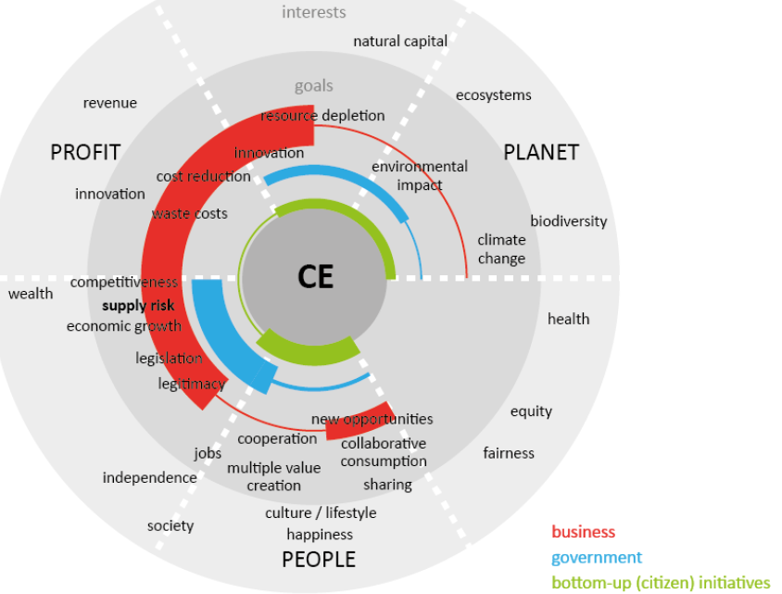

Figure 9: Radar of differences in goals and interests in the CE concept (Source: Mentink, 2013, p. 21)

Although different definitions and understandings of CE are used in both scientific and non-scientific contexts, some similarities between the most commonly used definitions can be identified. On the basis of a comparison, Mentink (2014) states that the most clear similarity relates to ‘the closure of resource loops’. In addition, in all explored cases CE is about ‘thinking in systems’ or ‘the realisation of a change on system level’. So, it can be stated that CE as a concept is commonly used in context of achieving a change in our way of thinking till a certain degree.
The understanding of the CE concept by the Ellen MacArthur Foundation [EMF] is often used by scholars and others when referring to the circular economy. That is why the EMF is worldwide very influential (Ellen MacArthur Foundation, 2012; 2013). The foundation is an indispensable actor in the contemporary buzz and popularity about CE. Since the founding of EMF in 2010 by the namesake, they have contacts with multinationals, governments and other organisations. Bastein, et al. (2013), IMSA (2013), Accenture (2014), C2C BIZZ (2013) and Giurco, et al. (2014) are only few recent publications in which is referred to the definition provided by the Ellen MacArthur Foundation. The research of McKinsey that has been conducted on behalf of the EMF is the most important script (Ellen MacArthur Foundation, 2012). In their research the potential benefits of the introduction of a circular economy in Europe were explored. This script has resulted in enthusiasm among governments, businesses and other organisations to start exploring and working on CE, themselves. In addition to the influence of the EMF with their definition on the content-side of CE, it also has a clearly identified function in the spread of the concept. The EMF defines CE as follows:
“The circular economy refers to an industrial economy that is restorative by intention. It aims to enable effective flows of materials, energy, labour and information so that natural and social capital can be rebuilt. It seeks to reduce energy use per unit of output and accelerate the shift to renewable energy by design, treating everything in the economy as a valuable resource” (Ellen MacArthur Foundation, 2013, p. 26).
Central to this definition of EMF is the picture in Figure 10. This picture ‘pops up regularly in presentations and publications and is referred to as ‘the butterfly diagram’. Figure 10 represents the different loops, both natural and technical, that are part of a circular economy. Five principles are underlying this model. These are: (1) Designing out of waste, (2) Build resilience through diversity, (3) think in systems, (4) shift to renewable energy sources and (5) think in cascades (Ellen MacArthur Foundation, 2012). These principles are corresponding to the earlier mentioned common principles in various definition of the CE Concept. Moreover, the five principles (and the definition of EMF in general as well) are mainly based on the schools of thought described in table 1.
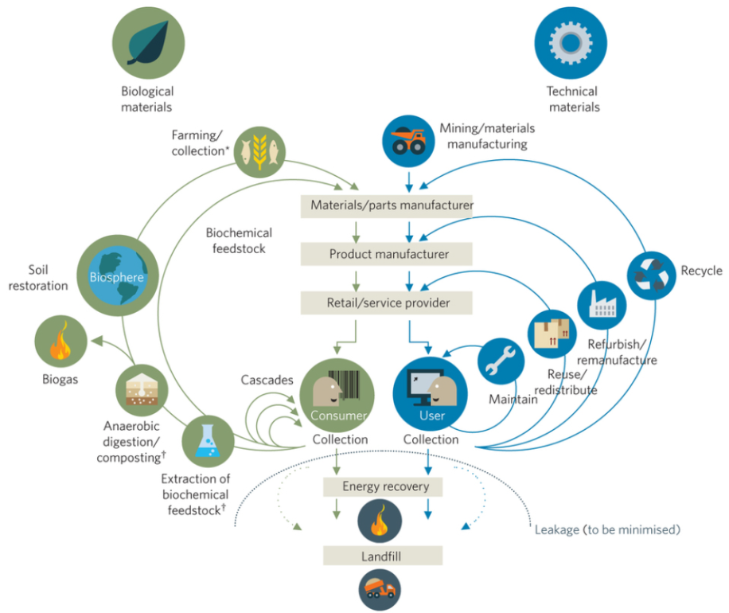
Figure 10: The butterfly diagram of the EMF (Source: EMF, 2012, p. 24).
4.4 CE in the Netherlands
Crucial for the development of CE in the Netherlands has been the commitment of the Dutch government, by incorporating the concept in their policy. Based on the report of the EMF and McKinsey the parliament asked for a research in which the possibilities for a circular economy in the Netherlands were explored. This research was conducted by TNO (Bastein, et al., 2013) and had a huge impact on the development of the concept in the Netherlands. Many governments, companies and other organisations refer to this research of TNO. Because of the outlined benefits, it encourages actors to start exploring and working on the CE in their own environment. The report can be seen as a crucial enabler for the current buzz surrounding CE. The report of TNO is almost completely based on the understanding of CE provided by the EMF (Mentink, 2014; Bastein, et al., 2013). Based on the implications of the TNO report, CE gets a serious place in the policy of the Dutch government with the program ‘Van afval naar grondstof’ (from waste to resource) from the Ministry of Infrastructure and the Environment. In this program the concept is defined as:
“circular economy is an economic system that has the reusability of products and raw materials and the conservation of natural resources as a start point, and pursues the creation of value in every link of the system” (Ministry of Infrastructure and the Environment, 2013, p. 3).
A definition that is based on the understanding of the EMF and that is closely related to the raw materials issue. The importance of the acknowledgment of the Dutch authority is related to several aspects. First of all, specific actions are linked to the concept (supporting measures, but also the beginning of circular procurement in the own organisation). In addition, a network (RACE coalition) is established in which different organisations explicitly focus on the realisation of the benefits of CE undertaking (MVO Nederland, 2014). Finally, the Dutch government has an appearance and acts as a role model, which influences other actors.
In addition to the Dutch government, intermediaries play an important role in the spread of the CE concept in the Netherlands. Like the EMF, those actors try to improve the awareness of the concept and support companies and other organisations in exploring and applying the CE ideology. Those intermediaries are being part of a mix of NGO’s and commercial consultancy firms. While searching the internet, I encountered several organisations that are repeatedly associated with the CE concept. Those organisations are: Acceleratio, Accenture, Circle Economy, De Groene Zaak, Het Groene Brein, IMSA, Kirkman Company, MVO Nederland, Nederland Kantelt, Royal HaskoningDHV, Stichting Circulaire Economie, TNO and Urgenda. Some of these organisations are only focused on the CE concept, but most of them focus on sustainability in general or are ‘even’ engaged to consultancy tasks in other fields. Another characteristic of these intermediaries relates to the fact that they often use the CE concept in combination with other concepts like ‘transitions’, ‘new economy’ and ‘new business models’. In addition to their consultancy tasks, intermediaries are responsible for the organisation of numerous events and workshops on CE. For many of these events, companies are willing to pay large amounts of money. During these events, there are often presentations of ‘experts’ of the organisations mentioned above. These are often supplemented and interspersed with presentations of practical examples that are designated as CE initiatives.
Practical examples could be very influential in the development of the concept. In the establishment of the campus concept in the Netherlands Kooij and his colleagues name the example of the campus developed around Philips in Eindhoven. This campus did not develop in accordance with the ‘rules for campus development’. Nevertheless, this practice is seen as ‘the’ example of the campus concept in the Netherlands. Often is referred by organisations to ‘Eindhoven’ instead of the generic term ‘campus’. Therefore, it has been very important for the development of the campus concept in the Netherlands (Kooij, et al., 2012). In comparison with the example of the campus concept, practical examples have been less important in the development of the CE concept. Initiatives from Interface and Turntoo/Philips are two examples of business initiatives that often is referred to in the Netherlands. However, there are no examples of initiatives where continuously is referred to on large scale and thereby being decisive in the constitution of the concept. This could have something to do with the haziness and size of the concept. A concept such as the ‘campus’ relates to a ‘clear’ geographical concentration of certain activities. CE instead, refers to the economy as a whole consisting of many and divergent aspects.
A striking element relates to the fact that there is need for practical examples of the CE concept. This is probably the result of the need to understand the concept better. In the selection of cases for the analysis in the Chapters 5 - 8 I made an attempt to map CE initiatives (that are situated in the Gelderland region). Therefore I asked for input from different experts and organisations, among these were: the Radboud University, Royal HaskoningDHV, MVO Nederland, RVO Nederland, KieMT and different municipalities. None of these organisations had an overview of practical examples. Rather they were only able to name a few initiatives. Moreover, they all asked what my definition of a CE contained, because this was decisive if they were able to name initiatives. This shows again, that (till this moment) practical examples play a modest role in the development of the concept. Therefore, the CE concept is still a more of a conceptual term, which is lacking a specific and clear definition.

4.5 CE in Gelderland
The Netherlands is a relatively small country, in which regions have a similar institutional context. Therefore, the development of the CE concept on national level, described in the previous section, can be applied to the Gelderland region as well. The important discourses on CE and key actors in Gelderland are described below in more detail.
The institutional province ‘Gelderland’ first came into contact with the concept in 2013. In response to the publication of TNO, it was explored what the concept could mean for the province itself. Within the province, they are for some time working with other sustainable concepts such as: the ‘bio-based economy’ and ‘energy transition’. CE on the other hand is still new and there is no clear embedding of the concept in the policies yet. In the coalition agreements of this year, CE is described as follow: “The province stimulates cross-connections between sectors. The circular economy is the binding theme between agriculture, industry, water management and environment/energy” (Province of Gelderland, 2015, p. 7). CE is described as a theme. It appears that by the province the concept is only used as generic term and an actual implementation does not exist yet. This conclusion is confirmed in the interview I had with an official from the Province. In this it became clear that the Province is still exploring the theme and is looking for a way to work with the concept in relation to the already implemented (sustainable) concepts.
A similar development can be identified by the municipalities in the Gelderland region. For the three largest municipalities of the region: Nijmegen, Apeldoorn and Arnhem I explored how is referred to CE. These municipalities came into contact with the concept since approximately 2013. Also in their publications is often referred to dominant discourses on CE: EMF and TNO. Just like in the province, the concept is seen as an overarching theme. CE is used in terms of a final goal: “the projects or actions can contribute to a CE” (Municipality of Arnhem and Greenspread, 2015; Municipality of Apeldoorn, 2015; Municipality of Nijmegen, 2013). Differences can be identified as well, these are related to the connection of the concept to the already existing policy. In the note of Apeldoorn the concept is strongly connected to clean tech (Municipality of Apeldoorn, 2015). Arnhem on the other hand, is talking about circular economy in terms of ‘energy’ (Municipality of Arnhem and Greenspread, 2015). Both themes are part of their local focus. The municipality of Nijmegen seems to be further in the implementation of the CE concept. CE is described as a generic theme, but in addition specific actions are taken in order to make the connection with practice. In this, reference is made to CE (related) initiatives from the 4daagsefeesten, TPN West and the wastewater treatment facility (Municipality of Nijmegen, 2013). Also, recently the CE Boostcamp has been organised, a large event that aimed at creating and conceiving projects for CE initiatives in Nijmegen (CE Boostcamp WWW, n.d.).
Within the region the CE concept has not yet been embedded in the policies (although some authorities are further than others). It seems that authorities want to connect with the current buzz surrounding CE. Therefore, the concept seems to have a motivating or inspiring effect. In addition to the regional and local authorities, intermediaries are important actors. Especially the organisations, which are active at national level and described in the previous section are influential in the region. But, more local and/or regional orientated organisations play a role in the establishment of CE in Gelderland as well. These organisations are: VNO/NCW Midden, Clean Tech Centre, kiEMT, RNCT and the Regionaal Nijmeegs Centrum voor Circulaire Economie. These organisations support companies in the region. Moreover, they try to create awareness for the CE concept by means of workshops and events.
A lot is happening in the field of the education in the Gelderland region. Last year, the Radboud University started with a CE traject in the honors program for excellent bachelor students. In addition, at the HAN and Saxion a teaching program is started in which students explore the possibilities of CE in practice. Also, different scholars are engaged with the topic of CE. One of them is Jan Jonker, who is focusing more on new business models, but is a popular speaker on this theme in the region and beyond. Education and science play an important role in the development of the CE concept. However, since this is only a recent development, it has not noticeable attributed to the etablishment of a clear and ‘common’ or dominant understanding of the CE concept in the region.

5 – 8
The Chapters five to eight cover the results of the analysis of the four CE business initiatives. Chapter (5) is about Lazuur food community, Chapter (6) about Dirk III, Chapter (7) about EcoProFabrics and finally Chapter (8) covers the results of the analysis of the ‘Energie en Grondstoffen fabriek’ (EFGF). Each chapter is structured based on the same format.
First, an introduction is given on the CE business initiative, in which the choice for case selection is discussed. Subsequently, the initiative is described and the CE principles are identified. Next, the development of the initiative is chronologically described, linking it to relevant elements of the ‘Theoretical triangle’ (Figure 5): how is business initiative conceived and developed in the interaction between ‘model’, ‘governance’ and ‘the bundle of practices’ and what is the role of pioneers in this process? In answering these questions, a distinction is made in relevant periods in the development of the initiative. For each period is discussed which combination of relations and drivers has been decisive. The division in periods differs from case to case, because each business initiative developed through a unique path. All chapters are concluded with a perspective on the future of the initiatives. Again a connection is made with the ‘Theoretical triangle’. In this final section, the extent to which the CE notion is implemented in the business initiative is discussed as well.

5 Lazuur food community
5.1 Introduction
“Goed voedsel, goed voor iedereen met zorg voor de Aarde” (Lazuur food community WWW, n.d.).
Translated in English this quote implies: “Good food, good for everyone, with care for the earth”. The quote reflects the ideology of Lazuur food community in one sentence. Lazuur is a local organic food store initiative, responding on the growing and urgent demand for a sustainable food retail (Lazuur food community WWW, n.d.). Lazuur is organised in a circular food chain, in contrast to the organisation of the well known supermarkets nowadays. The CE concept is clearly embedded and used in the organisation structures of the initiative. In addition, the chosen perspective on the food retail is embraced and valued by others as well (e.g. Gelderlander (5 January 2015)). This makes Lazuur food community a suitable case for this research. Moreover, Lazuur is founded and developed in Wageningen, a place in Gelderland. Therefore, the case is located within the research area, which relates to the final criterion for case selection.
The roots of the initiative go way back in the past. As there has been a continuous interaction between developments in practice, changes in vision and interaction between actors, the case is packed with information. And still, Lazuur food community is in full motion. In order to map the drivers behind the development of the local translation of CE, interviews were held with four actors that have a role in the initiative. The roots of the initiative can be traced back to the 70’s of last century. However, it was not possible to speak with actors that were decisive for the development of the initiative in that period. That is why information about the start of the initiative is derived from the conversations with the contemporary members of Lazuur food community and online publications (an overview of the interviewees can be found in Appendix A). The interviews were supplemented with information from the Lazuur website, the statutes and publications on the Lazuur concept in ‘Celebrate Food’ (InnovatieNetwerk 2012).
5.2 A description of the CE business initiative
In the organisation of Lazuur food community two components can be distinguished: (1) the Lazuur foundation and (2) Lazuur Wageningen.
(1) The foundation has juridical ownership over the Lazuur concept, as is described in the statutes (Lazuur foundation, 2011). The objective of the foundation is to stimulate the purpose and to guard the ideology of Lazuur by supporting the realisation of new Lazuur markets. The concept is not bounded to Wageningen alone. Instead the Lazuur concept is universally applicable. During the writing process of this thesis, the role of the Lazuur foundation changed. From now on, the Lazuur foundation will exclusively focus on stimulating the implementation of the Lazuur concept in Wageningen. The new foundation ‘Coöperatie van voedsel.coop facilitators B.A.’ will focus on the dissemination of CE thinking in food retail to other places.
(2) In Wageningen, the Lazuur concept is implemented in the organic food store ‘Lazuur food community Wageningen’. The store is the physical place were all elements that constitute the business initiative come together. The core business does not differ much from the business activities of other health food stores or food retailers. However, as the food retail is organised on the basis of CE principles there are some differences. Lazuur Wageningen has the legal form of a limited partnership (in Dutch: ‘commanditaire vennootschap’). This implies that the organisation has both managing and sleeping partners. There are four managing partners who are responsible for the affairs of the business. The sleeping partners include the consumers and producers, which are entitled to participate in the organisation. Although they have invested in the store, they have a limited financial liability. That is why producers and consumers are co-owners of the store. In this context we speak of ‘community funding’.
Consumers can decide to take a customer card. The customer card can be compared with a revolving loan, for which in exchange they receive control and get a say in the Lazuur market. When the customer decides to denounce the customer card they retrieve the invested money. When using a customer card, you do not receive interest on the loan. Instead customers receive vouchers, which can be used to buy products in the store. In addition, the customer has the privilege to participate. Due to this participation, they determine to a certain extent what will be on the shelf. A customer card is though not an obligation. Without such a card you can still do your shopping in the store. Because money is directly flowing from the investments of the consumers, producers are immediately paid off. This has the result that the supplier credit disappears. Moreover, producers are actively involved within the organisation. Jointly is explored what suppliers will deliver. Because Lazuur has the ideal to deliver sustainable and local products, many suppliers are involved. This makes the process more labour intensive. Just like the consumers, suppliers can invest in Lazuur. In return, suppliers receive a participation fee, which is established at 2%. With this fee, they build their own piece of capital in the market. If the supplier chooses to leave the market, he or she is permitted to take their own share.
Four principles are embedded and reflected in the organisation of the Lazuur food community concept. These principles are visualised in Figure 11.
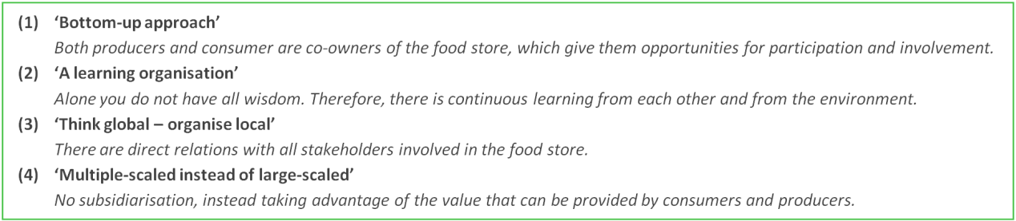
Figure 11: Overview of the principles embedded in the Lazuur concept (source: Lazuur food community, WWW, n.d.)
On the basis of the four principles and the description of the organisation of Lazuur food community, the CE notion in the initiative can be described as; ‘closing the chain of food retail, both financial and regional’. In this notion of CE, the social aspect is important. Intensive collaboration, transparency, participation and co-ownership are important in order to close the chain. In this analysis the focus relies upon the health food store ‘Lazuur Wageningen’. However, since the foundation Lazuur played an important role in the development of the initiative, the foundation is taken into account as well.

5.3 The analysis of the development of Lazuur food community
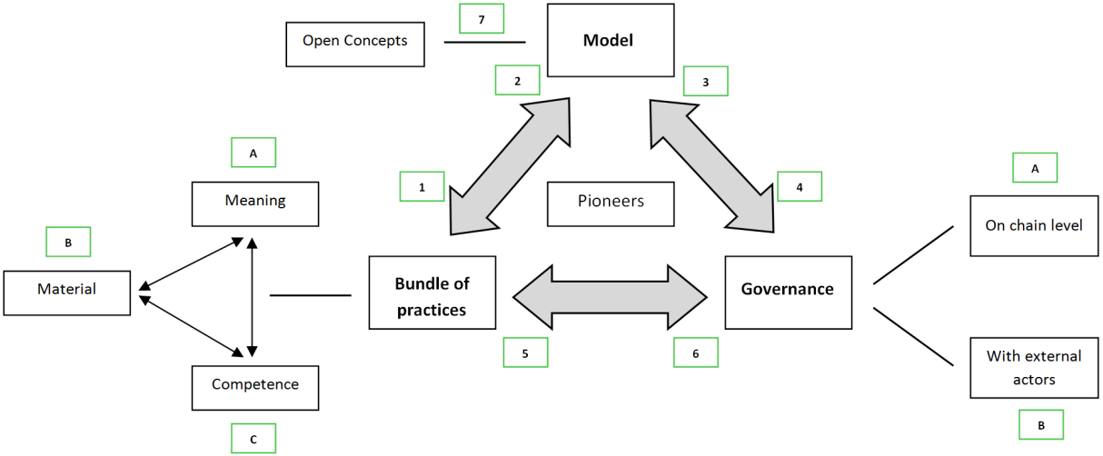
The way in which Lazuur food community is conceived and developed as a result of the interaction between ‘practices’, ‘model’ and ‘governance’ is discussed in this section. The ‘Theoretical triangle’, displayed in Figure 12, is used in the analysis. Numbers and letters were added to ‘Theoretical triangle’. The numbers 1-7 refer to the central relations in the triangle. For example, relation [1] corresponds with the influence of the model on the bundle of practices and relation [2] corresponds with the influence of the bundle of practices on the model (i.e. there is resistance in the bundle of practices or ideas in the model are changed due to bundle of practices). The letters in the Figure refer to the elements in the bundle of practices and the two types of governance. They are added to a number if clear insights are derived on specific elements. If for example the model has an assignable effect on the governance ‘with external actors’, the relation [4B] is used. In the text will be referred to the relevant connections in the ‘Theoretical triangle’, by making a reference to the number (and letter) that corresponds with the relation in the conceptual model in Figure 12.

Figure 12: The ‘Theoretical triangle’ for the analysis of the development of Lazuur
On the 15th of December 2013 the Lazuur food community Wageningen was officially opened. With this event the CE ideas, which were constituted by the founding of the Lazuur concept two year earlier, were established in the store. Nevertheless, the principles underlying this notion of CE were already (to a large extent) embedded in the precursor of Lazuur food community Wageningen, which was founded in the 70’s of last century. Since that time, the store in Wageningen, the organisation behind the food retail and the vision on the initiative developed step by step. In the analysis of this development, four phases are distinguished. The first phase relates to the emergence of Pee Pastinakel, an organic shop established by citizens, in 1974 (section 5.3.1). The second phase covers a period of approximately thirty years since the founding of Pee Pastinakel. This period is characterised by expansion of the organic shop (5.3.2). In the third phase, a renewed vision is established, which results in the founding of the Lazuur concept and foundation (5.3.3). The fourth and final phase covers the period in which the renewed vision is applied on the store in Wageningen (5.3.4).
5.3.1 The emergence of an organic food store
The first step in the development of Lazuur food community can be traced back to the emergence of Pee Pastinakel, an organic shop (or health food store), in 1974. The emergence of Pee Pastinakel can be explained by the common drive of a group citizens, to organise the food retail by themselves. This group of pioneers grew into a group of two hundred actors. Together they constitute the idea [3] and implement the idea [1 and 4]. Looking at the constitution of the idea for Pee Pastinakel some clear drivers can be identified. Those drivers relate mainly to the social economic context of that time.
In the 60’s and 70’s of last century widespread student revolts took place. Wageningen was one of the places in the Netherlands were students expressed their dissatisfaction with the way in which higher education and in more general the society was organised. They protested for democratisation and participation possibilities. And, at the same time they had a strong aversion of the capitalistic economic system. Students represented a significant proportion of the group pioneers, who started Pee Pastinakel. Another societal discontent that has been an important driver refers to the limited attention that is paid to the environment in relation to food retail. In addition to the social economic dissatisfaction, certain concepts and movements were important drivers. In the interviews with Inno Kock and Pieter van Gurp, reference is made to the ‘Reform’ and ‘Good Food’ movement. The biodynamic agriculture (BDA), an approach of Rudolf Steiner, is named as well. BDA is based on anthroposophic principles. Emerging from these sources of inspiration is a need for the use of a holistic approach. Applying this approach to the food retail, it implies that all elements must be taken into account. Therefore, attention must be paid to social and environmental aspects in food retail as well. The whole of concepts and social drivers named above has been decisive for the constitution of the model [7].
Initially, implementing the model resulted in people baking bread themselves and the self-cultivation of leeks, carrots and other products on land in a biologically responsible way. These products were sold from garage distribution points. So, food retail is organised in another way, when consumers take over the role of producers [4A]. This is closely related to a change in the bundle of practices [1]. The activities in themselves are not new; baking, cultivation and selling are activities which are not different from the conventional and dominant way in which (bio) food is produced and consumed. However, the distribution of these products by citizens is a new dimension in the practice of ‘retailing organic food’ [Both 1A and 1C].
The next step in the development of the initiative, relates to the professionalisation of the initiative. A property is purchased in which a store is established, wherefrom the products are sold. This property is entirely financed by the consumer base. Moreover, staff is hired and increasingly products are bought from local growers and suppliers. This professionalisation is caused by a common desire from the pioneers involved in Pee Pastinakel [5]. A striking element in this development relates to the fact that due to the professionalisation and especially by adding a material dimension to the bundle of practices (e.g. the store) the model is energised [2]. A physical place is created, which is a stable base from which the vision on sustainable food retail can evolve.
5.3.2 Expansion of the organic food store
With the emergence of Pee Pastinakel a new food retail initiative emerged in which principles of collaboration (‘bottom-up approach’) and local organisation (‘think global, organise local’) are already incorporated. The phase that follows on the emergence of Pee Pastinakel is mainly characterised by an expansion of the organic food store. In the thirty years that follow, an increase takes place in the turnover, the number of clients, the surface of the store and the assortment. In addition to the expansion of the organic food store, the name changed from Pee Pastinakel to Sprokkel and was finally renamed in Buys & Ko. This change was accompanied by a change in the legal form. The organisation has been a cooperation, but the legal forms of a partnership and a foundation were applied to the organisation as well. All these developments have been important in the establishment of the store as we know it nowadays. Therefore, these developments are named in this section. However, it is difficult to explain those developments, due to the chosen theoretical framework (Figure 12). As these developments primarily relate to the expansion of the initiative and changes in the organisation structure (e.g. name), they cannot be explained by the interaction between the ‘model’, ‘governance’ and ‘bundle of practices’.
5.3.3 Working on a renewed vision for the food retail
From approximately 2005, a renewal in the vision on the future of Buys & Ko takes place. Led by Inno Kock, one of the (recent) pioneers in the initiative, they start exploring the possibility to strengthen the principles that are already embedded in the initiative. This renewal of the model results in the introduction of the customer card and the founding of the Lazuur concept. In this third phase, which is distinguished in the analysis of the development of Lazuur food community.
A number of drivers are responsible for the renewal of the model, these drivers relate mainly to the interaction between actors. First of all, Buys & Ko experienced a decrease in the involvement of consumers in the organisation. Customers were still funding Buys & Ko, but the intrinsic engagement faded away slowly. The people who were involved in Buys & Ko from the first impulse increasingly vanished, because in the meantime they were more than thirty years later in time since the emergence of the initiative [3A]. At the same time in society a transition was going on, in which the health food sector became more up-scaled and chain formation took place. Increasingly, health food stores became part of a chain store. Simultaneously, regular supermarkets became more active in the health food sector. This results in the fact that organic products were more often find on the shelves of supermarkets like Albert Heijn as well [3B]. As a reaction on these trends, conversations were held with multiple consumers and suppliers. These conversations provided the input for the renewal of the model, in which the principle of Lazuur as a ‘community’ was enhanced [3A]. In order to strengthen this principle in Buys & Ko, the customer card was introduced at the end of 2007. With the introduction of the customer card, an actual tangible tool was added to the interaction between Buys & Ko and their customers [4A]. Moreover, the introduction of the customer card had an effect on the routines in the daily businesses of Buys & Ko (by means of the emergence of new cash flows) [1]. In these routines, the principle of Lazuur as a community was strengthened as well. The (symbolic) importance of the customer card for Buys & Ko is confirmed by Pieter van Gurp. He states that: “the customer card made the initiative a whole, it made it possible for us to establish connections”.
The renewal of Buys & Ko was more frequently noticed by others. This resulted in the fact that Buys & Ko increasingly was invited to present their business model to others. This was an incentive to work on the conceptualisation of the initiative [3]. At the same time, they received an innovation of InnovatieNetwerk (a platform of the Dutch national government aimed at the stimulation of innovations in different policy fields), to think about ‘a market of the future concept’. The InnovatieNetwerk launched the question: ‘What does the supermarket of the future look like?’ (InnovatieNetwerk, 2012). Different actors were engaged to this question, but the encounter of Inno Kock with Luuk Rövekamp (a freelancer specialised in cooperation’s and marketing in food retail) in this network, was a crucial moment. It appeared that they had a common drive; ‘inventing a food retail of the future concept’. This common drive constituted the basis for collaboration. The partnership resulted in the founding of the Lazuur concept in 2011 and relates to a renewal of the model [3A].
Looking at the development of the Lazuur concept and foundation in more detail, it is important to note that this concept relates to the establishment of a generic model for food retail. In the constitution of the Lazuur concept, the visualisation of the supermarket of the future created by the InnovatieNetwerk was used as a start point. Designers and artists did research in the Netherlands and abroad. On the basis of these insights they made a visual description of the supermarket of the future, which stands for brightness and transparency, and was named ‘Lazuur’ (InnovatieNetwerk, 2012). The name ‘Lazuur’ was used in the further development of the concept. However, the description of InnovatieNetwerk was not useful, in order to give actual an actual implementation tot the concept. Instead, both (professional) experiences and expertise from Inno Kock and Luuk Rövekamp were determining in this context [2]. Both pioneers had decades of experience in the food retail and were experienced in working in a cooperation. In addition to the practical knowledge, two practical examples served as inspiration. These were the People Supermarket in London and the Brooklyn Food Coop in the U.S. Both initiatives are based on cooperative principles and are characterised by an extensive involvement of consumers and producers. Other sources of inspiration named in the interviews were ‘Slow Food’, ‘Cooperative Movement’, ‘Fair Trade’, ‘BDA’ and ‘Alternative Business Models’. Those sources of inspiration were brought in by the pioneers. Some of these concepts were already a source of inspiration for the establishment of Pee Pastinakel in 1974.
The whole of concepts, experiences and expertise described above, has been decisive for the establishment of the Lazuur concept as it is described in section 5.2 [7]. However, it is not possible to trace certain elements in the Lazuur concept back to specific sources of inspiration.
Barriers and enablers
In both the development (and implementation) of the customer card and the establishment of the Lazuur concept, the same barrier is experienced. This barrier relates to the interaction between pioneers and the interaction of the pioneers with others involved in the initiative [3A]. There is a discrepancy between the desire and the reality. Knowing and recognising a development is one thing, the execution of this development is more complex. Step by step, actors involved in Buys & Ko had to be convinced of this next step. Aligning actors was the biggest barrier in this phase. Competences of the pioneers, relating to ‘people management’, proved to be important enabler in this context.

5.3.4 Implementation of the renewed principles
On the 15th of December Lazuur food community Wageningen was officially opened. Buys & Ko was transformed in ‘Lazuur food community Wageningen’, by applying the Lazuur concept in the store. The final distinguished phase in the analysis of the development of Lazuur food community relates to the implementation of the renewed model in Buys & Ko.
Although most of the principles were already embedded in Buys & Ko, some changes and adoptions were necessary. The most important change relates to the renovation of the store. The entire store has been gutted, a wall is removed to create more space and the store received another structure and format. The new look of the store was inspired on the description of ‘Lazuur’, created by the InnovatieNetwerk. The renovation was essential in order to make the concept visible. The market needs to project transparency and brightness. Moreover it had to look like a real market where the demand for and supply of product comes together [1B]. According to the interviewees, the renovation has been a crucial step in the development of the Lazuur market in Wageningen, by making the concept tangible [1].
The renovation of the store is accompanied by a change of the name, from Buys & Ko into Lazuur Wageningen. As is mentioned in the previous section, the name is retrieved from the ‘Lazuur concept’ described by InnovatieNetwerk (InnovatieNetwerk, 2012). According to Inno Kock and Pieter van Gurp, a change in name of the organisation was a logical step in the development of the initiative and fits within the new presentation of the store to their customers [4A]. Pieter van Gurp described it as follows: “it would fit within the new identity and impetus of the store”.
Barriers and enablers
In the implementation of the renewed (Lazuur) model, there were several barriers that can be identified. Some of these barriers made it even impossible to implement the ideas of the Lazuur model. On the other hand certain factors can be identified that revealed to be relevant in an attempt to overcome these barriers. All barriers that are identified relate to the ‘governance’.

The barrier that is continuously a constraint in the implementation (and already is mentioned in section 5.3.3 as well) relates to the interaction between actors involved in the initiative [3A]. The staff should be able to identify with the changes in the organisation. It appeared that not everyone had the competences to immediately start with the new ideas and new approach of Lazuur. The management of the staff, by the pioneers, has been crucial in the successful implementation of the Lazuur concept. Another barrier regarding the interaction between actors relates to the traditional employer – employee role. In order to stimulate the development of Lazuur, it is important to avoid this traditional relation. However, as an employer you have to deal with contracts and collective agreements, which make it almost impossible to avoid this position. This makes it difficult to get actors moving, especially when they do not share the same vision. According to the interviewees, the alignment of the entire staff to the same vision for the store is still not completely achieved [3A].

The presence of certain competences has been indispensable in order to create alignment between the actors involved in Lazuur food community. The managers held personal conversations with the staff, in which clearly was outlined what was expected from the staff in the new situation and how the employee in dispute would fit within this approach. Moreover, meetings were held and field trips to growers and producers were organised. This has been organised in order to influence the knowledge and experience of staff. But on the other side, these activities took place to influence the motivation and emotion of the staff as well.

Another barrier relates to renovation of the store. Plans for reconstruction were already made in approximately 2004. Although these plans were different from the contemporary design, they came up against the same barrier; ‘high rents in the city centre of Wageningen’. This made and still makes it not possible to move to a larger location and expand the retail space extensively. This has resulted in the fact that the original plans for Lazuur Wageningen were adopted [3B]. In the ideal ‘Lazuur model’, different suppliers would have had a place in the store. For example, a baker and a butcher. By the presence of suppliers in the store, the food retail process would have become more transparent and it would have fit within the principle of local and region organisation as well.
5.4 Future: towards a closed loop in the food retail
Ideally, Lazuur is a food community in which a continuous (closed) loop of both means and money from producers to consumers is embedded, with a transparent process and involvement of both consumers and producers. Of course, initiatives are developed in a continuous changing environment in which a complete attainment of model is a utopia. Nevertheless, some specific steps could be taken in order to optimise and improve the implementation of the CE notion. This is emphasised by the interviewees as well.
Regarding the ‘closing of chains’, there is space for ‘improvement’. In section 5.2 is described that Lazuur food community strives for ‘closing the loops both financially and regional’. At this moment, these chains are not fully closed yet. Closing the chain regionally relates to two aspects: geographically and local in the sense of short and direct relations. At this moment, it is not possible to purchase locally in Wageningen and surroundings alone [3B]. It is a requirement that there are suppliers who are anticipating on the needs of Lazuur. For example, there is not a greenhouse near Wageningen. In order to have a sufficient stock and a diverse segment of products during the entire year, other actors outside the region or wholesalers must be approached. This results in the fact that money flows from the community and with this, the region as well. Lazuur food community made a commitment with the customers. Therefore, empty shelves or a declining range of products could be disastrous for the business. The fact that Lazuur Wageningen works with organic products, makes the range of possible suppliers even smaller. So, a step can be made when more regional suppliers are part of the Lazuur food community instead of wholesalers. However, as is mentioned, it is difficult to have a grip on this. Lazuur food community is in fact actively exploring the possibilities to close the chain of money and products further. For example, they explore the possibility to work with local money that could be used to buy products on the Lazuur market. This could ensure that money stays within the region.
Another aspect of the CE notion in Lazuur relates to the active involvement of actors in the retail process. In an ideal food community, producers, consumers and retailers determine together the direction of the organisation. Some improvements in the implementation of this principle is possible. According to Pieter van Gurp, the cultivation agreements with producers still take place through the lens of a linear approach. The alignment on the production and supply of products should instead be organised as an ongoing dialogue, in order to ensure the continuation in supply. This ongoing dialogue is not achieved yet. The commitment of the producers up to even the financial connection is missing, as suppliers are often driven by interests related to money [3A]. According to Pieter van Gurp there is an intention to improve these relations, but there is still a long way to go. This is confirmed by one of the suppliers of Lazuur. They stated that differences in their relation, since the introduction of the Lazuur model, were not experienced yet. This only shows one example of a possible improvement. Yet, Lazuur is already working on different initiatives that could contribute to an increase of the involvement of actors. For example, home-made products are sold in the store and recently they had a test in which actors who had a surplus of certain product could offer these products to other, through the store.
So, possible improvements for a complete implementation of the model relate mainly to the organisation of the initiative [4] and especially the governance with external actors [4B]. However, it is important to mention that such improvements are difficult to steer.
6 Dirk III
6.1 Introduction
“We zijn pas geslaagd als: de huishoudens of bedrijven in de Betuwe daadwerkelijk een verlaging van kosten zien voor energie, vervoer, gezondheid, voedsel en wonen. Of als mensen zich lokaal betekenisvoller voelen” (Dirk de Derde WWW, n.d.).
Translated in English this quote means: “We are only succeeded when households or businesses in the Betuwe experience a reduction in the costs for energy, transport, health care, food and housing. Or if people feel more meaningful in their own local/regional environment”. The quote describes the objective of Dirk III (fully written: Dirk de Derde). Dirk III is a group of citizens in the Betuwe, which is engaged to the facilitation of a transition towards a new (CE) economy in the Betuwe. This means that they do not produce any goods themselves. Instead, they provide a service. This service is aimed at facilitating a transition towards a CE on regional scale. Dirk III is a suitable case to do research on, because the CE concept contains a vision on the economy in which services have a place as well. Moreover, it is all about the way in which the CE concept is implemented in the initiative. The foundation Dirk III refers to the CE concept itself (Dirk de Derde WWW, n.d.) and in the facilitation for a ‘renewal’ of the economy, CE principles are clearly reflected in the initiative. Because Dirk III is founded and operational in the Betuwe (a region in Gelderland) as well, the case complied all criteria for case selection.
The initiative is relatively young and is still mainly situated in the ideation or conceptual phase. Nevertheless, by means of different data sources, insights were gained in the drivers behind the development of the local translation of CE. Interviews were held with the pioneers and contemporary members of the Dirk III foundation (an overview of the interviewees can be found in Appendix A). The results of the interviews were supplemented with information from the website, meeting reports and presentations.
6.2 A description of the CE business initiative
The foundation Dirk III is the linchpin of the initiative. Dirk III is managed by a core team of four actors: Dennis Kerkhoven, Jan de Kock, Peter van Luttervelt and Wim Wink. They are the pioneers behind the initiative as well. The foundation is aimed at guarding and diffusing the ideology of Dirk III. In other words they are aimed at facilitating a transition towards a new economy in the Betuwe. The Betuwe region mainly consists of rural municipalities. A strict geographical demarcation is not maintained. The activities of Dirk III are mostly concentrated in the West of the Betuwe, but at the same time some activities exceed the borders of the region.
The ‘new economy’ in the objective of Dirk III refers to a renewal of the contemporary economy, approached from a holistic perspective. It is about a change towards a local or regional organisation of the economy. This ambition is emphasised by two concrete targets. (1) Citizens should experience a reduction in costs and (2) an increasing participation and involvement of the ‘Betuwenaren’ in their region should be experienced (Dirk de Derde WWW, n.d). In order to clarify and substantiate the objective of Dirk III, seven principles are described. These principles are visualised in Figure 13. The seven principles represent the transitions that are central to the creation of a renewed economy.
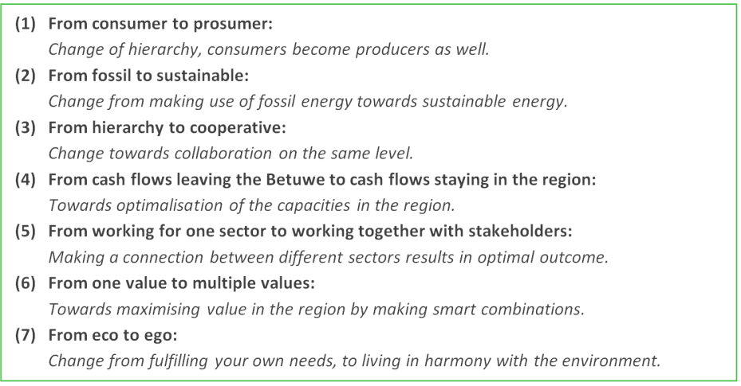
Figure 13: Translation of the seven principles of the Dirk III ideology (source: Dirk de Derde WWW, n.d.)
By means of a number of activities, Dirk III builds an infrastructure in which the described principles are reflected. The core team of Dirk III has the function of ‘quartermaster’. They connect ideas, actors and activities that contribute to the objective of Dirk III. A learning environment is created in which ideas and initiatives can evolve. The intention of Dirk III is not to accomplish new initiatives themselves, instead the role of the group is to facilitate and match ideas, initiatives and actors. Around the core team there is a group of approximately thirty actors who are actively involved in Dirk III. This circle is again surrounded by more than two hundred actors who have embraced the ideology of Dirk III and support the initiative. In addition to the foundation, there are a number of cooperation’s in which actual ideas and initiatives are developed, the ‘regional area cooperation Rivierenland’, the ‘citizen cooperation wind energy’ and the ‘village cooperation Haaften’.
All these activities are organised by citizens and constitute the basis of the infrastructure for the realisation of a renewed economy. In this context the CE concept is used as an overarching designation. The CE notion in Dirk III can be described as follows: ‘A renewed version of the economy in which the focus relies on the regional level. An economy in which the value that can be derived locally and regionally is utilised, by making use of smart technologies, business models and combinations’.
6.3 The analysis of the development of Dirk III
The way in which Dirk III is conceived and developed as a result of the interaction between ‘practices’, ‘model’ and ‘governance’ is discussed in this section. Therefore the ‘Theoretical triangle’, displayed in Figure 14, is used in the analysis. An explanation about the use of numbers and letters in the analysis, corresponding to the relations in Figure 14, can be found in section 5.3.
Dirk III is officially founded in 2013 with the establishment of the Dirk III foundation. However, the roots of the initiative can be traced back until the end of the year 2011. During these two years, the idea and vision for Dirk III is created and developed. This is not a development that has taken place at once. Instead the idea is developed step by step. In the analysis of this development three phases are distinguished. The first phase is characterised by the establishment of an idea for a regional energy cooperation (6.3.1). In the second phase the original ideas are widened towards a holistic vision on the economy for the Betuwe (6.3.2). Finally, in the third phase the translation of the ideas in society takes place (6.3.3).

Figure 14: The ‘Theoretical triangle’ for the analysis of the development of Dirk III
6.3.1 The establishment of the BEC
The first step in the development of Dirk III can be traced back to the encounter of Jan de Kock, Peter van Luttervelt and Wim Wink at the end of the year 2011. After this encounter, they jointly start working on the idea for a regional energy cooperation in the Betuwe [BEC]. The first phase relates mainly to the establishment of ideas for the BEC. This can be translated to the ‘Theoretical triangle’ in Figure 14, as the establishment of the ‘model’.
Jan de Kock, Peter van Luttervelt and Wim Wink are the pioneers behind the emergence of the initiative. Their role has been indispensable in the development. As the three men meet during a meeting on transitions organised by ‘Duurzaam & Succesvol Ondernemen Rivierenland’, a partnership is born. Despite the fact that they did not knew each other (well) and had different professional backgrounds, they decided to explore the possibility for collaboration on the realisation of actual initiatives in the field of sustainability. This is a clear connection between ‘governance’ and the ‘model’ in Figure 14 [relation 3]. The relation is filled by a similar dream for the future ‘a sustainable society’. This is a feeling of unity, which has grown organically and has been crucial for the emergence of the partnership between Jan, Peter and Wim. Jan de Kock uses in this context the word “zielemaatjes” (soulmates) in order to describe the feeling of unity. So, the encounter of the pioneers is characterised by coincidence, networking and a shared vision on the future.
The partnership results in an idea for the ‘BEC’. This idea is described by Wim Wink as follows: “The Betuwe is known for its many fruit growers. Those fruit growers have often large barns. The surface of these rooftops is often not used. Many of these roofs have asbestos, so in these cases renovation is necessary. This is an opportunity to exploit the new roofs for generating energy for the local society, by means of solar energy. The BEC could acts as a facilitator in this process, making connection between different actors relevant in this development”. The content of this vision (the model) is determined by the individual and diverse expertise, experiences and inspiration of the three pioneers. The merging of individual backgrounds constitutes the input for the model [3A]. That is why in Figure 15 an overview is given of the background, drivers and sources of inspiration of the three pioneers.
Despite the diverse backgrounds, some similarities can be distinguished in the overview in Figure 15. All three pioneers are inspired by certain (sustainability) concepts. Moreover, they are all driven by social motives, whether it relates to the feeling of responsibility for future generations or the ceding of businesses and work in general, from society. Also, actual developments that take place in the Betuwe and practical examples are part of the common drive (and inspiration) of the pioneers [3A]. In addition, input is derived from practices in the constitution of the idea for the BEC as well [2]. This relation is filled by experiences from the own professional activities (e.g. entrepreneurship and process management) [2]. Again, the position of the pioneer is crucial. He is the connecting node.

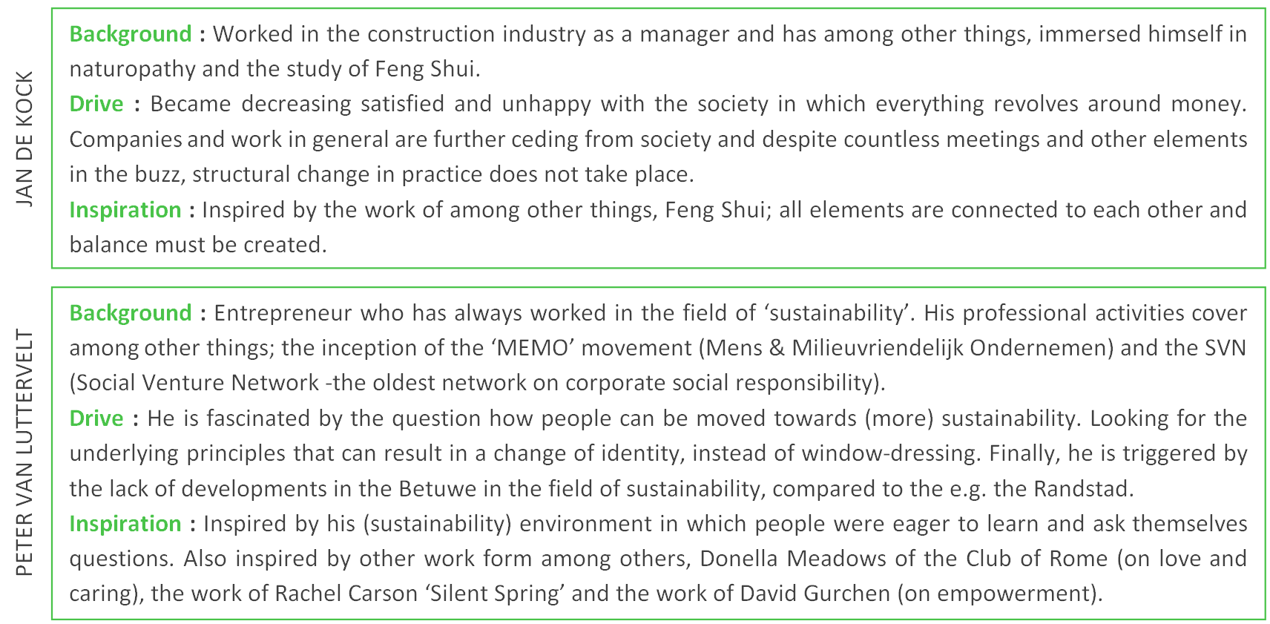

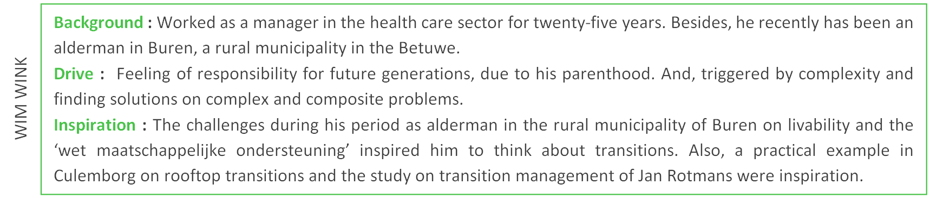

Figure 15: Background of founding fathers ‘BEC’
The whole of individual inspiration and expertise was melted [3A] and constituted the input for the idea of the BEC [7]. Although the accumulation of inspiration and expertise was decisive, some sources of inspiration were explicitly reflected in the idea for the BEC. For example, Transition Management. During the establishment of the idea for the BEC, Wim Wink followed a course on Transition Management that was taught by Jan Rotmans. The principles of Transition Management provided a guideline for the design of the transition arena. This relates to the way in which the rooftop transition, which is central to the BEC, must be facilitated [3B]. Another example relates to the accidental encounter of the pioneers with the wind farm near Dijl. Due to this encounter the focus of the model was expanded. Instead of focussing on solar energy alone in the rooftop transition, other forms of sustainable energy (e.g. wind energy) were taken into account as well [3B].
6.3.2 Towards a holistic view on the economy
Despite the fact that the idea for the BEC has developed substantially, something was missing that kept the model from developing and implementing the ideas in society [7]. A break through takes place in 2012, when Dennis Kerkhoven (the fourth pioneer behind Dirk III) joins the initiative. As a result of his involvement, the idea for the BEC is transformed into a holistic perspective on the economy in the Betuwe [3A]. The second distinguished phase, is characterised by a major change in the model, which includes the introduction of the CE concept as well.
In the community of the Economy Transformers, Dennis Kerkhoven came into contact with Peter van Luttervelt. When they found out that they both lived in the Betuwe, the first contacts were made for collaboration. The ambition of Dennis Kerkhoven on a sustainable future was similar to the ambition of the other pioneers. In addition, individual motives played a role as well. There was already a drive to start exploring the possibility of self-sufficiency in energy in the own household. Dennis Kerkhoven proposed to do this jointly with others, because not everyone can afford solar panels. Driven by this social motive, he decided to seek for cooperation in order to create an infrastructure that would support this idea. So, both individual and shared motives were decisive for the choice of Dennis Kerkhoven to participate.
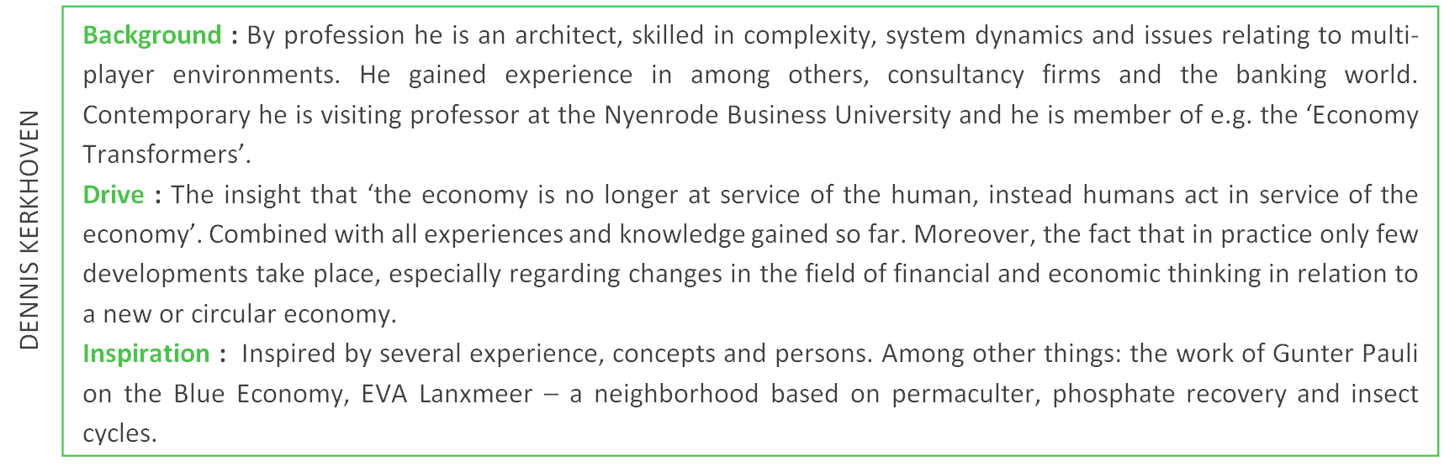
The part of the puzzle that was missing was related to some form of inspiration [7]. The pioneers of the first hour have indicated that the initiative would probably have stranded if Dennis Kerkhoven had not joined. The impulse given to the model is powered by the introduction of new competences, networks and most important new sources of inspiration [3A]. That is why it is important that an overview of the background of the fourth pioneer ‘Dennis Kerkhoven’ is provided. This overview is visualised in Figure 16 below.

Figure 16: Background of Dennis Kerkhoven
The participation of Dennis Kerkhoven has resulted in the introduction of a system approach in the model. The renewal of the model did not relate to the purpose of the initiative ‘the realisation of the necessary playing field in which local initiatives can develop’. Instead, the renewal was related to the spot on the horizon; a change from ‘energy transition’ towards ‘the realisation of a new economy’. With this new spot on the horizon, some other changes to the original idea for the BEC were made. The real system innovation is contained in different societal fields and is reflected in our households. In order to create a transition, crossovers between different societal fields must be created. Therefore a holistic view is necessary. In the original idea for the BEC the focus on energy was redeemed for all aspects relevant to households. The choice for themes is derived from this: energy, transport, health care, food and housing. Another change is related to the way in which practice is observed. Instead of looking to practice in a material or intrinsic way, every element in society is seen as an asset; an asset that contributes to a new economy. An instrumental perspective on practice emerged. Dennis Kerkhoven explains this with an example: “we are involved in a windmill park and in this context we are not talking about a windmill, but again we speak of one of the assets that are important in the transition to another economy” [7]. All changes in the model (that are described above) are the result of the involvement of Dennis Kerkhoven [3A]. With the change of perspective in the model, the name is changed as well, from ‘BEC’ to ‘Dirk III’.
Zooming in on the specific sources of inspiration responsible for the change of the model, multiple sources can be identified. First, the personal experiences and expertise of Dennis Kerkhoven on e.g. system thinking and architecture were important. In addition, both concepts and practical examples are used. The work on the ‘Blue Economy’ of Gunter Pauli served as inspiration for the system and circular thinking. Blue Economy is about closing the ecological systems without the loss of waste and energy. In this approach, the nature and techniques arising from the nature serve as a source of inspiration (Pauli, 2010). In addition to the Blue Economy, reference is made to permaculture. From this concept is derived how quality and intrinsic value, which is embedded in the region, can be utilised. Nico Baken and his work on ‘value cases’, has been another inspiration. And finally, three practical examples were named as source of inspiration: ‘Phillips, AMSL and Tesla’ were named. All three organisations have build or are building infrastructures and eco-systems [7].
Barriers and enablers
In the establishment of the model (the vision on Dirk III), some barriers were experienced. Despite the fact that the diversity between the pioneers was an important enabler for the successful development (e.g. different networks and different experiences, knowledge and competences), it has been a barrier at the same time. Understanding each other’s language is seen as the major challenge in the ideation of Dirk III [3A]. In addition, they had to ‘scrounge’ for support from the province, companies and other actors. These actors were though not clamouring to join [3B].

6.3.3 Execution of the ideas in practice
After approximately a year of working on the ideas for Dirk III, the official start of Dirk III with the implementation of the ideas in society, took place in 2013 with a kick off meeting on the 26th of June in Mariënwaerdt (Beesd) and the founding of the foundation Dirk III on the 27th of September (Dirk de Derde, 27 June 2013). This third phase that is distinguished in the analysis is characterised by the implementation of the ideas of Dirk III. However, in this phase the model in the ‘Theoretical triangle’ in Figure 14 is still subject to change as well.
One of the first observable changes relates to the establishment of the foundation [4A]. Structuring the initiative through the establishment of a legal form is seen as a logical step in the professionalisation of the initiative. The choice for a legal form of a foundation is made on the basis of practical considerations. In making a first start with Dirk III, it is convenient if you do not have to justify the choices made. Therefore, the legal form of ‘foundation’ is suitable. This substantive choice is made independent from the model.
In accordance with the model, the purpose of Dirk III is to facilitate the realisation of a new economy in the Betuwe. Establishing contacts and making connections between actors, initiatives and ideas is crucial in this context. Moreover, a main principle of the model relates to the fact that citizens (and ‘Betuwenaren’ in general) are actively involved in the initiative. That is why an attempt is made to attract more actors to participate in the initiative. In this way, in service of the model the governance structures with external actors are influenced [4B]. During the inspiration meeting in Beesd a first step was made in this. Later, roundtable meetings were organised in order to motivate actors and persuade them to support the ideas of Dirk III. A striking element in ‘recruiting’ actors for the initiative relates to the use of a specific concept that is reflected in the model. ‘The golden pentagon’, a concept showing the type of actors (five types) that should be involved in order to complete an initiative or project successfully [7], is used [4B]. The roundtable meetings, networking and the participation in events resulted in an increase of the number of actors supporting Dirk III. The participation of new actors had an effect on the model as well [3B]. Knowledge and inspiration is gained from these actors and just as important, new projects and ideas that contribute to the objective of Dirk III are introduced.
In order to provide a place for the actors who support and join the Dirk III ideology (and in order to increase the professionalisation of the initiative), cooperation’s were established [4A]. With this development, actors who were earlier operating independent from Dirk III were able to join the initiative in a cooperation. The importance of the emerged possibility for actors to actively participate in Dirk III is clearly reflected in one of the main principles in Figure 13: “from hierarchy to cooperative”. The regional area cooperation Rivierenland was founded on the 14th November of 2014. In addition to the regional cooperation, other cooperation’s were founded relating to a specific theme. For example, ‘the citizens wind cooperation’ and ‘the village cooperation Haaften’. Reflected in the establishment of cooperation’s, is a change in identity. This relates to a change ‘from consumer to prosumer’ [4]. This is one of the main principles in the model of Dirk III as well.
Barriers and enablers
During the implementation of the model in society, several barriers were experienced. Some of these barriers made it even impossible to implement the ideas of Dirk III. On the other hand certain factors can be identified that revealed to be relevant in an attempt to overcome these barriers.

In the implementation of the ideas of Dirk III, most barriers relate to the interaction between actors [3]. As well as in the establishment of the model, the mutual coordination between the four pioneers has been the largest barrier [3A]. This challenge is the result of different drivers, motives and personal ways of acting. In order to make the initiative a success and overcome these contradictions, they received external guidance. Moreover, during the process the roles became increasingly clear. Getting to know each other’s competences and weaknesses and to deploy them in the right way has been an important enabler. Another enabler in this context can be found in the way of ‘working together’. Every Friday the pioneers have a meeting and they start this meeting always with a chat about their personal life. If you look at the way in which they work together, it is striking that these relations are more than strict business relations alone. According to Wim Wink the feeling of “doing it together” has been very important to keep going on with the initiative, despite serious challenges. So, the competences and drive of the pioneers were indispensable in overcoming these barriers.
In addition to barriers between the pioneers, there were several barriers relating to the interaction with other actors. Especially during the first years of the initiative, the environment did not seem to be ready for the ideas of Dirk III. Wim Wink states: “when we started in 2011, in many places where we came it was ‘circular economy and transition management, what are you talking about?’”. The ideas did not seem to be contagious enough, which is one of the indispensable conditions for a transition described by Gladwell (2000) [3B]. The fact that the environment did not seem to be ready is evident in other ways as well. It turned out to be difficult to gain support from public bodies. The province for example is organised in different segments based on policy fields. This is the opposite of how Dirk III is organised, with a holistic perspective. This makes collaboration difficult. Moreover, in the region many conservative parties are in power and these parties constitute a constraining power for the development of innovative ideas [3B]. In addition to the authorities, also the financial institutions are named as a barrier for the implementation of the ideas. Financing the projects and Dirk III is difficult. This results in the fact that a lot of personal time is invested in the initiative. Moreover, the pioneers in Dirk III still need to earn their money in the ‘old economy’ [3B]. Those barriers resulted not in the fact that certain ideas or plans could not be carried out, rather it mainly has resulted in the loss of time.
Another barrier relating to the interaction of the pioneers with actors outside the chain, relates to the fact that there is little connectedness in the Betuwe – ‘all communities are small islands in the region’. This makes it even harder to organise a movement on regional scale [3B]. In an attempt to empower actors, the competences and networks of the pioneers were crucial enablers. A striking element in this context relates to the use of practical examples in order to clarify the ideas of Dirk III. The ideas of Gunter Pauli on the Blue Economy for instance, are explained by using the example of a coffee bean and how is made use of coffee beans in the ‘linear economy’. Dennis Kerkhoven stresses the importance of practical examples in the empowering process. He states that “people in the Betuwe are less concerned with processes of co-creation and brainstorming, in comparison with the Randstad. In the Betuwe people are better served by concreteness and the creation of precondition, so that people can start working”.
Where ideas in the beginning of the development of Dirk III are difficult to diffuse, during the development of Dirk III it becomes easier. According to the pioneers, the contemporary buzz surrounding CE is not the reason for this change. They think that it is definitely an enabler that CE becomes an object of interest in society, but the label CE is not decisive. According to the pioneers, actual developments in society, such as projects that were founded and a rising unemployment among fruit growers were decisive for a change in the way Dirk III is seen and acknowledged in the region. So, the ‘proven’ success of Dirk III and actual developments in society, are two final enablers in the empowerment.
6.4 Future: towards a new economy in the Betuwe
In order to achieve a realisation of the infrastructure for a new economy in the Betuwe and fully implement the principles underlying the model in society, still some steps need to be taken. Due to various barriers, which are mentioned in the previous sections, the model is not fully implemented yet. Moreover, some elements in the model are still unknown and during the implementation of the ideas, it must become clear how these elements are constituted or work. This relates for instance to the exact role of the Dirk III foundation.
It is hard to make statements regarding the extent to which the implementation of the ideas complies with the created model. Looking at the seven principles underlying the CE notion, as described in Figure 13, it is strikes that in the activities of Dirk III, all principles are reflected to a greater or lesser extent. The principles of ‘from consumer to prosumer’, ‘from hierarchy to cooperative’ and ‘from working for one sector towards working together with all stakeholders’ are clearly reflected in Dirk III. For example with the founding of the citizen wind cooperation. The other principles are to a less extent represented in the initiative so far. Take for example ‘from cash flows leaving the Betuwe to cash flows staying in the region’, this principle is much harder to discover in Dirk III. Different reasons can be designated for this: e.g. long-term principle and projects are not ready yet. Because Dirk III provides an infrastructure for a renewed economy, the degree to which the model is implemented in society is difficult to measure. Here is also referred to by the pioneers in Dirk III during the interviews. They stated that a way should be find in which the effects could be monitored in order to give substance to the set objective.
The future development of Dirk III towards a completion of their vision, contains the implementation of their ideas in society and a quantitative growth (more projects, more ‘followers or supporters’). The model already provides a lot of inspiration. Therefore, in order to boost the implementation of the model, changes should be encouraged in mainly the governance structures [4]. In the interviews with the four pioneers, already some possible improvements for achieving a complete implementation of the model were named. The main improvement on short term relates to the empowerment of new actors [4B]. The spread of the ideology is crucial and herein should be benefited from the buzz surrounding CE. In addition, financing should be realised to ensure the livelihood of Dirk III [4B]. Especially the governance structures are important, because Dirk III is a facilitating initiative. However, if elements in the interaction between actors are routinised, changes in the bundle of practices of Dirk III will be caused as well [1]. This relates to the proffesionalisation of the organisation, by for example in. This professionalisation relates to e.g. building organisations around new initiatives, founding a regional fund, exploring the possibility of an own coin and creating an incubator. If the organisation is made stronger by means of these changes, the ‘story’ will sold easier. Most of these actions are again strongly related to interaction between actors as well [4]. So, almost all components are available in Dirk III. That is why it is should revolve around the process and the optimisation of the ‘external governance structures’.

7 EcoProFabrics
7.1 Introduction
“EcoProFabrics will show that the old linear model in textiles, where garments are thrown away after use, can be replaced by a circular economic model, where used textiles are shredded into loose fibres then converted into new textiles without any loss in quality” (European Commission WWW, 18 March 2014).
This statement is made by Rien Otto, founding father of EcoProFabrics, during the kick-off of the project in 2014. EcoProFabrics is a project aimed at creating a full scale working CE model for work wear. The CE concept is embedded in an entire chain – including all facets from raw materials to service to the customer. The EcoProFabrics project is acknowledged by different organisations and institutions as a good example of a CE business model. For example, in Brussels EcoProFabrics is named as one of the ‘best cases’ (European Commission WWW, 18 March 2014). In addition, more and more media attention is gained, including e.g. an item of the popular Dutch television program ‘Een Vandaag’ (Een Vandaag WWW, 27 January, 2014). Despite the fact that different actors (from home and abroad) are part of the chain, the initiative meets the final criteria for case selection ‘the research area’ as well. The core of the initiative is located in Nijmegen, a place in the Gelderland region. In this environment the initiative is founded and developed.
The work wear chain in EcoProFabrics is operational for some time now. Therefore, interesting insights on the outcome of the implementation of the CE notion in practice are derived. Nevertheless, the CE model is still changing as well. For the analysis three interviews were held with important actors in the development of EcoProFabrics (an overview of the interviewees can be found in Appendix A). The results of these interviews were supplemented with information from the website, progress reports, news articles, written interviews and project descriptions.
7.2 A description of the CE business initiative
The unit of analysis is related to the CE work wear chain of EcoProFabrics. In this chain different organisations work together on the production, sales and recycling of work wear (Dutch aWEARness WWW, n.d.). In essence, the work wear of EcoProFabrics does not differ much from work wear that is produced according to a linear way of working. However, the way in which the production and consumption process is organised differs. In Figure 17, a description is given of the different nodes in the chain. What can be concluded of this description is that EcoProFabrics is aimed at closing the chain for the production of work wear. The actors in the chain need to collaborate intensively in order to optimise the reuse of raw materials and maximise the value, which is embedded in the chain. The CE concept is clearly reflected in the organisation of the chain and represents an example of ‘what a circular economic model’ could look like. The CE notion in EcoProFabrics is characterised by closing the loops of waste and intensive collaboration, in which transparency and trust are important principles.
It is important to mention that the CE work wear chain is part of the EU program EcoProFabrics. EcoProFabrics is a pilot project within the Eco Innovation Program of European Union. The project has a facilitating function (e.g. subsidy). It can be seen as an umbrella or a shell around the business of CE work wear. In the project is described which steps need to be taken in order to produce work wear within a CE (Dutch aWEARness WWW, n.d). Six organisations participate in the EcoProFabrics: EcoChain Technologies, Dutch aWEARness, Van Schoot Pompcenter, Bukk fashion, Royal HaskoningDHV [RHDHV] and Backhausen. While writing this thesis Backhausen is separated from the project and another organisation will replace their position in the consortium soon. Two of the named organisations do not directly take part in the (production) chain. These organisations are RHDHV and EcoChain Technologies. RHDHV is the lead manger (In Dutch: Penvoerder) of the consortium. This implies that they manage the different actors in the chain and guide the project EcoProFabrics. EcoChain Technologies is engaged to the development of software that can manage the chain – by tracing the materials and resources in the chain. This system is called ‘Circular Content Management System’ [CCMS]. CCMS is part of the EcoProFabrics project, but is separately developed from the CE work wear business. In total the EcoProFabrics project has a duration of three years, until mid 2017. After the termination date of the EcoProFabrics project, the CE work wear chain must be able to function independent from any form of subsidy.
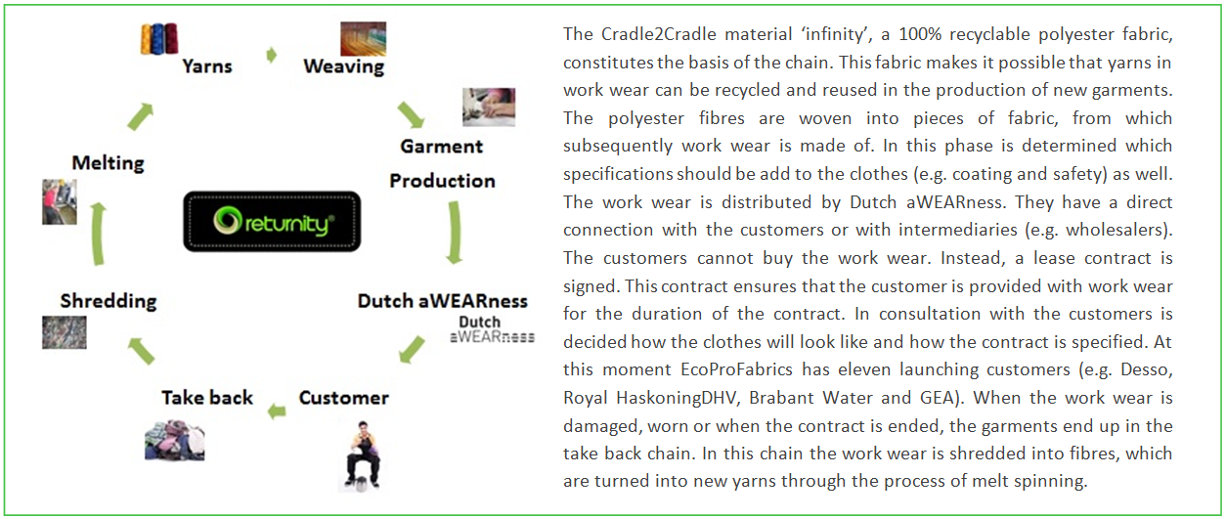
Figure 17: Overview of the CE work wear chain of EcoProFabrics (Source: Dutch aWEARness WWW, n.d.)
Because the EU project has been important in the development of the CE work wear chain, this project is taken into account in the analysis of the initiative. However, the main focus relies upon the CE work wear chain.
7.3 The analysis of the development of EcoProFabrics
The way in which EcoProFabrics is conceived and developed as a result of the interaction between ‘practices’, ‘model’ and ‘governance’ is discussed in this section. Therefore, the ‘Theoretical triangle’ displayed in Figure 18 is used in the analysis. An explanation about the use of numbers and letters in the analysis, corresponding to the relations in Figure 18, can be found in section 5.3.
EcoProFabrics officially started in January 2014 with the kick-off meeting in Amsterdam. However, the CE work wear chain was already operational and the first specific ideas were even conceived more than a decade earlier. The CE notion and the implementation of this notion in the textile industry developed step by step. Progressive experiences and knowledge has been important in this context. In the analysis of this development three phases are distinguished. The first phase is characterised by the establishment of a business in sustainable clothing (7.3.1). The second phase is about a change in perspective and emergence of a holistic and CE vision on the textile industry (7.3.2). Finally, in the third phase, ideas for a CE chain in textile industry are translated into practice (7.3.3).

Figure 18: The ‘Theoretical triangle’ for the analysis of the development of EcoProFabrics
7.3.1 The establishment of a sustainable clothing business
EcoProFabrics evolved from earlier gained insights and practices. The continuous interaction between the emergence of ideas and the implementation of these ideas in a business initiative has been decisive in this process. The constant factor in this development is the presence of Rien Otto. He is the pioneer and the driving force behind the initiative. Tracing back the roots of EcoProFabrics, the first distinguished phase is constituted by the early ideas and initiatives of Rien Otto, which eventually resulted in the sustainable clothing business of Dutch Spirit.
The establishment of the initiative starts with the motivation, inspiration and drive of Rien Otto, the pioneer. Our interview revealed that he has always been engaged to societal and sustainable issues. As an entrepreneur he has been active in diverse professions, from art galleries and social work to entrepreneurship in the textile industry. All professional experiences and in addition to this, experiences and encounters in personal life, constituted his motivation to work on societal and sustainable issues. This drive has been decisive in all steps that follow in the constitution of EcoProFabrics.
A first step in the constitution of a sustainable model can be found in the late 90’s of last century. Rien Otto was already working in the textile industry, designing and producing clothes for a number of brands. In those years also the initiative ‘local heroes was founded. One of the projects of this initiative relates to the construction of a school in a place in Ethiopia. At the site were the school was build, there was landfill of clothes. With his background in the clothing industry, Rien Otto was triggered to start exploring the possibilities of a more sustainable textile industry. Landfill of clothes, as part of a practice in the textile industry, is inspiration for the constitution of the sustainable model [2]. As a result of this inspiration and the earlier gained insights, a sustainable vision is created on the textile industry based on fair wear [7]. This vision is implemented in the already existing clothing business. This resulted in the fact that changes take place in the organisation of the production process (e.g. good working conditions and fair wages) [4A].
Subsequently, Rien Otto started to explore the possibility of organic cotton as an alternative fabric in producing sustainable clothes. However, it turned out that organic cotton was not a feasible and viable alternative, as the material is to vulnerable [2B]. In addition to fair wear, also climate neutral working became part of the sustainable vision on the textile industry, as a result of accumulation of experiences and advancing insights [7]. The sustainable vision that is created, results in the establishment of a new organisation ‘Dutch Spirit’ with his business partner [4A]. This organisation is the result of a similar drive and comparable ideas (model) about a sustainable textile industry. The organisation is started as an arty jeans label with the purpose to communicate sustainable awareness. This purpose was adapted due to a change in the model as the pioneers came across the ideas of Cradle2Cradle (C2C) [3A] (Wiesman, 21 December 2007). C2C refers to the re-use of natural sources and raw materials (McDonough & Braungart, 2005). Also C2C is applied on the clothing business [1B], initially in a pilot project at the end of the year 2007. Used t-shirts could be handed in against a returnable deposit. These shirts were shredded and the possibility was explored if the obtained material could be used as the basis for new garments (Wiesman, 21 December 2007). In this pilot project, the process is organised in another way as the production process is seen as a chain model and intensive collaboration is necessary [4A].
7.3.2 Towards the establishment of a CE vision on the textile industry
In 2008 there is a vision on a sustainable textile industry based on C2C. This vision is implemented as well in the clothing business of Dutch Spirit. Due to the influence of new inspiration and insights, the vision on a sustainable textile industry is expanded into a holistic perspective. The second phase in this analysis relates to the establishment of a CE vision on the textile industry, which results in a project plan for EcoProFabrics.
With the introduction of C2C to the sustainable vision on the textile industry a new piece of the puzzle is added to the model. The principles of C2C were seen as the logical next step and build on the earlier insights of e.g. the use of organic material, good working conditions and climate neutral working (Wiesman, 21 December 2007). All these concepts are reflected in the model as a part of a total overview [7]. Rien Otto has referred to this in the interview as follows: “I simply thought that people were not right. Fair trade is not the solution, organic cotton neither and the solution will also not be found in Cradle to Cradle. You should have a total overview, the solution can be found in looking at the interchanges and how you can improve these”. The pioneer is in this context indispensable for the emergence of a holistic vision on sustainability, a holistic vision that revolves around circularity. So, far before the contemporary buzz surrounding the CE concept, Rien Otto created already a circular vision.
A next step in the model is taken when contact is made with the firm Backhausen. This company makes use of C2C Gold certified fabric for furniture. The fact that this company is noticed and found, can be attributed to the network skills of the pioneer. With this encounter a new piece of the puzzle fell into place. They started exploring the possibility if and how this fabric could be made suitable for production (and recycling) of fashion and corporate wear. The result of this process is the fabric ‘Infinity’, a 100% recyclable polyester fabric [1B]. So, the encounter with the ‘right’ actors has strengthened the conviction that the developed sustainable vision can be applied to the textile industry [3].
Approximately simultaneously to the development of ‘Infinity’, an important organisational change takes place. Due to a different vision on the business, Rien Otto leaves Dutch Spirit. At the end of 2012 Dutch aWEARness is founded, a new organisation established by Rien Otto and his new business partner. Although this change is important to mention, it cannot be explained by means of ‘Theoretical triangle’ in Figure 18. In addition to the emergence of Dutch aWEARness, a new partnership was founded with EDC (European Design Centre). EDC came up with the idea for the possibility to make use of subsidies within the EU Eco Innovation Action Plan. Therefore, the encounter of EDC and Rien Otto has been an important enabler for the start-up of the practices in the CE work wear chain [5]. The subsidy has been crucial in order to make the chain operational, because it is difficult to acquire funding. Most banks does not support models based on lease constructions as it is implemented in EcoProFabrics [3B].
Together Dutch aWEARness and EDC started jointly working on the project plan for EcoProFabrics (in order to bring in the necessary funding)’ [3]. This plan is a reflection of the model that originally was intended for Dutch Spirit and is in line with the holistic vision, as is outlined above. Within the plan a strategic choice was made to focus on work wear. This decision was made on the basis of practical reasons. For instance, it is easier to have a single organisation or company as a client when the clothes are taken back in the chain, instead of individual consumers. Moreover, for the fashion industry other specifications are necessary compared to the work wear industry. Although it is important to mention the reasons that underlay the choice for work wear, just as with the organisational changes it cannot be explained by means of the ‘Theoretical triangle’ in Figure 18. At the same time as writing the project plan, actors were selected and approached for a position in the chain (Figure 17) and the EcoProFabrics plan. The fact that the right partners were founded can be attributed to the experience as an entrepreneur and the competence of ‘networking’ of the pioneer.
The project plan for EcoProFabrics is approved in the summer of 2013, which resulted in receiving the necessary funding for the organisation of the chain. Despite the approval, the project is not able to start due to a bankruptcy of EDC. The position of EDC, as consortium leader of the EU project EcoProFabrics, is replaced by RHDHV. An important enabler for the collaboration can be found in an accidental encounter a year earlier between Rien Otto and Jan-Paul Kimmel of RHDHV. Similar ideas about the CE constitute the basis for a partnership. Although there is a comparable vision, the partnership is loaded with different and sometimes contradictory interests. The entry of RHDHV and the other actors (in the consortium) had not an effect on the model, as it is reflected in the project plan of EcoProFabrics [3]. Although RHDHV did not made any substantial changes in the vision for the CE chain at this moment, by the accession of RHDHV to the consortium useful competences and knowledge about e.g. project management and leading consortia were added.
Barriers and enablers
This phase is mainly characterised by the establishment of the CE vision (adaption of the model). In this process barely barriers were experienced. The already mentioned bankruptcy of EDC was a constraining factor in the development, because it caused a delay in the project. Nevertheless it did not affect the actual content of the model [3]. Another barrier relates to the chain formation at the end of this phase. In addition to problems that are similar to those relating to entrepreneurship and the development of a new business in general, extra challenges emerge due to the advanced form of collaboration. All actors, which are part of the consortium and the chain of EcoProFabrics need to be aligned to a similar vision. Aligning all actors in the chain to a similar model was and is still a challenge. Edward Pfeiffer, manager of the consortium, refers to this as follows: “we all signed for the same, however the wavelength we were on differed strongly”. In the field of the governance creating ‘a common understanding and agreement’ has been a major challenge and constraint [3A]. Competences related to ‘people management’ and ‘project management’ are important in this context.

7.3.3 Execution of the CE work wear chain
In March 2014 the EcoProFabrics EU project has officially been approved by the EU, allowing the consortium to start. The chain, however, was already partially operational (with the production of work wear). The last phase, distinguished in this analysis, relates to the execution of the CE work wear chain. Because the chain starts running at once, different activities and developments take place at the same time. Moreover, these developments are closely related to barriers in the implementation. That is why in this last phase, the developments are discussed on the basis of different elements in the implementation (in which attention is paid to the barriers and enablers as well), instead of describing the development step by step chronologically.
In section 7.3.2, already is mentioned that aligning actors in the chain has been a challenge. This is still a challenge when the CE work wear chain is operational. According to Rien Otto, aligning the partners to a certain degree is successfully achieved. However, most of the partners in the chain are still working on the basis of ‘linear principles’ in their own business (in which self interest is predominant). Transforming the way in which these organisations work is much harder. This resulted in the fact that the partnership is affected, because full transparency is not possible while this is prescribed by the model [3A]. As time passes, the alignment of the partners in the chain is improving [3A]. However, this is not always successfully achieved. For example, the firma Backhausen was not able to translate the customers’ wishes in the production of the work wear, to a desired level. Conversations between Dutch aWEARness, RHDHV and Backhausen revealed that in terms of competences and drive substantial elements were missing. That is why recently has been decided that Backhausen will leave the project [3A].
The loss of such an organisation seems to be a huge drain for the initiative. And in fact, it has resulted in a delay. However, simultaneously Rien Otto already contacted two other companies via his network, which are more experienced in the profession of making textile for clothes from ‘circular raw materials’. This shows once again the indispensable position in the initiative of Rien Otto as pioneer. His wide network (even to a high level in the European and Dutch politics) and his extensive experience in entrepreneurship were important enablers.
In addition to the alignment of the partners, the chain as a whole must function as well. In this context a barrier arose regarding the second part of the model, the ‘take-back chain’. How this part of the chain should work is thought out and embedded in the model (Figure 17). However, in practice the take-back chain cannot be tested full-scale within the timeframe of the EcoProFabrics project. It takes time before the work wear is sold and moreover the work wear needs to be worn. Being not able to test the take-back chain has been a barrier in the development of the initiative, because there was not a clear image in the degree to which the take back chain would function well [3A]. After a partnership with Nike, through the Launch Nordic network, this barrier was defeated. Nike helped testing the re-use of the 100% polyester fibres. Testing the take-back chain confirmed that the CE model as a whole functions and hereby the model was endorsed [3].
One of the most important factors for the success of the chain relates to the acquisition of customers. This has been one of the main activities in the initiative during the last year. Both Dutch aWEARness and RHDVH has spoken with (potential) customers and other relations in order to find out what their specific needs are. Regarding the expectations about the target group, two aspects are identified in which there was a discrepancy between the expected and the reality. First, they underestimated what it means to design clothes for companies (the performance side). Quality and functionality is more important compared to the fashion industry. This was stated by Edward Pfeiffer. In addition, it appeared that companies had often already long-term contracts with work wear suppliers. It is difficult to break in on these contracts. Although these expectations are not specifically related to the CE notion, they are an element in the model [3].
Implementing the vision in the business initiative is a process of pioneering and exploring. An important part of the business relates to obtaining revenue. Without an increasing turnover or a new source of income the EcoProFabrics chain will stop running when the current subsidy ends. In advance, it was not completely clear what the entire business case would look like. However, insights derived from conversations with (potential) customers provided information to close these ‘black holes’ in the model. An example can be found in the price setting of the work wear. While implementing the model, they found out that customers prefer user costs, above the price per item. These user costs should be similar, or preferably lower than the costs they make in their current work wear contracts. Although the price setting is not directly related to the CE notion, it is an element that influenced the total model (of which the price is an element) [3].
A final striking element in the implementation of the model relates to the influence of legislation. Some laws had a restrictive effect, which act as a barrier in the implementation of the model in the business initiative. It is important to mention that these restrictions in the law were known in advance. That is why there were no surprises during the implementation instead the model is adjusted to the restrictions in advance. An example can be found in the law on the transportation of certain materials to other countries. The EcoProFabrics model reflects a closed loop in which materials are re-used for the production of work wear. The legislation is based on another perspective in which materials are seen as waste instead of a material that can be used again. According to the law it is forbidden to transport waste to other countries. This makes it impossible to conduct certain activities in the chain abroad. This is a constraint in the governance (legislation), caused by a different meaning [3B].
7.4 Future: towards a closed loop for the textile industry
EcoProFabrics is contemporary situated in the implementation phase. The CE work wear chain is running for some time now, but as Edward Pfeiffer describes it: “at the same time it is ‘learning on the job’”. That is why the model is subject to change as well. The CE notion is developed step by step and the resulting model is translated in a functioning chain as well. This notion of the CE concept is based on closing the loops of waste and intensive forms of collaboration between actors, in which transparency and trust are important. Despite the fact that there is a working chain based upon these principles, there are differences between the ideal image and the reality. This discrepancy is partially caused by the described constraints in the previous sections. There is space for improvement. This is also emphasised by the actors involved in the initiative. During the interviews some possibilities for improvement, in order to extent the level of circularity, were named as well.
Different organisations constitute together a closed loop for the production (and distribution) of CE work garments. There is collaboration between the different organisations and there is a certain degree of trust as well. However, these partnerships are not fully steeped by circularity. Both Edward Pfeiffer and Rien Otto state in their interviews that the way in which business is done, is purely linear. In this context, the old-fashioned way of pricing and also the ‘contracting’ are mentioned as examples. The business of the actors participating in the chain, are in most cases organised in a linear way. Therefore, own interests are more important, rather than the common interest. According to the ideal model, the common good is decisive, which will result in a more efficient organisation of the chain. However, due to this ‘linear mindset’ the model is not fully implemented in EcoProFabrics [3A]. According to Edward Pfeiffer it requires time before this will change: “then you will automatically notice that you are part of a certain cooperation and are able to save money, instead of merely being part of a partnership”. In accordance with the model, ideally ‘sharing’ (of e.g. knowledge and information) is an important element as well. Since actors are working and participating from mainly their own interest, there are restrictions in the degree of sharing. The actors participating in the chain consider what kind of information they share with the rest of the partners. This is necessary in order to prevent that others take advantage of your business. So, at this point there is space for improvement as well in order to increase the level of circularity [3A].
A development in EcoProFabrics that already contemporary takes place could improve the level of circularity in the business initiative. This relates to the development of the CCMS system. CCMS is a tool, which could make it possible that materials and raw materials in the chain are traced. This system is currently being developed. In the future it could support the management of the chain. This tool (material component) could ratify and strengthen the CE model [2B].
So, the work wear garments in its self do not differ much from work wear that is produced in a ‘traditional linear economic model’. The difference can be found in the organisation of the initiative; the way in which substance is given to the chain. Therefore, in order to improve the implementation of the CE notion in EcoProFabrics, one should mainly steer on the ‘governance relations within the chain.

8 Energie en Grondstoffen Fabriek
8.1 Introduction
“Winnen, verwerken en afzetten van energie en grondstoffen uit afvalwater waarmee een bijdrage wordt geleverd aan de circulaire economie.” (Hoogenboom & P2Managers, 2014, pp. 15).
This quote, abstracted from the transition program of the ‘Energie en Grondstoffen Fabriek’, can be translated in English as follows: “Extraction, processing and the deposition of energy and raw materials from wastewater, which contributes to the circular economy”. The quote represents the objective of the ‘Energie en Grondstoffen Fabriek’ [EFGF], an initiative from the Dutch Water Authorities. EFGF is a project in the field of wastewater treatment. The Dutch Water Authorities endeavour to contribute to the CE, as they are an important node in the water cycle in our modern urban environment. This contribution should be achieved by means of various measures and projects, organised under the name of EFGF. The initiative is recognised and acknowledged by others as a good practice in sustainability. For example, in 2009 EFGF has already been awarded with the climate innovation price ‘Groene Parel’ (Duurzaamgebouwd WWW, 2009). Although EFGF is a national initiative, the case fits within the final criterion for case selection, which relates to the research area. Because, one of the places where an EFGF has arisen is the wastewater treatment plant [WWTP] in Nijmegen (which is part of the Rivierenland Water Authority).
Analysing this initiative is accompanied by a high degree of complexity. The initiative has evolved at different levels within the Dutch Water Authorities. Moreover, the initiative is situated in the implementation phase. But, at the same time the model is adapted as well. That is why for the analysis interviews were held with five actors who play(ed) an important role in the development of EFGF in different levels of the Water Authorities (an overview of the interviewees can be found in Appendix A). The results of the interviews were supplemented by different data sources: the website of EFGF, the transition program (Hoogenboom & P2Managers, 2014) and the signed Green Deals (Green Deal, 2014; Green Deal, 2011).
8.2 A description of the CE business initiative
The EFGF is an initiative from the Dutch Water Authorities aimed at the preservation of one of the tasks of the Dutch Water Authorities: the wastewater treatment process. The ultimate goal of the EFGF is that in 2050 the WWTP’s don’t have residuals anymore. Instead, it should be possible that all wastewater in the Netherlands can be transformed into useful products (Hoogenboom & P2Mangers, 2014). As an actor in a larger chain, they provide herewith a contribution to the CE. The CE concept is clearly reflected in the objective of the EFGF. This CE notion is strongly based upon ‘closing the loops of waste’, in which new forms of collaboration are an important means. In order to realise the recovery of raw materials and the generation of energy from wastewater, different means are used and various activities take place.
As the Dutch Water Authorities are a large organisation, the EFGF has various forms. The EFGF does not only relate to the realisation of actual ‘EFGF’s’ at WWTP’s, in fact EFGF relates to a brand and overarching network as well. The first element that can be distinguished in the EFGF, relates to the (learning) network EFGF. The twenty-three Regional Water Authorities in the Netherlands can join the EFGF voluntarily. At this moment, all Regional Water Authorities are participating in the initiative. Actors from the Regional Water Authorities come together in a network, in which local and (inter)national developments and problems regarding the EFGF are discussed. The network has a facilitating function: jointly knowledge is developed, they work on the elimination of common barriers and actors in the Regional Water Authorities are motivated to implement the EFGF.
The responsibility for the implementation and realisation of the EFGF at the WWTP’s rests with the Regional Water Authorities. They can decide in which WWTP and how they want to implement the EFGF. The realisation of the EFGF and therewith the actual improvement of sustainability, takes place at the WWTP. A short description of the process of wastewater treatment could be useful in this context. This description is given in Figure 19.
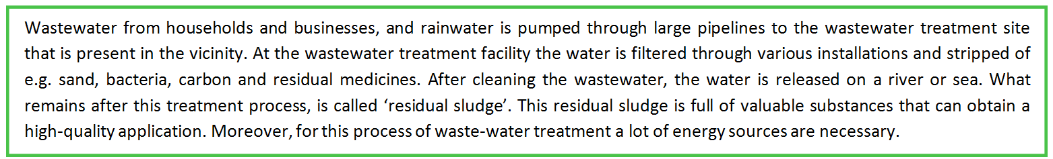

Figure 19: Short description of the wastewater treatment process
In each WWTP different measures could be taken in order to maximise the extraction of raw materials and energy. For instance, the adoption of techniques, the creation of smart combinations and the establishment of new forms of collaboration. It depends on the Regional Water Authority in question and the specific environment of the WWTP, how the EFGF is implemented and what kind of measures are used. Because the environment of the WWTP is crucial for the opportunities of an EFGF (and there are over three hundred WWTP’s in the Netherlands), in this analysis one site is explored in particular. This is the WWTP in Nijmegen. Nevertheless, as the EFGF concept is a national initiative and developments in the Dutch Water Authorities influence the specific WWTP, attention is paid to the developments of and in the EFGF network as well.
8.3 The analysis of the development of the EFGF
The way in which the EFGF is conceived and developed as result of the interaction between ‘practices’, ‘model’ and ‘governance’ is discussed in this section. Therefore the ‘Theoretical triangle’, displayed in Figure 20, is used in the analysis. An explanation about the use of numbers and letters in the analysis, corresponding to the relations in Figure 20, can be found in section 5.3.
Approximately ten years ago the EFGF emerged as a new direction for sustainability within the Dutch Water Authorities. In these ten years the EFGF developed from a generic vision into dozens of specific embodiments at WWTP’s. This development has not taken place at once. Instead the EFGF is developed step by step at different levels within the Dutch Water Authorities. In the analysis of this development four phases are distinguished. The first phase is characterised by the emergence of the ‘Energie Fabriek’ [EF], a sustainable vision on the WWTP (8.3.1). Subsequently, a distinction is made in the further elaboration of this vision or model on policy level within the Dutch Water Authorities (8.3.2). At the same time the vision for the ‘EF’ is implemented at the WWTP. This is relating to the third phase in this analysis (8.3.3.). Finally, in the fourth phase the ‘Grondstoffen Fabriek’ [GF] is founded and added to the ‘EF’, as a next step in the creation of closed loop in wastewater treatment.

Figure 20: The ‘Theoretical triangle’ for the analysis of the development of EFGF
8.3.1 The emergence of the ‘Energie Fabriek’
The first step in the development of the EFGF can be traced back to beginning of 2008 with the emergence of the ‘EF’ concept. A concept based on the extraction of energy from wastewater. Different drivers are responsible for the emergence of this concept, which relates to a (renewal of the) sustainability vision on WWTP’s. Translated to the ‘Theoretical triangle’ in Figure 20, this relates to the first steps in the constitution of a CE model.
In the wastewater treatment process (Figure 19) a huge amount of energy is used. Until a decade ago, it was assumed on large scale in the Dutch Water Authorities that 30% self-sufficiency in energy would be a challenge for the WWTP’s. 100% energy neutrality seemed even impossible. However, the coincidence of a number of drivers, resulted in the emergence of the ‘EF’ and more important a new mindset. A quote of Renze van Houten, former manager of Water Authority Aa en Maas, enhances this:
“In 2000 I made a proposal in context of a subsidy program. This was for another employer. In this plan we proposed to pull apart wastewater in three streams: ‘water’, ‘energy’ and ‘nutrients’. This idea is ingloriously perished. While what we are doing at the moment with the EFGF had a lot of similarities with that proposal”.
In the practices that constitute the wastewater treatment, it is possible to extract energy from wastewater. It even is executed at the WWTP’s for decades (but not in the quantities that we speak of nowadays). In this context the renewed mindset is caused by changes in the governance [relation 3]. The most important driver in this relates to the repositioning of the Dutch Water Authorities within society. Regularly, the existence and usefulness of the Water Authorities is discussed within the national politics. Moreover, the organisation has been struggling for years with a dusty and old-fashioned image. As a response on the issues about the position in society, the traject of ‘Waterwegen’ is founded in 2007 by the association of Dutch Regional Water Authorities (the coordinating body). ‘WaterWegen’ had the purpose to strengthen the position of the Dutch Water Authorities in society. By means of a contest, innovative ideas that contribute to this purpose were submitted by the Regional Water Authorities. In total more than eighty ideas were submitted and the ‘EF’ turned out to be the winning concept (EFGF WWW, n.d.).
That the ‘EF’ concept won the contest cannot be ascribed to coincidence. Four similar ideas, with the purpose to increase the energy efficiency at WWTP’s, were submitted. Despite the fact that the four proposals were developed separately, it appeared that there were shared ideas or perspectives among a number of Regional Water Authorities [3A]. Moreover, at the same time a term agreement on energy efficiency (MJA3) was signed between the national government and the Dutch Water Authorities. This agreement proposed to create structural energy management within the organisation. This was accompanied by the specific objective to realise a progression in the energy efficiency of 2% each year [3B]. This was a stimulating driver for the win of the ‘EF’ as well. A final driver relates to fact that at the WWTP’s, an increasing number of actors was engaged to the optimisation of energy use. Together these drivers were responsible for the emergence of the ‘EF’. Winning the contest was the indispensable moment in this, because it created commitment from the management of the Dutch Water Authorities [3A].
In the second half of 2008, the winning idea was developed in a specific plan by actors of the four Regional Water Authorities that submitted a similar idea for the contest (Aa en Maas, Hollands Noorderkwartier, Veluwe and Rivierenland). The result of this cooperation is an approach for the realisation of ‘EF’s’ (energy neutral WWTP’s) wherein the recovered energy can be used as a product for society. Three tracks are attached to this: (1) marketing track - ‘how can we brand the ‘EF’’, (2) Research track and finally (3) the realisation track - ‘what is necessary for the actual realisation of ‘EF’s’’ [7]. In the establishment of the actual content of this vision (or the model) both governance and practices has been influential. All actors working on the plan have their own expertise, knowledge and experiences. Gathering these backgrounds has been the most decisive source of inspiration [3A]. A source of inspiration that is explicitly named relates to the Transition Model of Jan Rotmans. The Transition Model provides a tool for achieving and stimulating transitions or incremental changes (within an organisation). This concept is reflected in the model, as it used to describe the way in which the realisation of ‘EF’s’ should be facilitated [7]. Although the 'EF’ concept mainly is aimed at a ‘change of roles’ (from energy user to energy producer), substantive knowledge about the wastewater treatment process has been important as well. This knowledge is embedded in the bundle of practices constituting the wastewater treatment [2].
Barriers and enablers
In the establishment of the sustainable vision on the WWTP nearly any barriers were experienced. The biggest challenge in the establishment of the ‘EF’ concept is related to the commitment of managers [3A]. In particular, the ‘middle-management’ is difficult to convince when it comes to innovative ideas. However, the drivers mentioned above resulted eventually in the support from the management within the Dutch Water Authorities. In this process it is striking that it is not possible to distinguish one or few pioneers that have been indispensable. Because the initiative is supported in different places within the Dutch Water Authorities, actors can be replaced without major consequences for the development of the concept.
8.3.2 Embedding of the ‘Energie Fabriek’ in the Water Authorities
Mid 2008 a clear idea for the ‘EF’ has emerged. In the second phase distinguished in this analysis, the plan for the ‘EF’ is developed into a complete program and network organisation. In addition to an optimisation of the model, an infrastructure is build that supports the establishment of actual ‘EF’s’ at WWTP’s.
In service of the designed vision for the ‘EF’, a network organisation is founded in which the Regional Water Authorities can participate voluntary [4A]. As is described in section 8.2, in this network experiences and knowledge are shared. The network organisation has grown from four Dutch Water Authorities in 2009, to the participation of all Regional Water Authorities nowadays. One of the most important tasks is to address common barriers that occur in the establishment of the ‘EF’s’. The network organisation is in this context the link between the Regional Water Authorities or the WWTP’s and the Association of Dutch Regional Water Authorities or the Dutch Government. A clear result of the network organisation can be found in the realisation of a Green Deal signed by the Dutch government (Green Deal, 2011). In the acceleration and up scaling of the extraction of sustainable energy from wastewater, the Water Authorities experienced fiscal barriers. With the signed Green Deal, the Dutch government made a promise to adapt the legislation and regulations that were barriers in the acceleration and up scaling of sustainable energy extraction. Translated to the ‘Theoretical triangle’ in Figure 20, this relates to a change of the ‘governance structures outside the chain’ in service of the model [4B].
In addition to the realisation of energy neutrality of WWTP’s, an important objective of the ‘EF’ concept relates to the realisation of a ‘change in roles’ (from a waste processer, to a producer of something new). This objective stems from the social driver to reposition the Dutch Water Authorities in society, as is described in the previous section. This change in role and identity seems to be successfully achieved [3A]. This is stated in all interviews that were conducted for this analysis (Appendix A). Moreover, the Dutch Water Authorities are awarded for this change in roles with the climate innovation price ‘Groene Parel’ as well (Duurzaamgebouwd WWW, 2009). The degree in which this change is experienced locally at the WWTP is discussed in the next section, in which is elaborated on the implementation of the concept in the WWTP’s.
Barriers and enablers
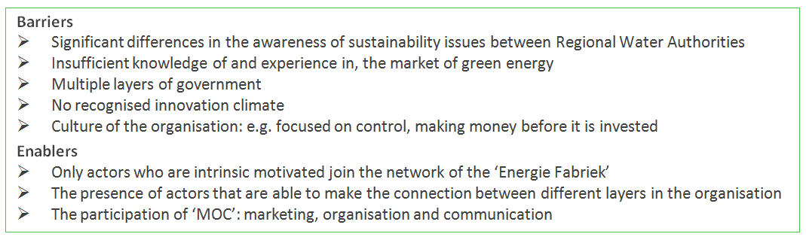
In the roll-out of the concept ‘EF’ at policy level (Dutch Water Authorities) a number of barriers were experienced. These barriers resulted mainly in a delay of the development. Barriers which made it impossible to implement the model were not identified. These barriers and in addition important enablers in overcoming these barriers, were all related to the interaction between actors within the Dutch Water Authorities [3A]. Therefore, these barriers and enablers are visualised in Figure 21.

Figure 21: Barriers and enablers during implementation of ‘Energie Fabriek’ at policy level
8.3.3 Implementation of the ‘Energie Fabriek’ in the WWTP
Simultaneously to the developments that took place at national level within the network organisation of the ‘EF’, the concept is implemented in the Regional Water Authorities. They are responsible for the actual development of ‘EF’s’ at WWTP’s, as is discussed in section 8.2. In this phase, the generic model ‘EF’ received a specific implementation within e.g. the Water Authority Rivierenland. This implementation is decisive for the changes that are caused at the WWTP’s.
Already in section 8.2 is argued that every WWTP is unique and that the exact implementation of the ‘EF’ depends on the environment in which this WWTP is embedded. In this analysis the Water Authority Rivierenland is examined, in which special attention is paid to the WWTP in Nijmegen. In Rivierenland three WWTP’s have been designated for the implementation of an ‘EF’. The choice for these plants is based on the control area in which they are embedded. Moreover, the potential for the realisation of energy neutrality is taken into account. The implementation of the ‘EF’ can be achieved in two ways, by changing the existing practices of the wastewater treatment process or by starting new partnerships.
The implementation of the ‘EF’ concept in the WWTP in Nijmegen did not cause significant changes in the bundle of practices of the wastewater treatment process [1]. This can be explained by the fact that in Nijmegen in the years before the introduction of the ‘EF’, the extraction level of energy from wastewater was already high. Investments had been made in the facilities and the installations of the WWTP had been optimised already. This was also confirmed in the interviews. Willy Verstegen, former manager of the WWTP in Nijmegen, states that: “in Nijmegen we were already well on track”. In addition to changes in the practices of the wastewater treatment process, the model assumed that new partnerships are important in the establishment of an ‘EF’. In service of the model, new partnerships are not founded [3]. As well as with the practices, at the WWTP in Nijmegen already some partnerships were established before the introduction of the ‘EF’. An example can be found in the partnership between the ARN (waste incinerator) and the WWTP. The ARN uses filtered wastewater as cooling water for their installations, in exchange the WWTP receives ‘heat’ that is used as an energy source for the wastewater treatment process. In addition to the already existing partnerships, the WWTP in Nijmegen is in fact exploring the possibilities for new partnerships.
The most important effect of the introduction of the ‘EF’ concept in Nijmegen, can be found in the incensement of the drive to optimise the energy efficiency in the WWTP [4A]. This is also emphasised by three of the interviewees (who are engaged to the WWTP in Nijmegen). They state that the concept only was important in accelerating the achievement of energy neutrality. The motivating force of the concept can be identified in other Regional Water Authorities as well. An example of this motivational power is clearly reflected in a large and continuous discussion between the Regional Water Authorities about the definition of an ‘EF’. ‘Are you allowed to use flows from third parties (e.g. offal’s) in an attempt to increase the energy production or must all energy be extracted from the own wastewater?’ This was only one of the questions about the definition of the ‘EF’, which was raised. However, it caused a certain contest or battle between the Regional Water Authorities. Therefore, the model has a clear affect on the drive of actors [4A].
In order to place the influence of the model on the WWTP’s in perspective, it is important to mention that Nijmegen is only one of the more than three hundred WWTP’s in the Netherlands. Every WWTP is unique. In comparison, some WWTP’s in the Netherlands experienced both changes in the practices and the partnerships due to the introduction of the ‘EF’.
Barriers and enablers
The barriers in the implementation of the ‘EF’ are mainly depending on the unique environment in which the WWTP is embedded. In terms of technology, there are almost no restrictions in Nijmegen. Barriers relate therefore mainly to the interaction with other actors [3]. For example, other actors were not willing or able to work on smart combination regarding energy production and efficiency [3B]. Most important enabler in the implementation of the ‘EF’ relates to the presence of motivated actors at the WWTP. This explains the large differences between Regional Water Authorities. In comparison to the ‘EF network’ at national level, for the implementation of the ‘EF’ at WWTP’s the presence of certain motivated actors (pioneers) is decisive. The reason why the WWTP in Nijmegen was already highly developed (regarding energy neutrality) can be attributed to the presence of motivated actors. In Nijmegen for example, at the beginning of each year targets were made for the reduction of energy at the WWTP. These targets created a certain game among the staff to achieve these targets. In this, concepts are not the main trigger for actors instead it is about the practical achievement of energy efficiency.
8.3.4 Extension of the vision: the emergence of the ‘EFGF’
In 2011 the ‘Grondstoffen Fabriek’ [GF], a similar concept as the ‘EF’, is founded. The newly established concept revolves around the extraction of raw materials from wastewater and is seen as the follow-up to the ‘EF’ [7]. First, the concept and related activities take place parallel to the ‘EF’. Later, they are fused into the EFGF. In this last distinguished phase, a next step is made in the model towards a comprehensive sustainability (and CE) vision on the WWTP. This phase is not limited to the ideation alone; at different levels within the Dutch Water Authorities changes were caused.
The ‘GF’ is the result of the coincidence of a number of drivers. Two important drivers can be identified in the interaction between actors [3]. On behalf of the Association of the Dutch Regional Water Authorities, an outlook of the wastewater chain in 2030 was made. In addition to this outlook, the report RWZI 2030 was written. From these scripts was derived that the wastewater treatment process needed a broader perspective in which a distinction could be made in three flows: water, energy and nutrients. Specific attention was yet not paid to nutrients. In addition to those reports, the practices of the wastewater treatment process were decisive. In a number of Regional Water Authorities there were problems with phosphate in the WWTP. Phosphate, a type of struvite, precipitated on the installations of the WWTP. This was a clear incentive to start exploring the possibility of phosphate recovery from wastewater [2]. Moreover, phosphate is a scarce commodity, which makes it an interesting source for distribution. Subsequently, in 2011 the Dutch Water Authorities joined the nutrients platform in which collective agreements were made between the Regional Water Authorities [3]. By the coincidence of the described drivers above, was decided to explore the possibilities of resource recovery from wastewater. After the success of the ‘EF’, the same format is chosen for the development of the concept. So, the combination of practical knowledge, experiences, insights in marketing and communication and concepts (i.e. Transition Model) was important in the constitution of the ‘GF’. This eventually has resulted in a network organisation [4A], which is fused with the ‘EF’ in the beginning of 2014.
The implementation of the ‘GF’ in WWTP’s is still in its infancy. Primarily is explored what the possibilities of the ‘GF’ are. Moreover, like the ‘EF’, the actual implementation of the ‘GF’ concept depends on the unique environment in which the WWTP is embedded. These factors make it hard to explore changes in both the bundle of practices and the governance structures. However, as the ‘GF’ is more complex than the ‘EF’, especially relating to the change in roles from waste processor to producer of resources, it is possible to identify barriers in the early stage of the development in which the ‘GF’ is situated.
The further change of identity and with this a change in roles (following the ‘EF’), is an important result of the introduction of the ‘GF’ concept. Producing and distributing nutrients as a Water Authority encountered opposition. Especially in the national politics arose the question, whether this was part of the legal task of the Dutch Water Authorities [3B]. A large judicial research was conducted to confirm that producing nutrients from wastewater could be carried out by the Dutch Water Authorities. On the basis of e.g. this research, the minister expressed support for the change in roles. This has been an important endorsement for the ‘GF’ [3B]. In addition to the change in identity, another clear change has taken place in the ‘governance’. In implementing the ‘GF’ concept and start winning nutrients from wastewater, the jurisdiction revealed to be a barrier. That is why a Green Deal is signed with the Dutch government. With this Green Deal an agreement is made, which ensures the support of the Dutch government and their preparedness to change laws and regulations if this proved to be a relevant barrier for the development of the ‘GF’ (Green Deal, 2014) [4B]. An example of this relates to production of phosphate. Legislation that was a barrier for the distribution of phosphate (derived from wastewater) was adjusted.
Looking at the implementation of the ‘GF’ concept in the WWTP in Nijmegen, just like the ‘EF’ no significant changes were caused by the implementation [1]. This can be explained by the fact that the ‘GF’ is only recently introduced. However, the ‘GF’ resulted in an increasing drive of actors engaged to the WWTP in Nijmegen, to explore the possibilities for the extraction of nutrients [4A]. Despite the fact that an exploration of these possibilities takes place, there has to be clear and identifiable reason for the extraction of nutrients from wastewater. This reason relates to a problem in the wastewater treatment process (e.g. struvite, which clogs the installation and is a reason to start winning phosphate). As extraction of nutrients is often an expensive and energy-guzzling process, there must be a clear business case in order to start with the extraction. This does not only apply for the WWTP in Nijmegen, but applies for all WWTP’s. This can be seen as a barrier as well [3], as the ‘GF’ is only implemented if there is a business viable business case.
8.4 Future: towards a closed loop in wastewater treatment
In order to achieve the objective of the EFGF and make a significant contribution to the CE by extracting, processing and depositing energy and raw materials from wastewater, still some steps need to be taken. This is clearly reflected in the plans of the Dutch Water Authorities as well. As for example, the target for energy neutrality is set at 2050 (Hoogenboom & P2Managers, 2014). Moreover, the ‘GF’ is only founded four years ago, with results that still much is unknown about the possibilities. Nevertheless, already seven WWTP’s are an ‘EG’ and nine WWTP’s are currently transformed into an ‘EG’. Also regarding the ‘GF’ already some actual developments did take place; in ten WWTP’s phosphate will be retrieved and in four places the possibility for the extraction of cellulose is explored. If these numbers are compared with the total amount of WWTP’s (over three hundred), these are only small steps. So, in quantitative terms there is a lot of space for improvement.
Looking at the way in which the CE notion is implemented in the WWTP’s, possible improvements can be identified as well. This is clearly stated in the interviews with key actors in the development of the EFGF too. The CE notion in the EFGF is based on ‘closing loops of waste’. This CE notion is reflected in the WWTP’s were the ‘EF’ and ‘GF’ is implemented to varying degrees. In Nijmegen for example they already succeeded in energy neutrality. However, regarding the extraction of nutrients there is not much activity and it seems that not much will change in the near future. This can partly be explained by the type of WWTP, as one of the most important factors relates to the environment in which the WWTP is situated. That is why every WWTP is unique and needs another approach.
Nevertheless, some general statements can be made regarding the future of the EFGF and possible improvements. Despite the fact that there are some ‘black holes’ in the EFGF concept, which need to be explored further, there seems to be enough inspiration [7]. In order to strengthen the CE notion within the Dutch Water Authorities especially interventions in the governance seem to be relevant and especially the interaction with external actors [4B]. Because there are certain (technological) limitations in the practices of wastewater treatment (e.g. the coherence in the process and lack of certain techniques), collaboration with external actors making smart combinations could be a useful alternative. Especially regarding the ‘GF’ new partnership could provide new opportunities, as in the ‘GF’ nutrients are retrieved that cannot be used in the WWTP. Depending on the environment, this could provide lots of opportunities. In addition to the governance with external actors, improvements in the interaction between actors within the Dutch Water Authorities are possible as well [4A]. Especially looking at the differences in which the EFGF concept is embedded in the Regional Water Authorities. The concept EFGF could be a useful tool in this context, because it has appeared that people are motivated by the concept.

9 Conclusion
9.1 Introduction
This research started with a description of an aspiration of a sustainable future. Contemporary in society, increasingly CE business initiatives emerge that contribute to this aspiration. In this research I explored how these kinds of initiatives are conceived and develop, and what the important drivers are in this context. With different insights from social sciences, a theoretical framework was created, which was used to study this phenomenon. In accordance with this perspective, the constant interaction between ‘practices’, ‘governance’ and ‘model’ (in the ‘Theoretical triangle’), result in a local translation of the CE concept in a business initiative. A qualitative research strategy was used to apply the theoretical framework in practice. The development of the CE concept was mapped and dominant discourses and key actors in this context were identified. However, the core of the analysis was related to the exploration of the emergence and development of four CE business initiatives.
In this Chapter the conclusions of this research are presented. In addition, a critical reflection on the research and research process is given. First, in section 9.2 the conclusions derived from the analysis are described, by formulating answers to the four sub questions. Subsequently, in section 9.3 an answer is given on the main research question and is evaluated to what extent the objective in this research is achieved. In section 9.4 a critical reflection on the research process and the final product is given. The Chapter will be concluded with section 9.5, in which the recommendations arising from this research for possible follow-up research are described.
9.2 Conclusions
In this section the most important conclusions for the four sub questions are summarised. A distinction is made between the analysis of the CE concept (Chapter 4) and the analysis of the CE business initiatives (Chapter 5-8).
CE concept
The first sub question relates to the development of the CE concept in Gelderland. This question is formulated in this research as follows:

- How is the concept ‘CE’ conceived and developed in Gelderland and which key discourses and actors can be identified in this development?
The CE concept is conceived and developed in Gelderland in light of the aspiration and search for a more sustainable economic system. This development connects seamlessly to the way in which the CE concept is conceived and developed in (inter)national context. The ample character of the concept is the result of multiple (theoretical) sources underlying CE. Yet, it is possible to identify similarities in different popular understandings of the concept. CE is about (1) the closure of resource loops and (2) system thinking. These principles are embedded in the CE notions of dominant actors in the development of the concept as well. The EMF and TNO can be identified as the dominant actors in the diffusion and popularisation of the CE concept. In addition, it can be stated that intermediaries in general are indispensable actors in the development.
The CE concept is yet not fully landed on large scale in the Gelderland region. There is still much uncertainty and nescience about the concept. However, the CE concept has a motivating function. The concept is seen as a general category or theme, where one can link up with or contribute to, rather than a source of substantive inspiration. Actors want to engage to the concept because it offers a lot of potential. In this inspiration and motivation, the mentioned dominant actors are indispensable.
Finally, it is remarkable to note that there are no practical examples identified that are dominantly used in the spread of the CE concept. This could possibly be explained by the open character of the concept; CE relates to a system approach and there are no examples that could possibly represent all aspects of this system.
CE business initiatives
Three sub questions were central to the analysis of ‘Lazuur food community’, ‘Dirk III’, ‘EcoProFabrics’ and ‘EFGF’. Each question relates to another aspect of the process. Four diverse business initiatives were examined. Nevertheless, in this section an attempt is made to identify similarities between these cases. In the analysis is made use of the ‘Theoretical triangle’, which is displayed below in Figure 22. Also in drawing conclusions, reference will be made to the relevant relations in the conceptual model.

Figure 22: The ‘Theoretical triangle’ for the conclusion
- How is the notion of CE for the business initiative established and which crucial drivers can be identified in this development?
This sub question relates to the constitution of the ‘model’ in Figure 22. Relevant connections are in this context [2], [3] and [7]. On the basis of the theoretical framework and the insights of the introduction (Chapter 1), an assumption was made that pioneers are the driving force behind the establishment of CE notions. In the collaboration with others, these pioneers are driven and inspired by various sustainability concepts in the constitution of their CE notion. Moreover, a clear connection of this CE notion with the contemporary buzz surrounding the concept was predicted. Based on the analysis, this hypothesis can be confirmed to a certain extent.
The analysis has proved that CE notions are constituted step by step in the interaction between ideation and the implementation of ideas in a business initiative. Even if business initiatives are already operational, changes take place in the model due to the fact that an unknown field is explored. Pioneers are not able to have a complete overview over the possible effects of the implementation of the constituted model in a business initiative. That is why during the entire development of business initiatives, insights derived from practices [2] and new partnerships or encounters with others [3], influence the model. By the addition of new insights and inspiration, the model is increasingly evolving from a vision carried by one or several sustainability motives into a system or holistic perspective [7]. Pioneers are in fact the driving force behind the constitution of these specific CE notion. They provide a lot of inspiration, derived from practices [2] and through the interaction with others [3]. In the interaction with others, important drivers relate to ‘a shared vision on the future’ and ‘networks’. Networks revealed to be important in different way for the inspiration, development and facilitation in the constitution of the CE notion.
In the hypothesis was assumed that pioneers are driven by various sustainability concepts and especially the contemporary buzz surrounding the CE concept would be an influential driver in this context. At this point, the hypothesis is partially rejected. The contemporary buzz surrounding the CE concept did not seem to be influential in the establishment of CE notions, as no important connections with dominant discourses and actors were identified. On the other hand, diverse (sustainability) concepts (which are reflected in the roots of the CE concept as well) are important in the constitution of CE notions. These concepts do not only have a motivating or inspiring function. In some cases they provide substantive input for the model (e.g. Dirk III and EcoProFabrics). However, mainly developments in society, experiences and expertise of certain practises revealed to be important in both inspiring pioneers to start ‘working on’ the CE notion and giving substantive meaning to CE notion as well.
- How is the concept CE implemented in the business initiative and to what extent are the business activities and governance structures adjusted to the principles of CE?
This sub question relates to the influence of the ‘model’ (the specific CE notion) on both ‘governance structures’ [4] and ‘bundle of practices’ [1] in Figure 22. On the basis of the theoretical framework and the introduction (Chapter 1), the assumption was made that ‘models’ are implemented in different ways, depending on the environment in which they are implemented. Both ‘governance structures’ and the ‘bundle of practices’ are adapted in order to meet the desired vision (model). Based on the analysis, this hypothesis can be confirmed.
The analysis has proved that CE notions are implemented in the business initiative. This process takes not place at once, rather the continuously interaction between the ‘model’ on the one hand and both ‘governance’ [3 and 4] and ‘practices’ [1 and 2] on the other hand, is decisive for the specific implementation. Changes in the CE notion during the process, consequently results in changes in the business initiative. In Chapter 2 was assumed that insight in the specific content of the relations (e.g. [1] and [4]) would be obtained in the analysis of the business initiatives. These insights have been obtained. In line with the hypothesis, it can be stated that these relations are very diverse and it depends on e.g. the type of initiative and the sector, what the content of these relations will look like.
A striking feature relates to the fact that in the implementation of the specific CE notion, mainly governance structures change (both, within the chain and with external actors) [4]. This adaption of the governance structures is often related to the identity; a change of roles (e.g. from consumer to prosumer or from processors to product manufacturers). Practices are to a less extent adapted as result of the implementation of the CE model in the business initiative [1]. A possible explanation for this can be found in the fact that the CE notion (and thus the CE concept) mainly relates to ‘another way of organising our economic activities’, which is embedded in the governance. However, if practices change in service of the model, it provides an endorsement of the CE notion [2]. Especially the material dimension within the bundle of practices is important in this context, as it makes the CE notion tangible, by e.g. a renovation of a store or the introduction of a track and trace system for raw materials and products [2B].
- What are the barriers for the implementation of CE in practice and how do pioneers deal with these barriers?
This sub question relates to the resistance of the ‘governance structures’ [3] and the ‘practices’ [2] on the implementation of the CE model in the business initiative (in Figure 22). On the basis of the conceptual model and the introduction (Chapter 1), the assumption was made that the competences of pioneers are determining in an attempt to overcome barriers during the implementation of the CE notion in a business initiative. Those barriers are very diverse and are mainly relating to the relation between the ‘model’ and ‘the governance’[3]. Based on the analysis, this hypothesis can be confirmed.
The analysis has proved that barriers for the implementation of the CE notion in a business initiative are very diverse. The kind of barrier depends on the environment in which the notion is implemented, the sector, the phase of the development in which it is situated and the size of the initiative. Barriers differ in the degree of persistence as well. Especially barriers embedded in the practices of the initiatives (e.g. the lack of certain technologies or knowledge) [2] and the governance structures with external actors (e.g. a barrier legislation) [3B] are persistent. This could even result in the fact that certain ideas cannot be applied in the business initiative. This can be explained by the fact that ‘routinisation of behaviour’ (practices) and the institutional setting (important part of the governance) are difficult to have a grip on.
In line with the hypothesis, it can be stated that mainly the governance structures act as a barrier during the implementation of the CE notion [3]. A major barrier relates to the alignment of the actors involved in the initiative (and the chain) [3A]. Creating another mindset in these partnerships, in which the principle of ‘own interest first’ is put aside, is a key challenge in this context. This ‘linear way of thinking and acting’ is experienced in the environment as well. Regarding different elements, the environment does not seem to be ready (e.g. jurisdiction and, mindset of other companies and governmental bodies) [3B]. Because most barriers are related to the ‘governance’, the pioneer has in fact a crucial role in tackling barriers. Competences related to ‘people management’ and ‘networking’ are important in this context. Moreover, ‘time’ is an important enabler as well. Often patience is required, because due to the intensive forms of collaboration your are highly depending on others. As ideas and initiatives are increasingly embraced by actors in society, it might be an indicator that the CE concept has become more embedded within the region.
9.3 Implications
Answering the sub questions in the previous section provides insights that are used to formulate an answer on the central research question, described below:
“How do notions of CE circulate in society and how are business initiatives conceived and developed as a local translation of these notions and ideas about CE?”
In the contemporary buzz surrounding the CE concept, intermediaries are the driving force behind the spread and popularisation of the concept in society. Despite the fact that a growing number of business initiatives emerge that are labelled as ‘CE’, the drivers which are responsible for the emergence of such initiatives are much more diverse than the CE concept alone. In fact, in the studied cases hardly connections with dominant discourses in the contemporary buzz surrounding CE are identified. Instead, the business initiatives are the result of processes that sometimes are unfolding for decades.
In this development, one of the main drivers is constituted by (sustainable) concepts. Some of these concepts are embedded in the roots of the CE concept as well. Those concepts act mainly as a form of motivation for pioneers. In addition to concepts, developments that take place in society constitute an indispensable driver in the emergence of CE business initiatives. But, knowledge and experiences of specific practices are important as well. All these drivers are connected by the imaginary of ‘a future sustainable society’. In this context sustainability relates to the broadest sense of the word, taking into account social aspects as well.
Pioneers are the actors who are able to translate all inspiration into an actual initiative. This is achieved in the interaction between imaginaries, practices and the interaction with other actors. The translation of CE notions into actual accomplishments, is characterised by a change of the way in which we organise our economic activities. In service of CE notions mainly governance structures change. This change revolves around intensive collaboration and changing roles. Because this is contrary to the way in which we have organised our economy, a lot of barriers emerge. This seems to confirm the proposition (where often is appointed to), that CE relates to a change in the process-side of economic production.
In the realisation of business initiatives based on CE notions, decisive are concrete knowledge and experience of practices in the initiative. The unique environment in which the business initiative is embedded is crucial in this context. Therefore, it can be concluded that the regional scale (the level at which this research is carried out) does not have an (important) effect on the emergence and development of CE business initiatives. Instead, the unique local environment is decisive. That is why the strength of this research lies also in the results of the analysis of the individual cases.
The objective of this research was formulated in advance as “gaining insight in the combination of drivers that explain the way in which CE business initiatives are conceived and developed”. The results of this research contribute to this objective. A clear overview of drivers is not derived from the results, but already in Chapter 1 it was appointed that a set of general drivers in all probability would not be the result of this research. The second (external) part of the objective relates to the objective of the research results – what do you want to accomplish with the derived insights? This part of the objective was formulated as follows: “where these insights could be used to support companies and other organisations in their transition towards a more sustainable economic model”. My advice, based on the analysis, is summarised in the bullet points below. In line with the external objective in this research, this advice relates to the recommendations for practice:
- This research must be seen as ‘learning from good examples’, because in every CE business initiative different drivers are decisive.
- The establishment of CE business initiatives is to a great extent determined by coincidence. However, these coincidences can be facilitated. Networks can be an important means in this context.
- Indispensable in the development of CE business initiatives are pioneers who persevere. The competences of ‘networking’ and ‘people management’ are decisive for achieving success.
- The CE concept can be a useful tool for inspiring people and motivate people to participate.
- Making use of (practical) examples is an important key in understanding, implementing and diffusing CE notions.
- CE principles can be reinforced by adding a material dimension. This makes it understandable.
- Practical knowledge and experiences from practice are important in making the CE concept tangible, as well as giving substantive meaning to the business initiative.
- A change in mindset or roles of actors, is crucial for the emergence of CE business initiatives. Therefore, facilitating this process must be optimised.
These are the recommendations that are derived from this research, which are in my opinion important in context of the research question and objective. The studied business initiatives could be the reason for the reader to draw other conclusions based on your own perspective or interest. Therefore, it is useful to see each case in this research as ‘a good example’ of CE business initiatives that contributes to achieving a sustainable and resistant future.
9.4 Research reflection
Although answers are formulated on the research question and the objective of the research is achieved to a certain degree, some limitations in the research can be identified as well. In this section the research process and results are critically reflected.
Theoretical framework
In this research the core of the theoretical framework was constituted by the ‘Theoretical triangle’. The analysis confirmed that this conceptual model was useful in analysing the way in which CE business initiatives are conceived and developed. More information about the specific implementation of the relations between the three concepts had to become clear during the analysis. Although some specific insights are derived, it was not possible to make hard and (statistical) generalisable statements on those relations. Because, the relations were very diverse in the four cases. Nevertheless, this has never been a main objective in this research.

A disadvantage of the chosen theoretical framework relates to the fact that certain seemingly important developments or drivers could not be explained by means of the conceptual model. In accordance with the ‘Theoretical triangle’, the emergence and development of CE business initiatives take place by the interaction between ‘model’, ‘governance’ and ‘practices’. The consequence of this chosen strategy is that certain changes or developments could not be explained. The theoretical triangle was not able to explain changes that take place within one concept of the triangle, because it is assumed that changes take place due to the interaction between the three concepts. For example, a quarrel between actors (governance) causes the emergence of new partnerships (governance). In addition, growth (e.g. quantitative growth of a store) is difficult to explain by means of the Theoretical triangle as well. Because quantitative growth is (often) not related to the model, does not relate to changes in practices (only the scaling up of practices) and does not relate to interaction between actors.
It appeared to be a challenge to apply the ‘Theoretical triangle’ on the data and to leave aside certain developments not fitting in the conceptual model. The chosen theoretical strategy has several strengths, as is described in Chapter 2. A limitation in my eyes, relates to the generic character of the conceptual model. The analysis revealed that certain changes could appear in more than one place in the conceptual model. For instance, an effect of the model could relate to a change in the governance structures as well as a change in the bundle of practices. This is also related to the fact that certain elements in the bundle of practices are strongly connected to the other concepts in the model. For instance, the interaction between actors (governance) is often related to certain competences (e.g. collaboration and networking) and the ‘meaning’ in the bundle of practices is often related to the ‘model’. This is made even more complex, because certain elements in the governance (e.g. a partnership in the chain) could become an important routine in the business initiative and with this constitute a practice (as practices relate to the routinisation of behaviour). The distinction between ‘governance’ and ‘practices’ in the ‘Theoretical triangle is therefore fuzzy. A final comment regarding the interaction between the central concepts in the triangle, relates to the fact that the direct connection between ‘governance’ and ‘practices’ (relations [5] and [6] in Figure 22) is barely identified. This can be explained due to the fact that a change in respectively ‘the bundle of practices’ or the ‘governance’ is almost always driven by ‘the model’ (even though it is in the background). Therefore, within the ‘Theoretical triangle’ changes go often through the model.
By working systematically and making the same choices for each case, regarding the placement of the data in the conceptual framework, the results have been minimally affected. In addition, regardless of the place of the data in the conceptual model, the development of the business initiatives is still described. However, when the relations in the conceptual model would have been demarcated better, the analysis would have been more cutting edge. The generic character of the theoretical framework can be found in the concepts that are used as well. Especially, the understanding of ‘governance’ is broad. Such interpretation of the concept results in the fact that more space is created for the own interpretation of the researcher. By being transparent in the analysis and working systematically I tried to keep the reliability as high as possible.
A last outcome about the use of theories in this research relates to the notion of ‘practice theory’ as is formulated by Shove and her colleagues (e.g. Shove & Pantzar (2005) and Shove, et al. (2012)). In advance, a distinction is made between three dimensions (meaning, material and competences). In addition, those dimensions are further operationalised in specific measurable aspects. During the analysis it appeared that it was not possible to place the results in this specific level of results. Therefore, this level of implementation has been neglected.
Methodology
The most important aim of the methodology is to ensure that the answer on the research question is derived in a systematic and reliable manner. The chosen qualitative research strategy proved to be useful and relevant for this research. Different measures were taken in order to improve the trustworthiness of this research. Those measures were explained in Chapter 3. Despite these measures, some limitations can be identified in the methodology of this research.

One of the main challenges in qualitative research relates to limiting the researcher’s own interpretation, as is extensively discussed in Chapter 3. During two phases in this research, it appeared to be difficult to stay completely objective. The first moment relates to the data collection. During the first interviews I was strongly focused on recognising dominant discourses about CE, such as EMF and TNO, loosing attention for other concepts and discourses. This is also a result of the generic conceptual model used, lacking specific focus. After some discussions with my supervisors, I became more aware of this. Whereupon I took this into account during the other interviews. Using secondary data was also useful in this context in order to ban out this bias. The second moment of interpretation ‘the coding of data’ also proved to be challenging. Due to the generic character of the conceptual model, parts of the data could fit within more than one, sometimes contradictory codes. I tried to work as systematically as possible and stick to the deductive coding scheme. Although the results are in my opinion objectively derived, the reliability of this research could have increased if someone would have looked over my shoulder during the coding process. However, looking at the time and the amount of work this would have been difficult to realise.
In addition to reducing the influence of my personal interpretation during the research, there is also a ‘limitation’ in the methodology regarding the case selection. I chose to explore four diverse business initiatives. This is in line with the character of the CE concept, because a large variety of initiatives is attributed to the concept. A disadvantage however relates to the fact that those cases are difficult to compare. For instance, EFGF uses CE mainly as an overarching theme, in contrast to EcoProFabrics for example. Although it is all about the way in which the CE concept is used, studying more comparable cases (regarding the connection with the CE concept), would have provided more useful insights in the comparison of the different cases. Another methodological aspect relates to the data collection. An interview guide was used, in which a distinction was made between different periods. The interviews revealed that such distinctive (chrono)locigal did not exist at all, instead the business initiatives were the result of an iterative process. That is why those periods were ignored. In addition to the interview guide, there was a challenge in terms of the output of the interviews. The set-up of the interviews was not very strict (in line with the chosen strategy). Which resulted in the fact that it was difficult to connect some of the interview data to the conceptual model. In contrast, making use of a ‘more’ structured interview setting could have prevented this. However, a strict interview setting has the disadvantage that useful information, which does not fit within the interview guide, is neglected.
The research process and final product
The research process lasted ten months, of which I spend six months on the executing of the research. Writing my research proposal took a lot of time. Moreover, the combination of writing a thesis combined with gaining experience during my internship organisation proved to be difficult sometimes. With the result, that the research process has been delayed.

The case selection is already discussed in this section. In hence side, the analysis of four cases proved to be too much work regarding the available time. Moreover, focusing on two or three cases would have allowed me to gain more in-depth insights in the business initiatives and explore specific drivers for the emergence and development of CE business initiatives. Another barrier regarding the research process relates to the complexity of the analysis. Due to the chosen theoretical framework, it proved to be a challenge to work towards specific results. Also, from this consideration it would have been useful to work with a more specific and demarcated theoretical framework.
The research process resulted in a final product, this thesis. Regarding this final product one clear limitation relating to the form can be distinguished. During the writing, the English language proved to be a challenge. Especially making nuances in the text was difficult for me. This does not diminish the results of the research, although it could have improved the quality. A final comment regarding the final product relates to the relevance of the results. In Chapter 1, both the societal and academic relevance are described. In hence side, the societal relevance proved to be substantial. The CE concept is still active and popular in sustainability debates. Moreover, also the enthusiasm and willingness of people to participate in this research has confirmed this as well. And most importantly, the relevance is reflected in the outcomes as well, contributing to the objective of this research. According to the academic relevance, it was stated that this research would contribute to different academic debates. The results of this research are very useful for gaining more insight in the CE concept and sustainability in general. Moreover, with a case study on the circulation of a concept, a contribution is made to the academic literature on ‘open concepts’ as well. This is done by showing how the CE concept acts differently depending on the context. A final remark can be made on the use of practice theory. In relation to the other mentioned academic debates, insights are less valuable for practice theory than expected in advance. The theory was very useful as a framework in understanding and tracing CE business initiatives as ‘practices’. However, ‘only’ generic insights are gained in the three dimensions constituting practices. For especially practice theory, it is useful to understand the specific (change of) elements, constituting CE business initiatives. This level, of specific elements, is only achieved to a certain degree, by gaining insights in the three dimensions of practice theory.
9.5 Recommendations for further research
Based on the conclusions in this Chapter and the reflection on this research, a number of recommendations for further research can be distinguished. In general it is stated that research on CE is important in context of ‘achieving a sustainable and resistant future’. Moreover, there is a clear demand for research on CE from diverse actors in society.
First, it is obvious (and more important useful) to conduct a similar research on other CE business initiatives, in order to assess the results of this study. This will reinforce the conclusions of this research. Moreover, it would be interesting to conduct a similar research focussing on CE business initiatives which are situated in the same sector or are the same regarding the development phase or type of business initiative. This makes a good comparison between different cases possible. A consequence is that such a research should be conducted at a higher geographical scale (national or perhaps even global), because only few actual CE business initiatives are acknowledged and identified.
Building on the conclusions of this research, it would especially be interesting to look at the way in which the CE concept acts and has an influence on changes in the business initiative. This research was explorative and had a broad and generic theoretical framework. Conducting research on the CE concept, making use of a more focused theoretical framework could be very useful in this context. One could for example exclusively focus on the influence of the CE notion on the interaction between actors, or focus on the influence of the CE notion on the activities within an organisation. This could provide specific information on the relations explored in this research. Especially exploring the relation between the CE concept and the governance structures (interaction between actors) could be interesting, as it proved to be the most dominant relationship in this research.
The focus of research could be on the constitution of CE notions as well. In this research I was not able to trace the principles underlying the CE notion back to specific sources of inspiration, which were decisive for constituting these individual principles. Using intensive qualitative research gaining insights in the elements constituting CE notions, could provide useful information on the importance of concepts and discourses in the emergence of CE ideas.
Concluding, future research on the CE concept is very useful. Despite the fact that CE seems to be a label, which is replaceable by other concepts, it has a visible effect on society. In this context it is important to gain insight in the ways a concept such as CE has effect on specific practices and governance relations, because it contributes to the transition of our society towards a more resistant and sustainable one.
References
- Accenture. (2014). Innovative business models and technologies to create value in a world without limits to growth, Accenture.
- Andersen, M.S. (2006). An introductory note on the environmental economics of the circular economy, Sustainability Science, 2 (1), pp. 133-140.
- Bastein, T., Roelofs, E., Rietveld, E. & Hoogendoorn, A. (2013). Kansen voor de circulaire economie in Nederland, TNO-rapport. Delft: TNO.
- Baxter, J. & Eyles, J. (1997). Evaluating qualitative research in social geography: Establishing ‘rigour’ in interview analysis, Transactions of the Institute of British Geographers, 22 (4), pp. 505-525.
- Benyus, J.M. (1997). Biomimicry: Innovation Inspired by Nature, New York: William Morrow.
- Bermejo, R. (2014). Circular Economy: Material scarcity, European Union policy and foundations of Circular economy, in Bermejo, R. (2014). Handbook for a sustainable economy, Springer.
- Bruns, E. & Ohlhorst, D. (2011). Wind Power generation in Germany: a transdisciplinary view on the innovation biography, Journal of Transdisciplinary Environmental Studies, 10 (1), pp. 45-67.
- Buttel, F.H., Hawkins, A.P. & Power, A.G. (1990). From limits to growth to global change, Constraints and contradictions in the evolution of environmental science and ideology, Global Environmental Change, 1 (1), pp. 57-66.
- C2C BIZZ. (2013). Guided choices towards a Circular Business Model, funded by Interreg IVB, Eindhoven: C2C BIZZ.
- CE Boostcamp, WWW. (n.d.). Circular Economy BOOSTCAMP: Towards a Circular City, retrieved from: http://www.ceboostcamp.com/nl/, latest accessed on 17 March 2015.
- Ceci, F. & Lubatti, D. (2012). Personal relationships and innovation diffusion in SME networks: A content analysis approach, Research Policy, 41, pp. 565-579.
- Clifford, N., French, S. & Valentine, G. (2010). Key methods in geography, London: SAGE Publications ltd.
- Cole, M.A. (1999). Limits to growth, sustainable development and environmental Kuznets curves: An examination of the environmental impact of economic development, Sustainable Development, 7, pp. 87-97.
- Creswell, J.W. (2007). Qualitative inquiry and research design: Choosing among five approaches, Thousand Oaks: Sage.
- Czarniawska, B & Joerges, B. (1996). Travels of ideas, in Czarniawska, B. & Sevo’n, G. (eds). Translating organizational change, Berlin: Walter de Gruyter, pp. 13-48.
- Dieperink, C., & Brand, I. & Vermeulen, A. (2004). Diffusion of energy-saving innovations in industry and the built environment: Dutch studies as inputs for a more integrated analytical framework, Energy Policy, 32, pp. 773-784.
- Dirk de Derde. (2013, 27 June). Verslag bijeenkomst Mariënwaerdt: Dirk III – voor meer dan energie, Retrieved from: http://www.dirkdederde.nl/wp-content/uploads/27-juni-2013-Dirk-III-22.pdf, latest accessed on 02/08/2015.
- Dirk de Derde, WWW. (n.d.). Uitgangspunten Dirk de Derde, retrieved from: www.dirkdederde.nl, latest accessed on 29/07/2015.
- Dutch aWEARness, WWW. (n.d.). Cycle of infinity: a 100% recyclable polyester fabric, retrieved from: http://dutchawearness.com/materials/returnity/, latest accessed on 12/08/2015.
- Duurzaam gebouwd WWW. (2009). ‘De Energiefabriek’ winnaar Groene Parel 2009, retrieved from: http://www.duurzaamgebouwd.nl/society/20091214-de-energiefabriek-winnaar-groene-parel-2009, latest accessed on 28/08/2015.
- Een Vandaag, WWW. (2014, 27 January). Duurzame mode: 100% recyclebare kleding, retrieved from: http://www.eenvandaag.nl/economie/48897/duurzame_mode_100_recyclebare_kleding, latest accessed on 12/08/2015.
- Elkington, J. (1998). Cannibals with forks: The triple bottom line of 21st century business, Gabriola Island, BC: New Society Publishers.
- Ellen MacArthur Foundation. (2013). Towards the circular economy, Opportunities for the consumer goods sector, Cowes: Ellen MacArthur Foundation.
- Ellen MacArthur Foundation. (2012). Towards the circular economy, Economic and business rationale for an accelerated transition. Cowes: Ellen MacArthur Foundation.
- Energie en Grondstoffen Fabriek [EFGF], WWW. (n.d.). Energie en Grondstoffen Fabriek, een initiatief van de Nederlandse Waterschappen, retrieved from www.efgf.nl, latest accessed on 27/08/2015.
- European Commission. (2014). Mededeling van de commissie aan het Europees Parlement, de Raad, het Europees Economisch en Sociaal Comité en het Comité van de Regio’s: Naar een circulaire economie, een afvalvrij programma voor Europa, Brussels: European Commission.
- European Commission, WWW. (2014, 13 March). Clothing project to explore the circular economy for textiles, retrieved from: http://ec.europa.eu/environment/ecoap/about-eco-innovation/good-practices/eu/20140318-clothing-project-to-explore-the-circular-economy-for-textiles_en.htm, latest accessed on 12/08/2015.
- European Resource Efficiency Platform [EREP]. (2014). Manifesto and policy recommendations, Brussels: European Resource Efficiency Platform.
- Foucault, M. (2003). Society must be defended: Lectures at the Collège de France, 1975–76, New York: Picador.
- Frosch, R.A. & Gallopoulos, N.E. (1989). Strategies for manufacturing, Scientific American, 261 (3), pp. 144-152.
- Fusion. (2014). What do Europe’s Small and Medium sized businesses think about the Circular Economy?, Fusion Observatory Report. February 2014.
- Geels, F.W. & Schot, J. (2007). Typology of sociotechnical transition pathways, Research Policy, 36, pp. 399-417.
- Gelderlander. (2015, 5 January). Lazuur wint Wageningse ondernemersprijs, Gelderlander.
- Giddens, A. (1984).The constitution of Society, Cambridge: Polity Press.
- Giurco, D., Littleboy, A., Boyle, T., Fyfe, J. & White, S. (2014). Circular Economy: questions for responsible minerals, additive manufacturing and recycling of metals, Resources, 3 (2), pp. 432-453.
- Gladwell, M. (2000). The tipping point: how little things can make a big difference, Boston: Little, Brown and Company.
- Gonzales, P.D.R. (2005). Analyzing the factors influencing clean technology adoption: a study of the Spanish pulp and paper industry, Business Strategy and the Environment, 14, pp. 20-37.
- Graedel, T. (1994). Industrial ecology: definition and implementation, Industrial Ecology and Global Change, pp. 23-41.
- Gram-Hanssen, K. (2011). Understanding change and continuity in residential energy consumption, Journal of Consumer Culture, Special Issue: Applying Practice Theory to the Study of Consumption, 11, pp. 61-78.
- Green Deal. (2014). C174-Green Deal Grondstoffen Unie van Waterschappen – Rijk.
- Green Deal. (2011). Green Deal tussen Unie van Waterschappen met de Rijksoverheid.
- Gregory, D., Johnston, R., Pratt, G., Watts, M.J. & Whatmore, S. (2009).The dictionary of Human Geography, 5th edition, Chichester: John Wiley & Sons Ltd.
- Gregson, N., Crang, M., Fuller, S. & Holmes, H. (2014). Interrogating the circular economy: the moral economy of resource recovery in the EU, Economy and Society, 43 (4).
- Greyson, J. (2007). An economic instrument for zero waste, economic growth and sustainability, Journal of Cleaner Production, 15, pp. 1382-1390.
- Gunder, M. & Hillier, J. (2009). Planning in ten words or less: a Lacanian entanglement with spatial planning, Farnham: Ashgate Publishing Limited.
- Halkier, B., Katz-Gerro, T. & Martens, L. (2011). Applying practice theory to the study of consumption: theoretical and methodological considerations, Journal of Consumer Culture, 11 (1), pp. 3-13.
- Hart, S.L. & Milstein, M.B. (2003). Creating sustainable value, Academy of Management Perspectives, 17 (2), pp. 56-67.
- Hendrikx, B. & Lagendijk, A. (2008). Associationalist regionalism: from powers of association to associations of power, in Hebinck, P.G.M., Slootweg, S. & Smith, L (ed.). (2008). Tales of development. People, Power and Space, Assen: van Gorkum.
- Het Groene Brein. (2015). Kenniskaart Circulaire Economie, commissioned by Ministry of Infrastructure and the Environment, The Hague: Het Groene Brein.
- Hoogenboom, J. & P2Managers. (2014). Energie en Grondstoffen Fabriek: ‘winnen wat van waarde is’ – transitieprogramma 2014 – 2018, Energie en Grondstoffen Fabriek, Waterschappen.
- Hulme, M. (2010). Problems with making and governing global kinds of knowledge, In: Global Environmental Change, 20, pp. 558-564.
- IMSA. (2013). Unleashing the power of the circular economy, Amsterdam: IMSA.
- InnovatieNetwerk. (2012). Celebrate Food III, Op weg naar de eerste Lazuurmarkt, Utrecht: InnovatieNetwerk.
- Jones, A. & Murphy J.T. (2010). Practice and Economic Geography, Geography Compass, 4, pp. 303-319.
- Jones, M. (2009). Phase space: geography, relational thinking, and beyond, Progress in Human Geography, 33, pp. 487-506.
- Jonker, J., Oosting, J. & Verhagen, H. (2013). Inleiding: Werken aan de WEconomy, in J. Jonker (eds). (2013). Werken aan de WEconomy, Deventer: Kluwer.
- Kooij, H.J., Lagendijk, A., Moonen, A. & Peeters, H. (2012). Novio Tech Campus door de bril van assemblagetheorie, Ruimte en Maatschappij, 4, pp. 24-45.
- Kooij, H.J., Van Assche, K. & Lagendijk, A. (2014). Open concepts as crystallization points and enablers of discursive configurations: The case of the innovation campus in the Netherlands, European Planning Studies, 22 (1), pp. 84-100.
- Kuijer, L. (2014). Implications of social practice theory for sustainable design, Delft: Delft University of Technology.
- Kumar, R. (1999) Research Methodology: A Step-by-Step Guide for Beginners, Thousand Oaks, CA: Sage Publications.
- Lagendijk, A. & Needham, B. (2012). The short lifespan of the Netherlands Institute for Spatial Research. On the framing practices of a think tank for spatial development and planning, Regional Studies, 46 (4), pp. 475-491.
- Larson, A. (1992). Network dyads in entrepreneurial settings: A study of governance exchange relationships, Administrative Science Quarterly, 37, pp. 76-104.
- Lazuur food community, WWW. (n.d.). Lazuur food community, retrieved from: www.lazuur.com, latest accessed on 18/07/2015.
- Lazuur foundation. (2011, 6 October). Statuten Stichting Lazuur food community, Wageningen: Lazuur.
- Lyle, J.T. (1996). Regenerative design for sustainable development.
- Malthus, T. (1798). An essay on the principle of population, London: St. Paul’s Church-Yard.
- Mason, J. (2002). Qualitative researching, London: SAGE Publications.
- Mathews, J.A. & Tan, H. (2011). Progress toward a Circular Economy in China, the drivers (and inhibitors) of eco-industrial initiative, Journal of Industrial Ecology, 15 (3), pp. 435-457.
- McDonough, W. & Braungart, M. (2005). Cradle to Cradle: Remaking the way we make things, New York: North Point Press.
- Mentink, B. (2014). Circular Business Model Innovation: A process framework and a tool for business model innovation in a circular economy, Delft: University of Technology.
- Meyer, B. (2011). Macroeconomic modeling of sustainable development and the links between the economy and the environment, Osnabrück: Gesellschaft für Wirtschaftliche Strukturforschung mbH.
- Ministry of Infrastructure and the Environment. (2013). Brief aan de voorzitter van de Tweede Kamer der Staten-Generaal: betreft Van Afval naar Grondstof, The-Hague: Ministry of Infrastructure and the Environment.
- Mollison, B. & Holmgren, D. (1978). Permaculture: Lesmurdie Progress Association.
- Municipality of Apeldoorn. (2015). Voorjaarsnota 2015: Door leeft!, Apeldoorn municipality.
- Municipality of Arnhem and Greenspread. (2015). New energy made in [Arnhem]: Programma 2015-2020.
- Municipality of Nijmegen. (2013). Duurzaamheid in uitvoering: 2013-2017, Nijmegen municipality.
- Municipality of Venlo WWW. (n.d.). Duurzaamheid in beleid: Cradle to Cradle, retrieved from: http://venlo.nl/gemeente_en_beleid/duurzaamheid/Pages/C2C.aspx, latest accessed on 18 March 2015.
- MVO Nederland. (2014). Nieuwe samenwerking brengt winst circulaire economie dichterbij, WWW, retrieved from: http://www.mvonederland.nl/publicatie/nieuwe-samenwerking-brengt-winst-circulaire-economie-dichterbij, latest accessed on 16 January 2015.
- Neumann, B. & Tygstrup, F. (2009). Travelling concepts in English studies, European Journal of English Studies, 13 (1), pp. 1-12.
- Nieuwe Business Modellen, WWW. (2015). Activiteiten Nieuwe Business Modellen, retrieved from: http://www.nieuwebusinessmodellen.info/nl/activiteiten, latest accessed on 17 March 2015 .
- O’Brien, M., Miedzinski, M., Giljum, S. & Doranova, A. (2014). Eco-innovation and competitiveness: Enabling the transition to a resource-efficient circular economy, Luxembourg: European Union
- Pauli, G.A. (2010). Blue Economy- 10 years, 100 innovations, 100 million jobs, Taos: Paradigm Publications.
- Pearce, D.W. & Turner, R.K. (1990). Economics of natural resources and the environment, New York: Harvester Wheatsheaf.
- Peyroux, E., Pütz, R. & Glasze, G. (2012). Business Improvement Districts: The internationalization and contextualization of a ‘travelling concept’, European Urban and Regional Studies, 19 (2), pp. 111-120.
- Pike, A., Rodríguez-Pose, A. & Tomaney, J. (2006). Local and Regional Development, Abingdon: Routledge.
- Province of Gelderland. (2015). Ruimte voor Gelderland: Coalitieakkoord 2015-2019, the Province of Gelderland.
- Qing-Zhong, M. (2006). The new development conception of tourism circular economy and its systematic operation mode, Journal of Yunnan Normal University, 5, pp. 58-62.
- Reckwitz, A. (2002a). The status of the material in theories of culture: From social structure to artefacts, Journal for the theory of social behaviour, 32, pp. 195-217.
- Reckwitz, A. (2002b). Toward a theory of social practices: A development in culturalist theorizing, European Journal of Social Theory, 5, pp. 243-263.
- Rheden nieuws. (2014, 9 December). Circulaire Economie slaat aan in de regio, retrieved from: http://rheden.nieuws.nl/nieuws/42666/circulaire-economie-slaat-aan-in-de-regio/, latest accessed on 17 March 2015.
- Rhodes, R.A.W. (1996). The new governance: Governing with government, Political Studies, 44 (4), pp. 652-667.
- Rogers, E. (1995). Diffusion of Innovations, New York: Simon and Schuster, Free Press.
- Rohdin, P. & Thollander, P. (2006). Barriers to and driving forces for energy efficiency in the non-energy intensive manufacturing industry in Sweden, Energy, 31, pp. 1836-1844.
- Røpke, I. (2009). Theories of practice – New inspiration for ecological economic studies on consumption, Ecological Economics, 68, pp. 2490-2497.
- Rotmans, J. (2006). Transitiemanagement: sleutel voor een duurzame samenleving, 2e druk, Assen: Van Gorcum.
- Saldana, J. (2013). The coding manual for qualitative researchers, 2nd edition, London: SAGE Publications Ltd.
- Schatzki, T. (2002). The Site of the Social: A philosophical account of the constitution of social life and change, University Park, PA: Pennsylvania State University Press.
- Schatzki, T.R., Cetina, C.K. & Savigny, E.V. (eds.). (2001). The practice turn in contemporary theory, London: Routledge.
- Schuurman, M. (2013). De circulaire economie komt eraan! Een routekaart voor transformatie van de maakindustrie, in J. Jonker (eds). (2013). Werken aan de WEconomy, Deventer: Kluwer.
- Shove, E. (2012). The shadowy side of innovation: unmaking and sustainability, Technology Analysis & Strategic Management, 24 (4), pp. 363-375.
- Shove, E. & Pantzar, M. (2005). Consumers, producers and practices: Understanding the invention and reinvention of Nordic Walking, Journal of Consumer Culture, 5, pp. 34-64.
- Shove, E., Pantzar, M. & Watson, M. (2012). The dynamics of social practice: Everyday life and how it changes, London: Sage.
- Shove, E. & Walker, G. (2010). Governing transitions in the sustainability of everyday life, Research Policy, 39, pp. 471-476.
- Shove, E. & Walker, G. (2007). CAUTION! Transitions ahead: politics, practice, and sustainable transition management, Environment and Planning, 39 (4), pp. 435-448.
- Smith, A., Voß, J.P. & Grin, J. (2010). Innovation studies and sustainability transitions: The allure of the multi-level perspective and its challenges, Research Policy, 39, pp. 435-448.
- Southerton, D., Olsen, W., Warde, A. & Cheng, S.L. (2012). Practices and trajectories: A comparative analysis of reading in France, Norway, the Netherlands, the UK and the USA, Journal of Consumer Culture, 12 (3), pp.237-262.
- Spaargaren, G. (2011). Theories of practices: Agency, technology, and culture, exploring the relevance of practice theories for the governance of sustainable consumption practices in the new world-order, Global Environmental Change, 21, pp. 813-822.
- Spitz, G., Koks, E. & Heintze, P. (2012). De groene economie, tweede druk, Amsterdam: NCDO.
- Spurling, N., McMeekin, A., Shove, E., Southerton, D. & Welch, D. (2013). Interventions in practice: re-framing policy approaches to consumer behaviour, Sustainable Practices Research Group.
- Stahel, W.R. & Reday-Mulvey, G. (1981). Jobs for tomorrow: The potential for substituting manpower for energy, New York: Vantage Press New York.
- Stenberg, A.C. (2007). Green ideas travelling across organizational boundaries, Building Research & Information, 35 (5), pp. 501-513.
- Strang, D. & Meyer, J.W. (1993). Institutional conditions for diffusion, Theory and Society, 22, pp. 487-511.
- Tate, W.L., Ellram, L.M. & Gölgeci, I. (2013). Diffusion of environmental business practices: A network approach, Journal of Purchasing and Supply Management, 19 (4), pp. 264-275.
- Throgmorton, J. A. (1996). Planning as Persuasive Storytelling: The Rhetorical Construction of Chicago’s Electric Future, Chicago: University of Chicago Press.
- UNEP. (2011). Decoupling natural resource use and environmental impacts form economic growth: A report of the working group on decoupling to the international resource panel, United Nations Environment Programme.
- United Nations Population Fund. (n.d.). Population trends, find on: http://www.unfpa.org/population-trends, latest accessed on 12 February 2015.
- Van der Have – Feijen, C. (Forth coming 2015). Using backcasting and Circular business models for implementing circular economy in the furniture sector, Master thesis research.
- Vennix, J.A.M. (2010). Theorie en praktijk van empirisch onderzoek, fourth edition, Harlow: Pearson Education Limited.
- Verschuren, P. & Doorewaard, H. (2007). Het ontwerpen van een onderzoek, fourth edition, The-Hague: Lemma.
- Visser, G. (2012). The creative repertoire: How the creative city as a global concept is interpreted in the Dutch cities of Leiden and Amsterdam, Master thesis Economic Geography, Nijmegen: Radboud University.
- VNG. (2015). Masterclass Duurzaam Doen voor gemeenten, retrieved from: http://www.vng.nl/onderwerpenindex/milieu-en-mobiliteit/nieuws/masterclass-duurzaam-doen-voor-gemeenten, latest accessed on 17 March 2015.
- Warde, A. (2005). Consumption and theories of practice, Journal of Consumer Culture, 5 (2), pp. 131-153.
- Wiesman, A. (2007, 21 December). Groene held: Rien Otto, Sprout, retrieved from: http://www.sprout.nl/artikel/groene-held-rien-otto, latest accessed on 12/08/2015.
- Yanow, D. (2006). Thinking interpretively: philosophical presuppositions and the human sciences, In Yanow, D. & Schwartz-Shea, P. (Eds.). Interpretation and method: empirical research methods and the interpretive turn, London: Routledge.
- Yin, R. (2003). Case study research, design and methods, London: SAGE.
- Yin, R. K. (1994). Case Study Research: Design and Methods (2nd edition), Newbury Park, CA: Sage Publication.
- Zhijun, F. & Nailing, Y. (2007). Putting a circular economy into practice in China, Sustainability Science, 2 (1), pp. 95-101.

Appendix A: List of interviewees
List of interviewees, accompanied by the name of organisation, a description of the interviewee, the date of the interview and the Chapter in which the interviews are used:
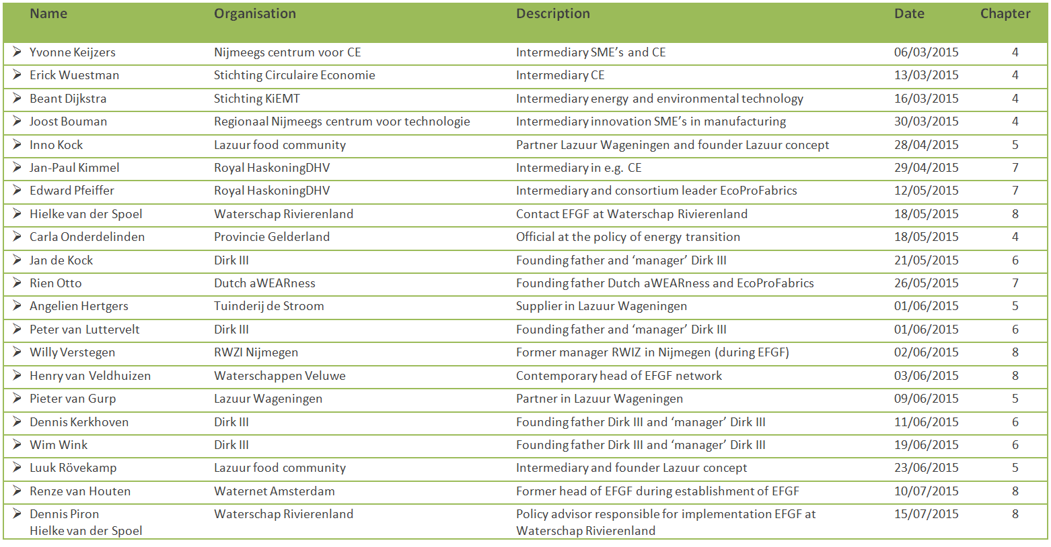
Appendix B: Interviewguide
The interview guide used in interviews, based on the sub questions and the conceptual model:
 | Invention  (if applies) | Ideation | Implementation | Operational  (If applies)
Concept | - Awareness of CE  - Connections with concept | - Invention CE  - Connection with concept  - Implementation of CE  - Application of CE in ideas | - Change in vision on CE  - Connections with concept  - Implementation of CE  - Application of CE in practice | - Change in vision on CE  - Connections with concept  - Implementation of CE  - Application of CE in practice
Practice | - Business activities  - Status of business  - Need for innovation | - Grounds for change  - Context of ideation | - Grounds for change  - Change in business activities | - Business activities  - Success  - Future development/ innovation – towards CE
Governance | - Actors involved  - Type of relations | - Actors involved  - Type of relations  - Barriers | - Actors involved  - Type of relations  - Barriers | - Actors involved  - Type of relations  - Barriers

Appendix C: Code book
Three parts of the code book are visualised in this Appendix: the deductive codes, inductive codes and inductive codes about the time period. All codes are accompanied by an explanation on the content of the codes.
Deductive codes:
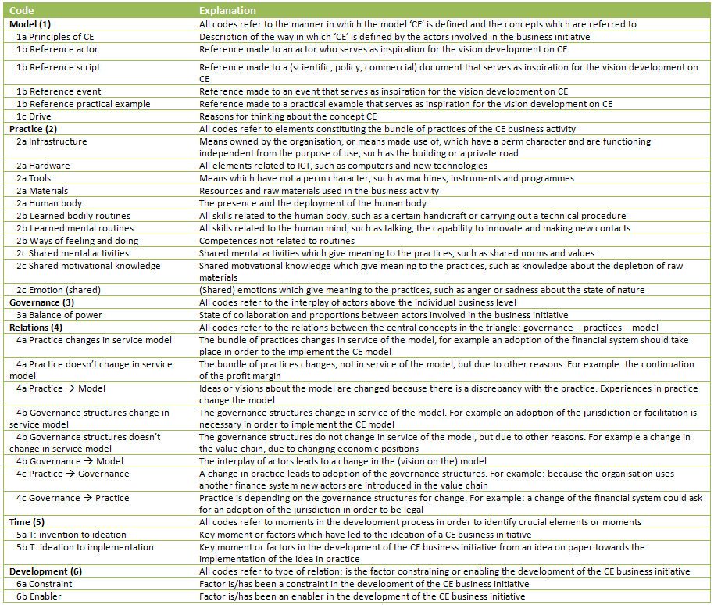

Inductive codes:
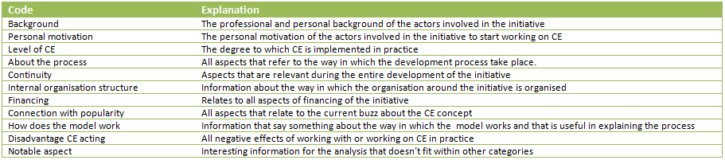

Codes referring to the relevant phase in the development of each case:
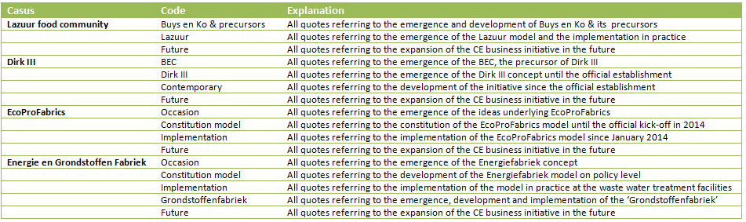

www.lazuur.com
www.drikdederde.nl
www.dutchawearness.com/circulareconomy/ecoprofabrics/
Information about the foundation local heroes and its activities can be found on www.local-heroes.nl
www.efgf.nl

