Chinese Development Projects and Subnational Poverty

Stevens, Frank
Student No. s1031050

Master’s Thesis
Radboud University Nijmegen
MSc in International Economics and Development

Supervisor: Prof. Jeroen Smits

July 2020

Abstract
China’s emergence as a development financier presents renewed opportunity to study the impact of investment in infrastructure on global poverty and inequality. With a preference for investing in connective infrastructure and willingness to implement projects globally, China’s policies on aid delivery are distinct. Evident from the sectoral composition and geographical location of their development finance. This paper uses a 2SLS strategy that exploits differences in local exposures to a common overproduction shock originating in China’s steel industry to determine the local average treatment effect of Chinese infrastructure projects. Leveraging two sources of variation to form a shift-share style instrument to examine the short-term effects of Chinese development assistance on subnational and national poverty levels as measured by the International Wealth Index. Results suggest that infrastructure projects within the transport sector have a significant short-term poverty reducing effect of as high as a 3%. Which translates roughly to 18 thousand households lifted out of poverty in the mean region. A significant effect that is in line with theoretical considerations and previous empirical studies. This paper encourages traditional OECD donors to revaluate the importance of their aid budgets to further global development and reduce geographic inequalities.

Table of Contents
Introduction 1
Figure 1: Development Finance (ODA & OOF) between 2000-2014 2
Literature Review 3
Development Finance & Subnational Development Outcomes 3
Theories on Spatial Inequality 4
Infrastructure Development & Subnational Development Outcomes 6
Chinese Development Finance & Infrastructure Projects 6
Data & Methods 7
The International Wealth Index 8
AidData’s Geocoded Global Dataset of Chinese Official Finance 8
World Steel Association Statistical Yearbooks 9
Empirical Strategy 9
Figure 2: Steel Production & Exports 10
Figure 3: Steel Production & Development Finance 10
Figure 4: Steel Production & Subnational Poverty 11
Results & Analysis 13
Conclusions 15
References 17
Tables & Figures* 21
Table 1: Project Commitments and Estimated Value by CRS Sector 21
Table 2: Project Commitments and Estimated Value by Flow Class 21
Figure 5: Global Distribution of Development Projects by Top 5 CRS Sectors 22
Figure 6: Global Distribution of Chinese Development Projects by Flow Class 23
Table 3: OLS & Reduced Form Regressions – Subnational Level 24
Table 4: 2SLS & 1st Stage Regressions – Subnational Level 25
Table 5: OLS & Reduced Form Regressions – Country Level 26
Table 6: 2SLS & 1st Stage Regressions – Country Level 27
Table 7: Largest Sectors Following Transport – Subnational Level 28
Table 8: 2SLS with Project Values & Counts – Subnational Level 29
Table 9: Summary Statistics 30
Appendices 31
Figure 7: Histogram of Dependant Variable 31
Figure 8: Residual Analysis & Regression Fit 31
Table 10: Influence of Yhat < 0 32
* Figures 1-4 are placed inline with text and figure 7-8 in the appendices.

The analysis carried out in this research paper has been made available for reproduction. The repository with all requirements can be found here: https://github.com/frankstevens1/china_devprojects_poverty#readme

Introduction
In 2000, the Chinese government adopted a 'Going Out' policy encouraging firms to invest abroad, which led to a rapid expansion in foreign direct investment, development finance and export finance from China. The policy fundamentally altered the scale and scope of all forms of state sponsored financial transfers (Djankov, 2016; Dreher et al., 2017) and has positioned China among the largest international development financiers. Figure 1 shows that development finance from OECD countries flattened out between 2000 and 2014, facing reductions in aid budgets, while China continued to broaden its bilateral development finance. Marking a shift in the political and economic landscape of international cooperation, a development that has been met with widespread international attention. Consequently, a variety of examinations of non-traditional donors began emerging amongst aid literature that had previously been centred around the investigation of western aid programmes. Early literature shows that China’s aid programme was poorly understood, largely due to the Chinese government’s lack of transparency regarding their flows of official development finance (Bräutigam, 2011). A characteristic that led many critics to believe that China’s primary intentions were to smooth access to natural resources and that their aid practices threatened hard-won political reforms by providing support to authoritarian regimes. Considering these and other ill-founded criticisms, researchers have made use of the considerable amounts of publicly available information that do exist to comment on China’s development cooperation. China’s motives, determined by aid allocation patterns, are found to be no different from those of western donors (Dreher & Fuchs, 2015) though policies regarding disbursements are clearly distinct. Unlike traditional donors, China’s development assistance is generally a government to government relationship and rarely channelled through non-government organizations nor disbursed in cash (Brautigam, 2009; Zhang et al., 2015). Additionally, the key focal point of China’s aid programme is infrastructure development, and the principal forms of development assistance include complete projects, goods & materials, and technical cooperation (Hwang et al., 2016; State Council, 2014). A priority that was recently echoed by President Xi Jinping during his address at the 2017 Belt and Road Forum for International Cooperation, where he stated that “infrastructure connectivity is the foundation of development through cooperation” (Xinhua, 2017). An area that has been neglected by OECD development cooperation in recent years and the reason why Chinese development finance may provide an important counterpoint to finance from traditional donors, allowing countries to develop much needed infrastructure and to invest in productive activities (Bräutigam, 2011). Empirical studies on the impacts of Chinese development assistance are mainly centred around economic growth, governance, and trade. However, how poverty and inequality – leading issues in development economics – are affected is not well documented (NguyenHuu & Schwiebert, 2019). This paper makes use of a recent dataset released by AidData containing geocoded Chinese development projects across the world, in combination with the Global Data Lab’s International Wealth Index, to empirically examine the impact of Chinese development projects on poverty. The methodology follows broadly a strategy developed by Dreher et al. (2017) to examine to what extent Chinese development projects affect economic growth in recipient countries. The strategy employs 2SLS instrumental variable regression to estimate local average treatment effect (LATE) of receiving a Chinese development project, with the first stage effect makes use of variation over time in Chinese steel production – a major input commodity used in infrastructure development – and the cross sectional variation in the probability of a subnational region receiving a Chinese financed development project. Due to a lack of disaggregated data existing empirical studies of the effects of aid have primarily been conducted at the national level, however the existence of large regional disparities has consequences for the discernibility of the effects of development projects relative to other economic variations. Motivating the use of subnational level analysis where national development indicators may be misleading, because examining effectiveness of development interventions intended to promote the income growth of those at the bottom of the distribution implies understanding how successfully they target the economically disadvantaged within recipient countries. The findings of this study are limited to the short term effects due to data limitations, however the results demonstrate that Chinese infrastructure projects within the transport sector have significant effect in short term of as high as a 3% reduction in subnational poverty levels. Which translates roughly to 18 thousand households lifted out of poverty in the short term in the average region with 600 thousand households. A significant effect that is in line with theoretical considerations and previous studies.

Figure 1: Development Finance (ODA & OOF) between 2000-2014
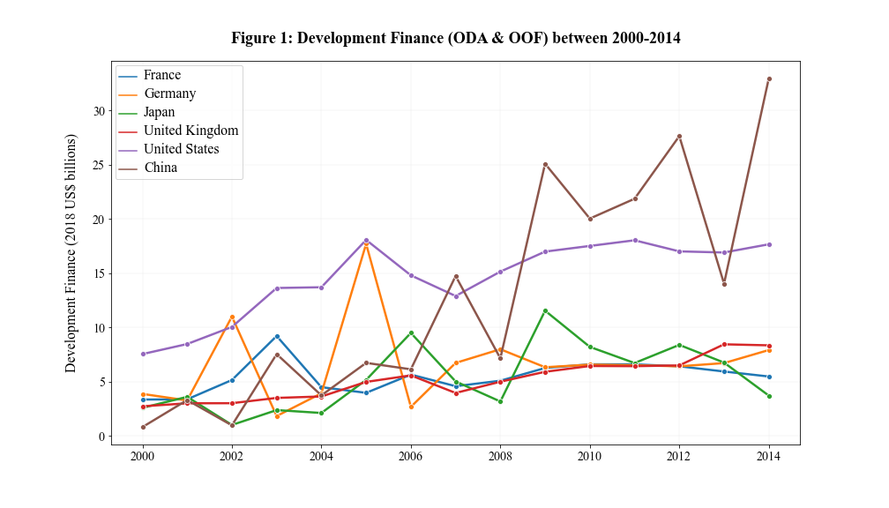
Data sources: OECD & AidData
The remainder of the paper is setup as follows. First, a review of the literature is provided with respect to development finance, unequal spatial development outcomes and how infrastructure projects can diffuse economic activity to less developed regions. What follows is an explanation of the data and methodology, a discussion of the results and finally the conclusions. A separate section following the references contains all relevant tables, including summary statistics and regression tables as well as visual overviews of the global distribution of Chinese development projects. Minor technical issues regarding the regressions are discussed in the appendices based on a residual analysis and a fitted plot.

Literature Review
This section begins with a brief discussion of the relevance of subnational investigation when considering global development goals such as poverty alleviation. Followed by a brief review of literature that examine the relationships between development finance and subnational development outcomes, which highlights the significance of spatial inequalities. Subsequently, theories of unequal spatial development are discussed, affirming the pivotal role assumed by investment in infrastructure for national and subnational development. Followed by a section that reviews empirical literature relating to infrastructure investments and development outcomes. Finally, China’s role as a development financier with a comparative advantage in infrastructure development is discussed, along with the current state of empirical evidence regarding the impacts of Chinese development projects which clarifies the gap in the literature this thesis addresses.

Development Finance & Subnational Development Outcomes
In 2015, the United Nations General Assembly (UNGA) set the Sustainable Development Goals (SDG) to be achieved by 2030 for a better and more sustainable future for all. Among the 17 goals are the eradication of poverty and the reduction of inequalities. Although, reducing inequality is a new addition to UNGA’s development goals, the World Bank has been pursuing pro-poor growth for a long time (Coady et al., 2004). The bank’s two overarching goals are to end extreme poverty and to promote shared prosperity. Explicitly referring to a reduction of the people living under $1.90 a day to less than 3% by 2030 and promoting the income growth of the bottom 40% of the population in all countries (Chandra, 2013). It has long been a general agreement among traditional donors that recipient need should be factored into aid allocation decisions to target poverty reduction. Confirmed by empirical findings that traditional donors allocate their aid to countries with lower GDP per capita, particularly multilateral institutions who are uniquely poverty sensitive (Dollar & Levin, 2006). However, promoting income growth of those at the bottom of the distribution implies strengthening the efforts of development interventions that successfully target the poor within recipient countries. Particularly in low- and middle-income countries, where considerable spatial disparities are widely present and regional variations in per capita income seem to increase with development (Kanbur & Venables, 2005b; Kim, 2008). Consequently, recent increases in the availability of disaggregated spatial data has led scholars within the aid allocation literature to analyse the subnational distribution of development projects – an understanding that may dramatically improve poverty reducing efforts (Elbers et al., 2007).
Despite poverty reduction being at the top of donor’s priorities, subnational aid allocation literature reveals that traditional development finance flows disproportionately to more prosperous regions (Öhler et al., 2017). Measured in terms of asset ownership and housing quality (Briggs, 2017) or proxied by infant mortality, maternal health and malnutrition (Öhler & Nunnenkamp, 2014). Nonetheless, assessing donor allocation of development finance requires consideration of several operational factors that may influence within-country allocation. One of the many factors likely to influence within-country geographical aid allocation is access. The costs of delivering aid to remote areas is higher and therefore the expected return relative to more accessible areas will be lower. Although, more accessible areas generally perform better economically, they are also more populous and often have a larger absolute poverty headcount. Consequently, investing in remote areas may be deemed inefficient and lead to subnational patterns of aid allocation that differ from those solely based on poverty. Therefore, aid allocation literature is often assessed in parallel with aid effectiveness literature, which typically examines the effects of aid on growth with the most common result being that there is a minor positive effect (Clemens et al., 2012; Dalgaard et al., 2004). However, due to issues of causal inference there remains no clear consensus (Easterly, 2003; Roodman, 2007). Dreher & Lohmann (2015) argue that one reason for a lack of robust findings is the previous literature’s focus on country level rather than regional level growth. Development projects may impact growth in targeted areas, though the magnitude of these impacts are not likely to be measurable at the country level while they may be detectable at the regional level. Dreher & Lohmann (2015) conduct the first subnational study on the effects of aid on growth and highlight the importance of examining aid flows at the regional level. Although their study finds no robust evidence of any effects of World Bank projects on regional economic growth, they do find correlations that are significant and successively stronger at lower administrative levels. Although, the relevance of studying development outcomes at the subnational level is evident, reliable measures are few and as a result empirical studies of development outcomes beyond economic growth are scarce. Regional growth is clearly relevant as rapid national development is often found to exacerbate rather than reduce spatial inequalities (Kim, 2008). An observation that is documented by burgeoning literature of spatial inequalities of various forms found across Africa, Asia, Latin America the Middle East and Central & Eastern Europe (Kanbur & Venables, 2005a; Kanbur, Venables, & Wan, 2006). Inequitable spatial distribution of development outcomes implies growth may not translate to a reduction in poverty or improvements in living standards. Therefore, the way in which development projects reduce – or reinforce – existing inequalities of spatial development should be considered when studying their impact. In the next section we turn to a theoretical overview of spatial inequality.

Theories on Spatial Inequality
Neoclassical economics suggest that regional disparities are equalized as a country develops through a process of convergence occurring via factor mobility and diffusion. An idea that has heavily influenced development economics, as well as the study of regional inequality. Broadly these theories view regional growth as a process of resource allocation, stressing the importance of mobility of supply side factors, i.e. capital and labour. They assume that labour moves to more developed regions in pursuit of higher wages while capital moves to more labour intensive sectors seeking more profitable – and hence less developed – regions, a process that ultimately leads to a convergence in regional development (Wei, 2015). In other words, interregional inequality is the result of temporary disequilibrium conditions in the supply and demand of mobile factors, which equalize in the long run. A process infamously modelled by Kuznets’ inverted-U model of income inequality and economic growth, which argues that regional inequality tends to rise before it reduces as economies mature over time (Kuznets, 1966). However, as economics has become more plural over time the criticism of neoclassical theories have gained more acceptance by the mainstream and the processes of development clearly remain disputed. Criticism varies, though it has often been directed at the neoclassical models’ assumptions – particularly free factor mobility – and inability to account for short term changes, open economies or observed patterns of regional divergence (Armstrong & Taylor, 2000). Richardson (1978) argues the assumption of factor mobility, suggesting that factors can be ‘sticky’ because in many countries their mobility is impeded. Immobility can be the result of family and social ties, regional variations in the cost of living or the cost involved with moving. These causes of immobility can reasonably be expected to be particularly relevant for unskilled labour in the setting of low-income countries. Where a lack of employment opportunities is a national phenomenon, which increases the risk involved with migration. Above all, additional factors – cultural, geographical and institutional – are also argued to influence factor mobility and regional development (Krugman, 1991; Porter, 1990). Criticism of once conventional theories of development led to various evolutions in the field of development economics, one of which was the so-called ‘geographical turn’. An evolution that was characterized by a revitalized study of the role of location, physical geography and local conditions in regional inequality (Wei, 2015). For example, an important reason for the persistence of poverty and regional inequality in Africa is believed to be due to poor access and availability of local infrastructure (Christiaensen et al., 2003; Sachs, 2006). Theories of new economic geography suggest that investment in improving local conditions – including local transportation, local resources and local labour market conditions – through localized infrastructure projects can reduce geographical impediments to development by improving regional linkages, providing access to markets and fostering employment opportunities (Gannon & Liu, 1997; Rodríguez-Pose & Hardy, 2015). It is through these mechanisms that donor funded infrastructure development projects are expected to reduce regional poverty and foster convergence as countries develop. However, empirical studies of the relationship between localized infrastructure development projects and subsequent regional development outcomes remain limited due to a lack of disaggregated data. Existing studies are either conducted using national level data or narrowed down to the study of a single country. The following section turns to the evidence presented by some of the work in this area.

Infrastructure Development & Subnational Development Outcomes
Although the logic of using development finance to fund infrastructure development is compelling, research suggests that the effects for economically challenged regions are not strictly positive. Literature highlights the importance of investing in road infrastructure to increase access to markets (Mu & van de Walle, 2011; Parada, 2016) and to improve vulnerable households’ productive capacity (Jacoby, 2000). Road infrastructure lowers transportation costs and in turn the cost of inputs which leads to higher production, higher household income and increased regional employment (Khandker et al., 2009). Additionally, Khanna, (2014) point out the spillover effects of transit networks to geographically proximate regions which lead to convergence in incomes across regions. Baum-Snow et al. (2017) examine these effects in China and find that ring road investments diffused 50% of industrial GDP from urban areas to outlying areas. On the other hand, researchers have found that the type of road investments can define local gains. Though investment in local rural roads that join villages to towns can maximise rural potential, highways improving connectivity with the urban core are found to have no effect (Dercon & Hoddinott, 2011; Fan & Chan-Kang, 2005) or even reduce rural firms’ competitiveness (Start, 2001). To mitigate negative externalities of increased urban connectivity, De Ferranti et al. (2005) advocate coordinating such investments with investments in education, health and the provision of credit. Also shown to be an effective strategy for diffusing economic activity as it nurtures the development of local markets and reduces local unemployment (Isserman & Rephann, 1995; Meng, 2013). Therefore, development banks globally are scaling up efforts to improve financing to infrastructure as the deficit is large in low- and middle-income countries, deterring potential towards poverty eradication. The Asian Development Bank estimates that emerging Asian economies have an infrastructure deficit amounting to $1.7 trillion annually, which is required to maintain growth and tackle poverty. Similarly, the African Development Bank estimates the African continent’s current infrastructure needs lie between $130 and $170 billion per year. Infrastructure gaps that China is willing and able to finance as well as implement while traditional lenders are deterred by poor credit ratings or slowed down by excessive bureaucratic processes.

Chinese Development Finance & Infrastructure Projects
During the 1980s, China opened its economy to foreign investment and experienced rapid economic growth as well as increases in interregional inequality (Kanbur & Zhang, 2005). In response the government adapted policies of regional inclusion that redirected private and public investment to the economically challenged central and western China, a policy known as the “Develop the West Campaign” (Bluhm et al., 2018). Research found that the campaign helped to combat the trend of increasing inequality across regions (Huang & Wei, 2016). China’s own experience with regional inequality are reflected in their foreign assistance policy’s emphasis on investing in complementary social and productive sector projects in regions where transportation projects are implemented (Li et al., 2013). Taken together with previously discussed theoretical considerations, China may not only be the only willing financier of physical infrastructure, but also the most suitable to reduce regional inequality and poverty. Based on their emphasized preferences for; (1) promoting connectivity through infrastructure and (2) complementary projects that promote agglomeration economies to reduce regional disparities. Additionally, their comparative advantage in implementing infrastructure projects is well documented by anecdotal evidence of Chinese infrastructure projects built in record time (Swedlund, 2017). Therefore, considering infrastructure projects are effective investment for poverty reduction through the reduction spatial inequality and regional spill overs, transport projects financed by China are expected to have discernible regional poverty reducing effects. Empirically supported by Dreher et al. (2017) who find that Chinese development projects have a positive effect on economic growth and Bluhm et al. (2018) who find that infrastructure investments lead to a more equal distribution of economic activity.

Data & Methods
The dataset used is a combination of subnational indicators from the Global Data Lab’s (GDL) area database, a recently released geocoded dataset of Chinese government-financed development projects and Chinese steel production figures sourced from The World Steel Association’s Statistical Yearbooks [2000, 2010, 2018, 2019. GDL’s subnational indicators are the product of aggregating data gathered from various household surveys which are nationally conducted at varying administrative regions, which are not always based on the same official administrative subdivisions. Further complicated by changes in those subdivisions over time, therefore for this study the subnational coding system developed by GDL, gdlcodes, is used as the unit of analysis. Fortunately, AidData’s geocoding effort provides geolocation details for most Chinese development projects included in their dataset. The precision of the geolocation details varying from within a 25 km radius from the project site to first-order administrative regions. All the development projects can therefore be aggregated precisely to gdlcodes using GDL’s publicly available shapefiles. A small number of project points lie marginally outside of polygons (gdlcodes), this is expected to be due to measurement error and offshore projects. These projects are assigned to their nearest polygon. The resulting sample includes 4,077 unique project locations with a total estimated value of US$162 billion located within 617 unique subnational regions in 103 countries. The classification of commitments across CRS sectors is shown on page 21 in table 1 and across CRS flow classes in table 2. Projects are in Africa, Asia, Latin America, the Middle East, and Eastern Europe. Figures 5 & 6 map project locations according to CRS sectors and flows, respectively. Projects are committed over the 15-year period from 2000 to 2014, with a minimum of 86, average of 271 and maximum of 411 projects per year. In the following sections the variables used in the analysis are described. Table 9 on page 30 presents the summary statistics of the dataset.

The International Wealth Index
The International Wealth Index (IWI) is the first asset based index of household material well-being that is comparable across place and time applicable to all low an middle income countries (Smits & Steendijk, 2015). The index was developed by employing data on 2.1 million household’s possession of consumer durables, access to facilities and housing quality from 165 household surveys conducted between 1996 and 2011 in 97 low- and middle-income countries. Through principle component analysis asset weights are derived to construct the IWI formula. The resulting index is a stable and easily interpretable index with which the economic situation of households can be evaluated and compared across all regions of the developing world. The position on the index indicates the extent to which households own basic assets that are universally valued, including consumer durable such as a mobile phone, housing characteristics such as roofing quality and access to facilities such as running water. The index runs from 0 to 100, where 0 indicates the household owns none of the assets and 100 indicates all the assets are owned. Smits & Steendijk (2015) tested the usefulness of the index by comparing the IWI with common measures of material well-being and demonstrated that the index is strongly correlated with various poverty headcount ratios. Therefore, the IWI can be interpreted as a reliable measure of poverty levels of subnational regions due to its basis on the household level. The Global Data Lab at Nijmegen University in the Netherlands updates this index as household surveys are released and makes the IWI publicly available alongside a variety of other subnational indicators. The dependant variable used in this paper is iwipov50_{irt}. The percentage of households in region r in country i below an IWI value of 50 in year t. An indicator that is strongly correlated with poverty headcount ratio at $2.00 a day (Smits & Steendijk, 2015).

AidData’s Geocoded Global Dataset of Chinese Official Finance
Details of the Chinese government’s development financing program are not systematically made publicly available at the project-level. However, the AidData research lab, at the College of William & Mary in Williamsburg, Virginia, has developed a novel dataset that captures a total of 3,485 projects worth US$ 274 billion. Most of the projects are geocoded with points at varying regional levels within countries, resulting in a total of 6,190 discreet project locations in 138 countries over the period of 2000-2014 in Africa, the Middle East, Asia and the Pacific, Latin America and the Caribbean, and Central and Eastern Europe. The underlying data is collected using an open source method called Tracking Underreported Financial Flows (TUFF), for details see Strange et al. (2017). Projects can be disaggregated by sector and flow class as projects are classified according to the common reporting standard developed by the Development Assistance Committee (DAC).
CnAid_{irt} is the explanatory variable of interest derived from AidData’s dataset. The variable can take 3 forms; as a dummy variable indicating the presence of 1 or more projects, a count indicating the number of projects or the dollar value of projects committed. The commitment is made in year t destined for sub-national region r in country i and is classified by CRS sector & flow type. Additionally, the dummy is used to construct p_{ir}, the probability of region r in country i receiving a project. Calculated as the fraction of years a region received 1 or more projects over the period 2000-2014. The probability varies only across regions not over time. The preferred form of explanatory variable to determine the local average treatment effect is the binary form, as countries that received a project are considered as the treatment group and the dummy takes a value of 1. Allowing for the most straightforward and intuitive interpretation of the results. However, because effects of development projects are also expected to vary across the intensive margin additional regressions using project value and project count are also presented.

World Steel Association Statistical Yearbooks
These yearbooks presents a cross-section of steel industry statistics including production and trade. Yearbooks 2000, 2010, 2018 & 2019 were used to compile a time-series of variable steel_{t}; the Chinese steel industry’s total production of crude steel in year t measured in thousand tonnes. Indirect steel exports was also extracted to demonstrate the relationship between Chinese steel overproduction and steel exports in the following year, see figure 2.

Empirical Strategy
To determine the effect of Chinese development assistance on subnational poverty levels, the dependant variable of interest is the percentage of the region’s population living under the poverty line. Smits & Steendijk (2015) have demonstrated the effectiveness of IWI in measuring poverty, with an impressive Pearson’s correlation of 0.914 between national percentages of households with an IWI value below 50 and the World Bank’s Poverty Headcount Ratio at $2.00 a day. Therefore, as the poverty line use IWI 50, and examine the effects of regions receiving a Chinese development projects through the change in the percentage of households below this level. The main explanatory variable of interest would ideally be a dollar value committed per region per year, unfortunately comprehensive estimates of dollar values committed per project location are near impossible to estimate (Bluhm et al., 2018). Individual projects often fall under an umbrella investment and AidData then splits these data evenly across project locations. For this reason, a binary variable indicating the presence of development projects is preferred. Therefore, main results can be interpreted as the local average treatment effect (LATE) of an additional Chinese development projects on regional poverty. Estimated project values are used as the explanatory variable in a secondary regression, which can be interpreted as a robustness check of the significance, direction, and magnitude of the effect. However, either form of the explanatory variable suffer from a simultaneity bias. Given that in order for the subnational allocation of development projects to “make great efforts to ensure benefits for as many needy people as possible” (State Council, 2014) it is bound to be based on regional poverty levels. The empirical strategy addresses this issue. Following Bluhm et al. (2018) who employ the two stage least squares (2SLS) approach with a shift-share style instrument to study the impact of Chinese infrastructure projects on the diffusion of economic activity in developing countries. The strategy exploits two sources of variations. First, the plausibly exogenous time variation in Chinese steel production, which is a supply-driven component of the explanatory variable of interest – Chinese infrastructure development assistance (CnAid). China’s steel production has long been considered as a strategic industry and drove their rapid economic growth and as domestic demand slows the industry is producing surpluses which are driving exports, see figure 2. Chinese overproduction of steel leads to increased exports in the following year, much of which is destined to foreign infrastructure projects. Some of which are financed by China, whose development assistance does not usually involve bilateral financial transfer but are commonly delivered in kind, as exports of Chinese goods & materials, complete projects, export credits and technical cooperation (Bräutigam, 2011; State Council, 2014; Zhang et al., 2015). Therefore, steel is expected to be a relevant instrument for Chinese development assistance, particularly in the form of infrastructure projects. To demonstrate this relationship Figure 3 shows the correlation between Chinese steel production and total dollar value of development assistance committed in the following year. The 1-year lag of steel production allows for surpluses to translate to international development projects. Together, Figures 1 & 2, show that overproduction in steel leads to greater exports, which is argued to lead to more commitments to infrastructure projects.

Figure 2: Steel Production & Exports

Figure 3: Steel Production & Development Finance
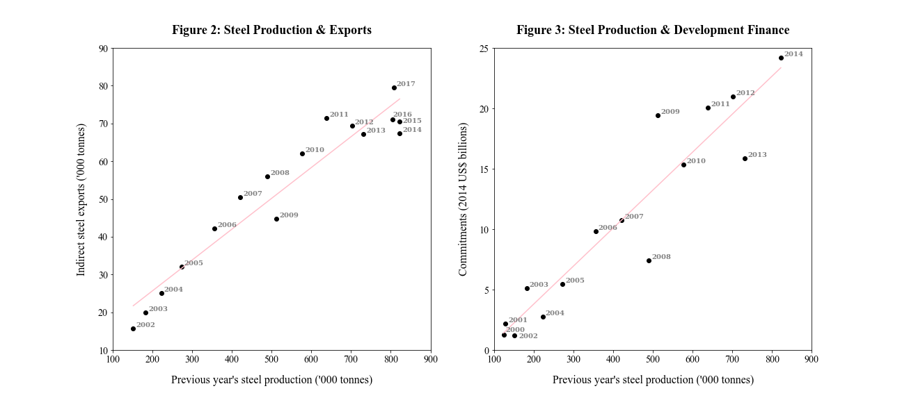

The second source of variation is the cross-sectional variation in regions’ probability of being a recipient of Chinese development assistance (p_{ir}). Which is measured as the fraction of the number of years over the period 2000 and 2014 in which the region had an active project. Taken together, the interaction of these two sources of variation form a shift-share style instrument that exploits differences in local exposure to a common overproduction shock originating in China. The logic behind this approach is similar to that of a difference-in-difference estimation. In other words, the effects of Chinese development assistance on regional poverty levels induced by domestic overproduction of steel is compared across two groups: regular recipient regions and irregular recipient regions. To see this, we turn to the reduced form shown in figure 4. The regions in the sample are divided into two groups based on the frequency of receiving Chinese development projects during the sample period. The sample’s median value is used to create 2 similarly sized groups, the regions below the median are considered irregular recipients and those above are regular recipients. The reduced form demonstrates the relationship between Chinese steel production, lagged by an additional 2 years to allow for the completion of development projects, and the average poverty level in regular and irregular recipient regions. There is a strong negative correlation among regular recipients, while that correlation is weak amongst irregular recipients. Naturally, these correlations do not imply causation. To distinguish the effects that are attributable to the presence of Chinese development projects our estimation strategy will make use of a strict set of fixed effects as well as control for the initial poverty levels. However, the expectation based on theoretical considerations and relationship demonstrated by the reduced form in figure 4 is that there is a significant and negative effect on poverty levels in regions that regularly host a Chinese development project.

Figure 4: Steel Production & Subnational Poverty
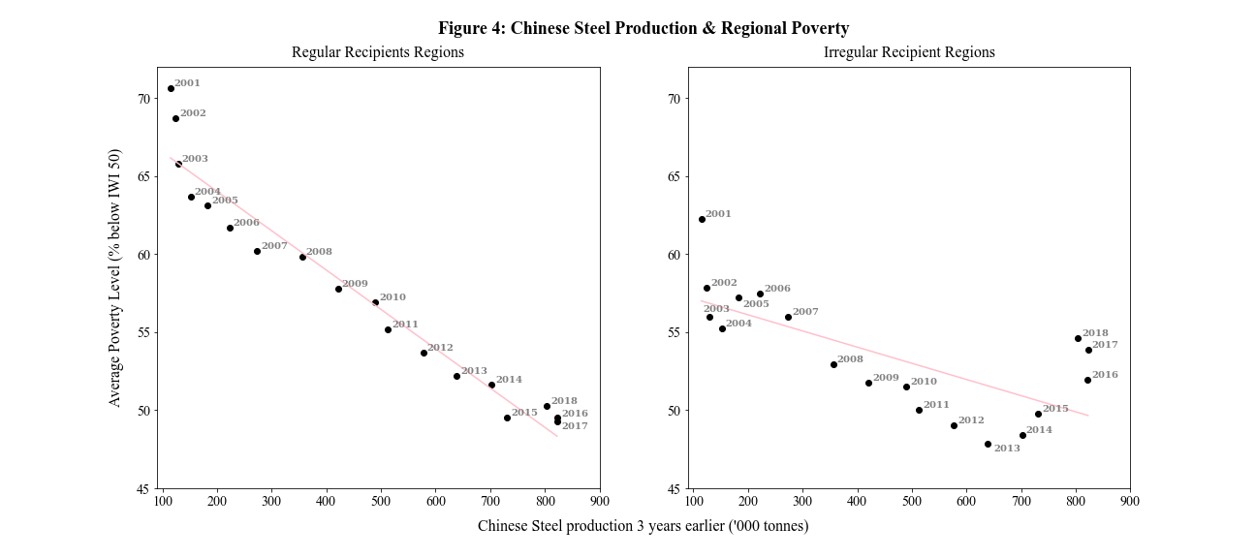

This identification strategy relies on the interaction term being exogenous and assumes that a change in Chinese steel production does not lead to a change in the probability of receiving development projects between regular regions and irregular regions. An assumption that appears to be realistic. Additionally, Bluhm et al. (2018) examine this assumption in detail by examining the variation in steel production along variations in the location of projects for different quartiles of probabilities to receive projects and conclude that there is no reason to believe the assumption is violated. A limitation of this strategy is that it relies on a large sample for instrument strength, which is tested using F statistics tests of whether the endogenous regressors is under- or weakly identified. The regressions call for robust standard errors therefore the usual approach in the applied literature is to use Kleibergen-Paap F-statistic compared to critical values tabulated by Stock & Yogo (2005) and conclude that instruments are weak if the statistic is below those critical values. Another limitation is that the strategy relies on annual variation and with a dataset that spans only 15 years the analysis is limited to the use of annual data instead of data averaged over several periods. This means that the results will be interpreted as short term effects, unlike typical aid effectiveness literature. A final limitation is the lack of control variables available at subnational level, such as institutional quality. Therefore, the specification relies on multiple fixed effects to absorb a wider variety of potential sources of variation and isolate the effect of development projects. REGHDFE, a Stata module developed by Correia (2016) is employed to fit 2SLS regression while absorbing multiple fixed effects and clustering standard errors at the country level to account for within country spillover effects. Regional fixed effects absorbs variation at unit of analysis to account for a lack of control variables available at the subnational level. While year fixed effects absorbs shocks that affect all regions of a country similarly in a particular year. Taken together the 1st and 2nd stage equations that are jointly estimated through 2SLS are:
$$CnAid_{ir\left(t-2\right)}=β_{1}\left(ln⁡(Steel_{t-3})×{\overline{p}}_{ir}\right)+iwipov{50}_{ir(t-1)}+u_{ir}+λ_{it}+v_{irt} (1)$$
$$iwipov{50}_{irt}=β_{2}CnAid_{i\left(t-2\right)}+iwipov{50}_{ir(t-1)}+μ_{ir}+λ_{it}+v_{irt} \left(2\right)$$
Where equation 2 is the main equation of interest and $iwipov{50}_{irt}$ is the percentage of households in poverty in region r in country i in year t. $CnAid_{ir\left(t-2\right)}$ is a indicates the presence of Chinese development project, lagged by 2 years to allow for project completion – based on the average time that projects in the dataset are completed. $ln⁡(Steel_{t-3})$ is the instrumental variable measured as the natural logarithm of metric tonnes of steel produced in China lagged by an additional year to allow for domestic over production to translate into the commitment of international development projects. The initial level of poverty, $iwipov{50}_{ir(t-1)}$, is included to control for an overall trend in poverty levels. Also, because our sample includes a large array of poverty levels and it is easier to remedy poverty in regions with higher initial poverty levels. The control is also included in the first stage equation. The coefficient of the instrument ${(β}_{1})$ is interpreted as the elasticity of the probability to receive a project induced by changes in Chinese steel production. Consider that the average annual change in steel production between 2000 to 2014 was 13.7% and take the coefficient $\left(β_{1}\right)= 0.288$ (see table 4, page 25). This average production increase raises the probability of a receiving a project by about 4% $\left(0.137×0.288\right)$ in regions that always receive projects. While in regions that only receive a project in 15% of all years, the average production increase raises the probability of receiving a project by 0.5% $(0.137×\left(1.180×0.15\right))$. The main result of the study lies in the coefficient ${(β}_{2})$ which is interpreted as the short term local average treatment effect (LATE) on poverty levels of Chinese development projects induced by domestic overproduction of steel. This LATE is for regions that host a project in all years and is therefore considered the upper boundary of the effects on poverty regions can be expected from hosting a Chinese development project.

Results & Analysis
This section will refer to the main results of the study, which are presented in the tables and figures that follow the references on pages 21-30. The following section begins with an analysis of the classification of the Chinese development projects by CRS sectors and flows. Followed by an analysis of the regression results.
Table 1 shows that the sample used covers 4077 unique project locations across a variety of CRS sectors amounting to an estimated total value of US$ 162 billion, this is 65% of the entire AidData dataset that could be matched to gdlcodes (regions as classified by the Global Data Lab) using geolocation details. The largest sector, in terms of project count, is by far transport and storage, which includes the construction and maintenance of road, rail, water and air infrastructure as well as public transport services and transport policy administrative and planning assistance. Although, the energy generation and supply sector makes up the largest sector in terms of estimated project value, followed by transport. Figure 5 shows that projects within the transport sector most widely distributed across the globe, while the energy sector is more concentrated in Africa. In terms of project count transport is followed by 2 social sectors: the health and education sector. How infrastructure development within these sectors affects poverty in the short term is not well documented. However, in terms of estimated project value both sectors are relatively small, so effects are not expected to large in magnitude. Additionally, the instrument of steel production, which is highly correlated with other commodities used in construction (Bluhm et al., 2018), would be driven primarily by the construction of schools and hospitals within these sectors. Which may have positive influences on non-monetary development outcomes such as child maternity and expected educational attainment. However, any effects on these outcomes is unlikely to materialize in the short term. The 4th and 5th largest sectors in terms of project count are energy generation & supply and communications. Economic sectors that can plainly be expected to have short term effects on subnational poverty levels, considering that access to public facilities as well as ownership of a mobile phone are considered universally desirable assets and are amongst those that shape the International Wealth Index (IWI). Additionally, literature has shown that the impacts of improved infrastructure in these sectors are pro-poor (Puga et al., 2009; Urban, 2019) and the mechanisms through which they translates to poverty reduction, such as improved productivity, can intuitively be considered short term effects. Table 2 shows how the sample is broken down by classifications as defined by the Development Assistance Committee (DAC). Official Development Assistance (ODA) is defined as “flows of official financing administered with the promotion of the economic development and welfare of developing countries as the main objective” (OECD, 2003). While Other Official Flows (OOF) are defined as flows that do not match the ODA definition and include grants for commercial purposes. The bulk of Chinese projects fall under ODA, however the estimated value of OOF is 3 times that of ODA. Figure 6 shows that ODA and OOF are spread equally across Asia, while Latin America receives primarily OOF projects and ODA is concentrated in the eastern region of Sub-Saharan Africa.
Table 3 & 4 present the main results of this paper, the specifications estimating the effects of all Chinese development projects, those that are classified as ODA and those within the transport sector. First, the OLS models in table 3 columns 1-3, foreshadow a negative relationship although they are all insignificant and suffer from an expected simultaneity bias. Columns 4-6 report the reduced form estimates, in which the instrument of lagged Chinese steel production interacted with the regional probability of receiving a project is regressed directly on the poverty indicator. Similarly, the direction of the effect is negative though the effect size is increased by an order of magnitude. Significance is also improved, the instrument for all projects and ODA projects are significant at the 10% level while for transport is significant at the 5% level. This is impressive given the restrictive two-way fixed effects while controlling for initial poverty levels with a lagged dependant variable. Tentatively suggesting that the OLS estimates are indeed upwardly biased due to simultaneity, contingent on the strength of our instrument. Table 4 columns 1-3 present the results of the joint estimation of the first and second stage, which sees the effect of total and ODA projects turn insignificant. Transport projects, however, remains quantitively and qualitatively similar to the reduced form estimate. The Kleibergen-Paap F-statistic of 36.79 is well above the rule of thumb 10% critical value of 16.38. Indicating that we can reject the null hypothesis that the maximum bias relative to OLS due to a weak instrument is below 10% (Stock & Yogo, 2005). Additionally, the first stage regression shows that our instrument is significant at the 1% level and strongest for transport projects with a positive relationship of 0.706. Indicating that a 10% annual growth in Chinese steel production translates to an increase in a regular recipient region’s probability of hosting a project by 7% $(0.706×0.10)$ or by 3.5% in regions that only receive projects in half the years $\left((0.706×0.5\right)×0.10)$. The first stage coefficient of total projects and ODA projects are both about 0.3, still relevant but clearly less highly correlated. Encouragingly, the first stage results are similar in magnitude to those found by Bluhm et al., (2018) despite our smaller sample size. Considering the strength of the instrument, our results suggest that subnational regions that receive a Chinese transportation project can expect a regional reduction in poverty levels of around 3.4%. Translating to approximately 18 thousand households for the average region with a household population of 600 thousand.
Table 5 & 6 present a similar analysis at the national level. The setup is the same, in terms of independent variables, fixed effects and controls used however the observations are aggregated at the country level. Naturally implying that our sample size is significantly reduced, which was expected to pose problems for instrument strength. Table 5 shows that similar to the subnational estimation OLS is insignificant while the reduced form improves significance improves and the effect size is an order of magnitude larger. However, the first stage in Table 6 shows that we can only rely on the strength of the instrument for transport projects as it remains positive and significant with a magnitude of 0.525. While the instrument for total projects turns negative and is only significant at the 10% level and the instrument of ODA projects remains only slightly positive but loses significance completely. Additionally, confirmed by the 2SLS joint estimates in columns 1-2 which show that Kleibergen-Paap F-statistic of total and ODA projects are incredibly low indicating unacceptable maximum bias relative to OLS. The instrument for transport on the other hand has a Kleibergen-Paap F-statistic of 18.52 hovering just above the acceptable 10% critical value. Additionally, the effect size of transport projects is strikingly similar to that of the subnational level and is significant at the 5% level. Suggesting that countries can expect a 2.6% reduction in household poverty from hosting a transport infrastructure project. Our regressions were kept parsimonious at the subnational level due to few control variables being available at the regional level, however the results of our country level test suggest additional variables can be tested using the strategy proposed. Table 6 column 7 presents a robustness check by including the logged FDI inflows to countries. One concern is that steel originating from China may not only be driving Chinese investments, but that other foreign investors purchase steel from China for foreign investment projects. However, column 7 demonstrates that controlling for FDI inflows leaves the effect unchanged. Future research may look into relaxing the fixed effects and including a larger array controls common in aid effectiveness literature, such as institutional quality.
Finally, table 7 & 8 present secondary regressions at the subnational level. Table 7 finds that the instrument is relevant and strong for both health and education projects. Suggesting that Chinese projects in this sector may indeed consist largely of construction within those sectors. The instrument strength is only marginally compromised with a Kleibergen-Paap F-statistic of 14.02, and the effect size of energy projects on poverty is highly significant and large at -7.6%. Communications projects seem to not be driven by steel production at all, the first stage coefficient is insignificant, and the F-statistic is very low. The binary explanatory variable indicating the presence of a Chinese project is replaced with project values and project counts in Table 8. The instrument is found to remain relevant with high F-statistics and the magnitude of the effect implies similar findings as the main regression results. A doubling of project value or number of projects in the transport sector is associated with a 0.8% and 1% reduction in poverty, respectively. While a 100% increase in ODA is associated with a 1.2% reduction in subnational poverty.

Conclusions
The 2000s clearly marked a shift in the political and economic landscape of international development cooperation. Spurring an interest in improving the poor understanding of non-traditional donors policies. Resulting in various criticisms from sceptical scholars cautioning about the potential threats of the emergence of China as a major development financier. However, more recent studies reveal that China’s motives cannot be distinguished from those of traditional donors as recipient need plays a central role in China’s aid programme. More importantly, however, scholars have gained a better understanding of China’s distinct foreign aid policies which in itself is a source of variation that can may be leveraged in providing further understanding of China’s role in international development cooperation. An openly voiced preference for financing infrastructure development and willingness to provide expedited implementation sets China apart in its ability to reduce existing inequalities of spatial development. Spatial inequalities that are reinforced when subnational aid flows are disproportionately allocated to more prosperous regions. Promoting income growth of those at the bottom of the distribution implies strengthening the efforts of development interventions that successfully target the poor within recipient countries. A pivotal role is assumed by investment in transport infrastructure to encourage factor mobility and foster convergence of subnational development, which is currently an impediment to national growth. This effect of a lack of access and impediments to immobility is experienced even by the workers in the development sector as costs of delivering aid to remote areas is increased and reduces the effectiveness of that aid. By investing in connective infrastructure Chinese development projects are reducing geographical impediments to development by improving regional linkages and diffusing economic activity. Additionally, as shown by the results of this study, reducing regional poverty, and fostering convergence of income as countries develop. This study has also highlighted the relevance of subnational investigation when considering global development goals such as poverty alleviation. Transport projects are found to have a poverty reducing effect at both the national and subnational level of up to 2.6% and 3.4% implying that these investments are fostering inclusive growth within and between countries. Scaling up aid for infrastructure is a notable policy goal as research is making it overwhelmingly clear that localized infrastructure projects can benefit vulnerable households’ welfare through improved productive capacity, employment opportunities, access to markets and a general reduction in the costs of living. Low- and middle-income economies to date have massive infrastructure deficits which need to be financed in order to maintain growth and tackle poverty, traditional OECD donors are encouraged to assume global responsibility in understanding that 0.7% is an insufficient target to reach this major impediment to global advancement.

References
Armstrong, H., & Taylor, J. (2000). Regional economics and policy. Blackwell.
Baum-Snow, N., Brandt, L., Henderson, J. V., Turner, M. A., & Zhang, Q. (2017). Roads, Railroads, and Decentralization of Chinese Cities. The Review of Economics and Statistics, 99(3), 435–448. https://doi.org/doi:10.1162/REST_a_00660
Bluhm, R., Dreher, A., Fuchs, A., Parks, B., Strange, A., & Tierney, M. (2018). Connective Financing: Chinese Infrastructure Projects and the Diffusion of Economic Activity in Developing Countries.
Brautigam, D. (2009). The Dragon’s Gift. Journal of Chemical Information and Modeling. https://doi.org/10.1017/CBO9781107415324.004
Bräutigam, D. (2011). Aid “with chinese characteristics”: Chinese foreign aid and development finance meet the OECD-DAC aid regime. Journal of International Development. https://doi.org/10.1002/jid.1798
Briggs, R. C. (2017). Does Foreign Aid Target the Poorest? International Organization, 71, 187–206. https://doi.org/10.1017/S0020818316000345
Chandra, A. (2013). Ending Extreme Poverty and Promoting Shared Prosperity. Retrieved April 9, 2020, from https://www.worldbank.org/en/news/feature/2013/04/17/ending_extreme_poverty_and_promoting_shared_prosperity
Christiaensen, L., Demery, L., & Paternostro, S. (2003). Macro and Micro Perspectives of Growth and Poverty in Africa. Source: The World Bank Economic Review, 17(3), 317–347. https://doi.org/10.1093/wber/lhgO25
Clemens, M. A., Radelet, S., Bhavnani, R. R., & Bazzi, S. (2012). COUNTING CHICKENS WHEN THEY HATCH: TIMING AND THE EFFECTS OF AID ON. Source: The Economic Journal, 122(561), 590–617. https://doi.org/10.1111/j.l468-0297.2011.02482.x
Coady, D., Grosh, M., & Hoddinott, J. (2004). Targeting of Transfers in Developing Countries. In Targeting of Transfers in Developing Countries. https://doi.org/10.1596/0-8213-5769-7
Correia, S. (2016). REGHDFE: Stata module to perform linear or instrumental-variable regression absorbing any number of high-dimensional fixed effects; https://ideas.repec.org/c/boc/bocode/s457874.html. Statistical Software Components.
Dalgaard, C.-J., Hansen, H., & Tarp, F. (2004). On the Empirics of Foreign Aid. In Source: The Economic Journal (Vol. 114).
de Ferranti, D., Perry, G. E., Lederman, D., Valdes, A., & Foster, W. (2005). Beyond the City. In Beyond the City. https://doi.org/10.1596/0-8213-6097-3
Dercon, S., & Hoddinott, J. (2011). Livelihoods, Growth, and Links to Market Towns in 15 Ethiopian Villages. SSRN Electronic Journal. https://doi.org/10.2139/ssrn.774325
Djankov, S. (2016). The Rationale Behind China’s Belt and Road Initiative. China Quarterly of International Strategic Studies, 5(2), 233–248. https://doi.org/10.1142/S2377740019500155
Dollar, D., & Levin, V. (2006). The Increasing Selectivity of Foreign Aid, 1984-2003 q. World Development, 34, 20342–046. https://doi.org/10.1016/j.worlddev.2006.06.002
Dreher, A., & Fuchs, A. (2015). Rogue aid? An empirical analysis of China’s aid allocation. Canadian Journal of Economics. https://doi.org/10.1111/caje.12166
Dreher, A., Fuchs, A., Hodler, R., Parks, B. C., Tierney, M. J., Dreher, A., & Fuchs, A. (2019). Is Favoritism a Threat to Chinese Aid Effectiveness? A Subnational Analysis of Chinese Development Projects. AidData Working Paper 83.
Dreher, A., Fuchs, A., Parks, B., Strange, A. M., & Tierney, M. J. (2017). Aid, China, and Growth: Evidence from a New Global Development Finance Dataset.
Dreher, A., & Lohmann, S. (2015). Aid and Growth at the Regional Level. Retrieved from www.aiddata.org
Easterly, W. (2003). Can Foreign Aid Buy Growth? In Journal of Economic Perspectives (Vol. 17). Retrieved from http://www.whitehouse.gov/news/releases/2002/ll/20021126-8.html#3
Elbers, C., Fujii, T., Lanjouw, P., Özler, B., & Yin, W. (2007). Poverty alleviation through geographic targeting: How much does disaggregation help? Journal of Development Economics, 83(1), 198–213. https://doi.org/10.1016/j.jdeveco.2006.02.001
Fan, S., & Chan-Kang, C. (2005). Road Development, Economic Growth, and Poverty Reduction in China (Vol. 5). Retrieved from www.ifpri.org
Gannon, C., & Liu, Z. (1997). Poverty and Transport. World Bank Working Papers, (June), 1–152.
Gehring, K., & Lang, V. (2018). Stigma or Cushion? IMF Programs and Sovereign Creditworthiness. SSRN Electronic Journal. https://doi.org/10.2139/ssrn.3169341
Huang, H., & Dennis Wei, Y. (2016). Spatial inequality of foreign direct investment in China: Institutional change, agglomeration economies, and market access. Applied Geography. https://doi.org/10.1016/j.apgeog.2014.12.014
Humphrey, C., & Michaelowa, K. (2019). China in Africa: Competition for traditional development finance institutions? World Development, 120, 15–28. https://doi.org/10.1016/j.worlddev.2019.03.014
Hwang, J., Bräutigam, D., & Eom, J. (2016). How Chinese Money is Transforming Africa: It’s Not What You Think. Retrieved from https://www.pairault.fr/sinaf/index.php/statistiques/15-references/826-how-chinese-money-is-transforming-africa-it-s-not-what-you-think
Isserman, A., & Rephann, T. (1995). The economic effects of the appalachian regional commision an empirical assessment of 26 years regional development planning. Journal of the American Planning Association, 61(3), 345–364. https://doi.org/10.1080/01944369508975647
Jacoby, H. G. (2000). Access to Markets and the Benefits of Rural Roads. The Economic Journal, 110(465), 713–737. https://doi.org/10.1111/1468-0297.00562
Kanbur, R., & Venables, A. J. (2005a). Spatial Inequality and Development. In Spatial Inequality and Development. https://doi.org/10.1093/0199278636.001.0001
Kanbur, R., Venables, A., & Wan, G. H. (2006). Spatial Disparities in Human Development : Perspectives from Asia. Retrieved from http://archive.unu.edu/unupress/2005/spatialdisparities.html
Kanbur, R., & Venables, T. (2005b). Introduction: Spatial inequality and development. Journal of Economic Geography, 5(1), 1–2. https://doi.org/10.1093/jnlecg/lbh059
Kanbur, R., & Zhang, X. (2005). Fifty years of regional inequality in China: A journey through central planning, reform, and openness. Review of Development Economics. https://doi.org/10.1111/j.1467-9361.2005.00265.x
Khandker, S. R., Bakht, Z., & Koolwal, G. B. (2009). The Poverty Impact of Rural Roads: Evidence from Bangladesh. Economic Development and Cultural Change, 57(4), 685–722. https://doi.org/10.1086/598765
Khanna, G. (2014). The Road Oft Taken: The Route to Spatial Development. Available at SSRN 2426835, (July). Retrieved from http://papers.ssrn.com/sol3/papers.cfm?abstract_id=2426835
Kim, S. (2008). Spatial Inequality and Economic Development: Theories, Facts, and Policies Commission on Growth and Development. Retrieved from www.growthcommission.orgcontactinfo@growthcommission.org
Krugman, P. (1991). Geography and Trade. In Economic Policy. Leuven: Leuven University Press jointly with The MIT Press.
Kuznets, S. S. (1966). Modern economic growth: rate, structure, and spread. New Haven, Conn.: Yale University Press.
Li, J., Newenham-Kahindi, A., Shapiro, D. M., & Chen, V. Z. (2013). The Two-Tier Bargaining Model Revisited: Theory and Evidence from China’s Natural Resource Investments in Africa. Global Strategy Journal, 3(4), 300–321. https://doi.org/10.1111/j.2042-5805.2013.01062.x
Meng, L. (2013). Evaluating China’s poverty alleviation program: A regression discontinuity approach ☆. https://doi.org/10.1016/j.jpubeco.2013.02.004
Mu, R., & van de Walle, D. (2011). Rural roads and local market development in Vietnam. Journal of Development Studies, 47(5), 709–734. https://doi.org/10.1080/00220381003599436
NguyenHuu, T., & Schwiebert, J. (2019). China’s role in mitigating poverty and inequality in Africa: an empirical query. Journal of the Asia Pacific Economy. https://doi.org/10.1080/13547860.2019.1632645
OECD. (2003). OECD Glossary of Statistical Terms - Official development assistance (ODA) Definition. Retrieved July 10, 2020, from https://stats.oecd.org/glossary/detail.asp?ID=6043
Öhler, H., Negre, M., Smets, L., Massari, R., & Bogetić, Ž. (2017). Putting Your Money Where Your Mouth Is Geographic Targeting of World Bank Projects to the Bottom 40 Percent. Retrieved from http://econ.worldbank.org.
Öhler, H., & Nunnenkamp, P. (2014). Needs-Based Targeting or Favoritism? The Regional Allocation of Multilateral Aid within Recipient Countries. Kyklos, 67(3), 420–446. https://doi.org/10.1111/kykl.12061
Parada, J. (2016). Access to modern markets and the impacts of rural road rehabilitation: Evidence from Nicaragua *. Retrieved from http://javierparada.weebly.com/about-me.html
Porter, M. E. (1990). The Competitive Advantage of Nations Harvard Business Review.
Puga, P., Cardoso, G., Espanha, R., & Mendoca, S. (2009). Telecommunications for the Needy: How needed are they? Informatica Economica Journal, 13(2), 175–188. Retrieved from https://ideas.repec.org/a/aes/infoec/v13y2009i2p175-188.html
Richardson, H. W. (1978). Regional and urban economics. New York: Penguin.
Rodríguez-Pose, A., & Hardy, D. (2015). Addressing poverty and inequality in the rural economy from a global perspective. Applied Geography, 61, 11–23. https://doi.org/10.1016/j.apgeog.2015.02.005
Roodman, D. (2007). The Anarchy of Numbers: Aid, Development, and Cross-Country Empirics. The World Bank Economic Review, 21(2), 255–277. https://doi.org/doi:10.1093/wber/lhm004
Sachs, J. (2006). The end of poverty : economic possibilities for our time. New York: Penguin Books.
Smits, J., & Steendijk, R. (2015). The International Wealth Index (IWI). Social Indicators Research. https://doi.org/10.1007/s11205-014-0683-x
Start, D. (2001). The Rise and Fall of the Rural Non-farm Economy: Poverty Impacts and Policy Options. Development Policy Review, 19(4), 491–505. https://doi.org/10.1111/1467-7679.00147
State Council. (2014). China’s Foreign Aid (2014). In Government White Paper.
Stock, J. H., & Yogo, M. (2005). Testing for Weak Instruments in Linear IV Regression. In Identification and Inference for Econometric Models (pp. 80–108). https://doi.org/10.1017/CBO9780511614491.006
Strange, A. M., Cheng, M., Russell, B., Ghose, S., Parks, B., Aguilar-Rojas, M., … Yaqin Muhammad Noor, S. B. (2017). AidData Methodology: Tracking Underreported Financial Flows (TUFF) Version 1.3 College of William and Mary.
Swedlund, H. J. (2017). The development dance : how donors and recipients negotiate the delivery of foreign aid. Cornell: Cornell University Press.
Urban, F. (2019). Energy, poverty and development. In Energy and Development. https://doi.org/10.4324/9781351047487-1
Wei, Y. D. (2015). Spatiality of regional inequality. Applied Geography, 61, 1–10. https://doi.org/10.1016/j.apgeog.2015.03.013
Xinhua. (2017, May 14). Full text of President Xi’s speech at opening of Belt and Road forum - Xinhua | English.news.cn. Retrieved July 9, 2020, from http://www.xinhuanet.com/english/2017-05/14/c_136282982.htm
Zhang, Y., Gu, J., & Chen, Y. (2015). China’s Engagment in International Development Cooperation: The State of the Debate. (1), 1–36. Retrieved from http://opendocs.ids.ac.uk/opendocs/bitstream/handle/123456789/5781/ER111_DevelopmentBanksfromtheBRICS.pdf?sequence=1

Tables & Figures*

Table 1: Project Commitments and Estimated Value by CRS Sector
CRS Sector | Projects | Commitments (2014 US$ millions)
Transport and Storage | 1042 | 57448
Health | 661 | 1760
Education | 456 | 1194
Energy Generation and Supply | 348 | 62770
Communications | 335 | 3916
Government and Civil Society | 244 | 1995
Emergency Response | 230 | 250
Agriculture, Forestry and Fishing | 188 | 2570
Other Social infrastructure and services | 183 | 4943
Water Supply and Sanitation | 157 | 3967
Industry, Mining, Construction | 101 | 15787
Other Multisector | 53 | 556
Developmental Food Aid/Food Security Assistance | 18 | 7
General Environmental Protection | 13 | 79
Action Relating to Debt | 9 | 147
Support to NGOs and Government Organizations | 8 | 376
Women in Development | 8 | 12
General Budget Support | 6 | 13
Non-food commodity assistance | 4 | 41
Trade and Tourism | 4 | 908
Business and Other Services | 4 | 3056
Unallocated / Unspecified | 3 | 30
Population Policies / Programmes and Reproductive Health | 1 | < 1
Banking and Financial Services | 1 | 10
Total | 4077 | 162045

Table 2: Project Commitments and Estimated Value by Flow Class
Flow Class | Projects | Commitments (2014 US$ millions)
ODA-like | 2670 | 37751
OOF-like | 784 | 90896
Vague (Official Finance) | 623 | 33189
Total | 4077 | 161836

Figure 5: Global Distribution of Development Projects by Top 5 CRS Sectors
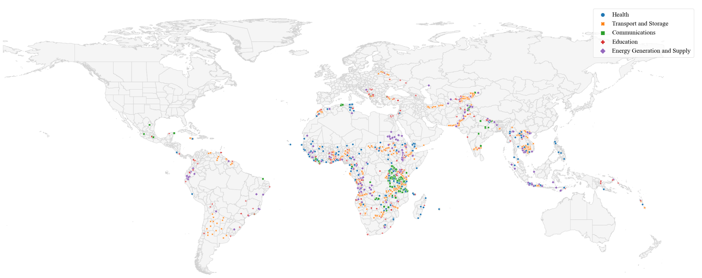

Figure 6: Global Distribution of Chinese Development Projects by Flow Class
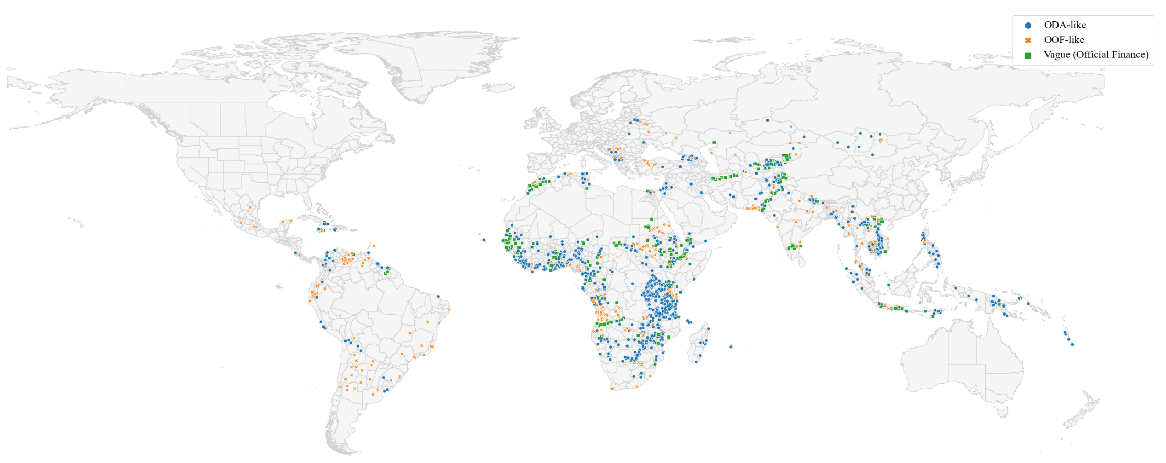

Table 3: OLS & Reduced Form Regressions – Subnational Level
 | (1) | (2) | (3) | (4) | (5) | (6)
 | iwipov50 | iwipov50 | iwipov50 | iwipov50 | iwipov50 | iwipov50
iwipov50_{t-1} | 0.978**** | 0.978**** | 0.978**** | 0.978**** | 0.978**** | 0.976****
 | (0.0137) | (0.0137) | (0.0137) | (0.0121) | (0.0122) | (0.0111)
CnAid _{t-2} (Total) | -0.000382
 | (0.000839)
CnAid _{t-2} (ODA) |  | -0.00114
 |  | (0.000851)
CnAid _{t-2} (Transport) |  |  | -0.000668
 |  |  | (0.00237)
ln(steel) _{t-3} × p_{total} |  |  |  | -0.00559*
 |  |  |  | (0.00311)
ln(steel) _{t-3} × p_{ODA} |  |  |  |  | -0.00601*
 |  |  |  |  | (0.00338)
ln(steel) _{t-3} × p_{transport} |  |  |  |  |  | -0.0252**
 |  |  |  |  |  | (0.0124)
Region FE | Yes | Yes | Yes | Yes | Yes | Yes
Year FE | Yes | Yes | Yes | Yes | Yes | Yes
Adj. R² (within) | 0.941 | 0.941 | 0.941 | 0.945 | 0.945 | 0.945
Clusters (Country) | 103 | 103 | 103 | 103 | 103 | 103
Regions | 1188 | 1188 | 1188 | 1188 | 1188 | 1188
Observations | 13790 | 13790 | 13790 | 13790 | 13790 | 13790
Estimation Method | OLS | OLS | OLS | OLS | OLS | OLS
Notes: CnAid refers to a dummy variable indicating the presence of Chinese development projects within the sector or flow class indicated Similarly, p refers to the probability of receiving a Chinese development project within the indicated sector or flow class. Standard errors clustered by country are in parentheses. Columns 4-6 are reduced form models using the proposed instrument.
Significance levels: * p < 0.10, ** p < 0.05, *** p < 0.01, **** p < 0.001.

Table 4: 2SLS & 1st Stage Regressions – Subnational Level
 | (1) | (2) | (3) | (4) | (5) | (6)
 | iwipov50 | iwipov50 | iwipov50 | CnAid _{t-2} (Total*) | CnAid _{t-2} (ODA*) | CnAid _{t-2} (Transport*)
iwipov50_{t-1} | 0.977**** | 0.977**** | 0.975**** | -0.00451 | 0.00780 | -0.0129
 | (0.0128) | (0.0130) | (0.0120) | (0.0637) | (0.0482) | (0.0384)
CnAid _{t-2} (Total) | -0.0173
 | (0.0111)
CnAid _{t-2} (ODA) |  | -0.0208
 |  | (0.0131)
CnAid _{t-2} (Transport) |  |  | -0.0344**
 |  |  | (0.0153)
ln(steel) _{t-3} × p* |  |  |  | 0.288**** | 0.270**** | 0.706****
 |  |  |  | (0.0424) | (0.0465) | (0.116)
Region FE | Yes | Yes | Yes | Yes | Yes | Yes
Year FE | Yes | Yes | Yes | Yes | Yes | Yes
Kleibergen-Paap F-Statistic | 49.20 | 38.33 | 36.79
Clusters (Country) | 103 | 103 | 103 | 103 | 103 | 103
Regions | 1188 | 1188 | 1188 | 1188 | 1188 | 1188
Observations | 13790 | 13790 | 13790 | 13790 | 13790 | 13790
Estimation Method | 2SLS | 2SLS | 2SLS | 1st Stage | 1st Stage | 1st Stage
Notes: CnAid refers to a dummy variable indicating the presence of Chinese development projects within the sector or flow class indicated Similarly, p refers to the probability of receiving a Chinese development project within the sector or flow class indicated in the header. Standard errors clustered by country are in parentheses.
Significance levels: * p < 0.10, ** p < 0.05, *** p < 0.01, **** p < 0.001.

Table 5: OLS & Reduced Form Regressions – Country Level
 | (1) | (2) | (3) | (4) | (5) | (6)
 | iwipov50 | iwipov50 | iwipov50 | iwipov50 | iwipov50 | iwipov50
iwipov50_{t-1} | 0.999**** | 0.999**** | 0.999**** | 0.994**** | 0.994**** | 0.992****
 | (0.0161) | (0.0161) | (0.0158) | (0.0134) | (0.0129) | (0.0135)
CnAid _{t-2} (Total) | 0.000588
 | (0.000403)
CnAid _{t-2} (ODA) |  | 0.000528
 |  | (0.000462)
CnAid _{t-2} (Transport) |  |  | -0.00143
 |  |  | (0.00107)
ln(steel) _{t-3} × p_{total} |  |  |  | -0.00787**
 |  |  |  | (0.00318)
ln(steel) _{t-3} × p_{ODA} |  |  |  |  | -0.00808***
 |  |  |  |  | (0.00262)
ln(steel) _{t-3} × p_{transport} |  |  |  |  |  | -0.0130**
 |  |  |  |  |  | (0.00550)
Country FE | Yes | Yes | Yes | Yes | Yes | Yes
Year FE | Yes | Yes | Yes | Yes | Yes | Yes
Adj. R² (within) | 0.973 | 0.973 | 0.973 | 0.976 | 0.976 | 0.976
Clusters (Country) | 102 | 102 | 102 | 102 | 102 | 102
Observations | 1242 | 1242 | 1242 | 1393 | 1393 | 1393
Estimation Method | OLS | OLS | OLS | OLS | OLS | OLS
Notes: CnAid refers to a dummy variable indicating the presence of Chinese development projects within the sector or flow class indicated Similarly, p refers to the probability of receiving a Chinese development project within the indicated sector or flow class. Standard errors clustered by country are in parentheses. Columns 4-6 are reduced form models using the proposed instrument.
Significance levels: * p < 0.10, ** p < 0.05, *** p < 0.01, **** p < 0.001.

Table 6: 2SLS & 1st Stage Regressions – Country Level
 | (1) | (2) | (3) | (4) | (5) | (6) | (7)
 | iwipov50 | iwipov50 | iwipov50 | CnAid _{t-2} (Total*) | CnAid _{t-2} (ODA*) | CnAid _{t-2} (Transport*) | iwipov50
iwipov50_{t-1} | 0.988**** | 1.011**** | 0.996**** | -0.170 | 0.00847 | 0.130 | 0.994****
 | (0.0259) | (0.0279) | (0.0129) | (0.295) | (0.286) | (0.335) | (0.0136)
CnAid _{t-2} (Total) | 0.0550*
 | (0.0306)
CnAid _{t-2} (ODA) |  | -0.101
 |  | (0.0995)
CnAid _{t-2} (Transport) |  |  | -0.0266** |  |  |  | -0.0250**
 |  |  | (0.0101) |  |  |  | (0.0220)
ln(steel) _{t-3} × p* |  |  |  | -0.154* | 0.0633 | 0.525****
 |  |  |  | (0.0799) | (0.0735) | (0.128)
ln(FDI)_{t-2} |  |  |  |  |  |  | 0.00066
 |  |  |  |  |  |  | (0 .000591)
Country FE | Yes | Yes | Yes | Yes | Yes | Yes | Yes
Year FE | Yes | Yes | Yes | Yes | Yes | Yes | Yes
Kleibergen-Paap F-statistic | 3.505 | 1.311 | 18.52 |  |  |  | 19.53
Clusters (Country) | 102 | 102 | 102 | 102 | 102 | 102 | 101
Observations | 1239 | 1239 | 1239 | 1239 | 1239 | 1239 | 1163
Estimation Method | 2SLS | 2SLS | 2SLS | 1st Stage | 1st Stage | 1st Stage | 2SLS
Notes: CnAid refers to a dummy variable indicating the presence of Chinese development projects within the sector or flow class indicated Similarly, p refers to the probability of receiving a Chinese development project within the sector or flow class indicated in the header. Standard errors clustered by country are in parentheses.
Significance levels: * p < 0.10, ** p < 0.05, *** p < 0.01, **** p < 0.001.

Table 7: Largest Sectors Following Transport – Subnational Level
 | (1) | (2) | (3) | (4) | (5) | (6) | (7) | (8)
 | iwipov50 | iwipov50 | iwipov50 | iwipov50 | CnAid _{t-2} (health*) | CnAid _{t-2} (education*) | CnAid _{t-2} (energy*) | CnAid _{t-2} (communications*)
iwipov50_{t-1} | 0.978**** | 0.978**** | 0.973**** | 0.980**** | 0.0323 | -0.00687 | -0.0176 | 0.0219
 | (0.0137) | (0.0137) | (0.0125) | (0.0138) | (0.0260) | (0.0160) | (0.0201) | (0.0152)
CnAid _{t-2} (health) | -0.00210
 | (0.0125)
CnAid _{t-2} (education) |  | -0.00213
 |  | (0.0116)
CnAid _{t-2} (energy) |  |  | -0.0766***
 |  |  | (0.0273)
CnAid _{t-2} (communications) |  |  |  | -0.0672
 |  |  |  | (0.0630)
ln(steel) _{t-3} × p* |  |  |  |  | 0.420**** | 0.636**** | 0.561**** | 0.472
 |  |  |  |  | (0.112) | (0.0936) | (0.149) | (0.290)
Region FE | Yes | Yes | Yes | Yes | Yes | Yes | Yes | Yes
Year FE | Yes | Yes | Yes | Yes | Yes | Yes | Yes | Yes
Kleibergen-Paap F-Statistic | 17.30 | 46.82 | 14.02 | 2.690
Clusters (Country) | 103 | 103 | 103 | 103 | 103 | 103 | 103 | 103
Regions | 1188 | 1188 | 1188 | 1188 | 1188 | 1188 | 1188 | 1188
Observations | 13794 | 13794 | 13794 | 13794 | 13794 | 13794 | 13794 | 13794
Estimation Method | 2SLS | 2SLS | 2SLS | 2SLS | 1st Stage | 1st Stage | 1st Stage | 1st Stage
Notes: CnAid refers to a dummy variable indicating the presence of Chinese development projects within the sector or flow class indicated Similarly, p refers to the probability of receiving a Chinese development project within the sector indicated in the column header. Standard errors clustered by country are in parentheses.
Significance levels: * p < 0.10, ** p < 0.05, *** p < 0.01, **** p < 0.001.

Table 8: 2SLS with Project Values & Counts – Subnational Level
 | (1) | (2) | (3) | (4) | (5) | (6)
 | iwipov50 | iwipov50 | iwipov50 | iwipov50 | iwipov50 | iwipov50
iwipov50_{t-1} | 0.976**** | 0.976**** | 0.975**** | 0.978**** | 0.978**** | 0.978****
 | (0.0124) | (0.0120) | (0.0121) | (0.0130) | (0.0132) | (0.0129)
ln($CnAid _{t-2})_{total} | -0.00648
 | (0.00415)
ln($CnAid _{t-2})_{ODA} |  | -0.0123*
 |  | (0.00653)
ln($CnAid _{t-2})_{transport} |  |  | -0.00824*
 |  |  | (0.00424)
CnAid _{t-2} (Total) |  |  |  | -0.00428
 |  |  |  | (0.00260)
CnAid _{t-2} (ODA) |  |  |  |  | -0.00666
 |  |  |  |  | (0.00405)
CnAid _{t-2} (Transport) |  |  |  |  |  | -0.01000*
 |  |  |  |  |  | (0.00526)
Region FE | Yes | Yes | Yes | Yes | Yes | Yes
Year FE | Yes | Yes | Yes | Yes | Yes | Yes
Kleibergen-Paap F-Statistic | 9.835 | 32.80 | 69.71 | 35.74 | 42.18 | 32.57
Clusters (Country) | 103 | 103 | 103 | 103 | 103 | 103
Regions | 1188 | 1188 | 1188 | 1188 | 1188 | 1188
Observations | 13790 | 13790 | 13790 | 13790 | 13790 | 13790
Estimation Method | 2SLS | 2SLS | 2SLS | 2SLS | 2SLS | 2SLS
Notes: $CnAid refers to a variable indicating the value of Chinese development projects within the sector or flow class indicated. CnAid refers to a count variable indicating the number of Chinese development projects. Similarly, p refers to the probability of receiving a Chinese development project within the indicated sector or flow class. Standard errors clustered by country are in parentheses. Significance levels: * p < 0.10, ** p < 0.05, *** p < 0.01, **** p < 0.001.

Table 9: Summary Statistics
Subnational Level | count | mean | sd | min | max
iwipov50 | 18296 | .5114914 | .3699758 | 0 | 1
CnAid_{total} (dummy) | 17984 | .1046486 | .3061086 | 0 | 1
CnAid_{ODA} (dummy) | 17984 | .0775133 | .2674117 | 0 | 1
CnAid_{transport} (dummy) | 17984 | .0205738 | .1419566 | 0 | 1
CnAid_{total} (count) | 17984 | .2260899 | .9885267 | 0 | 32
CnAid_{ODA} (count) | 17984 | .1483541 | .7104291 | 0 | 19
CnAid_{transport} (count) | 17984 | .0579404 | .5784709 | 0 | 29
steel | 25180 | 507942.1 | 279480.7 | 114588 | 928264
ln(steel) | 25180 | 12.9246 | .7155362 | 11.6491 | 13.74107
p_{total} | 25180 | .1045618 | .1659132 | 0 | 1
p_{ODA} | 25180 | .0773365 | .1492996 | 0 | .9333333
p_{transport} | 25180 | .0204925 | .0524662 | 0 | .5333333
p_{health} | 25180 | .0276251 | .0869878 | 0 | .7333333
p_{education} | 25180 | .0183532 | .0534409 | 0 | .4
p_{energy} | 25180 | .0116865 | .0366945 | 0 | .3333333
p_{communications} | 25180 | .0076013 | .025658 | 0 | .2666667
$CnAid _{total} | 17984 | 8.987089 | 112.5787 | 0 | 8221.052
$CnAid _{ODA} | 17984 | 2.099137 | 26.2922 | 0 | 1075.026
$CnAid _{transport} | 17984 | 3.194381 | 51.7009 | 0 | 2541.69
Country Level | count | mean | sd | min | max
iwipov50 | 1617 | .4863505 | .3535344 | .0001 | .999
CnAid_{total} (dummy) | 1540 | .5318182 | .4991487 | 0 | 1
CnAid_{ODA} (dummy) | 1540 | .4324675 | .4955793 | 0 | 1
CnAid_{transport} (dummy) | 1540 | .1168831 | .3213853 | 0 | 1
steel | 2158 | 508279.9 | 279701.6 | 114588 | 928264
ln(steel) | 2158 | 12.92514 | .7159764 | 11.6491 | 13.74107
p_{total} | 2158 | .5320049 | .2587535 | .0666667 | 1
p_{ODA} | 2158 | .4328699 | .2835172 | 0 | 1
p_{transport} | 2158 | .1180414 | .1391962 | 0 | .6666667
FDI | 2091 | 2.53e+09 | 7.29e+09 | -9.37e+09 | 9.93e+10
ln(FDI) | 1987 | 19.86428 | 2.229195 | 10.43922 | 25.32134

Appendices
Figure 7 presents the distribution of the poverty variable; it has a bimodal distribution with peaks at the higher and lower end. The study included several regions with low poverty levels; however, these were included in the study as they were still recipients of Chinese projects. Conducting an analysis – not presented – without the regions with an iwipov50 of 0 had no significant effect on the results.
Figure 8 presents a residual analysis and an actual versus predicted value plot. The residuals are within acceptable bounds and show no patterns indicating misspecification or nonlinearity. However, there are several predicted values (45) that fall below 0, which is realistically not possible. This results in a slight downward bias, which is expected to be due to the binary nature of the explanatory variable with many 0 values. However, removing the observations that yield predicted values below 0, shows that their influence on the results is negligible. Table 10 column 1 presents the results with the observations included and columns 2 with the observations removed. For future research the use of the change in IWI may be better suited for the identification strategy, however the changes in year to year IWI levels are so small that it would require grouping data by 5 year period in order to have sufficient variation. This would lead to a study of the local average treatment effect of Chinese development projects on poverty levels in the long run. However, currently neither IWI data nor Chinese project data is not available for longer periods to allow for this study to be done.

Figure 7: Histogram of Dependant Variable
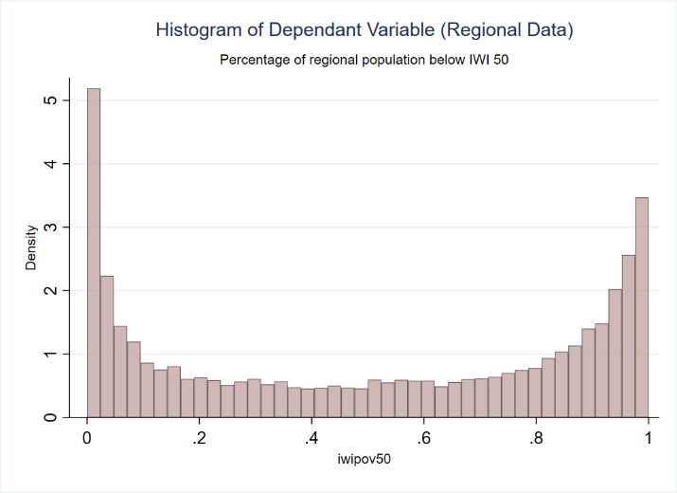

Figure 8: Residual Analysis & Regression Fit
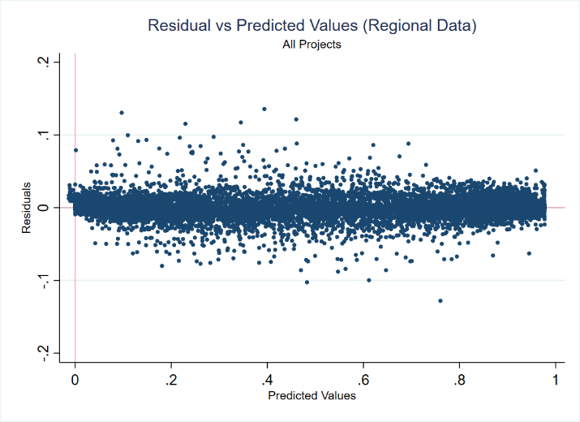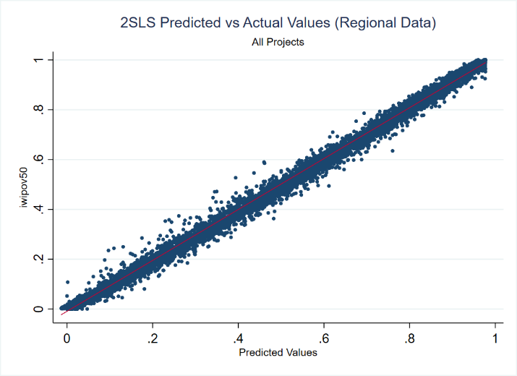

Table 10: Influence of Yhat < 0
 | (1) | (2)
 | iwipov50 | iwipov50
iwipov50_{t-1} | 0.975**** | 0.975****
 | (0.0120) | (0.0121)
CnAid _{t-2} (Transport) | -0.0344** | -0.0343**
 | (0.0153) | (0.0154)
Region FE | Yes | Yes
Year FE | Yes | Yes
Kleibergen-Paap F-Statistic | 36.79 | 36.36
Clusters (Country) | 103 | 103
Regions | 1188 | 1188
Observations | 13794 | 13675
Estimation Method | 13790 | 13671
Standard errors in parentheses
* p < 0.10, ** p < 0.05, *** p < 0.01, **** p < 0.001

This instrument was originally introduced by (Dreher et al., 2019) in a 2016 working paper, and has since been adopted by subsequent work for varying research questions. Examples include; Bluhm et al., (2018); Gehring & Lang (2018); Humphrey & Michaelowa (2019).
Common reporting standard (CRS) used by participating donors to report their aid flows to the Development Assistance Committee (DAC) databases. China and many other non-DAC donors do not participate, but AidData researchers have classified Chinese financial flows according to these standards.

