ERP Implementation and Firm Performance:
How the Motivation to Adopt explains Performance Variation


Master Thesis

Author: Hilke Wilt
Student No: S1030937
Date: December 18th, 2020
Supervisor: Drs. R.H.R.M. Aernoudts
University: Radboud University Nijmegen
Specialization: Master Economics, Accounting & Control

Abstract
This thesis encompasses an empirical study on the relation between Enterprise Resource Planning (ERP) and organizational financial performance. Inspiration for this study is grounded in the ambiguous nature of the results on contemporary research in this domain. Better understanding the factors affecting the direction and extent of the impact which an ERP system has on the performance of the firm is desired. Over the last decades, numerous studies have investigated the impact of ERP on organizational financial performance and those studies (Poston & Grabski, 2001; Chapman & Kihn, 2009) believe a positive relation between those variables exists but when and how those effects occur is still an unexplored area of research.
The paper of Quattrone and Hopper (2005) is used to illustrate a gap in the ERP literature. This article shows that implementing an ERP may lead to different outcomes in terms of control, depending on the reason behind the implementation. A parallel is drawn to the area of ERP and firm’s financial performance and therefore this research includes the reason to adopt as a moderating factor in investigating the relation between ERP and financial performance. Based on extended literature review, the four mains reasons to adopt (technical, strategic, competitiveness and business process) are connected to specific accounting measures upon which performance improvement is expected.
For the purpose of understanding the reason behind the ERP implementation, an e-mail questionnaire is used and send to 55 Dutch Listed firms. Financial information is retrieved through Eikon and FactSet and a panel-data regression is employed. The results show that the effect of ERP on firm performance is positive and significant for three proxies of firm performance when using four consecutive years after ERP implementation. Moreover, the reason to adopt seems to be a relevant variable in explaining the variance in firm performance. It can be concluded that ERP implementations vary in terms of effect on firm performance depending on the motives of implementation. Although not all hypothesized proxies show significant results in line with expectations, the results are strong enough to show that implementation heterogeneity exists and is essential in improving the understanding of performance enhancements from ERP implementations. Finally, a recommendation on future research includes more focus on how the implementation of ERP enables companies to improve their financial performance instead of only focussing on the direct relation between ERP and financial benefits as it is believed that real benefits stem from add-on modules and digitization in which the core ERP only has an enabling function.

Keywords: ERP, Enterprise Resource Planning System, organizational performance, longitudinal study

Acknowledgements
This thesis is written in order to complete the master’s programme Accounting and Control at the Radboud University. I started this program more than two years ago with the pre-master programme. Back to school at the age of 38 had quite an impact on me personally. The strong intrinsic motivation to succeed has certainly contributed to the achievement of the good results so far. But of course, this could not have been accomplished without the support of some important people who I would like to thank by name.
First, I would like to thank my supervisor Drs. Roeland Aernoudts who has supported me continuously in the process of writing my Master Thesis. Not only by giving valuable comments content wise, but also by being patient, understanding and by continuously telling me “keep it simple” and “don’t worry”.
Furthermore, I would like to thank Toine Nillezen and Rob Peters, two ERP professionals, for the conversations we had. The important insights from these conversations increased the quality of this thesis.
Finally, I would like to thank my friends and family. My friends, who missed out on me occasionally because of study obligations but never stopped inviting me and initiating get togethers. My parents and sisters, who know how badly I wanted to finish this master, by continuously mirroring this goal in times when my motivation had completely subsided. And of course, my husband Dirk and our three loving children Robine, Nienke and Tieme. The love, kisses and hugs, cups of thee and chocolate cookies, patience and non-stop support means the world to me. It was not always easy, but your unconditional love motivated me to do well.

Hilke Wilt
Vught, December 2020

List of Contents

Abstract 2
Acknowledgements 3
List of tables 6
1 Introduction 7
1.1 Introduction 7
1.2 Research Problem 9
1.3 Relevance 10
1.4 Outline 10
2 Literature Review 12
2.1 Investing in Information Systems 12
2.2 Empirical Literature Review 13
2.3 Contextual Factors 15
2.4 Motivations for ERP 17
2.4.1 The system rationale 19
2.4.2 The strategy rationale 19
2.4.3 The competitiveness rationale 20
2.4.4 The business process rationale 21
2.5 Motivation – Benefits Framework 22
2.6 Performance Benefits 25
2.7 Libby Boxes 27
3 Methodology 30
3.1 Research Design 30
3.2 Research method 31
3.3 Data Collection 32
3.3.1 Eikon & Factset 32
3.3.2 Survey 32
3.4 Measurements 34
3.4.1 Dependent Variables 34
3.4.2 Independent Variable 36
3.4.3 Interaction Term 37
3.4.4 Control Variables 37
3.4.5 Time Frame 37
3.5 Statistical Model 38
3.6 Methodology discussion 38
3.6.1 Human error 38
3.6.2 Missing data 38
3.6.3 Validity and Reliability 39
4 Results 40
4.1 Sample and Data 40
4.2 Primary Outcomes 42
5 Conclusion, limitations, and future research 47
5.1 Answer to research question 47
5.2 Implications of findings 49
5.3 Limitations 51
5.4 Future research 52
References 54
Appendix 59
Appendix A Variable definitions and abbreviations 59
Appendix B Questionnaire 59
Appendix C Results Industry Cluster 60

List of figures
Figure 1 Information systems and business functions (Laudon & Laudon, 2004) 12
Figure 2 Framework on the Benefits of IT investments (Dehning & Richardson, 2002) 16
Figure 3 Predictive Validity Framework Libby Box ---- Hypothesis 1 27
Figure 4 Predictive Validity Framework Libby Box ---- Hypothesis 2, 3 and 4 29

List of tables
Table 1 High level classification on motivations to implement an ERP (Chand et al., 2005) 18
Table 2 ERP Motivation-Benefits Framework 24
Table 3 Performance Benefits 26
Table 4 Data Inclusion 40
Table 5 Categorical Data 41
Table 6 Continuous Data 41
Table 7 Table of Correlations 42
Table 8 Regression Results Relationship ERP and Firm Performance 45
Table 9 Regression Results Intraclass Correlation (ICC) 45
Table 10 ERP and firm performance modified by the reason to adopt => Expected Directions 46
Table 11 ERP and firm performance modified by the reason to adopt => Unexpected Directions 46
Table 12 Results Hypotheses 1, 2 and 3 48
Table 13 Results Hypothesis 4 49

1 Introduction

1.1 Introduction
Enterprise Resource Planning Software (ERPs) can be described as “configurable information system packages that integrate information and information-based processes within and across functional areas in an organization” (Kumar & Van Hilligersberg, 2000, p20). ERPs are currently the most advanced administrative corporate IT solutions (Granlund & Malmi, 2002). The reason for implementing such ERP systems is to integrate information systems among different departments which makes it possible to manage the sub-system in an integrated manner making the information available at all levels of the organization. A wave of ERP implementations has emerged, resulting in a rapidly increasing number of adopters. Investments in ERP are frequently justified by the productivity and profitability improvements that follow their implementation. Information technology in general will help streamline existing business processes which should then lead to a more efficient and profitable company (Goeke & Faley, 2009). Based on this, apparently simple, explanation, a lot of organizations (and organizations of all types and sizes) have invested heavily in ERP but the related financial benefits have been difficult to measure.
ERP system implementation is the single largest IT investment. According to a 1999 survey conducted by META group, the average implementation cost is US$15 million per year and the time path to implement averaged almost 2 years (Poston & Grabski, 2001). Even with such high implementation costs, organizations frequently underestimate the complexities connected to implementing an ERP system. Underestimating the potential difficulties and complexity that goes hand in hand with a companywide ERP implementation can lead to catastrophic results as exemplified by many large businesses who implemented ERP systems. Scott (1999) mentions that “if ERP systems fail, they have the potential of contributing to the failure of the business itself”. O’Leary (2004) refers at research completed by the Gartner research company as they found out that globally 55% up to 75% of all ERP projects “fail”. The definition of ‘failure’ is not rigid but means the projects did not reach their objectives.
What we know about ERP systems is that implementing such an IT solution is costly and time-consuming. Because of the high failure rate of companies implementing ERP systems, the need for continuous research and exploration of factors influencing the implementation results is high. Early research contained relatively simple and descriptive studies of organisations implementing ERP systems (Grabski, Leech & Schmidt, 2011). Based upon these studies, other research directions were addressed and explored. Examples of other research questions are: What is needed for a successful implementation of an ERP system? How do ERP systems influence organizations? How does ERP change the roles of individuals? Does an ERP implementation lead to financial benefits? According to Grabski, Leech and Schmidt (2011), the research topics can be categorized into three main ERP research areas.
The first category in the ERP research domain is literature identifying the fundamental factors for a fruitful ERP system implementation and effective usage of the system. The conditions that are believed to increase the probability of a successful implementation are commonly referred to as critical success factors (CSFs). Research concentrates on identifying those conditions (Chang et al., 2014). Research on critical success factors in the implementation of ERPs has focused on identifying those factors that are correlated with a successful implementation. Many studies identified a set of essential factors that are vital to the success of ERP implementations, such as implementation team, management support and organisation-ERP fit (Somers & Nelson, 2001; Stephanou 2000; Hong & Kim, 2002).
The second category of research are studies covering the organisational impact of ERP implementations. Not only individuals are affected by ERP related changes, also at organizational-level impacts cannot be ignored. Ke and Wei (2008) researched the impact of organisational culture on ERP implementation and concluded that success of an ERP implementation relies upon the fit between the organisational culture and the ERP system. Another focus in this direction of research is the effect ERP systems have on management accounting and the accounting function. Scapens and Jazayeri (2003) in their study focussed on how ERP systems change the role of management accountants and claim that the characteristics of ERPs reduced routine jobs, provide managers with more accounting knowledge and create a wider role for the management accountants. From a risk management perspective, ERPs offer advantages in terms of internal controls and improved audit trails. ERP research address internal control issues and the need for ERP audit techniques.
The final topic of research covers the question whether economic value is connected to an ERP implementation. Poston and Grabski (2001) believe that, based on organization theories, ERP systems are expected to (i) reduce costs by improving efficiencies through computerization and (ii) enhance decision-making by providing timely enterprise-wide information. Both effects should be associated with improved firm performance. They found no significant improvement in firm performance, except for the cost of goods sold scaled by revenues for a three-year lagged parameter. Another paper on ERP and financial performance relates to the study of Chapman and Kihn (2009). This study aims to get a better understanding of how ERP integration assists managers in enhancing performance. Both studies exemplify the so-called internal evaluation of firm benefits (Grabski et al., 2011). Another area of research investigates the market reaction after an announcement of a planned ERP implementation. A common finding within this research is that firms who implement an ERP do experience an overall positive market reaction, especially for small healthy firms (Hayes, Hunton & Reck, 2001) but obtaining the financial benefits usually occurs after a period of operation, around two to three years after implementation (Hitt, Wu & Zhou, 2002).
Evidence from prior research regarding incremental contribution of ERP systems to firm performance is not consistent and only few studies provide some evidence of systems payoff across financial ratios. Although a lot has been written in this direction, gaps and uncertainties remain and with that future directions of research unfold. The paper of Quattrone and Hopper (2005) is used to illustrate a gap in the ERP literature. This article examines the effect of implementing an ERP system upon management control in two different firms. They illustrate that implementing the same ERP may lead to different outcomes in terms of control. Even though the same information system (ERP) was implemented it is not surprising that outcomes differ because reasons as to why to adopt a certain technology are different and not considered in this study. Implementing ERP from a strategic point of view will lead to different results compared to implementing ERP from a technical point of view. Articles on the relationship between ERP implementation and firm performance (Poston & Grabski, 2001; Chapman & Kihn, 2009, Hunton et al. 2003) all found no evidence of performance impact of ERP systems and all disregard this contextual factor.

1.2 Research Problem
Over the last 2 decades, the contribution of ERP systems to firm performance has received great attention in prior studies research on accounting systems (Chen, Elbashir, Peng & Zhu, 2016). This increasing attention matches the ever-growing ERP investments that companies are making over the last decades. The lack of consistent evidence on the performance impact of ERP systems is assigned to research models and methodologies used in ERP systems payoff studies. For instance, prior studies have ignored the fact that every ERP implementation has a different reason or goal and not including this factor reduces the chance of finding evidence of the impact of ERP adoption on firm performance. In general, the specific factors driving the relationship between ERP investments and organizations performance remain quite limited.
The aim of this study is to further explore how ERP implementations affect firm performance while including the contextual factor as to why organisations implement. Current research on the relation between ERP implementations and firm performance indicate little or no performance effects related to increasing information technology expenditure. But given the features of ERP (e.g. reduce redundancy in data, information sharing across business processes and access to information for decision making), firms who implement ERP systems should experience an overall reduction in cost and a general improvement in decision making activities (Poston & Grabski, 2001). Could it be the case that implementing an ERP system with the aim to realize business growth and expanding the scope of the company, has a different effect on firm performance compared to implementations with the primary goal of streamlining data and getting rid of manually data entries? The reason as to why a company wants to implement an ERP system is a key contextual factor to consider when postulating the impact of ERP on firm performance. This leads to the following research question:

To what extend does the reason to adopt an ERP system moderate the relationship
between ERP implementation and firm performance?

A quantitative research methodology will be adopted in this study. A literature review will be conducted resulting in a theoretical framework and hypothesis development after which financial data and data on the intentional implementation reasons will be collected and analysed.

1.3 Relevance
An answer to the research question is a worthwhile pursuit because it helps increase our understanding of the extent to which ERP adopting firms have realized expected benefits due to ERP implementation. This study adds the contextual variable on the intentional reason as to why companies implement ERP and analyses whether this factor has a differential effect on (long-term) financial performance. These insights are especially important in the case of ERP systems, since a significant investment in resources is required for their implementation, while realization of financial benefits is reported to significantly lag expectations (Peterson, Gelman & Cooke, 2001). Practically, the results of this study will therefore provide useful insights to managers, IT professionals and users who need to legitimize such a significant investment in organizational resources. The implications of this research allow organisations to be managed up front in their expectations that ERP adoption, by definition, will lead to improved firm performance and it will provide insights under which conditions this is truly the case.
Secondly, the theoretical contribution is to provide a conceptual model on the intentional reasons as to why organisations implement an ERP system. Which intentional reasons exist, how are those reasons related to expected financial benefits from the ERP implementation and which measuring instrument are used to do so?

1.4 Outline
The remainder of this thesis is structured as follows. The second chapter will provide a theoretical foundation and (i) further elaborates on the initial reasons as to why companies implement an ERP system, (ii) provide a motivation-performance benefits framework after which (iii) the development of hypothesis is completed. Chapter three of this thesis considers the methodology used for this study. Not only the research design will be explained, also the research method, the method for data collection, the different variables, and the method for analysing the data will be described. The fourth chapter will cover the empirical results which form the basis of the final chapter with the main conclusions, discussion points, and possible directions for future research.

Literature Review

2.1 Investing in Information Systems
In order to flourish, management in the modern days relies heavily on information. Nothing moves without information and it has even been described as a singular resource needed to develop other resources. An information system uses the resources of people, hardware, software, data and networks to perform input, processing, output, storage and control activities (O’Brien, 2002). O’Brien (2002) divides information systems in two types according to their supportive objectives: operating support systems and management support systems. Contrary to this, Laudon and Laudon (2006) divide information systems according to business functions into functional information systems and cross-functional information systems (Enterprise information systems).
According to Laudon and Laudon (2006) the functional information systems can be divided into four types coherent to the business function they support. Those areas are: (i) Sales and Marketing, (ii) Manufacturing and Production, (iii) Finance and Accounting and (iv) Human Resources. Figure 1 shows that each business function has its own specialized information systems at each level (operational, management and strategic).

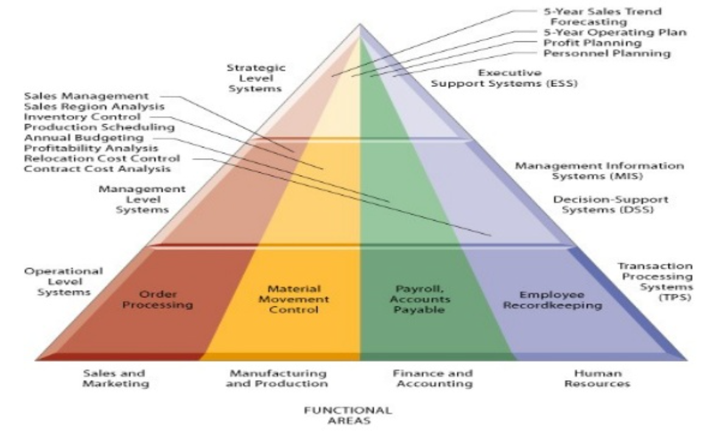
Figure 1 Information systems and business functions (Laudon & Laudon, 2004)

Not all business activities are incorporated within just a single functional area. It is impossible to classify applications by functional area and consequently, this resulted in the need to establish systems by processes. This process-view is paramount because some business tasks are fragments of a business process and, in addition, those processes are cross functional (Laudon and Laudon, 2006). Laudon and Laudon (2006) indicate that many processes cross divisional boundaries. They divide cross-functional information systems in two types. If it goes across entire enterprises, it is called an “Enterprise System” (ERP) and “Inter-organizational System” (IOS) if across multiple enterprises.
Enterprise Resource Planning Systems (ERPs) are highly integrated, complex systems and widely implemented as the backbone of many manufacturing and services organizations. ERPs are designed to direct attention to the problem companies face with information fragmentation or “islands of information” (Muscatello, Small & Chen, 2003). An ERP manages and integrates a company’s financial, supply chain, operations, reporting, manufacturing, and human resource activities. It allows the modules to share and transfer information freely (Hicks & Stecke, 1995) and in addition, all information is stored in one database accessible by all modules eliminating the necessity of entering the same data multiple times.
ERPs offer tremendous opportunities. Olsen, Chae and Sheu (2005) claim that, with the implementation of ERP, organisations are better equipped to provide information more consistently in a standardized, centralized, and cost-efficient way. Other benefits of implementing ERP is the ability to integrate business processes (Davenport, 1998), improving efficiency and increasing profitability (Brakely, 1999) and the ability to view and manage the extended enterprise of suppliers, alliances and customers in an integrated whole (Muscatello et al., 2003).

2.2 Empirical Literature Review
The relation between ERP systems implementations and organizational performance has induced much attention among researchers around the world. Poston and Grabski (2001) conducted research on the impact of ERP system implementation on the firm’s financial performance and suggest that, organisations who adopt an ERP system, seem to get efficiency gains to some extent, but also face increased costs. In their study they investigated 49 companies who adopted an ERP system. The results of this study show a limited and insignificant positive correlation between ERP and firm performance and the gains seem to offset the costs resulting in an unclear conclusion whether an ERP implementation leads to an increase in firm performance. However, they reported a significant decrease in the ratio of employees to revenue in each of the 3 years and a significant improvement in the ratio of cost of goods sold to revenue in year three. Poston & Grabski (2001) show the complexity of links between ERP and performance because they did find a direct link to cost/sales ratio but failed to show this to residual income. As such, they show a direct link to one aspect of performance making generalization of their findings with regards to performance complex. Companies are spending millions of dollars on ERP systems and those systems fail to deliver financial benefits. This overall missing significant financial improvement following an ERP adoption has become known in subsequent studies as the “productivity paradox”. As the Poston and Grabski (2001) study found no significant improvement in firm performance except the three years lagged improvements in cost of goods sold scaled by revenue, follow-up investigation to reassess possible benefits is needed which could identify the factors affecting the relationship between ERP implementation and firm performance.
Poston & Grabski (2001) analysed the results of their study and identified a few reasons that could potentially explain those disappointing results. To begin, ERP benefits may be realized only after 4 to 5 years after the implementation process and they included a lag of only 3 years. Most likely, this was not sufficient. The second explanation they give is that real benefits of ERP systems implementations will result from utilization of add-on packages such as customer relationship management (CRM) and advanced planning system. Thirdly, reengineering of business processes is combined with the implementation of an ERP system and this makes it hard to analyse performance implications. Comparing previous performance with ERP post-implementation performance could provide insights only when this is done using a longer time frame. Additionally, not included in this research where macroeconomic or contextual factors and recommended is to include a control sample of firms, matched on industry and size, that have not adopted ERP. The last reason they mention is the fact that implementation and organizational characteristics should be known and measured in order to identify the true success and impacts of the ERP implementations.
Building on the limitations of the Poston and Grabski (2001) study, Hunton et al. (2003) examined the benefits from the implementation of an ERP from a different perspective. The objective of the study was observing a difference in performance effect between adopters and non-ERP adopters. The observed statistical effects were caused not by increased performance of adopters but instead by a decrease in performance of non-ERP adopters. They found that ROA, ROI and ATO were significantly better over a three-year period for adopters as compared to nonadopters. In line with the study of Poston & Grabski, no significant pre- and post-adoption performance improvement for ERP adopters was found. An overall financial performance improvement for ERP adopters has not been supported.
Previous work that study the impact of an ERP implementation on firm performance was not only empirical in nature as some studies had an exploratory character and were based on the perceptions of the ERP users’. For example, Hitt, Wu, and Zhou (2002) mention that most of these exploratory studies are interviews, case studies or industry surveys. Contrary to this, empirical research compared the performance of public firms that adopted ERP and matched those with equally sized public firms that had not adopted ERP (non-adopting firms). The three major studies by Nicolaou (2004), Poston and Grabski (2000) and Hunton et al. (2003) applied this approach. Even though using the same general methodology, the conclusions were contradictory. The studies of Hunton et al. (2003) and Poston and Grabski (2000) used a three-year post-adoption timeframe, whereas Nicolaou (2004) used four years of post-adoption financial data. In line with the comment made by Poston and Grabski (2000), the three-years of data used in their research might not have been enough to capture the impact of the ERP implementation on firm performance and they propose to do a four-to-five-year longitudinal study to see the full impact of the ERP implementation on organizational performance. In order to investigate the full impact of ERP adoption, this study uses four years of post-adoption data. Having included this in the methodology allows the researcher to formulate the first hypothesis.

H1: The implementation of an ERP system has a positive effect on the financial performance of the firm when using four years of post-adopting data

2.3 Contextual Factors
Despite the large investments, the benefits of the IT-spending could not be found in the firm-level output in the early 1990s studies (Velcu, 2007). The late 1990s studies showed evidence of positive IT returns in firms which restructured the organizations to take advantage of the new technology. (Hitt and Brynjolfsson, 1996). Even though late 1990 evidence is present on IT investments, the research results on the relation between ERP implementations and firm performance remain inconsistent. As a result, the latest research efforts strive to understand when and why there is a payoff (Dehning & Richardson, 2002; Rikhardsson & Kraemmergaard, 2006).
Poston and Grabski (2001) and Hunton et al. (2003) found no significant improvements in firm performance ratios expect for three years lagged improvement in COGS scaled by revenues. A new investigation to reassess possible benefits was needed, which could also further clarify the myriad of factors affecting the ERP and firm performance relationship. Hayes, Hunton and Reck (2001) mention the existence of a variety of contextual factors that may help explain the strength and direction of the ERP implementation impact on the performance of the firm. A factor that may influence the strength and direction is the financial health of the firm, since prior research shows that the market responds differentially to healthy and unhealthy firms. In their study, Brynjolfsson and Hitt (1998) observe that the IT payoffs are conditional, therefore they support research on factors that influence the impact of IT on firm performance. Dehning and Richardson (2002) propose a general framework (Figure 2) where the relation between IT and firm performance follow three main paths. Path 1 entails a direct connection between IT and firm performance, bypassing the effect of IT on business processes, and measuring firm performance by using market- or accounting performance measures.

Figure 2 Framework on the Benefits of IT investments (Dehning & Richardson, 2002)
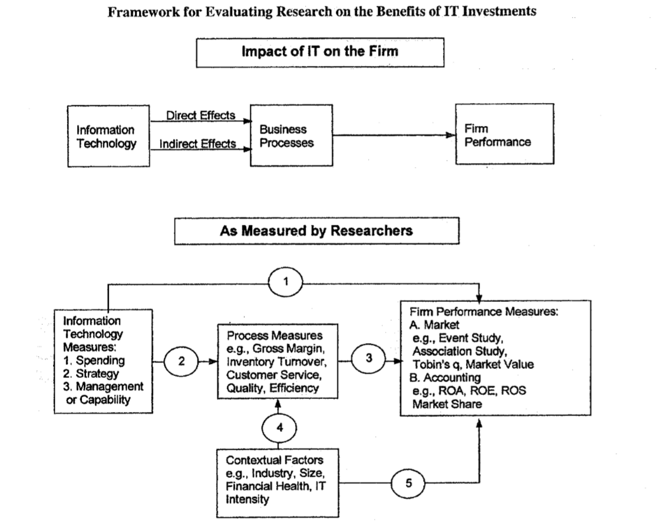
Path 2 describes the relation between IT and business process performance (inventory turnover, turnover ratios) and path 3 shows how the process measures combine or/and interact in order to determine firm performance. What can be learned from the study of Hayes et al. (2001) is that the link between IT and financial performance depends upon contextual factors (industry, size, financial health, IT intensity). This may affect the IT impact on both business processes (BPs) and overall firm performance, therefore Dehning and Richardson (2002) define two more paths by including contextual factors in their model. The contextual factors affect business processes through path 4, and overall firm performance through path 5.
The above-mentioned framework points at the lack of studies on the changes in BPs caused by IT investments and the effect of those process changes on organizational performance in the post-implementation stage. Velcu (2007) presents an “inside the black-box” approach to the analysis of economic benefits by examining the BP changes that occur in companies that have different motivations for their ERP implementation projects. The purpose of this study is to explore what BP changes happen in companies implementing ERP with different motivations and the impact of those process changes on organizational performance. The results provide an outlook into the interrelationships between ERP motivations and the benefits of ERP. Also, Itnner, Larcker and Randall (2003) call for further research that might begin to unpick the relationship between the causal factors behind the technical and organisational factors that contribute to actual performance.
The paper of Quattrone and Hopper (2005) reflects the importance of including contextual factors when analysing the effect of an ERP implementation. Their study is about the effect of implementing an ERP system upon management control in two multinational firms. They show that the adoption of the same ERP may lead to different outcomes in terms of management control and thus display completely different results from their implementation. Two case studies describe those contrasting journeys towards organisational architecture when implementing ERP. The authors state that, because in both cases ERP was implemented, the outcome for both should be the same but when looking closely, this is not the case. It is not an unexpected outcome because the reasons as to why to adopt a certain technology differ from one another. Implementing ERP from a strategic point of view will change the whole organisation compared to implementing ERP from a technical point of view which most frequently contains replacing a legacy system. The authors do not take this important factor into account, resulting in a complex paper with an obvious outcome. This example supports the importance of including the company’s motivation to pursue such an ERP application when analysing the effect of this IT implementation on the performance of the organization.

2.4 Motivations for ERP
Information technology has played an important role in global economies. Companies rely on IT for fast communications, data processing and market intelligence. IT plays an integral role in every industry helping companies to reach their goals. ERP implementation is the most frequently implemented IT solution. A lot of research has been conducted on ERP and the reasons why organizations implement such systems vary from implementation to implementation. Given the potentialities of ERP systems in terms of functionality and benefits, it is not surprising that companies have different reasons for adopting such a system (Ross, 1999). Upon researchers, the first agreed high-level classification of the reasons motivating companies to implement ERP systems entail technical versus business-driven reasons (Mabert, Soni & Venkataramanan, 2000; Chand, Hachey, Hunton, Owhoso & Vasudevan, 2005; Botta-Genoulaz & Millet, 2006) (Table 1). Some companies have mainly technical reasons for investing in an ERP system. Examples are replacing incompatible systems, reduce operating costs and solving maintenance headaches related with aging legacy systems (Markus & Tanis, 2000). Other companies possess largely business led motivations for adopting such a system. For example, the company may need, but not have due to limitations in the current systems, the ability to have an “available to promise” planned production capacity to the customer. Or the company needs a more integrated IT solution that accommodates business growth. According to Salimi & Dankbaar (2008), ERP implementations with a technical motivation tends to be handled as a one-off project. In contrast to implementations considered from a process perspective, where the focus is on the improvement of business processes, the goals of the process are continually under review. An important note to be made is that it is not uncommon that companies have both technical and business motivations for adopting ERP software.

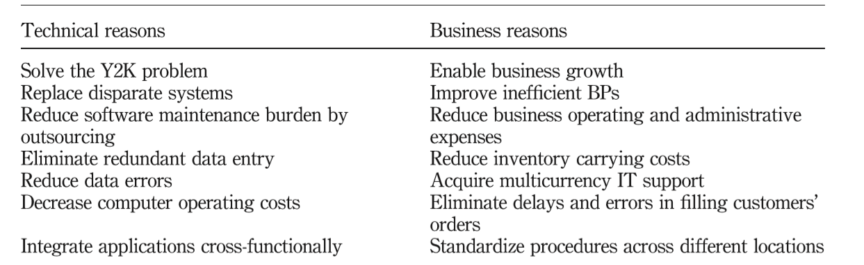
Table 1 High level classification on motivations to implement an ERP (Chand et al., 2005)
In a paper of Leyh (2015) and based on the review of case studies using academic literature, several goals and reasons are identified for implementation of an ERP project. It is difficult to distinguish between reasons and goals. Sometimes, goals can be viewed as reasons and vice versa. For example, the goal of an ERP implementation can be to cut IT costs whereas it may also be necessary for the company to reduce IT costs which can then be a reason to implement the ERP. So, the goal of the company can be translated in the reason for implementation. To avoid this complexity and duplication, in the next section only reasons will be described which are not interpreted as goals. The case study review of Leyh (2015) covered 18 papers, including 36 case studies. The companies in this sample existed of 28 largescale enterprises and S&MEs operating within the manufacturing sector, process industry and public sector. Based on the 36 case studies, only 4 out of 6 identified implementation reasons were mentioned in the case studies and the first 3 reasons were mentioned more than 10 times. The top three reasons are: the adjustment to changed business processes, adjustment to company growth (but also the ambition to growth) and necessary system upgrade to obtain new functions. According to Bradford (2015), 4 reasons exists as to why a company undertakes an ERP implementation. Those reasons are: the need for new technology, streamline with the organizations strategic direction, the need to keep up with competition and business process as a rationale. Based on the reviewed literature, a theoretical explanation on the main implementation reasons, which will be used as a basis for this study, will be provided in the next section. This foundation will allow for linking the theoretical explanation of the concepts to practice.

2.4.1 The system rationale (1)
Firms often must cope with existing legacy systems. One of the most common reasons to spend money on ERP systems is grounded in the fact that it is not worth the cost of keeping the existing legacy system and the decisions is made to part. From a maintenance perspective, old technology is often far more costly to keep compared to newer, lighter, and more advanced systems. Additionally, it turns out to be more difficult and expensive to find a support team who is familiar with the outdated system. Security issues, a lack of modern features and functionalities and a lack of flexibility to customize or integrate are additional problems for companies who are still working with legacy systems. The system becomes a liability for the organization instead of an asset for growth. ERP systems on the other hand, promise to deliver an integrated software solution to companies need for information when the replacement of legacy information systems is desired. Upgrading the system results in better visibility of data and the opportunity for data integration. Bradley (2008) used eight case study companies to examine critical success factors for implementing ERPs using the framework of classical management theory and concluded that 4 out of 8 companies implemented ERP because replacing their legacy system and obtaining new functions was required in order to stay competitive. Mandal & Gunasekaran (2003) in their case study at a water corporation, reviewed the existing legacy system and they found that repair was not cost effective and replacement with an ERP system was the only option. Kremers and van Dissel (2000) analysed why firms upgraded their IT system to ERP. They found that the technical reasons (such as compliance, expired program support, dissatisfaction with current system, and keeping the system up to date) were the most frequently mentioned reasons and more than half of the companies (57%) in their sample mentioned a technical reason as key reason as well.

2.4.2 The strategy rationale (2)
ERP adoption can be driven by a specific strategy, such as growth, mergers & acquisition, diversification, or globalization. Most companies, especially small and medium enterprises, encounter fast expansion and double-digit growth or heavy transformations within the firm. The aim for a company to implement an ERP system can also to be better equipped for anticipated growth. The latter is a defined goal of an ERP implementation project and not an example of a reason for firms to implement ERP. In addition, the goal of expansion and growth cannot always be predicted.
Growth can also be a reason for ERP projects. As a business becomes more and more mature, it is reasonable that pre-existing processes and systems are no longer a perfect fit. This type of growth is called organic growth and requires more than an accounting system solution. In times of delivering such growth strategies, complexities as managing multiple locations, dealing with increased staff communications needs and managing processes remotely ask for an IT landscape to support this request. Legacy or basic systems simply cannot handle this. Not only functional challenges arise, also in terms of information management ERP offers help. As the company’s grows, the need for cross functional and cross departmental information is evident. Without ERP, the process of sharing information across those departments becomes challenging as information is captured in the department silo and difficult to access. Xue, Liang, Boulton and Snyder (2007) conduct a case study at FurnutureCo who’s growing business volume cannot be handled via manual business process management and as a result ERP was implemented.
Companies growth can also be non-organic. Examples of non-organic growth are mergers and acquisitions. When a company acquires another company, the information system strategy may include the desire to have a system which is flexible in adopting and incorporating multiple ways of managing and tracking a business and easy and fast to rollout at newly acquired companies.

2.4.3 The competitiveness rationale (3)
There are many ways in which ERP software can support companies to run their business more efficiently, allow the company to be more flexible and adaptive (increasing innovative power) and save money and offer better products, services, and prices than the competitor. In some cases, fundamental changes throughout the entire firm are needed to keep up with competition and remain competitive. Adjusting products, reduce production cycles, making business processes more efficient and quicker access to information and statistics are some examples of those changes. To remain competitive, businesses look at technology to gain those advantages. According to Singla (2008) ERP systems are designed to increase the firm’s competitiveness by boosting the ability of the firm to produce timely and accurate information all over the enterprise and its supply chain. The adjustments should not only be practically implemented but implementation within the ERP system is essential as well. The continuous change in the business environment for competitive firms represents the era of global competition and innovation (Naveed, Ahmad & Ahmad, 2016). In which country the company is located, where the products are manufactured or where they are sold does not make a difference nowadays. Instead, what business model you have is crucial for the success of a company and information technology has a huge impact on how a company’s business model has changed. From the old conventional, isolated business model, information technology has changed it in a more coordinated, internally and externally integrated, networked business model. Davenport (1998) in his study describes the case of Elf Atochem North America, a $2 billion regional chemical subsidiary of the French company Elf Aquitaine. The company was hampered by the fragmentation of important information systems among the multiple business units. Ordering systems were not integrated with production, business units were tracking and reporting its financials independently and management was not getting the information needed to make sound and timely decisions. Also, from a customer perspective and as a result of every business unit being managed separately, doing business with the company was not easy. To place a single order, a customer would have to make phone calls to different units. Management knew that, especially in the commodity business, the company that can offer the best customer services often wins the order. The reason for implementing the ERP was to improve the service levels and become competitive. After implementing the ERP, the system gave Elf Atochem the real time information needed to connect sales and production planning, which enabled the company to alter production runs in response to customer demands. Elf Atochem gained important advantage over most competitors because it received the information needed to enhance tactical decision making. The system enables more effective decision making resulting in more efficient and profitable operations.

2.4.4 The business process rationale (4)
Companies adopt an ERP system to improve inefficient key business processes. Companies want to attain best practices in their business processes so they can achieve targeted, specific, and measurable performance improvements such as inventory reductions, improved manufacturing processes and faster orders. It is important to know that the profitability of your business is dependent upon the quality of the processes that support the business. When focussing on operational activities, that are activities processed daily, information technology is proven to cut costs and increase output by automating (repetitive) operations (Shang & Seddon, 2002). Investing in information technology facilitates in streamlining processes and as an ERP automates business processes and enables process change those are expected to offer benefits. ERP software can help businesses to improve their internal processes by integrating various business activities. E.g., from tracing raw materials to production planning, scheduling to optimizing and managing inventory and improving customers relationships. ERP will help the firm to eliminate inefficiencies and improve the proceedings of a business. With an ERP system, companies can operate on a “just-in-time” inventory schedule that prevents inventory levels from getting too high or low. The system allows to set up tailor-made flags and warnings in order to monitor the specific stock levels and send warnings in case the levels exceed the pre-defined upper and lower bound. Especially manufacturing firms struggle to manage fluctuations in demand and growing competition. Those companies are constantly looking for various opportunities to streamline operations and increase process efficiency. Umble, Haft & Umble (2003) in their study concluded that ERP helps in reducing inventory levels by 15-20%. Streamlining inventory management and efficiently preparing for customer demand are not the only examples of enhancing business processes. Also improving employee productivity (Singla, 2008) and, as a result, reducing labor time as well as using ERP to automate supply chain by improving communications between manufacturers and their suppliers are just a few examples of how ERP can improve business processes.
The story behind implementing an ERP system within organisations is particularly useful in order to get better grip on how the relationship between the ERP implementation and the effect on firm performance come to being. This explorative search on the most important reasons which yield firms to adopt such system provides useful insights which allows the second hypothesis to be formulated.

H2: ERP implementation reasons exhibit significant differences in firm performance

2.5 Motivation – Benefits Framework
According to Markus & Tanis (2000), the management of the organisation adopting the enterprise system will always reflect on questions in terms of success. Will or did our investment pay off? When looking at research covering IT investments, not limited to ERP, it shows that not only costs are hard to quantify, but benefits are also difficult to identify and quantify (Seddon et al. 2002; Irani, Sharif & Love, 2001). To be able to measure the benefits from an ERP implementation, we should better understand what types of benefits organizations can achieve from their system and when those benefits will most likely be realized. According to Davenport (2000) and Markus and Tanis (2000) benefits from ERP have a multidimensional character which can range from operational advancement to support for strategic objectives. An important question to be asked is what types of benefits firms can expect after implementing their ERP. Shang & Seddon (2002) did research on the different types of benefits and presented a framework listing the benefits many companies accomplished from the adoption of an ERP system. The benefits can be classified into five different dimensions: operational, managerial, strategic, IT infrastructural and organizational benefits. Operational benefits are benefits that arise from the automation of business processes. ERP systems with their functionality of data analysis can facilitate decision making and improve performance in, especially, operating divisions resulting in managerial benefits. Strategic benefits cover the benefits that arise from the system’s ability to support business growth, innovation, and competitive advantage. IT benefits mainly come from the reduction of IT costs related to the maintenance of legacy systems. Finally, the ERP system enables business learning, staff empowerment and improves working patterns leading to organizational benefits.
Not only Shang & Seddon (2002) present a framework listing the benefits of adopting an ERP, also Chand et al. (2005) presented a framework dividing the ERP benefits into only three categories being operational, tactical, and strategical benefits. Since the focus in this research will be on financial performance, more specifically on profitability, cost reduction and efficiency, sales growth and capital structure, the ERP benefits included in this research will be limited to financial benefits only. Looking at the benefits framework of Shang & Seddon (2002), the managerial and organizational benefits are difficult to measure and quantify in an accounting measure. Improved decision making, better resource management, changing work patterns and building common vision are just a few examples. The study of Galy and Sauceda (2014) supports the fact that performance benefits are most frequently categorized into the dimensions that follow the management pyramid categories described in the study of Chand et al. (2005) being operational, tactical, and strategic benefits. An interesting addition to the categorization of the implementation benefits is the fact that Zuboff (1985) suggests that the benefits of the ERP implementation and operations highly depends on firm’s intention to use the ERP system to automate, informate or transformate. Organizations with the motivation of automating business processes (business process rationale) use ERP to automate in order to have consistent data across the organization. Also, automation applies to firms with the goal to have one integrated system. Success will be conceived in terms of reduction in IT budget or/and increased productivity. According to Zuboff’s (1985) notion on the faces intelligent technology represents, automate operations also applies on the system rationale/motivation for implementing an ERP solution. Automate means that managers typically invest in new IT technology because it not only cuts the IT costs in the long run, but in addition allows them to accomplish their operations more quickly at less cost (Zuboff, 1985). Organizations who implement ERP out of a system rationale, have the initial objective to automate the business with one integrated system and benefits are realized in reduction of IT budget and increased productivity and efficiency of the working staff. According to Velcu (2007) operational benefits are those type of benefits arises from the automation of business processes. An ERP system automated daily operational processes and thus, one would expect the system to offer benefits in terms of cost reduction and productivity improvement.
Informate implies that the ERP is being used to generate management and operational information to advance (process) improvement. The informate level focuses on data from ERP that supports the process of tactical decision-making and ERP system can be used to inform affected parties across the value-chain such that decision making at all levels is improved (informate). Informate means that the ERP system generates information about the underlying processes, which (when presented in a particular manner and at an appropriate time), improves the knowledge and a required action or decision can be made. According to Chand et al. (2005), identifying and meeting the customer needs proactively, better forecasting and increased revenue as a result, are a few examples of benefits related to implementing an ERP with the intention to use the system to Informate. Firms who implement ERP out of competitiveness rationale, have the initial objective to informate. This level focuses on the fact that an ERP can provide information which supports tactical decision making and thus provides tactical benefits.
Transformate means that the deployment of the ERP system has a major change, and the scope of the business is redefined with new, information-based products and services. In order to compete in global markets, organizations need to be agile and flexible and capable of transforming themselves to survive in today’s highly competitive market. According to Zuboff’s (1985) notion on the faces intelligent technology represents, transformate operations best applies on the “strategy rationale” for implementing an ERP solution. The goal of implementing the ERP system is to facilitate business agility. In order to provide value-added services and compete in the (global) markets, firms must be agile and capable (and thus flexible) to transform in order to survive in the competitive markets of today. Zuboff (1985) notion of transformation highlights the fact that ERP systems can positively affect the “success” of an organization. Transformate looks at the strategic impacts and benefits of the ERP implementation.
Even though Shang and Seddon’s benefits categories as well as the benefits category used by Chand et al. (2005) can serve as an extremely useful framework for evaluating the benefits of ERP systems, both do not link the benefits to the motivation for ERP implementation as recommended by Markus and Tanis (2000). They suggest that there should be a connection between reasons for adoption and benefits and this research aims to do so. By linking the ERP motivations for adoption to Zuboff’s levels of automate, informate and transformate and to the potential benefits, a framework is provided to better understand the direct contributions and benefits of ERP implementations (Table 2). This framework can be tested, and the findings of this research will provide insights on how those reasons for implementation and true financial benefits are connected and the implications allow organisations to be managed up front in their expectations concerning the impact of the ERP on financial performance.
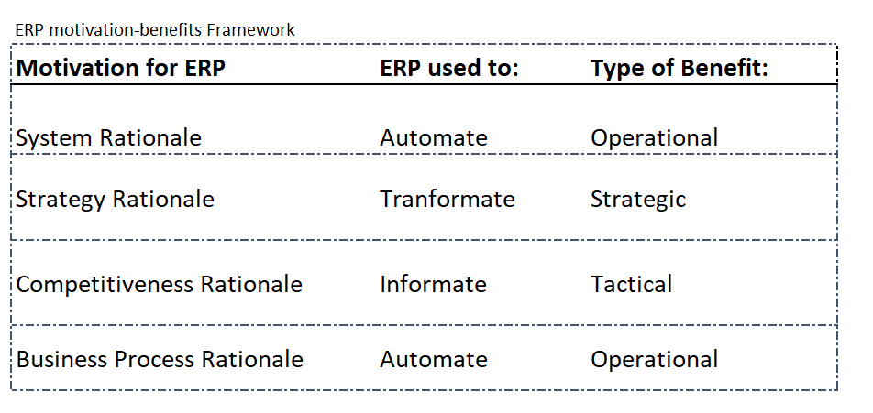
Table 2 ERP Motivation-Benefits Framework

2.6 Performance Benefits
The majority of firm-level analysis measures ERP investment in the aggregate. This means little is known about the performance impact and contributions if you look at the different types of IT investments with different motivations and goals and whether those differences impact different aspect of firm performance. Bharadwaj, Bharadwaj & Konsynski (1999, p1020) argue “it appears that firms benefit unequally from their different IT investments” thus it would be remarkably interesting to examine impact on firm performance when looking at the different reasons or purpose of the ERP investment. What are the differences in financial performance when looking at the more technical purpose of ERP implementation versus the more strategic implementation?
Investment in IT to automate business processes are usually performed to reduce cost in standard, repetitive processes. Those are associated with lower cost but not specifically with more firm-level product innovation (Shang & Seddon, 2000). What can be expected is that ERP investment with the goal of streamlining business processes are associated with immediate cost reductions (Aral & Weill, 2007). Since ERP systems automate the business processes and enable process changes it is expected that ERP systems also offer productivity gains. The ERP system integrates disparate processes across the organization, the result is more streamlined business processes and smooth and transparent flow of information. Streamlining business processes by ERP improves productivity and will drive efficiency (Chand et al., 2005). An increase in production per employee, production by labour hour, production by labour costs are just a few examples (Shang & Seddon, 2002). ERP investments that stem from a more technical reasoning are usually enterprise-wide infrastructure implementations which have a disruptive nature and create high up-front costs (Weill & Broadbent, 1998). It is therefore expected that ERP implementation with a more technical motivation have a drop in financial performance immediately after implementation (higher short-term costs, lower short-term profitability), and increased performance in terms of lower (IT) costs in the long run.
Investment in ERP, where ERP is used to tranformate the business, leads to strategic benefits. This category focuses on the benefits that arise from the system’s ability to support business growth (Chand et al., 2005). Growth can come from entries into a new market, development of new products, services, or business processes. According Markus & Tanis (2000) the financial goal of the ERP system, where ERP is implemented to facilitate business growth, is market valuing and growth in revenue. Hayes et al. (2001) and Hitt et al (2002) support this statement as they found that having more ERP modules is associated with higher market valuation and higher revenue. Based on the findings of the case study conducted by Shang & Seddon (2002) no immediate post implementation strategic benefits are expected. The ERP system support in the goal of implementing the ERP system to facilitate business agility and most likely those benefits will be achieved a few years after implementation of the ERP system.
The informate level focuses on data from ERP that supports the process of tactical decision-making and ERP system can be used to inform affected parties across the value-chain such that decision making at all levels is improved (informate). Identifying and meeting the customer needs proactively, accurate commitments to trading partners, better forecasting and increased revenue as a result, are a few examples of benefits related to implementing an ERP with the intention to use the system to informate. ERP is used to provide information for managing the business not only internally but also to improve cooperation with customers and suppliers. The ERP investment can improve the adaptability of firms and enable more effective decision making. Sales analysis help optimize products and pricing, thus enabling more efficient and profitable operations. The ERP implementation can improve data collection and decision making, identifying new opportunities for revenue generation and profitability improvement.
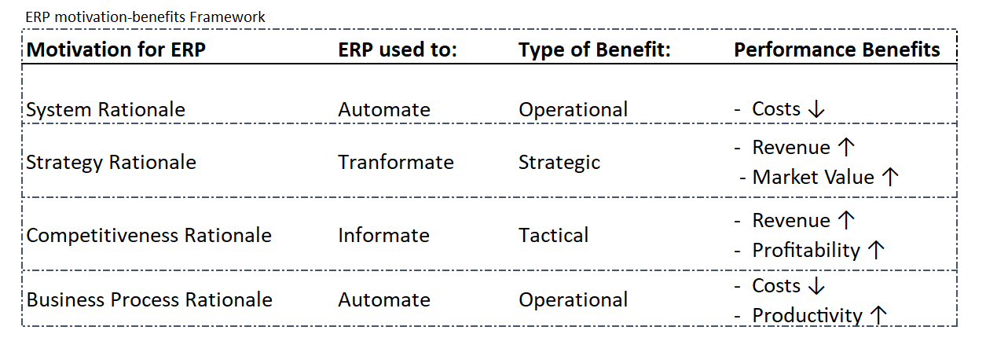
Table 3 Performance Benefits
The ERP-benefits framework can now be extended with the financial performance benefits (Table 3). This addition assumes that not the ERP investment as such is associated with improved financial performance but the specific reason and motivation as to why companies invest in ERP solutions explain performance improvement and performance difference along the dimensions consistent with their motivation. Thus, it would be interesting to examine the impact of ERP implementations on firm performance considering the different motivations, resulting in the following hypothesis.

H3a: The implementation of ERP has a positive effect on the company’s costs if the main reason to implement is system.
H3b: The implementation of ERP has a positive effect on the company’s market value and revenue if the main reason to implement is strategy.
H3c: The implementation of ERP has a positive effect on the company’s profitability and revenue if the main reason to implement is competitiveness.
H3d: The implementation of ERP has a positive effect on the company’s costs and productivity if the main reason to implement is business process.

H4: Investments in ERP systems are associated with higher firm performance only along the performance dimensions consistent with the motivation of the implementation.

2.7 Libby Boxes
In order to provide a visual overview of the conceptual relationships described in the previous paragraphs and examined while doing quantitative research, it is important to construct a predictive validity framework. This predictive validity framework is also known as Libby Boxes (Libby, 1981). Figure 3 and 4 show how Libby Boxes can be used to represent what counts and what gets counted. The top boxes are the underlying constructs based on theory and show the cause-and-effect relationship. The bottom boxes represent the proxy measures for each construct, this is what gets counted. Because other factors are likely to affect the relationship between ERP implementation and Firm Performance, the box control variables capture those variables omitted from the simple model even though they may influence what gets counted (firm performance) as an effect. Those control variables might influence the firm’s financial performance or might influence the measurement error, such as bias or noise (Bloomfield, 2015).
Figure 3 Predictive Validity Framework Libby Box ---- Hypothesis 1
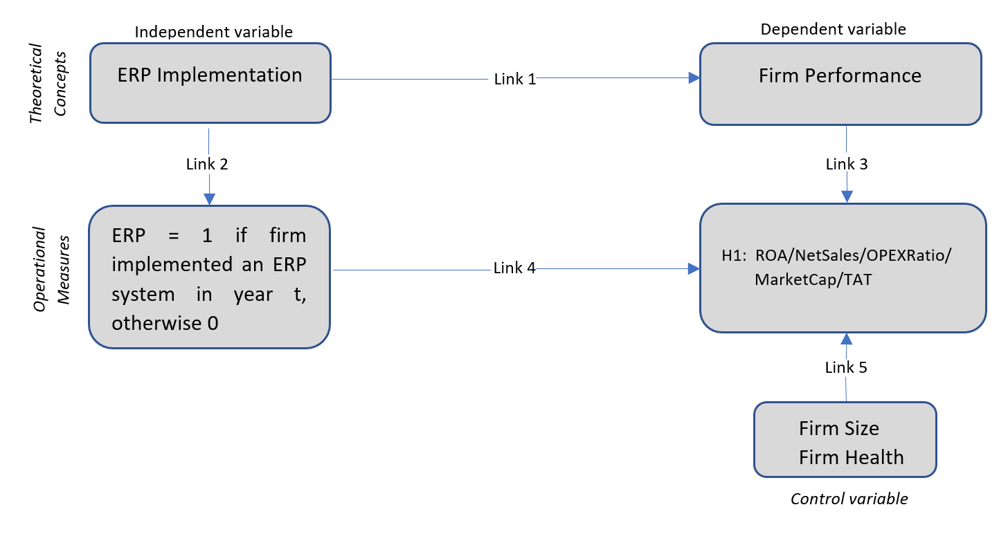
The construct validity refers to how the operational variables are measured. In addition, it pays attention to whether those measurements represent the conceptual variables (Bisbe, Batista & Chenhall, 2007). The second and third link in figure 3 demonstrate how to measure both the dependent and independent variables. The independent variable is measured by asking the year of implementation via a questionnaire, where the year prior and the year of implementation is assigned a zero and the 4 years following the year of implementation a one. Furthermore, the dependent variable is operationalized through the firm financial performance by using accounting measures. The accounting-based measures used are Return on Assets (ROA), Net Sales, Operational Expenses scaled by Net Sales (OPEXRatio), Market Value measured by market capitalization (MarketCap) and Total Assets Turnover (TAT).
The internal validity addresses the relation between the independent and dependent variables. An important element is the fact that the observed results are indeed from the effect which the independent variables has on the dependent variable. In other words: are the construct and the subsequent hypothesis logical and consistent? Internal validity can be achieved through testing the conceptual theories by examining the relation between the independent and dependent variables. This is shown by the fourth link in Figure 3. The data used are from primary and secondary sources. The primary data is obtained via a questionnaire distributed under CFO’s from Dutch publicly listed firms whereas the secondary data is retrieved from the databases FactSet and Eikon used to measure financial performance. In addition, control variables (the size of the firm and the firms’ financial health) are used and including those variables results in higher internal validity.
The last element of the validity framework relates to external validity, which is reflected in the first link of Figure 3. This link represents whether the results can be generalized to other measurement methods, time periods or samples observed. The sample consists of only publicly listed firms which makes it hard to draw conclusions beyond the scope of publicly listed firms. More specifically, small and medium enterprises have specific characteristics and their motivational underpinning of why ERP systems are implemented could potentially be distributed in a different way. For example, strategy as motivation for ERP (global expansion / M&A) is expected to be less applicable while other reasons for implementation would be more appropriate and not part of current research.
Looking at Figure 4, the predictive validity framework is extended with another variable. This variable affects the relationship between independent and dependent and is called a moderating variable. In this model the moderating variable is “reason to adopt” which is operationalized by using a categorical variable (dummy coding variable) with information about the applicable reason for companies to adopt an ERP system. This information is retrieved via the primary data source (questionnaire) and included in the model. Hypothesis 2 is formulated in order to test the strength of the moderating variable “reason to adopt” in explaining the differences in firm performance among the reason-groups. Including this variable and testing this conceptual theory with hypothesis 2 contributes to the internal validity of the framework. Hypothesis 3 covers the predicted firm performance improvements on specific accounting measures that, based on the motivation-benefits framework in Table 3, relate to the different implementation reasons. To prevent missing unexpected and unpredictable outcomes, hypothesis 4 states that higher firm performance, based on the defined accounting measures, will only occur along the dimension (measures) consistent with motivation of implementation, and thus consistent with performance benefits explained in Table 3.

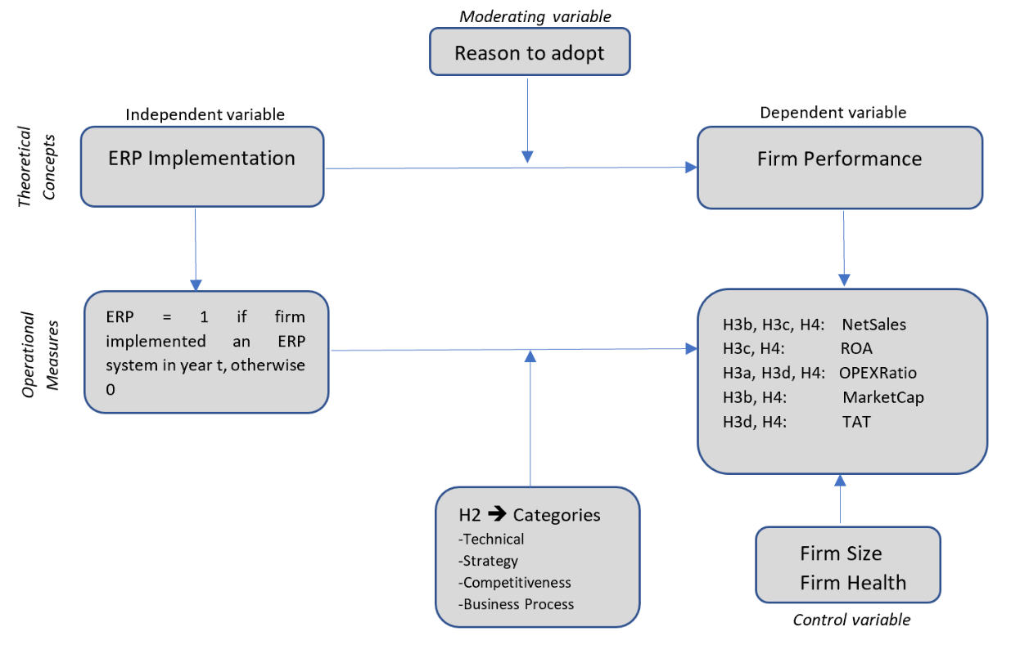
Figure 4 Predictive Validity Framework Libby Box ---- Hypothesis 2, 3 and 4

Methodology

This chapter explains the research design of the study. The methodology of doing research will be discussed first, after which the data collection process is explained. Next an explanation on the sample and variables will be provided and this chapter will finish with a discussion on the quality of chosen methodology.

3.1 Research Design
According to Ahrens and Chapman (2006), one can distinguish between a methodology and a method in doing research. A methodology is the general approach to studying a research topic (Ahrens & Chapman, 2006). This study tries to identify causal relationships between factors and adopts a quantitative research method. According to Cohen (1980), this type of research is defined as social research that uses empirical methods and empirical statements. An empirical statement is a descriptive statement about what “is” the case in the “real world” rather than what “ought” to be the case. The first element in a quantitative method is explaining the phenomena. The foundation of this type of research is a solid theoretical model. A proper literature study is conducted to theorize and model the phenomena and define testable hypothesis. This part connects to the next step in quantitative research: collecting numerical data. In order to use mathematically based methods to analyse that data, it has to be in numerical form. According to paradigms of Chua (1986), the ontological assumption of quantitative research is that reality is objective and singular apart from the researcher. This means that reality is independent of those who observe it. From an epistemological viewpoint, the researcher is independent from that being researched and a deductive methodology is used to develop hypothesis. A quantitative research method in this case is advantageous because it allows for measuring financial performance as numbers are included. Also, results are reliable and generalizable to a larger population, leading to prediction, explanation and understanding. Examples from earlier studies on the relation between ERP implementations and firm performance using a quantitative research method are Chapman & Kihn (2009), Hunton et al. (2003), Kallunki, Laitinen and Silvola (2011), O’Leary (2004), Booth, Matolscy & Wieder (2000), and Poston & Grabski (2001). Either by mail survey or questionnaires, but also by doing statistical analysis only with data retrieved from databases after first selecting the sample companies who implemented an ERP.
The research is conducted following three successive steps. First, the literature review is done which is important in order to define the limit of the research and to evaluate promising research directions. In this study, literature is needed to derive the motivations for ERP system implementations and the expected effect on performance parameters and subsequently to develop hypothesis. The second step, which is part of the data collection process, is to collect information about the motivations behind recent ERP implementations. Information about other possible important contextual factors, retrieved from a solid literature review, are gathered via this questionnaire as well. The companies are contacted, and a questionnaire will be sent after this initial contact. Via this questionnaire more information about the reason of implementation and year of implementation are gathered. The next step is to retrieve financial data from FactSet and Eikon after which analysis can take place. An appropriate sample size is required for validity. With a sample size too small, the results may not yield validity. The sample consists of all companies on the Dutch Stock Exchange, large (AEX), mid (AMX) and small cap (AScX) lists. The reason as to why large companies with over 50 employees are preferred is because it can be assumed that a systematic management accounting system is used more often compared to smaller units.

3.2 Research method
The research method covers the specific procedures for collecting and analysing data. As previously outlined, the object of this research is to examine the performance effect of ERP implementations while including the motivation as to adopt but also factors identified in previous research into consideration that might possibly influence this effect. This study is quantitative in nature and the methods of data collection is dependent on the type of data needed in answering the research question. A mixed research method approach is applied to collection the data as both qualitative and quantitative data is required. Information about the reason to implement is a type of information that cover experiences and meanings and cannot be described numerically. On the other hand, quantitative data in the form of financial data is needed in order to test the hypotheses. The collection of the data will come from primary and secondary data sources. Primary data relates to the qualitative part of this research methods and is original information which is collected for the purpose of answering the research question. The secondary data collection applies to the quantitative character and is information that has already been collected and thus easier and fast to access.
The aim of this study is to assess how a range of variables are associated with a particular outcome and determine the strength of such relationship in order to better understand how these factors relate to each other in a population. To be more concrete, how does ERP implementation as a variable affect the firms’ financial performance as an outcome and how does the motivation to implement the ERP affect this relationship? A regression analysis is a statistical tool used to model the relationship between the dependent and one or more independent variables. Specifically, regression analysis describes how the value of the dependent variable changes when one of the independent variables increases or decreases, while holding the other independent variables constant. In this study, as we include multiple moments in time and multiple economic entities (companies) but through time the economics entities do not change, we are using a Panel Data regression to determine the statistical relationship between the independent and dependent variable. Doing panel data regression with a fixed-effects (FE) model allows for only analysing the impact of variables that vary over time. The FE model explores the relationship between the predictor (ERP implementation) and the outcome variable within an entity (the companies). Each company within the sample has its own individual characteristics that may or may not influence the predictor variable. When using a FE model, we control for the fact that something within the individual company may impact or bias the independent or dependent variables. To analyse the data, the statistical program STATA was used.

3.3 Data Collection
Two sources of data are employed in order to collect the data required. The first one is a survey in the form of a questionnaire. The CFO’s of all the Dutch listed firms are contacted via Linked In, and after a positive response on the request to participate they were sent an email-questionnaire. This email-questionnaire serves as the mode of data collection regarding the year companies implemented their ERP system and the main implementation reason for doing so. The second source of data are online databases that contain company specific data. Those databases are employed to obtain the values of the indicators of organisational size, health, and financial performance.

3.3.1 Eikon & Factset
The CFO’s who responded to the email questionnaire are set to represent the company they are working for. The company specific information received through the questionnaires are matched against the secondary data retrieved from the databases Eikon and Factset. This secondary data covers the financial performance indicators used as measures for financial performance and financial data used to control de model.

3.3.2 Survey
In order to assure the reliability of this research survey, some important criteria in the work of Van der Stede, Young & Chen (2006) are followed. This section addresses those criteria, which are the purpose of the survey, definition of the target population and the sample, the type of respondents, and the response rate.
Purpose of the Survey
A well-designed survey should be conducted with a pre-defined research objective in mind. This is required so to avoid an incorrect selection of the sample of respondents. According to Pinsonneault and Kreamer (1993) and Sudman and Blair (1999), the survey research can be used for two main purposes: description and explanation. The appropriate purpose of survey in this study is explanation, as it is used to test theory that states the expected causal relationship among the defined variables. The variables contain the year at which the company implemented its ERP and the motivation behind this implementation.

Definition of the Target Population
Generalization is acknowledged as a quality standard in quantitative research. Generalization is an act of reasoning which draws broad inferences from particular observations (Polit & Beck, 2010). The target population defines those units for which the findings of the survey are meant to generalize and is the total group of individuals or companies from which the sample is drawn. The sample is the group of companies that ultimately take part in the investigation. In this study the target population, which is subject to these generalizations, are all companies which have implemented the core ERP system. In other words, their first acquaintance with an ERP system. Obviously, it is not possible to approach all organizations in the target population due to time and resource limitations. The survey population in this study comprises all listed Dutch firms in the Eikon database. The survey responses are filtered against the dimension of having implemented an ERP, as companies who have not implemented an ERP are excluded from the sample used in this research.
Level of analysis and Type of Respondents
In contrast to the target population (which is the collection of all respondents that the researcher would like to study), the survey population entails all the respondents available. Based on this, it is obvious that the survey population should only include subjects which are part of the target population. According to Van der Stede et al. (2006) one needs to examine whether the company is represented by one individual or by multiple individuals (employees) at different hierarchical levels within the organisation. Because it is said that survey studies go beyond the level of analysis of the individual, it is suggested that multiple employees represent the company to increase validity. Even though the latter is understood, in this thesis the email questionnaire (Appendix B) is only targeted at Chief Financial Officers (CFO’s) of the selected organizations. The rationale behind this decision is twofold. First of all, senior managers in general are believed to have the knowledge to answer questions regarding strategic decisions and secondly the CFO specifically because the CFO will always be involved in investment decisions such as the implementation of an ERP solution (Bradford & Florin, 2003).

Response Rate
An email with the online questionnaire was sent to the email addresses of 55 CFO’s of Dutch publicly listed companies extracted from the Eikon database. The original lists contained of 78 companies, but 23 companies could not be included due to a lack of financial data in Eikon and where excluded from the mailing list. The 55 email addresses where retrieved via an email lookup service. Each recipient received this email which contained a short introduction (Appendix B) about the research and the importance of their participation. In some instances, a second email which was part of a follow-up procedure, was sent approximately two weeks after the first email and encompassed a reminder message in which recipients were asked consider participation. Because of the relatively small sample sizes, only the non-respondent CFO’s were part of this second email batch. After the first round 15 organizations filled in the questionnaire. The reminder email resulted in 12 additional firms filling in the questionnaire which makes the total number suitable for analysis 27.

3.4 Measurements
Measurement is the process of observing and recording the observations that are collected as part of a research effort. This section explains what is being measured and how it is measured.

3.4.1 Dependent Variables
Three performance measures can be identified to capture differential performance (Nicolaou & Bajor, 2004). Those performance measures are accounting, market, and risk measures. The most frequently used measure of performance are the accounting measures. Accounting measures are publicly available and those capture information on many dimensions of a firm’s operation. This also makes it possible to link different accounting measures to the earlier defined ERP motivation-benefits framework. Firms who successfully adopt an ERP system should be able to improve their financial performance by either raising revenue or decrease costs. Traditional accounting variables are most likely to capture change in performance and this study will therefore use accounting measures to capture financial performance and test the research hypothesis.
Based on the current literature on the relationship between ERP implementation and financial performance the employed accounting measures which represent cost and profitability will be discussed. Nicolaou (2004) and Hunton et al. (2003) used return on assets (ROA), return on investment (ROI), and return on sales (ROS). Poston & Grabski (2000) as well as Nicolaou (2004) used the measure Cost of Goods Sold scaled by Sales (COGSS). Another variable that has been examined is the accounting measure of Selling, General and Administrative Costs. Specific to ERP, implementing the software with the aim to automate process steps and providing more electronic trails of employee responsibility (Gurbaxani and Whang, 1991). According to Poston & Grabski (2001), ERP systems should streamline monitoring activities and decrease errors, expecting a reduction in SG&A costs. Cost reduction should be evident in both SG&A as well as in the overhead associated with cost of goods sold. Based on the motivation-benefits framework presented in Table 3, combined with the relevant literature on ERP and firm performance, the following performance measures will be used in this study.

Costs => (Operational Expenses)
Investing in ERP is expected to result in lower operating expenses (OPEX) to sales in the post-implementation period (Ali, van Groenendaal, Weigand, 2020). Operating expenses covers the cost expenses for firms’ day-to-day activities not directly associated with the production process. ERP adoption is expected to reduce these operating expenses through automation, accuracy and innovation which lowers maintenance costs. Operating expenses is scaled by sales to show how efficient a company is at keeping costs low while generating revenue or sales. It measures the company’s operational efficiency.

Profitability => Return on Assets
Return on Assets is one of the most widely used financial measures for performance measurements. The ROA measure in this study is an overall performance measure that grasps 2 phenomena. The first one is profitability improvements, due to a possible combination of cost reductions and sales growth. The second development captured are efficiency improvements due to a combination of streamlined internal operations. ROA can be improved when asset costs are reduced (reduce inventory costs by managing the levels of inventory to reflect sales expectations) and/or income increased. As the formula to calculate ROA includes Net Income, reducing expenses is another way to increase the number. As improvement in the ROA measure can reflects both sales growth, reduced asset costs, as well as reduced expenses it is expected that the post-ERP-implementation increase in ROA is insignificantly different between the companies with different implementation reasons (Nicolaou, 2004). ROA is calculated as net income divided by the book value of total assets. A weakness of ROA is the vulnerability of accounting fraud like earnings management (Carter, D’Souza, Simkins & Simpson, 2010).

Revenue => Net Sales
Net Sales is not a commonly used measure for performance measurement, but it is believed that this factor is important to portray a complete picture. Net Sales cross-validates the results but also add a point of distinction due to the difference in the formula that is used. This measure is not used very frequently but Return on Sales (ROS) has been used more often. ROS is not applicable for this study as it measures the company’s operational efficiency and how much profit is being produced per dollar of sales. This study is more interested in growth of revenue which is a universally relevant number. Especially performance benefits stating from a in ERP implementation with a more strategic and competitiveness rationale are expected to show increases in revenue.

Market Value => Market Capitalization
Market Capitalization refers to the total dollar market value of a company’s outstanding shares of stock. Commonly referred to as “market cap”, it is calculated by multiplying the total number of a company’s outstanding shares by the current market price of one share.

Productivity => Total Assets Turnover
The deployment of an ERP system is also associated with improved efficiency. A few studies show significant improvements for total asset turnover (TAT) (Velcu, 2007; Galy & Sauceda, 2014). TAT shows how a firm is performing in terms of revenue over assets. The higher TAT, the more productive and efficient the firm is organised.

3.4.2 Independent Variable
ERP
ERP is a categorical variable taking on the value of zero, in the year before and the year of the implementation. The variable takes the value of one the four years following the year of implementation.

Reason of implementation
Following the theoretical explanation of the reasons or motivations to implement an ERP, the variable “reason” is another categorical variable used in the regression analysis. This variable is a dummy coding variable because it compares each level of a variable (each reason) to a reference category. In this way the categorical variable is made into a series of dichotomous variables, which means that the variable can only have a value of zero or one. For all but one of the levels of the categorical variable, a new variable will be created that has a value of one for each observation at that level (for example a one for reason = strategy) and zero for all the others (zero for all other reasons). The level of the categorical variable that is coded as zero in all of the new created variables is the reference level, or the level to which all of the other levels are compared.

3.4.3 Interaction Term
An interaction term is created between the two independent variables ERP and Reason. This is created because it is expected that the impact of the ERP implementation on firm performance is depending on the value of another independent variable, namely reason to implement.

3.4.4 Control Variables
Some factors must be controlled for in order to assess the relationship between the independent and dependent variables without other variables intervening that relationship. Those variables are held constant. Looking at previous studies regarding the effect of ERP implementation on organizational performance, two domains are identified to control for, firm size and firm health.
Firm Size
Firm size is a frequently used control variable in research on the effect of ERP on firm performance. This can be seen in the studies of Hunton et al., (2003) and Wier et al., (2007). It is expected that firm size will have a positive impact on firm performance as larger firms operate on a larger operational scale and better organizational settings (Koch & McGrath, 1996). To control for firm size, a common measure is the natural log of assets.

Financial Health
The leverage ratio measures the degree to which the assets of the firm are financed debts and equity. The lower the value, the less risk is indicated since firms with higher values rely more on external lenders (Ali, van Groenendaal, Weigand, 2020). Leverage can be calculated by the sum of current long-term debt scaled by total assets at the end of the year.

3.4.5 Time Frame
Kallunki et al. (2011) in their study about the impact of ERP on management control systems and firm performance explain that ERP performance must be investigated over the course of several years because ERP is seen as a long-term capital investment affecting the entire organisation. Also, Nicolaou and Bhattacharya (2006) highlight the strategic character of an ERP implementation and explain that payback will be accomplished after and over several years. Poston and Grabski (2001) and Nicolaou (2004) in their research point out the existence of a two to three-year time lag before ERP implementation materializes in terms of improvement in organizational performance. To conclude, following the literature this study applies a four-year time horizon after the year of implementation. Four years seems to be an adequate amount of time to achieve a positive return on investment of the ERP implementations. It can be agreed upon that, looking at the nature of ERP investments, benefits in terms of financial performance cannot be expected quickly.

3.5 Statistical Model
Since the obtained dataset is characterized by time, cross-section, and firm specific dimensions a panel data regression will be conducted. Two different equations are used to model for both hypothesis 1 (Model 1) and hypothesis 3 and 4 (Model 2).
Model 1:
Firm Performance_{it} = α + β1ERP_{it} + β2FirmSize_{it} + β3FirmHealth_{it} + β4-9Year_{t} + ε_{it}
Model 2:
Firm Performance_{it} = α + β1ERP_{it} + β2Reason + β3FirmSize_{it} + β4FirmHealth_{it} + β5-10Year_{t} + β11ERP*Reason_{it} + ε_{it}

3.6 Methodology discussion

3.6.1 Human error
In this research quantitative data was collected from two different sources, Eikon and FactSet. No control can be gained over the quality of data retrieved from those databases. The data was transferred to excel, and calculations were made. Manually adapting data can cause accidental errors to occur. By searching for abnormal and/or unreasonable values, attempted was to reduce the problem of human errors. A data inspection was conducted, by ranking the data from low to high, and high to low. Secondly, skewness and kurtosis measures were obtained. High values resulted in checking the observation points and manually checking the data one more time.

3.6.2 Missing data
During the data collection process 23 observations were lost due to missing data (see section 4.1). The missing data was not to be found in annual reports as it concerned financial information on too many parameters in too many years which would be a very time-consuming activity. Because of time constraints it was decided to not send the CFO’s of those companies a questionnaire and as a result those companies were not included in the sample.

3.6.3 Validity and Reliability
The methodological set-up is extremely important in order to ensure reliability and validity. “Considerations must be given not only to the results of the study but also to rigour of the research” (Heale & Twycross, 2015 P.66). Rigour refers to extent in which the quality of the study is enhanced by the researcher. In quantitative research, this is achieved through the measurement of the concepts of validity and reliability. Validity refers to how accurately a method measures what it is intended to measure, and reliability refers to how consistently a method measure something.
The email questionnaire is targeted at CFO’s only, which represents a group of senior business executives and formal member of top management team. The decision to target senior managers is based upon the strong belief that managers possess the knowledge needed to answer the questions regarding essential ERP implementation decisions as it is most likely that those managers were involved in the ERP implementation. This approach can result in increased validity of the study. Also, the chosen mixed research methodology is appropriate for the research question being investigated and the corresponding research methods (questionnaire and statistical methods) increases the validity. According the high response rate, the respondents were very motivated to participate in the study which increases the quality of the answers and contributes to the validity. The sample chosen represents companies who are located in the same country, which makes it possible to ignore big cultural differences, economic country specific circumstances and many other factors. The limited degree of variability of cases in the sample has a positive effect on reliability. Contrary, the relatively small sample size is a limiting factor in terms of reliability.

Results

4.1 Sample and Data
The sample consist of firms with listing positions on the Dutch Stock Exchange (large AEX, mid AMX and small cap AScX). Financial and non-financial information was collected using the databases Eikon and FactSet. Firms with missing data, financial or non-financial, were excluded from the sample. The final list of companies (55 firms) was used as a basis for sending out the email questionnaires. Considering a 6-year observation range, the sample equals 162 observations. An overview of the final data inclusion is summarized in Table 4.
Table 4 Data Inclusion
This table shows the data flow between data retrieval, excluding data and the final included observations. For every exclusion criterion the counted number of excluded observations are shown.
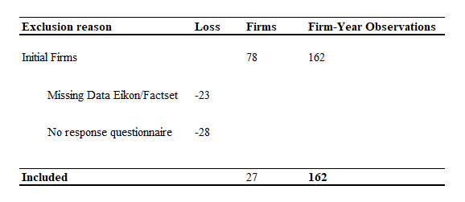

Next, the descriptive statistics will be presented for the data which is included in the model. Table 5 presents details on the categorical variable, showing the number of observations per subgroup. As can be seen, 44.44% of the observations has implemented ERP with the reason to streamline business processes compared to 33.33% which implemented on more technical grounds and 22.22% with a strategic reason. Competitiveness (reason 3) was never mentioned as main reason to implement the ERP system. The second categorical variable is the year in which ERP was implemented, where the highest percentages are visible in the year 2007 and 2008.
Table 6 shows descriptive data for the continuous variables. Measurement on skewness and kurtosis are included. Kurtosis measures the extreme values on either side of the mean and thus can be used discover outliers (DeCarlo, 1997). Like similar research on ERP and firm performance (Hunton et al., 2003; Brazel & Dang, 2008), all continuous variables are winsorized at upper and lower 1% of the sample distribution.

Table 5 Categorical Data
In this table the number of firm observations per subcategory of the categorical variables are presented. Also, the corresponding percentages per subgroup are shown.
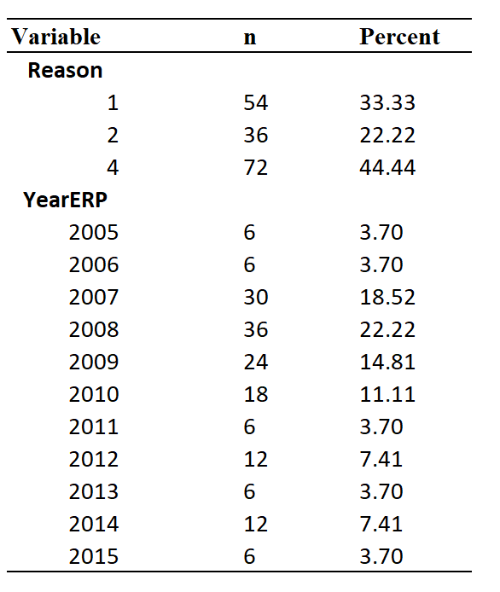
Table 6 Continuous Data
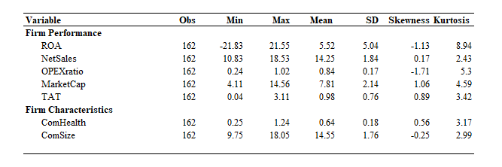
This table presents the sample descriptive statistics for the continuous variables used in the model. (SD equals standard deviation). In all further tables the variable names will be shortened when necessary, a list of abbreviations can be found in in Appendix I. All continuous variables are winsorized at upper and lower 1% of the sample distribution.
Table 7 presents the correlation table. Correlation is a measure of how strongly related two quantitative variables are. A positive correlation means the two variables tend to move together; a negative coefficient means they tend to move in opposite directions. The larger the coefficient the stronger the relationship. Correlation coefficients higher than 0.7 are considered to be strong (Studenmund, 2017). The correlation between Firm Size and NetSales is extremely high (0.782) which is explainable as both measures use Net Sales as source of data. Both variables are not used simultaneously, and ComSize will not be used as a control variable in regressions with NetSales as a dependent variable.
Table 7 Table of Correlations
This table present the correlation coefficients, between the categorical variables in the main model. Note: *p<.05, **p<.01,***P<.001, two tailed, N = 162
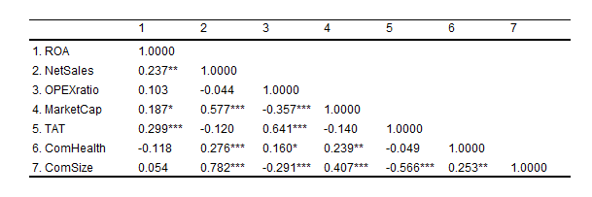

4.2 Primary Outcomes
The results of the regressions are summarized and presented in Tables 8 through 10. Table 8 presents the effect of ERP implementation on firm performance for Dutch Listed firms, using the different proxies for firm performance, and is related to hypothesis 1. Table 9 looks at the intraclass correlation and answers how much of the variance in firm performance is explained by including the reason to adopt. These results contribute to answering hypothesis 2. Finally, Table 10 shows the results of the regressions while including interaction effects based on the explorative section of my literature review. It examines the impact of ERP implementation on firm performance for the different motivations along the performance measures that fit those reasons for adopting the ERP. These results correlate to hypothesis 3a until 3d.
In Table 8 the effect of the implementation of an ERP system on firm performance is being analysed by doing a panel data regression with fixed effects for years. Significant and positive results can be found on the proxies ROA, NetSales and TAT which indicates that the implementation of ERP is value enhancing for Dutch listed firms resulting in acceptance of the first hypothesis. With regards to ROA the results indicate that for firms implementing ERP, ceteris paribus, ROA will increase with 2. Interpretation for NetSales is different as the value of NetSales used in the regression was the natural log (ln) of NetSales. This means the coefficient of NetSales in the regression results (0.082) indicates that the NetSales will increase with 8% when firms implement ERP. In addition, the control variable ComHealth shows significant results in 4 out of 5 regressions, varying from significance on 1% level to 5% level. In addition to the panel regression of Table 8, a panel regression clustering approach has been used to check for clustering in the number of observations. This method classifies individuals into clusters. In this instance we checked for industry clusters, so that within each industry cluster, the slope parameters are homogeneous, and all intra-cluster heterogeneity (variance) is due to the standard two-way error component structure. The clusters are heterogeneous because they do not share the common parameters. This model is useful for exploring heterogeneity in the slope parameters because no prior knowledge about the industry parameter structure is presence. When the residuals correlate the number of independent observations decrease which results in a higher standard error and a lower T-Value and thus lower significance of the coefficient. The effect of this cluster regression results in a higher p-value (decreased significance) for the proxy ROA and TAT (Appendix C). This implicates that clusters of observations exist which Stata corrects for in the number of observations leading to higher standard errors and a lower T-value. Even though this cluster-regression influences the significance of the dependent variables, an important side note must be made. Stata must calculate the level of correlation between the independent observations and given the limited number of observations this dataset provides this estimate becomes very inaccurate. Therefore, the OLS results shown in Table 8 will be used for further analysis.
Table 9 involves assessing the relevance of the different reasons to implement ERP (technical, strategy, competitiveness, and business process) in explaining the variance in firm performance. For this purpose, a variance components analysis is used. The total variation in firm-performance is decomposed in a between-reasons component and a within-specific reason-groups component. This decomposition enables testing of the hypothesis that there are (statistically) significant differences in firm performance between reasons to adopt within ERP implementations. Absent significant results indicate there is little reason to consider and include reasons for ERP implementation as this variable would not add much to existing literature in explaining the effect of an ERP system implementation on firm performance. The results show statistically significant coefficients for all 5 measures of firm performance, ranging between 1% and 11% heterogeneity between reasons to adopt. This indicates that, e.g. using MarketCap as proxy for firm performance, 11% of the variance can be explained by including the reason to adopt ERP, 89% of the variance in firm performance can be found within the specific reason-groups. Hypothesis 2 can be accepted, and thus the reason to implement an ERP system exhibits significant differences in firm performance. Including this variable as a contextual factor in explaining differences in post-implementation firm performance has proven to be valuable.
Table 10 shows how this contextual variable moderates the relation between ERP and the firm performance proxies consistent with the reasons to implement, based on the performance-benefits framework presented in Table 3. This means that regressions are run per implementation reason and combined with the financial parameter where improvement is expected. An interaction term is created that interact both ERP (assigned with a “1” in the years following the ERP implementation) and the reason of implementation which is a dummy coding variable because it compares each level of a variable (each reason) to a reference category. The outcomes indicate a significant positive result for NetSales when the ERP was implemented with a strategic motivation. The effect of the ERP on Net Sales, while including this strategic motivation, would be: 2.8% + 15.4%*1(=Strategy). This means the effect of the ERP implementation on NetSales increases with 15.4% to 18.2% for firms that implemented based on this rationale. Hypothesis 3b can be partly accepted, as only revenue shows a positive effect because market value is positive (2.5%) but insignificant. Another significant, but negative, interaction term can be found when firms implement ERP out of a business process rationale with total assets turnover (TAT) as dependent variable showing firm performance in terms of productivity. This result indicates that for those firms their productivity ratio TAT will decrease with 7% after ERP implementation. Although the results are significant, the direction of the coefficient is not what was expected and therefore hypothesis 3d is rejected. Hypothesis 3c has not been tested as the sample-firms did not indicate to have implemented ERP out of competitiveness arguments. In addition, the results regarding hypothesis 3a were insignificant and no prove has been found that firms who implement ERP with the aim to replace their legacy system, costs have dropped as the coefficient is positive instead of negative.
What can be learned from the study of Chapman & Kihn (2009) is to not forget testing relationships between variables which are not expected based on extended literature review. This can be seen as explorative as it is conducted to have a better understanding of the existing problem without providing conclusive results. To make sure no important significant relations were missed, hypothesis 4 is formulated which expects to find higher firm performance only in the performance dimensions formulated in Table 3. This hypothesis allows for testing the proxies of firm performance which do not correspondent to the reason of implementation as formulated in Table 3. Table 12 shows that when using ROA as dependent variable the interaction term is significant and positive when companies implement ERP based on technical grounds. In addition, the interaction term ERP*BusinessProcess is significant when NetSales is used as variable for firm performance but the coefficient shows a negative number indicating lower financial performance instead of increased financial performance as stated in hypothesis 4.

Table 8 Regression Results Relationship ERP and Firm Performance
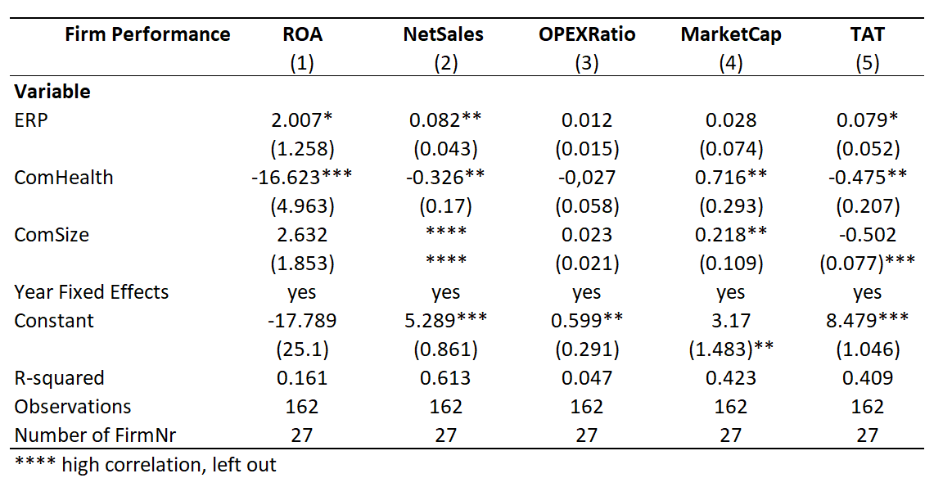
This table present the results on the ERP-Firm Performance relationship. This model uses 5 proxies of firm performance, ROA – NetSales – OpexRatio – MarketCap and TAT. Fixed effects for years were included (signified by yes) but not presented in the table as those results do not add to the discussion. Coefficients are presented in the table with standard errors in parenthesis below. Superscripts***, ** and * indicate the levels of significance at the 1%, 5% and 10% respectively.
Table 9 Regression Results Intraclass Correlation (ICC)
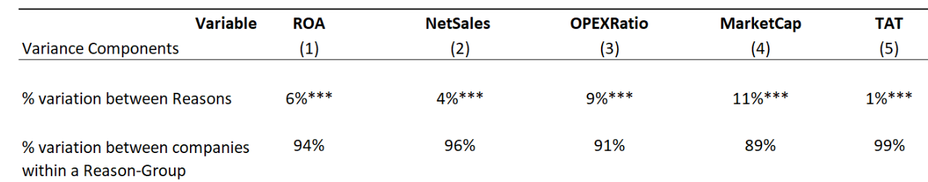
This table present the results on the variance components analysis. This model uses 5 proxies of firm performance, ROA – NetSales – OpexRatio – MarketCap and TAT. Percentages are presented in the table and superscripts***, ** and * indicate the levels of significance at the 1%, 5% and 10% respectively.

Table 10 ERP and firm performance modified by the reason to adopt => Expected Directions
This table present the results on the ERP-Firm Performance relationship modified by the different reasons to adopt. This model uses 5 proxies of firm performance, ROA – NetSales – OpexRatio – MarketCap and TAT. Fixed effects for years were included (signified by yes) but not presented in the table as those results do not add to the discussion. Coefficients are presented in the table with standard errors in parenthesis below. Superscripts***, ** and * indicate the levels of significance at the 1%, 5% and 10% respectively.
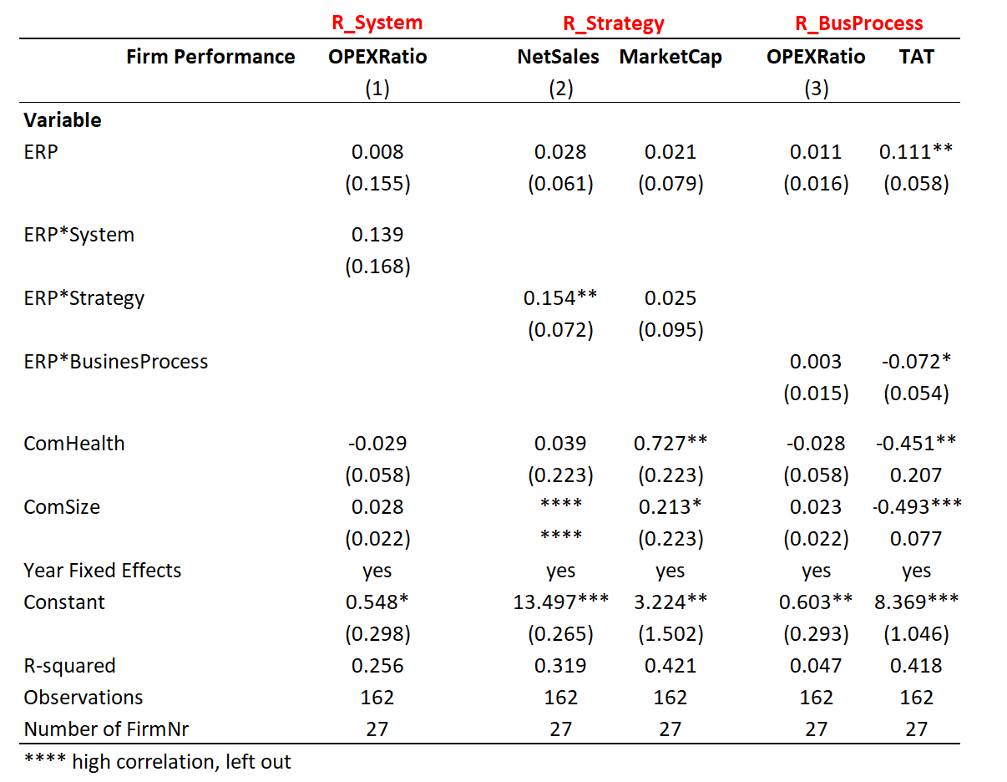

Table 11 ERP and firm performance modified by the reason to adopt => Unexpected Directions
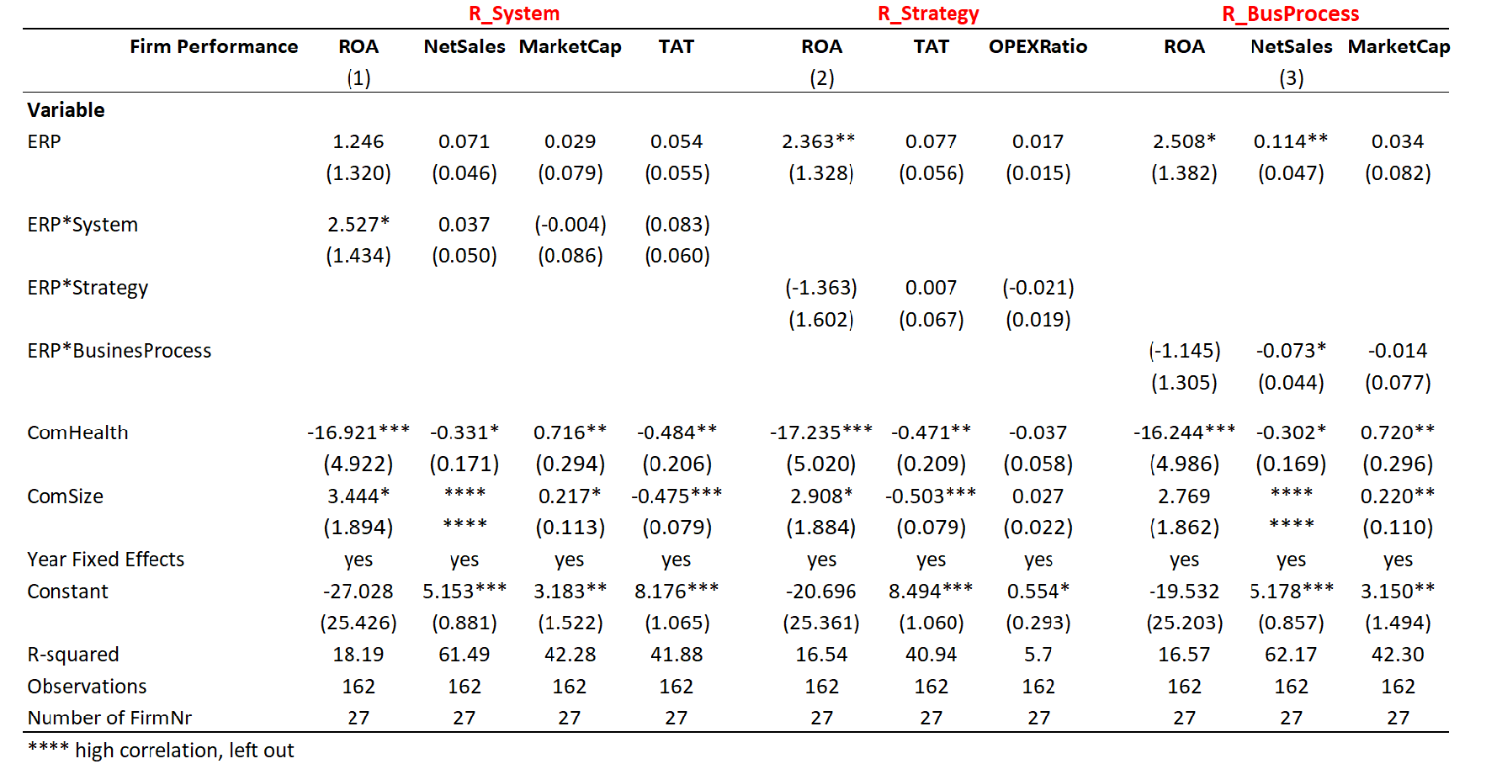
This table present the results on the ERP-Firm Performance relationship modified by the different reasons to adopt. This model uses 5 proxies of firm performance, ROA – NetSales – OpexRatio – MarketCap and TAT. Fixed effects for years were included (signified by yes) but not presented in the table as those results do not add to the discussion. Coefficients are presented in the table with standard errors in parenthesis below. Superscripts***, ** and * indicate the levels of significance at the 1%, 5% and 10% respectively.

Conclusion, limitations, and future research
Based on a sample of 27 Dutch listed firms which have implemented ERP in the last decennia, research was conducted on the influence of a mediating factor on the impact of ERP system implementation on organizational performance. This mediating factor was retrieved after extensive literature review on the relationship between ERP system implementation and firm performance. Contemporary accounting research on this relationship does not all point towards improved organizational performance, something which is expected based upon the huge investments’ companies make. Research on this phenomenon evolved and contextual factors which mediate the relationship between ERP and firm performance have been incorporated. This research builds upon this development. Based upon literature review with an explorative nature, the contextual factor “reason to adopt” has become the central theme in this study. The formation of hypothesis development was a gradual process. The hypothesis formulation has a funnel-shaped character because it begins broad with the first hypothesis and on the basis of extensive literature it leads you step by step to the very narrow point of the thesis, the hypothesis where the reason to adopt is included with very specific performance outcome measures. It is hypothesized that investments in ERP are associated with higher firm performance only along the dimensions consistent with the motivation of the implementation. Those are translated into 4 hypotheses, which can be found in section 2.6. All hypothesized relationships are examined by using a survey in the form of an email questionnaire which was employed to retrieve the intentional reason to implement the ERP system and the year of implementation. The data on organizational performance, organizational size and financial health was obtained from a secondary source, namely Eikon and FactSet.

Answer to research question
After collecting the data, several panel regressions are employed to analyse this data and provide an answer to the research question addressed in this study. The research question was formulated as follows:
“To what extend does the reason to adopt an ERP system moderate the relationship
between ERP implementation and firm performance?”
The results of the first panel data regression indicate that while including a post-implementation time horizon of 4 years, the effect of an ERP implementation on firm-performance is positive and significant on the proxies Return on Assets (ROA), Revenue (NetSales) and Productivity (TAT). This confirms the valid comment made by Poston and Grabski (2000) and Hunton et al. (2003), that a minimum of a four-year longitudinal study is needed in order to see the full impact of the ERP implementation on organizational performance. Especially the performance impact on net sales and market value needs a longer time span to become visible as improved net sales and market valuation might stem from strategic changes and those do not yield an immediate return. Moreover, following the studies of Leyh (2015) and Bradford (2015) who have qualitatively (case studies and questionnaires) researched the different grounds upon which companies implement an ERP system, this study builds on this direction quantitively. The results related to the second hypothesis underlines the importance of including the reason to adopt as significant differences in firm performance between the reasons to implement are found. Those differences, dependent on the firm performance proxy, vary between 1% and 11% with the latter related to MarketCap. Hypotheses 3a until 3d show some positive and significant effects on how the contextual factor influences the relationship between implementing an ERP and the performance of the firm. This means that it is proven that companies do increase their performance as a result of the ERP implementation, but it is crucial to first understand the reason and the goal of the company’s implementation and subsequently which financial parameters the improved performance is expected. ERP implementation based on strategic and business process rationale seems to have the strongest links with improvement in firm performance. Thus, the answer to the research question is that reason to adopt has proven to be an important contextual factor to include as it significantly explains the variance in firm performance between the different reasons and secondly, it strengthens the relationship between ERP implementation and firm performance when the implementation has been executed based on strategic motivations or based on streamlining of business processes. Hypothesis 4 was used to test for unexpected relationships between the reasons to adopt and firm performance proxies (not hypothesized under 3). Those regression results are captured in Table 13 and indicated that when ERP is implemented based on technical grounds, the coefficient firm performance in terms of ROA is positive. This means that profitability is positively affected, which was not expected based on the literature.
Table 12 Results Hypotheses 1, 2 and 3
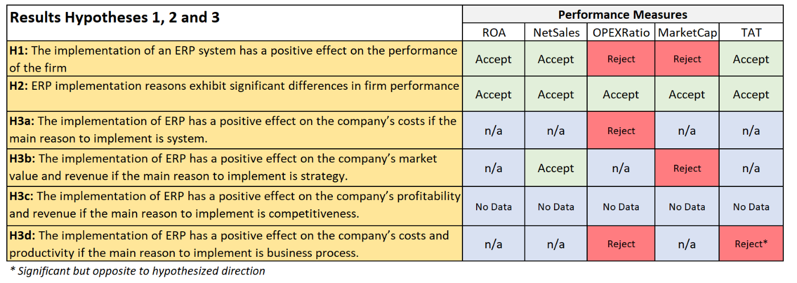
“Accept” represents a significant coefficient in the direction stated as in the hypothesis, on a significance level of either 1%, 5% or 10%. The cells which show ”n/a” have not been tested on this particular combination, as this was not hypothesized.

Table 13 Results Hypothesis 4
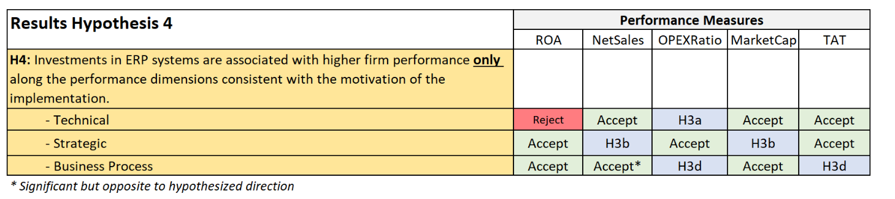
“Accept” represents NO significant coefficient in the direction stated in hypothesis 3, on a significance level of either 1%, 5% or 10%.

5.2 Implications of findings
The findings of this study can have interesting implications for ERP research, but also for practice as ERP implementations and the process of decisions making can be improved. Based on the findings, key-players and key-stakeholders can be better managed upfront as this study provides information on expected performance benefits that ERP implementation comprise.
The first implication of the results of this study show that a longer time frame (4-years post-implementation) indeed show positive and significant effects on 3 out of 5 proxies representing the firms’ financial performance. This study examines the effect of the adoption of an ERP on a firm’s long-term operational performance. Corresponding to long-term is the fact that these systems influence a firm’s performance over a long-term time horizon. Given the nature of ERP investments, their expected benefits cannot be observed in a short period of time. What can be learned from previous studies (Poston & Grabski, 2001; Chapman & Kihn, 2009) is that companies should have used their ERP system for long enough time to realize financial performance returns.
Secondly, based on the literature review one of the main reasons why companies implement ERP was said to be competitiveness. However, the input received through the questionnaire does not confirm this inside as not one of the 27 companies in the sample acknowledged this to be the main reason of their ERP implementation. According to Vilpola (2008) the reasons why companies implement ERP vary between replacing old inadequate systems to organisational changes in order to improve efficiency. An explanation for the fact that competitiveness has not been mentioned as main reason could be that a lot of ERP modules like customer relationship management (CRM), sales, and planning systems are add-on solutions which most frequently are not implemented from the start. Especially those modules give companies the complete set of tools to not only better manage operations and streamline their internal processes but to improve competitiveness through data integration and other all-inclusive solutions which enhance competitiveness. The questionnaire explicitly asked for information about the company’s first acquaintance with ERP where it may be assumed that add-on solutions are most often not implemented from scratch. Although competitiveness does not seem to be a driver to implement ERP, this research does demonstrate that including the reason to adopt as contextual factor moderating the relationship between an ERP system and firm financial performance has proven to be valid. Differences in firm performance can be explained by the company’s rationale upon which the ERP system has been materialized and is an excellent starting point to shed light on the ambiguous results concerning the relation between ERP system implementation and firm performance.
Thirdly, support for the positive and significant effect on different proxies of firm performance when including the reason of the implementation indicates that ERP implementations are not homogenous in this regard as assumed in previous research (Poston & Grabski, 2001; Chapman & Kihn, 2009). What can be concluded is that ERP implementations vary in terms of effect on firm performance depending on the motives of implementation which are positioned on the technical-strategic continuum. That is, when ERP is implemented with the aim to improve their strategic position, post-implementation performance on NetSales is significantly higher compared to NetSales in case the ERP implementation was conducted based on other motives. The same applies to TAT when ERP is implemented with the goal to streamline business processes. These findings may have important implications for research about ERP and performance effects as it is argued that perceiving implementation heterogeneity from this perspective may be essential in improving the understanding of performance enhancements from ERP implementations (Davenport, 2000). In addition, although certainly not all proxies show significant results in line with the hypotheses, ROA turns out to be a strong measure of firm performance with positive coefficient in the regressions linked to hypothesis 1, 2 and 4. As improvements in ROA can reflect both sales growth, reduced assets costs as well as reduced expenses, it seems valid that the post-ERP implementation increase in ROA can appear for all companies, regardless of their implementation reason.
The final implication comes from the reported findings of a negative and significant impact of the implementation of ERP on organisational financial performance in relation to two proxies when the rationale behind the implementation is to streamline the business processes. The measures of firm performance which show negative and significant results are TAT (Table 10) and NetSales (Table 11). Noteworthy about the results reflecting the business process implementation is that 4 out of 5 coefficients from the interaction terms have a negative sign. It was expected that investment in information technology facilitates the practice of streamlining processes and according to Shang & Seddon (2002) implementing an ERP system is expected to cut costs and increase output by automating (repetitive) operations. As the results of this research indicate the latter may not be true, it is relevant to present an interpretation of this counterintuitive effect. An explanation of those unexpected results can be rooted in the fact that ERP requires effective business processes and especially those companies that implement ERP with the goal to streamline those, most often need more than only implementing an ERP solution. ERP requires effective business processes and in case they are not available, business process reengineering (BPR) is needed to ensure they are in line with the requirements prescribed by the ERP tool. So, it is safe to assume that BPR and ERP in some cases go hand-in-hand. This depends on how well the current processes fit the new ERP system and what is needed to fit the current processes in the system. The same ambiguity regarding the effect of ERP implementation on organizational performance applies for BPR and organizational performance. According to Al-Mashari (2001), BPR and firm performance are positively correlated because when business operations are redesigned and effectively performance then the performance will also enhance. On the other hand, Lotfollah, Ziaul, Seyed & Saeedreza (2012) briefed that BPR implementation has a negative effect on organizational performance because companies always encounter problems in running the business after extensive process redesign. Even though BPR was not in the scope of this study, a possible implication for this finding is that companies who implement ERP based on business process grounds might have opted for BPR bundled with the ERP package which together could potentially have an even more disruptive effect on firm performance.

5.3 Limitations
Prudence is called for regarding the generalization of the results of this study as the limitations of this study may affect generalizability. The first important limitation to be mentioned, and despite the fact some significant results are found in this study, the sample size of 27 firms is relatively small compared to other studies that cover the same topic. Poston and Grabski (2001) and Hunton et al. (2003) obtained sample sizes of 49 and 63, respectively. The main problem with a small sample size is interpretation of the results, grounded in the fact that small studies can provide results quickly, but they do not always yield reliable or precise estimates. Therefore, strong conclusions drawn from this study should not be made, instead the data from this study should be used to design larger confirmatory studies, for example a replicatory study to ‘test’ whether the research hypothesis holds true while using a similar methodology but a bigger sample.
The second limitation is the possibility of reverse causality. According to Katz (2006), identifying reverse causality is sometimes a matter of common sense. Reversed causality means that two variables are associated but not in the way you would expect. This means that the independent variable ERP implementation does not cause the dependent variable firm performance to change, but the performance of the firm causes the firm to implement an ERP system. Given the fact that an ERP investment in associated with investing a large amount of money, a financially healthy and growing company experiences a better financial position upfront which distorts the post-implementation financial performance picture. A method of instrumental variables (IV’s) is a general approach to the estimation of causal relations using observational data. Given the limited scope and timeframe of this study, this has not been applied in the regression estimates leaving a problem of potential endogeneity. The third limitation links to the concept of validity and to the qualitative part of this study: the questionnaire. The practice of pretesting is highly regarded as an effective technique for improving validity in qualitative data collection procedures and the interpretations of findings (Collins 2003; Brown, Lindenberger & Bryant 2008). Pretesting involves simulating the formal data collection process on a small scale to identify problems related to data-collection instruments, sessions, and methodology. In this study pretesting the questionnaire could have positively contributed to the validity of the research as it could have provided an opportunity to revise the questions to ensure that appropriate questions are being asked and the questions are clearly understood and interpreted. Due to the small sample size and time constraints this pre-test has not taken place.
Finally, and with any empirical study, a comment regarding generalizability or external validity should be made. The first argument relates to the fact that only Dutch companies are sampled. In general, the larger and more divers the population the more one can generalize the results. Secondly, selection bias affects the validity and generalizability of the results as because survey respondents could decide entirely for themselves whether or not they want to participate. Self-selection will lead to biased data as the respondents who choose to participate will not well represent the entire target population.

5.4 Future research
Based on the findings of this study, recommendations regarding future research are provided in the next section. In line with the future research areas mentioned in the paper of Grabski, Leech & Schimdt (2011), the inter-organizational benefits of ERP and more specifically the financial benefits remain a research area that requires attention. This research has shown, although one should take the limitations about generalizations into consideration, that the reason to adopt is an important contextual factor that may help explain the strength and direction of the ERP implementation impact on the financial performance of the firm. The four included implementations reasons, all positioned on the technical-strategic continuum have been validated in the field (Markus & Tanus, 2000). Nevertheless, a different methodological approach is advised in order to better understand where on the continuum the ERP system implementation reason can be positioned. To better grasp the essence of construct, multidimensional indicators can be used to represent the different reasons of implementation. Based on the answers, which should have a quantitative measure e.g., a seven-point Likert-scale, an index can be created (Diamantopoulus and Winklhofer, 2001) to quantify the rationale behind the ERP system adoption on the technical-strategic continuum. This, contrary to the zero-one dummy variable approach used in this research, which does not allow for nuanced meaning. Important to note is that quite some attention should be paid to the design of the questionnaire, including pre-testing as it helps to assess the quality of a questionnaire. One of the critical observations on survey research within accounting is the lack of pre-testing (Van der Stede et al., 2005). This pre-testing establishes validity whereas reliability in this instance can be anticipated by using multiple questions to measure a single construct.
A final comment on the overarching research area of ERP implementation and financial performance must be made. Grounded on the findings of this study that zero firms implemented ERP based on competitiveness arguments, extensive literature review and conversations with experts in the field, future research should focus more on how the implementation of ERP enables companies to improve their financial performance instead of focussing solely on the direct relation between ERP and financial benefits that stem from this ERP. Research on ERP and firm performance focusses on implementation of the “core” ERP, which comprises installing the software, integrating different business functions and processes, and working with real time data. The lack of conclusive evidence leaves room for further thinking. A potentially interesting line of thought is that implementing ERP is seen as a precondition for success instead of believing that implementing the core ERP results in increased financial performance. Add-on modules like CRM and Sales, but also the concept of digitization, are expected to increase financial performance in which implementing the core ERP only has an enabling function. It is expected that more ERP-modules is associated with higher revenue and market valuation. This statement calls for further research.

References

Al‐Mashari, M. (2001). Process orientation through enterprise resource planning (ERP): a review of critical issues. Knowledge and Process Management, 8(3), 175-185.
Ali, I., van Groenendaal, W. J. H., & Weigand, H. (2020). Enterprise Resource Planning Systems Implementation and Firm Performance: An Empirical Study. Journal of Information Systems Engineering and Management, 5(1).
Aral, S., & Weill, P. (2007). IT assets, organizational capabilities, and firm performance: How resource allocations and organizational differences explain performance variation. Organization science, 18(5), 763-780.
Bharadwaj, A. S., Bharadwaj, S. G., & Konsynski, B. R. (1999). Information technology effects on firm performance as measured by Tobin's q. Management science, 45(7), 1008-1024.
Bloomfield, R. J. (2015). Rethinking managerial reporting. Journal of Management Accounting Research, 27(1), 139-150.
Booth, P., Matolcsy, Z., & Wieder, B. (2000). The impacts of enterprise resource planning systems on accounting practice–the Australian experience. Australian Accounting Review, 10(22), 4-18.
Botta-Genoulaz, V., & Millet, P. A. (2006). An investigation into the use of ERP systems in the service sector. International journal of production economics, 99(1-2), 202-221.
Brown KM, Lindenberger JH, Bryant CA. Using pretesting to ensure your messages and materials are on strategy. Health Promotion Practice. 2008;9:116–122.
Bradford, M. (2015). Modern ERP: Select, Implement, and Use Today’s Advanced Business Systems. Lulu.com.
Bradford, M., & Florin, J. (2003). Examining the role of innovation diffusion factors on the implementation success of enterprise resource planning systems. International journal of accounting information systems, 4(3), 205-225.
Bradley, J. (2008). Management based critical success factors in the implementation of enterprise resource planning systems. International Journal of Accounting Information Systems, 9(3), 175-200.
Brakely, H. (1999). What makes ERP effective?. Manufacturing Systems (MSI), 17(3), 120
Brazel, J. F., & Dang, L. (2008). The effect of ERP system implementations on the management of earnings and earnings release dates. Journal of information systems, 22(2), 1-21.
Brynjolfsson, E., & Hitt, L. (1996). Paradox lost? Firm-level evidence on the returns to information systems spending. Management science, 42(4), 541-558.
Brynjolfsson, E., & Hitt, L. M. (1998). Beyond the productivity paradox. Communications of the ACM, 41(8), 49-55.
Carter, D. A., D'Souza, F., Simkins, B. J., & Simpson, W. G. (2010). The gender and ethnic diversity of US boards and board committees and firm financial performance. Corporate Governance: An International Review, 18(5), 396-414.
Chapman, C. S., & Kihn, L. A. (2009). Information system integration, enabling control and performance. Accounting, organizations and society, 34(2), 151-169.
Chand, D., Hachey, G., Hunton, J., Owhoso, V., & Vasudevan, S. (2005). A balanced scorecard based framework for assessing the strategic impacts of ERP systems. Computers in industry, 56(6), 558-572.
Chang, M., W. Cheung, C. Cheng, and J. H. Y. Yeung. 2008. Understanding ERP system adoption from the user’s perspective. International Journal of Production Economics 113 (2): 928–942.
Chen, S., Elbashir, M., Peng, X., & Zhu, D. (2016). The effect of ERP systems competences on business process and organizational performance. International Journal of Management Theory and Practices, 17(1), 5-35.
Chua, W. F. (1986). Radical developments in accounting thought. Accounting review, 601-632.
Collins D. Pretesting survey instruments: An overview of cognitive methods. Quality of Life Research. 2003;12:229–238.
Davenport, T. H. (1998). Putting the enterprise into the enterprise system. Harvard business review, 76(4).
Davenport, T. H. (2000). Mission critical: realizing the promise of enterprise systems. Harvard Business Press.
DeCarlo, L. T. (1997). On the Meaning and Use of Kurtosis. Psychological Methods, 2(3), 292-307.
Dehning, B., & Richardson, V. J. (2002). Returns on investments in information technology: A research synthesis. Journal of information systems, 16(1), 7-30.
Galy, E., & Sauceda, M. J. (2014). Post-implementation practices of ERP systems and their relationship to financial performance. Information & Management, 51(3), 310-319.
Goeke, R. J., & Faley, R. H. (2009). Technical opinion Do SAP successes outperform themselves and their competitors?. Communications of the ACM, 52(10), 113-117.
Grabski, S. V., Leech, S. A., & Schmidt, P. J. (2011). A review of ERP research: A future agenda for accounting information systems. Journal of information systems, 25(1), 37-78.
Granlund, M., & Malmi, T. (2002). Moderate impact of ERPS on management accounting: a lag or permanent outcome? Management accounting research, 13(3), 299-321.
Hayes, D. C., J. E. Hunton, and J. L. Reck. 2001. Market reactions to ERP implementation announcements. Journal of Information Systems 15 (1): 3–18.
Hayes, D. C., Hunton, J. E., & Reck, J. L. (2001). Market reaction to ERP implementation announcements. Journal of Information systems, 15(1), 3-18.
Heale, R., & Twycross, A. (2015). Validity and reliability in quantitative studies. Evidence-based nursing, 18(3), 66-67.
Hicks, D. A., & Stecke, K. E. (1995). The ERP maze: enterprise resource planning and other production and inventory control software. IIE solutions, 27(8), 12-17.
Hitt, L. M., Wu, D. J., & Zhou, X. (2002). Investment in enterprise resource planning: Business impact and productivity measures. Journal of management information systems, 19(1), 71-98.
Hong, K. K., and Y. G. Kim. 2002. The critical success factors for ERP implementation: An organizational ﬁt perspective. Information & Management 40 (1) 25–40.
Hunton, J. E., Lippincott, B., & Reck, J. L. (2003). Enterprise resource planning systems: comparing firm performance of adopters and nonadopters. International Journal of Accounting information systems, 4(3), 165-184.
Irani, Z., Sharif, A.M. & Love, P.E.D. (2001) Transforming failure into success through organisational learning: an analysis of a manufacturing information system. European Journal of Information Systems, 10, 55–66.
Kallunki, J. P., Laitinen, E. K., & Silvola, H. (2011). Impact of enterprise resource planning systems on management control systems and firm performance. International Journal of Accounting Information Systems, 12(1), 20-39.
Katz, M. (2006). Study design and statistical analysis: a practical guide for clinicians. Cambridge University Press.
Ke, W., & Wei, K. K. (2008). Organizational culture and leadership in ERP implementation. Decision support systems, 45(2), 208-218.
Koch, M. J., & McGrath, R. G. (1996). Improving labor productivity: Human resource management policies do matter. Strategic management journal, 17(5), 335-354.
Kremers, M., & Van Dissel, H. (2000). Enterprise resource planning: ERP system migrations. Communications of the ACM, 43(4), 53-56.
Kumar, K. & Van Hillegersberg, J. (2000). ERP experiences and evolution. Communications of the ACM, 43, 23-26.
Laudon, K. C., & Laudon, J. P. (2004). Managing the digital firm. Managing Information Systems, 197-200.
Laudon, K & Loudon, J, 2006. “Management Information Systems: managing the digital firm”, ninth edition, Prentice hall.
Leyh, C. (2011). Why do companies implement ERP systems? The goals and reasons behind ERP implementation projects. Readings on enterprise resource planning, 19-35.
Libby, R. 1981. Accounting and Human Information Processing: Theory and Applications. Prentice Hall.
Lotfollah, N., Ziaul, H., Seyed, M. A., & Saeedreza, H. (2012). Impact of IT on process improvement. Journal of emerging trends in computing and information sciences. 3,(1).
O’Brien, J. A. (2002). Management Information Systems: Managing Information Technology in the E-business Enterpresie (5 edn.: McGraw-Hill Higher Education).
O'Leary, D. E. (2004). Enterprise resource planning (ERP) systems: an empirical analysis of benefits. Journal of emerging Technologies in Accounting, 1(1), 63-72.
Mabert, V. A., Soni, A., & Venkataramanan, M. A. (2000). Enterprise resource planning survey of US manufacturing firms. Production and Inventory Management Journal, 41(2), 52.
Mandal, P., & Gunasekaran, A. (2003). Issues in implementing ERP: A case study. European Journal of Operational Research, 146(2), 274-283.
Markus, M. L., Axline, S., Petrie, D., & Tanis, S. C. (2000). Learning from adopters' experiences with ERP: problems encountered, and success achieved. Journal of information technology, 15(4), 245-265.
Markus, M. L., & Tanis, C. (2000). The enterprise systems experience-from adoption to success. Framing the domains of IT research: Glimpsing the future through the past, 173(2000), 207-173.
Muscatello, J. R., Small, M. H., & Chen, I. J. (2003). Implementing enterprise resource planning (ERP) systems in small and midsize manufacturing firms. International Journal of Operations & Production Management.
Naveed, R. T., Ahmad, N., & Ahmad, S. (2016). Attainment of Competitive Advantage through ERP and Procurement. Arabian Journal of Business and Management Review (Oman Chapter), 6(3), 37.
Nicolaou, A. I. (2004). Firm performance effects in relation to the implementation and use of enterprise resource planning systems. Journal of information systems, 18(2), 79-105.
Nicolaou, A. I., & Bajor, L. H. (2004). ERP systems implementation and firm performance. Review of Business Information Systems (RBIS), 8(1), 53-60.
Peterson, W.J., L. Gelman and D.P. Cooke. 2001. “ERP Trends”, New York, NY: The Conference Board; Report 1292-01-R
Polit, D. F., & Beck, C. T. (2010). Generalization in quantitative and qualitative research: Myths and strategies. International journal of nursing studies, 47(11), 1451-1458.
Poston, R., and S. Grabski. 2001. Financial impacts of enterprise resource planning implementations. International Journal of Accounting Information Systems 2: 271–294.
Quattrone, P., & Hopper, T. (2005). A ‘time–space odyssey’: management control systems in two multinational organisations. Accounting, organizations and society, 30(7-8), 735-764.
Rikhardsson, P., & Kræmmergaard, P. (2006). Identifying the impacts of enterprise system implementation and use: Examples from Denmark. International Journal of Accounting Information Systems, 7(1), 36-49.
Ross, J. W. (1999). Surprising facts about implementing ERP. IT professional, 1(4), 65-68.
Salimi, F., & Dankbaar, B. (2008). Strategic approaches to ERP implementation. Journal of International Technology and Information Management, 17(1), 1.
Scapens, R. W., and M. Jazayeri. 2003. ERP systems and management accounting change: Opportunities or impacts? A research note. European Accounting Review 12 1: 201–233.
Scott, J. (1999). ERP Effectiveness in the Classroom: Assessing Congruence with Theoretical Learning Models. AMCIS 1999 Proceedings, 274.
Seddon, P.B., Graeser, V. & Willcocks, L. (2002) Measuring organisational IS effectiveness: an overview and update of senior management perspectives. The Database for Advances in Information Systems 33, 11– 28.
Singla, A. R. (2008). IMPACT OF ERP SYSTEMS ON SMALL AND MID SIZED PUBLIC SECTOR ENTERPRISES. Journal of Theoretical & Applied Information Technology, 4(2).
Shang, S., & Seddon, P. B. (2002). Enterprise system benefits: how they should be assessed.
Somers, T. M., and K. G. Nelson. 2001. The impact of critical success factors across the stages of enterprise resource planning implementations. 34thAnnual Hawaii International Conference on System Sciences.
Stephanou, C. J. 2000. The selection process of enterprise resource planning ERPsystems. AMCIS 2000
Studenmund, A. H. (2017). Using Econometrics. Seventh Global Edition. Pearson Education.
Umble, E. J., Haft, R. R., & Umble, M. M. (2003). Enterprise resource planning: Implementation procedures and critical success factors. European journal of operational research, 146(2), 241-257.
Van der Stede, W. A., Young, S. M., & Chen, C. X. (2006). Doing management accounting survey research. Handbooks of management accounting research, 1, 445-478.
Velcu, O. (2007). Exploring the effects of ERP systems on organizational performance. Industrial Management & data systems.
Vilpola, I. H. (2008). A method for improving ERP implementation success by the principles and process of user-centred design. Enterprise Information Systems, 2(1), 47-76.
Weill, P., & Broadbent, M. (1998). Leveraging the new infrastructure: how market leaders capitalize on information technology. Harvard Business Press.
Wier, B., Hunton, J., & HassabElnaby, H. R. (2007). Enterprise resource planning systems and non-financial performance incentives: The joint impact on corporate performance.
Xue, Y., Liang, H., Boulton, W. R., & Snyder, C. A. (2005). ERP implementation failures in China: Case studies with implications for ERP vendors. International journal of production economics, 97(3), 279-295.
Zuboff, S. (1985). Automate/informate: The two faces of intelligent technology. Organizational dynamics, 14(2), 5-18.

Appendix

Appendix A Variable definitions and abbreviations
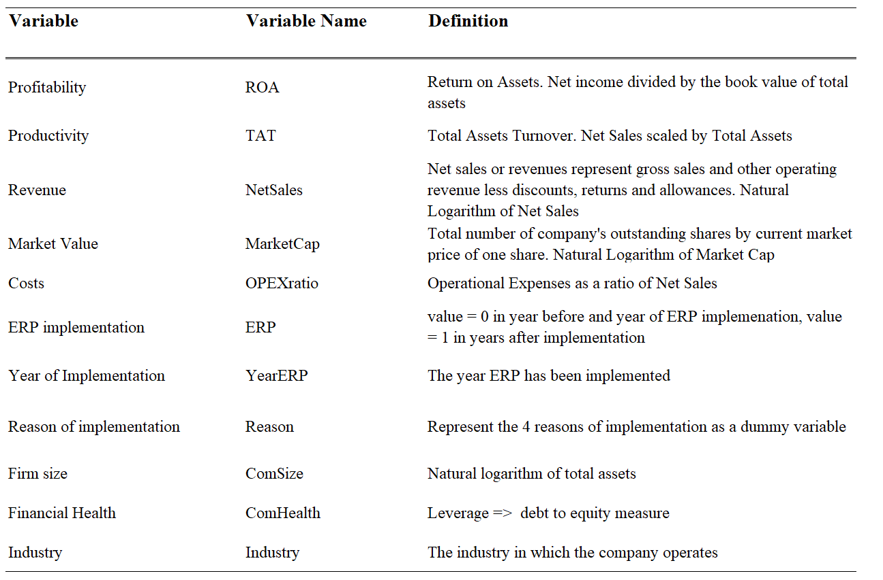

Appendix B Questionnaire

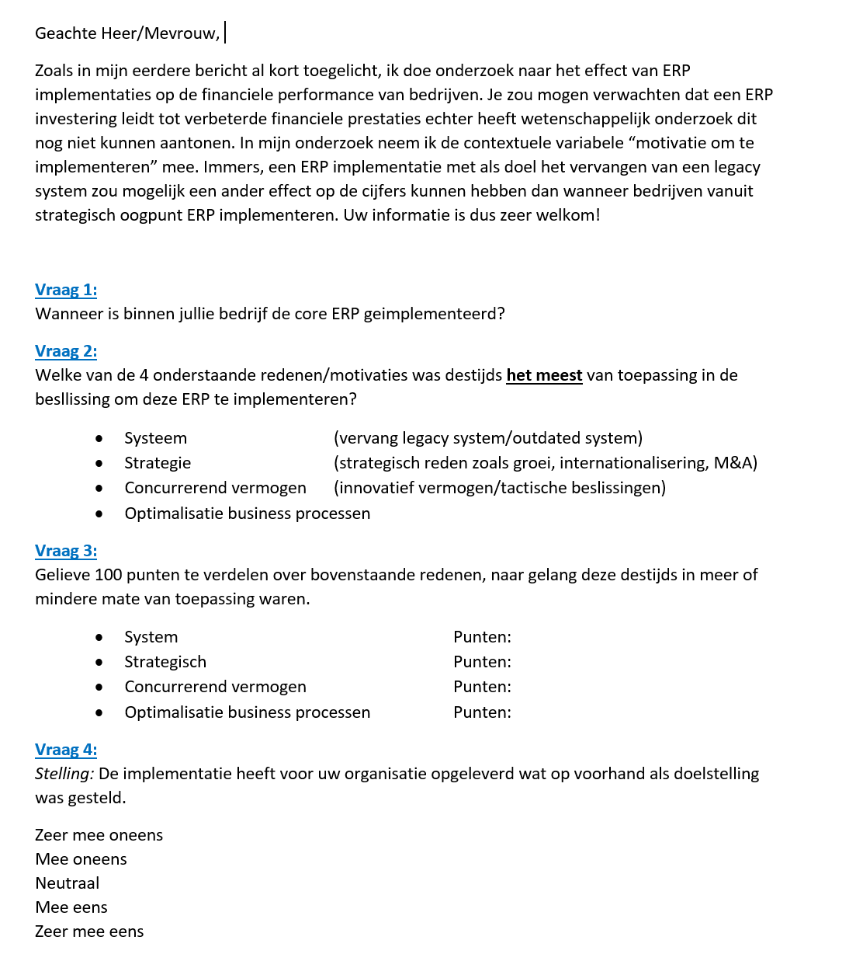

Appendix C Results Industry Cluster
