2017
Joep Gobbens
Radboud University Nijmegen Ministry of Economic Affairs of the Netherlands
2017
Smart Specialisation, from theoretical concept to policy practice


Smart Specialisation, from theoretical concept to policy practice
A qualitative research towards the difference between the theoretical concept and the policy practice of smart specialisation in the Netherlands. This research serves as a master thesis, it is written in collaboration with the Ministry of Economic Affairs of the Netherlands.

Joep Gobbens s4049276
Master Economic Geography
Radboud University of Nijmegen
Ministry of Economic Affairs of the Netherlands
Tutors: Prof. Dr. Arnoud Lagendijk
Dr. Pieter Heringa
July 2017, Nijmegen

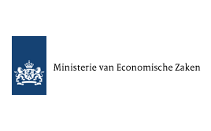

Preface

Before you lies the result of a qualitative research towards smart specialisation. Smart specialisation showcases one of the many attempts by the European Union to improve the economic welfare of regions in the European Union. With smart specialisation comes a concept that is up to date with theoretical ideas about regional innovation policy and takes into account the differences that exist between regions in Europe. It is unique that so many regions drafted an innovation strategy according to the same concept. Smart specialisation offers a chance to study the road a concept undertakes from a whiteboard-concept to a policy practice used in almost every region in the European Union.
This research has been partly undertaken and written during my internship at the Ministry of Economic Affairs of the Netherlands. The Ministry of Economic Affairs is responsible for the European Structural Funds of which smart specialisation strategy is an ex-ante conditionality. In this capacity the Ministry monitors the implementation of the smart specialisation strategy in the regions in the Netherlands. Currently the Ministry is contemplating the role of smart specialisation in the future.
The ministry of Economic Affairs helped me in this research by providing a place to work among a group of very helpful and experienced people. They also offered an extensive network of possible candidates for interviews. I would like to thank all my now ex-colleagues at the Ministry of Economic Affairs on the department Innovation and Knowledge. Special thanks go to my tutor at the Ministry of Economic Affairs Pieter Heringa, whose expertise has been of great value to this reserach, specifically by helping me focus the research in a way that offered useful results for the ministry of Economic Affairs. Finally I would like to thank Arnoud Lagendijk, my tutor from the Radboud University. His guidance was indispensable for this research. Furthermore his willingness to participate in the seminar about regional policy I organized helped me to bring my internship to a meaningful conclusion.

Index

Chapter 1 Introduction 1
1.1 introduction 1
1.2 Research goal 1
1.3 research question 2
1.4 Conceptual model 3
1.5 Methodology 4
1.6 case study 5
Chapter 2 Theoretical framework 7
2.1 Policy rationales 7
2.2 Regional innovation strategies in the Europe Union 8
2.2 Cluster policy 10
2.3 Dilemma's in regional policy 13
2.4 Smart specialisation 15
Chapter 3 Context 23
3.1 National policy in the Netherlands 23
3.2 European policy 24
3.3 The actors 26
3.4 The two Dutch cases 28
4.1 Analysis protocol 32
4.2 Policy rationales 35
4.3 The process of developing a smart specialisation in practice 49
4.4 Effectiveness of smart specialisation 54
Chapter 5 Conclusion 58
Literature 64
Appendix 1: interview guide 67
Appendix 2: table of interviewees 68

Chapter 1 Introduction

1.1 introduction
Knowledge for Growth (K4G), a research group established by the European Union in 2005, explored why Europe was lagging behind on the United states, South-Korea and Japan on economic competitiveness with a focus on research and development. The research group concluded that research investment in Europe was fragmented, lacking in co-ordination between stakeholders and research investment was lacking critical mass. Furthermore they observed a ‘me-too’ syndrome: regions too often invested in fashionable and similar areas such as ICT and nano- and bio-technologies (Midtkandal and Sörvik, 2012). The Knowledge for Growth group urged for structural change. Regions should enable growth of new activities, based on the strength and the potential of that specific region (Midtkandal and Sörvik, 2012). The first observations and recommendations of the Knowledge for Growth expert group were further developed and resulted in a strategy: the Research and Innovation Strategies for Smart Specialisations (RIS3), or simply smart specialisation. In short, smart specialisation focuses on research and innovation in a few selected activities based on a region's specific strength and competitive advantage. ‘It is about specialising in a smart way, i.e. based on evidence and strategic intelligence about a region's assets and the capability to learn what specialisations can be developed in relation to those of other regions’. (EU, 2011, p. 7). Smart specialisation is a relative new concept, based on some of the principles of Regional Innovation Strategies. It does not replace existing regional development policies but adds extra focus on a few promising areas. One of the key elements of smart specialisation is the entrepreneurial discovery process. The goal of this process is to reveal what the most promising areas of innovation are in a region. This is done in a bottom up approach, with regional stakeholders as key figures of the process. Instead of the more traditional, bottom down approach where policy makers make the strategic choices for the region. Policy makers no longer make important decisions but instead have a more facilitation role (Foray, et. al., 2009).
The idea of Smart specialisation was received positively by the European Commission. It offered a new tool for regional development that was in line with the Europe 2020 strategy and its goals of smart, sustainable and inclusive growth. Therefore the development of a smart specialisation strategy became an ex-ante conditionality for regions to acquire funds from the European Funds for Regional Development (EFRD). This prompted almost all European regions to develop a smart specialisation.
However the relative fast transition of smart specialisation from ‘blackwall’ concept to implementation provided problems as conceptual development of the theory were still ongoing while policy makers already started to use this theoretical concept in practice. According to some researchers this resulted in a gap between theoretical development and practical application of the concept (Aranguren and Wilson, 2013). Because of this gap different versions of the same concept appeared to be existing alongside each other. Furthermore the relative short period since the concept of smart specialisation has been introduced means that the effectiveness has yet to been proven.

1.2 Research goal
The concept of smart specialisation has had a surprisingly fast rate of implementation in Europe, thanks to the ex-ante conditionality of the EFRD. However this fast rise of the concept has a drawback, there has been little time to research all aspects of this strategy. Kroll speaks of a rather swift, even hasty manner in which the strategy was adapted by the European Union. ‘[…] leaving little room for the in-depth exploration of the implications of the concept and the diverse potentials that it might harbor and, more importantly, how to articulate and communicate these properly’ (Kroll, p. 1, 2015). The conceptual development of the theory was not yet complete, which leads to difficulties disentangling what was the core of the theoretical concept and what was result of practical orientated policy reasons. In short, the policy and practice are ahead of the theory (Midtkandal, Sörvik, 2012). Eventually both academics and policymakers alike did not have a clear, shared view of what ‘smart specialisation’ actually means. This linear leap from theory to practice without proof of concept has often been criticized (Aranguren and Wilson, 2013).
But also for the practical application of the smart specialisation strategy challenges are recognized (Morgan, 2013). First there is a conceptual challenge, this is the issue mentioned before and will be the central issue in this research. Secondly, there is an operational challenge. The European Commission has come up with 6 step approach to help policymakers design their strategy (EC, 2012). However these steps in itself are cause for problems. ‘Although these steps might look prosaic and simple, in practice every single one of them has the potential to provoke deep divisions, especially in regions where there is little or no tradition of robust public debate’ (Morgan, 2013, p. 105). The third challenge described by Morgan is the political challenge. The multi-level strategy needs to have support from the most important actors in the region. Getting the important actors on the table and creating a setting in which actors are comfortable to share information is a difficulty the government has to face. Furthermore because of the fast implementation of RIS3 there has been little time to see how the new RIS3 policy compares, and fits in with already established policy initiatives (Aranguren and Wilson, 2013).
This research main focus is on the conceptual challenge. The aim of this study is to help bridge the gap between theory and practice by reflecting how the practical application of the concept compares to the theoretical background. This research will make clear if the concept of smart specialisation is being implemented according to ideas and concepts of the theory. This leads to the following research goal:

The goal of this research is to help bridge the gap between the theoretical concept and the policy practice of smart specialisation by analyzing and comparing both their versions of how smart specialisation should be developed.

Since smart specialisation is a concept with a bottom up approach, this research will include all relevant actors and not exclusive (local) governments. This research will help policy makers understand if their version of smart specialisation is the same as is described in theory. At the same time it can also be helpful for theorists to get feedback from the experience of practitioners with the concept of smart specialisation. A research should either focus on a theoretical or a practical problem (Verschuren and Doorewaard, 2007). With this research goal, both seem to be addressed. However, the focus of this research is on a theoretical problem with a strong practical relevance. Meaning that the primary goal of this research will be to answer a theoretical problem. But policy makers on national and European level are already starting to discuss the layout of the new multiannual financial framework (post 2020). One point of discussion will be the role of the smart specialisation concept in the new period. The results of this research will be helpful for this discussion. It will give insight in how well the theoretical ideas of smart specialisation are translated to policy practice. Because of this relevance the research will be conducted in collaboration with the ministry of Economic Affairs of the Netherlands.

1.3 research question
The research goal has been described in the previous paragraph. It is important that realistic goals for the research are set. One important aspect of this is to have a clear focus and demarcation in the research. Not all aspects of the smart specialisation concept can be addressed in one research, therefore this research will focus on the first phase of smart specialisation. This is in theory described as the entrepreneurial discovery process, in which the different actors analyse the strength and weaknesses of their region and develop a strategic plan. Not exclusively the government, but all relevant actors in the region should develop the knowledge and decide what areas in the regions have the potential to grow. The process of entrepreneurial discovery is the basis of the regional development that smart specialisation hopes to achieve. It is also one of the important new elements of regional development when compared to more traditional strategies. The described research goal in combination with the focus on the process of entrepreneurial discovery leads to the main research question:

Are smart specialisation strategies in the Netherlands developed according to the entrepreneurial discovery process that is described in the theory, and is this process and the resulting smart specialisation strategies experienced as beneficial and effective by policy makers and regional actors?

There are a number of research questions that will help to find an answer to the main questions:

- Why and how was the concept of smart specialisation developed?
- What is the theoretical definition of smart specialisation, and particularly the entrepreneurial discovery process?
- Is there any difference in the way that the different levels of governance (EU, national and regional) understand smart specialisation?
- How has the smart specialisation strategy been developed in the two Dutch cases?
- What are the differences between the theoretical idea of entrepreneurial discovery, and how the process of entrepreneurial discovery was implemented in the two Dutch cases?
- How effective is smart specialisation in the cases at dealing with the cluster dilemma’s?

Answering the research question will provide the knowledge that is necessary to address the main research question. The research questions therefore guide the research towards a final conclusion.

1.4 Conceptual model
The conceptual model helps visualize the relation between the different concepts and actors. The research objective of this research is the supposed difference between the theoretic concept of smart specialisation and the policy practice of smart specialisation. All relevant concepts and actors to this research object and their relations can be seen in the conceptual model (figure 1).

Figure1: conceptual model 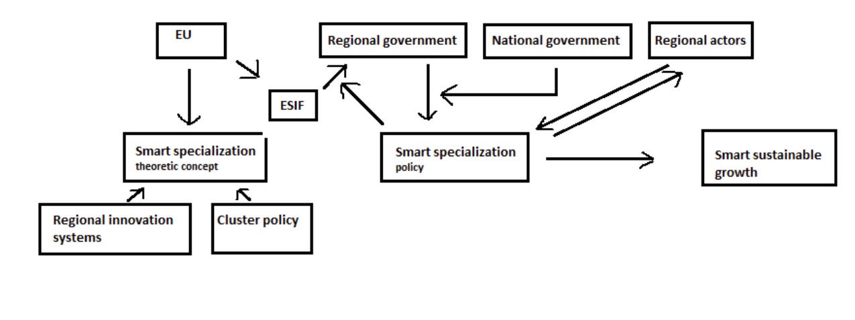

1.5 Methodology
In this paragraph the way in which this research will be executed is explained.

1.5.1 Research strategy
This research will consists of 2 parts. The first part of the research will be more descriptive. A literature research will help create a theoretical framework in chapter 2. Here the reasons and need for smart specialisation will be discussed. Why was smart specialisation necessary, what was wrong with previous regional innovation strategies, how did smart specialisation became in practice so fast, how does smart specialisation fit in with current regional innovation strategies, how exactly is the process of entrepreneurial discovery described by the theory and how is it seen by policy makers are a few examples of the questions that will be discussed in this part. The goal of this part is to create a context of the current state of smart specialisation. Also in this first part of the research the information needed for the analysis will be gathered. This consists of a general overview of the cases, actors and national and European policy related to regional innovation. The second part of this research will be an in-depth analysis focusing on two cases in the Netherlands. This research will take the form of a case study. A case study is a form of qualitative research in which one or multiple case(s) is/are the subject of the study. ‘This qualitative case study is an approach to research that facilitates exploration of a phenomenon within its context using a variety of data sources. This ensures that the issue is not explored through one lens, but rather a variety of lenses which allows for multiple facets of the phenomenon to be revealed and understood’ (Baxter, 2008, p. 544). Focusing on the cases is necessary to research exactly how the theory is used in reality by policy makers, how this relates to the theory, and what the experience of the different actors related to the cases is with the concept.

1.5.2 Research material
Besides a plan for the research strategy, a plan of how to obtain data for this research is also necessary. McCann et al. (2016) noted that when it comes to studying the success, or effectiveness, of a public policy it is important to use both qualitative and quantitative data. ‘when it comes to evaluating the effects of public interventions, and especially where knowledge-related and innovation related issues are at stake, not everything can be even approximately captured by metrics. As such, a mix of quantitative and qualitative indicators is not only the best approach, but without such an approach a quantitative approach alone will produce biased results, as will a qualitative-only approach’ (McCann et al., 2016, p. 549). It is however not the main goal of this research to evaluate the effectiveness of smart specialisation in practice. The focus is on the theoretical debate of smart specialisation and the practical application of the theoretical concept. Evaluation of the efficiency of smart specialisation are needed, but face a number of problems. First, the relative short period since smart specialisation has been introduced means that quantitative data is still hard to get by. Secondly, it is difficult to dissect which changes to regional success or failures are caused by which policy interventions. An evaluation of the effectiveness of smart specialisation strategies is useful and necessary, it will however not be the done in this research. Therefore the need for quantitative data for this research will be relative small. Quantitative data might be used to back up certain assumption made during the research, but it will not be the main focus. The most important data will be qualitative data. Policy documents will serve as a basis. With a desk study relevant policy documents will be gathered and analyses. Further information will be gathered with in-depth interviews with regional actors. The interviews will be used to confirm the conclusions drawn from the desk research (triangulation). Furthermore these interviews will be used to gain insight in the experiences and opinions of regional actors with smart specialisation.

1.5.3 Research design
The research design will explain how this thesis is constructed by making clear what the purpose of each chapter is. In this first chapter the research plan is presented. The issue that is going to be researched is introduced as well as how and in what way this is going to be done. In the second chapter a theoretical framework will be created. It will focus on regional innovation strategies in general, cluster policy and dilemma’s in regional innovation policy. Then the smart specialisation theory, with extra focus on the process of entrepreneurial discovery, will be described, based on the literature. The third chapter will provide more context relevant for the analysis. It will analyze the different policies and different actors on both national and European level that are related to regional innovation strategies. Furthermore the two Dutch cases will be introduced. In chapter four the analysis takes place, answering the remaining research questions. First the analytical protocol will explain what data is needed and how this will be achieved. The analysis itself will consists of three elements. First the policy rationales of EU, national and regional level about smart specialisation will be sought. Secondly a comparison of the theoretical definition of the entrepreneurial discovery process with the policy practice will be made. And the third part is an analysis of the effectiveness of the smart specialisation concept with the help of the cluster dilemma’s. Finally in chapter 5 the main research question will be answered and based on this research some policy recommendations will be given. This chapter will conclude with ideas for further research and a reflection on this research.

1.6 case study
In this paragraph the choice for case study will be explained.

1.6.1 Case study
This research will take the form of a case study. When conducting a case study a few choices need to be made. There are four basic types of case study designs, based on two choices. One is the choice for a single unit of analysis or multiple units of analysis. The second choice is between a single case or multiple cases (Yin, 1984). A single case study can be chosen when there is a ‘critical case’. This is possible when a well formulated theory is tested which offers very specific propositions. A single case might than use to confirm or refute this theory. Other reasons for a single case study might be that the research focuses on an extreme or unique case, which are so rare that each specific case is worth researching, or a revelatory case which is also rare, and was previously inaccessible for researchers. Multiple case study is seen as more compelling and robust (Yin, 1984). However practicality is an issue since multiple case study might require extensive resources and time. When conducting multiple case study there is the choice between cases that offer similar results or cases that offer contrasting results. The choice for a single unit of multiple unit of analysis depends on the type of case(s). Single unit of analysis focuses on a single process or phenomena. Multiple units of analysis might be chosen when attention is also given to subunit(s) within a case.
This research will take the form of multiple case study with a single unit of analysis. Multiple cases will be researched since this means results of each case can be compared with each other. Conclusions drawn have more weight when they are supported by multiple cases. There will be a single unit of analysis: the entrepreneurial discovery process. In order to keep the research focus and clearly demarcated only the entrepreneurial discovery process of the smart specialisation will be researched. The implementation and evaluation of smart specialisation in the region are thus not the object of this research. This will help focus the research and keep the research within the timeframe that is available.

1.6.2 Explanation for choice of cases
After the choice for multiple case study with a single unit of analysis the cases needs to be selected. The research will take place in the Netherlands. The number of possible cases is limited to four since the Netherlands is divided in four regions (north, east, south and west) each with its own smart specialisation strategy. Due to the timeframe in which this research is planned to be conducted only two cases will be selected. This will ensure enough time can be spend on each case. At the same time conclusions from one case can be compared with the other case, making the conclusions more valid. The two cases that will be central in this research are the northern and the southern regions of the Netherlands. The northern region of the Netherlands is economical the weakest region in the Netherlands with few larger companies and less R&D activities than in the rest of the Netherlands. The smart specialisation strategy is used by the northern region for their regional strategy (AWTI, 2014). The Southern region of the Netherlands is a region of a different nature. It is a region with a number of larger companies and high R&D related activities. Also part of the southern region already has a strong tradition of working together. Around Eindhoven and Helmond the economic development organization Brainport published the strategic vision document Brainport 2020 (Brainport Development, 2011). This document was labelled by the OECD as a smart specialisation strategy (OECD, 2013). By choosing two different cases the research will have enough input to analyse the smart specialisation concept. It should be noted that the goal of this research is not to compare the two cases with each other. The two cases are both used to help better understand the smart specialisation concept and the entrepreneurial discovery process.

Chapter 2 Theoretical framework
In this chapter the theoretical framework for the rest of this research will be created. Since the research question involves the different interpretations of smart specialisation it is important to have a clear theoretical definition of smart specialisation. In chapter 1 this theoretical understanding of smart specialisation is hypothesized to be different from how smart specialisation is used in practice. The theoretical framework thus functions as the theoretical version of smart specialisation, which will be compared to the policy practice version later on. For this purpose only theoretical scientific literature will be used in this chapter. Besides smart specialisation, this chapter will also create a broader understanding of concepts relevant to smart specialisation and theories related to smart specialisation. This will help place the smart specialisation in context. The theory about policy rationales will also be shortly introduced since policy rationales are used in the analysis.

2.1 Policy rationales
The concept of policy rationale is part of a group of theoretical work that studies the translation from theoretical concepts to policy practice and governance. Because the concept of policy rationale will be used in the analysis it will be shortly explained and defined in this chapter.

2.1.1 Different policy rationales
Policy rationales are a bundle of theoretical ideas, assumptions and concepts that offer guidance for policy makers on how to design, implement and evaluate policy. Laranja et al. note about policy rationales that they: ‘[...] contain assumptions about the nature of the system within which an intervention is to be made. Implicitly or explicitly they articulate, problematise and justify the need for intervention and outline the logic through which that policy intervention is expected to lead to the intended outcome (Laranja et al., 2008, p. 823). Different scholars speak of different kinds of rationales. Bach (2006) makes a differentiation between governance policy rationales and specific policy rationales (in Laranja et al., 2008). Governance policy rationales are visions of how and when to make and implement a policy action. Specific policy rationales, in contrast, are rationales derived from specific concepts and theories which offer ideas on how to design and implement specific policy instruments. Laranja et al. adapt, modify and further specify the idea of the governance policy rationales and specific policy rationale:

‘[...] what Bach and colleagues call governance policy rationales in our view become meta-rationales (high-level philosophies about the proper modes and limits of government
action—often informed by ideological positions) which influence in turn the way in which specific ideas are taken up and interpreted in the policy process. Those ideas which are taken up become specific policy rationales.’ (Laranja et al., 2008, p. 824).

It should be recognized that there is a difference between rationales derived by academics from theoretical theories and concepts and rationales effecting policy makers when they design, implement and evaluate particular policy instruments. ‘[...] theories are seldom directly taken up by policy-makers and unproblematically translated into specific policy rationales.’ (Laranja et al., 2008, p. 284). Theories are rarely adapted in a one-to-one transfer of ideas to policies, policy makers rather ‘cherry-pick’ certain elements of the theory that are attractive while ignoring other elements. Besides ‘cherry-picking’ from policy makers, the focus of policy itself also shifts in time. ‘It is also important to take into account that the focus of policy, the terms used, and the theories underpinning its design and implementation change over time.’ (Fagerberg, 2017, p. 498).

2.1.2 Elements of a policy rationale
Since the concept of policy rationales is used in the analysis it is important to specify what elements make up a policy rationale. For the purpose of this research policy rationales are assumed to contain four elements. The first element are the assumptions about the nature of the system. This reflects ideas and principles of how a system functions in a certain way and what aspects are seen as important. These assumption can be observed for example in the choice of terminology. Fagerberg gives the examples of the different terms industrial policy is given over time: ‘while in the 1960s the focus was on science (and hence the term ‘science policy’ was popular), it later shifted to technology (and ‘technology policy’) and more recently innovation (with the associated term ‘innovation policy’)’ (Fagerberg, 2017, p. 498). Analysis of policy documents or scientific papers focused on such differentiations can therefore reflect certain assumptions in the choice of terminology. The second element of a policy rationale is the (perceived) need for an intervention. This is the recognition and definition of a problem by policy makers and the urgency to address this problem. The third element is the desired situation after the policy intervention. Goals and targets are often used in this context. The final element of a policy rationale defined for this research is the logic of how the policy intervention leads to the intended outcome. This is the idea of the steps that are required to take in order to address the problem and realize a more desired outcome (Laranja et al., 2008).

2.2 Regional innovation strategies in the Europe Union
This second paragraph focuses on regional innovation strategies in the context of the European Union (also known as RIS and RITTS). Here the emergence of regional strategies, innovation strategies and finally regional innovation strategies will be explained. There will be no in-depth analysis, but a general overview. Many of the ideas and principles of regional innovation strategies were also the basis for smart specialisation (Midtkandal and Sorvik, 2012). But smart specialisation was created because of the faults within regional innovation strategies that led to the idea that they were not effective enough. This paragraph will help understand where the ideas and principles that are the basis of smart specialisation originated from and what problems smart specialisation tries to overcome.

2.1.1 Regional development strategies
Regional development strategies have gotten increasingly more attention from the 1980s onward. Florida recognized the importance of regions as collectors and repositories of knowledge and ideas, and the role that regions have by providing an environment and infrastructure that facilitates this flow of knowledge. ‘Despite continued predictions of the ‘end of geography,’ regions are becoming more important modes of economic and technological organization in this new age of global, knowledge-intensive capitalism.’ (Florida, 1995, p. 528). This realization of the importance of regions prompted many governments to start thinking of strategies to improve their regions. Lagendijk and Cornford (1999) speak of the emergence of a regional development industry. Encouraged by national funding, a number of development agencies, technology transfer centers, training organisations and consultancy companies arose. This resulted in the emergence of a large body of concepts, theories and models related to regional development. In the EU, the European Commission had a large role in regional development through the European Funds for Regional Development (EFRD). Which radically changed the organisational field in the EU. ‘The EU, [...], through its funding framework for regional and social policy has played a major structuring role, notably through its insistence on partnerships, comprehensive regional development strategies as part of bidding for Structural Funds and its promotion of innovation and networking as development approaches.’ (Lagendijk and Cornford, 1999). Which resulted in a multi-level governance where ideas and funds came from European level but were focused on regional level. In the same period a shift from mass production regions towards learning regions was observed. Before, a region's wealth was seen as a result of the region's ability to mass produce goods for low production costs, based on the region’s natural comparative advantages. However there came a shift towards the idea of a region’s wealth depending on the region’s ability to mobilize and harness knowledge and ideas (Florida, 1995). In this period the focus shifted from a top-down approach to a more bottom up approach with a focus on innovation. There came an emphasis on networking, innovation and best practices. This resulted in regional development strategies concentrating more on entrepreneurship, technological capacity of existing small and medium enterprises (SMEs) and regional skill level. Instead of what was then more traditional, focusing on attracting jobs by, for example, attracting branch plants (Lagendijk and Cornford, 1999). Attracting foreign direct investment was seen as an important tool to improve (regional) economic growth. It was believed that foreign direct investments created jobs and foreign owned companies were more efficient than domestic companies (Florida, 1995).

2.1.2 Innovation in a regional context
As mentioned before, innovation became an important focus in regional development strategies, especially from the 1980s onward. It was recognized that the major source of value creating was no longer through physical labour, but through knowledge based capitalism (Florida, 1995). There are different forms of innovation found in different literature sources or policy papers. Generally a distinction between four types of innovation can be made (Levin et al., 1994, in Langvik et al. 2005).
- product innovation: the development of products or services of an organization
- process innovation: development in the process of the production of a product
- structural innovation: changes in how companies organize their businesses
- market innovation: the creation of a product that results in the existence of a new market
Brulin describes three different models in which innovation is created. Innovation can be seen as the result of a linear model. It starts in findings of basic research, is refined in research institutes and/or laboratories and finally R&D departments (often of larger companies) make it ready for mass production. Another model describes innovation as the result of a triple helix systems. Interaction between knowledge institutes, businesses and governmental institutes all contribute to innovation. The third model focuses on the importance of relationship-building and networking. Not the institutional system but the set of relations are important. Despite this distinction, it is generally assumed that innovation is the result of a mixture of these three models (Langvik, 2005). Regional innovation systems acknowledge innovation as having a regional component. Region is the site of innovation. Innovation occurs in an institutional, political and social context. Innovation activities of businesses are largely based on localized resources. Also, innovation is largely embedded in social relationships. These factors contribute to the need for a regional strategy concerning innovation.

2.1.3 Regional innovation systems
The concept of regional innovation systems has become relevant in the early 1990s. Regional innovation systems are the results of two bodies of work. That of research related to systems of innovation and that of regional sciences, more specific spatial agglomeration (Morgan, 1997). Regional innovation systems focuses on localized capabilities (specialised resources, skills, knowledge and cultural values). Doloreux and Parto describe regional innovation systems as: ‘[...]a set of interacting private and public interests, formal institutions and other organizations that function according to organizational and institutional arrangements and relationships conducive to the generation, use and dissemination of knowledge.’ (2004, p. 9). Regional innovation systems are seen as a model that is applicable to all regions, regardless of their economic strength. This is important in the context of the cohesion policy. However regional innovation systems have had critique regarding its analytical basis. Among the different applications of regional innovation systems there is difference in which factors and spatial attributes should be central. Lagendijk (2005) therefore argues that regional innovation systems should not be seen as a single model but as a broad set of ideas concerning innovation, interactions and space, and the role that different actors have. ‘It is not so much the translation of a common RIS concept, but the selective invocation of the broad discourse on innovation and regional development, that underpins the use of RIS in policy-making and explains the wide variation in this usage’ (Bruijn and Lagendijk, 2005, p. 1156). Thus regional innovation systems has different embodiments, of which smart specialisation is one.

2.2 Cluster policy
The relevance of clusters to this research is that cluster policy has been, and still is an important strategy when it comes to economic regional development. Furthermore clusters as a concept is used in the concept of smart specialisation.

2.2.1 Clusters
The ‘cluster idea’ has its roots in economic and social sciences of the last century. Marshall already speaks of ‘industrial districts’ in his book Principles of Economics in 1890. However clusters were really introduced and seen as a relevant factor in regional economy since the publishment of ‘The competitive advantages of Nations’ by Michael Porter in 1990 (Kuah, 2002). Michael Porter, among others, continued working on this concept from the 1990s onwards. Clusters are defined by Porter as ‘[...] geographic concentrations of interconnected companies, specialised suppliers, service providers, firms in related industries, and associated institutions (e.g., universities, standards agencies, trade associations) in a particular field that compete but also cooperate’ (Porter, 2000, p. 15). Clusters are therefore not merely a single industry, but consist of companies and organizations (the cluster actors) that are somehow connected to one another. These cluster actors are often not competitors but have a different role in the same industry. They encompass specialised suppliers of inputs and suppliers of specialised infrastructure. Clusters extend to manufacturers of complementary products or companies related to each other with the same technologies, skills or inputs. Porter argues that managing the entire value chain in localized clusters offers the strongest competitive advantages. Besides companies directly involved with the production chain, institutes that provide related education and/or knowledge can also be a part of a cluster (Porter, 1990).
A few examples of well-known clusters are Silicon Valley in California and Route 128 in Boston both with their clustering of innovation and electronics activities or London with a cluster of financial and services activities. Clusters are present both in advanced and in developing regions, however they are usually more complex in the advanced regions. The geographical scale of clusters is difficult to define. It relates to the range of which informational, transactional, incentive, and other efficiencies occur. Borders of clusters are also constantly changing as new industries emerge or existing industries grow or decline. Cluster borders are not limited by political borders and can therefore span across land borders (Porter, 2000). Clusters are a relevant concept because of the shared advantages they can provide for the different cluster actors. ‘Clusters, broader than traditional industry categorizations, capture important linkages, complementarities, and spillovers in terms of technology, skills, information, marketing, and customer needs that cut across firms and industries’ (Porter, 2000, p. 18). In clusters both business and governments should adapt a new way of thinking. Businesses should not only look for competition advantages inside their own sphere. Instead they should also look at what goes on outside the locations in which their businesses reside. The health of the cluster is important for the health of the company. Having competitors nearby might actually be beneficial for the company. For governments it means that in order to reach national economic improvements, there should be a focus on regional level. National level policy alone might not be sufficient (Porter, 2000).
There are a number of reasons why clusters emerge and have a positive effect on economic growth in a region. Traditionally externalities or agglomeration externalities are seen as the main reason for cluster forming. Agglomeration externalities are side-effects or spillovers which are hard to put a price on. They are cost reductions that are made possible because of the geographical nearness of different companies (Kuah, 2002). More recently Innovation is recognized as being vital to clusters. Innovation is the hearth of cluster growth. Because of the concentration of human capital in clusters, clusters will attract new companies which than in turn bring more innovative activity (Swann et al., 1998). This process of positive effects reinforcing itself in clusters is referred to as the positive feedback loop. This feedback however does not continue indefinitely and at some point elements such as competition and congestion might halt this process and even start a decline in the cluster growth (Kuah, 2002).

2.2.2 Cluster policy
The goal of cluster policy is to develop and improve existing clusters, as the creation of new clusters is seen as hard to achieve. It focuses on the dynamics of the governance of the clusters and cooperation between the different cluster actors. New clusters mostly emerge from existing ones (rather than being built from the ground up). The first step of cluster policy is recognizing and defining an existing cluster. Governance of a cluster should be done by removing obstacles, relaxing restraints and eliminating inefficiencies that hinder innovation and productivity (Porter, 2000). Constraints can be practical like infrastructure and availability of educated labor. But other constraints are the result of government policies. Ideally all restraints and costs by the government that are laid on companies should be terminated. Unless these restraints also provide compensation or result in some social value for the cluster actors (Porter, 2000). Cluster policy calls for government to provide public or quasi-public goods that affect a large group of linked companies. Government investments in cluster environment earn a higher return than investment in individual firms or industries or large scale investment in national economy.
Cluster policy argues for a type of governance were the government and the cluster stakeholders work together on a cluster strategy. This type of governance is called ‘associative governance’, in which a number of civic entrepreneurs, strategic actors who have knowledge about the weaknesses and chances of the region, ‘pull’ the process. It is not relevant which governance institute or private company these civic entrepreneurs represent. What is important is that the civic entrepreneur is able to look at the process without only thinking of its own interests. Civic entrepreneurs are also not necessarily top managers but should rather be nominated in a bottom-up form, giving them more support (Ebbekink, et al., 2015). Ebbekink, et al. argue for the importance of the human role in cluster policy. Which people are chosen as civic entrepreneurs and the personal relations between different actors can have a huge effect and even be the difference between success and failure of a cluster policy (2015). A shared identity for the cluster, felt and acknowledged by its cluster members, is also important according to Ebbekinkg, et al. (2015).

2.2.3 Cluster policy and smart specialisation
Cluster policy and smart specialisation are not the same (EC, 2011). The scale is different, clusters are specific groups of actors that share a common field. Smart specialisation has a broader scope as it encompasses innovation investments on regional level. There is also a difference in the focus of clusters, which is on cooperation. Cluster policies focuses on creating and strengthening the cooperation between different actors. The focus of smart specialisation is on discovery of the most promising areas of investments based on specific characteristics of the region. Also the tools of cluster policies are fairly narrow in scope. The tools provided by smart specialisation are designed for a broader process, even though they are currently less defined. Which is a result of smart specialisation being a fairly new strategy, compared to cluster policy (Aranguren and Wilson, 2013). There is however considerable overlap between the cluster policy and smart specialisation strategy. Both seek to facilitate cooperation between different regional actors, both strategies are place specific, both strategies focus on building and strengthening comparative advantages, both cope with challenges when it comes to evaluating the effectiveness of their actions and finally both call for a different role of the government than has been traditional (Aranguren and Wilson, 2013).
Clusters have the main advantage for smart specialisation that they inherently support cooperation between different actors in the region. This quality is why clusters are helpful bodies for implementing different kinds of regional policies. For smart specialisation, clusters can be helpful in both the design and the implementation of the smart specialisation strategy. According to the S3 Platform the focus should be on existing clusters since creating new clusters may lead to counterproductive results: ‘Fragmentation and proliferation of cluster initiatives often leads to dispersion of forces and financial resources as well as to less cooperation and fewer synergies between them’ (S3 Platform, 2012, p. 67). The S3 platform describes three steps on how to effectively incorporate clusters in the designing and implementation of smart specialisation. The first step entails using cluster mapping to identify regional competences and assets. Cluster mapping is a tool that has been used, and proven it effectiveness long before the smart specialisation strategy. For European regions, the European Cluster Observatory tool is an example of a database of European regions (Lindqvist et al., 2013). The second step entails supporting existing clusters. Budgetary provisions should be provided by regional, national or European funding. Also clusters should be stimulated and supported to work together with other actors for example knowledge institutes and science parks. The third step provided by the S3 Platform is to promote cluster management by strengthening cooperation between different clusters on national or local level.

2.3 Dilemma's in regional policy
There are a number of dilemmas which cluster policy and regional innovation policy encounters. These dilemmas have been made apparent by both the literature and practice of clusters and regional innovation policies. In this paragraph the four most pressing and recognized dilemma’s will be explained. These dilemma’s will be based off literature of both cluster policy and regional innovation policy.

2.3.1 Involving relevant actors
Literature acknowledges the importance of involving regional actors in the process of creating a regional strategy. Regional actors possess ‘strategic knowledge’ which are generally seen as insights into strategic development options of the region and existing obstacles, constraints and inefficiencies in the cluster environment (Lagendijk, 2011). But besides a source of strategic information, regional actors can also play an important role in cluster development as actors of change (Smith, 2003). Thus the regional actors are important for regional development in different ways. ‘The literature on cluster policy provides ample evidence of the need for policy-makers to engage with what is happening “on the ground” via broad strategic planning processes. The cluster actors possess certain endogenous capacities, as well as vital forms of “strategic intelligence”, essential for successful cluster reinforcement’ (Ebbekink and Lagendijk, 2011, p. 739). However involving the right actors in a regional strategy is a difficult task (Burfitt and Macneil, 2008). Larger companies are usually easier to involve. These companies have more resources to allocate to such projects and see their involvement as an opportunity to lobby for their own agenda. Smaller companies (SME’s) and especially new players (young dogs) are harder to involve since they lack resources, experience and general ‘know how’. For instance Steve Jobs might have been a strategic genius in IT, he was also known for lacking personal hygiene and alternative clothing (Isaacson, 2011). Thus making it harder for him to be allowed to participate in sessions where strategic regional choices are made. And there is another aspect that needs to be taken into account. Actors often have conflicting and/or hidden agendas. This means that individual objectives are pursuit instead of objectives for the region as a whole. This becomes especially problematic when larger companies have more influence than smaller companies (Huxman, 2000 in Murfitt and Macneil).

2.3.2 Selecting priorities
Another problem regional policy makers face is how to select the priorities in which the region hopes to excel. This selection of activities raises a few issues. First, regions tend to choose the same activities, often trying to recreate success stories. Silicon Valley is the most known example for this issue. Regions try to emulate the success of Silicon Valley by focusing on information, biotechnology and nanotechnology (Hospers, 2005). However these priorities might not be the best fit for the regions specific strengths and assets. This ‘me too’ mentality of regions has been especially observed and criticized in Europe. Regions were replicating investment in innovation areas from each other, without realizing the differences that exist between regions. By emulating successful ideas from other regions there came a lack of original ideas, which meant that all regions tried to achieve a competitive advantage in the same area (Aranguren and Wilson, 2012). Another issue is that when choosing certain activities, other activities are automatically left out. The tools used by cluster policy already tend to exclude certain industries. R&D subsidies will not benefit more traditional industries (for example textile industry) as other, more modern activities. But, as mentioned before, cluster policy calls for regional governments to specifically choose certain activities for the region. This means that some activities get support while other activities are left to market forces (Hospers, 2005). This conflicts with the desire to create a strategy that is supported by all regional actors.
Another issue is that focusing on a selected number of activities contains a risk. It is not certain that the investments will pay off, the selected activities might not be as successful as expected. ‘French high-tech policy in the 1980s shows the risks of a strategy of picking winners. After five years of subsidising the micro-electronics sector the French had to admit that they had backed the wrong horse’ (Hospers, 2005, p. 453). This is a reason why policy makers prefer not to choose at all but rather focus on general goals. By spreading public investments across multiple areas the risks of failure are smaller.

2.3.3 The role of policy makers
The third dilemma is what role policy makers should have when it comes to regional development. Policy makers are almost always the catalysator of regional development. Having no need for profit, the government is neutral and capable of looking at the region as a whole. However there are arguments to not let policy makers make all strategic decisions of regional development. It is recognized by the literature of public choice theory that policy makers do not necessarily have more knowledge than entrepreneurs (among others: Wolf, 1990; Larking, 2012; Tullock et al., 2002). There are examples of government making the wrong assessment. An example is the voiced opinion of the Swedish minister of Trade in the 1960s that Volvo’s attempt to sell cars to America was as fruitless as trying to sell fridges to Eskimos. Later export to America became Volvo’s most profitable business (Hospers, 2005).

2.3.4 Focus on traditional activities or new activities
The final dilemma observed is if regional policy should focus on traditional activities or new activities. Regional policy makers tend to look at ‘best practices’ and try to emulate their successes. However not all regions succeed in their attempt to create a new, high tech industry. This is because there are large differences between regions starting position, economic structure and institutional elements. Not all regions have, what Cooke calls ‘absorptive capacity’ for new technologies (2002). Therefore what works in one region might not work in another. Also generally creating clusters from the ground up is hard to achieve (Palazuelos, 2005). It takes a long time to embed a new industry in the region and the costs are generally high, while there is a real chance that it might fail. Examples are the Siberian ‘city of science’ Akademgorodok in Russia, Southern Italy and the Ruhr Area in Germany (Hospers, 2005). There are also reasons why regional policy makers might want to focus on traditional industries. One argument is that new, high-tech industries usually offers less employment than traditional industries (Drucker, 1985). Policy makers aiming at greater job opportunities in their region therefore might want to consider focusing on traditional industries. Aims of restructuring and national industrial policy consideration are other reasons for policy makers to keep investing in traditional industries (Hayter, 1997).
But pursuing these multiple objectives in regional policy are criticized because they hinder a clear cut strategy (Hospers, 2005). Regional policy aimed at traditional policy should be used to give the industry a chance to revitalise (Tödtling & Trippl, 2004). However there is the risk of the industry becoming dependent on the public support, without structural improving its functioning. This way the industry remains dependent on the public support, without succeeding in making connection with new market developments (Hospers, 2015).
The dilemma for regional policy makers is that both traditional and new industries have their benefits and their risks. ‘[...] the new economy may be too advanced for a region, while old economy sectors do not seem to offer viable opportunities either.’ (Hospers, 2005, p. 455). Policy makers must realize that each region is unique, they should therefore make a choice based on the region’s own specific context (Atherton, 2003).

2.4 Smart specialisation
Smart specialisation is the concept that is central to this research. It is a concept that was introduced in 2008 by the advisory expert group Knowledge for Growth or K4G (K4G, 2008). Since then, smart specialisation has been the center of numerous scientific papers discussing and criticizing different elements of the concept. In this paragraph the theoretical definition of smart specialisation will be central. It is the theoretical framework that will outline how smart specialisation is understood and defined by the scientific literature.

2.4.1 Term: ‘smart specialisation’, ‘RIS3’ or ‘S3’
The term smart specialisation refers to the ‘Research and Innovation Strategy for Smart Specialisation that was outlined by Knowledge for Growth. Knowledge for Growth was an advisory expert group to the European Union established in 2008 by the then European Commissioner Regional Policy Potočnik. The concept of ‘regional innovation system' (RIS), was the starting point for the Knowledge for Growth Group when they developed the smart specialisation concept (EC, 2011). Research and Innovation Strategy for Smart Specialisation is often abbreviated with ‘RIS3’ or even ‘S3’. Also the term ‘Smart Specialisation’ is sometimes used. Both ‘RIS3’, ‘S3’ and Smart specialisation refer to the same concept. For clarity and consistency purposes where possible the term ‘smart specialisation’ will be used in this research.

2.4.2 Need for smart specialisation
A few reasons can be observed that led to the development of the smart specialisation strategy. The first ideas for smart specialisation come from the work of the Knowledge for Growth expert group (K4G). K4G explored why Europe was lagging behind the US, Japan and South Korea on R&D related areas. The group recognized a ‘me too’ mentality in European regions when it comes to allocation of research and innovation investments (Midtkandal and Sorvik, 2012). Regions in Europe where replicating investment in innovation areas from each other, without realizing the differences that exist between regions. By emulating successful ideas from other regions there came a lack of original ideas (Aranguren and Wilson, 2012). Furthermore K4G further noted that: ‘[...] research investment in Europe was overly fragmented, lacking in co-ordination of research and innovation (R&I) investment between stakeholders, and lacking critical mass’. Therefore K4G argued for policy that allocated public research and innovation resources in a more smart and efficient way. The need for smarter and more efficient use of public resources was strengthened by the financial and economic crisis of 2007-2008. The result of this crisis were budgetary constraints on public investments (EC, 2011). This caused governments to look for policy concepts that helped manage their investment expenditures.
Another reason for smart specialisation was the cohesion policy of the EU with its goal to tighten the gap that exists between different regions. During the last decades horizontal policies dominated at the regional level in the EU. Horizontal policies improve generic factors of the regional system of innovation and minimize risks that arise when investing in a selection of priorities (Trajtenberg, 2012). However horizontal policies did not help less developed regions to bridge the knowledge gap between them and stronger regions. According to Foray this was because innovation needs more than general framework conditions. It also needs specific capabilities and resources. In top regions these specific capabilities and resources are provided by industrial associations, large companies, universities and public research organisations through spillover effects. However in less developed regions the ecosystem does not provide all these necessary capabilities (Foray, 2016). Foray therefore argues that ‘[...] a policy is needed to support not only the development of a public research infrastructure, but also above all the emergence of ‘micro-systems of innovation’ (2016, p. 1430). With micro-system of innovation Foray means: ‘the network of companies, research institutions, specialised services and complementary capabilities that are mobilized to explore collectively a certain new domain of opportunities’ (2016, p. 1430). Therefore there was a need for regional development policy that addressed this issue. However regional development policies in less developed regions face extra challenges. Less developed regions have less diverse economies, lower levels of human capital, limited institutional coordination and cooperation possibilities, weaker governance systems and a greater dependency on development aid and funding than economically stronger regions (McCann et al., 2016). The challenge is that there is a huge difference of the innovative strength of regions, and the investments being made by governments. Figure 2 shows these differences of innovative strength of regions in Europe. This means that weaker regions have less options for innovation-promotion than stronger regions. The need for policy support aimed at enhancing innovation is relatively greater in weaker regions but the ability of those regions to develop and implement successful policy aimed at improving innovation is often limited. This is referred to as the innovation paradox (Muscio et al., 2015, in McCann, Ortega-Arguilés, 2016). 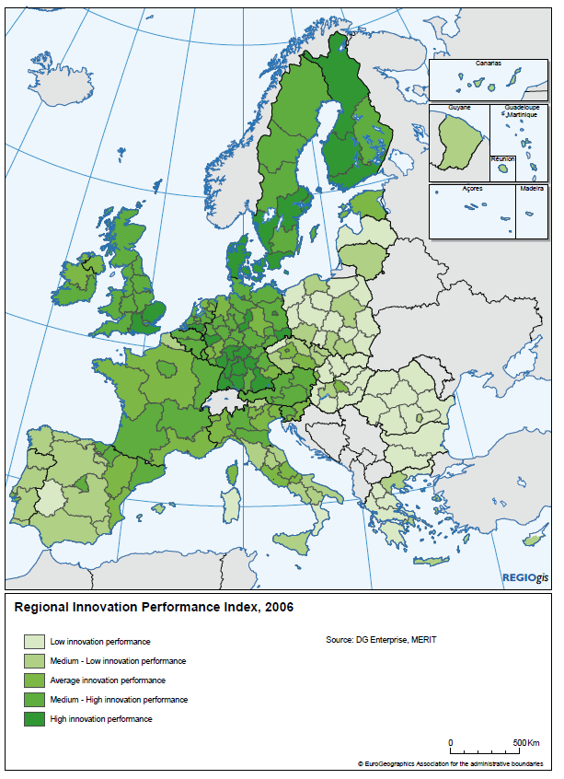
Figure 2: regional innovation performance index (EC, 2011, p. 4)

A final reason for smart specialisation are the dilemma’s discussed in the previous paragraph. As is described in paragraph 2.3 previous regional strategies offered insufficient conceptual tools to cope with these dilemmas. Smart specialisation was designed to provide policy makers with conceptual tools previous regional innovation strategies lacked (Midtkandal and Sorvik, 2012).

2.4.3 Principles of smart specialisation
According to Foray the main idea of smart specialisation strategy is ‘[...]to allow government to undertake strategic actions in order to build future competitive advantages, while preserving or even promoting a bottom-up principle of entrepreneurial
initiative and dynamics’ (2016, p. 1428). The first principle is that regions should focus innovation efforts and investments in a non-neutral logic, i.e. focusing more on a few areas specifically selected for that region. Regions do differ greatly from each other on many aspects. Smart specialisation urges regions to analyze where their strengths and weaknesses lie and focus innovation investment on those areas in which regions have the most potential to build a globally competitive specialisation. ‘European regions are therefore required to identify the key areas, activities or technological domains where they are more likely to enjoy competitive advantage and focus their regional policies to promote innovation in these fields (OECD, 2011, p. 18). Not sectors, but activities are the level of prioritising for innovation investments (EC, 2011). The advantage of focusing on activities is that activities can be tied to specific technologies, capabilities and assets. It allows regions to focus their investment even more specific than is the case with sectoral prioritising. This prioritization will give regions a competitive advantage over other regions. An important element of creating a competitive advantage is innovation, which allows improvement and change of existing activities or perceiving and discovering new activities (Kuah, 2002). From an European point of view, this has the advantage that EU regions do not compete with each other. Instead each of them focusses on a few specialities which can grow to be competitive on a global scale. Thus smart specialisation helps prevent uniformity and duplication between European Union regions (EC, 2011). However once a region has chosen a path it does not mean that a region should stop the process of discovering new areas. Smart specialisation recognises that discoveries of new technologies might emerge. These new technologies should not be ignored just because a pre-determined path has been laid out. So besides specialising, regions should also have the capability to allow for technological diversification (OECD, 2011). This is important since regional plans under the framework of the Structural Funds of the EU have a timeframe of 7 years. However new opportunities due to technological advancements might arise in a shorter time span.
The second main principle of smart specialisation is the use of an entrepreneurial process of discovery. The discovery of what the strength and weaknesses of a region are, and which areas the regions should focus on, should be done by the region itself. Smart specialisation therefore argues for the use of a bottom up approach, where the government serves merely a facilitation role. An important amount of the input should come from actors inside the region itself, not just from governmental organisation, but from businesses, knowledge institutes and societal organisations. This means that the role of the government is different than is the case in traditional regional strategies. When it comes to the process of entrepreneurial discovery the government should not be the sole actor who decides the areas of specialisation. Instead the government should provide incentives to convince all relevant regional actors to participate in the process of entrepreneurial discovery. There is some debate about this role of the government according to smart specialisation with some pointing at the risks of too much private influence in a region (Aranguren and Wilson, 2013; Navarro et al., 2012; OECD, 2011). The process of entrepreneurial discovery is an important element of smart specialisation. It will be discussed in more detail in the next sub-paragraph.
Besides the facilitating role in the entrepreneurial discovery process, the government is has also a role in the evaluating and assessing of the potential effectiveness of the smart specialisation strategy. Smart specialisation recognizes the need to monitor and evaluate the progress of the smart specialisation strategy. This is of extra importance since smart specialisation involves specific investment in activities, from which the effective outcome is unclear. It involves a larger amount of risk than is the case with horizontal government policies. Yet another role of the government is to make sure that support is directed towards sectors where there is potential and opportunities for improvement. This can be done by providing complementary investments in the form of training and education for new specialities. A last role of the government is to stimulate coordination and connection among different territories (Aranguren and Wilson, 2013).
Smart specialisation is specially developed to be applicable to all different regions in the European Union. McCann and Ortega-Argiles recognize that in economically stronger regions smart specialisations leads to refining and sharpening of existing practices. While in moderate economically regions (South European regions) smart specialisation leads to real progress. However in the weakest economical regions (East European regions) designing and implementation of a smart specialisation strategy has proven to be difficult and less successful. According to McCann and Ortega-Argiles this is because these regions lack robust government arrangements (2016).
A final principle discussed here is that smart specialisation is seen as a complementary concept that should not replace existing regional strategies. The nature of smart specialisation is vertical, meaning that it focusses on a few specific areas. However horizontal pre-conditions should already be in place for smart specialisation to be effective. If this is not the case the smart specialisation strategy might not be effective. Horizontal and general framework policies are a therefore a necessary first step (McCann and Ortega-Arguiles, 2016b).

2.4.4 The entrepreneurial discovery process
The entrepreneurial discovery process (EDP) is the backbone of the smart specialisation concept. A smart specialisation strategy should always be preceded by and be the result of an EDP (Foray, 2016). The EDP consists of two elements. First is the ‘entrepreneurial’ element which means that the EDP should be done by entrepreneurs in a bottom up approach. Many authors have criticized the top down approach that was used in regional policy making:

‘There is a long history of policies setting priorities and objectives in a top-down and
central planning mode and letting bureaucratic committees decide what was best left to
the market. These policies generated a lot of inefficiencies and most often failed to stimulate
dynamism and innovation.’
(Foray, 2016)

Instead the smart specialisation concept argues for a bottom up approach in which regional stakeholders are involved in the EDP. The government should acknowledge that they are not an omniscient planner. Instead they should harvest knowledge that is scattered among regional stakeholders. These regional stakeholders should be agents representing firms, universities, higher education institutes, independent inventors, innovators and societal organisations. Who these regional actors are will be different for each region, depending on the presence and role of knowledge institutes, companies, public research institutes and firms. However with this emphasis on regional stakeholders it might become unclear what the role of the government should be. While the process of entrepreneurial discovery should come up with the potential areas of investment, in the end the government decides where and how public funds are invested. ‘[...]the real challenge is how to inform this policy decision from an entrepreneurial process that brings together the diverse knowledge on capabilities and possibilities that is embedded and constantly evolving among a wide range of agents in the economy.’ (Aranguren and Wilson, 2013, p. 6). Which means that while the government makes the final decision, this decision should be based on knowledge of regional actors.
The second element of the EDP is the ‘discovery’ part. The goal of the EDP is to ‘discover’ entrepreneurial knowledge. Entrepreneurial knowledge is not just knowledge about technology and science but also has a place-based element. Knowledge about science and technology is the starting point, but this knowledge is then combined with knowledge about the region’s market growth potential, likely competitors and the entire set of input and services required for launching a new business activity. This entrepreneurial knowledge is of strategic value when deciding which future areas of innovation of technologies are profitable and suitable for investments. But it also helps discover which weaknesses a region has that might hamper innovation (EC, 2011).
Gheorghiu et al. (2016) noted the lack of tools for the process of entrepreneurial discovery and proposed a toolkit based on foresight principles for the process of entrepreneurial discovery. In this model there are 3 conditions which a process of entrepreneurial discovery should confirm to:
- It should provide ‘inclusive’ evidence
- It should provide argument-based exploration of prioritization options. Because the process of entrepreneurial discovery should consist of multiple actors, it is important that proposals and assessments of potential priority fields are supported by substantive arguments
- there should be consensus regarding the selection of priorities based on shared assumptions.
The model consists of 4 ‘compartments’ to use the terminology of Gheorghiu et al.
Compartment 1: ecosystemic transparency, data analytics and beyond.
In compartment 1 a social network analysis for the process of entrepreneurial discovery is central. The main principle behind the toolkit Gheorghiu et al. propose, is that of inclusive knowledge. Inclusive knowledge is more than just a standard indicators of innovation and research activity. It should result in a systematic map which allows individual actors to locate their own position relative to other actors and activities. This provides actors with a better understand of their niche and their position within the wider ecosystem. Understanding their own position will help actors spot similar interest and find potential networks of collaborators. ‘inclusive’ evidence enables actors to appreciate ‘where they stand’ in complex networks of actors and relationships (Gheorghiu et al., 2016, p. 36). The idea for inclusive knowledge comes from the observation that, while actors hold distributed information and most likely have more knowledge of their immediate environment, this does not mean that actors are well informed of the world outside their environment (Schein, 2010, in Gheorghiu et al. 2016). It is important to package this information in a format that is informative, easy to communicate, easy to absorb and comprehensive. They also argue for the use of data tools to translate the information into visually appealing and accessible graphs and maps (2016).
Compartment 2: mapping global trends, horizon scanning with a technological radar for weak signals
In this compartment the focus is on horizon scanning, for this purpose Gheorghiu et al. suggests to design and use a strategic radar system. The primary goal of this strategic radar system is to provide data on ‘weak-signals’. Weak signals is a term, used in foresight literature that refers premature and vague information on discontinuities or surprising threats and opportunities for organizations (Ansoff, 1975 in Gheorghiu et al., 2016). Horizon scanning can provide information on short cycle technologies, peripheral trends and opportunities of key enabling technologies, all relevant for the process of entrepreneurial discovery.
Compartment 3: entrepreneurial dialogue
Entrepreneurial dialogue is the centerpiece of the toolkit that Gheorghiu et al. propose. This entrepreneurial dialogue should consists of four stages:
- initiation: this phase consists of two elements. One is to collect and structure a preliminary evidence base. The second is to select participants for the other stages of the entrepreneurial dialogue (based on the information of the preliminary evidence base)
- exploration: this phase informs participants to the information that is gathered in the first 2 compartments (based on the social network analyses and horizon scanning). The participants should than be induced to offer further information through a consultation process (for example an entrepreneurial workshop).
- consolidation: here actors should ‘look over the horizon’ and match local ecosystems and global trends in a set of detailed scenarios of fields of smart specialisations priorities.
- commitment: In this phase a final selection is made of the priorities from the previous phase
Compartment 4: public policy alignment
In this compartment the need to integrate smart specialisation in the context of the national or regional policy space is central. This is almost entirely dependable on the conditions of the national and regional context. Foray (2016) describes smart specialisation mainly as a complementary strategy, meaning that it should not impede to much with existing policies. However Gheorghiu et al. suggest that in some regions it may lead to decoupling of existing policy and the new smart specialisation strategy (2016).
This theoretical framework about the EDP will help compare the theoretical ideas and principles of the EDP with the policy practice of the EDP. Table X contains an assessment matrix. This matrix contains all elements of an EDP which are further outlined into indicators, based off the theoretical outline provided in this paragraph. In the analysis this assessment matrix will provide a conceptual tool to analyse how well the policy practice includes the ideas of the theory.

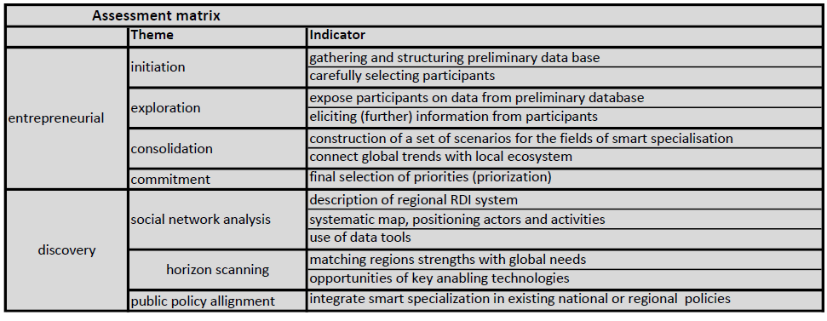
This assessment matrix does not only reflect the toolkit of Gheorghiu et al. but also other contains elements of other theoretical sources. Therefore the division in ‘compartments’ is abandoned. Instead the matrix has a general division between the entrepreneurial and discovery element of the EDP. The different compartments of Gheorghiu et al. as well as elements of other theoretical sources used in this paragraph can be found in the ‘themes’. The indicators are also based on the theoretical framework of this chapter and will be important for the analysis in chapter 4.

Chapter 3 Context
This chapter gives an outline of the general actors and policies related to the concept of smart specialisation. Understanding the context does not directly answer the main research questions but is necessary to perform the analysis. First the policies of the Netherlands and the European Union will be discussed. Where possible a link to the smart specialisation strategy will be made. Then the actors on European and national level will be central. Finally the two Dutch cases will be briefly introduced.

3.1 National policy in the Netherlands
In this paragraph the national policy landscape of the Netherlands in relation to innovation will be shortly summarized.

3.1.1 Innovation policy
The idea of the national policy is that businesses are given more space. There are less subsidies but in return also less taxes, less rules, better and more usage of the knowledge infrastructure, better connections fiscal and better education. The goals of the Netherlands for the innovation policy are in line with the European goals, these entail:
- the Netherlands in the top 5 knowledge based economies by 2020
- a growth of R&D expenditures to 2.5% of the GDP by 2020
(AWTI, 2016)
The national policy has different ways of achieving these goals. The first is financial support. There are two types of financial support: direct and indirect financing. Direct financing tools offer direct financial support, while indirect tools offer financial support by reducing costs, mostly through fiscal benefits. An example of a direct financing tool is the Toekomst fonds (Future Funds) an innovation fund which is used for fundamental research and innovation in SMEs. The idea behind indirect tools is that societal benefits are large then private benefits of R&D investments because of knowledge spillovers (EL&I, 2011). In order to bridge this gap the government lowers costs or raised the benefits of R&D for companies. The largest indirect tool for stimulating private R&D expenditures is the WBSO (Wet Bevordering Speur en Ontwikkelingswerk or Law Enforcing Research and Development). It allows the private sector to reduces the costs of expenditures on R&D labor, research equipment and research prototypes. Most companies using this law are SMEs (EL&I, 2011). Other examples of instruments are the RDA and the Innovationbox.

3.1.2 Top Sector policy
Besides purely financial tools, the government sometimes enters the innovation process as an organizing party. This is done in the case of universities and research institutes but also in the top sector policy. The top sector policy focusses on nine sectors. These sectors are chosen because they are knowledge intensive, export orientated, require sector specific laws and regulations and can deliver a contribution towards societal challenges (EL&I, 2011). The sectors are:
- chemistry
- creative industry
- energy
- high tech systems and materials
- life sciences & health
- agro & food
- logistics
- horticulture
- water
- headquarters
The Top Sector Policy stimulates and facilitates public private cooperation in these sectors in triple helix connections. The sectoral approach of the Top Sector Policy is also the starting point of the smart specialisation strategy in the Netherlands. This is stimulated by the national government in order to better incorporate smart specialisation in the Top Sector Policy (EZ, 2012). However a sectoral approach is criticized by the theory of smart specialisation which rather focuses on activities. ‘With their regional focus on regions, the structural funds can be seen as supplementary to the Dutch top sector policy […] the challenge to the Top-Sector policy is to allow for local differentiation’ (McCann and Ortega-Argilés, 2014, p. 418).

3.2 European policy
In this paragraph European policies related to smart specialisation will be introduced.

3.2.1 Europe 2020 Strategy
The economic and financial crisis of 2008 led to the realization by the EU that change was needed for the European economy to be better able to adjust to global changes and crisis’s. The Europe 2020 Strategy was the plan to bring Europe out of the crisis and to transform the economy to a smart, sustainable and inclusive economy. The Europe 2020 strategy focuses on these three priorities:
- Smart growth: developing an economy based on knowledge and innovation.
- Sustainable growth promoting a more resource efficient, greener and more competitive economy.
- Inclusive growth: fostering a high-employment economy delivering social and territorial cohesion.
(EC, 2010, p. 5)
These priorities should help reach the goals that are put forward in the Europe 2020 strategy:
- 75% of the population aged 20-64 should be employed.
- 3% of the EU’s GDP should be invested in R&D.
- the ‘20/20/20’ climate/energy targets should be met (including an increase to 30% of emission reduction if the conditions are right).
- The share of early school leavers should be under 10% and at least 40% of the younger generation should have a tertiary degree.
- 20 million less people should be at risk of poverty
(EC, 2010, p. 5)
The Europe 2020 Strategy is used as a reference framework. Eurostat, the EU office for statistics has monitored progress of the targets and published progress reports (Eurostat, 2016). Based on these reports and a public consultation in 2015 the conclusion was made that the Europe 2020 Strategy was still an appropriate framework and that the program could continue until 2020.

3.2.2 Cohesion policy
Cohesion policy is Europe's local and regional development policy that aims at supporting job creation, business competitiveness, economic growth, sustainable development and improve citizens’ quality of life (EC, 2014). Cohesion policy specifically focuses on enhancing the long term development of the weaker regions of Europe, thus reducing the economic and social differences between different regions in the EU. The EU budget for the cohesion policy 2014-2020 is 351.8 billion euro, however the impact of the cohesion policy for 2014-2020 is expected to be 450 billion euro. This is because the cohesion policy is a catalyst for public and private funding. Member states are obliged to co finance the projects with their national budget. A distinction is made between less developed, transition and more developed countries based on their gross domestic product (GDP). Based on this distinction the EU funds can provide between 50% and 85% of the total financing. The investor confidence that is created is expected to result in more private investment (EC, 2014).
In the cohesion policy 2014-2020 the money for the cohesion policy comes from different funds. The European Structural and Investment Funds (ESIF) is the collective name for funds of the EU. ESIF consists of 5 funds. The largest of these 5 are the European Fund for Regional Development (EFRD), which promotes balanced development in different regions in the EU. The European Social Fund (ESF), which invest in employment related issues such as employment and education opportunities, and help disadvantaged people who are at risk of social inclusion. And the Cohesion Fund, which focuses on countries with a GDP below the 90% of the EU average and is used for sustainable development and to improve connectivity.

3.2.3 Horizon 2020
Horizon 2020 is an EU research and innovation programme to create sustainable growth and high value jobs in Europe. In Horizon 2020 the seventh Framework Programme for Research and Technological development (FP7), the European Institute of Innovation & Technology (EIT) and innovation elements of the Competitiveness and Innovation Programme (CIP) are combined in one programme for financing innovation and research. The programme has three main objectives:
- Excellent Science: Strengthening the EU’s position as world leader in science and attracting the best talents to work together across Europe;
- Competitive Industries: Strengthening industrial leadership in innovation to get Europe back on the path to growth and job creation;
- Better Society: Innovating to tackle societal challenges shared by all Europeans, across six key themes: Health, demographic change and well-being; Food security, sustainable agriculture, marine and maritime research and the bio-economy; Secure, clean and efficient energy; Smart, green and integrated transport; Climate action, resource efficiency and raw materials; and Inclusive, innovative and secure societies.
(EC, 2013, p. 4)
The programme has a budget of almost 80 billion euros and is expected to attract more investments through national public and private investments. The program mainly finances small and large independent research and innovation projects (EZ and OCW, 2013).

3.2.4 Vanguard Initiative
The vanguard Initiative is the result of a collaboration between progressive industrial regions in Europe. Their goals are in line with the goals of the EC which state that a new form of industrial entrepreneurship is needed that focuses more on innovation. They feel that regions can offer a contribution to these goals since regions are close to the entrepreneurial dynamics. The initiative states that they: ‘ [...] know what the companies in our regions need and can translate this into a powerful and forward-looking policy’ (Flemish government, 2013). The initiative argues for strong multi-level governance that supports the growth of combinations between innovation and entrepreneurship. The smart specialisation is seen as an important strategy for matching strategic roadmaps between national and European level, aligning strategic investments that these roadmaps result in and upgrading regional partnerships and clusters with global potential (Flemish government, 2013). The Initiative seeks to develop interregional cooperation. First there is a top down step in which regional authorities identify strategic topics. Then a bottom up step follows in which regional actors of different regions cooperate to identify specific topics to work together on (Liebert, 2017). The goal is to create co-operations between different regions with common goals and complementary resources. This co-operation facilitates the sharing of knowledge, information and available resources to creating opportunities business cooperation and/or joint participation in European projects (Liebert, 2017).

3.3 The actors
There are different actors involved in the smart specialisation concept on European, national and regional level. In this paragraph an outline of the relevant actors will be given.

3.3.1 European level
European Commission
The European Commission (EC) is the political executive arm of the European Union. There are 28 commissioners, one from each country, responsible for different policy areas. The Commission is led by a commission president, currently Jean-Claude Juncker. The EC is responsible for drawing up legislations, implementing the decisions of the European Parliament and executing the budget (EU, 2012). Regarding cohesion policy and smart specialisation the European Commission has connections on national level with government and ministries, and on regional level with management and auditory authorities (Damen-Koedijk, 2016).

European Council
The European Council defines the political direction and priorities of the EU. The European Council is not directly involved with negotiating or adopting laws but sets the EU’s policy agenda. The European Council consists of the heads of the governments or states of the EU and the president of the European Council, currently Donald Tusk. As the European Council has no direct involvement with specific plans, they are not directly involved with the smart specialisation concept.

European Parliament
The European Parliament has the role of political control and consultation. This entails among other things, passing European laws proposed by the European Commission, democratic scrutiny of all European Union institution and establishing the EU budget (EU, 2012). The European Parliament is not directly involved with the implementation of smart specialisation strategy but played an important role in the passing of the smart specialisation strategy.

Knowledge for Growth expert group
The Knowledge for growth expert group is not an official institute of the European Union but functioned as an advisory group to the commissioner Potočnik. The group consisted of independent expert who discussed economic themes in the context of the EU based of their own research and other relevant literature (K4G, 2008). The results of these discussions were reflected in a number of papers that were published in the period 2008 and 2009. As a knowledge group they are responsible for the idea and first concept of smart specialisation.

Smart specialisation Platform
The smart specialisation platform or S3 platform was established in 2011 with the goal of assisting regions in developing, implementing and reviewing their smart specialisation. This is done by bringing together knowledge and expertise from relevant actors such as universities, research centers, regional government and businesses (EC, 2010). Besides providing knowledge about the concept and implementation, the platform also maps the areas of specialisation of different regions in Europe. This might help regions with similar expertise’s find each other and establish relations.

3.3.2 National level
Ministry of Economic Affairs (EZ)
The ministry of economic affairs can be seen as the governmental body representing the national government when it comes to the smart specialisation strategy. It is responsible for evaluating the smart specialisation strategies of the regions and approving them before they are officially send to the EC. EZ is also tasked with making sure that there is not too much overlap in the different smart specialisation strategies (EZ, 2011).

Managing authority (MA)
The managing authorities are involved in the implementation of the ERDF. The Netherlands are divided in 4 regions: north, south, east and west. Each region has its own MA. The MA is responsible for the management of the operational plan.

Audit authority (AA)
The audit authority (AA) is tasked with carrying out audits on the management of the OP and operations within the OP. The AA works on the basis of an audit strategy which needs to be checked and approved by the EC.

Certifying authority (CA)
The task of the certifying authority (CA) is to certify statements of expenditure by the MA to the EU and make sure these statements are reliable, verifiable and comply with all the rules. Whenever the MA asks the EC for a payment the CA has to verify this request and draw up and submit a certified statement. The CA also maintains accounting records of the expenditure.

3.4 The two Dutch cases
In this paragraph the two Dutch cases will be introduced. Information about the regional profile and their smart specialisation will be provided.

3.4.1 The northern region
The northern region of the Netherlands consists of the provinces Groningen, Friesland and Drenthe. All three of them are represented in the ‘Samenwerkingsverband Noord-Nederland’ (partnership north Netherlands henceforth called SNN). This collaboration exists since 1992. Since 2005 also the 4 largest cities of this region, Groningen, Leeuwarden, Assen and Emmen have important advisory roles in SNN. The northern-region of the Netherlands has the smallest population of all 4 regions with 1.718.000 inhabitants as of January 2016 (Statline, 2017). The northern region does not have as high a mass or concentration of economic activities as other regions (AWTI, 2004). There is however a relative high presence of SME’s compared to the other regions.

3.4.2 The smart specialisation plan of the northern region
The northern region is the only region in the Netherlands that regards the smart specialisation strategy as a new and leading strategy for regional innovation policy (AWTI, 2011). The smart specialisation strategy has the ambition to obtain not just economical but also societal benefits from innovation. Most societal challenges are shared with the rest of the Netherlands, like energy supply, water, health and food supply. Some societal challenges are more pressing for the northern region mainly ageing of the population, livability and environmental problems. In the smart specialisation strategy the northern region highlights four societal challenge which they want to focus on. These challenges are:
- Health, demographic and wellbeing
- Food security, sustainable agriculture and bio-economy
- reliable, clean and efficient energy
- clean and safe water supply
These are pressing challenges for the northern region but they are also relevant for the rest of Europe (SNN, n.d.). The smart specialisation strategy considers these societal challenges as the leading agenda points. According to the strategy tackling these issue requires a intersectoral approach which is what leads to meaningful innovations. Crossovers from sectors with the societal challenges are the focus point (SNN, n.d.). A strong point of the region recognized in the strategy is the application of new innovation in practice. This is partly because of a relative large amount of SME’s which are capable of connecting innovation to practical needs. Also a the mentality of the region (called the ‘human measure’) which refers to close communities and short connections means that people are more willing to participate in different testing grounds and experiments. Therefore the region wants to promote itself is Living Lab Region, the place to test and first apply new innovations (SNN, n.d.).
The sectors agrifood, energy, healthy ageing, smart (sensor) systems and materials and water technology are seen as the strong clusters of the regions. These are the sectors in which the region has special experience with (SNN, n.d.). Figure 3 shows how the societal challenges and the regional assets are connected with each other. This figure represents the main elements of the smart specialisation strategy of the northern region. 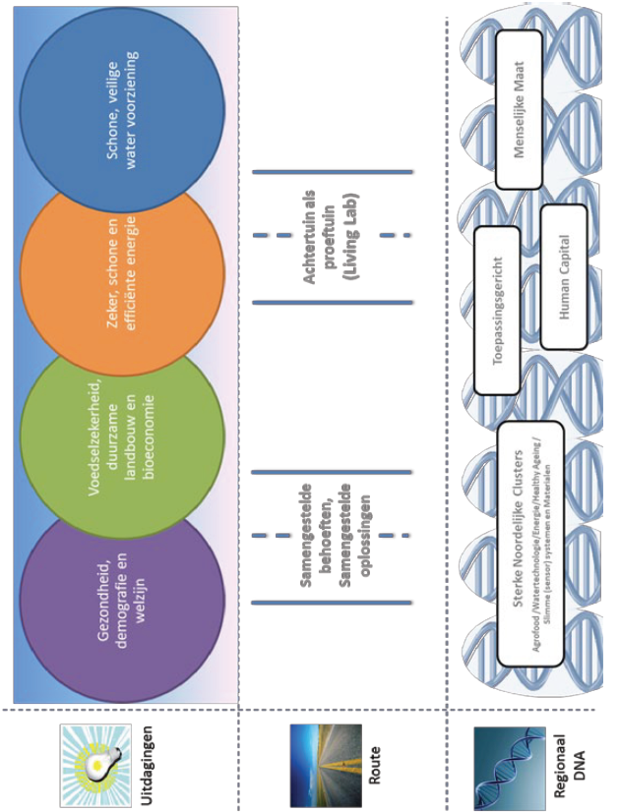
Figure 3: RIS3 North Netherland (SNN, n.d., p. 19)

3.4.3 The southern region
The southern region of the Netherland consists of the provinces Zeeland, North-Brabant and Limburg. In some definitions of the ‘southern region’ the province Zeeland is not included but is instead a part of the western region. However for the smart specialisation the province Zeeland is part of the southern region. The population is larger than the northern region with 3.615.000 people as of January the first (Statline, 2017). A large portion of innovation investments of the Netherlands take place in the Southern region, in 2009 this was 41% (CBS, 2010, in RIS Zuid Nederland)). Also four of the five largest global R&D companies are located in the Southern region (PHILIPS, ASML, DSM, NXP, OCÉ). The innovation governance model of the Southern region consists of a number of triple helix partnerships, in which the governance has a more modest, but important role as coordinator.

3.4.4 The smart specialisation strategy of the southern region
The smart specialisation strategy of the southern part of the Netherlands is based on a long-standing tradition of triple helix cooperation and the resulting strategies, strategic networks and implementation plan (Stimulus, 2013). The smart specialisation strategy of the southern region is based on economic development agendas, strategies and policy plans from the past 10 years. These plans are largely complementary and together cover the whole geographical area of the southern Netherlands. A few examples of previous regional plans are the Brainport 2020 strategy, Strategic Board of the South-West Netherland Agenda, provincial economic plans and agendas and the operational programs of the triple helix organizations of the sub regions (Stimulus, 2013). The smart specialisation strategy of the Southern region of the Netherlands focuses on the clusters High Tech, Agro & Food and Chemistry. These three sectors together represent 68% of the private R&D investments in the Netherlands and are well represented in the southern region. The smart specialisation strategy of the southern region also states that the southern region has a strong knowledge institutes which are embedded in the region. The Eindhoven University of Technology has a focus on health, energy and smart mobility, Tilburg University has a focuses on social innovation and Maastricht University has a focuses on quality of life, learning and innovation, and Europe and the globalising world. Besides these sectors the smart specialisation strategy also focuses on clusters by strengthening existing clusters, helping new or upcoming clusters and stimulate cross-overs between clusters both in the region as cross-overs between clusters globally. However there are different challenges for the southern region. Because of globalization the region has the compete directly with other innovative region inside and outside Europe. The smart specialisation strategy states a number of points on which the region should focus in order to keep their competitive position:
- developing, attracting and keeping enough talent
- attract sufficient venture capital
- diversification of the economy
- increase the valorisation capability
- increase international reputation and visibility
- attract public and private R&D investments from outside the region (Stimilus, 2013)
In order to do this the region should be as attractive as possible for companies, inhabitants and visitors. The smart specialisation strategy also sets itself a few goals:
- a top 3 position as innovative and competitive region in Europe
- an increase of the contribution to the Netherlands GNP with 40 billion euros
- an economic growth of 3%
- living labs, in 2020 world renown as breeding ground for innovative solutions
- in 2020 almost complete job opportunity
The strategy of the Southern region includes the domains people, technology, businesses, basics and governance. These domains have been used before in strategies by Brainport for example in Brainport 2020 (Brainport Development, 2011). The smart specialisation strategy of the southern regions main focus is on clusters (figure 4). 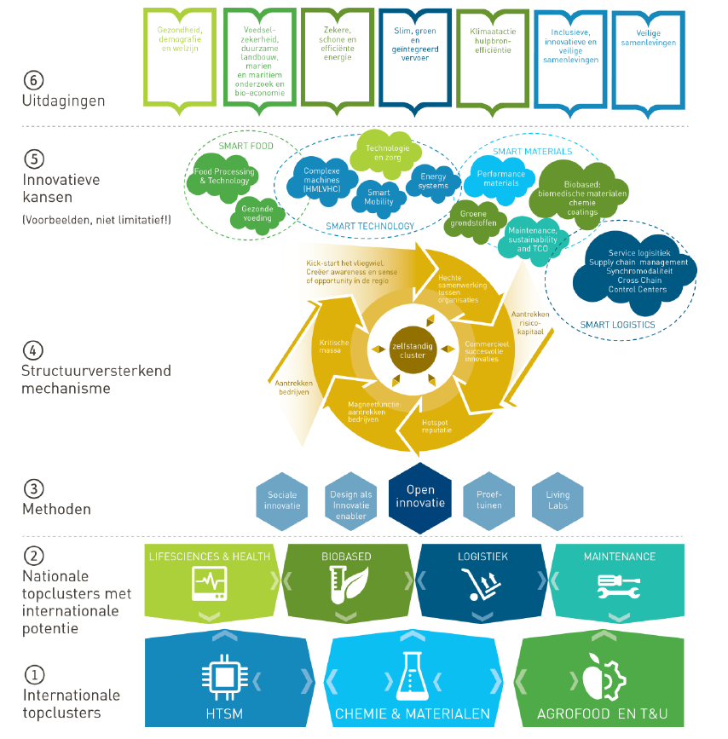
Figure 4: RIS3 South Netherland (Stimulus, 2013, p. 28)

Chapter 4 Analysis
In this chapter the analysis will be performed. This will give insight in how the smart specialisation strategy is developed and implemented in practice. For this, the two cases of the Netherlands, the northern and the southern region, are central. In the first paragraph the analysis protocol is introduced. This explains what knowledge is sought in what data and how this is analysed. The rest of the chapter various analytical tools will be used to analyse the data. By doing so the remaining research questions will be addressed.

4.1 Analysis protocol
In chapter 1 the main research question has been formulated which is: ‘Does the concept of entrepreneurial discovery from the smart specialisation strategy work in practice as is described in theory, and is it experienced as beneficial and productive by policy makers and regional actors?’. To help guide this research towards the main question a number of subquestion have been formed in the first chapter. The first two questions have already been answered in chapter 2 and 3, these were:
- Why and how was the concept of smart specialisation developed?
- What is the theoretical definition of smart specialisation, and particularly the entrepreneurial discovery process?
The goal of this chapter is to answer the remaining sub questions and in doing so also the main question. This paragraph will explain what data will be gathered in what way, what analytical tools will be used where, and what results this might offer. For this research the form of multiple case study has been chosen. The cases, including their smart specialisation strategy, have been introduced in chapter 4. The focus here will be on answering the rest of the subquestions with the help of the two cases.

4.1.1 The sub questions
The sub questions help guide this research towards the main question. The first two sub questions have already been addressed. Here for the remaining sub questions will be explained how the answer will be sought, with what data and what the results might be expected.

Questions 3
The first question the analysis will focus on in paragraph 5.2 is:
- Is there any difference in the way that the different levels of governance (EU, national and regional) understand smart specialisation?
For this question the policy rationales of each level of governance will be deduced from a number of policy documents. The tool used for this analysis is the policy rationale scheme, resulting in one scheme per policy level (EU, national and regional). The schemes of the different policy rationales will make it possible to compare the 3 policy rationales. The result is a clear understanding of if and how the policy rationales of different level of governance are different.

Questions 4 and 5
The next two questions the analysis will focus on in 5.3 are:
- How has the smart specialisation strategy been developed in the two Dutch cases?
- What are the differences between the theoretical idea of entrepreneurial discovery, and how the process of entrepreneurial discovery was developed in the two Dutch cases?
The first question is a descriptive question. For this question the policy documents are a the primary source of data (including the results of the analysis in 5.2). The interviews with regional actors will provide confirmation and additional information where necessary. This will result in a clear understanding of how the smart specialisation was developed in both the cases. The second question entails a comparison between the theoretical concept of the EDP and the practice of EDP in both cases. To help with the comparison an assessment matrix has been designed. This assessment matrix will be used as a tool that allows the two cases to be compared with the theory. This result will show if and where the practice of the EDP is the same as the theory about the EDP.

Question 6
The final question the analysis will focus on is:
- How effective is smart specialisation in the cases at dealing with the cluster dilemma’s?
This question measures the effectiveness of the smart specialisation strategy on dealing with the cluster dilemmas. The cluster dilemmas are seen as issues that previous regional innovation strategies and cluster policy have struggled with. Smart specialisation was designed to tackle these dilemmas. This question will analyse if the smart specialisation strategy is an effective concept to do this for the two cases. Four cluster dilemmas have been observed and explained in the theoretical framework (chapter 2) based off literature. These four dilemma’s will serve as the tool to answer question 6. The data will be a combination of the interviews, policy documents and the results of the first 2 parts of the analysis. This will result in an understanding of how effective smart specialisation is compared with previous regional (innovation) policies.

4.1.2 Data sources
The data used in this analysis comes from two sources. The first source of data are policy documents. For the analysis it becomes necessary to understand with what policy rationale policy makers utilize the smart specialisation concept. To understand what the policy rationale of different policy makers is a desk research of relevant policy documents will be performed (table X). This desk research will focus on the rationale of three different levels in which the concept of smart specialisation is used. These are the policy rationale of the European Union, national level and regional level. For each level a number of policy documents have been selected. These will be the main source of information when for the policy rationales. The desk research performed in the first part will be useful for the rest of the analysis.
The second source of data are interviews with regional actors. The choice of which people to interview is important, since different persons depending on their (previous) function offer different insights, views and knowledge. It is necessary to think beforehand which interviewees, with what knowledge are chosen for the interviews. A general categorization used for this analysis is between three different kinds of actors: the (regional) government, knowledge institutes and private sector. The choice of interviewees will further be based on this description of the actors of the previous chapter. Appendix X shows which interviewees have been interviewed for this research. The goal of the interviews will be to confirm information found in the literature and obtain further information that cannot (easily) be provided in another way. This includes information that is not obtainable in literary sources, for example communication and relations between actors. But also to gain an insight in the experiences and opinions of the actors. For this purpose a 2 main goals are set which the interviews should achieve:
- to get a clear, comprehensive idea of how the smart specialisation strategy was developed
- to get an idea of the experience and opinions of regional actors of the development process, the outcome and the general concept of smart specialisation
The interviews will take the form of semi-structured interviews. This means that to guide the interviews and to make sure that all interviews are conducted in more or less a similar way an interview guide has been created. The interview guide will be used by the interviewer to structure the interviews. The interview guide (appendix x) exists of a number of open question and points that should be covered during the interview. However it is possible (and likely) that the conversation will diverge from the interview guide. This is not problematic, as long as the interviewer ensures that all relevant points are addressed during the interview. For each interview small adjustments to the interview guide can be made to better fit the interviewee.

4.1.3 Analytic tools
Analytic tools offer a structured way of analysing and drawing conclusions from raw data. For this analysis three tools will be used. The first tool is the scheme of the policy rationale. The goal of this tool is to understand the policy rationale of the EU, national government and regional stakeholders based of policy documents. For each policy level (EU, national and regional) a policy documents are inserted in the scheme. The scheme consists of the 4 elements that make up a policy rationale (according to the description of a policy rationale in the theoretical framework). A further subdivision is made to help create more focus. For each document relevant quotes will be inserted in the appropriate element. These quotes might be altered slightly to be more compact and understandable. The resulting schemes will make it possible deduce the policy rationale from the policy documents. It will also provides a tool to compare the different policy rationales with each other.
The second tool is the assessment matrix. This tool will help compare the two cases to the theoretical concept of the entrepreneurial discovery process as is described in chapter 2. The assessment matrix subdivides the EDP in different themes and indicators. These themes and indicators should be included in the development of a smart specialisation strategy according to the theory. For each case will be analysed if these indicators are present in the process of developing the smart specialisation.
The final analytic tool are the cluster dilemmas. The cluster dilemmas are described in chapter 2:
- how to involve all the relevant actors
- which activities are chosen and which are left out
- what is the role of (regional) government
- focus on traditional or new industries
These are dilemmas with which previous regional strategies and cluster policies struggled. The smart specialisation strategy was designed to offer an alternative strategy that allowed policymakers to overcome these dilemmas. It is therefore a helpful base for evaluating the effectiveness of the smart specialisation. These dilemmas will also be used in the interviews when asking about the interviewees opinion of the smart specialisation strategy.

4.2 Policy rationales
The first part of the analysis addresses the question: ‘is there any difference in the way that the different levels of governance (EU, national and regional) understand smart specialisation?‘. New ideas and principles are formed in the theoretical debate. At some point these ideas and principles from the theory are taken up by policy makers. First on European level then on national level and finally on regional level. In this paragraph a desk research will be performed to observe these policy rationales. A policy rationale of the EU, national and regional level will be deduced from a number of policy documents. Interviews with regional actors are used to confirm the results of the desk research. In chapter 2 policy rationales were defined as a bundle of theoretical ideas, assumptions and concepts that are the basic principles for policy makers to design, implement and evaluate policy. For the purpose of this research a policy rationale is understood as consisting of four elements. These are:
- nature of the system: general understanding and assumptions about relevant issues such as global developments, the economy and (regional) governance
- need for intervention: ideas about certain elements of the current situations that are undesirable and which requires a policy intervention change the current situation
- intended outcome: what the desired situation is as a result of the intervention
- logic of how the intervention leads to the intended outcome: ideas and assumptions about how the intervention leads to the desired situation
By understanding the view of the policy makers on these four elements the policy rationale becomes apparent. To help with this analysis the policy rationale scheme for each policy level will be created. For each policy document relevant parts will be inserted in the right place in the policy rationale scheme. The resulting scheme will show if and what each policy document view is on these 4 elements. The second step is to use these policy schemes to deduce the policy rationale. A policy rationale is not just the statements found in a policy document. Instead it is the underlying principles and ideas that leads to these statements. The formulation of these policy rationale therefore requires an interpretation of the policy rationale scheme. Once this is done these schemes and the resulting formulated policy rationales can be compared, thus answering the research question.

4.2.1 Policy rationale of the European Union
For the EU the following policy documents are subjected to the desk research:
- EC, 2010(b), Europe 2020, a strategy for smart, sustainable and inclusive growth.
- EU, 2012(b), Guide to Research and Innovation Strategies for Smart Specialisations (RIS 3).
- EC 2014(b) National/regional innovation strategies smart specialisation.
- Gianelle et al. (2016) Implementing Smart Specialisation Strategies, a handbook.
Table 1 shows the result of this desk research. This scheme results in the following policy rationale of the EU. Here the observations of the desk research will be presented for the 4 elements of the policy rationale.

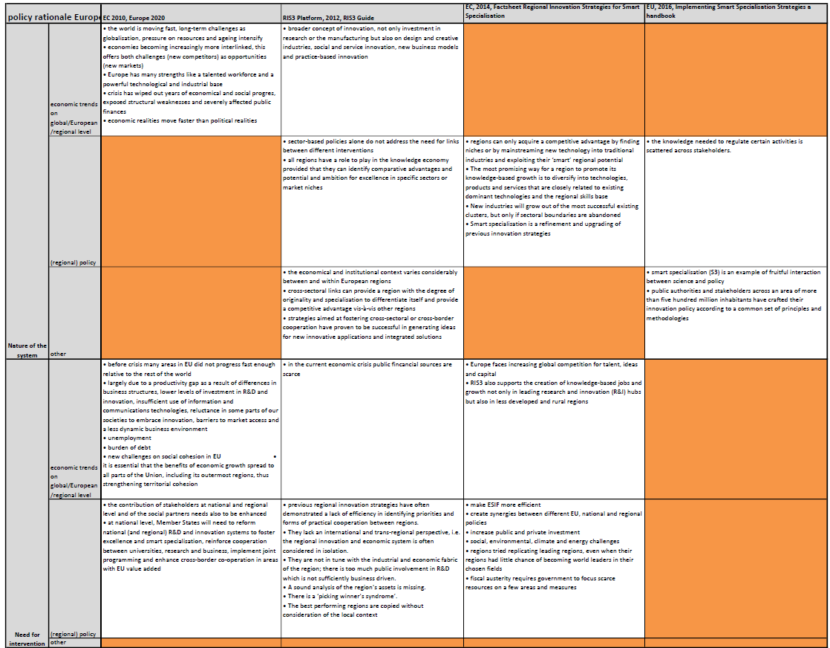
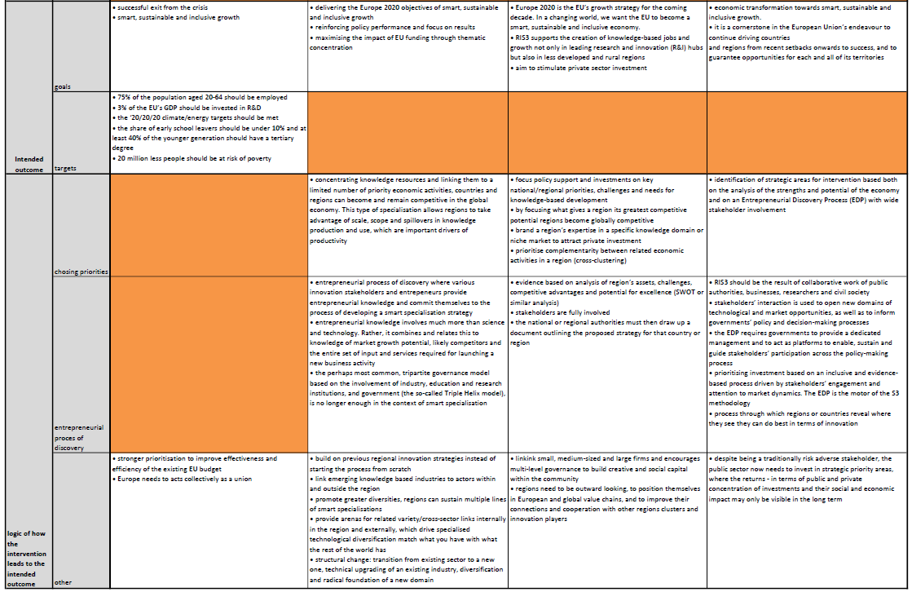Nature of the system
The European policy documents acknowledges global changes as an important factor. ‘[...] the world is moving fast and will be very different by the end of the coming decade’ (EC, 2010b, p. 7). According to the documents this effects the EU in a number of ways. Global climate changes and resource challenges puts pressure on the environment and exposes customers and businesses to price shocks. Economies become more interlinked which offers both opportunities as new markets open to the EU, but also challenges as the EU faces more competitors. Also the financial crisis in 2008 has had an influence on economies worldwide. For Europe the financial crisis has exposed structural weaknesses and severely affected public finances, resulting in public financial sources becoming more scarce. For regions these global changes mean an increasing global competition for talent, ideas and capital. The documents also have different statements about regional economy and regional policy. Regions are only capable of acquiring a comparative advantage if they can identify market niches or by mainstreaming new technology into traditional industries. However the economic and constitutional context varies considerably between European regions. In order to gain a competitive advantage it is necessary that regions have an international perspective, regions should not consider their economic system in isolation. ‘It is important [...] to take a realistic view of the region’s position in an international perspective’ (EU, 2012b, p. 47). Strategies aimed at fostering cross-sectoral or cross-border cooperation are seen as effective for generating ideas for new innovative applications and integrated solutions.

Need for intervention
The important role of the global context in the EU policy documents is also reflected by the understanding of the need for intervention. The financial and economic crisis of 2008 is seen as an important reason, requiring structural change in the EU. It resulted in an economic setback with unemployment, increased social cohesion and a scarcity of public finances. But even before the crisis European regions were already lagging behind when compared to the US, Japan and South Korea. It is not only global changes which are the reason for an intervention. The documents of the EU mentions a number of fault with previous regional policies:
‘Previous regional innovation strategies have often suffered from one or more of the following weaknesses:
- They lack an international and trans-regional perspective, i.e. the regional innovation and economic system is often considered in isolation.
- They are not in tune with the industrial and economic fabric of the region; there is too much public involvement in R&D which is not sufficiently business driven.
- A sound analysis of the region's assets is missing.
- There is a ‘picking winner's syndrome’.
- The best performing regions are copied without consideration of the local context.’
(EU, 2012b, p. 11).
According to the EU policy documents there was also no attention for societal challenges. Finally the strategies could be more efficient, which means that European structural funds are used more efficient.

Goals and targets
General goals for the EU’s social market economy are set out in the EU 2020 Strategy. The main goal is a successful exit from the crisis and confronting structural weaknesses. For this goal three priorities are stated in the EU 2020 Strategy:
- ‘smart growth, based on knowledge and innovation;
- sustainable growth, promoting a more resource efficient, greener and competitive economy;
- inclusive growth, fostering a high employment economy delivering economic, social and territorial cohesion.’
(EU, 2012b, p. 7)
Specific goals of the Europe 2020 strategy are 75% of the population aged 20-64 should be employed; 3% of the EU’s GDP should be invested in R&D; the ‘20/20/20 climate/energy targets should be met; The share of early school leavers should be under 10%; at least 40% of the younger generation should have a tertiary degree; and 20 million less people should be at risk of poverty. While these goals and targets are stated in the EU 2020 strategy they are repeated in the policy documents about smart specialisation. More specific for regional development the smart specialisation guide (EU, 2012b) states that the smart specialisation strategy should lead to the creation of knowledge based jobs and growth. Both for leading R&I hubs but also for less developed and rural regions. Smart specialisation should also aim to stimulate private sector investment.

Logic of how the intervention leads to intended outcome
The essential logic of the smart specialisation strategy is to focus efforts on those areas which are most promising for that region. ‘RIS3 focuses economic development efforts and investments on each region’s relative strengths, exploiting its economic opportunities and emerging trends, and taking action to boost its economic growth.’ (EC, 2014, p. 3). The RIS3 guide (EU, 2012b, p. 7) contains a roadmap, consisting of six steps which policy makers can use as guideline for the implementation of a smart specialisation strategy. These steps are:
Step 1. Analysis of the regional context and potential for innovation
This analysis should focus on regional assets, the strong and weak points of the regions should be analyzed to find which areas the region might build a comparative advantage on. Also there should be a clear view of the position of the region in the EU and even global scale. Finally the analysis should focus on the dynamics of the entrepreneurial environment. This is where the process of entrepreneurial discovery is introduced. Participation of relevant entrepreneurial actors is essential for this step.
Step 2. Governance: ensuring participation and ownership
The governance design should be flexible enough to allow different actors from the region to play a role in the design of the smart specialisation strategy. However it is important to be aware of specific powerful lobbies, major regional stakeholders or interest groups having too much influence on the choice of strategic priorities. To help with this issue, RIS3 argues for the use of ‘boundary spanners’, people or organizations that have enough knowledge to help moderate the process.
Step 3. Elaboration of an overall vision for the future of the region
Step 3 is about having the information gathered in step 1 focused on a clear shared vision of what the goals for the future are for the region as a whole. This is important to keep keep the relevant actors engaged. Especially since the smart specialisation strategy is a long-term process.
Step 4. Identification of priorities
Choosing a limited number of priorities or areas is essential to a smart specialisation strategy. It is a combination of a top down approach in which broad objectives and European Union policies are aligned and a bottom up approach in which priorities are selected in which a region has the potential to excel.
Step 5. Definition of coherent policy mix, roadmaps and action plan
At this point there exists a clear idea of the goals and there is a set of chosen priorities or areas. Step 5 is about creating a roadmap, action plan and coherent policy mix. These should outline the steps that are going to be undertaken in order to reach the goals.
Step 6. Integration of monitoring and evaluation mechanisms
The final step is about setting up tools that allow for monitoring and evaluating the progress of the smart specialisation plan. It is important that a clear set of measurable indicators are included in the smart specialisation plan in order to allow this monitoring.

4.2.2 Policy rationale of the European Union
The policy rationale scheme makes it possible to deduce a number of rationales that form the policy rationale of the EU. First the focus of the EU is not a single region, but on the EU as a whole. It has a focus on the ‘bigger picture’. Regions are the central scale of this particular intervention. However the underlying rationale is not to help individual regions per se but the whole EU through these regions. This is shown partly by the hope that smart specialisation will create more diversity between regions in Europe. The Europe 2020 Strategy states that EU member states need to adjust funding procedures to ensure diffusion of technology across EU territory. By preventing regions from copying best cases but instead focus on their own strengths. Also the policy documents speak of the hope that smart specialisation will allow for more cooperation between regions. ‘ [...] smart specialisation is also pointing regions towards more strategic cross-border and trans-regional cooperation to achieve more critical potential and related variety.’ (EU, 2012b, p. 10). It is also important to keep in mind that smart specialisation is a part of the EU's Cohesion Programme. This is underlined by the pillar ‘inclusive growth’ of the EU 2020 Strategy. This means that the smart specialisation concept should be applicable in all regions of Europe, even though there are notable differences between institutional and economic landscape of different regions in the EU.
A second rationale of the EU is that the smart specialisation strategies should be place-based. While the differences that exist in local context of regions in the EU, the smart specialisation should be applicable in all these different regions. Hence the focus of the EU rationale on a place based approach. This result in a heavy emphasis of the smart specialisation concept on assessing the regional context.
A third rationale of the EU is the need to be more efficient with public funds. This need comes from the extra strain on the public budget as a result of the financial crisis.
A finale rationale that vertical investment is necessary. Horizontal investment are not sufficient, especially for economically weaker regions. Horizontal investments are still seen as necessary, and should not be neglected. But in order to gain a competitive advantage regions should focus only on a small number of carefully selected activities or niches.

4.2.3 Policy rationale scheme of the national government
For the national level the following documents have been objected to the desk research:
- EZ, n.d., Factsheet Smart Specialisation (S3).
- EZ, 2012, Richtinggevende notitie voor Smart Specialisation Strategy.
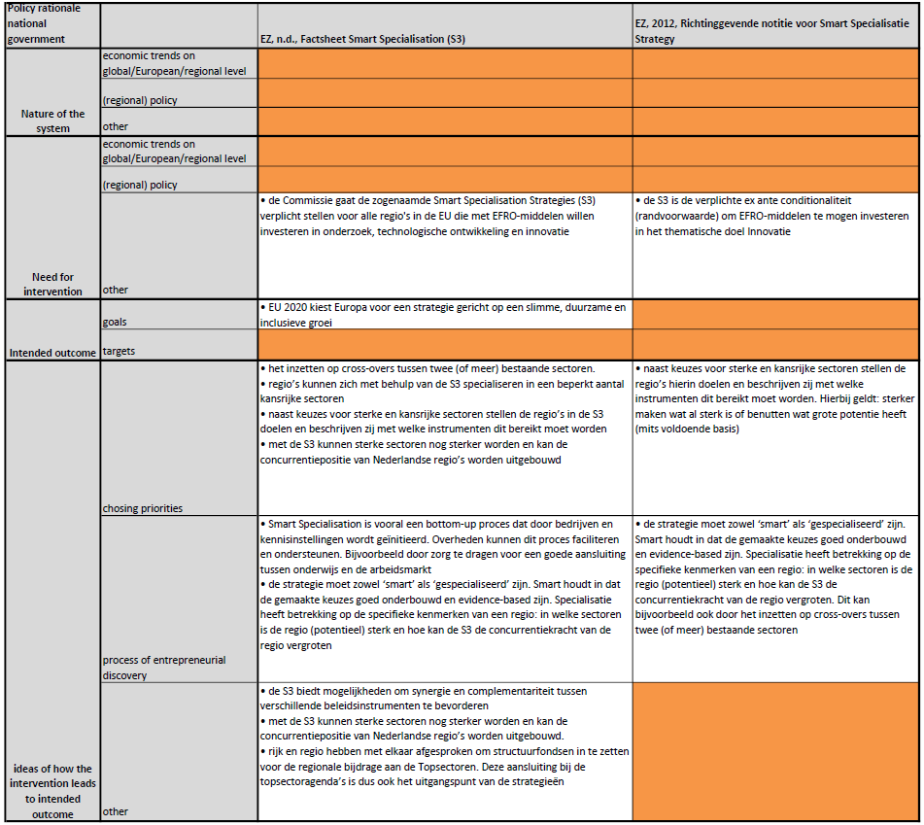
Table 2 shows the policy rationale scheme of the national government.

As is mentioned in chapter 3 the ministry of Economic Affairs (EZ) speaks for the national government when it comes to smart specialisation. However EZ had a relative small role, being neither really involved in development or implementation of the smart specialisation. The concept of smart specialisation and the ex-ante conditionalities for the EFRD come directly from the EC. The process of developing and implementing the smart specialisation strategies takes place on regional level. EZ stand between the EC and the regions. The role of EZ was to help regions develop a strategy by providing them information about the concept. Also EZ had to ensure that the resulting smart specialisation strategies met the ex-ante conditionalities set by the EU. Because of this there are only a few short policy documents about smart specialisation on national level. These documents constantly refer to the EU documents for ideas and principles about the smart specialisation. This can also be observed in the scheme of the national policy rationale (table x). All policy document of EZ about smart specialisation are directly based on sources from the theory or EU. The few document available result in the scheme having many blank spots. The only notable aspect is that the national policy rationale argues for a connection between the smart specialisation and the national policy program ‘Top Sector policy’. ‘National government and regional government have agreed to use the structural funds for the regional contribution to the Top Sectors. This connection to the Top Sector agenda is a starting point for the strategies’ (EZ, n.d., p. 1, translated from Dutch).

4.2.4 Policy rationale of the national government
As has been noted the national government does not have a strong view of the smart specialisation concept. Instead they adopt the ideas and views of the EU about the smart specialisation concept. However the desire of the national government to connect the smart specialisation strategies to the Top Sector policy is interesting. Indeed the EU documents do urge the smart specialisation to be made to fit in existing regional and national policies. However the Top Sector policy is based on the idea of sectoral division. This division in 9 Top sectors helps to stimulate public and private cooperation in triple helix connections. However this is in conflict with ideas of theory which states that focus should be on activities, not sectors. Because cross sectoral connections are the areas where innovative opportunities are.

4.2.4 policy rationale scheme of the regional level
The policy rationale of the regional level will be based on the two cases (North and South Netherlands). The following documents have been central for this desk research:
- SNN (n.d.) Research and Innovation Strategy Smart Specialisation (RIS3) Noord-Nederland
- SNN (2014) Operationeel Programma voor de doelstelling ‘Investeren in de groen en werkgelegenheid’.
- Stimulus (2013) Smart Specialisation Strategy, RIS3 Zuid, De kunst van het combineren.
- Stimulus (2014) Operationeel Programma Zuid-Nederland 2014-2020.
Table 3 shows the policy rationale of the regional level.

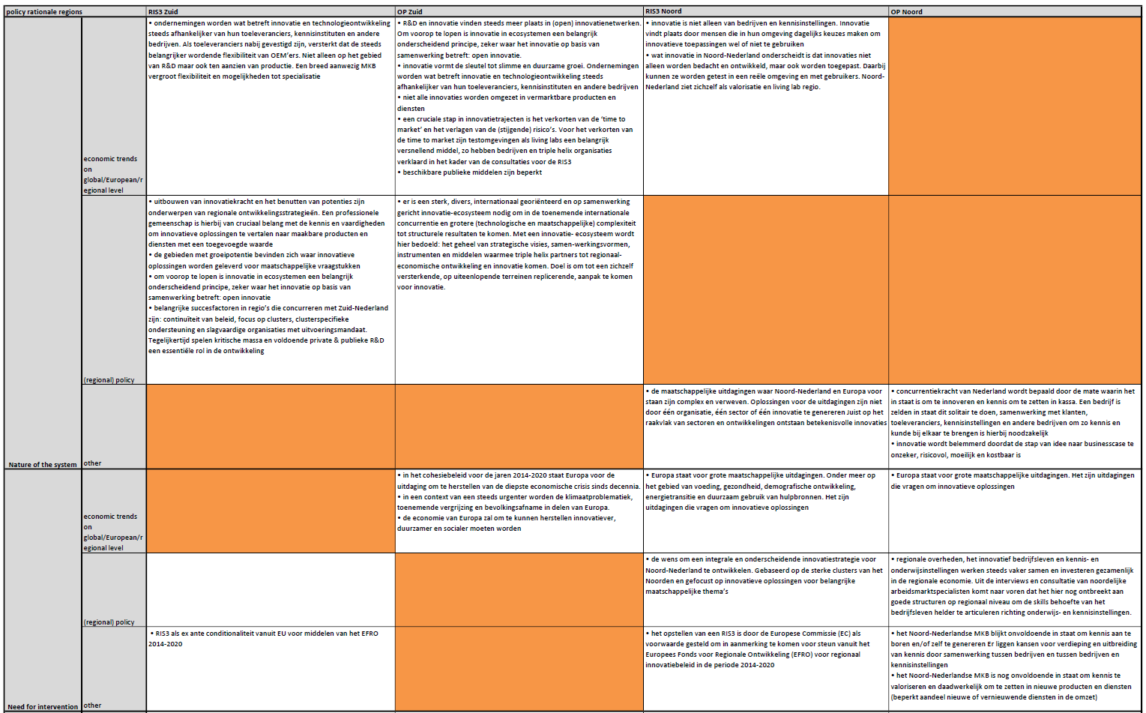
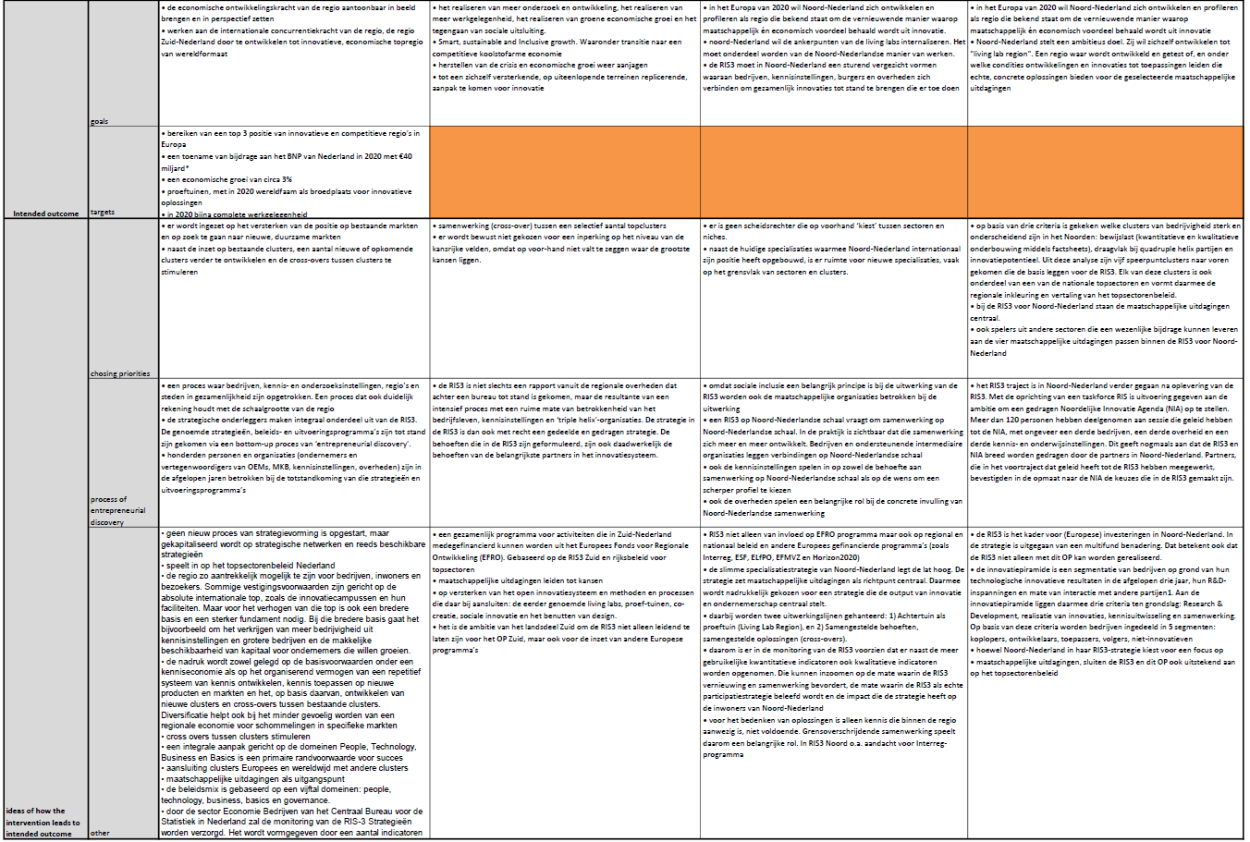
Nature of the system
The regional documents rarely emphasize the changing global context. The only mention of the global context in the documents is the impact of societal challenges. There is however a strong emphasis on the innovation system of the region. The southern case even speaks of a community: ‘The power of the community is that both competences as skills are present to translate innovative solutions to productable goods and service with a high added value.’ (Stimulus, 2013, p. 3, translated from Dutch). The southern case names four domains (people, technology, business and basics) which are important for this system. Other elements that southern documents recognize as being important for regional innovation policy are continuity of policy, focus on clusters and enough public and private investments in R&D. While the southern case speaks of triple helix organisations the northern cases uses the term ‘quadruple helix’. This to underline the important role of societal organisations and ‘users’: ‘Innovation takes place by people who make daily choices in their environment to use or not use innovative applications’ (SNN, n.d., p. 6, translated from Dutch). Also the northern case state the importance of a short ‘time to market’. Living labs are seen as an useful concept, connecting innovative solutions to the need of people and helping reducing the time to market. It is also clear that the regional documents comply with the wish of EZ to use the top sectors as starting point for the smart specialisation strategy.

Need for intervention
There is relatively little about the need for intervention in the documents from the regions. The southern case only recaps problems stated in the cohesion policy of 2014-2020. The main challenge is a recovery of the economic crisis, while other issues as climate related problems, population ageing and population decline are also becoming more urgent. However the southern case does not state any problems within the region or regional policy. The northern documents mention societal challenges. Unlike the southern case, the northern case does mention problems within the region. SME’s in the northern region insufficient capable of generating knowledge and validating innovation. Also structures to communicate needs for skills from businesses to knowledge institutes are missing. However there seems not to be a clear integrated need for intervention. It is however interesting that both the southern and the northern case do mention the ex-ante conditionality of a smart specialisation strategy for the EFRD.

Intended outcome
For the intended outcome the goals of smart, sustainable and inclusive growth as were stated in Europe 2020 strategy are repeated in the regional documents. There are also goals in the regional policy documents specifically designed for their region. The southern case formulates the following goals:
- ‘a top 3 position as innovative and competitive region in Europe
- an increase of contribution to the GPD from the Netherlands of 40 billion
- an economic growth of 3 percent
- living labs, with in 2020 world fame as breeding ground for innovative solutions
- in 2020 almost complete working opportunities [...]’
(Stimulus, 2013, p. 23, translated from Dutch).
The northern region does not formulate targets. However the region wants to become a ‘living lab region’. A region where innovation are developed and tested which leads to concrete solutions.

Logic of how the intervention leads to intended outcome
The documents of both cases focus on both existing markets and specialisations as well as new specialisations. However both cases also state that they do not wish to exclude sectors or activities beforehand. Not only the focus on these sectors or activities is important, also the stimulation of cross sectoral activities is repeatedly mentioned. In both cases societal challenges are used as starting point. Both cases note the importance of a bottom up process when developing the smart specialisation. The northern case also specifically mentions the importance of the involvement of societal organisations. Both cases also implicitly or explicitly note that the smart specialisation is connected with the national Top Sector policy.

4.2.5 Policy rationale of the regional level
The main important rationale that is recognized by the regions is the focus on horizontal policy measures. Regions seem to understand smart specialisation more as a regional development strategy, rather than only a regional innovation and research strategy. This is illustrated for example by the focus on the domains people, technology, business and basics by the southern region. But also the apprehension to choose priorities is stated on both cases, which shows that the region do not want to focus on a few selected areas. They rather focus on all economic activities available in their region. This is confirmed by interviews with regional actors who state that in the end the goal is to use all the funds available and not limit these funds to a list of predetermined priorities.

4.2.6 comparing the different policy rationales
When comparing the different policy rationales a number of differences stand out. The EU policy rationale is more focussed on diversification of the European regions. They emphasise the need for regions to specialise in a few niches on which they can build a comparative advantage. The logic of the EU is that European regions should not focus on the same areas of innovation but each should invest in different niches. Creating more diversity and complementarity between European regions. ‘Smart specialisation is about generating unique assets and capabilities based on the region's distinctive industry structures and knowledge bases’ (K4G, 2012). This entails the selection of ‘priorities’. While the term ‘priorities’ is most likely chosen to avoid giving the impression of excluding other areas, it is without a doubt that the policy rationale of the EU means for the strategy to focus on a limited number of priorities. ‘The priority setting for national and/or regional research and innovation strategies for smart specialisation should consist of the identification of a limited number of innovation- and knowledge-based development priorities [...]’ (K4G, 2012, p. 51) and ‘It is of crucial importance that RIS3 governance bodies focus on a limited number of innovation and research priorities [...]’ (K4G, 2012, p. 22). However the regional policy rationale seems to hold a different view. The northern case states that ‘There is no referee who chooses between sectors and niches in advance’ (RIS3 Noord, 2012, p. 8, translated from Dutch). And also the southern case does not chose a limited number of priorities stating in the OP that ‘The prioritization and focus is mainly achieved by focusing on cross-overs between international top clusters and between international and national top clusters and their contribution to societal challenges. There has been chosen not to limit the level of promising areas, because it is impossible to recognize beforehand where the biggest opportunities are’ (OP South, 2014, p. 14, translated from Dutch). While the argument that it is impossible to recognize beforehand where the biggest opportunities are seems just, it is addressed in the EU rationale. It is understandable that regions are holding back on selecting only a few priorities, since this entails leaving other areas and niches out. While from an EU point of view it is understandable that each region should focus on different areas and niches to create a wider and different ‘Europe of regions’ regions themselves do not want to limit their economic chances just because it is already being done in another European region.
Another observed difference between the policy rationales is in the need for the intervention, and more specifically the way that funds are spend. One of the points of the EU rationale for the need for smart specialisation is the scarcity of public funds because of the economic crisis. The economic crisis of 2008 and its effects on the availability of public funds is repeatedly stated. For example the EC states in their communication about the EU2020 Strategy that ‘The crisis has also made the task of securing future economic growth much more difficult. [...] Our public finances have been severely affected, with deficits at 7% of GDP on average and debt levels at over 80% of GDP [...]’ (EC, 2010, p. 7). Table X shows that other EU policy documents share this point. Thus smart specialisation is seen as a means to more efficiently use the available public funds. This way even in times of austerity in public funds the regional economy can still effectively be boosted. However the policy rationale of the regions do not state this point as one of the main reasons for smart specialisation. In the RIS3 Zuid there is no mention of the crisis or austerity measures whatsoever. In OP South the crisis is only mentioned twice when a short references is made to the Europe 2020 strategy. In the RIS3 Noord only mentions austerity measures on EU and national level in the SWOT analysis. No mention of the crisis or austerity measures is made in the OP Noord. Both smart specialisation documents of the two cases do however note that a smart specialisation strategy is an ex-ante conditionality for the EFRD. Suggesting that that is the main reason for the smart specialisation strategy. This does raise the question if the policy rationale of the EU and the regions share the same idea of why the intervention is necessary. For the EU smart specialisation offers a means to cope with scarce public funds while the regions seems to regard the smart specialisation strategy partly as a means to be able to obtain funds from the EFRD.
The EU policy rationale emphasises the need for an outward looking element in the smart specialisation strategy. The RIS3 Strategy Guides states that ‘[...] a region should be able to identify its competitive advantages through systematic comparisons with other regions, mapping the national and the international context in search of examples to learn from, or to mark a difference with, and performing effective benchmarking.’ (K4G, 2012, p. 19). Underlining the importance of including the position of the region compared to other regions. The Factsheet of the EC also notes that ‘[...] regions also need to be outward looking, to position themselves in European and global value chains, and to improve their connections and cooperation with other regions, clusters and innovation players.’ (EC, 2014, p. 3). Which underlines the importance of an outward looking vision in strategic choices. However this outward looking element (both in analysis and in strategy) seems to be (partly) absent in the regional policy rationale. Both smart specialisation strategies of the cases do analyse the presence and stake of the national clusters in their region compared to other regions in the Netherlands (thus linking the smart specialisation strategy to the national Top Sector policy). However a link with other European regions is missing both in analysis and strategy. For example the document RIS3 Zuid does offer an extensive source of visual maps containing data about the different clusters and sectors in the region. However the only maps that show the whole EU focus only on the European union network by air and train.
Another interesting point the literature analysis has shown is the different use of triple helix or quadruple helix. The RIS3 Strategy Guide clearly states that the concept of triple helix is no longer sufficient for the smart specialisation. ‘The perhaps most common, tripartite governance model based on the involvement of industry, education and research institutions, and government (the so-called Triple Helix model), is no longer enough in
the context of smart specialisation’ (K4G, 2012, p. 21). Instead the RIS3 Strategy Guide argues of the addition of a fourth group ‘[...] the traditional, joint-action management model of the triple helix, based on the interaction among the academic world, public authorities, and the business community, should be extended to include a fourth group of actors representing a range of innovation users, obtaining what is called a quadruple helix’ (K4G, 2012, p. 37). However the other policy documents show no clear consensus on either triple helix or quadruple helix. The Handbook Implementing Smart Specialisation Strategies, another policy document on EU level both uses the term triple helix and quadruple helix. In one of the documents of the national level the term ‘triple helix’ is used twice. On regional level the RIS3 Noord uses the quadruple helix, while RIS3 South still only uses the triple helix concept.
A final point is that the regional policy documents do not give as clear a explanation of the need for the intervention as the EU policy documents did. This might be because the regional policy makers feel that there is a need to explain this. They might feel it has already been explained in the policy documents of the EU. But maybe they do not experience the need for this new policy intervention as much as the policy makers on EU level.

4.2.7 conclusion
Based on the analysis a few conclusions can be drawn regarding the policy rationales:
- the policy rationale of the national government (EZ) almost completely adopts the policy rationale of the EU
- the EU sees smart specialisation as a means to achieve more diversification between European regions. This means that each regions should use the smart specialisation to prioritise and specialise in a few selected areas. However regions seems reserved when it comes to focus on a few areas and thus exclude other areas. They do not want to exclude areas beforehand, arguing that unexpected changes and opportunities might arise.
- in the EU rationale smart specialisation is an answer to the economic crisis. Smart specialisation offers a way to use public funds more efficiently because of the selected number of priorities to invest in. Regions do not see smart specialisation in that context. For them smart specialisation is a requirement to use all the means made available to them through the EFRD
- according to the EU the smart specialisation strategy should have an outward looking element. Besides analysis of the region's own strengths regions should map the national and international context. Regions however only barely mention this element.
- according to the EU triple helix model is not enough in the context of smart specialisation. Instead the EU argues for the use of the so called quadruple helix, in which societal organisations are also included. While the northern case does use this model the southern case still uses the triple helix model

4.3 The process of developing a smart specialisation in practice
The two questions this part of the analysis will focus on are:
‘How has the smart specialisation strategy been developed in the two Dutch cases?’ and
‘what are the differences between the theoretical idea of entrepreneurial discovery, and how the process of entrepreneurial discovery was implemented in the two Dutch cases?’

4.3.1 The northern region
A number of documents are the base for the development of the smart specialisation strategy of the northern region. A position paper in 2011 describes the position of the northern region in relation to the Europe 2020 goals. This position paper was a cooperative effort of SNN, knowledge institutes, businesses and cluster organisations. It underlines the commitment of the region to the Europe 2020 goals and describes the important role of five key clusters of the region to reach these goals. The ‘Houtskoolschets 2014-2020’ (charcoal sketch 2014-2020) was created by SNN and the northern regional governments in 2012 and reflects their vision of the future use of European resources for the northern region. This document was created with input from local governments and knowledge institutes. Also in 2012 the ‘Sociaal Economische Raad’ (social and economic council of the Netherlands) or SER was asked by SNN to formulate an advice for the smart specialisation strategy of the northern region. This advice that was finished in 2012 can be seen as a first ‘building block’ for the smart specialisation strategy of the northern region. For this advice SER consulted 39 clusters, knowledge institutes, businesses, local governments and individuals. In the appendix E of the ‘Research and Innovation Strategy Noord-Nederland’ (2012, p. 37). The consultation process for the smart specialisation strategy is described. There are 3 phases, phase 0 is the position paper of 2011. Phase 1 are the charcoal sketch 2014-2020 and the advice by the SER. Even though these 2 documents were created by SNN and the SER it should be noted that for both documents input from regional actors was obtained and used. The second phase is the consultation phase. A broad consultation among governments, businesses, knowledge institutes and societal organisations was used to gather information and ideas. This information was used to gain insights in if and how the different clusters could contribute to the regional innovation agenda. This resulted in factsheets of 7 of the 9 national top sectors. The use of these 7 top sectors shows the continuation of the national top sector policy in the regional policy. An important concept by the factsheets is the livecycle approach. According to the smart specialisation strategy this concept will help evaluate the future relevance of each cluster. The third and final phase was about reflection and feedback about a concept version of the smart specialisation strategy and to create support for the implementation agenda. In this phase all the regional actors that were consulted earlier in the process were invited to offer feedback on the concept version of the smart specialisation strategy.

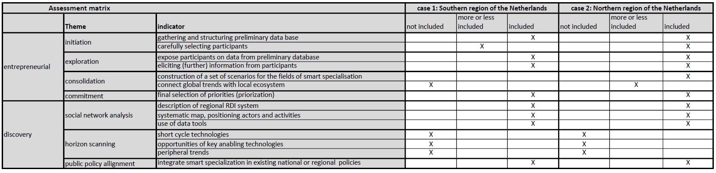
The assessment matrix (table 4) shows how well the EDP of the northern region complies with the concept of EDP of the theory (see chapter 2). It shows the ‘entrepreneurial’ element of the EDP of the norther EDP closely follows that of the theoretical concept of an EDP. There is an extensive preliminary database in the form of the different documents and the factsheets that are the building blocks of the smart specialisation. A large number of regional actors were involved in the EDP, representing all elements of the quadruple helix. The smart specialisation strategy was written cooperatively with regional actors while the regional governments assumed a more facilitating role. According to the regional actors this was a new situation, which called for regional actors to look beyond their own interests. The ‘discovery’ element of the EDP of the region is partly conform the theoretical concept of the EDP. The description of the RDI system is mostly based on the aforementioned factsheets about the top sectors. Even though the document RIS3 Noord does not include maps positioning actors and activities such maps are included in the advice by the SER which was used as building block for the smart specialisation strategy. The only missing component of the theoretical concept of an EDP in the regional EDP is a clear horizon scanning. The northern region’s EDP is mostly inward looking, with a heavy emphasis on the top sectors. This shows that the focus of the analysis is more in the regions owns strengths and less on the global opportunities. The final theme in the assessment matrix is the incorporation of the smart specialisation strategy in existing regional and national policy. The smart specialisation strategy is based on existing regional policy (as has been described before). Building on strategic choices made in these policy plans while adding more focus. The smart specialisation also incorporated national policy by using the top sectors of the national program ‘top sector policy’.

4.3.2 The southern region
As mentioned in chapter 4 the south-east part of the Netherlands already had a strong tradition of regional cooperation between actors and choosing priorities in a number of triple helix cooperations. The strategy Brainport 2020 was used as an example by the OECD of a successful smart specialisation strategy, even though it was not specifically drafted to be a smart specialisation. This shows that the principles of smart specialisation where already uphold and used in the south east region. However this strategy did not cover the whole area which the smart specialisation strategy needed to cover. Because the smart specialisation strategy was an ex-ante conditionality for the EFRD the national government decided to keep the demarcation of the regions (north, east, south and west) as was used for the previous operational plan (OP) of the period 2007-2014. Region south therefore had a strategy that was basically a smart specialisation, but this did not cover the whole region. Beside the Brainport 2020 strategy, other parts of the region south also had regional economy plans. This led region south to decide that it was not necessary to start up a new process of strategy formation, but instead to capitalize on existing material. According to the smart specialisation strategy south these include:
- Brainport 2020 strategie
- Strategic Board Zuidwest-Nederland Agenda
- provincial economic agendas and programs
- operational programs of the triple helix organisaties in the sub regions
- roadmaps and innovation contracts of relevant top sectors
- a number of researches and benchmarking reports
The challenge south was facing was to expand on the Brainport 2020 strategy to create a smart specialisation strategy that covers the whole area. The region drafted the following roadmap that leads to the creation of a smart specialisation strategy:
- take note of the RIS3 philosophy;
- decide on starting position and material;
- determine strategic base;
- RIS3 assessment, pre-test;
- fill-in, supplement and update where necessary;
- update quantitative substantiation;
- compilation of the strategic RIS3 base;
- develop a monitoring system;
- possible peer review/expert review RIS3 OP South;
- finalise RIS3 for OP South.
(translated from Dutch out of: RIS3 South, 2013)
There were two groups installed. One was a writers-group, tasked with developing the smart specialisation strategy and putting it on paper. This group consisted of representatives of the 3 provinces (Zeeland, Noord-Brabant and Limburg). The other group was a reference group in which businesses, knowledge institute and societal organisations were also apart. They were represented through triple helix organisations. The reference group had a meeting each time an intermediate product was finished. Notable intermediate products were the position paper, ‘houtskoolschets’ (charcoal schematic), RIS3 strategy and the 80% version of the OP South (OP South, 20..). The reference group was not only involved with the smart specialisation strategy but with the whole process that resulted in the OP Zuid.
The process of the development of the smart specialisation strategy for the region South will now be compared to the concept of entrepreneurial discovery as is described in the theory. For this purpose the assessment matrix has been filled in (see table X). First the ‘entrepreneurial’ element is addressed. The matrix shows that the northern case includes all themes except connecting global trends with the local ecosystem. You could argue that this element is included through the societal challenges. Which does connect global trends to the local context. However this theme should go more in depth, analysing where the region's strengths and opportunities in a global context. All other themes were included in the regions process of developing the smart specialisation strategy. Regional actors were involved in the process.
The second part of the assessment matrix focusses on the ‘discovery’ element. The first theme is the social network analysis. Social network analysis entails an analysis of the regional R&D activities. By mapping these activities regional actors should be able to identify their own position in the region related to other R&D activities. To present these data in an informative, comprehensive and easy communicable way Gheorghiu et al. argue for the use of data analytical tools. The southern region already had a large quantity of data and material because of the previous regional plans as a result of the triple helix cooperations. This data has been put together resulting in different maps of the whole region. In the RIS3 Zuid document a selection of these maps are used to reflect the regional assets (p. 9-20).
The second theme of discovery element is horizon scanning. The goal of horizon scanning is mapping emerging global trends. While the social network analysis focuses on region itself, horizon scanning focuses on trends outside the region. Both in the document RIS3 Zuid and in the process of entrepreneurial discovery south did not do an extensive horizon scanning. The only mention in the document RIS3 Zuid is a short reference to globalisation. However the RIS3 Zuid is largely based on existing material. In this material horizon scanning can be seen. For instance in the Brainport 2020 document a whole chapter is devoted to the following societal developments: shift of economic power, climate, energy, food supply, availability of raw materials, ageing and congestion). And also on the following trends in business: speed and new business models, increasing importance of public R&D, supply chains, open innovation, international alliances and sustainable and socially responsible business practice (Brainport 2020, 2011). Horizon scanning has not specifically been performed within the process of entrepreneurial discovery for the smart specialisation. This is however because of the already available strategy documents in the region in which horizontal scanning has been done.
The final theme of the process of entrepreneurial discovery is the alignment of the smart specialisation in existing national or regional policies. Triple helix cooperations are an important factor in regional policy in the region south. The document on which the document RIS3 Zuid is based reflects the regional policy. With national level the connection is made with the top sector policy. ‘There is clearly a complementary connection with national policy. South incorporates the topsector policy in the creation of the RIS3. The most important topsectors and topclusters for the Dutch economy are facilitated in the RIS3 by working on the ecosystem of knowledge intensive, innovative and sustainable economic top regions with focus and cooperation’ (translated from Dutch out of RIS3 Zuid, 2013). The priorities of the smart specialisation are a selection of the topsectors of the national policy. It is however unclear exactly what the impact of the smart specialisation strategy is on both regional policy. While some of the regional actors argue that the smart specialisation was a useful update of previous regional strategies others argue that the smart specialisation strategy main purpose was to comply to EU ex ante conditionality for the EFRD. The RIS3 is closely connected to the EFRD, however this is only seen as a small element of all the regional investments.
An important element of this existing material were interviews that had been held in south-east Brabant with businesses of the region. These interviews were not specifically performed for the smart specialisation. However they had the goal of mapping which sectors the region excelled in and which business opportunities the region had. This way businesses where they felt the government should focus on for stimulation innovation in the region.

4.3.3 Conclusions
Based on the analysis with the assessment matrix the following conclusions can be made:
- the process of creating the smart specialisation strategy in the regions has mostly follow the description of an EDP in the theory.
- the only element which is described by the theory but is missing in the regions is an outward looking component, referred to in the theory as horizon scanning
- although most elements of the theoretical description of the EDP are present in the region, it should be noted that these elements are often based on previous documents and consultations. It is therefore questionable how much elements of the EDP would already have been used in regional plans without smart specialisation.
- the ‘arbitrary’ scale of the southern region causes not all parts of the region to have had the same input in the EDP. The EDP in the Southern case was mostly based on the work of Brainport. Therefore Zeeland and Zuid Limburg felt less involved in the process

4.4 Effectiveness of smart specialisation
This paragraph addresses the question: how effective is smart specialisation in the cases at dealing with the cluster dilemma’s? The cluster dilemmas described in chapter 2 are dilemmas or obstacles with which previous regional policy struggled. This paragraph will focus on seeing how effective smart specialisation is at tackling these issues. For each dilemma will be analysed if and what conceptual means the theory about smart specialisation offers. Then the cases will be used to see if and how effectively these conceptual means are in practice at dealing with these dilemmas.

4.4.1 How to involve all relevant actors
This dilemma is about the issue of how to involve all relevant actors in your regional plan. The theory of smart specialisation has a clear view on this dilemma. The smart specialisation strategy should be the result of a cooperative process among all relevant regional actors (EU, 2012b). The entrepreneurial discovery process describes how this should be done. However there are still different ideas in development in the theory of smart specialisation of how this can be done (…). For instance Gheorghiu et al. (2017) argue for the use of concepts and tools from the foresight theory in the EDP, while Fellnhover (2017) speaks of the possible benefits of online mechanisms in order to stimulate stakeholder engagement in the EDP.
In the previous paragraph (5.3) a description is given of how the smart specialisation was created in both cases. The conclusion that can be drawn from this analysis is that a large number of regional actors were involved in the process of creating a smart specialisation strategy. The interviews with regional actors in both cases confirms this view, showing that in both cases smart specialisation is widely accepted and endorsed by all actors who participated in the entrepreneurial discovery process.
However a few issues become apparent in the interviews with regional actors. For the southern case the geographical scale of the region result in some issues. The southeastern part of the region (the area surrounding Eindhoven and Helmond) have had a longer tradition of regional cooperation in multiple triple helix contexts. In these triple helix organisation regional and local governments, businesses and knowledge institutes work together towards a stronger regional economy. Also societal partners and users are increasingly more involved in the triple helix organisations. Through these triple helix organisations the southern region already had a broad basis of consultation with regional actors through the form of interviews. Also this region already had a strategic plan which was basically a smart specialisation strategy: the Brainport 2020 Strategy. Because of this the southeastern part of the region took the central role of developing the smart specialisation strategy of the southern region. The southwestern part of the region (Zeeland and Brabant) and southern part (South Limburg) did not have this advantage. For the province Zeeland this even meant that no regional actors were directly involved in the proces. Instead regional government and the regional development organisation Impuls Zeeland represented the regional actors. While they have close connection with the regional stakeholders it is questionable if they can convey all strategic information that stakeholders poses. The northern region did not have this problem of scale the southern region had since the northern region was already organized in this geographical region in the ‘Samenwerkingsverband Noord Nederland’ (Cooperation of the Northern Netherlands or SNN). Regional actors did see some geographical differentiation in activities. However this did not lead to major problems, arguably because all these different parts were involved in the process early on. Thus the geographical scale offers some problems for the development of the smart specialisation strategy. There is a no clear definition what the geographical scale should be for the smart specialisation.

4.4.2 What is the role of the different policy makers
This dilemma focuses on the role of the different layers of policy makers. The role of policy makers is often criticized as bottom-down without any idea what is going on on the ground. The EU is the policy level on which the theory has been turned into a policy tool. The EU also sets the ex-ante conditionalities. Basically telling the regions in what way the smart specialisation should be developed and what the resulting smart specialisation strategy should look like. However the EU do not limit the region in their strategic choices. The role of the national government in the creation of the smart specialisation strategies is small. The desk research of the policy documents show that the national government functions as a bridge between EU and regional policy level. Taking note of what the EU expects and passes this down to the regional governments. This way the main function of the national government was to help regions create their smart specialisation strategies conform the EU ex ante conditionalities. The only real input of the national government was to stimulate the regions to connect the smart specialisation strategy with the national policy programme Top Sector Policy. The ex-ante conditionalities of the EU did stimulate the regions to develop their smart specialisation strategy in a bottom up manner.
The two cases central in this research did create their smart specialisation strategies according to the norms of the EU and national government. The interviews with regional actors did confirm that the role of policy makers was limited, serving a more facilitating role.

4.4.2 Which priorities are chosen and which are left out
This dilemma involves around the question of which activities a region should focus on. The critique with this issue is that regions tend to copy successful cases. However because of different circumstance this might not be the best choice for each region.
According to the theory choice of priorities should be the result of two elements. The first element consist of an inward looking analysis. Mapping the regional strengths and weaknesses (a SWOT analysis is used in many regions). The second element is an outward looking element. The selection of priorities should also be based on how good a region is compared to the rest of the world. Gaining a competitive advantage is often mentioned as one of the goals of the smart specialisation strategy. This outward looking perspective is important to judge how much potential certain activities have for your region.
On this point interviews resulted different point of views. One issue which seems to be seen different by regional actors is how much focus the smart specialisation strategy brings. Generally the idea seems to be that the smart specialisation strategy gives a more narrow focus. But the priorities are still vague enough that most projects can one way or another fit in the smart specialisation strategy.
In the southern region yet again the scale of the region seems to result in a problem. Because of the differences that exist between the southeastern and southwestern region there are different priorities for these parts of the region. For the southwestern area activities as water management, leisure economies and logistic are of importance. While the sector High Technology Systems and Materials (HTSM) is of far lower importance for the southwestern part while this is one of the main activities of the southeastern part of the southern region. The difficulty lies thus with the difference between the region itself. Not just organisatorisch (as has been previously described) but also on substantively points. Another way the difference in the region itself might be problematic is the level of excellence. One regional actor argues that while smart specialisation focuses on making excellent priorities even more excellent maybe it is better to focus on making good priorities better.
Another issue with choosing priorities is which criteria to use. It is not just based on how large the share of that sector is for the region. Of importance is also how well other regions perform. The sector creative industry was not included in the smart specialisation of the southern region, even though there is a substantive sector located around Eindhoven. But this sector cannot compete with the creative industry sector located in the Randstad. However from both regions regional actors raise concerns when it comes to excluding activities. Especially when the regional economy is already facing difficulties it seems not logic to exclude certain activities because they might not fit a regional plan.

4.4.4 Focus on traditional or new activities
The final dilemma is if regional research and innovation plans should focus on traditional or new activities. Traditional activities are generally industries which have a large presence in the region. Because of this traditional activities are responsible for economic activities and job opportunities. However new activities are activities where the biggest opportunities are. They offer a more viable option for future success. Both activities have a role to play in the regional economy. The dilemma is on which type of activity regional policy should focus.
One of the advantages that the smart specialisation offers is that it connects what the strengths and weaknesses of a region are with opportunities. This way new activities are found that have connections with traditional activities. It is therefore never an outcome of a smart specialisation strategy to focus on an entire new activity. While that activity might be promising, if the region has no affinity with this activity it will not be a part of the smart specialisation strategy. But this also means that when an activity might be strongly present in the region but does have little promise for the future it is also excluded. If executed correctly the smart specialisation strategy will also look at where future opportunities are. This is an important criteria when choosing priorities, excluding traditional activities if they are at the end of their economic success.
However regional actors do not seem to find this dilemma urgent. They still seem reluctant to exclude traditional activities from regional plans. An example in the northern case is the tourism and recreation industry. It is not chosen as one of the clusters that is relevant for the smart specialisation strategy. However it still fits in the smart specialisation strategy through the societal challenge ‘health, demographic and wellbeing’.
Thus the smart specialisation concept is a helpful tool in dealing with this dilemma. The strength of smart specialisation concept is that it does not focus on either traditional or new activities per se. It does provide a framework which helps evaluate how important and successful certain activities might be for that specific region. Regions who have the capabilities to focus on new promising activities have the opportunity to do so. While regions in which these new activities have a low chance of succeeding should realise this through the smart specialisation strategy. However the reality is that regional policy still seems hesitant to leave traditional activities out of regional plans.

4.4.5 Conclusions
The analysis leads to a few conclusions regarding effectiveness of smart specialisation of dealing with cluster dilemmas:
- smart specialisation offers conceptual tools to deal with the cluster dilemma's
- regional actors are positive about the smart specialisation strategy itself. They have different ideas how smart specialisation might be improved
- conceptually smart specialisation is still in development, with new elements and tools only recently being introduced in the theory (such as foresight toolkits and online mechanisms)
- lack of a clear definition of the geographical scale on which the smart specialisation strategy should be focused
- almost all regional actors content with the RIS3 strategy, however there are different ideas of how the RIS3 should be used
- regional governments apprehensive to exclude activities in the smart specialisation strategy

Chapter 5 Conclusion
In this final chapter the research will come to a conclusion. First the results of the research are shortly recapped. The analysis and the conclusions already drawn in the analysis will then make it possible to formulate an answer to the main research question. This chapter will end with a reflection on this research, policy recommendations and recommendations for future research.

5.1 Short recap of the research
The issue central in this research is the supposed difference of the concept of smart specialisation in theory and smart specialisation in practice. While the concept was relatively new, the EU already made smart specialisation strategy an ex-ante conditionality for the European Fund for Regional Development. Therefore the theoretical debate about the principles and tools of smart specialisation was still ongoing when regions already started to develop and implement their own smart specialisation strategy. But because theory was still unclear about certain elements of smart specialisation policy makers were forced to find their own interpretation. According to the literature this resulted in a bridge between how smart specialisation was understood by theorists and by policy makers. The goal of this research is to help bridge this gap between smart specialisation in theory and in practice. This leads to the following main research question:

Are smart specialisation strategies in the Netherlands developed according to the entrepreneurial discovery process that is described in the theory, and is this process and the resulting smart specialisation strategies experienced as beneficial and effective by policy makers and regional actors?

To help guide this research towards answering the main research question six additional research questions have been drafted. The first two research question are: Why and how was the concept of smart specialisation developed? and What is the theoretical definition of smart specialisation, and particularly the entrepreneurial discovery process? Both questions are answered in chapter 2 where the literature about smart specialisation has been used to create a theoretical outline which explains the theoretical principles and features of smart specialisation.
The next research question is: Is there any difference in the way that the different levels of governance (EU, national and regional) understand smart specialisation? For this question the concept of policy rationales was used. Policy rationales are the underlying ideas and assumptions that steer the policy makers actions. For each of the three different policy level (EU, national and regional) a policy rationale is derived based on a literature study of policy documents and further supplemented by interviews with regional actors. This resulted in a number of findings. First that the policy rationale of the national government does not deviate much from the policy rationale of the EU. The role of the national government is mainly to help the regional actors understand the concept of smart specialisation and develop the smart specialisation according to the ex-ante conditionalities of the EU. The analysis has shown that there are differences in the policy rationales of the EU and the region. For the EU the smart specialisation offers a way to use public funds more effective, offering a way to cope with the effects of the economic crisis. Also the EU wants to use smart specialisation to create more diversity between regions in Europe. This means that according to the EU the regions should focus only on those areas and activities in which regions might hope to gain a comparative advantage. In contrast regions remain more inward focused. An analysis of global trends and changes are missing and a comparison of the weakness and strengths of the regions with other regions are not mentioned. Also an important rationale of the regions is the traditional, horizontal policy measures. This means that regions are apprehensive to exclude certain areas or activities beforehand. They rather stick to a broad regional development plan instead of specialising in only a few selected areas.
The next two research questions both relate to the entrepreneurial process of discovery: How has the smart specialisation strategy been developed in the two Dutch cases? and What are the differences between the theoretical idea of entrepreneurial discovery, and how the process of entrepreneurial discovery was implemented in the two Dutch cases? These questions were answered with the help of the assessment matrix that was created based on the theoretical framework of chapter 2. The assessment matrix showed that the development of the smart specialisation strategies in the two cases is mostly according to the entrepreneurial discovery process described in the theory. However an outward looking element (in the theory referred to as horizon scanning) is missing in the two cases. Also the analysis showed that the smart specialisation strategies of both regions were based partly on previous documents or consultations. Most elements of the concept of entrepreneurial discovery were not new and did not have much impact on regional policies. However in the southern case the geographical scale of the region did complicate the entrepreneurial discovery process. Especially Zeeland, west-Brabant and south-Limburg are not part of the region covered by Brainport and had less experience with triple helix type of collaborations.
The final research question is about the effectiveness of the smart specialisation concept: How effective is smart specialisation in the cases at dealing with the cluster dilemma’s? The cluster dilemmas described in chapter 2 are central in answering this research question. This analysis has shown that the concept of smart specialisation is effective and useful for dealing with the cluster dilemmas. Regional actors are positive of the entrepreneurial discovery project and the resulting smart specialisation. However the main problem seems to be how the smart specialisation strategy can be used so it remains relevant for the region. In the current setting the main purpose of the smart specialisation strategy seems to be to distribute the European Funds for Regional Development. Due to the relative small budget of the European Funds for Regional Development for more advanced regions this is seen by regional actors in the two cases as barely worth it. However the analysis has shown that the concept of smart specialisation is still being developed and improved.

5.2 Conclusions
The main research question can be split up in two elements. The first element is the development of the smart specialisation strategy. This research leads to the conclusion that the development of the smart specialisation in the 2 Dutch cases is mostly as how the theory describes an entrepreneurial discovery process. The only element which is missing or lacking in practice which is deemed important in the theory is an outward looking element. In the theory about smart specialisation an outward looking element has an important role. The goal of smart specialisation is to help regions focus on a selection of priorities in which they can become globally competitive. Because of this the theory suggest that it is not enough to look at the region's own strength. The regions strengths also needs to be compared with the situation outside the regions borders. However it was also discovered that even though different elements of the entrepreneurial discovery process were indeed in some time done in the regions, it was not one single process. The entrepreneurial discovery process in both cases consisted of consultations and analyses that were already conducted. There were meetings organized specifically for the smart specialisation strategy, but not all input was gathered specifically for that process. Especially material about the own regions strength, based on analysis and consultation of regional actors was already available in both cases. This leads to the conclusion that the entrepreneurial discovery process can be seen as an effective concept to create a regional strategy. However since regions in the Netherlands already develop regional strategies with some of the principles of smart specialisation, the entrepreneurial discovery process did not lead to major changes. Regional actors rather felt that they had to adapt existing material in a way that fit with the EU’s ex-ante conditionalities. The main motivation for the regions enter an entrepreneurial discovery process seems to be that it was required by the EU for the European Funds for Regional Development.
An important analytical concept in understanding and explaining the different perspectives of policy makers about smart specialisation are the policy rationales. The policy rationales, derived from policy documents, show the institutional roles that policy makers on different levels adapt. This has revealed that the policy makers on EU level are mainly concerned with improving the EU as a whole. From this perspective regions should only specialize in areas or niches unique for that region with which they can compete globally. This way regions in Europe complement each other, instead of competing with each other. Regions are required to have an outward looking perspective and use this perspective to make a prioritization of areas on which to focus. However the main concern of policy makers on regional level is the regions welfare. There main interest is what is happening in their region. They are not keen on making prioritizations but rather keep a broader scope. Therefore regions do not really specialize but rather create a more traditional broad development strategy.
A final observation about the development of the smart specialisation strategy is that in the southern case the geographical scale of the region resulted in some difficulties. In the southern region the southeastern area is connected in the triple helix organization Brainport. In the area surrounding Eindhoven and Helmond is a large agglomeration of R&D companies. This region has experience with smart specialisation type strategies. The strategy document ‘Brainport 2020’ was recognized by the OECD as a document developed and featuring the principles of smart specialisation. But when the smart specialisation strategy had to be created it had to cover the whole southern area. The main obstacle of the southern region was not per se to create a smart specialisation strategy, but to incorporate the south western region in the strategy. As a result the south western part of the region had to jump in a process of regional development that was already way ahead. This caused an uneven balance in the entrepreneurial discovery process. This reveals the issue of what scale to choose. National governments are free to choose the scale and number of regions in their country. In the Netherlands there is chosen for four regions (north, east, south and west). However in some cases this demarcation seems to be artificial and not logical. For example the province Zeeland is has many connections with its neighboring province South-Holland. But because of the chosen regions, Zeeland and South-Holland are in a different region, while Zeeland is in the same region as South-Limburg, which is geographically in a completely different part of the Netherlands.
The second element of the research question focuses on the impact and effectiveness of the smart specialisation strategies. The smart specialisation is seen as a concept with effective conceptual tools. Especially the entrepreneurial discovery process is helpful in making strategic choices with all relevant actors. The entrepreneurial knowledge is provided by regional actors, policy makers are required to use this knowledge instead of developing a regional plan by themselves. The main principles of smart specialisation, and especially the entrepreneurial discovery process do offer solutions to the cluster dilemma’s. It should also be noted that the concept of smart specialisation is still in development. New conceptual tools are being developed in theory (for instance the role of digital platforms and elements of foresight theory in the entrepreneurial discovery process). Which means that the usefulness of smart specialisation might be further improved. It is however observed that not all aspects of the theoretical concept translate that well to policy practice. For example the two issues previously mentioned of regional policy makers being reluctant to add focus on the chosen priorities and the lack of an outward looking element in the analysis.
The final part of the main research question is how effective the regional actors and policy makers consider the smart specialisation concept. It is noteworthy that all regional actors are positive about their own smart specialisation strategy. In this way the entrepreneurial discovery process seems to have created support and a sense of ownership from the regional actors. However there are different ideas of what the exact role of the smart specialisation strategy is and/or should be. There is a consensus among regional actors that the current role of smart specialisation as distribution mechanism of the European Funds for Regional Development is insufficient. This is also because the budget for the Netherlands of the European Funds for Regional Development is relative small compared to other European programs (such as Horizon 2020). It is likely that the ex-ante conditionalities for the European Funds for Regional Development are the most important reason for the Dutch regions to create a smart specialisation strategy. At this moment smart specialisation can be seen as a promising theoretical concept that does not yet work perfectly in the Dutch cases. This is mainly because these regions already develop regional plans according to the principles of smart specialisation. And because the smart specialisation strategy is currently mainly being used as a distribution mechanism for the European Funds for Regional Development.

5.3 Policy recommendations
This research led to different insights and ideas of how the practice of smart specialisation in the Netherlands might be improved. Ideally the smart specialisation strategy is a vision document for the entire region which affects choices of where the region should focus their research and development investments on. To share these ideas with policy makers 3 policy recommendations will be formulated.
- The first policy recommendation is that the exact role of smart specialisation strategy in regional policy should be made more clear. It is interesting to note that almost all regional actors support the smart specialisation strategy of their region, but ideas of the exact role of smart specialisation differ widely. Smart specialisation should be more than just a distribute mechanism for the European Funds for Regional Development. This is how smart specialisation is perceived at the moment, which is insufficient due to the relative small budget of the European Funds for Regional Development for more developed regions. One option is to broaden the scope of smart specialisation. This way smart specialisation could be transformed to a regional development strategy, instead of focusing just on a few selected priorities. Another option might be to add more focus to the strategies. This is in line with the theory, however in practice it does not yet happen. By adding more focus smart specialisation focuses only on those selected niches which have the most potential to grow. By doing so smart specialisation can exist alongside broader regional development strategies.
- The second policy recommendation is that the national government should be more involved in ensuring that regions add more depth in their prioritization. The regions should use the smart specialisation strategy to focus more on the most promising areas and activities in their region. Development of traditional industries is still achieved by other regional or local development policies. Also the national government should ensure that regions add an outward looking perspective in their analysis. This is the only element that is currently absent in the policy practice of both cases.
- The third policy recommendation is that the scale and the timeframe of the smart specialisation strategies should be reconsidered. The southern case illustrates the problems that can be the result of demarcation of the region. The difficulty of creating a demarcation of regions that is both logical and covers all of the Netherlands is however understandable. The timeframe of the strategies is also an issue. Regions are afraid that new opportunities due to technological changes might occur on a shorter timeframe than the smart specialisation strategy currently cover. Therefore the smart specialisation strategy might not allow for funding of these new opportunities. Updating of the strategy, or allowing room for these new opportunities in the strategy is therefore seen as important. At the same time the effectiveness of such strategies are only observable after many years. Which means that no drastically changes should be made to these strategies to soon.

5.3 Reflection on the research
The main aim of this research was to compare the theory with practice. For this it is necessary to first acquire a clear idea of how smart specialisation is depicted in the theory. However I realized when I was developing the theoretical framework that the line between theory and practice is not always crystal clear. The EU was closely involved in development of the smart specialisation. The expert group Knowledge For Growth, while consisting of independent experts, was established by the EU. The first ideas brought forward by this group was theoretical. But they were then asked to help regions understand the concept of smart specialisation and advice regions on how to develop and implement smart specialisation. The resulting ‘RIS3 Handbook’ was more policy than theory oriented. The role of Dominique Foray is illustrative for this issue. He is a renowned researcher who is seen as one of the most important founder of the smart specialisation concept. As a researcher he has published different papers about the theoretical concept of smart specialisation and underlying ideas and principles. He is however also closely involved in EU’s efforts to transform this idea to a policy understandable and usable by regions in Europe. This illustrates the close connection that sometimes exist between theory and practice. The way in which I formulated the research goal and research question presumes a clear distinction between theory and practice. But the reality is less black and white. However I do think that I was able to make a clear distinction between theory and practice. In the future I might be more aware of the complicated relation between these two elements.
Another point of reflection is about the desk research of the policy documents. The literature study used to derive the policy rationales did prove to be a helpful tool. It did reveal the policy rationale of different policy levels. However using this analytical tool also has its limits. It is not always possible to find viable policy documents. Therefore an extensive search of the available policy documents and a careful selection of which documents to analyse is paramount. Because of the collaboration with the ministry of Economic Affairs I was able to find policy documents about smart specialisation from the national government. However this would otherwise have been difficult, if not impossible. Also the analysis of the resulting policy schemes requires a lot of interpretation of the researcher. Therefore it is unwise in my opinion to draw conclusions based only on a desk research. The interviews with regional actors allowed me to triangulate the results of the interviews with the desk research and vice versa. This way it was possible to verify the results of the desk research.

5.4 Recommendations for further research
While this research has answered the main research question, it also leads to new questions. The specific focus of this research was on the development of the smart specialisation strategy. The relation of the smart specialisation strategy with other policy was briefly mentioned when necessary. The entrepreneurial process of discovery entailed a detailed analysis of the region's profile and a list of priorities which are most promising for the region. While it is currently only coupled to the European Funds for Regional Development ideally it steers all R&D related activities in the region. An interesting subject for further research might be how much impact the smart specialisation strategy has on the region. This research has shown that the smart specialisation strategy itself is widely supported and endorsed by regional actors. However interviews with regional actors show that the operational plan (that comes after the smart specialisation strategy) is already less supported by regional actors than the smart specialisation. This raises the question if and what the impact of the smart specialisation is. It is however debatable when the impact of the smart specialisation strategy might be expected to be seen. If the timeframe is still too early it might also be useful to look at the impact of smart specialisation in subsequent policy (documents).
Another recommendation is to research how the entrepreneurial discovery process takes form in less developed regions. The smart specialisation is part of Europe’s cohesion policy aimed at closing the gap between economic strength of different European regions. The starting point of the smart specialisation concept was help create a concept that allowed weaker regions to catch up with more developed regions. This research showed that the developing of the smart specialisation in the two cases was almost completely as described in theory. However this was partly due to the fact that certain values of the EDP (bottom up, based on regions strength, etc.) were already apart of regional policy in the Netherlands. This might not be the case in Eastern-European countries with less institutional frameworks. The concept of EDP might be ‘newer’ to them which may lead to different results. This might either mean that these regions benefit more from this concept or that they are less capable of using this concept.

Literature
Adviesraad voor Wetenschap, Technologie en Innovatie(AWTI)(2014) Regionale Hotspots, Broedplaats voor Innovatie. Quantes, Den Haag.
Aranguren, M. J., Wilson, J. r. (2013) What can experience with clusters teach us about fostering regional smart specialisation? Ekonomiaz, June, 2013.
Atherton, A. (2003) Examining Clusters Formation from the ‘Bottom-up’: An Analysis of four cases in the North of England. Environment and Planning C: Government and Policy, 21, p. 21-35.
AWTI (2016) Balans van Topsectoren 2016. Advies voor Wetenschap, Technologie en Innovatie. Den Haag, juli 2016.
Barca, F. (2009) An Agenda For a Reformed Cohesion Policy, A place-based approach to meeting European Union challenges and expectations. Independent report.
Brainport Development (2011) Brainport 2020, Top Economy, Smart Society. Eindhoven, 2011.
Bruijn, P., Lagendijk, A. (2005) Regional Innovation Systems in the Lisbon Strategy. European Planning Studies, 13:8, p. 1153-1172.
Burfitt, a., Macneill, S. (2005) The Challenges of Pursuing Cluster Policy in the Congested State. International Journal of Urban and Regional Research, vo. 32.2, p. 492-505, June 2008.
Carayannis, E. G., Rakhmatullin, R. (2014) The Quadruple/Quintuple Innovation Helixes and Smart Specialisation Strategies for Sustainable and Inclusive Growth in Europe and Beyond. Journal of the Knowledge Economy, 5.212-239.
Damen-Koedijk (2016) EU Cohesion Policy & Accountability, Coverage, Context, Content & Costs in the case of ERD in the Netherlands. Universiteit van Twente.
Doloreux, D., Parto, S. (2004) Regional Innovation Systems: A Critical Synthesis. Intech, Discussion Paper Series, 2004-17.
Ebbekink, M., Hoogerbrugge, M., Lagendijk, A., Kerkhof, J. (2015) Cluster Governance, Lessen voor clusters in Nederland. Platform 31.
EL&I (2011) Naar de top, Het bedrijvenbeleid in actie(s). Ministerie van Economische zaken, Landbouw en Innovatie.
European Commission (2010a) Communication from the commission to the european parliament, the council, the european economic and social committee and the committee of the regions, Regional policy contributing to smarth growth in Europe 2020. Brussels, 553.
European Commission (2010b) Europe 2020, a strategy for smart, sustainable and inclusive growth. Brussels 2010.
European Commission (2014a) An introduction to EU Cohesion Policy 2014-2020.
European Commission (2014b) National/Regional innovation strategies for smart specialisation (RIS3). Cohesion Policy.
European Union (2011) Regional policy for smart growth in Europe 2020. EU publications Office, Brussels.
European Union (2012a) Consolidated versions of the Treaty on European Union and the Treaty on the Functioning of the European Union. Official journal of the European Union, C326, Volume 55.
European Union (2012b) Guide to Research and Innovation Strategies for Smart Specialisations (RIS3). European Union, Luxembourg.
Eurostat (2016) Smarter, greener, more inclusive? Indicators to support the Europe 2020 Strategy. 2016 edition, Luxembourg: Publications Office of the European Union, 2016
Gianelle, C. D., Kyriakou, C., Cohen and Przeor, M. (2016) Implementing Smart Specialisation Strategies, a handbook. European ommission, EUR 28053.
Fagerberg, J. (2017) Innovation policy: Rationales, challenges and lessons. Journal of Economic Surveys, Oxford and Malden, vol. 31, no. 2, p. 497-512 (2017).
Flemish government (2013)
Foray, D., David, P.A., Hall, B. (2009) Smart specialisation – The Concept. Knowledge Economists Policy Brief No. 9, June, 2009.
Foray, D., Rainoldi, A. (2013) Smart Specialisation programmes and implementation. Joint Research Center, No. 02/2013.
Foray, D. (2016) On the policy space of smart specialisation strategies. European Planning studies, 24:8, p. 1428-1437.
Florida, R. (1995) Toward the learning region. Futures, Vol. 27, no. 5, p. 527-536.
Isaacson, W. (2011) Steve Jobs, the Biography. Spectrum.
Kroll, H. (2015) Weaknesses and Opportunities of RIS3-type Policies. Frauenhofer Institute for Systems and Innovation Research ISI. Karslruhe.
Knowledge for Growth (K4G) (2008) Knowledge for growth, European Issues and Policy Challenges.
Knowledge for Growth (K4G) (2009) Knowledge for growth, Prospects for science, technology and innovation. November, 2009. Belgium.
Lagendijk, A., Cornford, J. (1999) Regional institutions and knowledge - tracking new forms of regional development policy. Geoforum 31 (2000): 209-218
Laranja, M., Uyarra, E., Flanagan, K. (2008) Policies for science, technology and innovation: Translating rationales into regional policies in a multi-level setting. Research Policy, no. 37, p. 823–835, 2008.
Larking, P. J. (2016) Public choice theory, And occupational Licensing. Harvard Journal of Law and Public Policy, vol. 39 no. 1 (2016): 209-331.
Liebert, M. A. (2017) The Vanguard Initiative, Boosting Innovation Deployment. Industrial Biotechnology, vol. 13, no. 1, February 2017.
Lindqvist, G., Ketels, C., Sölvell, ö. (2013) The Cluster Initiative Greenbook 2.0. Ivory Tower Publishers, Stockholm.
Marshall, A. (1890) Principles of Economics. Macmillan and Co., London.
McCann, P., Ortega-Argile´s, R. (2016a) Smart specialisation, entrepreneurship and SMEs: issues and challenges for a results-oreinted EU regional policy. Small Business Economics, no. 46: 537-552.
McCann, P., Ortega-Argile´s, R. (2016b) Smart Specialisation: Insights from the EU Experience and Implication for Other Economies. Journal of regional research, no. 36: 279-293.
Midtkandal, I., Sörvik, J. (2012) What is Smart Specialisation? Norwegian News, issue 5, 2012.
Ministry of Economic Affairs and ministry of Education, Culture and Science (2013) Dutch solutions to worldwide challenges. Vijfkeerblauw.
Morgan, K. (2013) The regional state in the era of Smart Specialisation. Ekenomiaz, No. 83, 2013.
OECD (2013) Innovation-driven Growth in Regions: The Role of Smart Specialisation. OECD Publications, Paris.
Palazuelos (2005) Cluster: Myth or Realistic Ambition for Policy-makers? Local Economy, vol. 20, no. 2, p. 131-140, May 2005.
Peter Berkowitz, Eric Von Breska, Jerzy Pieńkowski and Angel Catalina Rubianes (2015) The impact of the economic and financial crisis on the reform of Cohesion Policy 2008-2013. European Commission, working papers, 03/2015.
Porter, E. (1990) Competitive advantage of nations. New York, Free Press.
Stimulus (2013) Smart Specialisation Strategy, RIS3 Zuid, De kunst van het combineren.
Stimulus (2014) Operationeel Programma Zuid-Nederland 2014-2020. Europees Innovatieprogramma Zuid-Nederland, versie 24 oktober 2014.
Swann, G. M. P., Prevezer, M., Stout, D. (1998) The dynamics of industrial clustering: International comparisons in computing and biotechnology, Oxford, Oxford University Press.
Tullock, G., Seldon, A., Brady, A. L. (2002) Government failure, a primer in public choice. Cato institute, Washington, 2002.
Verschuren, P. J. M., Doorewaard, J. C. A. M. (2007) Het ontwerpen van een onderzoek. Boom Lemma Uitgevers, Den Haag.
Wolf, C. (1990) Markets or Governments: Choosing Between Imperfect Alternatives. Cambridge, The MIT Press, September 1990.

Appendix 1: interview guide
To help understand how the interviews where (generally) structured an interview guide is provided in this appendix. This interview guide was used as the basis for each interview. However for each interview the interview guide was adjusted to better fit the function and knowledge of that specific interviewee.

Was there a need for a new type of regional innovation strategy
- How was the regional innovation policy shaped before the smart specialisation strategy
- How does the smart specialisation strategy relate to existing regional policy
- What were the expectation of smart specialisation

How was the process of smart specialisation developed?
- How were all actors involved in the process
- What was there input
- What was there impact on the final smart specialisation strategy
- How valuable was this input from actors
- What was the role of the national and local governments
- Was the geographical scale good for the smart specialisation
- How was the analysis about the regions strength and weakness conducted
- How are the strategic choices in the smart specialisation strategy made

What is the impact of the smart specialisation strategy
- What are the consequences of the strategy for the region
- Did it effect cross overs in the region
- Did it effect cross border cooperation

What is your opinion of the smart specialisation as a concept
- Is it innovative
- Did it bring something new
- Is there something missing

How should smart specialisation be shaped in the future
- Is there a role for smart specialisation in the future
- What changes should be made to the concept of smart specialisation

Appendix 2: table of interviewees

