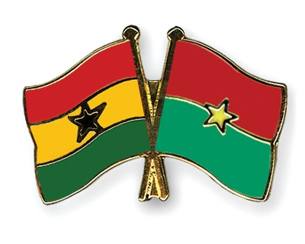
Climate change and conflict in Ghana and Burkina Faso

A case study analysis of the relationship between climate change and conflict in Ghana and Burkina Faso

MASTER THESIS

Student: David Dortmans – s4799763
Supervisor: Dr. H. W. Bomert
Human Geography: Conflict, Territories and Idenitities
Radboud University Nijmegen

June, 2021

Abstract
This thesis focusses on a theoretical model which tries to conceptualize the relationship between climate change and conflict in Ghana and Burkina Faso. The research presumes that there is an indirect relationship between these mechanisms, namely that climate change has a negative impact on resource availability and that it has a negative influence on performing livelihood practices for locals. This causality is expected to have a social effect. Examples of this are economic instability, political instability, migration and extremism. The aim of this research is to understand if the social effects occur as a result of climate change, and if these social effects trigger violent conflict. The climate in Ghana and Burkina Faso has changed drastically during the last couple of decades. Change in precipitation and rainfall patterns are clearly visible in meteorological data. These changes in climate lead to resource scarcity. This development affects people and causes economic instability and migration. These two developments can be seen as the main triggers for violent local conflict, as economic instability and migration lead to a destabilization of the region’s status-quos. Furthermore, the threat of violence as a result of religious extremism is more and more present, mainly occurring as a spill-over effect from Mali.

Foreword
I have written this thesis to conclude my master in Human Geography: Conflict, Territories and Identities. The process of writing this thesis has been different from what I expected, as the COVID-19 crisis emerged during this period. This crisis had consequences for writing the thesis, as it forced me to stay in the Netherlands. I was not able to conduct field research, something I looked forward to doing prior to writing this thesis. Despite this disappointment, my interest in the topic did not change, and I decided that I did not want to change the topic of my thesis. It did mean that I had to be more creative in gathering data, as most of the contact with experts in the field now had to be conducted via online communication and the plan of executing a survey with local people was thrown out of the window very quickly. All these factors meant that the whole process was a little less enjoyable, but I still think that I learnt a lot, both about the topic as about doing research in general.
During the process of writing this thesis, I have received a lot of help from different people who have contributed massively, and I would like to thank them for that. First of all, I want to thank my supervisor Dr. Bomert, who was always quick to respond to my questions and provide feedback during the whole process of writing this thesis. Secondly, I would like to thank my friends and peers who have provided ideas, solutions and valuable feedback when I did not know how to proceed during the process. Thirdly, I would like to thank all the people who were willing to help me with providing contacts and information, and to the people who were willing to be interviewed. The information I gathered from those people was essential for this thesis.

Table of contents

Abstract 2
Foreword 3
Table of contents 4
Chapter 1: Introduction 6
1.1 Problem definition 6
1.1.1 Applying the problem to Ghana and Burkina Faso 8
1.2 Scientific relevance 9
1.3 Societal relevance 9
1.4 Research questions 10
Chapter 2: Theoretical framework 11
2.1 Climate change and conflict 11
2.2 Climate change and migration 13
2.3 Research model 15
2.4 Conceptual framework 15
Chapter 3: Outline of context for Ghana and Burkina Faso 16
3.1 Geographical location 16
3.2 Climate change in Burkina Faso 16
3.3 Climate change in Ghana 18
3.4 The north-south divide in Ghana 19
3.4 Social effects 19
3.4.1 Political and economic instability 20
3.4.2 Climate change and migration in Ghana and Burkina Faso 21
3.4.3 Land ownership 22
3.4 Conflict 23
3.4.1 Triggers for interstate and intrastate conflict in Ghana 23
3.4.2 Triggers for interstate and intrastate conflict in Burkina Faso 23
Chapter 4: Methodology 25
4.1 Research methods 25
4.2 Data collection 29
4.3 List of interviewed people 30
Chapter 5: Analysis and results 31
5.1 Ghana 31
5.1.1 North-south divide in Ghana 31
5.1.2 The division of water between energy in the south and agriculture in the north causes concerns on a security-level in Ghana 33
5.1.3 Management of regional water sources poses a threat for instability in Ghana 35
5.1.4 Economic instability emerges in Ghana as a result of climate change 35
5.2 Burkina Faso 37
5.2.1 Water availability and water quality are main concerns in Burkina Faso 37
5.2.2 The tensions between pastoralists and agricultural communities pose a threat for conflict in Burkina Faso 38
5.2.3 Declining rainfall and erratic rainfall negatively influence food security in Burkina Faso 40
5.3 Applicable to Ghana and Burkina Faso 42
5.3.1 Border instability between Ghana and Burkina Faso emerges as a result of climate change 42
5.3.2 External and internal migration occurs as a result of climate change in Ghana and Burkina Faso 42
5.4 Other possible threats 43
5.4.1 The danger of a rising sea level 43
5.4.2 The threat of desertification 44
5.4.3 The threat of religious extremism 45
Chapter 6: Conclusion & Recommendations 48
6.1 Conclusion 48
6.2 Limitations and recommendations 52
Bibliography 54

Chapter 1: Introduction

Problem definition
Climate change is the world’s first real global man-made environmental problem and a firm warning that human activities can influence our physical environment on a global scale (Gleditsch, 2012). Literature on climate change and conflict shows that the relationship between climate change and the debate on its security implications has intensified (Scheffran et al., 2012). If the historical trend regarding the link between rainfall and social conflict continues, we will most likely see more (societal) conflict in the future (Hendrix & Saleyhan, 2012). An example of why and how climate change can trigger conflict has been put forward by Buhaug (2016), who argues that, among other things, rising temperatures, shifting precipitation patterns, and more extreme weather events threaten to undermine local and global food security by reducing renewable surface water and groundwater resources in most dry and subtropical regions. These worsening conditions can trigger conflict. Based on their findings, Hendrix & Glaser (2007) suggest that inter-annual variability in rainfall is a more significant determinant of conflict than climate, land degradation, and freshwater resources. At a national level, less rainfall or higher temperatures could lead to conflict among consumers of water, e.g. farmers and herders, as well as to urban unrest, insurrections, and other forms of civil violence, especially in the developing world (Koubi, 2019).
It is clear that developing countries are the most susceptible to climate change impacts (Reid, 2014). Their economies are heavily dependent on those sectors that are vulnerable to the climate, such as agriculture, fishing, forestry and hydropower (Reid, 2014). Africa may be especially sensitive to rainfall shocks, given the dependence of many African economies on agriculture (Hendrix & Saleyhan, 2012). Hendrix & Saleyhan (2012) conclude, based on data on 47 African countries from 1990 to 2008, that rainfall shocks have a significant effect on both large-scale and smaller-scale instances of political conflict. Figure 1 shows drought levels and the location of armed conflicts. An interesting observation is that (although it is unclear what the exact relationship between the two is) there are many armed conflict events in areas plagued by drought.
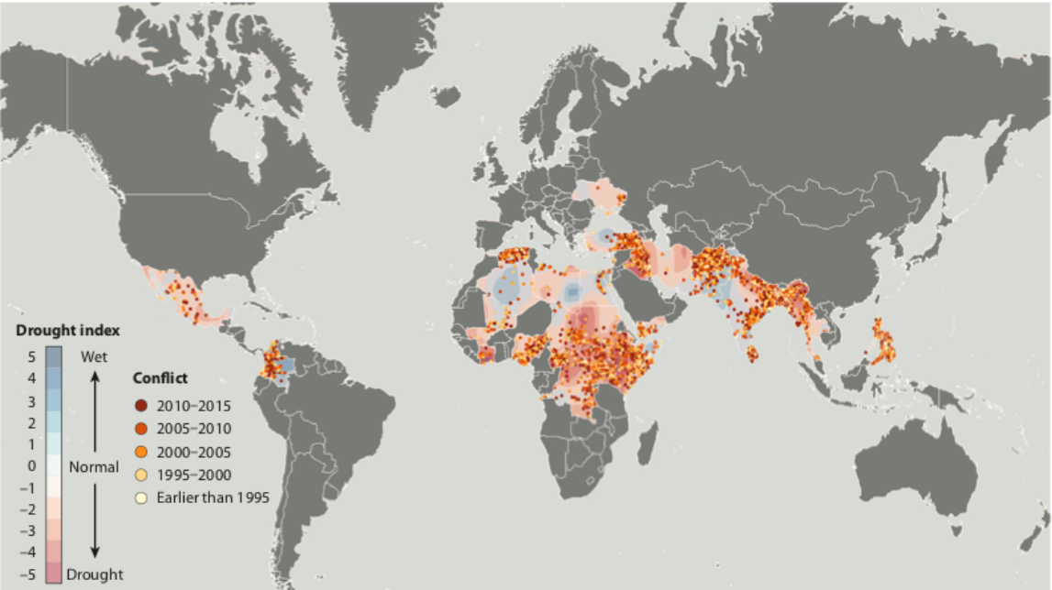
Figure 1: Drought levels (2005-2014) and location of armed conflict events (1989-2014) (NOAA PDSI & UCDP) (Koubi, 2019)
According to Raleigh & Urdal (2007), a (low) level of GDP is the most important predictor of armed conflict. The inability of a poor state, given less capacity as a result of a lower national income, to react to tensions over degradation may quite easily lead to violent conflict (Raleigh & Urdal, 2007). Mendelsohn, Dinar and Williams (2006) also studied the impact of climate change on rich and poor countries, and concluded that the poorest countries in the world will suffer much more from the results of climate change than the richer ones – poor countries are mostly located in low latitude regions, with much higher temperatures than optimal, whereas more wealthy countries are located in the mid to high latitudes with cooler temperatures. This suggests that environmental and demographic factors may be second to other drivers of armed conflict (Raleigh & Urdal, 2007).
Reduced resources increase competition, which leads to conflict (Homer-Dixon 2001). This is in line with Saleyhan’s (2008) argument that climate change and resource scarcity (which can be the result of climate change) can directly lead to violent conflict or, at least, lead to a significantly higher risk of violence. There is, however, a notable lack of knowledge regarding possible insecurity implications of climate change mitigation (Buhaug, 2016). Again, a direct causal link is not very likely, but indirect effects via adverse economic or livelihood impacts are not inconceivable (Buhaug, 2016).
High population density, measured locally, is a consistently strong predictor of armed conflict (Hegre & Raleigh, 2016). Population density and conflict are presumably correlated, because densely populated areas and large cities are attractive conflict locations, both because they provide better opportunities for organizing and financing conflict and because they represent strategic targets (Hegre & Raleigh, 2007). The (possible) relationship between climate change, violent conflict and human insecurity is explained by Barnett & Adger (2007) in Table 1. The table shows that climate change is seen as an indirect effect which could exacerbate processes leading to violent conflict. According to them, factors affecting violent conflict are vulnerable livelihoods, poverty, weak states and migration.
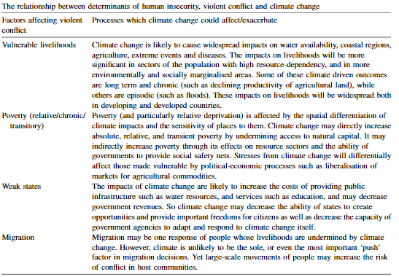
Table 2: The relationship between determinants of human insecurity, violent conflict and climate change (Barnett & Adger, 2007)

1.1.1 Applying the problem to Ghana and Burkina Faso
This research focuses on how climate change and conflict are related in Ghana and Burkina Faso. There are a few important differences that make Ghana and Burkina Faso interesting to compare. First of all, Ghana is a coastal country whilst Burkina Faso is a land-locked country. Secondly, Ghana is one of the wealthiest countries of western Africa, whereas Burkina Faso can be seen as one of the poorest countries in this region. These differences might have an impact on how the countries are able to adapt to the consequences of climate change.
Both countries meet many of the possible triggers regarding violent conflict and climate change, for example a reliance on rain-fed agriculture and vulnerability to drought (Brown & Crawford, 2008). Consequently, drought is the top natural disaster risk in both countries (Brown & Crawford, 2008). Furthermore, Ghana and Burkina Faso already face considerable development challenges from existing economic, population and environmental stresses (Brown & Crawford, 2008). According to the ‘Climate Change Profile’ by the Dutch Ministry of Foreign Affairs (2018, p. 6):
“Transboundary climate-related conflicts in Ghana are likely to increase, e.g. current tensions with Burkina Faso over its decision to withdraw water from the Volta which would reduce the water levels required for hydropower generation in Ghana. Other conflicts/tensions include the movement of Fulani herdsmen and their cattle from the dry Sahel region into farming communities in southern Ghana, water allocation disputes between the north and south of the country, and tensions arising from economic dependence on climate change-susceptible crops such as cocoa. Such conflicts not only arise from climate change, but can also deepen vulnerability to climate change effects as they often result in increased poverty and eroded social networks.”
To add to this, Ghana and Burkina Faso have to deal with significant cross-border issues, in particular the allocation of the waters of the Volta River Basin, increased economic integration and cross-border migration (Brown & Crawford, 2008). In the early 2000s, during a time of declining rainfall in parts of West Africa, there was a threat of conflict between Ghana and Burkina Faso linked to increasingly scarce water resources (SIDA, 2018). According to projections, temperatures in all zones in Ghana are on the rise, while rainfall will reduce and become increasingly erratic (Asante & Amuakwa-Mensah, 2015). This climate change and variability, in combination with the reliance of the Ghanaian economy on agricultural, energy and forestry sectors make the country more vulnerable (Asante & Amuakwa-Mensah, 2015).
Another issue that applies to both Ghana and Burkina Faso is a rapid growing population. Ghana’s population is 22.5 million and increasing at a rate of 1.9 per cent a year, whereas that of Burkina Faso is 13.9 million and rising even faster, at 2.8 per cent a year (Brown & Crawford, 2008).

1.2 Scientific relevance
The literature shows that environmental scarcity can trigger violent conflict. However, there is not much research yet on how the level of climate change experienced during the first two decades of the 21st century can have additional effects on the (potential) correlation referred to above. This research might help in filling the knowledge gap by focussing on how climate change and conflict have an impact on Ghana and Burkina Faso, in order to add information for this specific research topic.
Ohlsson (2000) argues that the loss of livelihoods resulting from environmental scarcity of arable land and water form a special case of growing importance. Agriculture is still by far the largest single source of livelihoods and income (Ohlsson, 2000). According to Koubi (2019), future research should continue to investigate how climatic changes interact with and/or are conditioned by socioeconomic, political, and demographic settings to cause conflict and uncover the causal mechanisms that link these two phenomena. Rosenzweig & Parry (1994) specifically argue that whereas production in the developed world has so far benefited from climate change, production in developing nations has declined. According to Sayne (2011), forty percent of all intrastate conflicts since the second half of the twentieth century involved disputes over limited natural resources, two dozen of which since 1990. Furthermore, Sayne (2011) states that, although not all of these conflicts had direct links to climate change, adding resource disputes to the mix generally doubles the average length and relapse rates of civil violence. Harder living conditions for people in poor countries as a result of climate change combined with the fact that forty percent of all intrastate conflict during the last six decades involved limited natural resources, makes poor countries very prone to situations where conflict occurs.
There is no decent empirical foundation for a direct link between violent conflict and climate change (Buhaug et al., 2008). In the words of Brown & Crawford (2008), “there is little research that has managed to construct an empirical link between climate change and conflict in West Africa (or anywhere else for that matter). That is not to say that such a link might not appear in the future, but the drivers of conflict and instability are complex. Simple models of causation are inappropriate. Researching the relationship between climate change and conflict in Ghana and Burkina Faso will help in finding constructive solutions in order to prevent future conflicts.” (Brown & Crawford, 2008, p. 50)

1.3 Societal relevance
A clear insight into the relationship between climate change and conflict in Ghana and Burkina Faso will pave the way for finding constructive solutions in order to prevent (future) conflicts. Insight into the causes and origins of conflict creates the opportunity to prevent social mechanisms that can lead to conflict being mobilized. This would be of significant social relevance for neighbouring Ghana and Burkina Faso, as well as for the world.
We do know that agricultural production is sensitive to weather and thus directly affected by climate change, as argued by Nelson et al. (2013). The underlying societal issue that is addressed in this research is that climate change can have a huge impact on the direct livelihood practices of people, for instance on fishermen and farmers. If these activities become more complicated or even impossible as a result of climate change, these people lose their way of living with all of its consequences. We do not know yet in what ways this decrease in quality of life exactly influences people, nor how they respond to it. There are many potential effects, but I am specifically interested in the effect of climate change on conflict. Although we already know that climate change has a greater influence on poor countries as compared to rich countries (Mendelsohn et al., 2006), not that much is known about the specific effects of this climate change on these poor countries, in particular if and how it triggers conflict.
As mentioned before, Ghana and Burkina Faso already face considerable development challenges from existing economic, demographic and environmental stresses (Brown & Crawford, 2008). This research can be relevant for the population of Ghana and Burkina Faso, because it can help in pointing out the problems with regard to triggers of conflict and prevent a worsening of the living conditions.

1.4 Research questions
This research focuses on how climate change impacts a specific contemporary conflict. Needless to say that other factors might (and do) have contributed to this conflict, for example political and economic tensions. The main research question is: “To what extent has climate change contributed to conflict in Ghana and Burkina Faso?”
This thesis is split into different topics, where the focus will shift between conflict specifically in Ghana, conflict specifically in Burkina Faso and interstate conflict. For this research, it is important to take into account other factors that can influence conflict, in order to be able to understand if climate change plays a role in triggering violent conflict.
Based on this, two sub-questions have been formulated:
- To what extent can/does climate change impact livelihood practices in Ghana and Burkina Faso?
- To what extent can/does the impact of climate change lead to political and economic instability?
Because conflict and migration are often intertwined, a specific third sub-question regarding migration has to be included as well:
- To what extent does climate change and conflict lead to (forced) migration in Ghana and Burkina Faso?

Chapter 2: Theoretical framework

The academic discussion regarding climate change and violent conflict started around 1970. Ever since, there has been a lot of debate concerning the hypothesis that climate change leads directly to violent conflict. The consensus seems to be that violent conflict is not the direct result of climate change as such, but rather that climate change can play a role in the emergence of conflict.

Climate change and conflict
In its fifth assessment report, the Intergovernmental Panel on Climate Change (2014) states that violent conflict arising from deterioration in resource-dependent livelihoods such as agriculture and pastoralism is highly likely to occur. Furthermore, the IPCC (2014) recognizes the threat of violent conflict as a result of the effects of climate change, such as poverty and economic shocks. One of the most prominent researchers of the climate change and conflict debate is Thomas Homer-Dixon. His key finding is that “scarcity of renewable resources—or what I call environmental scarcity—can contribute to civil violence, including insurgencies and ethnic clashes” (Homer-Dixon, 2001, p. 177). Based on this conclusion, he predicts that “in coming decades the incidence of such violence will probably increase as scarcities of cropland, freshwater, and forests worsen in many parts of the developing world” (Homer-Dixon, 2001). Homer-Dixon thus argues that climate change influences conflict, as environmental scarcity will occur more often as a result of climate change. His studies show that resource scarcity induced by environmental degradation (albeit, often in combination with political, economic and social factors) can lead to destabilized and/or fragile states; the latter being a likely cause of conflict.
The Intergovernmental Panel on Climate Change defines climate change as “A change in the state of the climate that can be identified by changes in the mean/and or the variability of its properties, and persists over an extended period, typically decades or longer. It refers to any change in climate over time, whether due to natural variability or as a result of human activity”. (IPCC, 2007, p. 30) In its next, fifth assessment report, the IPCC adds that “It is extremely likely that more than half of the observed increase in global average surface temperature from 1951 to 2010 was caused by the anthropogenic increase in greenhouse-gas concentrations and other anthropogenic forces together.” (IPCC, 2014, p. 5)
In this fifth assessment report (2014), the IPCC identifies observed impacts of climate change for:
- Physical systems: glaciers, snow, ice, rivers, lakes, floods and/or drought, coastal erosion and/or sea level effects
- Biological systems: Terrestrial ecosystems, wildfire and marine ecosystems
- Human and managed systems: Food production, livelihoods, health and/or economics.
According to Hendrix & Glaser (2007), most scholars use a conventional discourse based on a neo-Malthusian perspective, arguing that population growth, coinciding with increases in affluence and per capita rates of consumption, will cause exponentially increasing demands on natural resources, inevitably resulting in shortages, land and water degradation, and distributional conflicts.
Many scholars researching the relationship between climate change and conflict take Homer-Dixon’s key findings as a starting framework for their research. However, based on more recent literature, it shows that scholars nowadays have different insights than Homer-Dixon regarding this specific topic. According to Lind, Ibrahim & Harris (2010), for instance, as far as the correlation between conflict and climate change is concerned, a distinction between two prominent perspectives has to be made. The first perspective states that climate change is worsening resource scarcities and generates new conflicts and security challenges (Lind, Ibrahim & Harris, 2010). Events such as severe droughts, with localized violence and grim humanitarian consequences, contribute to a narrative according to which climate change has a negative impact on resource scarcities, leading to conflict and social breakdown (Lind, Ibrahim & Harris, 2010). The other perspective, however, argues that it is not climate change as such that causes conflict, but rather that the (in)effectiveness of governance and institutions in response to climate shocks will determine the likelihood of conflict and/or collaboration around resource issues (Lind, Ibrahim & Harris, 2010). According to this latter perspective, climate change factors do not directly cause violent conflict, but rather merely affect the parameters that in particular cases are important in generating violent conflict.
The starting point for most causal chains that try to relate climate change to conflict is that climate change results in a reduction of essential resources for livelihood, such as food or water, which might have as a consequence that those affected by the increasing scarcity start fighting over the remaining resources (Nordås & Gleditsch, 2007). Hendrix & Glaser (2007) suggest that interannual variability in rainfall is a more significant determinant of conflict than climate, land degradation, and freshwater resources. However, this interannual variability in rainfall does directly influence the degradation of farmland and availability of water.
Another possibility is that because of climate change people feel forced to leave a particular region, adding to the number of international refugees or internally displaced persons (Nordås & Gleditsch, 2007). Barnett and Adger (2007) have analysed a wide range of studies dealing with these effects, particularly focusing on countries where a large majority of the population is still dependent on employment in the primary (agricultural) sector. If climate change results in reduced rainfall and access to the natural capital sustaining livelihoods, poverty will become more widespread, leading to increased grievances and better recruitment opportunities for rebel movements.
Another way in which conflict might be influenced by climate change lies in our response to the burning of fossil fuels, in itself a major cause of the greenhouse effect (Nordås & Gleditsch, 2007). Gleditsch argues that environmental stress should be seen as a variable, among others, that can contribute to an escalation of conflict. Economic and political factors should be seen as (more) crucial factors regarding the outbreak of conflicts. Barnett and Adger (2007) note that conflict could occur as a result of mitigating action to reduce emissions from fossil fuels.
Spillmann (1995) adds to the debate by stating that the link between climate change and conflict can also be seen as direct, whereas in that view political and economic factors are the result of this process. Transformation of the climate does not only affect nature, but also influences social and political systems and can therefore lead to conflict. Changing climatic conditions cause health issues but also endanger the crop production and therefore the food supply. As a result, people are pushed out and physically forced to leave their homes. The impact of these processes is challenging the stability of existing social and political orders (Spillman, 1995). Spillman (1995) further mentions that factors like societal mechanisms for regulating conflict, group identities and the arming of parties involved in a conflict can determine whether the solution of conflict will be peaceful or violent.
Saleyhan (2008) brings up that states often bear responsibility for environmental degradation and resource shortfalls, either through their own projects and initiatives or by neglecting the environment. Clearly, climate change can be seen as a stress factor beyond the control of individual governments. However, governmental policies and neglect can compound the effects of climate change (Saleyhan, 2008). Furthermore, Saleyhan (2008) states that it is important to note that, while climate change and its associated effects – sea-level rise, desertification, erratic weather, etc. – are broad, structural conditions affecting humanity, armed conflicts as such are the product of failures of government, ambitious rebel leaders, or a combination of both.
Hendrix & Glaser (2007, p. 697) critique the neo-Malthusian perspective by stating that:
“Even assuming the conventional causal mechanisms are valid, neo-Malthusian analysis does not identify short term causes that trigger the outbreak of conflict. It does predict conflict over access to resources, but the causal mechanisms are so complex, and the environmental changes so gradual, that identifying theoretical or empirical thresholds that trigger violence once crossed is difficult.”
In an analysis of civil conflict in Sub-Saharan Africa, Miguel, Satyanath and Sergenti (2004) focused on the impact of economic shocks on the likelihood of civil conflict in this region. They found that (whilst using data on rainfall variability) increased rainfall had a positive impact on income growth, but a negative impact on the likelihood of conflict.
ntuitively it often seems that periods of large-scale societal instability and
uncertainty coincide with sociopolitical and ideological extremism.
It often seems like periods of large-scale instability on a social level in combination with uncertainty can coincide with sociopolitical and ideological extremism (Hogg, Kruglanski & Van den Bos, 2013). According to these researchers, people try to reduce feelings of uncertainty (caused by processes such as climate change and the influence this has on livelihood practices) by grounding one’s attitudes, values and understanding of the world in consensus to similar people who share and agree one’s view of the world. This development causes people to be prone to the effects of religious extremism (Hogg, Kruglanski & Van den Bos, 2013).

2.2 Climate change and migration
Homer-Dixon’s (1999) environmental conﬂict model maintains that scarcities of renewable
resources such as cropland, fresh water, and forests, induced in large part by population
growth, contribute to migration and violent intrastate conﬂict in many parts of the
developing world.
Homer-Dixon’s (1999) environmental conﬂict model maintains that scarcities of renewable
resources such as cropland, fresh water, and forests, induced in large part by population
growth, contribute to migration and violent intrastate conﬂict in many parts of the
developing world.
Homer-Dixon’s (1999) environmental conﬂict model maintains that scarcities of renewable
resources such as cropland, fresh water, and forests, induced in large part by population
growth, contribute to migration and violent intrastate conﬂict in many parts of the
developing world.
Homer-Dixon’s environmental conflict model maintains that in many parts of the (developing) world scarcities of renewable resources such as cropland, fresh water, and forests contribute to migration and violent intrastate conflict (Hartmann, 2010). In his own words:
“Population growth and unequal access to good land force huge numbers of people onto marginal lands. There, they cause environmental damage and become chronically poor. Eventually, they may be the source of persistent upheaval, or they may migrate yet again, helping to stimulate ethnic conflict or urban unrest elsewhere.” (Homer-Dixon, 2001, p. 155)
The effects of climate change can thus result in migration of people. Already in 1990, the Intergovernmental Panel on Climate Change noted that the greatest single impact of climate change could be on human migration (Brown, 2008). Brown (2008) states that while the scientific argument for climate change is increasingly convincing, it is not quite clear how the consequences of climate change have an impact on the distribution of the human population. According to Reuveny (2007), people have three options when climate change drastically effects their lives. Whilst facing severe environmental degradation due to climate change, people can either mitigate the effects, do nothing and accept a lower quality of life, or leave the affected areas (Reuveny, 2007).
According to Reuveny (2007), there are several reasons why climate change-induced migration can lead to conflict:
- Competition: The arrival of migrants can put pressure on the resource base of the receiving country (or region), resulting in tensions between natives and migrants;
- Ethnic tension: When environmental migrants and residents belong to different ethnic groups, the migration process might lead to tensions between those groups;
- Distrust: Environmental migration may generate distrust between the area of the migration’s origin and host area. For example, the migrants’ origin country may suspect that the receiving country accepts migrants in order to upset the ethnic balance in the country of origin;
- Fault lines: The conflict may also follow existing socioeconomic fault lines. For example, migrant pastoralists and resident farmers may compete over land, or migrants and residents may compete over jobs;
- Auxiliary conditions: Whereas developed economies can absorb migrants in various sectors, underdeveloped economies, reliant on the environment for survival, are limited in this regard, particularly if their resources are scarce. Therefore, they are more prone to conflict due to the arrival of environmental migrants.
Barnett & Adger (2009) criticise the current pessimistic literature on climate change and migration. It states that there is evidence that framing migration as a threat leads to policies that do little to control migration but rather limit the benefits of migration to migrants and their original and destination communities (Hartmann, 2010).
Table 2 lists examples of climate extremes leading to migration and conflict since 2000. It shows that different types of climate events in different regions can cause major impacts on migration and the presence of conflicts.
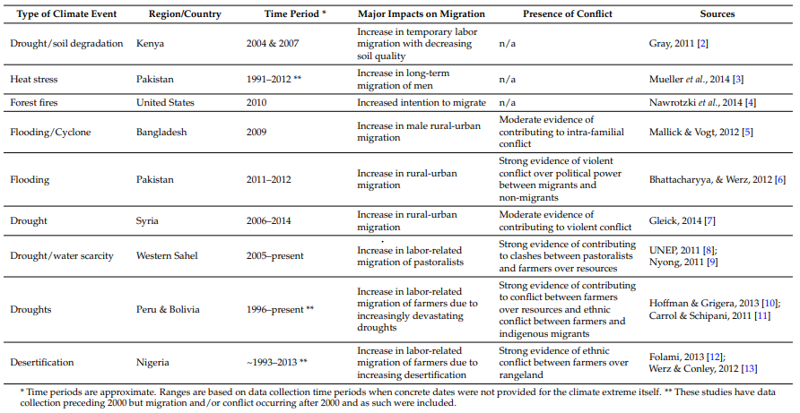
Table 3: Examples of climate extremes leading to migration and conflict since 2000 (Burrows & Kinney, 2016, p. 2)
The theories and concepts used in this chapter will be operationalised in the methodology section of this research. The findings in the theoretical framework are important for this research, as they pose a starting point for this research, a bottom line with which further observations can be made in the specific region. This research will fill focus on the effects and consequences of climate change on different processes such as social effects of climate change (economic instability, political instability, migration and issues on land ownership).

2.3 Research model
Most scholars agree that the relationship between climate change and conflict should be seen as indirect. The main causal mechanism that is being sketched shows that the impact of climate change leads to scarcity of resources and migration. The impact of the effects of climate change on resource scarcity is partly determined by the (in)effectiveness of governance to deal with the consequences of climate change. When consequences of climate change like resource scarcity and an increase of natural disasters occur, this has an influence on social factors like economic and political instability and migration. It is important to acknowledge that migration has always been a phenomenon in Burkina Faso and Ghana, and that climate change should not be seen as the only factor influencing this process. Violent conflict can be seen as an indirect result of the causal link between the practical consequences of climate change and the social effects climate change has on livelihood practices.

2.4 Conceptual framework
A conceptual framework is established to help explore the relationship between climate change and violent conflict. The relationships drawn in this conceptual framework are based on academic literature in the specific field of climate change and violent conflict.
Extremism
Climate change
Precipitation change
Temperature change
Desertification
Sea level rise
Consequences
Resource scarcity

Ineffective governance of effects climate change
Increased difficulty to maintain livelihood practices
Social effects
Economic instability
Political instability
Climate change induced migration
Violent conflict
Regional conflict
Interstate conflict
Issues land ownership

Chapter 3: Outline of context for Ghana and Burkina Faso

3.1 Geographical location
Ghana is a country situated in West Africa along the Gulf of Guinea and the Atlantic Ocean. The country is bordered by Ivory Coast on the west, Togo in the east and Burkina Faso in the north. Ghana’s climate is tropical, and there are two main seasons: the dry season and the wet season. The country exceeds three hydro-climatic zones. In general, annual precipitation decreases once moving further north. The south-central part of the country is covered with a major plateau, whilst the rest of the physical terrain of the country exists primarily of low plains which are punctuated with uplands. The Volta Basin situated in the eastern part of the country is the largest artificial lake of the world. The geographical location of Ghana has made the country vulnerable to the effects of climate change. According to the World Bank, almost one third of West Africa’s population lives along the coast of the Gulf of Guinea, and the number of people who could be flooded as a result of a rising sea level is estimated to be 70 million people by 2080 (Campbell, 2016). Furthermore, processes like desertification are potential dangers, especially in the north of Ghana.

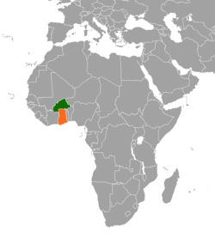
Figure 4: Map of Africa, highlighting Ghana (orange) and Burkina Faso (green)

Burkina Faso is situated directly north of Ghana and is a landlocked country that also borders Mali and Niger in the north, Togo and Ghana to the south, Ivory Coast to the southwest and Benin to the southeast. The largest part of the country is covered by peneplain; a low-relief plain formed by protracted erosion. The southwest of the country forms a sandstone massif, with the highest peak, Ténakourou, having an elevation of 749 meters. Like Ghana, Burkina Faso has a primarily tropical climate with two very distinct seasons; the rain season and the dry season. With the country bordering the Sahara on the north, desertification is a real threat in Burkina Faso, as confirmed by the European Commission that considers the southern Sahel to be one of the regions most prone to desertification (European Commission, 2016).

3.2 Climate change in Burkina Faso
Burkina Faso can be divided into three climatic zones. The northern part of the country is characterized by a Sahelian climate, the central part of the country can be characterized by a Sudano-Sahelian climate, whereas the southern part of the country can be characterized by a Sudanian climate (De Longueville et al., 2016). The main difference distinguishing these climate types is the annual amount of rainfall (as can be seen in Figure 3). In the northern part of Burkina Faso, trends in rainfall show that rainfall is scarce and irregular, with an average annual precipitation of less than 500 mm. The agro-climatic conditions are thus very constraining for agriculture and the main economic activities are extensive pastoralism and rain-fed agriculture (Hampshire & Randall, 1999). Ingram, Roncoli & Kirshen (2002) mention that the conditions for agriculture are more suitable in the southern part of Burkina Faso (with an average rainfall of over 900 mm). Furthermore, the rainfall in Burkina Faso is characterized by a high degree of seasonal and annual variability. De Longueville et al. (2016) studied trends of rainfall and temperature with data from many weather stations all over Burkina Faso, and concluded that Burkina Faso has experienced a very significant temperature increase over the period of 1950 to 2013, whilst there was a negative trend in total annual rainfall in all the regions of the country during the same period.
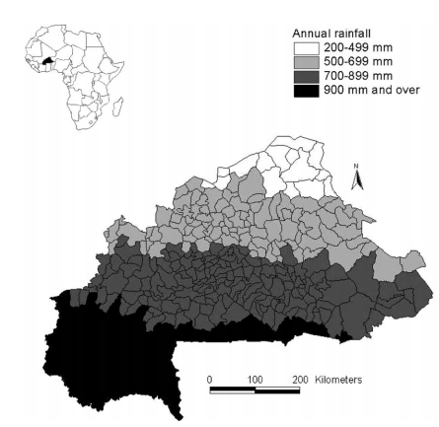
Figure 5: Map of Burkina Faso showing mean annual rainfall at the department level, 1960-1998 (Henry, Schoumaker & Beauchemin, 2004, p. 426)
In 2007, the National Adaptation Program of Action (NAPA) in Burkina Faso identified four sectors as particularly vulnerable to climate change, summarized by Brown & Crawford (2008).
- Water: A projected increase in the frequency of heavy rains and flooding is expected to cause widespread erosion across each of Burkina Faso’s four basin slopes.
- Agriculture: The NAPA (2007) predicts that average annual rainfall will drop by 3.4 per cent by 2025. Given Burkina Faso’s economy being heavily dependent on rain-fed agriculture, such a drop will have significant implications for crops and planting cycles across the country.
- Stockbreeding: An expected rise of temperature by 1.7 degrees Celsius by the middle of the 21st century will, in combination with decreased rainfall, cause reduction of drinking points open to stockbreeders. Furthermore, the threat of floods is a danger for livestock.
- Forestry/fisheries: Increased erosion and siltation are expected to damage land and water ecosystems. Forestry biomass is predicted to decrease by 90 million cubic meters by 2050.
It should be noted that there are barriers to the process of climate change adaptation in Burkina Faso as a result of cultural traditions. An example is given by Nielsen & Reenberg (2010), who show that people are sometimes reluctant to embrace the diversification strategies of labour migration, development work and gardening, which are three major adaptation strategies for climate change that are in some cases available for people. Their adherence to traditional concepts like personal integrity and shame have shown to be crucial in processes of livelihood diversification. This process of adaptation to climate change can be seen as an existential challenge, as the strategies that are available confront the cultural self-image of some tribes that are known to have a nomadic lifestyle (Nielsen & Reenberg, 2010).

Climate change in Ghana
According to Asante & Amuakwa-Mensah (2015), three major physical impacts of climate change have been identified in Ghana. These are: temperature change, change in rainfall, and sea level rise. Ghana faces the direct effect of climate change in the form of health problems, disruption of agricultural systems, flooding of coastal areas and low operating water level of the country’s only hydro-generating dam. Temperatures are rising in all zones in Ghana, whilst rainfall has been reducing and becoming increasingly erratic; the same pattern as in Burkina Faso. The dependence of the Ghanaian economy on agricultural, energy and forestry sectors makes the country more vulnerable (Asante & Amuakwa-Mensah, 2015). According to the Ghanaian Ministry of Food and Agriculture (MOFA, 2007), agriculture provides employment to about 50.6 per cent of the labor force. Furthermore, it contributes the largest share to the Gross Domestic Product.
In 2000, Ghana formulated its first official national communication on the subject of climate change. In this policy, Ghana identified three main aspects that might be affected by climate change, as summarized by Brown & Crawford (2008):
- Water: Simulated scenarios projected that there would be a reduction in water flows of around 20 per cent in all river basins by 2020. This number would rise to between 30 and 40 per cent by 2050.
- Agricultural crops: Projections indicated that the average maximum temperature would rise between 2.5 and 3 degrees Celsius by 2100. Furthermore, it is estimated that yields of maize would decrease by 6.9 per cent by 2020.
- Coastal zones: An estimated sea level rise of 1 meter by 2100 could inundate 120 square kilometers of land and put 132,000 people at risk in Ghana’s coastal zones.
Socio-economic factors such as a high illiteracy level, heavy dependence on climate-sensitive livelihood practices and limited access to information with regard to climate change make people vulnerable to the effects of climate change in Ghana (Dumenu & Obeng, 2016). Another aspect that makes Ghana vulnerable to the effects of climate change is the process of desertification. Land degradation as a result of deforestation and overgrazing contributes to desertification in northern Ghana. Desertification has diverse effects on crop yields resulting in loss of livelihoods and low income, famine and malnutrition (Armah et al., 2010). As mentioned by Owusu (2012), land degradation poses a serious threat to agriculture, natural resources and the livelihood support system in Ghana. The fragile ecosystem and the large population base of specific areas add to this threat. According to Owusu (2012), there are several threats that influence the process of desertification in Ghana in a negative way. Examples of these threats are: soil depletion, erosion, declining crop yield, use of marginal lands and reduction of fallow. Owusu (2012) concludes: “Desertification in Ghana is real and at a stage where its reversibility would require a more focused and integrated approach, which goes beyond what local capacity, including financial, manpower and technological resources can address and would therefore require support from the central government.” (Owusu, 2012, p. 13)
Sea level rise as a result of climate change is another problem impacting Ghana. According to the IPCC (2007), the global average sea level rose at an average rate of around 1.8 mm per year from 1961 to 2003 and at an average rate of about 3.1 mm per year from 1993 to 2003 (IPCC, 2007). According to Nicholls et al. (2007), this trend is expected to continue for centuries (Nicholls et al. 2007). The reason for this rise in sea level can be associated with the global rise in temperatures caused by climate change. According to Addo & Adeyemi (2013), climate change projections have identified the West African coastal zone to be at risk of flooding by 2080. The West African coast, which includes Ghana, is considered highly vulnerable to climate change and its associated sea-level rise. The reason for this vulnerability is the high concentration of poor population in potentially hazardous areas that are at risk to the effects of sea-level rise. With Accra being a coastal city, this already means that 4.2 million people are at direct risk at the effects of sea-level rise. Addo & Adeyemi (2013) claim that sea level rise and increased storm surge activities as a result of climate change have exacerbated the incidence of flooding in recent times on certain parts of the Ghanaian shoreline.

3.4 The north-south divide in Ghana
The northern part of Ghana seems to be the part that is most influenced by the danger of food insecurity. More than 80% of the population of northern Ghana is engaged in agriculture (Ghana Statistical Service, 2013); yet, one in every five persons is food insecure, while one in every nine children dies of malnutrition before the age of five (Biederlack & Rivers, 2009). This shows that food insecurity can be identified as a direct problem for northern Ghana, whilst the effects of climate change can worsen this problem. According to Nyantakyi-Frimpong & Bezner-Kerr (2015), there are three major reasons that explain the geographical inequality in food insecurity and migration which makes the northern part of Ghana more vulnerable:
- Climate variability: Northern Ghana is situated in the southern part of the Sahel. The region therefore experiences severe droughts and climatic variability, with important implications for agriculture.
- British colonial rule: The first period of British colonial rule in Ghana (then called Gold Coast) was mainly focused on the southern part of Ghana (the coastal areas). The northern regions of Ghana were not annexed until 1901, whilst some of the southern parts were annexed starting from 1874. The northern regions were neglected during the annexation and people living in the north had to move to the south in order to earn an income and pay colonial taxes (Nyantakyi-Frimpong & Bezner-Kerr, 2015).
- Neoliberal development policies: After independence in 1957, state policy and planning continued to embrace the same regional bias, having an important influence in the disparity in development. Post-colonial state policies focused on the extraction of natural resources. Thus, with low resource endowments, little government revenue flowed into the north, thereby resulting in limited transport and marketing infrastructure and agricultural extension.

Social effects
The social effects as a result of climate change and its consequences could play an important role in inflicting conflict in Ghana and Burkina Faso. Potential social effects of climate change that have been identified are political instability, economic instability, migration and issues of land ownership.

3.4.1 Political and economic instability
Social effects as a consequence of climate change could play a role in conflict. Buhaug, Gleditsch and Theisen (2008) argue that the ability of the state to manage the consequences of resource competition is crucial in determining whether or not conflict will escalate into violence. They add to this by stating that poor and institutionally weak regimes are often not able to respond in a proper way to these social effects resulting from climate change. This can partly be explained by the fact that compensation and providing shelter are expensive in cases of emergency.
There are different ways in which climate change and its effects can cause economic and political instability in Ghana and Burkina Faso. The instability in Burkina Faso is nowhere more visible that in its politics, as argued by Englebert (2018). An example of this is that since 1966 the military have seized power five times, either from civilians or from other soldiers. Furthermore, according to Englebert (2018), there has never been a peaceful transition of power from one competitively elected regime to another. Furthermore, some analysts predict that climate change may result in some crops becoming unsuitable for cultivation as a result of precipitation change and temperature change. There are a few divides in Ghana that explain economic and spatial inequalities. Tsikata & Seini (2004) summarize these spatial and economic differences:

- North-south dichotomy: A number of studies have emphasized the disparity between the north and the south of Ghana. Lack of economic development and lower general quality of life are two of the main aspects that differentiate the north from the south. One very important factor in this disparity is the unequal distribution of natural resources within Ghana. Furthermore, there is a sharp inequality on a social welfare level between the north and south of Ghana.
- Urban-rural dichotomy: Urban regions perform better on the welfare scale in Ghana than rural communities. This can be partly explained by the urban bias in provision of welfare services and the unequal distribution of decision-making power between urban and rural communities.
- Differences between rural communities: Difference in resource endowments emerge between communities that are focused more on export-related agriculture and those communities that are more closely tied to subsistence production.

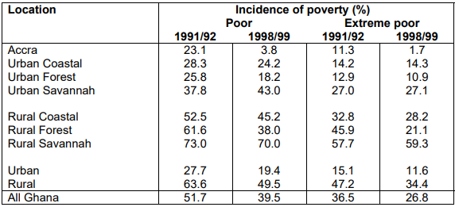
Table 6: Poverty trends in Ghana in the 1990s (GSS, 2000)

Table 4 illustrates spatial differences that influence economic instability, by showing the incidence of poverty, where the rural savannah (mostly in the north) shows a way higher percentage of poverty than urban regions. The spatial differences explained here have a direct relation with economic instability in Ghana, as there is a lot of inequality between certain regions. The north-south dichotomy and urban-rural dichotomy show that the lack of economic development and lower general quality of life in the northern regions of Ghana make this region even more prone to experience problems from the effects of climate change.

The north-south dichotomy accounts mainly for Ghana in this case, but is also applicable to Burkina Faso. As shown in Figure 3, generally speaking, rainfall is much more apparent in the south of Burkina Faso than in the north of the country. This leads to the premise that rain-fed agriculture is harder to perform in the north of the country, leading to migration streams and welfare differences between different parts of the country.

3.4.2 Climate change and migration in Ghana and Burkina Faso
Overall, there is a long history of migration from Ghana and Burkina Faso to other West African states, as well as to Europe and North America. According to Adepujo (2003), Ghana can traditionally be seen as a major migration-receiving country in West-Africa. On the other hand, Burkina Faso can be seen as a traditionally major labour-exporting country. These migratory configurations have changed over the last couple of decades. Adepoju (2003) mentions that highly skilled migrants have moved from Ghana and migrated to other countries where they are able to receive a higher salary. Also, Ghanaian students tend to study abroad more often, and most of them do not return to Ghana after finishing their study.
According to Anarfi, Kwankye, Ababio & Tiemoko (2003), migration movements within Ghana, Burkina Faso and other West African countries date back to a period long before colonisation (Ghana was a colony from 1821 until 1957). A survey regarding internal migration and urbanisation in Ghana, shows that more than 80 per cent of respondents gave economic reasons for migrating from their previous locations. The pattern of internal migration in Ghana can also be characterized by the differences in the level of poverty between north and south. In addition, the capacities of regions to respond to new economic opportunities tend to be a reason for people to migrate internally within Ghana (Anarfi, Kwankye, Ababio & Tiemoko, 2003).
An important factor in growing migration figures was the establishment of ECOWAS (Economic Community of West African States) in 1975. The mandate of ECOWAS is to create a large trading bloc in West Africa. Its vision is to create a ‘borderless region’ where the population has access to abundant resources and is able to exploit them through the creation of opportunities under a sustainable environment. The fact that ECOWAS focuses on this establishment of a ‘borderless’ region means that people can cross borders between West African countries easily and this leads to more interstate cooperation, also meaning that migration figures are rising.
Burkina Faso has long been characterized by intense mobility, both within the country and to other countries such as Ivory Coast and Ghana (Hampshire & Randall, 1999). According to Henry, Schoumaker & Beauchemin (2004), circulation is a prominent feature in migration of Burkinabe people. They tend to maintain strong links with their place of origin, resulting in a large part of migrants who return to their home village at some point. An example of migration taking place in Burkina Faso is the movement of Fulani (one of the largest ethnic groups in the Sahel and West Africa, characterized by a lifestyle of nomadic pastoralism). According to Tonah (2002), Fulani pastoralists living in Burkina Faso move to the south seasonally as a result of environmental and climatic factors, which means they often cross the border with both Ghana and Ivory Coast. As a result of an increase of both human and cattle population in Northern Ghana (often initiated by the moving Fulani crossing the border), there has been a corresponding increase in the incidence of crop destruction by livestock and consequently, farmer-pastoralist conflict. According to MECV & SP/CONEDD (2006), longer dry seasons in Burkina Faso are causing farmers to migrate from northern and central parts of the country into the fertile east and west, bringing them into contact with settled farmers in these richer areas. Greater populations congregating in smaller fertile areas may increase competition for valuable lands and accelerate environmental degradation. (MECV & SP/CONEDD 2006)
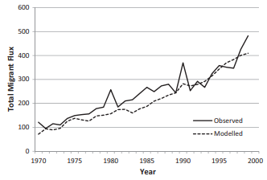
Table 7: Simulated and observed total migration fluxes in Burkina Faso from 1970 to 1999 for individual migrants (Kniveton, Smith & Wood, 2011)
Rain-fed agriculture is the main source of livelihood in rural Burkina Faso, which means that it is logical to expect some impact of annual and seasonal rainfall on migration. According to Henry, Schoumaker & Beauchemin (2004), a variability in migratory responses exists in Burkina Faso; some people move for a short period of time and return to their original destination within a few months, while other people leave their region permanently to move to urban areas or to better endowed rural areas. Climate change can be seen as a trigger for more migratory movements of people. The reason for this is that the effects of precipitation change, temperature change and the possible danger of desertification and sea-level rise influences the livelihood practices of people in a negative way.

3.4.3 Land ownership
Land ownership in countries in West-Africa has historically led to potential trouble. In Ghana, 80% of the total land area is customarily owned by clans, stools, skins and families (Kuusana et al., 2013). The state owns 18% while the remaining 2% is held in dual ownership by the state: the beneficiary interest being held by the community and the legal right being vested in the state (Kuusana et al., 2013). In Ghana, land ownership has traditionally been perceived as not only including the earth or soil, but also the water and the properties located on it (Awunyo-Akaba et al., 2016). One can acquire land through purchase, lease or tenancy from the government, skin or stool or families (Kuusana et al., 2013). Most of the respondents (68%) of this particular research did not know the size of their lands (Kuusana et al., 2013).
A complex situation prevails in contemporary northern Ghana, where the issue of land ownership and the question of political representation have always been and still are difficult problems to solve (Weiss, 2007). Each party has its own interpretation of the background and the roots of their dilemma and each group is putting forward its own agenda for solving their particular problems with regard to land ownership (Weiss, 2007). Apart from local communities and local ethnic or religious groups competing with each other, the Ghanaian state is involved as a third, and usually not very impartial, party (Weiss, 2007). Ghanaian communities are caught up in multi-faceted contests over authority and influence inspired, in part, by the politics of decentralization and Ghanaians’ continuing quest for access to land (Berry, 2009). According to Tonah (2002), all over Northern Ghana, land belongs to particular lineages, extended families and individual households, where it is viewed as a common resource bequeathed by the ancestors and meant to be passed on to future generations. Beyond its economic use, land has significant social and religious roles amongst the people. The issues of land ownership described here are potential triggers of conflict. Processes like desertification and population increase take place, whilst (forced) migration as a result of climate change also plays a role in issues with regard to land ownership. These processes result in situations where more people need to make a living off the same or even a smaller amount of available land that is usable for livelihood practices such as rain-fed agriculture, which can be a trigger for violent conflict in this region.

3.4 Conflict
Climate change could exacerbate existing tensions in Ghana and Burkina Faso, according to Brown & Crawford (2008). The effects of climate change that create tensions on social factors such as political and economic instability can be seen as reasons for these tensions.

3.4.1 Triggers for interstate and intrastate conflict in Ghana
According to Brown & Crawford (2008), there are five concerns on a security level that are caused by the effects of climate change in Ghana:
- The north-south divide: Extreme poverty in Ghana is concentrated mainly in the rural north. Governmental services are not as well serviced in the north as in the south. Furthermore, the north has suffered the most from the effects of climate change, and demand for water is rapidly rising as an effect of the growing population.
- Management of regional water sources: Ghana recognizes a possible threat of instability as a result of the effect of water management between Ghana and Burkina Faso. Ghana and Burkina Faso make up 85 per cent of the Volta River Basin, and much of the water flowing through this Basin flows through Burkina Faso before reaching Ghana. Future pressure on water shortage can to conflicts between the two countries.
- The division of water between energy in the south and agriculture in the north: A direct result of the north-south divide is the division of water between these regions. Water in the south of the country travels from rivers that come from the north of Ghana. If the water level falls too low in the Akosombo Dam situated in the south (just north of Accra), this leads to an energy crisis in the entire country as energy is generated from this Dam (Addax, 2007).
- Border instability: Ghana recognizes that conflict emerging in bordering countries (potentially as a result of climate change) can cause instability as a result of flows of refugees, hostile neighbours and regional economic disruption.
- Economic instability: Some analysts predict that climate change will cause unsuitability of cultivation of certain crops (such as cocoa). This can fundamentally influence Ghana’s economy in a negative way and therefore cause economic instability.

3.4.2 Triggers for interstate and intrastate conflict in Burkina Faso
The effects of climate change have been summarized by local experts in Burkina Faso into four main concerns (summarized by Brown & Crawford, 2008):
- Water availability: It is expected that pressure on water availability and quality will rise as a result of siltation, erosion and variable and declining rainfall.
- Relationship between pastoralists and agricultural communities: The range of and resources to which Burkina Faso’s pastoralist community has access has been diminishing as a result of the expansion of farming and population growth in combination with drought and desertification. As a result of this process, pastoralist communities rely less on the mutually beneficial relationship with agricultural communities. This results in those two groups increasingly competing in the marketplace, which puts even more pressure on their relationship.
- Migration: Climate change has resulted in dry seasons to last longer in Burkina Faso. This causes farmers to migrate from the northern (driest) and central parts of Burkina Faso into the fertile west and east. This causes these migrants to get into contact with settled farmers. As mentioned by MECV & SP/CONEDD (2006), greater populations congregating in smaller fertile areas causes competition for valuable lands. Furthermore, there is a chance that this process accelerates environmental degradation.
- Food security: Declining rainfall and expected increase in the frequency of floods and droughts have caused concern in the ability of Burkina Faso to maintain agricultural production. This leaves the country in a precarious position.
The results from the research conducted by Brown & Crawford (2008) and Tsikata & Seini (2004) about triggers for conflict in Ghana and Burkina Faso show that there are possible threats. The conclusions include predictions about what could happen when certain (climate) events occur, but there are no direct implications of conflict as a result of climate change in these papers. Therefore, the first analytical part of this research will focus on finding out if the implications made in these articles are up to date and/or if there should be additions and changes to these implications.
To help doing so, a few hypotheses are formulated, summarised from important notions in literature.
Ghana:
- The north-south divide in Ghana does still exist
- The division between the South (water for energy) and the North (water for agriculture) causes concerns on a security level in Ghana
- Management of regional water sources poses a threat for instability in Ghana
- Economic instability emerges in Ghana as a result of climate change
Burkina Faso:
- Water availability and water quality are main concerns in Burkina Faso
- The tensions between pastoralists and agricultural communities pose a threat for conflict in Burkina Faso
- Declining and/or erratic rainfall negatively influence food security in Burkina Faso
Applicable to both Ghana and Burkina Faso:
- Border instability between Ghana and Burkina Faso emerges as a result of climate change
- External and internal migration occurs as a result of climate change in Ghana and Burkina Faso
The second part of the analysis will focus on missing concerns with regard to climate change and conflict in the articles from Brown & Crawford (2008) and Tsitiki & Seini (2004), such as desertification, rising sea level rise and extremism.

Chapter 4: Methodology

4.1 Research methods
For this research, semi-structured interviews have been conducted with various actors regarding climate change and conflict in Burkina Faso and Ghana. These actors involve a few local experts, some representatives of ministries in Ghana and Burkina Faso, and a number of representatives of the Dutch Ministry of Foreign Affairs who are active in West Africa. The reason for using a qualitative research design is that a qualitative research method aims to understand a given research problem or topic from the perspectives of the population it involves. Asking multiple questions and the ability to differentiate the questions slightly with regard to the person that is interviewed is very useful for this research topic.
Logically, by using semi-structured interviews as a method for this research, an interview guide has been put together in order to have an overview during the interviews. According to Given (2020), semi-structured interviews are especially useful in research questions where the concepts and relationships among them are relatively well understood. With regard to the main research question of this research: “To what extent can climate change contribute to conflict in Ghana and Burkina Faso”, the concepts of climate change and conflict are well understood as individual concepts, but the relationship between the two concepts has to be scientifically improved.
Harrell & Bradley (2009) summarize the advantages of using semi-structured interviews: interviews are most likely to provide the depth of information that might be useful in seeking a very complete response. Focus groups and interviews are also the best methods to resolve seemingly conflicting information, because the researcher has the direct opportunity to ask about the apparent conflict. This is applicable to the topic of climate change and conflict, as there are still many different theories on this topic which are sometimes conflicting. Furthermore, it is possible for the researcher to prioritize issues or assign weights to different issues (Harrell & Bradley, 2009). Harrell & Bradley (2009) add that interviews can be placed on a continuum of structure, from highly structured to completely unstructured. Semi-structured interviews are in between those methods, meaning that the researcher can decide how much control he wants on topics that are discussed during the interaction. Another advantage of using semi-structured interviews is that by systemizing and standardizing the questions asked and the way the answers are interpreted, the chances that two interviews will elicit different information on the same topic decrease (Hersen, Turner & Beidel, 2007). This means that the reliability of this research method is high.
Using semi-structured interviews as a research method has some disadvantages. First of all, it may hinder rapport. (Semi-)structured interviews may impede the connection between the interviewer and interviewee because interviews are problem-centered rather than person-centered (Beidel, Turner et al, 2007). Furthermore, interviewers can be overly focused on the questions they must ask, and therefore may miss important behavioral information as well as other information that could be essential for the research (Beidel, Turner et al, 2007). Another difficulty with regard to (semi-)structured interviews is that it can be challenging to establish the validity of any particular semi-structured interview. This can be seen as inherently problematic, because it is impossible to be certain that diagnoses by experts are in fact valid in the first place (Beidel, Turner et al, 2007).
A practical disadvantage of using the research method of semi-structured interviews in this specific research is that those interviews all took place online, partly as a result of COVID, and partly because local researchers were located in West Africa. Opdenakker (2006) states that in face-to-face interviews, there is no significant time delay between question and answer, which means that the answer of the interviewee is more spontaneous, and without an extended reflection.
Apart from emergence and management of conflict, other concepts such as migration, influence on livelihood practices and economic and political influence will be brought forward in the interview guide. Hereby, it is important to understand which are the root causes of conflict and what are triggers for conflict and migration.
As concluded from the theoretical framework and research model, a few main variables and indicators of the possible relationship between climate change and conflict are discovered, which are also the framework for the interview guide:
VARIABLES | iNDICATORS
Climate change effects | Precipitation change, temperature change, desertification, sea level rise
Impact of climate change | Resource scarcity, increased difficulty to maintain livelihood practices
Social effects | Economic instability, political instability, migration, issues on land ownership
Violent conflict | Regional & interstate conflict

In addition to using semi-structured interviews in order to gather information for this research, a few questions and concepts will be analyzed by using a literature study. A combination of those two methods helps in the process of triangulation and also gives a more complete picture of the processes going on in Ghana and Burkina Faso with regard to climate change and conflict. According to Snyder (2019), literature study as a research method is more useful than ever because of the tremendous speed of knowledge production, while at the same time this knowledge production is fragmented and interdisciplinary. Furthermore, Snyder (2019, p. 339) states that “They can serve as a basis for knowledge development, create guidelines for policy and practice, provide evidence of an effect, and, if well conducted, have the capacity to engender new ideas and directions for a particular field.”
There are different methods that can be used in a literature study, but for this research the semi-structured or narrative review approach is most useful. According to Snyder (2019), this approach is designed for topics that have been conceptualized differently and studied by various groups of researchers within diverse disciplines, which can hinder a full systematic review process. This is applicable to the research field of climate change and conflict, as there are many different theories on these topics.
The variables used here are represented by different indicators which can measure the impact on climate change and conflict in Ghana and Burkina Faso. The variables and indicators used in this research are mainly based on research conducted more than ten years ago, and therefore it is scientifically important to test if the premises in these researches are still applicable and/or if there should be adaptations to these premises. The indicators include historical empirical data on the subject, and are summarized in the following table:

Variable | Element | Indicator | Description | Literature
Climate change | Precipitation change | Rainfall trend | General movement of rainfall over an extended period of time in Ghana and Burkina Faso | Henry, Schoumaker & Beauchemin, 2004 (Burkina Faso)  Issahaku, Betey Campion & Edziyie, 2016 (Ghana).
Climate change | Precipitation change | Seasonal variability in rainfall | Prediction of difference in rainfall between seasons in Ghana and Burkina Faso
Climate change | Temperature change | Average temperature changes in Ghana and Burkina Faso | Average temperature changes in Ghana and Burkina Faso | Climate Analytics (2016), Serdeczny, Adams et al.
Climate change | Sea level rise | Global sea level rise | The global average sea level rise | Fourth assessment report of the Intergovernmental Panel on Climate Change, 2007
Climate change | Sea level rise | Average annual mean sea level in Ghana | Average annual mean sea level in Ghana | Permanent Service for Mean Sea Level (PSMSL, 2018)
Climate change | Sea level rise | Dense population of coastal areas in Ghana | Dense population of coastal areas in Ghana | Addo & Adeyemi (2013)
Climate change | Desertification | Danger of desertification | Desertification is a process that destroys fertile land. This can be caused by drought, overpopulation, over-farming, deforestation and climate change. | (The Borgen Project, 2020)
Climate change | Desertification | Effects of desertification | Examples of threats regarding desertification in Ghana and Burkina Faso are: soil depletion, erosion, declining crop yield, use of marginal lands and reduction of fallow | Owusu (2012)
Impact of climate change | Resource scarcity | Soil erosion | Soil erosion is the result of a failure in the transition from natural vegetation to agriculture | World Wild Life n.d.), Soil erosion and degradation.
Impact of climate change | Resource scarcity | Water scarcity | Pressure on water systems that keep ecosystems thriving | World Wild Life (n.d.)  Water scarcity.
Impact of climate change | Increased difficulty to maintain livelihood practices | Flooding | A projected increase in the frequency of heavy rains can cause flooding in Ghana and Burkina Faso | National Adaptation Program of Action of Burkina Faso (NAPA), 2007
Impact of climate change | Increased difficulty to maintain livelihood practices | Forestry/fisheries | Increased erosion and siltation are expected to damage land and water ecosystems. Forestry biomass is predicted to decrease by 90 million cubic meters by 2050 | National Adaptation Program of Action of Burkina Faso (NAPA), 2007
Impact of climate change | Increased difficulty to maintain livelihood practices | Stockbreeding | An expected rise of temperature by 1.7 degrees Celsius by the middle of the 21st century will, in combination with decreased rainfall, cause reduction of drinking points open to stockbreeders | National Adaptation Program of Action of Burkina Faso (NAPA), 2007
Social effects | Economic instability  Forms of economic instability | Economic instability | Economic instability involves a shock to the usual workings of the economy | Pettinger (2020).  Tsikata & Seini (2004)  Tsikata & Seini (2004)  Tsikata & Seini (2004)
Social effects | Economic instability  Forms of economic instability | North-south dichotomy in Ghana | Existing disparity between the north and south of Ghana, which is caused by a lack of economic development and lower general quality of life in the north of Ghana compared to the south of the country
Social effects | Economic instability  Forms of economic instability | Urban-rural dichotomy | Urban regions perform better on the welfare scale, caused by urban bias in provision of welfare services and unequal distribution of decision-making power between urban and rural communities
Social effects | Economic instability  Forms of economic instability | Differences between rural communities | Differences in resource endowments emerge between communities that are focused more on export related agriculture and those communities that are more closely tied to subsistence production
 | Political instability | Political instability | Political instability involves the propensity of a government collapse either because of conflicts or rampant competition between various political parties | Hussain (2014)
 | Forms of political instability | Civil wars | Events that resulted in at least 1,000 total deaths from conflicts involving state forces, sustained at a rate of at least 100 deaths per year | Goldstone et al. (2010)
 | Forms of political instability | Adverse Regime Changes | Major, adverse shifts in political institutions that involve the sudden loss of authority of central state institutions | Goldstone et al. (2010)
 | Migration | Internal migration | Internal migration is defined as changes of usual residence within countries | Rees (2020)
 | Migration | External migration | Moving to a different state, country or continent | Rees (2020)
 | Land ownership | Issues on land ownership | Issues on land ownership

4.2 Data collection
First of all, it is important to mention that collecting data by using semi-structured interviews means that this research relies on secondary data collection. The research method of semi-structured interviews therefore poses a limitation for this research. It is therefore of great importance that sources used for this research have different backgrounds in order to gather data that is not biased. The process of triangulation can be ensured by using different sources for this research. This is necessary to ensure the internal and external validity. Semi-structured interviews have been conducted with people that represent the governments of Ghana and Burkina Faso, as well as regional experts that have worked on topics related to this research in Ghana and Burkina Faso.

List of interviewed people
Name interviewee | Represented institute
1: Janet Arthur & Abdul Abdulai | Dutch Embassy in Accra, Ghana
2: Meinke Lignac | Dutch Ministry of Foreign Affairs
3: Odde de Jong | Dutch Ministry of Foreign Affairs
4: Akinyinka Akinyoade | Africa Studies Centre, Leiden
5: Kaderi Bukari | Researcher University of Cape Coast
6: Charles Sanou | Researcher on livestock migration
7: Aly Diarra | PhD University of Gambia

Rainfall is predicted to become more seasonal, with prolonged dry periods between rainfall
event
Rainfall is predicted to become more seasonal, with prolonged dry periods between rainfall
eve

Chapter 5: Analysis and results

The analysis of this research includes two parts. The first part of the analysis focuses on answering hypotheses formulated on the basis of previous research on climate change and conflict in Ghana and Burkina Faso, conducted 13 and 17 years ago, respectively. The second part of the analysis focuses on missing concerns with regard to climate change and conflict, such as desertification, sea level rise and the threat of terrorism.
The hypotheses as previously formulated, are:
Ghana:
- The north-south divide in Ghana does still exist
- The division of water between energy in the south and agriculture in the north causes concerns on a security-level in Ghana
- The management of regional water sources poses a threat for instability in Ghana
- Economic instability emerges in Ghana as a result of climate change
Burkina Faso:
- Water availability and water quality are main concerns in Burkina Faso
- The tensions between pastoralists and agricultural communities pose a threat for conflict in Burkina Faso
- Declining rainfall and erratic rainfall negatively influence food security in Burkina Faso
Applicable to Ghana and Burkina Faso:
- Border instability between Ghana and Burkina Faso emerges as a result of climate change
- External and internal migration occurs as a result of climate change in Ghana and Burkina Faso.

5.1 Ghana

5.1.1 North-south divide in Ghana
A number of studies have emphasized the disparity between the north and the south of Ghana. Lack of economic development and a lower general quality of life are two of the main aspects that distinguish the north from the south. The three main reasons for the north-south divide in Ghana are climate variability, the effects of the British colonial rule, and neoliberal development policies (Nyantakyi-Frimpong & Bezner-Kerr, 2015). According to Bukari (Appendix 5, 2021), this is (still) the case. The northern part of Ghana, in comparison to the south, developed substantially later as a result of the lack of impact of the colonial rule, affecting processes like the establishment of primary and secondary schools taking place much later in the northern parts of Ghana than in the southern parts.
According to Abdulai (Appendix 1, 2021), the divide between the north and south of Ghana should be seen as: “That divide, even though geographically it exists, it is not a threat to our national unity, it is not a threat to our coexistence as people. It is because in the past, a lot of attention had not been put on the north. These stories, the dynamics and the status quos are now changing; a lot of effort has been made to bring up the north of Ghana to the level of the South’s development.” (Abdulai, Appendix 1, 2021)
The effects of the north-south divide in Ghana are still clearly visible. According to Bukari (Appendix 5, 2021), there is an influx of many young people who move from the northern parts to the southern parts of Ghana in order to seek jobs, in order to survive. He disagrees with Abdulai by stating that the divide is still existent and can cause instability. An example he gives is a group called ‘Kayayei people’. The word ‘Kayayei’ can be divided into two words, where Kaya means ‘luggage or burden’ in the Hausa language, and Yei means ‘woman’ in the Ga language. According to Bukari, there is an urban drift, which has always taken place in Ghana, especially showing trends of people moving from the north to the south of Ghana. This process negatively impacts the development of the north, because young people are leaving the region. The Kayayei people are an example of this trend, as these people are often young women from the northern parts who move into the southern parts of Ghana. According to Sosuh (2011), both external trafficking and internal trafficking of humans take place in Ghana. The internal trafficking happens mostly from rural to urban areas. In Ghana, there is a higher prevalence of internal trafficking, rather than an external one. According to Sosuh (2011), the current figure is pegged at 68.9%, and children form the largest group of those trafficked internally. The main causes for this trend include poverty and a traditional practice where children are entrusted to wealthier relations or families in the urban centers, either for education or better living conditions (Sosuh, 2011).
According to Akinyoade (Appendix 4, 2020), the effects of climate change are more visible in the northern parts of Ghana. He states that “The northern regions, that is where the problem is. Though of course it is in the south too. It is coming to the south because agricultural practices in the north are harder because of the worsening conditions, so farmers are moving down south.” This division between the north and south of Ghana can indirectly lead to conflict, according to Akinyoade (Appendix 4, 2020). The reason for this is that farmers in the north are moving to the southern parts of Ghana to make use of the better conditions for agricultural practices. An example of the better conditions for agricultural practices is the mean annual rainfall climatology which is shown in Figure 4. It shows that, in general, the regions in the south have a way higher level of annual rainfall than the northern ones. To do so, people can either buy land or rent land. Many people coming from the northern areas do not have money to do that, so there are local conflicts about money.

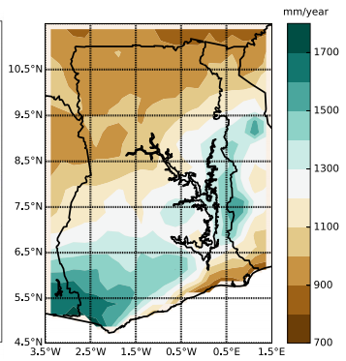

Figure 8: Mean annual rainfall climatology over Ghana during 1981-2015 (Atiah, Tsidu et al. (2020), p. 1395)

Another aspect that causes trouble resulting from the movement of people from the northern regions towards the southern regions is soil depletion. According to Akinyoade (Appendix 4, 2020), the problems that are caused by land practice in the north are being repeated in the south. According to him, the soil quality in Ghana is being impacted negatively because of land use practices causing soil depletion, which means that the components which contribute to fertility are removed and not replaced. Whereas this problem was originally mainly occurring in the north, it is now also happening in the southern parts of Ghana, and this is negatively influencing the level of food security of Ghana (Akinyoade, Appendix 4, 2020).

5.1.2 The division of water between energy in the south and agriculture in the north causes concerns on a security-level in Ghana
According to Brown & Crawford (2008), the division of water between energy in the south and agriculture in the north can lead to problems in Ghana, especially in the dry season. The division of water in Ghana is seen as a direct result of the north-south divide. Water in the south of the country travels downstream from rivers originating in the northern parts of Ghana or even Burkina Faso. If the water level falls too low in the Akosombo Dam situated in the south (just above Accra), this leads to an energy crisis in the entire country as energy is generated from this dam (Addax, 2007).
According to Abdulai (Appendix 1, 2021) and Arthur (Appendix 1, 2021), the division of water between the southern and northern parts of Ghana does not cause concerns on a security level in Ghana. They acknowledge that there are periods each year where there is water scarcity (mainly during the dry season). According to Arthur (Appendix 1, 2021): “The Black Volta comes all the way from Burkina to Ghana, but then down south Ghana dammed it for energy. And this dam does not affect people in the north […]. We have other water bodies in the north that were dammed for agriculture.” According to Arthur (Appendix 1, 2021), it is not the division of water between the south and the north that causes problems on a security level, but rather the development and maintaining of dams in the north that were built for irrigation purposes – even though the dams were constructed well. The cause of the existing troubles with regard to maintaining the level of water in dams can be derived from the increasing seasonal variability in rainfall, as well as changes in the rainfall trend. This causes water scarcity and soil erosion, because the transition from natural vegetation to agriculture becomes harder.
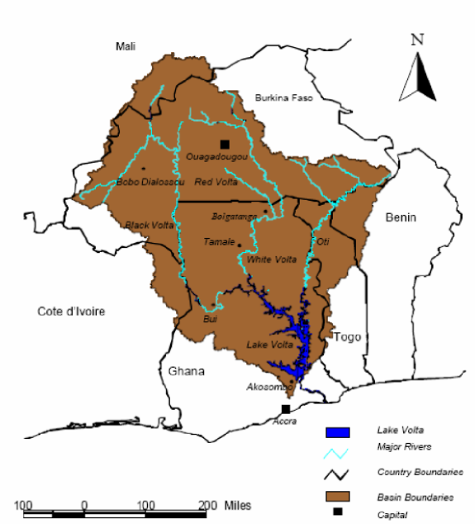
Figure 9: The Volta Basin and the six riparian countries (GLOWA-Volta project, 2003)
The issues posed by Brown & Crawford (2008), Addax (2007), Abdulai & Arthur (Appendix 1, 2021), are a logical result of the impact of global climate change and the resulting vulnerability of the Basin. According to Rodgers et al. (2007, p. 311), “The disproportionate dependency of Basin inhabitants on increasingly risky rainfed agriculture exacerbated by the exceptionally low levels of irrigation investment and irrigated area, the overall fragility of the West African economy and its sensitivity to movements in commodity prices, and the susceptibility of inhabitants to a wide range of waterborne and water-related illnesses.”
Although the division of water between agriculture in the north and energy-generation in the south does not directly lead to security concerns in Ghana, the impact of climate change on this division of water indirectly could have negative implications for this process. The main economic activities in the north are based on ‘risky rainfed agriculture’, as mentioned by Rodgers et al. (2007). In combination with the geographical conditions in the northern parts, this means that the northern parts of Ghana are extra vulnerable to the effects of climate change, resulting in water scarcity. This is illustrated in Table 3, which shows that the northern parts of Ghana experience a higher percentage of poverty than the other parts of Ghana. One could argue that the effects of climate change have a negative impact on the already existing north-south divide, making this divide even stronger.

5.1.3 Management of regional water sources poses a threat for instability in Ghana
Ghana recognizes a possible threat of instability as a result of the effect of water management. This threat exists within Ghana, but also as a potential cross-border problem. Ghana and Burkina Faso make up 85 per cent of the Volta River Basin, and much of the water flowing through this Basin flows through Burkina Faso before reaching Ghana. Future pressure on water shortage can lead to conflict between the two countries.
To prevent the management of regional water sources to pose a threat for instability in this region, the Volta Basin Authority was established. According to Arthur (Appendix 1, 2021), the Volta Basin Authority helps to prevent instability with regard to water sources as all countries involved are able to cooperate and make regulations with regard to the Volta Basin. Abdulai (Appendix 1, 2021) adds to this by stating that the impact of climate change has aggravated the situation in the northern parts of Ghana because the irrigation facilities are not functioning properly, which results in water scarcity, also because the rainy season has become shorter and less predictable.
According to Akinyoade (Appendix 4, 2021), there are some transboundary issues between Ghana and Burkina Faso even though the Volta Basin Authority was established. He states that there are two layers of conflict with regard to water management in this region. The first layer of conflict takes place during the rainy season, where dams in Burkina Faso do not have the capacity to retain enough water, causing areas in Ghana to flood. Bukari (Appendix 5, 2021) agrees with Akinyoade, by stating that “Burkina Faso has gone into a lot of agricultural production, they are trying to control the source of water. When this happens, it tends to cause a lot of problems for Ghana, […] sometimes there is a spill-over effect. The water comes into Ghana and destroys a lot of farms, a lot of crops and many houses. So, it really has an impact”. The second layer of conflict occurs during the dry season, as this is the period that most people are in need of water. This is when water scarcity occurs. According to Akinyoade (Appendix 4, 2021), there is not enough water during the dry season and the consequence of this is a limited electricity supply. This leads to the process of ‘load shedding’, which means that the electricity utility will interrupt the energy supply to certain areas to resort a balance between supply and demand of electricity. He states that the dam situation in Burkina Faso must improve on a general level.
Bukari (Appendix 5, 2021) adds to this by stating that the increasing variability of the rainfall pattern impacts these regions. The dry season is becoming longer than expected, mainly in the savannah parts in the north of Ghana. The impact of this changing rainfall pattern is influencing the livelihood practices of the local population, leading to pastoralists migrating away from the northern regions of Ghana because there is not enough water available (Bukari, Appendix 5, 2021). The movement of pastoralists from northern parts of Ghana towards the south can lead to instability, because the relationships that are built between communities are being disturbed by the influx of more people. This can lead to issues of land use, and according to Bukari (Appendix 5, 2021), people from the south become more antagonistic towards these migrants.

5.1.4 Economic instability emerges in Ghana as a result of climate change
According to Bukari (Appendix 5, 2021), the impact of climate change on the Ghanaian economy is enormous. The change in seasons, the changing rainfall patterns and the changing temperatures are impacting the farming industry. Bukari (Appendix 5, 2021) states: “Climate change should not only be seen in the fact that temperature, rainfall pattern and other things are happening, but it also has an impact on land use cover, the destruction of ecosystem services and animal production, it impacts the fertility of the soil. It creates a lot of economic instability for some people, and they do not have an option than to move to other places in order to find jobs.”
The effects of climate change do strengthen the north-south divide in Ghana, as agricultural practices become harder, which is a cause for economic instability in itself. Akinyoade (Appendix 4, 2020) mentioned that, “The northern regions, that is where the problem is. Though of course it is in the south too. It is coming to the south because agricultural practices in the north are harder because of the worsening conditions, so farmers are moving down south”. Apart from the north-south divide, climate change also influences the urban-rural dichotomy. Agricultural practices become harder to perform as a result of climate change, which causes people to migrate towards cities in order to seek jobs. According to Tsikata & Seini (2004), urban regions perform better on the welfare scale, because of an urban bias in the provision of welfare services and an unequal distribution of decision-making power between urban and rural communities. Thirdly, there are also differences in economic opportunities between various rural communities. Tsikata & Seini (2004) mention that differences in resource endowments emerge between communities that are focused more on export-related agriculture and those communities that are more closely tied to subsistence production.
All in all, one could conclude that climate change has a bigger influence on the northern regions than the southern regions in Ghana because these northern regions are more dependent on the weather as they focus more on agricultural practices. This strengthens the north-south divide and complicates the management of regional water sources, leading to more economic instability in Ghana.
According to Abdulai (Appendix 1, 2021), the Ghanaian government tries to improve the economic situation in the northern parts of Ghana by focusing on an economic development strategy. Abdulai (Appendix 1, 2021) states that the Ghanaian government has focused on building small dams in the north for irrigational purposes, trying to get people to produce agricultural commodities all-year round. Furthermore, they try to engage people and improve the infrastructure, to prevent the north-south divide in Ghana to become stronger.
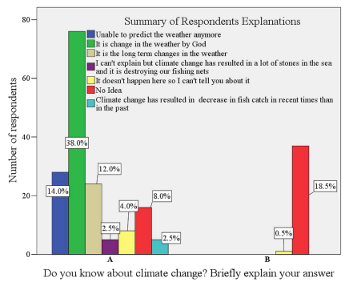
Figure 10: Respondents’ awareness and perception of climate change (Evadzi, Scheffran et al., 2017, p. 190)
Another issue with regard to economic instability is that people are often uninformed about the causes of climate change and are therefore less able to deal with the consequences, as they often do not understand how to put this into practice. Figure 6 shows that 38% of the respondents in a research by Evadzi, Scheffran et al. (2017) believe that the change in the weather is caused by God, or have difficulties to explain why the weather is changing.

5.2 Burkina Faso

5.2.1 Water availability and water quality are main concerns in Burkina Faso
According to Brown & Crawford (2008), pressure on water availability and quality is expected to rise as a result of siltation, erosion and variable and declining rainfall. The issues of water management have been addressed before. There are issues both in the rainy season and in the dry season. During the rainy season, climate change has resulted in more irregular rainfall patterns, meaning there are periods of erratic rainfall. This causes floods during the rainy season, because Burkina Faso’s dams do not have the capacity to retain so much water (Akinyoade, Appendix 4, 2020).
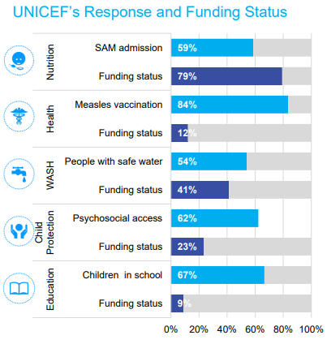
Figure 11: UNICEF’s Response and Funding Status (2021)
As shown in Figure 7, quality of water is still a concern in Burkina Faso. According to UNICEF, only 54% of people has access to safe water, also meaning that almost half of the people do not have safe access to water. Akinyoade (Appendix 4, 2020) states that the issues with regard to water retainment cause two main problems. First of all, the risk of floods during the rainy season, but secondly the lack of water during the dry season. According to Akinyoade (Appendix 4, 2020), there is an abundance of rainfall, more than enough for everyone. The problem, however, is that the water is not stored well, leading to problems during the dry season.
Furthermore, UNICEF (2021) states that the Ministry of Women, National Solidarity, Family and Humanitarian Action (MFSNFAH) has issued an alert in June 2020, predicting a high risk of flooding during the rainy season, which runs from June to September. Meteorological estimates expected a higher rainfall during the rainy season of 2020 than the average rainfall from 1981 to 2010. The predictions of the MFSNFAH turned out to be true, as it was estimated by UNICEF (2021) that more than 100,000 people were directly affected by the floods, leading to 41 casualties and 112 injured by September 2020. The government of Burkina Faso declared the flooding a national disaster.

5.2.2 The tensions between pastoralists and agricultural communities pose a threat for conflict in Burkina Faso
The relationship between pastoralists and agricultural communities has become more and more heated over the last couple of years. Brown & Crawford (2008) state that the range and resources to which Burkina Faso’s pastoralist community has access has been diminishing as a result of the expansion of farming and population growth in combination with drought and desertification. As a result of these processes, pastoralist communities rely less on the mutually beneficial relationship with agricultural communities. This results in those two groups increasingly competing in the marketplace, which puts even more pressure on their relationship (Brown & Crawford, 2008).
Brown & Crawford state that the threat for conflict between pastoralists and agricultural communities mainly plays a role within Burkina Faso, but according to various experts (Abdulai & Arthur Appendix 1, Akinyoade Appendix 4, Bukari Appendix 5, Sanou Appendix 6 & Diarra Appendix 7) the issues between pastoralists and agricultural communities are also occurring in Ghana and other West African countries. Furthermore, the issues are to be seen as cross-border tensions, as pastoralists often cross borders to seek for grazing spots for their cattle.
According to Akinyoade (Appendix 4, 2020), the problems with regard to agricultural communities and pastoralists are predictable: “We all know the time they will enter Ghana, we all know the time they will enter Côte d’Ivoire. For me, the context of conflict is predictable.” Akinyoade (Appendix 4) mentions that climate change plays an important role within the current tensions between pastoralists and agricultural communities. Earlier, there never used to be conflict between these groups because the agricultural communities knew when the pastoralists would enter, there was a ‘gentleman’s understanding’ between the groups. He mentions that climate change has disturbed the existing relationships, because pastoralists generally need to move further and earlier as a result of the changing rainfall pattern. This has caused a disturbance of the ‘gentleman’s understanding’, as pastoralists move into areas where this understanding between the two groups is non-existent.
Figure 8 shows the perception of pastoralists on climate change and climatic hazards in the Kompienga province, situated in the southeastern part of Burkina Faso. It shows that people clearly recognize that the rainy season has become shorter. Furthermore, a clear decrease in intensity of rainfall is visible in this province, whilst the temperature level has increased. These processes affect the livelihood practices of pastoralists.
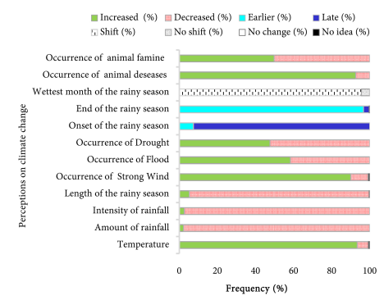
Figure 12: Perception of pastoralists and agro-pastoralists (n = 271) on climate change and climatic hazards in Kompienga province (Sanou, Tsado et al., 2018, p. 5)
Bukari (Appendix 5, 2021) recognizes the same patterns as Akinyoade. According to Bukari (Appendix 5, 2021), other issues are in place that strengthen the tensions between pastoralists and agricultural communities. He argues that “Some of the issues that are driving these conflicts are the impact of climate change, which is pushing herders to migrate to the semi-arid areas of West Africa to get resources for their animals. Another thing is land use change, now lands are becoming more scarce due to the impact of land grabbing.” He mentions that the commercialization and commoditization of land is an issue that is impacting the nomadic lifestyle of the pastoralist communities, as there is less land available for the pastoralists to move to. Furthermore, Bukari (Appendix 5, 2021) mentions that the increased number of cattle has complicated the relationship between the two groups. Another issue that is influencing the relationship between pastoralists and agricultural communities is the growing threat of terrorism. Pastoralists are moving away from particular areas in Burkina Faso as a result of terrorist activity. This results in pastoralist communities to move more southwards, leading to the same problems as mentioned before; the ‘gentleman’s agreement’ is not in place in these new areas. Furthermore, agricultural communities sometimes have the perception that pastoralists themselves are terrorists, resulting in agricultural communities to become more antagonistic towards pastoralists (Bukari, Appendix 5, 2021). Another part of this research is specifically dedicated to the topic of terrorism.
Sanou (Appendix 6, 2021) adds to the point made by Bukari (Appendix 5, 2021) about the commercialization and commoditization of land by mentioning that farmers are likely to expand their cropping area because they know there will be a decline in productivity as a result of climate change. Climate change is not the only factor for agricultural communities to expand their cropping area, however; population growth plays an important role as well. This is illustrated by Figure 9, which shows that the population in Western Africa is indeed rising at a quick pace. A logical result of population growth is that pressure on the land is becoming higher. Adding to this, according to Sanou (Appendix 6, 2021), certain areas are being avoided by pastoralists because of a high use of pesticides. Sanou (Appendix 6, 2021) mentions that the extensive use of pesticides in certain regions in Burkina Faso has caused fatalities among cattle in the past, and that is why pastoralists avoid these areas.
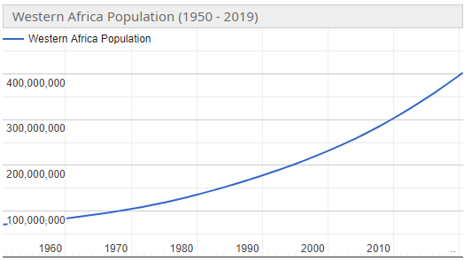
Figure 13: Western Africa population (1950-2019) (Worldometer, 2021)
According to Sanou (Appendix 6, 2021), the government of Burkina Faso allocated local government officials to bring forward a mechanism for conflict resolution. He states that this should rather be seen as a resolution instead of prevention of conflict in Burkina Faso. These local government officials have tried to design routes for pastoralists and their livestock, but Sanou (Appendix 6, 2021) brings forward that mistakes were made during the process of designing these routes because certain areas of the routes were occupied by crop farmers. He sees the problems between pastoralists and agricultural communities as a socio-economic problem. Another reported issue by Sanou (Appendix 6, 2021), is that the government created special areas that are designed for livestock, so that cattle can graze on these areas without crossing agricultural farms. Despite the creation of these areas for livestock, the rate of cropland increased by 6% each year, according to Sanou (Appendix 6, 2021). This means that it becomes even harder for pastoralists to find areas for cattle to graze, leading to tensions rising even higher in certain areas in Burkina Faso.

5.2.3 Declining rainfall and erratic rainfall negatively influence food security in Burkina Faso
The fact that water availability and water quality are main concerns in Burkina Faso also has an effect on the food availability. According to Sanou (Appendix 6), the food availability is becoming a crucial issue in Burkina Faso. The population growth means that more people need food whilst the area to produce this food is declining. The problems with regard to water availability and water quality are adding to the pressure on food availability, as it becomes harder to produce food during the dry season. Water scarcity can lead to pressure on water systems that keep ecosystems thriving, while shortage of water in the dry season can also lead to soil erosion, as the transition from natural vegetation to agriculture becomes more difficult.
According to Alvar-Beltran, Dao et al. (2020), because of the shifts in the onset and offset of the rainy season, increased dry-spell duration and intensified precipitation events, farmers in Burkina Faso have tried to adjust their agricultural activities, so as to be able to absorb climatic shocks. As a result, the most widespread practices are related to soil and water conversion practices. However, Alvar-Beltran, Dao et al. (2020) mention that because of the rate of change and the intensification of natural hazards, these practices seem to be insufficient in the long term. One can therefore conclude that declining rainfall and erratic rainfall negatively influence food security in Burkina Faso, because these changes are happening faster than the capability of people to respond to these changes.
Akinyoade (Appendix 4, 2020) agrees with Alvar-Beltran, Dao et al. (2020) by stating that the problem is not so much about the differences in rainfall caused by climate change, but more about the lack of ability to respond to the weather variability. According to him, there is enough rainfall on a yearly basis, so food security should not be impacted by declining rainfall. However, due to the lack of ability to respond to the increasing weather variability, lack of rainfall does influence food security negatively.
Sanou (Appendix 6, 2021) mentions that another issue impacts the food security of Burkina Faso. The establishment of national parks means that farmers are not allowed to cultivate certain fertile areas in Burkina Faso. The combination of a growing population and changing climate means that pressure on food security is rising, but people are not allowed to farm inside these protected areas. As shown in Figure 10, national parks (green areas) do not take up a very large area in Burkina Faso, but still cover a considerable amount of (fertile) land.
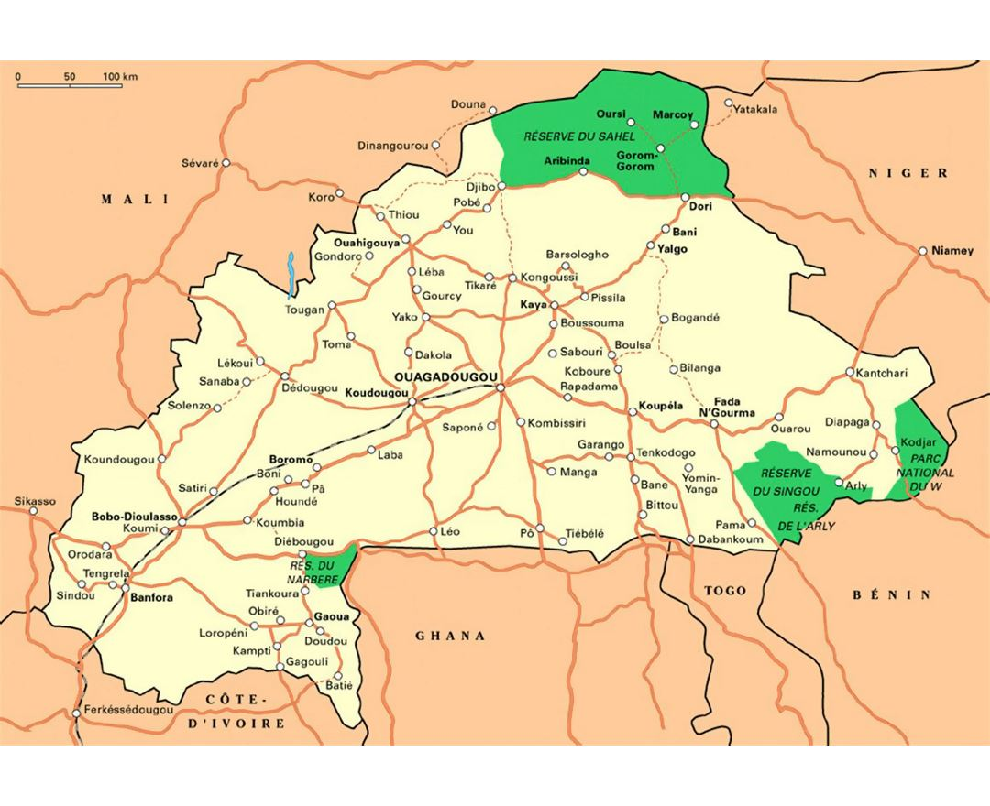
Figure 14: Large national parks map of Burkina Faso (Mapsland, n.d.)
Additionally, Sanou (Appendix 6, 2021) agrees with Akinyoade (Appendix 4, 2020) and Alvar-Beltran, Dao et al. (2020) that climate change is not the only factor impacting the food security in Burkina Faso. He mentions that population growth should be seen as another very important factor. The pressure on the land is becoming higher as a result of this population growth, which leads to farmers expanding their cropping area. This is strengthened by the premise that there is a decline in productivity as a result of climate change.

5.3 Applicable to Ghana and Burkina Faso

5.3.1 Border instability between Ghana and Burkina Faso emerges as a result of climate change
According to Brown & Crawford (2008), the Ghanaian government recognizes a threat of instability in the border regions between Ghana and Burkina Faso as a result of climate change. This instability could occur as a result of flows of refugees, hostile neighbors and regional economic disruption. Sosuh (2011) notices certain threats for border insecurity between Ghana and Burkina Faso. These are drug trafficking, arms trafficking, smuggling of goods, human trafficking, terrorism, money laundering, animal movement (pastoralists) and an influx of refugees.
According to Akinyoade (Appendix 4, 2020), the situation in the border regions between Ghana and Burkina Faso is quite calm. He mentions that the population living in the border regions is more often than not culturally related to each other, and that there is affinity between people living in these regions. Furthermore, cross-border movement is very fluid, partly as a result of the ECOWAS regulation: “The vision of ECOWAS is the creation of a borderless region where the population has access to its abundant resources and is able to exploit the same through the creation of opportunities under a sustainable environment” (ECOWAS, n.d.). The establishment of free movement of people between countries in West Africa can however also have a negative effect on stability along the borders. According to Takuo (2016), whilst border areas show potential for development, they are also fertile grounds for conflicts, insecurity, drug and human trafficking, and arms sales.
According to Akinyoade (Appendix 4, 2020), instability is more likely to occur on a regional level than on a local level, as fights never occurred between groups living in the border regions. Bukari (Appendix 5, 2021) agrees that the potential issues of border instability should be seen as more of an issue that is regional rather than local in character. The people living in the border region live together quite peacefully, according to Bukari. He predicts more issues on a national level between Burkina Faso and Ghana as the main water supply in Ghana comes from the Volta rivers coming from upstream in Burkina Faso. According to Bukari (Appendix 5, 2021), the daily movement of people across the borders of Ghana and Burkina Faso has nod led to any insecurity. This could partly be accounted for by the Ghanaian government, which established an immigration taskforce to monitor the activities of people moving in and out of Ghana.
It is important to take into account that the movement of pastoralists and the issues this brings forward between these pastoralists and agricultural communities can sometimes be cross-border related. As mentioned by Bukari (Appendix 5, 2021), the impact of climate change pushes pastoralists towards the semi-arid areas of West Africa in order to get resources for their animals. This is often a southwards movement, which means that it can push pastoralists from border regions in Burkina Faso towards Ghana, Benin, Togo and Ivory Coast. This movement can therefore be seen as a possible threat to the instability in border regions.

5.3.2 External and internal migration occurs as a result of climate change in Ghana and Burkina Faso
According to Brown & Crawford (2008), climate change has resulted in dry seasons to last longer in Burkina Faso. This causes farmers to migrate from the northern (driest) and central parts of Burkina Faso into the fertile west and east. This causes these migrants to get into contact with settled farmers. As mentioned by MECV & SP/CONEDD (2006), greater populations congregating in smaller fertile areas causes competition for valuable lands. Furthermore, there is a chance that this process accelerates environmental degradation.
According to Akinyoade (Appendix 4, 2020), there is a trend with regard to both external and internal migration within Burkina Faso and Ghana; people from both countries are moving southwards as a result of the effects of climate change. This starts with people in the northern and eastern parts of Burkina Faso moving towards the southern parts. Additionally, people from the southern parts of Burkina Faso cross the border towards Ivory Coast, Ghana, Benin and Togo. This causes external migration. Thirdly, people from the northern regions of Ghana often migrate towards the southern regions of Ghana, caused by climate change and the north-south dichotomy. These migration flows are in line with the movement of pastoralists in Ghana and Burkina Faso, as they often need to move further southwards to seek food and water for their cattle. This is illustrated in Figure 11, which shows that pastoralists clearly feel the impact of climate change as they see a decrease in income and an increase in food insecurity and effort in herding.
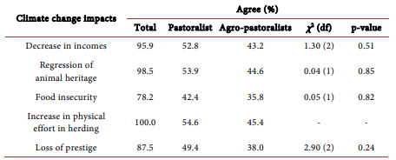
Figure 15: Perception on climate change impact on pastoral herder’s livelihood over last 10 years (n=271) (Sanou, Tsado et al, 2018)
According to Bukari (Appendix 5, 2021), the movement of people in Ghana and Burkina Faso has become a daily affair. However, it is not only climate change that causes people to move from Burkina Faso to Ghana. He mentions that a lot of young people move from Burkina Faso to Ghana because the Ghanaian economy and political system are more stable than in Burkina Faso. People from Burkina Faso try to establish networks with people who live in Ghana in order to make the movement easier. This type of migration has resulted in an increase in economic trade between Ghana and Burkina Faso. Both countries have market favourability regarding certain products, which means that there also is movement from Ghana back to Burkina Faso.
According to Diarra (Appendix 7, 2021), it is important to notice that the impact of climate change can sometimes lead to a rural exodus. People move from agricultural communities towards cities to seek small jobs because the impact of climate change has led to environmental problems. Diarra (Appendix 7, 2021) argues that there is a distinction between a climate change migrants and people who migrate because of other reasons such as economic opportunities. Not all cross-border migration is due to climate change. Some people move in order to profit from opportunities on the labour market.

5.4 Other possible threats

5.4.1 The danger of a rising sea level
Brown & Crowford (2008) mentioned the threat of the rising sea level for the coastal areas in Ghana. An estimated sea level rise of 1 meter by 2100 could inundate 120 square kilometers of land and put 132,000 people at risk in Ghana’s coastal zones. According to Abdulai (Appendix 1, 2021), the global rising sea level is a logical consequence of the general increase in global temperature, and therefore also having an effect on the coastal regions in Ghana. The effect on people is visible, according to Abdulai (Appendix 1, 2021), in the sense that coastal communities are being displaced as a result of the rising sea level, as the sea is generally becoming more dangerous for people who lived along the coastal delta. Arthur (Appendix 1, 2021) adds to this by stating that in certain places in Ghana you can see buildings in the sea that used to be on the shore just twenty years ago. Certain hard structures were built to prevent the sea from entering more coastal regions, but these structures are only temporary solutions (Evadzi, Scheffran et al., 2017). Furthermore, it is observed that investments in coastline protection through building hard structures in developing countries have remained largely ineffective (Klein et al., 2005). Arthur (Appendix 1, 2021) mentions that the effects of the sea entering coastal regions also has other impacts, such as sedimentation and erosion.
According to Akinyoade (Appendix 4, 2020), not enough attention is given to the technical aspects of preventing the sea from entering the coastal regions in Ghana. He states that there is a political aspect that is influencing this process, as the government is spending more money in certain regions than in other regions.
Table 12 shows that most of the respondents in a research are aware of the fact that the sea-level has risen over the last decade. Table 13 shows that more than half of the respondents of this research by Evazdi, Scheffran et al. (2017) have lost an item or property due to the rise in the sea level and the subsequent coastal flooding, and in many cases this has led to evacuation and/or resettlement of people. This shows that the impact of the sea-level rise is visible on a local level in the coastal region.
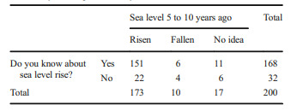
Table 16: Respondents awareness of change in sea-level close to their community for the past 5 to 10 years (Evadzi, Scheffran et al. (2017), p.191)
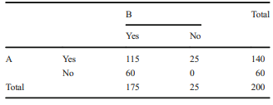
Table 17: Sea-level rise and coastal impact (A) have you lost any item or property situated close to the coast due to sea-level rise and coastal flooding (B) Did the incident in ‘A’ lead to you evacuation and/or resettlement (Evadzi, Scheffran et al. (2017), p. 191)

5.4.2 The threat of desertification
According to Brown & Crawford (2008), the range of resources to which pastoralist communities have access have been diminished as a result of the expansion of farming and population growth in combination with drought and desertification. The African sub-Sahara region is often regarded as the most seriously affected region when it comes to environmental degradation. Furthermore, it is regarded as a zone of high risk of further desertification (Capozzi, Di Palma et al., 2018). Niemeijer & Maccuzatto (2002) mention that Burkina Faso is a country prone to the effects of desertification as it is experiencing all the economic and demographic trends that are generally associated with desertification. According to Abdulai (Appendix 1, 2021), it is clearly visible that the process of desertification is taking place in parts of Burkina Faso and Ghana. Abdulai (Appendix 1, 2021) argues that this trend is having an influence on the livelihood practices of pastoralists. Desertification results in less available grazing fields for the cattle of pastoralists, which means they have to move further in order to reach grazing fields.
Bukari (Appendix 5, 2021) states that the process of desertification can partly be attributed to the mismanagement and misuse of land. An example of this is that Bukari (Appendix 5, 2021) notices that people are chopping more trees for firewood. This is having an impact on the environment, as vegetation partly contributes to preventing the desert to take over land. As Burkina Faso is situated closer to the Sahara Desert, it is more at risk to experience desertification than Ghana. According to Capozzi, Di Palma et al. (2018), Burkina Faso is critically sensitive to desertification. Human activities are playing a significant role in accelerating the process of desertification. Main factors in this process are overgrazing and over-exploitation of resources. Many areas in Burkina Faso are poorly vegetated and overexploited as a result of the heavy demographic pressure (Capozzi, Di Palma et al., 2018).

5.4.3 The threat of religious extremism
Recent developments have resulted in a growing threat of extremism in Burkina Faso and Ghana. According to Iwata (2016), poverty might provide a good recruitment opportunity for jihadist groups. Iwata (2016) argues that recent terrorist attacks in Burkina Faso where executed by local people who perceived maltreatment on the part of the central government. This resulted in resentment towards the government, and therefore it is easier for people to be recruited for jihadist groups. Iwata (2016) adds that residents of borderlands and marginalized areas might be more likely to share this kind of resentment towards the central government.
The instability in Mali with regard to religious extremism activated a spill-over effect in Burkina Faso and Ghana. According to Rupesighe & Bøås (2019), parts of Mali are currently in the grip of escalating insecurity, given an increase in inter-communal conflicts. Non-state actors and self-defense groups are contributing to the establishment of ‘jihadist’ groups and bandits (Rupesighe & Bøås, 2019). Climate change has an indirect impact on this development, as people are becoming more and more dissatisfied by the government attempts to deal with the effects of climate change for the local population. The absence and retreat of the state in combination with a neglect by international actors have opened regions of Mali for local, violent non-state actors who have become increasingly integrated and entrenched in the local communities. The affected regions in Mali are ethnically diverse and home to a mix of pastoralists, sedentary farmers and fishermen (Rupesighe & Bøås, 2019). The instrumentalization of local conflicts by Islamist groups ignites and exacerbates tensions between various groups, which results in the fueling and spreading of violence. These dynamics in Mali are spilling over towards Burkina Faso, as Burkina Faso has a similar ethnic constellation in its border zones, which have been affected by Islamist attacks (Rupesighe & Bøås, 2019).
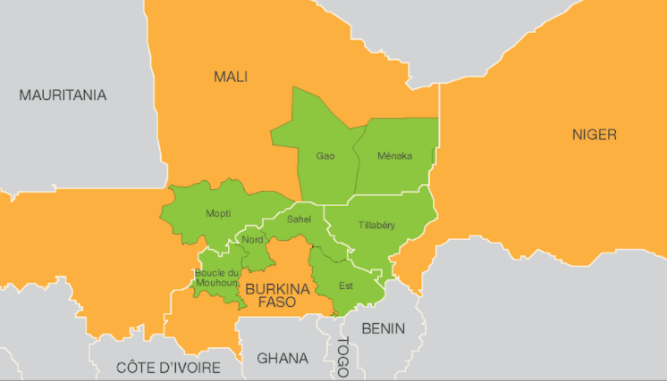
Figure 18: Liptako-Gourma region (Assanvo, 2019)
Assanvo, Dakono et al. (2019) point at the importance of instability in the Liptako-Gourma region. As shown in Figure 14, the Liptako-Gourma region is a cross-border region in Mali, Burkina Faso and Niger. According to Assanvo, Dakono et al. (2019), this region should be seen as the epicenter of the security crisis that is affecting the Sahel-Saharan strip. The rise in insecurity in this region can be attributed to the growth of three processes: violent extremism, transnational organized crime, and local conflicts. The context of these problems can be related to the severe droughts it experienced in the 1970s and 1980s, according to Assanvo, Dakono et al. (2019). These climatic disparities impacted the lifestyle of communities and exposed the states’ failures in terms of governance. Other tensions in the region occur as a result of a decrease in grazing areas, due to land being used for crops, as well as foraging resources and depletion of water (Assanvo, Dakono et al., 2019). These developments add to the instability between pastoralists and farmers. Figure 15 shows the evolution of the terrorist threat in Mali, Burkina Faso and Niger. It is clearly visible that the terrorist threat has increased over the last couple of years.
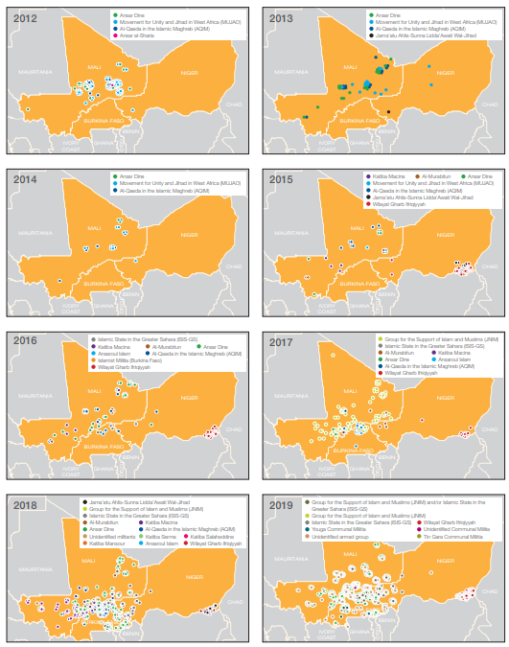
Figure 19: Evolution of the terrorist threat from 2012 to 2019 (ACLED, n.d.)
Apart from having direct implications for Burkina Faso, the threat of extremism also has an indirect effect, as it adds pressure on the demography of the country. Bukari (Appendix 5, 2021) sees the impact of terror groups from Mali in Burkina Faso; there is an influx of people who move into Burkina Faso as a result of terror attacks in Mali and Niger.
The different hypotheses that have been tested in Chapter 5 will be confirmed and/or denied in the upcoming conclusion. That way, an approach can be made to answer the research question and sub-questions for this research.

Chapter 6: Conclusion & Recommendations

Conclusion
Ghana and Burkina Faso are located in a very fragile region. The geographical location of the two countries in the west African region leads to different issues with regard to climate change. There are many experts on the topic of climate change who see the west African region as one of the most vulnerable in the world when it comes to dealing with the effects of climate change. As mentioned by Koubi (2019), researchers should focus on investigating how climatic changes interact with and/or are conditioned by socioeconomic, political, and demographic settings to cause conflict and uncover the causal mechanisms that link these two phenomena. In contemporary research there is a consensus that climate change has an impact on people’s livelihood, but the consequences of climate change on phenomena like conflict and migration are often yet to be explored.

Climate change
Precipitation change
Temperature change
Desertification
Sea level rise
Consequences
Resource scarcity

Ineffective governance of effects climate change
Increased difficulty to maintain livelihood practices
Social effects
Economic instability
Political instability
Climate change induced migration
Violent conflict
Regional conflict
Interstate conflict
Issues land ownership
Extremism
This research is based on a conceptual framework that tries to conceptualize the phenomena related to climate change into a model which explains the causal mechanisms with regard to climate change and conflict in Ghana and Burkina Faso.
Climate Change
The first part of the framework focuses on the different consequences of climate change experienced by people in this region. Both Burkina Faso and Ghana experience precipitation change. Burkina Faso is expected to see a projected increase in the frequency of heavy rains and flooding as a result of climate change. This projected increase most likely causes widespread erosion across all basin slopes in Burkina Faso. Furthermore, simulated scenarios have projected a short-term reduction in water flows of around 20 per cent in all river basins in Ghana, caused by precipitation change and poor water management. The visible trend in this region indicates that the amount of rainfall on a yearly basis does not change a lot, but climate change causes more erratic rainfall and a shorter rainy season. The average annual mean maximum temperature in Ghana and Burkina Faso is projected to rise between 2.5 and 3 degrees Celsius by 2100, whilst projections show that temperature is expected to have risen by 1.7 degrees by the middle of the 21st century.
Desertification & Sea level rise
Both the processes of desertification and sea level rise are slowly becoming a problem for Ghana and Burkina Faso. The impact of these two phenomena should be seen as more long-term problems for the livelihood practices of people, as the impact is not that prevalent yet. However, desertification is expected to have a huge impact on the livelihood practices of pastoralists in the future, as it results in less available grazing fields for the cattle of pastoralists, which means they have to move further in order to reach grazing fields. This process can still be halted and/or prevented, as desertification can partly be attributed to the mismanagement and misuse of land. The national governments of Ghana and Burkina Faso could play an important role in the prevention of desertification by investing in programs that teach people how to prevent mismanagement and misuse of land.
The process of sea level rise is also a long-term process, although the impact is already visible among some coastal communities. An estimated sea level rise of 1 meter by 2100 could inundate 120 square kilometers of land and put 132,000 people at risk in Ghana’s coastal zones. Nowadays, coastal communities are being displaced as a result of the rising sea level, as the sea is generally becoming more dangerous for people who live along the coastal delta. Data shows that more than half of the people who live in coastal areas have lost property due to the rise in the sea level and the subsequent impact of coastal flooding. In the long term, these developments can have huge implications for the livelihood of many people, as the rising sea level can push people from coastal regions towards the north, whilst desertification can push people from the dryer northern regions towards the south, leading to overpopulation in the central regions.
Resource scarcity and increased difficulty to maintain livelihood practices
The impacts of climate change described above (precipitation change, temperature change, desertification and sea level rise) impact the resource availability of Ghana and Burkina Faso. First and foremost, this influence is visible in the water availability of the two countries. The hypothesis “The division of water between energy in the south and agriculture in the north causes concerns on a security-level in Ghana” can however be considered to be false. Water availability is a concern for these countries, but does not directly lead to security concerns.
The impacts of climate change do strengthen the north-south divide in Ghana. The main activities in the northern parts are mainly based on risky rainfed agriculture. The geographical condition in these regions, in combination with precipitation changes, means that the northern parts of Ghana are extra vulnerable for the effects of climate change, resulting in water scarcity. Another factor influencing this process is that dams built in the northern regions of Ghana for irrigation purposes of agriculture are badly maintained. Issues with regard to water retainment cause two main problems. First of all, it means that water is even more scarce in the dry season. This is an unnecessary development, as there is an abundance of rainfall during the rainy season. Secondly, bad retainment of water increases the risk of floods during the rainy season, which already has led to floods in the past. In September 2020, it was estimated that more than 100,000 people were directly affected by floods in Burkina Faso. Furthermore, quality of water is a concern. Only 54% of people have access to safe water in Burkina Faso.
Water scarcity is not the only factor impacting resource scarcity; another factor is the range and resources to which Burkina Faso’s pastoralist community has access. This has been diminished as a result of the expansion of farming and population growth in combination with drought and desertification. Commercialization and commoditization of land is an important factor that is negatively impacting the nomadic lifestyle of the pastoralist communities. This process can be partly explained because farmers are likely to expand their cropping area because they know there will be a decline in productivity as a result of climate change. The result of this development is that pastoralists are pushed to migrate to the semi-arid areas of West Africa to get resources for their animals.
Ineffective governance
The governments of Ghana and Burkina Faso try to prevent the effects of climate change to influence the livelihood practices of local people. An example of this is the economic development strategy. Part of this economic development strategy is building small dams for irrigational purposes, but as mentioned before, these dams are not maintained well, causing issues for people with regard to water scarcity. Furthermore, the governments are trying to engage people and improve the infrastructure. Another example of this is that the governments have tried to design specific routes for pastoralists so they can direct their cattle through those routes without getting in contact with agricultural communities and by doing so prevent conflicts. However, mistakes are often made in the process of designing these routes, because some areas of the routes are occupied by crop farmers. In general, people in Ghana and Burkina Faso are often uninformed about the causes of climate change and are therefore less able to deal with the consequences. The general problem is that people often do not understand how to put measurements against the effects of climate change into practice.
Economic instability
The impacts of climate change lead to resource scarcity and increased difficulty to maintain livelihood practices due to the processes described above. A logical effect of this causal link is the impact on the economic systems of Ghana and Burkina Faso. The first logical impact of climate change on the economy is that changing temperatures and rainfall patterns are impacting the farming industry. Climate change destroys ecosystems and impacts the fertility of the soil. These effects are more visible in the northern regions, as the impact of climate change is the heaviest in these regions. The reason for this is that the northern regions are more dependent on the weather as they focus more on agricultural practices. This development leads to a strengthening of a north-south divide, as well as an urban-rural dichotomy.
Political instability
The conceptual framework acknowledges that the impact of climate change can lead to political instability in Ghana and Burkina Faso. Examples of political instability that can occur as a result of this phenomenon are a civil war and adverse regime changes in these countries. However, it appears that the current political instability is not directly caused by the effects of climate change. Burkina Faso runs the risk of more political instability in the upcoming years, but this is mainly caused by attacks by jihadi groups and vigilantes, often influenced from neighboring country Mali. People are more prone to join extremist groups as poverty might provide a good recruitment opportunity for jihadist groups.
Climate change induced migration
The effect of climate change generally results in southward migration, because the northern parts of Ghana and Burkina Faso experience the biggest impact of climate change. The effect of this is that a greater population has to congregate in a smaller area of fertile land, causing competition for this valuable land. This process also leads to more pressure on the available fertile land, causing environmental degradation. The general migration trend thus shows that people from northern areas of Burkina Faso are migrating towards the southern regions, and in turn people from the southern regions in Burkina Faso migrate further southwards, crossing the border towards Ivory Coast, Ghana, Benin and Togo. Thirdly, people from the northern regions of Ghana migrate towards the southern regions of Ghana. This process strengthens the north-south dichotomy. This process leads to more cross-border cooperation, as people from Burkina Faso try to establish networks with people living in bordering countries. There is a difference between climate change migrants and economic migrants, however. Not all cross-border migration should be seen as climate change-induced migration. Some people move in order to profit from opportunities on the labour market.
Issues with land ownership
The issues with land ownership are mainly caused by the conflicts between agricultural communities and pastoralists. The migration trend as described above, shows that pastoralists have to move further southwards in order to be able to feed their cattle. This means that the gentleman’s agreement that often existed between agricultural communities and pastoralists is being disturbed, because pastoralists whilst moving southwards come into contact with new agricultural communities, with whom this agreement is not in place. This has caused a disturbance in this gentleman’s agreement. The commercialization and commoditization of land strengthen this issue, as this is also impacting the nomadic lifestyle of the pastoralist communities, as there is less land available to move to.
Extremism
Religious extremism is a growing threat in Burkina Faso and Ghana. Poverty provides a good recruitment opportunity for jihadist groups, and the worsening condition with regard to maintaining livelihood practices is playing an important role in this process. Currently, religious extremism in Burkina Faso is a spill-over effect coming from instable regions in Mali.
To what extent has climate change contributed to conflict in Ghana and Burkina Faso?
Climate change has strongly contributed to conflict in Ghana and Burkina Faso, and will continue to do so in the future. The multiple climatic events that take place as a result of climate change are having a negative impact on people’s livelihood practices. Precipitation change and changing rainfall patterns are making it harder for people to perform agricultural practices and are also negatively influencing the soil, causing erosion. This is leading to resource scarcity. This resource scarcity has a direct negative impact on the economic stability of the two countries. Furthermore, it means that people often choose to migrate to areas where the effects of climate change are less noticeable.
Economic instability is a direct threat for violent conflict, as it means people are more prone to join extremist groups and are more vulnerable. Migration is a threat for violent conflict because it destabilizes the current status quo between agricultural communities and pastoralists. It is often the pastoralists that need to migrate further to feed their cattle who get into violent local conflict with agricultural communities. Climate change currently does not threaten to lead to interstate conflict between countries in West-Africa, although it does pose cross-border challenges for the countries involved, such as water retainment between countries and cross-border migration.

Limitations and recommendations

This research has a few limitations that should be taken into consideration. Firstly, the results of this research are only applicable to the specific region focused on in this research. As the relation between climate change and conflict is complex and involves multiple factors, it should be noted that the results and conclusions of this research are only applicable to Ghana and Burkina Faso.
A second limitation for this research is the lack of new empirical data gathered. By using the research methods of semi-structured interviews and literature study, this research relies on second-hand data. This can partly be attributed to the Covid-19 crisis, which did not allow me to travel to the countries involved for field work. Field work would most likely have helped in reaching more solid conclusions, as it would be easier to talk to people and observe the impacts of climate change myself. The lack of ‘locals’ in the list of interviewed people is another limitation of this research, partly caused by the same reason described above. This research could have profited from the experience of local people, as observations could become more practical instead of theoretical.
A part of the theoretical starting point of this research consist out of the premise that there are two perspectives in which conflict can occur as a result of climate change. The first perspective states that climatic events such as severe droughts can lead to localized violence and grim humanitarian consequences, which has a negative impact on resource scarcity, leading to conflict and social breakdown (Lind, Ibrahim & Harris, 2010). The second theoretical perspective brought forward by Lind, Ibrahim & Harris (2010) argues that it is not climate change that directly causes conflict, but rather the ineffectiveness of governance and institutions to respond to climate shocks. For the specific case of Ghana and Burkina Faso a combination of those two perspectives is most fitting. However, the theory states that droughts can lead to localized violence and then influence resource scarcity. Arguably, this is the wrong order of consequences. Drought can lead to resource scarcity and indirectly influence local violence.
An important theory in understanding the relation between climate change and migration is the theory of Homer-Dixon (2001): “Population growth and unequal access to good land force huge numbers of people onto marginal lands. There, they cause environmental damage and become chronically poor. Eventually, they may be the source of persistent upheaval, or they may migrate yet again, helping to stimulate ethnic conflict or urban unrest elsewhere.” (Homer-Dixon, 2001, p. 155) This theory directly can be directly applied to the case of Ghana and Burkina Faso. Climate change means that there is less and less access to fertile land, which is forcing more and more people to the same chunk of marginal land. Ethnic conflict is the result of this occurrence, although it is important to note that this ethnic conflict mainly occurs as a result of clashes between pastoralist groups and agricultural communities. Barnett & Adger (2007) argued that if climate change results in reduced rainfall and access to the natural capital sustaining livelihoods, which is the case in Ghana and Burkina Faso, this should lead to increased grievances and better recruitment opportunities for rebel movements. This is very applicable to the case of Ghana and Burkina Faso. Rebel movements in the form of religious extremist movements are a threat for the stability in the region. This is partly caused by the ability of extremist movements to recruit people as a result of increased difficulty in sustaining livelihoods. Hendrix & Glaser (2007) suggested that interannual variability in rainfall is a more significant determinant of conflict than climate, land degradation, and freshwater resources.
Interannual variability should not be seen as a more significant determinant of conflict that climate, land degradation and freshwater resources in Ghana and Burkina Faso. Land degradation in particular has a massive impact on the livelihood practices of local people, meaning that the impact of this phenomenon is as important as the impact of interannual variability in rainfall.
There are different opportunities for future research. First of all, field work could help in establishing what the governments of Ghana and Burkina Faso should do to address and prevent the effects of climate change leading to conflict. A quantitative approach among citizen could shed light on what would help people to prevent the effects of climate change having a large impact on their livelihoods. Furthermore, it is expected that the effects of desertification, sea level rise and extremism are going to become larger issues in the future, so an advanced research on one of these specific topics could help in preventing this development.

Bibliography
Addax. Bilingual news on Africa. 2007. Ghana: the energy crisis worsens. Posted by Fodé-Moussa Keita on 5 August 2007. Hydro-power crisis getting worse. Available at http://addax.wordpress.com/category/ghana
Addo, K. A., & Adeyemi, M. (2013). Assessing the impact of sea-level rise on a vulnerable coastal community in Accra, Ghana. Jàmbá: Journal of Disaster Risk Studies, 5(1), 1-8.
Adepoju, A. (2003). Migration in West Africa. Development, 46(3), 37-41.
Alvar-Beltrán, J., Dao, A., Dalla Marta, A., Heureux, A., Sanou, J., & Orlandini, S. (2020). Farmers’ Perceptions of Climate Change and Agricultural Adaptation in Burkina Faso. Atmosphere, 11(8), 827.
Anarfi, J., Kwankye, S., Ababio, O. M., & Tiemoko, R. (2003). Migration from and to Ghana: A background paper. University of Sussex: DRC on Migration, Globalisation and Poverty.
Atiah, W. A., Tsidu, G. M., Amekudzi, L. K., & Yorke, C. (2020). Trends and interannual variability of extreme rainfall indices over Ghana, West Africa. Theoretical and Applied Climatology, 1-15.
Armah, F. A., Odoi, J. O., Yengoh, G. T., Obiri, S., Yawson, D. O., & Afrifa, E. K. (2011). Food security and climate change in drought-sensitive savanna zones of Ghana. Mitigation and adaptation strategies for global change, 16(3), 291-306.
Asante, F. A., & Amuakwa-Mensah, F. (2015). Climate change and variability in Ghana: Stocktaking. Climate, 3(1), 78-99.
Assanvo, W. (2019). Is organised crime fuelling terror groups in Liptako-Gourma? ISS Africa
Assanvo, W., Dakono, B., Théroux-Bénoni, L. A., & Maïga, I. (2019). Violent extremism, organised crime and local conflicts in Liptako-Gourma.
Awunyo-Akaba, Y., Awunyo-Akaba, J., Gyapong, M., Senah, K., Konradsen, F., & Rheinländer, T. (2016). Sanitation investments in Ghana: An ethnographic investigation of the role of tenure security, land ownership and livelihoods. BMC Public Health, 16(1), 594.
Bächler, G., & Spillmann, K. R. (1996). Kriegsursache Umweltzerstörung: ökologische Konflikte in der Dritten Welt und Wege ihrer friedlichen Bearbeitung: Abschlussbericht des Environment and Conflicts Projects ENCOP (Vol. 2). Rüegger.
Barnett, J., & Adger, W. N. (2007). Climate change, human security and violent conflict. Political geography, 26(6), 639-655.
Beidel, D. C., Turner, S. M., Young, B. J., Ammerman, R. T., Sallee, F. R., & Crosby, L. (2007). Psychopathology of adolescent social phobia. Journal of Psychopathology and Behavioral Assessment, 29(1), 46-53.
Berry, S. (2009). Building for the future? Investment, land reform and the contingencies of ownership in contemporary Ghana. World Development, 37(8), 1370-1378.
Biederlack, L., Rivers, J., 2009. Comprehensive Food Security and Vulnerability Analysis (CFSVA) Ghana. United Nations World Food Programme, Rome, Italy.
Brown, O. (2008). Migration and climate change (No. 31). United Nations Publications.
Brown, O., & Crawford, A. (2008). Climate change: A new threat to stability in West Africa? Evidence from Ghana and Burkina Faso. African Security Studies, 17(3), 39-57.
Buhaug, H. (2016). Climate change and conflict: taking stock. Peace Economics, Peace Science and Public Policy, 22(4), 331-338.
Buhaug, H., N.P. Gleditsch & O.M. Theisen, 2008: Implications of Climate Change for Armed Conflict, World Bank Group: ‘Social Dimensions of Climate Change’ workshop
Campbell, J., (2016). Sea Levels along the West African Coast. Council on Foreign Relations
Capozzi, F., Di Palma, A., De Paola, F., Giugni, M., Iavazzo, P., Topa, M. E., ... & Giordano, S. (2018). Assessing desertification in sub-Saharan peri-urban areas: case study applications in Burkina Faso and Senegal. Journal of Geochemical Exploration, 190, 281-291.
De Longueville, F., Hountondji, Y. C., Kindo, I., Gemenne, F., & Ozer, P. (2016). Long‐term analysis of rainfall and temperature data in Burkina Faso (1950–2013). International Journal of Climatology, 36(13), 4393-4405.
Diao, X., & Sarpong, D. B. (2007). Cost implications of agricultural land degradation in Ghana: an economywide, multimarket model assessment.
Dumenu, W. K., & Obeng, E. A. (2016). Climate change and rural communities in Ghana: Social vulnerability, impacts, adaptations and policy implications. Environmental Science & Policy, 55, 208-217.
Dutch Ministry of Foreign Affairs. (04-2018). Climate Change Profile Ghana
ECOWAS (n.d.). Basic information
Englebert, P. (2018). Burkina Faso: Unsteady Statehood in West Africa. Routledge.
European Commission (2016). Which areas on the planet are at risk of desertification
Evadzi, P. I., Scheffran, J., Zorita, E., & Hünicke, B. (2018). Awareness of sea-level response under climate change on the coast of Ghana. Journal of Coastal Conservation, 22(1), 183-197.
Ghana Statistical Service, 2000. Poverty Trends in Ghana in the 1990s. Accra, Ghana.
Ghana Statistical Service, 2013. 2010 Population and Housing census Report: Non-Monetary Poverty in Ghana. Ghana Statistical Service, Accra, Ghana.
Gleditsch, N. P. (2012). Whither the weather? Climate change and conflict.
Glowa-Volta project, (2003), The Volta Basin and the six riparian countries
Goldstone, J. A., Bates, R. H., Epstein, D. L., Gurr, T. R., Lustik, M. B., Marshall, M. G., ... & Woodward, M. (2010). A global model for forecasting political instability. American Journal of Political Science, 54(1), 190-208.
Hampshire, K. & Randall S. (1999). Seasonal labour migration strategies in the Sahel: Coping with poverty or optimising security? International Journal of Population Geography, 5(5), 367–385.
Harrell, M. C., & Bradley, M. A. (2009). Data collection methods. Semi-structured interviews and focus groups. Rand National Defense Research Institute Santa Monica
Hartmann, B. (2010). Rethinking climate refugees and climate conflict: Rhetoric, reality and the politics of policy discourse. Journal of International Development: The Journal of the Development Studies Association, 22(2), 233-246.
Hegre, H., & Raleigh, C. (2007).Population size, concentration and civil war: a geographically disaggregated analysis. Policy Research Working Paper 4243 (June). World Bank, Washington, DC.
Hendrix, C. S., & Glaser, S. M. (2007). Trends and triggers: Climate, climate change and civil conflict in Sub-Saharan Africa. Political geography, 26(6), 695-715.
Hendrix, C. S., & Salehyan, I. (2012). Climate change, rainfall, and social conflict in Africa. Journal of peace research, 49(1), 35-50.
Henry, S., Schoumaker, B., & Beauchemin, C. (2004). The impact of rainfall on the first out-migration: A multi-level event-history analysis in Burkina Faso. Population and environment, 25(5), 423-460.
Hogg, M. A., Kruglanski, A., & Van den Bos, K. (2013). Uncertainty and the roots of extremism.
Homer-Dixon TF. (2001). Environment, Scarcity, and Violence. Princeton, NJ: Princeton Univ. Press
Hussain (2014). Can political stability hurt economic growth? World Bank Blogs
Ingram, K., Roncoli, M., & Kirshen, P. (2002). Opportunities and constraints for farmers of West Africa to use seasonal precipitation forecasts with Burkina Faso as a case study. Agricultural Systems, 74, 331–349.
IPCC, 2007: Climate Change 2007: Synthesis Report. Contribution of Working Groups I, II and III to the Fourth Assessment Report of the Intergovernmental Panel on Climate Change
IPCC, 2014: Climate Change 2014: Synthesis Report. Contribution of Working Groups I, II and III to the Fifth Assessment Report of the Intergovernmental Panel on Climate Change
Issahaku, A. R., Campion, B. B., & Edziyie, R. (2016). Rainfall and temperature changes and variability in the Upper East Region of Ghana. Earth and Space Science, 3(8), 284-294.
Iwata, T. (2016). Borders and Regional Security in Local Governments’ Cooperation in West Africa: Case Studies in Burkina Faso. Ritsumeikan Annual Review of International Relations, 15, 1-25.
Kniveton, D., Smith, C., & Wood, S. (2011). Agent-based model simulations of future changes in migration flows for Burkina Faso. Global Environmental Change, 21, S34-S40.
Homer-Dixon T. 1999. Environment, Scarcity and Violence . Princeton University Press: Princeton,
NJ
Koubi, V. (2019). Climate change and conflict. Annual review of political science, 22, 343-360.
Kuusaana, E. D., Kidido, J. K., & Halidu-Adam, E. (2013). Customary land ownership and gender disparity-evidence from the wa municipality of Ghana. Ghana Journal of Development Studies, 10(1-2), 63-80.
Lind, J., Ibrahim, M., & Harris, K. (2010). Climate change and conflict: moving beyond the impasse.
Mapsland. (n.d.) Large national parks of Burkina Faso with roads and major cities
MECV & SP/CONEDD(Ministère Environnemental et Cadre de Vie and Secrétariat Permanent du Conseil National pour l’Environnement el le Développement Durable) 2006. Programme d’Action National d’Adaptation à la variabilité et aux changements climatiques (PANA du Burkina Faso).
Mendelsohn, R., Dinar, A., & Williams, L. (2006). The distributional impact of climate change on rich and poor countries. Environment and development economics, 159-178.
Miguel, E., Satyanath, S., & Sergenti, E. (2004). Economic shocks and civil conflict: An instrumental variables approach. Journal of political Economy, 112(4), 725-753.
Ministere de l’environnement et du cadre de vie, Burkina Faso (2007). Programme d’action national d’adapatation a la variability et aux changements climatiques (Pana de Burkina Faso).
Ministry of Food and Agriculture (2007) Food and agriculture sector development policy (FASDEP II). Accra, Ghana
National Adaptation Program of Action of Burkina Faso (NAPA, (2007). United Nations Development Program
Nelson, G. C., Valin, H., Sands, R. D., Havlík, P., Ahammad, H., Deryng, D.& Kyle, P. (2014). Climate change effects on agriculture: Economic responses to biophysical shocks. Proceedings of the National Academy of Sciences, 111(9), 3274-3279.
Nicholls, R. J., Wong, P. P., Burkett, V., Codignotto, J., Hay, J., McLean, R., ... & Saito, Y. (2007). Coastal systems and low-lying areas.
Nielsen, J. Ø., & Reenberg, A. (2010). Cultural barriers to climate change adaptation: A case study from Northern Burkina Faso. Global Environmental Change, 20(1), 142-152.
Niemeijer, D., Mazzucato, V., 2002. Soil degradation in the West African Sahel—how serious is it? Environment 44, 20–31
Nordås, R., & Gleditsch, N. P. (2007). Climate change and conflict. Political geography, 26(6), 627-638.
Nyantakyi-Frimpong, H., & Bezner-Kerr, R. (2015). The relative importance of climate change in the context of multiple stressors in semi-arid Ghana. Global Environmental Change, 32, 40-56.
Ohlsson, L. (2000). Livelihood conflicts: Linking poverty and environment as causes of conflict (p. 16). Swedish International Development Cooperation Agency (SIDA).
Opdenakker, R. (2006, September). Advantages and disadvantages of four interview techniques in qualitative research. In Forum qualitative sozialforschung/forum: Qualitative social research (Vol. 7, No. 4).
Owusu, A. B. (2012). Farmers coping with the threat of desertification: A case study of the Upper East Region, Ghana. Wudpecker Journal of Agricultural Research, 1(8), 317-330.
Pettinger (03-2020). Causes of economic instability
PSMSL (2018), Data and Station Information for Tema & Takoradi
Raleigh, C., & Urdal, H. (2007). Climate change, environmental degradation and armed conflict. Political geography, 26(6), 674-694.
Rees, P. (2020). Internal Migration Measures and Trends International Encyclopedia of Human Geography (Second Edition)
Reid, H. (2014). Climate change and human development. Zed Books Ltd.
Reuveny, R. (2007). Climate change-induced migration and violent conflict. Political geography, 26(6), 656-673.
Rodgers, C., van de Giesen, N., Laube, W., Vlek, P. L., & Youkhana, E. (2006). The GLOWA Volta Project: A framework for water resources decision-making and scientific capacity building in a transnational West African basin. In Integrated assessment of water resources and global change (pp. 295-313). Springer, Dordrecht.
Rosenzweig, C., & Parry, M. L. (1994). Potential impact of climate change on world food supply. Nature, 367(6459), 133-138.
Rupesinghe, N., & Bøås, M. (2019). Local Drivers of Violent Extremism in Central Mali.
Salehyan, I. (2008). From climate change to conflict? No consensus yet. Journal of Peace Research, 45(3), 315-326.
Sanou, C. L., Tsado, D. N., Kiema, A., Eichie, J. O., & Okhimamhe, A. A. (2018). Climate variability adaptation strategies: challenges to livestock mobility in south-eastern Burkina Faso. Open Access Library Journal, 5(2), 1-17.
Sayne, A. (2011). Climate change adaptation and conflict in Nigeria. US Institute of Peace.
Scheffran, J., Brzoska, M., Kominek, J., Link, P. M., & Schilling, J. (2012). Climate change and violent conflict. Science, 336(6083), 869-871.
Serdeczny, O., Adams, S., Baarsch, F., Coumou, D., Robinson, A., Hare, W., ... & Reinhardt, J. (2017). Climate change impacts in Sub-Saharan Africa: from physical changes to their social repercussions. Regional Environmental Change, 17(6), 1585-1600.
SIDA. (2018). The relationship between climate change and violent conflict.
Snyder, H. (2019). Literature review as a research methodology: An overview and guidelines. Journal of Business Research, 104, 333-339.
Sosuh, M. M. (2011). Border security in Ghana: challenges and prospects.
Spillman, K. P. (1995). From environmental change to environmental conflict. Environmental and Conflict Project, Occasional Report, 14, 4-10.
The Borgen Project (22-04-2020). The effects of desertification in Africa
Tonah, S. (2002). Fulani pastoralists, indigenous farmers and the contest for land in Northern Ghana. Africa Spectrum, 43-59.
Tsikata, D., & Seini, W. (2004). Identities, Inequalities and Conflicts in Ghana.
UNICEF, (2021). Burkina Faso, Humanitarian Situation Report No. 10
Weiss, H. (2007). Contested historical and geographical narratives: Succession disputes, contested land ownership and religious conflicts in northern Ghana. Studia Orientalia Electronica, 101, 461-484.
World Wildlife. (n.d.) Soil erosion and degradation. Overview
World Wildlife. (n.d.) Water scarcity. Overview
Worldometer, (2021), Western African Population (1950 – 2019)

