When Democracy Weakens, Women Suffer: Understanding the Relationship between Democratic Backsliding and Femicide
A quantitative research that looks at the how democratic backsliding, through the repression of civil society organizations, the reversing of gender equality policies, and the undermining of the rule of law, affects femicide





Isabelle Klaver (s1083836)
Radboud University

Thesis Submitted in Partial Fulfillment of the Requirements for the Degree of Master in Political Science (MSc): Gender Equality, Diversity and Inclusion in Politics
Supervisor: C.T. van Ham
Nijmegen School of Management
Radboud University, Nijmegen, The Netherlands
22 June 2023
Word count: 17.514

Abstract

Different countries are experiencing an increase of femicide, which is the killing of women, primarily by men, because they are women. Next to this, democratic backsliding has become a global trend as more countries are gradually sliding back in to authoritarian regimes. This research investigates whether democratic backsliding leads to more femicide cases. It also investigates the causal mechanisms, by using mediation models with the variables repression of civil society organizations, reversing of gender equality policies, and the undermining of the rule of law. The regression analysis showed that the main hypothesis, arguing that democratic backsliding leads to a higher rate of femicide, was not supported, as no significant effect was found. The mediation hypotheses could therefore not be supported either, as there was no statistically significant main effect. However, the analyses were still done to check for indirect effects and this showed that the repression of civil society organizations and the reversing of gender equality policies leads to an increase of femicide.
This research further showed that using a quantitative method with the dependent variable femicide comes with challenges, as different definitions for femicide are used in different countries. Next to this, the data suggested that some authoritarian regimes might be window dressing as they had the lowest femicide scores. This all affected the results of the research, a universal approach regarding measuring femicide is needed for more reliable quantitative research.

Table of contents
Abstract 2
1. Introduction 4
2. Literature review 7
Conceptualisation femicide 7
Explanations of femicide 9
Feminist theories 9
Impunity theories 10
Economic theories 11
Cultural theories 12
Conflict 13
Women’s status 14
Individual characteristics 15
Hypotheses femicide explanations 16
Democratic backsliding and femicide 17
Conceptualization democratic backsliding 17
Regime type and femicide 17
Democratic backsliding, civil society and femicide 18
Democratic backsliding, reversing of gender equality policies and femicide 20
Hypotheses femicide and democratic backsliding 21
3. Data and Methods 22
The dataset 22
Operationalisation 23
Dependent variable 23
Independent variable 26
Mediation variables 27
Control variables 28
Research approach 30
Limitations 32
4. Results 34
Descriptive analysis 34
Explanatory analysis 36
Main hypothesis 36
Mediation hypotheses 39
Repression of civil society organizations 40
Reversing of gender equality policies 41
Undermining rule of law 42
5. Conclusion 45
Discussion 46
References 48
Appendix 56
Appendix A 56
Appendix B 57
Appendix C 59
Appendix D 63
Appendix E.1 65
Appendix E.2 65
Appendix F.1 66
Appendix F.2 66
Appendix G.1 67
Appendix G.2 67
Appendix H 68

Introduction

In 2022, a news article stated that in Latin America every two hours a woman is a victim of femicide (Green, 2022). The annual women’s march in Brazil this year focussed on the increase of femicide in the country (MercoPress, 2023). In the United States, femicide cases have increased by 24% between 2020 compared to 2014, with the coronavirus that happened next leading to a further 8% increase in intimate partner violence (Hamlin, 2023). Last year, over 100 women were the victim of femicide in Italy, and half of those victims were murdered by their intimate partner (Alberti & Tanno, 2022). Different news articles and scholars state that femicide is becoming a silent epidemic, meaning femicide is a widespread problem but despite this, it is receiving little public awareness and many cases go unreported (Hackman, 2021; Carey & Jones, 2010).
Next to this, the last decade democratic backsliding has become a global trend with more countries experiencing democratic backsliding, meaning they are gradually turning into authoritarian regimes (Carothers & Press, 2022). In 2022, the European Parliament declared that they do no longer acknowledge Hungary as a full democracy (European Parliament News, 2022). On May 28 this year, Erdogan got re-elected in Turkey. Since 2013, what was first once of the most progressive countries in South-Eastern Europe, Turkey slowly turned more into an authoritarian regime. The re-election of Erdogan does not seem to make a change in this process of democratic backsliding (Tuysuz et al., 2023). Next to this, the government of Poland has, since 2015, been trying to make systematic changes in the political sphere in the country, such as weakening their institutional checks and balances, leading to democratic backsliding in the country as well (Przybylski, 2018). Lastly, countries in Latin-America are under an “authoritarian threat” as an increasing amount of countries are experiencing democratic backsliding (Carey & Jones, 2010; Musalo & Bookey, 2013).
This research looks at the relationship between the above two phenomena. More specifically, it looks at how democratic backsliding affects the observed rise in femicide cases. The hypothesis is that democratic backsliding leads to an increase in femicide, as the process of democratic backsliding leads to women’s rights being less protected, which is thought to influence the incidence of femicide. The research question is thus as follows:

“To what extent is there a correlation between democratic backsliding and the levels of femicide across different countries?”

Three concepts that play a role during the process of democratic backsliding are used to describe the causal mechanisms that are theorized to explain why democratic backsliding might affect femicide. These are: the repression of civil society organizations, the reversing of gender equality policies and the undermining of the rule of law. The research question will be answered by doing a multiple linear regression analysis. The average femicide cases for 88 countries in the years 2017, 2018 and 2019 are collected, and as democratic backsliding is a gradual process that does not impact the femicide cases immediately, the year 2016 is analysed for democratic backsliding.
There is a major gap in the literature regarding worldwide quantitative research on femicide. The vast majority of the research regarding femicide are often country case studies. This research aims to fill in this gap as countries from all over the world are included in the used dataset. Also, most of the existing literature focusses on a narrow set of explanations of femicide. This research is looking at femicide from a broad perspective where theories of different schools of thoughts are used, which leads to a clear overview on the existing theories of femicide. The effect of democratic backsliding on femicide, has not been explored yet in quantitative research. This research can help with policy implications as femicide is a threat to women’s safety. When a direct effect between democratic backsliding and femicide is found, this can help with the creation of interventions such as strengthening democratic institutions and creating, for example, a safer place where women have access to well-functioning justice. The mediation variables that are used in this research help to precisely explain the causal mechanism between democratic backsliding and femicide, which is something that is also not done before.
Femicide is slowly becoming more talked about in the media through, for example, different talk shows. Next to this, politics is becoming more involved as well (NL Times, 2023). Further, protests against femicide are becoming more widespread, for example, last year Mexico had thousands of women protesting against femicide and against the president of the country for not doing enough against the rising numbers of femicide (Martinez, 2022). Also, social media is often used to spread awareness about femicide. For example, in Turkey the traditional media barely reports on femicide, so people use social media to spread the names, faces and stories of the victims (Bas et al., 2022). This all shows that society needs action against femicide. This research helps to play a role in this.
The research will start with a literature review where first the conceptualisation of femicide will be described as different definitions exists. Then, existing explanations of femicide will be discussed on both the macro- and micro level. These explanations result in control variables for the regression analysis. After this, the relationship between democratic backsliding and femicide will be discussed. The literature review then leads to one main hypothesis and 3 mediation hypotheses. Chapter 3 describes the used datasets, which are V-Dem and the World Bank. Then, the operationalisation of the variables and the research approach are explained, and the chapter ends with a discussion of the limitations of the used dataset and methodology. Chapter 4 will show the results of the regression analyses with the main effect, the control effects and the mediation models. Finally, chapter 5 provides the discussion and the conclusion of this research.

2. Literature review
This chapter starts with the conceptualisation of femicide. The history of the use of the word femicide will be explained, followed by different definitions that are used and what could be problematic about them. Then, I will present the definition that I will be using in this research.
After the conceptualisation, I will analyse various explanations of femicide that are found in the literature, and zoom in on the core explanation analyses in this thesis: the link between femicide and democratic backsliding. The chapter ends with the hypotheses that follow from the literature review.

Conceptualisation femicide
The word femicide was first used in 1976 by Diana Russell while she testified on the murders of women at the International Tribunal on Crimes Against Women in Brussels. The use of the term had a political purpose with the goal to produce changes in the social order which legitimized violence against women. Russell had used the term femicide with the aim of raising awareness about violence against women since the term homicide is gender-neutral and does not take into account gender inequality and a system whereby women are oppressed (Widyono, 2008; Corradi et al., 2016; Weil & Corradi, 2018).
Since then, new research emerged with new definitions. Radford (1992) argues that men are killed more often than women, but it rarely happens that they are killed for the mere fact that they are men. Radford (1992, 3) defines femicide as ‘the misogynous killing of women by men, motivated by hatred, contempt, pleasure or a sense of ownership of women, thus to be investigated ‘in the context of the overall oppression of women in a patriarchal society’. Next to this, Russell later redefined her own definition in a speech at the United Nations Symposium on Femicide as: “the killing of one or more females by one or more males because they are female” (Russell, 2012, 1).
The Vienna Declaration on Femicide held in 2012 specifies the forms that femicide can take, listing 11 forms:

“1) the murder of women as a result of intimate partner violence; 2) the torture and misogynist slaying of women 3) killing of women and girls in the name of “ honour”; 4) targeted killing of women and girls in the context of armed conflict; 5) dowry related killings of women; 6) killing of women and girls because of their sexual orientation and gender identity; 7) the killing of aboriginal and indigenous women and girls because of their gender; 8) female infanticide and gender-based sex selection foeticide; 9) genital mutilation related femicide; 10) accusations of witchcraft and 11) other femicides connected with gangs, organized crime, drug dealers, human trafficking, and the proliferation of small arms.” (Vienna Declaration on Femicide, 2012, 1).
Scholars highlight the importance to specifically take into account intimate partner violence when defining femicide, as data shows that women are more likely to be killed by their intimate male partner than by any other person (UNODC, 2018). However, other studies argue that the notion of ‘intimate’ can be problematic as it does not take into account the killing that occurs with dating relationships or sex workers (EIGE, 2021).
The term femicide is often used inconsistently and multiple issues arise with the definition of femicide. For example, can women themselves also be the perpetrator of a femicide crime? (Widyono, 2008). The definitions by Russell seem to not leave any room for this as she explicitly mentions “killed by men”. However, in her speech in 2012 she does mention “due to the fact that a small percentage of women also kill females because they are female, I recently adopted a definition.” (Russell, 2012, 1). It is unclear why Russell in her latest definition did add the notion of “killed by men”. I argue that it would be a limitation of the definition of femicide to only look at men killing women, as data shows that aunts, mothers and grandmothers also kill women in, for example, honour crimes (WHO, 2012).
Next to this, femicide should not be confused with gender-based violence. Femicide is a specific, and the most severe form of gender-based violence. Gender-based violence also includes economic, psychological and sexual harm done to women, whereas femicide only includes the murder of a woman (European Commission, n.d.).
Because of the inconsistent use of the word femicide, measuring femicide also comes with challenges. Femicide implies a woman is murdered, motivated by the fact that she is a woman. Thus, for the murder to be registered as femicide, there needs to be knowledge on the motivation of the killer. And this is not always clear. In 2021, 4 out of 10 cases of femicide were not able to be classified as femicide as there was no contextual data to allow this (UNODC, 2022). Therefore, the murder might be registered as homicide instead of femicide (EIGE, 2021).
As the different definitions of femicide are now clear, I will provide the definition of femicide that I will be using in this research. Women are in most femicide cases murdered by men, it is therefore important to recognize that women killed by women is rare. However, rare does not mean never, therefore I have decided to not exclusively include men as perpetrator in my definition as I am afraid that information will get lost (CFOJA, 2020). The definition used is then: “the killing of females, primarily by men, because they are female.” (CFOJA, 2020, 1). In this definition, it highlights the fact that the large amount of femicide is committed by men while still leaving room open for women and people that identify as non-binary killing women.

Explanations of femicide

Feminist theories
Feminist theory, which is also known as the patriarchal perspective, argues that patriarchy, which results in the oppression of women is the biggest threat within a society. Taylor and Jasinski (2011) state that patriarchy is embedded through all social institutions. For example, marriage and family can promote men’s use of violence against women, which will be discussed in more detail in the section below. Feminist theorists put the concept of power central when analysing femicide. They argue that violent acts by men against women are motivated by the desire to maintain power and coercive control over the woman. According to them, there is a system of male dominance where women’s access to resources are limited. Because of this, violence against women is a result of the subordinate position that women have within a given social structure (Taylor & Jasinski, 2011).
The system of male dominance has existed historically and across cultures. Female victimisation is most of the time linked with these structural characteristics such as gender roles and gender inequality, compared to male victimisation which is more focussed on socioeconomic development and facilitated by drugs and alcohol use (Corradi, 2021). According to theorists who put the concept of gender equality central, the advantaged position that men have in society and their interest in maintaining this power and willingness to use violence to do so, results in a greater risk of femicide (Taylor & Jasinski, 2011). So when following this argument, greater gender equality should decrease the risk of femicide as men lose the ability to control women. However, scholars also describe the backlash hypothesis which argues that when women start to gain more power and a more equal status to men, men feel threatened which leads to a higher risk of femicide (Bandelli & Corradi, 2021). This backlash hypothesis will be explored more below when we discuss theories about women’s status.
Evidence of feminist theories can be found in empirical studies, for example a study by Leites et al. (2015) analysed femicide in Brazil. The study found that the regions with the largest rate of femicide are the most economically significant regions in the agriculture. They argue that in farming regions, there is a strong traditional view of gender roles where male gender roles are highly valued: courage, strength and masculinity are seen as important values that are needed to work in the farms. Further, they state that rural areas in Brazil have strong traditional patriarchal values that promote sexism and the oppression of women, leading to a high rate of femicide (Leites et al., 2015).
It is also important to realize that not all women share the same experience of discrimination and oppression. Intersectionality is a term that was introduced by Kimberlé Crenshaw, a black feminist who argued that it is important to look at how different disadvantaged identities intersect and how these intersections shape different experiences of racism and oppression (Runyan, 2018). It is argued that “an intersectionality framework provides the opportunity to examine the interrelatedness of social inequalities, different systems of domination, and varying forms of discrimination at a range of levels.” (Joseph, 2020, 108).
In Canada, Indigenous women are significantly more likely to be murdered by their male partners or husbands than non-Indigenous women. Statistics show that even though Indigenous women only make up 4% of the population in Canada, they constitute 24% of femicide victim rates. Next to this, Indigenous women are also eight times more likely to be killed by strangers or male acquaintances than non-Indigenous people. Canadian Femicide Observatory for Justice and Accountability (CFOJA) argues that this is the result of the criminal justice system which does not adequately respond to the needs of Indigenous women (CFOJA, n.d).
Further, data shows that in the United States, black transgender women are overrepresented in the statistics on victims of femicide (Joseph, 2020). They face multiple forms of discrimination, because they are women, black, poor and transgender. They face transphobia, racism, sexism and classism. This creates multiple jeopardy for black transgender women which makes them more vulnerable in the society and gives them more risk of being a victim of violence (Joseph, 2020).
Lastly, Chowdhury (2022) argues that research is overlooking femicide victims with a disability. She argues that over the last few decades there has been an increase of interpersonal violence against women with disabilities. According to her, this issue has been rarely analysed by scholars and she calls for more research on this topic.
These studies show that when using feminist theories to analyse femicide, it is important to take into account intersectionality as otherwise important patterns and information regarding femicide can get lost.

Impunity theories
According to Geetha (2013, 15) “impunity is what keeps unequal class and gender arrangements in place. It is constitutive of power in all its forms and the relishing of impunity marks the exercise of power, rendering it desirable and attractive.’ It is therefore important to also look at theories that link impunity to femicide.
A study by Álvarez-Garavito and Acosta-González (2021), which analysed femicide in Latin-America, found that law and order has a large effect on femicide rates. They argue that people are rational individuals who make decisions through a cost-benefit analysis. When it comes to domestic violence, it can be said that both people in the relationship are rational human beings. However, even if the woman makes the rational decision to leave the relationship when it gets violent, this does not mean that the risk of being a victim of femicide is now completely gone. Actually, it is the opposite, femicide is more likely to occur when the woman leaves the relationship (Álvarez-Garavito & Acosta-González, 2021; Koç, 2022). Therefore, instead of looking at the interaction between men and women, they argue that the interaction between government and men should be analysed. Effective law enforcement against femicide works as a high cost in the cost-benefit analysis for a potential perpetrator and therefore can lead to the man refraining from his decision to kill (Álvarez-Garavito & Acosta-González, 2021).
Musalo and Bookey (2013) state that impunity by the government is resulting in an increase of violence against women. In Mexico, femicide rates have been increasing since 2007. A report by Observatorio Ciudadano Nacional del Feminicidio (OCNF) (2012) argues that there is a systematic pattern of impunity in Mexico where women lack access to the justice system. When women do report domestic violence, the majority of the cases do not get investigated and sanctions are rarely imposed. This leads to a high rate of femicide in Mexico, as murderers are aware that the chance of being punished is low. Next to this, women are less likely to go to the police when they are a victim of domestic violence as they know that it is unlikely that the police will help them (Musalo & Bookey, 2013). This increases the risk of femicide.
Another example can be found in Guatemala, which had a large increase in femicide cases in the last years, some scholars even call it a femicide epidemic (Carey & Torres, 2010). Carey and Torres (2010) argue that the increase of women being murdered in Guatemala is the result of a long history of acceptance of violence against women in the country, where the military and judiciary both play a role in normalizing misogyny. The impunity can be seen when looking at the aftermath of the civil war in Guatemala as a large amount of soldiers committed sexual crimes and almost none have faced any criminal sanction. Next to this, the overkill of women during the civil war also did not result in any criminal punishments. The study argues that these decisions by the court reinforce gender roles and propagate gender-based violence, resulting in an increase of femicide today (Carey & Torres, 2010).

Economic theories
It is often argued that high income inequality leads to an increase in violence, so it is important to take this into account when analysing causes of femicide as well (Braun, 1995). The relationship between inequality and violence is often explained with the relative deprivation theory. This theory argues that inequality leads to an increase of social tensions. The people that are less well-off feel frustrated with their disadvantaged position and feel that their situation is unfair. These feelings result into searching for compensation and satisfaction with no limits, including committing crimes such as femicide (Fajnzylber et al., 2001). Further, the frustrated masculinity syndrome is used to explain that when men are not content with their work or economic status, they feel frustrated and are afraid their masculinity is undermined, they then use violence against their partner to deal with this frustration and to gain a sense of authority (Sela-Shayovitz, 2010).
A study by Sela-Shayovitz (2010) looked at the effect of macro level stressors, such as security and economic pressures, on femicide in Israel during the Second Intifada. She expected that these stressors would lead to an increase of femicide rates, however, this effect was not found in the first years of the Intifada. The study then investigated why the effect was not significant and found that changes in policies occurred at the same time as the Second Intifada in Israel, which included stricter rules for domestic violence. This led to femicide rates being stable during the Second Intifada. However, there was a significant effect found for immigrant women, who were disproportionally affected by the economic recession. The study links these results to the frustrated masculinity theory, arguing that coping with both the economic hardship and the process of absorption into the society as an immigrant reinforced the frustrated masculinity syndrome of immigrant men, leading to more femicide cases.
Another study Prieto-Carrón et al. (2007) found similar results in Mexico and Central-America, in line with the frustrated masculinity syndrome. They found that men who are unable to find a job and live in a poor household feel frustrated with their status. In this case, the status is meant in economic terms. So when the man cannot find work and is unemployed, they feel that their status is undermined. They react on this frustration and embarrassment by turning to violence against their partner to impose their authority (Prieto-Carrón et al., 2007).
The relationship between poverty and homicide is a bit more ambiguous. Haddad and Moghadam (2010) found no significant effect between poverty and homicide in Iran. A study by Grana (2001) looked at the effect of poverty on femicide in the United States and found that there was a significant effect between the two. However, when adding control variables such as race and age, the effect did not hold. Other variables such as household income and unemployment rates also did not have a significant effect. The study concluded that femicide does not seem to be a class-based phenomenon and is neither limited to economic struggles and inequality (Grana, 2001). However, the literature does give contradictory results. For example, Stamatel (2014) found that less overall wealth and more inequality leads to higher femicide rates in Europe. But, the causal mechanism between the two stays vague and is not explained in the study, making the findings less credible.

Cultural theories
As mentioned in the feminist theories, cultures that promote sexist and patriarchal values have an increased risk of high femicide rates (Taylor & Jasinski, 2011). It is therefore important to analyse those values and practices that lead to a high risk of femicide in different cultures.
Shaheed (2011, 1) argues that “patriarchal culture seems to inevitably validate violence as an acceptable, sometimes even desirable, attribute of masculinity – while devaluing feminine attributes and those possessing such attributes, largely women”. This then results into explicit and implicit cultural legitimation for violence against women, which increases the risk of femicide.
Dayan et al. (2022) explored the idea whether there are significant differences in the rates of femicide across different social groups. The study uses Israel as a case study and found that minority groups are overrepresented in being the victims of femicide. The findings are then linked to Hofstede’s distinction between an individualistic culture, focussing on privacy and individual experiences versus collectivistic cultures, where the focus is on belonging to the group. The study concludes that people belonging to collectivistic cultures are more likely to be a victim of femicide. This is because an individual’s reputation in collectivistic cultures affects the status of the family as well. This makes women especially more vulnerable for honour’s killing where women are murdered to protect the reputation of the family. However, Christian Arabs, who are classified as a collectivistic culture, are underrepresented in the statistics on victims of femicide in Israel. The article states that the collective cultural dimensions of social groups might be moderated by high levels of education and socioeconomic status, which results into a decrease of femicide rates.
Another case study by Rahman (2018) looks at how dowry practices in Bangladesh lead to the murder of women. Dowry is a cultural practice where it is expected that the bride’s family gives money, gifts or property to the groom’s family. The cultural practices of dowry limit women’s autonomy and therefore reinforces gender inequality. In economic sense, the dowry payment is a big burden for the women and can lead to debt, making her economically dependent on her husband. When the family of the bride is not able to fulfil the requirements of the dowry payment, this results in conflict in the marriage. Rahman (2018, 17) states: “psychological, sexual, physical, socio-economic and many other forms of domestic violence occur because of the dowry practice, ultimately turning into femicide in Bangladesh.”
Lastly, a study by Boira et al. (2017) found that the Indigenous population in Ecuador share a culture of acceptance towards domestic violence. Phrases like “my husband has the right to hit me, he’s my husband it’s okay” are often heard (Boira et al., 2017, 35). Violence has a direct link with femicide as intimate partner violence increases the risk of femicide significantly (UN Women, 2021).

Conflict
According to the United Nations “conflict can result in higher levels of gender-based violence against women and girls, including arbitrary killings, torture, sexual violence and forced marriage” (OHCHR, n.d, 1). It is therefore important to analyse the relationship between countries in conflict and femicide.
Data shows that violence against women is often used as a weapon of war (Stark & Wessels, 2012). In the third volume of the Femicide publication by The Thailand Institute of Justice’s (TIJ), Wuyts and Krauth analyse the violence against Indigenous women (TIJ, 2015). They state that gender-based violence is used as a tool for the genocidal destruction of Indigenous people. Because of this, they argue that femicide needs to be seen broader as merely the killing of women. Instead, rape and other forms of sexual violence should be included in the definition. Genocidal rape often results into the murder of women. Even when this is not the case, the women might still be a victim of honour murders or might commit suicide due the impact of the trauma. Because of this, mass-rape is used as a tool for genocide of an ethnic group and thus increases the femicide cases (TIJ, 2015).
A study by Leites et al. (2014) found that regions where violence against men is high, the rate of femicide is also high. Their study uses male homicides as indicator to measure structural violence and femicide as indicator to measure gender-based violence. They then found a positive correlation between structural violence and gender-based violence. They argue that this means that when a certain society is more violent, it penalizes women more. The exact causal mechanism is not explained in much detail in the article by Leites et al. (2014). I argue that in situations of conflict, there will be more victims of killings for both men and women. However, Sjoberg (2014) shows that in countries that are in conflict or war, the concept of hierarchies becomes more important and traditional gender roles are reinforced. Therefore, as stated in the section on feminist theories, men will resort to violence to control women and impose authority on them, leading to higher rates of femicide (Taylor & Jasinski, 2011).
.

Women’s status
As stated in feminist theories, scholars that analyse femicide describe the backlash hypothesis, meaning that when women start to gain a higher status which is more equal to men, men feel threatened which can then lead to a higher risk of femicide (Bandelli & Corradi, 2021). This section will explore the effect of women’s status on femicide.
Cutright and Briggs (1995) tested the backlash hypothesis. They used data of the World Health Organization (WHO) of 21 developed countries between 1955-1989. They made dummy variables for countries where the ratio between men and female enrolment in tertiary education is above or below average. After their regression analysis, they conclude that a high female status results in a higher rate of femicide which confirms the backlash hypothesis. On the other hand, other scholars argue that both men and women with higher levels of education have a decreased risk to become a victim of violence. They argue that by making education available to women, women have more opportunities for economic independence and are less likely to be forced into early marriage which both leads to a decreased risk of femicide (Bigelow, 2018).
A study by Yodanis (2004) analysed 27 countries in Europe and North-America. The study finds that the higher the educational and occupational status of the women in a country, the lower the rates of sexual violence. However, when looking at physical violence, this effect does not hold. The study argues that when women are participating in institutions of higher education or workplace settings, men are more likely to see them as equal and do not see the women as a threat. When men do see women as a threat, it is argued that men use sexual violence as a tool to deter women from these higher positions. Yodanis (2004) further argues that the effect for physical violence was not significant because physical violence is less used as a tool to control women in public, but more in the intimate relationships at home. It is important to realize that this study talks about violence against women and not femicide. However, as mentioned earlier, violence against women has a direct link to a higher risk of femicide (UN Women, 2021).
A study that looked at the differences between femicide rates across European countries between 1985 and 2010 found that Eastern European countries have a higher femicide rate than Western European countries, but that this is the same for the murder of men (Stamatel, 2014). The study uses criminological theories and argues that changes in gender roles and status affect the situational and motivational context for femicide. Stamatel (2014) argues that when women leave the role as caretaker at home and start joining the labour force, the situational context changes in to becoming less protective of women, leading to a higher risk of femicide. The argument made by Gartner et al. (1990) is that women face the most risk when they are outside the home, away from family and friends. When traditional gender roles change, and women start working, their lifestyle and routine activities change and they will find themselves more outside their home. This then increases the risk of being a victim of femicide. However, I argue that this argument is outdated as now many studies show that women are most likely to be killed by their intimate partner (Sorrentino et al., 2020). For the motivational context, there is an increase in conflicts within families and outside through workforce competition. This argument is in line with the frustrated masculinity syndrome that was mentioned in the economic theories. Men feel that their position and dominance in the household is threatened and they impose authority on their partner in the form of violence to deal with their frustrations (Stamatel, 2014).

Individual characteristics
Lastly, it is not a theory, but to perhaps find other patterns of perpetrators and victims of femicide, it is important to analyse individual characteristics of those groups as well and analyse different general statistics.
A study looking at femicide rates in Italy found that 57.1% of the adolescent/young victims of femicide were unemployed (Sorrentino et al., 2020). They further found that 98.9% of the offenders were men, and 18.3% of the offenders had previously committed crimes. Less than 5% of the perpetrators had acted violently in their previous relationships. They find that in 60.3% of the femicide cases the offender was the intimate partner or ex-partner of the victim and in 13.7% of the cases it was a close family member. They also found that older women were ten times more at risk to become a victim of femicide when either the offender or victim had a physical or mental illness. The main motives for femicides were jealousy, incapability to accept the end of the relationship, and quarrels and conflicts.
Another comparative report that looked at statistics of femicide in Cyprus, Germany, Malta, Portugal and Spain found that there was no significantly higher risk for ethnic minority women or women that are unemployed or disabled to be a victim of femicide (Schröttle et al., 2020). They find that 99% of all the perpetrators were male. Women aged between 26 to 55 were represented the most among the victims of femicide. The study also stated that in Germany 27% of the murderers have mental health issues. Another important finding was that between 20% to 33% of the femicide cases, the offender committed suicide after the murder. Further, they found that prior domestic violence occurred in 62% of the femicide cases in Portugal, whereas this was the case for only 10% in Cyprus. Important here is that this is based on criminal records, so it might be that in some countries there was prior domestic violence however it remained unreported. Lastly, the report stated that the data was limited with regard to in-depth information on the motives of the killers. The Femicide Watch in Georgia found that the four main motives for femicide are sexist attitudes towards the victims, assumption of ownership, controlling the behaviour of the victim and to make the victim comply to stereotypical gender roles (UNODC, 2019). A study looking at femicides in Turkey found that motives for femicide are jealousy, divorce or the victim’s desire to divorce and doubts about the partner’s faithfulness. Further, different studies that looked at femicide in Turkey found that a low education of both the perpetrator and victim are risk factors for femicide (Koç, 2022).
Thus, the data on the micro-level shows that as stated in the conceptualisation, most perpetrators of femicide are men and often the intimate partner of the victim. Interestingly, the study by Schröttle et al. (2020) did not find a significant effect between a higher risk of femicide and ethnic minority women. This is not in line with the idea of intersectionality, which argues that women with an ethnic minority identity face double disadvantage and therefore are more vulnerable and more at risk of femicide (Runyan, 2018). Lastly, the motive for femicide that is related to sexist attitudes towards the victims is in line with feminist theories who argue that a society that promotes patriarchal values lead to a high risk of femicide (Taylor & Jasinski, 2011).

Hypotheses femicide explanations
Now that different existing explanations of femicide have been analysed, I will state my expectations for this research based on the literature review. These hypotheses will be used as control variables for the main hypothesis which will be stated in the sections below.
Regarding impunity, I expect that in countries where regulations against femicide are in place and rule of law is enforced, femicide is less prevalent. As the backlash hypothesis is something mentioned by a lot of scholars, I expect that when women gain a higher status, femicide cases will increase. I also expect that in countries that are in conflict, femicide is high. Regarding the economic theories, it is difficult to state a clear hypothesis as literature shows different results regarding the effect of poverty and economic inequality on femicide. However, because it is shown that both poverty and economic inequality could have a significant effect on femicide, the variables will be taken into account when analysing femicide.
However, one key explanation is missing in this literature, which is the role of political regime types, and specifically democratic backsliding, in explaining femicide. This is the key interest of this research and will be discussed in the next section.

Democratic backsliding and femicide

Conceptualization democratic backsliding
Democratic backsliding has become a global trend. The definition of democratic backsliding that will be used in this research is the definition from Bermeo (2016, 5), she states that democratic backsliding “denotes the state-led debilitation or elimination of any of the political institutions that sustain an existing democracy”.
Lührmann and Lindberg (2019) worked on the conceptualisation of democratic backsliding and use different terms in their analysis. Democratic recession is used for the processes of autocratization in a democracy. Next to this, democratic breakdown denotes a democracy that turns into a full autocracy. Lastly, autocratic consolidation is used to describe gradual declines of democratic traits in countries that are already in an authoritarian situation. According to a study by V-Dem, the level of democracies in 2021 went down to the levels compared to 1989 (Boese et al., 2022). The democratic backsliding is most evident in Asia-Pacific, Eastern Europe, Central Asia, Latin-America and the Caribbean (Boese et al., 2022).

Regime type and femicide
To analyse the role of democratic backsliding on femicide, it is important to first outline the impact that a regime type has on femicide.
The direct link between femicide and regime type has unfortunately not been researched enough. Therefore, this section will focus on the influence of regime types on gender equality as different research show that the level of gender equality in a country has a direct effect on femicide (Bakar et al., 2020; Corradi, 2021).
Scholars argue that women’s rights and democracy go hand in hand (Antila, 2022). Tripp (2013) explores whether political systems have an effect on promoting gender equality. According to Tripp, democratic regimes are more likely to have higher levels of gender equality compared to authoritarian and hybrid regimes, and lists 7 reasons why this is the case:

“(1) their higher levels economic growth, which have given rise to class forces that have pushed for greater equality; (2) stronger egalitarian attitudes; (3) more political space, which has allowed for the expansion of women’s movements to press for change; (4) the presence of femocrats within the state to push for equality; (5) the allocation of greater state resources to proequality measures as a result of higher levels of growth; (6) stronger, less corruptible, courts to enforce gender equality; and (7) for some countries, the need to comply with regional pressures (from the European Union) and international pressures for gender equality.” (Tripp, 2013, 530).

However, the findings are not clear cut. For example, authoritarian regimes also adopt female-friendly policies. A possible reason for that could be that countries want to show a modern face to the world and that they feel pressured to comply with the international norms regarding women’s rights (Donno et al., 2021). A study by Donno and Kreft (2019) found that 25% of authoritarian regimes have a higher level of gender equality compared to democratic regimes. They argue that dictators support women’s rights to secure women’s loyalty in the context of political support. According to them, it is less politically damaging to advance women’s rights than to, for example, promote other civil liberties such as freedom of speech and free and fair elections as the latter two can be a direct threat to the authoritarian regime. Another study by Htun and Weldon (2010) argue that when a country is democratic, the civil society will be more developed. This then leads to the government being more open to the organizing of civil society groups. When this is the case, women’s groups or women’s movements will have a greater chance of influencing the policy process. With authoritarian regimes, this is not the case. In here, the power lays almost fully with government elites when it comes to decision-making (Htun & Weldon, 2010).
Lastly, Walsh (2012) argues that the higher the quality of a democracy, the higher the levels of gender equality in that country. She states that in developed democracies women have more opportunities to use their voice and state their interest and therefore are more likely to shape the content of the debates.
It is clear that even though authoritarian regimes adopt gender equality policies, democratic regime are still more likely to be better at promoting women’s rights. As mentioned in the beginning of this section, gender equality has a direct link with femicide. I therefore expect the cases of femicide to be higher in authoritarian regimes compared to democratic regimes. This goes against the backlash hypothesis which states that more equality leads to men seeing women as a threat, eventually leading to more femicide (Bandelli & Corradi, 2021).

Democratic backsliding, civil society and femicide
A study by UN Women (2020) mentions a gender equality backlash that happened the last decade where reproductive rights, protections against gender-based violence and funding for women’s services are all threatened. Next to this, civil society is being restricted in countries that are experiencing democratic backsliding. Organizations that are protecting and defending human rights are being restricted in their power and are denied foreign funding (UN Women, 2020). When civil society organizations do organize, different countries have increasingly imposed physical attacks on activists. This process is gendered, because women’s organizations are disproportionality affected by the diminishing civic space. This is because in countries that are democratic backsliding, there is an emphasis on traditional values. In this situation, women’s rights organizations are seen as a threat to these values and are therefore restricted, and are sometimes even faced with gender-based violence and harassment (UN Women, 2020).
Roggeband and Krizsán (2021) argue that governments, in the context of democratic backsliding, use a selective mechanism where they reorganize the civic space. Civil organizations that are against the ideology of the country are restricted, whereas the space for organizations with the same ideology as the government is stable, sometimes even extended. Roggeband and Krizsán (2021, 24) argue that “the decreased space for civic organizing is a major threat for women as they have often been excluded from state institutions and male-dominated formal politics, and therefore, particularly dependent on civil society organizing”. Roggeband and Krizsán (2021) argue, just like the previous article by UN Women (2020), that governments restrict the space of women’s rights organizations to maintain traditional family and gender roles. Further, they analyse Croatia, Hungary and Poland, countries that are all experiencing democratic backsliding, and conclude that women’s rights organizations are indeed restricted, whereas organizations that have an anti-gender equality agenda have gained increased access to the political arena and different fundings. Baker et al. (2017) confirm these findings and state that countries experiencing democratic backsliding work towards a political sphere with reduced emphasis on social progress and women’s rights organizations do not match this objective. Therefore, these organizations are restricted.
Lastly, Roggeband and Krizsán (2019) state that women’s rights groups, next to protesting, also use forms such as networking and lobbying as strategies to challenge state actors. However, governments in countries that are experiencing democratic backsliding block these strategies therefore limiting the efforts of the women’s rights groups of engaging the state.
Civil society has played important roles in the fight against femicide. An example can be found in South Africa where a civil society organization created an initiative as a response to the increase of gender-based violence in the country. The organisation did research and found that a multi-stakeholder approach is needed to prevent the violence. They created a community with supervisors of gender-based violence and target hotspots where violence against women occurs often. The initiative showed to be effective in creating a multi-sectoral response to gender-based violence (Weideman, 2022). An article by Ziabara et al. (2021) examines the role of civil society on violence against women in Turkey. They state that “given that the state still needs to pick up the pace regarding the protection of women against inequality and violence, civil society’s part in enhancing social cohesion and supporting women in all aspects of their lives is crucial.” (Ziabara et al., 2021, 28).
Thus, I expect that democratic backsliding leads to a decreased civil space for women’s rights organizations because governments want to protect their traditional values (Roggeband & Krizsán, 2021; Baker et al., 2017; UN Women, 2020; Roggeband & Krizsán, 2019). I link these findings with the feminist theories that argue that femicide is more likely to occur in patriarchal societies where there is a big emphasis on traditional family and gender roles (Taylor & Jasinski, 2011 & Leites et al; 2015).

Democratic backsliding, reversing of gender equality policies and femicide
As discussed in the section on impunity theories, policies that protect women against violence are important to decrease the risk of femicide (Álvarez-Garavito & Acosta-González, 2021; Musalo & Bookey, 2013; Carey & Torres, 2010). Democratic backsliding often goes hand in hand with setbacks for gender equality (UN Women, 2020; Bogaards & Pető, 2022). Thus, in this section the relation between femicide and the reversal of gender equality policies in the context of democratic backsliding will be analysed.
Krizsán and Roggeband (2019) looked at democratic backsliding in Eastern European countries and analysed how this affects issues of gender. They state the governments start to openly question already existing policies that are in place to protect women’s rights. They explain different ways of how this process plays out. For example, when countries become more authoritarian the nationalist discourse is often used by the leaders of the countries. The leaders then argue that the gender equality policies were forced upon them by, for example, the European Union. They use this as an argument to reverse those policies to, according to the leaders, save the sovereignty of the state. Next to this and as mentioned before, governments in countries that are experiencing democratic backsliding give high value to traditional gender roles. The woman is expected to stay at home as a caretaker. Therefore, abortion and reproductive rights are limited which can be seen in different countries in Central and Eastern Europe (Krizsán & Roggeband, 2019).
Chiriţoiu (2019) analyses the reversal of gender equality policies and institutions in the context of democratic backsliding in Romania. She analyses two institutions that were set up in the early 2000s with the aim of fighting discrimination and create equal opportunities. These institutions are: The National Council for Combating Discrimination (CNCD) and the National Agency for Equal Opportunities for Women and Men (ANES) and are grounded in different laws in Romania. After the economic crisis in 2010 austerity measures. which are government policies with the goal to reduce public sector debt, were taken. As a result of this, the two institutions were dismantled and issues like domestic violence and gender equality were completely forgotten by the government. After this, gender equality process stalled in the country at the policy level and at the broader population. This gives evidence for the important role that institutions and policies play in achieving gender equality.
Szczygielska (2019) analysed gender equality policies in Poland. Poland has experienced democratic backsliding since 2015, since then the government increasingly tried to control all independent democratic institutions. When Poland gradually started to go more into an authoritarian direction, the new conservative government began to quickly dismantle gender equality policies and institutions after they had been elected. Szczygielska (2019, 125) speaks of a multi-faceted process of:

“(a); reversing existing policy frames; (b) reinterpreting existing policies, and (c) introducing new laws as a way of re-contextualizing the legal landscape of equality.”
Reversing existing policies is most likely to occur in policies regarding reproductive rights and sexual health in Poland (Szczygielska, 2019). With regard to reinterpreting existing policies, policies are changed to match the new objectives. In Poland, the integrity of family is more protected than female victims when it comes to anti-domestic violence laws. Lastly, new laws have been introduced in Poland to protect traditional values, for example, women are offered money to give birth to a fetus with a serious malformation or a life-threating health condition, this is in line with the anti-abortion discourse in Poland (Szczygielska, 2019).
Lastly, the reversal of gender equality policies is now very prevalent in Turkey, a country that is also experiencing democratic backsliding. Turkey was the first government to ratify the Istanbul Convention in 2012, which is a human rights treaty that creates a legal framework to protect women against violence. Since the last two decades, Turkey has experienced an increase of violence against women. On July 1 2021, Turkey announced the withdrawal from the Istanbul convention. It is argued that this decision was a large setback for women’s rights in the country (Günes & Ezikoğlu, 2022). The exact relationship between this withdrawal and femicide is difficult to measure as Turkey is not transparent about the femicide rates in the country and disguises the murder of women as suicides (Karakaş, 2021). However, civil society organizations in the country argue that femicide is increasing every year (SCF, 2020).
It is clear that democratic backsliding leads to the reversal of policies that are in place to protect women’s rights (Krizsán & Roggeband, 2019; Chiriţoiu, 2019; Szczygielska, 2019). I link these finding to the impunity theories because I expect that when policies that protect women decreases, the impunity increases. Impunity theories then state that countries where impunity against femicide is high, the femicide rates are also high (Álvarez-Garavito & Acosta-González, 2021; Musalo and Bookey, 2013; Carey & Torres, 2010).

Hypotheses femicide and democratic backsliding
Based on the literature review, the follow hypothesis will be used to test the main effect of this research.

Hypothesis 1: Democratic backsliding leads to a higher rate of femicide.

As stated in the section above, the literature shows 2 possible variables that could explain the causal mechanism between democratic backsliding and femicide. This will be tested with the following mediation hypotheses:

Hypothesis 2: The effect of democratic backsliding on femicide can be partially explained by the effect that democratic backsliding has on the repression of civil society organizations.
Hypothesis 3: The effect of democratic backsliding on femicide can be partially explained by the effect that democratic backsliding has on the reversing of gender equality policies.

The hypotheses above are based on the literature review, however, I will add one hypothesis that was not found in the literature. I expect that governments in countries that experience democratic backsliding undermine the rule of law, therefore laws protecting women might not be enforced, which could also impact femicide cases. This will be tested with the following mediation hypothesis.

Hypothesis 4: The effect of democratic backsliding on femicide can be partially explained by the effect that democratic backsliding has on the undermining of the rule of law.

3. Data and Methods

The dataset
Before the operationalisation of the used variables are explained, it is important to describe the two main datasets that are used for this research as the use of a specific dataset can come with potential biases.
This is a quantitative research where the used data is collected at the state-level. The data for the mediation variables “undermining of the rule of law”, “repression of civil society organizations”, “reversing gender equality policies” and the control variables “GDP per capita” and “liberal democracy index” are all collected through the Varieties of Democracy (V-Dem) research project. V-Dem (n.d) has the core aim of conceptualizing and measuring democracy, in which they use seven core principles of democracy: electoral, liberal, majoritarian, consensual, participatory, deliberative and egalitarian. For this research, dataset version 13, which was published in march 2023, is used to collect the needed data (Coppedge et al., 2023a). This dataset includes all 483 indicators from V-Dem and 59 indicators from external sources. Further, V-Dem gathers their data through 5 experts per country-year observation, which adds up to over 3700 country experts (V-Dem, n.d.).
Secondly, the data for the dependent variable “femicide” and the control variables “labour force participation male and female”, “school enrolment female” and “income inequality (Gini-index)” are collected from the World Bank Development Indicators (World Bank, 2023; World Bank Open Data, n.d.). The World Bank is the largest worldwide international development organization, with the main aim to reduce poverty. They state that the improvement of the quantity and quality of statistical data is crucial to achieve a world without poverty, as policies and targets are based on the existing data (World Bank Open Data, n.d.). The World Bank systematizes international data sets which are based on data collected by national statistical systems. The Development Data Group coordinates the statistical data and indicators of the databases. The majority of the data from the World Bank is thus collected from statistical systems of one of the 137 member countries of the World Bank. Next to this, the World Bank works together with the international statistical community, such as the agencies of the United Nations (UN) and the International Monetary Fund (IMF) (World Bank Open Data, n.d.).
In this analysis, the year 2016 will be analysed regarding democratic backsliding in different countries. For femicide, the average of each country will be taken from the years 2017, 2018 and 2019. The arguments behind this will be explained in more detail in the operationalisation of the dependent and independent variables.

Operationalisation

Dependent variable
The dependent variable in this research is femicide. The indicator that will be used for the dependent variable was found through the World Bank and collected by the UN Office on Drugs and Crime’s International Homicide Statistics’ database. The name of the indicator is “intentional homicides, female (per 100.000 female).” A note was added by the source, it is important to add this full note to make clear what exactly is measured:

“Intentional homicides, female are estimates of unlawful female homicides purposely inflicted as a result of domestic disputes, interpersonal violence, violent conflicts over land resources, intergang violence over turf or control, and predatory violence and killing by armed groups. Intentional homicide does not include all intentional killing; the difference is usually in the organization of the killing. Individuals or small groups usually commit homicide, whereas killing in armed conflict is usually committed by fairly cohesive groups of up to several hundred members and is thus usually excluded.” (World Bank Open Data., n.d, intentional homicides female).

This indicator fits the definition of femicide used in this research: “the killing of females, primarily by men, because they are female.” (CFOJA, 2020, 1). As stated in the conceptualisation, measuring femicide comes with challenges as the motivation of a murder is not always clear. But because the dataset of the World Bank speaks of “intentional homicides”, it is sufficient to use this variable to measure femicide. The variable is measured per 100.000 females, so a score of 1 would mean 1 out of every 100.000 women was the victim of femicide in a certain country. Table 1 shows the descriptive statistics of the dataset from the World Bank regarding femicide. The data on femicide goes from 1990 to 2020, and has relatively frequent missing values for some countries in some years. The most recent available year regarding femicide data is 2020, but as table 1 shows, the missing values for 2020 are a lot higher compared to other years. Therefore, for this research the average femicide cases of 2017, 2018 and 2019 is analysed for each country. This data on femicide is available for 88 countries as only the countries that had data on all three years were included. Figure 1 shows the full chart of the femicide scores in each country. The list of countries is diverse, including countries from the Middle East, Europe, South America and Asia. The map in Appendix A does show that countries in South America and Europe are overrepresented compared to countries in Asia and Africa, this is important to acknowledge when drawing conclusions from the results of this research.

Table 1
Descriptive Statistics on Femicide Dataset
Year | Valid N | Mean | Variance | Missing
2016 | 103 | 2.211 | 7.042 | 163
2017 | 104 | 2.128 | 6.179 | 162
2018 | 95 | 2.126 | 6.660 | 171
2019 | 98 | 1.674 | 3.543 | 168
2020 | 86 | 1.821 | 3.830 | 180

Source: World Bank, 2021.

Figure 1
Bar Chart of Femicide Scores in All Countries Per 100.000 Women
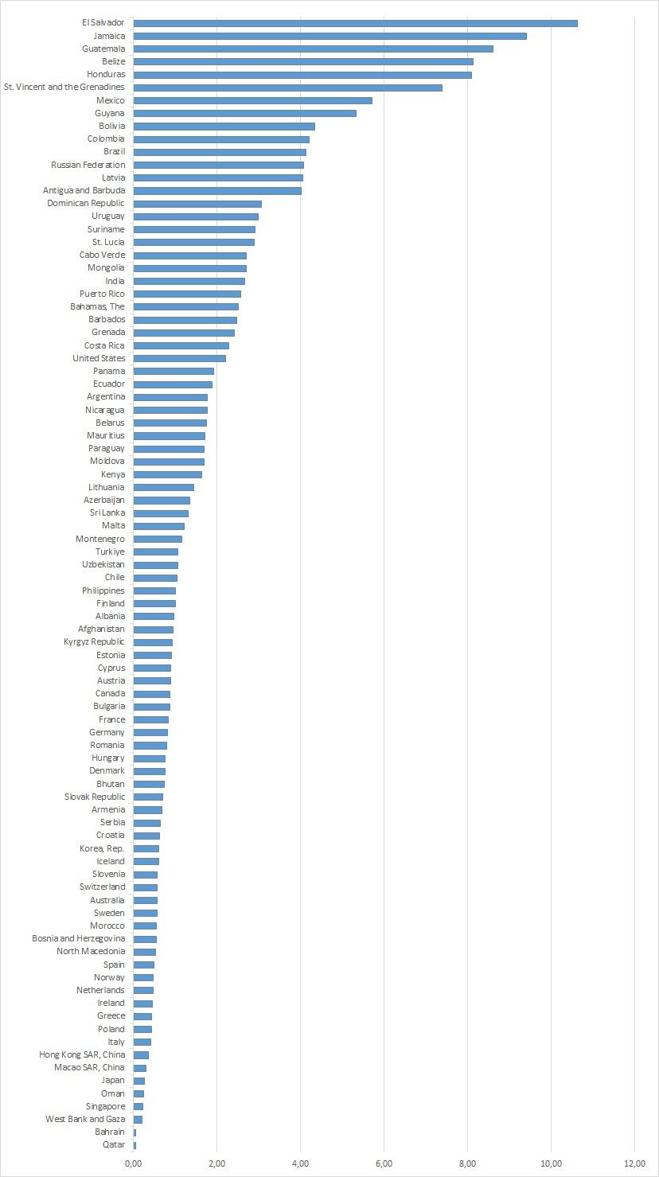

Independent variable
The independent variable used for this research is democratic backsliding. Unfortunately, there is no existing statistical dataset that states whether a certain country was experiencing democratic backsliding in a certain year. Thus, I created a dataset using inspiration of the research from Mechkova et al. (2017). In this research, they used the table created by V-Dem to decide whether a country was experiencing democratic backsliding. Every year, V-Dem releases a democracy report in which they analyse different developments in the past year regarding democracy around the world. In every report, they add a table that shows the different scores of the Liberal Democracy Index (LDI) in a certain country in the current year compared to 10 years ago. The LDI “combines the electoral “core” institutions with the liberal aspects – executive constraint by the legislature and high courts, and rule of law and individual rights” (Tai et al., 2022, 14). If a country is coded in the colour red, that means the country experienced substantial autocratization between 2006 and 2016. The democracy report (2017) by V-Dem states that countries coded red experienced “statistically significant” autocratization in the period under study. The graph from V-Dem (2017) is added in Appendix B, the table shows that when the confidence intervals of the LDI do not overlap, and when this is a backwards trend, it is then called substantial autocratization.
As mentioned in the section above, the data on femicide is analysed for the years 2017, 2018 and 2019. It is not expected that democratic backsliding has an immediate effect on femicide cases in the same year as the democratic backsliding occurred, as democratic backsliding is a gradual process (Lührmann & Lindberg, 2019). Thus, the year 2016 is analysed for democratic backsliding.
For my dataset, I coded each country that did not experience backsliding with a score of “0” and each country that did experience backsliding a “1”, table 2 shows the descriptive statistics of this dataset. Countries were only included if they also had data on the dependent variable femicide.

Table 2
Descriptive Statistics on Democratic Backsliding dataset
Year | Valid N | Mean | Variance | Missing
2016 | 78 | 0.13 | 0.113 | 11
Source: V-Dem, 2017.

Mediation variables

Repression of civil society organizations
To test whether the repression of civil society organization is a mediation variable between democratic backsliding and femicide, the variable “civil society organizations repression (CSOs)” is used from V-Dem. This variable asks whether the government attempts to repress CSOs. Each country is given a score between 0 and 4. The ordinal scale is used for this variable as this makes it easier to interpret the results. The scores that are given by V-Dem go from extreme repression to zero repression, thus the ordinal variable can be seen as continuous. However, to not make the interpretation confusing, the variable is recoded so that a score of 0 means that there is no oppression and a score 4 means that there is severe oppression. The exact scores are then as follows:

- “A score of 0 means no, the government does not repress the CSOs.
- A score of 1 means the government represses the CSOs weakly in which the government uses material sanctions (fines, firings, denial of social services) to deter oppositional CSOs from acting or expressing themselves.
- A score of 2 means the government represses CSOs moderately where the government engages in minor legal harassment (detentions, short-term incarceration) to represses the CSOs.
- A score of 3 means the government substantially represses CSO where the government arrests and imprisons leaders of and participants in oppositional CSOs who have acted lawfully.
- The score 4 stands for the government severely oppressing CSOs, where the government violently and actively pursues all real and even some imagined members of CSOs.” (Coppedge et al., 2023, 196).

Reversing gender equality policies
The reversing of gender equality policies is expected to play a role in the causal mechanism that explains the effect of democratic backsliding on femicide. However, worldwide data on this does not yet exist and it is difficult to find data that measures this concept in any other way. Therefore, the decision was made to use the variable women civil liberties index from V-Dem, which measures whether women have the ability to make meaningful decisions in key areas of their lives. This is connected to the reversing of gender equality policies as gender equality policies ensure that men and women enjoy the same civil liberties. This variable combines the indicators of freedom of domestic movement, the right to private property, freedom from forced labour and access to justice (Coppedge et al., 2023). The variable is an interval variable ranging from 0 to 1.

Undermining of the rule of law
As stated in the literature review, it is expected that the undermining of the rule of law partially explains the effect that democratic backsliding has on femicide. To test this mediation hypothesis, two indicators from V-Dem are used. The first one is judicial constrains on the executive index. The question asked for this variable by V-Dem is as follows: “to what extent does the executive respect the constitution and comply with court rulings, and to what extent is the judiciary able to act in an independent fashion?” (Coppedge et al., 2023, 51). The indicator is an interval variable where a score of 0 is the lowest possible score, meaning the executive does not respect the constitution, does not comply with court ruling and the judiciary is not able to act independently, and a score of 1 is the highest possible score meaning the opposite. The second indicator used for the mediation hypothesis is legislative constraints on the executive index. In here, the extent in which the legislature and government agencies are capable of questioning, investigating, and exercising oversight over the executive are measured. The scoring is the same for the previous indicator, a score of 0 means the legislature and government agencies are not capable at all to exercise oversight over the executive whereas 1 is the highest score.

Control variables
The literature review of this research showed that different factors could impact femicide cases in a country. This section will explain the operationalisation of the control variables. As stated before, democratic backsliding is a gradual process and therefore the average of 2017, 2018 and 2019 will be analysed for the dependent variable femicide, this will be the same for the control variables. For all control variables, a new variable was made that gives the mean of each country for 2017, 2018 and 2019. The data for those years is shown for all variables in descriptive tables in Appendix C.

Labour force participation male/female and school enrolment female
The World Bank gives different data for the participation in the labour force. It is possible to collect data that states how many exact men or women are enrolled into the labour force in a country. However, this number would not give clear information because a country with a big population could have a larger amount of women working in the labour force compared to a country with a small population, but relatively the numbers might be very different. Therefore, the variables that state the percentage of the labour force participation for male and female are used. The variable labour force male is chosen as a control variable for the frustrated masculinity theory, which stated that unemployed men feel frustrated with their status and impose authority on their partner (Sela-Shayovitz, 2010). Labour force female is chosen to test the backlash hypothesis which stated that once women gain a more equal status to men, men feel threatened and act this out through violence, whereas feminist scholars state that more gender equality should lead to less femicide (Bandelli & Corradi, 2021; Taylor & Jasinski, 2011). School enrolment female is chosen as a control variable as this gives information about women’s status as well. To avoid high multicollinearity in the analysis, school enrolment will not be controlled for men. The level of education is tertiary, as this is the same variable used in the research by Cutright and Briggs (1995) where they tested the backlash hypothesis. This indicator by World Bank gives the gross enrolment ratio of the total ratio (World Bank Open Data, n.d.)

GDP per capita and income inequality
To test the economic theories, and in particular the effect of poverty on femicide, the control variable GDP per capita will be used which was collected through V-Dem (Coppedge et al., 2023). To control for income inequality, the variable Gini-index from the World Bank is used which measures income inequality among the population. The scores go from 0 (0%) to 1 (100%) where a score of 0 means that there is perfect equality in a country and a score of 1 means there is perfect inequality among a population (World Bank Open Data, n.d.).

Conflict
The literature review showed that when countries are in conflict, this impacts the femicide cases. The idea was to use conflict as a control variable. However, an issue occurred regarding the data on conflict. Data on conflict in the V-Dem dataset only goes until 2012, whereas other data from the World Bank regarding state-based conflict goes up until 2016. Then, the indicator battle-related deaths from the World Bank was used to control for conflict. However, when analysing the data for conflict with the average of 2017, 2018 and 2019 it showed that this led to only 7 valid countries that could be used in the analysis. 7 countries are not enough to make reliable statements, to avoid doing this, the control variable conflict is removed from this analysis.

Liberal democracy Index
The literature review explained that regime type is thought to have an influence on femicide cases in a country as it is expected that countries with higher levels of democracy have less femicide cases than authoritarian countries (Htun & Weldon, 2010; Tripp, 2013). The variable liberal democracy index by V-Dem will be used to control for this. The definition of liberal democracy is : “the liberal principle of democracy emphasizes the importance of protecting individual and minority rights against the tyranny of the state and the tyranny of the majority. The liberal model takes a "negative" view of political power insofar as it judges the quality of democracy by the limits placed on government. This is achieved by constitutionally protected civil liberties, strong rule of law, an independent judiciary, and effective checks and balances that, together, limit the exercise of executive power. To make this a measure of liberal democracy, the index also takes the level of electoral democracy into account.” (Coppedge et al., 2023, 44). The scale of the variable is interval with the lowest possible score being a 0, meaning a fully authoritarian regime to 1, meaning a liberal democratic regime.

Research approach
The main aim of this research is to analyse the effect of democratic backsliding on femicide. The literature review resulted in one main hypothesis: democratic backsliding leads to a higher rate of femicide. As literature showed different concepts that could partially explain this hypothesis, three mediation hypotheses are added that look at how the repression of civil society organizations, the reversing of gender equality policies and the undermining of the rule of law can partially explain the effect that democratic backsliding has on femicide.
First, the descriptive statistics for all variables will be analysed to check for any anomalies. After this, the above 4 hypotheses will be tested through a multiple linear regression model which will be operated by the software SPSS. Before this is done, multicollinearity is checked, which looks at the overlap in variance that different indicators explain in the dependent variable. When this is high, it can give a problem with the reliability of the estimates that follow from the regression analysis, because the standard errors would be higher. To control for this, SPSS is used to calculate the different VIF scores. Scholars argue that a VIF score over 5 could potentially cause issues (Field, 2017). The list of VIF scores can be found in Appendix D. Appendix D.1 shows that the VIF scores are too high, with the Liberal Democracy Index having a VIF score of 17.700. When the LDI is removed, Appendix D.2 shows that the VIF scores are lower. The mediation variables used in the analysis are actually part of what the LDI measures as they are specific dimensions of the LDI. The decision was then made to not include control variables in the mediation models. Further, the mediation variables itself also show VIF scores on the higher side going from scores around 6 to 8. However, the models will test the mediation variables individually so this should not be a problem. All other variables have scores under 5 so it is possible to control for those variables in the same model.
The assumption of linearity and normality will be checked with a normal P-P plot, which can be found in Appendix E.1. This shows that the data of the dependent variable femicide is left-skewed, which means that more values in the dataset are on the extreme low side. Homoscedasticity and outliers are checked in Appendix F.1 and G.1. Both Appendixes also show issues, because of the left-skewed data. To solve this issue, a log transformation for the variable femicide is done to make the data more normally distributed. Appendix E.2, F.2 and G.2 show the new plots where it can be seen that the log transformation solved the issue. As this does give issues with the interpretation, the log transformation will be done as a robust check and added in the Appendix to see if the results do not differ from the regression analysis without the log transformation. Further, Appendix G.2 shows that there are still two outliers, outliers should only be removed when there is a good reason to do so, for example, poor sampling or a measurement error. This is not the case, therefore, the outliers will not be removed as they are natural variations (Field, 2017).
The main hypothesis will first be analysed without any control variables in model 1. Then, in model 2 all the control variables except the Gini-index and school enrolment female will be added since both of those two variables have high missings. The Gini-index and school enrolment female will then be added in model 3.
The models after this will test the mediation hypotheses. A mediation model tests why X (democratic backsliding) leads to Y (femicide) and tells us something about the possible causal mechanism between X and Y. To test a mediation hypothesis through SPSS, three different models need to be used in which 4 necessary conditions to support the mediation hypothesis need to be accepted. Firstly, the direct effect of X on Y has to be significant which will already be tested in model 1. Then, the effect of X on Z (the mediation variable), which is the indirect effect, needs to be significant which will be tested in a separate model for each mediation indicator. Then, the effect of Z on Y should be significant as well, this will be analysed in a separate model as well. Lastly, the effect of X on Y found in the last model should be smaller than the effect of X on Y found in model 1, because the effect is then partially explained by the mediation variable (Field, 2017).
All the hypotheses will only be accepted when the P-value is smaller than the accepted alpha of 0.05. The models used in this research are as follows:
Main hypothesis:
Femicide_{i} = b₀ + b₁Democratic backsliding_{i} + ε_{i}
Main hypothesis with control variables excluding Gini-index and school enrolment female
Femicide_{i} = b₀ + b₁Democratic backsliding_{i} + b₂Labour force participation male_{i} + b₃Labour force participation female_{i} + b₄GDP_{i} + b₅Liberal democracy index_{i} + ε_{i}
Main hypothesis including all control variables
Femicide_{i} = b₀ + b₁Democratic backsliding_{i} + b₂Labour force participation male_{i} + b₃Labour force participation female_{i} + b₄GDP_{i} + b₅Liberal democracy index_{i} + b₄School enrolment female_{i} + b₆Gini index_{i} + ε_{i}
Hypothesis with mediator repression of civil society organizations:
Model 1: Femicide_{i} = b₀ + b₁Democratic backsliding_{i} + ε_{i}
Model 2: Repression civil society organizations_{i} = b₀ + b₁Democratic backsliding_{i} + ε_{i}
Model 3: Femicide_{i} = b₀ + b₁Democratic backsliding_{i} + b₂Repression civil society organizations_{i} + ε_{i}
Hypothesis with mediator women civil liberties index:
Model 1: Femicide_{i} = b₀ + b₁Women civil liberties index_{i} + ε_{i}
Model 2: Women civil liberties index_{i} = b₀ + b₁Democratic backsliding_{i} + ε_{i}
Model 3: Femicide_{i} = b₀ + b₁Democratic backsliding_{i} + b₂Women civil liberties index_{i} + ε_{i}
Hypothesis with mediator judicial constrains on the executive index
Model 1: Femicide_{i} = b₀ + b₁Judicial constrains on executive index_{i} + ε_{i}
Model 2: Judicial constrains on executive index_{i} = b₀ + b₁Democratic backsliding_{i} + ε_{i}
Model 3: Femicide_{i} = b₀ + b₁Democratic backsliding_{i} + b₂Judicial constrains on executive index_{i} + ε_{i}
Hypothesis with mediator legislative constrains on the executive index
Model 1: Femicide_{i} = b₀ + b₁Legislative constrains on executive index_{i} + ε_{i}
Model 2: Legislative constrains on executive index_{i} = b₀ + b₁Democratic backsliding_{i} + ε_{i}
Model 3: Femicide_{i} = b₀ + b₁Democratic backsliding_{i} + b₂Legislative constrains on executive index_{i} + ε_{i}

Limitations
As the dataset and methodology have now been explained, it is important to recognize some of the limitations of the both the dataset and the methodology of this research.
The dataset from V-Dem uses an expert data methodology. This approach comes with different advantages and disadvantages. The experts have great knowledge on measuring democracy, and as many experts are used, this makes the data credible. However, as every researcher comes from their own background, there will always be an issue of subjectivity as each researcher looks at certain concepts from a different perspective (Lundberg, 2022).
One important issue regarding the used dataset is that statistical data on femicide might not give a perfect representation of the actual numbers of femicide in certain countries. This research looks at countries that are experiencing democratic backsliding, and different research show that authoritarian countries are more likely to hide femicide numbers and disguise them, for example, as suicide (Karakaş, 2021). This might lead to biases in this research. To see if this seems to be the case in this dataset, the data is checked on face validity. This led to the conclusion that countries where the literature review has shown that femicide is high (e.g Brazil and Mexico) do have higher rates of femicide in this dataset. However, other countries were women rights are severely oppressed do not show even an average number of femicide cases. For example, figure 1 showed that Qatar is ranked as the country with the least amount of femicide cases. Thus, if indeed authoritarian regimes report less femicide numbers than there actually are, this has consequences for the findings of the analysis as this then gives biased results. However, there is unfortunately no solution for this. Further, as stated in the operationalisation, data on femicide in Africa is very limited. Generalizations from the conclusions of this research therefore have to be made carefully and are most likely best applicable to South America and Europe.
Next to this, not all the indicators are exactly measuring the concept I intend to measure which can cause problems regarding the validity of this research (Bryant, 2000).
This issue is most prevalent with the mediation hypothesis regarding reversing of gender equality policies in countries that are experiencing democratic backsliding. As stated in the section above, there is no existing worldwide data regarding the reversing of gender equality policy. Therefore, other indicators needed to be used. It was, however, hard to find something that is very similar to the reversing of gender equality policies. Eventually the women civil liberties index from V-Dem is used, which measured freedom of domestic movement, right to private property, freedom from forced labour and access to justice. This indicator is used as it does say something about the government policies regarding women’s rights. However, it is not exactly measuring gender equality polices. The other issue was, as described, regarding the variable conflict as no reliable data for this variable was found. Therefore, conflict is removed from the analysis. Lastly, this research uses femicide as the dependent variable. Measuring femicide comes with different challenges which were described earlier. There is no worldwide indicator that exactly measures femicide in the way it is conceptualised in this research, as the worldwide definition also varies per country. This is a limitation of the research and will be further discussed in the conclusion.
Regarding the methodology, normally the sample sizes of each model would have to be the same to make reliable conclusions. However, due to the large missing values on school enrolment female and the Gini-index, the sample sizes differ. Otherwise, all the models would have to have the same amount of cases as the models with school enrolment female and the Gini-index, and this would lead to a large amount of crucial data getting lost, because the valid N of this research is already on the lower side.
Lastly, this research is analysing the year 2016 for democratic backsliding. However, changes occurred during 2016 such as the COVID pandemic and the Russia-Ukraine war. Therefore, a research on more recent years might give somewhat different results then when analysing 2016. However, as 2016 was the most logical year considering then multiple years of femicide rates in different countries could be taken the average of, this will give the most reliable results for the analysis.

4. Results

Descriptive analysis
In this section, the descriptive statistics of all the used variables in this analysis will be described. The descriptive statistics are showed in table 3. As discussed in chapter 3, democratic backsliding is analysed for the year 2016 and for all the other variables the mean value of the years 2017, 2018 and 2019 are used.
Firstly, it is important to analyse the descriptive statistics of the dependent and independent variables of this research. Femicide shows, as stated in the section on the dataset, that data on 88 countries is available. The variable femicide is calculated per 100.000 women, therefore the minimum femicide cases is 0.05 per 100.000 women and the maximum is 10.62 per 100.000 women. Figure 1, which was added in the chapter 3, showed that Qatar has the value of 0.05 whereas El Salvador has the value of 10.62. The mean value of femicide cases per 100.000 women in this dataset is 1.99 with a standard deviation of 2.208. Further, the used dataset in this research is made with the countries available for femicide, therefore, the variable femicide has 0 missing values. The independent variable democratic backsliding shows, however, 10 missing values. As this variable is a dummy variable where a score of 0 means a country did not experience democratic backsliding and a score of 1 means they did experience democratic backsliding, the minimum and maximum values are also a 0 and 1. The mean of the independent variable is 0.13, meaning 13% of the countries in this dataset experienced democratic backsliding. The standard deviation regarding democratic backsliding is 0.336.
Secondly, the mediation variables that are used in this analysis will be described. There are 4 variables that measure the mediation hypotheses. The women civil liberties index is used to measure the mediation effect of the reversing of gender equality policies. The judicial constrains on the executive index and the legislative constrains on the executive index are used to measure the mediation variable undermining of the rule of law. Lastly, the mediation hypothesis that argues that repression of civil society organizations partially explains the effect that democratic backsliding has on femicide, has a variable that perfectly corresponds to the intended measured concept. Data on all 4 variables are available for 78/79 countries, which then leads to the missing value of 10/9. Repression of civil society organizations is an ordinal variable with the lowest possible score being 0 and the highest possible score of 4, a score of 0 means a government does not repress civil society organization whereas a score of 4 means the government represses civil society organizations extremely. Table 3 shows that the minimum found value in the dataset is 0 and the maximum found value is 4. Next to this, the mean value is 1.25 which means that on the average, countries in this dataset experience weak to moderate repression of civil society organizations. The standard deviation has a value of 1.452. The other 3 mediation variables are index-variables with scores that can range between 0 and 1. The women civil liberties index has a minimum score of 0.28 and a maximum score of 0.98 with a mean value of 0.79, meaning that more countries in this dataset have a society where women have the ability to make meaningful decisions in key areas of their lives. The judicial- and legislative constrains on the executive index have a mean value of 0.71 and 0.69 respectively. A low value would mean that the countries experience a lot of judicial- and legislative constraints on the executive, whereas a high score means that the executive in the country respects the constitution, complies with court rulings, has an in independent judiciary and lastly, where the legislature and government agencies are capable of for example questioning and exercising oversight over the executive. The minimum and maximum values show that for the cases in this analysis, the countries range to the extreme sides of both ends as for example the judicial constrains on the executive index has a minimum score of 0.01 and a maximum score of 0.99.
Lastly, table 3 shows that the control variables have different amount of missing values which, as stated in chapter 3, had an influence on the regression models. As can be seen in table 3, both the Gini-index and school enrolment female show a high value of missings with school enrolment female having 22 missing values whereas the Gini-index even has 44 missing values. Therefore, those 2 variables are added in a separate model. The mean value of the Gini-index is 35.36 with a standard deviation of 7.586. These are percentages whereby a score of 0 means complete equality and a score of 100 means complete inequality. School enrolment female is the gross ratio of the total school enrolment rate on tertiary education. The mean is 143.31 with a standard deviation of 28.083. Those scores are also percentages, the World Bank (2021) clarifies that the gross enrolment includes students who are for example repeating their grade or students who are late or early enrolled, therefore “total student enrollment can exceed the population of the age group that officially corresponds to the level of education – leading to ratios greater than 100 percent” (World Bank, 2021, 1). Both the GDP per capita and the liberal democracy index have a valid N of 78. The liberal democracy index has a minimum value of 0.04 and a maximum value of 0.89. The mean value shows that the countries in this dataset have an average score of 0.52. The GDP per capita varies strongly with a minimum value of 1.75 up to a maximum value 83.30, with a mean value of 25.15. Lastly the labour force participation of both male and female show interesting values. The mean value of female participating in the labour force is 71.80% whereas for men this is much higher with an average mean of 95.95%. The minimum and maximum value are also higher for men compared to women where men have a minimum value of 47.60% and women as low as 17.87%. The maximum value for men found is 95.59% and for women 71.80%.

Table 3
Descriptive Statistics on Femicide, Democratic Backsliding, Repression of Civil Society Organizations, Women Civil Liberties Index, Judicial Constrains on the Executive Index, Legislative Constrains on the Executive Index, Liberal Democracy Index, Gini-Index, GDP per Capita, Labour Force Participation Male, Labour Force Participation Female, School Enrolment Female

 | Valid N | Minimum | Maximum | Mean | Standard deviation |  | Missing
Femicide | 88 | 0.05 | 10.62 | 1.99 | 2.208 | 0
Democratic backsliding | 78 | 0 | 1 | 0.13 | 0.336 | 10
Repression of civil society organizations | 78 | 0 | 4 | 1.25 | 1.452 | 10
Women civil liberties index | 79 | 0.28 | 0.98 | 0.79 | 0.170 | 9
Judicial constrains on the executive index | 79 | 0.01 | 0.99 | 0.71 | 0.276 | 9
Legislative constrains on the executive index | 78 | 0.04 | 0.98 | 0.69 | 0.273 | 10
Liberal democracy index | 78 | 0.04 | 0.89 | 0.52 | 0.254 | 10
Gini-index | 47 | 23.80 | 53.57 | 35.36 | 7.586 | 42
GDP per capita | 78 | 1.75 | 83.30 | 25.15 | 17.992 | 10
Labour force participation men | 86 | 47.60 | 95.59 | 70.92 | 7.773 | 2
Labour force participation female | 86 | 17.87 | 71.80 | 50.575 | 10.582 | 2
School enrolment female (tertiary) | 66 | 8.84 | 143.31 | 70.95 | 28.083 | 22

Explanatory analysis

Main hypothesis
This section will describe the results from the regression analysis, which will either support or reject the main hypothesis, including all control variables that are used in this research. The regression analyses can be found in table 4.
Model 1 shows the results that tested the main hypothesis of this research: democratic backsliding leads to higher cases of femicide. The hypothesis is not supported as no significant effect was found. The coefficient is 0.150 with a standard error of 0.724, however, this does not say anything as the P-value is not lower than the accepted alpha of 0.05. This is not in line with what was expected. The main hypothesis democratic backsliding leads to higher cases of femicide is thus rejected.
Model 2 shows the main effect with the control variables liberal democracy index, labour force participation male, labour force participation female and GDP per capita. The model shows that the coefficient of the main effect has now changed to a negative effect, meaning that countries experiencing democratic backsliding have lower level of femicide cases when control variables are included. However, a significant effect was again not found, so these results cannot be generalized.
The control variables labour force participation male and GDP per capita show that both variables have a p-value of less than 0.01, meaning there is a strong significant effect. Regarding labour force participation male, the effect is positive, meaning that countries with a higher level of men participating in the labour force, have higher femicide cases. This is not in line with the frustrated masculinity syndrome that stated that when men are unemployed they feel frustrated with their status and act this out on women to impose authority by using violence (Prieto-Carrón et al., 2007). The results of this research actually show the opposite, the more men are employed, the higher the femicide cases. However, I argue that these results can be in line with feminist theories. When men are primarily the breadwinner, traditional gender roles are reinforced. Feminist scholars argue that power is crucial when analysing femicide. When the majority of men are employed, and women are not, a system of male dominance occurs, resulting in a subordinating position of women which then, according to feminist scholars, leads to a higher rate of femicide (Taylor & Jasiniski, 2011). But, this argument has to be made carefully, as the variable labour force participation male is not a comparison to women that are employed. The descriptive values however did show that in the used dataset men are overrepresented in the labour force compared to women. But, there was no significant effect found for labour force participation female, this is not in line with neither the feminist scholars nor the backlash hypothesis stating that when women gain a more equal status to men, men feel threatened and act this out through violence, leading to more femicide cases (Bandelli & Corradi, 2021; Taylor & Jasinski, 2011). Thus, as labour force participation female did not have a significant effect, the evidence for the feminist theories is not strong. GDP per capita has a negative effect which means that the higher level of GDP per capita in a country, the lower the femicide cases. The expectations were unclear as the literature showed contradicting results regarding the effect of overall wealth on femicide, where multiple studies did not find a significant effect. One study by Stamatel (2014) did find a significant effect but the causal mechanism stayed unclear. The results of this research are thus in line with the findings of Stamatel (2014) and show that overall wealth leads to less femicide cases. Lastly, the liberal democracy index has a P-value of lower than 0.05 and therefore also has a strong significant effect on femicide. The effect is positive meaning the higher the liberal democracy index, the higher the femicide cases. These findings are not in line with the idea that countries with higher level of democracies have a low level of femicide (Antila, 2022; Tripp 2013). However, some studies argued that authoritarian countries comply with gender equality policies to show a modern face to the world and that therefore in certain authoritarian countries the level of gender equality is higher than in democracies (Donno et al., 2021; Donno & Kreft, 2019). This could explain why in this analysis countries with a higher liberal democracy index have higher cases of femicide. Another possible explanation that further research could confirm or reject, is that the effect of the liberal democracy index could be curvilinear, as it is possible that countries that are in the middle of the liberal democracy index have higher femicide cases as they are more unstable and therefore more prone to regime change.
Model 3 includes all control variables as the Gini-index and school enrolment female were added as well. As can be seen in the valid N, the available countries went down to only 37 countries. The results then show that in the entire model not a single significant effect was found. With a valid N of 37, this is not surprising. The expectation for the Gini-index was to find evidence supporting the relative deprivation theory, which argues that inequality leads to an increase of social tensions which can result in violence, including violence against women (Braun, 1995; Fajnzylber et al., 2001). But this was thus not found. School enrolment female was also analysed to see if women’s status affects femicide cases, in line with the research by Cutright and Briggs (1995) the level of education is tertiary, however and unlike their research, no significant effect was found.
The adjusted R² is a corrected goodness-of-fit model which shows the percentage of variance that the variables in the model explain in the dependent variable femicide. Model 2 has an adjusted R² of 0.335, meaning that 33.5% of the variance in femicide is explained by all the control variables and the independent variable together. This is a very high number, which means the used variables are fitted correctly to explain femicide. Model 3 shows a higher adjusted R², but because the model has a very small sample size, the model is merely used to analyse the effect of school enrolment female and Gini-index on femicide. Model 2 shows a significant F-value, meaning that the model significantly fits the data better than the simplest model, the mean. Model 1 does not show a significant F-value.
Lastly and as stated in chapter 3, to deal with the issue of the dependent variable femicide being left-skewed a log transformation was done to make the data more normally distributed. The results for the regression analysis with this transformation can be found in Appendix H. This shows that even though the coefficients are slightly different, the significant and non-significant effects stayed the same.

Table 4
Regression Analysis Testing Effect Democratic Backsliding on Femicide, Including Control Variables
 | Model 1 |  | Model 2 |  | Model 3
 | B. | SE. | B. | SE. | B. | SE.
Democratic backsliding | 0.150 | 0.724 | -0.162 | 0.676 | -1.343 | 0.888
Liberal democracy index |  |  | 2.269** | 1.220 | -0.167 | 2.532
Labour force participation male |  |  | 0.109*** | 0.033 | 0.116 | 0.070
Labour force participation female |  |  | 0.011 | 0.026 | 0.014 | 0.054
GDP per capita |  |  | -0.0767*** | 0.015 | -0.040 | 0.037
Gini-index |  |  |  |  | 0.046 | 0.067
School enrolment female (tertiary) |  |  |  |  | -0.021 0.017
Constant | 1.818*** |  | -6.876*** |  | -5.290
Adjusted R² | -0.013 |  | 0.335 |  | 0.445
F | 0.043 |  | 7.856*** |  | 4.786***
N | 77 |  | 74 |  | 37
Note: *p<0.1, **p<0.5, ***p<0.01

Mediation hypotheses
To start of this section, it is important to acknowledge that an issue occurred after analysing the main effect. As stated in chapter 3, for a mediation analysis different criterion need to be fulfilled. The first step is that there needs to be a significant effect between X and Y. Model 1, however, showed that this criterion is not fulfilled as democratic backsliding does not have a significant effect on femicide. Therefore, the conclusion can already be made that neither of the mediation hypotheses will be accepted. However, to see if there is a significant indirect effect and what this then could mean, the mediation models will still be done. For interpretation and clarification, all mediation variables include a figure that visualises the different paths of the mediation model.

Repression of civil society organizations
Table 5 shows the results of the mediation analysis with the mediation variable repression of civil society organizations. Indirect path B shows a significant effect, meaning that the repression of civil society organizations has a significant effect on femicide. This effect is positive, meaning the more the government represses civil society organizations, the higher the femicide cases. The total indirect effect is calculated by multiplying indirect path A with indirect path B. Normally, when there is a significant main effect, and both indirect pathways also show a significant effect, a Sobel test would be done. A Sobel test looks at whether the indirect effect is significant and if there thus is mediation effect. But because this is not the case here, a Sobel test would not have any use. Thus, even though there is an effect of the repression of civil society organizations on femicide, this effect is not a mediation effect as all other pathways do not show a significant result. Therefore, the hypothesis that states that the repression of civil society organizations partially explains the effect that democratic backsliding has on femicide, is rejected.

Table 5
Mediation Model with Variable Repression of Civil Society Organizations

 | Model 4
 | B. |  |  | SE.
Direct path C (Democratic backsliding > femicide) | 0.150 |  |  | 0.724
Indirect path A (Democratic backsliding > repression civil society organizations | 0.243 |  |  | 0.553
Indirect path B (Repression civil society organizations > femicide) | 0.404** |  | 0.180
Direct path C’  Indirect effect total | -0.183  0.098 |  | 0.814
N | 75

Note: *p<0.1, **p<0.5, ***p<0.01

Figure 2
Mediation Pathways of Repression of Civil Society Organizations
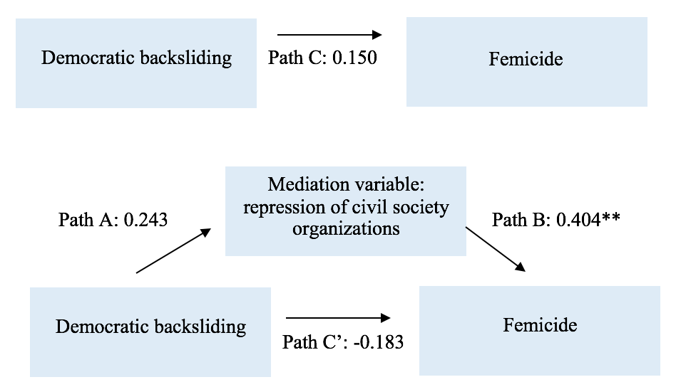

Reversing of gender equality policies
As stated in the operationalisation, the women civil liberties index is used to measure the reversing of gender equality policies as no better fitting data exists. Table 6 shows that again indirect path B has a significant value, meaning that when the women civil liberties index in a country increases, femicide is lower, as the found coefficient is negative. Thus, countries were women are able to make free decisions regarding key aspects of their life, femicide cases decrease. This is linked to the reversing of gender equality policies as gender equality policies ensure that men and women enjoy the same civil liberties. The indirect effect is 0.162, but as again only one pathway is significant, there is no mediation effect. Thus, the hypothesis that states that reversing of gender equality policies partially explains the effect that democratic backsliding has on femicide, can be rejected.

Table 6
Mediation Model with Variable Women Civil Liberties Index
 | Model 4
 | B. |  | SE.
Direct path C (Democratic backsliding > femicide) | 0.150 |  | 0.724
Indirect path A (Democratic backsliding > women civil liberties index) | -0.043 |  | 0.062
Indirect path B (Women civil liberties index > femicide) | -3.756** | 1.594
Direct path C’ | -0.247 | 0.813
Indirect effect total  N | 0.162  75
Note: *p<0.1, **p<0.5, ***p<0.01

Figure 3
Mediation Model with Variable Women Civil Liberties Index
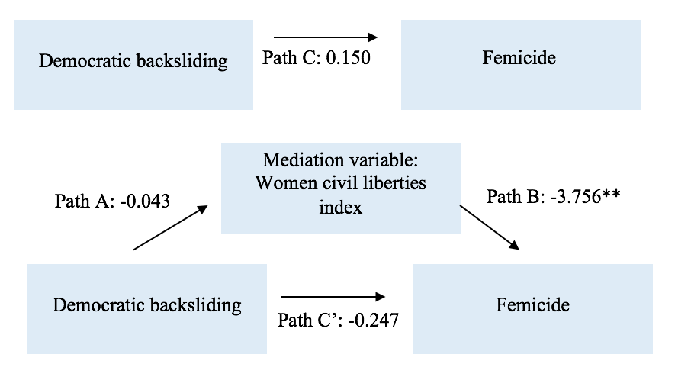

Undermining rule of law
To test the mediation variable undermining of the rule of law, two indicators are analysed. Table 6 shows the mediation variable judicial constrains on the executive index. Indirect path A shows a strong significant effect, meaning that democratic backsliding leads to less judicial constraints on the executive. No other effect is significant. The mediation variable legislative constraints on the executive index did not find any significant result. The hypothesis that states that the undermining of the rule of law partially explains the effect that democratic backsliding has on femicide can thus be rejected.
Table 6
Mediation Model with Variable Judicial Constrains on Executive Index

 | Model 4
 | B. |  | SE.
Direct path C (Democratic backsliding > femicide) | 0.150 |  | 0.724
Indirect path A (Democratic backsliding >judicial constraints on executive index) | -0.261*** |  | 0.089
Indirect path B ( judicial constraints on executive index >femicide) | -0.567 | 1.161
Direct path C’  Indirect effect total | -0.232  0.148 | 0.895
N | 75
Note: *p<0.1, **p<0.5, ***p<0.01

Figure 4
Mediation Model with Variable Judicial Constrains on Executive Index
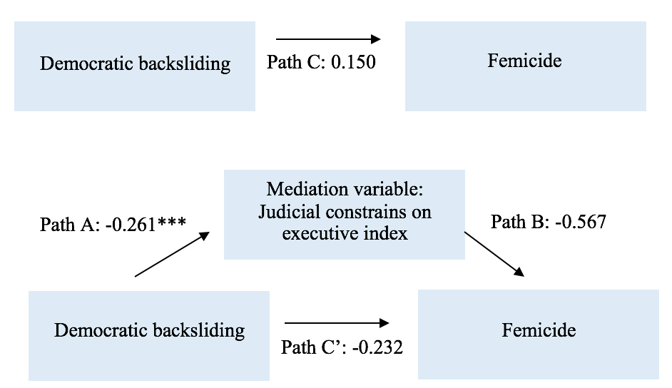

Table 7
Mediation Model with Legislative Constrains on Executive Index

 | Model 4
 | B. |  |  | SE.
Direct path C (Democratic backsliding > femicide) | 0.150 |  |  | 0.724
Indirect path A (Democratic backsliding >legislative constraints on executive index) | -0.152 |  |  | 0.098
Indirect path B (legislative constraints on executive index >femicide) | -1.323 |  | 1.044
Direct path C’ | -0.286 | 0.849
Indirect effect total | 0.201
N | 75

Note: *p<0.1, **p<0.5, ***p<0.01

Figure 5
Mediation Model with Variable Legislative Constrains on Executive Index
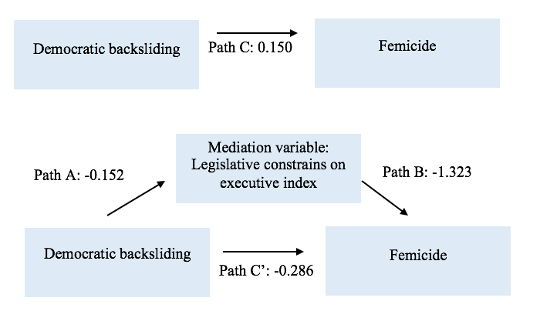

5. Conclusion
This research had the aim to investigate the correlation between democratic backsliding and the levels of femicide across different countries. The literature review showed different factors, such as patriarchy, impunity, income inequality, the frustrated masculinity syndrome and women’s status, that explain why femicide occurs. As the key interest of this study was to explain the impact of democratic backsliding on femicide, these explanations were then turned into control variables for the regression analysis as they both impact the dependent variable femicide and the independent variable democratic backsliding. The literature review regarding the link between democratic backsliding and femicide showed that existing research is limited. However, it was argued that women’s rights and democracy go hand in hand, with democracies being more capable of promoting gender equality (Antila, 2022; Tripp, 2013). The literature review showed that women’s organizations are disproportionally affected by the repression of civil society organizations in countries experiencing democratic backsliding, because women largely depend on the civic space as they are often already excluded from the male-dominated political sphere (Roggeband & Krizsán, 2021: Baker et al., 2017). The reversing of gender equality policies in countries experiencing democratic backsliding causes women to be less protected against violence, which I then linked to the theories of impunity that argued that impunity leads to higher cases of femicide (Krizsán & Roggeband, 2019; Chiriţoiu, 2019; Szczygielska, 2019; Álvarez-Garavito & Acosta-González, 2021; Musalo and Bookey, 2013; Carey & Torres, 2010). Therefore, the literature review led to the mediation variables repression of civil society organizations and reversing of gender equality policies. I added a third mediation hypothesis to analyse whether the undermining of the rule of law in countries experiencing democratic backsliding is a causal mechanism in the effect of democratic backsliding on femicide as well.
V-Dem and the World Bank were used to collected the needed data for the regression analysis. For the dependent variable femicide, data on 88 countries for the years 2017, 2018 and 2019 was available, which then per country was taken the average of for those three years. For democratic backsliding, data on 78 countries which also had data on femicide were available and the year 2016 was analysed. The regression analysis found that the main hypothesis that stated that democratic backsliding leads to higher femicide cases, was not supported, as no significant effect was found. Control variables showed different significant results. The more men are participating in the labour force, the higher the femicide cases. This was not in line with the frustrated masculinity theory that stated that when men are unemployed they get frustrated with their status and therefore use violence against women to impose authority (Prieto-Carrón et al., 2007). The liberal democracy index showed that the higher level of democracy, the higher the femicide cases. This is odd and not in line with the expectations that followed from the literature review. Possible explanations could be that authoritarian countries want to show a modern face to the world and therefore sometimes have better gender equality policies, or that the effect could possibly be curvilinear with countries in the middle of the liberal democracy index being more unstable and therefore more prone to regime type leading to a higher rate of femicide cases. Further research should explore this effect. Lastly, GDP per capita showed that the higher rate of GDP per capita in a country, the less femicide cases. This is in line with theory of Stamatel (2014) showing that overall wealth leads to less femicide. As the effect of democratic backsliding on femicide was not significant, it was already clear that the mediation hypotheses would not be supported either. However, they were still done to see if there was any significant indirect effect. This showed that the repression of civil society organizations and the reversing of gender equality policies, with the operationalisation of women’s civil liberty index, showed to have a significant effect on femicide in the expected direction. The more civil society organizations are repressed, the higher the femicide cases, and the higher the women civil liberties index, the lower the femicide cases. However, both were not a mediation effect as the main effect and the pathway of democratic backsliding affecting the mediation variables were not statistically significant. Judicial constraints on the executive index, which was used to partly test the mediation variable undermining of the rule of law, did not show a significant effect on femicide. However, it did show that democratic backsliding significantly leads to a higher level of judicial constraints on the executive. The legislative constraints on the executive, the other part of the mediation variable undermining of rule of law, showed no significant results. The rule of law is more strongly related to the judiciary, so these results are not surprising.
Thus, looking back at the research question of this study which was: “to what extent is there a correlation between democratic backsliding and the levels of femicide across different countries?”, this research showed that there is no correlation between democratic backsliding and femicide.

Discussion

The results of this research showed some odd findings, especially the significant effect that indicated a higher level of liberal democracy leads to higher levels of femicide. It is firstly important to recognize that there are 195 countries in the world and that the models only included 77 or 74 countries, with a limited availability of data in Africa and Asia. The sample might have caused the results to differ from the expectations. Next to this, the descriptive statistics also showed that countries not experiencing democratic backsliding were largely overrepresented in the dataset, with only 13% of the countries experiencing democratic backsliding. The data on democratic backsliding was coded as dummy variables, the results might have given different findings if the variable was coded as continuous where the exact level of backsliding of the liberal democracy index would be taken. Further research could test if this is the case.
Another possible cause is that measuring femicide is difficult, as there is no universal definition. Therefore, what some countries do report as femicide, other countries do not, which leads to inconsistent findings. It might also be the case that some countries purposely do not report femicide cases, as can be seen in Turkey where often the murder of women is reported as suicide (Karakaş, 2021). The fact that the lowest level of femicide in this dataset occurs in the authoritarian regime Qatar, suggests that some authoritarian countries might be window-dressing. The governments might want to give the idea of transparency but give, however, false statistics not representing the actual number of femicide in the country. This all affects the data of femicide in the dataset and therefore also the results.
Next to this, the operationalisation of the used variables came with some issues as well. For example, worldwide data on the reversing of gender equality policies does not exists. Therefore, the data of the women civil liberties index was used as gender equality policies do try to ensure that both genders experience the same civil liberties, so there is a connection. However, it does not measure the concept perfectly, so it is important to keep in mind that the conclusion regarding reversing of gender equality policies is better applicable for women civil liberties. There was also no reliable data found to test the theories of conflict affecting femicide, further research should look into this.
This research shows that a universal approach regarding femicide is needed for reliable global quantitative research. It would be extremely helpful if there is a universal definition of femicide that is applicable in all countries, where countries in all their honesty report the actual femicide numbers. When this is done, quantitative research will be more reliable, which can lead to a better approach of investigating causes of femicide. This can then help with creating suitable interventions to tackle this issue and to make sure that women are protected.

References
Alberti, M., & Tanno, S. (2022, November 25). More than 100 women murdered in Italy so far this year. CNN. https://edition.cnn.com/2022/11/25/europe/women-killed-italy-femicide-intl/index.html
Antila, A. (2022, March 8). How does democratic backsliding affect gender equality? Demo Finland. https://demofinland.org/en/how-does-democratic-backsliding-affect-gender-equality
Álvarez-Garavito, C., & Acosta-González, N. (2021). Femicide in Latin America: An economic approach. Desarrollo Y Sociedad, 88(1), 11–42. https://doi.org/10.13043/dys.88.1
Bakar, A., Jolokhava, T., & Miftaroska, J. (2020). Gender inequality and the impact on violence against women: The case of Georgia. Regional Academy on the United Nations.
Baker, A., Boulding, C., Mullenax, S., Murton, G., Todd, M., Velasco-Guachalla, X., & Zackary, D. (2017). Maintaining civic space in backsliding regimes: Research and innovation grants working papers series. USAID. https://www.usaid.gov/sites/default/files/2022-05/Maintaining_Civic_Space_in_Backsliding_Regimes_-_Research_and_Innovation_Grants_Working_Papers_Series.pdf
Bandelli, D., & Corradi, C. (2021). Femicide: The Notion, Theories, and Challenges for Research. Oxford Research Encyclopedia of Criminology and Criminal Justice. https://doi.org/10.1093/acrefore/9780190264079.013.590
Bas, O., Ogan, C. L., & Varol, O. (2022). The Role of Legacy Media and Social Media in Increasing Public Engagement About Violence Against Women in Turkey. Social Media + Society, 8(4), 1-13. https://doi.org/10.1177/20563051221138939
Bermeo, N. (2016). On Democratic Backsliding. Journal of Democracy, 27(1), 5-19.
Bigelow, C.S. (2019). Addressing the Global Prevalence of Femicide and Its Causes. The Borgen Project. https://borgenproject.org/addressing-the-global-prevalence-of-femicide-and-its-causes/
Boese, V. A., N. Alizada, M. Lundstedt, K. Morrison, N. Natsika, Y. Sato, H. Tai, and S. I. Lindberg. (2022). Autocratization Changing Nature? Democracy Report 2022. Varieties of Democracy Institute (V-Dem).
Boira, S., Tomas-Aragones, L., & Rivera, N. C. A. (2017). Intimate Partner Violence and Femicide in Ecuador. Qualitative Sociology Review, 13(3), 30–47. https://doi.org/10.18778/1733-8077.13.3.03
Bogaards, M., & Pető, A. (2022). Gendering De‐Democratization: Gender and Illiberalism in Post‐Communist Europe. Politics and Governance, 10(4), 1–5. https://doi.org/10.17645/pag.v10i4.6245
Braun, D. (1995). Negative consequences to the rise of income inequality. Research in Political Sociology, 5(1), 3–31.
Brazilian women march against increase in femicides. (2023, March 9). MercoPress. https://en.mercopress.com/2023/03/09/brazilian-women-march-against-increase-in-femicides
Bryant, F. B. (2000). Assessing the validity of measurement. In L. G. Grimm & P. R. Yarnold (Eds.), Reading and understanding MORE multivariate statistics (pp. 99–146). American Psychological Association.
Canadian Femicide Observatory for Justice and Accountability (CFOJA). (2020). No title. https://www.ohchr.org/sites/default/files/Documents/Issues/Women/SR/Femicide/2020/CSOs/femicide-observatory-canada.pdf
Canadian Femicide Observatory for Justice and Accountability (CFOJA). Murdered and Missing Indigenous Women and Girls | Femicide in Canada. (n.d.). https://www.femicideincanada.ca/about/history/indigenous
Carey, D. J., & Torres, M. G. (2010). Precursors to Femicide: Guatemalan Women in a Vortex of Violence. Latin American Research Review, 45(3), 142–164. https://doi.org/10.1017/s0023879100011146
Carothers, T., & Press, B. (2022). Understanding and Responding to Global Democratic Backsliding. Carnegie Endowment for International Peace. https://carnegieendowment.org/2022/10/20/understanding-and-responding-to-global-democratic-backsliding-pub-88173
Chowdhury, D. (2022). Women with disabilities and femicide: A Call for Research. Journal of Psychosocial Rehabilitation and Mental Health, 10(1), 81-86. https://doi.org/10.1007/s40737-022-00302-7
Chiriţoiu, A. (2019). The convoluted gender policy processes in Romania: institutional disarray and activist resilience. In A. Krizsán & C. Roggeband (Eds.), Gendering democratic backsliding in Central and Eastern Europe. A comparative agenda (pp. 161–199).
Cutright, P., & Briggs, C.M. (1995). Structural and cultural determinants of adult homicide in developed countries: Age and gender-specific rates, 1955–1989. Sociological Focus, 28(3), 221–243.
Coppedge, M., Gerring, J., Knutsen, C. H., Lindberg, S. I., Teorell, J., Altman, D., Bernhard, M., Cornell, A., Fish, M. S., Gastaldi, L., Gjerløw, H., Glynn, A., Grahn, S., Hicken, A., Kinzelbach, K., Marquardt, K. L., McMann, K., Mechkova, V., Neundorf, A., Paxton, P., Pemstein, D., Rydén, O., von Römer, J., Seim, B., Sigman, R., Skaaning, S. E., Staton, J., Sundström, A., Tzelgov, E., Uberti, L., Wang, Y.-T., Wig, T., & Ziblatt, D. (2023). V-Dem Codebook v13. Varieties of Democracy (V-Dem) Project.
Coppedge, M., Gerring, J., Knutsen, C. H., Lindberg, S. I., Teorell, J., Altman, D., Bernhard, M., Cornell, A., Fish, M. S., Gastaldi, L., Gjerløw, H., Glynn, A., Good God, A., Grahn, S., Hicken, A., Kinzelbach, K., Krusell, J., Marquardt, K. L., McMann, K., Mechkova, V., Medzihorsky, J., Natsika, N., Neundorf, A., Paxton, P., Pemstein, D., Pernes, J., Ryd ́en, O., von R ̈omer, J., Seim, B., Sigman, R., Skaaning, S.-E., Staton, J., Sundstr ̈om, A., Tzelgov, E., Wang, Y.-T., Wig, T., Wilson, S., & Ziblatt, D. (2023a). V-Dem Dataset v13. Varieties of Democracy (V-Dem) Project. Retrieved from https://doi.org/10.23696/vdemds23.
Corradi, C. (2021). Femicide, its causes and recent trends: What do we know? (Policy Brief). United Nations Development Programme. https://www.undp.org/content/undp/en/home/librarypage/womens-empowerment/femicide--its-causes-and-recent-trends--what-do-we-know-.html
Corradi, C., Servós, C. M., Boira, S., & Weil, S. (2016). Theories of femicide and their significance for social research. Current Sociology, 64(7), 975–995. https://doi.org/10.1177/0011392115622256
Dayan, H., Kugel, C., & Enosh, G. (2022). Exploring Homicide Diversity: Femicide Across Sociocultural Groups. Crime & Delinquency, 0(0), 1-23, https://doi.org/10.1177/00111287221086273
Donno, D., & Kreft, A. (2019). Authoritarian Institutions and Women’s Rights. Comparative Political Studies, 52(5), 720–753. https://doi.org/10.1177/0010414018797954
Donno, D., Fox, S. A., & Kaasik, J. (2021). International incentives for women’s rights in dictatorships. Comparative Political Studies, 55(3), 451–492. https://doi.org/10.1177/00104140211024306
NL Times (2023, March 8). Dutch MP’s, organizations call for more action against femicide. (2023, March 8). https://nltimes.nl/2023/03/08/dutch-mps-organizations-call-action-femicide
European Institute for Gender Equality (EIGE). (2021). Defining and identifying femicide: a literature review. Vilnius.
European Parliament News. (2022, September 15). MEPs: Hungary can no longer be considered a full democracy. https://www.europarl.europa.eu/news/en/press-room/20220909IPR40137/meps-hungary-can-no-longer-be-considered-a-full-democracy.
Fajnzylber, P., Lederman, D., & Loayza, N. (2001). Inequality and violent crime. Journal of Law and Economics, 45(1), 1-40. https://doi.org/10.1086/338347
Field, A. (2017). Discovering statistics using IBM SPSS statistics. Sage Publications Ltd.
Gartner, R., Baker, K. D., & Pampel, F. C. (1990). Gender Stratification and the Gender Gap in Homicide Victimization. Social Problems, 37(4), 593–612. https://doi.org/10.2307/800584
Grana, S. J. (2001). Sociostructural Considerations of Domestic Femicide. Journal of Family Violence, 16(4), 421–435. https://doi.org/10.1023/a:1012229011161
Green, M. A. (2022, November 29). A woman is a victim of femicide in Latin America every two hours. Wilson Center. https://www.wilsoncenter.org/blog-post/woman-victim-femicide-latin-america-every-two-hours
Geetha, V. (2013). On Impunity. Economic and Political Weekly, 48(2), 15–17. http://www.jstor.org/stable/23391174
Güneş, A., & Ezikoğlu, Ç. (2022). Legal and Political Challenges of Gender Equality and Crimes Against Women in Turkey: The Question of Istanbul Convention. Women & Criminal Justice, 33(1), 14–27. https://doi.org/10.1080/08974454.2022.2040695
Hackman, R. (2021, October 20). Femicides in the US: the silent epidemic few dare to name. The Guardian. https://www.theguardian.com/us-news/2021/sep/26/femicide-us-silent-epidemic
Haddad, G. K., & Moghadam, H. M. (2011). The socioeconomic and demographic determinants of crime in Iran (a regional panel study). European Journal of Law and Economics, 32(1), 99–114. https://doi.org/10.1007/s10657-010-9152-4
Hamlin, K. A. (2023, February 3). Femicide is up. American history says that’s not surprising. Washington Post. https://www.washingtonpost.com/made-by-history/2023/02/03/femicide-violence-against-women/
Joseph, J. (2020). Transphobic Femicide: An Intersectional Perspective. In: Joseph, J., Jergenson, S. (eds), An International Perspective on Contemporary Developments in Victimology (pp. 105-119). Springer.
Karakaş, B. (2021, March). Turkey’s femicide problem: “It was suicide!” – a state-sanctioned. Qantara.de - Dialogue With the Islamic World. https://en.qantara.de/content/turkeys-femicide-problem-it-was-suicide-a-state-sanctioned-cover-up
Kouta, C., Boira, S., Nudelman, A., & Gill, A. K. (2018). Understanding and preventing femicide using a cultural and ecological approach. In Policy Press eBooks (pp. 53–70). Policy Press. https://doi.org/10.51952/9781447347163.ch004
Krizsán, A. & Roggeband, C. (2019). Introduction: mapping the gendered implications of democratic backsliding in the countries of the CEE region. In A. Krizsán & C. Roggeband (Eds.), Gendering democratic backsliding in Central and Eastern Europe. A comparative agenda (pp. 4 – 30).
Koç, G. (2022). A Study of Femicide in Turkey From 2010 to 2017. SAGE Open, 12(3), 1-20. https://doi.org/10.1177/21582440221119831
Leites, G. T., Meneghel, S. N., & Hirakata, V. N. (2014). Female homicide in Rio Grande do Sul, Brazil. Revista Brasileira De Epidemiologia, 17(3), 642–653. https://doi.org/10.1590/1809-4503201400030006
Lührmann, A., & Lindberg, S. I. (2019). A third wave of autocratization is here: what is new about it? Democratization, 26(7), 1095–1113. https://doi.org/10.1080/13510347.2019.1582029
Lundberg, A., Fraschini, N., & Aliani, R. (2022). What is subjectivity? Scholarly perspectives on the elephant in the room. Qual Quant. https://doi.org/10.1007/s11135-022-01565-9
Martinez, A. I. (2022, March 9). Mexican women protest femicides as president warns against violence. Reuters. https://www.reuters.com/world/americas/mexican-women-protest-femicides-president-warns-against-violence-2022-03-08/
Mechkova, V., Lührmann, A., & Lindberg, S. I. (2017). How Much Democratic Backsliding? Journal of Democracy, 28(4), 162–169. https://doi.org/10.1353/jod.2017.0075
Musalo, K., & Bookey, B. (2013). Crimes without Punishment: An Update on Violence against Women and Impunity in Guatemala. Social Justice, 40(4),106–117. http://www.jstor.org/stable/24361613
Observatorio Ciudadano Nacional del Feminicidio (OCNF). (2012). Femicide and impunity in Mexico: A context of structural and generalized violence. Report presented before the Committee on the Elimination of all forms of Discrimination Against Women CEDAW. CDD. https://www2.ohchr.org/english/bodies/cedaw/docs/ngos/cddandcmdpdh_forthesession_mexico_cedaw52.pdf
Prieto-Carrón, M., Thomson, M., & Macdonald, M. (2007). No more killings! Women respond to femicides in Central America. Gender & Development, 15(1), 25–40. https://doi.org/10.1080/13552070601178849
Taylor, R., & Jasinski, J. L. (2011). Femicide and the Feminist Perspective. Homicide Studies, 15(4), 341–362. https://doi.org/10.1177/1088767911424541
Radford, J. (1992). Introduction. In: J. Radford and D. Russell (Eds.) Femicide: The Politics of Woman Killing (pp 3–12).
Rahman, M. M. (2018). Dowry, the Oppression of Women and Femicide in Bangladesh. Journal of Comparative Social Work, 13(1), 103–123. https://doi.org/10.31265/jcsw.v13i1.161
Runyan, A. S. (2018). What Is Intersectionality and Why Is It Important? Academe, 104(6), 10-14.
Roggeband, C., & Krizsán, A. (2021). The Selective Closure of Civic Space. Global Policy, 12(S5), 23–33. https://doi.org/10.1111/1758-5899.12973
Russell, D. (2012). Defining Femicide, Introductory speech presented to the United Nations Symposium on Femicide on 11/26/2012.
Scf. (2020). Turkey’s Interior Ministry accused of hiding femicide statistics. Stockholm Center for Freedom. https://stockholmcf.org/turkeys-interior-ministry-accused-of-hiding-femicide-statistics/
Schröttle, M., Arnis, M., Naudi, M., Dimitrijevic, L., Farrugia, M., Galea, E., Shakou, A., Kouta, C., Kofou, E., Pavlou, S., Iglesias, C., Magalhães Dias, C., Pontedeira, C., Magalhães, M.J., Coimbra, S., Paust, I., Pölzer, L., Marcuello Servós, C., Boira Sarto, S., Almaguer, P., Eito, A., Olaciregui Rodríguez, P. (2021). Comparative report on femicide research and data in five countries (Cyprus, Germany, Malta, Portugal, Spain.. FEM-UnitED Project.
Sela-Shayovitz, R. (2010). External and Internal Terror: The Effects of Terrorist Acts and Economic Changes on Intimate Femicide Rates in Israel. Feminist Criminology, 5(2), 135–155. https://doi.org/10.1177/1557085110366906
Sela-Shayovitz, R. (2021). Femicide and Femicide-Suicide in Israel: The Role of Immigration and the Cultural Context. Violence & Victims, 36(3), 347–362. https://doi.org/10.1891/vv-d-19-00087
Shaheed, F. Cultures, Traditions and Violence Against Women: Human Rights Challenges. (2011, March 7). [Presentation}. OHCHR. https://www.ohchr.org/sites/default/files/Documents/Issues/CulturalRights/Culturalrightsofwomen/SideEventHRC2011-WomenandCulture-FSpresentation.pdf
Sjoberg, L. (2014). Gender, War, and Conflict. John Wiley & Sons.
Sorrentino, A., Guida, C., Cinquegrana, V., & Baldry, A. C. (2020). Femicide Fatal Risk Factors: A Last Decade Comparison between Italian Victims of Femicide by Age Groups. International Journal of Environmental Research and Public Health, 17(21), 7953. https://doi.org/10.3390/ijerph17217953
Stamatel, J. P. (2014). Explaining variations in female homicide victimization rates across Europe. European Journal of Criminology, 11(5), 578–600. https://doi.org/10.1177/1477370814537941
Stark, L., & Wessells, M. G. (2012). Sexual Violence as a Weapon of War. JAMA, 308(7), 677-678. https://doi.org/10.1001/jama.2012.9733
Szczygielska, M. (2019). “Good change” and better activism: feminist reponses to backsliding in gender policies in Poland. In A. Krizsán & C. Roggeband (Eds.), Gendering democratic backsliding in Central and Eastern Europe. A comparative agenda (pp. 120 – 160).
Tai, H., Morrison, K., Lundstedt, M., Natsika, N., Alizada, N., Lindberg, S. I., Boese, V. A., & Sato, Y. (2022, March 1). Democracy report 2022: Autocratization Changing Nature? Democracy. https://democracy.issuelab.org/resource/democracy-report-2022-autocratization-changing-nature.html
The Thailand Institute of Justice’s (TIJ). (2015). FEMICIDE TARGETING OF WOMEN IN CONFLICT A GLOBAL ISSUE THAT DEMANDS ACTION. Volume III. https://www.unsavienna.org/sites/default/files/2020-09/Femicide%20III.pdf
Tripp A. M. (2013). Political systems and gender. In Waylen G., Celis K., Kantola J., Weldon L. (Eds.), The Oxford handbook of gender and politics (pp. 521-527). Oxford University Press.
Tuysuz, G., Gezer, Y., & Qiblawi, T. (2023, May 29). Erdogan wins Turkish election, extending rule to Third decade. CNN. https://edition.cnn.com/2023/05/28/europe/turkey-president-runoff-polls-erdogan-intl/index.html#:~:text=President%20Recep%20Tayyip%20Erdogan%20has,rule%20into%20a%20third%20decade.
United Nations Office on Drugs and Crime (UNODC) (2019). Global Study on Homicide: Gender-related Killing of Women and Girls. https://www.unodc.org/documents/data-and-analysis/GSH2018/GSH18_Gender-related_killing_of_women_and_girls.pdf
United Nations Office on Drugs and Crime. (UNODC). (2022). Femicide: An overview of data and trends. https://www.unodc.org/documents/data-and-analysis/briefs/Femicide_brief_Nov2022.pdf
UN Women. (2021). Gender-related killings of women and girls (femicide/feminicide): Global estimates of gender-related killings of women and girls in the private sphere in 2021. https://www.unwomen.org/-/media/headquarters/attachments/sections/library/publications/2021/femicide_report_v7_UNwomen_05082021.pdf?la=en&vs=3586
UN Women. (2020). Democratic Backsliding and the Backlash Against Women’s Rights. https://www.unwomen.org/sites/default/files/Headquarters/Attachments/Sections/Library/Publications/2020/Discussion-paper-Democratic-backsliding-and-the-backlash-against-womens-rights-en.pdf
Varieties of Democracy Institute. (2017). Democracy at Dusk? V-Dem Annual Report 2017. https://www.v-dem.net/documents/18/dr_2017.pdf
Vienna Declaration Femicide. (2012). https://www.femicideincanada.ca/sites/default/files/2017-12/VIENNA%20%282012%29%20DECLARATION%20ON%20FEMICIDE.pdf
V-Dem Project – V-Dem. (n.d.). V-Dem. https://www.v-dem.net/about/v-dem-project/
von Uexkull, N. (2017). Data on Conflict-affected Countries for Assessing Investment Climate Intervention Opportunities: Methodology note version July 12, 2017. World Bank.
Walby, S. (1989). THEORISING PATRIARCHY. Sociology, 23(2), 213–234.
Walsh, D. (2012). Does the Quality of Democracy Matter for Women’s Rights? Just Debate and Democratic Transition in Chile and South Africa. Comparative Political Studies, 45(11), 1323–1350. https://doi.org/10.1177/0010414012437165
Weil, S., & Corradi, C. (2018). Femicide across Europe: Theory, research and prevention. Policy Press.
What causes gender-based violence? - Gender Matters - www.coe.int. (n.d.-b). Gender Matters. https://www.coe.int/en/web/gender-matters/what-causes-gender-based-violence#Cultural
What is gender-based violence? (n.d.). European Commission. https://commission.europa.eu/strategy-and-policy/policies/justice-and-fundamental-rights/gender-equality/gender-based-violence/what-gender-based-violence_en#:~:text=Gender%2Dbased%20violence%20is%20violence,of%20a%20particular%20gender%20disproportionately
Widyono M. (2008) Conceptualizing femicide. In: Strengthening Understanding of Femicide: Using Research to Galvanize Action and Accountability (pp 7-25).
Weideman, M. (2022). Civil society organizations in South Africa successfully pilot innovative response to gender-based violence | An observer’s perspective. DevelopmentAid. https://www.developmentaid.org/news-stream/post/146166/civil-society-organizations-in-south-africa-successfully-pilot-innovative-response-to-gender-based-violence
World Bank Open Data. (n.d.). World Bank Open Data. https://data.worldbank.org/indicator/VC.IHR.PSRC.FE.P5
World Health Organization. (2012). Understanding and addressing violence against women. https://www.who.int/reproductivehealth/publications/violence/9789241548595/en/
World Bank. (2023). Gender Data Portal. https://databank.worldbank.org/source/gender-statistics
Yodanis, C. L. (2004). Gender inequality, violence against women, and fear: A crossnational test of the feminist theory of violence against women. Violence Against Women, 19(1), 655-675.
Ziabara, E., Mikroudaki, K., & Papazafeiropoulou, C. (2021). Violence Against Women in Turkey and the Impact of Civil Society. HAPsc Policy Briefs Series, 2(2), 24. https://doi.org/10.12681/hapscpbs.29489

Appendix

Appendix A
Figure 1
World Map of Femicide in all included countries in this research
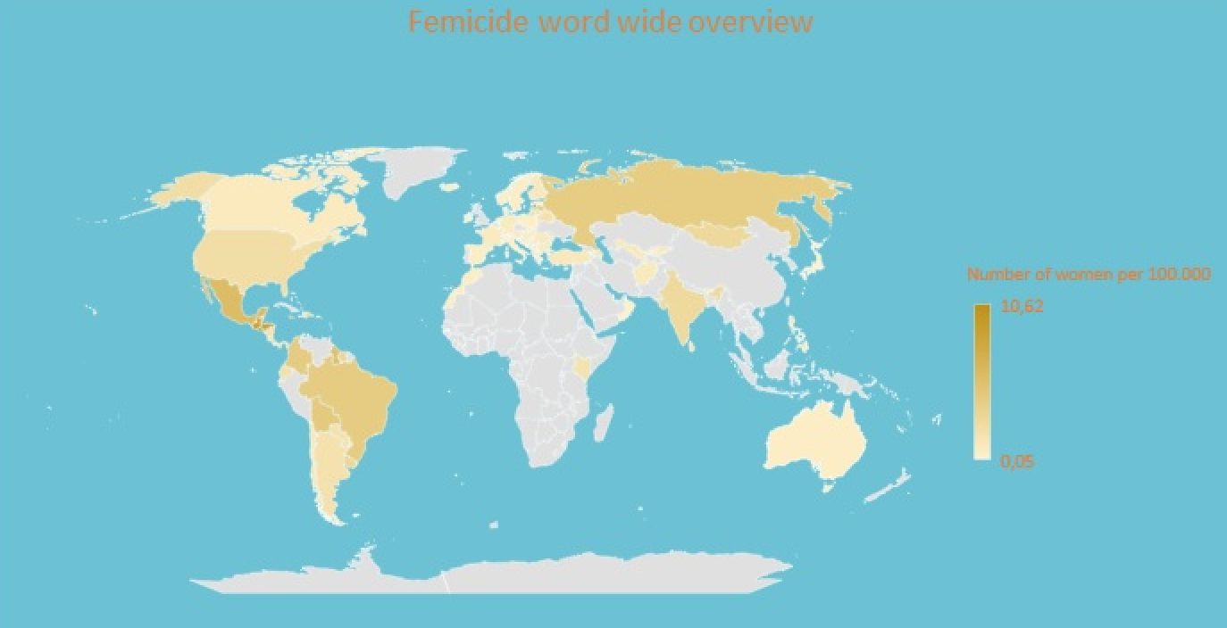

Appendix B
Figure 2
Table by V-Dem used for the dataset on Democratic Backsliding
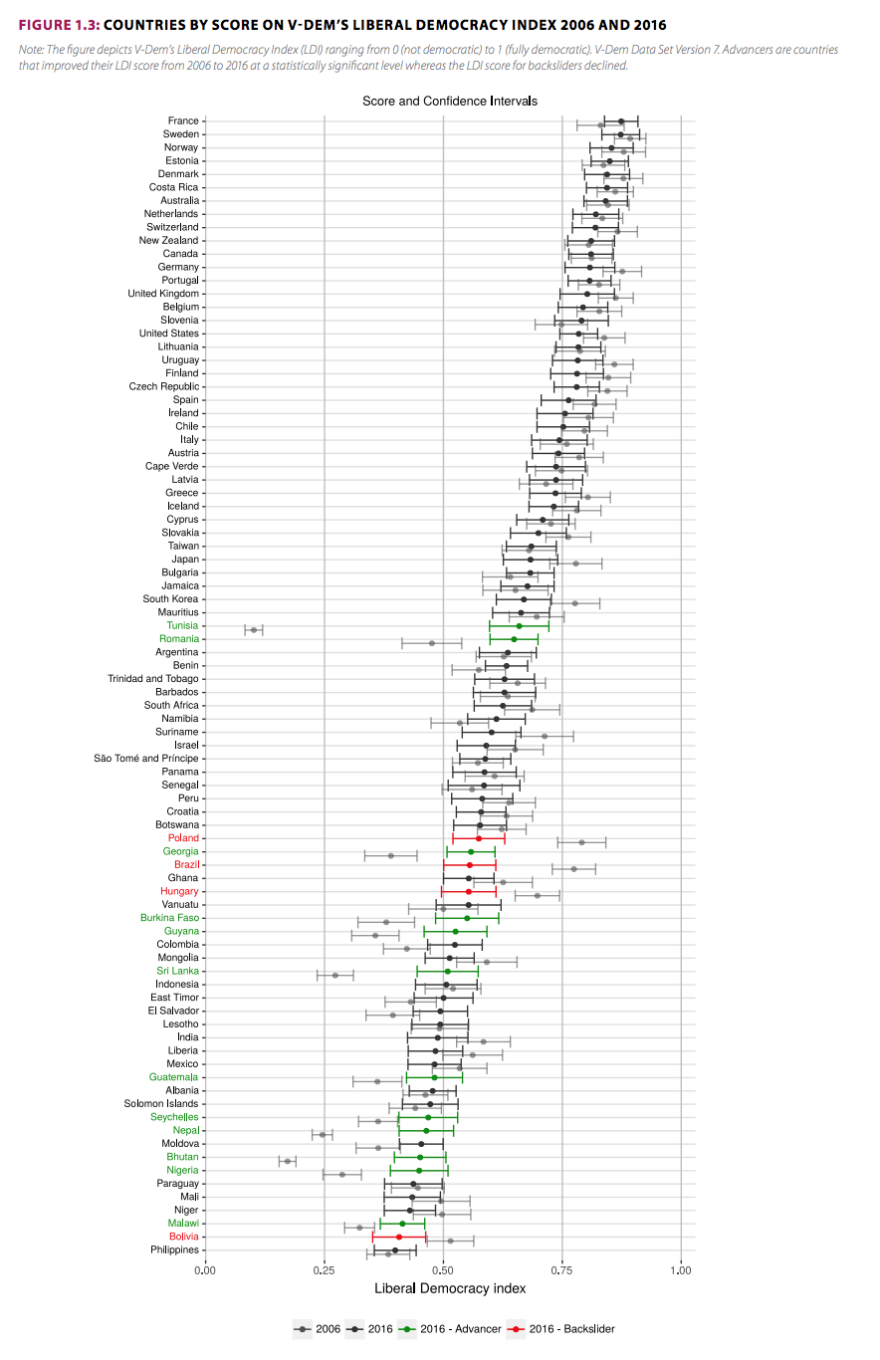
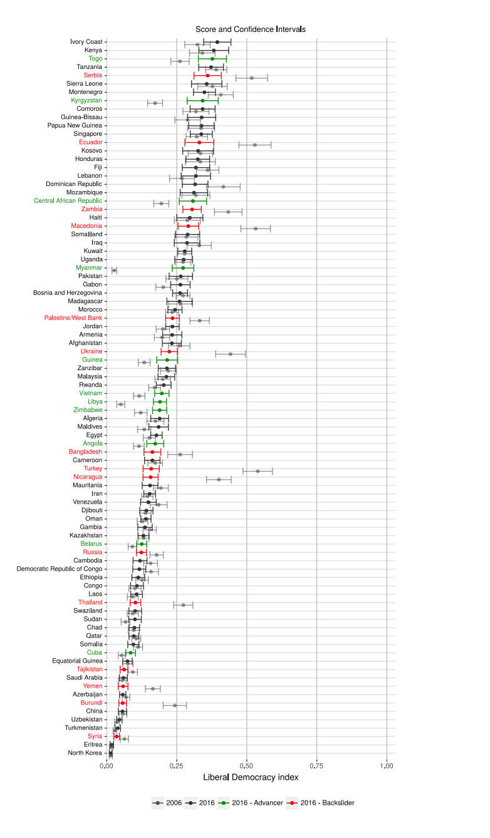

Appendix C
Table 1
Descriptive Statistics on Liberal Democracy Index dataset
Year | Valid N | Mean | Variance | Missing
2017 | 179 | 0.407 | 0.070 | 0
2018 | 179 | 0.406 | 0.069 | 0
2019 | 179 | 0.404 | 0.068 | 0

Table 2
Descriptive Statistics on Judicial Constrains on Executive index dataset
Year | Valid N | Mean | Variance | Missing
2017 | 179 | 0.583 | 0.097 | 0
2018 | 179 | 0.582 | 0.095 | 0
2019 | 179 | 0.583 | 0.094 | 0

Table 3
Descriptive Statistics on GDP per capita dataset
Year | Valid N | Mean | Variance | Missing
2017 | 174 | 17.380 | 310.346 | 3
2018 | 174 | 17.675 | 319.486 | 3
2019 | 174 | 17.827 | 324.165 | 3

Table 4
Descriptive Statistics on Legislative constraints on Executive index dataset
Year | Valid N | Mean | Variance | Missing
2017 | 177 | 0.597 | 0.092 | 2
2018 | 177 | 0.597 | 0.090 | 2
2019 | 178 | 0.600 | 0.088 | 1

Table 5
Descriptive Statistics on Women Civil Liberties Index dataset
Year | Valid N | Mean | Variance | Missing
2017 | 179 | 0.676 | 0.057 | 0
2018 | 179 | 0.674 | 0.056 | 0
2019 | 179 | 0.675 | 0.054 | 0

Table 6
Descriptive Statistics on Repression Civil Society Organizations dataset
Year | Valid N | Mean | Variance | Missing
2017 | 179 | 2.830 | 1.481 | 0
2018 | 179 | 2.840 | 1.563 | 0
2019 | 179 | 2.830 | 1.522 | 0

Table 7
Descriptive Statistics on Gini-index dataset
Year | Valid N | Mean | Variance | Missing
2017 | 76 | 2.211 | 48.918 | 190
2018 | 88 | 2.128 | 45.754 | 178
2019 | 69 | 2.126 | 50.539 | 197

Table 8
Descriptive Statistics on School Enrolment Female dataset
Year | Valid N | Mean | Variance | Missing
2017 | 177 | 48.848 | 1015.180 | 90
2018 | 179 | 48.973 | 1072.719 | 88
2019 | 170 | 52.193 | 1071.748 | 97

Table 9
Descriptive Statistics on Labour Force Participation Female dataset
Year | Valid N | Mean | Variance | Missing
2017 | 235 | 50.006 | 197.383 | 33
2018 | 235 | 50.010 | 200.968 | 33
2019 | 235 | 50.181 | 199.758 | 33

Table 10
Descriptive Statistics on Labour Force Participation Male dataset
 | Valid N | Mean | Variance | Missing
2017 | 235 | 45.890 | 70.952 | 33
2018 | 235 | 45.726 | 70.892 | 33
2019 | 235 | 45.563 | 70.812 | 33

Appendix D

Table 11
VIF scores including Liberal Democracy Index
 | VIF scores
Democratic backsliding | 1.511
Repression of civil society organizations | 4.119
Women civil liberties index | 6.623
Judicial constrains on the executive index | 9.262
Legislative constrains on the executive index | 9.509
Liberal democracy index | 17.700
Gini index | 3.735
GDP | 4.585
Labour force participation men | 4.329
Labour force participation female | 3.040
School enrolment female | 2.400

Table 12
VIF scores excluding Liberal Democracy Index
 | VIF scores
Democratic backsliding | 1.271
Repression of civil society organizations | 3.868
Women civil liberties index | 5.958
Judicial constrains on the executive index | 7.976
Legislative constrains on the executive index | 7.678
Gini index | 3.455
GDP | 3.981
Labour force participation men | 4.310
Labour force participation female | 2.921

Appendix E.1
Figure 3
Normal P-P Plot Femicide Without Log Transformation
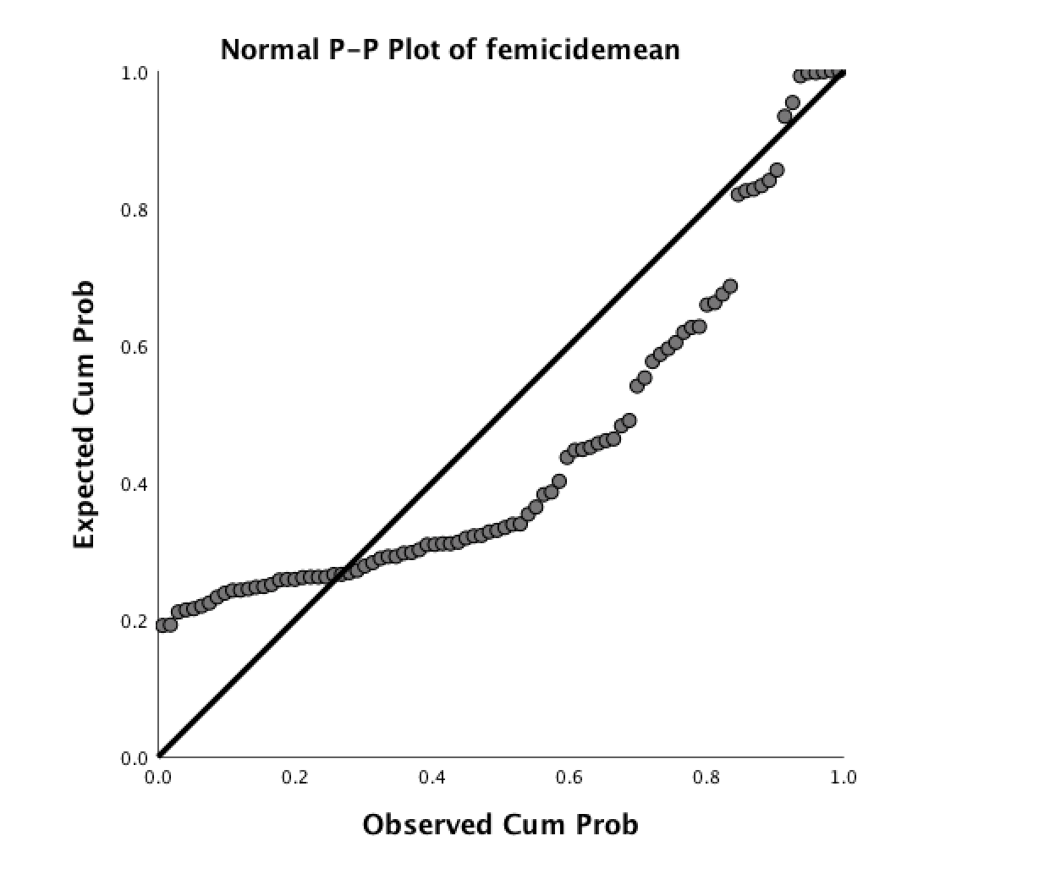

Appendix E.2
Figure 4
Normal P-P Plot Femicide With Log Transformation
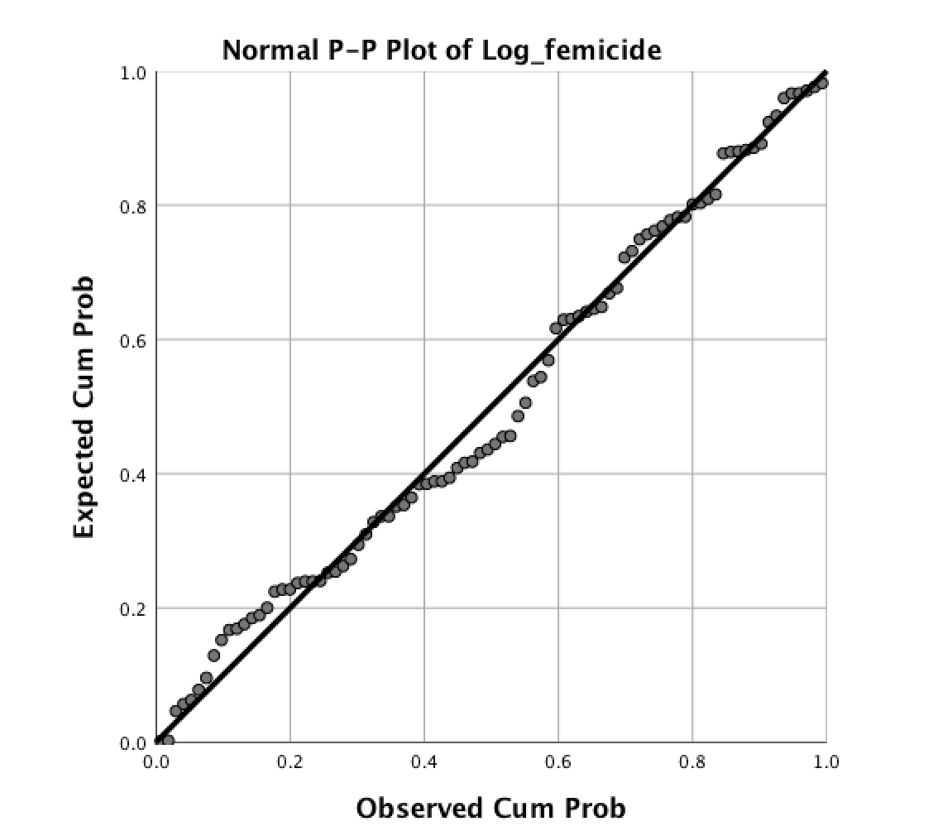

Appendix F.1
Figure 5
Scatterplot Without Log Transformation

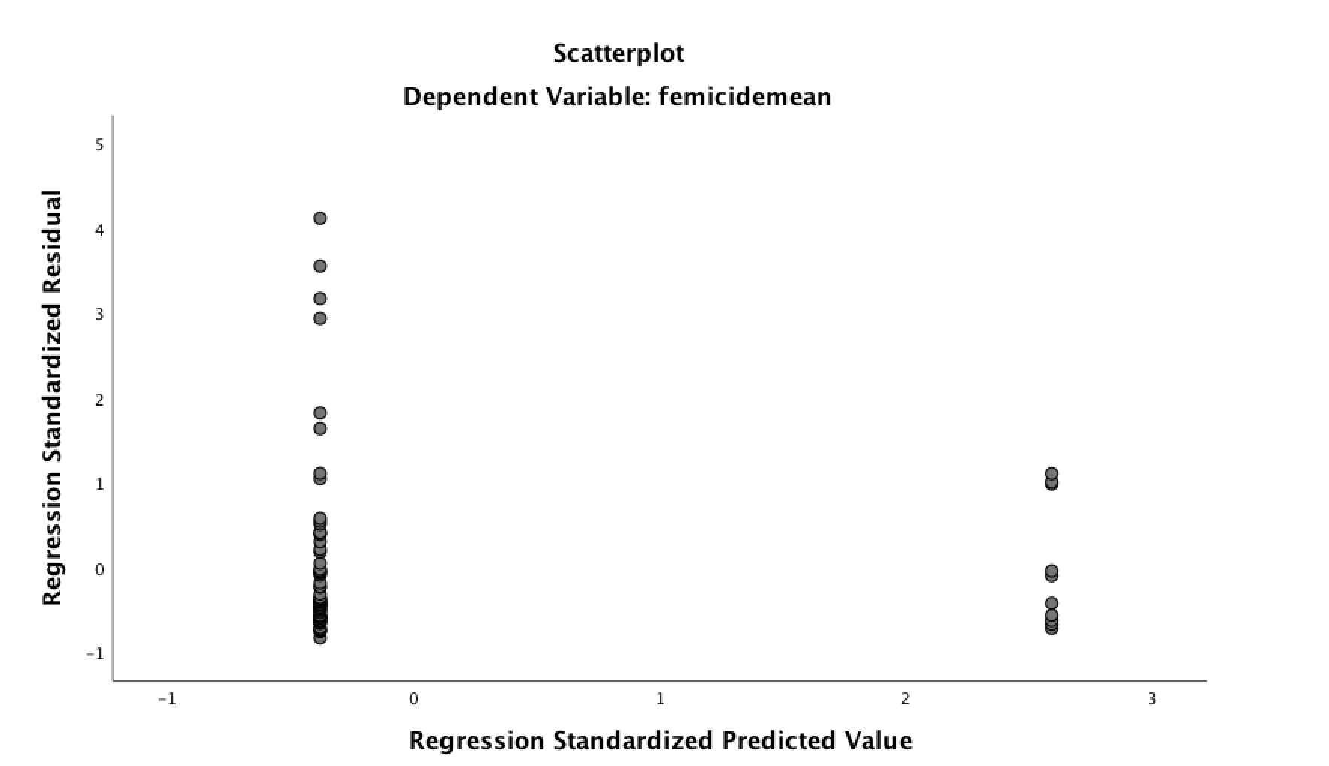

Appendix F.2
Figure 6
Scatterplot With Log Transformation
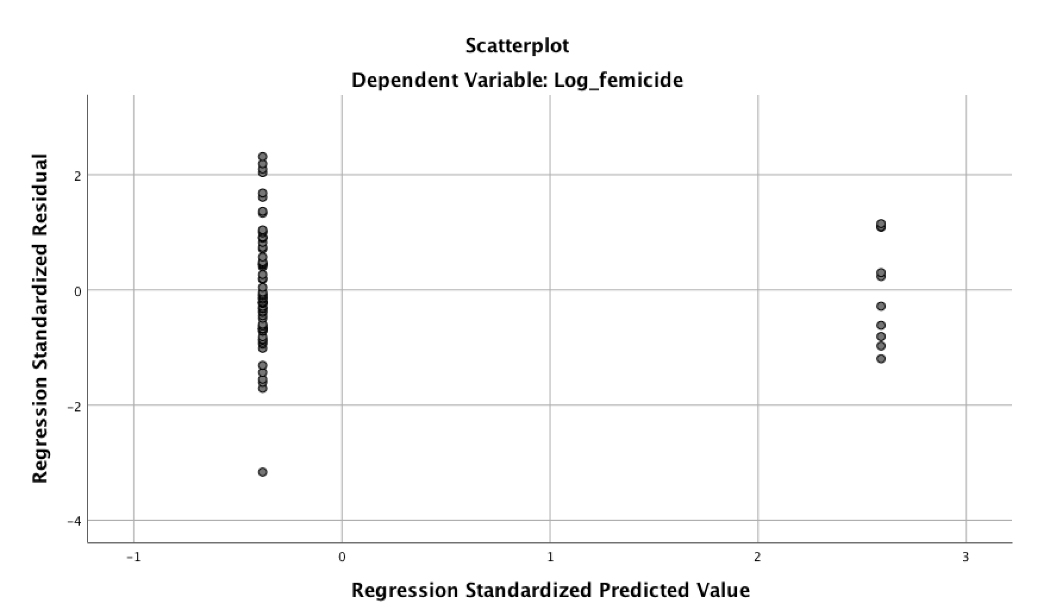

Appendix G.1
Figure 7
Boxplot Femicide Without Log Transformation
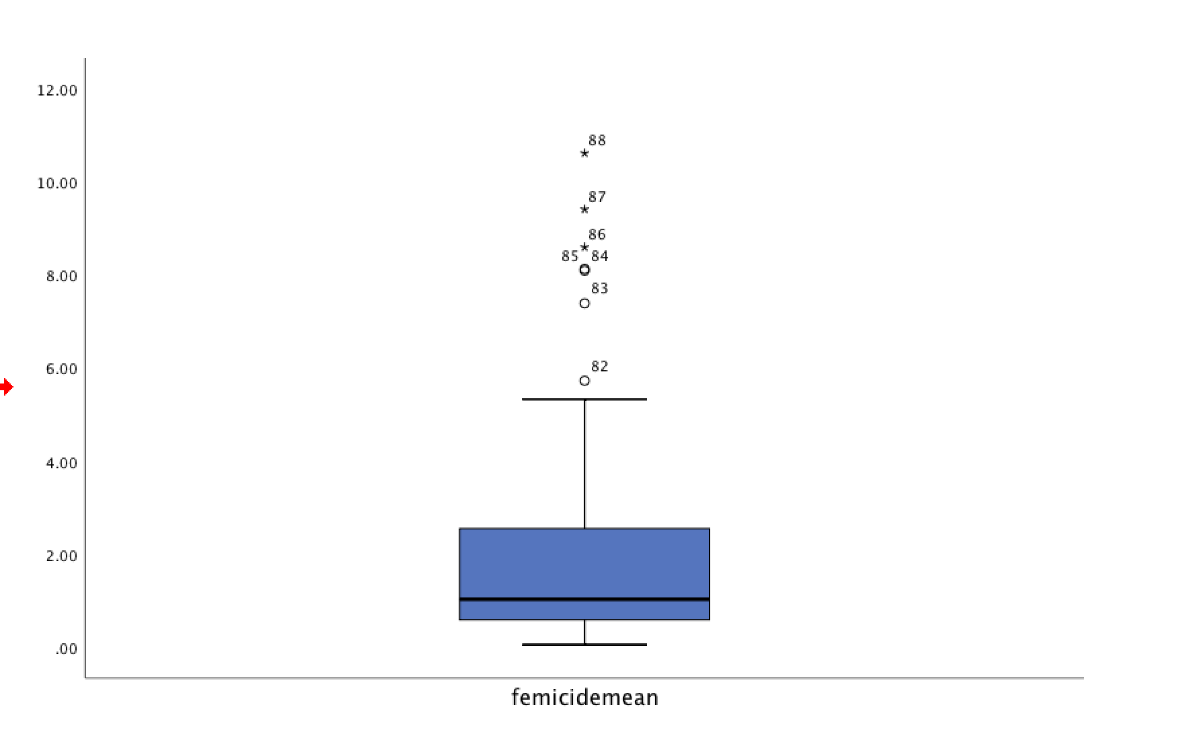

Appendix G.2
Figure 8
Femicide With Log Transformation

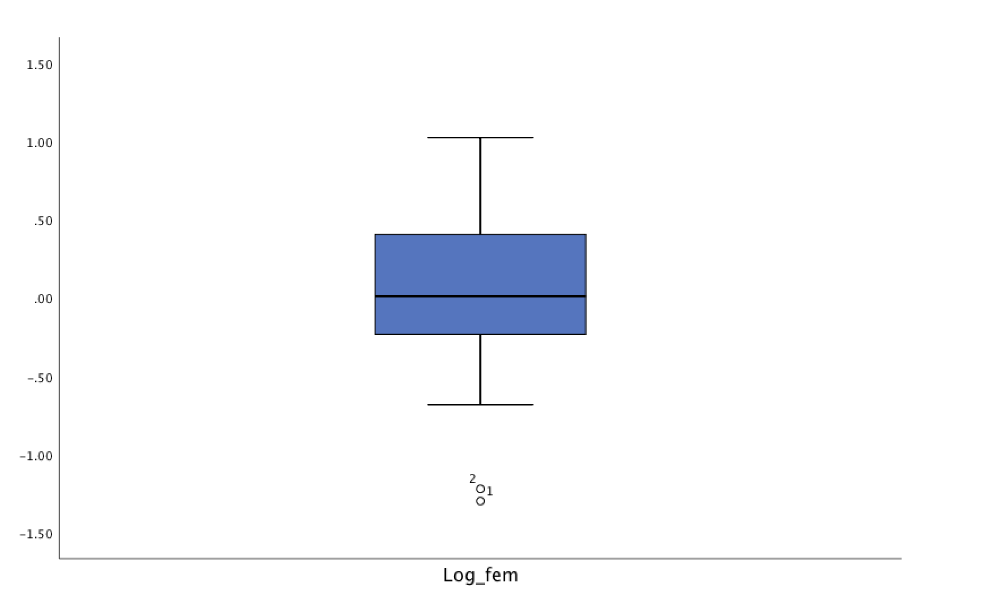

Appendix H
Table 13
Regression Analysis With Log Transformation
 | Model 1 |  | Model 2 |  | Model 3
 | B. | SE. | B. | SE. | B. | SE.
Democratic backsliding | 0.105 | 0.144 | -0.036 | 0.117 | -0.261 | 0.133
Liberal democracy index |  |  | 0.568** | 0.212 | -0.501 | 0.308
Labour force participation male |  |  | 0.012*** | 0.006 | -0.010 | 0.010
Labour force participation female |  |  | 0.005 | 0.04 | 0.007 | 0.007
GDP per capita |  |  | -0.018*** | 0.003 | -0.003 | 0.004
Gini-index |  |  |  |  | 0.024*** | 0.008
School enrolment female (tertiary) |  |  |  |  | -0.001 0.002
Constant | 1.818 |  | -0.931** |  | -1.790*
Adjusted R² | -0.006 |  | 0.414 |  | 0.500
F | 0.534 |  | 11.440*** |  | 6.286***
N | 77 |  | 74 |  | 37
Note: *p<0.1, **p<0.5, ***p<0.01

Table 14
Mediation Analysis Repression Civil Society Organizations With Log Transformation

 | Model 4
 | B. | SE.
Direct path C (Democratic backsliding > femicide) | 0.105 | 0.144
Indirect path A (Democratic backsliding > repression civil society organizations | 0.201 | 0.187
Indirect path B (Repression civil society organizations > femicide) | 0.506** 0.141
Direct path C’  Indirect effect total | -0.161 0.414  0.102
N  Note: *p<0.1, **p<0.5, ***p<0.01 | 75

Table 15
Mediation Analysis Women Civil Liberties Index With Log Transformation

 | Model 4
 | B. | SE.
Direct path C (Democratic backsliding > femicide) | 0.105 | 0.144
Indirect path A (Democratic backsliding > women civil liberties index) | -0.078 | 0.057
Indirect path B (Women civil liberties index > femicide) | -0.155** 0.296
Direct path C’ | 0.099 0.147
Indirect effect total  N | 0.233  75
Note: *p<0.1, **p<0.5, ***p<0.01

Table 16
Mediation Analysis Judicial Constrains on Executive Index With Log Transformation

 | Model 4
 | B. | SE.
Direct path C (Democratic backsliding > femicide) | 0.150 | 0.724
Indirect path A (Democratic backsliding >judicial constrains on executive index) | -0.328*** | 0.083
Indirect path B ( judicial constrains on executive index >femicide) | 0.000 0.201
Direct path C’  Indirect effect total | 0.111 0.159  0.000
N | 75
Note: *p<0.1, **p<0.5, ***p<0.01

Table 17
Mediation Analysis Legislative Constrains on Executive Index With Log Transformation

 | Model 4
 | B. | SE.
Direct path C (Democratic backsliding > femicide) | 0.150 | 0.724
Indirect path A (Democratic backsliding >legislative constrains on executive index) | -0.235 | 0.087
Indirect path B (legislative constrains on executive index >femicide) | -0.162 0.191
Direct path C’ | -0.062 0.149
Indirect effect total | 0.038
N | 75

Note: *p<0.1, **p<0.5, ***p<0.01

