**Merciless Taxation and False Pretence**

**An evaluation of Dutch policy on the purchase, possession and use of cars**

**Master Thesis:**

**Author:** BSc. M.P.B. Franken

**Student #:** 4169816 **Education:** COMPASS

**Faculty:** Nijmegen School of Management

**Instructor:** Prof. Dr. M. Herweijer

August 2014

**Preface**

You will be reading a piece on policy evaluation with Dutch policy on the purchase, possession and use of cars as its case. I have chosen for this subject due to my interest for cars. I myself have owned multiple cars not only for mobility, but also as a hobby. I have been introduced to unnecessary expensive tax policy regarding cars while owning these cars. Politically, I have always been interested in taxation without a clear cause or relevance. This subject can therefore be considered relevant to my interests. Additionally, I have avoided thousands of Euros in taxes by using multiple tax regimes which influence fuel prices and the used car market. As policy and policy evaluation are relevant for my field of study, the perfect opportunity arose to use scientific methods to determine "what works" regarding Dutch policy tax on cars and "why does it work".

I would like to thank Prof. Dr. M. Herweijer for his time as instructor and Dr. J.K. Helderman for his critical second opinion.

Matthijs Franken

**Contents**

**Introduction 5**

**Chapter 1 - Theoretical Framework 8**

§ 1 Introducing Policy 8

§ 1.1 - Defining Policy 8

§ 1.2 - Types of Policy 9

§ 1.3 - Steering 9

§ 1.4 - The Concept of Policy Instruments 10

§ 1.4.1 - Considerations on policy instruments 11

§ 1.4.2 - The effectiveness of policy instruments 11

§ 1.4.3 - The suitability of policy instruments 12

§ 1.4.4 - Overlap between Types of Policy & Policy Instruments 13

§ 2 Taxation 14

§ 2.1 – The Fiscal Instrument 14

§ 2.2 – Success or Failure of Taxation 14

§ 3 General Hypothesis & Conceptual Model 15

§ 3.2 - Conceptual Model 16

**Chapter 2 - Methodological Framework 17**

§ 1 Case Selection 17

§ 1.1 - Reasons for a case study 17

§ 1.2 - Case selection 17

§ 2 Conducting Evaluative Research 18

§ 2.1 - Evaluating Step by Step 18

§ 3 - Quality, Validity & Reliability 20

§ 3.1 - Guarding Internal & External Validity 20

§ 3.2 - Guarding Reliability 20

§ 3.3 Additional Quality Enhancement 21

§ 3.4 Sources & Analysis 21

**Chapter 3 – Dutch taxation on possession and use of cars 22**

§ 1 General taxation on buying a car 22

§ 1.1 - VAT 22

§ 1.2 - Old BPM Policy 22

§ 1.3 - BPM Abolishment policy & Gas Guzzler Tax, the new BPM 23

§ 2 General taxation on the possession of a car 24

§ 2.1 - Taxation on the possession of a car 24

§ 2.2 - Taxation on possession of older cars 26

§ 2.3 - Fuel Price & Fuel Taxes 27

§ 3 Statistics on the Dutch Fleet 28

§ 4 Adapting the conceptual model 32

§ 5 Testable Hypothesis 34

§ 5.1 - Irrelevant Theoretical Hypotheses 34

§ 5.2 - Combining relevant hypotheses with practical data 34

**Chapter 4 – Policy Analysis 36**

§ 1 Policy Analysis 36

§ 1.1 - VAT Policy 36

§ 1.2 - Old BPM Policy 37

§ 1.3 - New BPM Policy 39

§ 1.4 - Taxation on possession of cars 42

§ 1.5 - Taxation on possession of older cars 44

§ 1.6 - Taxation on Fuel 46

§ 2 Final Conceptual Model & Policy Field Analysis 49

§ 2.1 - Final Conceptual Model 49

§ 2.2 - Policy Integration 50

§ 2.3 - The use of fiscal instruments 51

**Conclusion 52**

**Discussion 55**

**Reflection 56**

**Bibliography 57**

**Introduction**

The year of 1992, the author of this thesis remembers it well. On a Saturday during spring, he and his father went from the Dutch village of Goirle to the Belgian village of Poppel. A trip of less than 10 kilometers. An easy distance to travel by car. Poppel is Belgian village known for its cheap fuel prices, cigarettes and alcohol when compared to Dutch vendors. The author and his father were there for the same reasons: fuel, alcohol and cigars. These products are cheaper due to lower taxes. As European integration made travelling to other countries almost effortless, citizens living close to the border can reap the benefits of multiple tax regimes. Refueling and shopping in Poppel is only one example. Another well-known example is the German village of Kranenburg near Nijmegen where many Dutch citizens reside due to favorable housing costs and a favorable tax regime. One might expect a government would adjust its policy to compensate this tax leak or negotiate with other countries to use a comparable system of taxes that does not encourage tax avoidance. But this does not appear to be the case as the author of this thesis has used that same gas station in Poppel for the last 6 years to refuel his car.

1886 is the year of birth for the modern car. Karl Benz introduced his "*Benz Patent-Motorwagen*". A luxury good for the upper class in its first decades. Cars became affordable for the general public in the first half of the 20th century. Since then, many marques have been created and many marques have long been since forgotten. A car as a product has a wide range of properties. Like many other products, a car can have different sizes, technical aspects and equipment. The basic function of the car is offering its user mobility. The ability to travel great distances in an acceptable amount of time. Other functions of a car can be social status or fulfillment of leisure and hobby desires. There are also clear differences between cars and other products. Cars need roads and the more citizens use cars, the better traffic needs to be regulated. These roads need to be financed collectively as individuals are not able to maintain an entire network of roads and a organization needs to take responsibility for creating, implementing and controlling traffic regulations. A car is also a prime example of a product that creates harmful externalities. Fuel based on fossil resources used in internal combustion engines is a prime example of a hazardous externality.

The properties of a car as a product, the need for roads, traffic regulation and compensation for externalities on the one hand and large differences in tax policy on cars and fuel taxes between countries on the other hand, have led to an interesting policy field: a puzzle asking for research. One might expect countries have somewhat common interests regarding cars. A proper road network capable of handling traffic, clear traffic regulation to avoid traffic jams, accidents and clear regulation on how to minimize externalities caused by the possession and use of cars.

With more than a century of experience with a society driving cars, policy makers may have invented "*best practices*" on how to deal with the possession and use of cars. That would imply effective policy has been developed which, over time, ensures that important goals are reached. In addition, if policy makers have developed best practices, one could argue that policy would be stable for many years and would be revised only to fine tune various elements or to ensure it properly fits with society. The author of this thesis experienced that the reality could not be further from the truth. Fiscal policy on the possession and use of cars is modified almost every year in the Netherlands. In addition, over the last few years, new taxes on the possession and use of cars are created, implemented and abolished rapidly. Optimists could argue that this "rapid" policy cycle consists of policy learning which quickly realizes its goals. However, it is also possible that rapidly creating, implementing and abolishing policy is an ineffective way of dealing with traffic problems.

Another interesting fact regarding Dutch policy on the possession and use of cars, is that possessing and using a car in the Netherlands is quite expensive when compared to other European member states. Various taxes on purchasing new cars, high road taxes and high fuel prices make cars an expensive good in the Netherlands. The Dutch (ANWB) interest group for car and bike owners continuously hammers on the unrealistically high price tag of buying, possessing and using a car in the Netherlands especially when compared to the total costs of infrastructure. They consider the car to be the cash cow of the Dutch government.

Frequent changes in existing policy and generally high costs on the possession and use of cars in the Netherlands produce interesting questions for research. What do frequent changes do with the functioning of multiple policies on one subject? What are the effects of taxation? Why is buying, possessing and using a car so expensive compared to the costs of maintaining the infrastructure? This thesis will try to offer readers an analysis on the effectiveness of existing Dutch tax policy on the one hand and the mechanism of pricing and its effects on the other hand. This leads to the following goal:

**Goal:**

"*To research if existing tax policy on the purchase, possession and use of cars functions in an integrated way and if these policies are effective.*"

To reach the goal of this thesis, the following main research question has been formed:

**Main research question:**

"*Does policy on the purchase, possession and use of cars in the Netherlands function in an integrated way and are these policies effective?"*

The main research question focuses on fiscal policy involved with the purchase, possession and/or use of cars. The difference is that possessing a car does not necessarily mean the car will be used extensively. This difference is illustrated by comparing a variable tax policy with a fixed tax policy. Any variable tax policy that levies the use of cars will not create much tax revenues from the possession of cars. On the other hand, a tax policy that levies at the possession of cars, will always generate its revenues proportionally to the amount of cars owned by all citizens but will not necessarily generate revenue from citizens actually using cars. Naturally, a combination of taxation both on possession and use is possible. It is also possible that no clear tax policy exists and that tax revenues are used to pay for the infrastructural demands and externalities created by driving.

The second part of the main research question aims to explain if the Dutch fiscal policies on the possession and use of cars are effective. The "*expensiveness*" of mobility in the Netherlands is often criticized by interest groups and citizens themselves. There can however be a good reason for the existing fiscal policies if they help the government in achieving given goals. It is also possible that existing policies are unnecessarily expensive.

**Theoretical Relevance:**

This thesis will use descriptive and evaluative research methods to focus specifically on fiscal policy involved with purchasing, possessing and/or using cars. No pre-existing theory will be used solely. A custom theoretical framework will be introduced to analyze existing and past policies regarding automobiles. The theoretical relevance lies in the development and application of this custom framework to analyze tax policies and their effects on a micro scale. The work of multiple authors will be combined into one theoretical framework that starts with the concept of policy itself and helps to explain policy choices and variants of policy. As the nature of policy on cars is often fiscal, extra attention will be paid to the fiscal element of policy. The tailor made framework starts from theory on policy instruments.

**Practical Relevance:**

Fiscal policy on the possession and use of cars in the Netherlands is controversial. Extensive research already exists and often shows absolute figures. Figures that can be used by political parties and interest groups to bolster their position in the public debate on cars and mobility. The practical relevance of this thesis lies in the thorough explanation of policies that are chosen and its effectiveness. Instead of absolute figures telling us what a certain situation is at a certain point in time, this thesis will also try to explain why a certain situation at a certain point in time has developed the way it is or why it is not the way the government intends it to be! In addition, this thesis also focuses on possible (un)intended side effects. The practical relevance of this thesis also lies in thorough research on these mechanisms that have sometimes been in place for decades.

**Contents**

In the first chapter, a tailor made theoretical framework will be described. The core of this framework is based on the policy instruments theory from Fenger & Klok (2014) but policy itself and the steering of behavior is also derived from Bekkers (2007). Practical insights on fiscal policy of the Dutch Audit Office (1999) will be used to augment the theoretical framework by making it suitable for an analysis on fiscal policy. General hypotheses will be derived from this theoretical framework by looking at the assumptions from a theoretical points of view.

The second chapter will describe the research methodology in use and the reason why this design is chosen. It will consist of an elaboration on the use of a case study, a case selection, methods suitable for an analysis of existing and past policy and methods suitable for an analysis of the effectiveness of existing and past policy.

The third chapter contains a case description of existing and past Dutch policy regarding the purchase, possession and use of cars. This chapter will also contain a combination of the knowledge from the theoretical framework with the practical knowledge on the case. General hypotheses introduced in the theoretical framework will be made more specific and testable based on the information from the case description in this chapter. It will show in a very practical defined way which hypotheses the analysis can support or must refute. The reason why the final definitions of relevant hypotheses take place in the fourth chapter is that readers do not have the practical knowledge on the Dutch case after reading just chapter 1. The general hypotheses from chapter 1 need to be fine-tuned for this case and this is why chapter four will be used to construct specific and testable hypothesis.

The fourth chapter will consist of the analysis in which the Dutch policies on purchasing, possessing and using cars will be described with the concepts drawn from the theoretical framework. An analysis on effectiveness will be included for each specific policy to be able to thoroughly evaluate each specific policy. The results of this fourth chapter will be used to support or refute all hypotheses. This will take place in a conclusion following chapter four in which the main research question will be answered. This conclusion also sums up the other relevant findings.

Finally, the author will reflect on the methods and concepts used in this thesis in a discussion followed by a general reflection.

**Chapter 1 - Theoretical Framework**

**Introduction**

In this chapter, the theoretical framework used in this thesis will be described. To be able to evaluate policy, theoretical insights on policy in general and the functioning of policy instruments is required. The work of multiple authors has been combined into a tailor made theoretical framework. The cornerstone of this framework is the policy instruments theory formulated by Fenger & Klok (2014). To offer readers a thorough theoretical foundation on policy in general, the theoretical framework also includes a general description and definition of policy based on Bekkers (2007). In addition, specific characteristics of fiscal policy instruments will be described based on research from the Dutch Audit Office (1999) as this thesis focuses heavily on taxation of the possession and use of cars. The goal of the theoretical framework is to give a first plausible answer to the research question on a general level and to gain theoretical insights in the workings of (fiscal) policy and policy instruments in general, the way broadening and restrictive policy instruments can be used, the effectiveness of policy instruments and how policy makers decide upon what policy instrument to adopt. In the final paragraph of this chapter, general hypotheses will be derived from the theoretical insights and a conceptual model on the functioning of tax policy will be introduced.

**§ 1 Introducing Policy**

**§ 1.1 - Defining Policy**

In an introductory chapter, Bekkers (2007:18) describes the concept of allocation. He claims allocation is the distribution of values for an entire society. Citizens' safety is used as an example. Bekkers (2007:19) continues and introduces the state, market and community as three alternate allocation mechanisms. Bekkers (2007:20) then introduces policy as the result of the need for allocation. Policy shows what choices have been made, why these choices have been made, for which groups or citizens a certain policy is meant and what instruments are used to pursue the policy goals. After his general introduction on allocation and policy, Bekkers (2007:21) offers two general definitions of policy, the first based on Hoogerwerf (1987) and the second based on Bovens et al. (1996:80):

Policy, Definition 1:

*"Reaching certain goals using certain instruments in a certain order in time."*

Policy, Definition 2:

*"Intentions, choices and actions of one or more governmental organizations aimed at steering certain developments in society."*

One can clearly derive "*goals*" from both definitions. In the first definition, goals are explicitly mentioned. In the second definition, it is clear goals exist as it explicitly mentions intentions, choices and actions from which one can derive that certain goals exist. In addition, the first definition introduces instruments and the second definition introduces steering. Based on these definitions from Hoogerwerf (1987) and Bovens et al. (1996:80) and Bekkers' (2007:25) elaboration, the definition of policy as used in this thesis is as follows:

Policy:

"*The intentions, choices and actions of one or more governmental organizations aimed at reaching certain goals or steering of citizens' behavior by using policy instruments over a certain timeframe.*"

To offer a comprehensive definition, the concepts of steering and policy instruments need to be elaborated. Also, in addition to a definition of policy for this study, various types of policy may also show very different characteristics. For that reason, a demarcation between various types of policy is also needed. The following 3 paragraphs deal with types of policy, the concept of steering and the concept of policy instruments.

**§ 1.2 - Types of Policy**

One can argue that different situations call for different types of policy. Bekkers (2007:24) introduces the following types of policy:

*Explorative Policy:*

Explorative policy is policy aimed at introducing a new vision or inspirational story used to prepare individuals for certain new measures against existing problems. Explorative policy can be used to mobilize actors to think about developments or changes in a certain system before clear goals are set (Bekkers, 2007:24).

*Distributive Policy & Re-distributive Policy:*

Bekkers (2007:24) introduces the concepts of distributive and re-distributive policy. Distributive policy is used to allocate given resources and/or wealth over a certain group according to certain standards. Re-distributive policy is used in the same manner but especially when the situation before re-allocation is considered unfair, unequal or discriminative. In redistributive policy, resources are taxed away from certain groups and spent in the benefit of other groups.

*Regulating Policy:*

Regulating policy is aimed at forcing certain activities to take place in a certain way. Legal obligations are part of it regulating policy. An example introduced by Bekkers (2007:25) is the obligation of municipalities in the Netherlands to check whether or not construction permits stroke with corresponding laws, rules and by-laws.

*Facilitating Policy:*

According to Bekkers (2007:25), facilitating policy is policy aimed at supporting the attainment of certain goals without forcing society or organizations into certain behavior. With facilitating policy, certain necessities for success are created. Bekkers (2007:25) uses special trash bins for glass as an example of facilitating policy as a government can facilitate the collection of garbage.

*Stimulating Policy:*

Stimulating policy is aimed at influencing behavioral patterns of citizens to make them behave in a certain desirable way. Desirable behavior is behavior according to certain values and defined by politicians (Bekkers, 2007:25)

*Constituting Policy:*

Bekkers (2007:26) describes constitutional policy as policy aimed at creating the institutions and organizations to carry out specific tasks. As an example, he mentions the Dutch Authority on Financial Markets aimed at combating market disturbances as.

**§ 1.3 - Steering**

Bekkers (2007:21) describes steering as intentionally influencing society in which act instruments are used. He also states that steering has to be legitimate and needs thorough argumentation (Bekkers, 207:92). An example to call for governments to steer behavior is a situation in which society is drifting towards behavior which collides with important values such as privacy or freedom of expression. A government can steer behavior to ensure the preservation of these public values. Bekkers (2007:94) also explains that steering can take many different forms as different phenomena may take place in a different context in society. Various contextual factors can therefore influence the way and to what extent governments can steer behavior.

The limits of steering are also described by Bekkers (2007:99). For extensive steering, a government needs adequate financial means. Without the proper financial backing, it is unlikely further steering is possible. A judicial argument against extensive steering is the complex web of laws, rules and regulations that come into effect if continuous regulatory steering takes place (Bekkers, 2007:100). Implementing and upholding policy may then become impossible and the image of society portrayed by laws, rules and regulations may not match with the real society. Finally, Bekkers (2007:100) introduces various arguments that stem from studies in Public Administration. It may be impossible to steer behavior at some point when only one organization or government is attempting to steer behavior. Second, the ideas of one government may be outdated. The government consists of many organizations that all have their own official task, (unofficial) goals and ideas how to steer society. Finally, there may not be an automatic and self executing relation between the creation of policy and the implementation of that policy. According to Bekkers (2007:101) the societal context and the implementation process are often left out when policies are discussed and adopted.

**§ 1.4 - The Concept of Policy Instruments**

The concept of policy instruments has been used in the definition of policy for this study and requires further elaboration. Bekkers (2007:186) considers policy instruments to be tools of the policy maker. Policy instruments are the means through which the behavior of citizens can be influenced. As this study evaluates multiple tax policies from the Dutch government, a thorough theoretical foundation on instruments is required. Fenger & Klok (2014) offer theoretical observations concerning policy instruments. Like Bekker (2007:188), Fenger & Klok (2014:189) describe a policy instrument as anything an actor can use to reach a certain goal. They broadly divide instruments in two categories. The first category contains instruments that directly achieve a certain goal such as a government providing public services like the construction of a bridge or road. The second category consists of instruments that influence the behavior of citizens and has been further divided into legal, economical, communicative and physical policy instruments (Fenger & Klok, 2014:191). Finally, Fenger & Klok (2014:191) also describe it is possible that a government formulates clear goals but does not intervene in society. In this case, a government opts for *laissez faire* and will let society itself deal with a problematic situation.

*Instrument 1: Legal Instruments*

According to Fenger & Klok (2014:191), legal instruments are used to steer citizens' behavior by allowing, requesting or prohibiting certain behavior. They use the example of parking zones in municipalities. A municipality may prohibit parking in certain areas. The intention is to influence the parking behavior of citizens by prohibiting parking under certain circumstances and on specific places. A legal instrument is enforced by negative sanctions as a fine or confiscating the driving license.

*Instrument 2: Economical Instruments*

Economical instruments are used to encourage or discourage certain behavior. The car owner has a free choice to alter her or his behavior. He is not compelled to comply. The pros and cons of behavioral alternative choices are modified by the government by making the expected outcomes more or less attractive. Fenger & Klok (2014:191) again use the example of parking zones in cities. A municipality can allow parking but charge a certain amount for parking tickets. Although the parking is allowed, it now has its price. The free choice is now if the car owner is willing to pay the price.

*Instrument 3: Communicative Instruments*

Fenger & Klok (2014:192) describe the communicative instrument as a message from the government towards citizens on a certain subject. This message will contain information or arguments with which the government tries to modify the behavior of citizens by altering the knowledge or appreciation of citizens of certain alternatives. Fear messages may deter certain forms of conduct. Positive examples may sometimes elicit imitation.

*Instrument 4: Physical Instruments*

The final instrument Fenger & Klok (2014:192) describe, is the physical instrument. A government can influence the behavior of citizens by creating physical barriers or physical opportunities. An example would be physical barriers in a certain area closing down a road in the night to carry out necessary maintenance making it impossible to reach that area by car. A positive (facilitating) example would be the construction of a bridge to enable citizens to cross a river.

**§ 1.4.1 - Considerations on policy instruments:**

Aside from the choice for a certain mix of instruments, Fenger & Klok (2014:192) argue that a government also has to decide if the instrument will be used universally or individually and if it is a restrictive instrument or more enabling.

*Universal & Individual Instruments:*

An instrument that will be applied universally affects a large group of people or multiple organizations. Fenger & Klok (2014:192) consider general laws a good example of universally applied legal instruments. An individual instrument is an instrument which is used for one particular case. Fenger & Klok (2014:192) describe subsidies for specific events as an example of individually applied instruments. According to Fenger & Klok (2014:193), individual instruments are more suitable to treat specific cases. They call it "fine-tuning" of policy. They argue that the effects of individual instruments can be greater compared to universal instruments if the target group is heterogeneous. However, a downside of individual instruments, is that they require more effort and information to apply than universal and general instruments.

*Restrictive & Widening Instruments:*

With restrictive and widening instruments, Fenger & Klok (2014:193) describe how certain instruments can broaden the options citizens have while other instruments can restrict such options. With legal instruments as an example, Fenger & Klok (2014:193) show how rights and entitlements clearly show an increase in possibilities on the one hand and duties and obligations clearly imply restrictions prohibiting behavior on the other hand. For economical instruments, restrictive instruments are use to tax and fine, whereas widening instruments are used to subsidize or facilitate certain choices. Subsidies can be awarded to promote certain behavior and tax levies can be used to make certain behavior less attractive (Fenger & Klok, 2014:194). When using communicative instruments, a broadening instrument helps citizens to gain more knowledge and insight on certain subjects, so they can better choose for themselves. While a restrictive instrument will consist of propaganda not to give all information to the citizen. Restrictive communication is a form of hiding relevant information from the car user and to supply her or him with useless information. This distortive information will restrict the choices of the groups that are addressed. Finally, when using physical instruments, Fenger & Klok (2014:194) argue that restrictive and widening instruments are used in a physical way. Bridges can be used to offer citizens extra travel opportunities while restricted access points or road blocks limit the travel opportunities.

Fenger & Klok (2014:195) note that most government policy consist of a instrument-mix. Instruments of different types are often combined together. Legal instruments that restrict unwelcome behavior for example, can be combined with economical instruments such as subsidies that make welcome behavior more attractive. It is also possible that an instrument is - for different groups - both restrictive and broadening. To show this, the example of warning labels on cigarette packings is used. To the public, it may seem as widening their knowledge while tobacco producers may consider it to be restrictive.

**§ 1.4.2 - The effectiveness of policy instruments**

The effectiveness of a policy instrument consists of the causal relation between the application of the instrument, the change of behavior and the attainment of policy goals. Fenger & Klok (2014:201) argue that the more effective a policy instrument is, the more its effects lead to the attainment of the intended policy goals. As the functioning of a certain instrument depends on specific features of the target group and the way the instrument is used, it is difficult to judge the effectiveness of a policy instrument up front (a priori). Regarding the 4 types of policy instruments described in part 1 of this chapter, Fenger & Klok (2014) argue that:

1. The effectiveness of communicative instruments is only small. A certain target group has to accept a certain message before they opt to change their behavior. Specific advice for individual situations however, can be effective in changing routine behavior according to Fenger & Klok (2014:201).

2. The effectiveness of economical instruments largely depends on the price elasticity of certain needs and desires. If car owners are responsive to changes in the price of gas or of a cleaner car, price reductions will have substantial effects. Fenger & Klok (2014:201) offer multiple examples of successful economical instruments where taxes are effectively used to change consumer behavior. However, they also offer a prime example of a less effective economical instrument, fuel taxes. Fenger & Klok (2014:201) state that a lack of equally interesting alternatives has led to little effectiveness on fuel taxes. The alternative must be easily available and that was not the case.

3. Legal instruments have, in theory, the most potential in theory. Fenger & Klok (2014:202) describe how many studies show that effective laws and regulations lead to behavioral changes. However, they also describe that there are plenty of examples of legal instruments where the enforcement of the law is problematic due to a large target group, behavior which is difficult to measure or a shortage in policing efforts.

Regarding physical instruments, Fenger & Klok (2014) offer no explanation on their effectiveness.

**§ 1.4.3 - The suitability of policy instruments**

Fenger & Klok (2014:202) argue that the choice for a specific instrument is rarely neutral in an ideological sense. Politicians promote certain interests and certain ideological positions, excluding others. They love instruments that protect the favored interests and confirm to their ideological prejudices. However they will oppose instruments that harm those interests or run counter to their favorite ideological positions. Fenger & Klok (2014:202) interpret the choice for policy instruments by looking at political preferences, developments in society and ethical criteria that are popular within the electorate.

*Political Preferences:*

Fenger & Klok (2008:237) argue that political preferences may create a preference for specific policy instruments. They use the example of New Public Management and Dutch public sector reforms of the 1980's to show an economic instrument was used to achieve political goals such as deregulation, privatization and budget cuts. Liberal citizens may not take kindly to legal or economical instruments if their freedom is hampered or if the role of the government in the economy increases. Fenger & Klok (2014:202) also argue that the choice of a certain policy instrument also involves considerations of one's political power. They claim actors ask themselves if deploying a certain instrument will increase their political power or not.

A second important factor influencing the choice for certain policy instruments, is the consensus between the actors involved. Fenger & Klok (2014:202) argue that consensus on certain instruments makes it likely these instruments will be deployed. On the other hand, if there is no consensus on a certain instrument, a combination of instruments can be created to reduce resistance from important actors. A package deal is made which favors interests of all parties involved.

A third import factor is the uncertainty of success in the employment of a policy instrument. According to Fenger & Klok (2014:203), policy instruments can be costly and their effects on certain situations may be unclear. Policy makers can then opt to implement a certain instrument for a limited amount of time opposed to a long term and stable commitment to an instrument. Costs and effects directly deal with efficiency. An instrument that adds more to the attainment of certain goals when compared to another instrument, is more efficient (Fenger & Klok, 2014:203)

*Developments of Society:*

The growing influence of the European Union and the rise of information and communication technology are two important conditions that influence the choice of popular instruments. Fenger & Klok (2008:238) Both trends influence the types of policy instruments that are chosen by the policy makers. Economical and legal instruments are often bound to budgetary and legislative boundaries created by the European Union. The rise of information, sensor and communication technology has led to many new possibilities when using communication and information (Fenger & Klok, 2008:238).

*Ethical Criteria:*

According to Fenger & Klok (2008:239), ethical dilemmas also can influence the choice for certain policy instruments. Ethics has to do with the acceptability of behavior and the interchangeability of positions: does the policymaker take the consequences of his own choices on the position of parties addressed into consideration. Would you respect a certain behavior when it is not you that chose and applied the instrument, but it is you that is confronted with the implementation of the instrument. Basically, ethical considerations are about the question if an instrument used to reach a certain acceptable goal does this in a way that is acceptable not only for the person that uses the instrument but also the person that suffers from this use of the instrument.. Fenger & Klok (2008:239) argue that in a open democracy ethical considerations play a role with every instrument both for widening and restrictive variants.

With the political preferences, developments of society and the weight of ethical criteria, Fenger & Klok (2008:239) make it clear that effectiveness and efficiency, although important, are not the only factors that decide which policy instruments are implemented. Studies of decision-making are relevant for documenting the preferences for instruments. Studies of implementation are relevant for documenting the effects of instruments.

**§ 1.4.4 - Overlap between Types of Policy & Policy Instruments**

The concepts on types of policy by Bekkers (2007) and the policy instruments theory (Fenger & Klok, 2014) show some overlapping explanations. One can clearly see that, for example, stimulating policy is similar to broadening economical instruments. In this theoretical framework, the types of policy will be used to describe a policy as a whole. The policy instruments theory will be used to describe instruments of which a certain policy consists. A policy can be called stimulating according to Bekkers' (2007) definitions and consist of economical instruments according to the policy instruments theory from Fenger & Klok (2014).

**§ 2 Taxation**

**§ 2.1 – The Fiscal Instrument**

In paragraph 1.4 of this chapter, the economical policy instruments were introduced. Governments possess multiple options to encourage or discourage welcome or unwelcome certain behavior. One way would be the use of taxation laws in both a broadening or a restrictive sense. The Dutch Audit Office (1999) describes fiscal instruments as either broadening or restrictive as they increase or reduce the financial costs of certain behavior. They distinguish between specific instruments for very specific behavior or more general instruments for common behavioral patterns (Dutch Audit Office, 1999:10). It should be noted that no clear demarcation between specific or general instruments is given. The Dutch Audit Office (1999:10 & 1999:48) offers multiple arguments in favor and against the use of fiscal instruments.

*Reasons in favor of fiscal policy instruments:*

Broadening fiscal instruments help create an attractive fiscal environment. In addition, fiscal instruments can be implemented in an existing executive organization while subsidies for example, are often not directly implementable in existing executive organizations.

*Reasons against fiscal policy instruments:*

The Dutch Audit Office (1999:10) claims fiscal policy instruments diminish the classic functioning of taxation. The prime reason to tax is to raise sufficient revenue to meet public expenditure. In addition, fiscal policy instruments create an increased complexity of the tax regime and difficulties in upholding the regime. This argument is similar to the limitations of steering as described in paragraph 1.3 of this chapter. In addition, fiscal policy instruments offer only limited insight in tax gains, implementation costs, administrative costs and citizen compliance. The Dutch Audit Office (1999:10) also notes that fiscal policy instruments have an open end as they can create attractive opportunities for citizens. This makes fiscal policy instruments hard to control and manage. On top of that, parliamentary control appears to be difficult if tax instruments are subject. The final argument against fiscal policy instruments from the Dutch Audit Office (1999:10) is that fiscal policy instruments have not yet been sufficiently judged on effectiveness and causality. There is a lot of nice talk and speculation but little hard facts and evidence. The Dutch Audit Office (1999:11) notes that it is important and must be possible to validate and evaluate the functioning of fiscal instruments regarding policy goal attainment. But these evaluations still are waiting to be carried out. This thesis is only a small step.

**§ 2.2 – Success or Failure of Taxation**

The Dutch Audit Office (1999:31) states that a successful fiscal instrument creates a situation in which:

- Knowledge on the existence and functioning of the fiscal instrument reaches the target group. This target group must then reconsider its behavior depending on the fiscal instrument.

- Behavior is changed as intended by the fiscal instrument and due to the fiscal instrument. It is possible that, although a fiscal instrument is in place, other factors lead to a change in behavior. This means the fiscal instrument does not function properly although policy goals may still be reached.

- Policy goal(s) are attained due to the fiscal instrument.

**§ 3 General Hypothesis & Conceptual Model**

General hypotheses on the policy and the functioning of policy can be derived from the first 2 paragraphs. The first two hypotheses deal with the concept of steering. Based on the insights of Bekkers (2007) described in paragraph 1.3 of this chapter, the following 2 hypotheses can be derived:

Hypothesis 1:

"*If steering is legitimate and thoroughly argumented, successful steering is more likely.*"

Hypothesis 2:

"*If a government continues steering attempts beyond the limits of steering, successful steering is less likely.*"

The following 4 hypotheses can be derived from the policy instruments theory (Fenger & Klok, 2014) described in paragraph 1.2 of this chapter:

Hypothesis 3:

"*If a combination of policy instruments is used in a more complex situation, success is more likely.*"

Hypothesis 4:

"*If no incentive exists for a target group to accept a message from a communicative instrument, the effectiveness of the instrument is small.*"

Hypothesis 5:

"*If the price elasticity of certain behavior is inelastic or if no equally interesting alternatives are offered, the economical instrument is less effective.*"

Hypothesis 6:

"*If a policy instrument strokes with political and/or ethical preferences, it is more likely to be used.*"

Specific information on taxation has been presented in paragraph 2 of this chapter. The success or failure of fiscal policy instruments has been described in paragraph 2.3. The following 2 hypotheses on fiscal policy instruments can be derived:

Hypothesis 7:

*"A successful fiscal policy instrument ensures knowledge of the instrument reaches the target group, changes behavior in an intended way and attains policy goals."*

Hypothesis 8:

*"An unsuccessful fiscal policy instrument fails to ensure knowledge of the instrument reaches the target group, fails to change behavior in an intended way and/or fails to attain policy goals."*

As hypotheses 7 and 8 explicitly show, they are each other's opposite. Relevant general hypotheses will be made more specific to the case after the case of Dutch taxation is first presented at somewhat more length.

**§ 3.2 - Conceptual Model**

Easton’s (1957:384) conceptual model of the public policy cycle will be used in this thesis. The following image shows the public policy cycle based on the insights in the first two paragraphs of this chapter.

**Image 1: Conceptual Model**

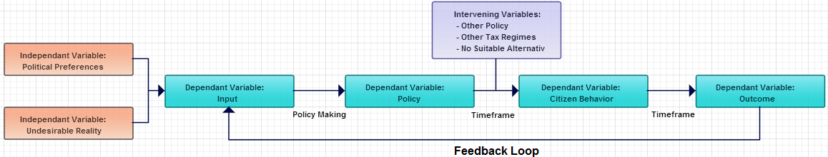

**Description**

The conceptual model starts at the dependent variable [DV] "*Input*". Certain input (like problems and support) leads to the adoption of policy. This can be caused by the independent variable [IV] "*Political Preferences*" and/or "*Undesirable Reality*" (perceived problems). Policy gets created from certain input. This is reflected by the arrow "*Policy Making*" from the DV "*Input*" to the DV "*Policy*". The DV "Policy" consists of intentions, choices, measures and actions. It aims at attaining certain goals and the steering of citizens' behavior by using policy instruments. The arrow from the DV "*Policy*" to the DV "*Citizen Behavior*" displays the first part of the time frame of policy. This time frame can be shorter, equal or longer than the intended timeframe. During this timeframe, the policy and its instruments are in operation. The DV "*Citizen Behavior*" is the behavior of citizens which results from implemented instruments. This behavior can be influenced by intervening variables [IV]. Examples of intervening variables are other policies in effect, other tax regimes citizens can use and the availability of suitable alternatives to the unwelcome behavior on which taxes are levied. Citizen behavior leads to an outcome. This is reflected by the arrow from the DP "*Citizen Behavior*" to the DV "*Outcome*". This arrow is the second part of the timeframe which can be shorter, equal or longer than the intended timeframe. The DV "*Outcome*" reflects reality after policy has been implemented and a certain timeframe has passed. The circularity of this model is reflected by the arrow from the DV "*Outcome*" to the DP "*Input*". The circularity is based on the idea that an unintended and unacceptable situation caused by one policy can become the input for a new policy in addition to other input as described earlier. This conceptual model, the policy cycle, will be specified in chapter 3 to better fit the practical situation of the case.

**Chapter 2 - Methodological Framework**

**Introduction**

In this chapter, the methodological aspects of this thesis will be explained. The first paragraph will contain a thoroughly described case selection. The second paragraph contains an introduction and approach on evaluative research. Insights from multiple authors are used to create an evaluative approach. All methodological choices regarding evaluative research and case studies are derived from the work of multiple authors. The quality, validity and reliability aspects of this thesis will be discussed afterwards. Finally, to be able to use the theoretical and methodological framework, certain concepts need to be defined. These concepts are listed and defined in the last paragraph of this chapter. All other concepts that have been defined in the theoretical framework or will be defined beforehand in the methodological framework will also be displayed to offer the reader a clear picture of the framework that will be used.

**§ 1 Case Selection**

**§ 1.1 - Reasons for a case study**

This thesis will conduct a case study of Dutch policy on the possession and use of cars. The choice for a case study has been considered and based on Swanborn (2008:22) who argues a case study is best used to study a certain phenomenon in its natural surroundings, over a certain period of time, using data from various sources, where a detailed description is desirable and where this detailed description is compared to a description given by involved subjects themselves. All of these points are relevant for this thesis. Policy is being evaluated in society, multiple measurements in time will be used, information and statistical data from various sources will be used and a detailed description will be given. The final point, comparing the detailed description with one given by subjects themselves, should be read as the comparison of the effects of policy with the intended effects of policy. No individuals are consulted for in this thesis. Swanborn (2008:38) further argues that the most important reason to choose for a case study is the detailed information a case study has to offer. Various other arguments in favor of a case study are about the relation between individuals in a certain context. These are not relevant for this thesis.

Swanborn (2008:44) also offers negative aspects of case studies. It is possible that a certain subject cannot be isolated from its context, cannot be observed continuously or can only occur rarely. For this thesis, these negative aspects are irrelevant. The subject, Dutch policy on the possession and use of cars can be isolated and investigated, can be observed as it has been in effect for years and continuously affects society with its rules and regulations.

**§ 1.2 - Case selection**

Policy on the possession and use of automobiles is the type of policy being researched in this thesis. In general, countries have nation-wide tax regimes on automobiles. Therefore, case selection consists of picking a country for evaluation. For this study, the Netherlands has been selected for describing policy, policy evaluation and comparison. It is a so called *extreme case*: high taxation and no policy adaptation despite clear unwelcome side effects.

**Case: Dutch tax policy on purchase, possession and use of automobiles in the Netherlands**

This case has been chosen because its frequent policy and tax regime changes regarding automobiles inspired the author to start this study. Looking at the frequency of policy changes, one would expect to find modern active policy making where results from evaluative research are used to modify existing policy. It is worthwhile to find out of this is the case. Second, taxation on cars in the Netherlands can be considered to be extremely high. One could argue that renewing the fleet of a country by using favorable opportunities is important to ensure cars are equipped with the latest technology to ensure fuel efficiency and preservation of the environment. It is therefore interesting to research the effects of the Dutch tax regime on the fleet of cars. Moreover, the author has personal experience with tax avoidance by using multiple tax regimes but has no quantified data. As this thesis will investigate the functioning of taxation, an extreme case is suitable.

Third, the choice of Dutch policy on the possession and use of cars has been based on what Swanborn (2008,59) calls "*pragmatic grounds*". The desire of the author to research this subject for his Master Thesis was the most important argument. Van Thiel (2007:103) also notes that the access or knowledge of a researcher regarding a certain subject can also be a pragmatic reason for a certain subject. This applies to this thesis as well. The author has followed developments on policy regarding the possession and use of cars for the past 5 years. In addition, many relevant documents and statistical data is readily available on Dutch taxation policy of cars. The central government, statistical agencies, interest groups and other independent groups all publish reports on taxation and legislation on the one hand and the developments of the Dutch fleet on the other hand. This allows a policy analysis to be combined with an analysis on effectiveness.

Finally, the Dutch case can be considered to be very homogenous. There are only slight differences between different provinces and only a few cities have begun to tinker with policy on cars more extensive than parking policy. In other countries taxation may differ per state or cities can decide themselves on environmental issues making a case heterogeneous and making it difficult to compare regions.

It is necessary to clarify what policy will be used for analysis. This thesis will focus on national taxation policy regarding the purchase of a car, the possession of a car and fuel pricing. All policies must also be universal. Specific policies that, for example, only apply to businesses will not be used. In addition, only policy for regular cars will be used. Taxation policy regarding large industrial vehicles and/or trucks will not be used. It is, however, possible that regular policy also affects businesses as businesses often offer employees a regular car for their activities. This is not an issue.

**§ 2 Conducting Evaluative Research**

**§ 2.1 - Evaluating Step by Step**

This paragraph will describe a step by step plan of evaluation. This plan is partly based on Bressers’ (2008:166) step by step guide on evaluative research. The choice for a case study and demarcation criteria on policy can be found in paragraph 1 of this chapter. The demarcation of concepts belonging to evaluative research methodology is as follows:

**Demarcating Research Methodology**

- Evaluative research based on a case study design of Dutch tax policy on the purchase, possession and use of cars

- Criteria of evaluation: policy effectiveness, policy integration, measured intended effects, measured unintended effects and desirability of measured effects.

- Evaluating by using a time-series analysis

The criteria of evaluation will now be elaborated.

*Evaluative Concepts: Effectiveness & Policy Integration*

Bekkers (2007:58) distinguishes between effectiveness, efficiency and policy integration. He considers effectiveness to be the degree to which certain measures have led to the desired situation. Effective policy is therefore policy that was able to bring about the intended effects. Bekkers (2007:301) notes that one has to look at the whole picture in a given situation when evaluating policy to ensure a proper judgment on a certain policy is given. It is, for example, possible that intended goals are attained but that no causal relation exist with a certain policy instrument or that effects from other measures appear to have the desired effect. Efficiency, Bekkers (2007:58) argues, deals with the costs of success. Efficient policy is policy with which intended goals are attained with little costs or effort. Finally, policy integration is the degree to which there are no conflicting goals or objectives within a certain policy or set of policies. It is also important that policy instruments do not conflict with each other or negate each others' effects (Bekkers, 2007:58).

*Evaluative Concepts: Measured (Un)Intended Effects & Desirability of Measured Effects*

Due to the controversy and struggles around fiscal policy on the possession and use of cars in the Netherlands, the following additional evaluative criteria will be used in this thesis:

*Measured intended effects:*

Measured intended effects are measured effects of policy which were also intended.

*Measured unintended effects:*

Measured unintended effects are measured effects of policy which were unintended

*Desirability of measured effects:*

Desirable measured effects are effects caused by policy which can be considered desirable. Both intended and unintended effects can be desirable. Desirability depends on intentions, targets and goals.

With these three additional criteria, a thorough policy evaluation will take place. Regarding the third criteria, the time-series analysis, the change of the Dutch fleet of cars over approximately 14 years will be researched. The “*fleet*” can be considered the dependant variable influenced by policy (if this causal relation exists!).

To conduct the evaluative research, a case description will be written followed by an analysis. This will take place as follows:

**Case Description & Analysis**

Bressers (2008:166) describes how the policy field and policy theory needs to be adequately described. He considers the policy theory to be the combination of all assumptions on which a policy is based. It shows similarity with the definition of Bekkers (2007:305) given earlier in this chapter. However, to offer clarity, policy field and policy theory will be clearly defined as:

Policy Field:

"*All policies in effect regarding a certain subject.*"

Policy Theory:

"*The general assumption on which a policy is based.*"

Policy itself has been clearly defined in the theoretical framework which can be found in chapter 1.

For this thesis, the policy field and policies regarding the purchase, possession and use of cars in the Netherlands can be derived from chapter three which contains the case description. The policy field consists of all policies described in chapter three. The policy theory will be based on the goals and instruments used per policy and will be described in the analysis of each policy. When one knows how a certain policy works, what instruments are used and what goals policy makers want to achieve, it is possible to derive general assumptions surrounding that policy.

To be able to conduct evaluative research in this thesis, knowledge on the desired situation and relevant hypotheses are necessary. The desired situation will be clearly stated in the third chapter containing the case description by explicitly mentioning policy goals per policy. This desired situation is based on statements from official documents and other sources in which government officials state desired targets. However, as some policy has been in effect for decades, it is possible that what was desirable originally can no longer be found or is no longer relevant. In this case, the most plausible desired situation will be described as a policy goal. Relevant hypotheses will be introduced in the third chapter by combining the general hypothesis from the theoretical framework with the practical information on the Dutch case found in chapter three.

After introducing the case and relevant hypothesis in the third chapter, the analysis will be described in the fourth chapter. It will typify policy and policy instruments per policy according to the concepts of the theoretical framework. In addition, elaboration on the way the government tries to steer behavior is described as well. After these descriptions, the actual evaluation of effectiveness takes place by combining multiple data sources and by looking at measured effects and their desirability. Relevant data and historical developments are compared with the policies from the case descriptions and the desired situation. Regarding the policy integration of the policy field and the use of fiscal instruments, the final paragraph of the analysis is devoted to an elaboration on policy integration of all policies and the use of fiscal instruments.

Bressers (2008:171) explains how the final step in evaluative research consists of rounding up and a report of the results. Bressers (2008:172) makes a special note of the double nature of evaluative research. On the one hand, it is scientific research, on the other hand, it is also an element in the policy cycle itself. For this thesis however, it is solely an academic research. Any remarks or reflection on the evaluative research for this thesis, will be added to the conclusion. The conclusion is used to round up the evaluative research of this thesis and to report the results.

**§** **3 Quality, Validity & Reliability**

**§ 3.1 - Guarding Internal & External Validity**

Regarding the introduction and description of the case, official documents are used and an objective description is given. No assumptions or conclusions will stem from introducing the case. Therefore, internal and external validity does not play a role in the ex ante analysis. However, in the ex post analysis, policy is evaluated by comparing an intended situation with an actual situation. Therefore, internal and external validity play an important role during the ex post analysis. To guarantee proper validity for this study, only existing statistical data and information from official sources will be used. Examples are statistics offered by governmental organizations and documents from reputable organizations. Measurements will not lead to new data. Therefore, the measurement in this study does not consists of measuring something new but comparing an intended situation or trend with an actual situation or trend based on existing published data. The internal validity is therefore covered. The external validity is safeguarded as country-wide policy and statistics are used so assumptions and conclusions automatically cover the entire possible area.

**§ 3.2 - Guarding Reliability**

The reliability of this research is safeguarded by using official or scientifically sound documents combined with objective statistical data. As these documents and data already exist, measuring a certain variable twice should always lead to the same result. As policies are analyzed using documents containing text, the interpretation of the reader does play a role. Therefore, when describing and comparing policies, it is possible that different researchers would give somewhat different explanations. Inter-rater reliability (Boeije, 2008:152) is therefore not 100% sound. However, if documents are clear about the goals of a certain policy, the inter-rater reliability does not necessarily lead to a disturbance as the effectiveness is measured with hard, sometimes statistical, data. It would only mean the introductory chapter would look somewhat different.

**§ 3.3 Additional Quality Enhancement**

Boeije (2008:148) elaborates on three different visions on research quality. Two of them will not be explained in detail as they are not relevant for this thesis. One of these visions sees proper research as objective as possible with a strong emphasis on validity and reliability. In addition, the researcher himself should state his personal opinion and theoretical perspective on a certain subject. This allows readers to judge for themselves in what way the position of the researcher influences his research. This method has been used in this thesis. The theoretical framework from the first chapter is the theoretical perspective of this thesis. The author has no additional opinion. An opinion on this subject will be formed after the policy evaluation has been thoroughly described in the fourth chapter.

**§ 3.4 Sources & Analysis**

For this thesis, primary and secondary research material will be used. As described earlier in this paragraph, triangulation will be applied. All gathered data will be thoroughly analyzed for relevant information on the subject. This means facts will be derived from existing primary and secondary sources and the policy field will be reconstructed according to these data sources. This thesis also applies a small META-analysis if existing sources are research projects that have been finished in the past.

**Chapter 3 – Dutch taxation on possession and use of cars**

**Introduction**

This chapter contains of a case description on Dutch policy on the possession and use of cars. Existing policy and policies in effect during the past 10 years will be described. A description will consist of the functioning of policy, the reasons why a policy was adopted and the policy goals. If no explicit relevant reasons for adoption or policy goals exist, a description on the possible reasons or goals will be given. The first paragraph of this chapter will deal with policy regarding the purchase of a car. The second paragraph of this chapter will deal with policy regarding the possession and use of a car. The third paragraph of this chapter contains statistics and other data that show the development of the Dutch fleet from 2000 until 2014. Based on all the empirical data, the fourth paragraph will contain the conceptual model adapted to the practical situation. Finally, the fifth paragraph of this chapter will contain the combination of the theoretical hypotheses from chapter one with the practical knowledge from this chapter into multiple testable hypotheses.

**§ 1 General taxation on buying a car**

**§ 1.1 - VAT**

The current Dutch VAT system has been introduced in 01-01-1969. The latest adjustment was on 01-10-2012 increasing VAT from 19% to 21% on non-essential goods. This means that individuals who purchase a car need to pay 21% VAT. Companies that buy a car but use it for company purposes only will have amount of VAT returned to them. However, VAT will have to be paid afterwards if the car is sold to a non-company owner. As VAT is levied on almost all products as taxation for general purposes, no extra elaboration regarding VAT and cars is necessary. VAT is used to generate sufficient tax revenues for the government. Therefore, the following policy goal is relevant:

Policy Goal:

"*Generate substantial tax revenues for the Dutch government.*"

**§ 1.2 - Old BPM Policy**

The old BPM policy [Belasting Personenauto's & Motorrijwielen] was a tax policy in effect from 1-1-1992 until 31-1-2008. BPM Tax was levied on new cars as they were registered after a sale using a fixed percentage of 45,2%. Since a percentage was used, the total BPM per car was proportional with the purchase price of the car. The amount of BPM for a specific car was reduced with an absolute number depending on the fuel type of the car. Buyers of a car with a petrol engine could subtract €1540. For a car with a diesel engine, €328 could be subtracted.

The following example shows how the BPM tax worked:

Brand new petrol car priced at €50.000 (excluding VAT)

( €50.000 / 100 ) * 45,2 = €22.600

€22.600 - €1540 = €21.060

Total amount of BPM liability: €21.060

If a car was imported from another country, an amount of BPM had to be paid based on a BPM write-off table or the actual market value of the car which depends on the age, mileage, condition and various other aspects of the car.

**Policy Usage: BPM-old**

The old BPM was used to generate revenue for the central government. No specific policy documents on the old BPM have been found. It came into effect on 1-1-1992. The actual judicial foundation only states that it is desirable to differentiate taxation on cars based on environmental aspects and fuel aspects (Overheid.nl, 2014). The old BPM however, only slightly differentiates on fuel aspects. The following policy goal is therefore relevant:

Policy Goal:

"*Generate substantial tax revenues for the Dutch government.*"

**§** **1.3 - BPM Abolishment policy & Gas Guzzler Tax, the new BPM**

Starting at 1-2-2008, the BPM was slowly phased out in favor of a combination between a fixed amount and modular amount of taxes based on cars' CO2 emissions. This modular part was called the gas guzzler tax. Up to 1-1-2013, the BPM percentage has decreased from 45,2% to 0%. As the BPM percentage decreased, the CO2 emission of a car became the deciding factor for extra taxation. As of 1-1-2013, extra taxation on top of the VAT is a combination of the new gas guzzler tax and the old BPM tax (ANWB, 2009:1). The name "BPM" however, is still used for this combined tax policy.

As the BPM was phased out over the course of 5 years, the gas guzzler tax was implemented step by step. At its introduction on February 2008, it worked as follows (ANWB, 2009:1), (ANWB, 2013:3):

Petrol bought after 1-2-2008:

Free of gas guzzler tax up to 232 grams of CO2 per kilometer after which €110 needs to be paid for each gram of CO2 per kilometer.

Petrol bought after 1-1-2009

Free of gas guzzler tax up to 212 grams of CO2 per kilometer after which €125 needs to be paid for each gram of CO2 per kilometer.

Diesel bought after 1-2-2008:

Free of gas guzzler tax up to 192 grams of CO2 per kilometer after which €110 needs to be paid for each gram of CO2 per kilometer.

Diesel bought after 1-1-2009:

Free of gas guzzler tax up to 176 grams of CO2 per kilometer after which €125 needs to be paid for each gram of CO2 per kilometer.

The following table shows how the new BPM, which consists of the gas guzzler tax and old BPM system, works:

Table 1: Emission Table



*Source:http://www.belastingdienst.nl/wps/wcm/connect/bldcontentnl/belastingdienst/prive/auto_en_vervoer/belastingen_op_auto_en_motor/belasting_van_personenautos_en_motorrijwielen_bpm/bereken_de_bpm/bereken_de_bpm_voor_een_personenauto*

A car its CO2 emission falls in any of the categories on the left. The fixed amount of tax levied it shown under "*Fixed amount*". The additional variable tax levied is shown under "*Variable amount*" and based on each gram of CO2 per kilometer in a certain emission category.

*Example:*

A new car with a CO2 emission of 160 grams per kilometer falls in the third category. The buyer needs to pay € 3.780 as shown under fixed amount. The buyer has to pay an additional (160-125*126=) € 4.410 due to the exact height of the emission in the category. The total amount of CO2 tax levied is the sum of the fixed and variable amount resulting in (3780+4410=) € 8190.

The fixed amount of the CO2 emission tax is what remains of the old BPM policy. Extra taxation on top of VAT for certain cars (under 124 g/km CO2 emission) has been completely abolished.

**Policy Usage: New BPM**

The European Parliament has spoken against the old BPM policy on multiple occasions (Reformatorisch Dagblad, 2006). It would hinder the integration of European tax regimes. The European Parliament wanted countries to introduce a tax policy that would base taxation on the CO2 emission of a car. The new BPM is the Dutch answer to European demands. Its goal is to stimulate the sale of cars with low CO2 emissions and ensure the sale of cars with high CO2 emissions is less attractive. Therefore, the following policy goals are in effect:

Policy Goal 1:

*"Generate substantial tax revenues for the Dutch government."*

Policy Goal 1:

*"Making the purchase of cars with low CO2 emissions more attractive."*

Policy Goal 2:

*"Making the purchase of cars with high CO2 emissions less attractive."*

**§ 2 General taxation on the possession of a car**

**§ 2.1 - Taxation on the possession of a car**

The current policy applies to cars under the age of 25 and produced at 1-1-1988 or later. Policy on cars above 25 years of age and produced before 1-1-1988 will be described in the next paragraph. The general taxation is a fixed tariff which depends on the following variables:

- Fuel type

- Weight

- Province the car is registered in

- CO2 emission of the car

Taxation on the possession of cars has been in effect since 1926. The current system is in effect since June 2012. Road taxes do not apply on cars that produce under 50 grams of CO2 per kilometer. This ruling is in effect until 1-1-2016. This is why the CO2 emission is relevant (ANWB, 2013:1). The province the car is registered in is important as the general road tax actually consists of 2 tariffs. On the one hand a fixed tariff for the national government. On the other hand, a fixed tariff for the province the car is registered in. Provinces can adjust this tariff themselves which leads to the situation that a car can be cheaper to possess in one province compared to other provinces. The weight in kilograms and fuel type is used to determine the exact tariff. A heavier car costs more than a lighter car and the tariff increases further if the car runs on Diesel or LPG. This may sound unfair but the cheaper Diesel and LPG prices compensate for this effect. Cars that run on LPG have another distinction in road taxes as cars that run on a so called "*Generation 3 Installation*" pay less than cars on an older LPG Installation. The following table shows the weight increments for cars:

Table 2: Weight Increments

|  |  |
| --- | --- |
| **0-550** | **1351-1450** |
| **551-650** | **1451-1550** |
| **651-750** | **1551-1650** |
| **751-850** | **1651-1750** |
| **851-950** | **1751-1850** |
| **951-1050** | **1851-1950** |
| **1051-1150** | **1951-2050** |
| **1151-1250** | **2051-2150** |
| **1251-1350** | **2151-2250** |

*Adapted from: http://www.belastingdienst.nl/rekenhulpen/motorrijtuigenbelasting/*

This table continues with increments of 100 kilograms to up to 5050 kilograms and does not increase in a linear way. The following 2 examples show the difference between provinces, weight increments, Petrol, LPG and Diesel fueled cars.

*Example 1:*

A Petrol, LPG and Diesel car of 1450 kilograms in the province of Gerderland & Noord-Brabant:

Table 3: Petrol, LPG and Diesel



*Adapted from: http://www.belastingdienst.nl/rekenhulpen/motorrijtuigenbelasting/*

*Example 2:*

A petrol car of 1025 kilograms compared to a petrol car of 2050 kilograms in the same province.

Table 4: Petrol, Different Weight



*Adapted from: http://www.belastingdienst.nl/rekenhulpen/motorrijtuigenbelasting/*

This table shows an increase in weight of 100%. Taxation increases with more than 100%. 229%[1] to be exact.

**Taxation on possession on cars with low emissions**

Since 2008, the government has made some exceptions on the general taxation on the possession of cars. Taxes on possession were decreased or abolished on cars with a CO2 emission under 110 grams (if petrol, LPG, hybrid) or 96 grams (diesel). The following table shows the taxation on the possession of cars with low emissions introduced in 2008:

Table 5: Taxation on the possession of cars with low emissions



Adapted from: Traa, Geilenkirchen & Hilbers (2014:80)

The table shows how the discount percentage increased to a full pardon from taxation on possession. This policy was abolished in 2014. Only cars with a CO2 emission of 50 grams per kilometer or less are still pardoned from taxation on possession until 2015.

**Policy Usage: Taxation on possession of cars**

Tax revenues from the possession of cars go to the central government and the 12 provinces of the Netherlands. These revenues are not automatically allocated for certain purposes but are considered to be general revenues which can be used for any type of government expenditure. No comprehensive policy documents exist on policy regarding the possession of cars. It is part of the general tax policy in the Netherlands. However, as CO2 emissions are involved, the following policy goals will be considered to be in effect:

Policy Goal 1:

*"Generate substantial tax revenues for the Dutch government."*

Policy Goal 2:

*"Steer citizen behavior to purchasing and possessing cars with low CO2 emissions."*

**§ 2.2 - Taxation on possession of older cars:**

*Taxation on possession of older cars up to 31-12-2013*

Up to 31-12-2013, car owners need not pay any road taxes if their car was 25 years of age or older. These cars were considered old-timers which would only be used for rare leisure activities. Basically, the system was as follows:

- Is the car less than 25 years of age? Road taxes apply.

- Is the car 25 years of age or older? No road taxes apply.

*Taxation on possession of older cars from 1-1-2014*

Starting at January 1 2014, car owners need not pay any road taxes if their car is 40 years of age. These cars are considered old-timers which will only be used for rare leisure activities. This policy contains an extra clause for cars produced before 1-1-1988 that aren't 40 years of age (Rijksoverheid, 2014). These cars can be treated as any other regular car and driven throughout the year. Owners can also opt to pay a certain tariff with a maximum of 120 euro to be able to drive their car for 9 months. The months December, January and February are excluded. This clause was created to provide car owners with a semi-old-timer option as they had already invested in their older car before the policy was announced and implemented. Diesel and LPG cars are excluded from this clause and can only become road tax free after they reach the age of 40 (Rijksoverheid, 2014). When comparing this newly adopted policy to the old situation, the following general rules apply:

- Is the car less than 25 years of age? Road taxes apply.

- Is the car 40 years of age or older? No road taxes apply.

- Is the car older than 1-1-1988 but not 40 years of age and does it not possess a Diesel engine or LPG installation? Owners can opt to drive their cars for a reduced tariff for 9 months.

**Policy Usage: Taxation on possession of older cars**

The government adopted a new policy on old-timers and older cars because the old policy became unfair. Many cars produced in the eighties could be driven without having to pay road taxes. These cars were often of good enough quality to last decades. Owners would go for a Diesel or LPG model to save on fuel costs as well. As these owners would continuously drive their cars throughout the year, they avoided general road taxes. This was considered to be unfair compared to citizens driving regular cars that are under 25 years of age. The newly adopted policy contains a clause for petrol cars between 25 and 40 years of age to compensate honest collectors of older cars. Diesel and LPG cars are excluded as these are usually used to drive large mileages. On top of that, older cars in general pollute more than younger cars. If citizens would continue to drive their older car because of a lenient tax regime, it would be more hazardous to the environment. With this newly adopted policy, the government wants to restore fairness regarding road taxes while making the possession and use of a hobby-car affordable. In addition, the government aims to reduce hazardous emissions by making the option of continuous driving under a lenient tax regime impossible. The following policy goals are in effect:

Policy Goal 1:

*"Offer citizens fair policy on the use of hobby cars."*

Policy Goal 2:

*"Restore fairness for citizens."*

Policy Goal 3:

*"Reduce the attractiveness of older, more hazardous, cars."*

**§ 2.3 - Fuel Price & Fuel Taxes**

Aside from regular policy on the purchase, possession and use of cars, the government also levies multiple taxes on fuel. The final fuel price consists of the following multiple variables:

*1. Production*

Production reflects the costs of the refining process. Crude oil is refined into gasoline and diesel. For LPG, other fossil fuels are used. This part of the fuel price is influenced by the international price of oil and natural gas (UnitedConsumers, 2014).

*2. Vendor Margin*

The vendor margin is the percentage of the fuel price that goes to multiple parties involved in the fuel supply chain. Examples are oil companies, transportation companies and owners of gas stations (UnitedConsumers, 2014).

*3. Fuel Tax*

Fuel tax is levied on fuel. It is a fixed amount which is adjusted yearly by the Dutch government. In 2014, the following fuel taxes are levied for gasoline, diesel and LPG:

Table 6: 2014 Fuel Tax



*Adapted from: http://www.unitedconsumers.com/tanken/informatie/opbouw-benzineprijs.asp*

*4. VAT*

Value added tax as levied on almost all products in a country. The VAT on fuel is 21%.

As of 2014, the fuel price for gasoline (95), diesel and LPG consists of the following percentages for each variable:

Table 7: 2014 Fuel Pricing



*Adapted from: http://www.unitedconsumers.com/tanken/informatie/opbouw-benzineprijs.asp*

The percentages shown in table 6 display the percentage of a certain variable of the total fuel price. Although VAT on fuel is 21%, 17% of the actual fuel price consists of VAT. It should be noted that VAT is levied over the fuel tax. So basically, Dutch citizens pay tax over tax. The following graph shows the development of the fuel price from 2000 up to 2013:

Graph 1: Fuel Price Development

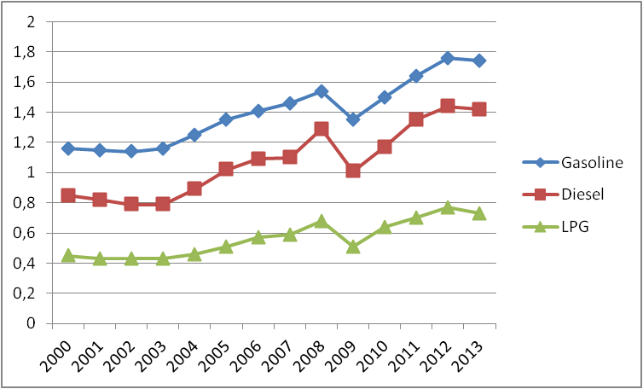

*Adapted from: CBS Statline 2014 (http://statline.cbs.nl/StatWeb/selection/default.aspx?VW=T&DM=SLNL&PA=80416NED&D1=a&D2=(l-30)-l&HDR=T&STB=G1)*

The graph clearly shows an increase of fuel prices. A short dip can be seen in the year of 2008. This is probably caused by the world economic crisis which followed the credit crunch of 2007. This graph is based on Appendix X which shows the development of fuel prices in the Netherlands from 2000 up to 2013 in numbers. The following table shows the development of fuel prices in percentages:

Table 8: Percentual Fuel Price Increase



*Adapted from: CBS Statline 2014*

*(http://statline.cbs.nl/StatWeb/selection/default.aspx?VW=T&DM=SLNL&PA=80416NED&D1=a&D2=(l-30)-l&HDR=T&STB=G1)*

Per year and fuel type, the columns show the percentual increase when compared to the previous year. The second column per fuel type shows the yearly percentual increase when compared with 2000. Table 7 clearly shows that the price of gasoline increased with 50% in 13 years, the price of diesel increased with 67,07% in 13 years and the price of LPG increased with 62,22% in 13 years.

**Policy Usage: Fuel Taxes**

The Dutch government uses fuel taxes and VAT to generate enough financial resources for the government budget. In general, fuel tax can also be used as a way to make the use of a car less interesting for citizens as costs increase. Only a small part of fuel taxes is automatically allocated to the construction and maintenance of roads, public transport and waterways since 2003 (CDA, VVD & D66, 2003:13). Although fuel taxes are a policy, no comprehensive documents exist. Fuel taxes are part of the general tax system. As they are used to generate income for the government and to steer people away from using cars, the following policy goals will be considered to be in effect:

Policy Goal 1:

*"Generate substantial tax revenues for the Dutch government."*

Policy Goal 2:

*"Reduce the use of cars and steer people towards alternatives for mobility."*

**§ 3 Statistics on the Dutch Fleet**

Aside from the descriptions of relevant policy, this paragraph will show actual data on the Dutch fleet of cars up to 2014. First, the development of the number of registered cars will be displayed in the following graph:

Graph 2: Number of registered cars

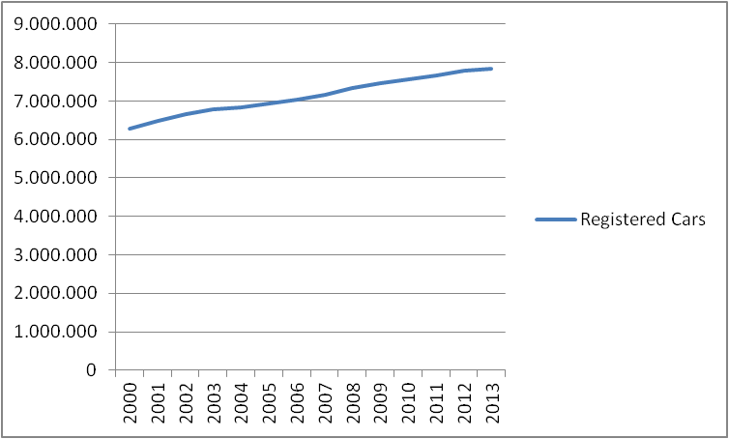

*Adapted from: CBS Statline 2014*

*(http://statline.cbs.nl/StatWeb/selection/default.aspx?VW=T&DM=SLNL&PA=70071ned&D1=0%2c3-8%2c12%2c39-45%2c665-671&D2=a&D3=0%2cl&HDR=T&STB=G1%2cG2)*

The graph clearly shows an increase in registered cars from 2000 to 2013. The number of registered cars increased from 6.285.504 to 7.847.602 which is an increase of 24,9%.

Second, the development of the mileage in kilometers in millions of Dutch citizens will be displayed:

Graph 3: Total Mileage x million kilometers

*Adapted from: CBS Statline*

(http://statline.cbs.nl/StatWeb/publication/?DM=SLNL&PA=80428ned&D1=0-9&D2=a&D3=a&D4=0&D5=18-22&VW=T)

Graph 3 clearly shows a continuous increase in the total mileage driven in the Netherlands.

The sale of new cars is also an important piece of information. The following graph shows the total sales of new cars from 1997 to 2013:

Graph 4: Sale of brand new cars by year

*Adapted from: CBS Statline*

(http://statline.cbs.nl/StatWeb/publication/?DM=SLNL&PA=37803hvv&D1=0-170&D2=(l-20)-l&VW=T)

Graph 4 clearly shows declining sales starting at 2000. The sale of brand new cars took a nose dive at 2008. This was probably caused by the world economic crisis following the credit crunch of 2007. Although sales rose in 2010 and 2011, they declined again in 2012 and never reached the level of 1999.

**§ 4 Adapting the conceptual model**

The conceptual model introduced in the theoretical framework can now be adapted to fit with the practical nature of the case description. The following image shows the adapted conceptual model:

**Image 1: Adapted conceptual model**

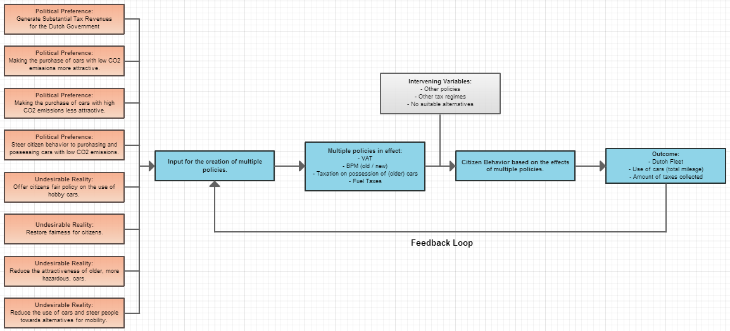

**Description:**

The model starts with multiple political preferences and reactions against undesirable realities. These ultimately form the policy goals. The difference between political preferences and undesirable reality is that a political preference focuses on desirable changes for a "*better*" future while the undesirable reality is based on the past. There can be some overlap between the two. Policy is created based on these political preferences and undesirable realities and any feedback from previous policy supplied by the feedback loop. This has lead to the multiple policies described in this chapter. These policies and intervening variables lead to certain citizen behavior. This citizen behavior leads to changes in the Dutch fleet, the use of cars and the amount of tax revenues collected by the Dutch government. For now, the intervening variables remain the same variables as used in image 1 (see chapter 1) as no intervening variables have been found yet.

The model can also be changed to reflect a single policy. The fuel taxes are used as an example below:

**Image 2: Conceptual model on fuel taxes**

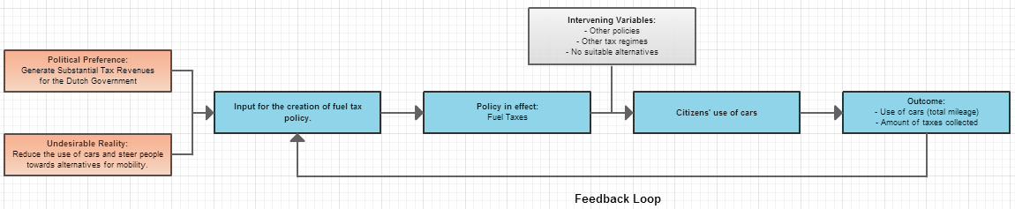

In this case, the need for tax revenues and the use of cars by Dutch citizens have lead to certain fuel tax policy. This policy influences (assumed!) citizens' use of cars which leads to a certain annual mileage driven by all citizens and a certain amount of tax revenues collected. Again, as no intervening variables are known, the same variables as used in image 1 (see chapter 1) are used. If fuel is a very inelastic good, the outcome will not reflect a substantial decrease in mileage over time and the feedback loop will report the inelastic property of fuel.

In the analysis, a final conceptual model will be presented based on the results of the analysis.

**§ 5 Testable Hypothesis**

**§ 5.1 - Irrelevant Theoretical Hypotheses**

Of the eight hypotheses introduced in the first chapter, hypothesis 1, 4 and 6 are irrelevant. The first hypothesis is irrelevant as this thesis does not analyze the legitimacy of policy or the arguments used. The fourth hypothesis is irrelevant as it appears that no communicative instruments are used. The sixth hypothesis is irrelevant as political and/or ethical preferences are not analyzed in this thesis. This means that hypothesis 2, 3, 5, 7 and 8 remain relevant.

**§ 5.2 - Combining relevant hypotheses with practical data**

To create testable hypotheses, the relevant hypotheses from the theoretical framework are combined with the policy goals described in this chapter. This leads to the following practical hypotheses:

**Hypotheses on the old BPM**

Hypothesis 1:

*"Substantial tax revenues were generated due to the old BPM."*

This hypothesis is based on theoretical hypothesis 5 on elasticity and the policy goal of the old BPM.

**Hypotheses on the new BPM**

Hypothesis 1:

*"Substantial tax revenues are generated due to the new BPM."*

Hypothesis 2:

*"The new BPM successfully steers citizens towards the purchase of cars with low CO2 emissions."*

Hypothesis 3:

*"The new BPM successfully steers citizens away from the purchase of cars with high CO2 emissions."*

These hypotheses are based on theoretical hypotheses 3, 5 and 7 on the one hand and the policy goals of the new BPM on the other hand.

**Hypotheses on taxation policy regarding the possession of cars**

Hypothesis 1:

*"Substantial tax revenues are generated due the taxation of possession of cars."*

Hypothesis 2:

*"Taxation on possession of cars succesfully steers citizens towards the purchase of cars with low CO2 emissions."*

These hypotheses are based on theoretical hypotheses 5 and 7 on the one hand and the policy goals of taxation on the possession of cars on the other hand.

**Hypotheses on taxation policy regarding the possession of older cars**

Hypothesis 1:

*"The revision of 2013 regarding the taxation of possessing an older car has successfully reduced the attractiveness of older, more hazardous cars."*

This hypothesis is based on theoretical hypotheses 5 and 7 on the one hand and the policy goals of taxation on the possession of older cars on the other hand.

**Hypotheses on fuel taxes**

Hypothesis 1:

"*Substantial tax revenues are generated due to fuel taxes.*"

Hypothesis 2:

"*Fuel taxes fail to reduce the use of cars and steer people towards alternatives for mobility.*"

These hypotheses are based on theoretical hypotheses 2, 5, 7 and 8 on the one hand and the policy goals of fuel taxes on the other hand.

No hypotheses on VAT are formed as VAT is not specific to this case. It is only involved as VAT is always involved when new goods are sold for the first time.

**Chapter 4 – Policy Analysis**

**Introduction**

In this chapter, Dutch policy described in chapter four will be analyzed. The first paragraph of this chapter consists of an analysis per policy based on the theoretical and methodological framework. The second paragraph of this chapter consists of a policy field analysis. The policy field consists of all policies analyzed in the first paragraph. The policy field analysis contains an elaboration on the policy integration between the analyzed policies and the use of fiscal instruments.

**§ 1 Policy Analysis**

**§ 1.1 - VAT Policy**

**Adopted:** 1969, modified in 2012

**Abolished:** N/A, ongoing

**Goal(s):**

1. Generate substantial tax revenues for the Dutch government

**Policy Theory:**

Levying taxes on all products leads to increased tax revenues as citizens need to buy products. VAT is therefore inescapable when a legit transaction takes place. Levying VAT on all products will therefore generate substantial tax revenues.

**Type of Policy: Re-distributive**

VAT can be considered to be a re-distributive policy. VAT is used to generate enough tax revenue for public spending. As the revenues from VAT are not used for a specific target, they can be used as funds for any project or policy. Re-distribution takes place by taxation on products on the one hand and distributing these funds on the other hand.

**Instruments used: Economical**

VAT can be considered to be an economical instrument as it is a financial measure increasing the cost of almost everything. It is used in a universal and restrictive way. Universal as it applies to all products and restrictive as it makes products more expensive. VAT clearly reduces the purchasing power of citizens as a country without VAT and compensating tax would make life about 21% cheaper.

**Steering:**

No intentional steering takes place. As stated before, VAT is a general means to generate tax revenues used universal. Avoiding VAT as an end-user is impossible in a legal way.

**Effectiveness:**

VAT on the price of new cars is effective if it generates substantial tax revenues for the government and if it does so over time. It is unclear what “*substantial*” is regarding VAT revenues as this is not specified. To judge the effectiveness of VAT revenues regarding cars, the sale of new cars will be used as a measure for effectiveness. The more new cars are sold, the more VAT the government collects. As VAT is not collected on used cars, the government would benefit more from citizens buying new cars. The sale of new cars has been described in the third chapter and illustrated with graph 2 which will be presented again:

Chapter 3 - Graph 4: Sale of brand new cars by year

*Adapted from: CBS Statline*

(http://statline.cbs.nl/StatWeb/publication/?DM=SLNL&PA=37803hvv&D1=0-170&D2=(l-20)-l&VW=T)

The graph clearly shows how the sale of new cars in 2013 is below the level of 1997. From 1997 to 2013, the sale of new cars has had its peaks around 1999 and 2011.

*Intended Effects*

VAT is levied on all cars sold as brand new. Graph 4 from chapter 3 clearly shows that between approximately 400.000 and 600.000 cars are sold in the Netherlands depending on the year. The intended effect is the levying of VAT on cars and with a few hundred thousand cars sold each year, this obviously takes place.

*Unintended Effects*

There are no known unintended effects resulting from the levying of VAT on brand new cars.

*Desirability of Effects*The effect of tax revenues increasing proportionally with the number of new cars sold is desirable as this is the goal of the policy.

*Success of Fiscal Instruments*

It is obvious that knowledge on the existence and functioning of VAT reaches Dutch citizens. As VAT in general has been around for centuries in some way in almost every country in the world, there is no reason to assume that Dutch citizens are not aware of VAT being levied on the price of a new car. VAT does not aim at behavioral changes and the only policy goal, generating tax revenues for the Dutch government, is attained. It is important to note that VAT is also levied on fuel. This will be described when fuel taxes are analyzed.

**§ 1.2 - Old BPM Policy**

**Adopted:** 01-01-1992

**Abolished:** Phased out since 01-02-2008

**Goal(s):**

1. Generate substantial tax revenues for the Dutch government.

**Policy Theory:**

Levying taxes on the sale of new cars leads to increased tax revenues as citizens need to buy new cars to replace aged vehicles. The BPM is therefore inescapable when a legit transaction takes place and will therefore generate substantial tax revenues.

**Type of Policy: Re-distributive**

The old BPM policy can be considered to be redistributive and de-stimulating. The redistribution aspect is the use of the old BPM to generate sufficient tax revenues for government expenditures. Revenues from the old BPM policy could be used for any government expenditure which basically means that citizens who buy new cars were paying for all kinds of government expenditures. It can also be considered de-stimulating. By substantially increasing the price of brand new cars, citizens may not be able to afford a car and may have to look at other options to provide in their needs for mobility. Public transport or used cars are alternatives.

**Instrument(s) used: Economical**

The old BPM is also a clear example of an economical instrument. The government needs tax revenues and uses an economical instrument on certain behavior to generate income. In this case it is the purchase of new cars. It is used universal as all individuals and companies were BPM liable. It is restrictive as it makes new cars more expensive which means certain groups cannot buy a new car or individuals have to buy a less expensive car than they would want to due to taxation.

**Steering:**

The old BPM policy does not contain an official goal from which the steering can be derived. Therefore, no intentional steering takes place.

**Effectiveness:**

To judge the effectiveness of the old BPM, it is necessary to look at the revenues it created between 2000 and 2008. The following graph shows the BPM revenue:

Graph 1: Total BPM Revenue x million euro’s.

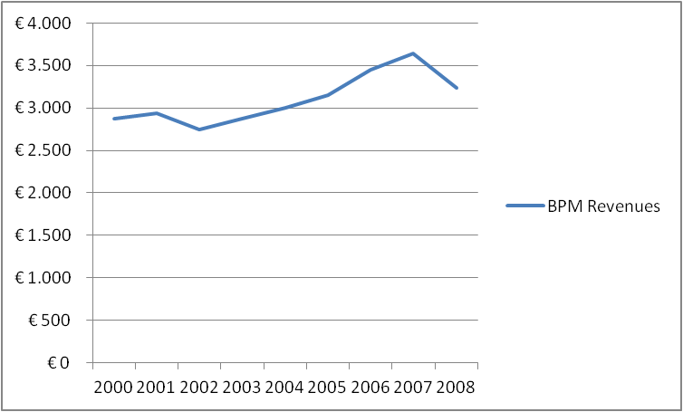

*Adapted from: CBS Statline*

(http://statline.cbs.nl/StatWeb/publication/?DM=SLNL&PA=81383ned&D1=0-2,9,14&D2=0-1,59-60&D3=23-25&VW=T)

The graph shows that the revenues from the old BPM increases over time. When graph 4 from chapter 3 presented earlier in this chapter is compared to this graph, it is obvious that, although the sale of new cars has dropped over time, the BPM revenue increases. The sharp decline after 2007 can be explained by the phasing out of the old BPM in favor of the new BPM.

*Intended Effects*

The intended effect is the generation of tax revenues. Graph 1 clearly shows these revenues are generated and have increased up to the point where the old BPM was phased out. The old BPM can therefore be considered a very effective policy for generating tax revenues.

*Unintended Effects*

There are no known unintended effects resulting from the old BPM policy.

*Desirability of Effects*

The generation of tax revenues is desirable as it is the policy goal.

*Success of Fiscal Instruments*

There are no reasons to assume that knowledge on the existence and functioning of the old BPM did not reach Dutch citizens. Any person who wants to purchase a new car will be confronted by the BPM calculation before he decides to purchase the car. The old BPM was not used to change behavior. As the old BPM was very successful in generating tax revenues, only policy goal was attained. As it is impossible to avoid BPM, it is clear that the policy goal was also attained due to the old BPM.

**§ 1.3 - New BPM Policy**

**Adopted:** 01-02-2008

**Abolished:** N/A, ongoing

**Goal(s):**

1. Generate substantial tax revenues for the Dutch government

2. Making the purchase of cars with low CO2 emissions more attractive

3. Making the purchase of cars with high CO2 emissions less attractive

**Policy Theory:**

The policy theory of the new BPM is a modification of the policy theory belonging to the old BPM. Levying taxes on the sale of new cars leads to increased tax revenues as citizens need to buy new cars to replace aged vehicles. The new BPM is therefore inescapable when a legit transaction takes place and will therefore generate substantial tax revenues. The Dutch government assumes a citizen acts as a homo economicus. The purchase of cars with low CO2 emissions is stimulated which should lead to an increase in the sale of cars with low CO2 emissions. Additionally, by de-stimulating the purchase of cars with high CO2 emissions, the sale of such cars should decrease.

**Type of Policy: Re-distributive**

Like the old BPM, the new BPM is an example of re-distributive policy. The new BPM generates tax revenues which have no set goal and can be used for any government expenditure. This is the general re-distributive aspect. In addition, the new BPM focuses taxation on cars with high CO2 emissions and creates favorable tax conditions for cars with low CO2 emissions. This means that redistribution also takes place directly as the tax barrier for citizens who want to buy a car with low CO2 emissions is now lower. The new BPM is a stimulating and de-stimulating policy for that same reason. On the one hand it encourages citizens to buy cars with low CO2 emissions by providing favorable tax rates. On the other hand, it discourages citizens to buy cars with high CO2 emissions by providing unfavorable tax rates.

**Instrument(s) used: Economical**

The new BPM is an economical instrument as it uses taxation to influence citizens’ behavior. It is universal as all individuals and business are liable for BPM. It is both restrictive and widening. Restrictive as taxation on cars with high CO2 emissions is proportionally higher when compared to cars with low CO2 emissions. It is widening because of that same reason. When compared to the old BPM policy, the new BPM policy makes cars with low CO2 emissions more affordable.

**Steering:**

The Dutch government uses the new BPM to steer citizens towards the purchase of new cars with low CO2 emissions. As the citizen is considered to act as a homo economicus, favorable and unfavorable tax rates are used to steer citizen behavior.

**Effectiveness:**

The most important dataset that would allow a judgment on the effectiveness of the new BPM is a dataset on sales of new cars divided by CO2 emissions. Sadly, the statistical bureau of the Netherlands does not have such a dataset. Other sources will therefore be used to judge the effectiveness of the new BPM. The following graphs display relevant information on the CO2 emissions of new cars and have been collected from multiple agencies:

Graph 2: Average CO2 emission of new cars since 2007

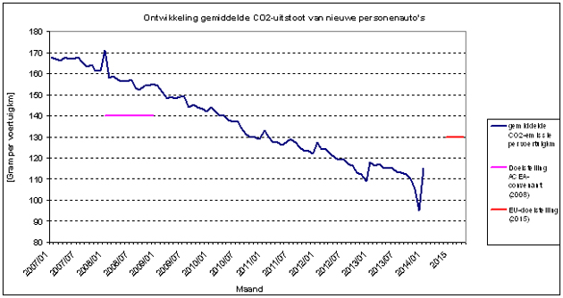

*Source: http://www.rwsleefomgeving.nl/onderwerpen/mobiliteit/monitoring-duurzame/co2-emissie/*

Graph 2 clearly shows that the average CO2 emission of new cars has continuously declined. This can be caused by innovation in the automotive industry. However, as the new BPM was introduced step by step since 2008, it can also be a clear example of the results of favorable tax rates on certain cars. The following graph can be used to clearly show that a sharper drop in the average CO2 emissions of new cars took place right before 2008:

Graph 3: Average CO2 emission of new car since 1998

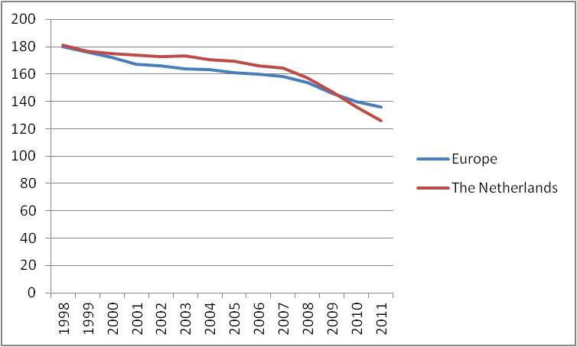

*Source: http://www.compendiumvoordeleefomgeving.nl/indicatoren/nl0134-Koolstofdioxide-emissie-per-voertuigkilometer-voor-personenauto%27s.html?i=5-20*

In accordance with the trend of the previous graph, this graph shows the average CO2 emissions from new cars over a longer period of time. It shows the trend in the Netherlands and the rest of Europe. It shows how the Netherlands used to perform worse than Europe up to 2007. Starting at 2007, the average CO2 emission of new cars in the Netherlands took a nose dive and was lower than the European average by 2009. This sharp decline shows there is more at work than just automotive innovation. The old BPM was phased out gradually in favor of the new BPM which involved a car its CO2 emissions. The nose dive observable in graph 3 went further down from 2008 and on. This explains the effect of the CO2 emission factor in the new BPM. In addition, as the new BPM starts to get expensive for cars with an average CO2 emission of 125 grams per kilometer or higher (see table 1 of chapter 3), citizens may be influenced to buy cars with an average CO2 emission of under 125 grams. Graph 3 shows that this is approximately true in 2011.

*Intended Effects*

Tax revenues are generated as new cars are sold. As shown earlier in this chapter, the sale of new cars is declining but is still consists of a few hundred thousand cars per year leading to substantial tax revenues (see graph 1 of this chapter). In addition, graph 2 and 3 introduced in this paragraph show that the average CO2 emission of new cars is declining as well. It has taken a nose dive since 2008. This too was intended by the new BPM. Another intended effect is a decline in sales of cars with high CO2 emissions. No specific data was found to prove if that did or did not happen but as the average CO2 emission of new cars are decreasing, it is likely to assume a decrease in sales of cars with high CO2 emissions constitute to this decrease.

*Unintended Effects*

One unintended effect of the new BPM has been described by Autotelex (2013). Autotelex is a company that provides services for the valuation of cars. The company has shown that there is an increase in the import of young cars. The following graph displays the increase:

Graph 4: Import increase in percentages

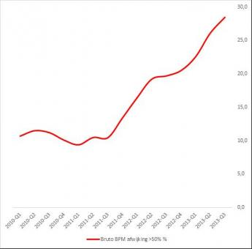

Source: http://www.autotelex.nl/autoopinie/795_Autotelex_brengt_gevolgen_BPM_heffing_bij_import_in_beeld

Graph 4 shows the import of cars rapidly increases each year. Autotelex (2013) describes that young cars are very popular as there are multiple ways to reduce the amount of BPM buyers need to pay. Although BPM is levied on new cars in the Netherlands only, it is also levied on used cars if the used car is imported from another country. However, due to cars naturally writing-off their value over the years as many other products, the exact amount of BPM is calculated in a different way and multiple variables such as age, mileage, value and damage are incorporated for imported cars. The result is that an imported car of a certain age with a certain mileage can be cheaper than that exact same model of the same age with similar mileage sold brand new in the Netherlands.

*Desirability of Effects*

The generation of tax revenue, increase in the sale of cars with low CO2 emissions and likely decrease in the sale of cars with high CO2 emissions are desirable. The increased import of young cars from other countries however, can be considered undesirable as the government collects less tax revenues that way. In addition, it means Dutch dealerships may see their sales decline as citizens may pick a young second hand car instead of a brand new car if the price differs substantially. Although it does not directly conflict with policy goals (some taxes are still collected), it does show that there are ways citizens can use to partially avoid taxation.

*Success of Fiscal Instruments*

There are no reasons to assume that knowledge on the existence and functioning of the new BPM does not reach Dutch citizens. Any person who wants to purchase a new car will be confronted by the new BPM calculation before he decides to purchase the car. In addition, Autotelex (2013) shows that citizens know very well how the new BPM works as they are importing young cars to avoid a part of the new BPM. The new BPM policy is effective in making the purchase of cars with low CO2 emissions attractive as graph 2 and 3 clearly show that the average emissions of new cars have declined over the years and especially since 2008 when the new BPM policy was introduced step by step. In addition, tax revenues are generated automatically as new cars are sold. The Dutch government is therefore successful in changing the behavior of citizens who want to purchase a new car. In addition, as tax revenues are still collected on every new car sold in the Netherlands, it is clear that the policy goals are attained due to the new BPM. It is important to note that the BPM revenue did start to drop after 2007. Graph 1 of this chapter shows that BPM revenues started to decline. It is possible that this is only due to the drop in sales of new cars (see chapter 3 graph 4). It is also possible that the government has to sacrifice some of the BPM revenues in return for a fleet of cars with lower CO2 emissions. If this is the case, the new BPM is basically a trade-off between substantial (but not optimal) tax revenues on the on the one hand and a substantial (but not optimal) drop of CO2 emissions of new cars. This would mean that the goals of the new BPM policy conflict with each other but not in such a severe way as the policy is still effective in attaining its goals.

**§ 1.4 - Taxation on possession of cars**

**Adopted:** 1926, last revision on June 2012

**Abolished:** N/A, ongoing

**Policy Goal(s):**

1. Generate substantial tax revenues for the Dutch government

2. Steer citizen behavior to purchasing and possessing cars with low CO2 emissions

**Policy Theory:**

Citizens require cars for their mobility needs. levying taxes on the possession of cars will generate tax revenues. In addition, if favorable tax conditions exist for cars with low CO2 emissions the possession of cars with low CO2 emission will increase as a citizen acts as a homo economicus.

**Type of Policy: Re-distributive**

The taxation on possession of cars is a redistributive policy in two ways. First, like the new BPM, it focuses taxation on cars with a certain CO2 emission and provides favorable tax rates for cars under a certain emission standard. Second, as with all other tax policies described in this chapter, the taxation on the possession of cars has no direct purpose meaning car owners pay for any kind of government expenditure with taxation on their possession of a car.

**Instrument(s) used: Economical**

An economical instrument is used as taxation is used to influence citizens’ behavior and to generate tax revenues. The instrument is universal as all car owners are liable for taxation. It is restrictive as it creates a barrier for owning a car if a citizen cannot afford the taxation on possession. It is also a broadening instrument as it offers citizens an affordable opportunity to provide in their mobility needs if they choose a car with low CO2 emissions.

**Steering:**

Citizens’ behavior is steered towards not owning a car, carefully choosing a car and/or owning a car with low CO2 emissions. Citizens who cannot afford the possession of any car due to this policy are steered away from owning a car and will have to look at alternatives for their mobility needs. Citizens who can own a car but have a certain budget will have to carefully decide what car they want to own as taxation varies. Finally, if citizens do not really care what type of car they own but just need to be able to drive, they are steered to buying a car with low CO2 emissions as they are cheaper to own.

**Effectiveness:**

To judge the effectiveness of taxation on the possession of cars, it is necessary to see if substantial tax revenues are collected and if these revenues rise over the years. Complete data on revenues from taxation on the possession of cars is available up to 2012 and shown in the following graph:

Graph 5: Tax revenues from the possession of cars x 100.000 euro

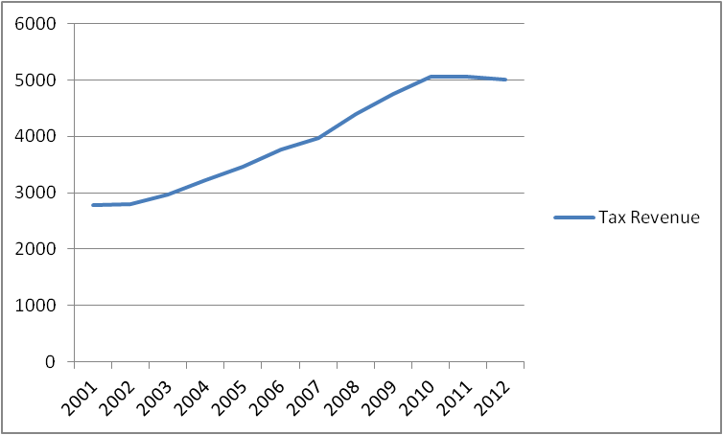

*Adapted from: CBS Statline*

(http://statline.cbs.nl/StatWeb/selection/?VW=T&DM=SLNL&PA=81383ned&D1=12&D2=0-1,59-60&D3=23-25&HDR=T&STB=G2,G1)

Graph 5 shows increasing revenues from the possession of cars. The revenues have risen up to 2010 after which they slightly drop. In total however, a sharp increase can be seen. In general, taxation based on possession appears to be very effective.

Aside from the general tax revenues, it is also important to judge whether or not this policy is effective in steering citizens towards the purchase of cars with low CO2 emissions. As the statistical bureau of the Netherlands does not have statistical data on the possession of cars with low CO2 emissions or tax revenues from cars with low CO2 emissions, the graphs (2 and 3) used in the analysis of the new BPM of this chapter are used to elaborate on the effectiveness taxation on the possession of cars.

*Intended Effects*

Graph 5 shows the revenue of tax levied on the possession of cars. This revenue has increased since 2001. It has stabilized around 2009. In addition, as graph 2 and 3 show, the average CO2 emission of new cars is declining over time. This proves that consumers tend to buy cars with lower CO2 emissions. It is possible that both the abolishment of taxation on possession of cars that emit under 110 grams of CO2 per kilometer and the new BPM policy have led to consumers buying these cars. Buying such a car became attractive due to the new BPM policy. Owning such a car became attractive due to favorable (or no) taxation on possession of such a car.

*Unintended Effects*

There are no known unintended effects resulting from the old BPM policy.

*Desirability of Effects*The generation of tax revenue and increase of cars with low CO2 emissions are both desireable as they directly contribute to the success of this policy.

*Success of Fiscal Instruments*

There are no reasons to assume that knowledge on the taxation on possession of a car does not reach Dutch citizens. It is likely but unclear if favorable tax conditions for cars with low CO2 emissions have indeed lead to an increase in the sale of these cars. Therefore, no solid verdict on the steering of behavior and the second goal of this policy can be given. It is clear however that the government collects a substantial amount of tax revenues from the possession of cars by Dutch citizens. This means that the first policy goal is attained due to this policy.

**§ 1.5 - Taxation on possession of older cars**

**Adopted:** Decades ago, revision adopted in 2013

**Abolished:** N/A, ongoing after revision

**Policy Goal(s):**

1. Offer citizens fair policy on the use of hobby cars

2. Restore fairness for citizens

3. Reduce the attractiveness of older, more hazardous, cars

**Policy Theory:**

Fairness is restored and possibilities for car enthusiasts are created if older cars are taxed proportional to their use for leisure activities. Diesel and LPG cars are never really used for leisure activities and were used to avoid taxes. If the possession of older Diesel and LPG cars is taxed regardless of age, the possession of older Diesel and LPG cars will drop.

**Type of Policy: Re-distributive**

The taxation on possession of older cars can be considered to be redistributive after the revision of 2013. The situation before 2013 was considered to be unfair as many citizens had an older car to be able to evade taxation and drive large mileages against little costs. Redistribution took place after the revision by increasing the age at which a car becomes tax free to 40 years. In addition, the revision provides car owners the option to drive certain periods in a year against a lower tariff if they want to use their car for leisure activities only. Unfairness has been taken away by treating old diesel cars, LPG cars and cars that are used throughout the year equal with younger cars covered by the taxation on possession of cars.

**Instrument(s) Used: Economical**

The taxation on the possession of older cars is an economical instrument since the revision of 2013 as it leads to the levying of taxes. It is universal as it affects all vehicles. It is restrictive as it excludes diesel cars, lpg cars and cars used throughout the years from a favorable tax rate. It is especially restrictive when compared to the pre 2013 revision where all cars aged 25 years or older were tax free. It can be considered partly widening as it does offer a favorable tax rate for individuals using a petrol car 25 years of age or older during a certain time of the year. The term partly is used as even these owners face a stricter regime when compared to the tax free policy from before the revision of 2013.

**Steering:**

The Dutch government attempts to steer citizens' behavior towards the abandoning of older, more hazardous cars by introducing taxation. These cars were attractive before the revision of 2013 as possessing them was tax free.

**Effectiveness**

Judging the effectiveness before the revision of 2013 is unnecessary as no taxes were levied. To judge the effectiveness of the taxation on possession of older cars after the revision of 2013, it is important to see what happened with older cars. If these cars have been demolished or have been exported, the policy can be considered to be effective as citizens are getting rid of their older car knowing it will no longer be completely tax free. The following 2 graphs show relevant data on the demolishing and export of vehicles aged 24 years or older:

Graph 6: Demolished vehicles 24 years of age or older

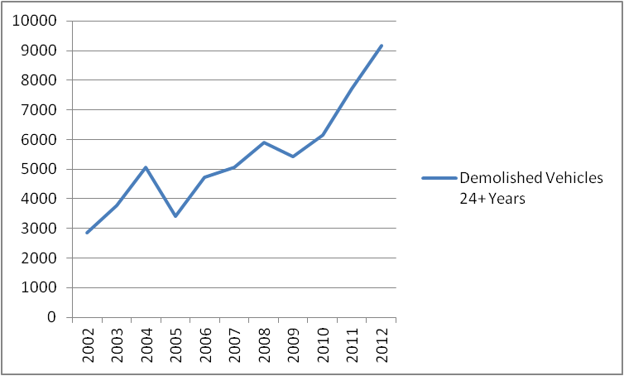

*Adapted from: CBS Statline*

(http://statline.cbs.nl/StatWeb/selection/?VW=T&DM=SLNL&PA=80357ned&D1=0-5&D2=0,4&D3=a&D4=l& HDR=G3,G2,G1&STB=T)

Graph 7: Exported vehicles 25 years of age or older

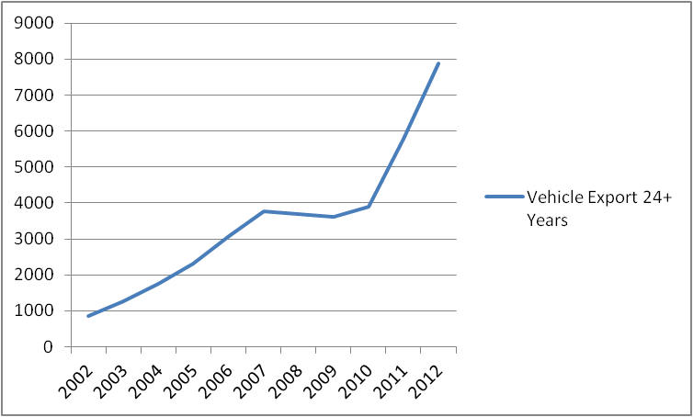

*Adapted from: CBS Statline*

(http://statline.cbs.nl/StatWeb/selection/?VW=T&DM=SLNL&PA=80357ned&D1=0-25&D2=0,4&D3=a&D4=l&HDR= G3,G2,G1&STB=T)

Both graphs show a similar trend. The export and demolishing of older vehicles rose sharply starting at 2010. Although the policy revision was adopted in 2013, an upcoming revision of the policy on older cars was inevitable and announced in 2012 (VVD & PVDA, 2012:37). Citizens knew up front tax free possession without limits would be over. The policy revision of 2013 can therefore be seen as an effective measure to reduce the attractiveness of older cars.

*Intended Effects*

The intended effect of the policy was that citizens would lose interest in possessing an older car. Graph 6 and 7 show that this has happened.

*Unintended Effects*

There are no known unintended effects resulting from this policy.

*Desirability of Effects*

Citizens losing their interest in possessing older cars is desirable as it directly contributes to the success of this policy.

*Success of Fiscal Instruments*

The intention to abolish the generous tax free position of older cars was explicitly mentioned in the agreement between the political parties that currently govern (VVD & PVDA, 2012:37). This means Dutch citizens were well aware of an upcoming policy revision. The Dutch government has successfully reduced the attractiveness of older cars especially when equipped with a Diesel or LPG engine. Graph 6 and 7 clearly show an increase in the demolishing and export of older cars. The third policy goal is attained due to the economical instrument this policy introduces. As the first and second goal of this policy are normative, they have not been analyzed for their effectiveness.

**§ 1.6 - Taxation on Fuel**

**Adopted:** Decades ago, exact date unknown

**Abolished:** N/A, ongoing

**Policy Goal(s):**

1. Generate substantial tax revenues for the Dutch government

2. Reduce the use of cars and steer people towards alternatives for mobility

**Policy Theory:**

The Dutch government assumes that a substantial amount of fuel will be bought yearly by Dutch citizens and that taxation on fuel would generate tax revenues for the Dutch government. In addition,

the citizen is seen as a homo economicus attempting to maximize utility. The Dutch government assumes that high taxation on fuel will lead to citizens looking for alternatives. An example would be a trip from one city center to another where the fuel costs are higher than the total costs associated with public transportation. In that case, the citizen would go for public transportation.

**Type of Policy: Re-distributive, Stimulating**

General taxation on fuel is a redistributive and stimulating policy. It is redistributive as it collects revenues from citizens’ fuel expenditures which can be used for any government expenditure. It is indirectly stimulating as it makes public transport and other mobility alternatives more attractive if they are cheaper.

**Instrument(s) Used: Economical**

An economical instrument is used as it solely involves taxation. It is used in a universal way as both private car owners and businesses pay fuel taxes. The instrument works restrictive as it increases the price of fuel and thus, the amount of fuel a person can buy with a certain budget.

**Steering:**

The Dutch government attempts to steer citizen behavior by using a restrictive economical instrument. This is a logical choice as they assume that Dutch citizens act as the homo economicus.

**Effectiveness**

Taxation on fuel is effective if tax revenues are substantial, stay the same or increase over the years. The policy becomes partially ineffective if revenues start to drop. In that case, citizens have found alternatives or make less use of their cars. The term partially is used as citizens making less use of cars and going for alternatives is also makes for effective policy as the second goal is to reduce the use of cars and steer people towards alternatives for mobility. The following graph shows the tax revenues from fuel taxes (up to 2012) over the years. In addition, graph 3 and table 8 from chapter 3 has been shown again to display the mileage driven by Dutch citizens:

Graph 8: Fuel Tax Revenue x million euro’s

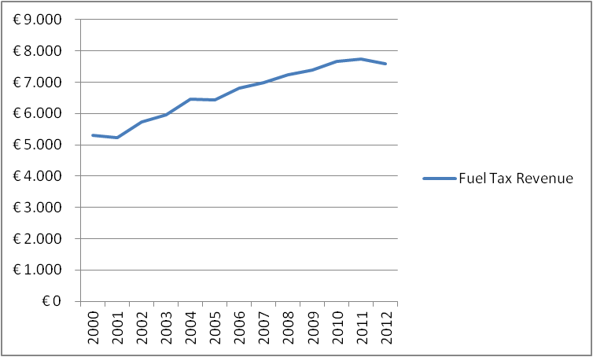

*Adapted from: CBS Statline*

*(http://statline.cbs.nl/StatWeb/selection/?VW=T&DM=SLNL&PA=81383ned&D1=10&D2=0-1,59-60&D3=23-25&HDR=T&STB=G2,G1)*

Chapter 3 - Graph 3: Total Mileage x million kilometers

*Adapted from: CBS Statline*

(http://statline.cbs.nl/StatWeb/publication/?DM=SLNL&PA=80428ned&D1=0-9&D2=a&D3=a&D4=0&D5=18-22&VW=T)

Chapter 3 - Table 8: Percentual Fuel Price Increase



*Adapted from: CBS Statline 2014*

*(http://statline.cbs.nl/StatWeb/selection/default.aspx?VW=T&DM=SLNL&PA=80416NED&D1=a&D2=(l-30)-l&HDR=T&STB=G1)*

*Intended Effects*

Graph 8 clearly shows that fuel tax revenues continue to increase throughout the years. This is obvious when compared to graph 3 and table 8 from chapter 3. The mileage driven in the Netherlands continuously increases as well even with a fuel price increase of 50%, 67% and 62%. The mileage driven by foreigners has also been included as they will have to purchase fuel in the Netherlands if they run out of fuel in the Netherlands meaning they also pay Dutch fuel taxes.

*Unintended Effects*

The borderless connection to Germany, Belgium and Luxembourg have lead to Dutch citizens buying fuel across the border. This is lucrative for Dutch citizens who live close to the border. According to the NOS (2014) this has lead to a loss of 65 million euro's only in January 2014. The ANWB (2014) even has a special page on the attractive custom of refueling cars in other European nations.

*Desirability of Effects*The increased tax revenue is a desirable effect as it ensures one policy goal is attained. The custom of Dutch citizens refueling their cars in other European nations is undesirable as the Dutch government does not collect any taxes on those transactions. In addition, Dutch vendors near the border see their gross revenues drop which jeopardizes the continuity of their businesses.

*Success of Fiscal Instruments*

The knowledge of the existence and functioning of the fiscal instrument reaches the target group as it is widely known that fuel taxes are levied. Dutch citizens may not know the exact amount of tax on a liter of fuel but do know the final price of fuel. Their behavior however, is not changed as intended. Policy goals for the fuel tax policy are therefore only partly attained as it does generate substantial tax revenues but fails to reduce the use of cars and fails at steering citizens towards alternatives for mobility.

**§ 2 Final Conceptual Model & Policy Field Analysis**

**§ 2.1 - Final Conceptual Model**

Based on the analysis in the first paragraph of this chapter, the following final conceptual model can be constructed:

**Image 1: Final Conceptual Model**

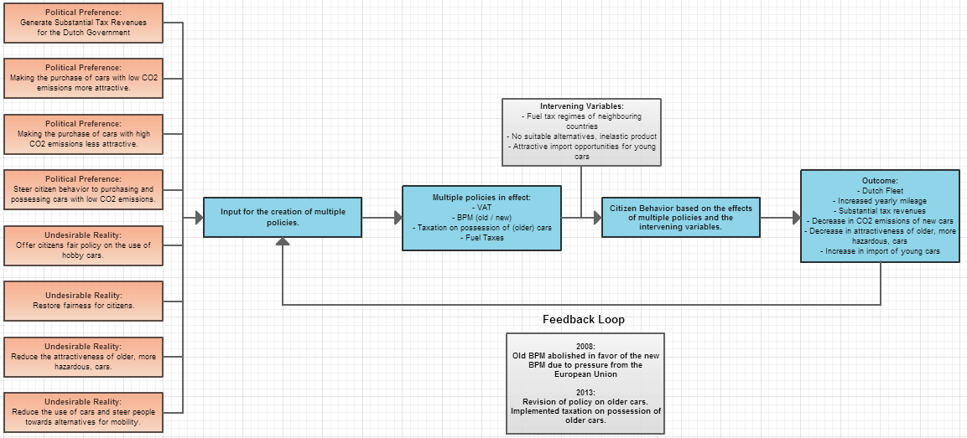

**Description**

The various political preferences and undesirable realities have lead to VAT, BPM (old & new), taxation on the possession of (older) cars and fuel taxes. Over time citizen behavior (influenced by multiple intervening variables) has lead to the described outcomes. The feedback loop has lead to the new BPM and the revision of policy on older cars.

**§ 2.2 - Policy Integration**

*Goal Integration*

When looking at the goals of the multiple policies that are or have been in effect in the Netherlands, one immediately sees that all policies are used to generate sufficient tax revenues for the government. Regarding the generation of sufficient tax revenues, all policies can be considered to be properly integrated with each other. If buying, possessing and using a car is seen as a cycle, each policy ensures tax revenues are generated in a part of that cycle. VAT and BPM are applied when purchasing a new car, taxation on possession of cars applies after the purchase when the car is owned and fuel taxes (also including VAT!) apply to the actual use of the car as cars consume fuel. Therefore, the policy field of the purchase, possession and use of cars in the Netherlands can be considered to be an integrated policy field on the part of generating tax revenues as one tax policy is clearly followed by another.

However, aside from generating sufficient tax revenues, other goals exist as well. After the new BPM was introduced, the Dutch government was no longer solely using the BPM to generate sufficient tax revenues. Citizen behavior was now subject to steering as the Dutch government implemented a modular tax system based on cars' CO2 emissions to influence citizen behavior. Graph 2 and 3 in the first paragraph of this chapter clearly show that the CO2 emissions of new cars dropped sharply after the introduction of the new BPM. This shows that the goals of the new BPM do not necessarily conflict with one another as tax revenues are still generated on the one hand and cars with lower emissions have increased in popularity on the other hand. As described in the analysis of the new BPM, the new BPM is basically a trade-off between substantial (but not optimal) tax revenues on the on the one hand and a substantial (but not optimal) drop of CO2 emissions of new cars. This would mean that the goals of the new BPM policy conflict with each other but not in such a severe way as the policy is still effective in attaining its goals.

Finally, regarding the two goals of fuel tax policy, the analysis shows that the policy is only effective in generating sufficient tax revenues. The total mileage driven by cars in the Netherlands keeps increasing every year as shown in graph 3 of chapter 3. Fuel taxes fit well in the policy field and clearly cover the use of cars in an adequate and inevitable way. In addition, there are no reasons to assume that the goal to generating sufficient tax revenues would conflict in any way with the goal to steering citizens towards alternatives. On the contrary, although the steering of citizen behavior fails in this case, these goals could go hand in hand in an effective way in another case with a different elasticity.

*Instrumental Integration*

The analysis shows that instrumental integration with different policies all attaining the same goal is present in this case. The economical instrument used with the new BPM policy and the policy on possession of cars make both the purchase and the possession of cars with low CO2 attractive due to favorable tax conditions. It is very likely that both instruments create a stronger incentive to buy a car with low CO2 emissions as consumers pay less BPM taxes on purchase and less road taxes the following years during possession. In addition, although there is no evidence that fuel taxes successfully steer citizens towards alternatives for mobility, it is possible that the economical instrument of high fuel taxes does steer citizens towards the purchase of cars with good fuel economy as these cars usually have low CO2 emissions. If this is the case, not two but three economical instruments from three different policies form an integrated whole which constitutes to the increased number of cars with low CO2 emissions in the Dutch fleet.

**§ 2.3 - The use of fiscal instruments**

In the theoretical framework, the reasons in favor and against fiscal policy instruments are described. Regarding the Dutch policy field, the analysis shows the policy field is effective in generating tax revenues. The Dutch Audit Office (1999:10) considers that to be the classic function of taxation. Although they claim fiscal policy instruments diminish that function, the analysis shows it is also possible that fiscal instruments can be effectively used for the generation of tax revenues. An exception is the new BPM as it sacrifices tax revenue on the one hand to increase the share of cars with low CO2 emissions in the fleet on the other hand. All other policy is effective in generating tax revenue.

One reason in favor of fiscal instruments is that they create an attractive fiscal environment. The analysis shows that no broad attractive fiscal environment exists. Only the new BPM creates attractive opportunities that are permanent. Although taxation on possessing a car is currently favorable for certain cars, this favorable policy will be completely abolished in 2015. All other tax policies do not create attractive opportunities but levy taxes universally instead. Even the enthusiast who possesses an old car for leisure purposes only is off worse as the old policy ruled that cars were road tax free after 25 years of age and new policy introduces taxation.

In addition, as described in the theoretical framework, fiscal policy instruments create an increased complexity of the tax regime and difficulties in upholding the regime. In the Dutch case however, this does not appear to be the case. The analysis of this chapter shows that the Dutch government is mainly generating sufficient revenue for public expenditure with the various tax policies. The complexity of various policies can be considered to be only little as only a few variables matter. The most complex tax policy would be the new BPM as it uses various levels of CO2 emissions. If complexity is an issue, it would be because of the frequent policy changes and revisions over time and not the policies themselves. The BPM, taxation on the possession of cars, taxation on the possession of older cars and fuel taxes have all been modified in the last 5 years.

Regarding parliamentary control, this thesis has not analyzed any political or parliamentary aspect of the policies. No judgment on parliamentary control of the policies can be given. The same goes for causality of fiscal judgments in general. As mentioned earlier in the theoretical framework, this thesis is only a small step towards knowledge on fiscal instruments. The analysis does shows that only the VAT and old BPM could be considered fully effective and causally connected to their subject as both are able to achieve their only policy goal, the generation of tax revenue. Other policies show that they are partially effective or introduce a trade-off as with the new BPM.

**Conclusion**

In this thesis, Dutch policy on the purchase and possession of cars has been evaluated. The goal of this thesis isTo research if existing tax policy on the purchase, possession and use of cars functions in an integrated way and if these policies are effective. To do so, the following main research question has been introduced:

**Main research question:**

"*Does policy on the purchase, possession and use of cars in the Netherlands function in an integrated way and are these policies effective?"*

A hybrid theoretical framework has been used to produce the result necessary for answering this research question. This framework consists of the work of multiple authors on policy in general, types of policy, policy instruments and more specific elaboration on fiscal instruments. A case study has been conducted on Dutch policy on the taxation involved with purchasing, possessing or using a car. A time-series analysis has been conducted over a period of approximately 10 years to be able to determine causal relations between the functioning of policies and reality. Based on the results from this analysis, the main research question can now be answered:

Dutch policy on the purchase, possession and use of cars functions in an integrated way. The analysis shows that the policies function in a serial way with no undesirable overlap. Upon purchasing a car, a citizen pays VAT and BPM. After the purchase of a car, the period of possession of the car and use of the car starts. During this period, a citizen pays tax based on the possession of the car and fuel taxes which are based on the use of the car. The tax based on possession differs per car based on age, weight, fuel type and emission properties of the car and is levied independent of the use of the car. Fuel taxes are modified almost every year by the central government and are paid per liter of fuel. The more a citizen uses his car, the more fuel taxes he will pay due to his increasing demand for fuel. In addition the better the fuel economy of the car, the less fuel taxes will be levied as a citizen requires less fuel for a given distance.

VAT, the old BPM, taxation on the possession of a car and taxation on the possession of an older car can be considered fully effective. Each policy is able to attain its goals with its instruments. There is also a clear causality between the policy and the attainment of its goals.

The new BPM and fuel taxes can be considered partly effective. The new BPM is a trade-off between generating revenues on the one hand and offering attractive tax opportunities on the other hand. Although revenues are generated and citizens are using the attractive tax opportunities, excessive use of the attractive tax opportunities would lead to a drop in tax revenues. The fuel taxes are levied under almost complete inelastic circumstances. Fuel taxes have substantially increased over the years but the mileage driven by citizens in the Netherlands continuously increase as well. Fuel taxes are an effective way of generating tax revenue but ineffective in steering citizens away from the use of cars towards alternatives for mobility. The effectiveness of fuel taxes is also slightly influenced by Dutch citizens profiting from more favorable fuel taxes in neighboring countries.

In this thesis, multiple testable hypothesis have been formed based on a combination of abstract hypotheses from the theoretical framework and practical information of the case description. The analysis has provided the results required to adopt or refute the hypotheses. The relevant hypotheses are listed below and adoption or refutation of a hypothesis is described:

**Hypotheses on the old BPM**

Hypothesis 1:

*"Substantial tax revenues were generated due to the old BPM."*

This hypothesis is adopted. The analysis clearly shows that the income from the old BPM rose from 2000 up to 2008. The fact that the number of new cars sold is dropping steadily did not seem to matter.

**Hypotheses on the new BPM**

Hypothesis 1:

*"Substantial tax revenues are generated due to the new BPM."*

This hypothesis is adopted. The new BPM creates substantial tax revenues. Although the new BPM is a trade-off between the generation of tax revenues and providing favorable tax conditions for certain cars, the analysis shows that a substantial amount of tax revenues is still generated.

Hypothesis 2:

*"The new BPM successfully steers citizens towards the purchase of cars with low CO2 emissions."*

This hypothesis is adopted. The analysis clearly shows that the sale of cars with low CO2 emissions has increased as the average CO2 emission of new cars has dropped sharply.

Hypothesis 3:

*"The new BPM successfully steers citizens away from the purchase of cars with high CO2 emissions."*

This hypothesis is adopted. The analysis clearly shows that the sale of cars with low CO2 emissions has increased as the average CO2 emission of new cars has dropped sharply. This makes it likely that citizens prefer cars with low CO2 emissions meaning that they are less likely to purchase a car with high CO2 emissions.

**Hypotheses on taxation policy regarding the possession of cars**

Hypothesis 1:

*"Substantial tax revenues are generated due the taxation of possession of cars."*

This hypothesis is adopted. The analysis shows how the tax revenues of taxation on the possession of cars has increased since 2001. Although it has stabilized in 2011 and 2012, the revenue in general does show a substantial increase.

Hypothesis 2:

*"Taxation on possession of cars successfully steers citizens towards the purchase of cars with low CO2 emissions."*

This hypothesis is adopted. As with the new BPM policy, the favorable tax policy on cars with low CO2 emissions has most likely steered citizens towards the purchase of these cars. The combination of the new BPM and favorable tax rates on possession is a good example of policy integration. Not only the purchase, but also the possession has become favorable.

**Hypotheses on taxation policy regarding the possession of older cars**

Hypothesis 1:

*"The revision of 2013 regarding the taxation of possessing an older car has successfully reduced the attractiveness of older, more hazardous cars."*

This hypothesis is adopted. The analysis shows how the demolishing and export of cars older than 24 years has increased. As cars aged 25 years or older used to be tax free, it was profitable to keep an ageing car. As strict conditions have been introduced after the 2013 revision, it is no longer profitable in many cases.

**Hypotheses on fuel taxes**

Hypothesis 1:

"Substantial tax revenues are generated due to fuel taxes."

This hypothesis is adopted. The analysis clearly shows that income from fuel taxes increases steadily and that it provides a continuous and reliable stream of revenue for the government.

Hypothesis 2:

"Fuel taxes fail to reduce the use of cars and steer people towards alternatives for mobility."

This hypothesis is adopted. To test the hypothesis, the development of the total mileage driven in the Netherlands has been researched. The analysis clearly shows that, while fuel taxes continuously increase, the total mileage driven increases as well. This means fuel taxes do not cause Dutch drivers to use available alternatives.

**Discussion**

This thesis consists of evaluative research based on a time-series analysis. Looking back at the analysis, it immediately becomes clear that a time-series analysis of at least a decade is very useful. Almost all tables and graphs are relevant due to their long time-span. If a period of only 5 years was used, relevant numbers would have been left out and wrong conclusions could have been drawn. Naturally, the relevant time-span of a time-series analysis depends on the subject and available sources but this thesis shows that a longer time-span does pay off.

While writing the research methodology for this thesis, the author has chosen to base the goals and policy theory of each policy on empirical data. No academic theory or assumptions were used to construct the policy goals and policy theory. This ensured that the author kept his feet firmly on the ground. It is possible that academic theories create a wrong image of policy goals and policy theory leading to academically correct but practically useless research findings. The use of academic theory did pay off however as in the case of fuel taxes, the Dutch government failed to steer citizen behavior. The abstract theoretical hypothesis on elasticity proved to be very relevant in this case as it explained the disability of fuel taxes to change citizen behavior. This shows the theoretical relevance of this thesis as academic insights can offer explanations when no logical explanation can be derived from a practical situation.

The interesting part of evaluative research is that when the researcher finishes his research, the process is far from over. Evaluative research can be considered a step in the policy cycle. As the conceptual model in this thesis has shown, a feedback loop exists and evaluative research can be the cause of feedback to the input step. The results from this thesis could be used for policy learning and demonstrates the practical relevance of evaluative research. On the other hand, it is also possible that the Dutch government is fully aware of the effects of certain policies but purposely keeps them intact due to reliance on the generation of tax revenues by multiple policies. This is especially the case regarding fuel taxes as fuel has proven to be very inelastic while fuel taxes keep increasing over the years.

Future research could compare Dutch tax policy on the purchase, possession and use of cars with policies in other European member states to see if it differs and why. This thesis shows that the Dutch government is mainly generating tax revenue from car owners. Other countries may have a tax system which is calibrated to cover the actual expenses of the government on citizen mobility. It would be interesting to see what the differences in policies and effectiveness are in a comparative case study. It may also be interesting to research if populations share inelasticity on fuel, mobility or other subjects associated with the purchase, possession and use of cars. It may be possible that an increase in fuel taxes can cause an incredible drop in the use of cars and tax revenues in some country.

**Reflection**

The analysis shows that Dutch policy is largely based on economical instruments used in a redistributive way. Looking back at the theoretical framework, Bekkers could think of modifying his view on types of policy and add a type which is used to maximize the generation of tax revenues on a certain subject. Although the policies have all been described as re-distributive, Bekkers (2007:24) may not imply with re-distributive policy that it leads to merciless, extensive and thorough taxation. An extra policy type called "*Extensive tax revenue generation*" may be relevant. In other countries it could be any other good or object which faces heavy taxation. Sweden for example, is known for its very high taxes on alcohol.

While gathering sources and information for this thesis, the author was surprised that there is no specific data on the CO2 emissions of new cars aside from average numbers. CO2 emissions of cars have been relevant since the end of the 90' when environmental labels were introduced. Such specific information also allows for a more thorough policy evaluation. In addition, the CBS does not offer detailed data on the import and export of old cars. The author had to look for other sources to get useful information. This is strange as it would be fairly easy to create data on older cars being registered in the Netherlands for the first time or being taken out of registration. Such data is useful for the Dutch government as well as it fits directly with evaluative research on the revised policy on the possession of older cars.

Finally, due to the added complexity and substantial increase in research efforts when analyzing political and ethical dimensions, the author has decided not to analyze the political and ethical dimensions of policies used in this thesis. This has rendered paragraph 1.4.3 of the theoretical framework quite useless.

**Bibliography**

Algemene Rekenkamer (1999). *Belastingen als beleidsinstrument*

Retrieved from:

http://www.rekenkamer.nl/Publicaties/Onderzoeksrapporten/Introducties/ 1999/03/Belastingen_als_beleidsinstrument?informatietype=kamervraag

ANWB (2014). Goedkoop tanken in vakantielanden

Retrieved from:

http://www.anwb.nl/nieuws/ledenvoordeel/2013/juli/goedkoop-tanken-in- vakantielanden

ANWB (2013). Autobelastingen 2013

Retrieved from:

https://www.anwb.nl/bestanden/content/assets/anwb/pdf/auto/themas/ autobelastingen/kl131200-factsheet-autobelastingen-met-bijlage.pdf

ANWB (2009). Factsheet Wijzigingen Belastingen Auto 2009

Retrieved from:

http://www.anwb.nl/binaries/pdf/auto/rijden/kosten/factsheet_wijzigingen-belastingen- auto-2009_4c.pdf

Autotelex (2013). Autotelex brengt gevolgen BPM heffing bij import in beeld

Retrieved from:

*http://www.autotelex.nl/autoopinie/795_Autotelex_brengt_gevolgen_BPM_ heffing_bij_import_in_beeld*

Bekkers, V. (2007). *Beleid in beweging: Achtergronden, benaderingen, fasen en aspecten van beleid in de publieke sector.* Den Haag: Lemma.

Belastingdienst (2014). Belasting van Personenauto's en Motorrijwielen (BPM)

Retrieved from:

http://www.belastingdienst.nl/wps/wcm/connect/bldcontentnl/belasting dienst/pri ve/auto_en_ vervoer/belastingen_op_auto_en_motor/ belasting_van_personenautos_en_motorrijwielen_bpm/

Belastingdienst (2014). Bereken Uw Motorrijtuigenbelasting

Retrieved from:

http://www.belastingdienst.nl/rekenhulpen/motorrijtuigenbelasting/

Boeije, H. (2008). *Analyseren in kwalitatief onderzoek. Denken en doen.* Den Haag: BoomOnderwijs

Bovens, M., 't Hart, P., van Twist, M., van Twist, M.J.W. (1996). *Openbaar Bestuur: beleid, organisatie en politiek.* Alphen aan den Rijn: Samsom.

Bressers, J.Th.A. (2008). Evaluatie van beleid, in: Hoogerwerf, A., Herweijer, M. (eds), *Overheidsbeleid. Een inleiding in de beleidswetenschappen* (155-176). Alphen aan den Rijn:Kluwer.

CDA, VVD, D66 (2003). meedoen meer werk minder regels.

Retrieved from:

http://www.rijksoverheid.nl/documenten-en-publicaties/notas/2003 /05/28 /regeerakkoord-balkenende-ii.html

Easton, D. (1957). *An Approach to the Analysis of Political Systems*. World Politics, Vol. 9 No. 3, pp. 383-400

Fenger, H.J.M., Klok, P.-J. (2014). Beleidsinstrumenten. In Hoogerwerf, A., Herweijer, M., (Ed.), *Overheidsbeleid: Een inleiding in de beleidwetenschappen* (pp 189-205). Alphen aan den Rijn, The Netherlands: Kluwer.

Fenger, H.J.M., Klok, P.-J. (2008). Beleidsinstrumenten. In Hoogerwerf, A., Herweijer, M., (Ed.), *Overheidsbeleid: Een inleiding in de beleidwetenschappen* (pp 223-241). Alphen aan den Rijn, The Netherlands: Kluwer.

Hoogerwerf, A. (1987). Beleid berust op veronderstellingen: de beleidstheorie, in: Lehning, P.B., Simonis, J.B.D. (eds), *Handboek Beleidswetenschap (23-40)*. Meppel: Boom.

NOS (2014). Tanken over de grens kost 65 mln

Retrieved from:

http://nos.nl/artikel/607443-tanken-over-de-grens-kost-65-mln.html

Overheid.nl (2014). Wet op de belasting van personenauto's en motorrijwielen 1992.

Retrieved from:

http://wetten.overheid.nl/BWBR0005806/geldigheidsdatum_04-10-2012

Refomatorisch Dagblad (2006). Europees Parlement: Schaf BPM af

Retrieved from:

http://www.refdag.nl/nieuws/economie/europees_parlement_schaf_bpm_af_1_181321

Rijksoverheid.nl (2014). Wijzigingen motorrijtuigenbelasting voor oldtimers

Retrieved from:

http://www.rijksoverheid.nl/onderwerpen/belastingplan-2014/motorrijtuigenbelasting- voor-oldtimers

Swanborn, P.G., (2008). *Case-study's: wat, wanneer en hoe*? Den Haag:BoomOnderwijs

Traa, M., Geilenkirchen, G., Hilbers, H. (2014). *Het kortetermijnramingsmodel voor het bezit en gebruik van personenauto’s in Nederland*. Den Haag: Planbureau voor de Leefomgeving.

UnitedConsumers (2014). Opbouw Brandstofprijzen

Retrieved from:

http://www.unitedconsumers.com/tanken/informatie/opbouw- benzineprijs.asp

Van Thiel, S. (2007). *Bestuurskundig onderzoek. Een methodologische inleiding.* Bussum:Coutinho

VVD & PVDA (2012). Bruggen slaan

Retrieved from:

http://www.rijksoverheid.nl/documenten-en- publicaties/rapporten/2012/10/29/regeerakkoord.html

1. (339 - 103) / 103 x 100