




Master Thesis – Evelien de Vries – 24th of June 2021

Raising the Flag in Times of COVID-19
Examining Individual Diversity in the Rally-Round-the-Flag Effect during the COVID-19 Pandemic

This page is left blank intentionally

Raising the Flag in Times of COVID-19
Examining Individual Diversity in the Rally-Round-the-Flag Effect during the COVID-19 Pandemic
Evelien de Vries
S1005207
e1.devries@student.ru.nl
Thesis Submitted in Partial Fulfillment of the Requirements for the Degree of Master in Political Science: Comparative Politics (MSc)
Supervision by Dr. T. Sipma
Nijmegen School of Management
Radboud University, Nijmegen, The Netherlands
24th of June 2021
Word count: 18197

Abstract
By comparing the levels of Prime Minister’s approval and trust in government of the same individuals in 2020 and 2021, this study examines one of the most important political consequences of the COVID-19 crisis, namely, whether the pandemic sparked the rally-round-the-flag phenomenon in the Netherlands. Subsequently, this thesis investigates the individual diversity in the rally-round-the-flag effect. By using OLS multiple regression analyses, it determines which types of individuals experienced the rally-round-the-flag effect during the COVID-19 crisis in the Netherlands, and why people differ in their levels of individual rallies. The results of the analyses produce three conclusions. Firstly, the data confirms that the COVID-19 pandemic has generated a national rally-round-the-flag effect in the Netherlands. Secondly, I found evidence that voters for a coalition party had the most substantial rallies, followed by voters for the relatively less critical opposition and in turn followed by voters for the critical opposition. Thirdly, I conclude that economic position does not explain the individual diversity in the rally effect generated by the COVID-19 pandemic in the Netherlands, but our mediation models do indicate that citizens whose economic insecurity increased during the pandemic, had a significantly smaller increase in Prime Minister’s approval and governmental trust.
Keywords: Rally-round-the-flag effect; run-from-the-flag effect; COVID-19; the Netherlands; multi-party system; opinion leadership; party choice; economic position; multiple linear regression analysis

List of Contents
Abstract III
List of Contents IV
List of Tables and Figures V
Chapter 1: Introduction 1
Chapter 2: Theoretical Framework 3
The Rally-Round-the-Flag Effect 3
COVID-19 Crisis and Rally-Round-the-Flag Effect in the Netherlands 5
Chapter 3: Methodology 11
Dataset: LISS Panel 11
Dependent Variables 12
Independent variables 14
Control variables 17
Statistical Analyses 19
Assumptions of Multiple Linear Regression 21
Chapter 4: Results 22
COVID-19 Rally in the Netherlands 22
Individual Diversity in the Rally-Round-the-Flag Effect 23
Chapter 5: Conclusion 32
Discussion 33
List of References 35
Appendix 39
Appendix 1: Selected Variables from LISS Panel 39
Appendix 2: Computed Variables 40
Appendix 3: Assumption Tests of Multiple Linear Regression 41
Appendix 4: T-test Rally-Round-the-Flag Effect with Filtered Group 46
Appendix 5: Opinion Leadership Regression Calculations 47
Appendix 6: OLS Regression with Coalition Distinction 49
Appendix 7: Sobel Tests Indirect Effect Economic Position 52

List of Tables and Figures
Table 1: Overview of Respondents per LISS Panel Questionnaire 12
Table 2: Frequency Table for Difference in Prime Minister’s Approval 13
Table 3: Frequency Table for Difference in Trust in Government 14
Table 4: Descriptive Statistics and Frequencies of Variables 18
Table 5: T-test of Means of Prime Minister's Approval and Trust in Government in 2020 and 2021 22
Table 6: Results of OLS Regression Analysis of Individual Diversity in Rallies 23
Table 7: Results of OLS Regression Analysis of Mediation of ΔEconomic Insecurity 29
Table 8: Mediation ΔEconomic Insecurity of Economic Position on ΔPrime Minister's Approval 30
Table 9: Mediation ΔEconomic Insecurity of Economic Position on ΔTrust in Government 31
Table 10: Selected variables from LISS Panel 39
Table 11: Manually Computed Variables 40
Table 12: Multicollinearity Scores (VIF) 44
Table 13: T-test of Means of Prime Minister's Approval and Trust in Government in 2020 and 2021 46
Table 14: Results of OLS Regression with Distinction between VVD and Other Coalition Party 49
Table 15: Results of OLS Regression with Distinction between Other Coalition Party than VVD and Less Critical Opposition 50
Table 16: Sobel Test Indirect Effect of Economic Position on ΔTrust in Government via ΔEconomic Insecurity 52

Figure 1 Brody's opinion leadership hypothesis (1991) 4
Figure 2 Mediation of Economic Insecurity on effect of Economic Position on Prime Minister’s Approval 9
Figure 3 Mediation of Economic Insecurity on effect of Economic Position on Trust in Government 9
Figure 4 Mean Scores Prime Minister's Approval and Trust in Government in 2020 and 2021 23
Figure 5 Mean Scores Prime Minister's Approval Differentiated by Party Choice 26
Figure 6 Mean Scores Trust in Government Differentiated by Party Choice 26
Figure 7 Scatterplot with Difference in Economic Insecurity and Difference in Prime Minister's Approval 41
Figure 8 Scatterplot with Difference in Economic Insecurity and Difference in Trust in Government 41
Figure 9 Histograms of each Included Variable 42
Figure 10 Scatterplot with Predicted Values and Residuals of Difference in Prime Minister's Approval 45
Figure 11 Scatterplot with Predicted Values and Residuals of Difference in Trust in Government 45

Chapter 1: Introduction
The year 2020 has been a turbulent one. The outbreak of the infectious virus SARS-CoV-2 put the world on hold. After years of globalization and the opening of national boundaries, most national governments decided to close their borders and put their systems into lockdown. The Netherlands has been hit hard as well. Over one million Dutch people got infected by the coronavirus in the year 2020 (Dong, Du, & Gardner, 2020). In the same year, almost 15 thousand people lost their lives to COVID-19 (ibid.). After ten months of an ‘intelligent lockdown’ (Haas, Faber, & Hamersma, 2020) and numerous extensive measures, the vaccination program has been launched (Rijksoverheid, n.d.) and several restrictions have been lifted.
As the international COVID-19 pandemic has affected the daily lives of countless citizens, various authors have argued that this crisis has generated national rallies (Baekgaard, Christensen, Madsen, & Mikkelsen, 2020; Bol, Giani, Blais, & Loewen, 2020). The rally-round-the-flag effect entails that in times of crisis, such as war or a global pandemic, political trust increases and incumbent leaders benefit from a rise in public support (Cunningham, 2020). Some prominent examples of the rally-round-the-flag effect were the Cuban Missile Crisis in 1963 and the War on Terrorism after the September 11 Attacks in 2001 (Hetherington & Nelson, 2003). After the latter crisis, the national percentage of presidential approval increased from 50 to 90 percent in two weeks (ibid.). In this study, I will argue that the COVID-19 crisis in the Netherlands holds several components of a crisis which could induce a rally-round-the-flag effect, as first described by John Mueller (1970). After presenting the theoretical background about the rally phenomenon and the pandemic, I will statistically test whether the COVID-19 pandemic has truly sparked a rally in the Netherlands.
Until now, most scholarly attention has been devoted to explaining the rally-round-the-flag effect on the meso or macro level. However, there happens to be minimal academic literature on how the rally-round-the-flag effect works on the individual level. If the rally effect has indeed manifested itself during the COVID-19 pandemic, it may be worthwhile to shift the focus from the national picture to the individual context. We do know that several individual characteristics can affect levels of political trust. For instance, populist voters tend to have lower levels of trust in political leaders (Rooduijn, 2018) or political institutions (Fieschi & Heywood, 2004). Moreover, research has shown that people who perceive themselves as economically insecure have reduced levels of political trust (Wroe 2015). It is interesting to examine whether and how these kind of characteristics affect the extent of individual rallies. Hence, besides assessing whether the COVID-19 pandemic has triggered a Dutch rally, the main goal of this thesis is to determine which types of individuals experienced the rally-round-the-flag effect during the COVID-19 crisis in the Netherlands, and why people differ in their levels of individual rallies.
In this study, I will first theorize that the opinion leadership mechanism, one of the hypothesized origins of the rally-round-the-flag effect, works quite similar on the micro level as it does on the national level. Opinion leadership scholars argue that during an existential crisis such as the COVID-19 pandemic, the political opposition is induced to be relatively silent or even carefully supportive of the government’s approach to the crisis. Voters respond to this attitude by increasing their presidential approval and trust in government (Brody, 1991). The Netherlands has been selected as the central case of this thesis, given that the political opposition in the Netherlands is not one united block of ideologically comparable political parties, as compared to majoritarian systems such as the United States. In such a highly diverse and volatile political system, it is improbable that every citizen increases its presidential approval and governmental trust, meaning that not every individual of a nation will rally around its government. As the opposition parties acted quite divergently during the pandemic, I expect the opinion leadership mechanism to work differently for various opposition voters. In order to test these theoretical expectations, I have divided Dutch voters into three groups, based on party choice: 1) voters for coalition parties, 2) voters for the ‘less critical opposition’ parties and 3) voters for the ‘critical opposition’. In the theoretical framework of this study, I will further clarify which political parties are considered critical or less critical. Based on the opinion leadership mechanism, I expect the coalition voters to have had the most significant rallies during the COVID-19 crisis in the Netherlands, followed by voters for the less critical opposition and in turn followed by the critical opposition. In this thesis, I will additionally hypothesize that the micro diversity in the rally-round-the-flag effect emerges from individual economic positions, given that the COVID-19 measures taken by the Dutch government have had distinct financial consequences for different economical groups. As entrepreneurs and jobless citizens were affected most heavily (Heeg, 2020), I expect them to be less satisfied with the government’s approach. Accordingly, I will test whether they have experienced a less substantial rally effect than paid employees, who were financially less affected by the COVID-19 measures. Supplementary, I will argue that a change in economic insecurity mediates the effect of one’s economic position on the individual level of the rally-round-the-flag phenomenon.
These group differences make the Netherlands a suitable case to examine individual heterogeneity in the rally-round-the-flag phenomenon. On top of that, the Dutch panel used in this study has measured Prime Minister’s approval and governmental trust right before and directly after the peak of the pandemic. Therefore, I can compare the levels of Prime Minister’s approval and trust in government of the same individuals in 2020 and 2021, while examining the effect of individual characteristics such as party choice and economic position. Hence, this study will first elaborate on the presence of the Dutch rally-round-the-flag effect during the COVID-19 pandemic, by measuring the difference in Prime Minister’s approval and trust in government between March 2020 and March 2021. Afterwards, this study will aim at exploring the individual diversity in the rally-round-the-flag effect in the Netherlands. The research question will be formulated as follows:
Has the COVID-19 pandemic generated the rally-round-the-flag phenomenon in the Netherlands
and how does this vary on the individual level?
This thesis can deliver a substantial contribution to academic literature about the global pandemic and crisis theories. First of all, existing academic literature has not yet resolved whether the COVID-19 crisis gave rise to a rally-round-the-flag effect in the Netherlands. This study will use exceptionally recent panel data to uncover the existence of this effect potentially originating from the pandemic. Most importantly, this study will explore the meaning of the rally-round-the-flag effect on the individual level. Especially concerning an extremely fragmented and volatile party system such as the Netherlands, it is interesting to analyze whether opinion leadership affects different voters in distinct ways. Moreover, previous scholars have not yet investigated the influence of one’s economic position on the rally-round-the-flag phenomenon. Furthermore, the actuality of this topic and the major role that COVID-19 currently plays in our society make this study highly societally relevant.
By means of a multiple linear regression analysis, I will measure the change in Prime Minister’s approval and governmental trust of several societal groups, differentiated by party choice and economic position. But first, the theoretical framework of this study will clarify why party choice and economic position could play a role in the diversification of the rally-round-the-flag effect on the micro level. In the third chapter of this thesis, I will elaborate on the employed dataset of LISS Panel, the operationalization of my variables and on the regression models used to test my hypotheses. The results of these analyses will be presented and thoroughly assessed in the fourth section of this thesis. In this chapter, each hypothesis will be confirmed or dismissed. In the fifth and conclusive chapter, the outcomes of the empirical analysis will be transformed into an answer to the research question. This last section additionally includes the limitations of this thesis and the recommendations for further research in the field of comparative politics.

Chapter 2: Theoretical Framework
In the subsequent chapter, the theoretical foundations of this study will be outlined. Firstly, the academic discussion surrounding the rally-round-the-flag phenomenon will be delineated. Afterwards, the selection of the COVID-19 crisis in the Netherlands as the central case in this study will be further clarified. In the key part of this chapter, I will argue that there exists diversity in rallies on the micro level. Accordingly, I will propose two theoretical explanations for this diversity in individual rallies, namely opinion leadership and economic position. Lastly, I will discuss economic insecurity as a potential mediator of the role of economic position concerning the diversity in individual rallies.

The Rally-Round-the-Flag Effect
In the 1970s, political scientist John Mueller provided the groundwork for what we currently know as the rally-round-the-flag phenomenon. He aspired to explain why certain intense events, like a war or similar crises, temporarily boost the president’s popularity (1970). Until that time, several scholars (Waltz, 1967; Wicker, 1967; Neustadt, 1960; Roper, 1969) observed that wars and crises brought Americans together in favor of the president, “regardless of the wisdom of the policies he pursues” (Polsby, 1964, p. 25). Mueller attempted to clarify changes in the president’s popularity using four explanations. One of those explanations was the “rally round the flag” variable (Mueller, 1970, p. 20), which predicts that international crises and comparable phenomena will provide the President with a brief boost in popularity (ibid.). He developed quite a limited definition of a rally, as it was based only on observations of rallies in the United States. Mueller stated that a rally point must be linked to an event which 1) is international, 2) directly concerns the United States and particularly the President of the United States and 3) it must be “specific, dramatic and sharply focused” (Mueller, 1970, p. 21). Mueller explained that events needed to be international, given that the rally-round-the-flag effect only appears when states are affected as a whole. His second precondition is based on the argument that large-scale conflicts between other powers would cause divided loyalties and are less probable to be relevant to the ordinary American. Lastly, events need to be specific, dramatic and sharply focused to guarantee public interest and awareness. Events which develop gradually are therefore not taken into consideration (ibid.).
Mueller distinguished between five categories of rallies: 1) Sudden American military intervention, for instance, the Bay of Pigs, 2) crucial military developments in ongoing wars, such as major events in the Korean or Vietnamese war, 3) important diplomatic developments, for example, the Truman doctrine, 4) major technological developments, such as the launch of Sputnik in 1952, and 5) meetings between the President of the United States and the head of the Soviet Union (Mueller, 1970). Given that Mueller based these categories specifically on the Cold War period, contemporary scholars do consider them as outdated (Hetherington & Nelson, 2003). Moreover, when Richard Brody carried out Mueller’s analyses using a larger time frame, including US presidents Nixon, Ford, Carter and Reagan, he found that two of the five event categories did not always involve a rally-round-the-flag effect (1991).
Mueller has provided us with an important framework for the rally-round-the-flag phenomenon. Yet, a large part of his ideas is biased towards the United States and slightly outdated. Given that scholars have repeatedly observed this phenomenon in other countries than the United States as well (Baum, 2002), academics now use a broader definition of the rally-round-the-flag effect, which is no longer particular to the United States. Therefore, a slightly modified definition of Mueller’s (1970) rally-round-the-flag effect will be employed in this thesis: a rally event 1) is international, 2) involves the nation and particularly the President or Prime Minister directly; and 3) is specific, dramatic, and sharply focused. Until today, the most prominent manifestation of the rally-round-the-flag phenomenon took place after September 11 attacks, after which the president’s approval rate jumped from 51 percent to 90 percent within 11 days (Hetherington & Nelson, 2003).

Origins of the Rally-Round-the-Flag Effect
After John Mueller introduced the concept, three waves of rally-round-the-flag scholars have searched for the origins of this phenomenon. The first wave of academics attributed the rally phenomenon to an automatic patriotic reflex (Murray, 2017). This patriotism school argues that in times of an international crisis, the President becomes the center of national attention, portrayed as a symbol for unity and power (Lee, 1977). He or she is transformed into a ‘living flag’. Individuals are trying to identify with an in-group, which is represented by the nation and its president. To put it briefly, crises boost citizens’ patriotism. The second wave of scholars investigating the rally-round-the-flag phenomenon challenged this idea of patriotism as a cause of the rally-round-the-flag effect. Brody (1991) proclaims the school of patriotism to be theoretically unsubstantiated and has undermined the idea by counterexamples. According to Brody, the patriotism hypothesis does not produce an accurate list of rally events. This can be illustrated by the Pueblo episode in 1968 and the Mayaguez incident in 1975. During the Pueblo episode in 1968, a United States navy ship called ‘Pueblo’ was captured and seized by North Korea (Schindler, 2004). The Mayaguez incident in 1975 was a rescue operation by the United States to liberate one of their military ships captured by the Cambodian Khmer Rouge (Wetterhahn, 2002). Brody argues that these two events were crises which, based on the patriotism hypothesis, should have sparked a rally-round-the-flag effect. However, the Mayaguez incident sparked a rally and the Pueblo seizure did not (Brody, 1991). Instead, Brody tried to explain the phenomenon from a different angle. He hypothesized that the main cause for a rally effect is the attitude of the political opposition on the government’s approach to the crisis. When a crisis occurs abruptly, the media provides the President with a monopoly on information. Due to the state of emergency, the political opposition is induced to remain silent or even becomes carefully supportive of the president’s handling of the crisis. Media corporations have journalistic incentives to report on the political debate, which becomes very unilateral in this context. When the media only broadcasts positive news about the president’s job performance, the public responds by temporarily increasing its presidential approval (Brody, 1991). Brody’s opinion leadership hypothesis is displayed in the schematic diagram in Figure 1.
Sudden international crisis
President obtains monopoly on information
Opposition falls silent or becomes supportive
Media broadcasts uncritical news about president's performance
Public increases presidential approval
Figure 1
Brody's opinion leadership hypothesis (1991)

The opinion leadership hypothesis can additionally explain why some crises do not spark a rally. When the opposition remains visibly critical of the president’s approach during the crisis, the public follows these signals and persists to be critical as well. The public opinion of the president’s attitude towards the crisis can even become more negative than before the crisis. The opinion leadership hypothesis has become the most commonly accepted explanation for the rally-round-the-flag phenomenon (Groeling & Baum, 2008). The third wave of scholars disagree that the patriotism and opinion leadership hypotheses are mutually exclusive. Patriotism could explain why the opposition leaders and media companies hold back their criticisms. As soon as the crisis hits, patriotic individuals are inclined to support the nation, which discourages the political opposition and the media to be openly critical about the head of the state (Hetherington & Nelson, 2003). Accordingly, the patriotism school is not as convincing in explaining the causes of rally effects as opinion leadership, but this does not imply that patriotism does not play a role.

Detecting the Rally-Round-the-Flag Effect
Rally events generally have positive implications for the public’s presidential approval and governmental trust (Hetherington & Nelson, 2003). Some scholars additionally mention an increase in identification with the president’s party as a third consequence, but empirical evidence has illustrated that this effect has not occurred during several sizeable rallies (ibid.). Therefore, this effect will not be included in this study. The first indicator, a surge of presidential approval, entails that right after a crisis situation starts, the President benefits from a significant increase in popularity. For example, during the Gulf War in 1991, the air campaign Operation Desert Storm generated a noteworthy rally for US President George Bush, as his approval rate grew by 18 percent within a month (ibid.). The second indicator of the rally-round-the-flag phenomenon is a rise in governmental trust. For instance, two weeks after the 9/11 Attacks, the general trust in the US government built up to a level not witnessed since the 1960s. In times of crisis, citizens assess the government’s performance based on particular “crisis-induced criteria” (ibid., p. 40), instead of usual criteria centered around social and economical issues. This leads to a temporary rise in government approval. When citizens return to their regular criteria after some time, they automatically drop back to their previous levels of trust in government. These developments only happen when a crisis classifies as a rally event (Mueller, 1970) and when the rally condition of opinion leadership is fulfilled (Brody, 1991). When the opposition remains seemingly critical of the president’s approach of the crisis, no rally effect will be observed.

COVID-19 Crisis and Rally-Round-the-Flag Effect in the Netherlands
Most research about the rally-round-the-flag effect is centered around American cases. However, this phenomenon has proven to take place outside the United States as well. In their study, Beijen, Otjes and Kanne (2021) illustrate that the rally-round-the-flag effect can also take place in multi-party coalition systems such as the Netherlands. Moreover, they demonstrate that not merely wars, but other events like diplomatic incidents can cause a rally as well. Political scientist Rory Costello (2020) argues that citizens can even rally around the political leaders of supranational organizations. In times of Brexit, the United Kingdom posed a significant threat to the economy of Ireland. During the Brexit-negotiations, the European Union acted on behalf of Ireland, which generated a rally-round-the-flag effect in favor of the EU, as the Irelanders’ public support for the EU increased significantly. These scholars have demonstrated that the rally-round-the-flag effect is more than a war-related American phenomenon.
An extremely prominent global crisis which could possibly spark a rally is the COVID-19 crisis. In January 2020, information was published about a mysterious lung disease originating from Wuhan, China (Tijdlijn Coronavirus, n.d.). Within two months, the SARS-CoV-2-virus had taken its grip on every continent in the world. Government officials initiated strict measurements and lockdowns, in order to inhibit the virus. At the time of writing this study in the spring of 2021, several states had started vaccinating its citizens, but most of the world was still in lockdown (Financial Times, 2021). The COVID-19 crisis is international, has consequences for all citizens within a nation and involves drastic government action. Besides, its speed of development and impact on society makes this crisis specific, dramatic, and sharply focused. For those reasons, this crisis has significant similarities with previous rally events and can therefore serve as an interesting case to study the rally-round-the-flag phenomenon. As discussed in the introduction of this study, the Netherlands serves as an interesting case to examine the rally-round-the-flag phenomenon generated by the COVID-19 pandemic. Beijen, Otjes and Kanne (2021) have demonstrated that in a multiparty coalition system such as the Netherlands, citizens will rally around the Prime Minister during a crisis. Moreover, the type of crises is not limited to wars, as diplomatic incidents can also spark the rally-round-the-flag effect. Accordingly, the Netherlands will be selected as the case of this research on COVID-19 rallies on the macro and micro level.
Earlier in this theoretical chapter, two potential origins of a rally have been discussed, namely, patriotism and opinion leadership. For two reasons, the school of patriotism is less relevant for this study focused on explaining a COVID-19 rally in the Netherlands. Most importantly, as discussed before, most scholars do not longer acknowledge patriotism as a sufficient explanation for the rally-round-the-flag phenomenon (Brody, 1991) Secondly, the patriotism hypothesis is merely based on observations in the United States, which is considered one of the most patriotic countries in the world (YouGov, 2016). In the Netherlands, people are overall reluctant to express love for their country. For instance, an extensive discussion has taken place about the placement of a Dutch flag in the parliament (Kompagnie, 2020). Moreover, the idea of the Christian party to require the national anthem to be sung at schools was quickly dismissed (Geling, 2020). For Americans, these matters would most likely be unthinkable. As there is no general base level of patriotism in the Netherlands, only a very small group of Dutch citizens would experience a patriotism-induced rally during a crisis. This theory could possibly explain the micro diversity in the rally-round-the-flag phenomenon, albeit for a small group. Still, as I wish to study the most considerable differences between citizens regarding individual rallies, this mechanism appears to be less relevant for this thesis. However, the school of opinion leadership might serve as a more suitable explanation of a Dutch COVID-19 rally. One essential question we need to ask ourselves is whether and how this mechanism works in one of the most proportional political system in the world (Jacobs, 2018). To determine whether the rally-round-the-flag effect has indeed taken place in the Netherlands during the COVID-19 crisis, two indicators of the rally effect need to be observed: an increase in presidential approval and an increase in trust in government. As the Netherlands does not have a president, but a Prime Minister, I will refer to presidential approval as Prime Minister’s approval throughout this thesis. This a theoretically accurate label for presidential approval, given that in practice and in the eyes of citizens, European Prime Ministers nowadays operate more as if they were presidents (Beijen, Otjes & Kanne, 2021). Hence, the following two hypotheses will be tested:
Hypothesis 1a: During the COVID-19 crisis, there has been an increase in Prime Minister’s approval
Hypothesis 1b: During the COVID-19 crisis, there has been an increase in trust in government

Opinion Leadership and Individual Rallies
In most studies on the rally-round-the-flag effect, the rally itself is measured by means of aggregated data on presidential (or Prime Minister’s) approval and trust in government. This seems to be based on an assumption that every individual is influenced in the same manner by a nation-wide crisis situation. However, particularly in an extremely fragmented and polarized party system such in as the Netherlands, it is improbable that every citizen increases his or her Prime Minister’s approval and governmental trust, indicating that not every individual will rally around its government, or not to the same extent. For this reason, it is interesting to analyze whether rally events affect individual voters in distinct ways.
Especially in a multi-party system such as the Netherlands, a mechanism such as opinion leadership will not have the same outcome for everyone. According to the school of opinion leadership, a ‘non-critical’ opposition generates a rally-round-the-flag effect, and a critical opposition could imply that a rally does not take place, or even trigger a reverse rally effect (Brody, 1991). However, in the Netherlands, the opposition is not one united block of ideologically comparable political parties. Due to the low electoral threshold, the current opposition block consists of nine parties. These nine parties are extremely diverse, given that their ideologies range from left-wing green to right-wing populist. The opposition parties also greatly differ in their viewpoints on the government’s approach to the COVID-19 crisis. Where a large part of the Dutch opposition is not openly critical about the government’s tactics, the conservative, right-wing, nationalist Party for Freedom (PVV) and Forum for Democracy (FvD) clearly stood out as ‘protest parties’ when assessing the government’s handling of the pandemic (Kieskamp, 2020). The FvD and PVV have portrayed themselves as continuous opponents of the Dutch corona policy, irrespective of the government’s policy orientation. In March 2020, at the start of the pandemic, the FvD and PVV felt that the Dutch government did not take enough measures to mitigate the spread of virus (Kieskamp, 2020). Three months later, in the middle of the intelligent lockdown, these parties campaigned for a quick relieve of the COVID-19 measures and opposed the new six-foot society, under the guise of re-establishing citizen’s freedom (Van Ast & Winterman, 2020). The other opposition parties remained relatively silent or even supported the government’s approach of the pandemic (Klaassen, 2021).
According to Mullunix (2016), voters’ policy preferences move along with the standpoints of their preferred party. By means of a survey experiment, he demonstrated that Republican voters support legislation that is supposedly promoted by the Republican Party, and Democratic voters support legislation that is supposedly promoted by the Democratic Party, even though these proposals are fictional and do not fit with the party’s regular views. Mullinix (ibid.) argues that being exposed to party’s positions on public issues trigger individual partisan motivations. According to Goren et al. (2009), these partisan motivations create a biased lens, through which individuals evaluate and filter information that reinforces the positions of their preferred party. As a result, people will adjust their policy preferences towards their party’s standpoints (ibid.). Additionally, Mullinix (2016) states that when parties are polarized on an issue, people’s willingness to follow their party’s lead is strengthened even more. Assuming that this theory operates correspondingly for Dutch voters, we can assume that the opinions of Dutch parties can steer individual political attitudes.
Due to this effect parties have on their voter’s standpoints, I believe that the range of differences in party positions has diverse implications for individual voters. These individuals can be divided into three groups: Voters for the critical opposition, voters for the relatively less critical opposition and voters for the coalition. Based on the opinion leadership hypothesis, I expect individuals who have voted for relatively less critical opposition parties to respond to the COVID-19 crisis by increasing their Prime Minister’s approval and trust in government, generating a rally-round-the-flag effect. However, when opposition parties are openly critical of the government’s approach to the crisis and portrayed accordingly by the media, I expect their constituency to experience a smaller rally-round-the-flag effect, or even an inverted effect. I will call this inverted rally-round-the-flag phenomenon the ‘run-from-the-flag effect’. The third group of individuals are voters for coalition parties. As the government receives a greater increase in support from its own voters than from voters of other parties during a crisis (Singh & Tir, 2018), I expect the coalition voters to experience the most intensive rally-round-the-flag effect. In order to test whether opinion leadership has different implications for individuals based on their party preference, the following hypotheses have been devised:
Hypothesis 2a: Voters for coalition parties have a larger increase in Prime Minister’s approval than voters for opposition parties which were portrayed as relatively less critical of the government’s approach to the COVID-19 crisis.
Hypothesis 2b: Voters for opposition parties which were portrayed as critical of the government’s approach to the COVID-19 crisis have a smaller increase in Prime Minister’s approval than voters for opposition parties which were portrayed as relatively less critical of the government’s approach to the COVID-19 crisis.
Hypothesis 3a: Voters for coalition parties have a larger increase in trust in government than voters for opposition parties which were portrayed as relatively less critical of the government’s approach to the COVID-19 crisis.
Hypotheses 3b: Voters for opposition parties which were portrayed as critical of the government’s approach to the COVID-19 crisis have a smaller increase in trust in government than voters for opposition parties which were portrayed as relatively less critical of the government’s approach to the COVID-19 crisis.

Economic Position and Individual Rallies
During the COVID-19 crisis, several measures have been taken by the Dutch government to slow down the spread of the corona virus. During the first wave of infections, which started in March 2020, Prime Minister Mark Rutte commanded an “intelligent lockdown” (Rijksoverheid, 2020). This lockdown comprised of several societal measures. Most measures were lifted fully or partially in June 2020. However, in September 2020, the number of COVID-19 infections surged again and the Netherlands entered the second wave, which lasted approximately until February 2021. From March 2021 onwards, the measures have gradually been loosened. Economically, both lockdowns primarily affected gyms, the cultural sector, the hospitality and retail industry and professionals with physical client contact (UWV, 2020). The government announced several financial aid packages, but according to employers’ organizations and trade unions, these initiatives were no more than a drop in the ocean (Soest, 2020).
The COVID-19 measures taken by the government undoubtedly have had severe economic consequences for a specific part of the population. Even though, these COVID-19 measures generally increased the level of trust in government (Oude Groeniger, Noordzij, Van der Waal and De Koster, 2021). However, not every citizen experienced an equal rise in political trust (ibid.). This diversity between rallies on the micro level can originate from a different source than the previously discussed mechanism of opinion leadership, namely, from individual economic positions. The rally-round-the-flag theory itself substantiates how the damaging of an economic position can limit the individual rally-round-the-flag effect. During a crisis, citizens mainly assess their government based on “crisis-induced criteria” (Hetherington & Nelson, 2003, p. 40). This means that instead of evaluating the government on the capability to solve social issues, the focus lies on the government’s handling of the crisis (ibid.). Before returning to the original evaluation criteria, this temporal change of perspective sparks a rise in presidential approval (or Prime Minister’s approval) and governmental trust (ibid.). This however does imply that citizens are generally satisfied with the government’s approach to the crisis. Applied to the Dutch context in times of COVID-19, this theory would indicate that Dutch citizens praised the government for its measures taken to prevent the spread of the virus, generating a national rally-round-the-flag effect. However, not everyone was satisfied with the Dutch COVID-19 measures. Due to the closing down of several sectors, entrepreneurs lost a large portion of their incomes, and unemployed citizens had substantially more trouble finding a new job (Heeg, 2020). The measures affected their economic position heavily. This severe decline of economic position would most likely lead to individual dissatisfaction with the government’s approach to the pandemic and cause a decrease in Prime Minister’s approval and trust in government. It is interesting to investigate whether the two economically marginalized groups (entrepreneurs and unemployed citizens) experience this effect on a different level than paid employees, given that of the three groups, the economic position of paid employees has remained relatively most similar during the COVID-19 pandemic. Most paid workers have an open-ended contract, instead of a flexible contract (Centraal Bureau voor de Statistiek, 2021a). Employees with an open-ended contract cannot easily be fired by their employers. If permanent employees are not fired summarily, employers need to present substantial arguments to be able to terminate their work contract (De Blaaij, 2021). Therefore, I expect that paid employees have had a larger increase in Prime Minister’s approval and trust in government than entrepreneurs and unemployed citizens during the pandemic. The remaining individuals which do not belong to the group of entrepreneurs, paid employees or the unemployed are not actively looking for a job or are relatively less marginalized economically by the Dutch COVID-19 measures. Some examples of these individuals are pensioners, volunteers or housewives and househusbands.
The difference between the self-employed, the jobless and paid employees regarding the level of individual rallies can (partially) be explained by economic insecurity. This means that belonging to one of the economically marginalized groups affects individual economic insecurity, which in turn affects the level of individual rallies (Figure 2 and Figure 3). Economic insecurity is “an individual’s perception of the risk of economic misfortune” (Dominitz & Manski’s, 1997, p. 264). The COVID-19 measures increased the risk of economic misfortune for marginalized groups such as the self-employed and the jobless. Entrepreneurs needed to close their doors, risking their companies to go bankrupt. In turn, the unemployed were out of work for a longer period due to a decrease in vacancies (Centraal Bureau voor de Statistiek, 2021b). Before the COVID-19 pandemic, economic insecurity has already proven to be a source of political distrust (Perry, 2021). According to Wroe (2016), citizen’s trust in politicians and political institutions is in part driven by personal economic experiences and evaluations. Specifically, citizen’s assessments of their economic insecurity contribute to a downfall of political trust (ibid.).
Kahneman and Tversky’s (1979) psychological prospect theory provides two foundations to theorize economic insecurity and its effects. Firstly, humans evaluate financial risks from their current economical position. Even though general wealth can serve as a buffer against financial misfortune, the relative evaluation of losses makes everyone susceptible to economic insecurity (ibid.). Secondly, humans have an aversion against losses, as they weigh losses more heavily than gains (Kahneman, 2011). These negativity biases help to explain why humans are mentally conditioned to fear economic insecurity (Wroe, 2016). As citizens actively support government programs which are aimed at resolving and preventing economic challenges, a recession of their (relative) economic position instantly violates their expectations of the functioning the state (ibid). As a result, the government is blamed for the increase in economic insecurity and citizen’s political trust declines. Given that political distrust is paired with a loss of presidential approval (Hetherington, 1998), a rise in economic insecurity can generate both a decrease in trust in government and a decrease in Prime Minister’s approval. As a rise in trust in government and Prime Minister’s are indicators of a rally, I expect that economic insecurity can (partially) explain why the self-employed and the unemployed experience a less substantial rally-round-the-flag effect than paid workers.
c’
b
a
Prime Minister’s approval
Economic Position
Economic insecurity
Figure 2
Mediation of Economic Insecurity on effect of Economic Position on Prime Minister’s Approval
c’
a
b
Trust in government
Economic Position
Economic insecurity
Figure 3
Mediation of Economic Insecurity on effect of Economic Position on Trust in Government

In order to test the individual rally diversity caused by the decline of one’s economic position and whether economic insecurity can explain the difference between the self-employed, unemployed and paid employees concerning the level of individual rallies, the following hypotheses have been established:
Hypothesis 4a: Self-employed workers and unemployed citizens have a smaller increase in Prime Minister’s approval than paid employees.
Hypothesis 4b: Self-employed workers and unemployed citizens have a smaller increase in trust in government than paid employees.
Hypothesis 5a: The effect of belonging to an economically marginalized group on Prime Minister’s approval can (partially) be explained by a rise in economic insecurity.
Hypothesis 5b: The effect of belonging to an economically marginalized group on trust in government can (partially) be explained by a rise in economic insecurity
In the subsequent part of this study, the selected dataset will be described, all variables will be operationalized and the methodology used to test the hypotheses will be outlined.

Chapter 3: Methodology
In the following chapter of this study, the statistical analyses of this study will be defined. Firstly, the questionnaires of LISS Panel will be described as the selected datasets for this thesis. Secondly, the dependent difference variables Prime Minister’s Approval and Trust in Government will be operationalized. Thirdly, the independent dummy variables Coalition and Less Critical Opposition will be operationalized, based on the party choice hypotheses, and the dummy variables Self-employed, Paid Employment, Unemployed and Other and the independent difference variable Economic Insecurity will be operationalized, based on the economic position and economic insecurity hypotheses. Fourthly, the control variables Age, Gender, Level of Education, Migration Background and base levels of Prime Minister’s Approval, Trust in Government and Economic Insecurity will be presented. Fifthly, the statistical methods used to test the set of hypotheses will be described. Last but not least, the assumption tests for the multiple regression models will be discussed.

Dataset: LISS Panel
For this analysis, I have selected data acquired from the Longitudinal Internet Studies for the Social Sciences (LISS) panel. This longitudinal panel is administered by CentERdata, which is part of the Tilburg University in the Netherlands (Scherpenzeel & Das, 2018). The panel uses a true probability method to select a representative sample from the Dutch-speaking population permanently living in the Netherlands. It was established in 2007 by drawing a random sample of 10,150 households from the national population register (Scherpenzeel, 2009). These households were recruited by telephone calls, letters and/or home visits. To maximize the number of households included in the panel, a thorough refusal procedure for the recruitment period was designed. Eventually, of the sample of 10,150 households, 5176 households joined the panel. Each household member aged 16 or older was asked to participate, producing a panel of 8026 active members. The 5176 households participate in monthly Internet questionnaires lasting about 30 minutes in total. Participants receive a monetary payment for filling in questionnaires. When necessary, LISS Panel provides households who do not have access to Internet at home with the means to complete the questionnaires (ibid.).
The LISS Panel consists of a core study and several thematic modules. For this study, I have selected variables from three questionnaires which are part of the core study: Background Variables, Politics & Values and Economic Situation: Income. From the Politics & Values questionnaire, I have used Wave 12, which was carried out between December 2019 and March 2020 (CentERdata, 2020b) and Wave 13, which was fielded between December 2020 and March 2021 (CentERdata, 2021b). From the Economic Situation: Income questionnaire, I have used Wave 12, which was fielded between June and July 2019 (CentERdata, 2019), and Wave 13, which was conducted between June and July 2020 (CentERdata, 2020a). The Background Variables questionnaire is updated monthly, so I have selected the dataset from March 2021 (CentERdata, 2021a), as this is the most recent dataset which additionally overlaps with Wave 13 of the Politics & Values questionnaire. Accordingly, relevant data from right before and right after the peak of the COVID-19 pandemic was obtained. In order to carry out the analysis, various variables from each dataset were selected (Appendix 1).
Of all 11,020 cases included in the dataset, 10,438 respondents participated in the questionnaire Background Variables in March 2021, 4968 respondents participated in the questionnaire Economic Situation: Income (Wave 12), 5781 respondents participated in the questionnaire Economic Situation: Income (Wave 13), 6286 respondents participated in the questionnaire Politics & Values (Wave 12), and 6322 respondents participated in the questionnaire Politics & Values (Wave 13) (Table 1). A total of 4416 respondents filled out all selected questionnaires.

Table 1: Overview of Respondents per LISS Panel Questionnaire
 | Background Variables March 2021 | Economic Situation: Wave 12 | Economic Situation: Wave 13 | Politics & Values: Wave 12 | Politics & Values: Wave 13 | All Question-naires
Valid | 10438 | 4968 | 5781 | 6286 | 6322 | 4116
Missing | 582 | 6052 | 5239 | 4734 | 4698 | 6904
Total | 11020 | 11020 | 11020 | 11020 | 11020 | 11020
Source: LISS Panel, CentERdata

Dependent Variables
The rally-round-the-flag effect can be detected by measuring the level of presidential approval (or in this case, Prime Minister’s approval) and trust in government (Hetherington & Nelson, 2003). When these two political attitudes surge significantly right after a crisis event, I can conclude that the rally-round-the-flag effect has materialized.

Difference in Prime Minister’s Approval
As the Netherlands does not have a President, presidential approval will be measured based on the support for the Prime Minister. During the COVID-19 pandemic, the Prime Minister of the Netherlands has been Mark Rutte (Parlement, n.d.). To determine the individual level of Prime Minister’s approval in the Netherlands during the COVID-19 crisis, I utilized micro level data of the LISS Panel. Specifically, the following question from the questionnaire Politics & Values was selected: What do you think of Mark Rutte? (Appendix 1). The answers to this question can vary from very unsympathetic (score 0) to very sympathetic (score 10) . In 2020, 333 out of a total of 5600 respondents have answered “I don’t know” (score -9) to this question, and in 2021, 226 out of a total of 5935 respondents have answered “I don’t know”. This variable has an interval measurement scale.
To measure the individual increase or decrease of Prime Minister’s approval between 2020 and 2021, I have computed the difference variable Difference in Prime Minister’s Approval (Difference in Prime Minister’s Approval, Appendix 2). By subtracting the individual scores on the 2020 variable from the individual scores on the 2021 variable, I have created a variable which demonstrates an individual increase or decrease in Prime Minister’s approval between 2020 and 2021.

ΔPrime Minister’s Approval = Prime Minister’s Approval 2021 – Prime Minister’s Approval 2020
When citizens’ Prime Minister’s approval is higher in 2021 than in 2020, the score on Difference in Prime Minister’s Approval will be positive. Consequently, when citizens’ Prime Minister’s approval is lower in 2021 than in 2020, the score on Difference in Prime Minister’s Approval will be negative. When the scores have not changed during the year, the score on Difference in Prime Minister’s Approval will be zero. An overview of the scores on Difference in Prime Minister’s Approval is presented in Table 2.

Table 2: Frequency Table for Difference in Prime Minister’s Approval
Score | Frequency | Percentage | Cumulative Percentage
-10.00 | 1 | 0.0 | 0.0
-9.00 | 1 | 0.0 | 0.0
-8.00 | 2 | 0.0 | 0.1
-7.00 | 5 | 0.1 | 0.2
-6.00 | 6 | 0.1 | 0.3
-5.00 | 13 | 0.3 | 0.6
-4.00 | 31 | 0.7 | 1.3
-3.00 | 57 | 1.3 | 2.6
-2.00 | 142 | 3.1 | 5.7
-1.00 | 387 | 8.5 | 14.2
0.00 | 1252 | 27.6 | 41.7
1.00 | 1258 | 27.7 | 69.4
2.00 | 639 | 14.1 | 83.5
3.00 | 352 | 7.7 | 91.2
4.00 | 176 | 3.9 | 95.1
5.00 | 116 | 2.6 | 97.7
6.00 | 63 | 1.4 | 99.1
7.00 | 33 | 0.7 | 99.8
8.00 | 6 | 0.1 | 99.9
9.00 | 2 | 0.0 | 100
10.00 | 2 | 0.0 | 100
Total | 4544 | 100
Source: LISS Panel, CentERdata

Difference in Trust in Government
The second indicator of the rally-round-the-flag phenomenon is a significant raise in trust in government. The following question from the Politics & Values questionnaire has been selected: Can you indicate, on a scale from 0 to 10, how much confidence you personally have in each of the following institutions? (Appendix 1). In the Dutch questionnaire, people were asked for their “vertrouwen” in the Dutch government. This word can be translated to “trust” as well as “confidence”. Although the concepts of trust and confidence are not entirely similar, this question from the survey captures the political attitude I wish to measure. Respondents could indicate their amount of confidence in the Dutch government from no confidence at all (score 0) to full confidence (score 10). In 2020, a number of 107 out of 5467 respondents have answered “I don’t know” (score -9) to this question, and in 2021, 97 out of 5986 respondents have answered “I don’t know”. Similar to the previous dependent variable, this variable has an interval measurement scale.

In order to determine the individual increase or decrease of governmental trust between 2020 and 2021, I have created the difference variable Difference in Trust in Government (Appendix 2). By deducting the individual scores on the 2020 variable from the individual scores on the 2021 variable, I have computed a variable which reveals an individual increase or decrease in trust in government between 2020 and 2021.

ΔTrust in Government = Trust in Government 2021 – Trust in Government 2020
When citizens’ trust in government is higher in 2021 than in 2020, the score on Difference in Trust in Government will be positive. Subsequently, when citizens’ trust in government is lower in 2021 than in 2020, the score on Difference in Trust in Government will be negative. When the scores have not changed during the year, the score on Difference in Trust in Government will be zero. An overview of the scores on Difference in Trust in Government is presented in presented in Table 3.
Table 3: Frequency Table for Difference in Trust in Government
Score | Frequency | Valid  Percentage | Cumulative Percentage
-10.00 | 1 | 0.0 | 0.0
-8.00 | 2 | 0.0 | 0.1
-7.00 | 5 | 0.1 | 0.2
-6.00 | 10 | 0.2 | 0.4
-5.00 | 25 | 0.5 | 0.9
-4.00 | 28 | 0.6 | 1.5
-3.00 | 75 | 1.6 | 3.1
-2.00 | 181 | 3.9 | 7.0
-1.00 | 426 | 9.1 | 16.1
.00 | 1370 | 29.4 | 45.5
1.00 | 1270 | 27.2 | 72.7
2.00 | 657 | 14.1 | 86.8
3.00 | 309 | 6.6 | 93.4
4.00 | 168 | 3.6 | 97.0
5.00 | 93 | 2.0 | 99.0
6.00 | 30 | 0.6 | 99.7
7.00 | 9 | 0.2 | 99.9
8.00 | 6 | 0.1 | 100
Total | 4665 | 100
Source: LISS Panel, CentERdata

Independent variables
I have theorized that the rally-round-the-flag effect varies on the micro level. The first explanation to this individual diversity is the mechanism of opinion leadership. The second explanation to this difference is a change in one’s economic position, possibly mediated by economic insecurity. By means of data from the LISS Panel, I have created variables for both theoretical mechanisms.

Party Choice: Critical Opposition, Less Critical Opposition or Coalition
Based on the school of opinion leadership, I have hypothesized that the individual political attitude of voters can be influenced by the standpoints of their preferred party. The Dutch citizens have been divided into three groups: Voters for critical opposition parties, voters for less critical opposition parties and voters for coalition parties. As I would like to measure the impact of voting for the critical opposition, less critical opposition or coalition on the individual rally-round-the-flag effect, I made use of dummy variables. A set of dummy variables represents each category of a categorical variable, such as party choice. A dummy variable takes on two quantitative values: 1 and 0. A score of 1 represents the presence of a certain characteristic and a score of 0 represents the absence of that characteristic (Hardy, 1993). I have theorized three categories k for party choice, so two (k – 1) dummy variables have been created. Hypotheses 2a, 2b, 3a and 3b compare voters for coalition and critical opposition parties to voters for relatively less critical opposition parties. Hence, Coalition and Critical Opposition will be included as dummy variables and Less Critical Opposition will serve as the reference category. As discussed in the theoretical framework, the conservative, right-wing, nationalist parties Forum for Democracy (FvD) and Party for Freedom (PVV) appeared to be continuous challengers of the Dutch corona policy (Kieskamp, 2020; Van Ast & Winterman, 2020). Accordingly, the FvD and PVV have been labelled as Critical Opposition parties. The other opposition parties have been labelled as Less Critical Opposition parties, as they have continued to be relatively silent or to even support the government’s approach of the pandemic (Klaassen, 2021). The remaining parties are part of the coalition and will therefore be labelled Coalition parties.
To compute the dummy variables Coalition and Critical Opposition (Appendix 2), the following question has been selected from the Politics & Values questionnaire: For which party did you vote in the parliamentary elections of 15 March 2017? (Appendix 1). Another potentially suitable panel question was: If parliamentary elections were held today, for which party would you vote? However, my hypotheses related to the opinion leadership mechanism are based on a certain level of party attachment. People who truly support a specific party will adhere to its standpoints. Citizens who need to make a definitive decision and cast their vote show their true party preference, rather than when they indicate their possibly capricious voting intentions. Therefore, I have selected the actual decision-making moment to measure citizen’s party preferences. Individuals who have voted for VVD (score 1), CDA (score 3), D66 (score 4) or ChristenUnie (score 8), will receive a score 1 on the Coalition dummy variable. Citizens who have voted for other parties will receive a score 0. Citizens who have voted for Forum for Democracy (score 13) or PVV (score 2) will receive a score 1 on the Critical Opposition dummy variable. Citizens who have voted for other parties will receive a score 0. The answers “I don’t know” (score -9), “I prefer not to say” (score -8) and “Blank” (score 14) have been filtered out of this dataset. Moreover, I have excluded non-voters, as they are not relevant for this thesis. As this study is focused on whether certain party preferences could affect the political trust of the constituency, only voters who have actively voted on a specific party and could conceivably be influenced by their preferred party’s standpoints are relevant to include.

Coalition = 1, if voted for VVD, CDA, D66 or ChristenUnie; Coalition = 0, otherwise

Critical Opposition = 1, if voted for Forum for Democracy or PVV; Critical Opposition = 0, otherwise

Less Critical Opposition = 1, if voted for GroenLinks, SP, PvdA, Partij voor de Dieren, 50Plus, SGP or DENK; Less Critical Opposition = 0, otherwise (ref.)
An overview of the number of voters per dummy variable is presented in Table 4. These dummy variables will be used to compare coalition and less critical opposition voters to critical opposition voters in their change in Prime Minister’s approval and trust in government during the COVID-19 pandemic.

Economic Position: Belonging to an Economically Marginalized Group
The second explanation for the individual diversity in rallies is the change in one’s economic position. I have theorized that the COVID-19 measures particularly have had a negative effect on the self-employed and the unemployed, which potentially limits the individual rally-round-the-flag effect for the individuals of these groups. Paid workers have been economically marginalized as well, but to a smaller extent than entrepreneurs and jobless citizens. In order to measure the micro diversity in Prime Minister’s approval and trust in government caused by belonging to one of these groups, three dummy variables have been computed. In the questionnaire Background Variables from March 2021, people were asked to indicate their primary occupation (Appendix 1). They could choose from the following categories: 1) Paid employment, 2) works or assists in family business, 3) autonomous professional, freelancer, or self-employed, 4) job seeker following job loss, 5) first-time job seeker, 6) exempted from job seeking following job loss, 7) attends school or is studying, 8) takes care of the housekeeping, 9) is pensioner (voluntary) early retirement, old age pension scheme), 10) has (partial) work disability, 11) performs unpaid work while retaining unemployment benefit, 12) performs voluntary work, 13) does something else, 14) is too young to have an occupation. These occupations have been divided over four categories: self-employed, paid employment, unemployed and other. The three categories self-employed, unemployed and other have been transformed into dummy variables Self-employed, Unemployed and Other (Appendix 2). The category paid employment has been transformed to the dummy Paid Employment and will be used as the reference category, as I wish to compare the individual rallies within this group to the self-employed and the unemployed. The difference between the category Other and the category Paid Employment is irrelevant for this study, so I will use this remainder category as a control variable, rather than interpreting its correlation scores.

Self-employed = 1, if answered Autonomous professional, freelancer, or self-employed;
Self-employed = 0, otherwise

Unemployed = 1, if answered Job seeker following job loss or First-time job seeker; Unemployment = 0, otherwise

Other = 1, if answered Exempted from job seeking following job loss, Attends school or is studying, Takes care of the housekeeping, Is pensioner (voluntary) early retirement, old age pension scheme), Has (partial) work disability, Performs unpaid work while retaining unemployment benefit, Performs voluntary work, Does something else, Is too young to have an occupation; Other = 0, otherwise

Paid Employment = 1, if answered Paid employment or Works or assists in family business;
Paid Employment = 0, otherwise (ref.)
Everyone within the reference category “Other” is not actively looking for a job or is relatively less marginalized economically by the Dutch COVID-19 measures than the self-employed, the unemployed and the paid employees. An overview of the number of individuals per dummy variable is presented in Table 4.

Difference in Economic Insecurity
I have theorized that the difference between the self-employed, unemployed and paid employees regarding their levels of individual rallies can (partially) be explained by an individual rise of economic insecurity. Similar to Wroe, I have followed Dominitz and Manski’s (1997) subjective definition of economic insecurity, which states that economic insecurity is “an individual’s perception of the risk of economic misfortune” (p. 264). The individual levels of economic insecurity before and after the most impactful COVID-19 measures have been determined and these scores have been used to calculate the impact of the COVID-19 measures on economic insecurity. From the questionnaire Economic Situation: Income, the following question has been selected: How satisfied are you with your financial situation? (Appendix 1). People with secure jobs or businesses often have a higher level of satisfaction with their financial situation (Medgyesi & Zólyomi, 2016). Therefore, I assume that when people are satisfied with their economic situation, they deem the risk of economic misfortune and hence their economic insecurity to be low. Therefore, this survey question accurately captures the individual level of economic insecurity. Participants could indicate their level of satisfaction between not at all satisfied (score 0) and entirely satisfied (score 10). Respondents who have answered “I don’t know” (score -9) have been filtered out of the dataset. This variable has an interval measurement scale.
I have computed the difference variable Difference in Economic Insecurity (Appendix 2), by deducting the individual scores on the 2020 variable from the 2019 variable. I have subtracted the scores of 2019 from 2020, as a decrease in satisfaction with one’s financial situation implies an increase in economic insecurity.

ΔEconomic Insecurity = Satisfaction with Financial Situation 2019
– Satisfaction with Financial Situation 2020
The Difference in Economic Security variable reveals an individual increase or decrease in economic insecurity between 2019 and 2020. Wave 12 was fielded between June and July 2019 and Wave 13 was fielded between June and July 2020. During the first fielding, the COVID-19 pandemic had not started yet. During the second fielding, the measures of the first heavy lockdown had just been gradually relieved. Therefore, the Difference in Economic Insecurity between these periods represents the change in economical insecurity caused by the first set of COVID-19 measures. When citizens’ satisfaction with their financial situation is lower in 2020 than in 2019, the score on Difference in Economic Insecurity will be positive. Accordingly, when citizens’ satisfaction with their financial situation is higher in 2020 than in 2019, the score on Difference in Economic Insecurity will be negative. When there is no difference between 2019 and 2020, the score on Difference in Economic Insecurity will be zero. An overview of the scores on Difference in Economic Insecurity is presented in presented in the frequency Table 4.

Control variables
In the statistical analysis, potentially influential participant characteristics need to be accounted for. As the main focus of this thesis is on political attitudes, the following control variables have been concluded: Gender, Age, Level of Education and Migration Background. These variables are all measured at an individual level. They originate from the questionnaire Background Variables, fielded in March 2021. The first control variable is Gender (Appendix 1). Respondents could choose between Male (score 1) and Female (score 2). The second control variable is Age (Appendix 1). For this survey item, respondents needed to fill in their age in numbers. The third control variable is Level of Education (Appendix 1). Respondents needed to indicate their highest level of education with a diploma. They could choose from six common levels, or indicate “Other” (score 7), or “Not (yet) completed any education” (score 8). The fourth control variable is Migration Background (Appendix 1). Respondents could choose from the options Dutch background (score 1), First generation foreign, Western background (score 101), First generation foreign, non-Western background (score 102), Second generation foreign, Western background (score 201), Second generation foreign, non-Western background (score 202) and Origin unknown or part of the information unknown (score 999, missing value). To account for these personal characteristics, the scores on these variables will be included in the regression analyses.

Controlling for Base Levels
As I am working with difference variables, the scores of the first time point of each variable need to be controlled for as well. Respondents who have scored very high on a variable during the first fielding cannot increase his or her score as much as someone who has scored lower during the first fielding. Accordingly, someone who has scored very low on a variable from the first fielding cannot decrease his or her score as much as someone who has scored higher during the first fielding. Therefore, I will control for the base level scores of Prime Minister’s Approval (Politics & Values, Wave 12), Trust in Government (Politics & Values, Wave 12) and Economic Insecurity (Economic Situation: Income, Wave 12).
Table 4: Descriptive Statistics and Frequencies of Variables
 | Min | Max | N | Mean | Std. Dev.
Rally-Round-the-Flag Indicators
Difference in  Prime Minister’s Approval | -10 | 10 | 4544 | 0.976 | 1.880
Difference in  Trust in Government | -10 | 8 | 4665 | 0.765 | 1.769
Party Choice
Coalition | 0 | 1 | 2115 | 0.493
Less Critical Opposition | 0 | 1 | 1702 | 0.397
Critical Opposition | 0 | 1 | 470 | 0.110
Economic Position
Self-Employed | 0 | 1 | 496 | 0.048
Paid Employment | 0 | 1 | 4199 | 0.402
Unemployed | 0 | 1 | 189 | 0.018
Other | 0 | 1 | 5553 | 0.532
Economic Insecurity
Difference in  Economic Insecurity | -7 | 9 | 4066 | -0.214 | 1.305
Gender
Male | 0 | 1 | 5113 | 0.490
Female | 0 | 1 | 5325 | 0.510
Age | 18 | 121 | 8776 | 50.002 | 18.670
Level of Education
Primary School | 0 | 1 | 630 | 0.060
vmbo | 0 | 1 | 1693 | 0.162
havo/vwo | 0 | 1 | 994 | 0.095
mbo | 0 | 1 | 2130 | 0.204
hbo | 0 | 1 | 2189 | 0.210
wo | 0 | 1 | 1185 | 0.114
Other | 0 | 1 | 192 | 0.018
Not (yet) completed any education | 0 | 1 | 833 | 0.080
Not yet completed any education | 0 | 1 | 592 | 0.057
Migration Background
Dutch Background | 0 | 1 | 5920 | 0.799
First generation foreign,  Western background | 0 | 1 | 298 | 0.040
First generation foreign,  non-Western background | 0 | 1 | 406 | 0.055
Second generation foreign,  Western background | 0 | 1 | 438 | 0.059
Second generation foreign, non-Western background | 0 | 1 | 347 | 0.047
Source: LISS Panel, CentERdata

Statistical Analyses

COVID-19 Rally in the Netherlands
In the first part of the statistical analysis, I aspired to measure whether a general rally-round-the-flag effect has taken place in the Netherlands between 2020 and 2021. To detect this phenomenon, two hypotheses (1a and 1b) have been established. I have made use of a paired samples T-test to calculate whether the means of the two indicators of a rally, Prime Minister’s approval and trust in government, have increased significantly between February 2020 and February 2021. A paired samples T-test is a variant of T-tests which can be used to compare two mean scores of the same group of respondents (Heijst, 2021). For both variables, the first mean score is measured in 2020 and the second mean score is measured in 2021. When the mean of Prime Minister’s approval and the mean of trust in government have significantly increased during the pandemic, this will correspond to my expectations and correspondingly, I will conclude that the rally-round-the-flag phenomenon has taken place in the Dutch epidemic context.

Individual Diversity in the Rally-Round-the-Flag Effect
The main goal of this study is to examine why micro diversity in the rally-round-the-flag effect occurs. In order to test my expectations on this micro diversity, six hypotheses (2a through 4b) have been devised. Moreover, I wish to examine whether economic insecurity can mediate the effect of belonging to an economically marginalized group due to the COVID-19 measures on the individual rally-round-the-flag effect. To measure this effect, two more hypotheses (5a and 5b) have been established. In order to examine individual diversity in the rally-round-the-flag effect, I have established two models. The first model estimates the causal effects of opinion leadership and economic position on the Difference in Prime Minister’s Approval, controlling for age, gender, level of education, migration background and the base level of Prime Minister’s Approval.

ΔY₁Prime Minister’s Approval_{it} = β₀ + β₁Gender_{i} + β₂Age_{i} + β₃Level of Education_{i} + β₄Migration Background_{i} + β₅Base Level of Prime Minister’s Approval_{it} + β₆Coalition_{i} + β₇Critical Opposition_{i} + β₈Self-employed_{i} + β₉Unemployed_{i} + β₁₀Other_{i} + ε_{i} (1)
Where ΔY₁Prime Minister’s Approval_{it} is the difference in Prime Minister’s approval between timepoints 2020 and 2021 (t) for individual i; Coalition_{i} is the dummy variable for whether the respondent i voted for a coalition party in the national elections of 2017; Critical Opposition_{i} is the dummy variable for whether the respondent i voted for a critical opposition party in the national elections of 2017; Self-employed_{i} is the dummy variable for whether the respondent i belongs to the category “Self-employed”; Unemployed_{i} is the dummy variable for whether the respondent i belongs to the category “Unemployed”; Other_{i} is the dummy variable for whether the respondent i belongs to the category “Other” and ε_{i} is the error term. In this regression analysis, I have controlled for gender (β₁), age (β₂), level of education (β₃), migration background (β₄) and the base level of Prime Minister’s Approval (β₅) for individual i in 2020 (t). The second model estimates the causal effects of the same independent variables on the Difference in Trust in Government, controlling for age, gender, level of education, migration background and the base level of Trust in Government.

ΔY₂Trust in Government_{it} = β₀ + β₁Gender_{i} + β₂Age_{i} + β₃Level of Education_{i} + β₄Migration Background_{i} + β₅Base Level of Trust in Government_{it} + β₆Coalition_{i} + β₇Critical Opposition_{i} + β₈Self-employed_{i} + β₉Unemployed_{i} + β₁₀Other_{i} + ε_{i} (2)
Where ΔY₂Trust in Government_{it} is the difference in Trust in Government between timepoints 2020 and 2021 (t) for individual i; and instead of controlling for the base level of Prime Minister’s Approval, I have controlled for the base level of Trust in Government (β₅) for individual i in 2020 (t).

Mediation Effect of Economic Insecurity on Economically Marginalized Individuals
As I wish to investigate the mediation effect of economic insecurity on belonging to one of the economically marginalized groups (Self-employed and Unemployed), three more models have been established. Model (1) and Model (2) allow me to measure the difference between the self-employed, the unemployed and paid employees concerning their Difference in Prime Minister’s Approval (effect c) and the difference between the self-employed, the unemployed and paid employees regarding their Difference in Trust in Government (effect c). The third model of this study is equal to Model (1), but adds the mediation variable Difference in Economic Insecurity. This model allows me to estimate the causal effect of the mediator variable Difference in Economic Insecurity on the Difference in Prime Minister’s Approval (effect b), and the difference between the economically marginalized groups regarding their the change in Prime Minister’s Approval, controlling for the mediator variable Difference in Economic Insecurity (effect c’).

ΔY₁Prime Minister’s Approval_{it} = β₀ + β₁Gender_{i} + β₂Age_{i} + β₃Level of Education_{i} + β₄Migration Background_{i} + β₅Base Level of Prime Minister’s Approval_{it} + β₆Coalition_{i} + β₇Critical Opposition_{i} + β₈Self-employed_{i} + β₉Unemployed_{i} + β₁₀Other_{i} + β₁₁ΔEconomic Insecurity_{it} + β₁₂Base Level of Economic Insecurity_{it} + ε_{i} (3)
Where ΔEconomic Insecurity_{it} indicates the difference Δ in economic insecurity between timepoints 2019 and 2020 (t) for individual i. I have additionally controlled for the base level of Economic Insecurity for individual i in 2019 (t). The fourth model is identical to the third model, but estimates the effects of belonging to an economically marginalized group, the Difference in Economic Insecurity and the effects of the control variables on Difference in Trust in Government. This model allows me to estimate the causal effect of the mediator variable Difference in Economic Insecurity on the difference in Trust in Government (effect b), and the difference between the economically marginalized groups regarding their change in Difference in Trust in Government, controlling for the mediator variable Difference in Economic Insecurity (effect c’).

ΔY₂Trust in Government_{it} = β₀ + β₁Gender_{i} + β₂Age_{i} + β₃Level of Education_{i} + β₄Migration Background_{i} + β₅Base Level of Trust in Government_{it} + β₆Coalition_{i} + β₇Critical Opposition_{i} + β₈Self-employed_{i} + β₉Unemployed_{i} + β₁₀Other_{i} + β₁₁ΔEconomic Insecurity_{it} + β₁₂Base Level of Economic Insecurity_{it} + ε_{i} (4)
The fifth and last model of this thesis estimates the causal effects of belonging to one of the economically marginalized groups “Self-employed” or “Unemployed” on economic insecurity, controlling for controlling for age, gender, level of education, migration background and the base level of Economic Insecurity. This model allows me to measure the effect of the independent dummy variables Self-employed and Unemployed on the mediator variable Economic Insecurity (a).

ΔY₃Economic Insecurity_{it} = β₀ + β₁Gender_{i} + β₂Age_{i} + β₃Level of Education_{i} + β₄Migration Background_{i} + β₆Self-employed_{i} + β₇Unemployed_{i} + β₈Other_{i} + β₉Base Level of Economic Insecurity_{it} + ε_{i} (5)
Where ΔY₃Economic Insecurity_{it} is the difference in Economic Insecurity between timepoints 2020 and 2019 (t) for individual i. The results of these statistical analyses will be thoroughly discussed in the fourth chapter of this study.

Assumptions of Multiple Linear Regression
In order to prevent systematic differences between my estimates and the actual population parameters, it needs to be tested whether the four assumptions of multiple linear are met. The first assumption is that there should be a linear relationship between the dependent and independent variables (Field, 2017). Most of the dependent variables are dummy variables or ordinal variables, which do not have a linear relationship with the dependent variables. However, the independent variable Difference in Economic Insecurity is an interval variable, which means it could have a linear relationship with the dependent variables. To demonstrate that this assumption is not violated, two scatterplots have been created (Appendix 3) which illustrate the relationships between Difference in Economic Insecurity and Difference in Prime Minister’s Approval (Figure 7) and between Difference in Economic Insecurity and Difference in Trust in Government (Figure 8). These scatterplots do not show any signs of a quadratic or logarithmic relationship between the variables, which means a linear relationship can be assumed (Statistics Knowledge Portal, n.d.). The second assumption that should be met is multivariate normality (Field, 2017). This means that the residuals of the variables should be normally distributed. To illustrate that my data does not violate this assumption, I have created histograms for each variable included in this thesis. These histograms can be found in Figure 9, in Appendix 3. The histograms show that each variable is normally distributed (in case this is possible), which indicates that I can safely assume multivariate normality of the data. The next assumption of multiple regression is that there should not be any multicollinearity, which implies that the independent variables included in my models should not be correlated (Field, 2017). In order to test this, the Variance Inflation Factor (VIF) scores have been calculated for each independent variable (Table 12, Appendix 3). The VIF scores show by how much the variance used to calculate the standard error for each coefficient is inflated (Field, 2017). When a VIF score is higher than 10, multicollinearity forms a problem. The VIF scores of the independent variables used in this study are not higher than 10, which demonstrates that this third assumption is neither violated. The last assumption of multiple regression is homoscedasticity (Field, 2017). Homoscedasticity means that the variance of error terms should be similar across the values of the independent variables. This can be illustrated by creating scatterplots with standardized residuals and standardized predicted values of the dependent variable, when including all relevant independent variables in the regression model. When the scatterplot shows a clear pattern, the model is heteroscedastictic. The scatterplots (Figure 10 and Figure 11, Appendix 3) do not show any clear pattern, which means this assumption has been met as well. In conclusion, none of the multiple linear regression assumptions have been violated.

Chapter 4: Results
In this chapter, the results of the OLS regression analyses will be presented and carefully examined. Firstly, I wish to explore whether the COVID-19 pandemic in the Netherlands has sparked a rally-round-the-flag effect. Afterwards, I will delve into this phenomenon a little deeper, to examine the functioning of rallies on the micro level. Subsequently, I will examine the role of one’s economic position in the Dutch pandemic. Reviewing the first two hypotheses will contribute valuable information about a potential Dutch COVID-19 rally. Answering the next eight hypotheses will grant insight in the functioning of the rally-round-the-flag effect on the individual level, which is the main objective of this thesis.

COVID-19 Rally in the Netherlands
Given that the rally-round-the-flag phenomenon can be detected by measuring Prime Minister’s approval and trust in government, the first two hypotheses have been established:
Hypothesis 1a: During the COVID-19 crisis, there has been an increase in Prime Minister’s approval
Hypothesis 1b: During the COVID-19 crisis, there has been an increase in trust in government
In order to determine whether the COVID-19 pandemic has triggered a rally in the Netherlands, I have conducted a paired samples T-test, which assesses the significance between two mean scores of an equal sample. In Table 5, the results of the T-test of the mean scores of Prime Minister’s approval and Trust in Government in 2020 and 2021 are presented.
Table 5: T-test of Means of Prime Minister's Approval and Trust in Government in 2020 and 2021
 | N | Mean Score in 2020 | Mean Score in 2021 | Difference in Means | t | Sig.  (2-tailed)
Prime Minister's Approval | 4544 | 5.42 | 6.40 | 0.976 | 29.527 | 0.000
Trust in Government | 4665 | 5.39 | 6.16 | 0.765 | 34.983 | 0.000
Source: LISS Panel, CentERdata
From March 2020 until March 2021, the mean Prime Minister’s approval expanded from 5.42 to 6.40 and the mean trust in government increased from 5.39 to 6.16. The test statistic t for the paired T-test for Prime Minister’s approval is 29.527 and the test statistic t of trust in government is 34.983. Both T-tests are significant with a p-value lower than 0.01, which means Hypothesis 1a and Hypothesis 1b are supported. In other words, evidence has been found for a Dutch rally-round-the-flag generated by the COVID-19 pandemic, measured between March 2020 and March 2021. Figure 4 visualizes the Dutch rally-round-the-flag effect during the COVID-19 pandemic by means of a graph.
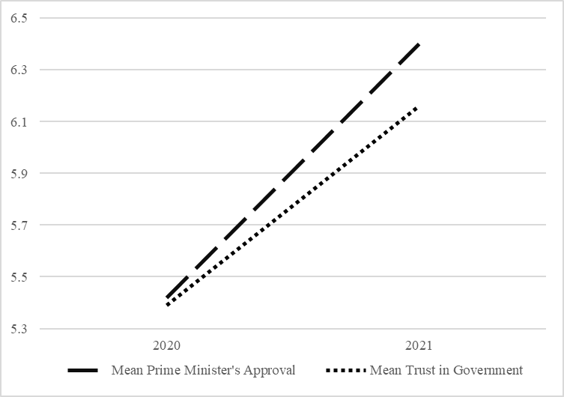
Figure 4
Mean Scores Prime Minister's Approval and Trust in Government in 2020 and 2021

Individual Diversity in the Rally-Round-the-Flag Effect
The main goal of this study is to explore the rally-round-the-flag phenomenon on the micro level. After concluding that the rally-round-the-flag effect has taken place in the Netherlands during the COVID-19 pandemic, seven OLS regression models have been estimated to examine the theories about the individual diversity in the rally phenomenon. After combining the datasets and filtering out cases with missing values on one or more of the included variables, I was left with 2643 respondents who have responded to all incorporated questions in this study. As the coefficients of several models needed to be compared, I have used this filtered group of 2643 respondents for all regression models. The first two models provide insight in the effect of opinion leadership and economic position on individual rallies. Model (1) estimates the correlation between individual Prime Minister’s approval and the control variables, party choice (for a coalition party or a critical opposition party), and economic position (determined by one’s primary occupation). Model (2) estimates the correlations between individual trust in government and the equal set of dependent variables. The results of these models can be found in Table 6. The standard deviation of each effect is shown in brackets. The statistical significance is presented by one (p-value < 0.1), two (p-value < 0.05) or three (p-value < 0.01) asterisks.
Table 6: Results of OLS Regression Analysis of Individual Diversity in Rallies
 |  | (1)  DV =  ΔPrime Minister’s Approval | (2)  DV =  ΔTrust in Government
Intercept |  | 2.146***  (0.233) |  | 2.141***  (0.219)
Party Choice
Less Critical Opposition |  | Ref. |  | Ref.
Coalition |  | 0.428***  (0.072) |  | 0.284***  (0.063)
Critical Opposition |  | -0.302***  (0.111) |  | -0.719***  (0.103)
Economic Position
Paid Employment |  | Ref. |  | Ref.
Self-Employed |  | -0.298*  (0.154) |  | -0.071  (0.140)
Unemployed |  | -0.363*  (0.216) |  | -0.318  (0.196)
Other |  | -0.173**  (0.086) |  | -0.073  (0.078)
Control Variables
Base Level Prime Minister’s Approval |  | -0.307***  (0.014)
Base Level Trust in Government |  |  |  | -0.393***  (0.015)
Gender |  | 0.205***  (0.064) |  | 0.082  (0.058)
Age |  | 0.008***  (0.003) |  | 0.012***  (0.002)
Level of Education |  | -0.078***  (0.023) |  | 0.009  (0.021)
Migration Background |  | -0.002***  (0.001) |  | -0.002***  (0.001)
N |  | 2643 |  | 2643
Standard errors in parentheses
*p < 0.1 **p < 0.05 ***p < 0.01

Opinion Leadership
Based on the theory of opinion leadership, I have hypothesized that individual diversity in the rally-round-the-flag effect can be explained by party choice. Given that the Dutch opposition is not one identical block, I theorized that the mechanism of opinion leadership works differently in the Netherlands. Therefore, the Dutch voters have been divided into three groups: Voters for coalition parties VVD, CDA, D66 and ChristenUnie, voters for critical opposition parties PVV and FvD and voters for relatively less critical opposition parties, which form the remainder of opposition parties. I have argued that voters for opposition parties which were portrayed as critical of the government’s handling of the COVID-19 pandemic (namely, the PVV and FvD) experienced a less substantial rally than voters for opposition parties which were portrayed as less critical of the government’s approach. Moreover, I stated that voters for coalition parties experienced more sizeable rallies than voters for opposition parties which were portrayed as relatively less critical of the government’s approach to the COVID-19 pandemic. Based on these theoretical notions, I devised the following four hypotheses:
Hypothesis 2a: Voters for coalition parties have a larger increase in Prime Minister’s approval than voters for opposition parties which were portrayed as relatively less critical of the government’s approach to the COVID-19 crisis.
Hypothesis 2b: Voters for opposition parties which were portrayed as critical of the government’s approach to the COVID-19 crisis have a smaller increase in Prime Minister’s approval than voters for opposition parties which were portrayed as relatively less critical of the government’s approach to the COVID-19 crisis.
Hypothesis 3a: Voters for coalition parties have a larger increase in trust in government than voters for opposition parties which were portrayed as relatively less critical of the government’s approach to the COVID-19 crisis.
Hypotheses 3b: Voters for opposition parties which were portrayed as critical of the government’s approach to the COVID-19 crisis have a smaller increase in trust in government than voters for opposition parties which were portrayed as relatively less critical of the government’s approach to the COVID-19 crisis.
Two OLS regression models have been estimated to test the hypotheses about party choice. The voters for coalition parties and voters for critical opposition parties have been included as dummy variables. Voters for less critical opposition parties served as the reference category. The results of Model (1) show that there is a significant (p < 0.01) positive difference of 0.428 in the change in Prime Minister’s approval between coalition voters and less critical opposition voters. In other words, voters for coalition parties experienced a 0.428 points larger increase in Prime Minister’s approval during the COVID-19 pandemic than voters for less critical opposition parties. This effect confirms Hypothesis 2a. This model additionally corroborates Hypothesis 2b, as there is a significant (p < 0.01) negative difference of -0.302 between voters for critical opposition parties and voters for less critical opposition parties concerning their change in Prime Minister’s approval. This means that voters for critical opposition parties had a 0.302 points smaller increase in Prime Minister’s approval during the COVID-19 crisis than voters for less critical opposition parties. These significant coefficients additionally show that the difference between the constituencies of the coalition and the critical opposition regarding their change in Prime Minister’s approval is 0.730. This indicates that coalition voters experienced a 0.730 points higher increase in Prime Minister’s approval than voters for the critical opposition. Furthermore, evidence has been found for the same distinctions of voters involving their change in trust in government. Firstly, Model (2) presents a significant (p < 0.01) positive difference of 0.284 between coalition voters and less critical opposition voters. This indicates that voters for coalition parties experienced a 0.284 points larger increase in governmental trust than voters for less critical opposition parties during the COVID-19 crisis. This effect supports Hypothesis 3a. A statistically significant (p < 0.01) difference, albeit negative, has also been found between critical opposition voters and less critical opposition voters. Citizens who have voted for one of the critical opposition parties perceived a 0.719 points smaller increase in their change in trust in government than citizens who voted for less one of the less critical opposition parties during the pandemic, which confirms Hypotheses 3b. These significant results also demonstrate that coalition voters experienced a 1.003 larger increase in trust in government than voters for the critical opposition. In conclusion, these first two models illustrate that voters for coalition parties experienced the largest individual rallies, followed by voters for less critical opposition parties who experienced less substantial rallies and in turn followed by voters for critical opposition parties who experienced even smaller individual rallies.
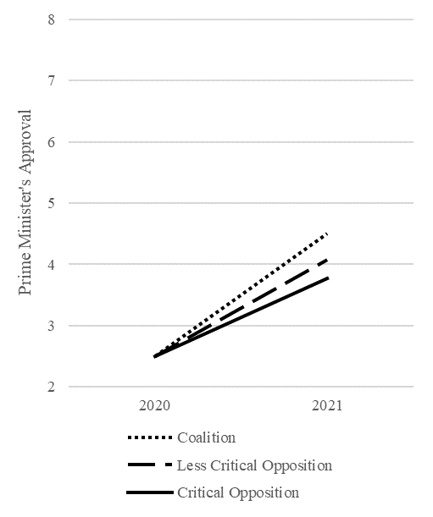
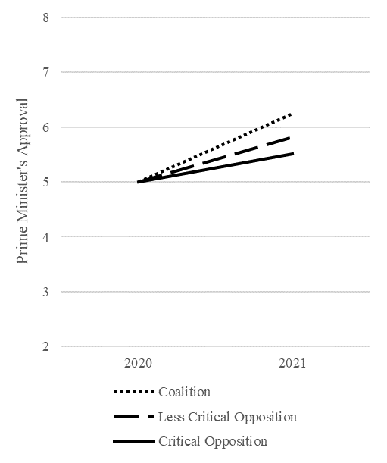
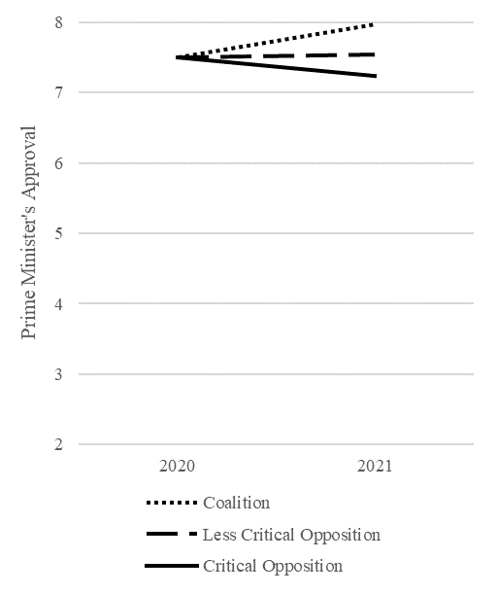
To make these regression results more tangible, I have created a hypothetical person which scores averagely on each of the variables and used these scores to fill out the regression formulas of Model (1) and Model (2). For the ordinal and dummy variables, the most frequently chosen option has been selected. This hypothetical person is a 44-year-old female with a Dutch background. She has an HBO diploma and belongs to the primary occupation category “other”. To illustrate the effect party choice can have on Prime Minister’s approval and governmental trust, I have altered the party choice of this hypothetical citizen from coalition, to less critical opposition to critical opposition and her base levels of Prime Minister’s approval and trust in government from 2.5, to 5.0 to 7.5, while keeping the rest of the variables constant. Using these scores and the regression equations, I have calculated the changes in Prime Minister’s approval and governmental trust for the three groups of voters, starting from three base levels in 2020. The results of these calculations are presented in Appendix 5 and the graphs of Figures 5 and 6. These graphs show that when this hypothetical person would have voted for the coalition in the elections of 2017, she would have had the highest increase in Prime Minister’s approval and in trust in government. Would she have voted for the less critical opposition, she would have experienced an increase in Prime Minister’s approval and trust in government starting from base levels 2.5 and 5.0, and a tiny decrease in Prime Minister’s approval and trust in government starting from base level 7.5. When she would have voted for the critical opposition, she would have had the smallest increase in in Prime Minister’s approval and in governmental trust, starting from base levels 2.5 and 5.0, and a sizeable decrease in Prime Minister’s approval and in trust in government starting from base level 7.5. In other words, the coalition’s constituency had the most significant rallies, followed by voters for the less critical opposition. Voters for the critical opposition had even smaller individual rallies, and when their base level in 2020 was high, they even experienced the run-from-the-flag effect. The ranking of these scores demonstrates that the regression formulae are in line with my expectations.
Figure 5
Mean Scores Prime Minister's Approval Differentiated by Party Choice
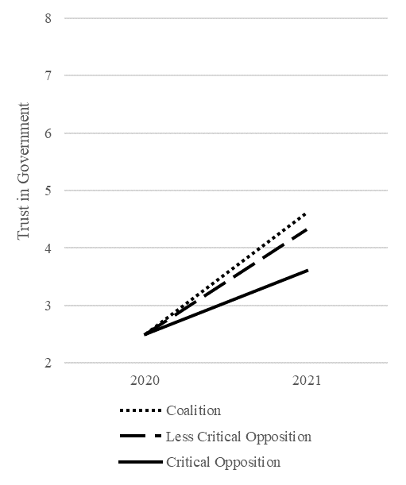
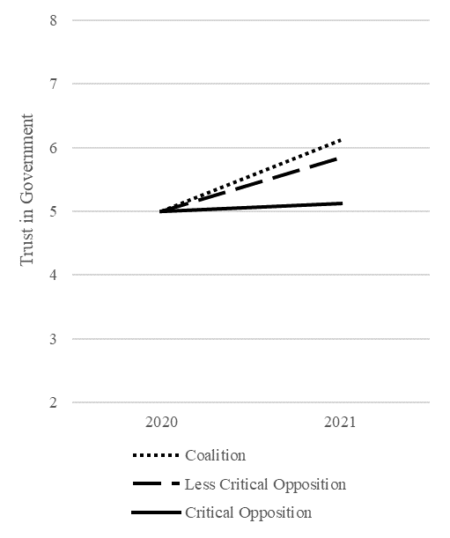
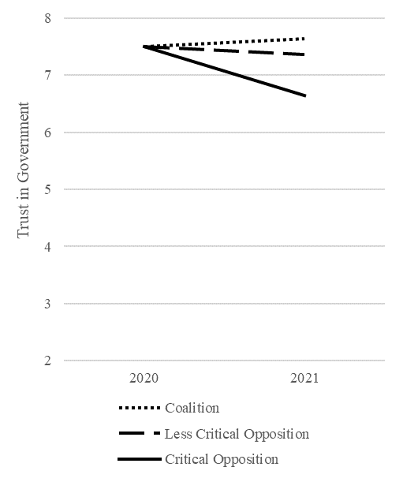
Figure 6
Mean Scores Trust in Government Differentiated by Party Choice
As I wish to explain the micro diversity in the rally-round-the-flag phenomenon as accurately as possible, another party choice distinction has been made: Voters for VVD and voters for other coalition parties than VVD. In order to measure the difference in rallies between these two groups, two more dummy variables have been created: 1) VVD Dummy and 2) Other Coalition Party than VVD Dummy (Appendix 2). Citizens who have voted for VVD score 1 on the VVD Dummy and 0 on the Other Coalition Party than VVD Dummy, and citizens who have voted for one of the other coalition parties CDA, D66 or ChristenUnie score 0 on the VVD Dummy and 1 on the Other Coalition Party than VVD Dummy. Models (1) and (2) have been estimated again, but I left out the Coalition Dummy and included the dummy variables Other Coalition Party than VVD and Less Critical Opposition (Appendix 6). The dummy variable VVD serves as the reference category. In this manner, I have analyzed the differences between VVD voters and voters for other coalition parties, while controlling for the constituency of opposition parties.
The results of these analyses (Table 14, Appendix 6) show that there is a significant (p < 0.01) difference of -0.324 in the increase of Prime Minister’s approval between voters who have voted another coalition party than the VVD and VVD voters. In other words, citizens who have voted for CDA, D66 or ChristenUnie experienced a 0.324 points smaller increase in Prime Minister’s approval than citizens who have voted for VVD. This indicates that during the COVID-19 pandemic, Prime Minister Mark Rutte won the largest gain in support from his own constituency. The government additionally acquired the biggest amount of trust from VVD voters, as there is a significant (p < 0.1) negative difference between voters for other coalition parties and VVD voters. Individuals who have voted for CDA, D66 or ChristenUnie had a 0.136 smaller increase in trust in government than individuals who have voted for VVD. These results provide detailed information about party choice and the rally-round-the-flag effect. On top of that, the outcome of this analysis are in contradiction with the conclusions of Beijen, Otjes and Kanne (2021), who have found no evidence for a significant partisan effect. Their analysis did not show that those who already support the Prime Minister’s party are more likely to support his policies. Therefore, this study’s verification of the partisan effect serves as a valuable contribution to academic literature about the rally-round-the-flag phenomenon.
Given that voters for a different coalition party than VVD experienced a 0.324 points smaller increase in Prime Minister’s approval than the VVD’s constituency and that voters for the less critical opposition had a 0.428 points smaller increase than coalition voters, it is relevant to assess whether there is a significant difference in the increase in Prime Minister’s approval between voters for a different coalition party than VVD and voters for a less critical opposition party. Moreover, voters for a different coalition party than VVD had a 0.136 smaller increase in trust in government than citizens who have voted for VVD and voters for the less critical opposition experienced a 0.284 smaller increase in governmental trust than coalition voters. As these scores are quite similar, it is worthwhile to additionally examine whether there is a significant difference in the increase in trust in government between voters for a different coalition party than VVD and voters for a less critical opposition party. Therefore, I have estimated Models (1) and (2) another time, excluding the Coalition Dummy, but including the dummies VVD and Other Coalition Party than VVD. As in the original models, the dummy Critical Opposition was included as well, while voters for the less critical opposition serve as the reference category (Appendix 6). In this way, I can compare the scores of voters for one of the other coalition parties than VVD to voters for the less critical opposition.
The results of these analyses are presented in Table 15, Appendix 6. According to the estimated model, citizens who have voted for another coalition party than VVD (which could be CDA, D66 or ChristenUnie), experienced a significantly (p < 0.01) higher increase in Prime Minister’s approval than voters for the less critical opposition. This indicates that although the scores in the previous models were fairly similar, voters for one of the other coalition parties than VVD still had a 0.293 higher increase in Prime Minister’s approval than voters for the less critical opposition. The second model shows comparable results, as citizens who have voted for a different coalition party than VVD increased their trust in government 0.206 points more than voters for the less critical opposition. This effect also reached significance (p < 0.01). Hence, these analyses demonstrate that the constituencies of the VVD, of the other coalition parties, and of the less critical and critical opposition all have had significantly different levels of individual rallies, with VVD voters experiencing the most substantial rallies and critical opposition voters the least substantial ones.

Economic Position
The theoretical discussion about the relationship between economic position and individual rallies resulted in the next four hypotheses, including two mediation hypotheses involving economic insecurity:
Hypothesis 4a: Self-employed workers and unemployed citizens have a smaller increase in Prime Minister’s approval than paid employees.
Hypothesis 4b: Self-employed workers and unemployed citizens have a smaller increase in trust in government than paid employees.
Hypothesis 5a: The effect of belonging to an economically marginalized group on Prime Minister’s approval can (partially) be explained by a rise in economic insecurity.
Hypothesis 5b: The effect of belonging to an economically marginalized group on trust in government can (partially) be explained by a rise in economic insecurity
Models (1) and (2) (Table 6) were additionally designed to test the effect of one’s economic position on the level of individual rallies. I have included the primary occupations “self-employed”, “unemployed” and “other” as dummy variables and “paid employment” was used as the reference category. The goal of these dummies is to examine the individual diversity in rallies between several economically marginalized groups, as some societal groups were hit harder by the COVID-19 measures than others. I hypothesized that self-employed workers and unemployed citizens were less satisfied than paid employees with the government’s approach of the pandemic, and thus experienced a smaller rally-round-the-flag effect. As I only wished to compare these three marginalized groups, all other primary occupations were included as a single dummy control variable Other. The first model presents a significant (p < 0.1) negative difference of -0.298 between entrepreneurs and paid employees. This indicates that individuals who are self-employed had a 0.298 points smaller rise in Prime Minister’s approval than paid workers during the COVID-19 crisis. Jobless citizens also experienced a significantly smaller rise (p < 0.1) in Prime Minister’s approval than paid employees during the pandemic. Their Prime Minister’s approval increased 0.363 points less than that of paid employees. These two effects support Hypothesis 4a. Unfortunately, the effects of the dummy variables Self-Employed and Unemployed on the difference in trust in government did not reach significance. In other words, no significant difference was found between entrepreneurs and paid workers and between jobless citizens and paid employees in their increase in governmental trust. Therefore, Hypothesis 4b is not supported. These results demonstrate that my theory of economic position only clarifies the individual difference in the change in Prime Minister’s approval, but cannot explain the individual difference in the change in trust in government. Hence, this theory does not necessarily explain the individual diversity in the rally-round-the-flag phenomenon.

Mediation of Economic Insecurity
Models (3), (4) and (5) were used to analyze the mediation effect of the difference in economic insecurity on the effect of belonging to one of the economically marginalized groups “self-employed” or “unemployed” on individual Prime Minister’s approval and trust in government. Table 7 presents the results of these regression analyses. The statistical significance is presented by one (p-value < 0.1), two (p-value < 0.05) or three (p-value < 0.01) asterisks.
Table 7: Results of OLS Regression Analysis of Mediation of ΔEconomic Insecurity
 | (3)  DV =  ΔPrime Minister’s Approval | (4)  DV =  ΔTrust in Government | (5)  DV =  ΔEconomic Insecurity
Intercept | 1.498***  (0.261) | 1.578***  (0.241) | -1.804***  (0.256)
Party Choice
Less Critical Opposition | Ref. | Ref.
Coalition | 0.404***  (0.072) | 0.255***  (0.063)
Critical Opposition | -0.293***  (0.111) | -0.722***  (0.102)
Economic Position
Paid Employment | Ref. | Ref. | Ref.
Self-Employed | -0.251  (0.154) | -0.029  (0.140) | 0.352***  (0.099)
Unemployed | -0.231  (0.216) | -0.193  (0.196) | 0.530***  (0.139)
Other | -0.113  (0.086) | -0.019  (0.078) | 0.071  (0.055)
Economic Insecurity
ΔEconomic Insecurity | -0.071**  (0.030) | -0.077***  (0.027)
Base Level Economic Insecurity | 0.125***  (0.023) | 0.116***  (0.021) | 0.326***  (0.013)
Control Variables
Base Level Prime Minister’s Approval | -0.322***  (0.014)
Base Level Trust in Government |  | -0.410***  (0.015)
Gender | 0.213***  (0.064) | 0.087  (0.058) | -0.062  (0.041)
Age | 0.005*  (0.003) | 0.009***  (0.002) | -0.009***  (0.002)
Level of Education | -0.088***  (0.023) | -0.001  (0.021) | -0.050***  (0.014)
Migration Background | -0.001**  (0.001) | -0.002***  (0.001) | 0.000  (0.000)
N | 2643 | 2643 | 2643
Standard errors in parentheses
*p < 0.1**p < 0.05 ***p < 0.01
There are four necessary conditions to establish support for a mediation hypothesis (Field, 2017):
- The direct effect of the independent variable (X) on the dependent variable (Y) (effect c) should be significant;
- The effect of the independent variable on the mediation variable (Z) (effect a) should be significant;
- The effect of the mediation variable on the dependent variable (effect b) should be significant;
- The effect of the independent variable on the dependent variable when controlling for the mediation variable (effect c’) should be smaller than the direct effect (c) or lose its significance.
Table 8 and Table 9 give an overview of the mediation effect of the difference in economic insecurity on the two dependent variables. Firstly, I will analyze whether the change in economic insecurity mediates the difference between being self-employed and being a paid employee, concerning the change in Prime Minister’s approval. The difference between the self-employed and paid employees (direct effect c) regarding the change in Prime Minister’s approval is significant (p < 0.1) with a coefficient of -0.298 (Table 8). The same counts for the difference between being an entrepreneur and being a paid employee involving the change in economic insecurity (effect a), which has a significant (p < 0.01) coefficient of 0.352. This indicates that entrepreneurs experienced a 0.352 larger rise in economic insecurity than paid employees during the pandemic. The effect of the change in economic insecurity on the difference in Prime Minister’s approval (effect b) is significant (p < 0.05), with a coefficient of -0.071. This indicates that citizens whose economic insecurity has increased with 1 point, lowered their Prime Minister’s approval with 0.071 points. When controlling for the change in economic insecurity, the difference between being self-employed and being a paid employee involving the Prime Minister’s approval is smaller and loses its significance. According to the necessary conditions as listed by Field (2017), this mediation effect is therefore supported.
I also found evidence for the mediation effect of the change in economic insecurity on the difference between being unemployed and being a paid employee, regarding the change in Prime Minister’s approval. The difference between the unemployed and the paid workers involving their Prime Minister’s approval (direct effect c) is significant (p < 0.1) with a coefficient of
-0.363 (Table 9). The difference in economic insecurity between being jobless and being a paid employee (effect a) with a coefficient of 0.530 is significant as well (p < 0.01). This indicates that the unemployed experienced a 0.530 larger increase in economic insecurity than paid employees during the pandemic. Effect b is similar for all independent variables, so it remains significant (p < 0.05). When controlling for the change in economic insecurity, the difference between the unemployed and the paid employees (effect c’) concerning the change in Prime Minister’s approval decreases from -0.363 to -0.231 and loses its significance. As a result, the mediation effect of the change in economic insecurity on the difference of being unemployed or a paid employee involving the difference in Prime Minister’s approval is supported. Given that the mediation effect on being self-employed is additionally supported, Hypothesis 5a is confirmed.
Table 8: Mediation ΔEconomic Insecurity of Economic Position on ΔPrime Minister's Approval
Variable  Effect | Self-Employed | Unemployed
Direct Effect X on Y (c) | -0.298*  (0.154) | -0.363*  (0.216)
X on Z (a) | 0.352***  (0.099) | 0.530***  (0.139)
Z on Y (b) | -0.071**  (0.030) | -0.071**  (0.030)
X on Y (c’)  when controlling for Z | -0.251  (0.154) | -0.231  (0.216)
Conclusion | Supported | Supported
Reference category: Paid Employment
Standard errors in parentheses
*p < 0.10 **p < 0.05 ***p < 0.01
As visible in Table 9, none of the mediation effects involving the change in trust in government are supported. The reason for this is that the difference between the self-employed and paid employees and the difference between the unemployed and paid employees (effect c) did not reach significance. Therefore, Hypothesis 5b will be rejected. However, I did find indications for two indirect effects, given that the variables Self-Employed and Unemployed do have three other significant coefficients. The first significant (p < 0.01) coefficient (which is similar for both variables) is the effect of the difference in economic insecurity on the difference in trust in government (effect b), which is -0.077. In other words, people who have a 1 point increase in economic insecurity during the COVID-19 pandemic lowered their governmental trust with 0.077 points. The second significant (p < 0.01) coefficient is the difference between entrepreneurs and the paid employees concerning their change in economic insecurity (effect a). This effect of 0.352 indicates that during the COVID-19 pandemic, self-employed experienced a 0.352 points larger increase in economic insecurity than paid workers. The third significant (p < 0.01) coefficient is the difference between being jobless and being a paid employee regarding the change in economic insecurity (effect a). In other words, the unemployed had a 0.530 larger increase in economic insecurity than the paid employees during the COVID-19 pandemic. To ensure whether the mediator significantly carries the influence of the independent variables Self-Employed and Unemployed to the dependent variable Difference in Trust in Government, I have carried out two Sobel tests, of which the results can be found in Table 16, Appendix 7. The Sobel tests confirm that there is significant (p < 0.05) indirect effect of economic position on the difference in trust in government, passing through the difference in economic insecurity.
Table 9: Mediation ΔEconomic Insecurity of Economic Position on ΔTrust in Government
Variable  Effect | Self-Employed | Unemployed
Direct Effect X on Y (c) | -0.071  (0.140) | -0.318  (0.196)
X on Z (a) | 0.352***  (0.099) | 0.530***  (0.139)
Z on Y (b) | -0.077***  (0.027) | -0.077***  (0.027)
X on Y (c’)  when controlling for Z | -0.029  (0.140) | -0.193  (0.196)
Conclusion | Not supported | Not supported
Reference category: Paid Employment
Standard errors in parentheses
*p < 0.10 **p < 0.05 ***p < 0.01

Chapter 5: Conclusion
Besides its consequences for international health and the economy, the COVID-19 pandemic has had important political implications. In this Master’s thesis, I have examined one of the most important political consequences of the COVID-19 crisis, namely, whether the pandemic sparked the rally-round-the-flag phenomenon in the Netherlands. As I did not expect an equal rally effect for each Dutch citizen, considering the complex political system in the Netherlands, I dove a little deeper and made several distinctions between population groups. This gave me the opportunity to investigate this phenomenon on the micro level. By means of ten hypotheses, I sought to answer the following research question:
Has the COVID-19 pandemic generated the rally-round-the-flag phenomenon in the Netherlands
and how does this vary on the individual level?
First of all, the paired samples T-test delivered evidence that both the mean Prime Minister’s approval and the mean trust in government increased significantly during the COVID-19 crisis. In other words, the COVID-19 pandemic has generated a national rally-round-the-flag effect in the Netherlands. This result has important implications for the further study of the rally phenomenon. Namely, it once again illustrates that the rally-round-the-flag phenomenon occurs outside the United States, and in particular, in a multi-party coalition system. Moreover, it proves that besides wars and diplomatic incidents, an international pandemic is able to trigger the rally-round-the-flag effect.
After observing this notable first result, several theories surrounding the rally-round-the-flag phenomenon have been examined. This led to two conclusions regarding the micro diversity in the rally-round-the-flag effect. Firstly, the results of the analyses demonstrated that there is a significant difference between coalition voters, voters for the critical opposition and voters for the relatively less critical opposition in their increases in Prime Minister’s approval and trust in government. Specifically, voters for a coalition party had the most substantial rallies, followed by voters for the relatively less critical opposition and in turn followed by voters for the critical opposition. This indicates that using the mechanism of opinion leadership on the micro level theoretically substantiates individual diversity in the rally-round-the-flag effect. Even in a highly volatile political system as the Netherlands, voters seem to be affected by the standpoints of their preferred party and parties’ behavior during a crisis can directly influence individual levels of political trust. Therefore, my first conclusion about micro diversity in the rally-round-the-flag effect is that the individual difference in COVID-19 rallies in the Netherlands can be explained by party choice and opinion leadership.
Secondly, the analysis of the role of economic position concerning individual rallies demonstrated that there is a significant negative difference between the self-employed, unemployed and paid workers in their increase in Prime Minister’s approval. The self-employed and jobless experienced a smaller increase in Prime Minister’s approval than paid employees. Unfortunately, no such effect was found for the difference in trust in government. Consequently, I conclude that economic position does not explain the individual diversity in the rally effect generated by the COVID-19 pandemic in the Netherlands. Still, this result does contribute noteworthy information about the role of economic position in the individual diversity of the rally-round-the-flag phenomenon. The discrepancy between the degree of the increase in Prime Minister’s approval and the degree of the increase in governmental trust is reflected throughout this study, given that the effects on the difference in Prime Minister’s approval continually turned out to be more sizeable than the effects on the difference in trust in government. Perhaps this is due to Dutch Prime Minister Mark Rutte and Health Minister Hugo de Jonge being the face of the COVID-19 strategies, instead of the government as a whole. This leads to citizens mainly blaming the Prime Minister for the degradation of their economic position or praising him for his handling of the crisis, rather than attributing this to the whole government.
Although individual economic positions did not prove to serve as a significant explanation for the micro diversity in tallies, the mediation models of this thesis present interesting results on both the difference in Prime Minister’s approval and the difference in trust in government. Namely, the OLS regression models showed that the difference between the self-employed, the unemployed and paid employees in their increase in Prime Minister’s approval can be explained by an individual increase in economic insecurity. As there was no significant difference between self-employed, unemployed citizens and paid employees in their increase in governmental trust, a second mediation effect was refuted. Nonetheless, the regression models and the Sobel tests did present a significant indirect effect of economic position on both the difference in Prime Minister’s approval and in trust in government, via the change in economic insecurity. The positive difference between the self-employed, unemployed and paid employees regarding their change in economic insecurity reached statistical significance, which means that entrepreneurs and jobless citizens had a higher increase in economic insecurity than paid workers. This provides evidence for our theoretical expectation that self-employed and unemployed citizens were financially affected more heavily by the COVID-19 pandemic than paid employees. On top of that, the analyses produced significant negative effects of the change in economic insecurity on the difference in Prime Minister’s approval and of the change in economic insecurity on the difference in governmental trust. This indicates that citizens whose economic insecurity increased during the pandemic, had a significantly smaller increase in Prime Minister’s approval and trust in government. This result corresponds with Wroe’s (2016) argument that the state is blamed for a rise in economic insecurity, which leads to a decline in political trust. I believe that the observed indirect effect cancels out the effect of economic position on the level of governmental trust, given that it starts as a positive effect of the independent variable on the mediator and continues as a negative effect of the mediator on the dependent variable. This could explain why the effect of one’s economic position on the individual increase in trust in government did not reach statistical significance. This means that these results do comply with my theoretical expectations, but that the mechanism works differently than anticipated. To conclude, besides party choice, a change in economic insecurity can additionally explain the micro diversity in the rally-round-the-flag effect.

Discussion
As the design and results of this study are based on a single case, one has to be cautious with generalizing its results to other states and political systems. Moreover, this thesis is not without limitations. In the first place, there is a discrepancy between the fielding times of Economic Situation: Income (CentERdata, 2019, 2020a) and Politics and Values (ibid., 2020b, 2021b). Wave 12 of the questionnaire Economic Situation: Income was carried out between June and July 2019 and Wave 13 between June and July 2020. I have used this questionnaire to measure the individual change in economic insecurity during the COVID-19 pandemic. Of the questionnaire Politics and Values I have used Wave 12, which was fielded between December 2019 and March 2020 and Wave 13, which was fielded between December 2020 and March 2021. I have selected this questionnaire to measure the difference in Prime Minister’s approval and trust in government during the COVID-19 crisis. As both surveys are carried out on different time points, the computed variables in this study are based on different periods. This could lead to an underestimation of the coefficients, given that in the summer of 2020, the COVID-19 measures were relatively new and possibly did not yet affect the Dutch economy as much as in a later stage of the pandemic. Hence, one has to be careful with interpreting the results of the mediation analyses. Nonetheless, both questionnaires were measured before and after the peak of the pandemic, which is why I do not expect my conclusions to be problematic.
Secondly, the variable of economic insecurity is measured based on satisfaction with one’s economic situation. When selecting this question from the questionnaires (CentERdata, 2019, 2020a), I assumed that when someone’s satisfaction with their economic situation increases, their risk of economic misfortune and therefore their economic insecurity would have decreased during the same period. Naturally, one can wonder whether this survey question accurately captures the individual level of economic insecurity, as the concepts of economic satisfaction and economic insecurity are not identical. As I have used unique panel data of LISS Panel which contains and equal group of respondents questioned in multiple instances, I did not choose to replace my data in order to seek for a more suitable measurement for the variable of economic insecurity. When interpreting the results of this thesis, one has to keep in mind that the difference economic insecurity is measured by a change in economic satisfaction.
Aside from is limitations, this thesis provides a strong base for future research on the rally-round-the-flag effect generated by the COVID-19 pandemic and the functioning of this phenomenon on the micro level. This research demonstrates that the effect of the COVID-19 crisis on the increase in Prime Minister’s approval has continued to be larger than the effect on the increase governmental trust. I argued that this possibly originates from the prominent role the Dutch Prime Minister has played during the pandemic, instead of involving the whole government when communicating to the public. Perhaps, future research can assess whether the visibility of the Prime Minister or President during a crisis affects the extent to which citizens increase their presidential approval as opposed to their trust in government. Additionally, follow-up research could examine whether the opinion leadership mechanism is the genuine theory which explains the difference in rallies between the constituencies of the political coalition, the critical opposition and the relatively less critical opposition. Possibly, patriotism plays a larger role than this study acknowledges. In addition, future research can further elaborate on the role of economic position, as the analyses only provided evidence for the effect of economic position on Prime Minister’s approval. The problem of my analysis may be founded in the division between entrepreneurs, paid employees and unemployed citizens. Therefore, a different group distinction or measuring one’s economic position in a distinct manner may result in other conclusions about the effect of economic position on individual rallies. For instance, one could make a distinction between paid workers with an open-ended contract and a flexible contract, as I expect employees with a flexible contract to be affected more by the economical consequences of the pandemic. Furthermore, upcoming studies could include the group of non-voters, as these citizens conceivably have deeply low levels of political trust, which causes them not to vote. It might be interesting to examine how a pandemic or a different crisis influences their political trust. Last but not least, the design of this study can be applied to multiple cases, in order to investigate whether the same level of individual heterogeneity in the rally effect can be observed in other states and other party systems. Altogether, this study has proven to be a meaningful starting point for future research.
This Master’s thesis on the Dutch COVID-19 rally and its individual implications made several contributions to the academic literature on the rally-round-the-flag phenomenon. First and foremost, this study has provided evidence for a rally induced by the SARS-CoV-2 virus in the Netherlands. Subsequently, this thesis has demonstrated there is a significant difference in individual rallies based on the electoral choice for a coalition party, a less critical opposition party or a critical opposition party. As not many studies are yet dedicated to the role of party choice regarding the rally-round-the-flag phenomenon, this result can be considered innovative in scientific literature. On top of that, the results on the impact of one’s economic position on individual rallies and the fundamental position of economic insecurity add a substantive amount of valuable knowledge to the field of comparative politics. In summary, this thesis provides essential additions to the broader discussion on international crises and political trust.

List of References
Baekgaard, M., Christensen, J., Madsen, J. K., & Mikkelsen, K. S. (2020). Rallying around the flag in times of COVID-19: Societal lockdown and trust in democratic institutions. Journal of Behavioral Public Administration, 3(2), 1–12. https://doi.org/10.30636/jbpa.32.172
Baum, M. A. (2002). The Constituent Foundations of the Rally-Round-the-Flag Phenomenon. International Studies Quarterly, 46(2), 263–298. https://doi.org/10.1111/1468-2478.00232
Beijen, M., Otjes, S., & Kanne, P. (2021). Rally ’Round the Prime Minister: A study into the effects of a diplomatic conflict on public opinion under coalition government. Acta Politica. Published. https://doi.org/10.1057/s41269-020-00190-4
Bol, D., Giani, M., Blais, A., & Loewen, P. J. (2020). The effect of COVID‐19 lockdowns on political support: Some good news for democracy? European Journal of Political Research, 60(2), 497–505. https://doi.org/10.1111/1475-6765.12401
Brody, R. (1991). The Rally Phenomenon in Public Opinion. In R. Brody (Ed.), Assessing the President: The Media, Elite Opinion, and Public Support (pp. 45–80). Stanford, CA: Stanford University Press.
CentERdata. (2019). Income Wave 12 [Dataset]. Retrieved from https://www.dataarchive.lissdata.nl/study_units/view/869
CentERdata. (2020a). Income Wave 13 [Dataset]. Retrieved from https://www.dataarchive.lissdata.nl/study_units/view/35
CentERdata. (2020b). Politics and Values Wave 12 [Dataset]. Retrieved from https://www.dataarchive.lissdata.nl/study_units/view/22
CentERdata. (2021a). Background Variables [Dataset]. Retrieved from https://www.dataarchive.lissdata.nl/study_units/view/322
CentERdata. (2021b). Politics and Values Wave 13 [Dataset]. Retrieved from https://www.dataarchive.lissdata.nl/study_units/view/22
Centraal Bureau voor de Statistiek. (2021a, February 16). Arbeidsdeelname; kerncijfers. Retrieved 17 May 2021, from https://www.cbs.nl/nl-nl/cijfers/detail/82309ned
Centraal Bureau voor de Statistiek. (2021b, February 16). Ontwikkelingen op de arbeidsmarkt in vierde kwartaal minder turbulent. Retrieved 13 May 2021, from https://www.cbs.nl/nl-nl/nieuws/2021/07/ontwikkelingen-op-de-arbeidsmarkt-in-vierde-kwartaal-minder-turbulent
Costello, R. (2020). Rally around the EU flag: Irish party positions on the EU in the wake of Brexit. Journal of Contemporary European Studies, 1–17. https://doi.org/10.1080/14782804.2020.1825352
Cunningham, K. (2020, May 28). The Rally-around-the-flag-effect and Covid-19. Retrieved 21 January 2020, from https://ukandeu.ac.uk/the-rally-round-the-flag-effect-and-covid-19/
De Blaaij, C. (2021, April 7). De voor- en nadelen van een vast contract voor werkgevers. Retrieved 17 May 2021, from https://www.xluitzendbureau.nl/blog/voor-en-nadelen-van-een-vast-contract/#:%7E:text=U%20moet%20100%20procent%20zeker,functie%20en%20voor%20uw%20bedrijf.&text=Dit%20zijn%20de%20belangrijkste%20voor,een%20vast%20contract%20voor%20werkgevers.
Dominitz, J., & Manski, C. F. (1997). Perceptions of Economic Insecurity: Evidence From the Survey of Economic Expectations. Public Opinion Quarterly, 61(2), 261–287. https://doi.org/10.1086/297795
Dong, E., Du, H., & Gardner, L. (2020). An interactive web-based dashboard to track COVID-19 in real time. The Lancet Infectious Diseases, 20(5), 533–534. https://doi.org/10.1016/s1473-3099(20)30120-1
Field, A. (2017). Discovering Statistics Using IBM SPSS Statistics. Thousand Oaks, Canada: SAGE Publications.
Fieschi, C., & Heywood, P. (2004). Trust, cynicism and populist anti‐politics. Journal of Political Ideologies, 9(3), 289–309. https://doi.org/10.1080/1356931042000263537
Financial Times. (2021, March 25). Lockdowns compared: tracking governments’ coronavirus responses. Retrieved 14 April 2021, from https://ig.ft.com/coronavirus-lockdowns/
Geling, G. J. (2020). Ik hou van Holland. Pleidooi voor patriottisme. Amsterdam, Netherlands: Bert Bakker.
Geurkink, B., Zaslove, A., Sluiter, R., & Jacobs, K. (2019). Populist Attitudes, Political Trust, and External Political Efficacy: Old Wine in New Bottles? Political Studies, 68(1), 247–267. https://doi.org/10.1177/0032321719842768
Goren, P., Federico, C. M., & Kittilson, M. C. (2009). Source Cues, Partisan Identities, and Political Value Expression. American Journal of Political Science, 53(4), 805–820. https://doi.org/10.1111/j.1540-5907.2009.00402.x
Groeling, T., & Baum, M. A. (2008). Crossing the Water’s Edge: Elite Rhetoric, Media Coverage, and the Rally-Round-the-Flag Phenomenon. The Journal of Politics, 70(4), 1065–1085. https://doi.org/10.1017/s0022381608081061
Haas, de, M., Faber, R., & Hamersma, M. (2020). How COVID-19 and the Dutch ‘intelligent lockdown’ change activities, work and travel behaviour: Evidence from longitudinal data in the Netherlands. Transportation Research Interdisciplinary Perspectives, 6, 100150. https://doi.org/10.1016/j.trip.2020.100150
Hardy, M. A. (1993). Regression with Dummy Variables. Thousand Oaks, Canada: SAGE Publications.
Heeg, R. (2020). Net afgestudeerd en werkloos? Nog jaren negatieve gevolgen. Retrieved from https://www.intermediair.nl/werk-en-carriere/loopbaanontwikkeling/net-afgestudeerd-en-werkloos-nog-jaren-negatieve-gevolgen
Heijst, L. (2021, May 28). T-test (t-toets) begrijpen en interpreteren. Retrieved June 1, 2021, from https://www.scribbr.nl/statistiek/t-toets/
Hetherington, M. J. (1998). The Political Relevance of Political Trust. American Political Science Review, 92(4), 791–808. https://doi.org/10.2307/2586304
Hetherington, M. J., & Nelson, M. (2003). Anatomy of a Rally Effect: George W. Bush and the War on Terrorism. Political Science and Politics, 36(01), 37–42. https://doi.org/10.1017/s1049096503001665
Klaassen, N. (2021, March 19). Na verkiezingen is er minder steun voor coronabeleid in parlement. Retrieved May 6, 2021, from https://www.parool.nl/nederland/na-verkiezingen-is-er-minder-steun-voor-coronabeleid-in-parlement~b5eea159/
Medgyesi, M., & Zólyomi, E. (2016, November). Job satisfaction and satisfaction in financial situation and their impact on life satisfaction (6). Retrieved from https://ec.europa.eu/social/BlobServlet?docId=17504&langId=en
Parlement. (n.d.). Minister-president. Retrieved May 6, 2021, from https://www.parlement.com/id/vh8lnhrogvvn/minister_president
Rijksoverheid. (n.d.). COVID-19-vaccinaties. Retrieved 16 February 2021, from https://coronadashboard.rijksoverheid.nl/landelijk/vaccinaties
Rooduijn, M. (2018). What unites the voter bases of populist parties? Comparing the electorates of 15 populist parties. European Political Science Review, 10(3), 351–368. https://doi.org/10.1017/s1755773917000145
Scherpenzeel, A. (2009, January). Start of the LISS panel: Sample and recruitment of a probability-based Internet panel. CentERdata. Retrieved from https://www.lissdata.nl/sites/default/files/bestanden/Sample%20and%20Recruitment_1.pdf
Scherpenzeel, A. C., & Das, M. (2018). “True” Longitudinal and Probability-Based Internet Panels: Evidence From the Netherlands. In M. Das, P. Ester, & L. Kaczmirek (Eds.), Social and Behavioral Research and the Internet: Advances in Applied Methods and Research Strategies (pp. 77–104). Retrieved from https://www.routledge.com/Social-and-Behavioral-Research-and-the-Internet-Advances-in-Applied-Methods/Das-Ester-Kaczmirek/p/book/9781848728172
Statistics Knowledge Portal. (n.d.). Regression Model Assumptions. Retrieved June 18, 2021, from https://www.jmp.com/en_us/statistics-knowledge-portal/what-is-regression/simple-linear-regression-assumptions.html
Van Ast, M., & Winterman, P. (2020, March 18). Coronavirus is nachtmerrie voor kabinet: ‘Een échte lockdown wil niemand.’ Retrieved May 6, 2021, from https://www.ad.nl/politiek/coronavirus-is-nachtmerrie-voor-kabinet-een-echte-lockdown-wil-niemand~abf819ed/
Wroe, A. (2015). Economic Insecurity and Political Trust in the United States. American Politics Research, 44(1), 131–163. https://doi.org/10.1177/1532673x15597745

Appendix

Appendix 1: Selected Variables from LISS Panel
Table 10: Selected variables from LISS Panel
Variable | Label | Source | Purpose(s)
geslacht | Gender | Background Variables March 2021 | Control variable: Gender
leeftijd | Age of the household member | Background Variables March 2021 | Control variable: Age
oplmet | Highest level of education with diploma | Background Variables March 2021 | Control variable: Level of Education
herkomstgroep | Origin | Background Variables March 2021 | Control variable: Migration Background
belbezig | Primary occupation | Background Variables March 2021 | Independent Dummy Variable: Primary Occupation
cv20l222 | What do you think of Mark Rutte? | Politics & Values Wave 12 | Dependent variable: Difference in Prime Minister’s Approval  Control variable: Base level Prime Minister’s Approval
cv20l013 | Confidence: Dutch government | Politics & Values Wave 12 | Dependent variable: Difference in Trust in Government  Control variable: Base level Trust in Government
cv21m222 | What do you think of Mark Rutte? | Politics & Values Wave 13 | Dependent variable: Difference in Prime Minister’s Approval
cv21m013 | Confidence: Dutch government | Politics & Values Wave 13 | Dependent variable: Difference in Trust in Government
cv21m307 | For which party did you vote in the parliamentary elections of 15 March 2017? | Politics & Values Wave 13 | Independent variable: Critical
ci19l006 | How satisfied are you with your financial situation? | Economic Situation: Income Wave 12 | Independent variable: Economic Insecurity  Control variable: Base level Economic Insecurity
ci20m006 | How satisfied are you with your financial situation? | Economic Situation: Income Wave 13 | Independent variable: Economic Insecurity
nomem_encr | Number of household member encrypted | All datasets | Identification of matching cases
Source: LISS Panel, CentERdata

Appendix 2: Computed Variables
Table 11: Manually Computed Variables
Variable | Label | Conduction
Difference in Prime Minister’s Approval | Difference in Prime Minister’s Approval between 2020 and 2021 | ΔPrime Minister’s Approval = Prime Minister’s Approval 2021 – Prime Minister’s Approval 2020
Difference in Trust in Government | Difference in Trust in Government between 2020 and 2021 | ΔTrust in Government = Trust in Government 2021 – Trust in Government 2020
Coalition | Voted for Coalition party in 2017 | Coalition = 1, if voted for VVD, CDA, D66 or ChristenUnie;  Coalition = 0, otherwise
Critical Opposition | Voted for Critical Opposition party (FvD/PVV) in 2017 | Critical Opposition = 1, if voted for Forum for Democracy or PVV; Critical Opposition = 0, otherwise
Less Critical Opposition | Voted for a Less Critical Opposition Party in 2017 | Less Critical Opposition = 1, if voted for GroenLinks, SP, PvdA, Partij voor de Dieren, 50Plus, SGP or DENK; Less Critical Opposition = 0, otherwise (ref.)
Difference in Economic Insecurity | Difference in Economic Insecurity between 2019 and 2020 | ΔDifference in Economic Insecurity = Satisfaction with Financial Situation 2019 – Satisfaction with Financial Situation 2020
Self-Employed | Autonomous professional, freelancer, or self-employed | Self-employed = 1, if answered Autonomous professional, freelancer, or self-employed;  Self-employed = 0, otherwise
Paid Employment | Paid employment | Paid Employment = 1, if answered Paid employment or Works or assists in family business;  Paid Employment = 0, otherwise
Unemployed | Unemployed (Involuntary) | Unemployed = 1, if answered Job seeker following job loss or First-time job seeker; Unemployment = 0, otherwise
Other | Not actively looking for a job or relatively less marginalized by the Dutch COVID-19 measures | Other = 1, if answered Exempted from job seeking following job loss, Attends school or is studying, Takes care of the housekeeping, Is pensioner (voluntary) early retirement, old age pension scheme), Has (partial) work disability, Performs unpaid work while retaining unemployment benefit, Performs voluntary work, Does something else, Is too young to have an occupation; Other = 0, otherwise
VVD | Voted for VVD | VVD = 1, if voted for VVD; VVD = 0, otherwise
Other Coalition Party than VVD | Voted for other coalition party than VVD | Other Coalition Party than VVD = 1, if voted for CDA, D66 or ChristenUnie; Other Coalition Party than VVD = 0, otherwise

Appendix 3: Assumption Tests of Multiple Linear Regression

Linear Relationship between Dependent and Independent Variables
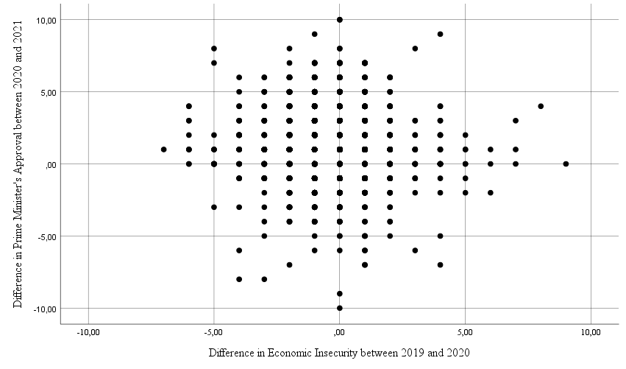
Figure 7
Scatterplot with Difference in Economic Insecurity and Difference in Prime Minister's Approval

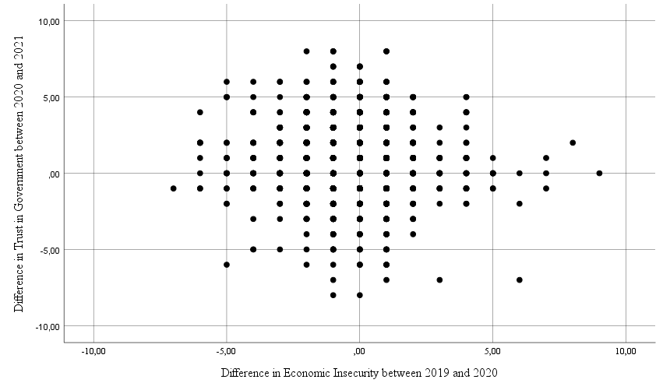
Figure 8
Scatterplot with Difference in Economic Insecurity and Difference in Trust in Government

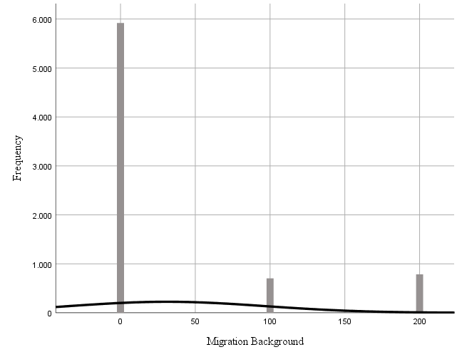
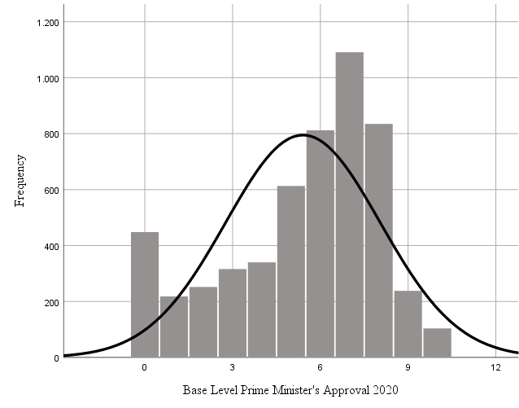
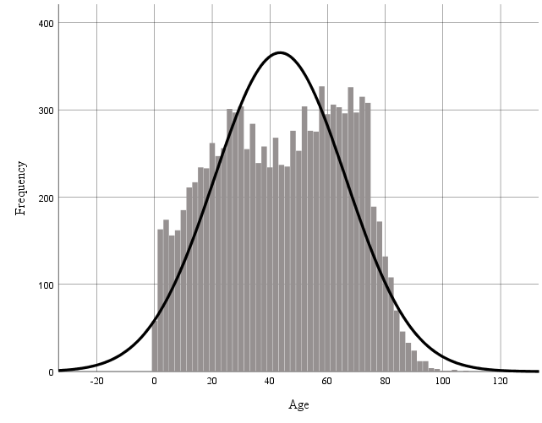
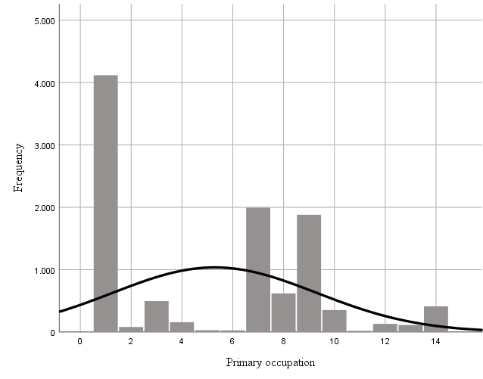
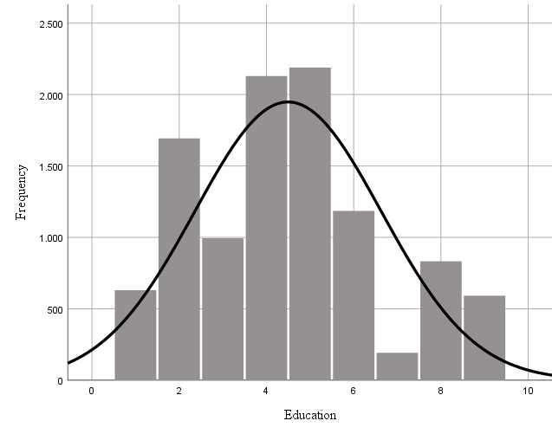
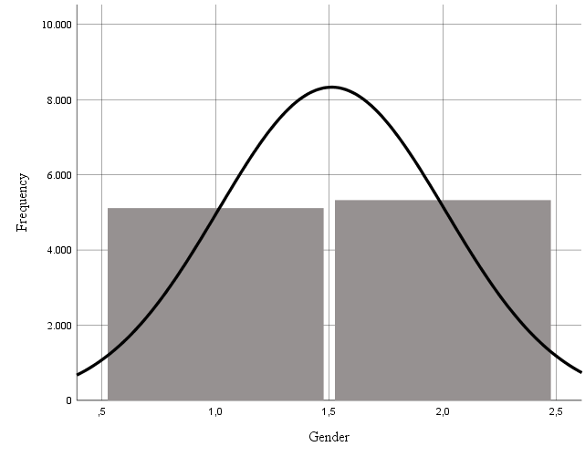
Multivariate Normality
Figure 9
Histograms of each Included Variable

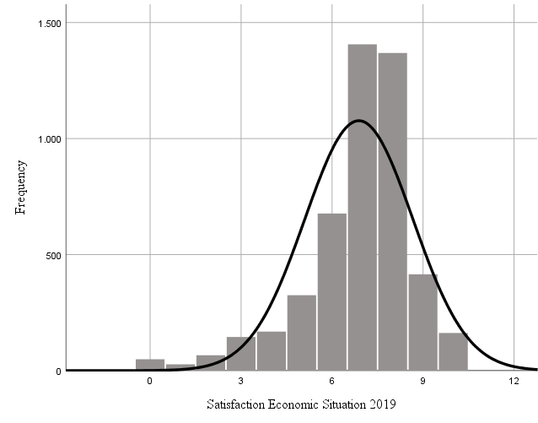
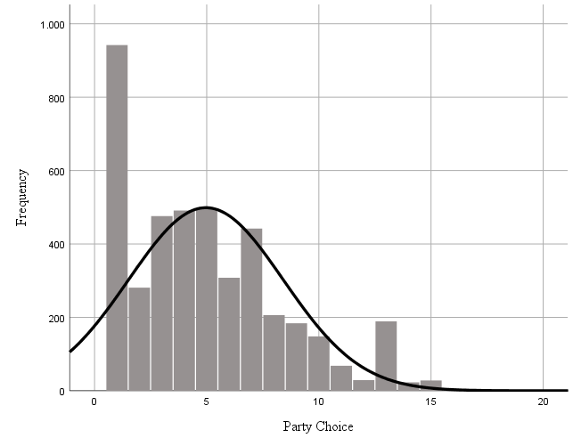
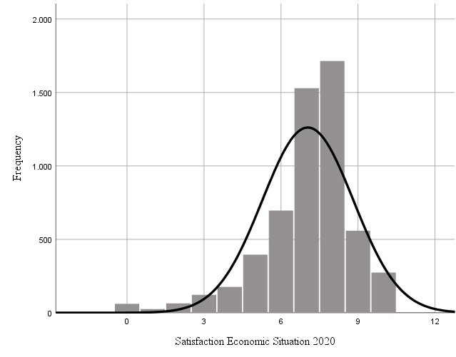
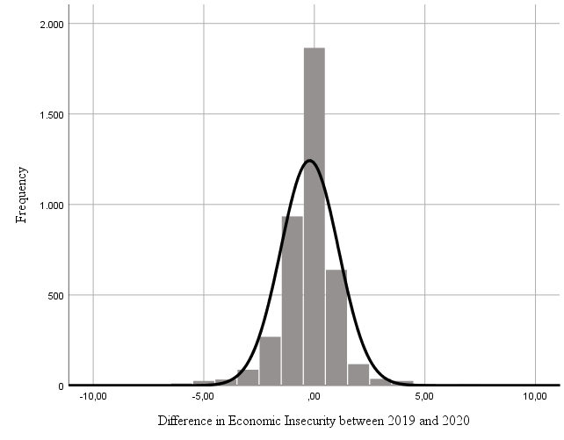
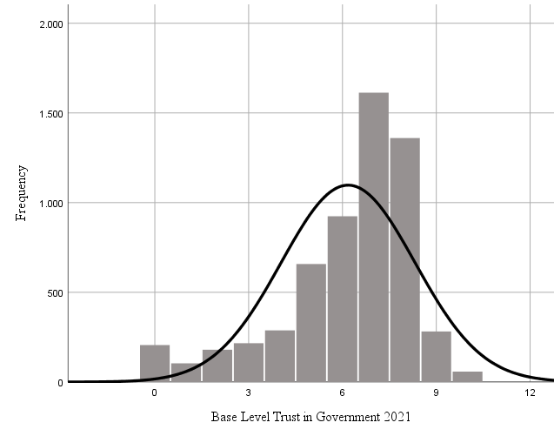
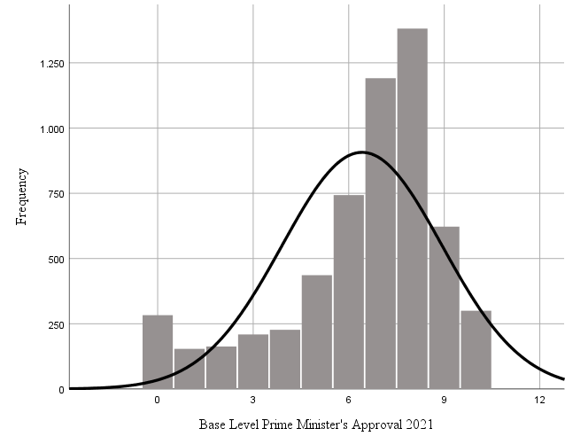
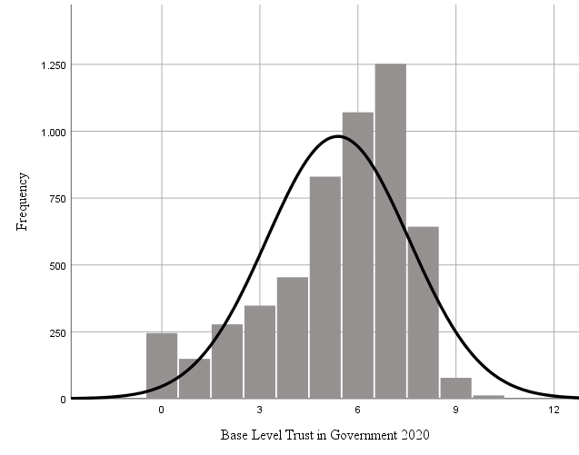
Table 12: Multicollinearity Scores (VIF)
 | DV =  ΔPrime Minister’s Approval | DV =  ΔTrust in Government
Party Choice
Less Critical Opposition | Ref. | Ref.
Coalition | 1.317 | 1.235
Critical Opposition | 1.245 | 1.295
Economic Position
Paid Employment | Ref. |  | Ref.
Self-Employed Dummy | 1.083 |  | 1.083
Unemployed Dummy | 1.057 |  | 1.055
Other Dummy | 1.874 |  | 1.863
Economic Insecurity
ΔEconomic Insecurity | 1.271 |  | 1.269
Base Level Economic Insecurity | 1.431 |  | 1.440
Control Variables
Base Level Prime Minister’s Approval | 1.381
Base Level Trust in Government |  | 1.321
Gender | 1.042 | 1.039
Age | 1.853 | 1.862
Level of Education | 1.180 | 1.176
Migration Background | 1.029 | 1.026
N | 2720 | 2726
Source: LISS Panel, CentERdata

No Multicollinearity

Homoscedasticity
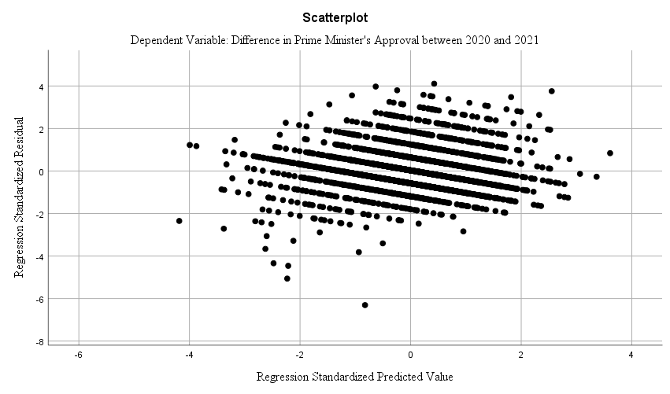
Figure 10
Scatterplot with Predicted Values and Residuals of Difference in Prime Minister's Approval

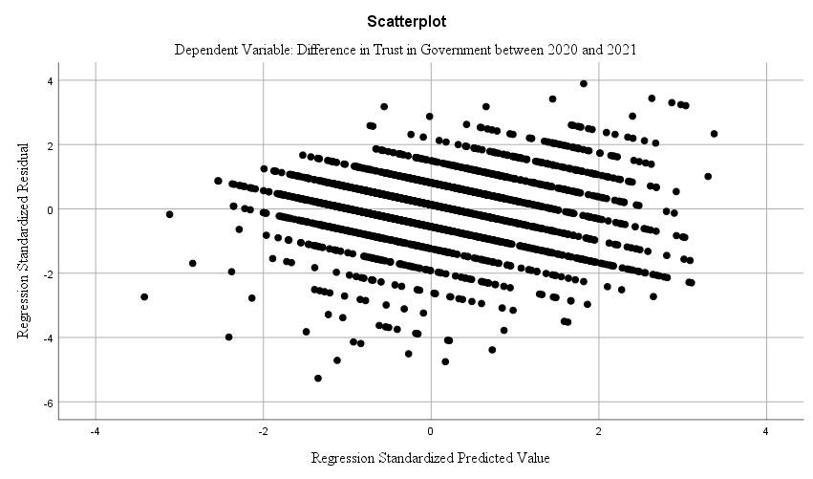
Figure 11
Scatterplot with Predicted Values and Residuals of Difference in Trust in Government

Appendix 4: T-test Rally-Round-the-Flag Effect with Filtered Group
Table 13: T-test of Means of Prime Minister's Approval and Trust in Government in 2020 and 2021
 | N | Mean Score in 2020 | Mean Score in 2021 | Difference in Means | t | Sig.  (2-tailed)
Prime Minister's Approval | 2643 | 5.46 | 6.41 | 0.956 | 27.414 | 0.000
Trust in Government | 2643 | 5.46 | 6.27 | 0.808 | 24.873 | 0.000
Source: LISS Panel, CentERdata

Appendix 5: Opinion Leadership Regression Calculations

Difference in Prime Minister’s Approval

ΔY₁Prime Minister’s Approval_{it} = 2.146 + 0.428*1 - 0.302*0 - 0.298*0 - 0.363*0 - 0.173*1 - 0.307*2.5 + 0.205*2 + 0.008*44 - 0.078*5 - 0.002*0 + ε_{i}
ΔY₁Prime Minister’s Approval (Coalition = 1; Base Level = 2.5) = 2.005 (1a)

ΔY₁Prime Minister’s Approval_{it} = 2.146 + 0.428*0 - 0.302*0 - 0.298*0 - 0.363*0 - 0.173*1 - 0.307*2.5 + 0.205*2 + 0.008*44 - 0.078*5 - 0.002*0 + ε_{i}
ΔY₁Prime Minister’s Approval (Less Critical Opposition = 1; Base Level = 2.5) = 1.578 (1b)

ΔY₁Prime Minister’s Approval_{it} = 2.146 + 0.428*0 - 0.302*0 - 0.298*0 - 0.363*0 - 0.173*1 - 0.307*2.5 + 0.205*2 + 0.008*44 - 0.078*5 - 0.002*0 + ε_{i}
ΔY₁Prime Minister’s Approval (Critical Opposition = 1; Base Level = 2.5) = 1.276 (1c)

ΔY₁Prime Minister’s Approval_{it} = 2.146 + 0.428*1 - 0.302*0 - 0.298*0 - 0.363*0 - 0.173*1 - 0.307*5 + 0.205*2 + 0.008*44 - 0.078*5 - 0.002*0 + ε_{i}
ΔY₁Prime Minister’s Approval (Coalition = 1; Base Level = 5) = 1.238 (1d)

ΔY₁Prime Minister’s Approval_{it} = 2.146 + 0.428*0 - 0.302*0 - 0.298*0 - 0.363*0 - 0.173*1 - 0.307*5 + 0.205*2 + 0.008*44 - 0.078*5 - 0.002*0 + ε_{i}
ΔY₁Prime Minister’s Approval (Less Critical Opposition = 1; Base Level = 5) = 0.810 (1e)

ΔY₁Prime Minister’s Approval_{it} = 2.146 + 0.428*0 - 0.302*0 - 0.298*0 - 0.363*0 - 0.173*1 - 0.307*5 + 0.205*2 + 0.008*44 - 0.078*5 - 0.002*0 + ε_{i}
ΔY₁Prime Minister’s Approval (Critical Opposition = 1; Base Level = 5) = 0.508 (1f)

ΔY₁Prime Minister’s Approval_{it} = 2.146 + 0.428*1 - 0.302*0 - 0.298*0 - 0.363*0 - 0.173*1 - 0.307*7.5 + 0.205*2 + 0.008*44 - 0.078*5 - 0.002*0 + ε_{i}
ΔY₁Prime Minister’s Approval (Coalition = 1; Base Level = 7.5) = 0.471 (1g)

ΔY₁Prime Minister’s Approval_{it} = 2.146 + 0.428*0 - 0.302*0 - 0.298*0 - 0.363*0 - 0.173*1 - 0.307*7.5 + 0.205*2 + 0.008*44 - 0.078*5 - 0.002*0 + ε_{i}
ΔY₁Prime Minister’s Approval (Less Critical Opposition = 1; Base Level = 7.5) = 0.043 (1h)

ΔY₁Prime Minister’s Approval_{it} = 2.146 + 0.428*0 - 0.302*0 - 0.298*0 - 0.363*0 - 0.173*1 - 0.307*7.5 + 0.205*2 + 0.008*44 - 0.078*5 - 0.002*0 + ε_{i}
ΔY₁Prime Minister’s Approval (Critical Opposition = 1; Base Level = 7.5) = -0.260 (1i)

Difference in Trust in Government

ΔY₂Trust in Government_{it} = 2.141 + 0.284*1 - 0.719*0 - 0.071*0 - 0.318*0 - 0.073*1 - 0.393*2.5 + 0.082*2 + 0.012*44 + 0.009*5 - 0.002*0 + ε_{i}
ΔY₂Trust in Government (Coalition = 1; Base Level = 2.5) = 2.107 (2a)

ΔY₂Trust in Government_{it} = 2.141 + 0.284*0 - 0.719*0 - 0.071*0 - 0.318*0 - 0.073*1 - 0.393*2.5 + 0.082*2 + 0.012*44 + 0.009*5 - 0.002*0 + ε_{i}
ΔY₂Trust in Government (Less Critical Opposition = 1; Base Level = 2.5) = 1.823 (2b)

ΔY₂Trust in Government_{it} = 2.141 + 0.284*0 - 0.719*1 - 0.071*0 - 0.318*0 - 0.073*1 - 0.393*2.5 + 0.082*2 + 0.012*44 + 0.009*5 - 0.002*0 + ε_{i}
ΔY₂Trust in Government (Critical Opposition = 1; Base Level = 2.5) = 1.104 (2c)

ΔY₂Trust in Government_{it} = 2.141 + 0.284*1 - 0.719*0 - 0.071*0 - 0.318*0 - 0.073*1 - 0.393*5 + 0.082*2 + 0.012*44 + 0.009*5 - 0.002*0 + ε_{i}
ΔY₂Trust in Government (Coalition = 1; Base Level = 5) = 1.124 (2d)

ΔY₂Trust in Government_{it} = 2.141 + 0.284*0 - 0.719*0 - 0.071*0 - 0.318*0 - 0.073*1 - 0.393*5 + 0.082*2 + 0.012*44 + 0.009*5 - 0.002*0 + ε_{i}
ΔY₂Trust in Government (Less Critical Opposition = 1; Base Level = 5) = 0.840 (2e)

ΔY₂Trust in Government_{it} = 2.141 + 0.284*0 - 0.719*1 - 0.071*0 - 0.318*0 - 0.073*1 - 0.393*5 + 0.082*2 + 0.012*44 + 0.009*5 - 0.002*0 + ε_{i}
ΔY₂Trust in Government (Critical Opposition = 1; Base Level = 5) = 0.121 (2f)

ΔY₂Trust in Government_{it} = 2.141 + 0.284*1 - 0.719*0 - 0.071*0 - 0.318*0 - 0.073*1 - 0.393*7.5 + 0.082*2 + 0.012*44 + 0.009*5 - 0.002*0 + ε_{i}
ΔY₂Trust in Government (Coalition = 1; Base Level = 7.5) = 0.142 (2g)

ΔY₂Trust in Government_{it} = 2.141 + 0.284*0 - 0.719*0 - 0.071*0 - 0.318*0 - 0.073*1 - 0.393*7.5 + 0.082*2 + 0.012*44 + 0.009*5 - 0.002*0 + ε_{i}
ΔY₂Trust in Government (Less Critical Opposition = 1; Base Level = 7.5) = -0.143 (2h)

ΔY₂Trust in Government_{it} = 2.141 + 0.284*0 - 0.719*1 - 0.071*0 - 0.318*0 - 0.073*1 - 0.393*7.5 + 0.082*2 + 0.012*44 + 0.009*5 - 0.002*0 + ε_{i}
ΔY₂Trust in Government (Critical Opposition = 1; Base Level = 7.5) = -0.862 (2i)

Appendix 6: OLS Regression with Coalition Distinction

Estimated Regression Models VVD Compared to Other Coalition Party than VVD

ΔY₁Prime Minister’s Approval_{it} = β₀ + β₁Gender_{i} + β₂Age_{i} + β₃Level of Education_{i} + β₄Migration Background_{i} + β₅Base Level of Prime Minister’s Approval_{it} + β₆Other Coalition Party than VVD_{i} + β₇Less Critical Opposition + β₈Critical Opposition_{i} + β₉Self-employed_{i} + β₁₀Unemployed_{i} + β₁₁Other_{i} + ε_{i} (1a_{VVD})

ΔY₂Trust in Government_{it} = β₀ + β₁Gender_{i} + β₂Age_{i} + β₃Level of Education_{i} + β₄Migration Background_{i} + β₅Base Level of Trust in Government_{it} + β₆Other Coalition Party than VVD_{i} + β₇Less Critical Opposition + β₈Critical Opposition_{i} + β₉Self-employed_{i} + β₁₀Unemployed_{i} + β₁₁Other_{i} + ε_{i} (2a_{VVD})

OLS Regression Results VVD Compared to Other Coalition Party than VVD
Table 14: Results of OLS Regression with Distinction between VVD and Other Coalition Party
 |  | (1)  DV =  ΔPrime Minister’s Approval | (2)  DV =  ΔTrust in Government
Intercept |  | 2.956***  (0.206) |  | 2.608***  (0.199)
Party Choice
VVD |  | Ref. |  | Ref.
Other Coalition Party than VVD |  | -0.324***  (0.080) |  | -0.136*  (0.074)
Less Critical Opposition |  | -0.659***  (0.080) |  | -0.376***  (0.071)
Critical Opposition |  | -0.920***  (0.113) |  | -1.038***  (0.104)
Economic Position
Paid Employment |  | Ref. |  | Ref.
Self-Employed |  | -0.318**  (0.128) |  | -0.033  (0.120)
Unemployed |  | -0.300  (0.186) |  | -0.187  (0.175)
Other |  | -0.125*  (0.072) |  | -0.076  (0.068)
Control variables
Base Level Prime Minister’s Approval |  | -0.324***  (0.012)
Base Level Trust in Government |  |  |  | -0.403***  (0.013)
Gender |  | 0.207***  (0.055) |  | 0.062  (0.052)
Age |  | 0.007***  (0.002) |  | 0.011***  (0.002)
Level of Education |  | -0.088***  (0.020) |  | 0.019  (0.019)
Migration Background |  | -0.001**  (0.000) |  | -0.001***  (0.000)
N |  | 2643 |  | 2643
Standard errors in parentheses
*p < 0.1 **p < 0.05 ***p < 0.01

Estimated Regression Models Other Coalition Party than VVD Compared to Less Critical Opposition

ΔY₁Prime Minister’s Approval_{it} = β₀ + β₁Gender_{i} + β₂Age_{i} + β₃Level of Education_{i} + β₄Migration Background_{i} + β₅Base Level of Prime Minister’s Approval_{it} + β₆VVD + β₇Other Coalition Party than VVD_{i} + β₈Critical Opposition_{i} + β₉Self-employed_{i} + β₁₀Unemployed_{i} + β₁₁Other_{i} + ε_{i} (1b_{VVD})

ΔY₂Trust in Government_{it} = β₀ + β₁Gender_{i} + β₂Age_{i} + β₃Level of Education_{i} + β₄Migration Background_{i} + β₅Base Level of Trust in Government_{it} + + β₆VVD + β₇Other Coalition Party than VVD_{i} + β₈Critical Opposition_{i} + β₉Self-employed_{i} + β₁₀Unemployed_{i} + β₁₁Other_{i} + ε_{i} (2b_{VVD})

OLS Regression Results Other Coalition Party than VVD Compared to Less Critical Opposition
Table 15: Results of OLS Regression with Distinction between Other Coalition Party than VVD and Less Critical Opposition
 |  | (1)  DV =  ΔPrime Minister’s Approval | (2)  DV =  ΔTrust in Government
Intercept |  | 2.162***  (0.233) |  | 2.138***  (0.129)
Party Choice
Less Critical Opposition |  | Ref. |  | Ref.
VVD |  | 0.659***  (0.093) |  | -0.397***  (0.080)
Other Coalition Party than VVD |  | 0.293***  (0.080) |  | 0.206***  (0.072)
Critical Opposition |  | -0.312***  (0.111) |  | -0.719***  (0.103)
Economic Position
Paid Employment |  | Ref. |  | Ref.
Self-Employed |  | -0.312**  (0.154) |  | -0.080  (0.140)
Unemployed |  | -0.312  (0.215) |  | -0.304  (0.196)
Other |  | -0.140  (0.086) |  | -0.055  (0.078)
Base Level Prime Minister’s Approval |  | -0.316***  (0.014)
Base Level Trust in Government |  |  |  | -0.394***  (0.015)
Gender |  | 0.217***  (0.064) |  | 0.087  (0.058)
Age |  | 0.007***  (0.003) |  | 0.011***  (0.002)
Level of Education |  | -0.074***  (0.023) |  | 0.010  (0.021)
Migration Background |  | -0.002***  (0.001) |  | -0.002***  (0.001)
N |  | 2643 |  | 2643
Standard errors in parentheses
*p < 0.1 **p < 0.05 ***p < 0.01

Appendix 7: Sobel Tests Indirect Effect Economic Position
Table 16: Sobel Test Indirect Effect of Economic Position on ΔTrust in Government via ΔEconomic Insecurity
Variable  Effect | Self-Employed | Unemployed
X on Z (a) | 0.352***  (0.099) | 0.530***  (0.139)
Z on Y (b) | -0.077***  (0.027) | -0.077***  (0.027)
Sobel Test Statistic | -2.225 | -2.284
Sig. (2-tailed) | 0.026 | 0.022
Reference category: Paid Employment
Standard errors in parentheses
*p < 0.10 **p < 0.05 ***p < 0.01

The sample used to test Hypotheses 1a and 1b provides an accurate estimate of the whole population. For the regression analyses, only a filtered group of 2643 respondents have been included, as I wish to compare the coefficients of diverse groups. These 2643 respondents have given a valid answer on all utilized variables of the dataset. To ensure the reliability of all of my results, I have additionally conducted a T-test using only the sub-sample of 2643 respondents (Appendix 4), which proves to be significant (p < 0.01) for both the increases in Prime Minister’s approval and trust in government.

