Dilemmas of a European voter

Wordcount:15539
Marc Emiel Anton Schilderman (1061737)
Radboud Universiteit
Faculteit der managementwetenschappen
Supervisor: Dr. Reinout van der Veer
Abstract
This thesis investigates a dilemma that citizens in Europe, and by extension their representatives in the European parliament, face. They sometimes have to form an opinion on a type of policy they do want, but which is brought forward at a level of government which they do not want to have control over the policy area concerned. This thesis investigates a citizen's ultimate choice by using experimental research. Respondents face a systematically varied proposal to determine which factors contribute to choices in such dilemmas. This thesis investigates in particular whether a redistributive proposal is judged differently from a non-redistributive proposal, and whether people with extreme feelings in favour or against the EU handle such a dilemma differently. The redistributive proposals are further divided into proposals where the country of residence of a citizen lives is a winner or a loser of the redistribution. The thesis produces some signs that both redistribution and extreme opinions on the EU are of influence on the way citizens face such a proposal. It does not however produce evidence that winning or losing a redistribution in a proposal is of influence on how citizens face such a dilemma.

Content
Introduction | 4
Scientific relevance | 5
Societal relevance | 6
Methodology | 6
Theories | 8
Attitudes to federalism | 9
Federalism and the European Union | 12
How to change a citizen’s opinion? | 17
Methods | 19
Conjoint experiments | 20
The concrete experiments of this study | 22
Method of statistical analysis | 25
Operationalisation | 27
Sampling | 29
Validity and reliability | 29
Results | 31
Regression analysis | 36
Assumptions | 42
Conclusions | 46
Discussions and Recommendations | 47

Introduction
In the 2024 European Parliament extreme and radical party groups have grown to their largest size yet. An attempt to merge party families in order to create a large far-right group in the European Parliament has been undertaken. If it were fully successful, this group could rise to become the second biggest party family in the European Parliament, trumping the social democrats. This would break the decades-long position of the Socialists and Democrats and the European People’s Party as the two biggest ruling party families. Until now the position of members of far-right parties has been relatively weak, because of internal division in the parliament. However, now that those members have become more dominant it has become more relevant to find out more about their voting behaviour in the European Parliament.
These often more Eurosceptic members of parliament have been studied in a recent article by Vestergaard (2021). He describes a dilemma they face between their standpoints involving restraining the power of the European Union on the one hand and their preferences for certain policies on the one hand. If they have to decide how to vote on a proposal that they support, but which would enlarge the involvement of the EU on this issue, they thus face a clear dilemma.
As Van Elsas (2015) shows, euroscepticism is not a purely right-wing phenomenon. Left-wing Eurosceptics differ from right-wing Eurosceptics in that they are more likely to want to protect the welfare states of nation countries and see foreign interference as a threat to the policy they reached. Right-wing parties see European cooperation as a cultural threat. They share, however, a sense of nationalism, and an image of elements of foreign nations as threats to their state. Right-wing and Left-wing Eurosceptics thus face a very similar dilemma as members of the European parliament.
Finally, the dilemma of Vestergaard (2021) can equally be studied the other way around. Members of the European Parliament who are in favour of European Integration face such a dilemma if a proposal hands back a certain responsibility to member states, but the national parliament is made up such that the policy they will vote for to replace the European regulation is more in line with the preferences of the Member of the European Parliament.
The causes and consequences of Euroscepticism have been studied very extensively. Particularly the causes and consequences of the increase in debate about the European Union, marked as increased politicisation, have been studied in a lot of detail. These strands of literature will inform the expectations of this thesis that those with very extreme opinions will handle the dilemma differently from those with weaker preferences. It also leads to the expectation that redistribution in a proposal makes it less likely to be supported.
This leads to the following research questions. The specific reasons for the inclusion of these two factors will be given in the chapter on theoretical considerations:
Research Questions
RQ1: To what extent do people with a stronger opinion on the European Union let that opinion weigh more strongly when faced with a policy dilemma?
RQ2: To what extent does the redistributive nature of a proposal lessen the chance of supporting a proposal with a policy dilemma?
Scientific Relevance
This thesis adds a number of elements to prior research. Firstly, it expands on the research of Vestergaard (2021) on the dilemma he proposes by looking at the way the general public handles the dilemma, rather than members of the European Parliament, and by looking at the way Europhilic members of parliament handle the dilemma, on which no research exists to date.
Secondly, research has pointed out that the politicisation of the European Union has come down in some countries over recent years (Conrad & Orlando, 2024). Yet, Eurosceptic parties have gained votes in the recent European election. It is interesting, therefore, to know what citizens expect from their members of parliament if they did vote for explicitly Eurosceptic parties or parties that used to be explicitly Eurosceptic. Do they expect their members of parliament to maintain their typical uncooperative style to weaken the European Union, or rather use their size to shift the policy of the European Union in their direction? It is in this case thus the shift towards a lower level of politicisation which enables this thesis to collect increased information on how voters handle this shift in the public debate surrounding the European Union. Somewhat similarly, it is interesting to know what citizens who voted for explicitly Europhilic parties want from their members of the European Parliament. How prepared are they to sacrifice EU power for their policy goals?
Finally, this thesis allows for the increased investigation of existing Euroscepticism theories (Schoene, 2019). This means that more grounds for their validity or invalidity can be given to them.
Societal Relevance
This article allows for a more democratic future integration. Firstly, it gives insight into the integration (or disintegration) preferences of a certain electoral group. It thus gives those seeking to further integrate the EU, more insight into what directions and ways of further integration will have the largest amount of support. Apart from this, members of parliament can also use the data to fit the way they vote to the way their voters want them to vote. This, yet again, increases the democratic legitimacy of their votes in the parliament. By comparing what Vestergaard (2021) says about the voting choices of members of parliaments, with the results that are found in this thesis about the way citizens would make those choices, this can be found out.
Finally, it will also provide possible arguments to combat extremism. If the results of the thesis show that under certain conditions voters are willing to let members of parliament disregard their Eurosceptic or Europhilic considerations. These findings may persuade radically Eurosceptic or Europhilic members of the European Parliament to go along with proposals they would support if it were not for the Eurosceptic of Europhilic considerations. In doing so this might moderate their views on these positions. This is morally positive as it both combats extremism and increases the governability of both the European Union (because of the decreasingly expressed Euroscepticism of the Eurosceptic members of the European Parliament) and the member states (because of the decreasingly expressed Europhilia of the Europhilic members of the European Parliament).
Methodology
The research questions can be answered using experimental research. Two different types of experimental research will be used in this thesis. They are the following: firstly, the impact of extreme opinions on the EU and redistribution will be measured using a vignette experiment. This is a type of experiment in which different respondents receive systematically different text fragments and are asked to rate their support for the proposals describe in the texts.
The second type of experimental research that will be used is a more standard random control experiment type. In this type of research, all respondents are first measured on a number of factors. They are then given a certain treatment. Finally, they will be measured on the same factors as before they received the treatment. In this thesis, the factors they will be measured on will all be vignettes which they are asked to rate. The first vignette is the same to all respondents, and contains the proposal. Respondents then receive the treatment, which is the knowledge that the proposal benefits the country of residence of the original respondents. Finally, they are asked to reevaluate their knowledge based on this new information. In this thesis, this type of experiment will be used to further investigate the functioning of the redistributive element, which this thesis predicts to influence the choice of respondents in the dilemma by Vestergaard (2021).

Theories
In this chapter, a model of the functioning of the dilemma presented by Vestergaard (2021) will be substantiated. Vestergaard presents a dilemma faced by Eurosceptic members of parliament. In this dilemma, members of the European parliament are faced with a directive that fits their ideological preferences. However, the proposal broadens the influence of the European Union. Hence, they have a dilemma between their preference for a smaller European Union and their preference for the policy. Vestergaard expects that they will choose to vote against the issue unless the issue is salient to them. Vestergaard expects the dilemma to be a “second-order” agenda.
In this thesis, the scope will be made broader to some extent. To achieve this, the way the dilemma will be looked at will differ from the article of Vestergaard (2021) in two separate ways. Firstly, this thesis will not look at the way members of the European parliament handle the dilemma, but at how the general public does so. Secondly, the dilemma will be adjusted to not only reflect vote choices of Eurosceptic citizens but also those more supportive of the European Union. In that case, the dilemma would be the other way around. A dilemma would then exist between a policy they are not (fully) in favour of but where an increase of power is brought to the European level. This choice both adds relevance to the study but is also put in place to widen the scope of the population that can be investigated, which is a practical advantage in finding sufficient amounts of respondents.
If the hypothesis of Vestergaard (2021) is adjusted to apply to all voters, the following will be the hypothesis:
Adjusted Vestergaard Hypothesis: Citizens let their vision of the European Union decide their support for an issue rather than their ideological position unless the issue is very salient to them.
This hypothesis will be adjusted based on a number of subsections of the literature. This will be done by investigating the general literature on federalism, with a particular focus on the United States; Secondly, by looking at the categorisations of attitudes towards the European Union; Thirdly, by looking at general theories on what factors lead to increased Euroscepticism.

Attitudes to Federalism
This section will reflect on the general predictors of support for policy proposals in federal systems, that can be found in the literature. These predictors will be used to substantiate the hypothesis on the way citizens decide on their support for proposals in the European Union. Before this is done it is important to know that there exists contestation on the extent to which the EU is a State. Some see the EU as a federal state in the making, while others see it as a unique system of government that merely shares elements with the federal system. Both sides of this debate, however, agree that models of federalism apply to the European model. Exploring the theories that exist on this general choice in federal systems may thus benefit the correctness of the theoretical expectations on choices made in Vestergaard’s dilemma in the context of the European Union (Mckay, 1999).
One such model is the one proposed by Rose-Ackerman (1981). She describes how preferences are formed in a unitary and a federal system of government. In a complete unitary system, there is no opportunity for debate about which level of government should enact a certain proposal, as there is only one level of government in which all power resides. For this reason, the level of government plays no role in the extent to which respondents support a legislative proposal.
In a federal system, however, preference formation works somewhat differently. Three factors contribute to the decision on whether or not to support a legislative proposal: one’s opinion on the content of the legislative proposal, whether or not the law is currently in place in one’s own province (meaning local federal entity) and neighbouring provinces, and, finally, the chance of spillover of positive or negative effects to and from other provinces. The spillover means that the presence of a proposal in neighbouring states can have an effect on preference formation in a state. It can thus be the case that the positive effects of a proposal affect other states as well, while the negative effects are constrained within the state that has enacted the proposal. For example, there might be a situation where one supports the legalisation of marihuana but fears the increase of nuisance to the local environment. In this case, there is a spillover from one state to the other. If a neighbouring state legalises marihuana, one can go there and make use of it. The nuisance, such as noise and smell, however, does not spill over to other states. In a situation like this a supporter of marihuana legalisation, may not be in favour of federal legislation mandating it, because the perceived positive effects are already present, and the federal legislation would only expand the negative effects to their state (Rose-Ackerman, 1981).
There exist different models of federalism and the model chosen might be of importance in the applicability of the model of Rose-Ackerman (1981). Heidbreder (forthcoming), for example, makes a general distinction between an American federal model and a German federal model. In the American model the province level and the federal level exist next to each other, producing their own policy. In this model of federalism every level of government has its own task about which it has a full say. In the German model, however, the local level implements policy created by the federal government. Both levels of government thus cooperate on proposals on the same themes. In the latter case the model of Rose-Ackerman is less relevant because legislation differs only on the details of implementation, and the federally determined outlines are the same from one state to the other.
The Rose-Ackerman model looks solely at interests derived from the state someone is from, not at ideological dispositions towards the power of a certain level of power. The theoretical expectation can thus be additionally substantiated by looking more specifically at theories that focus on these ideological dispositions, and what factors impact those. There exist three broad theories on ideological dispositions on the level of government that should produce policy within the context of the United States. They will be presented here, and their findings will be translated into the context of the dilemma between policy preference and preference of level of government, which was presented earlier.
A first theoretical strand is provided by Schneider & Jacoby (2013). They hold that citizens do have preferences about what level of government should take what action. They establish that satisfaction with government among citizens is significantly improved if governmental action is taken at the level, they think should take that decision. According to Schneider & Jacoby (2013), party identification does influence the strength of the preference, but this effect is rather small. In the wording of the dilemma this means that they provide evidence that people would prefer parties to vote against preferred policy on the wrong level.
An alternative strand is provided by Dinan and Hecklerman (2020). They write that the extent to which Americans care about which level of government makes a decision is based on their general ideology. Conservative Americans are relatively stable supporters of decentralised governments and are opposed to centralised government. Liberals, on the other hand, generally support the expansion of the powers of the federal government. The extent of this support, however, is strongly impacted by the matter of which governments are present at which levels. Specifically, the presence of a conservative (Republican) government on the federal level makes liberals far less supportive of taking policy at the federal level. This suggests that there exists a clearer ideological preference among conservatives and those in favour of local governmental power, and a less clear ideological preference among progressives and those in favour of federal control of government. In the wording of the dilemma: Eurosceptic voters would like their parties to vote against preferred policies on the wrong level, but Europhilic voters would not like their parliamentarians to vote for unpreferred votes expanding European Power.
A third major branch of the literature exists both in political science literature and notably also in legal literature. This is the literature on “partisan federalism” (Bullman-Pozen, 2014; Destradi e.a., 2020; Callagan e.a., 2017). In essence, they hold that the amount of support for federalism a party has is dependent on their control over federal or subnational entities. If they were in charge of the federal government, they would stop complaining about federal decisions infringing on the local governments and would stop attempting to nullify them. Most of this research focuses on the behaviour of politicians, and it is sometimes explicitly contrasted with the preferences of individual citizens, who are theorised to have more permanent preferences. Wolak (2016), however, finds systematic empirical evidence for this approach among ordinary citizens as well. They did research similar to that of Dinan and Heckelman (2020) but found evidence for a shift based on federal control in both parties. This also gives reasons to employ this theoretical lens in research focusing on the behaviour of ordinary citizens. In the terminology of the dilemma this means that supporters of the partisan federalism theory hold that everyone will always in the end make an ideological choice, and the level of government is not taken into account.
All three of these branches of research find some impact of partisan considerations on the level of government. The discussion is primarily on the extent of this impact. It can thus be theorised that it is at least an element that is taken into account in the decision. It does also seem logical that it must be very tempting to achieve an ideological goal that has been hard to reach, even if it is at a different level than they had preferred. The existence of political systems based on consensus and coalition-building shows that parties have been willing to compromise to turn parts of their political programs into action. It seems likely that citizens would similarly be willing to compromise and not demand a perfect match with their preferred outcome to be willing to support.
One important complicating factor that must be considered here is the existence of political parties that have focused in particular on the level of government decisions should be taken at. Christian Democrats are often associated with the principle of subsidiarity, using it as a way to balance their historically wide support base (Kalyvas & Van Kesbergen, 2010). Similarly in the United States Republicans often talk about the importance of state’s rights. In their case the theory of partisan federalism might be used to explain the effect measured by Dinan & Hecklerman (2020). In that case the level of government is part of the political agenda, and a compromise between the level of government and the ideological preferences cannot exist. Still, conflicts may arise between other elements of their political agenda.
In that case, and in line with the theory of Rose-Ackerman (1981) there might also be differentiation based on the current presence of the legislation in the province that one is a citizen of. If one believes in the importance of subsidiarity as part of their core principles it would not make sense to use the federal level to achieve things in other provinces, while in general one believes provinces should have the right to take decisions on this matter. If they would use the federal level to get the policy they support enacted nationwide, they would at the same time violate one of their core ideological principles, and thus not achieve ideological progress. It can thus be expected that they let their preferences on level of government determine their support for a proposal. If a party has no core ideological disposition towards which level of government, on the other hand, takes a policy decision, or if a party specifically supports the federal system, it would make sense to extend policy successes already present in their own province to other provinces.
The earlier Vestergaard (2021) hypothesis can thus be adjusted to include these findings in the following hypothesis.
Provisional hypotheses:
H1: Citizens who do not have a vision on level of government in their core ideology are not likely to let level of government weigh in on their level of support of an issue.
H2: Citizens who do have a vision on the level of government in their core ideology are likely to let it determine their support unless the issue is salient to them.
Federalism and the European Union
It is now useful to move the theoretical discussion to the more specific context of the European Union. There exists quite some literature on the functioning of the dilemma, in particular when it comes to the choice that citizens not governments or politicians make. However, we can still use some strains of the literature to sharpen our provisional hypothesis to fit the context of the European Union.
Categorising attitudes to the European Union
There exist many different categorisations of views on the European Union, particularly when it comes to Eurosceptic attitudes there exists a plethora of different categorisations. A number of them will be examined in his section.
Rodriquez-Aguilera de Part (2013) and Kaniok & Kominkova (2022) note that the term Euroscepticism is already generally a bit deceiving. It encapsulates different concepts and labels them as though they are one. This is the case because the term Euroscepticism was not developed by scientists, but by the media. They use it to mean both attitudes of disagreement with the idea of European integration as a whole, or the direction that the European Union is going into. This distinction is aligned with the common distinction between policy contestation and polity contestation. We could name the first category Euroscepticism and the latter category eurocriticism. Similar categorisations, with different terminology are made by Elsas and Van den Brug (2015) and Taggart and Szczerbiak (2002).
A separation between those two categories, however, is not entirely convincing. It is further nuanced by Perez (2008), who separates within the disagreement category. A distinction is drawn here between anti-Europeans, who are opposed to the idea of European integration, and want to dismantle the entirety of the European Union, and Eurosceptics who merely want the EU to not integrate any further, and maybe decrease integration in some areas. We could name the former category extended Eurosceptisicm, and the latter limited Eurosceptisim. A similar categorisation was made by Kopecky and Mudde (2002).
If we combine these categorisations, we end up with the following characterisation:
Figure 1: Characterisation of attitudes towards the EU
Resentment against the EU
Eurocriticism
Euroscepticism
Limited Euroscepticism
Extended Euroscepticism

Other studies have recently begun to stress the importance of going beyond simple dichotomies or single-dimensional categorisations of attitudes towards the European Union. Van den Hoogen et al. (2022) separate discourses surrounding the European Union into four categories, based on the combination of discourses in a small-n qualitative study and confirmation of the findings in a large-n survey. They find four different discourses: Firstly, there are those who have an anti-establishment view on the EU, meaning that they see it as a tool used by the elites to further their goals at the expense of the regular people. Secondly, there are those who have a pragmatic view of the European Union. They see the EU as a tool that can be used to achieve those things their individual member state cannot do as effectively on its own. However, the EU should not intervene in policy areas where the individual member state is just as effective on its own. Thirdly, there is a federalist discourse, of those who value the EU above their own member state and see the EU not as a means to achieve goals, but as a goal itself. Fourthly a disengaged discourse whose users have no strong feelings about the EU, and also feel that the EU is not very impactful.
There are a number of benefits to this newer approach, such as the broader scope, the robust development, and the inclusion of a category of disinterest in the EU, which the low turnout during EU elections, among other things, indicates is widespread. On the other hand, it does not fit our hypotheses very well, as it does not allow for a straightforward difference between core ideological convictions. For example, being anti-establishment can be a very general discontent with all levels of government and does thus not necessarily suggest a strong ideological preference for a certain level of government to make certain decisions. We will thus use the distinction drawn out earlier between Euroscepticism and Europhilic positions.
Based on this categorisation we can adjust the prediction we made based on federalism. This prediction held that “Level of government has no impact on support for policy proposals unless it is part of their primary ideology." The core ideology here can be seen if there is a case of strong Euroscepticism, meaning extended Euroscepticism, as defined earlier. If there is a case of moderate Euroscepticism, it will not be seen as part of the core ideology. Similarly, cases of strong Europhilic sentiments will be seen as part of the core ideology, while weak Europhilic sentiments will not be seen as such. The hypothesis can thus be adjusted based on these categorisations. By doing so this will thus change our hypothesis from reflecting on federalism towards reflecting on the European Union case.
Adjusted Provisional Hypotheses:
H1: Citizens who have a weak Eurosceptic or weak Europhilic view of the EU, are not likely to let the level of government weigh in on their level of support of an issue.
H2: Citizens who have a strong Eurosceptic or Strong Europhilic view are likely to let their view on the level of government determine their support.
Factors predicting Euroscepticism.
In this section we will reflect on different factors that are predicted to increase Eurosceptic sentiment among citizens. These will help us to predict when people might be more likely to choose for
Within the public attitude study of Euroscepticism Schoene (2019) separates three major causes of Euroscepticism: economic Euroscepticism, political Euroscepticism and cultural Euroscepticism. He finds the effect of cultural Euroscepticism is largest in size, but that all three factors give statistically significant relations with euroscepticism.
Economic euroscepticism is related to the supposed cost of being a member of the European Union, in particular when it relates to the euro currency. This relates both to the money directly gained from the European Union, and also to the monetary policy and the economic effects of this. The effect of this sentiment is supported by Borin e.a. (2021). They show that Euroscepticism is lower in regions which have received more money from cohesion funds. These citizens are theorised to recognise the benefits they personally get from the European Union.
The theory of economic euroscepticism is confirmed by general predictions on the interests of member states. According to Kelemen& Tarrant (2011) member states like to give away national control in favour of the effectiveness of European action. They make one exception to this general rule, however: member states do want to maintain control over issues relating to distributional issues. These economic issues are seen as a zero-sum game, where the interests of member states thus do not converge. This is reason to suggest that support for EU integration is lower in redistributive issues among citizens.
Other studies such as Senninger (2021) and Fidrmuc (2016) do not find a similar effect. In their study, focusing more narrowly on certain cases Senninger finds that the effect in certain of these cases is even somewhat negative in size. Similarly, Fidrmuc, who focuses on the effect of having received those funds on the vote result in the Brexit referendum finds no real effect.
Political Euroscepticism stems from the idea that the power that the EU has is used for priorities that are very different from those of the regular people. It is in many ways very similar.
Cultural Euroscepticism is related to the cultural attachment one has to one’s own country. The expectation here is that those who feel very culturally attached to their own country are less likely to accept supranational governing over them. Wessels (2007), makes such an argument in what he calls the buffer hypothesis. This hypothesis holds that attachment to a political community makes it less likely to be sceptical of it, or in other words it acts as a buffer. In particular this is the case when it comes to extended (Euro)scepticism, and it is less powerful in (Euro)criticism. An opposite argument is made by Abts et al. (2009), where they provide evidence that the more attachment one has to one’s nation-state, the more likely one is to be Eurosceptic.
Abts et al. (2008) also describe a different strand of research proposed about the presence of social attachment to other people. The more social attachment values would exist between people, the more trust they would have in politics in general, and the European project more specifically. This hypothesis of theirs is based on a broader theory known as social capital theory. This theory has recently been provided with increased evidence, for example by Bartscher e. a. (2022), who proofs that people in areas with high amounts of social capital were more willing to abide by the Covid-19 restrictions put in place by the government during the pandemic and thus halt the spread of the virus.
These arguments provide many different angles for hypotheses. Because of the experimental setup of the empiric research, and the limited availability of respondents we will have to limit the amount of hypothesis.
Of the angles presented above the distinction between distributive and non-distributive is particularly useful. There are three substantial arguments that inform this view. This is, firstly, because it most clearly relates to the characteristics of the proposal, rather than those of the correspondent, making it useful as a predictor of how a correspondent responds to different proposals. Secondly, it does also make sense theoretically that on financial issues citizens would fear more that they might have to pay to the benefit of other countries, than on general regulations, which apply to every country equally. Thirdly, the effect finds support in literature both on member-states and citizens.
We can thus adjust the hypotheses as follows:
Further adjusted hypotheses:
H1: Citizens who have a weak Eurosceptic or weak Europhilic view of the EU, are not likely to let level of government weigh in on their level of support of an issue.
H2: Citizens who have a strong Eurosceptic or Strong Europhilic view are likely to let their view on level of government determine their support.
H3: Citizens are more likely to let their view on level of government decide their choice in the dilemma if the issue is redistributive.

How to change a citizen’s opinion?
This section will reflect on what type of arguments might shift the position that citizens take on the dilemma. This part can be partially informed by the theoretical perceptions we used earlier. However, it is also useful to briefly investigate the theoretical perceptions on shift in opinion, because we can substantiate to what extent It thus informs the theoretical expectations of the second part of the experiment in this thesis.
One factor that is very consistently named in the literature about public opinion formation is the impact of the media. Evidence for this claim is provided in articles such as that of Druckman & Parkin (2005), or Boomgaarden e.a. (2006). These articles are primarily based on the impact of elections. The latter separates media bias into three categories: the visibility of certain candidates, the tone of the coverage, and the agenda that politicians are associated with. Wlezien (2024) finds a similar effect on public opinion but finds an opposite effect as well.
This raises a further question: To what extent is the public opinion formed solely based on the current day developments and trends as reflected in the media, or to what extent is there also a further impact of a general type of opinion consistency over time? Are there more deeply embedded idea systems on which our opinions and views are based?
An important and controversial article that has been written in an attempt to answer this question is that of Converse (1964). He distinguished between ideologies that are part of “the history of ideas” which he said influenced elites, but not the common citizens directly, other than through elites; and ideologies he called “folk ideologies.” They are distinguished he argued in that folk ideologies tend less to “attract the more sophisticated observer,”.
We can adapt this relationship by relying on Barber & Pope (2018) who find that ideological consistency is far bigger under voters who are less politically knowledgeable. In the terminology of Converse this can be interpreted as: policy elites, who can be expected to be quite knowledgeable, thus bringing forward this stability, and ordinary citizens, less politically knowledgeable follow them.
On this issue Petersen et al. (2010) investigate further the point made by Converse (1964) that elites can influence the importance of ideologies among the general public. They show the importance of the positions of political parties in a debate for the position that citizens take on the matter. They help citizens link underlying values to the issue at stake. In other words, the assumption of Converse is that people engage with the ideology debate (of the “history of ideas”) through the lens of political parties and the consistent values they carry with them.
However, within EU research there is an important counterexample to the idea that people’s view of an object is mainly decided upon by values taken up by political parties. Euroscepticism was a movement that current research holds started among the general public, before it became a position that (mainstream) parties held. This was already signalled by Van der Eick & Franklin (2004) who in the early 2000s called Euroscepticism a “sleeping giant” in that it was a major public debate that was not reflected by party stances but was predicted to become relevant and shake up the party system at some point. Later on, parties indeed started to develop more Eurosceptic views, and the issue of the European Union became more prominently discussed. In contrast to the prediction of both Converse (1964) and Petersen et al. (2010) this is a case where party elites followed an already existing ideological division, rather than shaping it through value contrast.
In summary, this section shows that there are certainly substantive reasons to believe that opinions are changeable, in particular when political knowledge is lower. This information can be combined with our earlier hypothesis. The variable of redistribution is particularly useful here because it is attached to the proposal, rather than the citizen.
We have found theoretical evidence earlier that redistribution is an important factor because of fears of colliding interest and of the citizen’s country being on the losing end of a single-sum game. We can investigate this by testing whether this effect holds if we frame the issue with the Netherlands as the winner of the redistributive conflict. This also allows us to investigate it with a smaller sample, because we execute in effect two experiments.
Final adjusted hypotheses:
H1: Citizens who have a weak Eurosceptic or weak Europhilic view of the EU, are not likely to let level of government weigh in on their level of support of an issue.
H2: Citizens who have a strong Eurosceptic or Strong Europhilic view are likely to let their view on level of government determine their support.
H3: Citizens are more likely to let their view on level of government decide their choice in the dilemma if the issue is redistributive.
H4: In case of issues relating to distribution, the support will go up if the Netherlands is framed as the winner, but stays the same if the Netherlands is framed as the loser of the redistributive conflict.

Methods
This thesis will make use of an experimental research design. Recently experimental research has become more popular among political scientists because it is able to deal with internal validity issues that survey research faces. Surveys measure an effect based on the current situation. They infer based on a relation between two factors and based on theoretical arguments, that an effect exists. However, it can never be said with certainty that an effect is causal and not just a correlation. It is unable to rule out that an alleged effect suffers from endogeneity. This would mean that the estimated effect is smaller in size, or possibly doesn’t exist (Rogowski, 2016).
To combat this problem, experimental researchers measure information, at a point at which causation has not yet taken place. They then provide the treatment to half of the respondents. This means they are not merely observers, but they intervene with their respondents. Researchers subsequently measure the same effect again and compare the changes in the group that received the treatment (treatment group), and the group that did not (control group).
Because this research type applies the treatment to a randomly selected group, a different statistical method can be applied. In such a case the average treatment effect among the respondents may be assumed to be equal to the average treatment effect among the whole population. The random distribution into groups means that all exogenous factors that may influence the results are assumed to be equally present in both groups. This means the impact is thus negligible. The average treatment effect can be calculated by deducing the average outcome of the control group, where the treatment was not applied from the average outcome among the treatment group where the treatment was applied (Druckman, e.a., 2012; Gerber & Green, 2011).

Conjoint experiments
Recently, a different type of experiment has risen to prominence within the realm of
experimental political science research. This experiment type is known as the conjoint type of experiment. The experiment is almost identical to a vignette experiment. The idea behind
this experiment is that a respondent is presented with a number of randomly allocated cases. The
cases vary based on a number of variables built into the case or vignette. These factors are
then used as explanatory variables in a regression analysis to find the effect. The regression
analysis is used here, in deviation from the analytical method used in regular experiments,
because the vignettes/cases used vary on more than just the variable of interest in that element
of the analysis (Druckman & Green, 2021).
This type of experiment thus has three main differences from ordinary experiments. Firstly,
as noted, a regression analysis is ordinarily used to analyse the results. Secondly, two or more
variables are studied within one experiment, rather than just one as in an ordinary experiment.
Thirdly, in this design there is no clear base measurement. The treatment of every vignette is
instantly given (Druckman & Green, 2021).
A common addition to the regular conjoint design method is to ask respondents to directly
compare two vignettes, and evaluate which they prefer (in our case this would be two EU
legislative proposals). A combination is possible as well: a respondent is then presented to
vignettes simultaneously and asked both to signal which they prefer, and, secondly, to rate
their support for each vignette individually (Druckman & Green, 2021).
This way of analysing data allows researchers to study the effect of multiple factors on the
dependent variable, even while using relatively small groups of respondents. It thus allows for
a fuller analysis. Additionally, there is some evidence that the use of this type of
experiment is helpful for the validity of the experiment. Conjoint designs can approximate
real-world situations, leading to more external validity. Apart from the fact that respondents to
conjoint surveys are shown to react quite consistently and meaningfully to vignettes/cases,
even if they are quite complex (Druckman & Green, 2021).
Vignette experiments are closely related to conjoint survey experiments. They differ in their
presentation of cases to respondents. Vignette studies present their cases in short texts, while conjoint survey experiments present their cases in tables. There exists evidence that vignette studies make respondents engage to a lesser extent, and are thus less likely to notice the
important differing factors (Druckman & Green, 2021).
Conjoint experiments rely on three main assumptions. Firstly, it is assumed that the
distribution of vignettes/cases is completely random. This can be achieved in the design of the
experiment. Secondly, it is assumed that prior vignettes respondents have responded to, do not
impact their reaction to a current vignette. If this does happen, then the results are not
independent. This issue may be resolved by only asking each respondent to react to a singular
vignette, so that no effect of prior vignettes exists. An issue of this type can be diagnosed by
separating the results based on the placement in the sequence of the vignette, and looking at
whether the results differ. A final issue, particular to conjoint experiments featuring a
comparison between two vignettes, is the impact of the order in which the two vignettes
within one question are presented. This can be diagnosed in a similar way to that in which the
second assumption was tested, but it is not resolvable (Druckman & Green, 2021).

The concrete experiments of this study
In this thesis two experiments will be conducted. This will firstly be a conjoint experiment, followed by a more traditional type of experiment.
In these experiments hypothetical examples of proposals of EU-legislation will be presented as a dilemma between what the response based on the respondent’s attitude towards the EU would be, and what the response based on the other ideological principles of the individual would be. The exact dilemma must differ based on the discourse group, as described in chapter 2, that the respondent belongs to. If the dilemma is not written differently some respondents would not face a dilemma at all.
In application, this means that for a supporter of the EU, who supports lower taxes, the dilemma would be a proposal that cuts the federal tax regime but would put in place lower taxes than are currently in place in the respondent’s own country. For a Eurosceptic who supports lower taxes, the dilemma would be between the end of Europeanisation of taxes, or the continued existence of lower taxes.
The first experiment will be a conjoint experiment, specifically a vignette experiment. There will be two factors that will be tweaked to measure their impact. These are, as hypothesised, whether or not the issue at hand is salient to the respondent, and whether or not the proposal is redistributive. The latter is varied by changing the vignette. The former is dependent on the salience of the issue at hand and the respondent. The salience of a political issue thus needs to be measured beforehand, alongside the earlier mentioned opinions on the EU and the issue at hand.
The issue that will be used here is inheritance taxation. There are a number of advantages to using this topic. Firstly, taxation policy can be both redistributive (by implementing a European tax on inheritance, meaning there will be different amounts of taxes for different countries), and not redistributive (by merely implementing rules, but allowing the member states to collect the taxes themselves), which is required to make a convincing vignette that can show variation. Secondly, it is a very controversial tax, which has recently seen opinion articles written both in favour and against its existence (Van Wensen, 2023; Schimmelpenninck, 2023). This means we are likely to get both supporters and enemies of the policy in the poll, minimising the impact of that on the final results.
The vignette used will look like this:
Het Europees parlement behandelt een voorstel over het [afschaffen/invoeren] van [Europese regels over de nationale belasting op erfenissen/ een Europese belasting op erfenissen]. Dit zal zorgen voor een [hogere/lagere] erfbelasting dan de belasting op erfenissen die nu in Nederland wordt geheven. Hoe staat u tegenover dit voorstel?
In this vignette there are three changing elements. The second changing element changes whether or not the vignette is redistributive. In one instance the tax is executed on the European level, and different amounts of taxes are thus collected from different countries and collected on the European level. In the other instance taxes continue to be collected on national levels, but according to the same rules. There is thus no flow of money between member states.
The first term changes based on the amount of support given towards the EU. This is measured beforehand. If a respondent is a supporter of the EU the vignette will ask to get rid of European rules, and if a respondent is not a supporter of the EU the vignette will ask to put in place regulation.
The third term is based on the amount of support given to inheritance taxes. This is also measured beforehand. The impact of the proposal in the vignette will be in line with the preference of the respondent, meaning that someone who wants lower inheritance taxes, will receive a proposal that will lower inheritance taxes.
Someone who thus lends their support to the proposal will choose to receive the policy they support on a different level than they would want, while those who don’t support the proposal in the vignette do not want to receive the policy they want if they can not receive it at the level they want.
In order to test the hypotheses that were developed we can look at the general impact a regression analyses, using the ordinary least squares, will need to be conducted. This will allow us to see the general impact of salience and redistribution on the choice within the dilemma. The hypotheses relating to salience have a moderating factor within them. This moderating variable thus needs to be introduced in a second model. The models will thus look like this:
The second experiment that will be conducted is set up to test the impact of being a winner or loser of a redistributive policy including a dilemma. It is inspired by what Sniderman (2012) calls a permissive experiment, specifically the counter-argument experiments. Permissive experiments use a directional force to try to get respondents to respond in a certain way. The counter-argument experiments are an example of this. They are experiments in which respondents face a proposal to judge upon and are then given a counterargument to their judgement on the basis of which they are asked to re-evaluate their judgment. The difference between the treatment group and the control group is the type of counterargument presented. In the case of the treatment group this is a substantive argument, the effect of which is tested. In the case of the control group this is an argument that provides no additional substantive information at all. An example of a not substantive counterargument is noting that the proposal will create a lot of problems, without specifying what those problems are (Sniderman, 2012).
In the first part of this experiment, respondents will be shown a vignette which will not specify whether the country of residence is a winner of the redistribution or not. In the second part of the experiment, a counterargument will be presented. Half of the respondents, being in the test group, will be given a substantial counterargument, which will reveal that the country of residence of the respondents is going to be a winner of the redistribution. The second half, being the control group, will be presented a counterargument that is not substantive. Respondents will then be asked to reevaluate their support. This isolates the exact impact of redistribution as it has been the only thing that changed between the first and second parts of the experiments.
The first part of the vignette shown will look like this:
Het Europees parlement wil een Europees kunst en cultuurfonds [oprichten/afschaffen]. Dit fonds investeert in Europese kunstenaars en theatermakers die moeilijk zelf rond kunnen komen. Elke lidstaat stopt verplicht geld in het fonds, en investeert zelf niet meer in kunst en cultuur. De Nederlandse regering wil [meer/minder] investeren in kunst dan dit fonds investeert in kunst. De wens tot [oprichting/afschaffing] zal dus leiden tot [minder/meer] investering in kunst. Hoe staat u tegenover dit voorstel?
The first factor will vary as the first factor in the vignette of the first experiment varies. This means that if someone is in favour of the EU, the fund will be abolished, while when the respondent is not in favour of the EU, the fund will be created. The final policy outcome (more or less spending on culture) will be in line with the preference of the respondent. At random a respondent will then be shown either this text:
Het kunst en cultuurfonds uit de vorige vraag bepaalt uitbetaling op basis van de hoeveelheid kunstenaars er in een land zijn. In Nederland zijn relatief veel kunstenaars geregistreerd, en Nederland krijgt dus relatief veel geld uit het fonds. Als u deze informatie meeneemt, wat is dan uw oordeel over het voorstel?
This text reveals that the Netherlands, the country of residence of the respondent, is a winner of the redistribution. The respondent is asked to reevaluate their answer. To measure the effect of this piece of information the following unsubstantial text is given to half of the respondents, in order to compare the effects:
Er is recentelijk debat gevoerd over dit laatste voorstel voor een kunst en cultuurfonds in het parlement. Een Europarlementariër die voor het voorstel was merkte daarbij op: “Wij geloven dat dit fonds al met al meer voordelen gaat hebben dan nadelen, daarom steunen wij dit voorstel.” Als u deze informatie meeneemt, wat is dan uw oordeel over het voorstel?
Method of statistical analysis
The nature of the vignette is such that it provides a situation in which accepting the proposal, or in the 10-point scale used in this survey giving a high level of support to the proposal is putting your ideological preferences higher than your level of government preferences. This is the case because the vignette is always shaped using information provided beforehand by respondents. Using this information, we can adjust the vignette in order to make sure it always appears as a proposal that creates the policy the respondent prefers, but not at the level they prefer. The variables used beforehand to adjust the proposal are the opinion of the respondent on the EU and their general view on inheritance taxation and art funds.
The vignette also differs in the extent to which it is redistributive. The difference here lies in whether or not the proposal is of a European tax on inheritance, and alternatively on European rules on inheritance taxation. In this instance rules mean that the tax is still collected at the national level, and hence no redistribution between member states takes place.
The formulas for the statistical analysis of the first experiment will be:
Choice for level of government= B0 + B1*EU-View
Choice for level of government= B0 + B1*EU-View + B2*Redistributive
Choice for level of government= B0 + B1*EU-View + B2*Redistributive + B3*Gender +B4*Age +B5*LeftRight
The formulas for the statistical analysis of the second experiment will be:
Choice for level of government=B0 +B1*Winner
Choice for level of government=B0 +B1*Winner + B3*Gender +B4*Age + B5*LeftRight

Assumptions of the OLS model
The Ordinary Least Square model of statistics comes with a number of assumptions. To ensure that these assumptions have been fulfilled and the model thus produces reliable outcomes these assumptions will have to be tested. The OLS assumptions and their methods of testing will be listed here (Field, 2013):
Firstly, there is the assumption of linearity and additivity. This assumption is necessary because the OLS model tries to fit the data into a linear model in order to look at how well the data fits this linear pattern. There could, however, well be a non-linear model that better fits the data. If it is curvilinear, or if the relationship between the variables cannot be found by adding up, but by multiplying the variables for example, this assumption is violated. The hypothesis of linearity can be easily tested by plotting a scatterplot and looking at to what extent there are other shapes noticeable in the data. In the case of the model of this thesis, there is an exception. All independent variables in the model are dummy variables, meaning they have just two possible answers. In this case no other relationships exist, and this assumption is thus automatically fulfilled. The control variables will need to be tested.
Secondly, there is an assumption of homoscedasticity. This assumption means that the variance of the dependent variable is not different on different levels of the independent variable. There exist statistical tests for this hypothesis, but they are not very reliable. Particularly in very large or very small sample sizes. An alternative way of testing this hypothesis is by looking at the variance in a scatterplot which includes both the dependent and independent variables. If no difference in variance is visible, this assumption is not violated. In this thesis the latter possibility will b, as it deals with a relatively small sample size.
Thirdly, there exists an assumption of no multicollinearity. This means that two independent variables in the same model should not be correlated to each other. To test this a variance indication factor (VIF) and a tolerance statistic can be calculated. If the highest VIF is lower than 10, the average VIF is not much higher than 1, and the tolerance statistic is not lower than 0,2 this statistic is not violated.
Fourthly, there exists an outlier statistic. This means that very high values on certain scores can impact the parameters in the formula to such a large extent that the data will be invalid. Outliers can be spotted in a scatterplot, and outliers may be deleted from the dataset.
Fifthly, there is an assumption of the independence and normal distribution of the errors. This means that the size of errors of the dependent variable is not different on different levels of the independent variable, and that the errors in general are normally distributed (meaning a lot of small deviations, and a small number of larger errors. This will be tested using a q-q plot.
Sixthly, there is an assumption of exogeneity. This assumption means that the correlation between our dependent variable is not in some way related to differences in other variables to which both the dependent and the independent variables are related. The experimental design used in this thesis means that all other variables than the dependent variables were controlled for, and endogeneity was unlikely to occur.

Operationalisation
Attitudes to the European Union.
To measure the support towards the European Union, we use the measurement instrument developed by Evans (2000). They develop a measurement based on items used in the CEVIPOF survey. They use the following items:
1. How French/European do you feel?
2. Are you for or against replacing the franc with the euro?
3. Should the EU’s political powers be increased, decreased or remain the same?
4. Has France benefited overall from European membership so far?
5. If the EU were abandoned tomorrow, would you be relieved, regretful, or indifferent?
6. How will European integration affect social protection?
7. How will European integration affect your way of life?
8. How will European integration affect economic growth?
These questions have been adjusted to reflect the Netherlands rather than France, and were translated to Dutch. Some of the questions might be outdated to some extent. In particular the question on the Eurocurrency. However, there still exists political parties wishing to return to the Euro currency. For this reason, this question is likely to still resonate with the respondents.
In which the answers to the questions are always binary.
Scores on these items are shown to roughly align, and do not show any level of subdimensionality. The scores on these items can thus be used to credibly develop a measure. In line with Evans this is done by using a -1 to 1 measure. This can be achieved by the following formula:

Support for the EU = -1 + 0.25 * agreement

Where agreement stands for the number of statements that were answered in agreement and thus in support of the EU. Some statements are rewritten to ensure that positive answers are always the answers that are in favour of the EU.

For the purposes of the phrasing of the dilemma (which, as described above, is partially dependent on the amount of support a respondent receives), a binary categorisation is needed. It seems most logical to attribute a "Europhilic" score to anyone who scores higher than 0, and a "Eurosceptic" score to anyone who scores lower than or exactly 0, as this splits the categories in half.

For the usage as a predicting variable, the variable is transformed, and the deviation from 0 is used. So 0.25 remains a deviation of 0.25, and -0.25 is also a deviation of 0.25.

Characteristics of the proposal
The randomly attributed characteristics of the proposal will be put in as dummy variables. These characteristics are being a winner or not, and the proposal being redistributive or not. These characteristics will be 1 if they fulfil their descriptor, and will otherwise be 0, the reference category.

Judgement on proposals
Proposals will be judged by using Likert items. This means that respondents will not simply be asked whether or not they agree with the proposal, but also whether they agree or disagree strongly or moderately (Vennix, 2019). This allows respondents to show more nuance in their answers. This is important because it allows us to pick up possible more nuanced effects of the treatment.

Control variables
Age, Gender, and Left-right opinion will be control variables. Left-right distribution will be collected on a scale from 1-10. Gender will be a dummy variable with Male as 1, and Female as 0. Female will thus be the reference category.

Sampling
This study focuses solely on the Netherlands. This choice is made for the practical reason that it is unfeasible to find respondents from other countries. Moving between countries was too costly and time-consuming.

The sampling strategy that has been employed in this study will be a convenience sample. Respondents have been collected through networks, websites that allow students to fill in each other’s surveys, and requests that were distributed through letterboxes at people’s homes. The requests were distributed through letterboxes without objections. The online websites are surveycircle.com and Surveyswap.nl. The network sample was found by asking people in person and posting on Linkedin, and other social media websites.

This way of selecting respondents means that there will be a substantial amount of bias towards younger and more highly educated students, as they are more likely to be present on those websites and within the network of the author of this thesis. There is also a bias towards a more left-wing sample than is representative of the general Dutch electorate. The political left-right position, age and gender of the respondents will be monitored in the survey.

The possibly negative effects of this bias on the reliability of the results of the experiment can be nuanced in a number of ways. Firstly, the personal characteristics of respondents will be entered into the models as control variables to ensure that the effects hold. Secondly, the fact that experimental research already ensures a relatively high level of internal validity.

Validity and reliability
Validity in experiment research can be separated into internal validity and external validity. Internal validity relates to the extent that the outcome of the experiments, as measured, reflects the actual effect produced by the experiment. External validity refers to the extent that the effects found can be used to say something about the way these processes work outside of this singular experiment (McDernott, 2011).
The external validity of survey experiments is hurt by the artificial nature of the survey setting (Druckman, e.a., 2011). This survey asks for a relatively quick judgement but excludes any influence of partisan priming on opinion formation. This hurts the certainty with which this study can claim that an effect that is found in the survey would at any point show up outside of this more or less controlled setting.
In the first experiment, a combination of two topics for a proposal is made to test the effects of salience on support for a policy proposal. This combination might become more or less credible depending on the combination of factors a respondent has marked as salient. A less credible case may produce some suspicion, particularly among those respondents who are already quite suspicious of the true intentions of the European Union. It might make them less likely to support a proposal than they otherwise would be. One case for example gave consequences to the abolition of a tax on the European level. This could be logical if that were the given result of the domestic process, but without explanation it might have confused respondents.
The sample is somewhat small, and the sampling strategy did not ensure an accurate representation which may have undercut the reliability of the sample to some extent.

Results
The sample
The sample used in the experiments consists of merely 126 people. This is a relatively limited sample, particularly considering the fact that in the experimental setup, which was used, different respondents face different vignettes, and each individual group thus consists of smaller amounts of people. This will hurt the external validity of the results. Nevertheless, this thesis can still give some insight into the way people handle dilemmas between policy preferences and a preference for the level of government they are in.
Three questions were asked to monitor the distribution among the sample. They asked for the gender of the respondent, age of the respondent, and left-right position. Table 1 summarises the answers to those questions, giving the means and medians of those variables.
Table 1: Descriptive statistics of control variables
 | Gender | Left-Right | Age
Mean | 0.5 | 4.28 | 39.74
Median | 0 | 4 | 32

On these factors the sample is quite representative of the broader population. There is a very even distribution between men and women. 50.4% of respondents are men, while 49.6% of respondents are women. This is approximately reflective of the broader population: Within the Netherlands men take up 49.7% of the population, and women 50.3% (CBS, n.d.).
The average age of the respondents sampled is 39.7. The average age of the general Dutch population is 42.4 (CBS, n.d.). The average age of the sample thus also seems to suggest that the sample is reflective of the general population. The median however is substantially lower than that of the general population of the Netherlands. The median age of the sample is 32, and seems to suggest that the sample might be substantially younger than the general population, as the median age in the Netherlands is 43(Eurostat, 2019). This is a relatively large deviation in terms of age. This can be explained by the usage of websites students use for exchanging surveys, which by its nature, has a large number of young users.
The final factor, the left-right position of respondents, seems to skew to the left. The average score is 4.28, with a median score of 4. According to the most recent data from the European Social Survey (ESS, 2020) the average left-right position of Dutch people based on 1470 respondents is 5.14, with a median of 5. This seems to suggest that there are somewhat more left-wing respondents than would be expected.
The averages on these factors are not substantially different from the averages in the population, other than on the factor of age. In the models these control factors will be included as control variables to counter the skews that do exist as much as possible.
The survey included two other elements based on which the population can be analysed. They are the vision of respondents on the EU; their opinion on inheritance tax and art subsidies; and finally, the salience these two topics have on respondents. We will briefly look at the results received for those two factors as well. Firstly, we will focus on the score for support of the EU. This is a score between -1 and 1, based on 8 different items.
Figure 2: Frequency distribution of opinion on the EU (Source: own data)
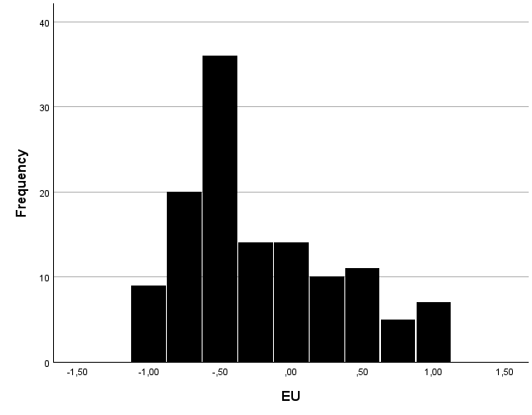

Figure 2 shows that there are much more respondents who lean to a Eurosceptic attitude than respondents who lean to the Europhilic attitude. This means our results are likely to hold better for respondents who are Eurosceptic, as they are overrepresented. This will need to be taken into account during the induction process. The results also show a noticeably large number of respondents with a score of -0.5. Thirty-six respondents had that as their result, compared to only 20 at the next most popular result, of -0.75. As these results lie in each other’s neighbourhood it is likely to be a reflection of the opinion of most respondents.
Secondly, the score of respondents on both the support for inheritance tax, and art subsidies can be found in figures 3 and 4:
Figure 3 Support for inheritance taxation (Source: own data)
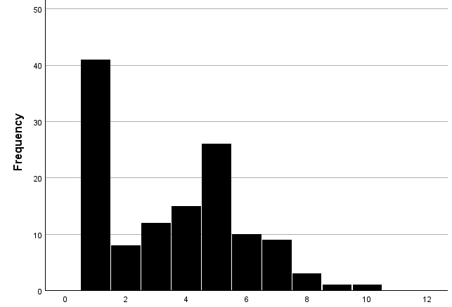

Figure 4: Support For Art subsidies (Source: own data)
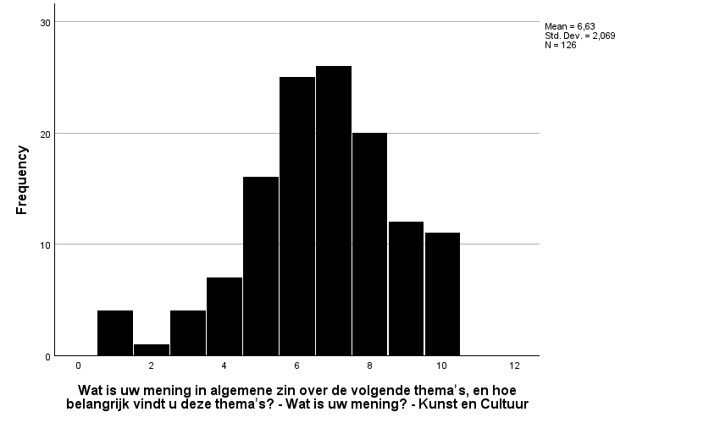

One skew in these graphs is very noteworthy. There is a large amount of respondents who are extremely opposed to the inheritance tax. This may be, because those who favour the abolishment of the inheritance tax all pick the option most opposed to the inheritance tax. There is a second big skew in the middle of the results. This might be the option where respondents who have no real opinion on inheritance tax. No option was given for respondents to express that they have no clear opinion, so respondents feeling that way are likely to choose this option.
Both in the case of support for inheritance taxation and in the case of support for Art subsidies one side is systematically underrepresented. Most people oppose inheritance taxation, while most people were in favour of subsidies to culture and art. This will need to be taken into account in the analysis and generalisation of the data.
In particular for the first experiment, where no traditional setup was used this can have influenced the results. In the later results, we reflect on a comparison between a before and after score among the same respondents, decreasing the likelihood of impact.
Analysis first experiment
In the first experiment the impact of two factors is assessed: whether or not the vignette a respondent received was redistributive, and the impact of extreme support of or opposition to the EU, on the answers. The amount of people with extreme opinions is summarised in figure 5.

Figure 5: Distribution of Extremism
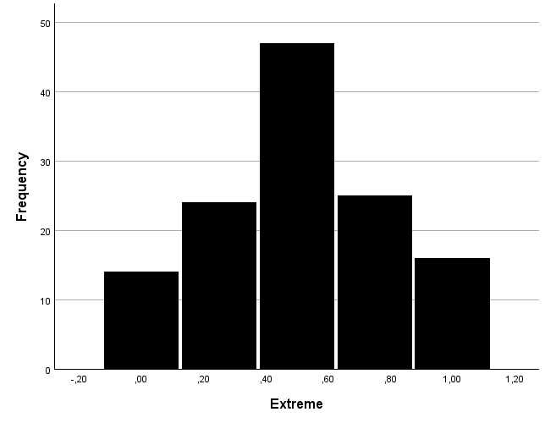

As the figure demonstrates, there is a relatively large spike at the value of 0.5, but the distribution otherwise seems relatively normal. There is no sign that this distribution will cause any problems in our statistical analysis.
Table 2 shows the distribution of respondents between the group that saw a vignette with a redistributive proposal, and the group that saw a non-redistributive vignette. This distribution was random, made by the computer, and the computer was set up to attempt to ensure that both groups are of roughly the same size.
 | Frequencies | Percentages
Redistributive | 62 | 50.8
Non Redistributive | 64 | 49.2
Table 2: Distribution among groups of redistribution

As the table shows the distribution was extremely equal, with one group holding 49.2% of the respondents, and the other holding 50.8%. The groups are also relatively similarly distributed among the control variables. The group that did receive a redistributive vignette is slightly more right-wing, and slightly younger. But overall there seems to be a relatively even distribution among the groups.
Regression analysis
To analyse the possible existence of effects between the dependent and independent variables a regression analysis will be used. This analysis brings forward the results as laid down in table 3.
Table 3: Regression analysis of the first experiment (source: own data)
Model | 1 | 2 | 3
 | b | b | b
Intercept | 7.284*** | 7.802*** | 7.536***
 | (0.487) | (0.554) | (0.849)
Extreme EU (Dummy)
Non-Extreme | Reference | Reference | Reference
Extreme | -1.481 | -1.617 | -1.740*
 | (0.831) | (0.825) | (0.859)
Redistribution (Dummy)
Not Redistributive |  | Reference | Reference
Redistributive |  | -0.899 | -0.895
 |  | (0.472) | (0.472)
Gender (Dummy)
Male |  |  | Reference
Female |  |  | 0.942*
 |  |  | (0.470)
Left-Right |  |  | 0.051
 |  |  | (0.115)
Age |  |  | -0.009
 |  |  | (0.012)
F | 3.180 | 3.441 | 2.449
Significance | 0.077 | 0.035 | 0.038
F change | 3.180 | 3.632 | 1.744
Significance | 0.077 | 0.059 | 0.162
R² | 0.026 | 0.039 | 0.056
R² Change | 0.026 | 0.029 | 0.041
N = 126
b unstandardized coefficient
Standard errors in parentheses
* p < 0.05; ** p < 0.01; *** p < 0.001

This table shows that, using an alpha of 0.05, the first model is not significant as a whole, while the second and third models are significant as a whole. The final model, including all variables, has a significance level of 0.038. This means that there is evidence that the model as a whole explains the variation that exists among the general public. The statistics do show that the change from the first to the second model is not significant, using an alpha of 0.05. Neither is the change from the second to a third. The change from the first to the second does near significance, however. In this model the redistribution variable was added. The difference between the first and second models is significant at a significance level of 0.058.
Analysis of the redistributive variable
The final model includes both the dependent variables of extreme opinions on the European Union, as well as the control variables. This model has an R-square of 0.05, meaning the model can explain 5.6 per cent of all the variance that occurs. In this model the redistribution variable has a significance level of 0.059. We must take into account two different explanations for this significance level. Firstly, the effect might reflect an effect that exists among the total population. Given the small size of the sample and the fact that we did find a nearly significant effect, this might point towards the existence of such an effect among the general population. Secondly, this small sample size also increases the risk that the significant effect is a result of an unintentional bias that might have come to exist in the process of random distribution. With that nuance in mind the results can be used to confirm the existence of an effect of the redistribution variable on the support of either side in the dilemma.
The introduction of this variable has an R square change value of 0.041. This means that this variable can explain 4.21 percentage points more variance than the model with only the extreme position on the Euroscepticism variable.
The negative direction of this effect is in line with the theoretical expectations of this thesis. The B-coefficient of the redistribution in the final model is -0.895. As the redistribution variable is a dummy variable this means that when the vignette was redistributive respondents scored the vignette on average 0.895 less than when the vignette was not redistributive. This is not a particularly strong effect.
This means that taking everything together the data here can be said to contain some evidence that can be used to affirm the third hypothesis. The results of this thesis thus lend some limited further credibility to the theory of economic Euroscepticism. As discussed, this concept was theoretically controversial with some studies finding evidence for its existence (Borin e.a., 2021; Kelemen and Tarrant, 2011), but some found no effect of this variable (Fidrmuc, 2016; Senninger, 2021). In particular it affirms Kelemen and Tarrant’s findings that member states are not likely to give away power if it means redistributing money. Kelemen’s findings on states are here reproduced among the general public.
One explanation for this difference within the literature can be that variance exists from country to country. This study focused solely on the Netherlands while Fidrmuc (2016) focused on the United Kingdom and Senninger (2021) focused on Austria. Another difference is that this thesis analysed the direct effect of economic benefit within a proposal on support for that particular proposal, while Fidrmuc analysed the effect of the general economic effect in a region on the vote result in the Brexit referendum in that region, and Senninger (2021) used similar data using the effect of voting results for Eurosceptic parties instead of in a referendum. It could be the case that the impact of redistributive policies on specific policy proposals is present, but that it does not affect the general opinion of respondents on the EU. The election results used in the studies of Senninger and Fidrmuc gave insight into at best a broader analysis of how citizens viewed the EU. In the case of the general election results the reasons can, of course be even broader.
Analysis of the extreme Euroscepticism position variable
On the effect of the extreme values variable on support no significant result can be seen to exist in the relationship between having an extreme opinion on the European Union on the one hand, and, on the other hand, choosing the level of government over the policy results when choosing to support legislation. The significance level of this factor in the final model was 0.047. This means that the relationship measured is significant within this model. However, the change in the model after the introduction of this variable is not significant, as it had a significance level of 0.077. There is thus no evidence for a causal relationship between extreme positions on support for the EU and what choice is made in the Vestergaard (2019) dilemma. The b-coefficient of this effect was -0.502. This means that respondents with extreme positions were on average less likely to choose policy over level of government in a proposal where they clash. This negative relationship is in line with the theoretical expectations of our thesis.
The fact that no evidence can be found for this theoretically expected relationship can be explained in two different ways. On the one hand it can be attributed to the small sample size of this thesis, and the somewhat unequal distribution of the extremism score. A small sample size increases the likelihood of a type 2 error, meaning rejecting a hypothesis while it is true. This means that a relationship can exist. What increases the likelihood that a type two error did occur here, is the quite extensive body of literature which has described the effect of partisan federalism, the theory upon which this factor was based.
Another explanation could be that the theory of partisan federalism does not translate very well to the context of the European Union. If this were true, this would suggest an important difference in how citizens evaluate the European Union in comparison to a regular federal government. For example, considerations of level of government could have played a much more important role, even for those who do not have expressed very extreme positions.
A third alternative explanation could be a problem in the operationalisation of extreme positions. This used the number of statements on which a respondent scored Eurosceptic to derive a score on extreme positions, rather than the extent to which respondents agreed with those statements. It might be the case that a part of the respondents support giving power to the European Union on certain issues but oppose it very strongly on others. Such results might not have been accurately captured by the measurement instrument.
A final possibility is that partisan federalism does not exist at all. However, considering the small sample size employed in this thesis and the relatively broad support for (a part of) the theory of partisan federalism, this appears unlikely.
Analysis of the second experiment
The second experiment consists of one variable of interest. This variable is whether, after the initial vignette was shown, the respondent received an empty bit of extra information, or the information that the Netherlands was a winner in the context. In deviation of the first experiment this variation was only brought in after the respondents had initially been introduced to the vignette, and after respondents had initially evaluated this vignette. The distribution among these two groups was random and done by the computer. Table 4 shows the distribution among the two groups.
Table 4: Distribution among winner and non-winner groups (source: own data)
 | Frequencies | Percentages
Winner | 58 | 54
Non-Winner | 68 | 46

This table shows that approximately 55% of respondents saw the non-substantial extra bit of information, while 45% of respondents received the substantial bit of information that the Netherlands was a winner of the redistribution. There does exist a substantial difference in how respondents evaluated the original proposal. This must be taken into account while analysing the results, because it can impact to what extent the impact takes place. However, it is not immediately problematic, because the difference between the evaluation before and after receiving an extra bit of information will be analysed. Apart from this there is also a substantial difference in age between the different age groups.
The treatment effect of this experiment among the respondents is calculated by finding the difference between the average result of the treatment group and that of the null group. The averages of these are 5.4 and 4.1. The difference between them is 1.3. While this seems like a pretty sizable effect, it must be taken into account that a difference in evaluation already exists before the treatment is applied. This means that these results are not very reliable and to account for this variance a regression analysis is more suited. This analysis gives the results as laid down in table 5.

Table 5: Regression analysis of the second experiment (Source: own data)
Model | 1 | 2
 | b | b
Intercept | 0.303 | -0.060
 | (0.228) | (0.584)
Winner or Loser (Dummy)
Loser | Reference | Reference
Winner | -0.553 | -0.632
 | (0.337) | (0.355)
Gender (Dummy)
Female |  | Reference
Male |  | -0.013
 |  | (0.345)
Left-Right |  | 0.023
 |  | (0.082)
Age |  | 0.008
 |  | (0.008)
F | 2.696 | 0.876
Significance | 0.103 | 0.481
F change | 2.696 | 0.286
Significance | 0.103 | 0.836
R² | 0.026 | 0.029
R² Change | 0.022 | 0.007
N = 126
b unstandardized coefficient
Standard errors in parentheses
* p < 0.05; ** p < 0.01; *** p < 0.001
This table shows that no significant relationship exists between receiving extra information that the Netherlands is a winner and receiving non-substantial information, is found. The significance level of this factor is 0.479. The B-coefficient of this factor in the final model is -0.348. This means it is negative, which confirms the theoretical expectations made on the direction of this effect.
There results mean that no evidence can be found for an effect among the general population between the country of residence of a voter gaining financially from a proposal and their support of it. In contrast to this, evidence was found in the first experiment that voters do care whether or not a proposal as a whole is redistributive. Both of these factors were included to test the theory of economic Euroscepticism. An explanation might be that people are not more opposed to redistributive proposals because they fear that their country of residence might lose money, but that instead they are opposed for a different reason. However, there could also be other reasons for the difference in effect measured among this sample between the first and second experiments.
Firstly, the small sample size again means that the results are not necessarily reliable. The effect that might exist might have been countered by a bias created during the random distribution. The small sample size increases the chance that such bias has been created. Additionally, the effect might have been too small to be measured as significant in a small group of respondents.
Secondly, a possible explaining factor is the fact that the treatment group received a treatment that used a logical explanation for why the Netherlands gained more from the fund than other countries. The vignette stated that this was the case because the Netherlands had more artists than was the case on average. This functioning might have been a reason for respondents to change their evaluation, even though it was not the treatment meant. If this is the case, the results have become unreliable.
In summary, the results of the second experiment cast some limited doubt on the theory of economic Euroscepticism. This is particularly true when it comes to the theory that winning a redistribution makes you more likely to support the proposal. However, there are also some issues that undercut the validity of the measurement instrument used here, and the data that it has produced.
Assumptions
In this section the assumption of the ordinary least squares model, as explained in the methodological chapter, and in case of violation adjustments will be made. Figure 6 shows the scatterplots of the 2 dependent variables that were not dummies and the independent variables they are modelled with.
Figure 6: Scatterplots of non-dummy independent variables with dependent variables. Left Right variable in the top row, age in the bottom row. First experiment outcome in left column, Second experiment in right column
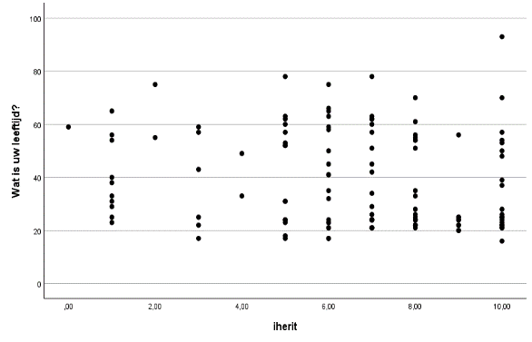
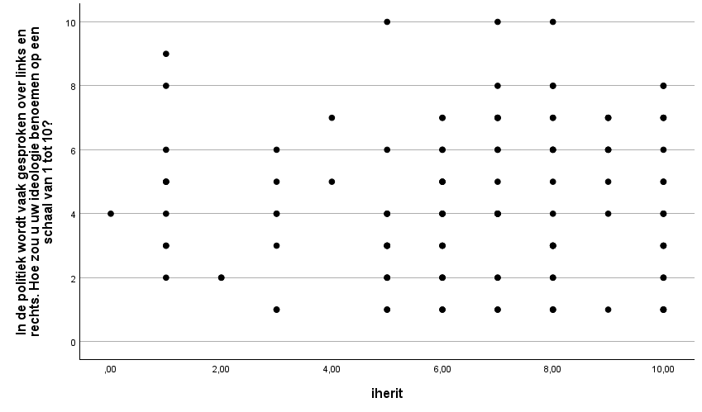
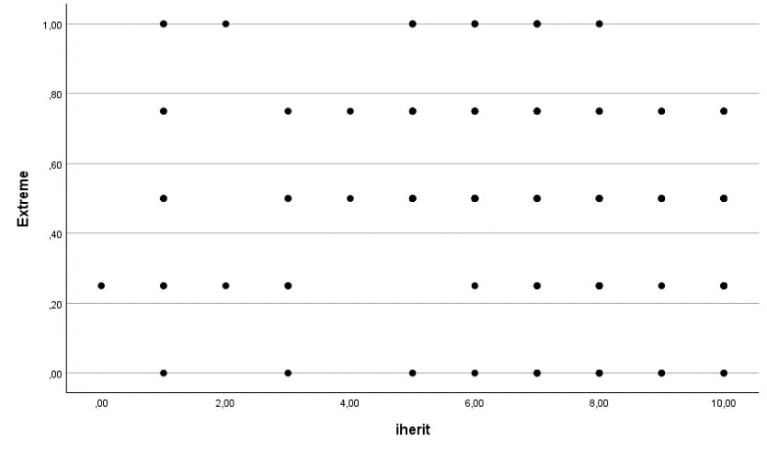
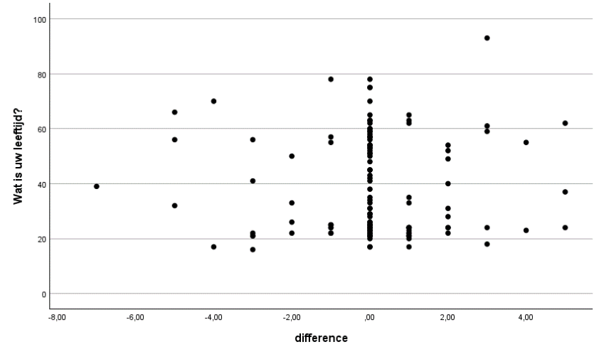

Most of the variables used were dummy variables for which the assumptions of homoscedasticity and linearity are automatically affirmed. None of the graphs of non-dummy variables follow a distinct pattern that would signify the presence of a relationship other than a linear one, such as a curvilinear relationship. This means the hypothesis of linearity and additivity can be confirmed.
Secondly, there are no particular sides of the graph that show notably less variance than the other side of that graph. While on some scores of certain variables there does exist less variation, this can best be ascribed to the small size of the sample. The assumption of homoscedasticity is thus affirmed.
Thirdly, the scatterplots do not give rise to the idea that there may be a notable outlier. This has the exception of one case on the age graphs. This concerns a person of the age of 94. This is the only person of an age higher than 84, and this person has a seemingly somewhat high score on the evaluation of the inheritance tax vignette. This might have impacted the regression analysis results for these variables. However to warrant deleting a case in its entirety a stronger argument is required. The case will thus be kept in.
The graphs in figure 7 are p-p plots. They are used to test the normal distribution of the residuals. The straight black line indicates what a normal distribution would expect, and the dots represent the observed data in this thesis. As is visible the data of both dependent variables broadly follow the black line, and thus the normal distribution. The assumption of the normal distribution can thus be affirmed.
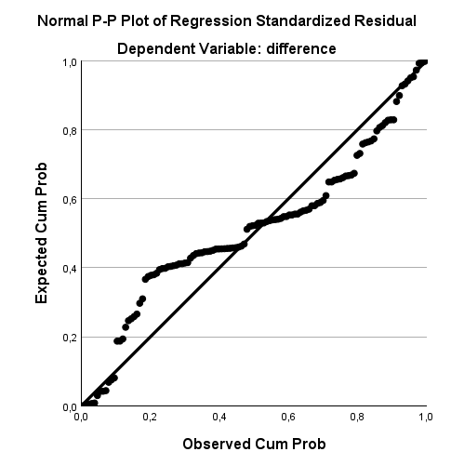
Figure 7: P-P plots for the first experiment (left) and second experiment (right)
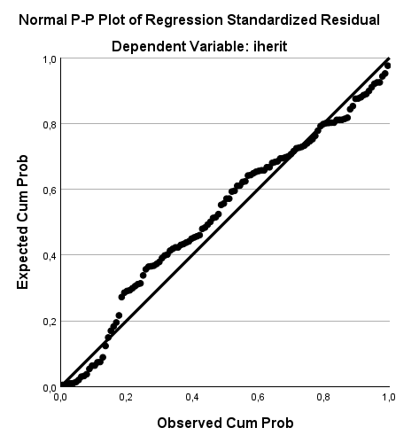
The graphs in figure 8 are q-q graphs meant to test the independence of the residuals. The interpretation works the same as the interpretation of p-p graphs: the data points should follow
the straight line. In the case of these graphs this is the case, and hence the assumption of the independent distribution of errors is validated.
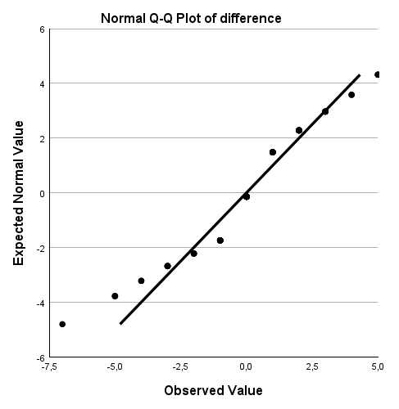
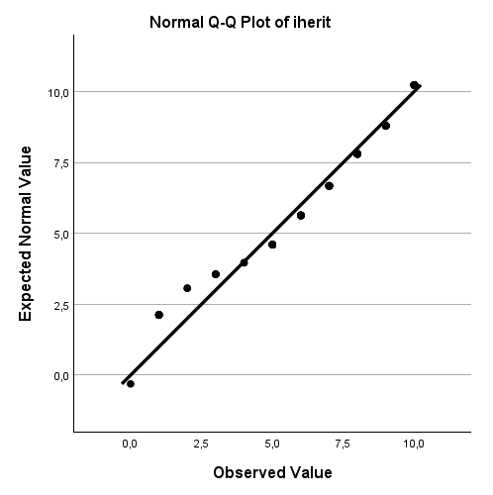
Figure 8: Q-Q plots for first experiment (left) and second experiment (right)

The final assumption to verify is that there is no multicollinearity. The tolerance levels are lower than 0.2, the largest VIF is not larger than 10, and the average of all VIF values is not substantially larger than 1 (it is 1.038 for the first model and 1.059 for the second model).
As explained in the section on methodology the assumption of exogeneity does not need to be verified because of the experimental design employed in this thesis.
Conclusions
In this chapter, conclusions will be drawn about the hypotheses developed in the theoretical chapter. Additionally, a reflection will be given on the quality of this study, and finally, recommendations will be given for possible future studies. The evaluation of the hypotheses needs to be done with a lot of caution, as a study with a small sample size cannot provide the evidence to make statements that are too bold.
The first and second hypotheses involved the influence of extreme opinions about the EU on the likelihood that a respondent would prioritise their ideological goals over the level of government at which these goals are achieved. It held that people with extreme opinions on the EU were more likely to let level of government lead their support for a proposal. These hypotheses were derived from the theory of partisan federalism, which holds that people only about federalism as an extension of their partisan preference, and change their position on federalism based on what party is in charge at which level of government. The data of this thesis does not provide evidence for either of these hypotheses. Despite the lack of data in this study, there is still a wide range of articles that provide evidence for the existence of a partisan federalism effect in the general federal system. There does thus seem to be evidence of the existence of this effect. One explanation is thus that this theory might hold in general, but does not hold properly in the context of the European Union. This would mean that even those with less expressed feelings on the European Union do care about the extent to which the EU has power. Consequently, we cannot with certainty reject this hypothesis, but the results have made the theory somewhat less likely, most particularly in the context of the European Union.
The third hypothesis involved the influence of a proposal being redistributive on prioritising ideological goals over the level of government at which these goals are achieved. The hypothesis held that redistributive proposals were more likely to let people prioritise the level of government at which they would take place. The results of the experiment that was conducted in this study did not fully confirm this theoretical expectation, but the significance level was close to being significant. Given the small sample size, this does not give any ground to reject the hypothesis. In contrast the near significance of the results, in the context of the smaller sample might even suggest that an effect could be found in a study with more respondents, and the population at large. The theory used to derive the theoretical expectation on redistribution was the theory of economic euroscepticism. The results of this thesis thus can give some cautious additional support to the importance of the theoretical concept of economic euroscepticism, which nevertheless was and remains quite controversial. This study, however, is different from other studies which studied this concept because this study studied the direct impact of the inclusion of a redistributive element in a proposal on support for that proposal. Earlier studies studied the impact of EU funding in the area a respondent lives in on the support that respondent gave in general towards the European Union. This means that this thesis more directly studied the impact, and its results might therefore be somewhat more convincing. Nevertheless, the small sample size of this study must continue to be taken into account.
Finally, the fourth hypothesis involved the influence of winning the redistribution on prioritising ideological goals over the level of government at which these goals are achieved. This hypothesis held that proposals in which the country of residence of someone would win the proposal. The data did not give ground to accept the hypothesis. This is notable as this hypothesis is derived from the same theoretical concept as the third hypothesis namely economic Euroscepticism. Some evidence was found for this hypothesis. One explanation could be that there might have been some impact from the explanation given to respondents in the treatment group on why the country of residence receives more from the fund than others. This was explained by saying that countries with more active artists would receive more money. The reason given might have negatively swayed some respondents who might have favoured stimulating artists in countries with a smaller art sector. Another methodological problem in this experiment may lie in distrust in the projection that the Netherlands would be a winner. Prooijen e.a. (2022) holds that a large distrust in organisations exists, and this could additionally explain these results. Nevertheless, the data provides not evidence for the hypothesis. It thus seems most likely that people are less supportive of redistributive proposals, but that they are not influenced by whether or not the Netherlands is projected to gain money from the redistribution.
Discussion and recommendations
This section will discuss some of the elements that could have negatively impacted the reliability and validity of this study, and offers recommendations for further studies on how tackle these issues in a better way. Additionally, some general recommendations will be made based on the results of this study.
As already discussed quite elaborately the sample wasn't as big as it would ideally have been. On top of this, the respondents were all citizens of the Netherlands. It is well possible that because of cultural differences the dilemma may be tackled differently by citizens of other countries. This could also have impacted the factor for which this thesis found a significant effect, namely the redistribution factor. One reason to suspect this is that the Dutch government has historically been quite reluctant to support the redistribution of money to other member states. This was the case in for example the case of financial aid during the Covid-19 pandemic (Verdun, 2021), and aid towards member states in financial problems during the Eurocrisis (Papadimitriou & Pegasiou, 2023). This might reflect a general and distinct attitude in the Netherlands towards redistribution. Citizens of other member states, whose governments showed less resentment towards these redistributive measures, may have been less reluctant to redistribution, and the effect might thus have been different. If a similar experiment undertaken in those countries would show evidence for a relationship, those results might thus provide a stronger test for the theory of economic euroscepticism.
Secondly, as was already reflected on in the discussion of the final hypothesis, some methodological advances can be made in future studies. The second experiment of this study did not use the currently very popular vignette set-up for experimental research. Rather it used an experimental set-up that did use vignettes but was set up as a randomly controlled experiment. The advantage of this setup was that the causal change as a consequence can directly be witnessed, in the difference from before to after the treatment. It did mean that the variance between the two groups was not one or a couple of words, as is ordinary in a vignette experiment, but rather a differing paragraph. In future studies seeking to use a similar set-up more consideration could be given to how the two vignettes can be kept as close to each other as possible. In the vignette in this thesis the explanation of how redistribution would take place might, as noted earlier, have influenced the results. To resolve this issue, it would have been best to involve that explanation in both vignettes. The only difference between the groups would then be the additional information that the country of residence of a respondent fulfils the criteria to gain a lot from the fund. This would isolate the treatment to a larger extent and thus increase the internal validity of the experiment.
Thirdly, because the dilemma was formulated differently based on the position of respondents on both the EU and the topics at hand, the distribution among the different possible vignettes was dependent on the respondents who filled in the survey. This led to a relatively uneven distribution between the different vignette groups, as reflected upon in the methodological chapter. This might have skewed the data to some extent. If this study is redone, the validity would increase if more of an effort were made to get a more even distribution among the vignettes.
Additionally, some general recommendations can be made for future studies that are undertaken on the basis of the results of this study. Firstly, new studies could compare the results of this study to the actual way members of the European Parliament will vote on proposals that contain a dilemma as proposed by Vestergaard (2019). This is true particularly for right-wing Eurosceptic members because as discussed in the introduction, right-wing Eurosceptic members have risen in number quite considerably since the 2024 European parliamentary elections. This might cause them to engage themselves with European Union politics more actively, since their position can be crucial for certain proposals. It would thus be a good idea to monitor this shift and evaluate of the effect redistribution has been shown to have on citizens also impacts them.
Finally, some additional research can be done on the causes of explicit Europhilia. This thesis based itself on a number of theories from the Euroscepticism literature, but it could also have benefitted from additional theory formation on Europhilia. In particular with the arrival of small parties such as Volt who specifically propagate such a position. This would be useful in particular as studies have indicated that Europhilia does play a role in voter’s choices as discussed by Otjes (2022).

Sources
Abts, K., Heerwegh, D. & Swyngedouw, M. (2008), Euroscepticisme in Belgie: economische belangen, culturele identiteit en politiek wantrouwen. Res Publica, 50(4): 357-381
Barber, M. B., Pope, J.C. (2018). Does Party Trump Ideology? Disentangling Party and Ideology in America. American Political Science Review 113(1): pp. 38-54.
Bartscher, A.K., Seitz, S. Siegloch, S. Slotwinski, M. Wehrhöfer, N. (2021). Social capital and the spread of covid-19: Insights from European countries. Journal of health economics, 80: pp. 1-15.
Boomgaarden, H.G., Claes, H. I. M. (2006). Media Effects on Public Opinion About the Enlargement of the European Union. JCMS 44(2): pp. 419-436
Borin, A., Macchi, E., Mancini, M. (2021). EU transfers and euroscepticism: can’t buy me love? Economic Policy 36(106): 237-286.
Bulman-Pozen, J. (2014). Partisan Federalism. Harvard Law Review, 127(4): pp. 1077-1146
Callaghan, t., Olson, A., Karch, A. (2017). Return of the “rightful remedy”: Partisan Federalism, Resource Availability, and Nullification Legislation in the American States. Publius: The Journal of Federalism, 48(3): pp. 495-522.
Conrad, M., Orlando, V. (2024). Reinforcing or moderating? The impact of Brexit on Italian and German Euroscepticism. Frontiers of Political Science 6: 1-8
Converse. (1964). The nature of belief systems in mass publics. In Apter D. (eds) Ideology and Discontent
De Koster, W., van den Hoogen, van der Waal, J. (2022). What Does the EU Actually Mean to Citizens? An in‐Depth Study of Dutch citizens' Understandings and Evaluations of the European Union. Journal of Common Market Studies, 60(5): pp. 1432-1448.
Destradi, S., Plagemann, J., Scharma, C.K. (2020). Partisan federalism and subnational governments’ international engagements: Insights from India. The journal of federalism, 50(4): pp. 566-592.
Dinan, J., Heckelman, J. C. (2020). Stability and Contingency in Federalism Preferences. Public Administration Review, 80(2): pp. 234-243
Druckman, J. N., Parkin, J.N. (2005). The Impact of Media Bias: How Editorial Slant Affects Voters. The Journal of Politics 67(4): pp. 1030-1049
Druckman, J.N. Green, D. P., Kuklinski J. H., Lupia, A. (eds.) (2012). Cambridge Handbook of Experimental Political Science Cambridge: Cambridge University Press
Druckman, J. N., Green, D. P. (2021). Advances in political science Cambridge: Cambridge University Press
Evans, J.A.J. (2000). Contrasting attitudinal bases to Euroscepticism amongs the French electorate. Electoral studies 19(4): 539-561.
Fidrmuc, J., Hulényi, M., Tunali, C.B. (2019). Can money buy EU love?. European Journal of Political Economy 60: pp. 1-13.
Field, A. (2017). Discovering Statistics Using IBM SPSS Statistics. Thousand Oaks: Sage
Gerber, A.S. & Green, D.P. (2011). Field experiments and natural experiments. In: Goodin, R. (ed.), The Oxford Handbook of Political Science. Oxford University Press
Heidbreder, E.G. (forthcoming). The Federal Core of EU Multilevel Administration (draft version). In: G.J. Brandsma (ed.), The Edward Elgar Handbook of EU Public Administration. Forthcoming.
Kalyvas, S. N., Van Kesbergen, K. (2010). Christian Democracy. Annual Review of Political science, 13: pp. 183-209.
Kaniok, P., Komínková, M. (2022). Hard and Soft Euroscepticism in the European Parliament. European Review, 30(1): pp. 79-95
Kelemen, R. D., Tarrant, A. D. (2011). The political foundations of the Eurocracy. West European Politics, 34(5): pp. 922-947.
Kopecky, P., Mudde, C. (2002). The Two Sides of Euroscepticism. European Union Politics, 3(3): pp. 297-326.
McDermott (2012). Internal and External validity. In: Druckman J. N. Greene, D. P., Kuklinski, J. H., Lupia, A. (eds.) Cambridge Handbook of Experimental Political Science. (pp. 102-114) Cambridge: Cambridge University Press.
Mckay, D. (1999). Federalism and European Union: A political economy perspective. Oxford: Oxford university press.
Otjes, S. (2022). From Eurorealism to Europhilia? The 2021 Dutch Elections and the New Approach of the Netherlands in EU Politics. Journal of Common Market Studies, 60(51): pp. 60-75
Papadimitrou, D., Pegasiou, A. (2023). From Bail-out to Bail-in: explaining the variegated responses to the international financial aid requests of Ireland and Cyprus. New Political Economy, 28(6): pp. 971-985.
Petersen, M. B., Slothuus, R. (2010). Political Parties and Value Consistency in Public Opinion Formation. Public Opinion Quarterly 74(3): pp. 530-550.
Pérez, I. (2008). La oposición a la Unión Europea en el sur de Europa: los casos español, portugués, griego e italiano,Tesis Doctoral, Universidad de Barcelona.
Pickup, M. & Evans, G. (2013). Addressing the endogeneity of economic evaluations in models of political choice. Public Opinion Quarterly, 77(3), 735-754.
Rodriguez-Aguilera de Prat, C. (2013). Euroscepticism, Europhobia and Eurocriticism. The Radical Parties of the Right and Left vis-à-vis" the European Union" The Hague: Euroclio.
Rogowski (2016). Presidential Influence in an Era of Congressional Dominance. American Political Science Review 110 (2): pp. 325-241
Rose-Ackermam, S. (1981). Does federalism matter? Political choice in a federal republic. Journal of Political Economy, 89(1): pp. 152-165.
Schimmelpenninck. (2023). De erfbelasting is de meest fatsoenlijke belasting; die schaf je niet af. Retrieved from: https://www.volkskrant.nl/nieuws-achtergrond/de-erfbelasting-is-de-meest-fatsoenlijke-belasting-die-schaf-je-niet-af~b6662025/
Senninger, R. (2021). Does European Union Funding Reduce Eurosceptic Voting?
Schneider & Jacoby (2013). 'Intuitive Federalism' and Public Opinion Toward Government. APSA 2013 meeting paper.
Schoene, M. (2019). European disintegration? Euroscepticism and Europe’s rural/urban divide. European Politics and Society 20(3): pp. 348-364.
Sniderman, P. M. (2012). The Logic and Design of the Survey Experiment. An Autobiography of a Methodological Innovation. In Druckman J. N. Greene, D. P., Kuklinski, J. H., Lupia, A. (eds.) Cambridge Handbook of Experimental Political Science. (pp. 102-114) Cambridge: Cambridge University Press.
Taggart, P., Szczerbiak, A. (2002). Europeanisation, euroscepticism and party systems: Party‐based euroscepticism in the candidate states of Central and Eastern Europe. Perspectives on European Politics and Society 3(1): pp. 23-41.
Van der Eijk, C. & Franklin, M.N. (2004). Potential for contestation on European matters at
national elections in Europe. In G. Marks & M.R. Steenbergen (eds.). European Integration and Political Conflict (pp. 32-50). Cambridge University Press.
Van Elsas, E., Van der Brug, W. (2015). The Changing relationship between left-right ideology and Euroscepticism, 1973-2010. European Union Politics, 16(2): pp. 194-215.
Van Wensen, J. (2023). Schaf de schenk- en erfbelasting af. Retrieved from: https://www.ewmagazine.nl/economie/achtergrond/2023/06/schaf-de-schenk-en-erfbelasting-af-1044552/#:~:text=Met%20de%20schenk%2D%20en%20erfbelasting,eieren%2C%20maar%20is%20dat%20niet.
Vestergaard, K. T. (2021). A ‘second-order’-agenda in the European Parliament? How Eurosceptic voting behaviour is moderated by issue salience. European Politics and Society, 22(3): pp. 331-346.
Wessels, B. (2007). Discontent and European Identity: Three types of Euroscepticism. Acta Politica, 42: pp. 287-306.
Wlezien C. (2024). News and public opinion: which comes first?. Retrieved from: https://ukandeu.ac.uk/news-and-public-opinion-which-comes-first/
Wolak, J. (2016). Core Values and Partisan Thinking about Devolution. The journal of Federalism, 46(4): pp. 463-485.

The term province is used here and in the rest of this section as a general term for a sub-entity within a federal system of government. Province can thus refer interchangeably to, for example, US States, German Bundesländer, Canadian Provinces, or EU countries.

