Submission form Master Thesis - Radboud University Repository

Name author: Milou Joosten, M.M.T.
Address: Minervaplaats 216, 6526JG Nijmegen
E- mail address: miloujoosten94@hotmail.com
Student number: s4334965
Supervisor: Dr. Roos Hoekstra-Pijpers
Master Programme: Urban and Cultural Geography
Title Master Thesis: An evaluation of Roze Stadsdorp Amsterdam - Creating neighborhood-inclusion and social
networks for LGB elderly in Amsterdam

I hereby grant permission to include the aforementioned master thesis in the Repository of the Radboud University in Nijmegen for publication on the world wide web for free.

I certify that the copyright of the publication rests with me or that the right to provide this permission has been obtained from the copyright holder.

I shall indemnify the Radboud University in Nijmegen from claims of third parties relating thereto.

Name author: Milou Joosten
Place: Nijmegen Date: 06-03-2019
Signature:
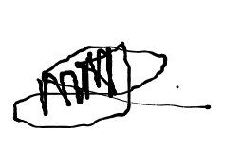

Send this signed submission form in with an abstract (max. 200 words) to the Secretariat of GPE
(inleveren-GPM@fm.ru.nl)

