Assessment Form for the MSc Thesis in Political Science
Student | Marleen Ensink
Student number | S1030238
Title of the thesis | Australian Climate Politics – A frame analysis of Australia’s Liberal Party’s climate change policy before and after the bushfires of 2019-2020
Assessed by  Supervisor  Second assessor | Nora Stel (supervisor) and Jutta Joachim (second reader)
Date | 9 July 2020
Mark (rounded to halves) | 7.5

The thesis is interesting, systematic and solid. It might have offered more elaborate reflection on and theorization of findings.

 | Criteria | - = insufficient  + = sufficient  ++ = very good  +++ = exceptional | Comments supervisor and second assessor
Theory/  design | The student has designed a research project centring on a clearly defined scientific problem in political theory and/or empirical political science.  For this, the student needs to (1) convincingly demonstrate the existence of an inconsistency, deficiency or ontological problem (within a theory, between theories, between theory and empirical reality) asking for a solution; and (2) convincingly argue why a solution is needed. | ++ | - The empirical relevance (climate change policy and effect of crises on policy-making) as well as the theoretical relevance (focus on intra-party politics and contributions to framing theory) is clearly established and convincing. The thesis makes a contribution in disproving the dominant assumption that climate change contentions are between parties rather than within. But it should have more explicitly outlined what the theoretical and practical benefits are of uncovering the intra-party politics of these dynamics.  - The case selection and demarcation is well-argued  - The historical background in CH1 is too elaborate for the Introduction and would have better fit in the empirical chapter (CH4)
 | The thesis  a. specifies the scientific and  b. societal relevance of the research question, and  c. justifies the choice of the (theoretical) approach, applied method(s), sources and/or data. | ++ | - The theoretical approach is convincingly and eloquently justified  - The sources used are extensive and relevant and their sampling is properly motivated and described. More reflection on the limitations of the evidence base would have been in order: since the thesis only uses public sources the real extent and nature of silence, voice, and exit – which are often negotiated behind closed doors – cannot be gauged  - More methodological literature could have been used to further legitimize research choices  - The research design and analytical strategy and systematic and coherent and clearly linked to the theoretical framework: operationalization and coding are well thought-through and presented
Application/  research | The thesis adequately represents and discusses the investigated theory or theories. It locates the theory in the evolution of (a) research programme(s) or scientific debate(s), engages with the state-of-the-art of academic contributions to the chosen theme, and identifies the strengths and weaknesses of earlier attempts to resolve the research problem. | ++ | - The discussion and operationalization of the core concepts is ambitious, systematic and presented in an accessible way. The linkages between the concepts are properly explicated in a researchable analytical framework although the integration might have been explained more elaborately in the narrative (beyond the figures)  - The table on 21 is not configured properly and needs to be redone before the thesis is archived  - For each concept, various theoretical positions/debates are identified and outlined
 | The thesis:  a. builds a logically and scientifically valid case for an original, clear and precise answer to the research question  b. and does so through consistent application of the chosen method(s) or approach | + | - The presentation and discussion of the data is transparent and systematic and the presentation of the findings is structured so as to follow the theoretical framework and respond to the research questions; good reflection on the deductive as well as inductive dimensions of the framing analysis (these are integrated in CH5)  - Main findings are clearly identified (although sometimes a bit repetitive); interesting comparison between different data categories (media and parliament); a good mix between ‘show’ and ‘tell.’  - The motivational frame aspect is not always convincingly identified/analyzed  - More methodological literature (on for instance coding and sampling) would have strengthened the methods section further  - More reflection on the role of media as framing actors would have been in order. Media statements are now sometimes uncritically taken as direct reflections of politicians’ policy preferences
Reflection | The thesis identifies the research’s major findings, the strengths and limits of the chosen theory or method, and the scientific and societal implications, indicating new avenues for future research | + | - The findings would have benefited from more contextualization and theorization so that their implications beyond the case at hand would be more evident  - The conclusion is somewhat repetitive and a crisp answer to the research question is lacking; the research question is answered, but a one-sentence summary of the main findings would have been welcome. Specifically, the key question of whether Liberal MPs agreed more or less among each other on climate change after the bushfires is not as straightforwardly answered as promised  - Excellent integration between inductive and deductive findings  - Proper linking back to theoretical debates in identifying contributions  - Excellent suggestions for further research
General/
process
 | The length of the thesis is appropriate (15.000 – max. 25.000 words, excluding bibliography); standard academic and style criteria are met (title page, contents, notes, quotations, references to literature and bibliography are in accordance with academic standards. | ++ | - All criteria are met  - Relevant appendices are offered
 | The thesis is written in eloquent and correct English, and is clearly structured. | ++ | - The thesis reads well; written and structured properly (if sometimes slightly too repetitive)
 | The research and writing were conducted in a sufficiently independent way. | ++ | - Marleen was proactive in the design, analysis and writing of the research
 | The student has adequately communicated with the supervisor on progress and obstacles, has met in-between deadlines, and has responded professionally to the supervisor's critique and suggestions. | ++ | - Marleen solicited and accommodated feedback aptly and professionally
 | (Reserved for remarks on merits of the thesis not covered by standard criteria)

Please send this form, the Turnitin report, an electronic copy of the thesis, the submission form for the Radboud Respository signed by the student, and the laudatio (350 words max) to Amanda van Eck-Boerboom at the department administration. No hard copy of the thesis is required unless you want one for yourself.

Please notify Ingrid Smitjes, at student administration, of the results via email; remember to mention the student’s name and student number, title of the thesis, date of assessment and course code: MAN-MTHPOL and specialization.

Place and Date: 9 July 2020

Signature supervisor:
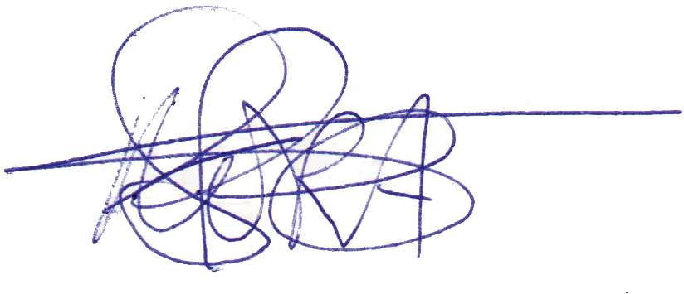

Signature second assessor:
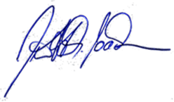

Submission form – Master Thesis Radboud University

Name Author: .................................................................................................................................................................
Address: .........................................................................................................................................................................
E- mail address: .............................................................................................................................................................
Student number: ............................................................................................................................................................
Supervisor: .....................................................................................................................................................................
Master Programme: .......................................................................................................................................................
Title Master Thesis: .......................................................................................................................................................

I hereby grant permission to include the aforementioned master thesis in the website of Department of Public Administration of the Radboud University in Nijmegen for publication on the world wide web for free.

I certify that the copyright of the publication rests with me or that the right to provide this permission has been obtained from the copyright holder.

I shall indemnify the Radboud University in Nijmegen from claims of third parties relating thereto.

Name: ............................................................................................................................................................................
Place: ............................................................................................................................................................................
Date: ............................................................................................................................................................................
Signature: .....................................................................................................................................................................

Please send this form to a.vaneck@fm.ru.nl (secretariat Political Science).
With this form you give us permission to upload your thesis in our repository.

When your thesis contains confidential information, please send a signed letter, also by email, to the secretariat.
We will make sure your thesis will not be visible in the repository and for other persons.

Beschikbaarstelling – Masterthesis Radboud Universiteit

Naam auteur: .....................................................................................................................................................
Adres: .................................................................................................................................................................
E-mail adres: .......................................................................................................................................................
Studentnummer: .................................................................................................................................................
Begeleider: ...........................................................................................................................................................
Opleiding: ............................................................................................................................................................
Titel Master-thesis: ..............................................................................................................................................

Ondergetekende stelt de genoemde publicatie “om niet” beschikbaar voor opname in de repository van de faculteit der Managementwetenschappen.

Ondergetekende verklaart dat het auteursrecht van de publicatie bij hem/haar berust dan wel dat over deze beschikbaarstelling toestemming is verkregen van de auteursrechthebbende.

Ondergetekende vrijwaart de Radboud Universiteit Nijmegen van claims van derden dienaangaande.

Naam:

.................................................................................................................................................................

Plaats: ............................................................................... Datum: ……………......................................

Handtekening:

NB.: Dit formulier ingevuld en ondertekend sturen/emailen naar: a.vaeck@fm.ru.nl (secretariaat B&P).
Met dit formulier geeft u ons toestemming om uw thesis in de scriptierepository te plaatsen.
Indien u dit niet wenst, in verband met vertrouwelijkheid van gegevens, gelieve dit dan ook door te geven in een brief met handtekening aan het secretariaat. Deze mag ook per email gestuurd worden.

