the role of policy instruments in the integration of energy storage systems into the dutch energy mix

Master’s Thesis for the Environment and Society Studies Programme at the Nijmegen School of Management, Radboud University

By Andrew Walker

August 2017

Colophon
This document is a Master’s Thesis for the completion of the Environment and Society Studies Programme at the Nijmegen School of Management, Radboud University, Nijmegen, Netherlands.

Title: The Role of Policy Instruments in the Integration of Energy Storage Systems into the Dutch Energy Mix

Version: Final Version

Date of Submission: 21st August 2017

Author: Andrew Walker

Student Number: s4694147

University: Radboud University
Nijmegen School of Management
Postbus 9108
6500 HK Nijmegen
Netherlands

Supervisor: Prof. Pieter Leroy
Professor – Environment, Radboud University

Internship Host Company: Pondera Consult
Postbus 579
7550 AN Hengelo (Ov.)
Netherlands
+31 (0)74 248 9940
www.ponderaconsult.com

Supervisor: Paul Janssen
Sustainable Energy Adviser



Images taken from http://www.ru.nl/english/ and http://ponderaconsult.com/
Acknowledgements
First, I would like to express my gratitude towards my thesis supervisor Pieter Leroy for his guidance and support throughout the research project. Furthermore, I would like to thank my internship host company, Pondera Consult, for offering me the opportunity to work alongside them, and for providing me a place to conduct my research. I would especially like to thank my supervisor Paul Janssen for the support given to me, as well as all my colleagues at Pondera Consult for their help and encouragement during the project. Finally, I would also sincerely like to thank all the interviewees who took time out of their busy schedules in order to meet and discuss my research and share their knowledge. Without them this final document would not be possible.
Andrew Walker
21st August 2017

SUMMARY
Wind and solar energy production is becoming an increasingly large component of the Dutch energy mix, as the government aims to reduce emissions in order to transition to a sustainable, clean-energy future. As wind and solar energy production increases, so too does the need for further integration of Energy Storage Systems (ESS) – the stochastic nature of wind and solar energy production necessitates the need for technologies such as batteries, which can store energy generated from wind and solar for use when required.

This thesis justifies the need for ESS and uses an adapted version of Transition Management theory to examine how policy instrument choice can facilitate (or hinder) the transition of ESS technologies in becoming established technologies (over a variety of scales) within the Netherlands. The thesis examines how policy instruments have allowed wind and solar energy production to successfully transition from niche to commercialisation, and the research finds that certain policy instruments have facilitated this transition. Based upon the policy instruments examined for the purposes of this research, it was found that lessons learnt from the transition of wind and solar energy to commercialisation cannot be applied to ESS due to inherent differences between the sectors.

However, based on primary data collected through a number of interviews with experts within the renewable energy and energy storage sectors, the research identifies a variety of re-occurring themes for discussion in regards to ESS. Evidence from the interviews suggests that policy instruments are currently holding the integration of ESS back within the Netherlands, although there are some structures in place which can be seen to help facilitate the transition towards commercialisation. The thesis details these themes and identifies which policy and technology instruments are most suitable in helping to facilitate the transition. The thesis explains where the transition sits within the policy and technology domains, and highlights the role of policymakers and technology actors in the transition.

The thesis concludes that although the increased integration of ESS is required, it is not the ultimate goal of the energy transition. The ultimate goal is a clean-energy future, and various options for flexibility, involving a number of different sectors, should be considered by policy and technology actors in order to achieve it.

Table of Contents
LIST OF FIGURES v
LIST OF ACRONYMS AND ABREVIATIONS vi

1 INTRODUCTION 1
1.1 Background, Research Aims, and Objectives 1
1.2 Research Questions 2
1.3 Theoretical Framework 2
1.4 Research Approach, Methodology, and Design 3
2 CLIMATE CHANGE, RENEWABLE ENERGY SOURCES, AND THE NEED FOR ENERGY STORAGE 3
3 LITERATURE REVIEW AND THEORETICAL FRAMEWORK 7
3.1 Introduction 7
3.2 Transitions and Transition Management 7
3.3 Instrument Choice Theory 11
3.4 Theoretical Framework 14
4 RESEARCH APPROACH, METHODOLOGY, AND DESIGN 17
4.1 Introduction 17
4.2 Research Aim 17
4.3 Assumptions 18
4.4 Research Questions 18
4.5 Methodology 19
5 TECHNICAL ASPECTS 23
5.1 Introduction 23
5.2 Renewable energy sources 23
5.3 Electricity Generation, Transmission, and Distribution 25
5.4 Energy Storage Systems 26
6 RESULTS AND DISCUSSION 27
6.1 Introduction 27
6.2 Results 27
6.3 Discussion and Recommendations 39
6.4 Limitations of the Research 44
7 CONCLUSION 45

REFERENCE LIST 47
APPENDICES 52

List of Figures

Figure 1 - Share of renewables in electricity production (including hydro) by geopolitical region (Source: Enerdata, 2017) 5
Figure 2 - Different stages of a transition at different system levels (Source: Rotmans et al. 2000 cited in Loorbach and Rotmans, n.d.) 8
Figure 3 - Multi-level perspective on transitions (Source: Geels and Schot, 2007 adapted from Geels, 2002) 9
Figure 4 - From niche dynamics to regime shift (Source: Schot and Geels, 2008, adapted from Weber et al. 1999) 10
Figure 5 - Current policy processes versus transition management processes (Source: Loorbach and Rotmans, n.d.) 11
Figure 6 - Areas of focus (Source: adapted from Geels, 2002) 16
Figure 7 - Instrument Choice Theory influencing policy (Source: adapted from Geels, 2002) 16
Figure 8 - Classification of ESS technologies (Source: adapted from Zhao, et al., 2015) 26
Figure 9 - Wind and Solar PV Energy Production in the Netherlands (Source: IEA, 2016b) 27
Figure 10 - Wind Energy Production in the Netherlands (Source: IEA, 2016b) 28
Figure 11 - Solar PV Energy Production in the Netherlands (Source: IEA, 2016b) 28

List of Acronyms and Abbreviations

Acronym or Abbreviation | Meaning
CBS | Centraal Bureau voor de Statistiek (Central Agency for Statistics)
CO₂ | Carbon Dioxide
CAES | Compressed Air Energy Storage
DC | Direct Current
DSO | Distribution System Operator
EV | Electric Vehicle
ECN | Energieonderzoek Centrum Nederland (Energy Research Centre of the Netherlands)
ESS | Energy Storage System
EPA | Environmental Protection Agency
EASE | European Association for Storage of Energy
EERA | European Energy Research Alliance
EU | European Union
FiT | Feed-in Tariff
FCR | Frequency Control Reserve
GW | Gigawatt
GW_{e} | Gigawatt electrical
GWyr | Gigawatt-year
GHG | Greenhouse Gas
HV | High Voltage
H | Hydrogen
ICT | Instrument Choice Theory
IPCC | Intergovernmental Panel on Climate Change
IEA | International Energy Agency
kV | Kilovolt
kWh | Kilowatt-hour
Li-ion | Lithium-ion
LV | Low Voltage
MV | Medium Voltage
MW | Megawatt
CH₄ | Methane
MEP | Mileukwaliteit Electriciteitsproductie (Environmental Quality of Electricity Production)
EZ | Ministerie van Economische Zaken (Ministry of Economic Affairs)
MLP | Multi-level Perspective
N₂0 | Nitrous Oxide
OG | Operational Goal
O | Oxygen
O₃ | Ozone
PV | Photovoltaic
PBL | Planbureau voor de Leefomgeving
PCR | Primary Control Reserve
PPP | Public-private Partnership
PHS | Pumped-hydro Storage
RES | Renewable Energy Sources
R&D | Research and Development
SER | Sociaal-Economische Raad (Social and Economic Council)
SDE | Stimulering Duurzame Energieproductie (Stimulation of Sustainable Energy Production)
SNM | Strategic Niche Management
SMES | Super-conducting Magnetic Energy Storage
TWh | Terawatt hour
TPES | Total Primary Energy Supply
TM | Transition Management
TSO | Transmission System Operator
UNDP | United Nations Development Programme
UNFCCC | United Nations Framework Convention on Climate Change
US | United States
VAT | Value Added Tax
H₂O | Water
WCED | World Commission on Environment and Development
WEO | World Economic Outlook

INTRODUCTION

Background, Research Aims, and Objectives
Conventional energy sources – such as coal, oil, and natural gas – are used in a variety of industries: oil-refining, petrochemical, iron and steel, agriculture, transport, and power generation (Honoré, 2017). The use of these conventional energy sources has led to increasing concerns over climate change and sustainability. As a result, recent decades have seen international agreements – such as the 1997 Kyoto Protocol which commits its signatories to reduce greenhouse gas emissions – and the increased adoption of technologies which can generate electricity from renewable energy sources (RES) – such as wind and solar. Indeed, various measures, including financial and regulatory, have been undertaken in the Netherlands to facilitate the integration of RES into the country’s energy mix. However, whereas conventional forms of energy are dispatchable – the generating plants can be turned on or off, at the request of the power grid operators or plant owner, to adjust power output supplied to the grid on demand – many RES are non-dispatchable and cannot adjust power output to meet changing demand. The stochastic nature of wind and solar energy production, for example, means it is almost certain that there will be fluctuations in energy supplied from these sources and power networks are likely to experience difficulties in meeting demand due to daily and seasonal variations. Energy Storage System (ESS) technologies have the potential to overcome the issues of meeting energy supply and demand by capturing energy which is produced when conditions for renewable energy are good but demand is low. The captured energy can be stored and converted to electrical energy when required.

Zhao, et al. (2015, p545) state that “recent development and advances in ESS and power electronic technologies have made the application of energy storage technologies a viable solution for modern power application”. However, although advances have been made and certain ESS technologies could be considered technologically mature – such as lithium-ion (Li-ion) batteries – overall, ESS technologies are less technologically mature than renewable energy production technologies. Indeed, as of 2015, 14% of Dutch electricty generation was from a RES (6% biofuels and waste; 1% solar; 7% wind) (IEA, 2016a), but there are currently only a handful of projects in the Netherlands which utilise an ESS, outside of the mobility sector. Although certain other renewable energy sources, such as geothermal, could be considered to be only at the early stages of development within the Netherlands, the assumption is made that energy production from biomass, solar, and wind is no longer considered a ‘niche’ industry. On the contrary, ESS integration with RES is still considered, in general, to be at early stages of development. These assumptions will be discussed further in Section 4.3.

Dutch government predictions see the share of wind and solar in the country’s electricity generation mix continue to grow in the period to 2030 (IEA, 2014), and energy storage will be vital for a clean-energy future based on renewable energy sources due to their inherent intermittency. This thesis examines the role that policy instruments can play in facilitating (or hindering) the further integration of ESS alongside RES in the Netherlands. The overarching aim of the research is to provide insight into the role that ESS technologies might play in the future, over several different levels – from domestic storage such as ‘behind-the-meter’ battery systems, through distributed storage, for example at wind farms, to centralised utility-scale storage facilities such as pumped-hydro storage (PHS) facilities. Furthermore, by examining which policy instruments were previously chosen by policymakers to facilitate (or hinder) the transition of renewable energy production to commercialisation, the lessons learnt can be used to recommend policy instrument choices to support the anticipated – and crucial – integration and utilisation of ESS alongside RES.

This introductory section will continue by briefly introducing the research questions, theoretical framework, and methods used to collect and analysis the research data. Section 2 will discuss climate change and why it is happening. It will explain and justify the need for a reduction in carbon dioxide (CO₂) emissions, the need for sustainable development, and the associated need for ESS technologies. Section 3 is a review of relevant literature in relation to transitions, Transition Management (TM) theory, and Instrument Choice Theory (ICT). Section 4 describes the research approach, methodology, and design. Section 5 introduces the different types of renewable energy sources and ESS technologies, and briefly describes the processes of electricity generation, transmission, and distribution. Section 6 presents the results of the study, addresses the research questions, and identifies the limitations of the research. Section 7 concludes with a summary of the research.

Research Questions
The main research question is: how can ESS technologies transition from niche to become established technologies at the regime level?

The sub-questions are:

- What role did different policy instruments play in the transition of renewable energy production (across different scales from domestic to large-scale) from niche to commercial adoption and diffusion in the Netherlands?

- What role do different policy instruments play in the ongoing integration of ESS with renewable energy production (across different scales from domestic to large-scale) in the Netherlands?

- How can the lessons learnt from Sub-questions 1 and 2 be utilised to support the evolution of ESS from niche to become commercially adopted and integrated with renewable energy production (across different scales from domestic to large-scale) in the Netherlands?

Theoretical Framework
To answer the research questions, this thesis utilises a theoretical framework based on Transition Management (TM) and Instrument Choice Theory (ICT). TM can, in theory, be used to manage complex societal systems which contain many different actors and domains over different levels – from niche level, through regime, up to landscape. These levels will be discussed further in Section 3.2. TM was chosen as it can be used to show how renewable energy production technologies have made the transition, and to provide knowledge and insights into how a similar transition can happen with ESS technologies. ICT helps explain why certain policy instruments were utilised in the transition of renewable energy production technologies, and can provide recommendations to facilitate the transition of ESS technologies to become more integrated. The framework is discussed further in Section 3.4.

Research Approach, Methodology, and Design
Before undertaking the research, the research aim needed to be defined and a number of assumptions had to be made, in order to ensure that the scope of the research was not beyond manageable within the timeframe for the study. Based on the overall aim and these assumptions, a reformulated set of research sub-questions was created which can be seen in Section 4.4. A research approach based upon semi-structured interviews with a variety of actors from different sectors – but involved in the fields RES and ESS – was then developed in order to answer the questions. A robust methodology explaining the reasons for the approach taken, as well as advantages, disadvantages and points for consideration or of note, is described in Section 4.5.

CLIMATE CHANGE, RENEWABLE ENERGY SOURCES, AND THE NEED FOR ENERGY STORAGE
The production and use of conventional energy sources such as coal, oil, and natural gas have a range of environmental impacts, including air pollution, acid deposition, and resource depletion. However, probably the most important environmental problem associated with such energy production and use is climate change (Blok, 2007). Recent decades have seen unprecedented changes to the climate system, causing impacts on natural and human systems on all continents and across all the oceans. It is widely accepted that humans are influencing the climate system, and anthropogenic emissions of greenhouse gases (GHGs) have increased since the pre-industrial era (IPCC, 2014).

Greenhouse gases include carbon dioxide (CO₂), water vapor (H₂O), methane (CH₄), nitrous oxide (N₂O), and ozone (O₃), as well as a number of fluorinated compounds that act as GHGs. These gases absorb infrared radiation in the Earth’s atmosphere which has been emitted from the Earth’s surface, thus trapping heat. As a result of human activities, such as the burning of fossil fuels, GHGs are entering the atmosphere at an increased rate (EPA, 2016). As more GHGs are added to the atmosphere, more heat is trapped leading to higher air temperatures near the Earth’s surface – enhancing the so-called ‘greenhouse effect’. According to the Intergovernmental Panel on Climate Change (IPCC) (2014, p1), the “[c]ontinued emission of greenhouse gases will cause further warming and long-lasting changes in all components of the climate system, increasing the likelihood of severe, pervasive, and irreversible impacts for people and ecosystems”. It is recognised that transforming socio-technical systems underpinning production and consumption patterns in sectors such as transport and energy is essential if human activities are to be brought back within ecological boundaries (Meadowcroft, 2009). Possible impacts could include:

- Droughts and water shortages, especially in regions that are already vulnerable;
- Regional decreases in food production;
- Deterioration of ecosystems that cannot adapt rapidly enough to the changing climate;
- Spread of diseases, such as malaria, to areas they did not occur before;
- Sea level rise, due to expansion of sea water and melting of icepack and glaciers;
- An increase of extreme weather events, such as hurricanes (Blok, 2007).

Carbon dioxide is the major anthropogenic contributor to climate change because it is emitted in much greater amounts than other GHGs (The Berkeley Atmospheric CO₂ Observation Network, 2017). CO₂ emissions should therefore be reduced, and international climate policy largely reflects this viewpoint. For example, the 1992 United Nations Framework Convention on Climate Change (UNFCCC) noted the adverse effects of climate change and stated its determination to protect the climate system by stabilising GHG concentrations at a level that would prevent dangerous anthropogenic interference with the climate system. Other important agreements include the 1997 Kyoto Protocol – which committed its Parties by setting internationally binding emission reduction targets – and the 2015 Paris Agreement. The Paris Agreement is considered important, as, for the first time, it brings all nations into a common cause to undertake ambitious efforts to combat climate change and adapt to its effects, with enhanced support to assist developing countries to do so. Its central aim is “to strengthen the global response to the threat of climate change by keeping a global temperature rise this century well below 2 degrees Celsius above pre-industrial levels and to pursue efforts to limit the temperature increase even further to 1.5 degrees Celsius” (UN, 2017) Furthermore, the 1992 Rio Declaration on Environment and Development recognised the need for sustainable development – defined by the World Commission on Environment and Development (WCED) (1987) as “development that meets the needs of present generations without compromising the ability of future generations to meet their own needs”. Current conventional energy systems can be considered unsustainable – resource depletion, climate change, and other environmental impacts may seriously affect the possibility of future generations to meet their own needs (Blok, 2007). Therefore, to achieve sustainable energy policies, the World Energy Assessment (UNDP, 2000, p34) recommends a number of aims:

- The delivery of affordable, modern energy supplies – including gaseous and liquid fuels, electricity, and more efficient end use technologies;
- Improving energy efficiency;
- Further integration of renewable energy sources;
- The use of advanced energy technologies.

Furthermore, the Assessment identifies key strategies and policies for achieving both economic growth and sustainable development. They include:

- Setting the right framework conditions – including continued market reforms, consistent regulations, and targeted policies – to encourage competition in energy markets, reduce the cost of energy services to end users, and protect important public benefits;
- Sending accurate price signals, including phasing out subsidies to conventional energy and internalising externalities;
- Removing obstacles or providing incentives, as needed, to encourage greater energy efficiency and the development and diffusion to wider markets of new sustainable energy technologies (UNDP, 2000).

It is therefore recognised that the application of certain strategies to promote the use of renewable energy sources, as opposed to conventional sources, could help reduce CO₂ emissions in line with international targets and promote sustainable development. Various market and non-market instruments (which are discussed further in Section 3.3) have been used around the world, to promote the integration of renewable energy sources and recent years have seen changes in the consumption of energy resources. According to the World Energy Council’s World Energy Resources Report (2016), the period since the millennium has seen growth of unconventional resources and improvements in technological evolution for all forms of energy resources. The share of renewables in electricity production can be seen in Figure 1.

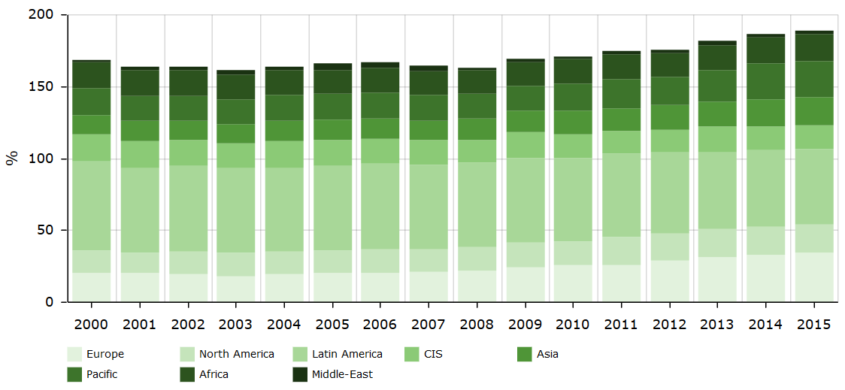
Figure 1 - Share of renewables in electricity production (including hydro) by geopolitical region (Source: Enerdata, 2017)

However, the increased integration of renewable energy sources into the energy mix is not without issues. For example, one problem with non-dispatchable renewable energy sources is that of intermittency – there may be no supply at times of high energy demand, or too much supply when there is low demand. Indeed, the electric power system must be able to maintain a near real-time balance between generation and load to function properly. However, this can be difficult due to the constant fluctuation of generators and loads: short-term variability results from the random turning on and off of millions of individual loads; longer-term variability results from changing daily and seasonal load patterns, or from random events such as changing weather patterns.

Historically, balancing the supply and demand fed into the power grid has primarily been achieved by power plants which are fired by easily storable fossil fuels (Donadei & Schneider, 2014). However, as renewable energy sources become more widely used in place of fossil fuels, it is important to seek more effective methods of storing energy and using it on demand. Energy storage system technologies are recognised as having the potential to overcome the issues of meeting energy supply and demand, by storing energy in a certain state (for example thermal or chemical energy), depending on the technology used, and converting it to electrical energy when required (Luo, et al., 2015).

There are diverse applications for energy storage, with wide variations of storage and delivery requirements – based on principles of energy versus power. If short discharge periods are required, devices that can deliver high power are needed, for example in overcoming fluctuations in the output of a wind turbine. Conversely, if there is no energy generation, for example on a windless day, a device that can store large amounts of energy and release it over a long period of time might be required (Hall & Bain, 2008). Furthermore, ESS technologies can be applied at different levels, ranging from energy generation, transmission, and distribution up to the customer or load site (EASE-EERA, 2017). An explanation of these levels is given in Section 5.3. Indeed, ESS can perform a number of functions over these different levels, including: arbitrage, provision of ancillary services, transmission support, and end-user peak shaving. At the macro-level, energy storage systems can manage the uncertainty associated with certain methods of renewable energy production and can increase system operation efficiency, enhance power absorption, achieve fuel cost savings, and reduce CO₂ emissions (Zhao, et al., 2015).

Energy storage is therefore vital for a clean-energy future based on renewable energy sources – a future which is envisaged by the Dutch Government. The Transition to sustainable energy report by the Ministry of Economic Affairs of the Netherlands (2016) presents the vision of the energy system of the Netherlands, focussing on the phase after 2023. The key issue of the report is how to achieve a CO₂ neutral energy supply by 2050, and there are three main principles of transition: 1) focus on CO₂ reduction; 2) make the most of the economic opportunities that the energy transition offers; and 3) integrate energy in spatial planning policy. The report states that the reliance on fossil fuels will decrease and the market is transitioning towards renewables, although natural gas will continue to play an important role for some time. It states that innovative solutions will be needed and the Dutch cabinet will promote innovation. The report states the transition will result in a sharp increase in the use of low-CO₂ electricity sources, such as the sun, wind, and water which means that both the demand and the supply will need to become more flexible. It also states that current market and regulatory policies provide a strong starting point for guaranteeing a reliable electricity supply.

In addition, the Energy Storage Roadmap NL 2030 report (DNV GL, 2015) notes three trends in the current European energy sector which form the basis of the energy transition: 1) decentralisation; 2) the ‘Europeanization’ of energy; 3) an increase in the amount of sustainable energy projects that have been implemented. Facilitating the transition requires extra flexibility in the supply and demand of energy and one method of doing this is through energy storage. The Roadmap aims to set out the desired future role of energy storage in the Netherlands and draw up an action plan for implementation. It identifies services which can be provided through ESS and provides a scenario and economic analysis of these services. It also analyses the current situation and identifies that there is no viable business case for the wholesale market at the current time. According to the report, this is because technologies are still too expensive and the current market model and legislative framework form barriers to the storage market at the moment. However, market research conducted together with Dutch businesses and knowledge institutes concludes that there are opportunities for the Netherlands to develop a role as a provider of storage capacity and the report recommends several concrete steps to increase flexibility. Finally, it makes two recommendations for action for a 2030 deadline: stimulation and support of research and development, and the removal of barriers in the legislation and market model and adaption of legislation to the desired situation.

Furthermore, The Delft Plan (Delft University of Technology, 2015) presents an outline of the role the Netherlands can play in making plans with regard energy in Europe in 2050, and in the realisation of a well-functioning internal energy market and towards the transition towards a CO₂-neutral energy supply. The plan states that it provides direction and perspective to policy, market players, academia and other stakeholders, focusing on no-regret steps. The plan will help transform the Netherlands into Europe’s ‘Energy Gateway’, and details why the Netherland’s natural strengths can allow it to do this. It states that the energy market is undergoing major development and how there is a shift towards decentralised energy production. According to the report, there will need to be effective innovation agendas in the future, with technical innovation combined with economic and other system studies. The plan introduces a variety of stakeholders (financers, government, Dutch European Union (EU) presidency) and suggests how their roles might change in the future; for example, when the market takes a different direction. It states that it will be important to invest in energy storage (amongst other scientific areas), and suggests a number of steps of how the Netherlands can become the Energy Gateway.

The amount of electricity generated from renewable energy sources is predicted to grow in the Netherlands (IEA, 2014), and, in the Energieakkord voor duurzame groei (The Energy Agreement on Sustainable Growth), the Dutch government committed to reaching the objective of a 14% share of energy generated from a renewable source by 2020, in accordance with EU regulations (Social and Economic Council, 2013).

This section has provided evidence that there is role to play for ESS technologies, with market and regulatory instruments playing an important part. The research undertaken for this thesis therefore has societal relevance and can provide information on how ESS technologies can be integrated alongside RES. This can be achieved by investigating the decisions behind instrument choice and applying Transition Management theory. These theories will be discussed in the literature review in the following section.

LITERATURE REVIEW AND THEORETICAL FRAMEWORK

Introduction
This section will outline the theoretical background necessary to conduct the research. Section 3.2 will introduce the theory behind transitions, and introduce the Strategic Niche Management (SNM) and Transition Management theories. Section 3.3 will then discuss Instrument Choice Theory before Section 3.4 explains why these theories were chosen as a framework for the research. Section 3.4 also identifies the most important focus areas and concepts which allow the final analysis to be undertaken.

Transitions and Transition Management
The three reports regarding Dutch energy policy discussed in Section 2 all specifically contained the word ‘transition’. In general terms, a transition can be defined as “a long-term process of change during which a society or a subsystem of society fundamentally changes” (Rotmans, et al., 2000, Rotmans, et al., 2001 cited in Loorbach & Rotmans, n.d., p2). All three reports are concerned with how the Netherlands can transition to a low-carbon future. In other words, the reports are concerned with how the Netherlands can make fundamental changes within the energy sector.

Loorbach & Rotmans (n.d.) discuss two concepts of transitions: multi-phase and multi-level. The multi-phase concept indicates that transition paths are non-linear and take place over several stages (as seen in Figure 2):

- A pre-development stage where there is very little visible change at the systems level but a large amount of experimentation at the individual level;
- A take-off phases where the process of change starts to build up and the state of the system begins to shift because of different reinforcing innovations or surprises;
- An acceleration phase in which structural changes occur in a visible way through an accumulation and implementation of socio-cultural, economic, ecological, and institutional changes;
- A stabilisation phase where the speed of societal change decreases and a new dynamic equilibrium is reached (Loorbach & Rotmans, n.d.).

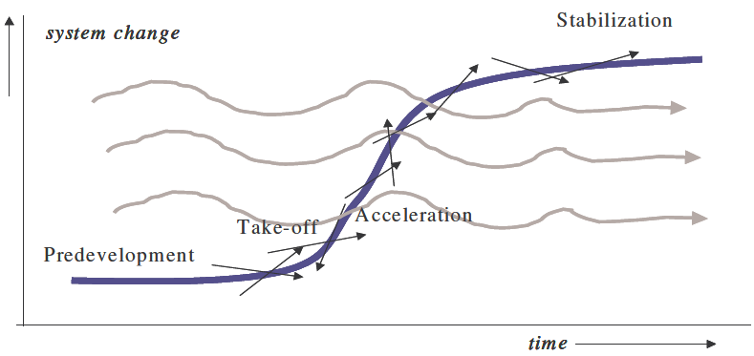
Figure 2 - Different stages of a transition at different system levels (Source: Rotmans et al. 2000 cited in Loorbach and Rotmans, n.d.)

A second concept of transitions is a three-level analytical hierarchy of ‘niche’, ‘regime’, and ‘landscape’ levels (Meadowcroft, 2009). This multi-level perspective (MLP) understands transitions as outcomes of alignments between developments over the three levels (Geels & Schot, 2007). According to Loorbach and Rotmans (n.d.), slow changes in society determine the macro-level societal landscape. At the meso-level are social norms, interests, rules and belief systems that underlie companies’, organisations’, and institutions’ strategies and political institutions’ policies. Individual actors, technologies, and local practices operate at the micro-level (Loorbach & Rotmans, n.d.). At the micro-level, ‘technological niches’ are formed and radical novelties emerge. These niches are spaces where radical new ideas are tried out and further developed, while sheltered from mainstream competition (Schot & Geels, 2008). Niches can put pressure on the regime level causing it to change, and, over time (often decades), new regimes influence the socio-technical landscape, as shown in Figure 3:

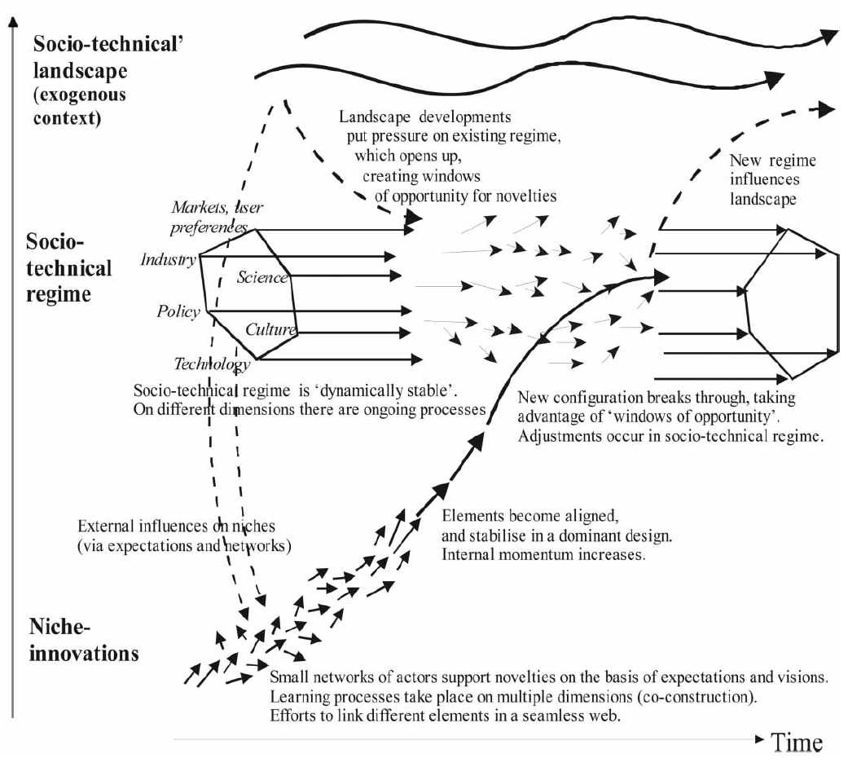
Figure 3 - Multi-level perspective on transitions (Source: Geels and Schot, 2007 adapted from Geels, 2002)

Strategic Niche Management expands on the concept of niches. SNM is an approach which suggests that “sustainable innovation journeys can be facilitated by creating technological niches, i.e. protected spaces that allow nurturing and experimentation with the co-evolution of technology, user practices, and regulatory structures” (Schot & Geels, 2008, p537). Schot and Geels (2008, p539) note that technological niches are “spaces in which radical novelties are tried out and developed further, while they are sheltered from mainstream competition”. Raven (2005, p9) states that in SNM “technological niches are the breeding ground for radical innovation”. Technological niches, which can be constructed by various actors including policymakers, users, and societal groups, may also jumpstart the development of ‘market niches’ – niches in which technology design and user demands have become stabilised (Schot and Geels, 2008). SNM theory defines success in terms of transformation of a technological niche into a market niche and eventually a regime shift (Schot and Geels, 2008 p.540), as shown in Figure 4:

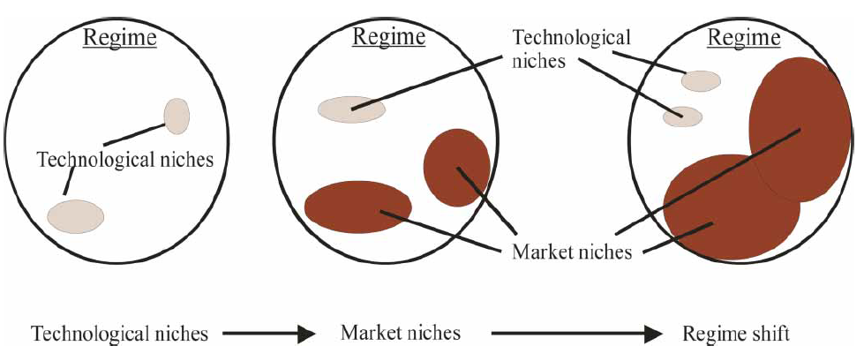
Figure 4 - From niche dynamics to regime shift (Source: Schot and Geels, 2008, adapted from Weber et al. 1999)

However, a number of criticisms have been laid at SNM. For example, SNM takes a technology as a starting point, and often follows a technology push approach. Technology-forcing policy can be risky; instruments such as standards may be used, but technology may not be suitably developed for it to be able to attain the measures set. Therefore, policy implementation may have to be postponed or may fail (Krozer, 2008). An alternative approach to help policymakers guide transitions along pathways which are desirable to them is Transition Management. TM offers broad possibilities for innovation, with Kemp and Rotmans (2005, cited in Meadowcroft, 2009, p325) describing it as “a deliberate attempt to bring about structural change in a stepwise manner”.

Transition management, in contrast to SNM, takes a societal problem – in the case of this research: climate change – as a starting point. Indeed, Loorbach and Rotmans (n.d., p9) state that “transition management consists of a deliberate attempt to stimulate a transition towards a more sustainable future”, whilst Meadowcroft (2009) describes an emphasis on the transformation of established practices in critical societal subsystems. TM uses several methods in order to achieve its objective (Loorbach & Rotmans, n.d.). According to Loorbach and Rotmans (n.d.), TM starts from a macro-vision of sustainability, building upon bottom-up (micro) initiatives, while in the meantime influencing the meso-regime. Meadowcroft (2009, p326) sees networks of actors coming together and developing practical activities and interactive processes to facilitate sustainable development, and emphasises the linking of technological and social innovation because “both sorts of change are necessary if society is to move on to a more sustainable pathway”.

Rotmans, et al. (2001, p22) summarise TM in terms of the following characteristics:

- Long-term thinking (at least 25 years) as framework for shaping short-term policy;
- Thinking in terms of more than one domain (multi-domain) and different actors (multi-actor) at different scale levels (multi-level);
- A focus on learning and a special learning philosophy (learning-by-doing and doing-by learning);
- Trying to bring about system innovation alongside system improvement;
- Keeping a large number of options open (wide playing field).

Rotmans, et al. (2001) continue to state that TM places policy in a longer-term perspective (within a time frame of 50-100 years) as opposed to current policy which aims for quick results (within a time frame of five to ten years). TM recognises that achieving quick results will not be effective in the long-term when dealing with complex social problems such as climate change. TM aims for both system optimization and system innovation, and recognises that a transition can be brought about by the gradual transformation of an existing system, instead of through the planned creation of a new system (Rotmans, et al., 2001).

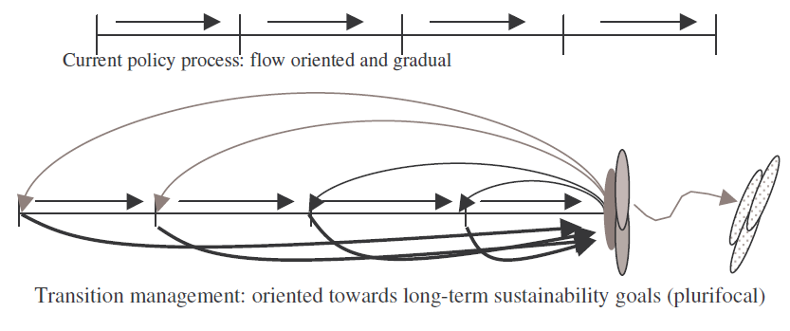
Figure 5 - Current policy processes versus transition management processes (Source: Loorbach and Rotmans, n.d.)

Rotmans and Loorbach (2009) see the first stage of transition management as the stimulation of niche development at the micro level, and the attempt to interconnect niches with the same direction. This can be done by establishing and organising a transition arena – a quasi-protected area for frontrunners (niche players and change-incline regime layers). Furthermore, according to Rotmans, et al. (2001), governments have an important role to play. They can act as either facilitator, stimulator, controller, or director (depending on stage of the transition), and have a guiding role, particularly when an enterprise has been removed from state control. They can introduce measures to ensure a real market is created, and can help make the market more attractive to newcomers. They can create the right conditions for market processes through tax policies and can create and manage niches. Meadowcroft (2009), , states that TM is closely associated with policy instruments such as sector-based collective visioning exercises, or collaborative and experiment projects, but traditional policy tools such as regulation, planning, and tax-based instruments remain an essential instruments for governance of sustainable development. Indeed, there are a number of tools available to policymakers which are discussed in the following section.

Instrument Choice Theory
According to Howlett, et al. (2009), when policymakers are exploring policy options, they consider not only what to do but also how to do it. To this end, policymakers utilise a variety of tools – known as policy instruments – when implementing policies. In the context of international environmental regulation, these instruments provide incentives for actors (such as producers, resource users, developers, and consumers) who cause or contribute to pollution, environmental degradation, and ecosystem stress to change their behaviour in more environmentally protective ways (Stewart, 2008). There is a wide body of literature discussing the variety of instruments available, with a number of ways of classifying them (Howlett, et al., 2009). This section will identify and discuss a variety of instruments available to policymakers, and describe several different methods of classification.

Hepburn (2006) explains that the role of a policy instrument is to achieve a particular target which should be carefully designed to meet a sensible overarching policy objective. If the target is ill-defined then the selection of the correct instrument will be pointless. However, he states that “once objectives are agreed and suitable targets adopted, policymakers can employ command-and-control regulation, and/or economic instruments, and choose between fixing a price or a quantity” (Hepburn, 2006, p.226). He sees two main forms of instrument, based on price or quantity respectively:

- Economic instruments which provide explicit price signals to regulate firms and individuals (for example, through taxes or subsidies);
- Command-and-control instruments which regulate by quantities (for example, through quotas or targets) (Hepburn, 2006).

Indeed, in the context of environmental policy, many authors suggest that command-and-control and economic instruments are the most important and most widely-used: Meckling and Jenner (2016) state that in both Europe and the US, regulators have used a variety of environmental policy based on either price or quantity instruments; Krozer (2008) states that in relation to emissions reduction the basic choice for policymakers is between command-and-control and economic instruments; the World Economic Outlook (WEO) report (2014, cited in Verdolini & Bosetti, 2017) groups the environmental policy instruments that governments use to support cleaner technologies under the banner of either economic or command-and-control.

However, other authors identify additional ways of classification. For example, Huber, et al. (1998) acknowledge a difference between certain, individual economic instruments, highlighting those which use the market (for example taxes or subsidies), and those which create markets (for example, tradeable permits or property rights). Furthermore, Stewart (2008) describes the category of information-based approaches, which provide incentives for actors to modify their behaviour but which allow them flexibility in doing so. Blok (2007) describes this approach as a ‘communication mechanism’, which assumes that people will change their behaviour when they are better informed. However, he notes that the effect of such instruments is often limited. Hood (1986, cited in Howlett, et al., 2009) uses the term ‘nodality’ to describe these approaches, with instruments including: public information campaigns, exhortation, benchmarking and performance indicators, and commissions and inquiries. In addition, Hood (1986, cited in Howlett, et al., 2009) also identifies a number of organisation-based policy instruments which make use of the formal organisations available to the particular government utilising them. Instruments in this category include:

- Direct provision of goods and services directly through government employees, funded from the public treasury;
- Public (or state-owned) enterprises totally or partially owned by the state but with a degree of autonomy from the state;
- Quangos (quasi-autonomous non-government organisations) which act as quasi-independent, self-organising actors;
- Public-private partnerships (PPPs);
- Family, community, and voluntary organisations;
- Market creation;
- Government (re)organisations through the creation of new agencies or at the reconfiguration of old ones (Howlett, et al., 2009).

As this section has shown, there are a wide variety of policy instruments available for governments, of which certain instruments may be more useful for policymakers in the context of environmental regulation. Indeed, within the area of energy, Blok (2007) identifies instruments which can be considered to improve energy efficiency, and therefore may be more relevant to the research undertaken for this thesis:

- Energy or carbon taxation;
- Investment subsidies or fiscal incentives;
- Emission trading;
- Energy efficiency standards;
- Negotiated agreements;
- Energy efficiency labelling;
- Research and Development (R&D) subsidies.

Blok (2007) also identifies instruments to be used to stimulate the production of energy from renewable sources:

- Feed-in tariffs (FiTs);
- Renewable energy portfolio standards.

These nine instruments could be categorised as either price, quantity, or information-based, and each will now be briefly introduced.

Blok (2007) states that energy taxes involve energy users paying a levy in addition to the market price when they purchase an energy carrier. When the levy is proportional to the carbon content of the energy carrier, the tax is known as a carbon tax. Subsidies are often provided to encourage investments in energy-efficient or renewable technology, whilst feed-in tariffs can be provided for electricity from RES that are delivered to the grid. Feed-in tariffs are normally paid via a surcharge on the electricity price and payment is dependent on performance: if no electricity is delivered, nothing is paid. Emissions trading allows an actor a certain amount of emission allowances. The actor must keep their emissions below this level, but they can buy or sell their allowances. Energy efficiency standards are generally either prescriptive or performance standards. Prescriptive standards impose requirements on specific components of equipment, whilst performance standards impose requirements on the overall level of energy use. Renewable energy portfolio standards (also known as renewable energy obligations) require that a specified amount of energy supplied is from renewable sources. Negotiated (or voluntary) agreements are agreements between governments and actors or groups of actors to limit or reduce energy use. Finally, energy efficiency labelling informs buyers or users of equipment about its energy performance (Blok, 2007).

In addition to the use of individual instruments, such as those described above, some authors recognise the use of hybrid instruments which combine elements of price and quantity regulation. For example, Hepburn (2006) notes that there is a focus on pure price and quantity instruments because of their simplicity, but more complicated hybrid instruments might be more efficient in certain circumstances. An example of a hybrid instrument is a credit-trading scheme whereby pollution or resource quotas are established by command-and-control measures, and actors who reduce their pollution below their quota level can sell their surplus to others (Stewart, 2008). Meckling and Jenner (2016) note that since the early 2000s European and United States (US) regulators have increasingly employed hybrid policy instruments. Furthermore, Bennear and Stavins (2007) state that multiple instruments (which are not hybrid) are often employed by policymakers to address a single environmental issue. However, Hepburn (2006) also notes that such ‘packages’ are often applied ad hoc or used in an attempt for politicians to ‘fix everything’; they can be problematic when instruments within the package are inconsistent with each other.

Indeed, choosing the correct policy instrument or instruments is an important part of policy formulation. Howlett, et al. (2009) state that exactly which instruments are selected depends on the nature of the problem context, who is conducting the analysis of the instrument’s technical and political feasibility and how this is conducted, and what ideas about appropriate and possible government actions these analysts will bring to any discussion. Howlett, et al. (2009) recognise that policy formulation is therefore a complex matter with a wide range of possible choices and mixes of policy instruments into potential policy options or alternatives. Policy instrument choice can, however, be evaluated. According to Blok (2007) this can take place ex ante (before policy implementation) or ex post (after the policy has been implemented for some time). Instruments can be judged on their effectiveness at reaching the pre-specified objective, their efficiency at reaching the required effect, and their side-effects.

Theoretical Framework
TM can, in theory, be used to manage complex societal systems which contain many different actors and domains over different levels. Whilst it is recognised that all these elements are interlinked and play a part in the overall objective of a transition to a sustainable future and a reduction in the effects of climate change, this research focusses on the energy system and policy and technology within it. This section will explain why these areas have been chosen as most relevant for research. As noted in Section 3.2, Rotmans et al. (2001) described five major characteristics of TM. These characteristics will be discussed in turn to justify the reason for these focus areas. This section will then explain how ICT can be linked to TM, to provide a framework to answer the research questions.

As previously discussed, the MLP sees a macro-level formed by a socio-technical landscape. According to Schot and Geels (2008), this is an exogenous environment beyond the direct influence of niche and regime actors, and changes at this level happen over timespans of decades. However, changes at the landscape level place pressure on the regime, whilst regime destabilisation creates windows of opportunity for nice innovations (Schot & Geels, 2008) – there is interaction between levels. In the context of this research, climate change is causing long-term change at the macro-level. Rotmans et al. (2001) state that TM is multi-level and that short-term policy is shaped in the context of long-term thinking. In this respect, it is considered that shorter-term policy instruments are selected with the overall objective of reducing the effects of climate change. According to Meadowcroft (2009), the policy agenda is typically dominated in the short-term, where the focus for technological advancement is often on incremental improvements to dominate designs. Policy instruments can protect niche innovations and help them stabilise to become part of the regime, or even replace it. The regime can then influence the landscape level, which is beyond the direct control of actors at the lower levels. This research will therefore focus on the niche and regime levels.

Rotmans et al. (2001) also characterise TM as acting over multiple domains. Transitions take place over several different, but connected, areas; for example, markets, user preferences, industry, science, policy, culture, and technology. Developments must come together in several domains for a transition to occur (Rotmans et al., 2001). Furthermore, a variety of actors, over different levels and domains, are involved with any transition. For example, according to Rotmans et al. (2001), the micro-level comprises individuals or individual actors (companies, environmental movements); the meso-level comprises networks, communities, and organisations. Actors can be both state and non-state. As this research is concerned with how policy instrument choice influences the adoption of innovative technologies, it will focus on the domains of policy and technology, alongside policymakers and technology actors. However, it is recognised that other domains and actors are important and have an influence on the overall transition process.

A further characteristic of TM is its focus on learning, and in particular on ‘learning-by-doing’. Meadowcroft (2009) states that developing experiments with novel practices and technologies and initiating change allows us to learn the potential, and limitations, of different approaches. TM, therefore, is relevant to this research as lessons learnt from past policy instrument choices can allow future choices to be more informed. Indeed, investigating the effectiveness (or ineffectiveness) of instruments to facilitate the use renewable energy production technologies can provide information and recommendations for instrument choice to facilitate the further integration of ESS technologies.

TM is also orientated towards both system improvement (improvement of an existing trajectory) and system innovation (representing a new trajectory of development or transformation) (Loorbach and Rotmans, n.d.). This research will be relevant across both approaches, in regards to the energy system.

The final characteristic of TM, as defined by Rotmans, et al. (2001), is that the approach keeps many options open, to hedge against changing circumstances. TM is therefore a useful approach for this research, as the research will investigate a variety of policy instruments in relation to a variety of renewable energy sources and technologies, and a variety of ESS technologies from the domestic to centralised level. The results of the research might suggest that a certain instrument may be effective for a certain ESS technology at the domestic level, but be ineffective at the centralised level, for example.

The above discussion allows the focus of the research to be defined. It focusses on policymakers and technology actors who can exert influence in the policy and technology domains at the meso- and micro-levels. The initial research will identify the policy instruments used to facilitate (or hinder) the transition of renewable energy production technologies from niche to regime level. Figure 6 shows the areas of focus; the area inside the red box contains the niche and regime levels, and the green boxes show the relevant domains. Renewable energy production technologies sit on the right of the figure; they have made the transition from niche to regime.

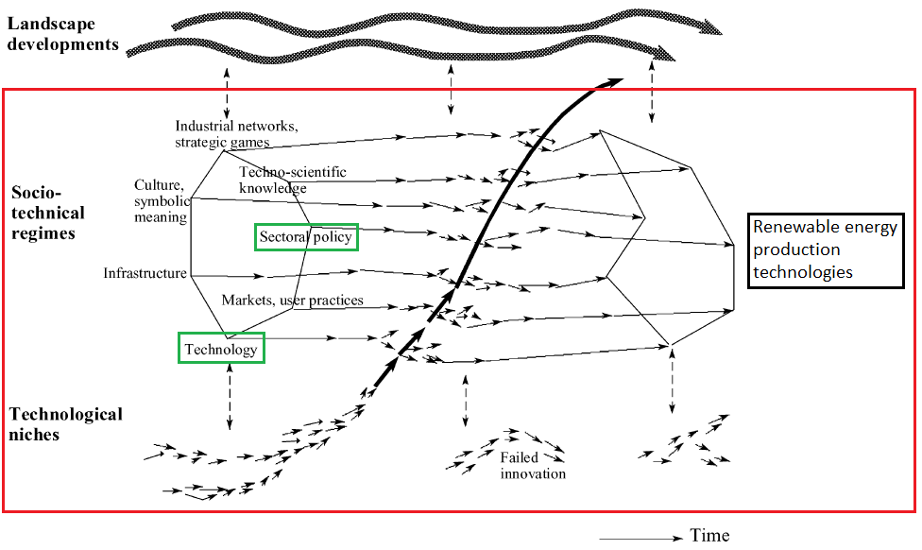
Figure 6 - Areas of focus (Source: adapted from Geels, 2002)

ICT is used to identify and evaluate the policy choices which facilitated (or hindered) this transition, as shown in Figure 7.

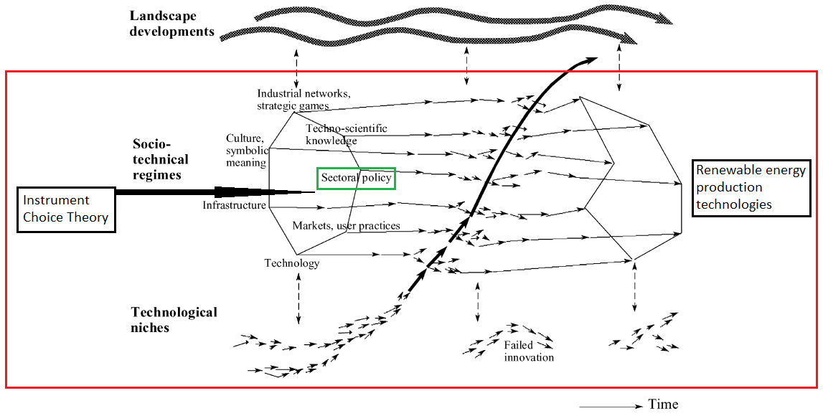
Figure 7 - Instrument Choice Theory influencing policy (Source: adapted from Geels, 2002)

Lessons learned from instrument choice in regards to renewable energy production technologies can be used to inform and improve decision-making in regards to ESS. The research considers both system improvement and system innovation, and will consider a wide variety of policy instruments and technologies over several different levels.

As will be discussed in Section 5.3, electricity generation can be centralised or decentralised. This research will investigate ESS integration across different levels – from decentralised domestic storage through to utility-scale centralised storage.

RESEARCH APPROACH, METHODOLOGY, AND DESIGN

Introduction
This section defines the research approach, methodology, and design. Section 4.2 identifies the research aim and describes the approach taken to reach it. Section 4.3 states a number of assumptions that have been made, whilst Section 4.4 contains the reformulated research questions. Section 4.5 discusses the theoretical framework used in the research, and the strategy used for collecting and analysing data. This section also details the ethical considerations undertaken.

Research Aim
Howard and Sharp (1983, cited in Bell, 2005, p.2) define research as “seeking through methodical processes to add to one’s own body of knowledge and, hopefully, to that of others, by the discovery of non-trivial facts and insights”. The research aim of this study is to provide facts and insights into the transition of renewable energy production technologies and ESS technolgies from niche level through to commercial adoption and diffusion at the regime level. As of 2015, 14% of Dutch electricty generation was from a RES – 6% biofuels and waste; 1% solar; 7% wind (IEA, 2016a). Although biomass is currently a large source of renewable energy in the Netherlands and the amount of biomass used to replace fossil resources is expected to increase of the coming years (PBL Netherlands Environmental Assessment Agency, 2014), questions have been raised over its sustainability and its ‘green’ credentials (Drouin, 2015). Furthermore, biomass could be considered different from wind and solar, insofar as it is dispatchable and electricity production is not halted or reduced if day-to-day meteoroligcal conditions are not suitable. For these reasons this study focuses instead on wind and solar energy production, and the integration of ESS alongside them.

The research also focuses on the key policy instruments introduced by the Dutch government to facilitate (or hinder) the transition. The research examines, analyses, and evaluates the different instruments, how and why each was chosen, and how each effected the transition of renewable energy production technologies to commercialisation. Then, the research provides insights into how ESS technologies can also make a transition to become more widely adopted. The research investigates what policy instruments are currently being used to integrate ESS technologies alongside renewable energy production, and why they are being used. Insights are provided into the role that ESS technologies might play in the future, from the domestic level up to large-scale applications. The lessons learnt from the research can be used to recommend policy instrument choices to support the anticipated integration and utilisation of ESS alongside renewable energy production.

Assumptions
In achieving the aim, the research makes the following assumptions:

- There are other potential methods of reducing the effects of climate change or improving sustainability (for example, reducing the overall demand for energy through changes in societal attitudes). However, it could be argued that this is not likely to happen in the foreseeable future due to ingrained behaviours, and therefore further integration of renewable energy production and ESS technologies are needed;
- Bioenergy/mass is a dispatchable renewable energy source. Energy is stored within the material which can be released when required, for example through combustion. However, this is not considered an ESS, as it is not a technology which has been specifically designed to capture energy;
- There is a large variety of renewable energy production and energy storage system technologies. Different methods of renewable energy production and energy storage are at various levels of technological maturity. In general, renewable energy production is more developed than ESS:
  - Within the Netherlands, renewable energy production from biomass, wind, and solar are no longer considered to utilise ‘niche’ technologies (although certain innovations within each sector might be);
  - ESS integration is still considered to be at early stages of development (although ESS deployment in off-grid or remote communities may be considered broadly competitive or near-competitive, and certain battery systems – such as Li-ion – are well utilised within the electric vehicle industry). It is also recognised that certain technologies might be at different stages of technological maturity than others;
- Policy instruments have facilitated (or hindered) the transition of renewable energy technologies.

Research Questions
As stated in Section 1.2, the main research question is: how can ESS technologies transition from niche to become established technologies at the regime level?

However, following the theoretical framework discussed in Section 3.4, the sub-questions can be reformulated based on the previous information given and assumptions made, and to better reflect the characteristics of TM and ICT. Therefore, the redefined sub-questions are:

- What role did different policy instruments play in the transition of solar and wind energy production (across different scales from domestic to large-scale) from niche to commercial adoption and diffusion in the Netherlands?

- What role do different policy instruments play in the ongoing integration of ESS with solar and wind energy production (across different scales from domestic to large-scale) in the Netherlands?

- a) Which policy and technology options and instruments are most suitable to facilitate the transition of ESS from niche to become commercially adopted and integrated with solar and wind energy production (across different scales from domestic to large-scale) in the Netherlands?
b) Where does this ongoing transition sit in relation to the policy and technology domains?
c) What roles do policymakers and technology actors play in this transition?

Methodology
According to Thomas (2013), methodology can be defined as the study of method; in turn, method can be defined as a technique used to collect data (O'Leary, 2004). Bell (2005, p.115) states that:

“Methods are selected because they will provide the data needed to produce a complete piece of research. Decisions have to be made about which methods are best for particular purposes and then data-collecting instruments must be designed to do the job.”

This section discusses which methods and instruments were chosen and designed in order to answer the research questions and achieve the stated aims and objective. The reasoning behind their selection will also be explained. O’Leary (2004, p.132) states that “the goals of research can be placed on a continuum from knowledge to change” and contends that at one end of a scale “basic” or “pure-research” can generate knowledge in order to build broader understanding of the issues at hand, whilst at the opposite end of the scale research can generate knowledge to expose and change the dominate system; a number of other goals sit within this spectrum, which she acknowledges may contain some overlap.

As discussed in previous sections of this thesis, current conventional energy systems are unsustainable and a transition towards sustainable energy is necessary. The definition of a transition provided earlier sees it as “a long-term process of change during which a society or a subsystem of society fundamentally changes” (Rotmans, et al., 2000, Rotmans, et al., 2001 cited in Loorbach & Rotmans, n.d., p2). Therefore, based on the stated research aim and research questions, it can be argued that this study both provides knowledge and actions change within the current energy system.

According to O’Leary (2004, p.138), “when the product of a study is both knowledge and change you have what is broadly known as action research”. The aim of action research, according to Denscombe (2002, p.27 cited in Bell, 2005, p.8) is “to arrive at recommendations for good practice that will tackle a problem or enhance the performance of the organization and individuals through changes to the rules and procedures within which they operate”. Previous sections of this thesis have defined an overarching problem (climate change) and this research aims to tackle it by providing knowledge and facilitating changes in the form of system improvement and system innovation; action research is therefore a useful approach for conducting this study. Although, as Kitchin and Tate (2000) acknowledge: “remaining objective within action research remains difficult, as a particular action is sought.” Indeed, this research studies how a change to further integration of ESS can be facilitated.

To this end, the research uses inductive reasoning to answer the research questions and develop a theory as to what policy instruments could be used to allow the increased integration of ESS technologies alongside renewable energy production technologies, at different levels from domestic up to utility-scale. Qualitative research was undertaken in the form of semi-structured open-ended interviews with a variety of actors involved in the energy storage sector, such as entrepreneurs and consultants. In total, fifteen interviews were conducted, each lasting approximately one hour. Fourteen interviews were conducted face-to-face with the participant, either at the participant’s office or at the researcher’s office. One interview was conducted over the telephone. Based on the information provided in these interviews, secondary sources of data, such as scientific journals, were also consulted in order to gain further insights into the areas of discussion.

The semi-structured interview method was chosen as it allows a framework of open-ended questions to be developed in order to steer the conversation with participants, but without constraining the interviewees’ responses to the questions. If an interviewee wished to diverge from the questions asked then it was possible, even encouraged. Indeed, any divergence might have produced data relevant to the topic which otherwise may not have been produced. The semi-structured interview method was useful because although the conversation was steered by the researcher, the open-ended questions reflected the participants’ own thinking better than if conducting a closed interview which gives no chance for the interviewee to diverge from the specific questions asked.

The questions asked in the semi-structured interview were along the lines of direct questioning about policy implementation for RES and ESS in the Netherlands, and as per the action research framework there was a continual refinement of thinking in between interviews. For example, if an interviewee’s line of discussion had not been previously considered but was thought to be relevant in following interviews, then this new area of discussion was broached with the interviewees. The questions themselves were not written in a list, but rather an interview schedule was created prior to each interview. Each interview schedule was written specifically for each individual participant, based on their role within a certain domain and on knowledge gained during previous interviews. Each interview schedule provided an aide-memoire of the important points for discussion, for example by using information taken from the interviewee’s company website. However, the schedule was not necessarily adhered to, depending on how the interview progressed. Furthermore, more general questions were also asked when nearing the end of each interview, taking more of an interview guide approach. These more general questions, on non-specific topics, allowed more of a free-form interview to be conducted and gave more scope for the interviewee to provide information on other topics of interest, which may not have been explored otherwise.

There are, however, a number of weaknesses in these methods. Interviews can be time consuming, and, according to Kitchin and Tate (2000, p214), the semi-structured interview:

“allows little flexibility in relating the interviews to particular individuals or circumstances (it removes individuality) and may also constrain and limit the naturalness and relevance of questions and answers (the question might not be relevant to an interviewee but requires a response, and a particularly interesting response cannot be followed up in more detail)”.

The interview guide approach allows those questions to be more flexible in order and specific wording, but this reduces the comparability of the responses (Kitchin and Tate, 2000).

Several other considerations also needed to be considered. The number of interviews to be conducted had to be determined based on the aim and objectives of the study, the size of the total population within the policy and technology domains (and specifically within the energy and energy storage sectors), and the type of data that needed to be collected. This required extensive preliminary research to identify individuals and organisations which would be able to provide useful and relevant information. When choosing participants to contact, a non-random sampling method was used, whereby the selection of interviewees was determined according to known characteristics, such as their role within the energy storage sector. It was recognised that there was the risk of selection bias from the researcher, and that interviews are subjective and each interviewee is likely to have their own agenda and biases. For these reasons, it was important that the sample was representative of the wider population within the relevant domains, in order to provide balance.

A total of 55 individuals, companies, or organisations related to the policy and technology sectors and energy and energy storage were contacted, by phone or by email, to request an interview. Emails were tailor written for each individual, company, or organisation, although the emails did follow a basic template. These initial contacts led to a total of fifteen interviews being conducted over the space of approximately eight weeks. The final selection of participants did indeed come from a wide variety of fields within the policy and technology domains, as can be seen in Appendix A. This vindicates that selection bias was not introduced by the researcher. It was noted, however, that of the individuals approached for interview whose name was known, the vast majority were men. Only one woman was subsequently interviewed. The reasons for this can be speculated upon but it is beyond the scope of this current research to do so. However, the responses to questions by the single woman interviewed did not differ particularly from those of her male peers, nor would there be any particular reason why they might. Therefore, this research makes the assumption that the significant gender imbalance did not alter the research findings. Furthermore, although respondents were not asked their age, the interviewees’ age range was clearly diverse. However, all interviewees were Dutch and thus not very representative in terms of national cultural diversity. However, as with the gender imbalance, this was not considered to materially alter the research findings.

A further consideration was that “even relatively powerful actors do not have perfect access to information, even should they wish to share it” (Crang, 2002, p.649), and that there might be problems due to the language used in the interviews. The interviews were conducted in the Netherlands between a non-Dutch speaking researcher and interviewees who spoke Dutch as their native language. The interviews were therefore conducted with all parties speaking English, and although all interviewees had excellent English-language skills it is recognised that there was the risk of confusion over the exact wording used, both in questions and replies; there might be limitations in terms of the respondents’ ability to express their thoughts and feelings using a non-native language. However, all participants agreed to the interviews being recorded (taking into account ethical issues which are discussed later in this section), which allowed for the content to be checked at a later date. Indeed, the interviews were transcribed as soon as possible after the event, although Crang (2002, p.652) recognises that the “informant quote, or even the full transcript, is poorly served by being taken as ‘data’”. Therefore, when transcribing or recounting the information provided in the interviews it was important that methodological transparency was ensured; the accounts needed to be credible and intelligible, and the interpretation must be dependable and be confirmable. To this end, the researcher provided the opportunity for the participants to review the results, once the project was nearing completion, and several minor comments were received back for action by the researcher.

Other ethical considerations were also considered, as potential risks from research include:

- causing psychological or physical harm to participants or others;
- damaging the standing or reputation of participants or others;
- infringing the privacy of participants or others;
- breaking the law;
- harming a community in some way (Thomas, 2013, p42).

Care was taken to ensure that none of the above occurred during the research process. Indeed, to protect the participants, it was important to ensure that they had a full understanding of their involvement in the project, and that their informed consent was given. According to O’Leary (2004), informed consent implies that participants are competent, autonomous, involved voluntarily, aware of their right to discontinue, not deceived, not coerced, and not induced. Furthermore, Blaxter et al. (2001, cited in Bell, 2005) state that “research ethics is about being clear about the nature of the agreement you have entered into with your research subjects or contacts”. To this end, it was made clear the reason that the research was being undertaken and there was transparency who would be receiving the final thesis. For example, as the researcher is working as an intern for a company within the Netherlands, it was made clear to interviewees that this company would also be receiving the final thesis. It was also made clear that the interviews were confidential and participants would remain anonymous; to this end, each interviewee was assigned a unique letter of the alphabet. This letter is then used in place of their name when discussing the interviews. The names of companies that individuals worked for or represented was also kept confidential (see Appendix A).

This study takes a critical realist approach in its ontology, that is towards the set of concepts and categories in the subject area or domain that shows their properties and the relations between them. Critical realism takes a causal-explanatory approach which allows for the examination of the root causes for niche creation and, therefore, it is possible to draw conclusions as to the reasons how and why they are created. An objectivist epistemology is then applied. This enables the researcher to use reasoning to draw conclusions without bias. However, it is noted here that a post-positivist paradigm understands that measurements are fallible and errors can be made. To achieve objectivity, it was necessary to triangulate the data received from different sources – as interviews alone are not infallible – in order to best interpret the information in as error-free way as possible. To interpret collected qualitative data, a ‘constant comparison’ method was used. This method “involves going through your data again and again … comparing each element … with all of the other elements” (Thomas, 2013, p.235).

After listening back to the interviews and re-reading transcripts, a number of themes and sub-themes emerged which captured the contents of the data. The data was reviewed once again, and, for each interview, relevant quotations and sections were matched to each theme. This method allowed the essence of the data to captured, as well as showing links between each theme, what viewpoints were unanimous, and what contradictions and paradoxes arose. These themes will be discussed more in Section 6.2.3.

Issues of reliability and validity were also considered. According to Thomas (2013, p.138), reliability “refers to the extent to which a research instrument such as a test will give the same result on different occasions”. Thomas (2013) continues to say that in interpretive research (as in the case of this research) you would not expect a different researcher to emerge with the same interview transcripts as in this research and therefore reliability is “irrelevant in interpretive research”. Validity “refers to how well a test measures what it is purported to measure” (Phelan & Wren, n.d.), and it was important to ensure that tools used in the research (such as interviews) are fit for the purpose and measure what they are supposed to measure. Furthermore, it was important not to mistake causal direction; in other words, it is important not to confuse what causes what (Thomas, 2013).

TECHNICAL ASPECTS

Introduction
This section will detail some of the technical specifics which are relevant to the research presented in later sections. Furthermore, it will look beyond solely the technicalities and highlight several ways in which these technologies are related to the policy and technology domains. Indeed, different technical features might enable or constrain certain policy options. Section 5.2 will introduce the variety of renewable energy sources which are available, and focus on those most commonly used in the Netherlands. Section 5.3 will explain the basics of electricity generation, transmission, and distribution. Section 5.4 will introduce the variety of ESS technologies available and their applications.

Renewable energy sources
Renewable energy sources are those which are non-finite and naturally replenished. Bioenergy, hydropower, wind energy, solar energy and tidal energy can be considered to be renewable energy sources. Geothermal energy is also often grouped alongside these, although strictly speaking geothermal energy is not an RES as energy can become depleted in a specific location, unless it is managed carefully. As previously explained, this research focusses on solar and wind energy; these two sources of energy will be detailed in the following sub-sections.

Solar Energy
Solar irradiation can be utilised in a number of ways:

- Heat production through solar collectors which are thermally isolated from the environment and heated by irradiation. The heat can be taken away by water or air, amongst others;
- Electricity production through so-called solar thermal power plants. Direct solar irradiation is concentrated by mirrors to generate high temperature air or steam, which can be used to produce electricity;
- Electricity production by use of the photovoltaic effect. Solar irradiation is converted directly into Direct Current (DC) electricity in photovoltaic (PV) cells (Blok, 2007).

Solar power is intermittent and generally non-dispatchable. It is not the same in all locations, is affected by cloud cover, and does not shine for all hours of the day in a given location (Hanania, et al., n.d.). Global installed capacity for solar-powered electricity has seen growth, reaching around 227 GW_{e} at the end of 2015; this accounts for about 1% of all electricity used globally (World Energy Council, 2017). Total installed capacity of solar panels in the Netherlands in 2016 was 2,000 MW – an increase of 500 MW from 2015 (CBS, 2017).

Two common ways to utilise solar power are through solar PV panels installed on the roofs individual houses, or on solar PV panels installed at large solar farms. Each method has its own benefits and are have distinct differences in respect the policy and technological domains. For example, although now a common sight in the Netherlands, solar PV panels installed on a roof might not be considered aesthetically pleasing to some individuals which might discourage their purchase. However, it is now possible to purchase Tesla Solar Roof solar PV tiles which are marketed as ‘Invisible Solar Tiles’ (Tesla, 2017) and are designed to look similar to regular roof tiles. Although it is beyond the scope of this research to investigate any regulatory processes involved, it is likely that new standards, codes, or regulation was introduced before they were made available on the market. A further example is that a large solar farm takes up a significant area of land which could be used for other purposes – such as for agriculture or a housing development – and when considering developing a solar farm, policymakers must make decisions over whether it is the most effective or efficient use of land resources.

Wind Energy
Wind energy utilizes the kinetic energy in flowing air masses to generate electricity (Blok, 2007). Wind power is converted to electrical energy by wind turbines. Wind power is intermittent and non-dispatchable due to various factors such as wind speed, air density, and turbine characteristics (Hanania, et al., n.d.).
World wind power generation capacity reached 435 GW at the end of 2015; approximately 7% of total global power generation capacity. The global growth rate is increasing, at 17.2% compared to 16.4% in 2014, and global capacity could grow to 977 GW by 2030 (905 GW on-shore and 72 GW off-shore). Global wind power generation reached 950 TWh in 2015, accounting for nearly 4% of global power generation. On-shore dominates but global off-shore capacity reached approximately 12,107 MW by the end of 2015, with 73 off-shore wind farms in 15 countries (World Energy Council, 2016). Wind energy production capacity within the Netherlands has increased dramatically over the last two decades (The Windpower, 2017), and there are currently 2,338 turbines installed in the Netherlands – both on- and off-shore – with a total generation capacity of 4,217 MW. The majority of this capacity (77.3%, 3,260 MW) is from on-shore turbines (Bosch & Van Rijn, n.d.).

The Netherlands is a relatively small and relatively densely populated country, and therefore it is difficult to build large-scale on-shore farms. When considering siting smaller-scale on-shore farms, or even individual turbines, various factors must be considered. Residents situated near turbines may complain about the landscape being spoiled, noise pollution, or shadow flicker from rotating blades, for example, and turbines might have an effect on wildlife including birds or bats. However, on-shore wind farms and individual turbines can be sited close to the place of electricity consumption and provide distributed energy generation. Due to their location, off-shore wind farms can consist of a greater number of turbines, with the potential to provide greater production capacity than smaller on-shore farms. These larger-scale farms are located further from the point of energy consumption and can be considered to be more centralised generation.

Both on- and off-shore wind farms have their own distinct attributes and each has a different impact in relation to the policy and technology domains. Different factors might affect the policymaking process in regards to developing each type of wind farm, and the scale and location of a wind farm could affect any ESS that might be installed alongside it. For example, due to technical constraints it may be easier to fit a large battery system alongside an on-shore farm or turbine as opposed to off-shore. The capital expenditure required to build an off-shore wind farm is likely to be greater than an on-shore farm of a comparable scale, and energy usage and emissions are likely to be greater in the production and disposal of off-shore wind farms as opposed to on-shore (Schleisner, 2000). These examples give an indication of how various political and technological factors need to be considered when planning, commissioning, or operating wind turbines or farms, and when considering whether to integrate ESS alongside it.

Electricity Generation, Transmission, and Distribution
An electricity supply system without storage facilities must balance energy production with the level of demand. To achieve this balance, systems utilise different types of power plant: base load power plants, intermediate load power plants, and peak load power plants. Base load power plants typically run for many hours a year, providing a continuous (or near-continuous) supply of electricity, but with slow response times and limited operational flexibility – they are slow and expensive to start up and shut down. Base load plants are typically nuclear or coal-fired. Peak load power plants, in contrast, are run occasionally in times of high demand. Peak load plants are typically fired by natural gas and are operationally flexible, with fast response times. Intermediate load power plants are in between, and are typically oil and gas-fired. Although these different plants have different response times, the conventional fuels they use are dispatchable – the plants can be turned on or off, at the request of the power grid operators or plant owner, to adjust power output. Renewable energy sources such as wind are non-dispatchable – they cannot adjust power output to meet changing demand.

Electricity generated by either conventional or renewable sources must be provided to the end user from its point of generation; the electrical grid is the system designed to do this. The grid consists of three main sections: electricity generation, transmission, and distribution. Electricity grids are currently characterised by large (~1000 MW capacity), centralised power stations which generate electricity for transmission through high voltage (~100 kV) overhead power lines to distribution sub-stations near the point of end-use. Here the voltage is transformed down in stages to ~10,000 for a suburb, for example, and then to ~230 V or ~110 V for a street of houses, for example (Twidell & Weir, 2006). Centralised power stations have traditionally used conventional energy sources, but it is possible to utilise some renewable energy sources in a centralised grid, for example at large-scale hydro plants.

In addition to centralised power stations, smaller capacity embedded generators can be utilised to make use of site-specific renewable energy sources in dispersed locations, for example at wind farms. Decentralised or distributed energy generation, such as this, could be connected to the grid or in some cases could be suitable for small-scale, autonomous applications remote from the grid, especially when a suitable energy storage system is integrated, for example a battery system (see Section 5.4).

Both centralised and decentralised renewable electricity generation is expected to increase, and it is expected that consumers will increasingly participate in the energy markets as ‘prosumers’, who generate electricity for their own use, for example through solar PV, and rely on the electricity grid for the residual balance. Due to the inherent variability associated with RES, consumers might choose between relying exclusively on the grid or combining it with local ESS (European Commission, 2017). The following section will introduce the assortment of ESS technologies available.

Energy Storage Systems
Energy storage is a varied subject area, with a wide variety of technologies available with differing attributes, technical features and financial costs. As of end-2015, the global installed energy storage capacity was 146 GW (World Energy Council, 2016), of which over 120 GW is capacity from pumped-hydro storage (Zhao, et al., 2015). Projections suggest a growth in the global energy storage market (World Energy Council, 2016).

There are a number of different methods for categorising ESS technologies. One of the most widely used methods is classification based on the form of energy stored in the system, for example: mechanical, electrochemical, chemical, electromagnetic, and thermal (Zhao, et al., 2015). This classification can be seen in Figure 8, with individual ESS technologies listed under each form of storage; a short description of each technology type is provided in Appendix B.

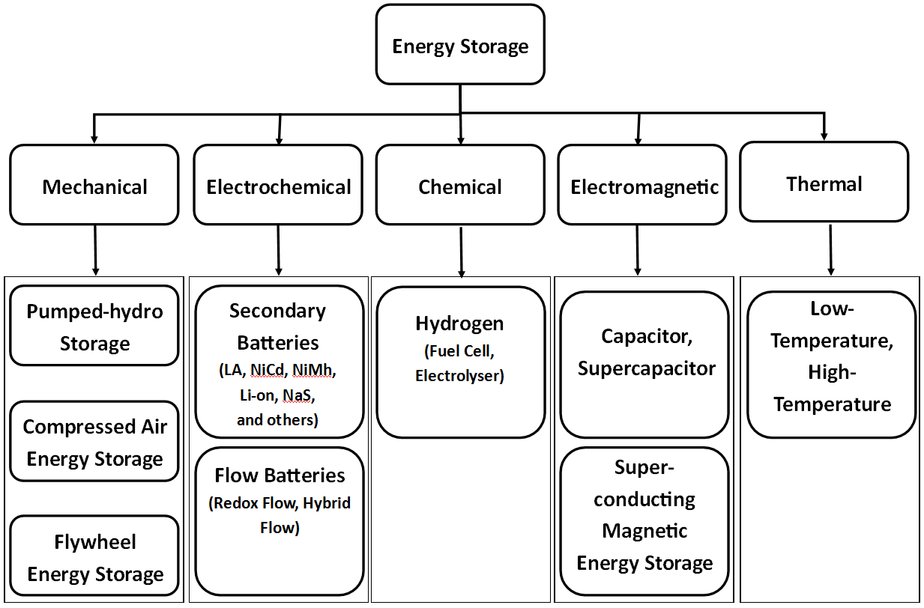
Figure 8 - Classification of ESS technologies (Source: adapted from Zhao, et al., 2015)

ESS technologies can be utilised at different levels within the energy network, from domestic-scale storage up to large-scale storage at the point of transmission, with a variety of applications across these levels. ESS technologies could broadly be categorised into those with a higher energy density (such as PHS), and those with a higher power density (such as supercapacitors). ESS technologies with larger energy densities might be more suitable for applications requiring large amounts of energy or with discharge durations of hours or longer, such as energy management; ESS technologies with higher power densities might be more suitable for applications requiring high-power output over periods of seconds or shorter, such as voltage or frequency regulation. However, it should be noted that there is overlap within these general groupings and the classifications are not static; applications may change as technological advances are made and many technologies are suitable for many different applications.

RESULTS AND DISCUSSION

Introduction
This section details the main findings of the research and provides an explanation of what they mean. Section 6.2 gives an overview of the research findings which are based on the primary data collected from the interviews and secondary data taken from a variety of reports. This section is further divided into sub-sections: Section 6.2.1 describes the actual and future contribution of RES in the Netherlands; Section 6.2.2 introduces several policies which have been successful in facilitating the use of RES; Section 6.2.3 details the main themes which are helping to facilitate or hinder the integration of ESS. This sub-section contains the main results of the research, and is broken down into a number of themes. These themes are the topics most commonly discussed during the interviews and are considered to be those most relevant for the research results. Following this sub-section, Section 6.3 discusses what the findings mean in relation to the Research Questions and the Theoretical Framework, before Section 6.4 highlights some of the limitations of the research.

Results

Actual and Future Contribution of RES
There was general consensus from the interviewees that there is an increasing focus on RES in Netherlands; Dutch energy policy can be seen to reflect this, as discussed in Section 2. Figures 9, 10, and 11 show how solar PV and wind energy production in the Netherlands has increased over the last several decades.

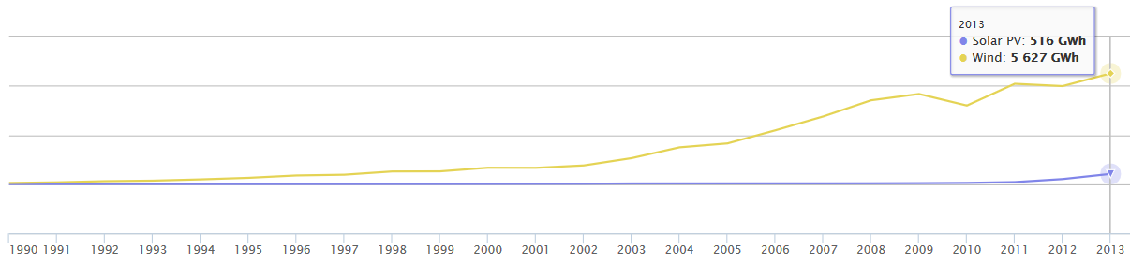
Figure 9 - Wind and Solar PV Energy Production in the Netherlands (Source: IEA, 2016b)

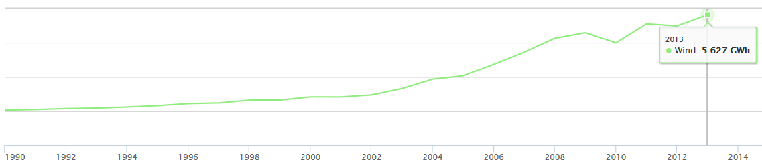
Figure 10 - Wind Energy Production in the Netherlands (Source: IEA, 2016b)

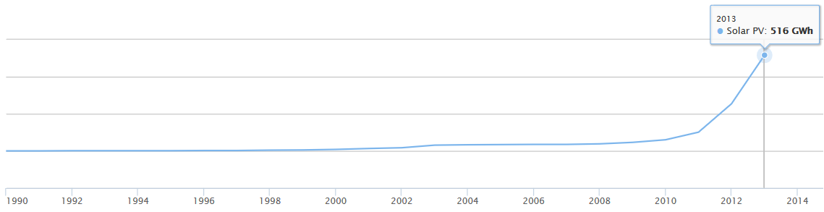
Figure 11 - Solar PV Energy Production in the Netherlands (Source: IEA, 2016b)

However, although there is much talk of RES integration, the transition of renewables to the regime level is not yet fully complete. Interviewee D, for example, mentioned that there was a form of lock-in the Netherlands, as people trusted conventional energy sources over RES. Interviewee N agreed that the Netherlands was still very much gas-dependent and locked-in to its use. Indeed, in 2015, 92% of the Total Primary Energy Supply (TPES) in the Netherlands was from a conventional source (15% coal; 38% oil; 39% gas) (IEA, 2016a).

Furthermore, as previously stated, conventional energy sources are used in a variety of industries, and only a relatively small amount is used for electricity generation. In 2014, just 11% of the domestic supply of natural gas (the single most widely used energy source in the Netherlands) went to electricity plants (IEA, 2017). Several interviewees stressed the relatively small role that electricity actually plays in the overall Dutch energy system. For example, although the figures quoted might not be entirely accurate, Interviewee H stated:

“80% of energy that we transport as a company to our customers is via the gas grid - for heating and cooking. A lot of people do not understand that; they think it's all about electricity. We hear about decentralised renewable electricity but 80% of energy is transported by the gas grid.”

In regards to electricity generation, only 8% of the total electricity generated in 2015 came from wind and solar combined. Although the figures quoted in this section are taken from different years and therefore cannot be compared exactly with one another, they still reflect the fact that electricity is only a relatively small part in the overall energy system within the Netherlands, and renewable energy sources only play a relatively small role in electricity generation. Indeed, it is debatable over how complete the transition of wind and solar is, and at which phase and level they sit in the TM framework.

Regardless of the exact stage of transition (debate about which is outside the scope of this report), it was largely agreed by the interviewees that wind and solar energy production is technologically mature, which confirms the assumption detailed in Section 4.3. Furthermore, there was widespread belief from the interviewees that the penetration of wind and solar would continue. Indeed, although renewables (including biofuels) accounted for just 5.8% of the Netherland’s TPES in 2015, the Energy Centre of the Netherlands predicts their use to rise to 12.5% by 2020 (although this falls short of the 14% target defined in the Energy Agreement on Sustainable Growth) and to 25.4% by 2035 (ECN, n.d.). The (ongoing) transition of wind to solar has undoubtedly been effected by energy policy.

Policies Endorsing RES
In 2014 the Dutch Ministry of Economic Affairs published a report on the country’s energy policy between 2007 and 2012 as defined in Article 14 of the Dutch budget (EZ, 2014, in Dutch). Within the article three operational goals (OGs) are defined in relation to energy policy: well-functioning energy markets (OG1), security of supply (OG2), and a sustainable and safe supply of energy (OG3). To achieve these goals a variety of policy instruments have been used. For the purposes of this thesis (with its focus on ESS), it was deemed excessive and unnecessary to evaluate all instruments to address Research Sub-question 1. Therefore, the decision was taken to focus on OG3 due to the fact that over 99% of government spending on energy policy in 2014 went on this goal (Kocsis & Hof, 2016). This was because almost all the financial instruments defined in Article 14, such as R&D subsidies, subsidies for energy production and tax deduction of sustainable investments fall under it (Kocsis & Hof, 2016). Furthermore, within OG3 the majority of expenditure went on sustainable production subsidies (Kocsis & Hof, 2016). Much of the remaining spending went on other financial instruments such as R&D subsidies or tax deduction of sustainable investments, whereas regulatory instruments such as laws, rules, regulations, consultations, and convenents did not require a substantial part of the budget (Kocsis & Hof, 2016). Interviewee O also considered sustainable production subsidies to be important tools in the wind and solar energy transition and therefore this section of the report will comment mainly on this type of instrument. According to Kocsis and Hof (2016, p1436), sustainable production subsidies:

“improve the business case of investments in renewable energy by subsidizing actual production. Production subsidies are meant to bridge the financial gap of investments in energy production, i.e. the difference between the costs of production per kWh in a reference installation (including a reasonable margin) and the average wholesale market price per kWh”.

Production subsidy in the Netherlands has had three forms: MEP (Mileukwaliteit Electriciteitsproductie; Environmental Quality of Electricity Production), SDE (Stimulering Duurzame Energieproductie; Stimulation of Sustainable Energy Production), and SDE+, a modified version of SDE which suceeded it. According to primary data taken from Interviewee O, and reports by Kocsis and Hof (2016) and the Ministerie van Economische Zaken (Ministry of Economic Affairs) (2014), these instruments have had a variety of successes, with SDE+ being considered to be an effective and efficient instrument in helping facilitate renewable energy sources into the Dutch energy mix.

Furthermore, at the domestic level, the saldering (net metering) scheme can be considered to have helped the growth of installed solar PV within the Netherlands (Huijben & Verbong, 2013, cited in van de Water, 2014). Net metering implies that connections to the electricity grid are billed only for net (annual) energy use. As a result, only energy tax, Value Added Tax (VAT), and transmission costs must be paid on the balance of kilowatts ‘imported’ from the public grid minus the kilowatts ‘exported’ to the grid (Vollebergh, 2014). Indeed, a number of interviewees agreed that the net metering scheme did indeed provide an incentive to invest in solar PV; for example, Interviewee K stated:

“the saldering regulation … caused a big increase in PV installed at home. So it's really a good instrument for supporting the sustainable energy.”

However, although net metering may encourage investment in solar PV, it may discourage investment in energy storage; this will be discussed further in the following section.

Factors and Policies Related to the Integration of ESS

Location
As previously discussed, as wind and solar penetration increases there will also be an increased need for ESS, and there are a variety of different ESS technologies with different attributes suitable for a range of applications. However, this research suggests that the suitability of an ESS technology for a certain application was based on more than that just its technological capabilities. For example, during the interviews there was much discussion regarding the scale of ESS technologies and where they should be located within the grid. As Interviewee B pointed out, there are different levels of the electricity network, with high voltage (HV) transmission lines, medium voltage (MV) substations, and low voltage (LV) within the home. This interviewee saw the possibility of both centralised and de-centralised storage over these levels, with larger-scale storage at the generation site, neighbourhood-scale storage at the substation level, and domestic-scale storage in individual households. However, although this was recognised as a possibility, in practice it is unlikely to be as straightforward as simply integrating storage over these levels as this suggests.

Role of Domestic-level Batteries
The location of ESS at the domestic level could be considered as being the most straightforward, as, by definition, it is located within or at an individual’s home. For domestic energy storage, batteries were the technology that was most widely discussed by the interviewees but there are a number of factors which are currently hindering their more widespread integration. For example, although domestic battery technologies (such as certain brands of Li-ion batteries) can be bought ‘off-the-shelf’ they remain relatively expensive. Based on current, relatively low electricity prices it is generally expected that it will take a number of years before the return on any investment in batteries is realised. Indeed, it could be considered that the high price of a battery plus installation costs, alongside solar PV panels would be a disincentive to invest, and homeowners who invest at the current time are those who do not necessarily expect a fast return on investment, and are wealthy enough to afford this. However, there are market opportunities for batteries which may encourage people to invest; batteries could allow owners to trade in electricity markets or act in the imbalance market, for example. Furthermore, a number of interviewees saw the primary control reserve (PCR) (or frequency control reserve (FCR)) market as providing the most opportunities for domestic-scale batteries. The purpose of the primary reserve is to stabilise frequency disruptions in the entire internationally interconnected high-voltage grid. Serious frequency disruptions can, in the worst case, initiate a black-out (TenneT, n.d.). European policy states that the Netherlands must have an available minimum primary reserve capacity of 96 MW in both regulating directions (in 2015) (TenneT, n.d.); market players can bid to offer capacity to TenneT (the Transmission System Operator (TSO)) in order to help stabilise disruptions. Whereas conventionally bidders needed to make available a minimum of 1 MW capacity for a certain time period, TenneT is trialling lower blocks which could help accommodate storage, as more, smaller players could be able to offer capacity to the TSO for PCR.

Ownership and Role of Aggregators
Furthermore, a number of interviewees see an increased role for aggregators in the future. Interviewee C described aggregators as software companies which aggregate between the energy market and the user. They provide demand-side management of pooled batteries, with the battery owners receiving a fee for providing capacity, and the aggregators charging a fee for providing the service. Aggregators can combine flexible assets to form a large portfolio and there are several projects currently in operation which pool battery capacity. For example, Eneco’s CrowdNett is a network of home batteries that can charge or discharge at the desired time to help balance the electricity network. Homeowners with solar panels are able to purchase a battery through the scheme at a subsidised price on the agreement that they offer 30% of the battery’s capacity to the network. The batteries combined form a ‘virtual power plant’ and together provide reserve capacity for the grid; an annual fee is paid to the battery owner. Another example is Enexis’ Jouw Energie Moment (Your Energy Moment). Participants in this scheme do not pay a fixed price for the energy that they use, but pay an amount associated with the current price of electricity in the energy market. At times of pressure on the grid they pay more, and when there is less pressure they pay less. Interviewee L explained how 40 homeowners were provided with a free Tesla Powerwall battery by the scheme, in order to pool a percentage of total capacity to provide services to the grid. Batteries can be used to store energy either generated by the homeowner or that is purchased when prices are cheaper, for example at night when load on the grid is low. Peak shaving, such as this, helps reduce the amount of energy purchased from the utility company during peak demand hours, and can lead to lower electricity bills, therefore making the purchase of a battery a financially more attractive option. However, Interviewee H did not see a future role for aggregators, as they felt that individuals would be able to trade on energy markets themselves, rather than paying a fee to a third-party.

It is important to note that although batteries can provide flexibility and have also have applications in other markets, they can only provide one service at a time. If capacity is made available for PCR, for example, then it cannot be employed for use in another market at the same time. To quote Interviewee F:

“Just as you can only spend a euro once you can only spend a kilowatt hour once, and you can only spend a second once. So, if your battery is employed for primary reserve for some time it cannot do the same thing with the same amount of time within the imbalance market, or in another market.”

Indeed, there has been EU-level discussion over whether battery storage systems looking to provide frequency regulation must be able to achieve maximum demand for either 15 minutes or 30 minutes. Providing for a shorter time period would make investment in batteries a more attractive option for market players, as the battery could be used for another purpose or in another market sooner than if capacity needed to be made available for 30 minutes at a time. At the time of writing this research it is not clear what the outcome of these discussions are, but the outcome of this could have implications for the energy storage market and for business cases for batteries.

Conflict between the Transmission System Operator and the Distribution System Operators
Furthermore, Interviewee I pointed out that there is an element of conflict between the TSO and the Distribution System Operators (DSOs); the PCR market is a service for which the TSO pays the ESS owners (whether they require the use of capacity or not). However, if, for example, the grid frequency was high and the ESS needed to absorb energy from the grid then there may be a large peak on the owner’s grid connection. The DSO may charge the ESS owner for this peak. Therefore, although the owner is getting paid by the TSO for providing the service, the owner might have to pay the DSO. This could be seen as disincentive for storage. Interviewee I believed this was an “old [fashioned] rule” and was an area that the PCR market could be improved for the storage owner.

Net Metering
As discussed in Section 6.2.2, net metering could be considered a successful instrument in regards to encouraging investment in solar PV at the domestic-level. However, it discourages homeowners to invest in batteries because it allows people who generate electricity with solar PV to effectively use the grid as a form of storage; there is no incentive to invest in an expensive battery when the grid performs a similar role. The net metering scheme was the most commonly mentioned policy instrument by the interviewees, and the majority felt that the scheme was holding back the integration of domestic storage. For example, Interviewee C stated:

“This [saldering] is a kind of a subsidy. It holds back people from buying a battery because the grid is the battery...you sell [electricity] for the contract price and you buy [electricity] for the contract price. If this ruling gets terminated then people have a business case for storing that cheaper PV power.”

Interviewee G agreed:

“I think there comes more opportunity for this energy storage technology when this net electricity regulation is finished.”

As did Interviewee H:

“Batteries are now not at the household level due to this saldering.”

‘Double’ and ‘Stepped’ Tax Systems
A number of interviewees also spoke about how the current energiebelasting (energy tax) system also hinders the integration of ESS. The current system taxes both consumers and producers of electricity, which Interviewee C believed holds back the integration of batteries; they explained how it works:

“If you buy power as a consumer or a company you pay tax on it. If you sell it you are a producer so you also pay tax. So, if you have a battery and you charge or discharge multiple times a day … then you pay tax on buying and selling so it's this double tax.”

Interviewee N agreed that the current system holds batteries back:

“There are also facts in the law that makes it difficult for storage. It's in the pricing system, it's in the taxes. These tax systems are not made for these things. You should change them.”

Interviewee I also stated that they felt the system should be changed:

“If you put a kWh from the grid into your storage and then you deliver back to the grid … then you have two times the taxation on the same kWh – that's indeed a part of the policy that should be changed.”

However, if the tax system were to be changed then the government may lose revenue and need to find a way of replacing it, possibly with taxes elsewhere. Interview L, however, stated that the income from electricity taxed compared to the total tax income to the government was relatively small, and believed that the overall societal costs could be brought down by changing the tax system. In fact, in 2014 the Dutch government collected 23.9 billion euros in environmental taxes and levies which was 9% of total government tax revenues including social contributions, with households contributing 66% and companies 34% (Statistics Netherlands, 2015). According to Statistics Netherlands (2015), the Dutch share of environmental taxes and levies in total taxes ranks amongst the highest in Europe.

Furthermore, a number of interviewees thought the current ‘stepped’ tax system held storage back. This system differentiates between various degrees of electricity consumer, from small (between 0 to 10,000 kWh per annum) through to large business (more than 10 million kWh per annum), with several levels in between. Large consumers pay significantly less tax proportionally on consumed electricity than small consumers (Belastingdienst, n.d., in Dutch), which could be seen as a disincentive for large consumers to invest in storage. Interviewee A describes this system as “1960s tax engineering” and sees no difference how and where energy is consumed:

“A kilogram of carbon dioxide is a kilogram of carbon dioxide. It doesn’t matter at all if this was created because I wanted to iron my shirt or because it was created because of melting some iron ore.”

Indeed, Interviewee A sees no justification for the differential prices and even sees some “strange incentives”, giving the example of a medium-sized enterprise where it makes better financial sense to consume more energy than they need in order to move into a different tax bracket and receive a reduced rate per kilowatt hour. However, Interviewee M thought that it was logical that large-consumers should pay less, and Interviewee G thought the situation was similar to many other countries. Interviewee L “liked” the current stepped system because it helps Dutch companies be competitive in international markets, but Interviewee N felt that this was no longer necessarily a valid argument and that it was important for the Netherlands to do more in regards to reducing CO₂ emissions regardless of any perceived competitive advantage in international markets.

Distributed Storage
Indeed, in regards to large electricity consumers, a number of interviewees spoke about the role of distributed storage integrated with wind or solar farms located at sites such as large real estate properties or large distribution centres for retailers. Interviewee H saw the possibility of these large electricity consumers installing a wind turbine or solar PV on site with a grid connection and ESS. Interviewee G also saw the storage alongside larger-scale wind or solar energy production:

“I think it's better to have distributed energy storage close to the production because the old situation was we have a central production and then dispersed consumption. But now it's dispersed production and dispersed consumption …. I think batteries are definitely interesting as it becomes cheap when you have MW storage, like with a wind turbine, and so each turbine or maybe group of turbines could have its own storage. I think that's where we need to go.”

Other interviewees shared similar views. For example, Interviewee A stated:

“I really do think the electricity supply will be de-centralised so with that comes the need for many relatively small storage systems instead of a handful of huge storage systems.”

Interviewee B stated:

“It makes sense to have batteries close to the wind farms.”

However, as Interviewee C points out, battery storage integrated with a wind farm may be more suited to applications such as frequency regulation or imbalance:

“Technically it's possible [to store the power of a wind farm with batteries] but if you have a 4 MW turbine you basically need a 4 MW battery to store one hour of power at peak. And that's a lot of batteries. So, batteries are really short term storage.”

Interviewee B agreed that technically it is feasible to integrate storage alongside wind or solar, explaining that storage can also help avoid investment costs in grid reinforcement; for example, by avoiding the need for additional cables or transformers. Indeed, storage could reduce storage owners’ grid connections, reduce the need for investment in the grid, and reduce the need for copper in the ground. These could be considered to be further benefits of storage, and there was general consensus amongst the interviewees that the TSO and DSOs would be some of the most important beneficiaries of ESS. However, the question regarding ownership of any ESS technology appears to be holding its integration alongside wind or solar farms back.

TSO and DSOs as Regulated Entities
As regulated public entities, the TSO and DSOs are forbidden under European law to engage in market activities due to concerns that as a monopoly they try to affect the performance of electricity markets in a way that could benefit themselves unfairly – they must act as neutral market facilitators. Currently, therefore, they are unable to invest in ESS and participate in markets such as PCR or imbalance. However, a DSO, for example, might be permitted to operate an energy storage system to provide grid services to ensure efficient, reliable, and secure operation of the distribution system, under the condition that other parties have not expressed an interest in owning, developing, managing, or operating storage. Furthermore, it could be considered that there are some grey areas whereby commercial, un-regulated arms of the DSOs can tender out for storage projects, for example. However, as it currently stands, when selecting the best option for a given project, storage cannot be chosen if it might create market distortions.

Interviewee K described a project in which it was investigated whether it could be cheaper to install a battery system rather than replace an over-loaded cable within the grid. In this case, it was deemed vastly more expensive to install a battery and a new cable was chosen as the best option instead. In a situation such as this, if a battery were able to be used for other applications, such as PCR, and therefore have an additional revenue stream then there may have been a viable business case for the DSO – they would have a larger portfolio and less risk. Indeed, Interviewee L stated that storage was more viable if different functions were combined. Furthermore, Interviewee K stated that they believed that the rules should be changed to allow grid companies to integrate themselves with storage; they felt that this would happen in the future. Interviewee H also thought that grid operators should be able to invest in batteries and suggested that the mandate should be changed, stating:

“Grid companies like us …. are natural companies to be active in this field at this moment because we have these electricity grids. We feel the pain that if we are not investing in flexibility or in that we will have to invest in copper. That’s not smart anyway.”

However, Interviewee N was more cautious over allowing public entities like the TSO and the DSOs to be involved in the markets:

“If you control the system you should not be a player on the system .… I think if you have a monopoly on a grid and you get money from tax payers and you use that money to go on the market, that's just not fair. Because then the others who are on that market should get that money as well – that's difficult. Therefore, that's why I think we say storage is a commercial thing. Or not – you take it completely off the market. You say ‘no, this is so important the community is going to take care of it’. Then the community do it with tax money – fine.”

Role of Communities
Indeed, the role of communities and community-scale storage was also an important theme for a number of interviewees. Interviewee N considered local community involvement to be a key point in helping integrate RES technologies, and to reach an overall aim of self-sufficiency. Energy storage would help towards that aim, and Interviewee N saw community-level storage as being easier to implement for a large number of households, as opposed to a large number of households each having their own smaller storage system:

“The larger scale the better it is. To solve for one household is more difficult than for 500.”

However, this raises the question of who should assume what responsibilities when it comes to implementation of ESS. Taking the example in the above quote, it could be argued that the responsibility for integrating storage (on the domestic/community-scale) should lie at a level above the individual homeowner – the responsibility should lie with the DSO or the municipality, for example. If the respective municipality, for example, took the initiate to install community-scale storage for 500 households, as opposed to waiting for 500 different households to each install domestic storage individually, then any benefits might be realised sooner or more efficiently.

Interviewee N also gave an example of a cooperation of farmers owning RES and ESS facilities and providing electricity to other members of a small (approximately 500 person) community for a “fair price”, whilst Interview M also discussed a private entity developing, owning, and operating community storage and selling services to the grid operator. However, this interviewee stated that they are currently unsure whether a DSO would be willing to buy services from a community storage system; this would need further consideration or research. Interviewee J stated that grid operators are uncertain as to where to place batteries within the network; Interviewee L is also unsure as to where batteries should be placed in the grid, but believes that market forces will determine where storage is located.

Role of Energy Storage Technologies other than Batteries
The interviewees generally did not see a role for utility-scale storage within the Netherlands, although certain utility-scale technologies could be feasible. However, as it currently stands, the country does not have such large-scale wind or solar farms and there was consensus that there is currently no business case for technologies such as CAES. However, various feasibility projects have been conducted and it might be a possibility in the future. PHS is generally not considered feasible in the Netherlands due to the generally low-lying, flat landscape. Furthermore, most of the focus from the interviewees was on batteries (in particular Li-ion), as they are one of the most technologically mature ESS types. Therefore, although other technology types (such as flywheels) were discussed during the interviewees, the consensus was that batteries will be the ESS technology which will be most widely adopted alongside wind and solar electricity generation within the Netherlands, at least in the near future. However, the integration of ESS alongside other technologies or within other sectors to provide flexibility was mentioned by a number of interviewees, and this will be discussed later in this section.

Subsidies and Funding
ESS do not produce energy themselves (and in fact often ‘leak’ energy, such as when batteries self-discharge) and therefore production subsidies might not be a suitable model to encourage their integration. However, other forms of subsidies or funding might help facilitate the integration of storage. Indeed, Interviewee N stated that SDE[+] is a “very good system” and thought that a similar system for storage could help. The interviewee described how, as well as the subsidy itself, the scheme also provides a level of security, and thought that subsidies could also help ESS integration by providing security for investors. Interviewee A also saw the need for the government to take on risks that are too large for individual households or companies. This interviewee thought that R&D funding in the Netherlands was good and saw it help new companies to “get off the ground”. However, this interviewee thought that the government could do more to help companies scale up once past the R&D stages. Interviewee A also thought that government investment towards pilot projects would help ESS integration and thought that other countries, such as Germany, do more than the Netherlands in this regard. Interviewee N agreed that funding would be helpful if pilot schemes were started, and Interviewee G acknowledged that financial aspects were holding energy storage back. This interviewee thought funding was needed to get a product to the market but cautioned that once a product was in the market it should no longer be subsidised:

“In the operational phase, I don’t think it’s a good idea to have subsidies anymore. Because if it’s a good product then it will be bought by consumers or there will be organisations who see the market in it and will buy these systems and make money out of it.”

Role of Government and Corporations
Further to the government’s role in regards to funding, a number of interviewees also acknowledged that the integration of batteries (and other RES and ESS technologies) was, at times, being held back by a lack of information sharing across and within different levels of the government; strong governmental leadership was also sometimes lacking. For example, Interviewee A described a “somewhat erratic strategy” from the government in regards to funding for wind technologies, whereby funding regimes changed several times making it difficult for investors. Interviewee L thought that short-term solutions from policymakers were problematic:

“There's not a long-term guarantee with long term commitments you can count on – and that's the most important. Everyone's asking – also big industry – for long term commitment from the government for certain rules. But often political parties have other things which they want to give to people in the Netherlands which are more popular.”

Furthermore, Interviewee A also spoke about how the large number of municipalities in the Netherlands (approximately 400) meant that knowledge sharing and cooperation was important. Interviewee J described the problem of every municipality having its own goal, thus making the energy transition difficult. In addition, Interviewee G described the process of getting an innovative battery project to pilot within a municipality; even if a product goes to pilot in one municipality, it may not be allowed in another. This interviewee stated:

“The flow battery as a concept is unknown in policy instruments. So, that's an obstacle because every municipality has to find out if they need to be afraid of the battery or not, and what measures need to be taken to create a safe situation. It would be helpful if there could be, in the legislation, a code for this type of equipment which makes it easy for municipalities to decide what conditions are needed to have a safe situation with a battery installed inside their municipality.”

They continued to say that information sharing was becoming more necessary to bridge any knowledge gaps, and more standards need to be developed for new technologies. Interviewee L agreed, stating that the government should be encouraged to play an increased role in developing standards. In addition, as previously stated, Interviewee N agreed that funding for pilot schemes would be helpful. This interviewee also stated that pilot schemes were useful as their pilot ‘status’ can allow them to sometimes bypass current regulations.

Although there were a number of negative comments made about the role of government, it was not all unfavourable. Interviewee E, for example, described a certain municipality as the “driving force” behind a hydrogen storage project, and how the municipality was cooperating closely with its citizens to get support for the project. Interviewee N stated that provinces and municipalities have said they want to be responsible in reaching European energy targets, and the interviewee believed this was a “very good sign”. This interviewee acknowledged that mistakes will be made by the government and it will take time for targets to be met, but, in general, they were positive about the government’s role.

A variety of interviewees also stated how cooperation between the government and large industry or corporations was important. Interviewee G thought that the situation was changing and there was becoming more acceptance from companies towards ‘greener’ policies or regulation; the example of the same large brewery was given by three separate interviewees. Interview G stated that the brewery had “a real focus on becoming sustainable” by investing in RES and other technologies. This example was not a one-off and was not considered to be a cynical attempt by companies at ‘greenwashing’. Indeed, Interviewee G stated that, in certain cases, large companies “run faster than the government” and believed that the government would need to come up with new policy instruments in response; Interviewee N also agreed that sometimes companies were ahead of the government and are “moving in a good direction”. Interviewee J agreed and believed companies were looking to the future and were willing to adapt to changing circumstances. Interviewee O thought that since the introduction of the Energy Agreement for Sustainable Growth in 2013 which was a broad agreement between a number of governmental and non-governmental organisations and corporations, the discourse in relation to sustainability has become “less political” and that there has been “more structural behaviour from the government”. This interviewee saw this interaction between different organisations as a positive. However, it should be noted that these views could be seen to somewhat contradict the results in regards to the ‘stepped’ tax system detailed earlier; interviewees felt that the current tax system held large consumers back from investing in storage, but evidence provided also suggests that there is belief that certain companies are committing to the energy transition. This could possibly be explained due to there being an overall commitment for companies becoming ‘greener’, although the tax system may hold the implementation of ESS back within this overall process.

Interlinking of Different Sectors
Furthermore, alongside discussion on ESS technologies, a number of interviewees also talked about the importance of interlinking different sectors (for example power, gas, heat, and mobility) in order for the energy transition to be successful, and played down over-reliance on ESS. Interviewee M, for example, made it clear that increased adaption of ESS technologies is not the overall objective of the energy transition and should be looked at as a means to achieve a goal of a zero-emission energy system:

“You wouldn't want to say ‘we want storage there’ just because it's storage – there's no point. Only if it's economically viable and system-wise viable – then it's relevant. Solar and wind you want anyway – that's the goal because it reduces emissions. Storage doesn't reduce emissions, but should be seen as a means to integrate more variable renewables.”

This interviewee, however, did acknowledge the need for flexibility, including storage:

“You want to create a level playing field – that's really what you want to achieve. Create a level playing field to have storage, demand response, flexible power plants, and grid connections to be able to evenly participate in the market.”

Indeed, Interviewee H saw the importance of connecting markets, storage, grids and different energy carriers in order to facilitate the energy transition, and along with Interviewee E, saw an increased role for energy conversion in the future. Energy conversion is the process of converting energy from one form to another; the term ‘Power-to-X’ is commonly used, where ‘X’ can be a number of energy forms. For example, electrical energy generated by a wind or solar farm can be used to split water (H₂O) into hydrogen (H) and oxygen (O). The hydrogen can be stored and transported, used as a fuel, and could be converted back to electricity at a later date if so required (albeit with energy losses during the conversion processes). In this example, the ‘X’ in the terminology would refer to hydrogen, although it could refer to a variety of other terms such as ‘heat’ or ‘mobility’. Although Interviewee E and Interviewee I stated that the did not see Power-to-Gas being viable for at least the next five years, they, and a number of other interviewees did see it becoming a future prospect. For example, Interviewee H stated that energy conversion would offer additional flexibility in the energy system and saw the need for energy conversion alongside storage. Electricity converted to gas could be used to power vehicles or injected into the existing gas grid to make the existing system cleaner, whilst converting electricity into another form at the point of production could avoid grid investments. Power could also be converted to heat: surplus energy generated by a wind or solar farm could be converted into steam in an electric boiler, for example. Stored heat can be used for applications such as district heating or horticulture. The role of electric vehicles (EVs) may also be of increased importance in the future, as they become more widely used. For example, while an EV is parked and plugged in it could provide ‘vehicle-to-grid’ services, whereby its battery could be utilised to charge or discharge to the grid if required. In the future, there could be additional market opportunities for applications such as this, when more flexibility is needed. However, even if there are market opportunities for these (and other) options, new regulation would likely be required before they could become part of the energy system.

Discussion and Recommendations
The main research question of this thesis asked: how can ESS technologies transition from niche to become established technologies at the regime level?

Based on the results described in the previous section it is possible to answer this question using the Theoretical Framework formulated in Section 3.4. The research sub-questions will first be discussed in the following three sub-sections, before the main research question is addressed in Section 6.3.4.

Sub-question 1
What role did different policy instruments play in the transition of solar and wind energy production (across different scales from domestic to large-scale) from niche to commercial adoption and diffusion in the Netherlands?

As the focus of this thesis was on the transition of ESS technologies (as opposed to the transition of solar and wind energy production) the results of the research somewhat overlooked this sub-question; the number of previous policy instruments used over several decades to facilitate the transition of wind and solar energy production was too large to fully cover them all in this research. Therefore, only a small number of instruments were covered in relation to this question. However, the results that were gathered show the majority of government spending on energy policy was on renewable energy production subsidies. These instruments have evolved over time and were generally considered to be successful in facilitating wind and solar energy production at levels above the domestic. Furthermore, the net metering scheme has been successful in encouraging domestic solar PV and the interviewees overwhelmingly agreed that the transition of wind and solar energy production was no longer niche and commercial adoption had occurred.

However, without a vastly more wide-ranging study it is not possible for this research to comprehensively answer this sub-question, although it can be concluded that the previously made assumption that wind and solar energy production are no longer considered to utilise ‘niche’ technologies is correct. Indeed, Statistics Netherlands (2015) reports that the Dutch government’s climate change mitigation policy (of which the budget is spent primarily on renewable energy production subsidies) resulted in raising the share of renewable energy sources in the total energy supply. Therefore, it can be concluded that the policy instruments utilised have been largely successful.

Sub-question 2
What role do different policy instruments play in the ongoing integration of ESS with solar and wind energy production (across different scales from domestic to large-scale) in the Netherlands?

In contrast to the results from Sub-question 1, policy instruments utilised to facilitate the integration of ESS with solar and wind energy production can generally considered to be unsuccessful. The instruments most widely mentioned and discussed by the interviewees were the net metering scheme – aimed at encouraging investment in solar PV at the domestic-level – and the ‘double’ energy tax. These schemes were generally considered to be holding back the integration of batteries within the home. Furthermore, the stepped tax system is a disincentive for larger electricity consumers to invest in ESS, and indeed can even encourage energy over-consumption.

Furthermore, problems were noted with organisational- and information-based instruments. For example, there are problems with communication mechanisms between different actors such as different governmental levels, and a lack of standards is holding integration back. A lack of understanding from various actors in regards to ownership and location of storage systems was also holding back its integration within the grid. Current regulation also holds back ESS in some situations; for example, the European regulation forbidding the TSO and the DSOs from owning ESS which might influence markets.

However, a number of positives can be seen. Strong steps towards the energy transition are being made by certain large companies, with voluntary agreements in place. At the community-level there are also a variety of encouraging signs such as farmers’ cooperatives working with local residents to provide renewable energy. However, as previously stated, there are questions over ownership and who should take responsibility for ESS integration.

Other positives include the use of pilot schemes, and the TSO considering reducing the capacity provision level for the PCR market. Projects such as the CrowdNett and Your Energy Moment schemes might also encourage storage, whilst subsidies for R&D or to help ESS technologies scale up or to enter the market can also be useful in helping the ESS integration.

Sub-question 3
a) Which policy and technology options and instruments are most suitable to facilitate the transition of ESS from niche to become commercially adopted and integrated with solar and wind energy production (across different scales from domestic to large-scale) in the Netherlands?
b) Where does this ongoing transition sit in relation to the policy and technology domains?
c) What roles do policymakers and technology actors play in this transition?

Operational goal 3 of Article 14 of the Dutch budget contains five sub-goals:

- Energy innovation;
- Energy saving;
- Sustainable energy production;
- CO₂ reduction;
- Nuclear safety and radiation protection (EZ, 2014, in Dutch).

Assuming that the OGs (and sub-goals) remain the same in coming years, it is recommended that there is sufficient expenditure towards the other sub-goals within OG1. Currently, the majority of the energy budget is spent on Sub-goal 3, but other areas are important in achieving the energy transition; ESS could arguably also have a role to play in Sub-goals 1, 2, and 4. Furthermore, OG2 (security of supply) will be important if RES and ESS technologies are to be further implemented. As a number of interviewees stated, there is uncertainty over the best locations for storage systems and how they will fit into the existing grid. There is also uncertainty within different levels of government and at times there is a lack of communication or cooperation; large companies are also sometimes considered to be ahead of the government in regards to the energy transition. It is likely that regulatory instruments, such as standards, will need to be developed to allow technologies to be more easily integrated safely and efficiently, and to allow a continued secure supply of electricity. This will require cooperation between different actors (e.g. DSOs, TSOs, municipalities, ESS owners) and will require long-term thinking and learning-by-doing; for example, as there is uncertainty with regards the optimal placement of ESS systems within the grid, experimentation might be required until the ideal location(s) are found.

Changes in the net metering scheme and the current tax regime would likely be needed to encourage households to invest in batteries alongside their solar PV. If an increase in domestic batteries is a desired outcome, the net metering scheme would require system improvement so that the existing trajectory of integration of solar PV can continue, but alongside an integration with batteries. The net metering scheme currently encourages investment in solar PV, and so removing it completely could have undesired consequences in regards to domestic solar PV installations if a new or modified scheme is not introduced. Herein lies what appears to be discord between domains within the socio-technical regime, with policymakers facing conflict when making decisions. For example, if a decision were made to remove the net metering scheme battery sales might increase for those households with solar PV already installed, but homeowners currently without solar PV might be discouraged from investing in panels and therefore there is less incentive for them investing in a battery. Policymakers face a dilemma over the best course of action to take, but incremental improvements of the existing trajectory might be the most pertinent strategy. Indeed, the net metering scheme has previously been modified, such as when the limit for the amount that could be offset was first raised from 3,000 kWh per year to 5,000 kWh per year (in 2011), before it was made unlimited (in 2013).

There has been discussion from policymakers in regards to whether the net metering scheme will continue, and during the writing of this thesis (July 2017) the decision was made to continue the scheme until at least 2023 (it was previously due to continue until at least 2020); at the time of writing it is not currently clear what (if any) changes will be made to the scheme after this date. van de Water (2014) discussed a number of scenarios, variations, or alternatives to net metering; these included: continuing the system in its current format, imposing a maximum on the amount of electricity which can be netted, modifying the time frame, modifying tariffs, restricting eligibility to certain target groups, changing the system to a feed-in tariff, abolishing net metering, replacing with a tax reduction which declines over time, or replacing with a tax rebate guaranteed for a number of years (for example fifteen years). It is beyond the scope of this research to investigate each scenario and make recommendations for action, but although the scheme is now guaranteed past 2020 another decision on the course of action past 2023 will need to be made within a few years.

Changes to the tax regimes could encourage both storage and the reduction of electricity consumption. Interviewee L suggested a new system whereby tax payable is relative to the price that consumers pay; this could stimulate consumers to respond better to the supply and demand of electricity. As the tax system currently stands, if electricity prices are low then consumers might be likely to use more electricity than when prices are high, simply because their bill may be lower even though they use more electricity. However, if tax payable is relative to the amount of electricity consumed, then large consumers pay more tax relative to small consumers, although they are on the same tax rate. This could discourage electricity consumption, even when prices are low. A scheme such as this can stimulate demand response, and if demand response is stimulated there is a better incentive to use ESS. However, any changes would require long-term thinking, planning, and communication mechanisms would need to be robust.

Although limited, the results from Sub-question 1 appear to show that policy instruments have been mainly positive in encouraging the transition of wind and solar energy production – the fact that these technologies are no longer niche is testament to that. Large amounts of government spending on energy policy goes towards renewable energy production subsidies but ESS technologies do not produce energy themselves. Therefore, energy production subsidies are unlikely to work effectively in regards to ESS – a different form of subsidy or funding is likely to be needed. R&D funding can help innovative technologies, and if the government decides that the integration of ESS is a desired outcome then the government being prepared to take on financial risks that are too big for individuals or companies could help achieve this. However, there must be a place in the market for products, no matter how much funding or subsidising they receive, or else they will ultimately fail to attract investments and will not achieve commercialisation. The results of the research do suggest, however, that as new market opportunities arise there will be increased scope for ESS integration.

Furthermore, markets such as PCR can allow battery owners to earn revenue from providing capacity of their batteries for grid services, but as new markets are created it is likely that new or updated regulatory measures will also need to be introduced. However, if they have the necessary funding (from government or elsewhere), pilot schemes are sometimes able to bypass regulation in specific circumstances. Pilot schemes can therefore be a useful tool for facilitating system innovation or improvement.

Main Research Question
How can ESS technologies transition from niche to become established technologies at the regime level?

Policy instrument choice should consider TM theory when attempting to facilitate the integration of ESS technologies to the regime level. Firstly, there are a large number of options available to actors in both the technology and policy domains. Storage from the small- to utility-scale is currently feasible using a variety of different technologies, many of which have the potential to be scaled up indefinitely assuming there are no constraints financially or due to locational issues; from a technological perspective, storage could be integrated immediately. However, the results make it clear that storage is not necessarily the desired outcome – the desired outcome is a clean-energy future based on renewable energy sources. Energy storage can help achieve this but policymakers must make decisions whether it is the best approach, taking into account other options such as power-to-gas or vehicle-to-grid. When making decisions, policymakers need to consider the long-term options that are available; for example, considering whether ESS might be cheaper to install than replacing copper cables when the need arises over the coming years, or considering if the existing gas grid could be utilised with gas converted from electricity generated from wind or solar energy. Once decisions are made, short-term implementation of options could be introduced as part of a process of learning-by-doing – bringing about change in a stepwise manner. For example, due to the uncertainty surrounding the optimal placement of ESS within the grid, test projects and pilot schemes could be utilised to test different options and make gradual improvements along the chosen trajectory. Furthermore, in achieving an energy transition over a timescale of years to decades a huge number of options are available for consideration by policymakers; learning through experimentation can also help to reduce the number of options to a more manageable amount as time progresses and the trajectory is stabilised.

Indeed, it can be seen that learning processes have been utilised in regards to the renewable energy production subsidies and shorter-term policy instruments that have previously been used in regards to RES. The MEP scheme ran from 2003 to 2006; SDE from 2008 to 2011; SDE+ from 2011 to present. The approaches have evolved over time and can be considered to have improved in a process of learning-by-doing. It can also be argued that the evolution of the subsidy schemes can be seen as both system improvement and system innovation. Indeed, according to Interviewee O, MEP originally focussed on electricity production by biomass, whereas SDE focussed on biomass and wind energy, with separate budgets for each RES. SDE+ had a combined budget for all renewable energy sources, allowing the market more choice – it is not constrained by smaller, individual budgets. This could be viewed as system innovation – changing the trajectory towards other forms of RES if the market called for them. Indeed, Interviewee O believes that the auction system currently used by SDE+ for off-shore wind drives innovation; cheaper solutions must be found or potential investors or innovators will be pushed out of the market. Furthermore, there have been changes within the schemes themselves. For example, at the end of 2015, the SDE+ scheme was modified to differentiate between on- and off-shore wind energy production, and a different tender process was introduced for off-shore. The evolution of the subsidy schemes can be viewed as system improvement. However, a production subsidy is not likely to be suitable for ESS (because ESS do not produce energy), so a similar process of learning would likely be needed for any policy instruments used to help facilitate the integration of ESS – the ‘perfect’ instrument will not be developed immediately. Furthermore, shifting social, economic, political, and other factors mean that, over time, amendments to instruments will be needed in order for them to continue to work effectively and efficiently.

In addition, as previously stated, governments can act as either facilitator, stimulator, controller, or director of transitions, and have a guiding role. They can introduce measures to ensure a real market is created, and can help make the market more attractive to newcomers. They can create the right conditions for market processes through tax policies and can create and manage niches (Rotmans, et al., 2001). However, decisions must take into account both short- and long-term objectives, and this is an area in which there appears to be problems with TM theory; TM calls for long-term thinking as a framework for shaping short-term policy, but, as Meadowcroft (2009) points out, the policy agenda is typically dominated in the short-term. It could be argued that TM takes the somewhat simplistic view that short-term policy will be decided upon taking into account the long-term goal, whereas this might not be the case. Indeed, Vergragt (2005, p305, cited in Kern & Smith, 2008, p4101) states that “the dilemma with long-term multi-stakeholder processes is that short-term objectives easily become dominant and long-term visions recede beyond the horizon”. Certain interviewees also believe that there are no long-term guarantees from the government, and if ESS technologies are to become further integrated it is important that ‘short-sightedness’ in decision-making should not hold their transition to commercialisation back.

Decisions also need to take into account multiple domains, actors, and levels. For example, decisions surrounding the location of a battery system might involve several levels of government, the grid operator, the land owner, local communities, the battery owner, and a variety of other actors. The results of pilot projects should be communicated effectively between and across different levels of government, and standards should be produced so that future projects can be completed more efficiently. If a certain municipality made a system improvement that can benefit other municipalities it is important that this should be shared; it might be even more important for this to happen if a system innovation is made, whereby the system trajectory is changed. If this innovation could benefit all municipalities there should be instruments in place to allow this to happen effectively.

Limitations of the Research
In conducting this research project a number of limitations or areas for improvement were noted. First, the fact that the researcher is a non-Dutch speaker meant that searching for information from Dutch-language websites might have proved more difficult than it would have been for a Dutch speaker; translation websites were often needed to be used, and internship colleagues sometimes had to provide help in translating. However, it could be considered that there are certain advantages of a non-Dutch researcher conducting a study within the Netherlands – an ‘outsider’s’ viewpoint might illuminate certain areas which had not been considered before, for example.

Second, as previously mentioned, the amount of policy instruments that have been used in relation to wind and solar was too great to investigate each individually, and the focus needed to be narrowed down. This meant that the results for Sub-question 1 might not have been as useful as intended prior to beginning the research.

Third, although the interviewees came from a variety of fields within the energy storage or renewable energy sectors, there were still several companies or institutions that potentially could have provided useful information if an interview could have been arranged with them. For example, Energy Storage NL (who aim to act as a central platform for knowledge and “best practices” in the field of energy storage in the Netherlands (Energy Storage NL, 2017)), the Netherlands Authority for Consumers and Markets (ACM) (who ensure fair competition between businesses, and protect customer interests (ACM, n.d.)), and the Ministerie van Economische Zaken (EZ) (Ministry of Economic Affairs) (which is the ministry responsible for energy policy, amongst other areas), amongst others, all might have provided information valuable for the research. Indeed, an interview had been arranged with a representative from Energy Storage NL, however this was postponed by the potential interviewee to a date which was considered by the researcher to be late in the research process. Therefore, the decision was made not to conduct this interview. In addition, contact was made with the Ministry of Economic Affairs although it was not possible to arrange an interview; the researcher was only made aware of the ACM until late in the research process. Again, a decision was made not to try and arrange as interview as it was considered that there must eventually be limits on the number of interviews conducted and the timescale that they are conducted over.

Finally, as stated in Section 3.4, it is recognised that a wide range domains and actors (within a TM framework) are important and have an influence on the overall transition process. However, due to the fact that this research was concerned with how policy instrument choice influences the adoption of innovative technologies, the study chose to focus on the domains of policy and technology, alongside policymakers and technology actors. A more wide-ranging study which took into account a greater number of domains and actors might produce more exhaustive results, for example such as how markets may influence policy choice and the transition of technologies. However, for the purposes of a research project of this size, the number of domains and actors needed to be limited and therefore the choice of selecting the policy and technology domains is justified.

CONCLUSION
Wind and solar energy are the most commonly used non-dispatchable renewable energy sources in the Netherlands and can be considered to have made a transition from niche to commercialisation. Furthermore, their utilisation is expected to grow over the coming decades and is encouraged by the Dutch government; as their use continues to increase there will be a greater need for energy storage systems. By adapting Transition Management theory to focus on policymakers and technology actors who can exert influence in the policy and technology domains at the meso- and micro-levels, this research project aimed to identify the policy instruments (such as economic or command-and-control instruments) used to facilitate (or hinder) the transition of wind and solar energy production technologies from niche to regime level. The research investigated whether lessons learnt from the transition of wind and solar energy production (in regards to policy instrument choice) could be applied to the ongoing transition of ESS from niche to commercialisation across different levels, from domestic up to centralised.

The research found that the number of policy instruments used in the wind and solar energy transition was too large to investigate fully (for a project of this size), and therefore the focus was narrowed down to those instruments which received the largest government funding – renewable energy production subsidies – and the net metering scheme. Overall, these instruments can be considered largely successful in facilitating the transition of wind and solar energy production from niche to commercialisation.

However, although ESS is technologically feasible in the Netherlands (at least at the domestic and distributed levels), the policy instruments currently used can generally be considered to be holding ESS integration back. Furthermore, it was found that it is difficult to apply lessons learnt from the wind and solar energy production transition to the ESS transition, as the policy instruments investigated for the former were either not suitable (in the case of renewable energy production subsidies), or hindered ESS integration (in the case of net metering).

In reaching the above conclusions, a number of interviews with experts within the renewable energy and energy storage sectors were conducted. These interviews identified a variety of themes which could be seen as generally hindering the integration of ESS. The themes included:

- Uncertainty over the optimal locations for placement of ESS within the electricity grid;
- The relatively high financial cost of domestic battery systems and the relatively slow return on investment for purchasers;
- Conflict between the TSO and DSOs in regards to certain services which can be provided by energy storage;
- The current net metering scheme;
- The current tax regime;
- Regulation forbidding the TSO and DSOs to engage in market activities;
- The generally-perceived lack of government funding;
- The generally-perceived lack of strong governmental leadership;
- The generally-perceived lack of information-sharing within and across organisations.

However, themes in regards to aspects which potentially could facilitate the further integration of ESS included:

- Trials or pilot schemes to encourage new market opportunities or technology implementation;
- The capacity to pool multiple battery systems to create ‘virtual power plants’;
- The potential for energy storage alongside distributed wind or solar energy production;
- The benefits of community-scale storage and co-operatives;
- Acceptance from companies towards ‘greener’ policies.

It should, however, be noted that there was sometimes contrariety within the results, such as whether the government was perceived to show strong or weak leadership, or whether the regulation forbidding the TSO and DSOs to engage in market activities was a positive or negative point. In general, batteries were considered to be the most viable option, and larger-scale ESS such as CAES or PHS was not generally considered feasible within the Netherlands at the current time.

Overall, by taking into account TM theory, the research concluded that long-term thinking is needed to facilitate the transition of ESS from niche to commercialisation, with short-term implementation of options introduced as part of a learning process helping to narrow down the number of options available. System innovation and improvement will help the transition, and policy decisions must be made which consider multiple actors, domains, and levels. Furthermore, although a conclusion can be made that the increased adoption of ESS will be needed in the future, it should not be viewed as the ultimate goal. Therefore, other options for flexibility (such as involving different sectors including power, gas, heat, and mobility) should also be considered.

Concluding this thesis, this research provides a stepping stone for future studies to investigate how current policy instruments could be improved to facilitate the increased adoption of ESS within the Netherlands, and how different options for flexibility over a variety of sectors can help attain targets such as those defined in the Energy Agreement on Sustainable Growth. Ultimately, this might help achieve the overall goal of a clean-energy future based on renewable energy sources, thereby helping to reduce the negative environmental effects associated with greenhouse gases such as carbon dioxide.

REFERENCE LIST
Authority for Consumers & Markets. (n.d.). Authority for Consumers & Markets. Retrieved July 20, 2017, from https://www.acm.nl/en/
BEAMS. (2010). Energy storage technologies for wind power integration. Brussels: Université libre de Bruxelles.
Belastingdienst. (n.d.). Tabellen tarieven milieubelastingen. Retrieved July 10, 2017, from https://www.belastingdienst.nl/wps/wcm/connect/bldcontentnl/belastingdienst/zakelijk/overige_belastingen/belastingen_op_milieugrondslag/tarieven_milieubelastingen/tabellen_tarieven_milieubelastingen
Bell, J. (2005). Doing your Research Project. A guide for first-time researchers in education, health and social science (4th ed.). Maidenhead: Open University Press.
Bennear, L. S., & Stavins, R. N. (2007). Second-best theory and the use of multiple policy instruments. Environmental Resource Economics, 37, 111-129.
Blok, K. (2007). Energy Extraction and Conversion. In Introduction to Energy Analysis. Amsterdam: Techne Press.
Bosch & Van Rijn. (n.d.). STATISTIEK. Retrieved July 20, 2017, from WINDSTATS.NL: http://windstats.nl/statistiek.php?p1=0&p2=7500&p=0&gemeente=
Centraal Bureau voor de Statistiek. (2017). Share of Renewable Energy at 5.9% in 2016. Retrieved July 11, 2017, from https://www.cbs.nl/en-gb/news/2017/22/share-of-renewable-energy-at-5-9-in-2016
Crang, M. (2002). Qualitative methods: the new orthodoxy? . Progress in Human Geography, 26(5), 647-655.
Delft University of Technology. (2015). The Delft Plan - The Netherlands as an Energy Gateway. Delft: TU Delft.
Díaz-González, F., Sumper, A., Gomis-Bellmunt, O., & Villafáfila-Robles, R. (2012). A review of energy storage technologies for wind power application. Renewable and Sustainable Energy Reviews, 16, 2154-2171.
DNV GL. (2015). Energy Storage Roadmap NL 2030. KEMA Nederland B.V.
Donadei, S., & Schneider, G.-S. (2014). Long-term energy storage with compressed air storages. Retrieved March 20, 2017, from http://www.ees-magazine.com/long-term-energy-storage-with-compressed-air-storages/
Drew, C. J. (1980). Introduction to Designing and Conducting Research (2nd ed.). Missouri: CB: Mosby Company.
Drouin, R. (2015). Wood Pellets: Green Energy or New Source of CO2 Emissions? Retrieved July 10, 2017, from http://e360.yale.edu/features/wood_pellets_green_energy_or_new_source_of_co2_emissions
Enerdata. (2017). Share of renewables in electricity production (including hydro). Retrieved July 24, 2017, from Global Energy Statistical Yearbook 2016: https://yearbook.enerdata.net/renewable-in-electricity-production-share-by-region.html
Energy Research Centre of the Netherlands. (n.d.). National Energy Outlook 2016. Petten: ECN.
Energy Storage NL. (2017). Organisation. Retrieved July 20, 2017, from http://www.energystoragenl.nl/organisatie?lang=en
European Association for Energy Storage & European Energy Research Alliance. (2017). Joint EASE-EERA Recommendations for a European Energy Storage Technology Development Roadmap Towards 2030 - Update. EASE-EERA.
European Commission . (2017). Energy storage - the role of electricity. Brussels: European Commission.
Geels, F. W. (2002). Technological transitions as evolutionary reconfiguration processes: a multi-level perspective and a case study. Research Policy, 31, 1257-1274.
Geels, F. W., & Schot, J. (2007). Typology of sociotechnical transition pathways. Research Policy, 36, 399-417.
Hall, J. P., & Bain, E. J. (2008). Energy-storage technologies and electricity generation. Energy Policy, 36, 4352-4355.
Hanania, J., Stenhouse, K., & Donev, J. (n.d.). Non-dispatchable source of electricity. Retrieved 3 16, 2017, from http://energyeducation.ca/encyclopedia/Non-dispatchable_source_of_electricity
Hepburn, C. (2006). Regulation by Prices, Quantities, or Both: A Review of Instrument Choice. Oxford Review of Economic Policy, 22(2), 226-247.
Honoré, A. (2017). The Dutch Gas Market: trials, tribulations and trends. Oxford: The Oxford Institute for Energy Studies.
Howard, K., & Sharp, J. A. (1983). The Management of a Student Research Project. Aldershot: Gower.
Howlett, M., Ramesh, M., & Perl, A. (2009). Studying Public Policy: Policy Cycles & Policy Subsystems (3rd ed.). Oxford: Oxford University Press.
Huber, R. M., Ruitenbeek, J., & Seroa da Motta, R. (1998). Market-Based Instruments for Environmental Policymaking in Latin America and the Caribbean - Lessons from Eleven Countries. Washington, D.C.: The World Bank.
Intergovernmental Panel on Climate Change. (2014). Climate Change 2014 - Synthesis Report. Geneva: Intergovernmental Panel on Climate Change.
International Energy Agency. (2014). Energy Policies of IEA Countries - The Netherlands 2014 Review. Paris: International Energy Agency.
International Energy Agency. (2016a). Netherlands - Energy System Overview. Retrieved April 13, 2017, from http://www.iea.org/media/countries/Netherlands.pdf
International Energy Agency. (2016b). Global Renewable Energy. IEA/IRENA Joint Policies and Measures database. Netherlands statistics. Retrieved July 10, 2017, from https://www.iea.org/policiesandmeasures/renewableenergy/?country=Netherlands
International Energy Agency. (2017). Netherlands: Natural gas for 2014. Retrieved July 10, 2017, from https://www.iea.org/statistics/statisticssearch/report/?year=2014&country=NETHLAND&product=NaturalGas
Kern, F., & Smith, A. (2008). Restructuring energy systems for sustainability? Energy transition policy in the Netherlands. Energy Policy, 4093-4103.
Kitchin, R., & Tate, N. J. (2000). Conducting Research into Human Geography. Theory, methodology and practice. Harlow: Pearson Education Limited.
Kocsis, V., & Hof, B. (2016). Energy policy evaluation in practice: the case of production subsidies and DEN-B in the Netherlands. Environment, Development and Sustainability, 18:1433-1455.
Krozer, Y. (2008). Innovations and the Environment (1st ed.). London: Springer.
Loorbach, D., & Rotmans, J. (n.d.). Managing Transitions for Sustainable Development. International Center for Integrative Studies (ICIS), Maastricht University.
Luo, X., Wang, J., Dooner, M., & Clarke, J. (2015). Overview of current development in electrical energy storage technologies and the application potential in power system operation. Applied Energy, 137, 511-536.
Meadowcroft, J. (2009). What about the politics? Sustainable development, transition management, and long term energy transitions. Policy Sciences, 42, 323-340.
Meckling, J., & Jenner, S. (2016). Varieties of market-based policy: Instrument choice in Climate Policy. Environmental Politics, 25(5), 853-874.
Ministerie van Economische Zaken. (2014). Beleidsdoorlichting. Artikel 14: Energiebeleid 2007-2012. Eindrapportage. Ministerie van Economische Zaken.
Ministry of Economic Affairs of the Netherlands. (2016). Energy Report - Transition to sustainable energy. The Hague: Ministry of Economic Affairs.
O'Leary, Z. (2004). The Essential Guide to Doing Resarch. London: SAGE Publications Ltd.
PBL Netherlands Environmental Assessment Agency. (2014). Biomass: wishes and limitations. Retrieved July 10, 2017, from http://infographics.pbl.nl/biomass/
Phelan, C., & Wren, J. (n.d.). Exploring reliability in academic assessment. Retrieved March 27, 2017, from https://www.uni.edu/chfasoa/reliabilityandvalidity.htm
Raven, R. (2005). Strategic Niche Management for Biomass: A comparative study on the experimental introduction of bioenergy technologies in the Netherlands and Denmark. Eindhoven: Eindhoven University Press.
Rotmans, J., & Loorbach, D. (2009). Complexity and Transition Management. Journal of Industrial Ecology, 13(2), 184-194.
Rotmans, J., Kemp, R., & van Asselt, M. (2001). More Evolution than Revolution: Transition Management in Public Policy. Foresight, 3(1), 15-31.
Schleisner, L. (2000). Life cycle assessment of a wind farm and related externalities. Renewable Energy, 20, 279-288.
Schot, J., & Geels, F. W. (2008). Strategic niche management and sustainable innovation journeys: theory, findings, research agenda, and policy. Technology Analysis & Strategic Management, 20(5), 537-554.
Social and Economic Council. (2013). Summary of: Energy Agreement for Sustainable Growth . Social and Economic Council.
Statistics Netherlands. (2015). Green growth in the Netherlands 2015. The Hague: Statistics Netherlands.
Stewart, R. B. (2008). Instrument Choice. In D. Bodansky, J. Brunné, & E. Hey (Eds.), Handbook of International Environmental Law (pp. 147-181). Oxford: Oxford University Press.
TenneT. (n.d.). Primary Reserve. Retrieved July 1, 2017, from TenneT: http://www.tennet.org/english/operational_management/system_data_preparation/primary_reserve.aspx
Tesla. (2017). Solar Roof. Retrieved July 27, 2017, from https://www.tesla.com/en_GB/solarroof?redirect=no
The BErkeley Atmospheric CO2 Observation Network. (2017). What is a Greenhouse Gas? Retrieved July 24, 2017, from The BErkeley Atmospheric CO2 Observation Network: http://beacon.berkeley.edu/GHGs.aspx
The Windpower. (2017). Production capacities. Netherlands. Retrieved July 20, 2017
The World Bank. (1997). Five Years After Rio: Innovations in Environmental Policy. Washington, D.C.: The International Bank for Reconstruction and Development/The World Bank.
Thomas, G. (2013). How to do your research project: a guide for students in education and applied social sciences. London: SAGE Publications Ltd.
Twidell, J., & Weir, T. (2006). Renewable Energy Resources (2nd ed.). Abingdon, Oxon: E&FN Spon Ltd.
U.S. Environmental Protection Agency. (2016). Climate change indicators in the United States, 2016, Fourth Edition. EPA 430-R-16-004.
United Nations . (n.d.). The Paris Agreement. Retrieved July 24, 2017, from United Nations Framework Convention on Climate Change: http://unfccc.int/paris_agreement/items/9485.php
United Nations Development Programme. (2000). World Energy Assessment. Energy and the challenge of sustainability. New York: UNDP.
University of California, Berkeley. (2017). What is a Greenhouse Gas? Retrieved March 20, 2017, from http://beacon.berkeley.edu/GHGs.aspx
van de Water, S. (2014). The impact of net metering regulations on the Dutch solar PV market. An analysis of past developments and the impact of future alternatives. Eindhoven: Eindhoven University of Technology.
Verdolini, E., & Bosetti, V. (2017). Environmental Policy and the International Diffusion of Cleaner Energy Technologies. Environmental Resource Economics, 66, 497-536.
Vollebergh, H. (2014). Green tax reform: Energy tax challenges for the Netherlands. The Hague: PBL Netherlands Environmental Assessment Agency.
World Commission on Environment and Development. (1987). Our Common Future. WCED.
World Energy Council. (2016). World Energy Resources 2016 Summary. London: World Energy Council.
World Energy Council. (2017). Energy Resources: Solar. Retrieved July 11, 2017, from https://www.worldenergy.org/data/resources/resource/solar/
Zhao, H., Wu, Q., Hu, S., Xu, H., & Rasmussen, C. N. (2015). Review of energy storage system for wind power integration support. Applied Energy, 137, 545-553.

Appendices
Appendix A – List of Interviewees

Interviewee Reference | Role / Job Description
Interviewee A | Company Founder: Developer of Flow Battery Systems
Interviewee B | Postdoctoral fellow researcher: DC Systems, Energy Conversion and Storage
Interviewee C | Director/Entrepreneur: Supplier of industrial energy storage systems
Interviewee D | Advisor / Business Developer: Transmission System Operator
Interviewee E | Consultant: Energy storage solutions
Interviewee F | Managing Consultant and CEO: Specialist in renewable energy generation and storage
Interviewee G | Team Manager Renewable Energy: International engineering consultancy
Interviewee H | Marketing Manager Business Development: Distribution System Operator
Interviewee I | Co-director: Company developing and marketing new technologies in the field of energy storage and energy efficiency
Interviewee J | Director, sustainable energy, policy advisor public and European affairs: Municipality within the Netherlands
Interviewee K | Consultant, energy transition: Distribution System Operator
Interviewee L | Business analyst / Co-founder: Tech company, expert in the field of demand respond software and energy
Interviewee M | Business leader, energy storage: International advisory service
Interviewee N | Director: Cooperation representing wind turbine owners and others
Interviewee O | Senior sustainable energy and environmental management adviser / partner: Specialist in wind energy

Appendix B – Overview of ESS Technologies
Mechanical
Pumped-hydro Storage (PHS)
Pumped-hydro Storage (PHS) is a large-scale ESS with a long history, high technical maturity, and large energy capacity[1][2]. A typical PHS plant consists of two water reservoirs at different elevations. During off-peak electricity demand hours, water is pumped into the higher elevation reservoir; at peak times the water can be released back into the lower level reservoir. During discharge, the water flows powers turbine units in order to generate electricity^{[1]}[3].

Compressed Air Energy Storage (CAES)
Compressed Air Energy Storage (CAES) is a large-scale EES technology capable of providing over 100 MW power output with a single unit^{[1]}. In conventional (known as diabatic) CAES systems, air is compressed using electrical compressors and then stored at high-pressure in underground structures, such as empty salt caverns, or in above ground tanks. When power production cannot meet demand, the compressed air can be released and mixed with natural gas, burned and expanded in a gas turbine driving a generator for power production.

Flywheel Energy Storage (FES)
Flywheel Energy Storage (FES) uses the mechanical inertia contained within a rotating flywheel to store energy[4]. During charge, the flywheel is spun by a motor; during discharge the same motor acts as a generator producing electricity from the rotational energy of the flywheel[5]. Energy is stored by keeping the rotating body at a constant speed, and the amount of energy stored is dependent on the rotating speed of the flywheel and its inertia.

Electrochemical
Secondary (Rechargeable) Batteries
Rechargeable batteries are one of the most widely used EES technologies^{[1][2]}. Battery Energy Storage (BES) systems store electricity in the form of chemical energy in a set of multiple cells, connected either in series, in parallel, or both, in order to obtain the desired voltage and capacity^{[2]}. Each cell consists of a liquid, paste, or solid electrolyte together with an anode and cathode^{[3]}. Many different types of battery have been developed for commercial use (for example Li-ion, Lead Acid (LA), Nickel Cadmium (NiCd), and ZEBRA batteries (NaNiCl)). When a potential is applied to the electrodes the battery is charged by an internal chemical reaction. This reaction is reversible and allows the battery to deliver the absorbed chemical energy when discharging.

Flow Batteries
Flow batteries are a relatively young technology which operate based on reversible chemical reactions^{[2]}. They use two liquid electrolytes, one positively charged and one negatively, as the energy carriers. During charging one electrolyte is oxidised at the anode and another is reduced at the cathode with selected ions passing through an ion-selective membrane and the electrical energy being converted to chemical energy. The process is reversed in the discharging phase. In contrast to conventional batteries, flow batteries store energy in the electrolyte solution. There are several different types of flow battery, including: Vanadium Redox Battery (VRB), Polysulphide Bromide (PSB), and Zinc Bromine (ZnBr). Flow batteries have been built in the MW class^{[3]}.

Chemical
Hydrogen Fuel Cells
Hydrogen, produced alongside oxygen when water is electrolysed, can be stored. When electricity generation is required, stored hydrogen (or hydrogen-rich fuel) can be passed through a fuel cell which can convert chemical energy in hydrogen and oxygen (from the air) to electricity^{[1]}. Heat and water are also released as a by-product^{[4]}.

Electromagnetic
Capacitor and Supercapacitor
A capacitor is composed of at least two electrical conductors (normally made of metal foils) separated by a thin layer of insulator (normally made of ceramic, glass, or a plastic film). When charged, energy is stored in an electrostatic field^{[1]}. Supercapacitors contain two conductor electrodes, an electrolyte, and a porous membrane separator. Energy is stored in the form of a static charge on the surfaces between the electrolyte and the two conductor electrodes^{[1]}.

Superconducting Magnetic Energy Storage (SMES)
Superconducting Magnetic Energy Storage (SMES) is a large cryogenically cooled superconducting coil capable of storing energy in the magnetic field generated by the direct current (DC) flowing through it[6]. A coil made from a superconducting material (e.g. Niobium-Titanium) under its superconducting state (usually at very low temperature) provides zero resistance when a current is passed through it; the electrical energy can be stored^{[1]}.

Thermal
Thermal Energy Storage (TES) may refer to a number of technologies which store heat energy using different approaches in insulated reservoirs^{[1]}[7]. TES systems can either be classified as high-temperature TES (the reservoir is maintained at a higher temperature than that of the ambient environment), or low-temperature TES (the reservoir is maintained at a lower temperature than that of the ambient environment). High-temperature TES systems include: latent-fusion-heat TES, sensible heat TES, or concrete TES. Low-temperature systems include: aquiferous low-temperature TES, and cryogenic energy storage. These methods are briefly described below:

- Latent-fusion-heat TES uses Phase Change Materials (PCMs) as the storage media and uses the energy absorption or emission in liquid-solid transition of these PCMs at constant temperature.
- Sensible Heat TES systems store energy in the form of high temperature sensible heat in a well-insulated volume. Storage is achieved by heating a bulk material (e.g. molten salt); the heat energy is recovered to produce water vapour which drives a turbo-alternator to produce electricity;
- Concrete TES utilises concrete or castable ceramics to store heat energy;
- Aquiferous low-temperature TES systems cool or freeze water which is then stored and used later to meet cooling needs during peak times;
- Cryogenic TES uses a cryogen (e.g. liquid nitrogen or liquid air) to achieve the electrical and thermal energy conversion. When power is needed, heat from the surrounding environment boils the liquid. The heated cryogen is used to generate electricity using a cryogenic heat engine^{[1][7]}.

Other
There are a number of other ESS technologies which are still at concept or early stages of research or development. Several of these will briefly be introduced in this section.

Solar
A number of fuels can be produced by solar energy which can be subsequently stored to provide the basis for later electricity generation. Methods to produce solar fuels include natural photosynthesis, artificial photosynthesis, and thermochemical approaches^{[1]}.

Gravity Power Module
The Gravity Power Module (GPM) is a large piston suspended in a vertical water-filled shaft extending deep underground. When the piston drops, water is forced down the storage shaft, up a return pipe and through a turbine. This spins a motor/generator to produce electricity. Grid power can be used to drive the motor/generator in reverse in order to force water back into the shaft, therefore raising the piston[8].

Metal-Air Batteries
Metal-Air batteries (such as zinc-air batteries) are the most compact and potentially least expensive batteries. They have characteristics of both batteries and fuel cells. Development is in the early stages and electrical recharging is currently difficult and inefficient^{[7]}.

Hybrid
Hybrid ESS refers to the integration of at least two different ESS technologies into one system or application^{[1]}. An example is the combination of supercapacitor and batteries in order to offer relatively large storage capacity and very fast charge and discharge rates^{[1]}.

Different authors might use different terminology to describe the same instrument or category of instrument; for example, Hood (1986, cited in Howlett, et al., 2009) uses the term ‘treasure’ to describe what other authors term as ‘economic instruments’.
[1] Luo, X., Wang, J., Dooner, M. and Clarke, J. (2015) Overview of current development in electrical energy storage technologies and the application potential in power system operation. Applied Energy 137, 511-536
[2] Díaz-González, F., Sumper, A., Gomis-Bellmunt, O. and Villafáfila-Robles, R. (2012) A review of energy storage technologies for wind power application. Renewable and Sustainable Energy Reviews 16, 2154-2171.
[3] Zhao, H., Wu, Q., Hu, S., Xu, H. and Rasmussen, C.N. (2015) Review of energy storage system for wind power integration support. Applied Energy 137, 545-553.
[4] ARUP (2015) Five Minute Guide: Electricity Storage Technologies.
[5] Chen, H., Cong, T.N., Yang, W., Tan, C., Li, Y. and Ding, Y. (2009) Progress in electrical energy storage system: A critical review. Progress in Natural Science 19, 291-312.
[6] Ali, M.H., Wu, B. and Dougal, R.A. (2010) An Overview of SMES Applications in Power and Energy Systems. IEEE Transactions on Sustainable Energy 1, 38-47.
[7] BEAMS (2010) Energy storage technologies for wind power integration. Université libre de Bruxelles.
[8] Wesoff, E. (2010) Gravity Power’s New Take on Pumped-Hydro Energy Storage. Greentech Media. Retrieved July, 20, 2017, from https://www.greentechmedia.com/articles/read/Gravity-Power

