THE ROLE OF COLLECTIVE IDENTITY IN THE MOBILIZATION OF INFORMAL CAREGIVERS TOWARDS CARE COMMUNITIES IN THE NETHERLANDS
MASTER THESIS JILDAU BOERSMA



Title page
Author
Student name Jildau Boersma
Student number S1103592
Academy Msc Organizational Design & Development

Practicalities
Supervisor Prof. Dr. Patrick Vermeulen
Second reader Dr. Lander Vermeerbergen
Subject Collective identity in Dutch local care communities
Submission date 24-06-2024

Preface
This master’s thesis represents the conclusion of my master studies organisational design and development at Radboud University Nijmegen. The journey to this point has been incredibly rewarding, and I am filled with gratitude for all new insights and inspiration I have received along the way. It is during this master year that I have found and developed my passion for the elderly care, which motivated me to write this thesis.
First and foremost, I would like to dedicate this thesis to Riet, also known as MDO consultancy (de Mee Denk Oma). Your vision and encouragement challenged me to look more reciprocally towards the future of elderly care and had a profound impact on this work.
Additionally, I want to thank my colleagues from Club Goud for their ongoing support and collaboration. A special note of appreciations goes to Cindy Koopsen en Moniek van Daal, who introduced me to the fascinating concept of community building and taught me how incredibly ‘fun’ elderly care can be. Your insights and experiences have significantly contributed to my research and broadened my perspective.
A special thank you goes out to the case locations Zonnetij and Griffioen. Your warm welcome and the access provided to the most well-willing people enriched my research with great conversations and invaluable insights. Your cooperation and openness were crucial to the success of this thesis.
I am also deeply grateful to my supervisor Prof. Dr. Patrick Vermeulen for the guidance, patience and most of all the trust I have received to follow my own path in this process. His expert advice and constructive feedback have been crucial in shaping this thesis. The same gratitude goes towards the thesis circle members with which I have collaborated throughout the process of writing this thesis.
Finally on a more personal note, I am deeply thankful to my family and friends for their endless support. It is because of the encouragement and faith from my parents, grandparents, boyfriend Mike and my dear friends Iris and Maud that I remained motivated, even during the most challenging times.
Completing this thesis has been a significant milestone in my academic journey, and I look forward to contributing to the field of elderly care with my knowledge of organisational design and development in the future.

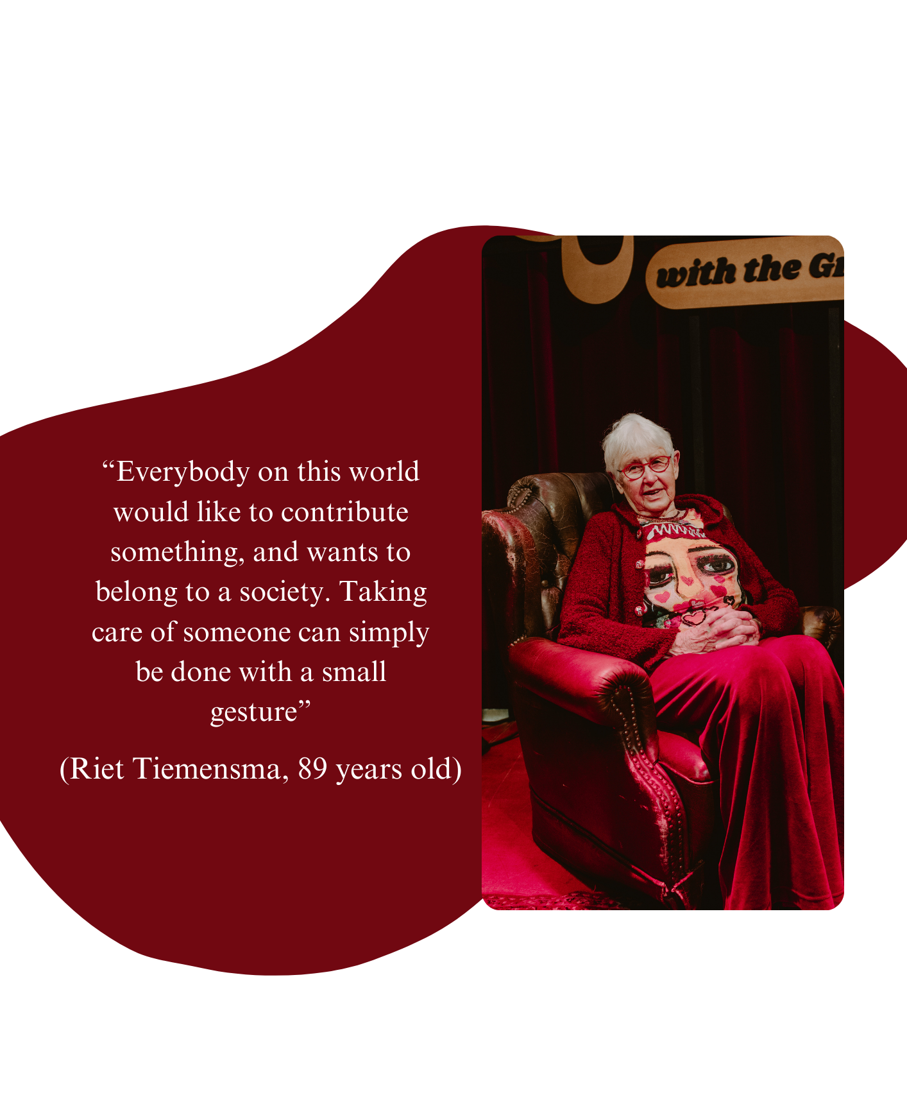

Abstract
Dutch society faces the challenge of an aging population, which yields a rise in health care demands. This situation is accompanied by a shortage in healthcare professionals, imposing an increasing workload on current caregivers. Local elderly care communities are considered a potential solution, which demand from both formal and informal caregivers to collaborate. Challenging however seems the mobilizations of such informal caregivers. In an effort to overcome these challenges to mobilize informal caregivers, solutions are sought in social movement theory, suggesting the development of a collective identity as a key motivator of mobilization. This research therefore aims to find answers to the question “How can a local care community develop a collective identity that mobilizes informal caregivers to participate”. This research undertakes a comparative case study, examining two established local care communities – One situated in a village and the other in a city – to inductively discover new empirical insights. The Gioia method is employed to analyse semi-structured interviews and documents, providing a systematic and qualitative rigorous approach to developing new conceptual insights. This research extends prior literature which highlighted that collective social identification can mobilize followers on cognitive, moral and emotional levels. It contributes by identifying four key measures that help to develop a collective identity. These four key measures include: stimulating ownership among members of the care community, enhancing emotional connectedness, connecting new individuals via informal networks, and finally establishing a separate community appearance.

Table of contents
1. Introduction 7
1.1 Problem definition 7
1.2 Research question(s) 8
1.3 Societal and Academic relevance 9
1.4 Further outline of the thesis 10
2. Theoretical framework 11
2.1 Concept of care community 11
2.2 Collective identity as a key motivator of mobilization 14
3. Methodology 18
3.1 Research design 18
3.2 Empirical setting 18
3.3 Data collection 20
3.4 Data analysis 25
3.5 Ethical reflection 26
3.6 Quality criteria 26
4. Findings 28
4.1 Stimulating ownership at members of the care community 28
4.2 Enhancing emotional connectedness 31
4.3 Connecting new individuals via informal networks 34
4.4 Establishing a separate community appearance 37
5. Discussion and conclusion 41
5.1 Discussion 41
5.2 Theoretical and practical implications 43
5.3 Limitations 44
5.4 Future research 45
5.5 Conclusion 45
6. Reference list 46
7. Appendices 52
A. Interview guide 52
B. Gioia coding tree 62
C. Informed consent form 63
D. Codebook 65

Introduction

Problem definition
Dutch society is challenged with an aging population that is caused by an increase in life expectancy and a decline in fertility rates, which is a common confrontation for developed countries (Hashimoto & Tabata, 2010). Worldwide, the average life expectancy at birth has increased from 46.5 years in 1950 towards 73 years in 2019 and is projected to reach 77 years in 2048 (World Health Organization, 2024). The Dutch population is expected to have a population where in 2040 a quarter of inhabitants will be 65 year or older (CBS, 2023). With this increase in longevity comes the emergence of complimentary challenges and ailments amongst this demographic. Hashimoto and Tabata (2010) highlight that the impact of this old-age survival is most likely to yield a rise in health care demands. They suggest that physical and mental health decline in an exponential way in the process of aging, which requires more nursing or similar social care. Aisa and Pueyo (2013) similarly suggest a shifting need in the labour market from non-health sector to the health sector, which is induced by this pressure from an increasing number of elderly. Even though a larger number of health care professionals is required to deal with the Dutch aging population, a shortage in professionals currently exists which imposes an increasing workload on current caregivers and, in turn, might deteriorate the quality of care for the elderly (Brandsma et al., 2020; Hori et al., 2004; Schuurmans et al., 2021). To tackle this increasingly pressing societal challenge, the Dutch government aims to support joint initiatives for healthcare organizations to experiment with novel solutions to battle staff shortages and quality of care (Schuurmans et al., 2021).
Dutch health care organizations have therefore experimented with new concepts going beyond the current forms of professional elderly care, hereby exploring the potential inclusion of, and collaboration with informal care givers (Kelders et al., 2016; Schuurmans et al., 2021). Care concepts where both formal and informal caregivers are included, are often being referred to as care communities (Canoy et al., 2023; Kelders et al., 2016). These informal caregivers could enable elderly to stay a part of the local community by offering assistance and a link to a social network (Byrne et al., 2009). In this manner the informal caregivers are expected to become an ally of the professional caregivers and therefore an integral part of the health system (Ferreira et al., 2022). The concept of ‘care community’ descended from the term communities, which is defined by Hillery (1955) as “a framework consisting of three distinct dimensions: ecological (space, time), social structural (networks of institutions and interactions), and symbolic cultural (identity, norms and values)”. This definition facilitates an understanding of a local community as it highlights both social structural importance of the personal interactions of members within local informal networks, combined with a sense of belonging to a larger group by identifying with a shared set of norms and values.
Even though care communities seem like a viable solution to the increasingly pressing demand for elderly health care, it seems challenging to mobilize informal caregivers (Ferreira et al., 2022; Kelders et al., 2016; Yasuoka, 2019). To address obstacles in mobilizing informal caregivers in local care communities, insights from certain aspects of social movement theory seem to be beneficial (Stoecker, 2018). Especially relevant, and resonating with the definition of community is the interest in collective identity which originates from the literature on social movement (Ma & Pouthier, 2023).A collective identity for this research can be defined as a perceived sense of belonging and shared status to a larger group (Polletta & Jasper, 2001). This collective identity allows for individuals to connect with a broader community on a cognitive, moral an emotional level and has proven to considerably persuade people to mobilize (Polletta & Jasper, 2001). Identification with a community, offering a shared identification with a group (van Zomeren, 2013), has proven to increase chances that members are willing to help proximal and distal others within the community (Vignoles et al., 2021). Therefore, a feeling of shared identity with others, might be seen as an important foundation for collective action (van Zomeren, 2013; Vignoles et al., 2021).
In changing towards a new concept of elderly care, which demands from both formal and informal caregivers to collaborate (Byrne et al., 2009; Canoy et al., 2023; Ferreira et al., 2022; Schuurmans et al., 2021), mobilization must be encouraged among individuals with very different values, concerns and interests (Vignoles et al., 2021). In an effort to bridge these differences, academics suggest that a sense of shared identity should be created among participants (Bavel et al., 2020; Ma & Pouthier, 2023; Vignoles et al., 2021).

Research question(s)
The concept of collective identity has been studied by multiple authors mainly in the context of social movement theory (Bavel et al., 2020; Ma & Pouthier, 2023; Polletta & Jasper, 2001; van Zomeren, 2013; Vignoles et al., 2021). While these studies provide valuable information, they do not provide detailed insights into the development of these collective identities. Therefore, this study aims to investigate the process of constructing a shared identity in the context of a relatively new social movement towards elderly care communities in the Netherlands. Consequently, this paper seeks to find an answer to the following research question(s):
“How can a local care community develop a collective identity in a manner that mobilizes informal caregivers to participate?”
- What factors influence the formation of a collective identity within a local care community?
- What do informal caregivers suggests motivates them to participate in the care community?

Societal and Academic relevance
This research builds upon recent papers that suggest that the mobilization of followers can be invoked by the pivotal role of collective social identifications (Bavel et al., 2020; Ma & Pouthier, 2023; Vignoles et al., 2021). Therefore, this study aims to contribute to the academic knowledge on the concept of collective identity (Bavel et al., 2020; Diani, 1992; Ma & Pouthier, 2023; Polletta & Jasper, 2001; van Zomeren, 2013; Vignoles et al., 2021), by offering empirical evidence of collective identity formation in local care communities. Previous studies discussed what role collective identity plays in the mobilization of individuals by offering three different levels to which people identify with a collective identity. This research aims to contribute to theory specifically by considering how a local care community can develop a collective identity to mobilize (in)formal caregivers towards such a care community. It is therefore that this study moreover contributes by offering insights in the context of health care.
Beyond its scholarly significance, this thesis seeks to contribute practical insights applicable to the frontrunners and early adopters of care communities. Care communities, and their focus on local collaboration between care facilities, neighbours and other informal caregivers, have gained increasing momentum (Schuurmans et al., 2021). In practice however, it seems challenging to mobilize people to participate beyond the boundaries of the care system, or continue the initiatives of such care communities (Canoy et al., 2023). This study therefore aims to provide insights derived from two established care communities, one located in a village and the other in a city centre. The goal is to share these insights with both individuals or organizations interested in developing similar care communities, or existing care communities searching for insights and steering mechanisms to strengthen their community . These insights focus on understanding of how to foster a shared identity among members, as this is expected to enhance the likelihood of collective action, as suggested by van Zomeren (2013) and Vignoles et al. (2021).

Further outline of the thesis
The following section will include a theoretical framework which will clarify current knowledge and insights on the concept of (care) communities and the role that collective identities play in the mobilization of individuals. Then the methodological choices for this study will be outlined. This section will detail the approach taken to collect, analyse, and interpret data. Each choice will be justified based on its suitability for the study’s objectives, ensuring rigor and validity in the research process. Following is the analysis of findings and answering of the research questions, which finally will result in a discussion of the revealed insights and their practical and theoretical implications.

Theoretical framework

Concept of care community
A conceptualization of the concept community
Before diving deeper into the concept of elderly care communities, one should first consider the definition of community, from which care communities originate. The term community knows many definitions with one of them highlighting its existence as an organizational form. Community as an organizational form, is known “to enable and enhance networking among autonomous and interdependent participants – which entails membership, commitment to shared goals and purposes, and rules for participation” (Adler & Heckscher, 2006; Kolbjørnsrud, 2018, p. 3; Snow et al., 2011). Similarly, Vermeulen and Liese-Happel, (2021) define community as “an organizational form in which a collection of mutually dependent actors or organizations voluntarily participate in a collective supported goal on the basis of common values or identity”(p.61). A common denominator in both definitions crucial to the community is the development of and the commitment towards a ‘collective goal & values’ as a starting point in the community formation. Vermeulen and Liese-Happel (2021) highlight two important principles that underlie such collaboration in communities. Firstly, they suggest that the end goal and the means to get towards such shared goals remain subject to discussion among all members, allowing the values of a community to change over time (Vogl, 2016 as in Vermeulen & Liese-Happel, 2021). Secondly, they suggest that the ultimate goal is continuously considered when decision are being made (Vermeulen & Liese-Happel, 2021). Both definitions moreover, characterize communities by their self-organizing fashion, implying that coordination and control mostly exists within the direct interaction among members rather than in a hierarchical manner (Kolbjørnsrud, 2018). Therefore, a community relies heavily on relevant information which is shared and available to all members, as this allows its members to deliberately network with others, and choose where to contribute to their community (Kolbjørnsrud, 2018; Puranam et al., 2014).
Additional to this organizational perspective, Hillery (1955) offers a broader conceptualization of the concept community and defines it as “a framework consisting of three distinct dimensions: ecological (space, time), social structural (networks of institutions and interactions), and symbolic cultural (identity, norms and values)”. This first dimension includes the ‘physical’ reality of space and time, covering the geographical location and resources that bind members of a community (Cnaan & Milofsky, 2018). The second dimension covers the organizational form of such a community, including the personal interactions with a network and the density of local organizations (e.g. schools, stores, churches, associations) that both form and are formed by interpersonal networks. Finally, the third dimension covers the cultural symbolic dimension of community which consists of the interrelated component of identity and culture. The ability of one to identify on an individual level with the communities’ norms and values, is here displayed in the expression of identity through the use of names, symbols and rituals, and shows a certain level of commitment and loyalty to the community (Cnaan & Milofsky, 2018).
Cnaan & Milofsky’s definition allows for an understanding of the community on a more local scale, in which a care community fares. In ecological terms, these local communities are defined by their geographical proximity, with members interconnected through their physical location. Within these geographical boundaries that are tangible and well defined, it might be assumed that individuals feel a sense of regional engagement and are therefore more willing to help and join a community (Schuurmans et al., 2021). This engagement may also signal that individuals identify with the communities’ norms and values (Cnaan & Milofsky, 2018). Local communities tend to rely on a foundation of both emotional and mutual support (Bulmer, 1987 as in Plemper & van Vliet, 2002), with individuals likely seeking support from neighbours who share similar norms and values. Finally, on the social construct, these local communities thrive on the interactions of formal and informal networks that exist in these local neighbourhoods, like churches or informal clubs. In a local community, members naturally engage with one another in various roles, including those of neighbours, consumers, workers, sport rivals or even based on religion (Stoecker, 2018).
The concept of ‘care communities’
The concept of care communities originated in the Netherlands around 2000 in the context of physically and mentally disabled care, then still famous for its innovative vision on the socialization of the healthcare industry (Plemper & van Vliet, 2002). This vision of care communities focused on the participation of mentally handicapped people in society, and the ability to live as independently as possible in their own home (Plemper & van Vliet, 2002). It is believed that care communities offer numerous benefits, such as integrating multiple care facilities and distributing both workload and knowledge across these facilities (Dessers & Mohr, 2019; Kolbjørnsrud, 2018; Snow et al., 2011). Moreover, fundamentally new in these care communities was its grounds in informal care and volunteer work which required collaborations between relations from both formal and informal networks (Plemper & van Vliet, 2002). Over the last few years, the concept of care communities has found its way to other fields of the Dutch transitioning healthcare system (Kelders et al., 2016), including the elderly care sector.
Informal and formal caregivers
Especially groundbreaking in the concept of community care thus seems to be the inclusion of, and collaboration with and between informal caregivers in addition to formal caregivers. (Byrne et al., 2009; Canoy et al., 2023; Ferreira et al., 2022; Kelders et al., 2016; Schuurmans et al., 2021). Whereas formal care is provided by healthcare professionals such as general practitioners or nurses at elderly healthcare facilities, the informal care is provided by informal caregivers like family members or volunteers (Yasuoka, 2019). Within the concept of care communities, informal caregivers ought to be a direct ally of the professional caregivers, and a crucial part of the health system (Ferreira et al., 2022). The key stakeholders in a care community consist of: the residents as recipients of care (Byrne et al., 2009), the formal caregivers in which a distinction is made between professional caregivers, workers in the community care system (case managers, day-care providers, physiotherapist, etc.), and general practitioners (Woodward et al., 2004), and finally the informal network including family members, local neighbours and acquaintances (Yasuoka, 2019).
The difficulties of mobilizing informal caregivers
Despite the crucial role that informal caregivers play in offering support and a link to a social network (Byrne et al., 2009), one should not underestimate the burden that bearing this responsibility of care might bring upon informal caregivers (Ferreira et al., 2022). When mobilizing informal caregivers to participate in care communities, Klandermans and Oegema, (1987) identify four necessary conditions for individuals to partake in collective action. Individuals need to (1) sympathize with the cause, (2) be aware of the opportunity to join, (3) want to participate and finally (4) be able to participate. This framework suggests that with each step, potentially individuals could opt out from participating (Klandermans & Stekelenburg, 2014). Challenges in motivating informal caregivers to join a local care community may arise if there is an inability to sympathise with the cause, for instance due to a lack of experienced grievance for the matter or insufficient action within one’s social network (Klandermans & Stekelenburg, 2014). Moreover, the motivation of an individual to take part in an initiative such as a local care community may be instrumental, reliant on the costs and benefits perceived, and/or ideological (Klandermans & Stekelenburg, 2014). The majority of informal caregivers extend their caregiving services driven by sentiments of love and affection towards those under their care (Kelders et al., 2016). However, the role of informal caregiver, is often assumed to be time consuming, where informal caregiver have to trade in time and income opportunities, to take care of the person at stake (Yasuoka, 2019). The opportunity costs, which include the loss of earnings and market-time due to informal caregiver duties, is often significant (Yasuoka, 2019), and can be appointed as a reason to remain from becoming an informal caregiver. These difficulties described above are exemplary for the challenges that informal caregivers encounter, which might withhold people to participate in such a care community, or which often lead to the downfall of existing local initiatives (Canoy et al., 2023).

Collective identity as a key motivator of mobilization
Insights from social movement theory on the mobilization of people
In order to overcome these challenges to mobilize informal caregivers to join a care community, the solution may lie in the development of a collective identity. This collective identity allows for some degree of identification with others, which allows for shared grievances to evolve (Klandermans & Stekelenburg, 2014) and highlights the interest in a shared common belief system (Stoecker, 2018) which are both critical for the mobilization of people. Social movement theory provides insights to how collective identities motivate individuals to mobilize where small-scale community-level initiatives, such as local care communities, can take note from some elements of the concept of social movement theory (Stoecker, 2018).
Social movement as a concept can be defined as “networks of informal interactions between a plurality of individuals, groups and/or organizations, engaged in political or cultural conflicts, on the basis of shared collective identities” (Diani, 1992, p. 3). This definition highlights that social movements are in its core based on a feeling of collective identities. Here scholars from social movement theory suggest that people tend to be more urged to mobilize, once a sense of collective identity is established (van Zomeren, 2013; Vignoles et al., 2021). The concept of collective identity is frequently cited as the key motivator of mobilization within social movements (Diani, 1992; Ma & Pouthier, 2023; van Zomeren, 2013; Vignoles et al., 2021), hence requiring further explanation.
Defining a collective identity
A feeling of shared identity with others, might thus be seen as an important foundation for collective action (van Zomeren, 2013; Vignoles et al., 2021). A shared identification with a group is commonly referred to as collective identity, where collective identity can be defined as a perceived sense of belonging and shared status to a larger group (Polletta & Jasper, 2001). This definition acknowledges that a collective identity is different from a personal identity, however might partly form an individual’s identity, where the individual experiences a perceived sense of belonging and shared status to a larger group (Polletta & Jasper, 2001). Such collective identity entails acknowledging a mutual status or relation and is remarkable for its promotion of fostering positive sentiments towards fellow group members (Polletta & Jasper, 2001). These positive sentiments could be explained by a shared sense of norms and values which are occasionally expressed in cultural materials (e.g.rituals, symbols, clothing, names) (Polletta & Jasper, 2001). Since (local) communities are known to share a commitment towards a ‘shared purpose’ including the formation of shared goals and values as a starting point (Adler & Heckscher, 2006; Kolbjørnsrud, 2018; Snow et al., 2011; Vermeulen & Liese-Happel, 2021), communities tend to invite members to identify on an individual manner with the communities’ norms and values (Cnaan & Milofsky, 2018). In order for informal caregivers to identify with the communities’ norms and values, the concept of collective identities emphasizes three drivers that together determine the individuals identification with a larger group. These three drivers are the individuals cognitive, moral, and emotional identification with the community and its norms and values (Ma & Pouthier, 2023; Polletta & Jasper, 2001).
Three key drivers of collective identification
Firstly, the individual’s cognitive connection with the community is seen as the element of logical reasoning of a collective identity, where individuals rationalize their participation as a member of a larger group (Ma & Pouthier, 2023). Here logical sensemaking serves as the foundation for judgements on why one should identify themselves with a larger group, where the desired outcomes are weighed against the expected outcomes (Olson, 1968 as in van Zomeren, 2013). This rationale could include a concern of self-interest, where the individual seeks either reputation or protection by becoming a part of a larger community (Polletta & Jasper, 2001). In a local care community, potential informal caregivers may assess the pros and cons of joining a care community and providing assistance to neighbours or acquaintances, with the logics of evaluating potential benefits to their reputation within the area. On the contrary, individuals might potentially opt not to participate in such local care community, given their previous experience with neighbours or acquaintances that also never contributed to a social caring community. In accordance with rational sensemaking, if nobody else undertakes action, why would they?
Merely relying on cognitive alignment and rationalization is inadequate to explain the attractiveness of a collective identity (Ma & Pouthier, 2023). The moral and emotional connection with the broader community are therefore considered essential factors driving follower and mobilization (Ma & Pouthier, 2023; Polletta & Jasper, 2001). The moral connection an individual experiences within a community is grounded in the individuals’ ethical considerations. These ethical considerations stem from intrinsic values and standards, providing individuals the opportunity to publicly and collectively voice these inner values (Ma & Pouthier, 2023). Here one considers what is right or wrong, and what one should or should not do. The moral connection with a collective identity can for instance motivate individuals to undertake collective action once the individuals’ moral standards are violated (van Zomeren, 2013). In local communities, potential informal caregivers might decide to identify with and participate in the local care community as it aligns with their ethical principles to step in in times of crisis, rather than outweighing potential benefits.
Finally, the emotional connection one experiences in a collective identity is described as a sense of belonging to a larger group (Ma & Pouthier, 2023). This feeling of belonging can evoke all sorts of emotions that an individual experiences. Emotion is understood as a dynamic psychological process that directs individuals’ responses to their surroundings (Lazarus, 1991 as in van Zomeren, 2013). Through cognitive assessment of their environment, individuals undergo the experience of specific emotions (such as anger or fear), which are linked to states of readiness for action, facilitating adaptive responses (van Zomeren, 2013). Within the local care community, members naturally connect with each other in a variety of roles, including those as neighbours, consumers, workers, sport opponents, or even based on religious believes (Stoecker, 2018). Once potential informal caregivers in the local community experience feelings of anger and fear that anything unpleasant might occur affecting people whom they share a collective social identifications (such as family, or community) with, these emotions might be seen as producers of great behavioural change (Bavel et al., 2020). This emotional motivation might for example address the grievances that individuals experience based on personal observations of how immediate family and acquaintances have been treated in other care facilities (Klandermans & Stekelenburg, 2014). Since emotions might frequently influence perceptions of risk even more than factual data (Bavel et al., 2020), this emotional resonance with a collective identity should not be underestimated as a key driver of mobilization of people towards a local care community.
This chapter has reviewed current literature on the concept of care communities, emphasizing their defining characteristics of commitment towards collective goals and values, and the facilitation of interactions within both formal and informal networks. Care communities are considered particularly relevant in addressing the elderly care crisis, as they incorporate both formal and informal caregivers efforts. However, the mobilization of informal caregivers has proven to be challenging. Social movement theory provides insights into how fostering a collective identity can help overcome these challenges. This collective identity distinguishes between three drivers, which together enable individuals to experience a sense of belonging to a larger group.

Methodology

Research design
This research aims to provide insights into how local care communities can develop collective identities in a manner that mobilizes informal caregivers to participate in such a local care community. Hereby focusing on the way that an individuals’ perceived collective identity stimulates motivation to join a local care community, considering the multiple perspectives of distinct members. In this research an in-depth understanding of the individual perception precedes statistical generalization and making exact statements about causal effects between concepts, as such a qualitative research design was chosen (Mills et al., 2010). This qualitative approach allowed for the generation of knowledge by collecting and interpreting material about a social phenomenon in reality, and afterwards translated into text (Bleijenbergh et al., 2022) This study moreover, required a qualitative approach as the concept of elderly care communities is relatively new, and has received limited coverage within the literature (Reid-Searl & Happell, 2012 as in Hunter & McCallum, 2019). Thus, an explorative-descriptive qualitative study was deemed suitable, since it first allowed for the purposive, systematic discovery of the findings, which afterwards allowed for descriptions to create a shared understanding of the phenomena studied (Hunter & McCallum, 2019). In line with this approach, inductive logic was used, which allowed the researcher to develop general statements as a result from observations from empirical phenomena (Vennix, 2019)
In this paper, a comparative case study design is adopted, focusing on two different care communities in the Netherlands. Case studies provide a means to analyse complex and poorly understood phenomena, making it well-suited for investigating the underlying how and why behind dynamic processes within real-world organization contexts (Yin, 2009). Moreover, a multiple case study was chosen since engaging in a multiple case study enhances the likelihood of making valuable contribution to theory development (Bleijenbergh, 2016). Hence, this research focuses on gathering and analysing in-depth information from two distinct local care community cases, to be able to compare and explore potential patterns in the collective identity formation among the members of local care communities.

Empirical setting
Two cases were chosen based on the following criteria : it concerned a pre-existing (1) and flourishing (2) care community with a distinct geographical context (3). For this research, it was interesting to gain insights into the differences and similarities between the attempts of both locations to motivate potential members to join the local care community.
Case 1: Griffioen Nijmegen
The first case is Griffioen, a residential complex situated in Waterkwartier, the oldest neighbourhood in Nijmegen. The premises are owned by Talis, a housing cooperative, which collaborates with ZZG Zorggroep, the primary care provider within the community as stated in the Griffioen development report of 2023, and responsible for nominating individuals for the 78 available apartments. The partnership is further enforced by collaborators such as BUUR, a local catering facility, Sterker Sociaal Werk, a regional welfare organization, and Riverland, a local health centre. These five partners constitute the foundation of the formal partnership that together defines the concept ‘Griffioen’.
The surrounding neighbourhood of Griffioen is characterized by challenges such as poverty, social isolation and the breakdown of social ties (Development report Griffioen 2023). The Griffioen partnership was therefore established in an attempt to develop a more innovative way of living, care, and wellbeing, with a strong aim to enhance local community involvement. It is therefore that in addition to the formal partnership between the aforementioned parties, the local neighbours were actively invited to participate and contribute to the local care community.
Griffioen’s particular relevance to this study lies in its effective integration of the local neighbourhood with formal care partners, making it an exemplary model of a local care community. Moreover, interesting for a comparative study like this, is the fact that this care community is situated within a neighbourhood of a larger city. The urban setting may potentially present different challenges compared to the formation of care communities in smaller villages, where individuals typically experience higher levels of social interactions and networks than urban residents (Moss et al., 2023).
Case 2: Zonnetij Aarle-Rixtel
The second case is Zonnetij, a residential complex located in the city centre of Aarle-Rixtel, a village in Noord-Brabant. The establishment is owned by Wocom, the housing cooperative, with a similar collaboration structure as for Griffioen. The main partners include the municipality of Laarbeek and principal regional healthcare provider Zorgboog, which offer home care services to apartment residents who live independently with assisted living arrangements. Recent developments involve the establishment of the Buurtkamer foundation, thereby formalizing the local residents and neighbourhood as official partners in the Zonnetij Partnership. The formation of the foundation represents a fully community-driven initiative led by residents and volunteers, who are responsible for managing the daily operation within the shared space known as Buurtkamer.
Since rural neighbourhoods tend to be characterized by higher levels of social interactions and greater social networks, the circumstances at a rural village as Zonnetij seems ideal for developing a local care community (Moss et al., 2023). Therefore it is unsurprising that Zonnetij is often praised as a good practice of a local care community (Alzheimer Nederland, n.d.). Additionally, as previously discussed, Zonnetij’s location in the heart of a smaller village, allows for the exploration of differences and similarities in the mobilization of local care community within an urban versus a rural context.

Data collection
Data collection for this comparative case study consisted of two distinct types of data. A document analysis is employed alongside semi-structured interviews as a triangulation strategy within this research (Bowen, 2009), which allows for the researcher to look at the same topic from different angles (Myers, 2019) in order to improve the probability that interpretation of the findings will be found more credible (Lincoln & Guba, 1985)
Semi-structured interviews
In order to generate in-depth insights into members’ perceptions of how collective identity can motivate them to join a local care community, semi-structured interviews were conducted. Semi-structured interviews are characterized by their involvement of pre-formulated questions, without having the strict requirement to precisely adhere to them during the interview (Myers, 2019). This semi-structured approach, which allowed the researcher to some extent to control the information addressed during the interview, moreover, left some space to deviate from the protocol in order to dive deeper into additional information (Bleijenbergh, 2016). The interview guide addressed three specific topics, including introductory questions about the organisation of the local care community (1), being part of the caring community (2), and the individuals motivation to participate in the local care community (3). This more flexible approach to interviews was selected because the research adopts an inductive stance, aiming primarily to construct novel theoretical models derived from empirical observations (Glaser & Strauss, 1967 as in Martin & Turner, 1986). Especially relevant for this study seemed the opportunity to explore initiatives mentioned by respondents, and the ways in which individual personal stories affected their motivation to participate. Since the researcher could not anticipate on such personal stories prior to the interviews, this inductive approach proved to be useful to further elaborate on participant suggestion. Finally, this semi-structured format ensured that all respondents in the study were presented with the same set of base questions (Bleijenbergh, 2016). The interview guide can be found in appendix A.
In total 16 interviews were conducted, 8 per case study. Respondents for these interviews were selected for diversity purposes, taking into account the various roles that members could potentially hold within a local care community. In consultation with the contact person of each organization, relevant participants were considered and approached. The final list of participants including their role can be seen in Table 1.
Important to mention is that data collection for this paper has been conducted by two master students within the framework of a larger study on local care communities. Data from all 16 interviews were therefore made available for analysis by two students, with one student assigned as responsible to o each location. The researcher of this study served as the primary contact for Zonnetij and attended at all eight interviews conducted there, as well as two interviews at Griffioen.
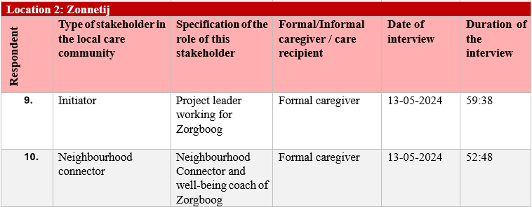
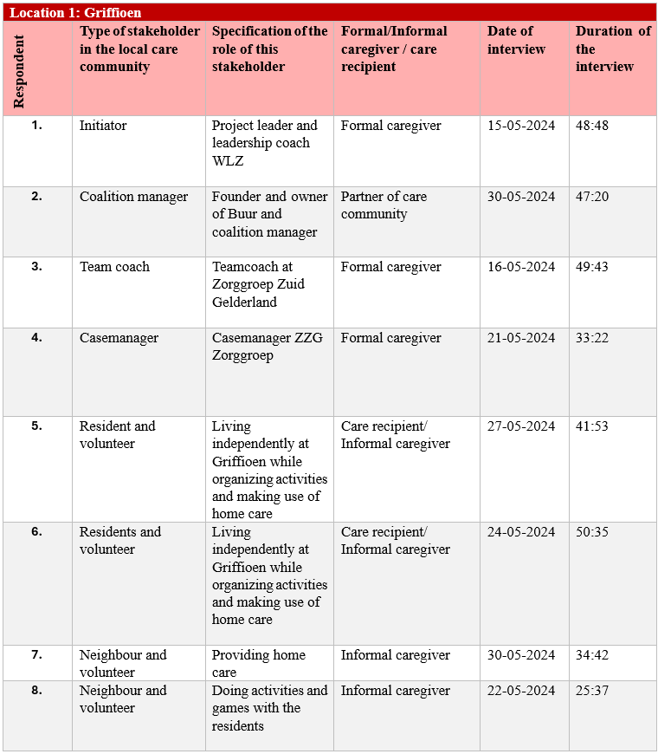
Table 1Interview participants including their role in local care community
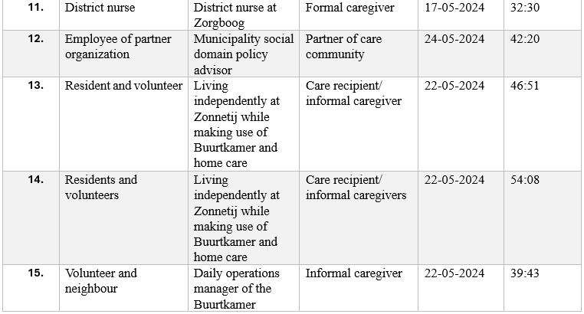
Documents and communication materials
Since collective identities tend to foster a shared sense of norms an values group members which are often expressed in cultural materials (Polletta & Jasper, 2001), this research aims to complement the insights from the interviews with a document analysis. A document analysis can be defined as “a systematic procedure for reviewing or evaluating documents – both printed and electronic material” (Bowen, 2009, p. 27). The documents therefore collected in this study, either include documents spreading the goals and values of the local care community, or documents calling out to the informal and formal network to contribute to the local care community. These documents were studied as they were expected to generate insights in how the local care community currently expresses their identity towards local community members. Access to the documents used in this study was either granted by the contact person of each location, or by doing an online search via the location’s website, local news articles, and finally looking for flyers distributed around the location. An overview of the documents and records studied can be found in Table 2.

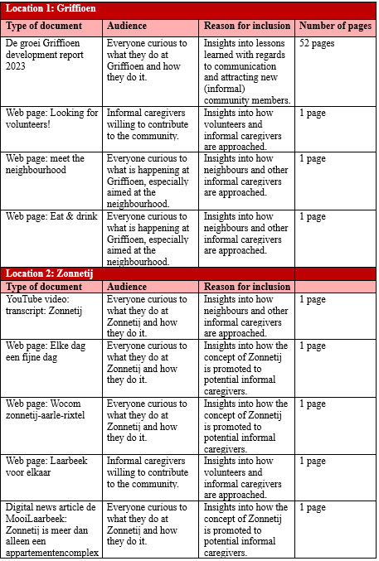
Table 2 Documents for analysis

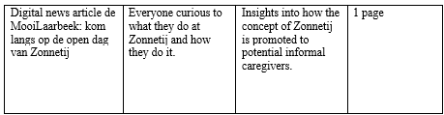



Data analysis
Gioia methodology
After conducting the interviews, transcripts were generated in order to prepare the interviews for data analysis. Both the interviews transcripts and the documents collected for this research are analysed following the so called “Gioia coding” to both inductively, however, also systematically develop new conceptual insights with qualitative rigor (Gioia et al., 2013). The Gioia method has proven to be a useful method in an impressive series of papers on organizational identity change (Langley & Abdallah, 2011), making it a highly relevant method for this study on collective identity formation within communities. Following the Gioia method, a well-organized data structure was created to illustrate the connection between informant-based (1st-order) codes and researcher-based (2nd-order) themes which finally are summarized towards a few theoretical aggregate dimensions (Gioia et al., 2013; Langley & Abdallah, 2011; Magnani & Gioia, 2023). The first round of coding searched for interesting quotes from respondents or documents to form the basis of the informant based first order codes. “Starting with people where energy is located” for instance originated from a quote from the initiator at Zonnetij who stated that “she always starts with the people who have energy(…)so we slowly started building”. After all interviews and documents passed through a first round of coding, the second round of coding took a more abstract level, where emerging themes were established, which is often referred to as axial coding (Gioia et al., 2013; Magnani & Gioia, 2023). In order to create a more general understanding of the first order codes and discover overarching relationships between multiple first order codes, themes such as ‘investing in initiatives with existing momentum’ were established. Finally, these emerging concepts were further distilled into aggregate dimensions, where a third round of coding helped to combine second order concepts into new potential theoretical insights. Concepts such as ‘investing in initiatives with existing momentum’ and ‘Higher support for bottom-up initiatives’ for example led to the aggregate dimension ‘Stimulating ownership among members of the care community’. The complete data structure can be found in appendix B. The discussion section will further elaborate on how these findings relate to the previously discussed theories on collective identity and organizational communities.

Ethical reflection
This research considers APA’s recommendations of ethical considerations (Smith, 2003).
First of all, the researcher considered multiple roles as both a master student in the field of organizational design and development, and as a professional in the field community building in elderly care as beneficial rather than unethical. However, by taking on this dual role, where recruited participants in the research were partially also business relations from the authors profession, it has been a careful process of balancing contrasting expectations. The main aim was that the researchers prior knowledge or relations with participants, did not interfere with the goal to objectively explore new potential theories.
To establish clearance and transparency, the researcher started each interview with an informed-consent procedure, offering the individual participants a digital consent form which required a signature before any interview could be conducted. For further insights into the consent-form please refer to appendix C. In order to respect the privacy and confidentiality of the participants in this research, all names have been anonymised throughout this research, Consequently, interview transcripts, tables and figures exclusively reference the interviewees by their relevant role titles. The collected data is stored in a digital personal cloud environment, where only the researcher had access to interview recordings, transcripts, and other confidentially signed information. The original (raw) data and the data used for this paper are stored separately, safeguarded by password protection for security measures. A secure cloud environment ensured both confidential and insured data storage.

Quality criteria
This qualitative research has employed the quality criteria proposed by Lincoln and Guba, (1985), focusing on credibility, dependability, transferability, and confirmability, rather than traditional measures of reliability and validity.
Credibility refers to the alignment of the interpretation and the actual context being studied (Symon & Cassell, 2012). In order to ensure credibility, the research design included four cross-presence interviews, where a peer-debriefing allowed for the researcher to critically and honestly look at biases within the interpretation of data and helped to reflect on questions that might have steered the respondent in a certain direction (Lincoln & Guba, 1985). Transferability acknowledges that instead of proving the results are applicable to all contexts, the researchers provides sufficient detail about the case context (Symon & Cassell, 2012). This research has tried to offer a thick description of both case studied in order for other researchers and readers to judge whether the findings of this study are informative for similar case contexts. Dependability involves detailing methodological choices in a manner that allows another researching using the same methodological design to achieve similar results (Symon & Cassell, 2012). To enhance dependability, this research has provided a transparent and detailed description of the research design, including justification for all methodological choices made throughout the process. Moreover, the adoption of a semi-structured approach for interviews enhanced the dependability and some kind of consistency in the data collection, as it allowed for a consistent set of questions to be repeated with each interviewee (Bleijenbergh, 2016; Lincoln & Guba, 1985). Finally, confirmability relates to the extent to which other researchers could verify the findings of the study. To ensure that both the data and interpretations are derived from evidence rather than being influenced by the researcher’s biases or assumptions (Symon & Cassell, 2012). The researcher has critically reflected upon her dual role in section 3.5 and recognized limitations in the research in section 5.3. Moreover, the researcher grants access to the documents, anonymized transcripts, and the codebook reflecting these documents, in order to assure transparency and allow for readers to critically asses the interpretations of quotes.

Findings
The interviews conducted at Zonnetij and Griffioen revealed a variety of measures contributing to the development of a collective identity of the care community which is previously defined as ‘a perceived sense of belonging and shared status to a larger group’ (Polletta & Jasper, 2001). The data makes a distinction between four key measures. The first recurring theme emerging from the data highlighted the pivotal role of the stimulation of a sense of ownership among (potential) community members in order to increase a sense of belonging among participants. To further increase such sense of belonging, the second theme emerging from the data emphasized the relevance of enhancing emotional connectedness among community members in order to establish a sense of belonging. The third theme identified within the data, highlighted the usefulness of employing a personal approach in engaging new individuals by doing so via the informal networks of current members to foster a sense of belonging to the community. Finally, the data revealed the significance of establishing a separate community appearance with which individual members can identify themselves.

Stimulating ownership at members of the care community
The interviews revealed that there are several factors that allow the stimulation of ownership among members. Some respondents suggested that a sense of ownership is best encouraged by investing in initiatives that already include existing energy and momentum. Another aspect relatively often mentioned by respondents is the fact that motivation among (informal) members tends to be higher once the initiative comes from themselves, and when they appeal to the personal values and interest of potential members. In line with these statements, some participants touched upon the relevance of approaching individuals in a more reciprocal manner to enhance a sense of belonging and ownership.
“But especially allowing space for the residents to take up their role. And then you slowly see something more develop and because you allow the space for people, they will automatically feel responsible. It is really nice to belong here. The atmosphere is really good. And I think especially because they, because that ownership is really at the people themselves” – Initiator Zonnetij
The above quote suggests that when individuals experience ownership, their sense of belonging to the community may be enhanced . The statement moreover implies that a sense of responsibility could develop when individuals are allowed to pursue their own initiatives. To potentially stimulate ownership and enthusiasm among (informal) members of the local care community, one respondents from each case highlighted the relevance of engaging
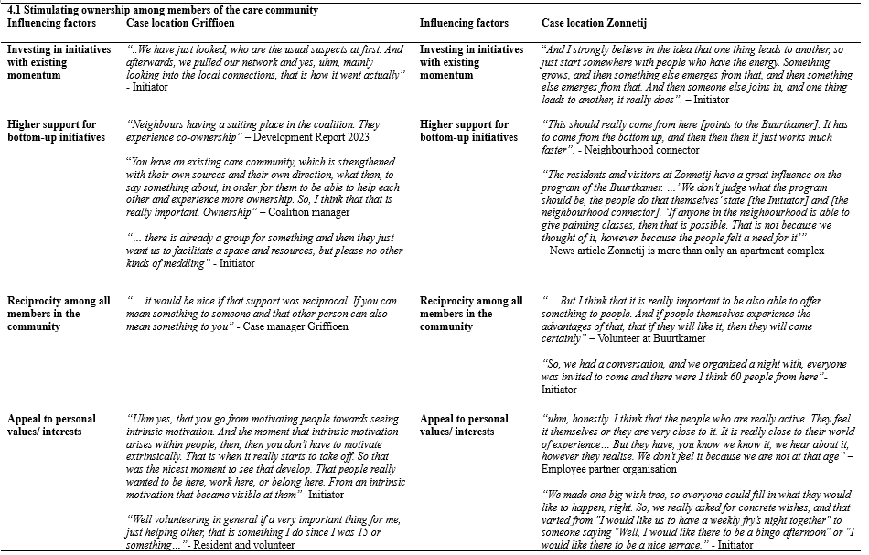
Table 3 Illustrative quotes stimulating ownership
people who are either already involved in organizing existing initiatives or who had ideas they were eager to develop (Table 3). By initially targeting these readily available opportunities, a domino effect of engagement within the community is expected to be triggered that allows for the attraction of other potential members.
The data revealed a preference for bottom-up initiatives that align with the personal values and interests of members of the local care community. There is a common belief among respondents from both locations that initiatives originating from within the community, rather than being imposed from above, generate more enthusiasm hence are more effective. One respondent from Griffioen for instance mentioned the relevance of aligning individuals with the community based on their personal values, as this allowed for their motivation to develop intrinsically rather than being extrinsically imposed (Table 3). Additionally, at Zonnetij, some respondents highlighted that considering members’ interest is essential for engaging and retaining them. This approach may not only increase the sense of ownership but also potentially accelerates the enactment process due to the intrinsic motivation and commitment of the community members involved. Such intrinsic motivation and commitment might indicate a moral level of identification, relating back to the individuals’ personal values and interests. The data revealed that all respondents were motivated to participate in a local care community based on their personal values and interests. This motivation can be understood as their moral convictions to contribute to the care community.
The news articles and websites discussing Zonnetij clearly express the value the organization attaches to its members’ involvement in organizing activities. “…When it comes from the residents, then there is immediate response…” (Neighbourhood connector Zonnetij). Two respondents at Zonnetij expressed this sentiment clearly, highlighting the participants’ believe that in order to convince people to contribute to the care community, initiatives must be rooted locally. Similarly, at Griffioen several distinct respondents stated that signalling and stimulating initiatives within the neighbourhood or among residents is essential to motivate people and create a sense of ownership. One respondent moreover suggested that the role of professionals in the community is to facilitate these bottom-up initiatives (Table 3). Additionally, reciprocity among all members of the community, and an understanding of equal partnership among formal and informal caregivers in the community is thought to be essential to develop a sense of ownership. By treating all members as equal partners in the collaboration, and by continuously re-evaluating what all parties could both contribute and gain from being a member of the community, a sense of ownership among new (informal) members might develop.
“… What are you coming to get here and what will you bring? What’s in it for you? Those are texts that are often used here. So reciprocity, because if I don’t feel that it benefits me in some way, whether you’re a resident of the neighbourhood or an or organization or whoever, yes, then people just drop out, so it always has to be: what’s in it for them, what’s in it for me, what am I coming to get, what am I coming to bring, where is that reciprocity?” - Initiator Griffioen
The above quote suggests the relevance of reciprocity, indicating that individual members tend to be more inclined to contribute something meaningful to the community once they perceive a fair return on their investment of time and efforts. This more cognitive and instrumental level of belonging seems to be encouraged by consistently emphasizing the benefits that (informal) members gain by contributing to the care community’s initiatives. A sense of reciprocity and collective accountability for positive outcomes might generate a stronger sense of ownership among (informal) members.
In short, these multiple factors illustrate that ownership among members seems to be best stimulated when initiatives with existing momentum among members or with a clear link to the individuals’ personal values and interest gain the necessary investment. A bottom-up strategy tends to be central to establish this. Moreover, ownership among members is experienced when there is reciprocity among all members in the community.

Enhancing emotional connectedness
In expressing their thoughts about creating a sense of belonging, respondents described multiple factors that influence emotional connectedness to a group. Several respondents mentioned that belonging increased if there was some sense of urgency or the perception of contributing to a higher purpose Moreover, respondents from both locations highlighted how a personal welcome to the community, and the ability to identify as ‘we’ resulted in emotional connectedness to a group (Table 4).
“Belonging is generally something that the community naturally maintains, right? Like if I feel like, oh, there is something going on and I have the fear of missing out, you know? When that happens, yeah, then you’re doing something right, that’s just really nice (…) Yeah, that is just really fun and then everyone is really motivated and you can feel a ‘we’ and as soon as there is a ‘we’ feeling, yeah then people also push a bit harder, or then they are also willing to…” - Initiator Griffioen
Enhancing a sense of belonging involves engaging individuals on an emotional level, strengthening their emotional connection to the group. A commonly acknowledged aspect among participants here is the idea of identifying as ‘we’(Table 4). While some respondents underscored the importance of using inclusive language to establish a sense of belonging, others highlighted the significance of contributing to something meaningful. This ‘we’ feeling emphasizes the community members’ feeling of being part of something larger than themselves, signalling a sense of emotional connection among participants. Moreover, the ability to contribute to something meaningful communicates the willingness of an individual to establish something in cause for a larger group then themselves, hinting towards the need for emotional connection. In addition, one respondent noted that a sense of belonging is established when the opportunity arises to rely on others. This illustrates the more instrumental need for an individual to be part of a larger community not simply to contribute, however, also to derive benefits from their partaking in the group, addressing identification on a cognitive level.
Moreover, the data indicated that a sense of belonging is partially characterized by the belief that one is contributing to a higher purpose. For example, this greater cause can be stimulated by a sense of urgency, as several respondents from both cases mentioned the health crisis affecting the elderly care institutes and their perceived responsibility to address it (Table 4). This awareness of a sense of urgency among members of both cases to respond to this societal challenge, has led to the emergence of a shared goal, promoting unity and group formation among members. This shared goal therefore allows for members to experience a sense of contributing to a higher purpose, which allows individuals on an emotional level to connect to the group.
Finally, a sense of belonging can be influenced by an individual’s initial first encounter with the care community. From both cases, some respondents noted the first welcome as a crucial first impression for new members (Table 4). One respondent from Zonnetij recounted their first personal interaction with the neighbourhood connector as a memorable experience that immediately fostered an emotional connection. By investing in getting to know personal information of new potential members, such as names, place of origin, or anything personal, the first welcome left such a meaningful memory, that potential members immediately experience a sense of belonging to the community. Similarly, at Griffioen, several respondents

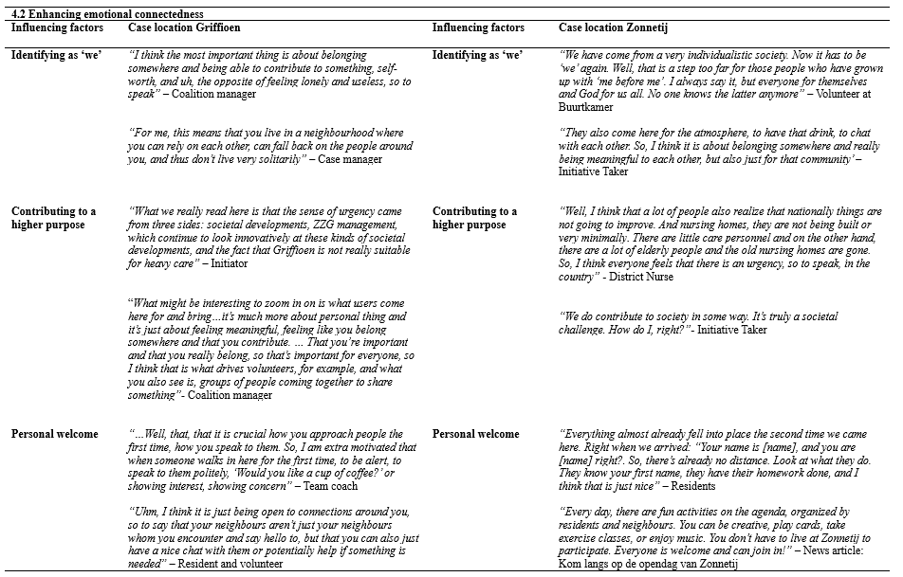
Table 4 Illustrative quotes enhancing emotional connectedness
described how a welcome involving simple small talk, a display of interest, or even an hello was beneficial to fostering a sense of belonging.
Overall, these various factors contributing to emotional connectedness highlighted that a sense of belonging is established on a more emotional level, where intangible aspects such as contributing to a higher purpose, identifying as ‘we’, and finally a perceived personal welcome allow for members to experience a sense of belonging.

Connecting new individuals via informal networks
A frequently recurring theme in the responses of participants seemed the importance of leveraging the informal networks of current members to expand the care community. Several respondents from both locations indicated that their involvement with the community was often influenced by previous connection with relatives or acquaintances who were already involved in or aware of the existence of the community. In order to stimulate the connection between these informal networks, multiple respondents noted the importance of the role of neighbourhood connector as a catalyst for care community development. Furthermore, both initiators discussed that knowing someone personally is crucial to engage potential members effectively.
“So maybe then through the village, if we know people there, we would ask for new volunteers within the village to get fresh blood again” – Initiator Zonnetij
“Well, relationship, right, so how do you make sure it works well with each other and that you also have fun with each other, enough team building, enough that there is laughter and that you know each other, because if I know you, I am much more inclined to do something extra than if I don’t know you” – Initiator Griffioen
The data showed that knowing each other personally had a favourable impact on the willingness to offer assistance (Table 5). The above quote suggests that individuals are more easily inclined to help someone out if they already share a personal relationship, touching upon an emotional sense of belonging. Furthermore, one respondent from Zonnetij added to this observation the fact that individuals becoming more familiar with each other, might discover shared ideas, which subsequently raise increased support among those involved. The respondent here continued to develop the arguments from section 4.1, suggesting that a sense of ownership among the inventors of an idea can initiate a chain reaction, and could potentially attract new (informal) members to the community. On the contrary one participant

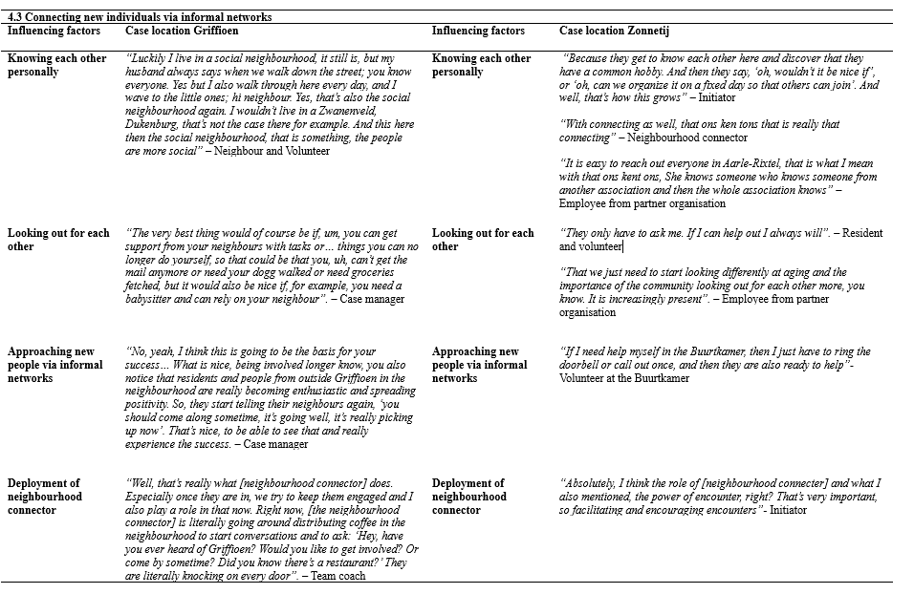
Table 5 Illustrative quotes connecting via informal networks
added “… people will meddle with anything. That is what you get when people are caring for each other, they will also meddle and speak their opinion. That can be both positive and negative” (District nurse, Zonnetij), therefore acknowledging how knowing each other may also strengthen more negative relations among members
Moreover, one common idea consistently discussed by several respondents from both locations was the inherent nature of the local community’s geographical placement and its effect on the ability to know each other. The community members of Zonnetij frequently referenced the phrase ‘ons kent ons’ (like-knows-like), as being a central motivator for engaging in communal activities or for doing something for your neighbours (Table 5). Given Zonnetij’s location in a small village with a limited number of inhabitants, respondents portrayed a community characterized by neighbours typically being well acquainted with each other. On the contrary, several respondents from Griffioen mentioned the additional effort required to build personal relationships with neighbours, attributing this challenge to the city’s characteristics of being individualistic and the impossibility of knowing all fellow residents.
Building on this notion, especially the initiators and respondents involved in the development of the community, mentioned the importance of approaching new people via the informal networks of current community members. For instance, at Zonnetij, all residents looking to apply for an apartment undergo two intakes with both the neighbourhood connector and the district nurse. During these intakes, it is explicitly stated that “We just really need the family and if they ever want to help then it’s much appreciated” (Neighbourhood connector Zonnetij). Similarly, at Griffioen, there is a strong emphasis on managing expectation during the initial stage of resident admission. “If we don’t manage expectations, then people see this place as a care centre… we help however in principle everything stays the same as when you lived at home. When you don’t explicitly state this, family distances themselves and you lose that line of connection” (Teamcoach Griffioen). Both locations demonstrate clear efforts to involve families as (informal) members of the community, tapping into the informal networks of residents.
In addition to the informal networks of residents, participants, primarily from Griffioen, explicitly stated the opportunity of using enthusiastic community ambassadors to help convince others to join (Table 5). One respondent noted that when current members, either volunteers, residents, or employees of the community speak positively about the community, it will raise awareness and potential interest among other. Two other respondents specifically used the word ambassadors to refer to active community involved in convincing others to join the community. At Zonnetij, while such terminology was not explicitly mentioned, four respondents acknowledged that a positive and enthusiastic attitude towards the community, and communicating this to others, might have a positive effect on their willingness to contribute.
Finally, the deployment of a neighbourhood connector has been stated by a majority of respondents from both locations to be highly relevant to effectively engage new individuals to the community (Table 5). At both Griffioen and Zonnetij, the neighbourhood connectors are designated the same clear two roles within the community. The first role involves gathering information about the neighbourhood’s current situation and “retrieving what is going on in the neighbour? What kind of questions are there”(Teamcoach Griffioen). Through conversations and mostly “Buurten buurten buurten [talking, talking, talking] (Initiator Zonnetij) with individuals and mapping out the local interests, the connector gains the necessary foundation to perform the second role. This role entails linking individuals or organizations who require assistance with those who are willing and able to offer help. This connecting of individuals is made possible through the informal bond that the neighbourhood connector already has established with the individuals, increasing the trust and willingness to get involved.
In sum, personally connecting new individuals via the informal networks of members increases the willingness to help out, as the previously established personal relation where people know each other proves to be a key reason to engage in community activities. In order to effectively approach new individuals for the community, it is crucial to address the family and acquaintances of existing members These current members, serving as ambassadors, play a pivotal part in inspiring and motivating new individuals to join through their influence and example. Finally, the neighbourhood connector serves a coordinating role for these ambassadors and the local interests of community members.

Establishing a separate community appearance
Zonnetij provided a clear illustration of how such a separate community appearance can be crafted through the design of an independent meeting space and a unique organizational image, encompassing elements such as a logo, slogans, and designated colours. Such image might tough upon an emotional bond with the care community where individuals identify as being part of a larger group. This separate community image is further strengthened to the extend where Zonnetij became officially recognized as a community through the
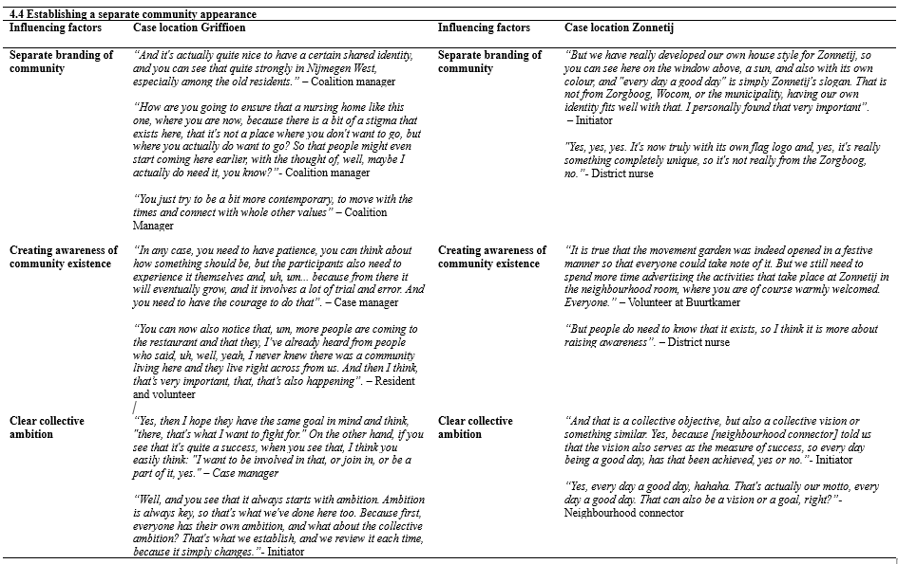
Table 6 Illustrative quotes separate community appearance
establishment of an independent foundation, managed entirely by community residents and volunteers serving in the board. The initiator from Zonnetij emphasized her believe in setting clear boundaries to establish the community’s independence.
“It's truly an independent [organization], um, really from the community where people want to belong. Yes, and identity. So you identify yourself with this community. And yes, if you have Zorgboog flags hanging, well then people see it more as "oh, that's a nursing home” – Initiator Zonnetij
The development report 2023 of Griffioen emphasized the importance of using a language that is collectively understood and created by the community itself. “The correct format, correct text and language, and indicating exactly what you commit to are important”. This collective language seemed important, particularly since two other respondents mentioned that the stigma that is present among care institutions required to be challenged (Table 6). To combat this prejudice of elderly care facilities, one respondent referred to Griffioen’s efforts to develop a more ‘hip’ [contemporary] image, by appealing to more recent ambitions of (potential) community members (Table 6).
Furthermore, alongside the creation of a separate community image, multiple respondents noted the importance increasing awareness about the community’s existence. Respondents from both locations observed that there is often a lack of awareness of the community’s existence once individuals have no direct connection with the community (Table 6). One respondent from Griffioen stated the necessity for individuals to engage directly with the community and its cause in order to understand its relevance and ambition. Similarly, a respondent from Zonnetij noted that it was only when she visited the community’s Buurtkamer herself, that she developed an understanding of the concept of a local care community. Creating awareness among potential members has been found to require a time-consuming investment. A crucial lesson learned by both initiators of Zonnetij and Griffioen is therefore:
“You really have to take the time to do that. Because yes, you… if you are part of, you have to get to know the people. You have to start engaging them in conversations. And then talking talking talking and listening a lot of listening in the beginning”. - Initiator Zonnetij
Lastly, the data revealed that establishing a clear collective ambition tends to be crucial to foster community identification where it touches upon the individuals ability to identify based on a moral level. According to a respondent from Griffioen, a collective ambition or vision serves as a strong tool to motivate individuals to engage in the care community (Table 6). Additionally, the initiators at both cases established that a collective ambition, objective or vision is fundamental to the community’s existence and partly determine what is perceived as a success among its members. Two respondents from Griffioen emphasized that the relevance of a collective ambition depends on the community’s ability to allow such ambition to evolve over time as well. One of their key insights included the importance of daily revisiting the common interest in order to sustain engagement among all members.
Overall, the data showed that the development of an independent community appearance is crucial for potential members to become aware of the community’s existence. Moreover, such a community identity including a clear collective ambition, allows for (potential) members to identify with the community, increasing chances that they are willing to contribute.
An overview of all insights gathered can be found in Figure 1.
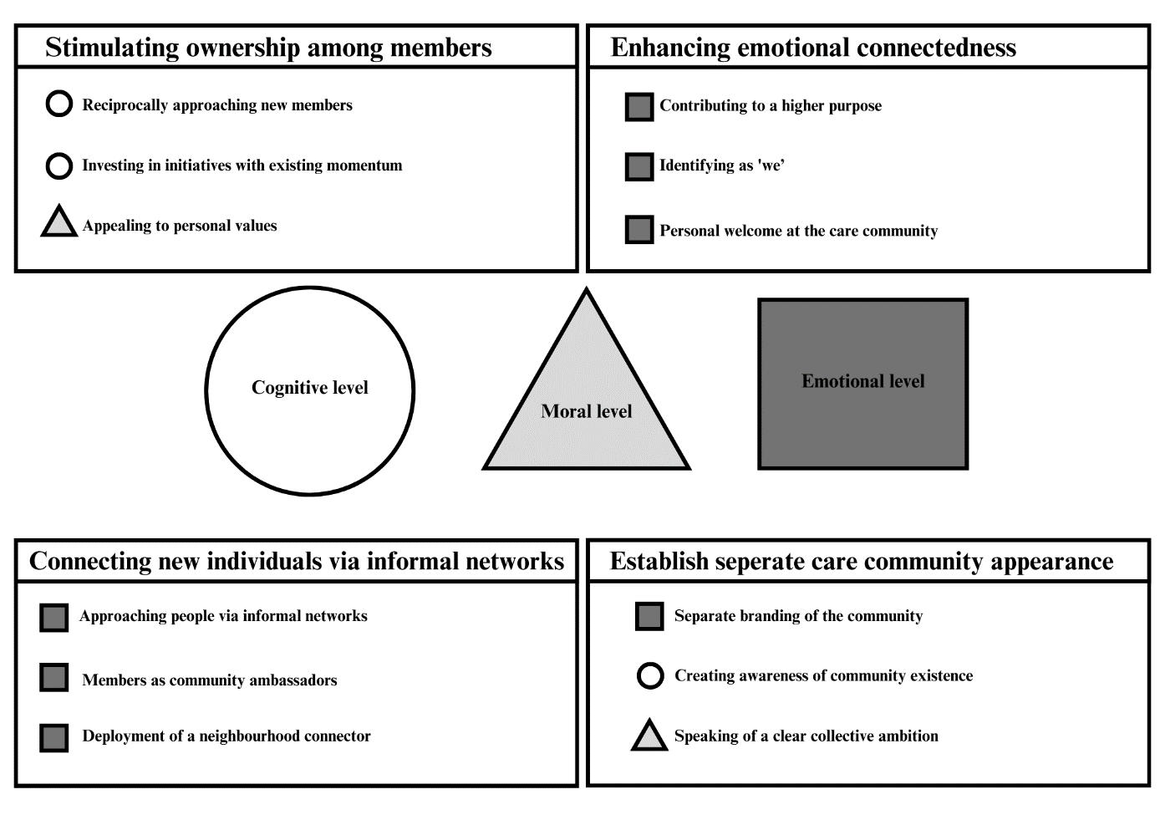
Figure 1 The four key measures to develop a collective identity

Discussion and conclusion
In this discussion, the results presented in the previous chapter will be evaluated by their implication in the context of existing literature, and what this implies for future research and practice. This research initially aimed to find answers to the question “How can a local care community develop a collective identity that mobilizes informal caregivers to participate?”. This question is separated into two sub-questions questioning “the factors influencing the formation of a collective identity within a local care community” and “Informal caregivers motivation to become engaged in the care community”. This study proposes that there are four crucial measures contributing to the development of a collective identity among members of a care community which mobilizes informal caregivers to participate.

Discussion
The first measure contributing to the development of a collective identity is the stimulation of ownership among members of the care community. As the findings of this study similarly suggested, the definition of communities inherently imply that coordination and control mostly exists in the direct interaction of members, where members choose how they like to contribute to the community (Kolbjørnsrud, 2018; Puranam et al., 2014). The findings of this research show that (informal) members where most motivated to become engaged in the care community if they experienced a sense of ownership within the care community. This ownership is best stimulated by for instance investing in initiatives with existing momentum among members or by putting a bottom-up strategy central where ideas from community members should be facilitated by the professionals within the community. Moreover, a reciprocal approach towards potential informal caregivers is seen to touch upon a cognitive level of collective identification. By considering all members including informal caregivers as equal, regardless of their role, everyone is expected to both contribute and gain something from their participation. This suggests that the individual is enabled to rationalize their participation in a larger group in an instrumental manner (Ma & Pouthier, 2023). Finally the research revealed that ownership is best stimulated if the community appeals to the informal caregivers personal values and interests. This latter point is also emphasized in the literature, proposing that the moral connection individuals feel within a community is rooted in the individuals’ ethical considerations. Since these principles are derived from intrinsic values and norms, individuals are enabled to express and collectively voice these inner values openly (Ma & Pouthier, 2023). By listening to and supporting the ideas and wishes of potential informal caregivers, which are often rooted in their norms and values, the care community can enhance the informal caregivers’ sense of belonging to the group.
Secondly, the findings revealed the importance of enhancing emotional connectedness to a group to experience a sense of belonging. The definition of a collective identity considers the individuals’ perceived sense of belonging to be crucial for one’s ability to identify with a group (Polletta & Jasper, 2001). Literature moreover suggested that this feeling of belonging is often accompanied by the emotional element of a collective identity, where the emotions experienced by individuals, in relation to the greater collective, might be seen as a producer of great behavioural change (Bavel et al., 2020). Similarly, this research revealed that a sense of belonging is enhanced on a more emotional level. The findings suggests that in order to enhance an identification on an emotional level, communities should clearly develop a statement of their purpose, which includes both a collective urgency with which individuals can identify themselves, and the clear aim to work towards a larger goal where individuals can experience to contribute to something meaningful. Moreover, the findings indicated that care communities should actively identify as a group by actively discussing matters with inclusive language such as ‘we’, as this allows for individuals to perceive a sense of belonging and recognize their contribution to something larger than themselves. This research moreover provided insights into the acquired experience of both care communities on how a personal welcome facilitates an immediate emotional connection which tends to enhance sense of belonging. By investing in a memorable and personal initial encounter with potential informal caregiver, individuals might more quickly perceive a sense of belonging.
Thirdly, it is believed that integrating new members into the community is most effective through informal networks. The findings revealed that potential participants found via members’ informal networks are more willing to assists. The pre-existing personal relationships among members proved to be a key reason to engage in community activities. These findings proved to be in accordance with previously discussed literature which suggests that the likelihood of members assisting proximal and distal others within the community increases when there is a personal identification with the community (van Zomeren, 2013; Vignoles et al., 2021). Moreover, the definition of social movement theory, mentions the importance of movements starting from the interaction in informal networks of people within the community (Diani, 1992). This research revealed that care communities can exploit the informal networks of current members by treating members as ambassadors of the community, with the role of inspiring and motivating new informal caregivers to join. By enabling individuals to share their stories and personally addressing acquaintances or family members, there is an increased likelihood of effectively engaging new informal caregivers in the care community. Additionally, this research identified the relevance of the role of a neighbourhood connector, whose task it should be to coordinates the efforts of these ambassadors and actively engages with the neighbourhood to stimulate the development of a social network.
Ultimately, the establishment of a separate community image seemed advisable to encourage identification with the community. The literature suggests that communities are formed on a shared commitment to a common purpose, starting with the formation of shared goals and values (Adler & Heckscher, 2006; Kolbjørnsrud, 2018; Snow et al., 2011; Vermeulen & Liese-Happel, 2021). The individual’s ability to identify with the communities’ norms and values is displayed in the expression of identity through the use of names, symbols and rituals (Cnaan & Milofsky, 2018; Polletta & Jasper, 2001). The data in this research revealed that the formation of a symbolic appearance seems highly relevant for individuals to identify with the local care community. Such symbolic image should reflect the collective ambition of the local care community, and distinguish itself from stigmatized types of elderly care facilities. Additionally, the research revealed that a collective ambition is not static and therefore should be continuously evaluated to sustain engagement among all its members.

Theoretical and practical implications
This study extends prior research suggesting that collective social identifications, as suggested in social movement theory, can be invoked to play a role to mobilize followers. Empirical evidence provided by this research validates the applicability of this claim in the context of local care communities. While previous studies have primarily focused on the role of collective identity in mobilizing individuals, and the varying levels of identification an individual might experience with a collective identity, this study contributes by exploring the measures through which such collective identity can be developed. The development of a collective identity is thereby promoted by addressing four key measures: stimulating ownership among members of the care community, enhancing emotional connectedness, connecting new individuals via informal networks, and finally establishing a separate community appearance. This research proposes that if all four measures are conducted properly following the various advices gained from the experiences of the cases researched, the development of a collective identity may be sufficiently stimulated to motivate increased participation in the local care community.
The findings of this study consequently have a number of important implications for future practice for practitioners and organizations that are either initiating a local care community or encountering difficulties in engaging new informal caregiver within the care community. Previous studies have proven a collective identity to be a key motivator for individuals to participate in a social movement. The data in this study has shown four critical measures that actively contribute to the development of such a collective identity. When initiator of care communities are prone to grow the network of informal caregivers, the findings of this research first suggest that ownership should be stimulated among members of the care community. This ownership should be reciprocal and aligned with the individuals’ values and interests, thereby facilitating both cognitive and moral identification with the care community. Secondly, in order to establish a sense of belonging and an emotional identification to the care community, the initiator should enhance emotional connectedness by emphasizing the higher purpose that the community serves and clearly identifying the community as ‘we’ rather than an individualistic endeavour. Thirdly, the data suggested that an emotional identification is stimulated once individuals personally know each other, which increases the willingness to help out. The initiators of care communities are therefore advised to connected new informal caregivers via the informal networks of members by approaching current members ambassadors of the community. Moreover, the deployment of a neighbourhood connector is stimulated, as to coordinate the efforts of ambassadors and keep track of what is happening in the neighbourhood. Finally, the initiators of care communities are encouraged to establish a separate community appearance, where such symbolic appearances should reflect the collective ambition of the local care community in order to differentiate itself from the stigmatized perceptions associated with traditional elderly care facilities.

Limitations
Even though this study provides valuable insights into the development of a collective identity within local care community and the mobilization of informal caregivers, this study should acknowledge some limitations. This paper only selected two cases, one in a city and one in a village. This limited number of cases allowed for a basic comparison, however, may limit the generalizability of the findings. Moreover, a case study on collective identity formation may be highly dependent on its context, where local elements such as informal networks, culture or history shaped a local communities background. This context dependability may limit the transferability of this papers results to other contexts. Additionally, the inductive approach and Gioia method applied in this research proved to be a powerful method for theories to emerge from the data. Nevertheless, subjectivity in the interpretation of data might pose limitations since the researcher’s bias might have influenced the results. Finally, respondents for the interviews were purposively chosen in consultation with the initiators of both care communities, where relevant participants were considered and approached. This strategy might have excluded other relevant stakeholder groups that could have influenced the development of a collective identity.

Future research
Several participants in this study highlighted the fact that the creation of a care community and the development of a social identity takes time and tends to naturally evolve over time. This would be a fruitful area for future work. Therefore, future studies are recommended to conduct a longitudinal case study including ethnographic observations. An longitudinal study would allow for the observation of how a collective identity of a care community and the commitment of informal caregivers might evolve over time, offering more insights in the dynamic process of collective identity formation. By using ethnographic observations, the researcher could immerse themselves in the culture of the local care community. This might extend the findings of this paper by going beyond the explicit behaviours and statements of participants, and examining the taken for granted assumptions which are impossible to discover in a short amount of time (Myers, 2019). Interesting would be the comparison between a fully established care community and an upcoming one, with additional insights from expert views.

Conclusion
To conclude, this study set out to determine “How a local care community can develop a collective identity that mobilizes informal caregivers to participate”. This research provides empirical evidence of previous research indicating that collective social identifications serve as a motivator to mobilize followers. This paper has moreover identified four measures that find answers to the how rather than the what or why of the development of a collective identity including: stimulating ownership among members of the care community, enhancing a sense of belonging, connecting new individuals via informal networks, and establishing a separate community image to encourage identification.

Reference list
Adler, P., & Heckscher, C. (2006). The Firm as a Collaborative Community: Reconstructing Trust in the Knowledge Economy. pp. 11–106. Oxford University Press. https://doi.org/10.1093/oso/9780199286034.003.0002
Aisa, R., & Pueyo, F. (2013). Population aging, health care, and growth: A comment on the effects of capital accumulation. Journal of Population Economics, 26(4), pp. 1285–1301. https://doi.org/10.1007/s00148-012-0448-2
Alzheimer Nederland. (n.d.). Voorbeelden van dementievriendelijkee woningen. Voorbeelden van Dementievriendelijkee Woningen. https://www.alzheimer-nederland.nl/belangenbehartiging/standpunten/woonvormen-voor-mensen-met-dementie/voorbeelden-van-dementievriendelijke-woningen
Bavel, J. J. V., Baicker, K., Boggio, P. S., Capraro, V., Cichocka, A., Cikara, M., Crockett, M. J., Crum, A. J., Douglas, K. M., Druckman, J. N., Drury, J., Dube, O., Ellemers, N., Finkel, E. J., Fowler, J. H., Gelfand, M., Han, S., Haslam, S. A., Jetten, J., Willer, R. (2020). Using social and behavioural science to support COVID-19 pandemic response. Nature Human Behaviour, 4(5), pp 460-471. https://doi.org/10.1038/s41562-020-0884-z
Bleijenbergh, I. (2016). Kwalitatief onderzoek in organisaties (2nd ed.). Boom Lemma.
Bowen, G. (2009). Document Analysis as a Qualitative Research Method. Qualitative Research Journal, 9, pp. 27–40. https://doi.org/10.3316/QRJ0902027
Brandsma, T., Stoffers, J., & Schrijver, I. (2020). Advanced Technology Use by Care Professionals. International Journal of Environmental Research and Public Health, 17(742), pp 1-16 https://doi.org/10.3390/ijerph17030742
Byrne, D., Goeree, M. S., Hiedemann, B., & Stern, S. (2009). Formal home health care, Informal care, and Family decision making. International Economic Review, 50(4), 1205–1242. https://doi.org/10.1111/j.1468-2354.2009.00566.x
Canoy, M., Smelik, J., & Ham, M. (2023). Zorgzame buurten—Inspirerende initiatieven die het systeem trotseren. Movisie. https://www.movisie.nl/publicatie/zorgzame-buurten-trotseren-systeem
CBS. (2023). Population in the future [Webpagina]. Statistics Netherlands. https://www.cbs.nl/en-gb/visualisations/dashboard-population/population-dynamics/population-in-the-future
Cnaan, R. A., & Milofsky, C. (Eds.). (2018). Handbook of Community Movements and Local Organizations in the 21st Century. Springer International Publishing. https://doi.org/10.1007/978-3-319-77416-9
Dessers, E., & Mohr, B. J. (2019). Integrated Care Ecosystems. In B. J. Mohr & E. Dessers (Eds.), Designing Integrated Care Ecosystems (pp. 13–23). Springer International Publishing. https://doi.org/10.1007/978-3-030-31121-6_3
Diani, M. (1992). The Concept of Social Movement. The Sociological Review, 40(1), 1–25. https://doi.org/10.1111/j.1467-954X.1992.tb02943.x
Ferreira, B., Diz, A., Silva, P., Sousa, L., Pinho, L., Fonseca, C., & Lopes, M. (2022). Bibliometric Analysis of the Informal Caregiver’s Scientific Production. Journal of Personalized Medicine, 61(12), 1–19. https://doi.org/10.3390/jpm12010061
Gioia, D., Corley, K., & Hamilton, A. (2013). Seeking Qualitative Rigor in Inductive Research. Organizational Research Methods, 16, 15–31. https://doi.org/10.1177/1094428112452151
Hashimoto, K., & Tabata, K. (2010). Population aging, health care, and growth. Journal of Population Economics, 23(2), 571–593. https://doi.org/10.1007/s00148-008-0216-5
Hillery, G. A. (1955). Definitions of community: Areas of agreement. Rural Sociology, 20, pp- 111–123.
Hori, T., Nishida, Y., Aizawa, H., Murakami, S., & Mizoguchi, H. (2004). Sensor network for supporting elderly care home. Proceedings of IEEE Sensors, 2004., 575–578. https://doi.org/10.1109/ICSENS.2004.1426230
Hunter, D. D. J., & McCallum, D. J. (2019). Defining Exploratory-Descriptive Qualitative (EDQ) research and considering its application to healthcare. Journal of Nursing and Health Care, 4(1).
Kelders, Y., Hoeve, S. ten, Kwekkeboom, R., Wittenberg, Y., Zal, S. van, & Schmale, L. (2016). Community Care and the Care Transition in the Netherlands. 25(4), 27–40. https://doi.org/10.18352/jsi.488
Klandermans, B., & Oegema, D. (1987). Potentials, Networks, Motivations, and Barriers: Steps Towards Participation in Social Movements. American Sociological Review, 52(4), 519–531. https://doi.org/10.2307/2095297
Klandermans, B., & Stekelenburg, J. V. (2014). Why People Don’t Participate in Collective Action. Journal of Civil Society, 10(4), 341–352. https://doi.org/10.1080/17448689.2014.984974
Kolbjørnsrud, V. (2018). Collaborative organizational forms: On communities, crowds, and new hybrids. Journal of Organization Design, 7(1), 1–21. https://doi.org/10.1186/s41469-018-0036-3
Langley, A., & Abdallah, C. (2011). Templates and Turns in Qualitative Studies of Strategy and Management. Research Methodology in Strategy and Management, 6, 201–235.
Lincoln, Y., & Guba, E. (1985). Naturalistic inquiry. Sage Publications.
Ma, X., & Pouthier, V. (2023). Constructing Collective Identities For Change With Aesthetic-affective Power: A Rhetorical Approach. Academy of Management Proceedings, 2023(1), 14388. https://doi.org/10.5465/AMPROC.2023.182bp
Magnani, G., & Gioia, D. (2023). Using the Gioia Methodology in international business and entrepreneurship research. International Business Review, 32(2023), 1–21. https://doi.org/10.1016/j.ibusrev.2022.102097
Martin, P. Y., & Turner, B. A. (1986). Grounded Theory and Organizational Research. The Journal of Applied Behavioral Science, 22(2), 141–157.
Mills, A., Durepos, G., & Wiebe, E. (2010). 15. Mills, A. J., Durepos, G., and Wiebe, E. [Eds.] (2010) Encyclopedia of Case Study Research, Volumes I and II. Sage.
Moss, J. L., Hearn, M., Cuffee, Y. L., Wardecker, B. M., Kitt-Lewis, E., & Pinto, C. N. (2023). The role of social cohesion in explaining rural/urban differences in healthcare access and health status among older adults in the mid-Atlantic United States. Preventive Medicine, 173, 107588. https://doi.org/10.1016/j.ypmed.2023.107588
Myers, M. D. (2019). Qualitative research in business and management. Sage.
Plemper, D. E., & van Vliet, D. K. (2002). Community care: De uitdaging voor Nederland. RMO Advies 25 De handicap van de samenleving. https://www.verwey-jonker.nl/doc/participatie/D8539234-5_013E.pdf
Polletta, F., & Jasper, J. M. (2001). Collective Identity and Social Movements. Annual Review of Sociology, 27(1), 283–305. https://doi.org/10.1146/annurev.soc.27.1.283
Puranam, P., Alexy, O., & Reitzig, M. (2014). What’s “New” About New Forms of Organizing? Academy of Management Review, 39, 162–180. https://doi.org/10.5465/amr.2011.0436
Schuurmans, J. J., Van Pijkeren, N., Bal, R., & Wallenburg, I. (2021). Regionalization in elderly care: What makes up a healthcare region? Journal of Health Organization and Management, 35(2), 229–243. https://doi.org/10.1108/JHOM-08-2020-0333
Smith, D. (2003). Five principles for research ethics. Https://Www.Apa.Org. https://www.apa.org/monitor/jan03/principles
Snow, C. C., Fjeldstad, Ø. D., Lettl, C., & Miles, R. E. (2011). Organizing Continuous Product Development and Commercialization: The Collaborative Community of Firms Model. Journal of Product Innovation Management, 28(1), 3–16. https://doi.org/10.1111/j.1540-5885.2010.00777.x
Stoecker, R. (2018). About the Localized Social Movement. In R. A. Cnaan & C. Milofsky (Eds.), Handbook of Community Movements and Local Organizations in the 21st Century (pp. 211–227). Springer International Publishing. https://doi.org/10.1007/978-3-319-77416-9_13
van Zomeren, M. (2013). Four Core Social-Psychological Motivations to Undertake Collective Action. Social and Personality Psychology Compass, 7(6), 378–388. https://doi.org/10.1111/spc3.12031
Vennix, J. (2019). Research methodology: An introduction to scientific thinking and practice. Pearson.
Vermeulen, P. A. M., & Liese-Happel, H. M. (2021). De community als organisatievorm. M&O: Tijdschrift Voor Management En Organisatie, 75(3), 61–76.
Vignoles, V. L., Jaser, Z., Taylor, F., & Ntontis, E. (2021). Harnessing Shared Identities to Mobilize Resilient Responses to the COVID-19 Pandemic. Political Psychology, 42(5), 817–826. https://doi.org/10.1111/pops.12726
Woodward, C. A., Abelson, J., Tedford, S., & Hutchison, B. (2004). What is important to continuity in home care?: Perspectives of key stakeholders. Social Science & Medicine, 58(1), 177–192. https://doi.org/10.1016/S0277-9536(03)00161-8
World Health Organization. (2024). World health statistics 2023 – Monitoring health for the SDGs. https://www.who.int/data/gho/publications/world-health-statistics
Yasuoka, M. (2019). Elderly care service in an aging society. Journal of Economic Studies, 46(1), 18–34. https://doi.org/10.1108/JES-04-2017-0102
Yin, R. K. (2009). Case study research: Desing and methods (4th ed.). Sage Publications.

Appendices

Interview guide
EEN STUDIE NAAR DE MOBILISATIE VAN ZORGZAME GEMEENSCHAPPEN EN DE MOTIVATIE VAN DE (IN)FORMELE ZORG OM BIJ TE DRAGEN.
Welkomstpraatje
Bedanken voor de medewerking
Allereerst wil ik je alvast bedanken voor je medewerking aan dit interview en dat je tijd vrij hebt gemaakt om ons te helpen in ons afstudeeronderzoek. Is het goed als ik ‘je’ zeg?
Toelichting interview
Voor onze master scriptie van de master Organisatie Ontwerp en Ontwikkeling aan Radboud Universiteit zijn wij onderzoek aan het doen naar het concept van zorgzame gemeenschappen. Hiervoor kijken wij naar initiatieven in Nederland die al aan de slag zijn gegaan om te experimenteren met nieuwe samenwerkingen tussen de formele zorg (denk aan verzorgende/ welzijnsteams/ partners zoals de fysio) en de wijk/buurt. Zulke initiatieven noemen wij in dit interview en in ons verdere onderzoek zorgzame gemeenschappen.

In het bijzonder zijn wij geïnteresseerd in wat het nou betekent voor deelnemers om onderdeel te zijn van de zorgzame gemeenschap, en daarnaast wat de achterliggende motivatie is voor mensen waardoor ze besluiten bij te dragen aan zo'n gemeenschap.

Het doel van het onderzoek is om de al bestaande initiatieven omtrent zorgzame gemeenschappen in kaart te brengen, en waardevolle geleerde lessen en inzichten op te halen. Deze ‘best practices’ kunnen zo worden gedeeld met andere locaties in Nederland die nog zoekende zijn naar hoe zorgzame gemeenschappen op te zetten.

Toelichting toepassing resultaten
Wij zullen uiteraard vertrouwelijk omgaan met de resultaten, die discreet verwerkt worden. Ik zou het interview graag willen opnemen. Hier heb je via het formulier al toestemming voor gegeven dus de opname staat al aan. Is dat nog steeds oké? Op deze manier kunnen wij de informatie terugluisteren en analyseren, wat ervoor zorgt dat de informatie niet verkeerd wordt begrepen en zo bruikbaar mogelijk is. Bij deze zou ik ook nog graag vragen of we u naam verder mogen benoemen bij het bespreken van de resultaten, of dat u graag anoniem wilt blijven?

Duur interview
Het interview zal maximaal een uur duren.

Opbouw interview
Ik zal beginnen met enkele inleidende vragen over locatie Zonnetij en het ontstaan van dit zorgzame initiatief. Hierna zullen we eerst doorgaan met vragen specifiek over wat het voor u betekent om onderdeel te zijn van Zonnetij en daarna wat u heeft gemotiveerd om deel te nemen aan dit initiatief. Als je aan het einde nog aanvullingen of opmerkingen hebt, hoor ik die graag.
Heb je op dit moment nog vragen? Zo niet, dan beginnen we nu met het interview.

Interview vragen (Initiatiefnemer/ kartrekker)
Introductievragen over de gemeenschap
1 | Wil je jezelf kort voorstellen? Kun je ons wat meer vertellen over deze zorgzame gemeenschap?  - Hoe ziet de organisatie eruit?  - Hoe is de gemeenschap ontstaan?  - Hoe is deze gemeenschap georganiseerd?
2 | Wat heeft jou ertoe gezet om te starten met dit zorgzame initiatief?  - Waar kwam de inspiratie vandaan?  - Hoe kwam je tot het idee van een zorgzame gemeenschap?  - Wie hebben jou hierbij voornamelijk geholpen?
3 | Wat betekent het begrip zorgzame gemeenschap voor jou?
4 | Kun je wat meer vertellen over jouw geleerde lessen binnen de zorgzame gemeenschap?  - Wat bleek erg uitdagend te zijn en waarom?  - Welke lessen zijn daar dan dus uitgetrokken?  - Kun je er ook een voorbeeld bij geven?
5 | Kun je wat meer vertellen over de successen van deze zorgzame gemeenschap?  - Waarom denk je dat dit tot een succes leidde.  - Wie denk jij dat echt hebben bijgedragen aan dat succes?  - Kun je er ook een voorbeeld van geven?
Onderdeel zijn van de zorgzame gemeenschap
6 | Wat betekent het voor jou om onderdeel te zijn van deze zorgzame gemeenschap?  - Waar komt dat dan vandaan?  - Kun je dat verder toelichten?  - Hoe werkt dat dan voor jou?  - Wat bedoel je daarmee?  - Kun je daar een voorbeeld van geven?
7 | Wat is het gezamenlijk doel binnen de zorgzame gemeenschap?  - Hoe zou je dit doel omschrijven?  - Hoe sluit dit doel aan bij jou als persoon? Wat betekent het voor jou?  - Hoe zie je dit doel terug in voorbeelden in de praktijk? Kun je daar een voorbeeld van geven?  - Hoe verhouden de doelen van de verschillende partners zich tot elkaar?  - Kun je hier voorbeelden van geven?  - Kun je dat verder toelichten?  - Wat bedoel je daarmee?
Motivatie om mee te doen aan de zorgzame gemeenschap
9 | In vraag 2 hadden we het over waarom je bent gestart met dit initiatief. Hier gaan we graag even wat dieper op in. Vanuit welke (andere) persoonlijke overtuigingen heb jij besloten kartrekker te worden van dit initiatief?  - Waarom is dat voor jou belangrijk?  - Hoe zie jij deze overtuiging(en) terug in de zorgzame gemeenschap?  - Wat voor persoonlijke gebeurtenissen in jouw leven hebben jouw gemotiveerd om dus kartrekker worden?
10 | Hoe heb je geprobeerd mensen te motiveren om mee te doen aan de zorgzame gemeenschap?  - Wat heb jij gemerkt is het meest succesvol in het motiveren van mensen om mee te doen?
11 | Wat vond jij persoonlijk het meest uitdagende in het motiveren van mensen om mee te doen aan de zorgzame gemeenschap?  - Hoe heb je toch doorgezet, wat moest je daarvoor doen?  - Wat zou jouw advies zijn voor andere locaties die mensen proberen te motiveren?
12 | Hoe wordt de betrokkenheid van buurtbewoners gestimuleerd binnen de zorgzame gemeenschap?  - Zijn er bepaalde initiatieven, programma’s of praktijken die worden toegepast om de betrokkenheid rond buren te vergroten?  - Zo ja, hoe denk je dat deze kunnen bijgedragen aan het versterken van de zorg voor ouderen binnen de gemeenschap?
13 | Hoe wordt de betrokkenheid van organisaties in de buurt gestimuleerd binnen de zorgzame gemeenschap?  - Zijn er bepaalde initiatieven, programma’s of praktijken die worden toegepast om de betrokkenheid rond buren te vergroten?  - Zo ja, hoe denk je dat deze kunnen bijgedragen aan het versterken van de zorg voor ouderen binnen de gemeenschap?

Interview vragen (Buurt bewoners)
Introductievragen over de gemeenschap
1 | Wil je jezelf kort voorstellen? Wat doe jij in deze zorgzame gemeenschap? (Welke rol/ wat draag jij bij?)
2 | Wat betekent het begrip zorgzame gemeenschap voor jou?
3 | Kun je ons wat meer vertellen over deze zorgzame gemeenschap?  - Hoe ziet de organisatie eruit?  - Hoe is de gemeenschap ontstaan?  - Hoe is deze gemeenschap georganiseerd?
4 | Kun je wat meer vertellen over geleerde lessen in jouw deelname binnen de zorgzame gemeenschap?  - Wat bleek erg uitdagend te zijn en waarom?  - Welke lessen zijn daar dan dus uitgetrokken?  - Kun je er ook een voorbeeld bij geven?
5 | Kun je wat meer vertellen over de successen van deze zorgzame gemeenschap?  - Waarom denk je dat dit tot een succes leidde.  - Wie denk jij dat echt hebben bijgedragen aan dat succes?  - Kun je er ook een voorbeeld van geven?
Onderdeel zijn van de zorgzame gemeenschap
6 | Wat betekent het voor jou om onderdeel te zijn van deze zorgzame gemeenschap?  - Waar komt dat dan vandaan?  - Kun je dat verder toelichten?  - Hoe werkt dat dan voor jou?  - Wat bedoel je daarmee?  - Kun je daar een voorbeeld van geven?
7 | Is er een gezamenlijk doel binnen de zorgzame gemeenschap?  - Hoe zou je dit doel omschrijven?  - Hoe sluit dit doel aan bij jou als persoon? Wat betekent het voor jou?  - Hoe zie je dit doel terug in voorbeelden in de praktijk? Kun je daar een voorbeeld van geven?
8 | Merk je aan de andere kant dat er ook verschillende doelen zijn tussen de verschillende partners in de gemeenschap? (Zorg/bewoners/ buurtbewoners/familie).  - Kun je hier voorbeelden van geven?  - Hoe werd er omgegaan met verschillen tussen deze doelen?  - Kun je dat verder toelichten?  - Wat bedoel je daarmee?
Motivatie om mee te doen aan de zorgzame gemeenschap
9 | Waarom heb je besloten mee te doen aan de zorgzame gemeenschap?  - Hoe werkt dat dan voor jou?  - Waarom is dat voor jou belangrijk?  - Kun je daar een voorbeeld van geven?  - Heb je ook ooit ergens over getwijfeld?
10 | Wat heeft er specifiek aan bijgedragen dat je betrokken werd bij de zorgzame gemeenschap? (Denk aan: overtuigingen/ ervaringen/ persoonlijke waarden).  - Waarom is dat voor jou belangrijk?  - Hoe zie je dit terug in de zorgzame gemeenschap?
11 | Zijn er persoonlijke ervaringen in jouw leven geweest die jou gemotiveerd hebben om bij te dragen aan de gemeenschap?  - Waren er bepaalde emoties verbonden aan die persoonlijke ervaringen?
12 | Waarom denk je dat andere mensen gemotiveerd kunnen zijn om mee te doen/ bij te dragen?  - Waar komt dat dan vandaan?  - Wat bedoel je daarmee?  - En wat zou mensen ervan kunnen weerhouden om mee te doen?
13 | Wat voor effect denk je dat jouw deelname aan de zorgzame gemeenschap kan hebben op andere om jou heen?
14 | Hoe wordt de betrokkenheid van buurtbewoners gestimuleerd binnen de zorgzame gemeenschap?  - Zijn er bepaalde initiatieven, programma’s of praktijken die worden toegepast om de betrokkenheid rond buren te vergroten?  - Zo ja, hoe denk je dat deze kunnen bijgedragen aan het versterken van de zorg voor ouderen binnen de gemeenschap?

Interview vragen (personeel (Zorgboog en van partnerorganisaties))
Introductievragen over de gemeenschap
1 | Wil je jezelf kort voorstellen? Wat is jouw rol binnen Zonnetij? (Welke rol/ wat draag jij bij?)
2 | Wat betekent het begrip zorgzame gemeenschap voor jou?  - Kun je dat verder toelichten?  - Kun je daar voorbeelden van geven?
3 | Kun je ons wat meer vertellen over Zonnetij?  - Hoe is de gemeenschap ontstaan?
4 | Kun je wat meer vertellen over geleerde lessen in jouw deelname binnen de zorgzame gemeenschap?  - Wat bleek erg uitdagend te zijn en waarom?  - Welke lessen zijn daaruit getrokken?  - Kun je er ook een voorbeeld bij geven?
5 | Kun je wat meer vertellen over de successen van deze zorgzame gemeenschap?  - Waarom denk je dat dit tot een succes leidde.  - Wie/wat denk jij dat echt heeft bijgedragen aan dat succes?  - Kun je er ook een voorbeeld van geven?
Onderdeel zijn van de zorgzame gemeenschap
6 | Wat betekent het voor jou om onderdeel te zijn van deze zorgzame gemeenschap?  - Waar komt dat dan vandaan?  - Kun je dat verder toelichten?  - Hoe werkt dat dan voor jou?  - Wat bedoel je daarmee?  - Kun je daar een voorbeeld van geven?
7 | Is er een gezamenlijk doel binnen de zorgzame gemeenschap?  - Hoe zou je dit doel omschrijven?  - Hoe sluit dit doel aan bij jou als persoon? Wat betekent het voor jou?  - Hoe zie je dit doel terug in voorbeelden in de praktijk? Kun je daar een voorbeeld van geven?  - Hoe is dit doel over tijd veranderd?
Alleen partner | Hoe ervaar jij de gezamenlijke ambitie en gedeelde verantwoordelijkheid van deze samenwerking binnen Zonnetij?
8 | Zijn er ook verschillende doelen tussen de verschillende partners in de gemeenschap? (Zorg/bewoners/ buurtbewoners/familie).  - Kun je hier voorbeelden van geven?  - Hoe werd er omgegaan met verschillen tussen deze doelen?  - Kun je dat verder toelichten?  - Wat bedoel je daarmee?
Motivatie om mee te doen aan de zorgzame gemeenschap
9 | Waarom heeft de gemeente besloten mee te werken aan het project Zonnetij?  Waarom heb je besloten om mee te doen en te gaan werken bij Zonnetij?  - Hoe werkt dat dan voor jou?  - Waarom is dat voor jou belangrijk?  - Kun je daar een voorbeeld van geven?  - Heb je ook ooit ergens over getwijfeld?
10 | Wat heeft er specifiek aan bijgedragen dat je betrokken werd bij de zorgzame gemeenschap? (Denk aan: overtuigingen/ ervaringen/ persoonlijke waarden).  - Waarom is dat voor jou belangrijk?  - Hoe zie je dit terug in de zorgzame gemeenschap?  - Hoe verhoudt dit zich over langere termijn?
11 | Zijn er persoonlijke ervaringen in jouw leven geweest die jou gemotiveerd hebben om bij te dragen aan de gemeenschap?  - Waren er bepaalde emoties verbonden aan die persoonlijke ervaringen?
12 | Waarom denk je dat andere mensen gemotiveerd kunnen zijn om mee te doen/ bij te dragen?  - Waar komt dat dan vandaan?  - Wat bedoel je daarmee?  - En wat zou mensen ervan kunnen weerhouden om mee te doen?
13 | Wat voor effect denk je dat jouw deelname aan de zorgzame gemeenschap kan hebben op andere om jou heen?  - Hoe kan dit anderen beïnvloeden?
14 | Hoe wordt de betrokkenheid van buurtbewoners gestimuleerd binnen de zorgzame gemeenschap?  - Zijn er bepaalde initiatieven, programma’s of praktijken die worden toegepast om de betrokkenheid rond buren te vergroten?  - Zo ja, hoe denk je dat deze kunnen bijgedragen aan het versterken van de zorg voor ouderen binnen de gemeenschap?
Vragen voor gemeente als partner
15 | Hoe ervaar jij de gezamenlijke ambitie van de samenwerking van Zonnetij?  - Kun je dat verder toelichten?  - Heb je daar voorbeelden bij?
Hoe ervaar jij de gedeelde verantwoordelijkheid in de samenwerking met Zonnetij?
- Hoe wordt daar mee omgegaan?
- Kun je dat verder toelichten?
- Heb je daar voorbeelden bij?

Ervaren werkgeluk onder personeel
15 | Hoe ervaar je je dagelijks werk en de werkdruk binnen Zonnetij?  - Hoe ervaar jij de werkdruk die komt kijken bij
16 | Hoe beïnvloedt werken in de woonconcepten jouw werkgeluk?  - Kun je ervaringen delen hoe dit jouw werkgeluk beïnvloedt?
17 | Hebben je het idee dat werken in deze nieuwe vorm, professionele inzet uitstelt, verlaagt of zelfs voorkomt?  - Is er meer ruimte vrijgekomen voor het leveren van zorg?  - Kun je dat verder toelichten?  - Of heb je hier wellicht een voorbeeld van?

Interview vragen (Bewoners)
Introductievragen over de gemeenschap
1 | Wilt u zichzelf kort voorstellen? Hoe is het voor u om te wonen bij Zonnetij?  - Hoelang woont u hier al bij Zonnetij?  - Hoe ziet een normale dag er hier uit voor u?
2 | Wat betekent het begrip zorgzame gemeenschap voor u?  - Hebt u al ooit eens van dit begrip gehoord?  - Hoe ziet dit er dan voor Zonnetij eruit volgens u?
3 | Kunt u ons wat meer vertellen over wonen bij Zonnetij?  - Welke mensen komt u vaak tegen?  - Hoe is voor u het contact met zorgmedewerkers?  - Hoe is voor u het contact met buurtbewoners & vrijwilligers in bijvoorbeeld de wijkkamer (Zonnetij).  - Hoe is voor u het contact met medebewoners?
4 | Kunt u wat meer vertellen over wat er juist fijn is aan wonen in Aarle-Rixtel bij Zonnetij?  - Waarom is dat voor u precies zo fijn?  - Kunt u hier ook een voorbeeld van geven?
5 | Kunt u wat meer vertellen over wat er wellicht lastig is aan wonen in Zonnetij?  - Waarom is dat minder fijn voor u?  - Kunt u hier ook een voorbeeld van geven?
Onderdeel zijn van de zorgzame gemeenschap
6 | Wat betekent het voor u om onderdeel te zijn van deze gemeenschap?  - Kunt u dat verder toelichten?  - Wat bedoelt u daarmee?  - Kunt u daar een voorbeeld van geven?
7 | Wij hoorden van Gerrie dat iedereen die hier komt wonen eerst een intake gesprek houdt om te kijken of Zonnetij passend is. Hoe verliep dat gesprek bij jou?  - Wat draag jij bij aan de gemeenschap?  - Wat kom jij echt halen bij de gemeenschap?
8 | We vertelden hier voor al dat voor ons zorgzame gemeenschappen inhouden dat er naast formele zorg, ook informele zorg betrokken is (familie/ kennissen/ buurtbewoners) Hoe vindt u het dat er ook (onbekende) mensen uit de buurt binnen komen en bijdragen in deze zorgzame gemeenschap?  - Kunt u dat verder toelichten?  - Wat bedoelt u daarmee?  - Kunt u daar een voorbeeld van geven?
9 | Heeft u nog tips voor de organisatie van Zonnetij om het wonen voor u hier fijner te maken?  - Wat heeft u nodig om fijner te wonen?  - Wie kan dat voor u betekenen?
Motivatie om mee te doen aan de zorgzame gemeenschap
10 | Heeft u er specifiek voor gekozen om bij Zonnetij te gaan wonen? En waarom?  - Waar komt u oorspronkelijk vandaan?  - Heeft de omgeving van Aarle-Rixtel een speciale betekenis voor u? Vertel eens meer?
11 | Zijn er persoonlijke ervaringen in uw leven die u wilt delen, die hebben bijgedragen aan dat je hier bent gaan wonen?  - Wat voor emoties waren er verbonden aan die persoonlijke ervaringen?
Vragen vanuit CZ onderzoek
12 | Heeft u het idee dat wonen binnen Zonnetij bevorderend is voor uw welzijn?  - Kunt u daar wellicht voorbeelden van geven?
13 | Vaak wordt het welzijn van mensen gemeten met iets wat positieve gezondheid heet. Dit begrip kent 6 onderdelen om dit te meten, graag kijk ik met u hoe u dit ervaart.  - Sinds u hier woont, hoe ervaart u uw fysieke gesteldheid?  - Sinds u hier woont, hoe ervaart u uw mentale welbevinden?  - Sinds u hier woont, hoe ervaart u uw gevoel van zingeving?  - Sinds u hier woont, hoe ervaart u uw kwaliteit van leven?  - Sinds u hier woont, hoe ervaart u uw sociale contacten?  - Sinds u hier woont, hoe ervaart u uw dagelijkse gang van zaken?

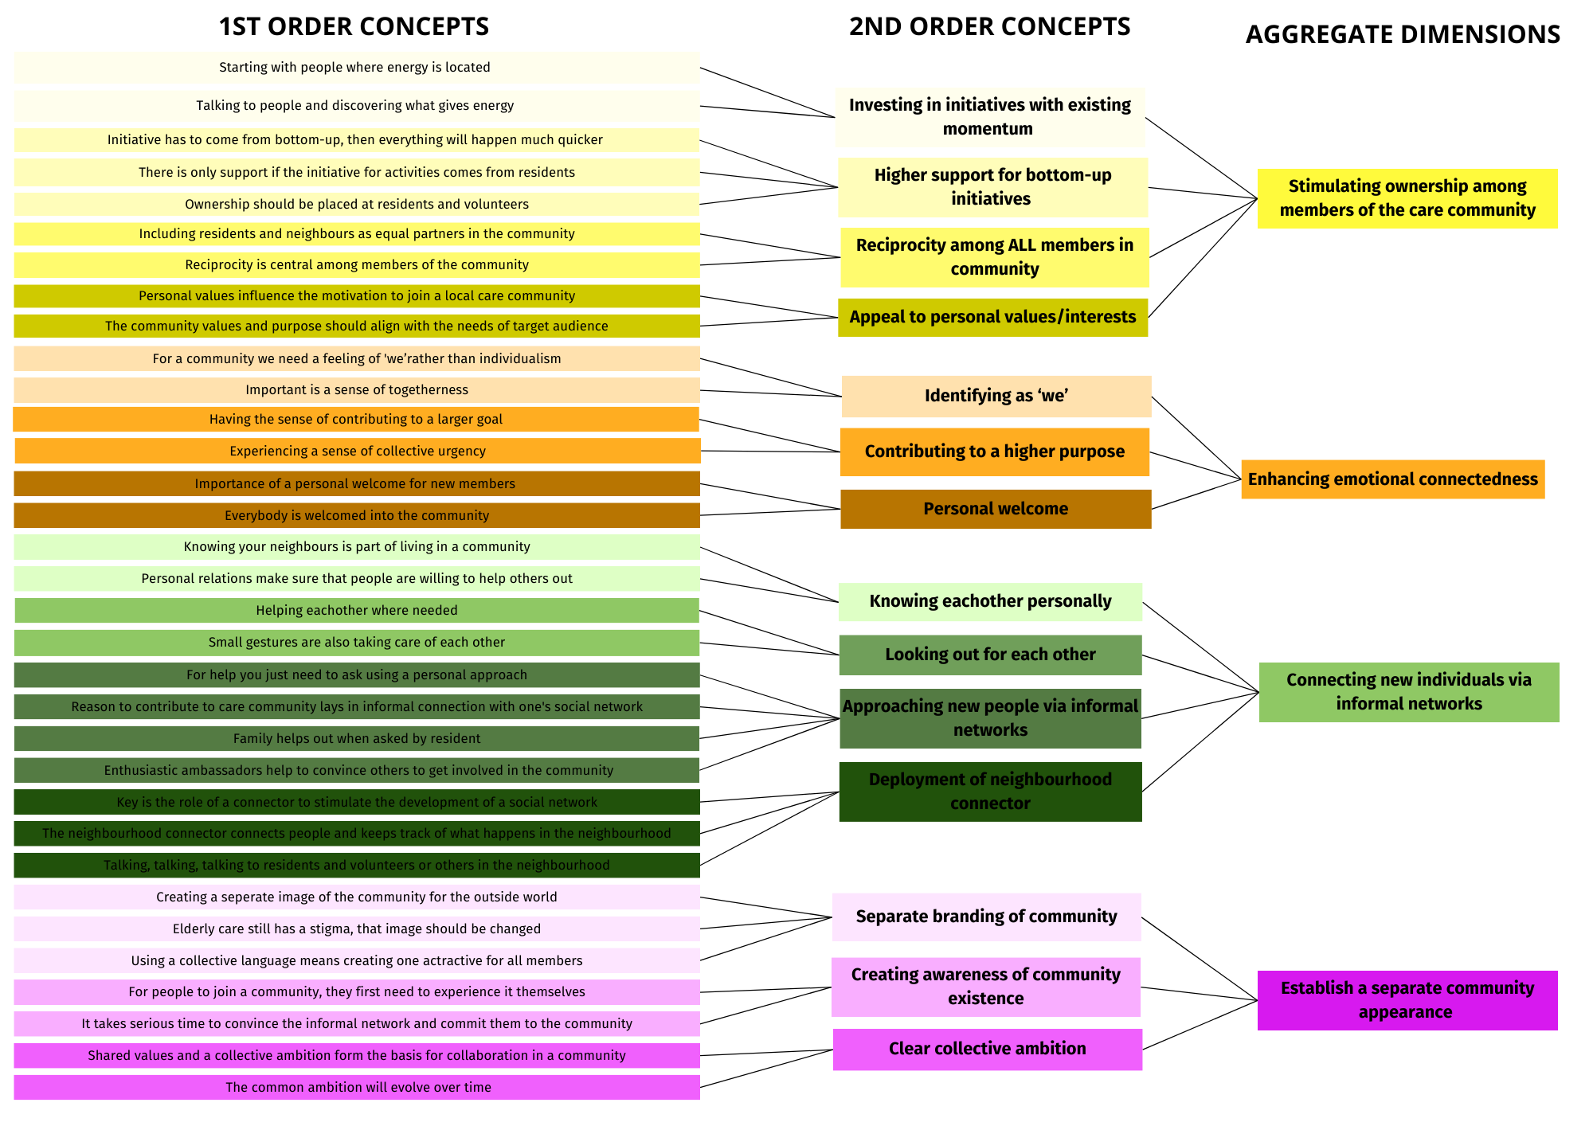
Gioia coding tree

Informed consent form
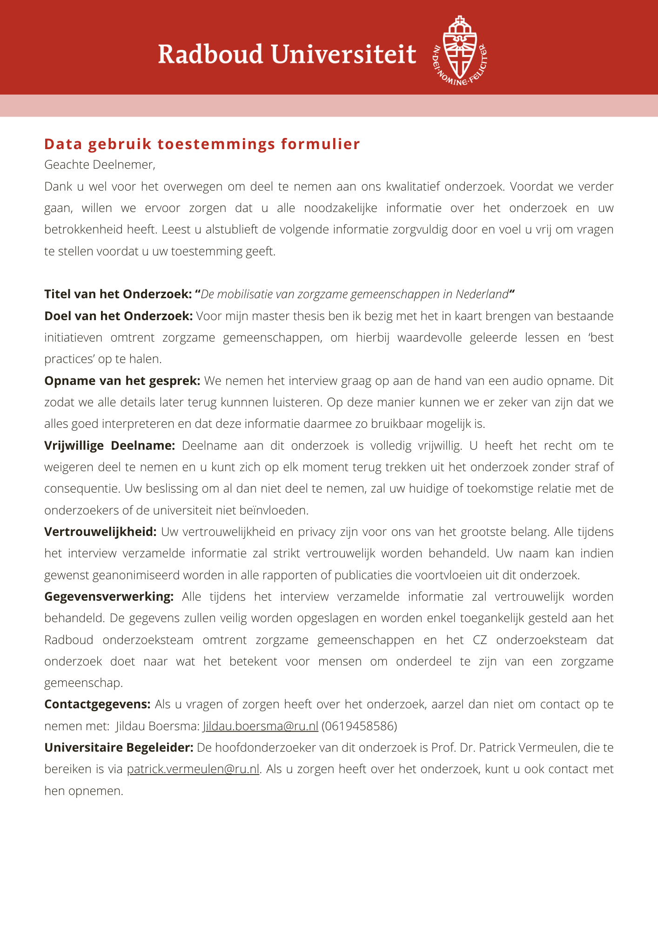
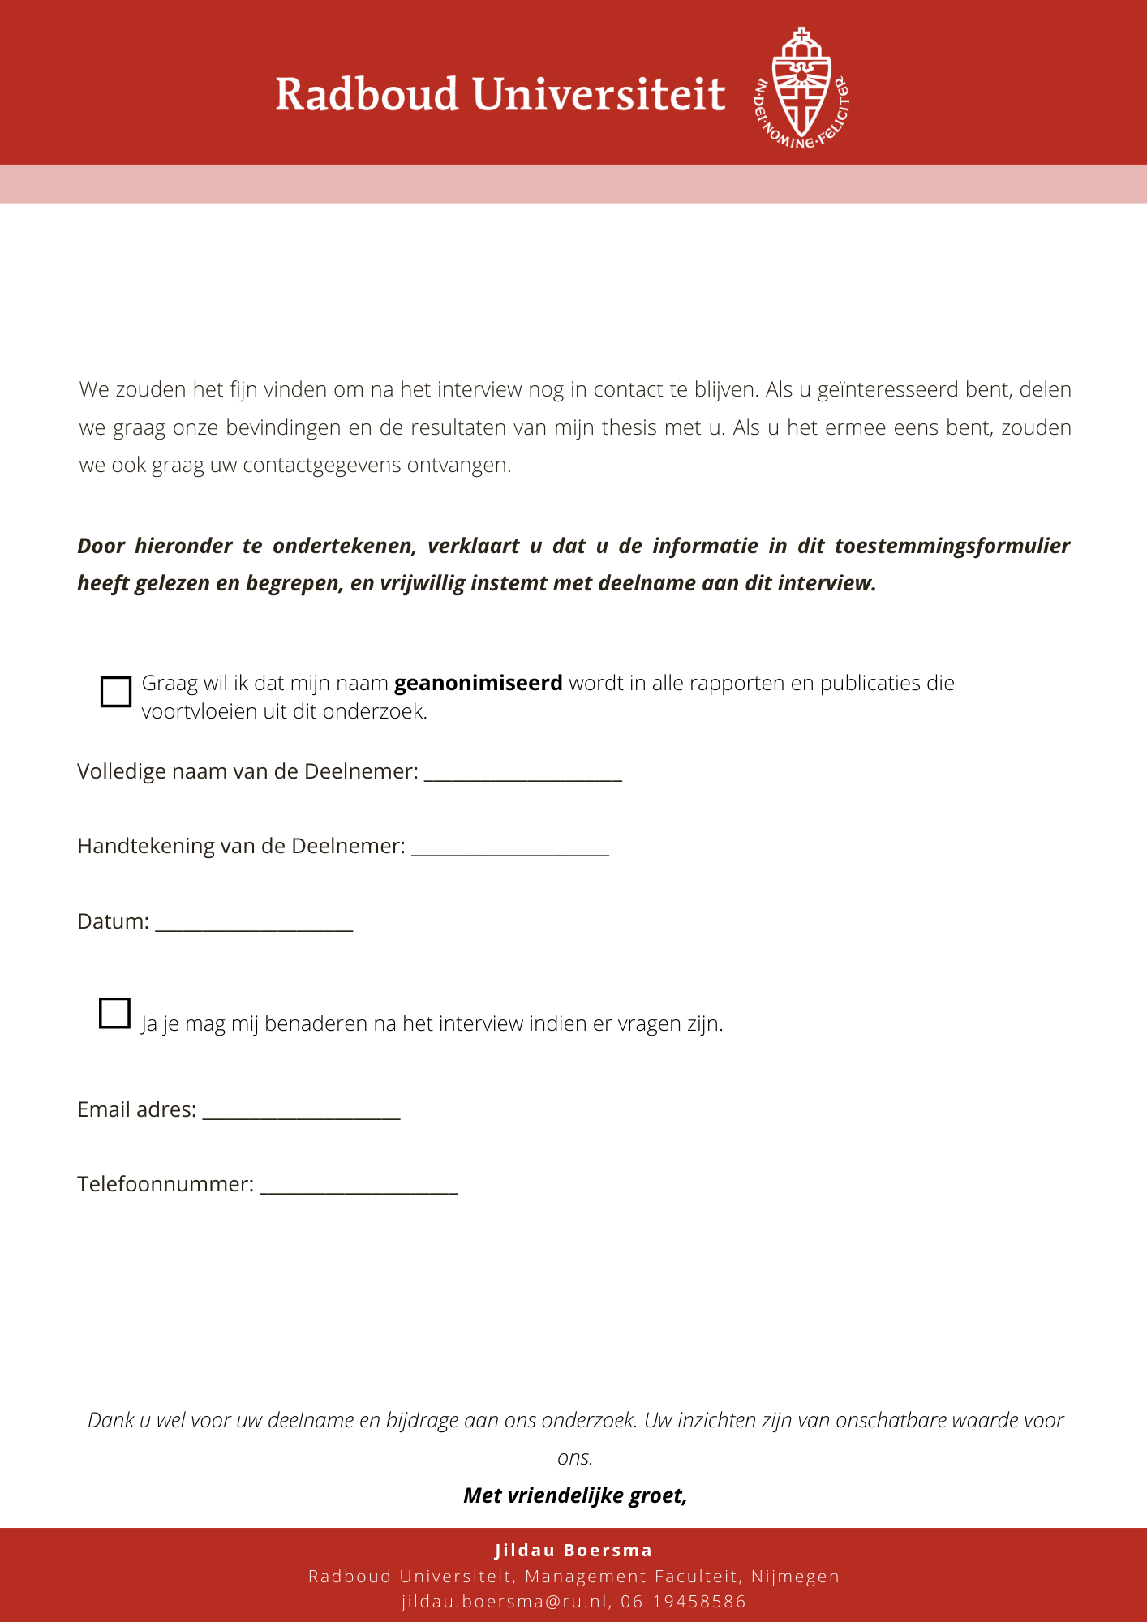

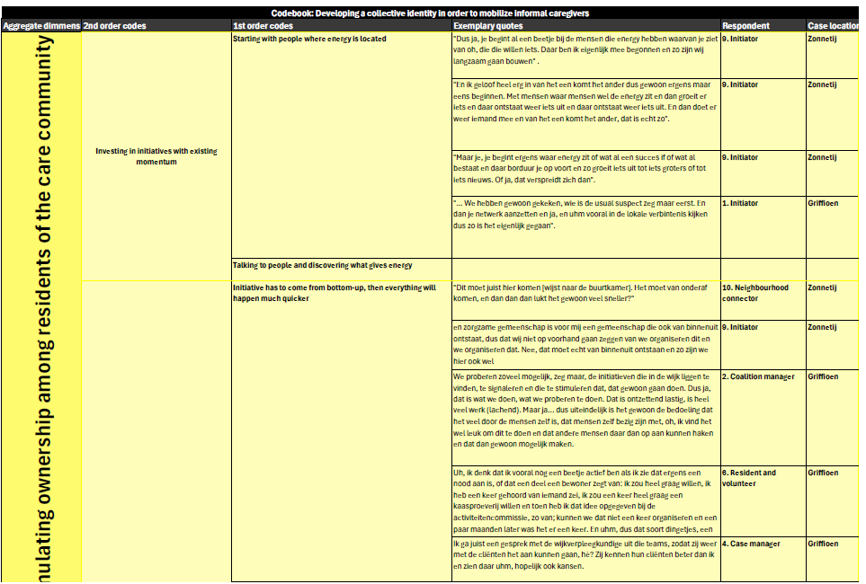
Codebook

