Board Composition’s influence on Environmental Innovation: How can Boards Drive Sustainability Transitions?

Name: Joep Haagmans
Student number: s1104183
E-mail: Joep.haagmans@ru.nl
Supervisor: Mirjam Goudsmit
Second examiner: Hans van Kranenburg
Date: 17-06-2024

Preface

I am proud to present you my master thesis on the influence of board composition on environmental innovation, which has the purpose to explore how boards could drive sustainable transitions. This thesis is part of the master Strategic Management (specialization of Business Administration) at the Radboud University in Nijmegen. The journey of writing my thesis has been challenging, but mainly insightful and rewarding. I have delved into the complexities and uncertainties that firms face in today’s world related to climate change, and studied how strategic leaders can navigate firms toward environmental innovation.

The adage “without friction no growth” which I touched upon in one of my supervisor sessions with Mirjam Goudsmit, suits perfectly with my experience in writing this thesis. On one hand, it refers to the obstacles encountered that have in the end enriched the quality of the study. On the other hand, it refers to one of the important findings in this study which suggests that considering multiple conflicting perspectives might be valuable for navigating the firm into a sustainable innovative direction.

In the end, I want to thank Mirjam Goudsmit for her support and guidance, whose expertise and motivational words have been very valuable. Additionally, I would like to thank my topic-group members Mart Leferink and Rick van der Kooi, as well as my family and friends for their support throughout this journey.

Joep Haagmans – 17 June 2024

Abstract

This paper explores the influence of board composition on the degree to which firms shift their innovative direction toward the development of environmental innovation. The paper aims to explore how the composition of boards can support firms to drive sustainable transitions. The study focuses on the automotive industry, which is placed in the context of severe environmental pressure to develop environmental innovations while sacrificing the development of products that impose environmental harm. Using a sample of 128 unique firms in the automotive industry, this study finds that diverse boards are positively associated with firms’ transitioning to the development of environmental innovation. Empirical findings from two regression analyses find support for the positive effect between surface-level board diversity and environmental innovation. The study thereby challenges certain prior studies that indicate the negative effects of social categorization and coordination failure due to diversity in demographics. The study also describes the moderating role of board tenure, in which long-tenured boards enable diverse boards to leverage their variety of perspectives, skills, and experiences into transitioning to the development of environmental innovation.

Keywords: Sustainable transition, environmental innovation, board composition, surface-level board diversity, board tenure.

Table of Contents
Preface 2
Abstract 3
1. Introduction 6
2. Theory 9
2.1. Theoretical background 9
2.1.1. Environmental Innovation 9
2.1.2. Boards and innovative direction 10
2.1.3. Board composition: Surface-level diversity 11
2.1.4. Board composition: Board tenure 14
2.2. Hypothesis development 15
2.2.1. Surface-level board diversity and degree of environmental innovation 15
2.2.2. Surface-level board diversity, board tenure, and degree of environmental innovation 16
2.3. Conceptual framework 17
3. Methods 17
3.1. Research setting 17
3.2. Data collection 18
3.3. Measures 19
3.3.1. Dependent variables 19
3.3.2. Independent variable 20
3.3.3. Moderator variable 20
3.3.4. Control variables 21
3.4. Analytical approach 22
3.5. Ethical considerations 23
4. Analysis and results 23
4.1. Descriptive statistics 23
4.2. Regression results: Analysis 1 29
4.3. Regression results: Analysis 2 32
4.4. Comparing the two analyses 34
5. Discussion and conclusion 34
5.1. Theoretical contributions 34
5.2. Practical contributions 36
5.3. Limitations and future research 36
5.4. Conclusion 37
References. 38
Appendix A: Sample characteristics and visualizations 42
Appendix B: Data checks and assumptions (Analysis 1) 46
Appendix C: SPSS statistical output (Analysis 1) 53
Appendix D: Data checks and Assumptions (Analysis 2) 56
Appendix E: SPSS statistical output (Analysis 2) 65
Appendix F: Patent classifications and descriptions 67
Appendix G : Critical reflection 67

Introduction

Severe amounts of greenhouse gas emissions produced by human-made practices are causing our climate to change, leading to catastrophic incidents globally. Populations are already experiencing hotter temperatures, more severe storms, increasing drinking water shortages, rising sea levels, and rising hunger and poor nutrition (United Nations, n.d.). According to the United Nations (n.d.), environmental impacts caused by human activity already take the lives of around 13 million people every year. It may therefore be evident that significant change in human behavior, reflected by a substantial reduction in greenhouse gas emissions, is extremely important in avoiding much worse impacts from climate change to come. The largest source of greenhouse gases comes from industries that burn fossil fuels for electricity, heat, and transportation (EPA, 2024). Therefore, multiple stakeholders are pressuring these industries to eliminate their polluting products and practices and to develop alternatives that prevent environmental harm (Truong & Berrone, 2022). One example of such environmental pressure is the Paris Agreement (United Nations, 2016), representing a legally binding international agreement by governments that forces countries to reduce greenhouse gas emissions substantially in the coming decades. Thus, as the world is facing the urgent challenge of climate change, firms in polluting industries are progressively pressured to sacrifice their polluting products for novel products that prevent environmental harm. The study explores how firms could drive the development of environmental innovation, which is defined as: “The production or assimilation of a product, that is novel to the organization and which results, throughout its life cycle, in a reduction of environmental risk, pollution and other negative impacts of resource use compared to relevant alternatives” (Kemp & Pearson, 2008, p. 7).
Although there is a wide consensus on the importance of environmental innovation, a critical question remains why some firms transition their innovative direction towards environmental innovation, whereas other firms seem to lag behind. Considering the firm’s external environment, there are two major antecedents for environmental innovation. First, normative pressure from the non-market environment, such as pressure from governments, regulatory bodies, and institutions, is viewed as an important driver of environmental innovation (Berrone et al., 2013). Firms in polluting industries are threatened with fines for high emissions and are therefore forced to invest in innovations that prevent environmental harm (Berrone et al., 2013). Governments might also drive environmental innovation in firms by adopting supportive policies, such as subsidies for sustainable inventions (Pacheco et al., 2017). Second, consumers’ environmental consciousness and demand for sustainable products drive firms to the development of environmental innovation (Albort-Morant et al., 2016). Besides external drivers, multiple other antecedents of environmental innovation are located inside the firm. Well-considered investment in research and development, access to environmental knowledge, environmentally-oriented strategic vision, and access to the right resources and capabilities are enabling firms to engage in the development of environmental innovation (Dzhengiz & Niesten, 2020; Wijethilake et al., 2018).
However, besides its beneficial capability to prevent environmental harm and the presence of multiple driving forces, the development of environmental innovation remains a complex and uncertain process for firms, creating significant tensions for its strategic leaders on which innovative direction to pursue (Truong & Berrone, 2022). Building on both upper echelons and dynamic capabilities theory (Hambrick, 2007; Hambrick & Mason, 1984; Teece et al., 1997), the study suggests that internal capabilities at the firm’s top-level are an important factor in enabling the firm to adapt its current resources and innovation processes, to respond to environmental pressure and shift their innovative direction toward environmental innovation. The study explores the influence of the board of directors (hereafter ‘board’) and aims to explore how these strategic leaders resolve the imposed tensions around environmental innovation.
First, the study takes a focus on heterogeneity in directors’ primary characteristics, such as age, gender, and nationality (hereafter ‘surface-level board diversity’). Whereas many prior studies (e.g. Chen et al., 2024; Dalton et al., 1998; Miller & Triana, 2009; Srikanth et al., 2016) study the influence of surface-level board diversity on conventional innovation, a focus on the consequences on environmental innovation is relatively new. Studies on conventional innovation find that diversity on boards is likely to reduce innovative effectiveness by causing social categorization and coordination failure (Chen et al., 2024; Srikanth et al., 2016). However, recent studies on environmental innovation point to the positive effects of board diversity, suggesting that diverse boards encourage management to commit to environmental innovation projects (Zaman et al., 2024) and that diverse boards are more likely to provide access to vital resources for such projects (Nadeem, 2020). However, there is no present study that, besides measuring increases in environmental innovation, simultaneously captures the severely demanded decrease in polluting conventional innovations. Therefore, it remains unexplored whether surface-level board diversity could influence the firm to transition its innovative direction towards environmental innovation. Second, and to further capture the composition of the board, the consequences of board tenure are considered on the relationship between surface-level board diversity and environmental innovation. Board tenure refers to the amount of time that directors serve on a board, and typically long board tenure is associated with reduced board performance (e.g. Eisenhardt, 1989; Hillman & Dalziel, 2003). However, board tenure is in this study argued to reflect the extent to which directors possess firm-specific knowledge (Bonini et al., 2022; Kor & Sundaramurthy, 2009). Such knowledge refers to an extensive understanding of specific firm issues such as corporate culture, R&D projects, stakeholder relationships, and past strategic challenges, which has to be accumulated over time (Wang et al., 2009).
This study argues that the nature of environmental innovation asks for greater variety in perspectives, expertise, and experience, which is a result of surface-level board diversity (Johnson et al., 2013; Zaman et al., 2024). The study challenges the perspectives on social categorization and coordination failure as a result of diverse boards. Second, the study argues for long-tenured boards to make the influence of surface-level board diversity on environmental innovation more positive. The study points to the context of environmental pressure for climate actions, and the benefits of extensive firm-specific knowledge, which challenges the traditional agency theory perspective that indicates the negative effects of long-tenured boards.
The ultimate purpose is thus to understand how boards could be composed to drive firms toward sustainable transitions. The research question that this study aims to answer is: “How does board composition influence firms to transition their innovative direction towards environmental innovation?”. To answer the research question, the study focuses on the automotive industry, which has been severely pressured to reduce the production of polluting cars and to develop more sustainable alternatives (Pohl, 2021). The study conducts two empirical analyses based on two different dependent variables. Analysis 1 includes a sample of 61 unique firms (878 firm-year observations) on a longitudinal period of eighteen years (2004-2022) and analyzes 18.280 industry patents, of which 14.129 reflect patents for combustion engine vehicles and 4.151 reflect electric vehicle patents. Analysis 2 includes a sample of 128 unique firms (1095 firm-year observations) between 2016 and 2021.
The study contributes to corporate governance theory, specifically to the literature on board composition. The study contributes theoretical insights and empirical evidence on the positive influence of diverse boards in transitioning the innovative direction of the firm toward environmental innovation. The study extends this finding with the finding that the positive relationship between surface-level board diversity and environmental innovation becomes more positive as average board tenure increases. Furthermore, the study contributes to innovation literature as it argues for both the attributes and environmental pressure associated with environmental innovation to be particularly important factors in shaping the board’s behavior.
The results provide practitioners with valuable information on the specific aspects of board composition that are important antecedents of environmental innovation. The study sheds light on the importance of reviewing the current perspectives, expertise, and experiences that are present on the board, and suggests a relatively rapid solution for accumulating firm-specific knowledge.
The remainder of the paper is organized as follows: The next section reviews the existing literature on environmental innovation, the role of boards in setting innovative direction, and the consequences of board composition. The theoretical background section is followed by the development of the hypotheses. Thereafter, the research methods, data analysis, and the empirical results are presented. Subsequently, the research findings are discussed, after which the implications, limitations, and future research directions are presented. Last, the conclusions are presented.

Theory

2.1. Theoretical background

2.1.1. Environmental Innovation

The consensus in strategic management holds that innovation is an important source of competitive advantage and therefore crucial to the survival and success of firms (Anderson et al., 2014; Cho & Pucik, 2005; Teece, 2007). Innovation is defined as “the process and the outcomes of attempts to develop and introduce new and improved ways of doing things” (Anderson et al., 2014, p. 1298). In today’s world, a particularly important sub-set of innovation is environmental innovation, which was previously defined as the development of novel products that prevent environmental harm and other negative impacts compared to relevant alternatives (Kemp & Pearson, 2008). This study particularly makes the distinction between conventional and environmental innovation. Typically, a firm's innovative direction aimed at conventional innovation is driven by known market demand and incremental technological advancements (Anderson et al., 2014). On the other hand, an innovative direction aimed at environmental innovation is driven by environmental regulations from governments, corporate sustainability strategies, stakeholder pressure, and more disruptive technological advancements (Berrone et al., 2013; Gatti et al., 2012; Shui et al., 2022)
The most evident attribute of environmental innovation is its strong emphasis on the prevention of environmental harm, which also differentiates environmental innovation from conventional innovation (Leyva-de la Hiz et al., 2019). It explains why societies, governments, and institutions demand firms to rather engage in environmental innovation, and it is argued that the development of environmental innovations is of particular importance to reach targets on reducing greenhouse gas emissions (United Nations, 2016). In addition to the benefits for the firm’s stakeholders, studies also find evidence for environmental innovation to be positively associated with organizational reputation (Pacheco et al., 2017) and high market valuation (Truong & Berrone, 2022).
However, compared to conventional innovation, environmental innovation brings certain uncertainties and challenges to firms (Leyva-de la Hiz et al., 2019). First, environmental innovation requires greater financial commitments (Berrone et al., 2013), whereas the financial returns on investments in environmental innovation tend to be more uncertain (Huang & Li, 2017). Wang and Bansal (2012) describe that environmental innovation requires a long-term mindset, as positive results take longer to appear. Second, to develop environmental innovations, firms must draw on novel competencies that are often located outside of the firm’s core competencies (Truong & Berrone, 2022), and on specific resources that have not yet been acquired (Ren et al., 2023). Firms must therefore be able to modify existing competencies and resources, develop crucial knowledge and skills, and acquire novel competencies and resources that are necessary for the development of environmental innovation (Teece, 2007).
Thus, considering both the benefits and the challenges concerned with environmental innovation, this study suggests that tensions are created within the strategic management of firms on which innovative direction to pursue. On one hand, it might be attractive for firms to continue to innovate in areas where their core competencies, knowledge, and resources are already present. Breaking conventional innovation patterns may be costly, while its outcomes are often uncertain. Some firms are therefore buying off-the-shelf alternatives focused on meeting minimal environmental standards (Berrone & Gomez-Mejia, 2009), or adopting simple environmental actions that are only symbolic (e.g. small modifications in packaging) and inefficient for the prevention of environmental harm (Truong & Berrone, 2022). In contrast, other firms are significantly transitioning practices to the development of novel solutions that aim at the prevention of environmental harm (Watson et al., 2018). Thus, the different attributes and antecedents of conventional and environmental innovation create tensions within the strategic management of firms on what innovative direction to pursue. Nevertheless, the study argues that accelerating, encouraging, and transitioning to environmental innovation is critical for an effective response to climate change (United Nations, 2016), and therefore it is important to further define the role of the firm’s strategic management in determining innovative direction.

2.1.2. Boards and innovative direction

Strategic management literature extensively focuses on how strategic leaders, such as directors and top executives, influence the firm’s strategic direction (Teece et al., 1997). Much of the literature builds on upper echelons theory, suggesting that the firm is a reflection of its strategic leaders and the decisions that they make (Hambrick, 2007; Hambrick & Mason, 1984). As of its origins, the upper echelon view is used in studying the influence of strategic leaders on firm performance. Further on, agency theory specifically emphasizes the critical role of the board and suggests that the board represents the interest of the firm’s shareholders, and that it has the responsibility to set strategic planning, monitor and advise management, and allocate resources to the firm’s management (Eisenhardt, 1989; Hillman & Dalziel, 2003). Additionally, resource dependency theory (Pfeffer & Salancik, 1978) proposes that firms need to obtain resources from their environment and that the board is a critical player in accessing these external resources. Considering its varying tasks and responsibilities, the board is argued to have an impact on the strategic direction of the firm (Dalton et al., 1998; Rao & Tilt, 2016).
Moreover, existing research also aims to explain the influence of the board on innovation (e.g. Chen et al., 2024; Miller & Triana, 2009). This study therefore further builds on extant research that establishes evident relationships between boards and innovative direction. The broadest manner through which the board influences innovative direction is through setting the firm’s long-term strategy (Klarner et al., 2020). Second, considering the board’s task to access critical external resources, the board is responsible for the resources that become available to the firm. For example, the type of mergers and acquisitions made by the board influences the firm’s access to technological knowledge and new product development capabilities (Grimpe, 2007). Furthermore, other ways through which boards influence innovative direction is by providing advice on innovation projects, and by allocating resources to innovation projects (Klarner et al., 2020). An example of a firm shifting its innovative direction comes from car manufacturer Volvo Car Group, which launched its first fully electric vehicle in 2019, and recently announced that it envisions a complete transition from combustion engine cars to electric vehicles by 2030 (Volvo Car Group, 2024). Volvo Car Group’s board deeply integrated sustainability into its strategy, and monitors and advises the firm on climate-related risks and opportunities (Volvo Car Group, 2024). In essence, it is suggested that boards shape the strategic direction and funding of the firm, which subsequently impacts the innovative direction of the firm (Robeson & O'Connor, 2013; Shui et al., 2022). The board does thereby has the potential to break the firm’s existing patterns of innovation (Teece et al., 1997). Whereas prior studies established clear links between the boards and the firm’s innovative direction, the critical question of this study remains how the board’s internal mechanisms steer the firm’s innovative direction towards environmental innovation.

2.1.3. Board composition: Surface-level diversity

Whereas the influence of boards on a firm’s innovative direction is evident, a more focused and nuanced approach to how boards are composed is needed to explore the relationship between boards and environmental innovation in more detail. Based on the upper echelons perspective that describes the influences of the board, Hambrick et al. (2015) indicate that the composition of the board is particularly important in explaining the firm’s decision-making. Other studies find that the composition of the board is associated with the board’s effectiveness in its monitoring, advising, and resource provision capabilities (Johnson et al., 2013; Klarner et al., 2020), which was previously argued to impact innovation outcomes.
Extensive prior research focuses on the study of diversity in directors’ demographics, reflected by the heterogeneity in age, gender, and nationality that is present on the board (e.g. Baker et al., 2020; Chen et al., 2024; Miller & Triana, 2009). In line with dynamic capabilities theory, the demographics of the board’s directors are a critical determining factor of the type of knowledge, perspectives, expertise, and experiences that are represented on the board, which influences the decisions made by the board (Johnson et al., 2013; Zaman et al., 2024). Across the domain of studies in board diversity and innovation, an explicit distinction is made between research that studies the effect of individual diversity components (e.g. gender diversity), and research that studies aggregate measures combining different diversity components. In line with studies by Zaman et al. (2024) and Chen et al. (2024), this study contends that different board demographics (age, gender, nationality) do not act in isolation, but instead interact with each other to have an aggregate effect on the board’s decision making. However, this study first considers studies on individual diversity effects (age, gender, nationality), to understand how specific demographics contribute to the aggregate effect of surface-level board diversity on environmental innovation.
Age. Heterogeneity in directors’ ages is argued to influence the innovative direction of the firm. First, Beji et al. (2021) argue that diversity in age groups increases the level of knowledge, perspectives, experience, and social external ties considered in decision-making, which is associated with balanced decision-making (Kearney et al., 2009). Beji et al. (2021) describe that boards with balanced decision-making are more likely to consider multiple perspectives, integrating the demands from society and the environment into their decisions. Second, different generations generally hold different values and beliefs, and therefore diversity in age groups helps boards to avoid the threat of narrow group thinking (Beji et al., 2021). Avoidance of narrow group thinking is important for environmental innovation, as it could cause attachment to the status quo and thereby harm the firm’s ability to shift to environmental innovation.
Gender. Studies on gender diversity in boards particularly focus on the effects of assigning more women directors. Whereas boards are still dominated by men (BoardEx, 2023), research is rather conclusive on the positive effects of gender diversity on environmental innovation. First, whereas women are generally more risk averse than males, causing them to be less in favor of high-risk and large unconventional research and development expenses (Bazel-Shoham et al., 2023), it could be assumed that women directors negatively influence environmental innovation. As discussed, an innovative direction toward environmental innovation might be costly, while outcomes are uncertain (Berrone et al., 2013; Huang & Li, 2017). However, studies show that gender diversity on the board is positively associated with more effective research and development expenses in environmental innovation (Almor et al., 2022). Second, the literature indicates that women consider their decision’s effects on multiple stakeholders, whereas men are generally more aimed at shareholders’ demands (Post & Byron, 2015). Considering the notion that the demands of stakeholders are increasingly aimed at environmental issues, women are more likely to be in favor of environmental innovations that address these stakeholder demands. Furthermore, the percentage of women on the board is positively associated with the likelihood of voluntary climate change actions (Ben-Amar & McIlkenny, 2015), and has a positive influence on the adoption of environmental CSR activities (McGuinness et al., 2017). Based on extant literature, it is thus suggested that the inclusion of female board members steers the firm’s innovative direction towards environmental innovation, mainly by changing the board’s cognitive frame toward societal issues, such as challenging climate concerns (Bazel-Shoham et al., 2023).
Nationality. Heterogeneity in national backgrounds is argued to have an important effect on environmental innovation. First, diversity in national backgrounds is associated with the attraction of critical international knowledge and resources, such as access to knowledge on worldwide institutional environments (Thams et al., 2018), or superior positions to leverage globally distributed resources for innovation practices (Nielsen & Nielsen, 2013). Furthermore, nationality-diverse boards are more likely to focus on enhancing the firm’s environmental performance (Beji et al., 2021). However, research also indicates that the presence of different nationalities on boards might cause cross-cultural conflicts and problems in communication (Katmon et al., 2019) and that the diversity in values and beliefs tends to trigger social categorization and disruptions in team dynamics (Chen et al., 2024).
Considering research on the influence of age, gender, and nationality diversity on environmental innovation, most literature indicates positive effects. Only a few studies point towards negative consequences due to problems in communication and group conflict (e.g. Katmon et al., 2019).
Extant literature on heterogeneity in combined demographics such as age, gender, and nationality, referred to as surface-level board diversity, has largely reached the consensus that heterogeneity in primary characteristics is a double-edged sword, leading to both positive and negative consequences on innovation. On the one hand, diversity in demographics is associated with a greater ability to protect stakeholders’ interests (Hill & Jones, 1992; Jain & Jamali, 2016) and to provide access to critical resources that are needed for environmental innovation projects (Nadeem, 2020). Furthermore, diverse boards are linked to information availability to encourage creativity, which is vital to environmental innovation (Chamorro-Premuzic, 2017). Miller and Triana (2009) find that variety in primary characteristics provides the board with different opinions and perspectives, and therefore such boards are more innovative (Miller & Triana, 2009). On the other hand, diversity in board demographics is associated with negative consequences, particularly linked to social conflict and reduced group harmony. Some studies indicate that high diversity in surface-level characteristics is likely to cause social categorization (e.g. Srikanth et al., 2016), reducing a team’s effectiveness. In addition, Chen et al. (2024) find that diversity in primary board characteristics hampers innovation due to reduced board effectiveness in performing its monitoring, advising, and resource provision tasks.
Findings on the influence of surface-level board diversity on innovation are somewhat inconclusive. The different findings by the discussed studies are likely to be explained by the differences in conventional and environmental innovation. However, there is no study yet that explains the influence of surface-level board diversity on shifting the firm’s innovative direction from conventional innovation toward environmental innovation.

2.1.4. Board composition: Board tenure

Knowledge coming from primary board characteristics often comes from educational sources, regional networks, and although such knowledge is critical, it is often available in the market and less specialized to the firm (Wang et al., 2009). However, knowledge on firm-specific issues cannot be obtained from such demographic characteristics and has to be accumulated over time (Wang et al., 2009). Firm-specific knowledge refers to understanding on matters that are unique to the firm, such as the firm’s relationships with stakeholders, its internal power structures, its long-term strategic planning, and its R&D efforts and product development cycles. It is therefore suggested that firm-specific knowledge supports the board to oversee complex decisions, as well as the short- and long-term consequences of these decisions (Fama & Jensen, 1983). Board tenure, referring to the amount of time that directors serve on a board, is in this study argued to capture the extent to which directors possess firm-specific knowledge (Bonini et al., 2022; Kor & Sundaramurthy, 2009). It is argued that directors join the board with limited firm-specific knowledge and that the level of firm-specific knowledge increases over time, as directors obtain an extensive understanding of firm-specific issues (Elms & Pugliese, 2023; Hambrick et al., 2015). Therefore, the longer a director serves on a firm’s board, the more firm-specific knowledge a director accumulates.
Most established research on the consequences of board tenure is based on agency theory and primarily discusses how director tenure is associated with directors’ ability to effectively perform their responsibilities. Studies based on traditional agency theory (e.g. Eisenhardt, 1989; Fama & Jensen, 1983; Hillman & Dalziel, 2003) suggest that long-tenured boards tend to lose independence towards the firm’s management, as directors build relationships with the firm’s CEO and management through the years (Bonini et al., 2022). As independence declines, directors are expected to be less motivated to critically assess management’s decisions (Hambrick et al., 2015), which reduces their ability to effectively perform their monitoring responsibilities. As the monitoring task of the board is argued to be important to prevent management from pursuing self-interested projects at the cost of the firm’s stakeholders (Eisenhardt, 1989), agency theory suggests that the board must remain independent from its management (Eisenhardt, 1989). Furthermore, long-tenured boards are argued to be more likely to become attached to the status quo, suggesting that breaking patterns of conventional innovation becomes unlikely (Hillman & Dalziel, 2003).
However, these prior studies do not take into account the potential benefits of firm-specific knowledge that is present on long-tenured boards. According to the resource-based view, firm-specific knowledge has the large potential to serve as a source of sustainable competitive advantage (Grant, 1996; Wang et al., 2009), and thus long-tenured boards might bring benefits to the firm. For example, it is argued that long-tenured directors who gained extensive firm-specific knowledge through the years, tend to be more effective in advisory roles (Hillman & Dalziel, 2003) and that directors with extensive firm-specific knowledge are better able to efficiently allocate resources to innovation projects (Dalton et al., 1998). Besides, boards with longer tenure are more likely to advise the firm’s management on investments that might not deliver immediate financial returns, but that are rather aimed at long-term benefits (Patro et al., 2018). Thus, whereas the largest share of established research indicates negative effects on board performance due to long-tenured boards, there is an evident alternative stream of research, mainly based on the resource-based view, that points to potentially positive influences on board performance as a result of directors’ firm-specific knowledge.
The study by Elms and Pugliese (2023) recognizes the potential of long-tenured directors to sustain high performance and points to certain conditions supporting the phenomenon. They argue that, as long as directors remain motivated and empowered, directors are enabled to sustain high performance on the board. Concerning motivation, research finds that long-tenured directors’ social and psychological identification with the firm grows with tenure on the board, which motivates them to make extensive efforts at monitoring and resource provision, instead of less effort (Hillman et al., 2008). Besides, long-tenured directors’ social identification with the firm creates the tendency to view themselves as a strategic partner of the firm, which further motivates them to leverage their firm-specific knowledge to the advantage of the firm (Boivie et al., 2021). Concerning empowerment, long-tenured directors in leadership positions, such as board chair, deputy chair, or chair of a committee, remain empowered through their formal roles (Elms & Pugliese, 2023). Besides, their high firm-specific knowledge and extended time on the board, in comparison to management, allows them to speak out on behalf of the board’s interest (Elms & Pugliese, 2023). Last, long-tenured directors are empowered through the greater added value of firm-specific knowledge in complex environments (Bonini et al., 2022). Considering this stream of research, the context in which long-tenured boards exist is of influence on their ability to sustain high performance.

2.2. Hypothesis development

The study’s hypotheses focus on the influence of board composition on the innovative direction that boards pursue. Specifically, the suggested hypotheses theorize how certain sets of board composition could influence the degree of environmental innovation in firms.

2.2.1. Surface-level board diversity and degree of environmental innovation

The first hypothesis suggests that the board’s heterogeneity in primary characteristics (age, gender, nationality) influences the innovative direction that a board pursues. Based on established research (Baker et al., 2020; Chen et al., 2024), this study argues that the extent of surface-level board diversity reflects the variety of perspectives, knowledge, expertise, and experiences that are present on the board. Although established literature describes both positive and negative consequences from such variety, one point where prior research reaches consensus is on the notion that the variety in perspectives, expertise, and experience influences the board’s decision-making (Hambrick & Mason, 1984; Johnson et al., 2013). As industries face increasing environmental pressure to shift to the development of products that prevent environmental harm, referred to as environmental innovation, firms are confronted with new complexities and uncertainties. This study builds on the view that for shifting the firm’s innovative direction to the development of environmental innovation, diversity in perspectives, expertise and experiences is important (e.g. Zaman et al., 2024). The nature of environmental innovation differs from conventional innovation, and therefore requires different knowledge, and capabilities and also breaks with existing patterns.
By suggesting a positive relationship between surface-level board diversity and environmental innovation, the study challenges the perspectives on social categorization and coordination failure. This study argues that – in the context of environmental pressure for actions against climate change – the benefits from surface-level board diversity outweigh the negative consequences, and allow boards to shift innovative direction to the development of environmental innovations. The hypothesis is in line with findings by Kearney et al. (2009), who find that diverse teams require a motivational mindset to overcome social categorization and subsequently benefit from the variety in knowledge, perspectives, and experiences. Thus, considering arguments on the importance of variety in perspectives, expertise, and experience, as well as the increasing environmental pressure, the study proposes the following hypothesis:

Hypothesis 1. Surface-level board diversity positively influences firms’ innovative direction to the development of environmental innovation.

2.2.2. Surface-level board diversity, board tenure, and degree of environmental innovation

The study theorizes a moderating effect of board tenure on the relationship between surface-level board diversity and the degree of environmental innovation. Hypothesis 2 further builds on hypothesis 1, which suggests that more surface-level diversity is associated with higher degrees of environmental innovation. The hypothesized positive influence from surface-level diversity is linked to the variety of perspectives, expertise, and experience that is needed for the board’s innovative direction towards environmental innovation. The effect hypothesized by hypothesis 2 indicates the ability of the board to further translate the benefits from board diversity into more pronounced changes in the firm’s innovative direction.
In the development of hypothesis 2, the severe environmental pressure imposed by climate change is suggested to be contextually important, as it is hypothesized to set the conditions for this hypothesis to be supported. This study argues that the environmental pressure that firms face enables long-tenured directors to remain motivated and empowered (Bonini et al., 2022; Elms & Pugliese, 2023), enabling them to leverage their firm-specific knowledge to the benefit of the board. This study particularly argues that long-tenured boards perform at their monitoring responsibilities, while thriving in their advising and resourcing provision responsibilities (Dalton et al., 1998; Hillman & Dalziel, 2003). Therefore, this study proposes the following hypothesis:

Hypothesis 2. Board tenure moderates the relationship between surface-level board diversity and the degree of environmental innovation, making the relationship more positive.

2.3. Conceptual framework

Figure 1
Conceptual framework based on the suggested hypotheses

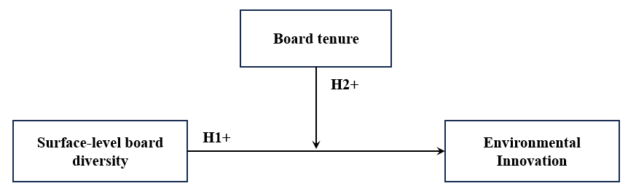

Methods

3.1. Research setting

Two empirical analyses were conducted based on quantitative secondary data extracted from Orbis, Orbis IP, BoardEx, Compustat, and LSEG. The study was placed in the context of severe environmental pressure for firms to eliminate polluting products and to transition to the development of products that prevent environmental harm. The automotive industry was used as a sample, as it was argued to reflect an industry situated in the suggested research context of severe environmental pressure: In 2022, the transportation sector was the second largest worldwide greenhouse gas polluter (Tiseo, 2023), of which the automotive industry accounted for 48% of greenhouse gas emissions (Fleck, 2023). The industry has therefore been severely pressured to transition to the development of more sustainable products (Pohl, 2021), and thus environmental innovation is particularly relevant to the industry. Within the automotive industry, the suggested shift to environmental innovation was reflected by a shift from the development of combustion engine vehicles to the development of battery electric vehicles (Möller & Schaufuss, 2022). Using SIC codes (SIC 371: Motor vehicles and motor vehicle equipment) in Orbis, all firms within the automotive industry were extracted from the database. However, as the study was designed to use data from BoardEx, which restricted data availability to only a few worldwide regions, the sample was extracted for North America, Europe, and the United Kingdom.
The study used two complementary analyses to add confidence to the findings. The patent-based environmental innovation measure (measuring the proportion of electric vehicle patent applications) and the LSEG Environmental Innovation Score (LSEG, 2024) both capture the firm’s orientation towards reducing environmental harm through shifting innovative direction. The dependent variable in Analysis 1 measures the firm’s patent activity in electric vehicles, reflecting direct environmental innovation outputs. The sample for Analysis 1 consisted of 878 firm-year observations of 61 unique firms in the automotive industry across eighteen years (2004-2022). The sample reflected a total of 18.280 patents, of which 4.151 reflected patents for battery electric vehicles, and 14.129 patents reflected patents for combustion engine vehicles. The dependent variable in Analysis 2, ‘Environmental Innovation Score’ captures the firm’s capacity to innovate in ways to reduce environmental impact and create sustainable market opportunities. The sample for Analysis 2 consisted of 1095 firm-year observations of 128 unique firms in the automotive industry, studying five years (2016-2021). The sample of Analysis 2 included the same 61 firms from Analysis 1 but was extended with car manufacturers that did not apply for patents. Together the two dependent variables complement each other by offering a view of both the immediate outputs and the overall strategic capability for shifting toward environmental innovation.

3.2. Data collection

Dependent variables. Analysis 1 used data on patents to study the sample’s innovative direction. Patents are granted for inventions made by firms that are novel, non-obvious, and have a useful application in the industry (Kemp & Pearson, 2008). In addition, patents measure innovation output, whereas, for example, research and development expenses only measure innovation input. By using patents as a measure of innovation, the study follows many prior studies (e.g. Berrone et al., 2013; Chen et al., 2024; Zhao, 2009). This study collected data on patent applications, rather than on patents granted, to avoid survivorship bias and the delay in patent office reviews. Data on patent applications was extracted from Orbis IP for all sample firms. The database provided detailed data on patent classifications and the year of application. In Appendix D, the International Patent Classification (IPC) codes that were used to distinguish the relevant nature of patent applications are presented. Analysis 2 used the variable ‘Environmental Innovation Score’ to study the sample’s innovative direction, which was extracted from LSEG.
Independent and control variables. Data on the variables related to board composition were extracted from BoardEx, whereas the control variables were extracted from both BoardEx and Compustat. Table 3 states the variables that were extracted, their operationalizations, and the database used for extraction.
Matching procedure. The data that was collected from different databases was merged based on several firm identifiers. Data from Orbis and Orbis IP was merged with data from BoardEx by matching BvD codes with ISIN codes in STATA, in which significant loss of data was unavoidable (see Appendix B). Data from Compustat was matched with the existing database based on matching Global Company Key codes with ISIN codes. The accuracy of the matching procedure was verified by controls on whether firms with the same name were matched.

3.3. Measures
The study’s variable measures are described below. Table 3 provides an overview of the operationalization of all variables included in the analysis.

3.3.1. Dependent variables

Analysis 1. Following Chen et al. (2024) and many more studies in strategic management research, the study used a patent-based metric to examine firms' innovation outcomes. To capture the degree to which a firm’s innovative direction is reflected by environmental innovation, the study calculated a ratio that reflects the proportion of EV patent applications, relative to the total of patent applications. The dependent variable was calculated for every firm year, and ranges from 0 to 1, in which a value close to one reflects a high environmental innovation. As the dependent variable was measured as a proportional value, it provided a normalized view of firms’ innovative direction, accounting for the varying absolute numbers of patent applications between firms. The dependent variable was calculated by:
$$Environmental Innovation= \frac{Number of EV Patents}{Number of EV Patents+ Number of CE Patents}$$

Analysis 2. The second analysis was conducted to complement the first analysis and used a different dependent variable. Environmental Innovation Score, calculated by (LSEG, 2024), reflects:
“A company's capacity to reduce the environmental costs and burdens for its customers, and thereby creating new market opportunities through new environmental technologies and processes or eco-designed products”. The measure ranges from 0 to 1, in which a score close to zero indicates poor relative environmental innovation performance, whereas a score close to 1 reflects excellent environmental innovation performance (LSEG, 2024).

3.3.2. Independent variable

Surface-level board diversity captures the heterogeneity in primary board characteristics such as age, gender, and nationality. Surface-level board diversity was calculated based on the Blau (1977) index, as $(1-∑ p_{i}^{ 2})$, in which $p_{i}^{ }$ is the fraction of board members that are part of a specific age group, gender, or nationality. The approach of combining different diversity scores into an aggregated construct follows recent research on board diversity which favors a bundle approach (e.g. Chen et al., 2024; Desender et al., 2016; Schiehll et al., 2014; Zaman et al., 2024) indicating to the effects of the specific demographics of the board that do not operate in isolation but rather interact and reflect together reflect the logic of a group.
The individual diversity scores on age and gender were formerly calculated by use of the Blau (1977) index. Nationality diversity was directly extracted from BoardEx. As the value of each Blau index depends on the number of possible categories, the individual indices were not yet suitable for aggregation. This is shown by the different maximum Blau index scores for gender diversity and age diversity. Gender diversity has two possible categories, whereas age diversity has five possible categories. Therefore, the maximum Blau index of gender diversity is 0.5 (= 1-(0.5² + 0.5²), whereas the maximum Blau index for age diversity is 0.8 (= 1-(0.20² + 0.20²+ 0.20² + 0.20² + 0.20²). To enable aggregation of the three indices, the individual indices were standardized by dividing each indice’s firm-year value by its highest ‘theoretically’ possible index value (Harjoto et al., 2015). For instance, the standardized index value of a 0.6 value in age diversity is 0.75 (=0.6 / 0.8). Subsequently, the individual indices were aggregated into the variable ‘surface-level board diversity’ by calculating the equally weighted average of the three Blau indices. This approach allowed for the observation of similarities and differences among the surface-level board diversity scores between firms (Elms & Pugliese, 2023).

3.3.3. Moderator variable

The study calculated average board tenure to capture the suggested moderation effect by board tenure, and thereby the extent to which directors possess firm-specific knowledge. Average board tenure is calculated as the average number of years that directors serve the board in the focal firm. To define long-tenured boards, the study followed The International Shareholder Services (ISS) that considers board tenures of more than 9 years to be excessive (ISS, 2024). The measure is in line with previous research measuring average board tenure (e.g. He & Yang, 2014). Average board tenure was calculated for every firm-year observation by:

$$Average Board Tenure= \frac{\sum{(Tenure of Each Board Member)}}{Number of Board Members}$$

3.3.4. Control variables

The analysis included control variables to account for relevant alternative firm-related explanations on the dependent variable. Following prior studies on innovation, this study controlled for board size, firm age, research and development intensity, and return on assets (ROA).
Board size was included and measured as the number of directors on the board. Controlling the number of directors on the board was considered critical, as it suggested that larger boards allow for greater variety in demographic board characteristics (Zaman et al., 2024). On the contrary, larger boards could be more sensitive to social categorization and coordination failure (Srikant et al., 2016). Firm age was included and measured as the number of years from incorporation. Certain studies suggest that older firms are more experienced, enabling them to benefit from prior learning (Petruzzelli et al., 2018). However, other studies suggest that older firms are rooted in outdated assumptions and might become victims to inertia (Tschang & Ertug, 2016). Research and development intensity was included and calculated as the ratio between research and development expenditures and total sales. The measure is an indication for input into innovation. Return on assets was included and measured as net income divided by total assets. Return on assets was considered as an indicator of firm performance.

Table 1
Measurement variables
Variable | Code | Operationalization | Database
Degree of environmental innovation | EnvInv | The proportion of EV patents relative to total automotive patents (CE+EV). | Orbis IP
Environmental innovation score | EnvInvScore | Score on the capacity to reduce polluting products, while developing novel environmental technologies and products | LSEG
Surface-level board diversity | SurfaceLevelDiv | Equally-weighted average of three diversity indices on age, nationality, and gender.
Age diversity | AgeDiv | Blau (1977) diversity index based on age groups: < 40, 40-49, 50-59, 60-69, > 80. | BoardEx
Nationality diversity | NatDiv | Proportion on diversity of directors from different nationalities. | BoardEx
Gender diversity | GenDiv | Blau (1977) diversity index based on the proportion of males and females. | BoardEx
Average board tenure | BoardTenure | The sum of board’s tenure / number of directors | BoardEx
Board size | BoardSize | Number of directors that serve on the board | BoardEx
Firm age | FirmAge | Year of observation – year of incorporation | Orbis
ROA | ROA | (Net income / total assets)*100 | LSEG
R&D intensity | RDIntensity | (R&D expenditure/sales)*100 | COMPUSTAT

3.4. Analytical approach
The study performed two regression analyses in SPSS (Analysis 1 and Analysis 2) to test the suggested hypotheses. Both analyses applied a time lag structure of 3 years (t + 3), suggesting that the influence from board composition results in certain innovative directions, captured as patents applications after three years. The lag structure is consistent with recent research by Chen et al. (2024), who studied the relationship between board diversity and conventional innovation.
Analysis 1 used the calculated ratio variable ‘Environmental Innovation’ as the dependent variable and conducted a binary logistic regression analysis in SPSS. Firm-year values tend to reflect either EV patents or CE patents, therefore causing a non-normal distribution (different variable transformations did not yield significant improvement on normality). The dependent variable was therefore computed to two categories; 0 = low environmental innovation, and; 1 = high environmental innovation, where all values below 0.5 were assigned 0 and all values of 0.5 and higher were assigned 1. Furthermore, as the group sizes of the dependent variable were unequal, a cut-off value of 0.2 was selected to improve the predictive accuracy of positive outcomes (EnvInv = 1). The selection process of the cut-off value is stated in Appendix B (Table 15), which also includes a detailed description of the performed processes related to data checks and testing assumptions of logistic regression. Analysis 2 used ‘Environmental Innovation Score’ as the dependent variable and conducted a linear regression analysis in SPSS. A detailed description of the performed data checks and tested assumptions for linear regression analysis is stated in Appendix D. Appendix D also contains a description of the multiple imputation method used to impute missing values for the dependent variable.

3.5. Ethical considerations

The study aimed to set a high standard of integrity by paying thorough attention to detail to assure the accuracy and credibility of the data analysis. The study also recognized its responsibility to report its data and results as honestly, accurately, and as openly as possible. Proper citation and transparency were maintained according to APA 7th edition guidelines.

4. Analysis and results

The study conducted two different regression analyses to explore the influence of board composition. The first analysis (Analysis 1) performed a logistic regression analysis studying the effect of board composition on the likelihood that a firm scores high on environmental innovation. The second analysis (Analysis 2) performed a linear regression analysis that studied the effect of the same phenomenon on the firm’s Environmental Innovation Score. The chapter is structured as follows: First, the descriptive statistics of the two analyses are illustrated and compared. Second, the empirical results of the two analyses are stated separately. Last, the study compared the results of two analyses and concluded on the tested hypotheses.

4.1. Descriptive statistics

Table 2 presents a summary of the descriptive statistics for the dependent, independent, and control variables included in the two analyses. The sample of Analysis 1 included 61 unique firms, located in Europe (30), North America (31), and the United Kingdom (1). Of the European car manufacturers, 33% were located in Germany, and of all North American car manufacturers, 87% were located in the United States. The sample of Analysis 2 included 128 unique firms, located in Europe (63), North America (58), and the United Kingdom (7) between 2016 and 2021. Of the European car manufacturers, 39% were located in Germany, whereas of all North American car manufacturers, 86% were located in the United States. Apart from car manufacturers from Asia (1st China, 3rd Japan, 4th India, and 5th South Korea), the United States (2nd) and Germany (6th), which were well-represented in both samples, are the world’s largest products of motor vehicles (Statista, 2024).
The two dependent variables both reflected an increasing trend over time. For the dependent variable in Analysis 1, measuring the degree of EV patent applications, a mean score of 0.153 was found. The mean score reflected that, on average, 15.3% of the sample firms’ patent applications were patents for electric vehicles. Throughout the analysis, the mean score increased from 13.0% in 2004 to 36.7% in 2021, indicating towards increased environmental orientation in firms. The minimum (0.000) and maximum (1.000) scores on EnvInv indicated that the sample included both firm years in which firms applied for no EV patents at all, whereas other firms only applied for EV patents. Figure 2 presents the sample’s absolute number of patent applications for both the EV and CE category. Remarkable is that the increasing mean scores on EnvInv were to a large extent coincided with significant reductions in CE patent applications, and not perse with increases in EV patent applications (Figure 3). This suggested that the reduction in further development of combustion engine vehicles is a substantial contributing factor in shifting to an environmentally oriented innovative direction. That is, exactly what the dependent variable in Analysis 2 measures. Besides, both graphs indicate that a change in innovative direction particularly occurred between 2016 and 2021. The dependent variable in Analysis 2, ‘Environmental Innovation Score’, measuring the firm’s capacity to reduce environmental harm while creating new market opportunities through new environmental products, identified a similar trend between 2016 and 2021 as the dependent variable in Analysis 1. Figure 4 presents the trend in EnvInvScore between 2016 and 2021, indicating that firms improved their capacity to eliminate polluting products and to develop environmental innovations. However, the presented figures stating mean scores did not yet confirm whether established car manufacturers transitioned to environmental innovation. For instance, it could be that established firms producing combustion engine vehicles lost market share to new entrants producing electric vehicles. Based on Table 4 and Table 5 it was identified that both established firms and new entrants adopted the development of EV patents in their innovative portfolio and that the extent of EV patent applications in these firms increased over time. In essence, the descriptive statistics on the two dependent variables provided insight into the increased adoption of environmental innovation and the shifting innovative direction of car manufacturers to environmental innovation.
Surface-level board diversity was hypothesized to influence environmental innovation in firms. The correlation coefficients (Table 6 and Table 7) indicated that surface-level board diversity has a positive and significant effect on environmental innovation (EnvInv = 0.073; EnvInvScore = 0.200). Across the two samples (Analysis 1 and Analysis 2), surface-level board diversity showed similar mean scores (SurfaceLevelDiv, Analysis 1 = 0.483; SurfaceLevelDiv, Analysis 2 = 0.498). Also, both samples reflected a different mean on surface-level board diversity between the two regions. Car manufacturers from Europe and the United Kingdom scored higher on surface-level board diversity than car manufacturers from North America, which was caused by lower nationality diversity in North American firms. Boards in North American firms are therefore considered more likely to particularly assign domestic directors, compared to boards from Europe and the United Kingdom.
Furthermore, boards in Europe and the United Kingdom reflected shorter average board tenure, while entailing larger boards than boards from North American firms. The correlation coefficients from board tenure on environmental innovation were found to be significant, but rather weak (Analysis 1 = -0.160; Analysis 2 = 0.061). For board size, the correlation coefficients from the second analysis particularly indicated a significant and positive effect on environmental innovation (analysis 1 = not significant; analysis 2 = 0.412). Moreover, in Analysis 1 only two out of four control variables indicated correlation with the dependent variable (FirmAge = -0.082; RDIntensity = 0.088), whereas in Analysis 2 all three control variables showed significant correlation with the dependent variable (BoardSize = 0.412; FirmAge = 0.165; ROA = 0.092). Note that RDIntensity was excluded from Analysis 2 as the variable showed 55.6% missing values, which was considered too high for reliable imputation, also considering it was only a control variable. Also, the Pearson correlation coefficients in Table 6 and Table 7 showed that in both analyses the individual diversity scores (age, gender, nationality) indicate strong and positive correlation, indicating their role in the variable of surface-level board diversity.

Figure 2
Analysis 1: sample’s patent applications (CE and EV patents)

Table 2
Percentage of firms that developed at least one EV patent.
Period: | 2004-2008 | 2018-2022
Established firms (45 firms) | 25% | 70%
Period: | < 2 years of existence | > 2 years of existence
New entrants (16 firms) | 56% | 80%
Note: established firms were active in the industry before 2015 (active in applying for patents)

Table 3
The average degree of EV patents in sample firms
Period: | 2004-2008 | 2018-2022
Established firms (45 firms) | 18.4% | 28.2%
Period: | < 2 years of existence | > 2 years of existence
New entrants (16 firms) | 23.4% | 38.9%
Note: established firms were active in the industry before 2015 (active in applying for patents)

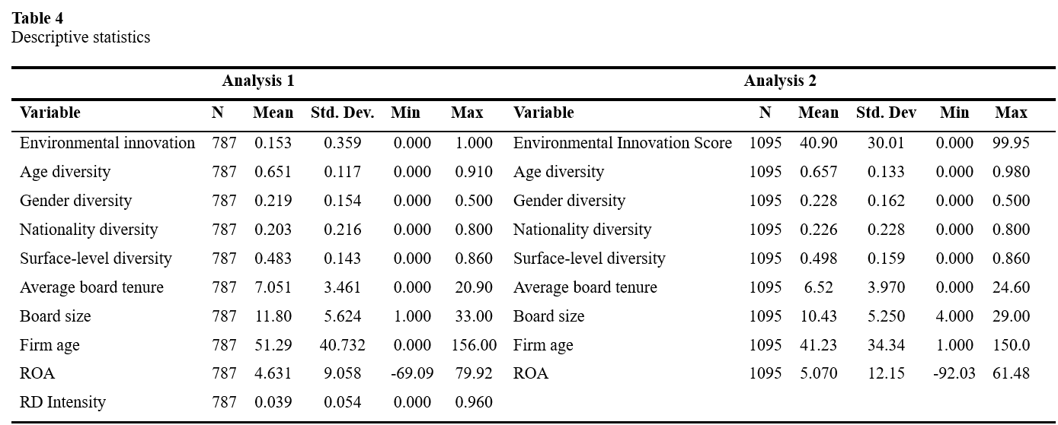

Table 5
Descriptive statistics per region
Analysis 1 | Europe & UK (31+1) |  |  |  |  | North America (29)
Variable | N | Mean | Std. Dev. | Min | Max | N | Mean | Std. Dev. | Min | Max
Environmental innovation | 321 | 0.133 | 0.340 | 0.000 | 1.000 | 466 | 0.165 | 0.372 | 0.000 | 1.000
Age diversity | 321 | 0.703 | 0.114 | 0.000 | 0.910 | 466 | 0.614 | 0.105 | 0.000 | 0.840
Gender diversity | 321 | 0.230 | 0.230 | 0.000 | 0.500 | 466 | 0.212 | 0.143 | 0.000 | 0.500
Nationality diversity | 321 | 0.314 | 0.314 | 0.000 | 0.800 | 466 | 0.127 | 0.174 | 0.000 | 0.700
Surface-level diversity | 321 | 0.546 | 0.137 | 0.000 | 0.857 | 466 | 0.437 | 0.128 | 0.000 | 0.739
Average board tenure | 321 | 5.960 | 2.199 | 0.000 | 11.41 | 466 | 7.831 | 3.901 | 0.100 | 20.9
Board size | 321 | 15.10 | 7.211 | 1.000 | 33.00 | 466 | 9.564 | 2.421 | 4.000 | 19.00
Firm age | 321 | 83.80 | 38.50 | 2.000 | 156.0 | 466 | 29.99 | 27.61 | 1.000 | 107.0
ROA | 321 | 5.276 | 5.862 | -14.2 | 54.7 | 466 | 2.310 | 23.82 | -69.0 | 79.91
R&D Intensity | 321 | 0.041 | 0.021 | 0.000 | 0.127 | 466 | 0.036 | 0.066 | 0.000 | 0.960

Analysis 2 | Europe & UK (63+7) |  |  |  |  | North America (58)
Variable | N | Mean | Std. Dev. | Min | Max | N | Mean | Std. Dev. | Min | Max
Environmental innovation score | 631 | 47.28 | 29.76 | 0.000 | 99.82 | 464 | 32.30 | 23.13 | 0.000 | 99.95
Age diversity | 631 | 0.687 | 0.128 | 0.245 | 0.983 | 464 | 0.608 | 0.127 | 0.000 | 0.936
Gender diversity | 631 | 0.301 | 0.155 | 0.000 | 0.500 | 464 | 0.226 | 0.159 | 0.000 | 0.500
Nationality diversity | 631 | 0.285 | 0.237 | 0.000 | 0.800 | 464 | 0.139 | 0.210 | 0.000 | 0.700
Surface-level diversity | 631 | 0.578 | 0.146 | 0.156 | 0.856 | 464 | 0.418 | 0.145 | 0.000 | 0.790
Average board tenure | 631 | 6.074 | 3.631 | 0.000 | 24.60 | 464 | 7.131 | 4.326 | 0.100 | 19.25
Board size | 631 | 11.71 | 6.309 | 4.000 | 29.00 | 464 | 8.680 | 2.370 | 4.000 | 17.00
Firm age | 631 | 47.56 | 35.02 | 1.000 | 150.0 | 464 | 32.36 | 31.75 | 1.000 | 120.0
ROA | 631 | 6.328 | 8.731 | -41.1 | 61.50 | 464 | 3.337 | 15.66 | -92.0 | 46.17

Table 6
Correlation matrix Analysis 1 (Pearson coefficients)

Variables | 1 | 2 | 3 | 4 | 5 | 6 | 7 | 8 | 9 | 10
1: EnvInv | 1
2: SurfaceLevelDiv | 0.073* | 1
3: AgeDiv | -0.028 | 0.425** | 1
4: GenDiv | 0.046 | 0.754** | 0.005 | 1
5: NatDiv | 0.089* | 0.571** | 0.139** | 0.026 | 1
6: BoardTenure | -0.160** | -0.320** | -0.152** | -0.218** | -0.218** | 1
7: BoardSize | -0.044 | 0.355** | 0.295** | 0.149** | 0.257** | -0.204** | 1
8: FirmAge | -0.082* | 0.170** | 0.146** | 0.085* | 0.101** | 0.089* | 0.186** | 1
9: ROA | -0.049 | -0.029 | 0.007 | -0.042 | 0.014 | 0.209** | -0.010 | 0.044 | 1
10: RDIntensity | 0.088* | 0.075* | -0.014 | 0.010 | 0.154** | -0.219** | 0.057 | -0.230** | -0.027 | 1
Note: ** significant at 1%; * significant at 5%.

Table 7
Correlation matrix Analysis 2 (Pearson coefficients)
Variables | 1 | 2 | 3 | 4 | 5 | 6 | 7 | 8 | 9
1: EnvInvScore | 1
2: SurfaceLevelDiv | 0.200** | 1
3: AgeDiv | 0.059** | 0.491** | 1
4: GenDiv | 0.188** | 0.755** | 0.043** | 1
5: NatDiv | 0.094** | 0.600** | 0.217** | 0.074** | 1
6: BoardTenure | 0.061** | -0.192** | -0.119** | -0.086** | -0.164** | 1
7: BoardSize | 0.412** | 0.357** | 0.290** | 0.224** | 0.177** | -0.024 | 1
8: FirmAge | 0.165** | 0.066** | -0.051** | 0.149** | -0.058** | 0.175** | 0.309** | 1
9: ROA | 0.092** | 0.120** | 0.098** | 0.126** | -0.034** | 0.208** | 0.088** | 0.134** | 1

Note: ** significant at 1%; * significant at 5%.

4.2. Regression results: Analysis 1

A logistic regression was performed as a first analysis to study the effects of board composition on the likelihood that firms have high environmental innovation (EnvInv = 1). Model 1 included all control variables. Model 2 included surface-level board diversity. Model 3 included average board tenure. Model 4 (full Model) incorporated the interaction of surface-level board diversity and average board tenure. The results of the logistic regression are presented in Table 9. Based on the Omnibus test of model coefficients, all four models were found to be statistically significant. From Model 1 to Model 4, the amount of variation explained improved by 6.2%, with model 4 (full Model) explaining 8.5% of the variation in the dependent variable. A remark is made here, as interpretation of the results requires specific attention due to the following concerns: First, the Hosmer and Lemeshow test of model fit was used to assess the overall predictive accuracy from model 1 to model 4. The Hosmer and Lemeshow tests were found to be significant for all four models (p < 0.05), indicating significant differences between actual and predicted values, therefore suggesting poor model fit (Hair et al., 2019). The classification tables, stated in Appendix B, showed that the models’ overall predictive accuracy was rather high (> 75% predicted correctly). However, the models were particularly poor at predicting EnvInv = 1 correctly, whereas predictive accuracy for EnvInv = 0 was very high. Difficulty in predicting EnvInv = 1 was caused by the small absolute number of observations in the category ‘high environmental innovation’ (EnvInv = 0: 667 observations; EnvInv = 1: 120 observations). The issue was strengthened by adding independent variables to the models, which created subgroups with even smaller numbers of observations for the subgroup of the dependent variable (Hair et al., 2019). In addition, the cross-tabulation, stated in Appendix B (Table 16), states the frequency distribution of EnvInv across computed categories of SurfaceLevelDiv. The table indicates that there were levels of SurfaceLevelDiv with counts of zero on EnvInv = 1, indicating to quasi-complete separation (Hair et al., 2019). The described concerns could impose issues in generating accurate parameter estimates and standard errors.
Despite concerns about model fit and predictive accuracy, the logistic regression was performed. In Model 2, the main effect of SurfaceLevelDiv was significant at p < 0.001. The model explained 4.2% (Nagelkerke R²) of the variance in the dependent variable and correctly classified 79.7% of the cases. The odds ratio suggested that a one-unit increase (0.01) on SurfaceLevelDiv results in a 797.5% increase in the odds of EnvInv = 1 (high degree of environmental innovation). It was argued that the extreme parameter estimate on the effect of SurfaceLevelDiv was a result of the model’s issues in predicting EnvInv = 1 (29.2% correctly predicted) and that a one-unit increase in SurfaceLevelDiv is unlikely to result in a 797.5% increase in EnvInv = 1. Hypothesis 1 suggested that SurfaceLevelDiv is positively associated with EnvInv. Based on the empirical results, the suggested direction by the hypothesis was supported, yet the study remains inconclusive on the magnitude of the effect and underlines the strong limitation of poor model fit.
Model 4 (full Model) included the interaction term (SurfaceLevelDiv*BoardTenure) to test hypothesis 2, suggesting that board tenure makes the relationship between surface-level board diversity and environmental innovation more positive. The model was significant at p = 0.015, explained 8.5% (Nagelkerke R²) of the variance in the dependent variable and correctly classified 77.7% of the cases. The model’s constant was not significant at p = 0.396 but was argued not to be of substantive interest, as finding both SurfaceLevelDiv and BoardTenure to be zero in firms is impossible. Overall, the model (p = 0.015; odds ratio = 1.884) indicated a significant interaction effect. Figure 5 presents the interaction plot. The lines representing short- and long-tenured boards suggested that short-tenured boards are slightly stronger positive contributors to the main effect. However, as SurfaceLevelDiv increased, the slope for long-tenured boards became more positive than for short-tenured boards. Overall, the interaction effect was considered weak and therefore hypothesis 2 was rejected.

Figure 3
The relationship between surface-level board diversity and environmental innovation, moderated by average board tenure.

Table 8
Logistic regression analysis of predictors of Environmental Innovation
 | Model 1 |  |  |  | Model 2 |  |  |  | Model 3 |  |  |  | Model 4
 | B | Wald | Odds ratio | SE | B | Wald | Odds ratio | SE | B | Wald | Odds ratio | SE | B | Wald | Odds ratio | SE
Constant | -1.357 | 0.494 | 0.993** | 0.010 | -2.161 | 29.877 | 0.115** | 0.395 | -0.951 | 3.640 | 0.386 | 0.498 | 0.707 | 0.721 | 2.029 | 0.833
BoardSize | -0.016 | 0.686 | 0.984 | 0.019 | -0.036 | 2.842 | 0.965 | 0.021 | -0.043* | 4.096 | 0.958 | 0.021 | -0.042* | 3.867 | 0.959 | 0.021
FirmAge | -.005 | 3.785 | 0.995 | 0.003 | -0.006 | 5.297 | 0.994** | 0.003 | -0.004 | 2.613 | 0.996 | 0.003 | -0.005 | 3.241 | 0.995 | 0.003
ROA | -.007 | 0.499 | 0.993 | 0.010 | -0.006 | 0.369 | 0.994 | 0.010 | 0.002 | 0.031 | 1.002 | 0.010 | -0.001 | 0.013 | 0.999 | 0.010
RDIntensity | 2.571 | 2.785 | 13.076 | 1.541 | 2.492 | 1.470 | 12.091 | 1.470 | 1.522 | 1.068 | 4.583 | 1.473 | 1.184 | 0.598 | 3.266 | 1.530
SurfaceLevelDiv |  |  |  |  | 2.194 | 8.277 | 8.975** | 0.764 | 1.459 | 3.489 | 4.300 | 0.782 | -2.084 | 1.614 | 0.124 | 1.642
BoardTenure |  |  |  |  |  |  |  |  | -0.130** | 12.771 | 0.878 | 0.037 | -0.418** | 10.672 | 0.658 | 0.128
Interaction* |  |  |  |  |  |  |  |  |  |  |  |  | 0.634* | 5.897 | 1.884 | 0.261
Nagelkerke R2 | 0.023 |  |  |  | 0.042 |  |  |  | 0.071 |  |  |  | 0.085
.-2 Log likelihood | 660.473 |  |  |  | 652.107 |  |  |  | 638.511 |  |  |  | 631.859
N | 787 |  |  |  | 787 |  |  |  | 787 |  |  |  | 787
Chi-square | 23.860** |  |  |  | 19.066* |  |  |  | 20.728** |  |  |  | 49.625**
Accuracy | 83.20% |  |  |  | 79.70% |  |  |  | 76.90% |  |  |  | 77.70%
Notes: B: unstandardized coefficient; SE: standard error; N: number of observations.
** significant at 1%; * significant at 5%

4.3. Regression results: Analysis 2

To test the hypotheses, a simple linear regression analysis was performed. Model 1 included all control variables. Model 2 included surface-level board diversity. Model 3 included average board tenure. Model 4 (full Model) incorporated the interaction of surface-level board diversity and average board tenure. As derived from the Adjusted-R² values (Table 5), the explanatory power of the models increased as additional variables were added. From Model 1 (controls only) to Model 4, the adjusted-R2 increase was 0.9%. Considering the multitude of factors known to influence innovation outcomes in practice, the amount of variance explained by the full model (18.2%) was considered meaningful (Hair et al., 2019). Hypothesis 1 suggested a positive relationship between SurfaceLevelDiv and EnvInvScore. The results in Model 2 indicated a positive and significant effect of SurfaceLevelDiv (b = 12.686; p = < 0.001), supporting hypothesis 1. The standardized Beta coefficient for SurfaceLevelDiv was 0.068, indicating that a one standard deviation increase in SurfaceLevelDiv (.159) resulted in a 0.068 standard deviation increase in EnvInvScore (0.068*30 = 2.04). The Adjusted-R² was 0.183, indicating that 18.3 % of the variance in EnvInvScore was explained by Model 2. Hypothesis 2 suggested that as average board tenure increases, the relationship between surface-level board diversity and EnvInvScore becomes more positive. The results in Model 4 (full Model) indicated a positive and significant interaction effect (b = 1.313; p = 0.043). Figure 8 presents the interaction effect. It is shown that, when SurfaceLevelDiv increases, the influence of long-tenured boards becomes significantly more positive than the influence of short-tenured boards. The interaction effect therefore suggested that diverse boards with long average board tenure are associated with high environmental innovation. Therefore, hypothesis 2 was accepted based on the results of analysis 2. In addition, BoardSize (b = 2.134; p = < 0.001) and FirmAge (b = 0.029; p = 0.049) were found to be significant control variables in the full model.

Figure 4
The relationship between surface-level board diversity and environmental innovation, moderated by average board tenure.

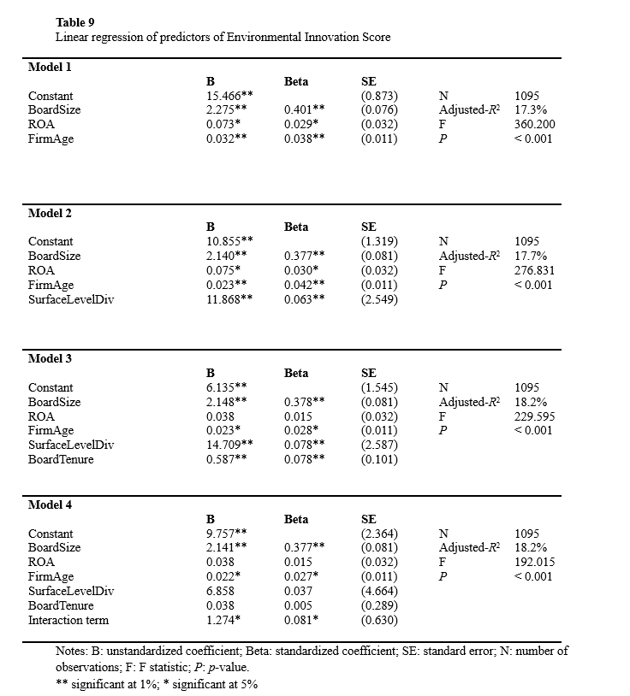

4.4. Comparing the two analyses

The study conducted two complementary regression analyses to add confidence to the hypotheses. Analysis 1 accepted hypothesis 1 based on the significant and positive main effect but did not interpret the results concerning the magnitude of the effect due to issues in generating reliable parameter estimates. Analysis 2 likewise accepted hypothesis 1, based on a significant effect indicating a positive direction. Analysis 2 suggested that a one-standard-deviation increase in SurfaceLevelDiv (0.159) results in a 2.04 increase in EnvInvScore.
Concerning hypothesis 2, analysis 1 found a significant interaction effect but was inconclusive on the specific influence of the moderator (board tenure) on the relationship between surface-level board diversity and environmental innovation. Therefore, hypothesis 2 was initially rejected. However, analysis 2 found a significant interaction effect that indicated to a positive moderation effect, in which diverse boards with long average board tenure are associated with high environmental innovation. Therefore, based on the empirical results in analysis 2 which were based on a larger sample size and models explaining larger amounts of variance, the initial rejection was revised and hypothesis 2 was accepted.

5. Discussion and conclusion

5.1. Theoretical contributions

This study explored the influence of board composition on the degree to which firms transition their innovative direction to the development of environmental innovations. The study specifically aimed to understand how strategic leaders of the firm resolve the tensions imposed by environmental innovation. Therefore, the study was placed in the context of increasing global pressure on firms to eliminate polluting products and to transition to the development of products that prevent environmental harm. The two hypotheses were first tested in Analysis 1, after which Analysis 2 added confidence and direction to the results. First, the study indicates that surface-level board diversity is positively associated with an innovative direction aimed at environmental innovation. The study argues that the benefits of variety in perspectives, expertise, and experiences outweigh the downsides of board diversity, such as social categorization and coordination failure. Therefore, diverse boards are enabled to leverage the variety in perspectives, expertise, and experience into strategic planning, monitoring and advising, and resource allocation related to environmental innovation. Second, the results indicate that average board tenure positively moderates the relationship between diverse boards and environmental innovation. The analysis suggests that, when surface-level board diversity is high, long-tenured boards leverage their firm-specific knowledge to further translate the benefits of board diversity into more pronounced changes toward the board’s envisioned innovative direction.
The study contributes to the literature on board diversity and environmental innovation (e.g. Zaman et al., 2024) and adds nuance to the concept of environmental innovation by capturing both reductions in polluting products and increases in products that prevent environmental harm. Furthermore, the study also sets a direction for explaining the opposing effect of board diversity on two types of innovation (i.e. conventional innovation and environmental innovation). Certain prior studies (Chen et al., 2024; Srikanth et al., 2016) indicate the negative effects of diverse boards on innovation, as these boards become victims of social categorization and coordination failure. Such negative phenomena slow down the board’s decision-making processes and undermine performance on monitoring, advising, and resource allocation. However, in line with other studies (e.g. Zaman et al., 2024; source; source) this study finds positive effects from diverse boards on environmental innovation. The study indicates two possible explanations for these contrary results.
First, one perspective that could explain the opposing effect is the contrasting attributes between the two types of innovation. Environmental innovation requires resources and competencies that are located outside of the firm, and diversity in demographics enables boards to access globally distributed knowledge and resources for innovation projects (Nielsen & Nielsen, 2013) (Thams et al., 2018). Conventional innovation, on the contrary, requires resources and competencies that are located at the core of the firm (Anderson et al., 2014). Therefore, such contrasting requirements suggest that diversity is beneficial for environmental innovation, whilst for conventional innovation its benefits are unclear. Considering that board diversity has the potential to impose social categorization and coordination failure, it is questionable whether there are benefits from board diversity related to conventional innovation that outweigh these negative effects.
Second, social categorization and coordination failure are the consequences of visible aspects of diversity, causing directors to identify with others whom they perceive to be in the same social category while differentiating from others (Anuar et al., 2023). However, this study suggests that the severe environmental pressure for climate action might change social dynamics on the board, creating a larger social category with the goal of resolving climate issues that over couples social groups based on visible aspects of diversity. Such a contextual contingency was not incorporated into the studies by Chen et al. (2024) and Srikanth et al. (2016) who describe the negative effects of board diversity. Nevertheless, no present research confirms the study’s argument, therefore creating an opportunity for future research.
Furthermore, this research contributes to the literature on board tenure and the associated influence of firm-specific knowledge. Long-tenured boards leverage the benefits of diverse boards into more pronounced shifts toward environmental innovation. The study argues that long-tenured directors, who remain motivated and empowered through environmental pressure (Elms & Pugliese, 2023), leverage the advantages of firm-specific knowledge into improved performance on strategic planning, monitoring and advising, and resource allocation. Therefore, an innovative direction aimed at environmental innovation is strengthened by long-tenured boards. The study finds no significant effect of board tenure when board diversity is low. This study’s results are contrary to findings by studies based on traditional agency theory (Berrone & Gomez-Mejia, 2009; Hillman & Dalziel, 2003) that did not place their studies in the context of environmental pressure or did not associate long board tenure with firm-specific knowledge. Somewhat paradoxically, this study argues that, in line with contrary studies, having directors on the board for too long might cause a lack of new perspectives, expertise, and experience, which is considered detrimental to environmental innovation or novel future innovative directions.

5.2. Practical contributions

The study provides important managerial guidance for board composition in firms This research suggests that variety in perspectives, expertise, and experience is a driving force in transitioning the firm’s innovative direction toward environmental innovation and that this variety in perspectives, expertise, and experience is derived from heterogeneity in directors’ demographics. In addition, long-tenured boards with extensive firm-specific knowledge leverage the benefits of diverse boards into more pronounced shifts toward environmental innovation. Therefore, this study suggests that firms should devote special attention to the composition of their boards, assuming these firms aim to respond to environmental pressure for climate action.
First, nominations committees and shareholders should assess whether certain perspectives, expertise, or experience are underrepresented on the board. To shift innovative direction of the firm and to break with existing patterns, the board needs fresh perspectives, challenging views, a broad network of social and international ties and directors that favor the environment. Therefore, the firm’s organs responsible for nomination and election of new directors should seize opportunities to enhance surface-level board diversity on aspects that are underrepresented.
Second, as firms benefit from firm-specific knowledge on boards, the firm should consider the appointment of new directors who have been working in relevant focal firm positions and possess valuable competencies, suggesting that these employees already possess significant firm-specific knowledge. As the accumulation of firm-specific knowledge costs time, assigning experienced top managers to the board could save valuable time in light of increasing climate concerns.

5.3. Limitations and future research

This study has certain theoretical and empirical limitations that also suggest future research opportunities. First, the study only included Western regions (Europe, the United Kingdom, and North America). Analysis of Asia would particularly be an interesting extension of the automotive industry sample, as car manufacturers from Asia are world’s largest electric vehicle producers and ahead in the race to dominate electric vehicle markets worldwide (Statista, 2024). Building on resource-dependency theory, car manufacturers from Asia seem to beat Western firms in the attracting scarce but critical resources, such as lithium batteries, needed for the development of electric vehicles (Lin, 2024). As attraction of resources is a vital responsibility of the board, future research could explore and compare the relationship between board composition and environmental innovation in Asia.
Second, whereas the use of an aggregate measure for the heterogeneity in board demographics is a valuable measure to capture the interaction and logic of a group, it is only a general approximation of the true underlying diversity in boards. Also, by computing the three individual diversity constructs (age, gender, nationality) the study lost significant opportunities for interpretation of individual effects. Furthermore, surface-level board diversity only entails the visible characteristics of the board and therefore future research could study the effect of individual and different dimensions on the firm’s innovative direction. Concerning the empirical analysis, Analysis 1 entails several limitations due to the small sample size and the distribution of the dependent variable. The patent based metric showed high variability between subsequent firm years, because innovation outcomes are only reported when a firm managed to develop an innovation suitable for patenting. Although Analysis 2 was able to account for limitations in Analysis 1, future research is encouraged to further add confidence to the relationship between board composition and shifting innovative direction toward environmental innovation by exploring different measures of innovation outcomes.

5.4. Conclusion

In conclusion, the study provides theoretical insights and empirical evidence on the role of board composition in influencing the firm’s transition toward environmental innovation. By studying the impact of surface-level board diversity, the research shows that diverse boards, characterized by diversity in age, gender, and nationality, are better equipped to navigate the complexities and uncertainties of environmental innovation. Diversity provides the board with a broader set of perspectives, expertise, and experiences, which are critical for addressing the environmental pressures for climate action. Moreover, the study underlines the positive moderating role of long-tenured boards in enhancing the relationship between surface-level board diversity and environmental innovation. The finding suggest that experienced boards effectively leverage their accumulated firm-specific knowledge to support diverse boards in driving substantial shifts toward environmental innovation. These findings challenge the traditional agency perspective on the negative effects of long board tenure and underscores the importance of a nuanced approach to board composition.
The practical implications suggest that firms should focus on increasing surface-level board diversity and ensuring that the board entails sufficient firm-specific knowledge. This combination can help firms to better respond to environmental pressures and drive sustainable transitions. Future research is encouraged to expand the scope of this study and to include different regions, particularly Asia, to further validate these findings, or to explore additional effects of board composition on transitioning to environmental innovation. Overall, this study contributes to the understanding of how strategic leadership at the board influences the firm’s innovative direction towards sustainable transitions.

References.

Albort-Morant, G., Leal-Millán, A., & Cepeda-Carrión, G. (2016). The antecedents of green innovation performance: A model of learning and capabilities. Journal of Business Research, 69(11), 4912-4917. https://doi.org/10.1016/j.jbusres.2016.04.052
Almor, T., Bazel-Shoham, O., & Lee, S. M. (2022). The dual effect of board gender diversity on R&D investments. Long Range Planning, 55(2), Article 101884. https://doi.org/10.1016/j.lrp.2019.05.004
Anderson, N., Potocnik, K., & Zhou, J. (2014). Innovation and Creativity in Organizations: A State-of-the-Science Review, Prospective Commentary, and Guiding Framework. Journal of Management, 40(5), 1297-1333. https://doi.org/10.1177/0149206314527128
Anuar, S. A. S., Hamzah, N., Rahmat, M. M., & Ab Ghani, N. L. (2023). Director's Identifications to Multiple Identities, Social Groups, and Board Oversight Roles: A Scoping Review. Sage Open, 13(3), Article 21582440231194809. https://doi.org/10.1177/21582440231194809
Baker, H. K., Pandey, N., Kumar, S., & Haldar, A. (2020). A bibliometric analysis of board diversity: Current status, development, and future research directions. Journal of Business Research, 108, 232-246. https://doi.org/10.1016/j.jbusres.2019.11.025
Bazel-Shoham, O., Lee, S. M., Munjal, S., & Shoham, A. (2023). Board gender diversity, feminine culture, and innovation for environmental sustainability. Journal of Product Innovation Management. https://doi.org/10.1111/jpim.12672
Beji, R., Yousfi, O., Loukil, N., & Omri, A. (2021). Board Diversity and Corporate Social Responsibility: Empirical Evidence from France. Journal of Business Ethics, 173(1), 133-155. https://doi.org/10.1007/s10551-020-04522-4
Ben-Amar, W., & McIlkenny, P. (2015). Board Effectiveness and the Voluntary Disclosure of Climate Change Information. Business Strategy and the Environment, 24(8), 704-719. https://doi.org/10.1002/bse.1840
Berrone, P., Fosfuri, A., Gelabert, L., & Gomez-Mejia, L. R. (2013). Necessity as the mother of "green' inventions: Institutional pressures and environmental innovations. Strategic Management Journal, 34(8), 891-909. https://doi.org/10.1002/smj.2041
Berrone, P., & Gomez-Mejia, L. R. (2009). ENVIRONMENTAL PERFORMANCE AND EXECUTIVE COMPENSATION: AN INTEGRATED AGENCY-INSTITUTIONAL PERSPECTIVE. Academy of Management Journal, 52(1), 103-126. https://doi.org/10.5465/amj.2009.36461950
Blau, P. M. (1977). Inequality and Heterogeneity: A Primitive Theory of Social Structure. New York: Free Press. https://www.scirp.org/reference/referencespapers?referenceid=1786397
BoardEx. (2023). Global Gender Diversity 2023. https://boardex.com/reports/global-gender-diversity-2023
Boivie, S., Withers, M. C., Graffin, S. D., & Corley, K. G. (2021). Corporate directors' implicit theories of the roles and duties of boards. Strategic Management Journal, 42(9), 1662-1695. https://doi.org/10.1002/smj.3320
Bonini, S., Deng, J., Ferrari, M., John, K., & Ross, D. G. (2022). Long-tenured independent directors and firm performance. Strategic Management Journal, 43(8), 1602-1634. https://doi.org/10.1002/smj.3370
Chamorro-Premuzic, T. (2017). Does Diversity Actually Increase Creativity? Retrieved 24/03/2024, from https://hbr.org/2017/06/does-diversity-actually-increase-creativity
Chen, G. L., Hsu, P. H., Lee, Y. T., & Mack, D. Z. (2024). How Deep-Level and Surface-Level Board Diversity, Formal and Informal Social Structures Affect Innovation. Journal of Management Studies. https://doi.org/10.1111/joms.13040
Cho, H. J., & Pucik, V. (2005). Relationship between innovativeness, quality, growth, profitability, and market value. Strategic Management Journal, 26(6), 555-575. https://doi.org/10.1002/smj.461
Dalton, D. R., Daily, C. M., Ellstrand, A. E., & Johnson, J. L. (1998). Meta-analytic reviews of board composition, leadership structure, and financial performance. Strategic Management Journal, 19(3), 269-290. https://doi.org/10.1002/(sici)1097-0266(199803)19:3<269::Aid-smj950>3.3.Co;2-b
Desender, K. A., Aguilera, R. V., Lópezpuertas-Lamy, M., & Crespi, R. (2016). A CLASH OF GOVERNANCE LOGICS: FOREIGN OWNERSHIP AND BOARD MONITORING. Strategic Management Journal, 37(2), 349-369. https://doi.org/10.1002/smj.2344
Dzhengiz, T., & Niesten, E. (2020). Competences for Environmental Sustainability: A Systematic Review on the Impact of Absorptive Capacity and Capabilities. Journal of Business Ethics, 162(4), 881-906. https://doi.org/10.1007/s10551-019-04360-z
Eisenhardt, K. M. (1989). AGENCY THEORY - AN ASSESSMENT AND REVIEW. Academy of Management Review, 14(1), 57-74. https://doi.org/10.2307/258191
Elms, N., & Pugliese, A. (2023). Director tenure and contribution to board task performance: A time and contingency perspective. Long Range Planning, 56(1), Article 102217. https://doi.org/10.1016/j.lrp.2022.102217
EPA. (2024). Sources of Greenhouse Gas Emissions. https://www.epa.gov/ghgemissions/sources-greenhouse-gas-emissions
Fama, E. F., & Jensen, M. C. (1983). SEPARATION OF OWNERSHIP AND CONTROL. Journal of Law & Economics, 26(2), 301-325. https://doi.org/10.1086/467037
Fleck, A. (2023). Cars Cause Biggest Share of Transportation CO₂ Emissions. Retrieved 24/03/2024, from https://www.statista.com/chart/30890/estimated-share-of-co2-emissions-in-the-transportation-sector/#:~:text=Cars%20and%20vans%20accounted%20for,laden%20mode%20of%20transport%20worldwide.
Gatti, L., Caruana, A., & Snehota, I. (2012). The role of corporate social responsibility, perceived quality and corporate reputation on purchase intention: Implications for brand management. Journal of Brand Management, 20(1), 65-76. https://doi.org/10.1057/bm.2012.2
Grant, R. M. (1996). Toward a knowledge-based theory of the firm. Strategic Management Journal, 17, 109-122. https://doi.org/10.1002/smj.4250171110
Grimpe, C. (2007). Successful product development after firm acquisitions: The role of research and development. Journal of Product Innovation Management, 24(6), 614-628. https://doi.org/10.1111/j.1540-5885.2007.00275.x
Hair, J., Black, W., Babin, B., & Anderson, R. (2019). Multivariate Data Analysis (Eight edition ed.). Cengage.
Hambrick, D. C. (2007). Upper echelons theory: An update. Academy of Management Review, 32(2), 334-343. https://doi.org/10.5465/amr.2007.24345254
Hambrick, D. C., & Mason, P. A. (1984). UPPER ECHELONS - THE ORGANIZATION AS A REFLECTION OF ITS TOP MANAGERS. Academy of Management Review, 9(2), 193-206. https://doi.org/10.2307/258434
Hambrick, D. C., Misangyi, V. F., & Park, C. A. (2015). THE QUAD MODEL FOR IDENTIFYING A CORPORATE DIRECTOR'S POTENTIAL FOR EFFECTIVE MONITORING: TOWARD A NEW THEORY OF BOARD SUFFICIENCY. Academy of Management Review, 40(3), 323-344. https://doi.org/10.5465/amr.2014.0066
Harjoto, M., Laksmana, I., & Lee, R. (2015). Board Diversity and Corporate Social Responsibility. Journal of Business Ethics, 132(4), 641-660. https://doi.org/10.1007/s10551-014-2343-0
He, L. R., & Yang, R. (2014). Does Industry Regulation Matter? New Evidence on Audit Committees and Earnings Management. Journal of Business Ethics, 123(4), 573-589. https://doi.org/10.1007/s10551-013-2011-9
Hill, C. W. L., & Jones, T. M. (1992). STAKEHOLDER-AGENCY THEORY. Journal of Management Studies, 29(2), 131-154. https://doi.org/10.1111/j.1467-6486.1992.tb00657.x
Hillman, A. J., & Dalziel, T. (2003). Boards of directors and firm performance: Integrating agency and resource dependence perspectives. Academy of Management Review, 28(3), 383-396. https://doi.org/10.5465/amr.2003.10196729
Hillman, A. J., Nicholson, G., & Shropshire, C. (2008). Directors' multiple identities, identification, and board monitoring and resource provision. Organization Science, 19(3), 441-456. https://doi.org/10.1287/orsc.1080.0355
Huang, J. W., & Li, Y. H. (2017). Green Innovation and Performance: The View of Organizational Capability and Social Reciprocity. Journal of Business Ethics, 145(2), 309-324. https://doi.org/10.1007/s10551-015-2903-y
ISS. (2024). Top Governance and Stewardship Issues. https://www.issgovernance.com/library/top-governance-and-stewardship-issues-in-2024/
Jain, T., & Jamali, D. (2016). Looking Inside the Black Box: The Effect of Corporate Governance on Corporate Social Responsibility. Corporate Governance-an International Review, 24(3), 253-273. https://doi.org/10.1111/corg.12154
Johnson, S. G., Schnatterly, K., & Hill, A. D. (2013). Board Composition Beyond Independence: Social Capital, Human Capital, and Demographics. Journal of Management, 39(1), 232-262. https://doi.org/10.1177/0149206312463938
Katmon, N., Mohamad, Z. Z., Norwani, N. M., & Al Farooque, O. (2019). Comprehensive Board Diversity and Quality of Corporate Social Responsibility Disclosure: Evidence from an Emerging Market. Journal of Business Ethics, 157(2), 447-481. https://doi.org/10.1007/s10551-017-3672-6
Kearney, E., Gebert, D., & Voelpel, S. C. (2009). WHEN AND HOW DIVERSITY BENEFITS TEAMS: THE IMPORTANCE OF TEAM MEMBERS' NEED FOR COGNITION. Academy of Management Journal, 52(3), 581-598. https://doi.org/10.5465/amj.2009.41331431
Kemp, R., & Pearson, P. (2008). Final Report MEI project about measuring eco-innovation. https://www.oecd.org/greengrowth/consumption-innovation/43960830.pdf
Klarner, P., Probst, G., & Useem, M. (2020). Opening the black box: Unpacking board involvement in innovation. Strategic Organization, 18(4), 487-519. https://doi.org/10.1177/1476127019839321
Kor, Y. Y., & Sundaramurthy, C. (2009). Experience-Based Human Capital and Social Capital of Outside Directors. Journal of Management, 35(4), 981-1006. https://doi.org/10.1177/0149206308321551
Leyva-de la Hiz, D. I., Ferron-Vilchez, V., & Aragon-Correa, J. A. (2019). Do Firms' Slack Resources Influence the Relationship Between Focused Environmental Innovations and Financial Performance? More is Not Always Better. Journal of Business Ethics, 159(4), 1215-1227. https://doi.org/10.1007/s10551-017-3772-3
Lin, C. (2024). 3 Drivers of China's Electric Vehicle Market. Harvard Business Review. https://hbr.org/2024/01/3-drivers-of-chinas-booming-electric-vehicle-market
LSEG. (2024). 2024 ESG Glossary with KPIs. In E. G. w. KPIs (Ed.), Excel: LSEG.
McGuinness, P. B., Vieito, J. P., & Wang, M. Z. (2017). The role of board gender and foreign ownership in the CSR performance of Chinese listed firms. Journal of Corporate Finance, 42, 75-99. https://doi.org/10.1016/j.jcorpfin.2016.11.001
Miller, T., & Triana, M. D. (2009). Demographic Diversity in the Boardroom: Mediators of the Board Diversity-Firm Performance Relationship. Journal of Management Studies, 46(5), 755-786. https://doi.org/10.1111/j.1467-6486.2009.00839.x
Möller, T., & Schaufuss, P. (2022). Road Mobility: Transition to Net Zero. Retrieved 24/03/2024, from https://www.mckinsey.com/capabilities/sustainability/our-insights/spotting-green-business-opportunities-in-a-surging-net-zero-world/transition-to-net-zero/road-mobility
Nadeem, M. (2020). Does board gender diversity influence voluntary disclosure of intellectual capital in initial public offering prospectuses? Evidence from China. Corporate Governance-an International Review, 28(2), 100-118. https://doi.org/10.1111/corg.12304
Nielsen, B. B., & Nielsen, S. (2013). Top management team nationality diversity and firm performance: A multilevel study. Strategic Management Journal, 34(3), 373-382. https://doi.org/10.1002/smj.2021
Pacheco, D. A. D., ten Caten, C. S., Jung, C. F., Ribeiro, J. L. D., Navas, H. V. G., & Cruz-Machado, V. A. (2017). Eco-innovation determinants in manufacturing SMEs: Systematic review and research directions. Journal of Cleaner Production, 142, 2277-2287. https://doi.org/10.1016/j.jclepro.2016.11.049
Patro, S., Zhang, L. Y., & Zhao, R. (2018). Director tenure and corporate social responsibility: The tradeoff between experience and independence. Journal of Business Research, 93, 51-66. https://doi.org/10.1016/j.jbusres.2018.08.033
Petruzzelli, A. M., Ardito, L., & Savino, T. (2018). Maturity of knowledge inputs and innovation value: The moderating effect of firm age and size. Journal of Business Research, 86, 190-201. https://doi.org/10.1016/j.jbusres.2018.02.009
Pfeffer, J., & Salancik, G. (1978). The External Control of Organizations: A Resource Dependence Perspective.
Pohl, T. (2021). How The Automotive Industry Is Driving Toward A Sustainable Future. Retrieved 24/03/2024, from https://www.forbes.com/sites/sap/2021/12/01/how-the-automotive-industry-is-driving-toward-a-sustainable-future/?sh=20b9b1818f1b
Post, C., & Byron, K. (2015). WOMEN ON BOARDS AND FIRM FINANCIAL PERFORMANCE: A META-ANALYSIS. Academy of Management Journal, 58(5), 1546-1571. https://doi.org/10.5465/amj.2013.0319
Rao, K., & Tilt, C. (2016). Board Composition and Corporate Social Responsibility: The Role of Diversity, Gender, Strategy and Decision Making. Journal of Business Ethics, 138(2), 327-347. https://doi.org/10.1007/s10551-015-2613-5
Ren, X. H., Xia, X. X., & Taghizadeh-Hesary, F. (2023). Uncertainty of uncertainty and corporate green innovation-Evidence from China. Economic Analysis and Policy, 78, 634-647. https://doi.org/10.1016/j.eap.2023.03.027
Robeson, D., & O'Connor, G. C. (2013). Boards of Directors, Innovation, and Performance: An Exploration at Multiple Levels. Journal of Product Innovation Management, 30(4), 608-625. https://doi.org/10.1111/jpim.12018
Schiehll, E., Ahmadjian, C., & Filatotchev, I. (2014). National Governance Bundles Perspective: Understanding the Diversity of Corporate Governance Practices at the Firm and Country Levels. Corporate Governance-an International Review, 22(3), 179-184. https://doi.org/10.1111/corg.12067
Shui, X. L., Zhang, M. H., Smart, P., & Ye, F. (2022). Sustainable corporate governance for environmental innovation: A configurational analysis on board capital, CEO power and ownership structure. Journal of Business Research, 149, 786-794. https://doi.org/10.1016/j.jbusres.2022.05.037
Sinigaglia, T., Martins, M. E. S., & Siluk, J. C. M. (2022). Technological evolution of internal combustion engine vehicle: A patent data analysis. Applied Energy, 306, Article 118003. https://doi.org/10.1016/j.apenergy.2021.118003
Srikanth, K., Harvey, S., & Peterson, R. (2016). A Dynamic Perspective on Diverse Teams: Moving from the Dual-Process Model to a Dynamic Coordination-based Model of Diverse Team Performance. Academy of Management Annals, 10(1), 453-493. https://doi.org/10.1080/19416520.2016.1120973
Statista. (2024). Motor vehicle production volume worldwide in 2023, by country. Statista Research Department. https://www.statista.com/statistics/584968/leading-car-manufacturing-countries-worldwide/
Teece, D. J. (2007). Explicating dynamic capabilities: The nature and microfoundations of (sustainable) enterprise performance. Strategic Management Journal, 28(13), 1319-1350. https://doi.org/10.1002/smj.640
Teece, D. J., Pisano, G., & Shuen, A. (1997). Dynamic capabilities and strategic management. Strategic Management Journal, 18(7), 509-533. https://doi.org/10.1002/(sici)1097-0266(199708)18:7<509::Aid-smj882>3.0.Co;2-z
Thams, Y., Kelley, K., & Von Glinow, M. A. (2018). Foreigners in the boardroom: The implications of attitudes toward immigration and conservatism in firms' sub-national context. Journal of Business Research, 91, 8-18. https://doi.org/10.1016/j.jbusres.2018.04.028
Tiseo, I. (2023). Distribution of greenhouse gas emmisions worldwide in 2021. Retrieved 24/03/2024, from https://www.statista.com/statistics/1167298/share-ghg-emissions-by-sub-sector-sector-globally/
Truong, Y., & Berrone, P. (2022). Can environmental innovation be a conventional source of higher market valuation? Journal of Business Research, 142, 113-121. https://doi.org/10.1016/j.jbusres.2021.12.040
Tschang, F. T., & Ertug, G. (2016). New Blood as an Elixir of Youth: Effects of Human Capital Tenure on the Explorative Capability of Aging Firms. Organization Science, 27(4), 873-892. https://doi.org/10.1287/orsc.2016.1067
United Nations. (2016). The Paris Agreement.
United Nations. (n.d.). Causes and Effects of Climate Change. United Nations. Retrieved 15/05/2024 from https://www.un.org/en/climatechange/science/causes-effects-climate-change
Volvo Car Group. (2024). Volvo Cars Annual and Sustainability Report 2023. Retrieved 20/03/2024, from https://vp272.alertir.com/afw/files/press/volvocar/202403050374-1.pdf
Wang, H. C., He, J. Y., & Mahoney, J. T. (2009). FIRM-SPECIFIC KNOWLEDGE RESOURCES AND COMPETITIVE ADVANTAGE: THE ROLES OF ECONOMIC- AND RELATIONSHIP-BASED EMPLOYEE GOVERNANCE MECHANISMS. Strategic Management Journal, 30(12), 1265-1285. https://doi.org/10.1002/smj.787
Wang, T. Y., & Bansal, P. (2012). Social responsibility in new ventures: profiting from a long-term orientation. Strategic Management Journal, 33(10), 1135-1153. https://doi.org/10.1002/smj.1962
Watson, R., Wilson, H. N., Smart, P., & Macdonald, E. K. (2018). Harnessing Difference: A Capability-Based Framework for Stakeholder Engagement in Environmental Innovation. Journal of Product Innovation Management, 35(2), 254-279. https://doi.org/10.1111/jpim.12394
Wijethilake, C., Munir, R., & Appuhami, R. (2018). Environmental Innovation Strategy and Organizational Performance: Enabling and Controlling Uses of Management Control Systems. Journal of Business Ethics, 151(4), 1139-1160. https://doi.org/10.1007/s10551-016-3259-7
Zaman, R., Asiaei, K., Nadeem, M., Malik, I., & Arif, M. (2024). Board demographic, structural diversity, and eco-innovation: International evidence. Corporate Governance-an International Review, 32(3), 374-390. https://doi.org/10.1111/corg.12545
Zhao, X. L. (2009). Technological Innovation and Acquisitions. Management Science, 55(7), 1170-1183. https://doi.org/10.1287/mnsc.1090.1018

Appendix A: Sample characteristics and visualizations

Figure 5
Initial sample’s degree of environmental innovation longitudinal development (dependent variable)

Figure 6
Initial sample’s diversity score longitudinal development (independent variables)

Figure 7
Additional sample’s environmental innovation score development (upper graph), in comparison with initial sample’s dependent variable (lower graph), from 2016 to 2021.

Figure 8
Analysis 2 sample’s diversity score development (upper graph), in comparison with Analysis 2 sample’s independent variable (lower graph), from 2016 to 2021.

Appendix B: Data checks and assumptions (Analysis 1)

Sample size reduction clarification Analysis 1:

- BoardEx restricts data availability to Europe, North America, and the UK. Therefore the rest of the world was excluded from the sample.
- Created a sample in Orbis:
  - Filtered for North America, Europe, and the United Kingdom
  - Filtered for industry: SIC 371: Motor vehicles and motor vehicle equipment, and SIC 375: Motorcycles, bicycles and parts.
  - Resulted in 6.408 unique firms
- Created patent sample in Orbis IP
  - Based on (Sinigaglia et al., 2022), all patent classifications for EV and CE are selected.
  - Patent file data range selected between 2004 and 2022
  - Resulted in 371 unique firms
- Matching Orbis IP (BvD codes) sample firms with complete BoardEx (ISIN codes) universe
  - For only 97 firms, Orbis links the firm’s BvD with an ISIN code.
  - For only 61 firms, BoardEx recognizes the ISIN codes
  - Resulted in a total sample of 61 firms.

Data checks and assumptions testing for logistic regression analysis

This appendix includes the steps that were taken to prepare the data for analysis and to ensure the assumptions for the specific analysis method were met, based on Hair et al. (2019). The intended type of regression analysis for testing this research’ hypothesis was a linear regression analysis. However, after checking the data and the assumptions for linear regression analysis, the decision was made to perform a logistic regression analysis. The steps taken are discussed below.

1: Data checks; measurement scale. All extracted data was prepared in Excel. The excel was subsequently imported to the SPSS software, which was used to perform the empirical data analysis. First, all variables were assigned the right measurement scale (nominal, ordinal, or scale), which was determined by the nature of the variable. In order to perform a regression analysis, all included variables must be of metric measurement level, this assumption was met.
2: Data checks; lag structure. This research used a lag structure on all independent variables in order to capture the effect of board composition on innovation outcomes after three years (t + 3 years). In SPSS, the independent, moderator, and control variables were lagged by performing the following steps: Transform; Compute variable; LAG(‘variable’, 3).
3. Data checks; Missing value analysis. In SPSS, the univariate statistics of the sample were tabulated. Table 10 states the count and the percentage of missing values for each variable involved in the analysis. Both the extent and type of missing data were analysed. As Table 10 shows, the extent of missing values for each variable were generally smaller than 10 percent. Only for the variable AGE, the percentage of missing data was at 10.5 percent. According to Hair et al. (2019), observations with up to 10 percent missing data are acceptable and could be ignored, however such extents of missing observations are suitable for imputation. As the sample size for analysis was rather small (61), the decision was made to impute the missing data in order to remain sample size for the analysis. Mean substitution is a widely used imputation method in which missing values of a variable are replaced by the mean value of that variable, calculated from the valid data that is present. According to Hair et al. (2019), mean substitution is a suitable imputation method for variables with 10% or less missing values. All missing values for the five variables were replaced by its mean, after which no more missing values were present. The univariate statistics after the adjustments are stated in Table 11.

Table 10
Univariate statistics (before adjustment)
Variables |  |  |  | Missing |  | Extremes
 | N | Mean | Std. Dev. | Count | Percent | Low | high
EnvInv | 787 | 0.169 | 0.327 | 0 | 0.000 | 0 | 148
AgeDiv | 787 | 0.650 | 0.117 | 0 | 0.000 | 15 | 0
GenDiv | 787 | 0.219 | 0.154 | 0 | 0.000 | 0 | 0
NatDiv | 787 | 0.202 | 0.221 | 28 | 3.6 | 0 | 0
SurfaceLevelDiv | 787 | 0.482 | 0.142 | 0 | 0.000 | 4 | 1
BoardTenure | 787 | 7.039 | 3.467 | 0 | 0.000 | 0 | 26
BoardSize | 787 | 11.80 | 5.628 | 0 | 0.000 | 1 | 79
FirmAge | 787 | 51.09 | 43.138 | 83 | 10.5 | 0 | 0
RDIntensity | 787 | 3.157 | 70.815 | 8 | 1.000 | 0 | 33
ROA | 787 | 3.448 | 18.821 | 4 | 0.500 | 42 | 27
Table 11
Univariate statistics (after adjustments)
 |  |  |  | Missing |  | Extremes
 | N | Mean | Std. Dev. | Count | Percent | Low | high
EnvInv | 787 | 0.169 | 0.327 | 0 | 0.000 | 0 | 148
AgeDiv | 787 | 0.651 | 0.116 | 0 | 0.000 | 20 | 0
GenDiv | 787 | 0.219 | 0.154 | 0 | 0.000 | 0 | 0
NatDiv | 787 | 0.202 | 0.216 | 0 | 0.000 | 0 | 0
SurfaceLevelDiv | 787 | 0.482 | 0.142 | 0 | 0.000 | 4 | 1
BoardTenure | 787 | 7.052 | 3.467 | 0 | 0.000 | 0 | 26
BoardSize | 787 | 11.81 | 5.628 | 0 | 0.000 | 1 | 79
FirmAge | 787 | 51.24 | 40.732 | 0 | 0.000 | 0 | 0
RDIntensity | 787 | 0.039 | 0.053 | 0 | 0.000 | 0 | 20
ROA | 787 | 4.631 | 9.058 | 0 | 0.000 | 40 | 28

4: Data checks; Extreme value analysis. Table 10 additionally states the extreme high and low observations that were identified by SPSS. It was considered important to detect extreme values, as they could have a disproportionate influence in the regression estimates (Hair et al., 2019). An observation is considered extreme by SPSS when it lays outside the range of Q1 – 1.5*IQR + 1.5*IQR. In order to analyse the defined extreme values, the frequency diagrams and normal distribution charts of the concerned variables were analysed. Table 12 describes how the extreme values were handled for each concerned variable.
Table 12
Extreme value analysis and actions taken
Variable | Are the extreme values acceptable? | What action was taken?
EnvInv | EnvInv ranges between 0 and 1, in which 0 reflects no development of EV patents at all, whereas 1 reflects exclusive development of EV patents. As the mean of EnvInv was .169, firm-year observations close to 1 were considered extreme values by SPSS. However, such scores are considered representative for the automotive sample and were thus considered valid. | None.
ROA | For ROA, a few outliers were detected by analyses of the frequency table. There were three very large negative values (e.g. -314), which are extremely unlikely to occur. | Values outside the range of -100 to 100 were removed, as value outside of this range are unlikely to occur in practice.
RDIntensity | Values above 1.00 are typically not feasible, as it is considered very unlikely for firms to spend more on R&D than they earn on sales. | All values larger than 1.00 were removed and the caused missing values were imputed by use of mean substitution. By this action, the mean value decreased from 3.09 to .039, which was considered much more reliable.

5: Assumptions of linear regression. Before running the intended linear regression model, its assumptions on linearity, normality, and homogeneity must be checked. Considering the normal P-P plot (stated below) that was extracted based on the relationship between SurfaceLevelDiv and EnvInv, the assumption of normality is significantly violated. In order to run a linear regression analysis, the standardized residuals must be distributed closely to the diagonal (Hair et al., 2019). The non-normal distribution of standardized residuals is explained by the non-normal nature of the dependent variable, which is a proportional variable that ranges from 0 to 1. The distribution of observations is very skewed and could not be solved by non-linear transformation methods. Therefore, the normal P-P plot of standardized residuals was analysed and was found comply with a normal P-P plot seen in logistic regression. Also, when considering the nature of the dependent variable, the frequently occurring scores of either 0 or 1 indicate that firms were likely to focus on either development of environmental innovation, or on development of conventional innovation. The decision was therefore made to conduct a logistic regression analysis as the empirical analysis method, as the data better suits this approach. EnvInv was transformed into a binary variable, reflecting either low environmental innovation, or high environmental innovation (0 = Low, 1 = High).

Linearity:

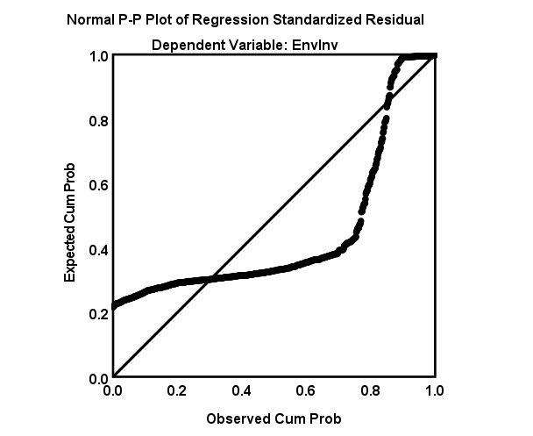

Homoscedasticity:
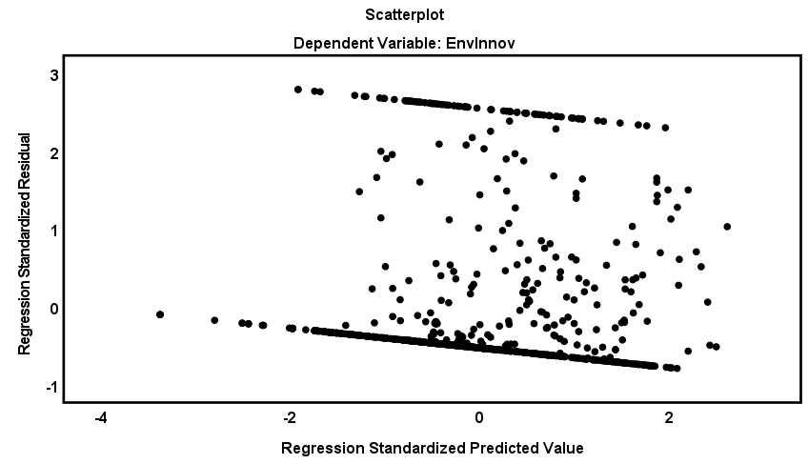

Normality of the dependent variable:

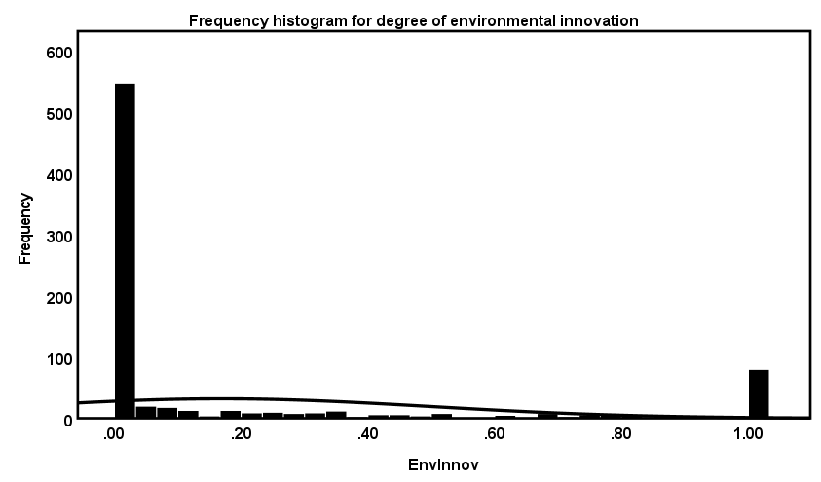

6: Assumptions of logistic regression; Independence of observations. Logistic regression requires each observation to be independent, suggesting that the data-points should not be from any dependent sample design. The independence of this study’s observations were confirmed by the fact that the independent variables measure different constructs, which was confirmed by their operationalizations. Also, the model should have little or no multicollinearity. By extracting the VIF statistic for the variables in the full model (Table 13), the assumption of low multicollinearity was met as all VIF values lay around 1 (values around 10 indicate high multicollinearity).

Table 13
Collinearity statistics
 | Collinearity Statistics
 | Tolerance | VIF
BoardSize | 0.709 | 1.266
FirmAge | 0.804 | 1.243
RDIntensity | 0.843 | 1.186
ROA | 0.925 | 1.081
SurfaceLevelDiv | 0.916 | 1.092
BoardTenure | 0.918 | 1.089

7: Assumptions of logistic regression; Linearity of the logit. In order to test for the assumption of linearity of the logit, a logit variable was computed for SurfaceLevelDiv in SPSS by: (SurfaceLevelDiv*LN(SurfaceLevelDiv)). Both the original independent variable and the logit variable were added in a binary regression model for the analysis. The results are stated in Table 14. The high p-value of the logit variable (0.606) indicated that the interaction term is not statistically significant. An insignificant interaction term suggests that the assumption of linearity of the logit holds true. The original SurfaceLevelDiv variable could therefore be further used in the logistic regression analysis.

Table 14
Statistical output for checking the linearity of the logit assumption

 | B | SE | Wald | df | Sig. | Exp(B)
SurfaceLevelDiv | 1.906 | 1.195 | 2.545 | 1 | 0.111 | 6.728
SurfaceLevelDiv_Logit | -1.665 | 3.227 | 0.266 | 1 | 0.606 | 0.189
BoardTenure | -0.131 | 0.037 | 12.757 | 1 | <0.001 | 0.877
BoardSize | -0.044 | 0.021 | 4.240 | 1 | 0.039 | 0.957
FirmAge | -0.004 | 0.003 | 2.462 | 1 | 0.117 | 0.996
RDIntensity | 1.594 | 1.479 | 1.162 | 1 | 0.281 | 4.923
ROA | 0.002 | 0.010 | 0.042 | 1 | 0.837 | 1.002
Constant | -1.711 | 1.576 | 1.179 | 1 | 0.278 | 0.181

Cut-off value selection process and predictive accuracy

Whenever group sizes of the dependent variable differ in logistic regression analysis, the analyst may want to see if other cut-off values yield better predictive accuracy (Hair et al., 2019). In order to improve accuracy, the aim was to maximize the Youden index to establish a balance between sensitivity and specificity. The study aimed to particularly improve sensitivity, as this is concerned with accuracy of finding true 1’s. In this study, finding true 1’s was considered important as the value reflects high environmental innovation.

Table 15
Predictive accuracy for different cut-off values

Cut-off value | Accuracy | Sensitivity | Specificity | Youden Index
0.5 | 0,849 | 0,017 | 0,999 | 0,015
0.4 | 0,849 | 0,025 | 0,997 | 0,022
0.3 | 0,844 | 0,092 | 0,979 | 0,071
0.2 | 0,762 | 0,433 | 0,822 | 0,255
0.1 | 0,337 | 0,433 | 0,249 | 0,074

Table 16
Cross-tabulation of frequency distribution for EnvInv
 |  | SurfaceLevelDiv
EnvInv |  | 0.0-0.2 | 0.2-0.4 | 0.4-0.6 | 0.6-0.8 | 0.8-1.0
EnvInv | 0 | 20 | 152 | 365 | 125 | 5
EnvInv | 1 | 0 | 30 | 61 | 28 | 1

Appendix C: SPSS statistical output (Analysis 1)

Table 17
Omnibus Tests of Model Coefficients (SPSS)

 |  | Chi-square | df | Sig. |  |  |  | Chi-square | df | Sig.
Model 1 | Step | 10.623 | 4 | 0.031 |  | Model 2 | Step | 8.395 | 1 | 0.004
 | Block | 10.623 | 4 | 0.032 |  |  | Block | 8.395 | 1 | 0.004
 | Model | 10.623 | 4 | 0.033 |  |  | Model | 19.018 | 5 | 0.002
 |  | Chi-square | df | Sig. |  |  |  | Chi-square | df | Sig.
Model 3 | Step | 13.651 | 1 | < 0.001 |  | Model 4 | Step | 6.621 | 1 | 0.010
 | Block | 13.651 | 1 | < 0.001 |  |  | Block | 6.621 | 1 | 0.010
 | Model | 32.669 | 6 | < 0.001 |  |  | Model | 39.291 | 7 | < 0.001

Table 18
Model Summary (SPSS)

 | .-2 Log likelihood | Cox & Snell R Square | Nagelkerke R Square
Model 1 | 661.448 | 0.013 | 0.023
Model 2 | 653.053 | 0.024 | 0.042
Model 3 | 639.402 | 0.041 | 0.071
Model 4 | 632.781 | 0.049 | 0.085

Table 19
Classification Table

 |  |  |  |  |  | Predicted
 |  |  |  |  | EnvInv
 | Observed |  |  |  | 0 |  | 1 |  | % Correct
Model 1 |  | EnvInv |  | 0 |  | 643 |  | 24 |  | 96.4
 |  |  |  | 1 |  | 107 |  | 13 |  | 10.8
 | Overall Percentage |  |  |  |  |  |  |  | 83.4
 |  |  |  |  |  | Predicted
 |  |  |  |  | EnvInv
 | Observed |  |  |  | 0 |  | 1 |  | % Correct
Model 2 |  | EnvInv |  | 0 |  | 593 |  | 74 |  | 88.9
 |  |  |  | 1 |  | 85 |  | 35 |  | 29.2
 | Overall Percentage |  |  |  |  |  |  |  | 79.8
 |  |  |  |  |  | Predicted
 |  |  |  |  | EnvInv
 | Observed |  |  |  | 0 |  | 1 |  | % Correct
Model 3 |  | EnvInv |  | 0 |  | 552 |  | 115 |  | 82.8
 |  |  |  | 1 |  | 66 |  | 54 |  | 45.0
 | Overall Percentage |  |  |  |  |  |  |  | 77.0
 |  |  |  |  |  | Predicted
 |  |  |  |  | EnvInv
 | Observed |  |  |  | 0 |  | 1 |  | % Correct
Model 4 |  | EnvInv |  | 0 |  | 551 |  | 116 |  | 82.6
 |  |  |  | 1 |  | 58 |  | 62 |  | 51.7
 | Overall Percentage |  |  |  |  |  |  |  | 77.9
Note: cut-off value = 0.200

Table 20
Variables in the equation (SPSS)

 |  | B | SE | Wald | df | Sig. | Exp(B)
Model 1 | BoardSize | .-0.007 | 0.010 | 0.494 | 1 | 0.482 | 0.993
 | FirmAge | 2.574 | 1.541 | 2.792 | 1 | 0.095 | 13.120
 | RDIntensity | .-0.005 | 0.003 | 3.798 | 1 | 0.051 | 0.995
 | ROA | .-0.016 | 0.019 | 0.687 | 1 | 0.407 | 0.984
 | Constant | .-1.357 | 0.261 | 27.092 | 1 | < 0.001 | 0.258
 |  | B | SE | Wald | df | Sig. | Exp(B)
Model 2 | BoardSize | .-0.036 | 0.021 | 0.364 | 1 | 0.091 | 0.965
 | FirmAge | .-0.006 | 0.003 | 2.884 | 1 | 0.021 | 0.994
 | RDIntensity | 2.497 | 1.470 | 5.315 | 1 | 0.089 | 12.143
 | ROA | .-0.006 | 0.010 | 2.849 | 1 | 0.547 | 0.994
 | SurfaceLevelDiv | 2.202 | 0.764 | 8.307 | 1 | 0.004 | 9.041
 | Constant | .-2.161 | 0.395 | 29.877 | 1 | < 0.001 | 0.115
 |  | B | SE | Wald | df | Sig. | Exp(B)
Model 3 | BoardSize | .-0.043 | 0.010 | 4.105 | 1 | 0.043 | 0.958
 | FirmAge | .-0.004 | 1.473 | 2.620 | 1 | 0.106 | 0.996
 | RDIntensity | 1.524 | 0.003 | 1.070 | 1 | 0.301 | 4.590
 | ROA | 0.002 | 0.021 | 0.033 | 1 | 0.856 | 1.002
 | SurfaceLevelDiv | 1.464 | 0.782 | 3.503 | 1 | 0.061 | 4.321
 | BoardTenure | .-0.131 | 0.037 | 12.823 | 1 | < 0.001 | 0.877
 | Constant | .-0.951 | 0.498 | 3.640 | 1 | 0.056 | 0.386
 |  | B | SE | Wald | df | Sig. | Exp(B)
Model 3 | BoardSize | .-0.042 | 0.021 | 3.875 | 1 | 0.049 | 0.959
 | FirmAge | .-0.005 | 0.003 | 3.247 | 1 | 0.072 | 0.995
 | RDIntensity | 1.185 | 1.530 | 0.599 | 1 | 0.439 | 3.269
 | ROA | .-0.001 | 0.010 | 0.011 | 1 | 0.915 | 0.999
 | SurfaceLevelDiv | .-2.075 | 1.642 | 1.596 | 1 | 0.206 | 0.126
 | BoardTenure | .-0.419 | 0.128 | 10.652 | 1 | 0.001 | 0.658
 | Interaction* | 0.633 | 0.261 | 5.872 | 1 | 0.015 | 1.884
 | Constant | 0.707 | 0.833 | 0.721 | 1 | 0.396 | 2.029

Appendix D: Data checks and Assumptions (Analysis 2)

This appendix includes the steps that were taken to prepare the data for analysis and to ensure the assumptions for the specific analysis method were met, based on Hair et al. (2019). The intended type of regression analysis for testing this research’ hypothesis was a linear regression analysis. The steps taken are discussed below.
1: Data checks; measurement scale. All extracted data was prepared in Excel. The excel was subsequently imported to the SPSS software, which was used to perform the empirical data analysis. First, all variables were assigned the right measurement scale (nominal, ordinal, or scale), which was determined by the nature of the variable. In order to perform a regression analysis, all included variables must be of metric measurement level, this assumption was met.
2: Data checks; lag structure. This research used a lag structure on all independent variables in order to capture the effect of board composition on innovation outcomes after three years (t + 3 years). In SPSS, the independent, moderator, and control variables were lagged by performing the following steps: Transform; Compute variable; LAG(‘variable’, 3).
3. Data checks; Missing value analysis. In SPSS, the univariate statistics of the sample were tabulated. Table 21 states the count and the percentage of missing values for each variable involved in the analysis. According to Hair et al. (2019), the type and extent of missing values were analysed. First, it was determined that the extent of missing data was too high for some variables, making it likely that the missing data will affect the results. The extent of missing data was considered high when missing data is larger than 10 percent. This was the case for Employees (56.1%) RDIntensity (55%), EnvInvScore (33.4%), and FirmAge (14.9%). As EnvInvScore was the dependent variable in the model (the others were control variables), it was considered most important to impute missing values for EnvInvScore. It was argued that deletion of missing cases was no suitable alternative, as the overall decrease in missing data would negatively affect the sample size. The next step was to diagnose the randomness of the missing data. The Little’s MCAR test was used to determine whether the missing data on EnvInvScore can be classified as MCAR. If no significant differences are found, then the missing data could be classified as MCAR. Little’s MCAR test was significant (p = 0.000) and therefore the missing data on EnvInvScore is MAR. Furthermore, Table 21 states the extent of missing data from EnvInvScore through the years. The following step was the select the imputation method. Considering that the randomness of missing data is MAR, the dataset is suitable for several imputation methods. Hair et al. (2019) state that only model-based methods can provide imputed data which results in unbiased and correct standard errors. Multiple imputation is an imputation method applicable to ‘missing at random’ (MAR) data processes in which several datasets are created with different sets of imputed data (Hair et al., 2019). The method fills in different plausible values derived from distributions of and relationships among observed variables in the dataset, and repeats this process multiple times to avoid creating false precision (NLM). The method does eliminate bias in imputed values, but also provides appropriate measures of standard errors (Hair et al., 2019).
The multiple imputation method was performed by using the ‘Multiple Imputation’ feature in SPSS. The first step was to include the model’s variables in the dialog box, from which the distributions and relationships will be used to predict the missing data. As both Employees (56.1%) and RDIntensity (55%) were found to posses very large extents of missing data, it was argued that these variables were no added value in predicting missing data, and were therefore left out of the multiple imputation method. However, all the other variables from the full model were used. Table 22 states the univariate statistics after the multiple imputation method.
Table 21
Univariate statistics before multiple imputation method
 |  |  |  | Missing |  | Extremes
 | N | Mean | Std. Dev. | Count | Percent | Low | high
EnvInvScore | 759 | 40.526 | 31.872 | 381 | 33.4 | 0 | 0
AgeDiv | 1140 | 0.655 | 0.130 | 0 | 0.000 | 23 | 3
GenDiv | 1140 | 0.247 | 0.163 | 0 | 0.000 | 0 | 0
NatDiv | 1084 | 0.224 | 0.233 | 56 | 4.9 | 0 | 0
SurfaceLevelDiv | 1140 | 0.509 | 0.160 | 0 | 0.000 | 2 | 0
BoardTenure | 1140 | 6.537 | 3.992 | 0 | 0.000 | 0 | 29
BoardSize | 1095 | 10.46 | 5.195 | 0 | 0.000 | 0 | 73
FirmAge | 970 | 38.48 | 35.933 | 170 | 14.9 | 0 | 25
RDIntensity | 513 | 0.042 | 0.039 | 627 | 55.0 | 0 | 31
ROA | 1120 | 2.561 | 23.590 | 20 | 1.8 | 75 | 32

Figure 9
Percentage of missing values on EnvInvScore per year

Table 22
Univariate statistics after multiple imputation method
 |  |  |  | Missing | Extremes
 | N | Mean | Std. Dev. | Count | Percent | Low | high
EnvInvScore | 5211 | 40.908 | 30.006 | 267 | 4.9 | 0 | 0
AgeDiv | 5478 | 0.657 | 0.133 | 0 | 0.000 | 150 | 45
GenDiv | 5478 | 0.228 | 0.162 | 0 | 0.000 | 0 | 0
NatDiv | 5478 | 0.226 | 0.227 | 0 | 0.000 | 0 | 240
SurfaceLevelDiv | 5478 | 0.497 | 0.159 | 0 | 0.000 | 60 | 60
BoardTenure | 5478 | 6.522 | 3.974 | 0 | 0.000 | 0 | 234
BoardSize | 5478 | 10.425 | 5.195 | 0 | 0.000 | 0 | 73
FirmAge | 5478 | 38.192 | 12.154 | 0 | 0.000 | 23 | 282
ROA | 5478 | 5.076 | 35.508 | 0 | 0.000 | 197 | 79

4: Assumptions: Checks from model 1 to model 4
Model 1: Controls
Linearity:
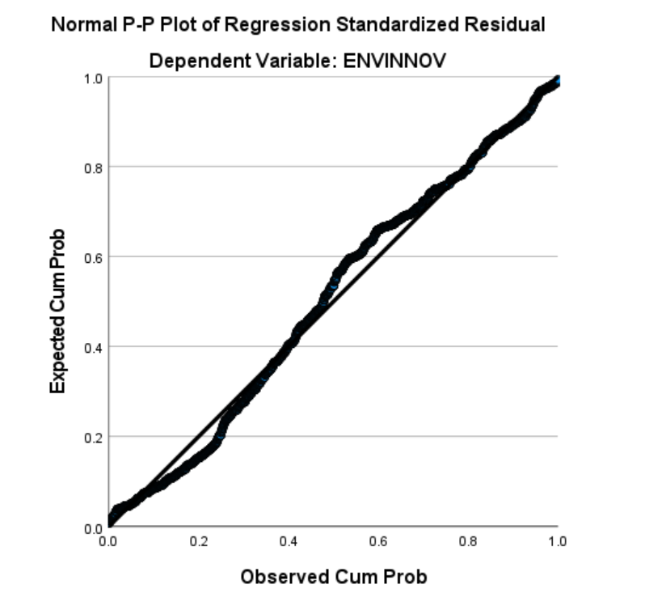

Homoscedasticity:
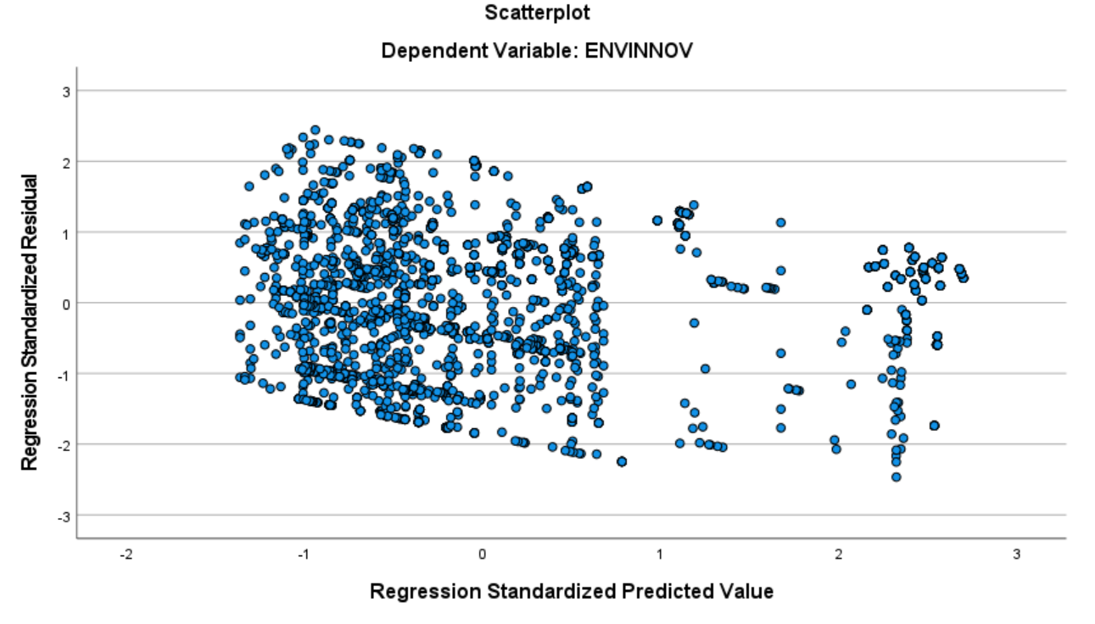

Normality of the dependent variable:
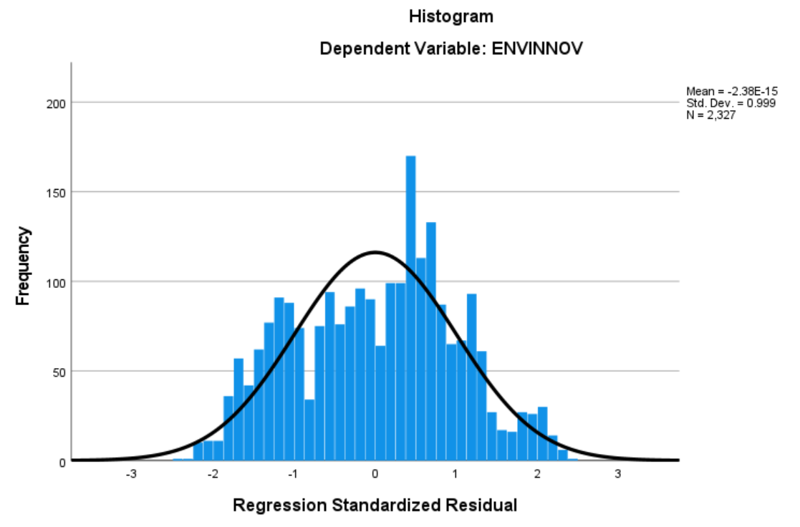

Model 2: Controls + independent variable
Linearity:
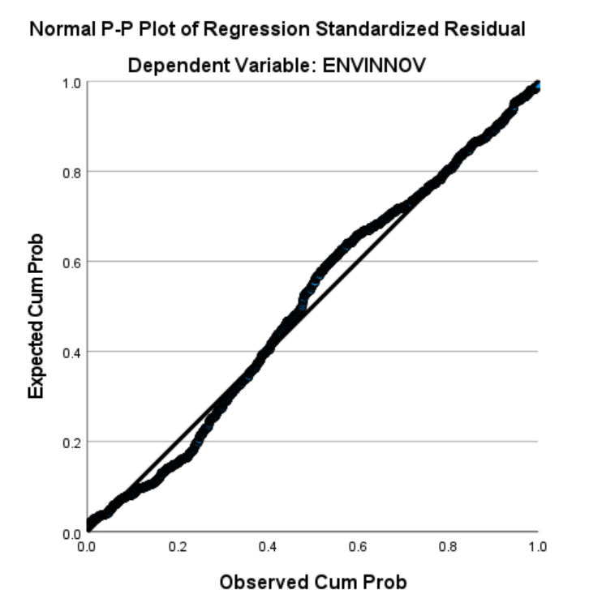
Homoscedasticity:
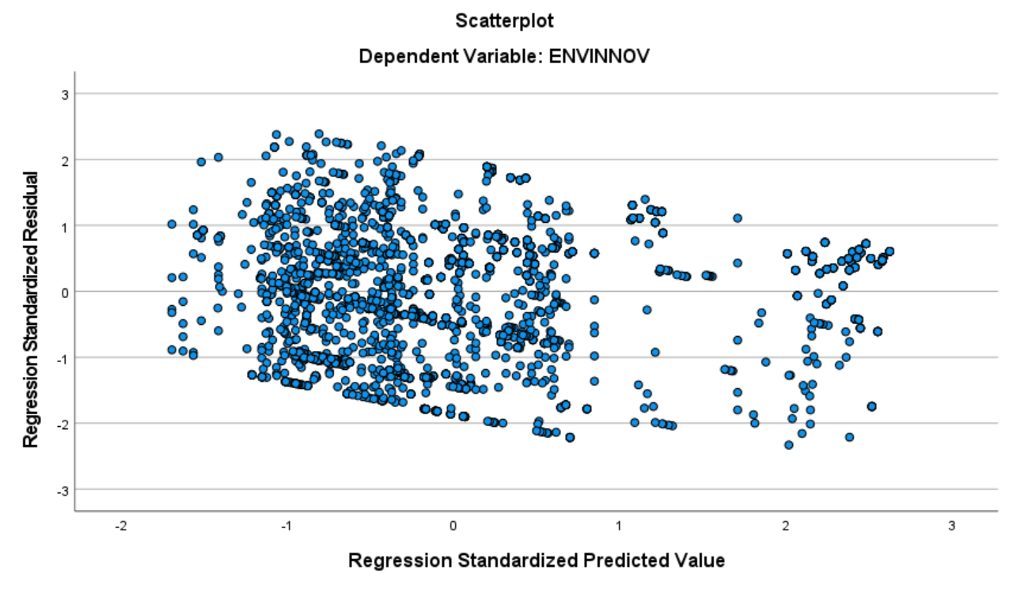

Normality of the dependent variable:
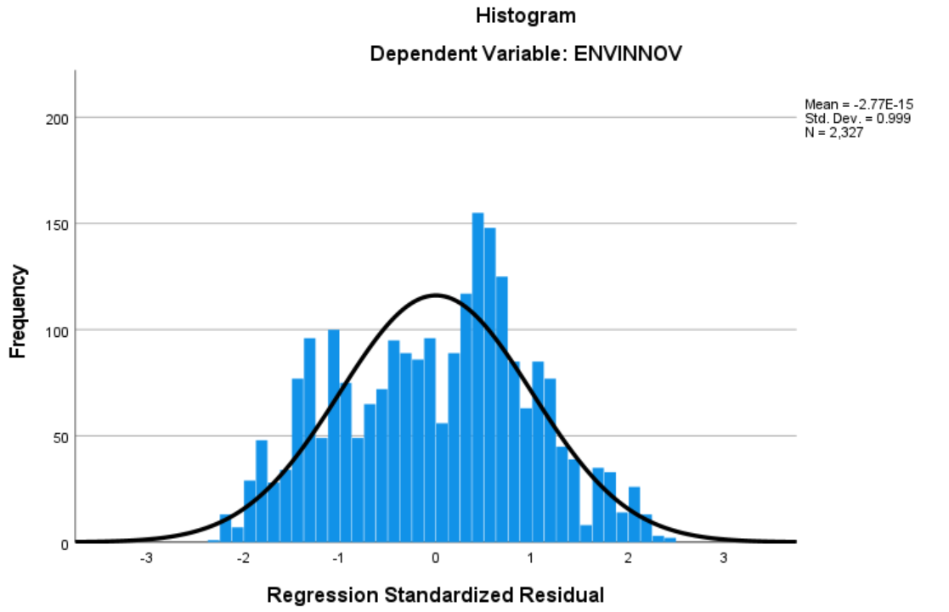

Model 3: Controls + independent variable + moderator variable
Linearity:
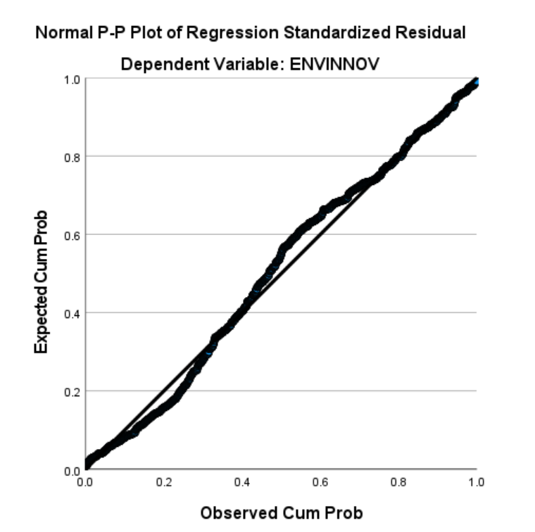

Homoscedasticity:
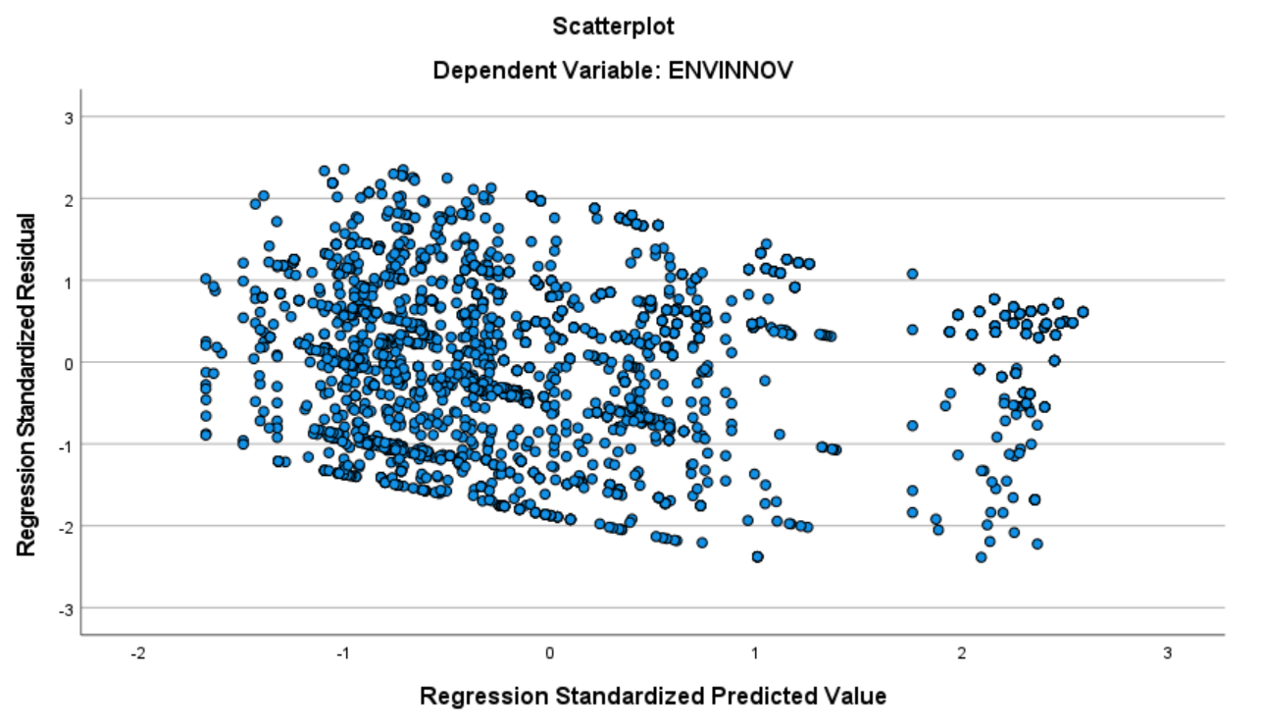
Normality of the dependent variable:
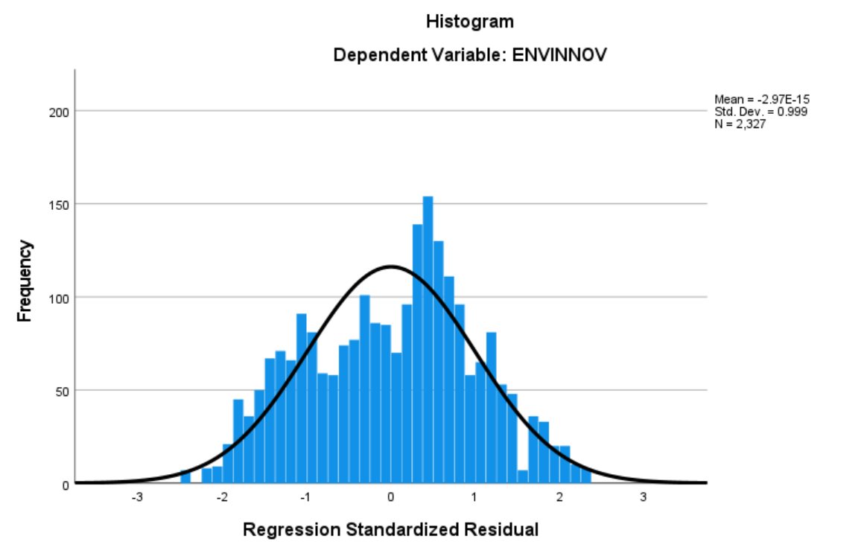

Model 4: Controls + independent variable + moderator variable + interaction term
Linearity:
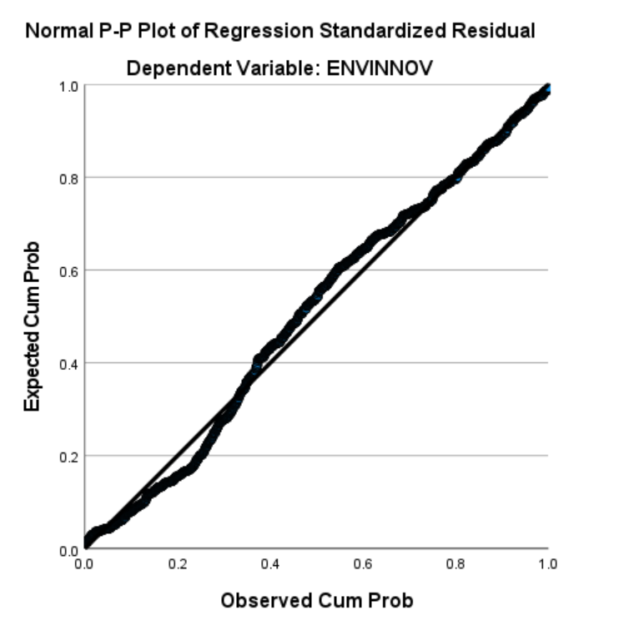
Homoscedasticity:
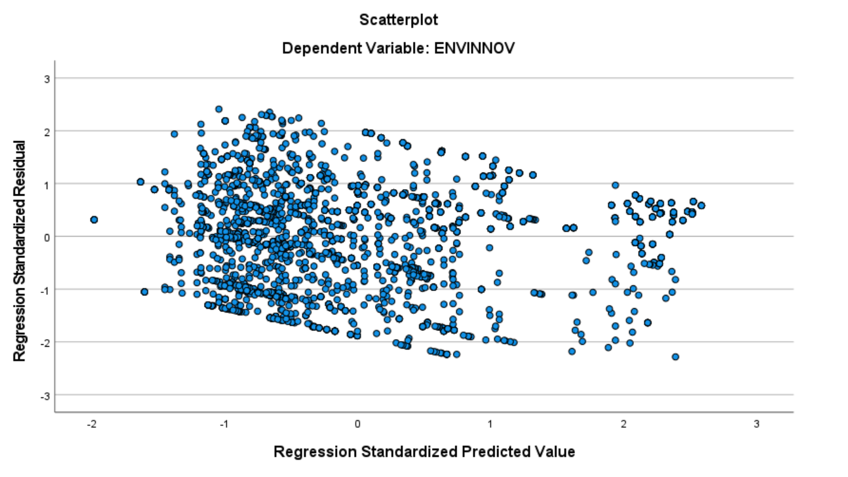

Normality of the dependent variable:
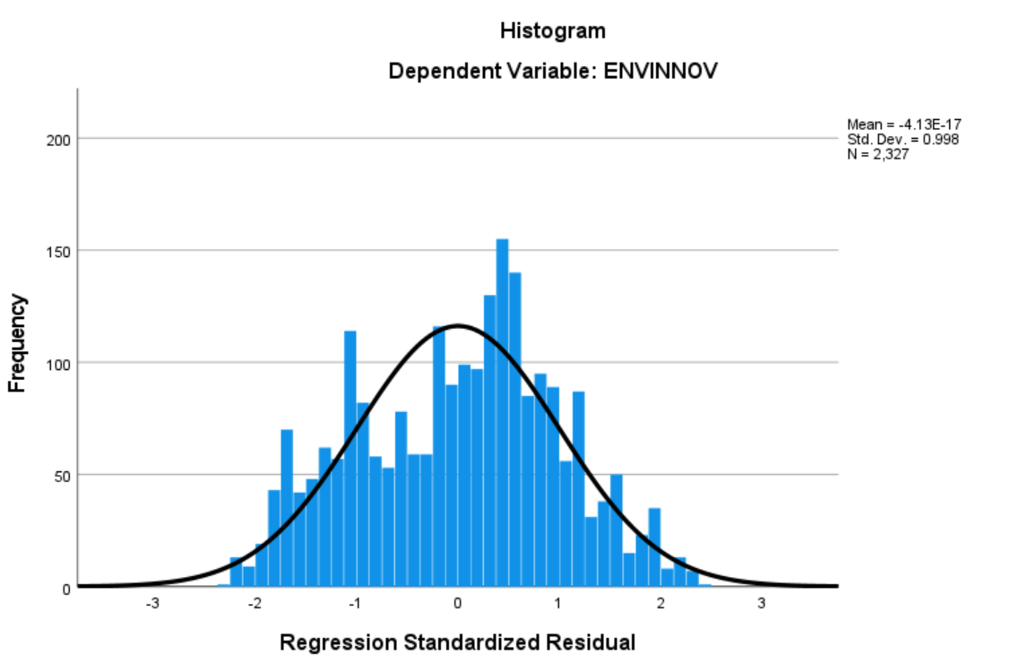

Appendix E: SPSS statistical output (Analysis 2)

Table 23
Model Summary
 | R | R Sqaure | Adjusted R Square | Std. Error of the Estimate
Model 1 | 0.417 | 0.174 | 0.173 | 27.338
Model 2 | 0.417 | 0.177 | 0.177 | 27.284
Model 3 | 0.417 | 0.183 | 0.182 | 27.197
Model 4 | 0.417 | 0.183 | 0.182 | 27.189
Note: Dependent variable: EnvInvScore; Model 1: controls; Model 2: controls + independent; Model 3: controls + independent + moderator; Model 4: full model.

Table 24
ANOVA

 |  | Sum of Sqaures | df | Mean Square | F | Sig.
Model 1 | Regression | 807.212.213 | 3 | 269.070.738 | 360.000 | < 0.001
 | Residual | 3.838.741.081 | 5136 | 747.418
 | Total | 4.645.953.294 | 5139
Model 2 | Regression | 823.350.411 | 4 | 205.837.603 | 276.507 | < 0.001
 | Residual | 3.822.602.883 | 5135 | 744.421
 | Total | 4.645.953.294 | 5139
Model 3 | Regression | 848.360.283 | 5 | 169.672.057 | 229.381 | < 0.001
 | Residual | 3.797.593.011 | 5134 | 739.695
 | Total | 4.645.953.294 | 5139
Model 4 | Regression | 851.385.577 | 6 | 141.897.596 | 191.948 | < 0.001
 | Residual | 2.794.567.717 | 5133 | 739.250
 | Total | 4.645.953.294 | 5139
Note: Dependent variable: EnvInvScore; Model 1: controls; Model 2: controls + independent; Model 3: controls + independent + moderator; Model 4: full model.

Table 25
Coefficients (SPSS)
Note: Dependent variable: EnvInvScore

 |  | Unstandardized B | Coefficients Std. Error | Standardized Coefficients Beta | t | Sig.
Model 1 | Constant | 15.466 | 0.873 |  | 17.724 | < 0.001
 | BoardSize | 2.275 | 0.076 | 0.401 | 30.048 | 0.022
 | ROA | 0.073 | 0.032 | 0.029 | 2.287 | 0.004
 | FirmAge | 0.032 | 0.011 | 0.038 | 2.855 | < 0.001
Model 2 | Constant | 10.855 | -1.319 |  | 8.232 | < 0.001
 | BoardSize | 2.140 | 0.081 | 0.377 | 26.415 | 0.017
 | ROA | 0.075 | 0.032 | 0.030 | 2.378 | 0.002
 | FirmAge | 0.023 | 0.011 | 0.042 | 3.108 | < 0.001
 | SurfaceLevelDiv | 11.868 | -2.549 | 0.063 | 4.656 | < 0.001
Model 3 | Constant | 6.135 | -1.545 |  | 3.971 | < 0.001
 | BoardSize | 2.148 | 0.081 | 0.378 | 26.602 | 0.236
 | ROA | 0.038 | 0.032 | 0.015 | 1.184 | 0.039
 | FirmAge | 0.023 | 0.011 | 0.028 | 2.063 | < 0.001
 | SurfaceLevelDiv | 14.709 | -2.587 | 0.078 | 5.685 | < 0.001
 | BoardTenure | 0.587 | 0.101 | 0.078 | 5.815 | < 0.001
Model 4 | Constant | 9.757 | -2.364 |  | 4.127 | < 0.001
 | BoardSize | 2.141 | 0.081 | 0.377 | 26.489 | 0.233
 | ROA | 0.038 | 0.032 | 0.015 | 1.192 | 0.049
 | FirmAge | 0.022 | 0.011 | 0.027 | 1.970 | < 0.001
 | SurfaceLevelDiv | 6.858 | -4.664 | 0.037 | 1.470 | 0.142
 | BoardTenure | 0.038 | 0.289 | 0.005 | 0.133 | 0.894
 | Interaction term | 1.274 | 0.630 | 0.081 | 2.023 | 0.043

Appendix F: Patent classifications and descriptions

Table 26
Patent classifications and descriptions

Battery electric vehicle patents (EV patents)
IPC | Description
B60L | Propulsion of electrically-propolled vehicles
B60K-001 | Arrangement or mounting of propulsion units in vehicles
B60W-010/08 | Including control of electric propulsion units, e.g. motors or generators
B60W-01/24 | Including control of energy storage means
B60W-01026 | For electrical energy, e.g. batteries or capacitors
Combustion engine vehicles (CE patents)
IPC | Description
F02B | Internal-combustion piston engines; combustion engines in general
F02D | Controlling combustion engines
F02F | Cylinders, pistons, or casings for combustion engines
F02M | Supplying combustion engines in general with combustible mixtures or constituents thereof
F02N | Starting of combustion engines; starting aids for such engines
F02P | Ignition, other than compression ignition, for internal-combustion engines
Note: Relevant patent classifications based on: (Sinigaglia et al., 2022)

Appendix G : Critical reflection

Through the process of writing my master thesis, I have experienced multiple challenging moments, as well as points where everything suddenly seemed to make sense.
First, the process of selecting an interesting and relevant topic was done in a very unstructured way. Although I knew that I was interested in broader topics, such as sustainability, strategic change, and leadership, these broad interests kept me away from diving into one certain direction. Therefore, the first few suggested research directions were considered too general and broad by the supervisor. Ultimately the decision was made to dive into top management teams, and specifically in the composition of their educational backgrounds, to study its influence on environmental innovation. I was satisfied with my research topic and started searching for relevant literature and writing my theoretical framework. However, here I overlooked a serious concern, which would cause problems later on. That is, I did not consider whether sufficient data was available at Radboud’s databases to collect data on top management team’ educational background. In a collaborative session with Radboud’s library team, I found out that no data was available on the topic, forcing me to change to another topic with only a few weeks until the proposal deadline. Thus, what I learned and directly applied in the search for a new research direction, was to check data availability first.
Besides learning from this mistake and considering it as a learning point, it also contributed to my personal growth. That I had to change research direction at such a late point in time came as a surprise, however I am very proud of the way I handled the situation. I managed to translate initial stress into motivation and after working as hard as possible, I was extremely happy to hear that the proposal was accepted in the first attempt.
The motivation that I gained from finishing the research proposal further increased through the remainder of the journey. Moving on to the analysis and results chapter, I experienced new challenges and difficulties. Due to difficulties in building the database, some time extra time had to be spent on this process. Although collaboration with the library team ran effectively, issues in matching the data between Orbis and BoardEx led to significant sample reductions, leaving me with only 61 firms for my initially planned regression analysis. Although this was a serious concern, the previous concern on shifting research direction made this issue feel like it should be possible to overcome. After discussing with Mirjam Goudsmit and Paul Ligthart, it was decided to conduct a second regression analysis. I experienced that, due to the process from data collection to conducting the analysis that I worked on before, I was able to run the second analysis much smoother.
Altogether, I believe that I have been through the process of writing a scientific paper in the exact way as how researchers, such as my supervisor Mirjam Goudsmit, describe the process. What I learned is that every decision made by a researcher has its effects on further research processes. Therefore, knowing what I know now about the involved processes, I would think about the effects of my decisions more extensively before performing certain actions. For example, combining the three diversity scores into one variable is such as decision. With this decision I lost significant interesting data, however afterwards no time was left to reconstruct the variables and perform the analysis all over again.
Ultimately, I have gained knowledge on strategic leadership in organizations, and what is needed for firms to transition to sustainable practices. Such knowledge is considered particularly relevant in today’s dynamic environments facing environmental pressure. Besides, I have improved on critical thinking skills, enabling me to reflect on the context and content of scientific papers.

