Compliance: just a case of fairer decision-making procedures?



Student Jan Dirk Stam
Student number 4364627
Department Nijmegen School of Management
Master specialization Comparative Politics, Administration and Society
Supervisor Dr. P.J. Zwaan
Second reviewer Dr. J.M.M.M. Tholen
Date March 2019

Table of Contents

Table of Contents 2
Chapter 1 – Introduction 3
1.1 Research design 4
1.2 Academic and societal relevance 5
1.3 Structure of the thesis 6
Chapter 2 – Theory 7
2.1 Compliance literature 7
2.2 Procedural fairness 10
2.3 Formulating hypotheses 11
2.4 Summary 13
Chapter 3 – Methodological framework 14
3.1 Research strategy 14
3.2 Data analysis 14
3.3 Conceptualization 16
3.4 Operationalization of the independent variable 16
3.5 Operationalization of the dependent variable 17
3.6 Control variables 22
3.7 Case selection 24
3.8 Data collection 25
3.9 Validity and reliability 26
3.10 Summary 27
Chapter 4 – Analysis 28
4.1 Hypothesis 1a – 1c 28
4.1.1 Descriptive statistics 28
4.1.2 Assumptions 29
4.1.3 Results 32
4.2 Hypothesis 2 37
4.2.1 Descriptive statistics 37
4.2.2 Assumptions 38
4.2.3. Results 38
Chapter 5 – Conclusion 40
References 45
Appendix 1 – assumptions dataset I 50

Chapter 1 – Introduction
“Why [do] governments, seeking to promote their own interests, ever comply with the rules of international regimes when they view these rules as in conflict with . . . their myopic self-interest?” (Keohane, 1984, p. 99).
The citation above represents a major puzzle in the fields of political science and public administration. Governments of member states of an international regime have to act in line with international rules, adhere to international agreements or transpose policies into their domestic law. International agreements, however, are not always in line with state preferences, since they are an agreement between various states with different interests. While member states need to comply with international rules, treaties and agreements, non-compliance might be tempting when these agreements are not in line with their preferences. Compliance is therefore a major concern of international organizations, such as the European Union. The EU spends much time and money to ensure that member states comply with EU law (European Commission, 2011; European Commission, 2017).
A lot of research is dedicated to explaining the degree of compliance with EU policy (e.g. Börzel, 2001; Tallberg, 2002; Mastenbroek, 2005; Angelova et al., 2012; Zhelyazkova et al., 2016). Much of the literature on compliance with EU law, however, focuses on the member states’ favorability with the outcome of the decision-making process (Haas, 1998; Underdal, 1998). The degree of compliance is often explained by the stance of a country towards a policy or law (a directive or regulation in the case of the EU) or by the instrumental ability of a member state to comply with the policy (Tallberg, 2002). However, less attention is dedicated to a third aspect: legitimacy. In as far as legitimacy is considered as a factor, the focus tends to be on the legitimacy a member state attaches to a supranational organization like the European Union and the effect this has on compliance (Börzel et al., 2010). However, next to the legitimacy member states attach to the EU, some suggest that specific decision-making processes also have a degree of legitimacy, which could influence the degree of compliance (Grimes, 2006). If the procedure of decision-making is perceived to be legitimate, or has ‘procedural fairness’, it is argued, this increases the legitimacy of the decision and the degree of compliance.

Goal of this study
The goal of this study is to explore the role of different decision-making procedures, and their degree of procedural fairness, in influencing the degree of compliance of EU member states with the decision taken in that decision-making procedure. This will shed a new light on the explanation of (non-)compliance. The study will investigate the following research question:

Research question:
To what extent does the procedural fairness of EU decision-making procedures affect member states’ compliance with decisions taken during that decision-making procedure?
The sub-questions that are sought to be answered are the following:
- What is the current state of the art in EU compliance literature?
- What does one mean by ‘procedural fairness’?
- Which hypotheses can be formulated about how procedural fairness affects compliance?
- How can compliance and procedural fairness be operationalized and measured?
- Too what extent can the hypotheses be falsified?

Research design
In the theoretical part of the thesis, EU compliance literature will be extensively discussed. The focus will be on the legitimacy aspect of compliance literature. The theory section will also contain a discussion of procedural fairness theory. In order to have a broad view on the theory on decision acceptance, the outcome favorability theory is explained as well.
To answer the research question, a quantitative approach has been chosen in this study, using statistical analysis. The degree of compliance, as measured by the stage of a so-called EU infringement procedure, is the dependent variable. Legal compliance is chosen as the unit of analysis, since practical compliance is often difficult to measure and time-consuming, for example when many directives have to be analyzed. Procedural fairness is the independent variable. It is measured through the number of times a proposal is discussed in the Council or preparatory bodies, whether or not a public consultation took place and which type of consultation was used, and the average weighting of votes of opposing member states in the Council. Various control variables are also included in the analysis.

1.2 Academic and societal relevance
The European Union has been subject of many studies on compliance (e.g. Tallberg, 2002; Mastenbroek, 2005; Angelova, 2012; Zhelyazkova et al., 2016). The EU produces a notable amount of legislation that must be implemented at the member state level. Some compliance theories focus on the ability of a member state to comply (Huber and McCarthy, 2004; Kaeding, 2008; Toshkov, 2008). Non-compliance with EU policy is caused by a lack of competences of the member state. But, there are more explanations for non-compliance. Some scholars suggest that member states do not comply deliberately, because the policy is not in their advantage (Börzel et al., 2010). However, the third type of explanations for non-compliance is as important. Member states may also not comply with a decision because the legitimacy of the European Union is questioned (Börzel et al., 2010). The legitimacy of EU decision-making procedures, so far, is related to the overall legitimacy of the EU. Research, however, shows that fair procedures can also build institutional legitimacy (Hibbing and Theis-Morse, 2001; Grimes, 2006). This has been overlooked in compliance literature and makes this study relevant to the literature on EU compliance.
The EU may be able to enhance its legitimacy for national governments by making decision-making procedures more ‘fair’. For the EU, a study into procedural fairness in relation to compliance may be of much added value, and is therefore societally relevant. In times where the legitimacy of the EU is often questioned, research into the effects of perceived legitimacy as a reason for non-compliance is also socially relevant. Recent research showed that 48% on the European population tends to mistrust the EU (Eurobarometer, 2018). If the governments do not think procedures are fair and therefore fall into non-compliance, this sentiment can trickle down to the population. Moreover, procedures can build the legitimacy of institutions (Grimes, 2006). Although this study focuses on explaining (non-)compliance of states, the results could indicate that the effects of perceived legitimacy of procedures on the acceptance of EU decisions, extend further than to governments alone and may offer a starting point for counteracting EU citizens’ distrust in the union.
To summarize, there is currently a gap in compliance literature; no thorough study into the influence of procedural fairness on compliance has been undertaken. This study enriches the compliance literature by adding and testing possible additional explanations for (non-)compliance. This will lead to a better understanding of the reasons for (non-)compliance, for example by member states of the EU. This is the scientific relevance of this study. The societal relevance of this study lays in the idea that when the reasons for (non-)compliance are better understood, measures to increase compliance can be taken. Reasons for mistrust in the EU might also be found.

1.3 Structure of the thesis
This thesis will be structured as follows. Following this introduction, compliance literature will be extensively discussed in chapter two, with an emphasis on legitimacy theory. The concepts of outcome favorability and procedural fairness will also be discussed and hypotheses are formulated in chapter two. In the third chapter, the used statistical methods of regression analysis and Mann-Whitney test will be explained and hypothesis and variables at play are described. The analysis will take place in the fourth chapter. Finally, in the fifth chapter, conclusions will be drawn. Explanations for the results will be elaborated upon, the research quality reflected on, and recommendations for future research provided.

Chapter 2 – Theory

2.1 Compliance literature
The literature on compliance is broad and extensive. In this thesis, the focus is on compliance related to the European Union. Mastenbroek (2005) provided an overview of this literature. This will be discussed and complemented with more recent literature on the topic. In EU compliance literature and research, three waves can be distinguished: an explorative wave, a ‘goodness-of-fit’ wave and a third wave with a focus the politics of compliance. The most recent literature, finally, focused more on the accession of new Eastern European Member states. After a short introduction of the concept of compliance, these waves are discussed.
After this discussion, various theories about the reasons for compliance will be discussed. The emphasis will be on the theory about legitimacy. The concept of procedural fairness is deepened hereafter. EU decision-making procedures are then discussed, in order to translate the components of procedural fairness to the EU level. The first three (sub-)hypotheses are formulated, based on what will have been discussed in this chapter. After having treated the concept of outcome favorability, the second hypothesis is formulated.
European integration has increased over the past decades. Starting from a collaboration project dealing with coal and steel in the 1950s, the European community has evolved into the ‘law making machine’ as it is known nowadays. Whether EU laws are binding can differ. Regulations, decisions and directives are binding. When a regulation is adopted, it must be entirely applied to the whole EU. A directive is a law that sets out a goal that the member state must achieve. Member states should transpose (legally translate) directives into national law, but can determine how to achieve the goals in these directives themselves. A decision is the type of law that only applies to and is binding for particular actors (for example a specific member state, or companies). Recommendations and opinions are not binding (European Union, 2018).

Three waves
Compliance refers to binding EU laws. Compliance is about implementing EU law in national legislation and execute the law properly. Member states have the option not to comply, or to comply to a lesser extent. Compliance research focuses on explaining the reasons for (non)compliance, mainly with (EU) directives (Mastenbroek, 2005). As mentioned before, compliance literature can be divided in three waves (Mastenbroek, 2005; Treib, 2014). Initially, non-compliance was described as a ‘black hole’, which had to be explored further. The first compliance researchers aimed at analyzing the implementation of a number of directives in twelve member states (Siedentopf and Ziller, 1988), being part of the varied group of scholars in the first wave of compliance research. They had backgrounds in and used literature from implementation research, international relations and legal studies (Mastenbroek, 2005). Non-compliance was mainly explained by legal dependent variables like national constitutional characteristics, the complexity of directives, the range and complexity of existing national laws and national legal culture (Krislov et al., 1986, Collins and Earnshaw, 1992; Mastenbroek, 2005; Treib, 2014). Regarding administrative explanations, it is due to internal co-ordination problems, among other reasons (Krislov et al., 1986). A lack of resources and the inefficiency of domestic institutions is another explanation (Mastenbroek, 2005). A final category of explanations for non-compliance is the political category, with causes varying from a lack of parliamentary co-operation due to non-consultation during the decision-making process to non-complying being politically desirable (Mastenbroek, 2005). In short, this first wave was rather explorative and eclectic.
In the second wave of compliance literature, the goodness-of-fit hypothesis was formulated. This is an influential theory, which states that the fit – or misfit – of European laws with domestic policies determines the degree of compliance (Héritier et al., 2001; Mastenbroek, 2005). ‘Fit’ in this respect refers to the fit between European policy requirements and the existing domestic institutions (Mastenbroek, 2005; Treib, 2014). So, when a European directive is easy to implement in the existing institutional arrangements of a member state, this member state is likely to comply. If the law would cause too much implementation costs, the member state is not likely to comply. This is the rational choice variant of the goodness-of-fit hypothesis. The sociological variant of the goodness-of-fit hypothesis is that adaptation also has normative costs, which determine the degree of compliance (Mastenbroek, 2005). In that case, compliance is more likely when norms, ideas, structures of meaning, or practices of an supranational organization fit to the norms of the member state (Börzel and Risse, 2003). The goodness-of-fit-hypothesis generated a clear theoretical framework, which was missing in the first wave. However, it turned out that this hypothesis does not always predict the outcome well and is too deterministic (Knill and Lenschow, 1998; Haverland, 2000).
The third wave deals with the politics of compliance. Explanations belonging to this wave point more to domestic actors and politics (Treib, 2014). These can use Europe, for example, to reach their own policy goals or to change the status quo (Mastenbroek, 2005). Another finding from the third wave is that the policy context – the degree of national support –, policy salience, and international pressure matter as well (Mastenbroek, 2005). Misfits between European policy and domestic institutions can be overcome by pressures from domestic actors (Börzel, 2003).
It could be argued that another wave in compliance literature arose, which is not mentioned in Mastenbroek’s article. Treib (2014) categorizes this new research field – created after the accession of Central and Eastern European member states – within the third wave. It has been investigated whether there is a difference between those new member states and the other European countries in terms of compliance (Falkner and Treib, 2008; Toshkov, 2008). Post-accession compliance of Central and Eastern European member states is also subject of this new research (Sedelmeier, 2008; Trauner, 2009).

Legitimacy reasons for compliance
As discussed, compliance literature tries to explain (non-)compliance. The three waves highlighted two categories of factors that can determine the degree of compliance: willingness of member states and their administrative capacity. However, this thesis will focus on a third factor: legitimacy (Zhelyazkova et al., 2016), with the other two serving as control variables. In the part below, literature on legitimacy as an explaining factor for compliance will be discussed.
Normative or legitimacy theories distinguish four reasons for compliance. Compliance can, in the first case, emerge from a correspondence between EU-directives and the ‘norm-set’ of the member state (Dimitrova and Rhinard, 2005; Breeman and Zwaan, 2009). The norm-set can differ in terms of policy instruments, styles and objectives and societal norms (Dimitrova and Rhinard, 2005). This comes close to normative fit: in case of a normative misfit, the degree of legitimacy of EU law is low, and non-compliance is likely.
Another theory is that, for some member states, compliance itself is the norm. In this case, member states have a culture of law-abidingness. Their normative opinion is that legislation of a supranational institution should be implemented into national law, and compliance is therefore simply the norm in those member states. Compliance behavior of Nordic member states in the EU is often explained from this stance (e.g. Sverdrup, 2004; Börzel et al., 2010). Whether or not states are Nordic serves in the dataset as control variable. Some scholars plea that such a culture might also be present in post-2004 accession states (Sedelmeier, 2008). A control variable about post-2004 accession countries is therefore also included in the dataset.
The third perspective is about the EU as a legitimate organization. In this situation, compliance is based on a member states’ consideration of the EU as the legitimate actor to make policy on a certain topic (Zwaan, 2012). If they do consider the EU to be a legitimate actor, it is likely that those member states will comply.
The final reason to comply is legitimate decision-making procedures. Actors will assess if the decision is taken in a ‘generally accepted manner’ (Zwaan, 2012; p. 19). The importance of this “procedural legitimacy” of a decision-making process is emphasized by multiple scholars, but not much discussed in the EU (Scott, 1991; Suchman, 1995, Hurd, 1999, March and Olsen, 2004). This thesis will therefor focus on the fourth reason within legitimacy theories.

2.2 Procedural fairness
It seems likely that legitimate decision-making procedures can influence compliance positively. Therefore, it is interesting to elaborate on the concept of procedural legitimacy or what is called ‘procedural fairness’. The fairness of a decision-making procedure – procedural fairness – influences the legitimacy of that procedure, as will be explained below.
A prominent researcher on procedural fairness is the social psychologist Tom Tyler. He found that procedural fairness affects the legitimacy of courts, law enforcement officials and compliance with court rulings. Based on these findings, research on the relation between procedural fairness and the legitimacy of political institutions began. Literature showed that procedural fairness can help create institutional legitimacy (Hibbing and Theiss-Morse, 2001; Grimes, 2006). Similar results were found on institutions like politics and government and more specifically on the Supreme Court in the United States (Ulbig, 2002; Tyler et al., 1996). Different experiments took place to test procedural fairness more empirically. A positive relation was found between the perceived neutrality of authorities and the willingness of people to accept the outcome of their decision (Tyler, 1994).
Scholars have focused on three aspects of procedural fairness: voice, dignity and consistency (Esaiasson et al., 2016). Voice is defined as ‘the opportunity for individuals to present their opinions in the decision-making process’ (Esaiasson et al., 2016; p. 5). The second aspect, dignity is defined as ‘when authorities recognize individuals’ status as respected members of society during interactions’ (Esaiasson et al., 2016; p. 5). Finally, consistency is defined as ‘the absence of systematic bias in the conduct of decision-making authorities’ (Esaiasson et al, 2016; p. 5).
A decision-making procedure would thus be more fair if participants in the procedure had more opportunities to express their preferences (voice), if authorities recognized individuals as respected members of society during interactions in the best way possible (dignity) and if a systemic bias in decision-making is absent (consistency). For the dignity component, the emphasis in this study lies predominantly on the society aspect of the definition, instead of how people are treated during interactions. It is very difficult to measure how society was treated during interactions with the EU, for the following reasons: this is firstly subjective and thus differs between every individual, and secondly, would require contacting many individuals involved in the interactions, which would be difficult. It is easier to measure that society was involved in interactions and that will be done in this study.

2.3 Formulating hypotheses
This theoretical framework showed that a positive relation between the level of procedural fairness and the level of compliance is likely. It also showed that procedural fairness has various aspects. The following hypotheses follow logically from that. In order to have more insight in the process and the exact composition of procedural fairness, the components are split in the first three hypotheses.
H1a:
The higher the level of voice in a decision-making procedure, the higher the level of compliance with that decision.
H1b:
The higher the level of dignity in a decision-making procedure, the higher the level of compliance with that decision.
H1c:
The higher the level of consistency in a decision-making procedure, the higher the level of compliance with that decision.
Formulating these hypotheses is the first step in this study. They will be specified further in the methodological chapter. That deserves thorough attention and discussion, since EU decision making procedures can have many forms. In order to specify the concepts of procedural fairness decently, it is important to understand EU decision-making procedures and their possible differences. The section below will elaborate upon that.

Decision-making procedures in the EU
To adopt EU law, several decision-making procedures are provided in various EU treaties. The most common procedures were previously the co-decision procedure, the consultation procedure and the cooperation procedure (Schulz and Konig, 2000). Since the Treaty of Lisbon, the procedures have been slightly adapted.
Nowadays, the most common decision-making procedure is the ordinary legislative procedure. When this procedure is used, the Commission has the right to propose legislation. The European Parliament and the Council attempt to agree upon the legislation together. If this is not successful, a trialogue is set up to mediate between the Parliament and the Council (European Union, 2018). Significantly, under this procedure, the EP has the power to veto legislative proposals. The ordinary legislative procedure requires the Council to vote on the proposal, either by Qualified Majority Voting (QMV) or by unanimity. The voting procedure that is used depends on the legal basis of the act (Heisenberg, 2005). The difference between voting by QMV or by unanimity in the Council is the first major difference in European decision-making procedures.
QMV has been extended to many decision-making subjects since the Single European Act was signed (Heisenberg, 2005). It is a rather complicated procedure that deserves some explanation. As decided by the Lisbon treaty, it is currently as follows. A proposal is accepted by the Council when 55% of the member states – in practice, this is 16 of the 28 – vote in favor or the proposal. Those countries have to cover 65% of the European population (European Council, 2017). However, member states have an option to block the proposal, called the ‘blocking minority’. If at least four members of the Council which together include 35% of the European population vote against, the proposal is rejected. This is a bias in favor of bigger member states, since smaller member states will never be able to block a proposal, simply because they will never reach the 35% population. This procedure entered into force on the 1st of November 2014. QMV was already introduced in the treaty of Nice, but these QMV rules were slightly different (Devaney and Poptcheva, 2014). According to some scholars, the power of the Commission has increased by the introduction of QMV, because not every member state has to agree with the proposal (Schulz and Konig, 2000).
One of the European special decision-making procedures is the consultation procedure. The European Parliament can only advise the Council on topics in this case. The second special procedure, the agreement procedure, gives more power to the European Parliament. In that case, the EP has to agree, put has no power to amend legislation. This used to be named the cooperation procedure (Schulz and Konig, 2000).
Since the co-decision procedure is most often used, this paper will focus on that procedure, its fairness and its impact on compliance with the legislation that is produced via this procedure. However, differences are still possible within this procedure. Therefore, the fairness of a procedure can also differ.

Outcome favorability
There is much debate about how procedural fairness interacts with other explaining factors, in particular outcome favorability (Gangl, 2003; Grimes, 2006; Esaiasson, 2010; Visschers and Siegrist, 2012; Esaiasson et al., 2012). Outcome favorability is about the willingness to accept a decision (Esaiasson et al., 2016); it is defined as ‘the degree to which a decision coincides with an individual’s preference’ (Esaiasson et al., 2016; p. 2). Outcome favorability is a predictor for decision acceptance and compliance, as is also found in EU compliance literature. Member states are more likely to comply when they favor the policy outcome (Mastenbroek, 2005). This has been studied extensively, in particular in third wave studies. So, outcome favorability – on state level – can determine an EU state’s degree of compliance.
The effect of procedural fairness on compliance would be especially visible when a member state does not favor the outcome of a certain decision-making procedure. Non-compliance would then be expected, from a ‘favorability’ / ‘willingness’-perspective. A high degree of procedural fairness could however lead to compliance, following the reasoning behind hypothesis 1. The effect of procedural fairness on compliance would be demonstrated convincingly in a case where the outcome favorability is low, the procedural fairness is high and the member state does comply.
This leads to the second hypothesis.
H2:
Member states who are against a certain directive for outcome reasons, are more likely to comply with that directive if the decision-making process was fair, compared to member states who are against a certain directive that had a less fair decision-making procedure.
The first hypotheses split the three components of procedural fairness. This hypothesis does not, because it focuses on the comprehensive level of procedural fairness – when all aspects are included. A member state could perceive a procedure as fair, even when one of the components would be low. An example makes this clearer: a process can still considered to be fair if voice and consistency are high, but dignity is low. Moreover, the first hypothesis already provides insight in the influence of the various components on compliance. Splitting the components therefore makes no sense for this hypothesis.
These hypotheses will be guiding the research that follows. In the conclusion, these hypotheses will be discussed again and conclusions will be drawn on whether they should be rejected or not.

2.4 Summary
In this chapter, an overview of compliance literature was provided. Hypotheses were formulated after discussion of the concepts of procedural fairness and outcome favorability. EU decision making procedures were discussed as well, in order to be able to specify the hypotheses further in the next chapter.

Chapter 3 – Methodological framework

In the previous chapter, the concept of procedural fairness and its components voice, dignity and consistency were elaborated upon. The legitimacy explanation for (non-)compliance was highlighted and it was made clear that fairness of decision-making procedures determines this legitimacy. Hypotheses were formulated in the final part, after EU decision-making processes were discussed.
This section is devoted to the methodology of this study and hence builds on choices made in the theoretical framework. All choices regarding methodology will be explained. This section thus contains information about the variables, the operationalization, the research units, a discussion about the up- and downsides of the statistical methods and an evaluation of the validity and reliability of the results.

3.1 Research strategy
In order to discover the relation between procedural fairness and compliance, this study investigates the influence of decision-making procedures on compliance, and more specifically, the fairness of these procedures. The first hypothesis will be tested by using multiple regression analysis, with 615 cases of (non-) compliance with 22 directives in the dataset. Decision-making procedures within the EU can vary in fairness. By coding 22 decision-making procedures on several ‘fair’ components, the ‘fairness’ of a certain decision-making procedure can be determined.
The second hypothesis will be tested by the Mann-Whitney test, but only with the 17 cases of (non-)compliance with 10 directives in the dataset where member states voted against a proposal for a directive in the European Council.

3.2 Data analysis

Regression analysis
In this thesis, regression analysis will be used to test the first hypotheses. In the section below, it is explained why regression analysis is best suited for these hypotheses.
Regression analysis is used to show a correlation between two variables, producing the regression coefficient that shows the effect of the independent variable on the dependent variable (Pollock, 2011). Regression analysis is also able to produce a coefficient that estimates to what extent the independent variable is able to explain the dependent variable, namely the R-square (Pollock, 2011). However, the direction of the relation also matters. Regression analysis can discover this ‘causal arrow’ by testing the correlation between two variables and its direction, for example between procedural fairness and compliance (Lewis-Beck, 1995).
In social sciences, it is not likely that a relation between factors is completely linear. This is also true for the relation between procedural fairness and compliance. Therefore, the error term matters. The error is the difference between the observed value and the predicted value (Lewis-Beck, 1995). This shows the variance in the correlation. The prediction error is calculated as the sum of the squares of the individual errors (Lewis-Beck, 1995). For various regression lines, this technique can be applied. The line with the smallest value, the least squares¸ predicts the relation best. The intercept is a constant line, which gives the predicted value for Y when X = 0 (Lewis-Back, 1995). The difference in Y, when X goes up with one, is the slope. Based on the slope, interferences about the relation can be made.
So, in this research design, multiple dependent variables predict the independent variable. This is called a multiple regression analysis (Pollock, 2011). The process is then named ordinary least squares (OLS) regression. An OLS regression model with multiple dependent variables has the following equation.
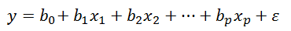
In this equation, is the intercept, 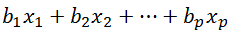 represent the slope and is the error term.
The interpretation of the coefficients is as follows. The significance of a relationship depends on the alpha, which usually has a value of 0.05. Coefficients below this value indicate that the variables are likely to be correlated. Significance can be determined with the t-score and a t-table. The critical t-value depends on the degree of freedom, which is calculated as N-2 (Lewis-Beck, 1995). In this research design, the degrees of freedom would be 613, since the number of cases is 615. The critical t-value then would be 1.964 (Lewis-Beck, 1995). If the t-score is higher than this critical value, the null hypothesis – which states that there is no relation between X and Y – can safely be rejected. If this t-score is lower than the critical t-value, the null hypothesis cannot be rejected.
If the value of the R-square is 1.0, the regression includes all the variation. This means that the independent variable(s) predict the dependent variable perfectly. On the contrary, if value of the R-square equals 0.0, there is no relation between X and Y (Lewis-Back, 1995). So, the R-square measures the ‘goodness-of-fit’ of the variables.

Mann-Whitney test
The dataset for the second hypothesis only counts 17 cases of (non-)compliance, the number of times a member state voted against a directive. This is too low to run a multiple regression analysis, because its assumptions will be violated. A better option is the Mann-Whitney test, named after the two scholars who invented it (1947). This test is suitable for eight cases at least and can be used for not normally distributed data. In an ideal situation, both groups have an equal size (Fay and Proschan, 2010). The low number of cases does, however, influence the generalizability of the results. The test compares two groups and analyses if they differ significantly, in this study in terms of compliance (Nachar, 2008).
The assumptions will be discussed in the analysis.

3.3 Conceptualization
The main independent variable (X) in this research is the ‘procedural fairness of EU decision-making processes’. In the theoretical framework, it has been conceptualized in the three components: voice, consistency and dignity.
The dependent variable (Y) is compliance. This is defined as ‘compliance with rules or decisions of governing authority’.

3.4 Operationalization of the independent variable
The independent variable, compliance is measured as follows. In case of non-compliance, the Commission can start an infringement procedure to urge or punish a member state to comply. A decision to start an infringement procedure can be found in the database on infringement decisions. A formal infringement procedure has different stages. To notify a member state that is non-compliant, the Commission sends a letter of formal notice. This indicates the start of an infringement procedure. The second step is that the Commission issues a reasoned opinion to the member state, explaining why the country is non-compliant with EU law. After that stage, the Commission can decide on a referral to the European Court of Justice. The Court, in the end, is able to impose (financial) penalties (European Commission, 2018). The further the infringement procedure is taken, the heavier the non-compliance of a member state.
So, the degree of compliance can be measured by the stage of an infringement procedure. The variable is measured at ordinal level, because a higher value means more non-compliance, but differences between values are not equal. The table below shows the stages of the infringement procedure and how they are measured in a structured manner. It is important to note that compliance is measured negatively: the higher in the infringement procedures, the less compliance.
Table 1: The different stages of the infringement procedure and the degree of non-compliance
Compliance phase | Value (x)
Case open | 1
Formal notice Art. 258 TFEU 1 | 2
Reasoned opinion Art. 258 TFEU | 3
Referral to Court Art. 258 TFEU - 260(3) TFEU | 4
Formal notice Art. 260 TFEU | 4 or 5
Referral to court Art. 260 TFEU | 6 and higher

To test the second hypothesis, data on compliance in 17 cases – 17 decision-making procedures in which (a) member state(s) voted against a directive – was drawn from the first dataset.
3.5 Operationalization of the dependent variable
It is difficult to operationalize procedural fairness, since fairness is subjective. As it is impossible to measure this subjectivity for this research, objective measures will be used as a proxy for this. Possible indicators will be discussed in depth for that reason. First, the aspects of procedural fairness are repeated, including their definition. Choices are made and explained later on in this chapter.

Possible indicators
The first component of procedural fairness is voice, defined as ‘the opportunity for individuals to present their opinions in the decision-making process’ (Esaiasson et al., 2016; p. 5). It is important to look for measurable manifestations of input moments for representatives of member states.
There are a number of possible indicators for this aspect. Some indicators are country-specific, some indicators vary per decision-making procedure.
- The number of times the proposal is discussed in the Council or in preparatory bodies.
A proposal of the Commission can be discussed multiple times, in the Council or in preparatory bodies. These ‘preparatory bodies’ are not further defined in EUR-Lex, but this is probably about the various Council working parties dealing with the proposal and COREPER I or II. For the member states, this offers an opportunity to present their opinion on the topic. In short, the more times a proposal is discussed in the Council, the more opportunities member states have to express their opinion.
- Speaking time per member state
Another option to test this component of procedural fairness is speaking time of the members of the Council. This might be difficult, because most of the deliberations have not been made public.
The second component of procedural fairness is dignity, defined as ‘when authorities recognize individuals’ status as respected members of society during interactions’ (Esaiasson et al., 2016; p. 5). For this, manifestations of the recognition of representatives of society should be taken into account, because being treated as a respected member of society clearly comes forward in the definition.
- Technical procedure
When the Commission decides that a certain proposal is technical, experts are obligatorily consulted (European Union, 2018). One could make the argument that involvement by experts increases input by society, for two reasons. Firstly, the experts are part of that society. Secondly, experts will advise about the consequences for society. The downside of this operationalization is that experts could be biased, or that they determine their opinion based on individual preferences or interests. This variable would be dichotomous, because there are only two options – either it is a technical procedure, or it is not.
- Public consultation
The European Commission provides the opportunity for citizens, companies and stakeholders to be consulted. An opinion can be presented to the Commission. The more responses the Commission receives from society, the more dignity the society has during the decision-making procedure. However, the exact number of responses is not always available. It is also an option to measure which type of consultation took place, since multiple types of consultation exist (van Ballaert, 2017). The literature also showed that public consultations can be legitimation-building (van Ballaert, 2017). A downside of this operationalization might be that whether or not a public consultation took place is not taken into account when civil servants are going to decide whether or not to comply.
Consistency, defined as ‘the absence of systematic bias in the conduct of decision-making authorities’ (Esaiasson et al, 2016; p. 5), is the final aspect of procedural fairness. In the ordinary decision-making procedure, some biases can be observed. Their absence would make the procedure fairer.
- Blocking minority
In the Council, around 80% of the decision are made through QMV (European Council, 2017). QMV has a bias in its rules. One example of a bias is the blocking minority. When 4 member states with 35% of the European population are against, the proposal is rejected. This is a bias in the decision-making rules towards the largest European member states, because small states will struggle to reach 35% of the European population together. A problem of this operationalization is that when a proposal is rejected by blocking minority, the proposal is obviously not approved. Measuring compliance is consequently not possible. So, the proposal need to be blocked one time, but has to be approved after. One could wonder if such a decision-making process occurs regularly. However, if similar processes could be included in the analysis, this would be interesting. In that case, some member states are clearly against the policy. It would be interesting to see if they complied if the procedure was fair.
- QMV or unanimity
The bigger member states seem to be favored anyway by QMV, because one of them – France, Germany, Italy and the U.K. – is always needed for a majority (Lewis, 2015). One could say that to some extent, the QMV has a bias in favor of the bigger states. Unanimity would be fairer. However, decisions formally made by unanimity are usually more politically salient (European Council, 2017). This could affect the degree of compliance and is a downside of this measurement.
- Average weight of opposing votes in the Council
In the Council, the votes of the member states are not equal. The votes of the member states are weighted, as is shown in the figure below. One could say that this is a bias and that not all member states are treated as equals. The same weight of votes would be the fairest option, because voting is normally equal: one person, one vote. This is not the case in the Council, which displays a clear bias towards bigger member states. Small member states cannot block a proposal with a blocking minority. Member states with less weight in the Council will consider it unfair when they vote against a proposal, but lack the weight needed to block it.
In order to measure the influence of procedural fairness, the number of opponents should also be included. The decision-making process becomes more unfair, when more member states oppose the proposal, but are unable to block it.
A problem is that this does not measure procedural fairness exclusively, because the number of opponents also indicates the favorability of a proposal. As shown, outcome favorability also affects compliance.
Figure 1: The weighting of votes in the European Council per member state, in 2018.
Member State | Weighting | Member State | Weighting
Belgium | 2,22 | Lithuania | 0,56
Bulgaria | 1,39 | Luxemburg | 0,12
Czech Republic | 2,04 | Hungary | 1,91
Denmark | 1,12 | Malta | 0,09
Germany | 16,10 | The Netherlands | 3,36
Estonia | 0,26 | Austria | 1,71
Ireland | 0,93 | Poland | 7,41
Greece | 2,10 | Portugal | 2,01
Spain | 9,08 | Romania | 3,83
France | 13,09 | Slovenia | 0,40
Croatia | 0,81 | Slovakia | 1,06
Italy | 11,95 | Finland | 1,07
Cyprus | 0,17 | Sweden | 1,97
Latvia | 0,38 | United Kingdom | 12,85
(Source: Council of the European Union, 2018).
- Number and population of opposing member states
A final way to measure a possible bias towards bigger member states in the decision-making procedure is to count the number of opposing member states and their population. The higher the number of member states that opposed an (accepted) directive, the lower the degree of fairness of the procedure. This is due to opposing member states being unable to prevent the decision with a blocking minority. For population, the same can be said. The higher the population of opposing member states was, the lower the degree of the procedure’s fairness.
All different options to measure procedural fairness have been discussed. Now, operationalization decisions will be made. This thesis focuses on the fairness of a decision-making process, so all measurements should be components of the decision-making process. The following components will be used to measure procedural fairness to test the first hypothesis.

Voice:
- The number of times the proposal is discussed in the Council or in preparatory bodies.
The opportunities that member states have to promote their interests increase the more time a proposal is discussed. This increases the fairness of the procedure. This can be measured on the website of EUR-Lex, the European law database, where among other things, legislative procedures are documented. Mostly, this value ranges between 3 and 10. This variable is measured at ratio level.

Dignity:
- Public consultations
Society is represented in the decision-making process by a public consultation. So, if a public consultation took place, the decision-making procedure was fairer. Whether or not the Commission held a public consultation can be found in the policy proposal of the Commission. Consultations are often intended for stakeholders and experts and not primarily for the public (Kohler-Koch and Quittkatt, 2013). So, various types of public consultations can be distinguished (van Ballaert, 2017). However, in this study it matters for whom the consultations are organized. Dignity is defined as ‘authorities recogniz[ing] individuals’ status as respected members of society during interactions’ (Esaiasson et al., 2016; p. 5). This definition does not make a strict difference between stakeholders and citizens. Consultations of citizens are more inclusive though, because both citizens and stakeholders have the opportunity to respond. More individuals are then recognized as respected members of society. Consultations for stakeholders only will therefore be indicated with a 1, whereas consultations for citizens and stakeholders will be indicated with a 2. This variable is measured at ordinal level.

Consistency:
- Average weighting of opposing and abstaining votes in the Council
Member states do not have the same weight of votes in the Council. The lower the average weighting of opposing votes in the Council, the more unfair the process. In that case, many member states with low weighting voted against, which is perceived as more unfair. Member states who abstain will also be considered as voting against. This can safely be stated for two reasons. First, it is clear that member states do not support the proposal when they abstain – if they did, they would have voted in favor. Second, the Council itself states on its website that an abstention counts as a vote against under QMV (European Council, 2017). The average weight of the opposing votes is calculated as follows. The value of the weight of opposing or abstaining votes as a percentage of the total weight of votes is calculated. This number is divided by the squared number of opposing or abstaining member states, in order to give more weight to an opposing or abstaining member state. Otherwise, the fairness would be too low if only one member state is against the proposal. This variable is continuous and measured at ratio level.
To test the second hypothesis, the dataset is split in two groups. The first group contains decision-making procedures with a level of procedural fairness under the average level of the procedural fairness of the total amount of cases. The second group consists of decision-making procedures with a level of the procedural fairness above the average level of the total amount of cases.
A new variable (Fairness I) is created to calculate the average fairness in the dataset. The composed variable contains for each decision-making procedure the values of voice and dignity added up, minus the value for consistency. The total value for fairness divided by the number of cases is the average value of procedural fairness in this dataset.
A second dummy variable is created on that basis (Fairness II). Cases with a higher value than the average level of procedural fairness get a ‘1’ and constitute the first group. Cases with a lower value than the average level of procedural fairness get a ‘0’ and constitute the second group of eight cases. This dummy variable is the independent variable; compliance the dependent variable. This dependent variable is measured exactly like it was measured for hypothesis 1.

3.6 Control variables
As mentioned in the theoretical framework, the factors to control for are willingness and administrative capacity. The willingness of member states can be derived from their voting behavior in the Council. This variable is dichotomous; either in favor or against.
The administrative capacity of a member state can be determined by amongst others the GDP of a country and the level of corruption (Börzel, 2003). To control for the size of the country, the GDP per capita is taken into account. For these numbers, data from the IMF is used. This variable is measured at ratio level and is continuous. The level of corruption is indicated by the Corruption Perception Index of Transparency International. Since it is hard to measure corruption objectively, this dataset – about the perception of corruption – is the best option to demonstrate the level of corruption in a country. Another indication for the administrative capacity is the quality of government (Dahlberg and Holmberg, 2014). The quality of government is measured by data from the Quality of Government Institute from the University of Gothenburg. Both variables are measured at ordinal level. Together, these variables represent the administrative capacity of an EU member state.
There are two other factors explaining compliance included in this analysis as control variables. Incorporating those factors in the theory ensures a closer look to the differences between countries and regions. First, a reason for compliance can be a culture of compliance in the states that acceded in 2004 and after. The EU required these states to transpose much EU policy as a condition for acceding (Sedelmeier, 2008). In these countries, a culture of complying with supranational law – as the norm – is present. The second theory about compliance is that Nordic countries would comply better with EU law because of a culture that favors abiding to the law (Sverdrup, 2004). With Nordic states, Denmark, Finland and Sweden are meant, in line with the definition of Sverdrup. Both variables are dichotomous.
Now the choices about operationalization are made, it is time for an overview of the variables in this study, and their operationalization. This is shown in the table below.

Table 2: Overview of the variables in this research
Variable | Component | Indicator | Measurement | Level of measurement | Effect on Y (compliance)
Dependent variable
Procedural fairness | Voice | Number of times a proposal is discussed in the (preparatory) bodies of the EU. |  | Ratio | +
 | Dignity | Public consultation | 0 = no public consultation  1 = public consultation only for stakeholders  2 = public consultation for citizens | Ordinal | +
 | Consistency | The number of opposing member states with low voting weight in the Council | (Total weight of opposing votes / Total weight of votes) * 100 / number of opposing member states² | Ratio  Continuous variable | -
Control variables
Willingness |  | Vote in Council | 0 = in favor  1 = against or abstain | Dichotomous | -
Administrative capacity |  |  |  |  | +
 | GDP per capita | International dollars |  | Ratio | +
 | Level of corruption | Corruption Perception Index | 0 = corrupt  100 = not corrupt at all | Ordinal | +
 | Quality of Government | Quality of Government Index | 0 = worst quality of government  100 = best quality of government | Ordinal | +
Accession |  | Year of accession | 0 = before 2004  1 = after 2004 | Dichotomous | +
Nordic |  | Geographical indication | 0 = Not Nordic  1 = Nordic | Dichotomous | +
Independent variable
(Non)-compliance |  | Stage of infringement procedure | 0 = Compliance  1 & 2 = Formal notice  3 = Reasoned opinion  4 = Referral to Court  5 = Formal notice Art. 260  6 and higher = Referral to Court Art. 260 | Ordinal

3.7 Case selection
In this section, the criteria for case selection are discussed. Data is needed about decision-making procedures of certain directives, and data about the compliance with those directives is needed as well.
This research design only includes decision-making procedures on and compliance with binding policies that have to be transposed into national legislation. So, only decision-making procedures on directives will be included, since member states have to report to the European Commission when they transposed directives in national legislation. Besides, it is more interesting to investigate binding policies, since those policies are obligatory for member states to implement. Since compliance normally takes time, the decision-making procedure should be finished by 2016. In that case, member states will have had approximately two years to implement the directive on the national level. So, the first criterion is that the decision-making procedure is about a directive and the second criterion is that the decision-making procedure was finished by 2016.
The directives of which the decision-making procedures will be analyzed are selected from a database with infringement procedures. In this database from the European Commission, delays in compliance per directive are visible. The third criterion is that at least one member state does not comply with the directive of which the decision-making procedure is analyzed.
It is important that all necessary information about the decision-making procedure can be found. For this, a memo by the European Commission has to be attached to the infringement decision in the database. The presence of such a memo is the fourth requirement for decision-making procedures to be selected.
Cases will be selected randomly, in order to meet statistical assumptions for the regression analysis. In this respect, randomly means without any preference for policy area, date of vote or other previously defined structure. Based on the above, members states’ compliance score with 22 directives have been selected to run a statistically significant and generalizable analysis. In total this has resulted in 615 cases of (non-) compliance with EU directives.
The data about the decision-making procedures will be gathered as follows. In the infringement database, directives will be randomly selected. The decision-making procedure of that directive will be analyzed. Sometimes, a memo with more explanation about the decision is attached to the file. Those memos contain important information about the decision-making procedure.
In this memo, a link can be found to a page in EUR-Lex about the decision-making procedure of the directive that is not complied with. On this page, information about the times the proposal is discussed can be found. Also, on that page, the procedure number can be found. When searching for this number in EUR-Lex, the original proposal can be found. Whether or not a public consultation took place and which kind of consultation was held can be found in the proposal by searching for ‘consultation’. The result of the vote on the specific proposal can be found in the database on public votes.
Memos prior to January 17, 2012 are not accessible in the infringement database. Therefore, only infringement procedures started after this date are used. However, infringement decisions can still be about directives from long before January 2012.

3.8 Data collection
European databases can provide many of the needed data, as is described below.

Voice
- The number of times something is discussed in the (preparatory) bodies of the Council can be found in EUR-Lex.

Dignity
- Whether or not a public consultation took place and what type of consultation it was can be found in the proposal from the Commission for a certain policy, accessible on EUR-Lex.

Consistency
- The weighting of opposing and abstaining votes in the European Council is shown in the results of the vote in the Council. The public voting results can be found on the website of the Council.

Non-compliance
- Data about non-compliance can be found in the database on infringement decisions of the European Commission.

3.9 Validity and reliability
In scientific research, validity is of crucial importance. It has two components, namely external and internal validity. When both concepts are explained, it becomes clear why they are considered so important in science.
Internal validity deals with the question of operationalization. High internal validity would mean that the researcher actually measured what he or she wanted to measure (Schmitter, 2016). To apply this to this thesis, the degree of internal validity would be to what extent procedural fairness is actually measured by the operationalization of voice, consistency and dignity. Some words need to be dedicated to that. It is clear that fairness is a subjective concept. On top of that, no clear operationalization about fairness existed, even if this could be measured objectively. So, many question marks are present regarding the internal validity of this study. However, answers are provided as well: all depends on the inferences made based on the study. Conclusions about the degree of fairness of a certain decision-making procedure should be drawn carefully. Fairness is subjective for everyone, but a decision-making process can have aspects that are objectively more or less ‘fair’ (Esaiasson et al., 2016).
The concept of external validity also matters, which is about the extent to which the data is representative for the population. This affects the generalizability of the findings (Della Porta and Keating, 2008) – something that is normally a concern for case studies, because those studies normally deal with few cases. For testing H1a-1c, the compliance with 22 directives are taken into account. In December 2016, almost 900 directives were in force (Gorb and Miller, 2017). The selected cases form together around 2,4% of the population, which is not very high. However, cases are selected randomly, which should increase their representativeness. Given the low amount of cases to test H2, external validity is problematic. Conclusions should therefore be drawn carefully, specifically for H2.
Finally, the reliability of this study should also be taken into account. Reliability is defined as ‘to provide agreement among independent observers’ (Schmitter, 2016; p. 29). For this reason, the components of procedural fairness are operationalized objectively. Other observers would find the same values for all cases. A problem could be that the weighting of votes will probably change after the UK leaves the EU, but since the distribution of today (May 1, 2018) is used during the research, others will find the same distribution on the first of May later on. To conclude, other researches and independent observers will produce the same data if they would repeat the measurements. Reliability is no point of concern.

3.10 Summary
This methodological chapter contained information about the research strategy and the research units of this study. Much attention was dedicated to operationalize the three components of procedural fairness – voice, dignity and consistency. Voice is measured by the number of times a proposal is discussed, dignity is measured by the type of public consultation – if any, and consistency is measured by the average weight of opposing member states in the decision-making procedure. Other independent variables, the dependent variable, and control variables were also conceptualized and operationalized. Six control variables are used in this study to control for administrative capacity, willingness and a culture or habit of compliance. Finally, some words were dedicated to the collection of data, the criteria for case selection and the validity and reliability of this study. Concerning the latter subject, the external validity of the dataset for the second hypothesis is problematic given the low amount of cases. Internal validity is also a point of attention, since procedural fairness is a subjective concept. Therefore should the outcome of the analysis – which will be conducted in the next chapter – be generalized carefully.

Chapter 4 – Analysis
All methodological and theoretical choices were explained in the previous chapters. Data has been gathered and imported into a dataset. In this chapter, the hypotheses will be tested, using a multiple regression analysis for the first three hypotheses and a Mann-Whitney test for the second. After having recalled the hypotheses once again, the descriptive statistics of both are discussed. Assumptions are discussed thereafter. Finally, the results of the analysis are presented and discussed.

4.1 Hypothesis 1a – 1c
To refresh the reader’s mind, the hypotheses are repeated below.
H1a:
The higher the level of voice in a decision-making procedure, the higher the level of compliance with that decision.
H1b:
The higher the level of dignity in a decision-making procedure, the higher the level of compliance with that decision.
H1c:
The higher the level of consistency in a decision-making procedure, the higher the level of compliance with that decision.

4.1.1 Descriptive statistics
Below, descriptive statistics about the first dataset are shown. The total amount of cases (N) is 615. One case is left out, because the member state, Italy, had two infringement procedures for the same directive. All variables included in the dataset are also shown. The variable with the abbreviation ‘AvWOpMS’ represents the average weight of opposing member states, the variable with the abbreviation ‘NumOpMS’ stands for the number of opposing member states and the variable with the abbreviation ‘PopOpMS’ shows the population of the opposing member states. On average, a proposal was discussed more than four times in the Council or preparatory bodies. The value 1,41 shows that a broad public consultation is usual in most of the cases. In all the cases, there were only 17 times that a member state only voted against a directive (0.03%).

Table 3: Descriptive statistics
 | Mean | Std. Deviation | N
Compliance | ,94 | 1,345 | 615
Number of times discussed | 4,10 | 2,873 | 615
Consultations | 1,41 | ,835 | 615
AvWOpMS | 1,4758 | 2,41459 | 615
NumOpMS | ,77 | 1,039 | 615
PopOpMS | 3,8173 | 6,52313 | 615
Stance | ,03 | ,164 | 615
GDP | 43324,67 | 17543,310 | 615
Corruption | 64,68 | 13,782 | 615
QGI | 49,6307 | 21,10944 | 615
Nordic | ,11 | ,310 | 615
MS2004 | ,46 | ,499 | 615

4.1.2 Assumptions
In statistical analysis, meeting assumptions is key. They ensure a valid and generalizable analysis. In the following section, assumptions for regression analysis are discussed and it is shown why the data does not violate the assumptions.
Lewis-Back (2011) listed the assumptions for regression analysis. They are shown below, including an explanation of how the data in this research meets those assumptions.
- No specification error.
  - Y is dependent (not independent).
Procedural fairness (X) influences compliance (Y), it is theoretically highly unlikely that compliance does influence procedural fairness.
  - The independent variables do in fact influence Y.
In the theoretical framework and the methodological chapter is explained how voice, consistency and dignity (X1, X2, X3) influence compliance (Y). The operationalization from those components is also discussed. Therefore, it is assumed that the independent variables do influence Y.
  - The form of the relationship between Y and (X1, … Xk) is linear (not nonlinear).
A linear form of the relationship indicates that changes in X1, X2 and X3 lead to a constant change in Y. It is likely that changes in the dependent variables will lead to changes in Y, but it is unclear if this change is constant. As is shown in the table presented in appendix 1 (figure 1), the relation between the number of times a proposal is discussed and the total degree of (non-)compliance is not completely linear. A scatterplot is also drawn for the other independent variables (appendix 1, figures 2-5). The last independent variable is split in two, namely the number of opposing member states and the total population they represent. These scatterplots show that the relation between the different IV’s and compliance is not perfectly linear. A multiple regression analysis still suits the data best, also because multiple independent variables can namely be included in this model. The relation between the independent and the dependent variable can also be described as linear.
- Absence of multicollinearity.
Collinearity of explanatory variables endangers decent multiple regression analysis (Graham, 2003). In this dataset, some predictors may be correlated, for example when the Commission deliberately strived for an extremely fair decision-making procedure in case of a very salient issue. For instance, in that case, more input moments for the member states might be correlated to more consultations. It is however not likely that the Commission uses this strategy so often that it would affect all directives in the dataset. Therefore, predictors are not correlated.
This is supported by the following outcomes. In table 3 of appendix 1, the Pearson correlations are shown. Correlations above 0.8 might be problematic and point to multicollinearity. In this case, the highest correlation between independent variables is the correlation between the population of opposing member states and the number of opposing member states. This is higher than 0.8, namely 0.857 – something that makes sense, since the two are correlated. The higher the number of opposing member states, the higher the population of opposing member states. Other highly correlated variables are the control variables QGI and corruption (0.974). This appears logical, because corruption affects the quality of governance. Moreover, these variables are aimed at controlling for the administrative capacity of a member state and are thus not central in this study. For the other correlations, the critical value of 0.8 is not met.
The same conclusion is drawn when the coefficients tables are taken into account (table 1 and 2 in appendix 1). The value for tolerance should be above 0.2, which is the case when control variables are not taken into account. Again, GCI and corruption are negative outliers with a value below 0.2. For the other independent variables, no problematic values are found. The VIF-value is also fine for all variables except GCI and corruption, since this should be below 10.
- The error term ∊ is well-behaved.
  - The error variance is homoscedastic. Error variance is constant across the values of the independent variables.
Figure 6 in appendix 1 shows that the data is homoscedastic, since the dots are not funneled.
  - The error terms are not auto-correlated.
It is unlikely that this assumption is violated, because this is usually a concern for time-series data. Some observations might be correlated though, because they observe the same directive. Often, multiple member states do not comply with a certain directive. This could be related to a feature of the directive.
The Durbin-Watson test can show autocorrelation of the residuals. When this number is below 1 or above 3, this is problematic. As is shown below, the value is 1.760, so the data has passed for this test. With control variables included, this value is 1.8, which is also not problematic.
Table 4: The Durbin-Watson test without control variables.

Model | R | R Square | Adjusted R Square | Std. Error of the Estimate | Durbin-Watson
1 | ,322ª | ,103 | ,096 | 1,279 | 1,760
a. Predictors: (Constant), PopOpMS, Number of times discussed, Consultations, AvWOpMS, NumOpMS
b. Dependent Variable: Compliance
Table 5: The Durbin-Watson test with control variables.
Model | R | R Square | Adjusted R Square | Std. Error of the Estimate | Durbin-Watson
1 | ,350ª | ,123 | ,107 | 1,271 | 1,800
a. Predictors: (Constant), MS2004, AvWOpMS, Stance, Number of times discussed, Nordic, NumOpMS, Consultations, GDP, QGI, PopOpMS, Corruption
b. Dependent Variable: Compliance

  - The error term is normally distributed.
The data is gathered randomly, so it is likely that this assumption is met. In the figure below, the distribution of the error term is shown. The closer the dots are to the line, the more normal the residuals are distributed. The values of the residuals seem to be quite normally distributed.
Figure 2: Distribution of the error term 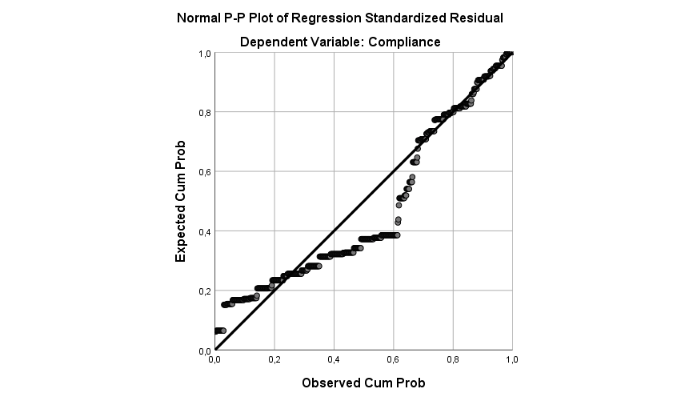

4.1.3 Results

4.1.3.1 Multiple regression analysis without control variables
The summary table of the model shows how well the model fits to the data. The table is shown below.
Table 6: Model Summary
Model | R | R Square | Adjusted R Square | Std. Error of the Estimate | Durbin-Watson
1 | ,322ª | ,103 | ,096 | 1,279 | 1,760
a. Predictors: (Constant), PopOpMS, Number of times discussed, Consultations, AvWOpMS, NumOpMS
b. Dependent Variable: Compliance

This table shows the quality of the prediction of the dependent variables. The value of 0.103 for the R square shows that 10,3% of the variability in the dependent variable is explained by the independent variables. This result indicates that compliance is not well explained by the variables in the model.
The statistical significance of the model can also be tested. Data about the statistical significance is shown in the ANOVA table.

Table 7: ANOVA table
Model |  | Sum of Squares | Df | Mean Square | F | Sig.
1 | Regression | 114,887 | 5 | 22,977 | 14,051 | ,000^{b}
1 | Residual | 995,887 | 609 | 1,635
1 | Total | 1110,774 | 614
a. Dependent Variable: Compliance
b. Predictors: (Constant), PopOpMS, Number of times discussed, Consultations, AvWOpMS, NumOpMS

With p < 0.05, the overall regression model is a good fit for the data, because the significance (0.000) is lower than 0.05.
The coefficients are shown in the table below. Interferences about the relation between X and Y can be made based on these coefficients.
Table 8: Coefficients
Model |  | Unstandardized Coefficients |  | Standardized Coefficients | T | Sig.
 |  | B | Std. Error | Beta | T | Sig.
1 | (Constant) | ,372 | ,122 |  | 3,044 | ,002
1 | Number of times discussed | ,015 | ,018 | ,031 | ,788 | ,431
1 | Consultations | ,204 | ,073 | ,127 | 2,808 | ,005
1 | AvWOpMS | ,147 | ,026 | ,264 | 5,580 | ,000
1 | NumOpMS | ,135 | ,098 | ,104 | 1,371 | ,171
1 | PopOpMS | -,026 | ,016 | -,128 | -1,608 | ,108
a. Dependent Variable: Compliance

The results show that in this model, with p < 0.05, the average weight of opposing member states is statistically significant. The chance that this variable – an indication of the consistency of the decision-making process – correlates coincidentally with compliance is very low. Furthermore, when the average weight of opposing member states goes up with one, the level of non-compliance rises with 0.031 standard deviation. The average weight of opposing member states thus has a negative effect of compliance. This is in line with expectations, because the higher the average weight of opposing member states, the lower the consistency, since the bias increases. Whether or not consultations took place, and which types of consultations, has a significance of 0.005. The chance that this variable coincidently correlates with compliance is also very low. This effect of the type of public consultation on non-compliance is positive, when the value of public consultation increases with one, the value for non-compliance rises with 0.127 standard deviation. This is not in line with expectations, because the higher the level of public consultations is, the fairer the process is, since the dignity increases.
No significant relationship was found between the number of times a proposal was discussed (‘voice’) and compliance.
The significance of both variables could however change when control variables are taken into account.

4.1.3.2 Multiple regression with control variables
Regarding assumptions, it has already been discussed that QGI and corruption correlate heavily, but that the data still passes the Durbin-Watson test, as proved below.
Table 9: Model Summary
Model | R | R Square | Adjusted R Square | Std. Error of the Estimate | Durbin-Watson
1 | ,350ª | ,123 | ,107 | 1,271 | 1,800
a. Predictors: (Constant), MS2004, AvWOpMS, Stance, Number of times discussed, Nordic, NumOpMS, Consultations, GDP, QGI, PopOpMS, Corruption
b. Dependent Variable: Compliance
The table also aims to show the explanatory power of the model, which is 12,3%, given the value of 0.123 for the R square. This is in line with expectations, since more explanatory variables are added to the model.
Table 10: ANOVA table
Model |  | Sum of Squares | Df | Mean Square | F | Sig.
1 | Regression | 136,258 | 11 | 12,387 | 7,665 | ,000^{b}
1 | Residual | 974,516 | 603 | 1,616
1 | Total | 1110,774 | 614
a. Dependent Variable: Compliance
b. Predictors: (Constant), MS2004, AvWOpMS, Stance, Number of times discussed, Nordic, NumOpMS, Consultations, GDP, QGI, PopOpMS, Corruption

With p < 0.05, the overall regression model is a good fit for the data, because the significance (0.000) is lower than 0.05.
The coefficients are shown in the table below.

Table 11: Coefficients
Model |  | Unstandardized Coefficients |  | Standardized Coefficients | T | Sig.
 |  | B | Std. Error | Beta | T
1 | (Constant) | 1,458 | ,710 |  | 2,055 | ,040
1 | Number of times discussed | ,013 | ,018 | ,027 | ,686 | ,493
1 | Consultations | ,206 | ,072 | ,128 | 2,841 | ,005
1 | AvWOpMS | ,147 | ,026 | ,263 | 5,595 | ,000
1 | NumOpMS | ,133 | ,098 | ,103 | 1,349 | ,178
1 | PopOpMS | -,027 | ,016 | -,129 | -1,627 | ,104
1 | Stance | ,072 | ,323 | ,009 | ,224 | ,823
1 | GDP | -2,518E-6 | ,000 | -,033 | -,574 | ,566
1 | Corruption | -,019 | ,018 | -,190 | -1,035 | ,301
1 | QGI | ,009 | ,011 | ,141 | ,781 | ,435
1 | Nordic | -,462 | ,207 | -,106 | -2,233 | ,026
1 | MS2004 | -,361 | ,142 | -,134 | -2,540 | ,011
a. Dependent Variable: Compliance
The data shows that in this model, when p < 0.05, the average weight of opposing member states is statistically significant, just like consultations. This is similar to the model without control variables. The Beta values for both variables change minimally and remain positive, like the previous analysis. So, with control variables included, the conclusions do not change. The average weight of opposing member states influences compliance negatively, and more public consultations also do. For the former variable, this is in line with expectations, while for the latter it is not. It should be noted that the significance of the other independent variables remains unchanged as well.
For the conclusions of this research, the results of testing hypothesis 1a – 1c only confirm the expectation of a positive relationship between consistency – the absence of a bias in decision-making procedures – and compliance. The results, surprisingly, show a negative relation between dignity and compliance. Explanations for this result will be provided in the conclusion. No relationship was found between voice and compliance.
The results for the control variables ‘Nordic’ and ‘MS2004’ are remarkable. These variables served as control variables, but they seem to explain compliance quite well, given their significance of 0.026 and 0.011. On top of that, the Beta is negative and rather strong (-,462 for ‘Nordic’ and -,361 for ‘MS2004), which indicates that both variables influence compliance positively in this regression model. So, this model proves that the relationship between being a Nordic member state or a member state that acceded the EU after 2004 and compliance is quite strong. Both variables explain compliance from a legitimacy perspective. This outcome thus proves that legitimacy matters for explaining compliance.

4.2 Hypothesis 2

In the section that follows, the second hypothesis will be tested. This hypothesis originates from the question if member states tend to comply better when the procedure was fair, in the case that they voted against the proposal. For this, a separate data set was created, including only the cases where member states voted against a policy proposal in the Council. It should be noted that in only 17 of the 615 cases did a member state vote against the directive. Due to this small N, this analysis uses the Mann-Whitney test.

4.2.1 Descriptive statistics
Below, descriptive statistics about this dataset are shown. As said, N = 17. The value for ‘stance’ is 1, because ‘stance’ indicates that a member state voted against the directive, which are the only cases included in the dataset. The level of non-compliance on average is 1.29, for all 615 cases this value is 0.94. A large difference between those values is expected from a willingness-perspective. Nordic states lack in this dataset, since they never voted against the 22 directives in the original database.

Table 12: Descriptive statistics
 | Mean | Std. Deviation | N
Compliance | 1,29 | 1,312 | 17
Number of times discussed | 4,00 | 1,414 | 17
Consultations | 1,88 | ,485 | 17
AvWOpMS | 2,7194 | 2,26903 | 17
NumOpMS | 2,18 | ,951 | 17
PopOpMS | 11,4400 | 8,51917 | 17
Stance | 1,00 | ,000 | 17
GDP | 40616,76 | 14431,308 | 17
Corruption | 63,94 | 15,462 | 17
QGI | 46,8500 | 23,32089 | 17
Nordic | ,00 | ,000 | 17
MS2004 | ,53 | ,514 | 17
The table below shows the descriptions before using the Mann-Whitney test, including dummy variable Fairness II. The maximum of this variable is 1, because it is dichotomous: either above or below the average level of procedural fairness.

Table 13: Descriptive statistics
 | N | Mean | Std. Deviation | Minimum | Maximum
Compliance | 17 | 1,29 | 1,312 | 0 | 3
FairnessII | 17 | ,47 | ,514 | 0 | 1

4.2.2 Assumptions
The assumptions of the Mann-Whitney test need to be discussed and, most importantly, met. Nachar (2008) listed these assumptions:
- The two investigated groups must be randomly drawn from the target population.
Data is randomly gathered to meet this assumption, as explained in section 3.3, case selection and section 3.9, data collection.
- Each measurement or observation must correspond to a different participant.
All observations differ from each other, because they either represent a decision of a unique member state (voting in favor or against a directive) or a decision on a unique directive. To put it differently, the same member state can be in the database multiple times, but it always concerns a vote on a different directive; or the same directive can be in the database multiple times, but the votes are always by different countries. This is how the UK is represented multiple times, but also directive 2014/104. So, the second assumption of Nachar is validated.
- The data measurement scale is ordinal or continuous.
The dependent variable, compliance, is measured on ordinal level; the higher the stage of the infringement procedure, the more non-compliance. The composed variable Fairness I is continuous, dummy variable Fairness II is dichotomous.
To conclude, all assumptions for the Mann-Whitney test are met.

4.2.3. Results
The results of the Mann-Whitney test are as follows.
Table 14: Ranks
 | Fairness II | N | Mean Ranks | Sum of Ranks
Compliance | 0 | 9 | 8,89 | 80,00
 | 1 | 8 | 9,13 | 73,00
Total |  | 17

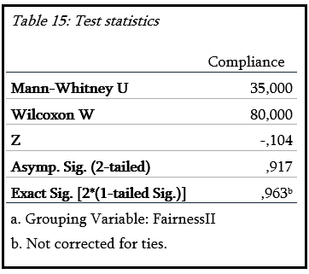
As shown in the table above, with p < 0.05, the result is not significant (0.917). No significant difference in compliance is found between the group with high procedural fairness and the group with low procedural fairness. This means that the null hypothesis cannot be rejected: member states who are against a certain directive are not more likely to comply with that directive if the decision-making procedure was fair, compared to member states who are against a certain directive and encounter a less fair decision-making procedure.
Testing this second hypothesis leads to the same conclusion as the analysis of the first dataset: procedural fairness influences compliance of EU member states to a limited extent. The added value of this analysis is that it provides more insight in the debate about the interaction between procedural fairness and outcome favorability, as referred to in the theoretical framework. Legitimacy – in this case procedural fairness – does not override willingness, or in this case outcome favorability, even in cases when procedural fairness is relatively high. More attention is dedicated to the consequences of this outcome for the field of compliance research in the following chapter; the conclusion of this study.

Chapter 5 – Conclusion

In this final chapter, the central question will be answered. Conclusions will be drawn, while recalling that the generalizability of the conclusions is low – specifically for H2 – for internal and external validity reasons. The broader implications for the field are also discussed, as well as the possibilities for subsequent research. Finally, the quality of the research will be reflected on.
5.1 Answering the research question and implications for the field of compliance research
The research question was: to what extent does the procedural fairness of EU decision-making procedures affect member states’ compliance with decisions taken during that decision-making procedure?
To start right away with the answer to this question: this study showed that procedural fairness of EU decision-making procedures affects member states’ compliance with decisions taken during that procedure to a limited extent. However, more can be said about this outcome. The more elaborate answer is that one of the three indicators of procedural fairness correlated negatively with compliance, namely the average weight of opposing member states. However, this could also be explained from the perspective of willingness. The reasoning would be that the average weight of opposing member states correlates with the popularity of a directive. So, the higher the average weight of opposing member states, the more unwillingness and the less compliance. Interestingly, the Pearson correlation did not show problematic values of correlation between the average weight and opposing member states and stance.
The two other predictors, consultations and the number of times a proposal is discussed, did not explain compliance as expected. The data showed a negative relation between (the type of) public consultations and compliance, whereas a positive relation was expected. On top of that, the relation was significant. It is difficult to explain this, recalling that in the literature on consultations there is broad consensus that consultations are legitimacy-building (e.g. Klüver, 2013). The Commission uses consultations to legitimize its proposals and gain political support (Klüver, 2013; van Ballaert, 2017). This study challenges that broad consensus, suggesting that more research on the relation between consultations and compliance is needed. An explanation for this outcome can be found in the operationalization of dignity. Esaiasson et al. (2016) focused in their definition of dignity on the way in which individuals are involved in the process and whether or not individuals are treated with dignity during the decision-making process. This definition was interpreted differently in this research, because it this is difficult to measure how individuals are treated by the Commission during the consultation process. This might have affected the results. Another explanation can be that through extensive consultations the stakeholders got too much influence, with three possible scenarios. In the first scenario, the Commission was convinced by the opinions of stakeholders and watered down the proposal too much in a direction that EU member states would not favor. It could also be that the proposal became too one-sided after consultations, in line with preferences of one group of EU member states. Other EU member states would not favor that proposal and would not be willing to comply. Both scenarios explain the result from a willingness perspective. However, more votes against the directive would be expected. The third and probably most convincing scenario is that broad consultations amongst experts and stakeholders made the proposal too complex. The complexity of a directive is also an explanatory variable for compliance (Collins and Earnshaw, 1992; Mastenbroek, 2005). In that scenario a vote against is not expected, but non-compliance might be an option, especially for member states with low institutional capacity.
No significant relation was found between the number of times a proposal was discussed and compliance. A certain degree of ambiguity is also present for this variable: more discussions could indicate a salient issue, both also more ‘input-moments’. This study was not able to clarify this relation further.
The image as described above was confirmed by the second hypothesis. The group with procedural fairness above the average degree of fairness did not differ significantly from the group with a value below the average. Still, conclusions should be drawn carefully because of the low amount of cases and the appurtenant issues with generalizability.
Perhaps the strongest indication for the explanatory power of fairness-related variables was the adjusted R square. Those values varied between 10.3 % and 12.3%, which indicates that the data was able to explain maximum 12.3% of the total variance. It is illustrative that in that dataset the control variables were included – of which two of them turned out to have a significant, positive correlation with compliance. This also says something about legitimacy-related variables as explanatory powers for compliance. Both variables – post-2004 accession and Nordic countries – explain compliance from a legitimacy point-of-view. In Nordic countries, compliance is explained by a strong culture of abiding to the law. In post-2004 countries, compliance is explained by compliance ‘as the norm’. Although the selected independent variables in this research – also related to legitimacy – did not explain compliance well, other legitimacy variables do. This leads to perhaps the most important conclusion of this thesis: legitimacy is a relevant third explanatory power for compliance, next to willingness and institutional capacity.

5.2 The possibilities for follow-up research
This study led to a number of follow-up questions, which can be relevant for future research. They can all be summarized around more in-depth research. Although compliance literature pointed convincingly towards a relationship between procedural fairness and compliance, this study could only prove a relationship between legitimacy and compliance. A case study on the relation between procedural fairness and compliance would be the first recommendation for follow-up research, because in-depth process tracing could shed more light on the relation between procedural fairness and compliance than this study did. Other theories about procedural fairness – with other indicators – could also be included in future research, since only one of Esaiasson’s indicators explained compliance well.
Follow-up research could focus on the other indicators of procedural fairness than the ones used in this study. The indicator for the first component, voice, was not significant. The number of discussions will probably never explain compliance well from a legitimacy perspective, because it also indicates the difficulty of negotiations between the EU member states. Another indicator for this component could be the perceived value of voice in the decision-making process, measured by a survey amongst delegates from EU member states.
Perhaps the most interesting result in this research is the result for public consultations, the second indicator. The explanations provided for this result deserve more attention. A case study on a directive with broad consultations but low compliance would be interesting, with one case concerning a member state with high institutional capacity and another case with low institutional capacity.
The third component, consistency, was perhaps the most difficult to measure, because the definition focused on the absence of a bias. This operationalization also suffered from ambiguity; it also indicates the stance of EU member states towards a proposal. Future research could try to measure the absence of this bias even better, for example though surveys amongst and interviews with delegates from EU member states.
In short, follow-up research is needed to test the given explanations for the result for public consultations and the claim that consultations may lead to a more complex directive. Future research should have a case study design and focus on the relation between procedural fairness and compliance, using techniques such as process tracing and including other components or indicators for procedural fairness, like the indicators suggested above.

5.3 Reflections on research quality
Looking back, there are some comments to be made about the way the research was conducted. First, fairness is a subjective concept, but was measured objectively. This choice was made for feasibility reasons. A statistical analysis requires many cases, so measuring the fairness of more than twenty decision-making procedures subjectively amongst national EU delegates – through surveys and/or interviews – would have taken much time. Moreover, as an outsider it would be difficult to figure out which delegates were involved in the decision-making process. An in-depth case study analyzing and comparing a few directives would perhaps have been a better choice, in order to explore the exact causal chain better. However, since the literature pointed clearly towards a relationship between those variables, a statistical analysis seemed obvious.
Secondly, it is difficult to grasp if the indicators of procedural fairness as defined by Esassaison et al. (2016) really make a difference for national policy officers in their decision to comply. Other theories would probably have resulted in other indicators, but Esaiasson’s theory looked promising as it was straightforward and defined the components of procedural fairness clearly, which made operationalization easier.
Operationalization was difficult, because EU decision-making processes have many variables. The choices for the indicators in this research have been discussed extensively in the third chapter and are subject to discussion. An example of a difficult choice was how to measure consistency (‘the absence of a bias’) objectively. As indicated earlier in this chapter, the indicator used in this research may also indicate willingness. Question marks regarding the internal validity of this study remain.
Fourthly, the quantity of cases was unfortunately not always ideal. For example, the outcome of the second hypothesis cannot be generalized, because of the low amount of cases included in the dataset. The external validity of this hypothesis is thus low. However, those cases were the only cases available. The future will probably deliver more cases, so this hypothesis should be tested again in a few years.
The final consideration is that no difference is made in the type of compliance. The Commission can start an infringement procedure when a directive is not implemented in national legislation, incorrectly implemented in national legislation or not properly implied (Börzel, 2001). No distinction between those types is made in this research focused on the influence of procedural fairness on compliance. The question to which type of compliance was considered to be less relevant.
The question is to what extent these flaws in the research design influenced the outcome of this research. Some aspects – another theory, other indicators, including different types of compliance, and non-manual data gathering – could lead to other results, but probably to the same outcome: procedural fairness explains compliance to a limited degree. A relation between both variables – if any – is in the best case weak. A completely different research design, with an in-depth comparative case study, using process tracing to reconstruct the domestic deliberation on whether or not to comply with a certain directive, could lead to a different outcome.
To conclude, this study is not without its flaws. Much of the flaws as discussed above are based on choices in the research design. Those choices were explained and discussed extensively, and contributed to the aim and to solving the research question of this thesis. Perhaps the biggest weakness of this research is that many choices had to be made on a practical and feasible basis. The research design did not allow for the maximum freedom in selecting indicators. Still, the quality of the research within the selected research design is decent, but another research method than statistical analysis would have been able to answer the research question better.

References
- Angelova, M., Dannwolf, T., and König, T. (2012). How robust are compliance findings? A research synthesis. Journal of European Public Policy 19(8): 1269-1291.
- Börzel, T. A. (2001). Non-compliance in the European Union: pathology or statistical artefact? Journal of European Public Policy, 8(5), 803-824.
- Börzel, T. A., Hofmann, T., Panke, D., & Sprungk, C. (2010). Obstinate and inefficient: Why member states do not comply with European law. Comparative Political Studies, 43(11), 1363-1390.
- Börzel, T.A. (2003). Environmental Leaders and Laggards in Europe: Why There is (not) a ‘Southern Problem’, Aldershot: Ashgate.
- Börzel, T. A., & Risse, T. (2003). Conceptualizing the domestic impact of Europe. The politics of Europeanization, 57-80.
- Breeman, G., & Zwaan, P. (2009). Domestic change and EU compliance in the Netherlands: Policy feedback during enforcement. European Integration, 31(3), 349-367.
- Collins, K. and Earnshaw, D. (1992) ‘The implementation and enforcement of European Community legislation’, Environmental Politics 1(4): 213–49.
- Council of the European Union. (2018, April 13). Interinstitutional File: 2016/0149 (COD). As retrieved from: http://data.consilium.europa.eu/doc/document/ST-7803-2018-INIT/en/pdf on April 27, 2018.
- Dahlberg, S., & Holmberg, S. (2014). Democracy and bureaucracy: How their quality matters for popular satisfaction. West European Politics, 37(3), 515-537.
- Della Porta, D., and Keating M., eds. (2008). Approaches and methodologies in the social sciences: A pluralist perspective. Cambridge University Press.
- Devaney, C. and Poptcheva, E. (2014). Changed rules for qualified majority voting in the Council of the EU. European Parliamentary Research Service, EU. As found on: http://www.europarl.europa.eu/RegData/etudes/ATAG/2014/545697/EPRS_ATA%282014%29545697_REV1_EN.pdf on January 3, 2019.
- Dimitrova, A. and Rhinard, M. (2005). The power of norms in the transposition of EU directives. Paper prepared for the ECPR Joint Sessions, Granada, Spain, 14–19 April 2005.
- Esaiasson, P. (2010). Will citizens take no for an answer? What government officials can do to enhance decision acceptance. European Political Science Review, 2(3), 351-371.
- Esaiasson, P., Gilljam, M., & Persson, M. (2012). Which decision‐making arrangements generate the strongest legitimacy beliefs? Evidence from a randomised field experiment. European Journal of Political Research, 51(6), 785-808.
- Esaiasson, P., Persson, M., Gilljam, M., & Lindholm, T. (2016). Reconsidering the Role of Procedures for Decision Acceptance. British Journal of Political Science, 1-24.
- European Commission. (2013, February 8). Compliance Matters. Directorate-General for Competition.
- European Commission. (2018). Infringement procedure. As retrieved from: https://ec.europa.eu/info/law/law-making-process/applying-eu-law/infringement-procedure_en on June 12, 2018.
- European Commission. (2018). Public consultations and other consultation activities. As retrieved from:
http://ec.europa.eu/social/main.jsp?catId=333&langId=en on October 5, 2018.
- European Commission. (2018). Public opinion. Eurobarometer. As retrieved from: http://ec.europa.eu/commfrontoffice/publicopinion/index.cfm/Chart/getChart/themeKy/18/groupKy/97 on January 4, 2019.
- European Council. (November 11, 2017). Qualified majority. As retrieved from: http://www.consilium.europa.eu/en/council-eu/voting-system/qualified-majority/ on April 25, 2018.
- European Parliament. (2018). Legislative powers. Powers and procedures. As retrieved from: http://www.europarl.europa.eu/aboutparliament/en/20150201PVL00004/Legislative-powers on April 24, 2018.
- European Union. (2018, February 2). How EU decisions are made. EU law. As retrieved from: https://europa.eu/european-union/eu-law/decision-making/procedures_en on April 24, 2018.
- European Union. Regulations, directives and other acts. EU law. As retrieved from: https://europa.eu/european-union/eu-law/legal-acts_en on 16 April 2018.
- Falkner, G., & Treib, O. (2008). Three worlds of compliance or four? The EU‐15 compared to new member states. JCMS: Journal of Common Market Studies, 46(2), 293-313.
- Fay, M. P., & Proschan, M. A. (2010). Wilcoxon-Mann-Whitney or t-test? On assumptions for hypothesis tests and multiple interpretations of decision rules. Statistics surveys, 4, 1.
- Gangl, A. (2003). Procedural Justice Theory and Evaluations of the Lawmaking Process. Political Behavior, 25, 119–49.
- Gorb, A. & Miller, V. (2017). Legislating for Brexit: EU directives. House of Commons Library.
- Graham, M. H. (2003). Confronting multicollinearity in ecological multiple regression. Ecology, 84(11), 2809-2815.
- Grimes, M. (2006). Organizing Consent: The Role of Procedural Fairness in Political Trust and Compliance. European Journal of Political Research 45, 85–315.
- Haas, P. M. (1998). Compliance with EU directives: insights from international relations and comparative politics. Journal of European Public Policy, 5(1), 17-37.
- Haverland, M. (2000) ‘National adaptation to European integration: the importance of institutional veto points’, Journal of Public Policy 20(1): 83–103.
- Hibbing, J.R. & Theiss-Morse, E. (2001). Process preferences and American politics: What the people want government to be. American Political Science Review 95: 145–153.
- Huber, J. & McCarty, N. (2004). Bureaucratic capacity, delegation and political reform. American Political Science Review 98(3): 481–494
- Hurd, I. (1999). Legitimacy and authority in international politics. International organization, 53(2), 379-408.
- Kaeding, M. (2008). Lost in translation or full steam ahead: the transposition of EU transport directives across member states. European Union Politics, 9(1), 115-143.
- Keohane, R. O. (2005). After hegemony: Cooperation and discord in the world political economy. Princeton University Press.
- Klüver, H. (2013). Lobbying in the European Union: interest groups, lobbying coalitions, and policy change. Oxford University Press.
- Knill, C. and Lenschow, A. (1998) ‘Coping with Europe: the impact of British and German administrations on the implementation of EU environmental policy’, Journal of European Public Policy 5(4): 595–614.
- Kohler-Koch, B., & Quittkat, C. (2013). De-mystification of participatory democracy: EU-governance and civil society. OUP Oxford.
- Krislov, S., Ehlermann, C. and Weiler, J. (1986) ‘The political organs and the decisionmaking process in the United States and the European Community’, in M. Cappelletti, M. Seccombe and J. Weiler (eds), Integration through Law: Europe and the American Federal Experience (Volume 1, book 2), Berlin: Walter de Gruyter, pp. 3–110.
- Lewis, J. (2015). The Council of the European Union and the European Council. Routledge Handbook of European Politics.
- Lewis-Beck, M. (1995). Data analysis: An introduction. Sage.
- Mann, H. B., & Whitney, D. R. (1947). On a test of whether one of two random variables is stochastically larger than the other. The annals of mathematical statistics, 50-60.
- March, J. G., & Olsen, J. P. (2004). The logic of appropriateness. In The Oxford handbook of political science.
- Mastenbroek, E. (2005). EU compliance: Still a black hole? Journal of European Public Policy 12(6): 1103-1120.
- Nachar, N. (2008). The Mann-Whitney U: A test for assessing whether two independent samples come from the same distribution. Tutorials in Quantitative Methods for Psychology, 4(1), 13-20.
- Pollock III, P. H. (2011). An SPSS companion to political analysis. CQ Press.
- Schmitter, P. C. (2016). The design of social and political research. Chinese Political Science Review, 1(4), 577-609.
- Schulz, H., & Konig, T. (2000). Institutional Reform and Decision-Making Efficiency in the European Union. American Journal of Political Science, 44(4), 653-666.
- Scott, W. R. (1991). Unpacking Institutional Arguments. S. 164–182 in: WB Powell, PJ DiMaggio (Hrsg.): The New Institutionalism in Organizational Analysis.
- Sedelmeier, U. (2008). After conditionality: post-accession compliance with EU law in East Central Europe, Journal of European Public Policy, 15:6, 806-825.
- Suchman, M. C. (1995). Managing legitimacy: Strategic and institutional approaches. Academy of management review, 20(3), 571-610.
- Sverdrup, U. (2004). Compliance and conflict management in the European Union: Nordic exceptionalism. Scandinavian Political Studies, 27(1), 23-43.
- Tallberg, J. (2002). Paths to compliance: Enforcement, management, and the European Union. International Organization 56(3): 609-643.
- The Quality of Government Institute. (2017). The European Quality of Government Index. As retrieved from: https://qog.pol.gu.se/data/datadownloads/qog-eqi-data on May 24, 2018.
- Toshkov, D. (2008). Embracing European law: compliance with EU directives in Central and Eastern Europe. European Union Politics, 9(3), 379-402.
- Trauner, F. (2009). Post-accession compliance with EU law in Bulgaria and Romania: a comparative perspective.
- Treaty of Nice amending the Treaty on the European Union, the Treaties Establishing the European Communities and Certain Related Acts, (2001).
- Treib, O. (2014). Implementing and complying with EU governance outputs", Living Rev. Euro. Gov. 9. As retrieved from: http://europeangovernance-livingreviews.org/Articles/lreg-2014- on April 20, 2018
- Tyler, T.R. (1994). Governing amid diversity: The effect of fair decision-making procedures on the legitimacy of government. Law and Society Review 28: 809–832.
- Tyler, T.R., Degoey, P. & Smith, H.J. (1996). Understanding why the justice of group procedures matters: A test of the psychological dynamics of the group-value model. Journal of Personality and Social Psychology 70: 913–930.
- Ulbig, S.G. (2002). Policies, procedures and people: Sources of support for government? Social Science Quarterly 83: 789–809.
- Underdal, A. (1998). Explaining compliance and defection: three models. European Journal of International Relations, 4(1), 5-30.
- Van Ballaert, B. (2017). The European Commission’s use of consultation during policy formulation: The effects of policy characteristics. European Union Politics, 18(3), 406-423.
- Visschers, V. H., & Siegrist, M. (2012). Fair play in energy policy decisions: Procedural fairness, outcome fairness and acceptance of the decision to rebuild nuclear power plants. Energy Policy, 46, 292-300.
- Zhelyazkova, A., Kaya, C., & Schrama, R. (2016). Decoupling practical and legal compliance: Analysis of member states’ implementation of EU policy. European Journal of Political Research, 55(4), 827-846.
- Ziller, J., & Siedentopf, H. (Eds.). (1988). Making European policies work: the implementation of Community legislation in the member states. Sage.
- Zwaan, P. J. (2012). Struggling with Europe: how initiators of horizontal forms of governance respond to EU formal rules. Wageningen: WUR Wageningen.

Appendix 1 – assumptions dataset I

Scatterplots

Figure 1: Scatterplot Number of times discussed (IV) and Compliance (DV) 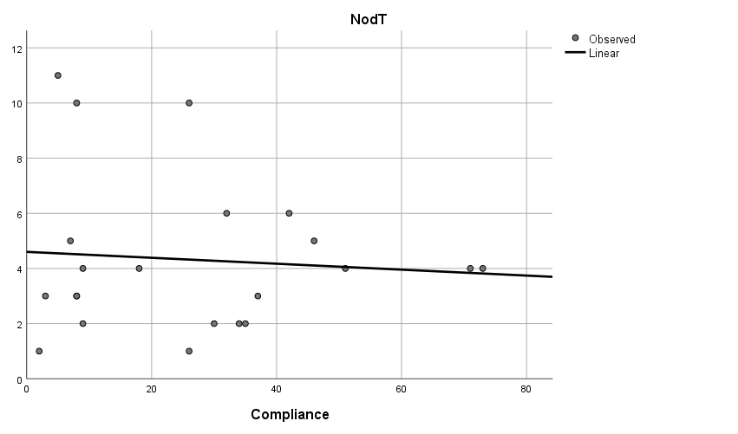
Figure 2: Scatterplot Consultations (IV) and Compliance (DV)
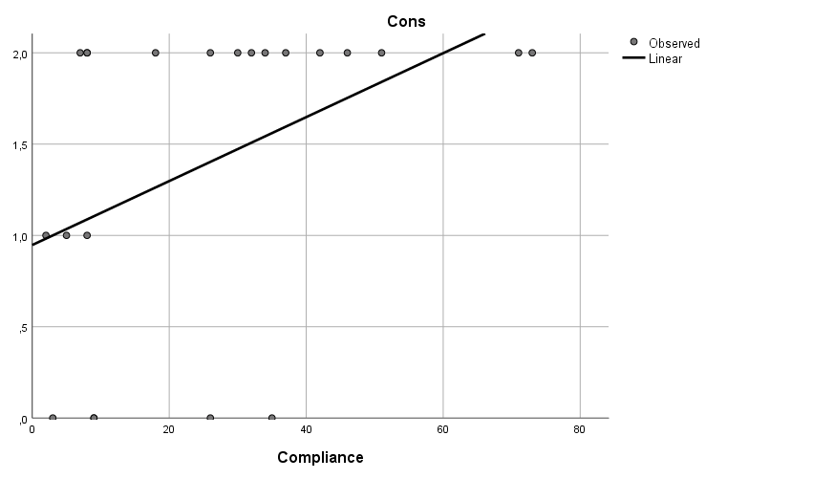

Figure 3: Scatterplot Average weight of opposing member states (IV) and Compliance (DV)
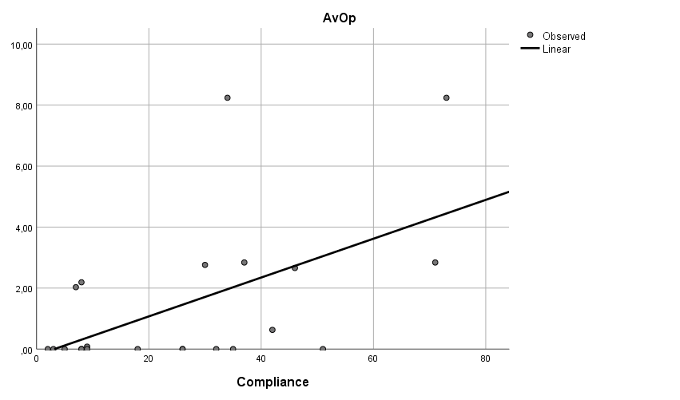

Figure 4: Scatterplot Number of opposing member states (IV) and Compliance (DV)
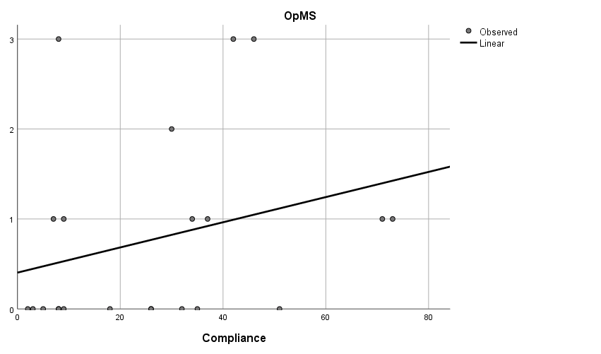

Figure 5: Scatterplot Population of opposing member states (IV) and Compliance (DV)
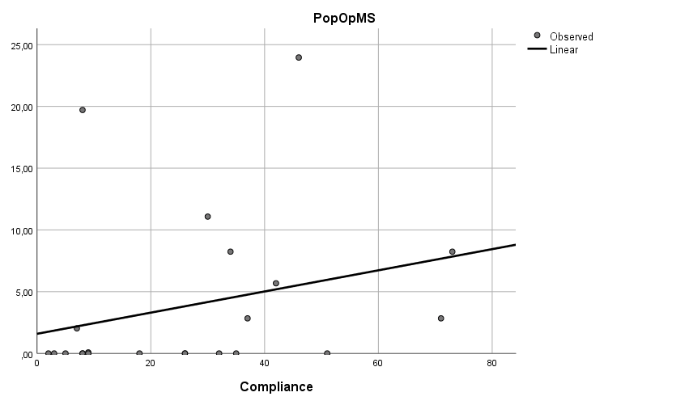

Figure 6: Scatterplot variance of residuals
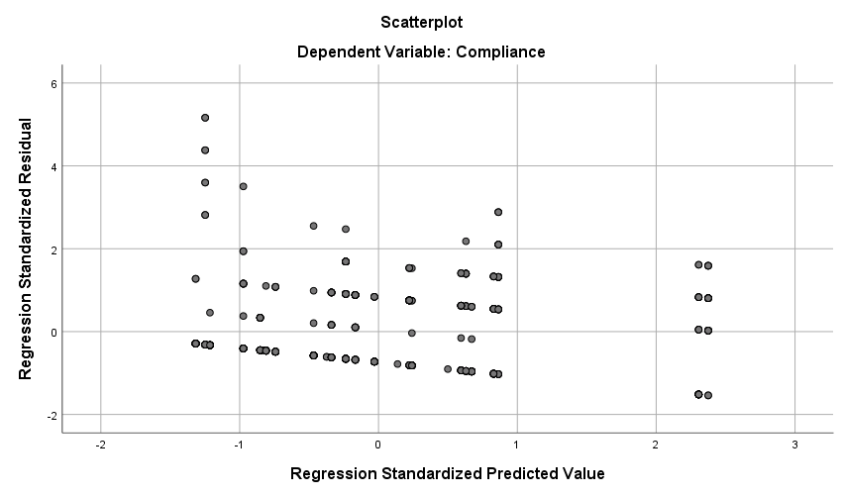

Coefficients and VIF
Table 1: Coefficients and VIF-value without control variables
Model |  | Unstandardized Coefficients |  | Standardized Coefficients | t | Sig. | 95,0% Confidence Interval for B |  | Collinearity Statistics
 |  | B | Std. Error | Beta | t | Sig. | Lower Bound | Upper Bound | Tolerance | VIF
1 | (Constant) | ,372 | ,122 |  | 3,044 | ,002 | ,132 | ,613
1 | Number of times discussed | ,015 | ,018 | ,031 | ,788 | ,431 | -,022 | ,051 | ,944 | 1,059
1 | Consultations | ,204 | ,073 | ,127 | 2,808 | ,005 | ,061 | ,348 | ,719 | 1,390
1 | AvWOpMS | ,147 | ,026 | ,264 | 5,580 | ,000 | ,095 | ,199 | ,658 | 1,520
1 | NumOpMS | ,135 | ,098 | ,104 | 1,371 | ,171 | -,058 | ,328 | ,255 | 3,928
1 | PopOpMS | -,026 | ,016 | -,128 | -1,608 | ,108 | -,059 | ,006 | ,231 | 4,320
a. Dependent Variable: Compliance
Table 2: Coefficients and VIF-value with control variables
Model |  | Unstandardized Coefficients |  | Standardized Coefficients | t | Sig. | Collinearity Statistics
 |  | B | Std. Error | Beta | t | Sig. | Tolerance | VIF
1 | (Constant) | 1,458 | ,710 |  | 2,055 | ,040
1 | Number of times discussed | ,013 | ,018 | ,027 | ,686 | ,493 | ,937 | 1,067
1 | Consultations | ,206 | ,072 | ,128 | 2,841 | ,005 | ,719 | 1,390
1 | AvWOpMS | ,147 | ,026 | ,263 | 5,595 | ,000 | ,658 | 1,520
1 | NumOpMS | ,133 | ,098 | ,103 | 1,349 | ,178 | ,251 | 3,982
1 | PopOpMS | -,027 | ,016 | -,129 | -1,627 | ,104 | ,231 | 4,321
1 | Stance | ,072 | ,323 | ,009 | ,224 | ,823 | ,938 | 1,066
1 | GDP | -2,518E-6 | ,000 | -,033 | -,574 | ,566 | ,445 | 2,248
1 | Corruption | -,019 | ,018 | -,190 | -1,035 | ,301 | ,043 | 23,172
1 | QGI | ,009 | ,011 | ,141 | ,781 | ,435 | ,045 | 22,371
1 | Nordic | -,462 | ,207 | -,106 | -2,233 | ,026 | ,641 | 1,561
1 | MS2004 | -,361 | ,142 | -,134 | -2,540 | ,011 | ,524 | 1,909
a. Dependent Variable: Compliance

Pearson Correlation
Table 3: Correlations
