*Impact of Culture on Board of Directors Composition*

A cross-country comparison study between developed and non-developed countries



Alba Maria Serna Chapa

s4696328

Radboud Universiteit

Nijmegen School of Management

A thesis submitted for the degree of

*Master in Economics in International Economics and Business*

Supervised by: Dr. Katarzyna Burzynska

Second reader: Dr. Gabriela Contreras

July 2017

Nijmegen, Netherlands

Abstract

Women inclusion in the board of directors is a topic that is present more than ever in microeconomic and macroeconomic studies. Reports from several international organizations conclude that there are a very low proportion of women on corporate governance. More importantly, the difference on women representation in boards gets magnified when taking into account the level of development of a country, such as between Latin American and European countries.

Such differences gives rising to the questions: Why does the number of women in the board of directors vary from one country to another? Moreover, why does it vary so much from one economical region to another? This thesis tests whether this difference is due to the variation in cultural aspects across countries.

Using a 2,900 sample of listed companies between Latin America and European countries, this thesis performs an OLS multiple regression with interactions to analyze the relationship between the percentage of women in the board of directors and the four Hofstede’s cultural dimensions, while controlling for other factors. The analysis of 29 countries during 2015 reveals that masculinity and individualism indeed have strong effects on corporate governance and should be taken into account in business and governmental policies. Moreover, this thesis also provides a basis for further research since, as seen in an OLS regression with interactions, the relationship between the percentage of women and the four cultural dimensions changes as a function of the level of income.

**Keywords:** Culture, board gender diversity, Hofstede’s cultural dimensions, multiple regression analysis, cross-country study, gender equality

Acknowledgements

Living in 2017 and realizing that women are still not equally treated with the same opportunities as men is what led me into choosing this topic for my master thesis. As I will, soon, enter the labor market myself I want to be considered by my employers to the same extent as my male colleagues and not discriminated because of my gender. Nowadays we see more and more women with higher educational degrees and occupying job positions that were only privileged for men. We have seen countries have their first women president, firms having their first female CEO and even first sportswomen in sports only considered by men. But why are we still talking about it? Shouldn’t that be a given?

Indeed, women are still underrepresented and that breach is even highlighted when in comes down to the level of economic development of a country. Being a women and being Latin American myself, I was interested in researching if culture plays a role on explaining that variance.

Three debts are in order. First I would like to thank God for never leaving me alone in the hard times that I have endured, not only when writing this thesis, but also during my Master’s year. Secondly, I would like to thank all my professors here at Radboud University that taught me so much and reminded me why I choose to study Economics in the first place. Moreover, I would like to thank my supervisor, Dr. Katarzyna Burzynska, for all her very insightful comments and direction. Finally, but not least important, I would like to thank all my family in Mexico: my parents and my two sisters for always believing in me and for their never ending support. From the bottom of my heart, thank you.

I hope that you enjoy reading this thesis and that it contributes to reduce the much endured gender inequality gap that has existed for so long.

Table of Contents

Chapter 1: Introduction 5

Chapter 2: Literature Review 9

2.1 Women Representation in the Board of Directors 9

2.2 Causes of Women Under-Representation on the Board of Directors 10

*2.2.1 Cultural Supply Factors* 11

*2.2.2 Cultural Demand Factors* 13

2.3 Hofstede’s Cultural Dimensions and Hypothesis 15

*2.3.1 Power Distance* 15

*2.3.2 Uncertainty Avoidance* 16

*2.3.3 Individualism* 17

*2.3.4 Masculinity* 19

2.4 Culture and Level of Development of a Country 20

2.5 Conceptual Model 21

Chapter 3: Research Methodology 23

3.1 Sample 23

3.2 Variables 24

*3.2.1 Dependent Variable* 24

*3.2.2 Independent Variables* 24

*3.2.3 Control Variables* 25

*3.2.4 Moderator Variable* 28

3.3 Method and Statistical Analysis 30

*3.3.1 Methodological Approach* 30

*3.3.2 Descriptive Statistics* 31

Chapter 4: Discussion and Results 33

4.1 Assumptions testing 33

4.2 Multiple Regression Analysis 36

4.3 Interaction Effects 39

4.4 Summary of Results 40

Chapter 5: Conclusions 42

5.1 Conclusions 42

5.2 Data limitations 43

5.3 Recommendations and further research 44

Bibliography 47

Appendix 61

# Chapter 1: Introduction

The pursuit of gender equality in the board of directors has increased in the last two decades at the national and firm level. At the macroeconomic level, it all started on the UN-conference in Beijing in 1995, where Gender Mainstreaming strategy was born (Verloo, 2005). Such approach assessed the implications for woman as well for men in all task and activities with the ultimate goal of achieving gender equality (Verloo, 2005). In this way, gender equality became a priority on most countries government agenda implementing policies to reach this objective. It is now common to encounter policies, such as *quotas*, underpinned by the premise that women’s participation has a positive impact on the performance of boards of the firms (Abdullah, Ismail and Nachum, 2016).

At the firm level, research on women on boards has emerged as a topic with the main purpose of achieving gender equality and has been analyzed from many different angles (Gabaldon, De Anca, Mateos De Cabo and Gimeno 2016). Because of this, there is no short explanations for the under representation of women in the top management (Fernandez-Mateo and Fernandez, 2016). Some researchers point out to the world events, challenges and social trends of the recent years that have pressured the increase of gender diversity on women on boards (Van der Walt and Ingley, 2003; Marini, 1990; Mulcahy and Linehan, 2014). Some others advocate for the inclusion of women on boards because of the empirical evidence results that they contribute to financial as well as non-financial performance of the enterprises (Lee, Marshall, Rallis and Moscardi, 2015; Klenke, 2003; Dollar, 1999).

Despite the attention and the efforts to counterattack this problem, gender diversity on corporate boards has not been achieved and there is clear evidence that gender discrimination at firm and national level still exist (Mulcahy et al., 2014). It is a fact that despite the gains women have made in mid-level management and the relevance of gender equality on firms, the number of women in top executive positions continue to remain small (Klenke, 2003). Less than a quarter of women are inside the board of directors in S&P 500 companies[1] and in 2016 there was only a 3% increase on women who held senior roles since 2011 (Catalyst, 2017). This has important repercussions if gender equality it’s the aim since, if this rate continues, women will not reach parity with men until the year 2060 (Catalyst, 2017).

Therefore, understanding the causes behind gender inequality in the board of directors is an important step to give solution to the problem. A country’s social and cultural characteristics are one of the factors that influence the gender diversity of the board composition of firms (Carrasco, Francoeur, Labelle, Laffarga and Ruiz-Barbadillo, 2012; Li, 2008; Jayachandran, 2015; Abdullah et al., 2016). The influence of culture on corporate governance structure (Li, 2008; Carrasco et al., 2012) has been used to examine the impact it has on the female level representation on the board of directors. Likewise, the consequence on women’s participation on boards reflects the configuration of the institutional as well as the cultural country’s framework (Abdullah, 2016). In this sense, culture, through its social norms, has a way to impact gender inequality and this varies from country to country. Subsequently, by analyzing the cultural dimensions of such countries one can test whether social norms inside a country have an impact on the board composition of the companies. Furthermore, by segmenting between developed and non-developed countries, the economic growth can be included on the analysis and evaluate why there is a cross-country difference between gender diversity and the level of development of a country.

I intend to extend the line of research focusing on the relationship between the cultural dimensions of developed and non-developed countries and the number of women there are on the board of directors of the firms. Accordingly, the research question can be defined as the following:

*What is the effect of cultural dimensions on the number of women there is on the board of directors of firms on developed and non-developed countries?*

This analysis will be tested empirically with Hofstede’s cultural dimensions and firm level data that will be explained further in the second section. In that matter, a possible answer as to why does the level of women representation on corporates board of directors differ so much between one country and another; and even more, from one economical region to another, can be given.

This thesis has two aims. The first one is to analyze the impact culture has on the female representation on the board of directors of firms. The second one is to test whether the level of economic development, measured by the level of GDP per capita, intensify the relationship between culture and the number of women there is in the board of directors.

In addition, this thesis will contribute to the existing literature in two ways. In the first instance I would like to complement in a more exhaustive way the current research that has been made on the relationship between cultural dimensions of a country and the number of female employees on the board of directors. It is my intention to include more countries, from different economical regions, and firms in my analysis. The current literature only explores such relationship inside one or few countries and between a small numbers of firms. Although there are advantages of concentrating on small number of countries, such as more in-depth investigation and no superficial conclusions, the assumptions from four of five countries tend to differ in many characteristics and comparisons, as a rule, cannot hold for a wider range of countries (Semenov, 2000). In addition under this contribution, I intend to add as control variable not only firm level but also country level variables. Until now the research that has been made only takes into account the explanatory power of firm level variables and dismiss the influence of country level ones (Carrasco, Francoeur, Labelle, Laffarga and Ruiz-Barbadillo, 2014; Abdullah et al., 2016). Nevertheless, influence of a country’s legal and economic system also play a part on shaping the board of directors compositions of the firm, as will be seen in the next pages.

My second contribution will be in taking into account as well the economical region of the involved countries. Because female directors in non-developed markets are scarcer than in developed ones (Abdullah et al., 2016), one question that arises is, does the level of income indirectly impact the number of women there is in the board of directors of firms? Work on culture and economics claims that causality works both ways- from culture to economics and from economics to culture (Guiso, Sapienza and Zingales, 2006). My results can prove if the level of economic development of a country, indirectly and through cultural dimensions, has an impact on the gender representation at the board of directors.

The analysis of 29 countries with 2,900 observations during 2015 reveals that masculinity and individualism indeed have strong effects on corporate governance and should be taken into account in business and governmental policies. In effect, results show that countries which are more collectivistic in nature and that value more masculine traits are more probable to exhibit less women in their board of directors companies. Moreover, this thesis also provides a basis for further research since, as seen in an OLS regression with interactions, the relationship between the percentage of women and the four cultural dimensions changes depending on the level of income of a country.

The thesis is structured as follows. First, there is the theoretical background section where I intend to describe the literature review on which this research is based, namely a brief explanation of gender diversity, the causes of women under-representation and its connection to culture at the firm and country level. In the third chapter, the empirical study with the sample, variables and methodology will be described. Chapter four will present and discuss the obtained results and, lastly, chapter five will conclude presenting the data limitations and recommendations.

# Chapter 2: Literature Review

## 2.1 Women Representation in the Board of Directors

Board diversity is the varied combination of attributes, characteristic and expertise contributed by board members in relation to board process and decision-making (Van der Walt et al., 2003). This includes variation in age, gender, ethnicity, culture and religion, among other attributes. Hence, having more female employees inside the board of directors comprise as a way of achieving board diversity.

The advantages of gender diversity of board of directors are the result of behavioral and professional differences between male and females. Financial (Barton, 2011; Rao and Tilt, 2016; Francoeur, Labelle and Sinclair-Desgagné, 2008; Carter, Souza, Simkins and Simpson, 2010) and non-financial (Bear and Post, 2010; Brammer, Millington and Pavelin, 2009; Glass, Cook and Ingersoll, 2016; Hunter, Hatch and Johnson, 2004) benefits of having a gender diverse board of directors have been proved by many researchers. Nevertheless, gender board diversity is often seen as not top business priority. In contrast, other initiatives that contribute in a more straightforward way to financial performance of the firm are given a bigger importance over diversity initiatives, since their benefits are not so direct and often unseen (Robinson and Dechant, 1997).

Financially speaking, gender diversity inside the board of directors can have an impact in the efficiency of the company. The board of directors is one of the most important structures inside the company’s corporate governance. Inside the board of directors important decision-making strategies that can impact the performance of the whole company are made (Nielsen and Huse, 2010). Hence, appointing women as corporate directors can influence board decision-making as women have different professional experiences and background (Hillman, Canella and Harris, 2012).

Likewise appointing women inside the board of directors is a way of break the vicious cycle of gender heterogeneity on top management. The appointment of a female CEO might break the institutional barrier against women who want to ascend to the top ranks of leadership (Lee et al., 2015).In the same way, having female board members serve as role models for other women that aspire the same career path and symbolizes career possibilities to others (Singh, Terjesen and Vinnicombe, 2008).

Whereas financial or non-financial benefits, female representation is an ethical issue that must be addressed by all companies. Women should be equally considered for leadership positions without weighing the increase in financial performance they will bring (Pletzer, Nikolova, Kedzior and Voelpel, 2015). Therefore, understanding the determinants that cause the lack of female representation in the board of directors its crucial for the overall health of a company.

## 2.2 Causes of Women Under-Representation on the Board of Directors

The change in the gender roles, the new challenges presented by globalization and the social trends on ethical activism we encounter have all made an influence on the development of board composition inside a company. Likewise, the research results that prove that gender diversity inside the board of directors can be beneficial to the performance of the firm can have an influence to enhance the women representation on the board. Society’s influence is also reflected on board diversity as well as globalization. In that sense, countries are today more multicultural and more gender sensitive than in previous time. Therefore, firms, especially multinational and transnational enterprises, face a more miscellaneous environment and economy that, at the same time, demand more diverse talent with a multicultural and diverse background (Van der Walt et al., 2003). In addition, the firm’s exposure to societal criticism, investors share of ownership, firm’s industry characteristics and the supply of female employees among the whole enterprise also shape representation of women in the board of directors (Gregoric, Oxelheim, Randøy and Thomsen, 2017). It is important then to divide the cultural factors that cause this under-representation into supply and demand, as seen as following.

### *2.2.1 Cultural Supply Factors*

Supply factors refers to the female employee’s point of view. This means that supply side barriers invoke gender differences in values and attitudes, identification with gender role expectation and work family conflict (Gabaldon et al., 2016), which are all related to a country’s social norms. From the employer’s point of view there is a limited pipeline of experienced female candidates available to fill senior executive roles (Smith et al., 2015).

In the first stance, the difference between women and male’s values and attitudes can have an impact on the pool of women in the workforce and, hence, the number of women to appoint on the board of directors. Because of discrimination perceptions, women expect demand-side factors to be biased against them and avoid putting themselves forward as job candidates for board membership (Fernandez et al., 2016). Cultural factors play a role in shaping this difference in attitudes between men and women. In some societies gender differentiated standards that put in a higher status men and their performance abilities than women, can help enhance the bias women have in assessing their own competences (Corell, 2016). It is for this reason that women have been proved to be, overall, less aggressive, less power-oriented and power-hungry than men (Gabaldon et al., 2016).

Human capital also plays a role in establishing the difference between men and women. Gender differences in education, profile and career experiences are unequal from men and women. According to Singh, Terjensen and Vinnicombe (2008), because “*women have to be twice as good as men*”, females that aspire to be on corporate boards might need to have more extensive human capital than their male counterparts in order to attract the attention of the selectors of boards (Singh et al., 2008). Because of this, women tend to compensate it with more education, which leads to having more women with MBA degrees (Gabaldon et al., 2016). Female directors were distinguished from male executives in have higher levels of education and being older, suggesting the previously mentioned, that women tend to have more human capital but require more time in proving their skills (Tharenou and Burgess, 2002). In relation to human capital and education, the fact that many females present bigger barriers to attend school and attain tertiary education helps to increase the lack of supply of women to be appointed as members of corporate boards. Culture is among the main determinants that contribute to the educational differences between male and females and hence, on human capital discrepancies (Lewis and Lockheed, 2015). In many countries, especially on non-developed ones, girls suffer from the start to attend to school because of the pre-existent culture of femininity, where a women’s role is to take care of the house and family. There are still strong cultural norms favoring boy’s education when a family has limited resources and forcing girls to child marriage that prevents them to attain a primary education (UNICEF, 2015)[2].

Women’s lack of managerial experience also contributes to the low supply of women’s self-selection to the board of directors. In a survey made to chief executives, results show that CEO’s point out as a critical reason for the absence of advancement of women the lack of qualifications and general management experience with profit and losses (Ragins, Townsend and Mattis, 1998). Likewise, the pool of talent of women to be appointed as members of the board of directors is small, since board experience is likely to be an essential requirement to be appointed (Singh et al., 2008). All in all, the requisites for women to accomplish and be appointed in the board of directors of companies are stricter than those for men, suggesting that the pool of female candidates get substantially reduced. Once again, culture also has an impact on this fact. One of the reasons women might not have managerial position experience is because the masculine culture inside a corporation. The demands made of women by the society to focus on the family life instead on their professional career it’s a major contributor on why women don’t aspire as much as men to become managers (Broughton and Miller, 2009).

Another reason for the low supply of women in senior positions is the difficulties on having a work-life balance job. The effect of home-time on occupational choice make women choose jobs with flatter rates of wage growth, i.e. no senior roles, because they are less penalized for taking long periods of absence for the labor force in case of maternity leave (Polachek, 1981). Because of family commitment, women are less likely to pursue high-profile careers than men, this include postulating as a member of the board of directors (Goldin and Katz, 2009). As a result of this, women will invest more hours than men in family related matters yet the same number of hours to work, which leads to difficulties in work performance (Gabaldon et al., 2016). The prevalence of masculinity in society it’s a major barrier for women that aspire to position in senior roles but are also demanded by cultural paradigms to take care of their family as a priority[3].

In conclusion, social norms shaped by cultural stereotypes about gendered jobs, gender segregation, competences and self-assessment biases and the balance between job and family preferences all contribute to the reduced pool of women to be appointed in the board of directors.

### *2.2.2 Cultural Demand Factors*

The demand-side factors looks into the employers/firms point of view. Inside these factors, the barriers that prevent women to advance to higher positions, for example discrimination and gender stereotypes, arising from culture, are considered.

Perhaps the most noticeable demand side barrier is gender discrimination. Foremost, gender can be used as a representation of unmeasured characteristics, which may lead to judgmental bias based on group rather than individual features (Gabaldon et al., 2016). Once again, social preconceptions that associate corporate leadership with masculinity comes into play. Such preconceptions and cultural norms can even be unconsciously made, or what some authors calls as “*implicit discrimination*” (Bertrand, Chugh and Mullainathan, 2005). Indeed, the fact that women on board constitute a minority can help other members to see female as out-group members and not as part of the group. The previous statement can help enhance differences in-group dynamics and hinder interactions among the board of directors (Gabaldon, et al., 2016). In a like manner, the *tokenism* represents a way of gender discrimination towards women. This theory indicates that women are appointed as members of the board of directors just to represent the minority group and not because of their competences (Smith and Parrotta, 2015). In this case, tokenism represents discrimination since once women are appointed inside board of directors, the firm accounts for this “requisite” to be completed. Therefore the assignment of just one women in the board of directors may not be enough to discard gender discrimination, since they can be appointed as tokens and find it difficult to voice their opinions and be heard. Hence, having a larger number of women on board will help to eliminate communication barriers and raise the minority voices (Bear and Post, 2010). Finally, gender discrimination wouldn’t be complete without mentioning the *glass ceiling* that women face inside a corporation. Glass ceiling is the term used to describe the invisible barrier women encounter when trying to advance on their career due to attitude or organizational bias (Ragins, Townsend and Mattis, 1998). It is often pointed out as the main cause that limits women’s participation in the board of directors. Board members are chosen by the CEO and all of them are, in their majority, male whom engage in “*homosocial reproduction*”, placing others who have the same characteristics as them- male, age and race – in the board of directors (Aarfken, Bellar and Helms, 2004). Altogether, *tokenism* and glass ceiling discrimination are constructed by cultural values and traditional gender roles (Lockwood, 2004).

Another demand side barrier that women face is the perceptions and misconceptions that they face because of their gender. As pointed before, women often face the cultural stereotype of being unprepared and lacking the experience and expertise require to be appointed in senior roles. In addition, women tend to have a more reduced access to networks, which has been identified as an important issue when considering to access to the board of directors (Gabaldon et al., 2016).

Lastly, institutions also play a role in shaping the external environment and, thus, may help to intensify structural barriers for women (Terjensen, Aguilera and Lorenz, 2015). As will be seen next, country level factors such as the female labor force participation, government gender policies and attitude toward equality in general enhance or reduce the demand of women in the board of directors.

## 2.3 Hofstede’s Cultural Dimensions and Hypothesis

As previously seen, cultural supply and demand factors influence the number of women on board there is on a company. Specifically, the legal, occupational and cultural environments are found to be the most relevant roles for the inclusion or exclusion of women on boards (Iannotta, Gatti and Huse, 2016). The latter, the cultural environment, will be the main topic of this chapter. Some researchers have analyzed Hofstede’s cultural dimensions and the impact they have on the demand of women on boards (Carrasco et al., 2014). I will take this approach as well and discuss how the four cultural dimensions created by Hofstede could be used to show the variations on gender diversity of the boards between countries.

### *2.3.1 Power Distance*

Power Distance dimension refers to the degree in which a country´s less powerful members of a society accept that the power is distributed unequally (Hofstede, 1984). In other words, this dimension is concerned with power inequality. The attitude towards power distance reflects the beliefs and social norms about the roles women and men have in the society or organization (Lee, Pillutla and Law, 2000). Therefore it is expected that power distance score should be relevant in societies where there is high levels of gender inequality, as Ghosh (2011) states “*a male dominated culture may exhibit high power distance characteristics*” (Ghosh, 2011, p. 95). A high value for power distance demonstrates that inequality in power and wealth are tolerated and accepted, this includes inequality inside the board of directors (Carrasco et al., 2014). In other words, power distance has a negative connotation for the organizational environment since it limits the participation and empowerment of their employees, in specific women. Hence, we can expect to have a negative relationship between power distance and the number of women in the board of directors.

In addition, high power distance cultures are characterized by having rigid social hierarchy (Guimond, Branscombe, Brunot, Buunk, Chatard, Désert and Yzerbyt, 2007). This means that societies that have strongly defined its gender roles, i.e. women engaging in home chores while men in business roles, will have a higher power distance scores. In low power distance cultures it is seen as appropriate and desirable to interact with people in different positions and people at the top of the social hierarchy often interact in ways that reduce the social and power distance between themselves and others (Breslin, 1993). Therefore, taking into account that the majority of board members are male, women in low power distance cultures have a bigger possibility to be appointed as board member since interaction with male top executives tends to occur regularly.

In effect, power distance discourages cross-gender social comparisons, which reinforce gender hierarchy (Glick, 2006). Linked to the before, in high power distances cultures interpersonal interactions with other members of your own group, for example gender group, is experienced as appropriate and comparisons with other members of other groups is not. In summary, there will be more gender inequality in high power distance cultures and reduced gender inequalities in low power distances cultures (Guimond et al., 2007) and, thus, societies exhibiting higher power distances values are expected to show lower number of women on boards (Carrasco et al., 2012). Therefore,

Hypothesis 1: *Countries with high level of power distance have a low number of women in the board of directors of their firms*.

### *2.3.2 Uncertainty Avoidance*

Uncertainty avoidance expresses the degree to which members of a society feel uncomfortable with uncertainty and ambiguity (Hofstede, 1984). This means that cultures with a high uncertainty avoidance index will be likely stick to traditional gender roles and less open to changes in including women to non-traditional jobs. Openness, acceptance and tolerance are, therefore, traits of low uncertainty avoidance cultures. Countries with a higher capacity to confront change and adapt to modern times will be more inclined to have firms with more gender diversity on their boards (Carrasco et al., 2012). Consequently, there is a negative relationship between uncertainty avoidance and the number of women in the board of directors.

Additionally, economic development is associated with more open and tolerant societies in acceptance of gender equality (Inglehart R.F. and Inglehart R.C., 2014). An open attitude toward minorities has played a role on countries to flourish economically (Berggren and Elinder, 2012). Tolerance is positively related to economic development (Berggren et al., 2012). Hence, a relationship between low uncertainty avoidance and economic development could also be expected.

Uncertainty avoidance is associated with traditional situations and customs. New and abnormal situations will lead to unknown results and consequences and, thus, will cause ambiguity. Traditionally, men and women are supposed to take on different social roles and activities, which leads to stereotypes shaping about gender characteristics (Meier-Pesti and Penz, 2008). In many cultures the appropriate place for women is within the house and participation in activities outside the domestic circle, such as in firms, is not seen with good eyes. In consequence, a shift from these traditional chores of women to one where they occupy an important position inside a corporation, such as inside the board of directors, is not easily tolerated in high uncertainty avoidance countries. Therefore,

Hypothesis 2: *Countries with high level of uncertainty avoidance have a low number of women in the board of directors of their firms*.

### *2.3.3 Individualism*

According to Hofstede (1984), *individualism* is the degree of the linkages between the individuals and the social group it belongs (Hofstede, 1984). The opposite view is a *collectivistic* dimension where there is a preference for close linkages between the individuals and a sense of obligation towards the group interest rather than the personal one. In other words, in collective societies, the individuals are willing to give priority to the goals of the group over their own personal goals and values (Dohi and Fooladi, 2008).

Individualistic societies tend to emphasize the privileges and rights of the individuals and expect that everyone stand for these rights (Forbes, Zhang, Doroszewicz and Haas, 2009); therefore, gender inequality is less likely to happen in this kind of culture. Collectivistic cultures are more associated with gender inequality. In an example given by Dohi and Fooladi, working married women in Japan are paid less than a man because the Japanese collectivistic structure is defined as traditional roles where the husband is at work and the wife stays at home (Dohi et al., 2008). Breaking this implicit cultural norm will be going against group values and rules. This kind of view has contributed to the gender pay gap, as well. In relation to this, women inside a corporation will have a difficult time to be a part of the board of directors if the majority of them are males. Ideas and behavior that differs from the group norms tends to be avoided in collectivistic societies (Yan, Alex, and Chan, 2007). Thus, if the standard view were to have only males in the board of directors of a company, it would be more difficult for women to break the *status quo* and be accepted on an all-male board. A positive relationship between individualism and the number of women in the board of directors is then expected.

In addition, it is easier for female employees to get promoted and have access to managerial positions, including being a member of the board of directors, in individualistic societies. Employee´s efficiency, educational background and skills are the most important factors to be considered for career advancement (Hofstede, 1984; Yan, Alex and Chan, 2007) and societal cultural norms and gender discrimination is less likely to be taken into account. In the same manner, women tend to be more prepared in terms of education in individualistic societies. Since they are expected to look after themselves and make the best decisions for themselves only, women in individualistic societies fight for their right to attend to school and enroll in tertiary education (Yan et al., 20007), having as a result the educational resources needed to be appointed as members of the board of directors. Therefore,

Hypothesis 3: *Countries with high level of individualism have a high number of women in the board of directors of their firms*.

### *2.3.4 Masculinity*

*Masculinity* represents a society’s preference for achievement, heroism, assertiveness and material reward, all considered to be representative of men traits (Hofstede, 1984). In masculine countries, gender roles are very distinct and separated, whereas, in feminine countries gender roles overlap (Stedham and Yamamura, 2004). Thus, in a high femininity culture both genders, male and female, can be assertive and delicate. In contrast, in a high masculinity culture, men are expected to be assertive and tough and women to be modest and tender. Taking into account the before, it will be more difficult for women to access the board of directors in a high masculinity country since board of directors are seen as part of an environment of performance, success, competition and aggressiveness, all masculine traits.

On masculinity societies men are view as superior to women. The idea that women are inferior to men, thus, makes it difficult for women to be appointed inside the board of directors in superiority corporate structure (Ortner, Rosaldo and Lamphere, 1974) comprised in their majority of a high degree of demographic homogeneity (Brammer, Millington and Pavelin, 2007). There is a small gender culture gap in low masculinity societies since socialization is toward non-traditional gender roles. A large number of women in non-traditional gender jobs, such as technical and managerial jobs, are encountered in low masculinity societies (Yan et al., 2007). Because of this, it is probable for a female employee to be appointed inside the board of directors in low masculinity societies.

Masculine cultures define gender roles in a traditional way and this can impact negatively how women are judged when trying to be appointed as members of the board of directors. If women succeed to climb to the top of the hierarchical ladder, this will be seen as assertive and competitive, which are considered masculine attributes (Hofstede, 1998). High values of masculinity indicate that the masculine role prevails and hence, it is expected to have a negative relationship with the number of women there is in the board of directors. Therefore,

Hypothesis 4: *Countries with high level of masculinity have a low number of women in the board of directors of their firms*.

## 2.4 Culture and Level of Development of a Country

When thinking on the factors that make a country economically grow, many individuals think on the importance of trade, accumulation of capital and labor and technical progress (Levine, 1992). Nonetheless, the previous factors alone are not sufficient to promote growth in a country; additional factors need to be considered.

Many researchers have claimed that culture is endogenous to economic development. That is, economic development has predictable effects on culture and social life (Tabellini, 2010; Inglehart and Baker, 2000; Tang and Koveos, 2008; Guiso et al., 2006). Culture and economic performance are assumed to influence each other (De Jong, 2013). In this manner, there is a casual relationship between culture and the level of economic development, measured by income, e.g. GDP per capita. For instance, as mentioned in the previous section 2.3, high power distance countries exhibit high inequality in power and wealth, nevertheless, if the level of income increases in a country the inequality is reduced and as a consequence female representation in the board of director’s increase (Hoeller, Joumard and Koske, 2014). Thereupon, GDP per capita can positively moderate the effect of power distance and the number of women in the board of directors.

In a like manner, women in uncertainty avoidance countries tend to be in charge of the house and occupy more “traditional” jobs. If the level of income of the people is higher, however, this will lead people to spend their disposable income in a less restrictive way (Elahee, Mamun and Sadrieh, 2016) and for women to divert from the traditional jobs since they will have more financial freedom. Uncertainty avoidance decrease as the level of income increases and this, in turn, raises the probabilities for women to enter the labor market and be appointed as members of the board of directors. Therefore, the level of income can positively impact the relationship between uncertainty avoidance and the women representation in the board of directors.

Likewise, if the population of a country emphasizes the achievement of self-interest rather than the interest of a group, i.e. have high individualistic scores, then the country may be more likely to have higher economic growth and GDP per capita (Gorodnichenko and Roland, 2011; Hofstede, 2001; Zhao, Li and Rauch, 2012). Increases in the GDP have been attributable to raising the female labor participation (Elbourgh.Woytek, Newiak, Kochhar, Fabrizio, Wingender and Schwarts, 2013), since women contribute more fully to national economies. Thereafter, the level of development of a country can regulate the treatment between individualism and the percentage of women in the board of directors.

Lastly, in a masculine society, women who are empowered and assertive (traits that come along with high income) are seen in a negative light. Thereupon, its is expected that the level of income per capita strengthens the negative relationship between masculinity and the number of women in the board of directors, i.e., the higher the income a women has in a masculine country, the harder it will be for her to be a member of the board of directors (Tang et al., 2008).

As seen in the previous paragraphs, cultural dimensions can have an impact on the number of women in the board of directors; hence, the level of development can intensify, either negatively or positively, the relationship between cultural dimensions the women representation in the board of directors. Therefore,

Hypothesis 5: *The level of income of a country enhances the effect that all cultural dimensions have on the number of women in the board of directors.*

## 2.5 Conceptual Model

My hypotheses are that each of Hofstede’s cultural dimensions has an impact on the firm’s board of director’s composition. In other words, culture influences the gender diversity of the board of directors of the firm. In addition, I argue that these influences are different between developed and non-developed countries since the level of income varies from these two economical regions.

Based on the literature review presented, the conceptual model is given below.

**+**

**+**

**+**

**CULTURE**

Power Distance

Uncertainty Avoidance

Individualism

Masculinity

**GENDER DIVERSITY**

Board of Directors Composition

*Figure 1: Conceptual Model*

# Chapter 3: Research Methodology

## 3.1 Sample

The presented thesis will take as a sample countries belonging from two regions of different economic development. From one side, non-developed Latin American countries will be analyzed. I will take into account 6 Latin American countries with firm data availability. On the other hand, 23 developed countries of the European Union will be considered. The corresponding countries considered on the sample can be found on Table 1 in the Appendix.

For all these 29 countries, the first 100 listed companies with the highest numbers of employees will be analyzed. I choose to make the data selection selecting the biggest firms in every country since larger companies are more representative of the national culture and more embedded into it (Adler and Gundersen, 2007). Since I am interested in measuring national culture, the bigger the company, the more employees it has and the more rooted national culture is on the firm’s employees since national culture outweighs organizational culture (Adler et al., 2007)[4]. Therefore, firm size is a good filter to select companies in each country. Thus, the only filter used to select the data was the number of employees and no other filter was applied[5].

The result of the data collection gave me a sample comprising 2,900 boards from 29 countries. All firm level data were extracted manually using Bureau van Dijk’s Orbis database; on the other hand, country level data were obtained from the World Bank database with the exception of the wage equality variable that was withdraw from the World Economic Forum survey. The year that was taken into account was 2015 since it is the last available year for most country level variables (GDP per capita, quotas, FDI).

## 3.2 Variables

### *3.2.1 Dependent Variable*

Because I want to analyze the gender diversity inside the company’s board of directors, the dependent variable is the number of women on the board of directors per company. This variable will be measured by the percentage of female members obtained diving the number of women inside the board of directors by the total number of the executive board members. Table 5, at the end of this chapter, presents the description and measurement of the dependent variable.

### *3.2.2 Independent Variables*

The most common tool for measuring culture is through survey questions at a country level. Hofstede dimensions of culture are one of the most used approaches and although they have been criticized[6] they constitute one of the most used and cited cultural framework in international business, management and applied psychology (Alesina and Giuliano 2015). Hofstede conducted a survey from over 80 countries of how values in the workplace are influenced by culture. From the results, he then created four dimensions[7] of national culture that represent independent preferences from one state of affairs over another that distinguish countries, and not individuals, from each other (Hofstede, 1980). The study was conducted between the years of 1969 and 1973, but since culture is considered to be deeply rooted and change very slowly, the dimensions can be considered up to date and used (De Jong, 2013). Each cultural dimension is measured on a scale that runs from 0 to 100, taking 50 as a mid-level score. This means that if a value is under 50 that dimension is considered low, in the same way, if a score is above 50 it is considered high on that scale. For Individualism dimension a lower value than 50 will be called a Collectivistic society. Likewise, for a lower value than 50 in Masculinity dimension, the society will be called Femininity.

All scores were retrieved from Hofstede’s official website[8]. The descriptions of the four independent variables are presented on Table 5 and the scores for each country are presented on Table 1 in the Appendix.

### *3.2.3 Control Variables*

Because gender inequality on the board of directors can also be explained by other variables other than cultural dimensions, several control variables were also included in the regression.

Gender composition of the company’s workforce varies among *industries*. Companies in industries such as Energy and Infrastructure, for example, have less women participation (World Economic Forum, 2016). Women are more likely to be managing companies that specialized in health and social services in trade (Bertrand and Hallock, 2001). Therefore, the sector where the company develops can have an impact on the number of women in the board of directors (Bertrand et al., 2001; Harrigan, 1981). To control for the industry at lower levels of disaggregation sectors will be classified in seven industries, which present the highest share of senior roles of female workforce according to the World Economic Forum[9] (World Economic Forum, 2016). The seven dummies will be classified with effects coding taking as the reference the general mean.

I also control for the *size of the firm* measured by the number of employees[10]. The impact of firm size on women representation on the board of directors is still inconclusive. In one side, it has been found that women in top managerial positions tend to work for smaller companies since they have greater chance of being taken into account for promotion (Bertrand et al, 2001; Rae, 1995). On the other hand, research results have as well showed that there is a positive relationship between organization size and the number of women on board of directors (McCormick and Marcellino, 2002; Harrigan, 1981; Dalton, 2010; Smith, 2015) since the larger the firm, the more visible it is to the public and this can affect, through society pressure, female representation on the board (Nekhili and Gatfaoui, 2013). Size of firm can affect the number of women on boards either negatively or positively, hence why control for this variable is made.

In addition, *board size* is also an important determinant in the appointment of women directors. It is more likely to have female directors in larger boards. This is also related with firm size since the bigger the firm, the larger the board and the more possibilities a female has to be appointed in it (Nguyen and Faff, 2006). An increase in the size of the board of directors is also followed by the appointment of women as member of them (Nekheli and Gatfaoui, 2013). From the before, a positive influence is expected from having a bigger board since the possibilities are greater for female employees. In general, there is a positive correlation between board size and minority diversity overall (Brammer et al., 2007).

As far as country level variables, the country’s economic development in terms of trade is controlled. This is relevant because more open economies alter the country’s local norms for a greater tolerance, including a greater role for women in companies (Noland, Moran and Kotschwar, 2015). The previously mentioned can be measured by the *FDI as a share of GDP* extracted from the World Bank database. Furthermore, a country’s economic development can be analyzed by measuring its *gender wage gap disparity*. Women earning less than men for the same job means that they face barriers that prevent them to advance in their career and to achieve senior positions because of discouragement (Adams and Kirchmaier, 2013). In effect, the lack of women on the board of directors could be influenced by the degree in which men and women receive unequal financial reward (Terjensen et al., 2008). This control variable can be weighted by the wage equality for similar work index from the World Economic Forum[11].

The structure of the board is also influenced by the quality of *governance* there is in a country. Determinants of board of structure differ in countries with different legal, institutional and regulatory system (Guest, 2008). The existing variations in the political and legal constraints on ownership and control across countries, specifically government regulations, affect the ways companies are owned and controlled and the processes by which ownership and control change inside the corporate governance (Prowse, 1990; Roe, 1993), including the appointment of women in the board of directors. A poor system of governance can result on gender discrimination and the violation of human rights (Ministry of Foreign Affairs of Denmark, 2008). This has an impact in women inside the board of directors since government fails to guarantee women’s rights in the absence of gender equality policy implementation. The average of the six dimensions of the Worldwide Governance Indicators[12] will be used to measure the political and legal system of the countries. In relation to government regulations, government institutions can also play a role in providing more opportunities for women to display their potential (Egon Zehnder, 2016). Some countries have implemented *gender quotas and other national measures* to guarantee a minimum number of women on the board of companies[13]. This have an influence in the number of women found in the board of directors and, thus, it is also controlled[14]. Table 3 and Table 4 in the Appendix show the average score of the WGI per each country and the national measures and quotas for each country, respectively.

Lastly, *female labor participation* in a country contributes to an increase in the number of women in the board of directors. The more females actively participate on the labor market, the more women are able to acquire experience and abilities necessary to become a board member (Adams et al., 2013). In addition to that, higher percentage of female labor participation is related to greater economic opportunities for women in accordance to the occupation they fill since they are now performing jobs that were exclusively for men in the past (Terjensen et al., 2015). Because of the above, female labor participation is expected to be positively associated with the number of female board directors and, hence, why I control for this variable. The variable will be measured by the country’s female labor force participation rate as a percentage of population ages fifteen or more, extracted from the World Bank database.

### *3.2.4 Moderator Variable*

As mentioned on section 2.4, the level of development can intensify, either negatively or positively, the relationship between cultural dimensions the women representation in the board of directors. To measure the economic development of a country GDP per capita is used as a moderator variable.

A moderator variable is one that affects the relationship between the dependent variable and the independent variable, in this case, the linkage between the percentage of women and the cultural dimensions. The moderator variable also affects the direction and strength of the relation between an independent variable and a dependent one (Baron and Kelly, 1986). Thereupon, the level of development of a country may be incrementally determinative of the percentage of women in the board of directors if taken into account alongside the cultural dimensions.

To conclude, Table 5 shows a summary of all the variables presented in this chapter along with their measurements.

|  |  |  |
| --- | --- | --- |
| Table 5: Summary of Variables | | |
|  | Description | Measurement |
| DEPENDENT VARIABLE | | |
| Women’s Board of Directors Representation | Female representation on the firm's board of director | Share of women on board |
| INDEPENDENT VARIABLES | | |
| Power Distance | Degree in which less powerful members of a society accept that power is distributed unequally. | Hofstede´s cultural dimension From 0 (low) to 100 (high) |
| Uncertainty Avoidance | Degree in which members of a society feel uncomfortable with uncertainty and ambiguity. | Hofstede´s cultural dimension From 0 (low) to 100 (high) |
| Individualism | Preference for loosely social framework in which individuals are expected to take care of only themselves. | Hofstede´s cultural dimension From 0 (low) to 100 (high) |
| Masculinity | Preference in society for achievement, heroism, assertiveness and material rewards. | Hofstede´s cultural dimension From 0 (low) to 100 (high) |
| CONTROL VARIABLES | | |
| Industry | Sector where the firm operates. | Divided into seven industries |
| Firm Size | How big a firm is. | Number of employees |
| Board Size | How big the board of directors of a firm is. | Number of members inside the board of directors |
| FDI | International trade and openness of a country. | FDI as a share of GDP |
| Wage Gap | Wage disparity between genders in a country. | Wage equality for similar work index |
| Governance | Quality of governance system in a country. | Average of the WGI index |
| Quotas | Whether a country implemented quotas or other national measures. | European Commission and Deloitte report |
| Female labor Participation | Female labor participation rate. | Female labor force rate as a percentage of population ages fifteen or more |
| MODERATOR VARIABLE | | |
| GDP per capita | Gross domestic product divided by the population in a country. | GDP per capita |

## 3.3 Method and Statistical Analysis

### *3.3.1 Methodological Approach*

For the methodological part, this thesis uses a multiple linear regression model alongside with interactions. An OLS multiple regression to test whether cross cultural differences between different economical regions have an impact on the proportion of female directors on corporate boards, while controlling for other factors (Carrasco et al., 2014) will be made. Regression analysis offers the possibility of including a large number of observations to conclude general deductions (De Jong, 2013). Additionally, multiple regressions offers the convenience of flexibility since interactions between variables can be incorporated as well as controlling for other variables that might also affect the model.

In addition, to test the hypothesis 5, an interaction between the main independent variables and the moderator variable will be performed. In other words, the value of the dependent variable will depend jointly upon the value of two independent variables (Aiken and West, 1991). In that way, we can see whether the conjunction of the cultural dimensions and the level of income are more significant on predicting the number of women in the board of directors or not. In analytical terms, the multiple linear regression can be presented in the following way, where **β** means the variables coefficients and is **ε** the error term:

WOMENBOARD = **β0**  + **β1** INDUSTRY+ **β2** FIRMSIZE + **β3** BOARDSIZE + **β4** FDI + **β5** WAGEGAP + **β6** GOVERNANCE + **β7** QUOTAS + **β8** FEMLABOR + **β9** EconomicalRegion + **β10** CULTURALDIMENSIONS + **ε**

Likewise, the second OLS equation with interaction terms added can be defined as:

WOMENBOARD = **β0**  + **β1** INDUSTRY+ **β2** FIRMSIZE + **β3** BOARDSIZE + **β4** FDI + **β5** WAGEGAP + **β6** GOVERNANCE + **β7** QUOTAS + **β8** FEMLABOR + **β10** CULTURALDIMENSIONS + **β11** GDP per capita + **β12** GDPpercapita * CULTURALDIMENSIONS + **ε**

To do the multiple regression analysis the subsequent steps will be made. First the four assumptions of linear regression, i.e. normality, linearity, multi-collinearity and homoscedasticity, will be tested in the data and, if necessary, corrected. Then, 5 models of regressions will be made. The first model will only include the control variables in order to better see the effect of culture in the following models. Model 2 through 5 will introduce each a cultural dimension to see their individual effect on the dependent variable. Because there is strong correlation between the four cultural dimensions[15], most studies examine the effect of culture in isolation (Zhao and Rauch, 2012), and therefore this thesis does not include a model with all the cultural dimensions in it. To analyze the effect of cultural dimensions on women representation in the different regions, the control variable *Economical Region* will be added in the regression in a dichotomous dummy variable where 1 accounts for European countries and 0 for Latin American ones. On the second OLS regression, the interaction variables will be centered and tested in 4 different models. Model 1 to 4 will each test each cultural dimension with the moderator variable to test for hypothesis 5.

### *3.3.2 Descriptive Statistics*

Descriptive statistics of women participation on board, per region and per country will be discussed in the next paragraphs. Table 6 presents the summary of board size and the number of women on board variables[16]. The average number of board members is of 6.7 individuals and the average number of women in the board of directors is of only 1.5 women, which represents the 22%. This is consistent with the presented information in the literature review section of lack of female representation. Women account for less than 50% of the representation of the board of directors.

|  |  |  |  |  |  |  |
| --- | --- | --- | --- | --- | --- | --- |
|  | Table 6: Descriptive Statistics of the Board Composition (n= 2,900) | | | | | |
|  | | Mean | Standard Deviation | Percentage | Minimum | Maximum |
|  | **Overall** | | | | | |
| Board Size | | 6.7 | 7 |  | 1 | 145 |
| Number Women | | 1.5 | 2.8 | 22% | 0 | 46 |
|  | **Latin America** | | | | | |
| Board Size | | 5.1 | 5.5 |  | 1 | 41 |
| Number Women | | .73 | 1.7 | 14% | 0 | 17 |
|  | **European Union** | | | | | |
| Board Size | | 7 | 7.3 |  | 1 | 145 |
| Number Women | | 1.6 | 3 | 23% | 0 | 46 |

The gender difference gets magnified when analyzing the two different economical regions. Women account for only the 14% of the board of directors members in Latin American countries, whereas they account for the 23% in European Union countries. Even though the European Union firms have larger gender diversity on their board of directors, the percentage is still small. The country with the highest representation of women in Latin America is Colombia, which is, coincidentally, also the only Latin American country that has established national measures or quotas to increase women representation in the firm’s board of directors. Lithuania, Belgium, France and Sweden are the European countries with the highest female representation in their board of directors. Most of these countries government also have imposed quotas to promote gender diversity on their firm’s boards. The sectors that have the most women in the board of directors are Health and Education, IT and Professional services. Table 7 and Table 8 in the Appendix show the descriptive statistics for board size and gender representation by country and the descriptive statistics for all the variables respectively.

# Chapter 4: Discussion and Results

## 4.1 Assumptions testing

There are four major assumptions that must be met in the sample data, or at least acknowledged and corrected, to avoid Type I and Type II errors (Osborne and Waters, 2002) and misleading conclusions. These are the assumption of linearity, multi-collinearity, homoscedasticity and normality.

To test for the assumption of *linearity* scatterplots between the dependent variable and each of the independent variables as well as between the dependent variable and the independent variables collectively were examined. Figure 2 in the Appendix shows the results[17]. As can be seen, there is a linear relationship between the dependent variable and each of the four independent variables. Moreover, the last figure shows that there is a linear relationship between the dependent variable and all collectively independent variables. Therefore, the assumption of linearity is met.

Next, examination for *multi-collinearity* was made with correlation matrix and VIF test. In the first stance, the correlation matrix between the independent variables and the control variables show a small to medium correlation. As a rule of thumb, there is a high correlation when the R-values are higher than .70 and a medium to small correlation when the values are less than .70 (Hinkle, Wiersma and Jurs, 2003). There is only one value suggesting multi-collinearity in the correlation matrix: the negative relationship between Power Distance and Governance (-0.762). This is consistent with the academic literature that predicts that higher power distance values have lower governance score. Which means that in societies where the power is distributed inequality between the populations, there is a low compliance with rules and authorities. Since the high correlation between these variables involves a control variable, i.e. Governance, the multi-collinearity is not of primary interest and does not affect the results. As long as the collinear variables are used only as control variables they are not a problem and the performance of the control variable as control are not disabled (Allison, 2012). In addition, the VIF test gave a result of 2.44, which is lower than 10. A VIF of 10 has been used as a rule of thumb to indicate excessive or serious multi-collinearity (O’Brien, 2007). Nonetheless, there are several rules of thumbs that differ with the number of VIF, such as the rule of 4 to test multi-collinearity (O’Brien, 2007). If taken into account the rule of 4, then one of the variables, i.e. Governance, does incur in multi-collinearity. Once again, this variable is a control variable and its impact is limited to the results. Likewise, as O’brien (2007) states *“The main goal of these examples is to put the interpretation of VIF into a context that does more than focus on the size of VIF and on the rules of 4 or 10 or some other arbitrary number designed to indicate excessive multi-collinearity*” (O´brien, 2007, p.679). Thus, in a combination between the VIF results and the context, it can be said that there is no multi-collinearity involved. Table 9 and Table 10 in the Appendix show the correlation matrix and the VIF results.

It is noteworthy to mention the relationship between the main four independent variables and the dependent variable. Of all the cultural dimensions, masculinity is the only dimension that presents very low correlation between the other cultural dimensions. The remaining three present high correlation between them. It is expected to find high power distance values in less individualistic countries; or the contrary, high power distance in collectivistic cultures. This means that people that are individualistic have a belief that they are in control of their destiny and expect authority figures to consult with them about decision-making (Hoftsede, 2001; Merkin, 2015). Furthermore, this is why it is more probable to find more equality in low power distance and individualistic countries. There is also a high positive correlation between power distance and uncertainty avoidance. Which means that high distance between oneself and their superiors is more prone in societies that are more tolerant for uncertainty. Lastly, there is a strong negative relationship between uncertainty avoidance and individualism, which means that collectivistic countries are more conservative, rigid and structured (Hofstede, Hofstede and Minkov, 2010). Because of this multi-collinearity present in the majority of the cultural dimensions, each model will analyze one cultural dimension at a time. Interestingly, there is no high correlation between the dependent variable and the four main independent variables, yet all their relationship direction is as expected. There is negative relationship between the percentage of women and power distance, masculinity and uncertainty avoidance but not for individualism, which is as expected and in line with the literature since collectivistic cultures tend to have less percentage of women and individualistic more.

In addition, GDP per capita has a negative correlation with the power distance, masculinity and uncertainty avoidance dimensions, yet a positive and high correlation with individualism dimension, which is in line with the theory presented in section 2.4. On the other hand, GDP per capita has a positive correlation with percentage of women, indicating that as the income per capita increases, so does the women representation on the board of directors.

To test for *homoscedasticity* assumption a scatterplot graph was made to see the association between the percentage of women in the board of directors and the residuals, i.e. the errors of the four independent variables. As can be seen in figure 3 in the Appendix, the fit line plotted in the graph shows that the amount of errors stays consistent as the line increases. In a statistical analysis, homoscedasticity can be evaluated calculating the variances of the four main independent variables to verify if the ratio of the largest sample variance to the smallest sample variance does not exceed 1.5[18]. Table 11 in the Appendix shows the variances for the variables and the ration of 1.2. Therefore, the assumption of homoscedasticity is also met.

Lastly, graphical and numerical tests to see if the residuals are *normally* distributed were made. Firstly, Q-Q plots were made since they are easier to interpret in the case of larger samples, such as this thesis sample (Field, 2009). Figure 4 in the Appendix shows the Q-Q plots and histograms for the dependent and the four independent variables[19]. As can be seen, the dependent variable is not normally distributed and Uncertainty Avoidance is slightly skewed towards the left. This is also in accordance with the numbers the Kolmogorov-Smirnov and Shapiro-Wilk test yield. Table 12 in the Appendix shows that none of the variables of interest have a normal distribution, with a significant p-value (p < . d )on, with a p-valueshows that none of the variables of interest have a normal distribution, with a p-value. 05). However, with large sample of data, e.g. samples over 50 data, the violation of the normality assumption should not be of concern and generalizations can be made, thus when having samples of thousands of observations, the distribution of the data can be ignored since distribution tends to be normal regardless of the shape of the data (Field, 2009; Elliott and Woodward, 2007; Altman and Bland, 1995). In the same manner, the Smirnov and Shapiro test have their limitations because in large samples it is very easy to have significant results from small deviations of normality (Field, 2009). Since this thesis sample consists of 2,900 observations, the assumption of normality is also assumed.

## 4.2 Multiple Regression Analysis

A multiple regression analysis allows determining the relative importance of each variable by weighing each dimension for the outcome of interest (Barbera, 2014). This is the reason why the majority of the researchers that analyze cultural dimensions, including Hofstede himself, use this kind of statistical method (Hofstede, 2001; Carrasco et al., 2014, Yan et al., 2007; Stedham et al., 2004; Li et al., 2008). Another alternative is to use multilevel analysis, which takes into account the different levels of the data (e.g. national and individual). This method is used when the individual level is the main goal of analysis because it takes into account the variance of the parameters (Field, 2009); however, in this case country level, i.e. cultural dimensions and their effect, are the main interest of the this thesis.

In the first multiple regression, the analysis was made in five models. The regression was analyzed using Stata statistical program. For easiness of comparison and scale, the standardized coefficients were taken into account for all variables.

Table 13, at the Appendix, shows the output of all the models. Model 1 includes only control variables. The majority of the variables shows statistically significance but except of female labor participation and firm size. Interestingly, the size of the firm does not have an effect on the number of women there is on the board of directors, which is consistent with the presented literature as being an ambiguous control variable. A surprising finding is the negative and significant effect quotas have on the percentage of women in the board of directors. Contrary to its aim, it seems that gender quotas its counterproductive due to the “*token effect*” as it shows that women want to be valued for what they can offer rather than their gender (Pletzer, Nikolova, Kedzior and Voelpel, 2015; Jones and Navia, 1999).

The most significant control variables are the size of the board, the gap between wages and the openness of the country (FDI). The results show that the larger the board, the greater gender diversity on it. In addition, the effect of inequality wage is also significantly important. The model shows us that in effect, an increase in the parity of wage will rise the percentage of women in the board of directors. In addition, there is a strong and negative relationship between how open a country is and women representation in the board of directors. While this thesis is limited in data, one explanation of this pattern could be that higher FDI raises the number of female workers in the labor-intensive/export-oriented sectors such as factories and *maquiladoras* (Pearson E., Pearson D. and Pearson R., 1981). Because women and children are the main target of such unskilled jobs, the number of women in the board of directors is reduced. Likewise, because women wages are typical lower than men’s, high FDI percentages may help widen the wage gap between men and women due to weakened bargaining power of women crowded in the MNCs (Braunstein, 2006; Chaudhuri and Mukhopadhyay, 2014), which is consistent with the high significance of wage gap variable. Lastly, women have less probability of becoming a member of the board of directors in firms in infrastructure, finance and energy sectors.

Overall, Model 1 is significant, which is in line with the literature review that the control variables affect in a substantial way the percentage of women in the board of directors and gives reason to include them in the subsequent models.

To test the first hypothesis we analyze Model 2. Power distance does not significantly affects the percentage of women in the board of directors. Both the significance and the coefficients are not of statistical importance. However, when combined with the other cultural dimensions, the significance of power distance increases to a relevant one. This is because power distance is highly correlated with other two cultural dimensions: individuality and uncertainty avoidance[20]. Accordingly, countries with a high power distance scores have low individualism scores and vice versa. In the same sense, countries with high power distance will have high uncertainty avoidance scores. By analyzing power distance alone, the percentage of women in the board of directors remains unchanged, which means that this cultural dimension doesn’t have an impact on the women representation on the board of directors by itself. Finally, a positive and significant coefficient in the Economical Region control variable show us that there is more probability to encounter women in the board of directors in European countries than in Latin American ones. Therefore, **hypothesis 1 is not supported**.

Model 3 tests hypothesis 2 by analyzing the effect uncertainty avoidance has on the percentage of women in the board of directors. The negative coefficient confirms that societies more open to change are willing to accept more risk and allow more presence of women in board of directors. However, its significance is not of importance and, therefore**, hypothesis 2 is not supported**.

Higher individualistic cultures have higher percentage of women in their board of directors, as presented in Model 4. Quotas variable is highly significant in this model. Since women are expected to take care for themselves, women in individualistic societies are more prone to react negatively to quotas because of fear of not being taken seriously (Bear at al., 2010; Nekhili et al., 2013). Likewise in accordance with the literature review, European countries are more individualistic and Latin American ones more collectivistic as signaled by the positive and significant coefficient of the Economical region control variable. **Accordingly, hypothesis 3 is supported**.

The masculinity dimension is analyzed in Model 5. The coefficient of masculinity is statistically and negatively related to the percentage of women there is in the board of directors. Hence, **hypothesis 4 is supported**. In masculine societies gender roles are more differentiated than in femininity cultures where there is more ambiguity. If a woman is equally skilled than a man, in masculinity societies the gender will have more weight when assessing the entrance of the board of directors. Female labor participation is negative when entered in this model. This means that the less women there is in the workforce in a masculine country, the more women representation in the board of directors. Once again this could explain the idea behind that women are elected on the board of directors in bases of their gender to fulfill a diversity requirement, a.k.a *tokenism*. Fewer women in the workforce means a lack of supply of skilled women and, therefore, more probabilities of being appointed in the board of directors in masculine societies. Finally, in this model a negative and statistical significance is seen in Economical region control variable, which confirms the theoretical assumption that European countries are more feminine than Latin American ones.

## 4.3 Interaction Effects

In the second OLS model with interactions an analysis whether the relationship between the cultural dimensions and the level of income of the country strengthens the impact culture has on the percentage of women was made.

Table 14 at the Appendix shows the output of the regression. Adding the interaction term into the model shows that GDP per capita impacts the four cultural dimensions (all interaction terms are statistically significant). Because it’s hard to describe the nature of the interaction effect just by looking at the beta coefficient, scatter plots were compiled in accordance with the Aiken and West method (Aiken et al., 1991). A variable to categorize two levels of GDP per capita was created. Countries with income per capita lower than $12,475 US were classified in the low-income group and the remaining, higher than $12,4750 US, were added in high-income group[21]. Figure 5 in the Appendix shows the results of these graphs.

The first graph shows that for higher income countries masculinity dimension is more important than for lower income countries with a correlation of .17 against .04. It can also be noted, because of the direction of the slope, that higher income countries are less masculine than lower income countries and that has an impact on the number of women in the board of directors. In general, there is no main effect of either masculinity or GDP, but there is a cross over interaction. The effect of GDP per capita on the percentage of women in the board of directors is opposite, depending on the score of masculinity. In the same way, individuality is more important for high-income countries that for lower income countries and they have higher percentage of women in the board of directors because of that. In fact, the interaction graph shows that there is a main effect for individualism. Since there are no parallel lines for power distance dimension, on average high income countries score higher in power distance than low-income countries, but this dimension is more important for the latter[22] (higher correlation). Lastly, uncertainty avoidance dimension tend to have more weight in high-income countries than lower income countries. Accordingly, there is a stronger interaction effect between masculinity and individualism cultural dimensions, which, interestingly, are the only two dimensions that were significant on the previous OLS regression.

This thesis aim is not to discuss in deep the interaction between cultural dimensions and GDP per capita, but instead show that the relationship between women representation in boards and culture varies depending on the level of income of a country. Indeed, as seen in the graphs and regression output, the strength of the relationship between the percentage of women and the four cultural dimensions changes as a function of the level of income. Therefore, **hypothesis 5 is supported**.

## 4.4 Summary of Results

The analysis above suggest that only two cultural dimensions have an impact on determining the number of women in the board of directors: masculinity and individualism. Moreover, this impact is different between Latin American and European countries as their level of income is significantly divergent. Indeed, this thesis results confirm the well know fact of Latin American countries being more masculine and collectivistic than European ones. Countries with higher scores on masculinity dimension tend to have fewer women in their board of directors as well as more collectivistic countries. These two cultural dimensions are the ones with the most weight when determining women representation in the corporate boards.

In addition, this thesis provides a foundation to further investigate the link between the level of income and the percentage of women in the board of directors through cultural dimensions since, as seen in this thesis, the effect of all cultural dimensions fluctuates when including the level of income of the countries. Indeed, more investigation is needed to understand the relationship between GDP and cultural dimensions and of GDP and women representation on boards.

# Chapter 5: Conclusions

## 5.1 Conclusions

It is a strong and hard fact that women are under-represented in the firm’s board of directors. This represents both an ethical and economical issue and, as such, governments and firms are taking action in correcting it. The past research is limited and inconclusive and therefore this thesis present and extension to this topic contributing to the literature and forming a foundation for further research.

The difference in the number of women there is in the board of directors among countries gave grounds for questioning whether the culture plays a role in determining these differences. This thesis results shows that some cultural dimensions indeed have a significant effect on the women representation in the board of directors. Power distance and uncertainty avoidance analyzed alone doesn’t impact female inclusion on the board of directors, unlike individualism and masculinity. Moreover, this thesis also confirms the findings previous research has made; Latin American countries are more masculine and collectivist and have higher scores in uncertainty avoidance and power distance than European ones. This also consistent on why there are fewer women in the board of directors in Latin American countries than in European countries.

In addition, this thesis expose that the level of development of a country, measured by GDP per capita, does play a significant role on determining women representation in the board of directors for all cultural dimensions. The masculinity and individualism dimensions once again proved to be more important that the other two. More research to analyze the effect of level of development change with specific cultural dimensions is recommended.

## 5.2 Data limitations

As with any research, this thesis is not without its limitations. The first restriction is the unequal number of countries between the regions. Six countries for Latin American were considered against 23 from the European Union since it was troublesome to find firm level data from Latin American countries, especially board membership information.

Also, due to time and data limitations, this thesis only considers the data from year 2015, which is a cross-sectional study. Cross-sectional studies may not provide information about cause and effect relationships as they study only one time period. Therefore, it is difficult to determine whether the outcome of this thesis can be used as reference for past or previous years. Including other years as a reference so to analyze them in a longitudinal study would provide more robustness to the conclusions extracted from this thesis. It could also be useful to see the trend of change in gender diversity in the board of directors in a period of time.

Many control variables that were also found out to have an impact on the board of directors were not taken into account in this thesis because of data limitation. For instance, it has been found out that the level of education and expertise is not the same from men and women. Controlling for this variable could have important implications. In the same sense, profitability of the firms in question can also be an important control variable for further research since firms that have better financial performance may select more women directors (Carter et al., 2010).

When segmenting the countries by its GDP per capita for the interaction effects, only 8 countries were assigned into low income and the remaining 21 into high-income countries. This disparity in numbers could affect the interpretation of results and, therefore, the reader’s consideration is recommended.

Finally, the effect that GDP per capita and culture have on each other was not taken into account. Because the main focus of this thesis is not to explore the relationship between these variables, the reverse causality can be a limitation not taken into account when introducing the interaction terms.

## 5.3 Recommendations and further research

This thesis has important managerial and country-level implications. On the managerial side, the findings on this thesis show that understanding corporate governance in different countries can be a vehicle for firms to seek legitimacy and acceptance when entering one country, especially firms with subsidiaries. Considering the influence of gender diversity on the board of directors can make an impact for top managers, shareholders, policy makers and even the own corporate board (Carter et al., 2010). For instance, multinationals that are looking to set up a subsidiary in another country must study and analyze the country’s society and look to conform to societal norms and values, including corporate governance structure. Accordingly, when considering board composition structure it’s important for multinationals to examine what types of structures would conform to societal norms of the host country, so they can gain authority and acceptance in the eyes of the society. Multinationals should implement objectives and rules to diminish the effect of a country’s culture, especially on high masculine and collectivistic countries. An example of such rules could be to educate employees and organizational leaders on how stereotypes, especially those that are unconscious, affect hiring decisions. The appointment of at least one senior leader who is responsible for monitoring institutional fairness and diversity could also help enhance gender diversity inside the enterprise (Walton and Cohen, 2011).

At the country level this thesis prove that policies implementations that some government have applied to increase female representation at the top management - such as quotas- have been inefficient. Gender quotas have a negative view, including women, who see them as the contrary of its aim, discrimination (Nekhili et al., 2013). Hence, government should move towards the direction of creating interventions that combat stereotypes instead of imposing measures that are not proven to reduce stereotypes. Countries that score high in masculinity and individualism can introduce legislations to counterattack or neutralize these effects. Because culture is a rooted trait that is difficult to get rid of, high masculinity and collectivist countries government should implement laws that ensure that everyone, especially women, are treated fairly in an environment that is free from any form of discrimination.

Hofstede’s cultural dimensions are proven to be stable over the decades even if they were collected since 1970 (Carrasco et al., 2014). Hofstede (2001) states that the factors that cause culture to shift are global, meaning that they affect many countries at the same time; thus, if one changes, they all change together so they relative positions remain the same. Nevertheless, further research should take into account other measures of culture such as the GLOBE project cultural dimensions to see if the results vary according to culture measurements. In addition, it would also be useful to analyze the impact of culture on the number of women in the board of directors on a reduced sample size covering equally amount of countries in both regions, Latin America and Europe.

Another recommendation is relating the dependent variable. The percentage of women in the board of directors may fluctuate among countries and may be influenced by increasing either the number of women or the size of the board. Therefore, taking into account a more conservative variable such as dichotomous variable (for instance where 1 if the board includes at least one women and 0 if no) could be more representative of gender diversity in the countries.

Lastly, to analyze the effect of culture each cultural dimension was examined in isolation. Accordingly, the assumption that the effects of cultural dimensions on women representation on corporate board are independent of each other was made. However, culture it’s a multidimensional term and the four cultural dimensions are correlated between them. The study of the four cultural dimensions and its impact on female representation all together calls for further investigation that goes beyond this thesis.

Regardless of is limitation, this thesis stills contribute to the academic literature by providing new evidence that culture can be an important factor that contributes on the difference on women representation in the board of directors between regions.

# Bibliography

Abdullah, S. N., Ismail, K. N. I. K., & Nachum, L. (2016). Does having women on boards create value? The impact of societal perceptions and corporate governance in emerging markets. Strategic Management Journal, 37(3), 466–476. https://doi.org/10.1002/smj.2352

Adams, R. B., & Kirchmaier, T. (2013). From Female Labor Force Participation to Boardroom Gender Diversity. https://doi.org/ECGI-Finance Working Paper No. 347/2013

Adler, N. J., & Gundersen, A. (2007). International dimensions of organizational behavior. Cengage Learning.

Ahern, K. R., & Dittmar, A. K. (2010). The changing of the boards: The value effect of a massive exogenous shock. Unpublished manuscript. University of Michigan.

Aiken, L. S., West, S. G., & Reno, R. R. (1991). Multiple regression: Testing and interpreting interactions. Sage.

Alesina, A., & Giuliano, P. (2015). Culture and Institutions. Journal of Economic Literature, 53(4), 898–944. https://doi.org/10.1257/jel.53.4.898

Allison, P. (2012). When can you safely ignore multicollinearity. Statistical Horizons, 5(1).

Altman, D. G., & Bland, J. M. (1995). Statistics notes: the normal distribution.Bmj, 310(6975), 298.

Andre, R. (1995): Diversity in executive networks: a national study of women´s representation in private sector economic development. Journal of Managerial Issues, 7 (3), pp. 306-322.

Apperson, M., Schmidt, H., Moore, S., Grunberg, L., & Greenberg, E. (2002). Women Managers and the Experience Of Work-Family Conflict. AMERICAN JOURNAL OF UNDERGRADUATE RESEARCH, 1(3).

Arfken, D. E., Bellar, S. L., & Helms, M. M. (2004). The ultimate glass ceiling the presence of revisited: Women boards. Journal of Business Ethics, 50(2), 177–186. https://doi.org/10.1023/B:BUSI.0000022125.95758.98

Baron, R. M., & Kenny, D. A. (1986). The moderator–mediator variable distinction in social psychological research: Conceptual, strategic, and statistical considerations. Journal of personality and social psychology, 51(6), 1173.

Barton, D. (2011). Capitalism for the Long Term. Harvard Business Review, 89(3), 84–91.

Beaman, L., Chattopadhyay, R., Duflo, E., Pande, R., & Topalova, P. (2009). Powerful Women : Does Exposure Reduce Bias ? Author ( s ): Lori Beaman , Raghabendra Chattopadhyay , Esther Duflo , Rohini Pande and Petia Topalova Published by : Oxford University Press Stable URL : http://www.jstor.org/stable/40506265. The Quarterly Journal of Economics, 124(4), 1497–1540.

Bear, S., & Post, C. (2010). The Impact of Board Diversity and Gender Composition on Corporate Social Responsibility and Firm Reputation. Journal of Business Ethics, 97(2), 207–221. https://doi.org/10.1007/s10551-010-0505-2

Berggren, N., & Elinder, M. (2012). Is tolerance good or bad for growth? Public Choice. https://doi.org/10.1007/s11127-010-9702-x

Bertrand, M., Black, S. E., & Jensen, S. (2014). Breaking the Glass Ceiling? The Effect of Board Quotas on Female Labor Market Outcomes in Norway. Norwegian School of Economics, 20256(National Bureau of Economics Research), 3–40. https://doi.org/10.2139/ssrn.2488955

Bertrand, M., Chugh, D., & Mullainathan, S. (2005). Implicit Discrimination Marianne Bertrand ; Dolly Chugh ; Sendhil Mullainathan The American Economic Review , Vol . 95 , No . 2 , Papers and Proceedings of the One Hundred Seventeenth Annual Meeting of the American Economic Association , Philadelphia , PA. The American Economic Review, 95(2), 94–98.

Bertrand, M., & Hallock, K. F. (2001). The Gender Gap in Top Corporate Jobs. Industrial and Labor Relations Review, 55(1), 3. https://doi.org/10.2307/2696183

Bilimoria, D. (2006). The Relationship Between Women Corporate Directors and Women Corporate Officers. Journal of Managerial Issues, 18(8), 17. https://doi.org/10.2307/40604524

Bochner, S., & Hesketh, B. (1994). Power Distance, Individualism/Collectivism, and Job-Related Attitudes in a Culturally Diverse Work Group. Journal of Cross-Cultural Psychology, 25(2), 233–257. https://doi.org/10.1177/0022022194252005

Brammer, S., Millington, A., & Pavelin, S. (2009). Corporate Reputation and Women on the Board. British Journal of Management, 20(1), 17–29. https://doi.org/10.1111/j.1467-8551.2008.00600.x

Brammer, S., Millington, A., Pavelin, S. (2007). Gender and Ethnic Diversity Among UK Corporate Boards. Corporate Governance : An International Review, 15(2), 393–403. https://doi.org/10.1111/j.1467-8683.2007.00569.x

Braunstein, E. (2006). Foreign direct investment, development and gender equity: a review of research and policy (No. 12). UNRISD Occasional Paper.

Brislin, R. (1993). Understanding culture's influence on behavior. Harcourt Brace Jovanovich.

Broughton, A., & Miller, L. (2009). Encouraging Women into Senior Management Positions: How Coaching Can Help An international comparative review and research. Brighton. Retrieved from www.employment‐studies.co.uk

Carrasco, A., Francoeur, C., Labelle, R., Laffarga, J., & Ruiz-Barbadillo, E. (2012). Cultural differences and board gender diversity. Iaccm, (410), 1–28. Retrieved from http://www.ipag.fr/fileadmin/user_upload/mediatheque/recherche/ATELIER_1.pdf

Carrasco, A., Francoeur, C., Labelle, R., Laffarga, J., & Ruiz-Barbadillo, E. (2014). Appointing Women to Boards: Is There a Cultural Bias? Journal of Business Ethics, 129(2), 429–444. https://doi.org/10.1007/s10551-014-2166-z

Carter, D. A., Souza, F. D., Simkins, B. J., & Simpson, W. G. (2010). The Gender and Ethnic Diversity of US Boards and Board Committees and Firm Financial Performance. Corporate Governance: An International Review, 18(5), 396–414. https://doi.org/10.1111/j.1467-8683.2010.00809.x

Carver, J. (2002) On Board Leadership. New York: Jossey-Bass, John Wiley

Catalyst. (2017, February 07). Women in Management. Retrieved April 14, 2017, from <http://www.catalyst.org/knowledge/women-management>

Catalyst. *Pyramid: Women in S&P 500 Companies*. New York: Catalyst, March 1, 2017.

Chaudhuri, S., & Mukhopadhyay, U. (2014). FDI and Gender Wage Inequality. In Foreign Direct Investment in Developing Countries (pp. 139-160). Springer India.

Cooray, A., & Potrafke, N. (2011). Gender inequality in education: Political institutions or culture and religion? European Journal of Political Economy, 27(2), 268–280. https://doi.org/10.1016/j.ejpoleco.2010.08.004

Correll, S. J., & Correll, S. J. (2016). Constraints into Preferences : Gender , Status , and Emerging Career Aspirations Published by : American Sociological Association Stable URL : http://www.jstor.org/stable/3593076 Constraints into Preferences : Gender , Status , and Emerging Career Aspirat, 69(1), 93–113.

Cox, P. L., Friedman, B. A., & Tribunella, T. (2011). Relationships among cultural dimensions, national gross domestic product, and environmental sustainability. The Journal of Applied Business and Economics, 12(6), 46.

Cuberes, D., & Teignier, M. (2014). GENDER INEQUALITY AND ECONOMIC GROWTH: A CRITICAL REVIEW. Journal of International Development, 26(2), 260–276. https://doi.org/10.1002/jid.2983

Dalton, D. R., & Dalton, C. M. (2010). Women and corporate boards of directors : The promise of increased , and substantive , participation in the post Sarbanes-Oxley era. Business Horizons, 53(3), 257–268. https://doi.org/10.1016/j.bushor.2009.12.004

Davidov, E., Schmidt, P., & Billiet, J. (2011). Cross-cultural analysis: Methods and applications. Routledge.

De Jong, E. (2013). Culture and economics: on values, economics and international business. Routledge.

Deloitte. (2015). Women in the boardroom A global perspective (4th ed., pp. 1-72, Rep. No. 4).

Dohi, I., & Fooladi, M. M. (2008). Individualism as a Solution for Gender Equality in Japanese Society in Contrast to the Social Structure in the United States. Forum on Public Policy.

Dollar, D., Gatti, R., & Filmer, D. (1999). Gender inequality income and growth: Are good times good for women? The World Bank, (1), 1–42. Retrieved from http://darp.lse.ac.uk/frankweb/courses/EC501/DG.pdf%5Cnhttp://scholar.google.com/scholar?hl=en&btnG=Search&q=intitle:Gender+inequality,+income,+and+growth:+are+good+times+good+for+women?#0

Dorius, S., & Firebaugh, G. (2010). Trends in Global Gender Inequality. Oxford University Press, 88(5), 1941–1968. Retrieved from http://www.jstor.org/stable/40927534

Egon Zehnder. (2016). 2016 Egon Zehnder Latin American Board Diversity Analysis. Retrieved May 03, 2017, from http://www.egonzehnder.com/leadership-insights/2016-egon-zehnder-latin-american-board-diversity-analysis.htm

Elahee, M., Mamun, K., & Sadrieh, F. NATIONAL CULTURE AND INCOME INEQUALITY: A CROSS-COUNTRY ANALYSIS.

Elliott, A. C., & Woodward, W. A. (2007). Statistical analysis quick reference guidebook: With SPSS examples. Sage.

Elborgh-Woytek, M. K., Newiak, M. M., Kochhar, M. K., Fabrizio, M. S., Kpodar, M. K., Wingender, M. P., ... & Schwartz, M. G. (2013). Women, work, and the economy: Macroeconomic gains from gender equity. International Monetary Fund.

Elson, Diane and Ruth Pearson. 1981. “Nimble fingers make cheap workers: An analysis of women’s employment in Third World export manufacturing.” Feminist Review, Vol. 7, pp. 87–107.

Erhardt, N. L., Werbel, J. D., & Shrader, C. B. (2003). Board of director diversity and firm financial performance. Corporate Governance, 11(2), 102–111. https://doi.org/10.1111/1467-8683.00011

European Commission. (2015). Gender balance on corporate boards: Europe is cracking the glass ceiling [Brochure]. Author. Retrieved May, 2017, from http://ec.europa.eu/justice/gender-equality/files/womenonboards/factsheet_women_on_boards_web_2015-10_en.pdf

Fernandez-Mateo, I., & Fernandez, R. M. (2016). Bending the Pipeline? Executive Search and Gender Inequality in Hiring for Top Management Jobs. Management Science, 62(12), 3636–3655. https://doi.org/10.1287/mnsc.2015.2315

Forbes, G., Zhang, X., Doroszewicz, K., & Haas, K. (2009). Relationships between individualism-collectivism, gender, and direct or indirect aggression: a study in China, Poland, and the US. Aggressive Behavior, 35(1), 24–30. https://doi.org/10.1002/ab.20292

Francoeur, C., Labelle, R., & Sinclair-Desgagné, B. (2008). Gender diversity in corporate governance and top management. Journal of Business Ethics, 81(1), 83–95. https://doi.org/10.1007/s10551-007-9482-5

Gabaldon, P., De Anca, C., Mateos De Cabo, R., & Gimeno, R. (2016). Searching for Women on Boards: An Analysis from the Supply and Demand Perspective. Corporate Governance (Oxford), 24(3), 371–385. https://doi.org/10.1111/corg.12141

Galor, O., & Weil, D. (1993). The Gender Gap, Fertility and Growth (NBER Working Paper Series No. 4550). Massachusetts.

Ghosh, A. (2011). Power Distance in Organizational Contexts-A Review of Collectivist Cultures. Indian Journal of Industrial Relations, 47(1), 89–101. Retrieved from http://0-search.ebscohost.com.library.regent.edu/login.aspx?direct=true&db=bth&AN=69815239&site=eds-live

Glass, C., Cook, A., & Ingersoll, A. R. (2016). Do Women Leaders Promote Sustainability? Analyzing the Effect of Corporate Governance Composition on Environmental Performance. Business Satrategy and the Environment, 25(7), 495–511. https://doi.org/10.1002/bse.1879

Glick, P. (2006). Ambivalent sexism, power distance, and gender inequality across cultures. In S. Guimond (Ed.), Social Comparison and Social Psychology (pp. 283–302). Cambridge: Cambridge University Press. https://doi.org/10.1017/CBO9780511584329.015

Goldin, C., & Katz, L. F. (2009). American Economic Association Transitions : Career and Family Life Cycles of the Educational Elite Author ( s ): Claudia Goldin and Lawrence F . Katz Source : The American Economic Review , Vol . 98 , No . 2 , Papers and Proceedings of the One Hundred Twe. American Economic Association, 98(2), 363–369.

Gorodnichenko, Y., & Roland, G. (2011). Which dimensions of culture matter for long-run growth?. The American Economic Review, 101(3), 492-498.

Gregoric, A., Oxelheim, L., Randøy, T., & Thomsen, S. (2017). Resistance to Change in the Corporate Elite : Female Directors ’ Appointments onto Nordic Boards. Journal of Business Ethics, 141(2), 267–287. https://doi.org/10.1007/s10551-015-2703-4

Guimond, S., Branscombe, N. R., Brunot, S., Buunk, A. P., Chatard, A., Désert, M., … Yzerbyt, V. (2007). Culture, gender, and the self: Variations and impact of social comparison processes. Journal of Personality and Social Psychology, 92(6), 1118–1134. https://doi.org/10.1037/0022-3514.92.6.1118

Guiso, L., Sapienza, P., Zingales, L., & Mccormack, R. C. (2006). Does Culture Affect Economic Outcomes? Journal of Economic Perspectives—Volume, 20(2—Spring), 23–48.

Harrigan, K. (1981). Numbers and Positions of Women Elected to Corporate Boards. The Academy of Management Journal, 24(3), 619–625.

Hancıoğlu, Y., Doğan, Ü. B., & Yıldırım, Ş. S. (2014). Relationship between Uncertainty Avoidance Culture, Entrepreneurial Activity and Economic Development. Procedia-Social and Behavioral Sciences, 150, 908-916.

Hillman, A. J., Canella, A. A., & Harris, I. C. (2002). Women and racial minorities in the boardroom: How do directors differ? Journal of Management, 28(6), 747–763. https://doi.org/10.1016/S0149-2063(02)00192-7

Hinkle, D. E., Wiersma, W., & Jurs, S. G. (2003). Applied statistics for the behavioral sciences.

Hoeller, P., Joumard, I., & Koske, I. (2014). Reducing income inequality while boosting economic growth: Can it be done? Evidence from OECD countries. The Singapore Economic Review, 59(01), 1450001.

Hofstede, G. (1984). Culture's consequences: International differences in work-related values (Vol. 5). Sage.

Hofstede G, Culture’s Consequences: Comparing Values, Behaviors, Institutions, and Organizations Across Nations.  Second Edition, Thousand Oaks CA: Sage Publications, 2001

Hofstede, Geert, Gert Jan Hofstede, and Michael Minkov. "Cultures and organizations: Software of the mind. Revised and expanded." McGraw-Hill, New York (2010).

House, R. J., Hanges, P. J., Ruiz-Quintanilla, S. A., Dorfman, P. W., Javidan, M., Dickson, M., & Gutpa, V. (1999). Cultural influences on leadership and organizations: Project GLOBE. Advances in Global Leadership, 1(2), 171–233. https://doi.org/10.1017/CBO9781107415324.004

Hunter, L. M., Hatch, Al., & Johnson, A. (2004). Cross-National Gender Variation in Environmental Behaviors n. Social Science Quarterly, 85(3), 677–694. https://doi.org/10.1111/j.0038-4941.2004.00239.x

Iannotta, M., Gatti, M., & Huse, M. (2016). Institutional Complementarities and Gender Diversity on Boards: A Configurational Approach. Corporate Governance (Oxford), 24(4), 406–427. https://doi.org/10.1111/corg.12140

Inglehart, R., & Baker, W. E. (2000). Modernization, cultural change, and the persistence of traditional values. American sociological review, 19-51.

Inglehart, R. F., & Inglehart, R. C. (2014). Genetic Factors, Cultural Predispositions, Happiness and Gender Equality. Journal of Research in Gender Studies, 4(1), 32–100.

Jayachandran, S. (2015). The Roots of Gender Inequality in Developing Countries. Annual Review of Economics, 7(1), 63–88. https://doi.org/10.1146/annurev-economics-080614-115404

Jenkinson, T., & Mayer, C. (1992). The assessment: corporate governance and corporate control. Oxford Review of Economic Policy, 8(3). Retrieved from http://ideas.repec.org/a/oup/oxford/v8y1992i3p1-10.html

Jones, M. P., & Navia, P. (1999). Assessing the effectiveness of gender quotas in open-list proportional representation electoral systems. Social Science Quarterly, 341-355.

Kinias, Z., & Kim, H. S. (2012). Culture and Gender Inequality: Psychological Consequences of Perceiving Gender Inequality. Group Processes & Intergroup Relations, 15(1), 89–103. https://doi.org/10.1177/1368430211408940

Klasen, S. (2002). Low Schooling for Girls, Slower Growth for All? Cross-Country Evidence on the Effect of Gender Inequality in Education on Economic Development. The World Bank Economic Review, 16(3), 345–373. https://doi.org/10.1093/wber/lhfOO4

Klenke, K. (2003). Gender influences in decision-making processes in top management teams. Management Decision, 41(10), 1024–1034. https://doi.org/10.1108/00251740310509553

Lagerlöf, N.-P. (2003). Gender Equality and Long-Run Growth. Journal of Economic Growth, 8, 403–426. https://doi.org/10.1023/A:1026256917489

Lee, C., Pillutla, M., & Law, K. S. (2000). Power-Distance, Gender and Organizational Justice. Journal of Management, 26(4), 685–704. https://doi.org/10.1177/014920630002600405

Lee, L.-E., Marshall, R., Rallis, D., & Moscardi, M. (2015). Women on boards. MSCI. Retrieved from https://www.msci.com/documents/10199/04b6f646-d638-4878-9c61-4eb91748a82b

Levine, R., & Renelt, D. (1992). American Economic Association A Sensitivity Analysis of Cross-Country Growth Regressions A Sensitivity Analysis of Cross-Country Growth Regressions. Source: The American Economic Review, 82(4), 942–963. Retrieved from http://www.jstor.org/stable/2117352

Lewis, M. a, & Lockheed, M. E. (2005). Social exclusion: The emerging challenge in girls’ education. Exclusion, Gender and Education: Case Studies from the Developing World, (Unesco), 1–27.

Li, J., & Harrison, J. R. (2008). National culture and the composition and leadership structure of boards of directors. Corporate Governance, 16(5), 375–385. https://doi.org/10.1111/j.1467-8683.2008.00697.x

Licht, A. N., Goldschmidt, C., & Schwartz, S. H. (2005). Culture, law, and corporate governance. International Review of Law and Economics, 25(2), 229–255. https://doi.org/10.1016/j.irle.2005.06.005

Lockwood, N. R. (2004). The Glass Ceiling: Domestic and International Perspectives Definition of the Glass Ceiling. HR Magazine, 49(2). https://doi.org/10.1.1.470.6766

Loukil, N., & Yousfi, O. (2016). Does gender diversity on corporate boards increase risk-taking? Canadian Journal of Administrative Sciences, 33(1), 66–81. https://doi.org/10.1002/cjas.1326

Lyngsie, J., & Foss, N. J. (2017). The more, the merrier? Women in top-management teams and entrepreneurship in established firms. Strategic Management Journal, 38(3), 487–505. https://doi.org/10.1002/smj.2510

Maas, C. J. M., & Hox, J. J. (2004). Robustness issues in multilevel regression analysis. Statistica Neerlandica, 58(2), 127–137. https://doi.org/10.1046/j.0039-0402.2003.00252.x

MacCormack, C. P., & Strathern, M. (1980). Nature, culture and gender. Cambridge University Press.

Maher, M., & Andersson, T. (2000). Corporate governance: effects on firm performance and economic growth. SSRM, (February), 1–41. https://doi.org/10.2139/ssrn.218490

Marini, M. M. (1990). Sex and gender: What do we know? Sociological Forum, 5(1), 95–120. https://doi.org/10.1007/BF01115139

McCormick Hyland, M., & Marcellino, P. A. (2002). Examining gender on corporate boards: A regional study. Corporate Governance: The international journal of business in society, 2(4), 24-31.

Meier-Pesti, K., & Penz, E. (2008). Sex or gender? Expanding the sex-based view by introducing masculinity and femininity as predictors of financial risk taking. Journal of Economic Psychology, 29(2), 180–196. https://doi.org/10.1016/j.joep.2007.05.002

Merkin R (2015) The relationship between individualism/collectivism: consultation and harmony needs. J Intercult Commun 39

Ministry of Foreign Affairs of Denmark . (2008). Gender Equality in Good Governance (pp. 1-15, Rep.). Danida.

Mulcahy, M., & Linehan, C. (2014). Females and Precarious Board Positions: Further Evidence of the Glass Cliff. British Journal of Management, 25(3), 425–438. https://doi.org/10.1111/1467-8551.12046

Nekhili, M., & Gatfaoui, H. (2013). Are Demographic Attributes and Firm Characteristics Drivers of Gender Diversity? Investigating Women’s Positions on French Boards of Directors. Journal of Business Ethics, 118(2), 227–249. https://doi.org/10.1007/s10551-012-1576-z

Nguyen, H., & Faff, R. (2006). Impact of board size and board diversity on firm value: Australian evidence. Corporate Ownership and Control, 4(2 A), 24–32.

Nielsen, S., & Huse, M. (2010). Women directors’ contribution to board decision-making and strategic involvement: The role of equality perception. European Management Review, 7(1), 16–29. https://doi.org/10.1057/emr.2009.27

Noland, M., Moran, T., & Kotschwar, B. R. (2016). Is Gender Diversity Profitable? Evidence from a Global Survey. https://doi.org/10.1162/REST_a_00160

O’brien, R. M. (2007). A caution regarding rules of thumb for variance inflation factors. Quality & Quantity, 41(5), 673-690.

Ortner, S. B., Rosaldo, M. Z., & Lamphere, L. (1974). Woman, Culture, and Society. Woman, culture and society.

Osborne, J. W., & Waters, E. (2002). 1 Four Assumptions Of Multiple Regression That Researchers Should Always Test.

Papamarcos, S. D., & Watson, G. W. (2006). Culture's consequences for economic development: An empirical examination of culture, freedom, and national market performance. Journal of Global business and Technology,2(1), 48.

Pletzer, J. L., Nikolova, R., Kedzior, K. K., & Voelpel, S. C. (2015). Does gender matter? female representation on corporate boards and firm financial performance - A meta-analysis. PLoS ONE. https://doi.org/10.1371/journal.pone.0130005

Polachek, S. W. (1981). Occupational Self-Selection: A Human Capital Approach to Sex Differences in Occupational Structure. The Review of Economics and Statistics, 63(1), 60. https://doi.org/10.2307/1924218

Prowse, S. D. (1990). Institutional investment patterns and corporate financial behavior in the United States and Japan. Journal of Financial Economics, 27(1), 43–66. https://doi.org/10.1016/0304-405X(90)90020-Z

Ragins, B. R., Townsend, B., & Mattis, M. (1998). Gender gap in the executive suite: CEOs and female executives report on breaking the glass ceiling. Academy of Management Executive, 12(1), 28–42. https://doi.org/10.5465/AME.1998.254976

Ramly, Z., Chan, S.-G., Zulkhairi Mustapha, M., & Sharoja Sapiei, N. (2017). Women on boards and bank efficiency in ASEAN-5 : the moderating role of the independent directors. Review of Managerial Science, 11(1), 225–250. https://doi.org/10.1007/s11846-015-0186-4

Rao, K., & Tilt, C. (2016). Board Composition and Corporate Social Responsibility : The Role of Diversity , Gender , Strategy and Decision Making. Journal of Business Ethics, 138(2), 327–347. https://doi.org/10.1007/s10551-015-2613-5

Ridgeway, C. L. (2008). Framed Before We Know It: How Gender Shapes Social Relations. Gender & Society, 23(2), 145–160. https://doi.org/10.1177/0891243208330313

Robinson, G., & Dechant, K. (1997). Building a business case for diversity. Academy of Management Perspectives, 11(3), 21–31. https://doi.org/10.5465/AME.1997.9709231661

Roe, M. J. (1993). Some differences in corporate structure in Germany, Japan, and the United States. The Yale Law Journal, 102(8), 1927-2003.

Ruigrok, W., Peck, S., & Tacheva, S. (2007). Nationality and gender diversity on Swiss corporate boards. Corporate Governance, 15(4), 546–557. https://doi.org/10.1111/j.1467-8683.2007.00587.x

Seguino, S. (2000). Gender Inequality and Economic Growth: A Cross-Country Analysis. World Development, 28(7), 1211–1230. https://doi.org/http://doi.org.ru.idm.oclc.org/10.1016/j.worlddev.2011.05.002

Semenov, R. (2000). Cross-Country Differences in Economic Governance Semenov , R . Tilburg University.

Singh, V., Terjesen, S., & Vinnicombe, S. (2008). Newly appointed directors in the boardroom:. How do women and men differ? European Management Journal, 26(1), 48–58. https://doi.org/10.1016/j.emj.2007.10.002

Singh, V., Vinnicombe, S., & Johnson, P. (2001). Women directors on top UK boards. Corporate Governance, 9(3), 206–216. https://doi.org/10.1111/1467-8683.00248

Smith, N., & Parrotta, P. (2015). Why so Few Women on Boards of Directors? Empirical Evidence from Danish Companies in 1998–2010. Journal of Business Ethics, 1–23. https://doi.org/10.1007/s10551-015-2974-9

Stedham, Y., & Yamamura, J. H. (2004). Measuring national culture: Does gender matter? Women in Management Review, 19(5), 233–243. https://doi.org/10.1108/09649420410545953

Tang, L., & Koveos, P. E. (2008). A framework to update Hofstede’s cultural value indices: economic dynamics and institutional stability. Journal of International Business Studies. https://doi.org/10.1057/palgrave.jibs.8400399

Terjesen, S., Aguilera, R. V., & Lorenz, R. (2015). Legislating a Woman’s Seat on the Board: Institutional Factors Driving Gender Quotas for Boards of Directors. Journal of Business Ethics, 128(2), 233–251. https://doi.org/10.1007/s10551-014-2083-1

Terjesen, S., Barbosa Couto, E., & Morais Francisco, P. (2016). Does the presence of independent and female directors impact firm performance ? A multi-country study of board diversity. Journal of Management & Governance, 20(3), 447–483. https://doi.org/10.1007/s10997-014-9307-8

Terjesen, S., & Singh, V. (2008). Female presence on corporate boards: A multi-country study of environmental context. Journal of Business Ethics, 83(1), 55–63. https://doi.org/10.1007/s10551-007-9656-1

Tharenou, P., & Burgess, Z. (2002). Women Board Directors : Characteristics of the Few. Journal of Business Ethics, 37(1), 39–49. https://doi.org/10.1023/A:1014726001155

Tharp, B. M. (2009). Defining “Culture” and “Organizational culture”: From anthropology to the office. Interpretation a Journal of Bible and Theology, Harworth.

Thompson, D. (2001). Radical feminism today. Sage.

Triana, M. D. C., Miller, T. L., & Trzebiatowski, T. M. (2014). The Double-Edged Nature of Board Gender Diversity: Diversity, Firm Performance, and the Power of Women Directors as Predictors of Strategic Change. Organization Science, 25(2), 609–632. https://doi.org/10.1287/orsc.2013.0842

UNICEF. (2015, July 23). Girls' education and gender equality. Retrieved May 01, 2017, from https://www.unicef.org/education/bege_70640.html

Van der Walt, N., & Ingley, C. (2003). Board Dynamics and the Influence of Professional Background, Gender and Ethnic Diversity of Directors. Corporate Governance: An International Review, 11(3), 218–234. https://doi.org/10.1111/1467-8683.00320

Verloo, M. (2005). MAINSTREAMING GENDER EQUALITY IN EUROPE . A CRITICAL FRAME ANALYSIS APPROACH. The Greek Review of Social Research, 11–34.

Walton, G. M., & Cohen, G. L. (2011). A brief social-belonging intervention improves academic and health outcomes of minority students. Science,331(6023), 1447-1451.

Wieland, S., & Flavel, B. S. (2015). The influence of gender diverse corporate boards on employee-orientation. Journal of Management and Governance, 19(4), 825–848. https://doi.org/10.1007/s10997-014-9293-x

Women on Boards of Directors and Firm Performance: Does Culture Matter? (n.d.). https://doi.org/10.1111/corg.12165

WorldBank. (2017). Worldwide Governance Indicators. Retrieved May 03, 2017, from http://info.worldbank.org/governance/wgi/index.aspx#doc

World Economic Forum. (2015). The Global Gender Gap Report 2015. World Economic Forum (Vol. 25). https://doi.org/10.1177/0192513X04267098

World Economic Forum. (2016). The Industry Gender Gap Women and Work in the Fourth Industrial Revolution.

Yan, H., Alex, C., & Chan, W. H. (2007). How Culture Affects Female Inequality Across Countries: An Empirical Study. Journal of Studies in International Education, 11(2), 157–179. https://doi.org/10.1177/1028315306291538

Zajac, E. J., & Westphal, J. D. (1996). DIRECTOR REPUTATION, CEO/BOARD POWER, AND THE DYNAMICS OF BOARD INTERLOCKS. Academy of Management Proceedings, 1996(1), 254–258. https://doi.org/10.5465/AMBPP.1996.4980568

Zhao, X., Li, H., & Rauch, A. (2012). Cross-country differences in entrepreneurial activity: The role of cultural practice and national wealth. Frontiers of Business Research in China, 6(4), 447-474.

# Appendix

Table 1: Countries considered on this thesis sample with their Hofstede’s scores.

|  |  |  |  |  |
| --- | --- | --- | --- | --- |
| Country | Power Distance | Individualism | Masculinity | Uncertainty Avoidance |
| **Latin America** | | | | |
| Argentina | 49 | 46 | 56 | 86 |
| Brazil | 69 | 38 | 49 | 76 |
| Chile | 63 | 23 | 28 | 86 |
| Colombia | 67 | 13 | 64 | 80 |
| Mexico | 81 | 30 | 69 | 82 |
| Peru | 64 | 16 | 42 | 87 |
| **European Union** | | | | |
| Austria | 11 | 55 | 79 | 70 |
| Belgium | 65 | 75 | 54 | 94 |
| Bulgaria | 70 | 30 | 40 | 85 |
| Czech Republic | 57 | 58 | 57 | 74 |
| Denmark | 18 | 74 | 16 | 23 |
| Estonia | 40 | 60 | 30 | 60 |
| Finland | 33 | 63 | 26 | 59 |
| France | 68 | 71 | 43 | 86 |
| Germany | 35 | 67 | 66 | 65 |
| Greece | 60 | 35 | 57 | 100 |
| Hungary | 46 | 80 | 88 | 82 |
| Ireland | 28 | 70 | 68 | 35 |
| Italy | 50 | 76 | 70 | 75 |
| Lithuania | 42 | 60 | 19 | 65 |
| Luxembourg | 40 | 60 | 50 | 70 |
| Netherlands | 38 | 80 | 14 | 53 |
| Poland | 68 | 60 | 64 | 93 |
| Portugal | 63 | 27 | 31 | 99 |
| Romania | 90 | 30 | 42 | 90 |
| Slovakia | 100 | 52 | 100 | 51 |
| Spain | 57 | 51 | 42 | 86 |
| Sweden | 31 | 71 | 5 | 29 |
| United Kingdom | 35 | 89 | 66 | 35 |

*Source: Hofstede’s official website*

Table 2: Sectors with highest share of female workforce as board members

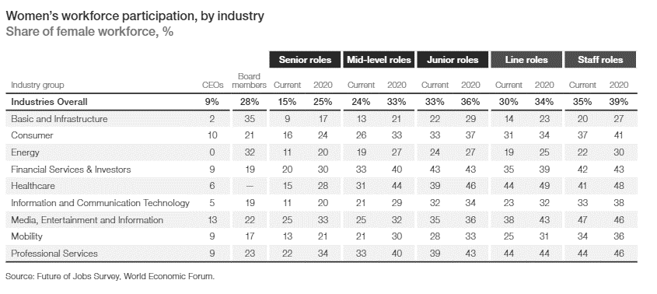Source: The Industry Gender Gap 2016 report by the World Economic Forum

Table 3: World Governance Indicator Averages

|  |  |
| --- | --- |
|  | |
| Country | Governance Average Index |
| Argentina | -0.36 |
| Brazil | -0.17 |
| Colombia | -0.22 |
| Mexico | -0.27 |
| Peru | -0.21 |
| Austria | 1.47 |
| Belgium | 1.29 |
| Bulgaria | 0.12 |
| Czech Republic | 0.94 |
| Denmark | 1.72 |
| Estonia | 1.19 |
| Finland | 1.77 |
| France | 1.12 |
| Germany | 1.53 |
| Greece | 0.19 |
| Hungary | 0.50 |
| Ireland | 1.51 |
| Italy | 0.46 |
| Lithuania | 0.95 |
| Luxembourg | 1.72 |
| Netherlands | 1.66 |
| Poland | 0.85 |
| Portugal | 1.04 |
| Romania | 0.21 |
| Slovakia | -1.07 |
| Spain | 0.78 |
| Sweden | 1.75 |
| United Kingdom | 1.52 |

*Source: WorldBank database*

Table 4: Quota and other national measures for women representation on boards.

|  |  |  |
| --- | --- | --- |
| Country | Quota Percentage | Other national measure |
| Austria | 35% for supervisory boards by 2018. | Mandatory requirements: For listed companies, obligation to report on the initiatives taken to promote more women in positions of leadership in their corporate governance reports. |
| Belgium | 33% for executives and nonexecutives in state-owned and listed companies by 2017 and by 2019. | Program to increase the representation of women on boards and in management positions. |
| Denmark | No quota | From 2013 obligation to all companies to self-regulate and set their own targets.  A company can be fined if it hasn’t set any target figures or hasn’t submitted any reporting. |
| Finland | No quota | The Act on Equality between Women and Men requires government bodies or state-owned enterprises with boards of elected representatives to have both men and women equally represented. |
| France | 40 % by 2017. |  |
| Germany | 30 % for supervisory boards of the listed companies. | Other companies have to set individual quantitative objectives of women on boards with regard to non-executive and executive board members and senior managers below board level and deadlines to achieve them. |
| Greece | 33 % only companies fully or partially owned by the State. | Hellenic Corporate Governance Code (2013): diversity of skills, views, competencies, knowledge, qualifications, and experience relevant to the business objectives of the company. |
| Italy | 33 % by 2015 for listed companies and state-owned companies. |  |
| Netherlands | Target of 30 % in the executive boards and supervisory boards of large companies | Self-regulation: diversity clauses in the Dutch Corporate Governance Code of 2009. |
| Poland | No quota | The Code of good practices establishes a target of 30% for 2015 and a priority rule for equally qualified women. |
| Portugal | No quota | A government resolution of 2015 encourages listed companies to attain 30% of the underrepresented sex at their administrative bodies by 2018. |
| Spain | 40 % by 2015 in state-owned companies with 250 or more employees. |  |
| Sweden | No quota | The Corporate Governance Code of 2004 has a voluntary goal of parity for listed companies to explain their board selection mechanism. |
| United Kingdom | No quota | The recommended target for listed companies in FTSE 100 is of 25%. |
| Colombia | Mandatory 30 % female quota for decision-making positions at all government entities. |  |
| Brazil | The Brazilian senate is discussing the inclusion of mandatory quotas for state and federal mixed-capital companies, which would require a 40 % representation of women on boards by 2022. | Bill is currently awaiting approval. Not implemented yet. |

*Source: European Commission and Deloitte report.*

Table 7: Board Size and Women representation in boards by Country and Region.

|  |  |  |  |
| --- | --- | --- | --- |
|  | Average Size of Board | Average Number of women in board | Percentage of Women on Boards |
| **Latin America** | | | |
| Argentina | 4.46 | 0.47 | 10% |
| Brazil | 6.75 | 0.52 | 8% |
| Chile | 3.73 | 0.48 | 13% |
| Colombia | 8.41 | 2.41 | 29% |
| Mexico | 5.95 | 0.36 | 6% |
| Peru | 1.8 | 0.16 | 9% |
| **Europe** | | | |
| Austria | 7.28 | 0.81 | 11% |
| Belgium | 20.13 | 7.92 | 39% |
| Bulgaria | 4.59 | 0.8 | 17% |
| Czech Republic | 3.67 | 0.36 | 10% |
| Denmark | 8.09 | 1.62 | 20% |
| Estonia | 5.54 | 0.94 | 17% |
| Finland | 7.03 | 1.72 | 24% |
| France | 14.43 | 4.86 | 34% |
| Germany | 3.51 | 0.33 | 9% |
| Greece | 4.91 | 0.32 | 7% |
| Hungary | 4.97 | 0.77 | 15% |
| Ireland | 9.71 | 2.16 | 22% |
| Italy | 6.3 | 1.45 | 23% |
| Lithuania | 2.55 | 1.78 | 70% |
| Luxembourg | 7.24 | 0.76 | 10% |
| Netherlands | 4.32 | 0.69 | 16% |
| Poland | 2.47 | 0.32 | 13% |
| Portugal | 6.77 | 1.2 | 18% |
| Romania | 3.16 | 0.91 | 29% |
| Slovakia | 4.88 | 0.91 | 19% |
| Spain | 10.01 | 1.67 | 17% |
| Sweden | 9.62 | 2.97 | 31% |
| United Kingdom | 11.3 | 2.62 | 23% |

Table 8: Descriptive Statistics of all variables

|  |  |  |  |  |  |
| --- | --- | --- | --- | --- | --- |
|  | | | | | |
|  | Observations | Mean | Std. Dev. | Min | Max |
| **Dependent Variabl**e |  |  |  |  |  |
| Percentage Women on Boards | 2900 | .1796 | .2483 | 0 | 1 |
| **Independent Variables** |  |  |  |  |  |
| Power Distance | 2900 | 53.0344 | 20.3479 | 11 | 100 |
| Individualism | 2900 | 53.7931 | 20.6673 | 13 | 89 |
| Masculinity | 2900 | 49.4827 | 22.3778 | 5 | 100 |
| Uncertainty Avoidance | 2900 | 71.5862 | 20.7125 | 23 | 100 |
| **Control Variables** |  |  |  |  |  |
| Industry | 2900 | .7351 | 0.44131 | 0 | 1 |
| Firm Size | 2900 | 14454.54 | 41265.86 | 65 | 611366 |
| Board Size | 2900 | 6.6751 | 7.0816 | 1 | 145 |
| FDI | 2900 | 6.1771 | 14.8324 | -4.5699 | 71.7169 |
| Wage Gap | 2900 | 0.597 | 0.08927 | 0.475 | 0.799 |
| Governance | 2900 | 0.794 | 0.7721 | -1.07333 | 1.7678 |
| Quotas | 2900 | 0.5517 | 0.4974 | 0 | 1 |
| Female Labor Participation | 2900 | 52.3537 | 5.3257 | 39.306 | 65.729 |
| Moderator Variable | | | | | |
| GDP per capita | 2900 | 28003.29 | 21092.68 | 6027.126 | 99717.74 |

Figure 2: Scatterplots for Linearity test

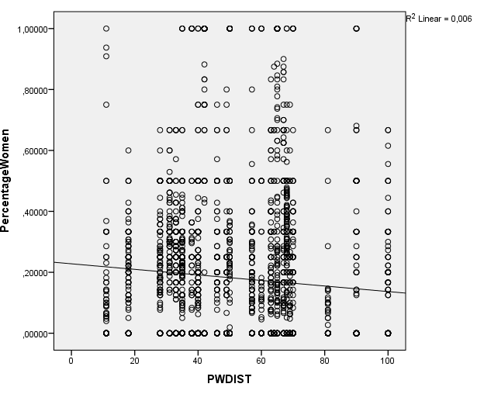 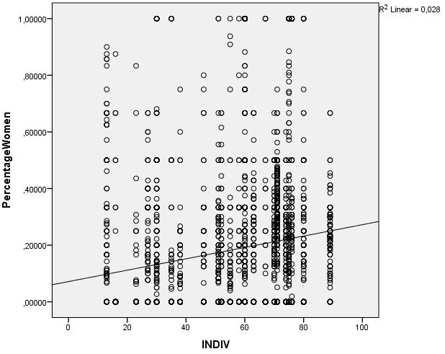

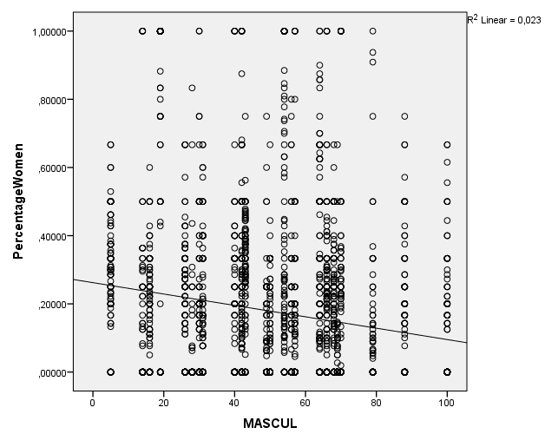 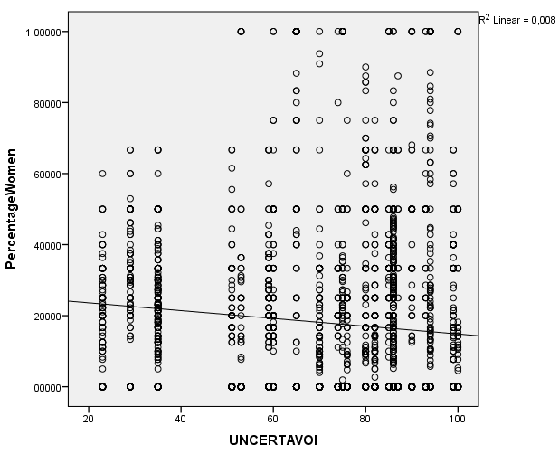

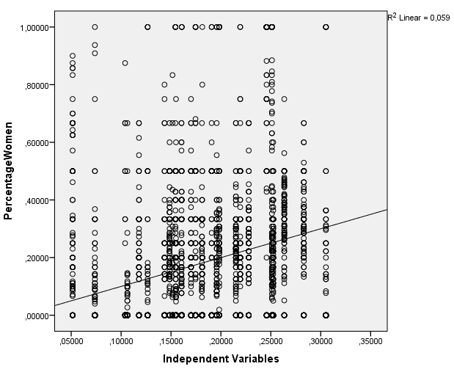

Table 9: Correlation Matrix (Stata and SPSS)

|  |  |  |  |  |  |  |  |  |  |  |  |  |  |
| --- | --- | --- | --- | --- | --- | --- | --- | --- | --- | --- | --- | --- | --- |
|  | Percentage Women | Power Distance | Individualism | Masculinity | Unc. Avoidance | Firm Size | Board Size | FDI | Wage Gap | Governance | Quotas | Fem. Participation | GDP per capita |
| Percentage Women | 1 | -0.746 | 0.167 | -0.1502 | -0.0914 | 0.0697 | 0.1469 | -0.0341 | 0.1638 | 0.1232 | 0.0528 | 0.0221 | .042 |
| Power Distance | -.0746 | 1 | -0.559 | 0.265 | 0.582 | -0.092 | -0.063 | -0.255 | -0.506 | -0.762 | -0.275 | -0.344 | -0.620 |
| Individualism | 0.167 | -0.559 | 1 | 0.026 | -0.566 | 0.254 | 0.209 | 0.111 | 0.418 | 0.613 | 0.283 | -0.05 | 0.584 |
| Masculinity | -0.1502 | 0.265 | 0.026 | 1 | 0.19 | 0.017 | 0.002 | 0.062 | -0.396 | -0.461 | -0.142 | -0.438 | -.0135 |
| Unc. Avoidance | -0.0914 | 0.582 | -0.566 | 0.19 | 1 | -0.158 | -0.065 | -0.319 | -0.574 | -0.454 | -0.075 | -0.47 | -.0533 |
| Firm Size | 0.0697 | -0.092 | 0.254 | 0.017 | -0.158 | 1 | 0.238 | -0.01 | 0.029 | 0.173 | 0.21 | 0.04 | 0.166 |
| Board Size | 0.1469 | -0.063 | 0.209 | 0.002 | -0.065 | 0.238 | 1 | 0.031 | 0.163 | 0.177 | 0.24 | -0.004 | 0.225 |
| FDI | -0.0341 | -0.255 | 0.111 | 0.062 | -0.319 | -0.01 | 0.031 | 1 | 0.325 | 0.27 | -0.278 | 0.061 | 0.576 |
| Wage Gap | 0.1638 | -0.506 | 0.418 | -0.396 | -0.574 | 0.029 | 0.163 | 0.325 | 1 | 0.628 | 0.186 | 0.261 | 0.636 |
| Governance | 0.1232 | -0.762 | 0.613 | -0.461 | -0.454 | 0.173 | 0.177 | 0.27 | 0.628 | 1 | 0.362 | 0.273 | 0.732 |
| Quotas | 0.0528 | -0.275 | 0.283 | -0.142 | -0.075 | 0.21 | 0.24 | -0.278 | 0.86 | 0.362 | 1 | 0.149 | 0.224 |
| Fem. Participation | 0.0221 | -0.344 | -0.05 | -0.438 | -0.47 | 0.04 | -0.004 | 0.061 | 0.261 | 0.273 | 0.149 | 1 | 0.175 |
| GDP per capita | 0.042 | -0.620 | 0.584 | -0.135 | -0.533 | 0.166 | 0.225 | 0.576 | 0.636 | 0.732 | 0.224 | 0.175 | 1 |

Table 10: VIF results (Stata)

|  |  |  |
| --- | --- | --- |
| Variable | VIF | 1/VIF |
| Governance | 5.61 | 0.1781 |
| Individuality | 3.72 | 0.2687 |
| Uncertainty Avoidance | 3.68 | 0.2716 |
| Power Distance | 3.14 | 0.3186 |
| Wage Gap | 2.31 | 0.4322 |
| Fem. Participation | 2.13 | 0.4686 |
| Masculinity | 2.11 | 0.4745 |
| FDI | 1.69 | 0.5913 |
| Quotas | 1.55 | 0.6467 |
| Firm Size | 1.18 | 0.8475 |
| Board Size | 1.16 | 0.8587 |
| Industry | 1.02 | 0.9791 |
| Mean VIF | 2.44 |  |

Table 11: Variance and Ratio of Independent Variables

|  |  |
| --- | --- |
| Variance and Ratio | |
|  | Variance |
| Power Distance | 414.04 |
| Individualism | 427.14 |
| Masculinity | 500.77 |
| Uncertainty Avoidance | 429.01 |
| Ratio | 1.2 |

Figure 3: Homoscedasticity Graphs

1. *Using SPSS*

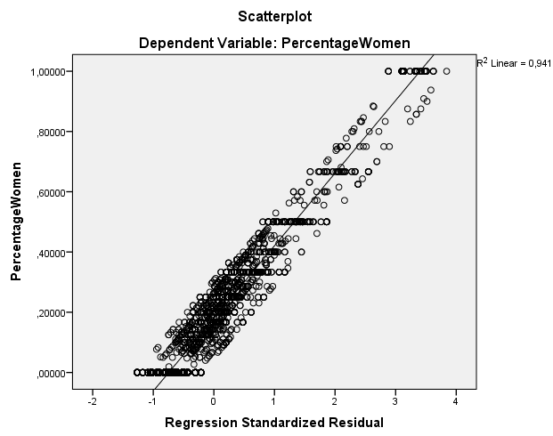

1. *Using Stata*

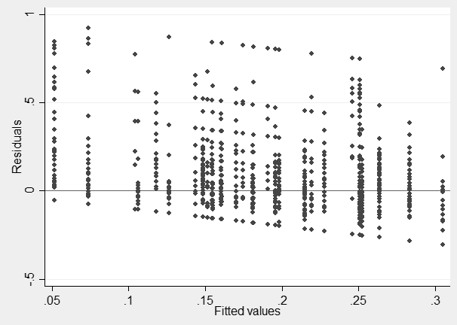

Figure 4: Normality Graphs

1. *Q-Q plots*
   1. Dependent Variable

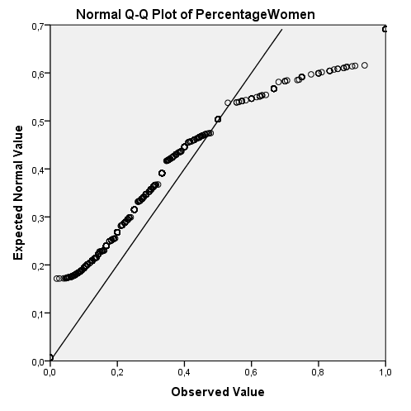

* 1. Independent Variables

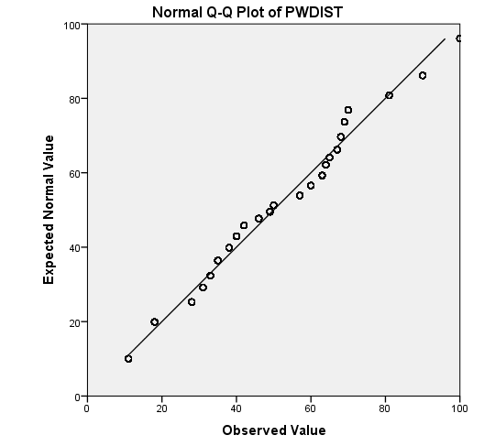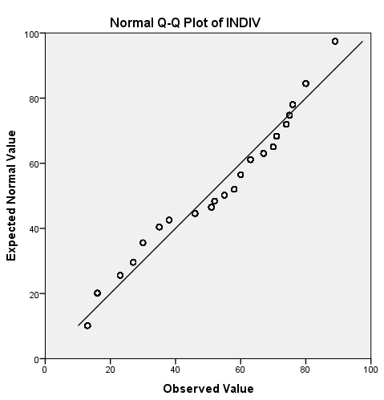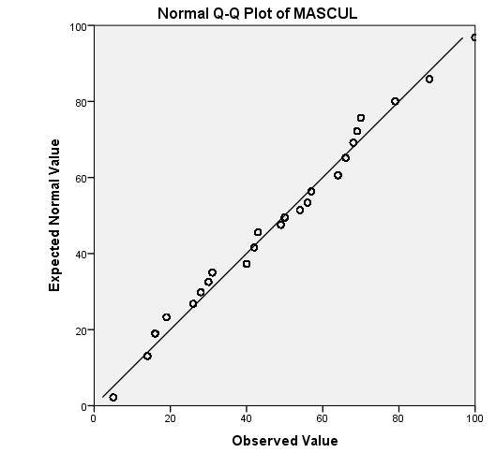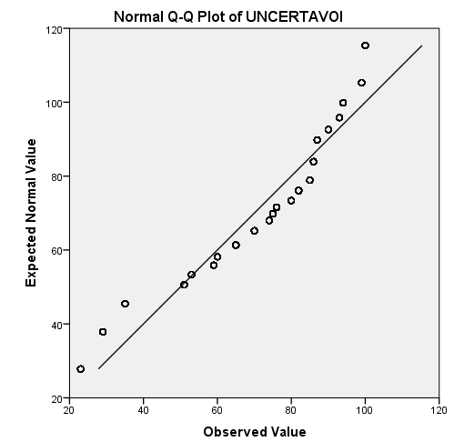

1. *Histograms*
   1. Dependent Variable



* 1. Independent Variables

 

 

Table 12: Kolmogorov-Smirnov and Shapiro-Wilk test for normality

|  |  |  |
| --- | --- | --- |
| Variable | Kolmogorov-Smirnov | Shapiro-Wilk |
| Percentage of Women | .0000 | .0000 |
| Power Distance | .0000 | .0000 |
| Individualism | .0000 | .0000 |
| Masculinity | .0000 | .0000 |
| Unc. Avoidance | .0000 | .0000 |

Table 13: OLS Multiple Regression output

|  |  |  |  |  |  |
| --- | --- | --- | --- | --- | --- |
| OLS analysis of cultural dimensions that affect the proportion of women on corporate boards (n= 2,900) | | | | | |
| Variable | Model 1 | Model 2 | Model 3 | Model 4 | Model 5 |
| Industry |  |  |  |  |  |
| Infrastructure | -.068 (.156) | -.071 (.001)*** | -.071 (.001)*** | -.070 (.001)*** | -.070 (.001)*** |
| Consumer | .001 (.940) | .005 (.799) | .006 (.782) | -.004 (.840) | .010 (.629) |
| Energy | -.048 (.175) | -.054 (.008)** | -.054 (.008)** | -.055 (.007)** | -.051 (.012)* |
| Finance | -0.059 (.103) | -.068 (.001)*** | -0.064 (.002) | -0.061 (.003) | -0.035 (.086) |
| Health and Education | .019 (.543) | .018 (.370) | .018 (.365) | .022 (.264) | .016 (.402) |
| Professional Services | .001 (.997) | .002 (.996) | .006 (.989) | .007 (.877) | -.001 (.977) |
| IT | .006 (.997) | -.004 (.837) | -.004 (.833) | -.001 (.944) | -.006 (.735) |
| Firm Size | .037 (.052) | .030 (.116) | 0.029 (.138) | 0.021 (.282) | .040 (.034)* |
| Board Size | 0.131 (0.000)*** | 0.141 (0.000)*** | .139 (0.000)*** | .133 (0.000)*** | .144 (0.000)*** |
| FDI | -0.129 (0.000)*** | -.111 (0.000)* | -.111 (0.000)*** | -.109 (0.000)*** | -.056 (0.013)* |
| Wage Gap | 0.163 (0.000)*** | .112 (0.000)*** | .111 (0.000)*** | .116 (0.000)*** | .072 (0.007)** |
| Governance | 0.057 (.027)* | -.021 (.552) | -.005 (.871) | -.035 (.250) | -.093 (.003)** |
| Quotas | -0.067 (.002)** | -.070 (.002)** | -.068 (.002)** | -.071 (.001)*** | -.048 (.029)* |
| Fem. Labor | -0.027 (.153) | .022 (.314) | .021 (.381) | .030 (0.159) | -.010 (.643) |
| Economical Region (1=Europe/0=Latin America) | - | .140 (0.000)*** | .137 (0.000)*** | .107 (0.000)*** | -.184 (0.000)*** |
| Power Distance | - | -.023 (.447) | - | - | - |
| Uncertainty Avoidance | - | - | -.007 (.776) | - | - |
| Individualism | - | - | - | .076 (0.005)** | - |
| Masculinity | - | - | - | - | -.158 (0.000)*** |
| Adjusted R² | 0.0626 | 0.068 | 0.058 | 0.065 | 0.064 |
| F- Test | 14.84 | 15.048 | 13.88 | 15.51 | 15.37 |
| p value | 0.000*** | 0.000*** | 0.000*** | 0.000*** | 0.000*** |
| *p values in parentheses* | | | | | |
| *\*p<.05; **p<.01;*** p<.001* | | | | | |

Table 14: Interaction Effects

|  |  |  |  |  |
| --- | --- | --- | --- | --- |
| OLS analysis of cultural dimensions with the level of income (n= 2,900) | | | | |
| Variable | Model 1 | Model 2 | Model 3 | Model 4 |
| Industry |  |  |  |  |
| Infrastructure | -.067 (.002)** | -.081 (.000)*** | -.071 (.001)** | -.070 (.001)*** |
| Consumer | .001 (.958) | -.008 (.703) | -.006 (.765) | .001 (.945) |
| Energy | -.041 (.041)* | -.056 (.006)** | -.057 (.005)** | -.046 (.022)* |
| Finance | -0.011 (.599) | -0.064 (.002)** | -0.048 (.019)* | -0.052 (.013)* |
| Health and Education | .006 (.769) | .022 (.263) | .021 (288) | .008 (.671) |
| Professional Services | .001 (.997) | .001 (.997) | .001 (.997) | .001 (.997) |
| IT | .006 (.740) | .002 (.921) | -.002 (.986) | -.002 (.894) |
| Firm Size | .043 (.023)* | .042 (.029)* | .030 (.119) | .045 (.019)* |
| Board Size | .102 (0.000)** | .136 (0.000)** | .139 (0.000)** | .138 (0.000)** |
| FDI | .026 (0.325) | .062 (0.032)* | -.001 (0.969) | -.096 (.001)*** |
| Wage Gap | .286 (.000)*** | .206 (0.000)*** | .204 (0.000)*** | .199 (0.000)** |
| Governance | -.015 (.685) | 0.170 (0.000)*** | 0.059 (0.065) | 0.018 (0.621) |
| Quotas | -.044 (.047)* | .008 (0.722) | -038 (.095) | -.027 (.238) |
| Fem. Labor | .02 (.282) | -.053 (0.013)* | .012 (0.569) | -.052 (0.012)* |
| Power Distance | -.018 (0.552) |  | - | - |
| Uncertainty Avoidance | - | -.169 (0.000)*** | - | - |
| Individualism | - | - | .143 (0.000)*** | - |
| Masculinity | - | - | - | -.100 (0.000)*** |
| GDP per capita | -.027 (0.474) | -.301 (0.000)*** | -.247 (0.000)*** | -.077 (0.048)* |
| Power Distance*GDP per capita | .277 (0.000)*** | - | - | - |
| Unc. Avoidance*GDP per capita | - | .214 (0.000)*** | - | - |
| Individualism*GDP per capita | - | - | -.057 (0.045)* | - |
| Masculinity*GDP per capita | - | - | - | .104 (0.000)*** |
| Adjusted R² | 0.101 | 0.09 | 0.081 | 0.082 |
| F- Test | 21.45 | 18.934 | 16.997 | 16.037 |
| p value | 0.000*** | 0.000*** | 0.000*** | 0.000*** |
| *p values in parentheses. Standardized coefficients* | | | | |
| *\*p<.05; **p<.01;*** p<.001* | | | | |

Figure 5: Visualization of Interaction Effects (SPSS)

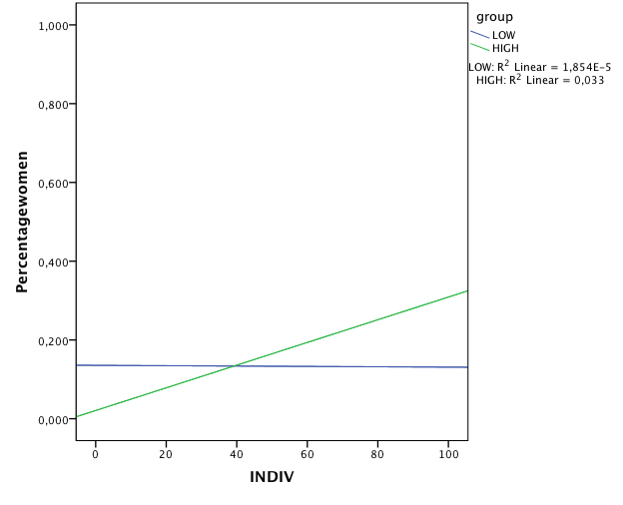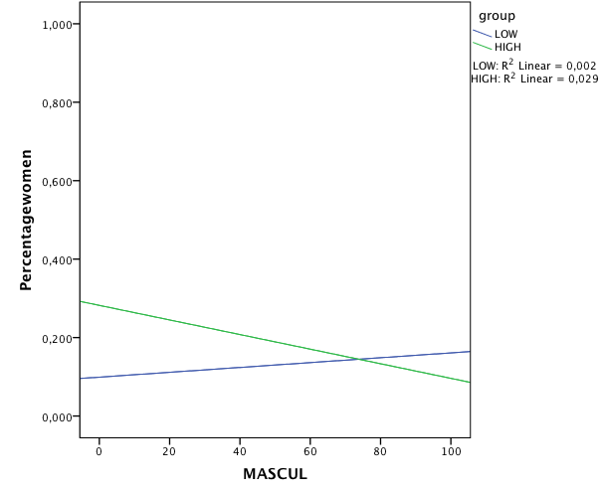

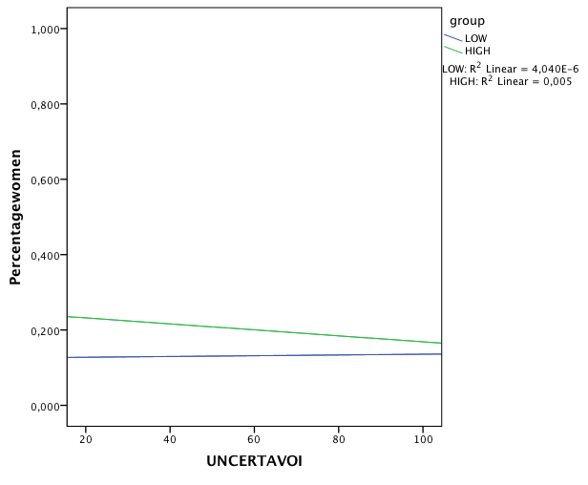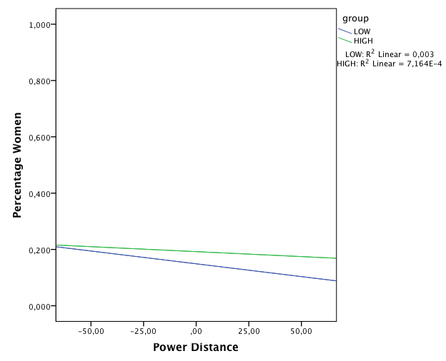

1. According to Catalyst (2017), 19.9% of women have a seat on the board of directors in S&P 500 companies.
2. According to UNICEF, one third of girls in non-developed countries marry before the age of 18 and give birth before the age of 20, making it difficult to continue with school.
3. It is for this reason that female managers are less likely to be married and to have children than their male counterparts (Apperson et al., 2002).
4. In her book, Adler notes that the bigger the company the more probable the employee resist organizational culture, especially if it goes against the beliefs of their own national culture.
5. All firms with missing values, i.e. no number of employees or no information on board of directors were discarded.
6. Criticism includes relevancy problems, cultural homogeneity, political influences and statistical integrity (Jones, 2007).
7. In 1991 and 2010, Hofstede added two more dimensions: Long term orientation and Indulgence respectively. Because not all of our countries have such scores, they will not be taken into account for this thesis.
8. https://geert-hofstede.com/national-culture.html
9. See Table 2 in the Appendix for an overview of the industries and their percentages.
10. Firm size can be measured by different variables: total assets, turnover, number of employees, etc.
11. This is the result of the World’s Economic Forum Executive Opinion survey from 2015-2016. Where 0 equals total imparity and 1 equals total parity.
12. The WGI was initiated by Daniel Kaufmann and Aart Kraay (1999) and comprises of six broad dimensions of governance over the period of 1996 and 2015: voice and accountability, political stability, government effectiveness, regulatory quality, rule of law and control of corruption (WorldBank, 2017).
13. Dichotomous dummy variable where 0 equals no quotas or national measures encountered in the country and 1 if otherwise.
14. Quotas in place taken into account as of the year of 2015. Information retrieved from European Commission Database and Deloitte *Women in the Boardroom: A Global Perspective* report.
15. Correlations can be seen in the correlation matrix in Table 9 of the Appendix.
16. Note that the descriptive statistics is for the number of women in board and not for the share of women on boards, this is for the easiness of comparison in absolute numbers.
17. Scatterplots were ra n using SPSS and Stata programs in combination.
18. This is used as a rule of thumb.
19. Q-Q plots were made using SPSS and histograms were made using Stata.
20. Table 9 in the Appendix presents the correlations between the four cultural dimensions.
21. World Economic Situation and Prospects and World Bank.
22. It is important to note that only 8 countries were scored under low income and the remaining 21 were segmented into high-income countries, which might affect the results. See data limitations on next chapter.